Standardization Sector
ITU-T Technical Report
(05/2026)
YSTR.ACC-SCC
Guidelines on developing information and communication technology services for accessible smart sustainable cities and communities (SSC&C)
ITUPublications | International Telecommunication Union


Technical Report ITU-T YSTR.ACC-SCC
Guidelines on developing information and communication technology services for accessible smart sustainable cities and communities (SSC&C)

Summary
Smart sustainable city services can have a ripple effect beyond improving physical accessibility for all, especially for persons with disabilities (PWDs), those with age-related disabilities and those with specific needs. PWDs can benefit from more efficient and sophisticated city services through smart sustainable city services. Thus, it is an important opportunity to improve quality of life using city functions equivalent to the quality of life enjoyed by those without disabilities. However, as seen in many other use cases of information and communication technologies (ICTs), not considering the needs of PWDs from the design stage will create barriers for these persons. Using a two-layer structure of accessibility consideration principles, this Technical Report provides development guidelines to be considered at each layer to implement accessible smart sustainable city services. Exemplar accessible smart sustainable city services are illustrated in Appendix II.

Keywords
Accessibility, accessible smart sustainable cities and communities, persons with age-related disabilities, persons with disabilities, persons with specific needs, universal design, vulnerable groups.

Note
This is an informative ITU-T publication. Mandatory provisions, such as those found in ITU-T Recommendations, are outside the scope of this publication. This publication should only be referenced bibliographically in ITU-T Recommendations.

© ITU 2026
All rights reserved. No part of this publication may be reproduced, by any means whatsoever, without the prior written permission of ITU.
Table of Contents
Page
1 Scope 1
2 References 1
3 Definitions 1
3.1 Terms defined elsewhere 1
3.2 Terms defined in this Technical Report 2
4 Abbreviations and acronyms 2
5 Background 2
6 Two-layer structure of accessibility consideration principles 2
7 Interface layer: accessible smart sustainable city services as an interface to city services 4
7.1 Accessibility principles concerning interface layer 4
7.2 Accessibility guidelines concerning the interface layer 8
8 Information layer: accessible smart sustainable city services as a tool for users with specific needs 9
8.1 Accessibility principles concerning the information layer 10
8.2 Accessibility guidelines concerning the information layer 10
Appendix I – Use case on good practices of accessible smart sustainable city services 13
I.1 Use case: Preventive safety service system 13
Appendix II – Exemplar accessible smart sustainable city services 16
II.1 Accessible public transport service 16
Bibliography 18

Technical Report ITU-T YSTR.ACC-SCC
Guidelines on developing information and communication technology services for accessible smart sustainable cities and communities (SSC&C)

1 Scope
This Technical Report describes guidelines for developing accessible information and communication technology (ICT) services for smart sustainable cities for everyone, including but not limited to, persons with disabilities (PWDs), persons with age-related disabilities and those with specific needs. It introduces a two-layer structure of accessibility consideration principles and provides development guidelines to be considered at each layer, to implement accessible smart city services.

2 References
None.

3 Definitions

3.1 Terms defined elsewhere
This Technical Report uses the following terms defined elsewhere:
3.1.1 accessibility [b-ITU-T F.791]: The degree to which a product, device, service or environment (virtual or real) is available to as many people as possible.
3.1.2 accessibility feature [b-ITU-T F.791]: An additional content component that is intended to assist people hindered in their ability to perceive an aspect of the main content.
3.1.3 Internet of things (IoT) [b-ITU-T Y.4000]: A global infrastructure for the information society, enabling advanced services by interconnecting (physical and virtual) things based on existing and evolving interoperable information and communication technologies.
NOTE 1 – Through the exploitation of identification, data capture, processing and communication capabilities, the IoT makes full use of things to offer services to all kinds of applications, whilst ensuring that security and privacy requirements are fulfilled.
NOTE 2 – From a broader perspective, the IoT can be perceived as a vision with technological and societal implications.
3.1.4 sign language [b-ITU-T F.930]: A natural language that, instead of relying on acoustically conveyed sound patterns, uses signs made by moving the hands combined with facial expressions and postures of the body to convey meaning. It is also called signed language or simply visual signing.
3.1.5 sign language interpretation [b-ITU-T F.791]: Synchronized showing of an interpreter who uses sign language to convey the main audio content and dialogue to people who use sign language.
3.1.6 smart sustainable city [b-ITU-T Y.4900]: A smart sustainable city is an innovative city that uses information and communication technologies (ICTs) and other means to improve quality of life, efficiency of urban operation and services and competitiveness, while ensuring that it meets the needs of present and future generations with respect to economic, social, environmental, as well as cultural aspects.
3.1.7 specific needs [b-ITU-T F.791]: This replaces the use of the term 'special needs'. This term refers to a wide range of categories including women, children, youth, indigenous people, older persons with age-related disabilities, persons with illiteracy, as well as persons with disabilities (PWDs), see [b-ITU PP Res.175], [b-WTDC Res.58], and [b-WTDC AP] and clause 6.39 (of [b-ITU-T F.791]).
3.1.8 universal design [b-ITU-T Y.4211]: The design of products, environments, programmes and services to be usable by all people, to the greatest extent possible, without the need for adaptation or specialized design. "Universal design" shall not exclude assistive devices for particular groups of persons with disabilities where this is needed.
NOTE – Paraphrased from [b-UNCRPD].

3.2 Terms defined in this Technical Report
None.

4 Abbreviations and acronyms
This Technical Report uses the following abbreviations and acronyms:
FGI Focus Group Interview
FM Frequency Modulation
ICF International Classification of Functioning, Disability, and Health
ICT Information and Communication Technology
IoT Internet of Things
PWD Person With Disabilities
SSC&C Smart Sustainable Cities and Communities
UI User Interface
W3C World Wide Web Consortium
WCAG Web Content Accessibility Guidelines

5 Background
Smart cities can provide various services to residents by converging ICT into the city's infrastructure. Smart cities use ICT, including the Internet of things (IoT), to build various smart sustainable city infrastructures.
Smart cities have services that directly help individuals' daily lives, and background services that increase efficiency by improving city functions. Smart sustainable city services, both directly and indirectly, provide residents with benefits in various fields, such as health and well-being, quality of life, housing, civic engagement and emergency services.
In particular, these services can have a ripple effect beyond improving physical accessibility for PWDs, those with age-related disabilities and those with specific needs. Everyone, including PWDs, can benefit from more efficient and sophisticated city services through smart sustainable city services. Thus, it is an important opportunity to improve quality of life using city functions equivalent to the quality of life of those without disabilities. However, as seen in many other use cases of ICTs, without consideration for PWDs from the design stage, it is bound to be another barrier for these persons.

6 Two-layer structure of accessibility consideration principles
Urban environments are experienced differently based on various social factors. Older adults commonly encounter mobility barriers; safety considerations can influence how some people, including women, use public spaces; some communities can face barriers to full participation in urban environments; socio-economic class influences access to quality housing and essential services; and disability shapes individual capacities to navigate and interact with city infrastructure, highlighting multiple layers of urban experience.
Smart cities, through inclusive technological solutions and equitable urban planning, can mitigate these disparities by fostering environments that accommodate diverse populations. Accessible smart cities can be understood in multiple dimensions. The most fundamental part is to ensure that all citizens, including PWDs, can use the same level of service without discrimination due to physical and cognitive disabilities, as well as cultural, linguistic or contextual differences.
This starts with lowering the barriers to smart sustainable city services by securing accessibility to ICTs that serves as a user interface (UI). Furthermore, accessibility can be increased by integrating smart sustainable city services with assistive devices (e.g., screen readers, hearing aids and braille keyboards) for PWDs. As identified in [b-ITU-T Y.4211] in the context of smart public transport services, smart sustainable city services may be used to create access tools for persons with many types of disabilities and specific needs, including physical, visual, hearing and cognitive disabilities.
Additionally, smart sustainable city services play an essential role in increasing the accessibility of city services to PWDs. It means smart sustainable city services themselves can function as an assistive means of city services. The accessibility of city services that could not be solved by existing physical city infrastructure alone can be provided through smart sustainable city services. For example, remote sign language interpretation services can be integrated into public services. In addition, using metaverse technology, citizens with visual or physical disabilities can experience educational or administrative services regardless of disabilities in a virtual environment. Smart cities may also provide more advanced services to users with specific needs. For example, smart grid technology can track the stable power supply of a hospital or an individual's life support device. Further, it is also possible to provide a safe interaction for persons with visual disabilities using a location service.
Each dimension mentioned can be mapped into an interface layer and an information layer, as shown in Figure 1. The accessibility principles can be more clearly distinguished using these two layers of structure. In particular, the information and services provided in accessible smart sustainable city services must satisfy the needs of all users at an equal level. Therefore, first, accessible smart sustainable city services must satisfy accessibility in providing information or services to users. Second, they must be customized so that the information provided can meet users' specific needs. By dividing them into interface and information layers, clearer accessibility considerations for each level can be determined.
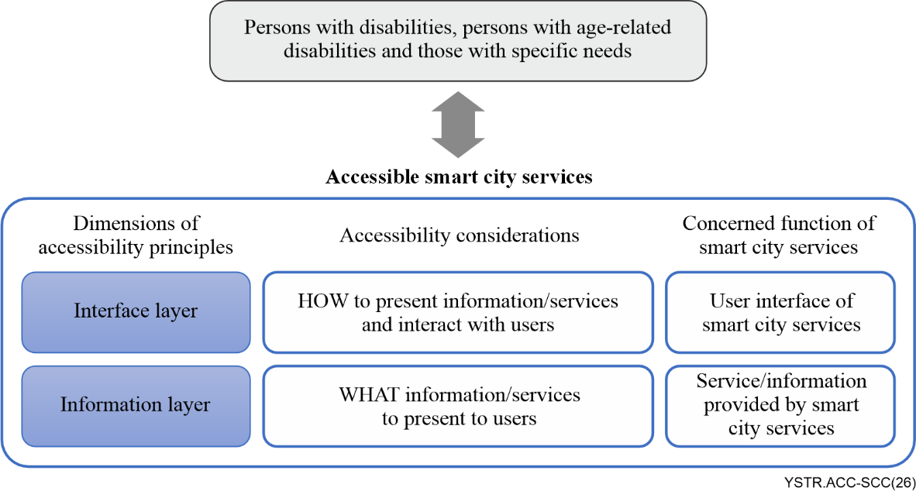
Figure 1 – Two-layer structure of accessibility consideration principles
The interface layer focuses on ensuring appropriate accessibility of UIs so that smart sustainable city services can be used independently of visual, auditory, physical and cognitive disabilities, as well as the user's specific needs. The IoT-based smart sustainable city service communicates with users through various UIs such as users' smart devices, wearable devices, kiosks and embedded panels. In addition, smart sustainable city services should appropriately reflect multiple user needs, such as accessibility assistance devices.
The information layer is related to constructing a service system so that users with specific needs can appropriately address their needs using urban services. This can be implemented through a proper design that reflects factors concerning the user's environment and specific needs.
Clauses 7 and 8 provide development guidelines to be considered at each layer to implement accessible smart sustainable city services.

7 Interface layer: accessible smart sustainable city services as an interface to city services
This clause examines the accessibility principles that smart sustainable city interfaces must have for users with disabilities to use the service.
In this clause, the basic accessibility principles that all UIs participating in smart sustainable city services should have, regardless of the interface's nature, are first considered. After that, accessibility principles for the two different types of devices are discussed.
Various types of devices are integrated in smart sustainable city services, ranging from personal devices for an individual to public devices for all citizens. If these devices are integrated in smart cities, there are principles that must be common to secure accessibility. However, it is noted that the direction of accessibility principles that each device should pursue may differ depending on which authority the device is managed by. The accessibility principles required in each case are classified depending on how the devices are used (i.e., as personal devices or public facilities), according to the method of using smart sustainable city services. Figure 2 shows the composition of the accessibility principles according to the characteristics of such devices.
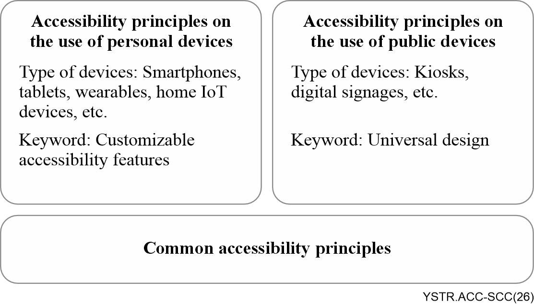
Figure 2 – Composition of the accessibility principles for smart sustainable city services

7.1 Accessibility principles concerning the interface layer

7.1.1 General accessibility principles
Before discussing the general accessibility principles, it is important to mention that the general accessibility standards that devices should basically comply with are not covered here. General accessibility standards for the characteristics of each device are addressed in the individual platform accessibility standards. For web-based environments, Web Content Accessibility Guidelines (WCAG) standards for World Wide Web Consortium (W3C) can be referenced in [b-W3C WCAG 2.2] and for smartphone UIs in IoT environments, [b-ITU-T Y.4219] is available. Some other relevant standards for other types of devices may be helpful. Even if no standards exist for a particular device, the two aforementioned standards may be helpful.
This Technical Report introduces the accessibility principles to be considered in configuring smart sustainable city services, even if they comply with the general accessibility standards that devices should have.
1) The interface of smart sustainable city services must be designed so that the included functions are easily perceivable by users
It may sound obvious, but it must be noted that how PWDs perceive may differ from how persons without disabilities perceive. Intuition sometimes depends on human senses such as sight or hearing. How users with visual or hearing disabilities perceive may differ from the perception of those without disabilities. For example, those without visual disabilities commonly perceive red as a colour that marks a stop, warning or danger, but colour-blind users may be unable to distinguish red. Likewise, a person with developmental disabilities or a foreigner from another culture are people with different perceptions. To solve this problem, it is necessary to comply with international norms that are not subordinate to culture and use various methods simultaneously.
2) The interface of smart sustainable city services must be developed considering as many types of disabilities and environments as possible and considering future scalability.
Accessibility technologies also develop with technological advances. In particular, various auxiliary devices are emerging that can assist with or reduce the inconvenience experienced by PWDs through the development of artificial intelligence technology and various new emerging technologies. Because smart sustainable city services usually aim for a very long lifecycle, they must be designed to accommodate not only the current level of technology but also various accessibility-related technologies to be introduced in the future.
3) When implementing existing accessibility features, it is necessary to ensure maximum compliance with the relevant accessibility standards and to standardise as soon as possible when introducing new accessibility features.
PWDs and those with age-related disabilities need more time to acquire and understand new skills. When technologies with similar functions operate differently, complexity increases and the learning cycle becomes longer. As smart sustainable city services are generally provided by integrating various unit services, it is very important to simplify them by standardising accessibility features.
4) The interface of smart sustainable city services must be designed and developed from the user's point of view.
This principle needs to be understood in two respects. First, development based on developer-centred validity and development difficulty must be avoided. There is no guarantee that convenient use from the developer's point of view is necessarily convenient from the point of view of users with disabilities. It may not be convenient for all users just because they make it easy and simple. Through understanding the characteristics of a disability, it is necessary to determine what parts the user finds difficult and what functions are helpful.
Second, for this, it is necessary to understand the disability. Many developers easily fall into the error of jumping to conclusions about what PWDs or cannot do.
However, it is necessary to consider various user environments because not all persons with, for example, visual disabilities or those with age-related disabilities necessarily use all functions easily. Additionally, trust in technology varies significantly among users; many people may feel uncomfortable or unsafe relying solely on digital solutions and instead prefer human interaction. Therefore, designing smart cities requires careful consideration of accessibility, usability, trustworthiness, privacy and the preservation of personal choice, ensuring technological innovation complements rather than replaces human-centred services and interactions.
For example, many persons with visual disabilities can effectively use various functions of their smartphones. Also, many older persons with age-related disabilities actively use smartphones as much as young people.
5) The environmental factors of users must also be considered.
At first glance, considering the user's environment may seem to be an issue unrelated to accessibility, but disability is not something that causes difficulty for a person. Factors that hinder PWDs from living equally with those without disabilities are often caused by environments created around persons without disabilities. Voice-oriented contents, public posts that rely entirely on sight and pedestrian paths that do not consider wheelchair movement are typical examples of urban environments centred around persons without disabilities.
In addition, even if it is an environment that is not too much for many users, it may be a barrier for some users. For example, although smart sustainable city services utilising smartphones could increase accessibility for many PWDs and those with age-related disabilities, some users who use smart sustainable city services over smartphones in a mobile network environment may face the challenges of high data usage costs, slow speed and insufficient network coverage. To minimise the risk of providing non-affordable services, care should be taken to ensure the service can function without high burdens to users, as many persons with disabilities are often in economic difficulties. For example, challenges such as limited access to high-cost digital devices and services, the financial burden of assistive technologies and the lack of digital education opportunities due to economic difficulties significantly impact the accessibility of ICTs for PWDs. To address these challenges, governments and international organizations discuss and implement solutions such as providing assistive devices at affordable prices and offering free digital education programmes as much as possible.

7.1.2 Accessibility principles on the use of personal devices
Personal devices include smartphones, tablets, wearables and home IoT devices. Here, the personal device includes home devices shared with a family. This includes cases where users can use the device exclusively at the moment of use, even if they are not family members, and assistive technologies may be connected and used.
The characteristic of a personal device is that the user can change the accessibility features of the device to suit his or her accessibility needs. Setting these devices to meet the user's specific needs is important. It is also important that the connection with the assistive technologies used by the user, such as hearing aids and braille displays, works smoothly.
The accessibility principles of smart sustainable city services using this type of device are as follows:
1) Smart sustainable city services must support various devices that correspond to the various accessibility needs of users.
Services that support various devices are a matter of choice for persons without disabilities, but for PWDs, there are devices that better meet their specific needs. Persons with visual disabilities may prefer smart speakers that provide information by voice and control devices through voice conversations. Persons with hearing difficulties may prefer a choice of connecting to voice-based information using t-coil (telecoil) or Bluetooth technologies, both commonly used in hearing aids and other hearing technologies. Persons with physical disabilities may want to use computers, smartphones or tablets that can connect their specific assistive technologies. Of course, it is important to provide accessibility features in all devices with as much enhancement as possible. Still, it must be considered that various devices can be complementary alternatives to each other in terms of accessibility.
The t-coil is a device embedded in hearing aids and other hearing technologies such as cochlear implants that directly receive audio signals from telephones or public loop systems, providing clearer sound. It reduces background noise and amplifies audio, helping persons with hearing disabilities to hear more clearly. This technology is vital in enhancing accessibility for persons with hearing disabilities.
2) The interface of smart sustainable city services must provide a feature to customize to meet users' specific needs.
Providing accessibility functions to meet the user's specific needs is a common requirement in general information and communication devices. Smart sustainable city services must be able to be used well even if the user's location changes, regardless of whether the user is at home, at work or on the move. As mentioned in the previous clause, the user's accessibility needs may change according to changes in the environment.
In addition, various user devices such as smartphones, smartwatches and tablets can be connected to use the service by moving the work done on one side to another device. It is also necessary for a user using multiple devices to control the accessibility function of all devices in a single setting.
3) Smart sustainable city services must be compatible with users' assistive technologies.
Many general-purpose information and communication devices, including smartphones, provide accessibility functions for PWDs and support the connection of assistive technologies. However, many of these functions depend on the services provided. Ultimately, when designing and developing smart sustainable city services, they must be provided considering the use of these functions.
It is necessary to increase the accessibility of users with disabilities by making the most of these assistive technologies when developing smart sustainable city services. Many persons with disabilities prefer older technologies that operate reliably, albeit somewhat less technologically advanced, to newer, not fully stable, and under-developing technologies. New technologies are encouraged but existing technologies must be maintained for greater scalability.
For example, persons with hearing disabilities who use hearing aids prefer hearing loop technology, which is built into most hearing aids by default, to Bluetooth connections. It was developed long ago but it is still a widely used technology. Of course, hearing loop technology is not a complete technology. Since it is an analogue connection, the audio quality is largely dependent on the distance between the hearing loop and the recipient's hearing aids. The sound quality of hearing loop technology is not as good as that of digital voice transmission technology and is vulnerable to noise. However, although hearing loop technology has been around for quite a few years, it is installed in most hearing aids and operates stably. Bluetooth connectivity may provide better sound quality than hearing loop technology. Still, many problems must be solved regarding high-power consumption, unstable connection and one-to-many connection response. In addition, there are barriers to entry for users who have difficulty learning and using new technologies.
Many persons with visual disabilities still prefer using traditional white canes as their primary mobility aid, despite the availability of more advanced electronic mobility devices. White canes are highly reliable, affordable and simple to use, making them accessible to a broad range of users regardless of their financial or technical capabilities. They provide immediate tactile feedback about the surrounding environment, such as obstacles and changes in surface texture, allowing users to navigate effectively with minimal learning requirements. Additionally, white canes are lightweight, require no maintenance and function without the need for batteries or software, which eliminates the risk of malfunction.

7.1.3 Accessibility principles on the use of public devices
Public devices refers to devices used by multiple people or used by the public at the same time. Such devices may include kiosks and digital signage. A feature of these devices is that the user cannot change the device's settings to accommodate his or her specific needs. Therefore, it is necessary to incorporate appropriate functions so that more users with specific needs can be accommodated.
The accessibility principles necessary to provide smart sustainable city services through these devices are as follows:
1) It is necessary to develop a service applied with a universal design to accommodate various specific needs.
Various efforts are needed, such as taking appropriate alternative measures for persons with visual or hearing disabilities or providing sufficient time to understand information for users with cognitive disabilities (see [b-ISO/IEC TR 29138-1] for a list of user needs required to accommodate various specific needs in the information system. In addition, for information system requirements for persons with visual disabilities, see [b-ITU-T F.922]).
2) Smart sustainable city services must ensure that the needs of as many users as possible are reflected and provide appropriate alternatives.
If possible, it is necessary to provide a function for accessing the information through a personal device or to provide a method for using a user's assistive technologies. For example, the use of the hearing loop technology that utilizes frequency modulation (FM) frequencies is of great help when persons with hearing disabilities using hearing aids are exposed to noisy environments.
Not all public devices can incorporate alternative technologies. However, by utilizing smartphones that provide IoT technologies and location-based functions, it is possible to provide a method of using auxiliary technologies through personal devices, as an alternative to the information services of public devices.
3) Physical accessibility must be considered together with smart sustainable city service accessibility.
Public devices must consider accessibility from not only the perspective of information and communication but also physical accessibility. For example, when installing kiosks that require user interaction, appropriate heights must be ensured so that wheelchair users do not feel uncomfortable using them.
4) Accessible hardware interfaces must be considered in the design of public devices.
Public devices must incorporate hardware interfaces that support inclusive interaction, such as tactilely distinguishable controls, operable input mechanisms and hardware components that provide visual, tactile or auditory feedback. Alternative input mechanisms must be considered where touch-based interaction alone may limit accessibility for certain users.

7.2 Accessibility guidelines concerning the interface layer
This clause provides practical guidelines for implementing accessible smart sustainable city services in terms of the interface layer, ensuring that all users, including PWDs, can effectively interact with these services.
1) Consistent and predictable interfaces
Ensures that UIs follow a consistent layout and behaviour to help users predict and understand how to interact with them. This includes consistent navigation structures, icons and terminology across all smart sustainable city services.
2) Keyboard accessibility
Ensures that all functionalities of smart sustainable city services are operable through a keyboard interface or alternative input interface. This is crucial for persons with mobility disabilities who cannot use a mouse or touch screen.
3) Screen reader compatibility
Ensures that all text content is accessible via screen readers, delivered in a linear order that is easy to understand, and usable by persons with visual disabilities.
4) Alternative text for non-text content
Provides text alternatives for all non-text content, such as images, icons and multimedia. This enables persons with visual disabilities to understand the content through screen readers.
5) Colour and contrast
Ensures sufficient contrast between text and background colour, avoids using colour as the sole means of conveying information and provides text labels or patterns in addition to colour codes.
6) Adjustable text size
Allows users to adjust text size without loss of content or functionality and implements responsive design techniques to accommodate different screen sizes and user preferences.
7) Error identification and suggestions
Provides clear error messages and suggestions for correcting errors. This helps persons with cognitive disabilities to complete tasks without frustration.
8) Time-out and interruption
Provides mechanisms for users to extend the session time if it is time-limited, to notify users of time limits and to provide accessible means to request more time.

8 Information layer: accessible smart sustainable city services as a tool for users with specific needs
The information layer encompasses all data and content provided to users within smart sustainable city services. Beyond the simple act of delivering information, the information layer must be designed to ensure that users can access and effectively utilize the information. This is an essential component for smart sustainable city services to offer inclusive and efficient solutions for all users. The information layer includes real-time traffic information, public service alerts, community activity and resource information, and access to government services. For instance, real-time traffic updates, such as public transit schedules or road congestion data, assist users in planning their travel, while public service alerts like disaster warnings or power outage notifications provide critical information during emergencies. Additionally, community activity information, such as park locations or cultural event schedules, helps residents make better use of urban resources, and accessible government services like online complaint systems or tax payments enhance administrative convenience for citizens.
When discussing accessibility in smart cities, focusing solely on the UI is insufficient. The information itself must also be accessible to ensure that all users can utilize it equally. For users with disabilities, information must meet the criteria of perceivability, understandability and operability. Perceivability means designing information so that users can easily perceive it through visual, auditory or tactile methods. This can be achieved, for example, by adding captions to multimedia content or ensuring compatibility with braille displays. Understandability refers to providing information in a clear and simple manner, allowing users to comprehend and utilize it easily. This can involve avoiding complex terminology or structuring information logically. Finally, operability means that information must be compatible with a variety of assistive devices and usable without physical limitations. This includes supporting tools such as screen readers and magnifiers as well as accommodating diverse interaction methods like voice commands and touchscreens. These elements are critical to ensuring the accessibility of the information layer, enabling smart sustainable city services to create an inclusive and effective environment for all users.

8.1 Accessibility principles concerning the information layer
The principles for designing the information layer provide a fundamental approach to ensure that all users can equally access and utilize information.
1) The information in smart cities must be designed with a user-centred approach.
Information must not focus solely on specific types of disabilities but must be designed with consideration for the diverse environments and needs of all users. For instance, users with visual disabilities should be able to access text-based information in formats fully compatible with screen readers. Similarly, users with hearing disabilities must receive video content accompanied by captions or sign language interpretation to ensure equal access to the same information. This approach emphasizes the development of solutions that go beyond addressing specific disabilities, fostering inclusivity for all users.
2) The information in smart cities must be provided through multimodal delivery methods.
Information must be delivered in multiple formats to meet the varying needs of users. For example, disaster warnings must be provided simultaneously in text and audio formats.
An approach that aligns with this need is total conversation technology, which integrates video for sign language interpretation, text for written communication and voice for speech. This method ensures that persons with hearing disabilities, speech disabilities, cognitive challenges or language barriers can access and interact with critical information in a way that suits their needs. For example, the European Emergency Number Association (EENA) advocates for the use of total conversation in emergency services, enabling real-time, inclusive communication during crises.
Public transit schedules could be delivered as visual maps, auditory announcements and tactile vibrations on smartphones. Such multimodal delivery enhances accessibility while enriching the user experience in both emergency situations and daily urban service usage.
3) The information in smart cities must be delivered in real time with accuracy.
Information provided in smart sustainable city services must remain up-to-date and be delivered in real time to ensure users receive the information they need when they need it. For instance, public safety alerts must be accurate and timely to avoid confusion during emergency situations. Therefore, information must be sourced from reliable channels and designed to reach users without delays or errors. This is critical to ensuring user safety and convenience simultaneously.
4) The information in smart cities must ensure compatibility with assistive devices.
Information must be designed to integrate seamlessly with a wide range of assistive devices, ensuring that users can overcome physical limitations and access information effectively. For example, text-based content must be fully compatible with screen readers, while connections to braille displays must be supported for users who rely on tactile formats. Additionally, for users with hearing disabilities, information must be designed to work with hearing loop systems for an optimized experience. Such compatibility is essential to providing users who utilize assistive devices with an equal and inclusive experience within smart sustainable city services.
These principles for designing the information layer form a critical foundation for smart cities to provide inclusive and accessible environments for all users. They also contribute significantly to creating innovative, user-centred service designs.

8.2 Accessibility guidelines concerning the information layer
This clause provides practical guidelines for implementing accessible smart sustainable city services in terms of the information layer, ensuring that all users, including PWDs, can perceive, understand and effectively utilize the information provided. These guidelines complement the interface-layer considerations by focusing on how content and data should be delivered and structured for maximum inclusivity.
1) Clear and consistent information presentation
Ensures that information is presented in a clear, simple and consistent manner. Use plain language and uniform terminology across services so that users with cognitive disabilities or limited language proficiency can easily understand the content. Avoid complex jargon or overly technical terms and structure information with clear headings, labels or summaries to aid comprehension and navigation.
2) Multi-lingual support and localization
Provides information in multiple languages and culturally appropriate formats. Important smart sustainable city service content (e.g., public announcements or service instructions) must be available in the primary languages used by the community. Where applicable, include alternative language support such as sign language for hearing-impaired users (e.g., critical announcements could be accompanied by a sign language interpretation video). Using universally recognized symbols or pictograms alongside text can further help users with low literacy or who speak different languages understand the information.
3) Multimodal information delivery
Delivers information through multiple sensory channels (visual, auditory and tactile) to accommodate diverse user needs. For example, a public safety alert might be displayed as on-screen text and graphics, announced via audio output or text-to-speech and accompanied by a vibration pattern on mobile devices. Providing simultaneous channels ensures that if a user cannot perceive information in one mode (e.g., a hearing-impaired user missing an audio alert), they can obtain it through another mode (e.g., reading the text or feeling a haptic alert).
4) Alternative text and captions for content
Provides text alternatives for all non-text content so that information is perceivable to users with sensory disabilities. For images, charts, maps or infographics, include descriptive text or data summaries that can be read by screen readers, allowing users with visual disabilities to understand the visual information. Likewise, ensure all audio or video content is supplemented with captions and/or transcripts for users with hearing disabilities. For critical video content (such as emergency broadcasts or instructional videos in city services), consider providing sign language interpretation as well, so that hearing-impaired users who prefer sign language can have equal access to the information.
5) Real-time and accurate data provision
Ensures that information is kept up to date and delivered in real time with a high level of accuracy. Many smart sustainable city services (e.g., live public transit schedules, disaster warnings or healthcare alerts) are time sensitive, so any delays or outdated information can significantly impact users. Design the information layer to fetch and distribute data from reliable sources promptly. For instance, if a train schedule changes or a road is closed, the service must update immediately so that users – especially those with disabilities who may need extra planning time – receive timely and correct information. This guideline is critical for user safety and for maintaining trust in smart sustainable city services.
6) User personalization and control
Allows users to customize the presentation of information to suit their individual needs and preferences. Different users benefit from different configurations – some may need larger text or high-contrast colour themes, while others might prefer simplified content. Smart sustainable city services must provide settings or adaptive modes that let users adjust text size, choose colour contrast schemes or switch to an "easy read" version of content with simplified language. Users should also be able to control the speed of content playback (e.g., slowing down spoken announcements or scrolling marquees) and pause or review information at their own pace. Providing such flexibility empowers users with disabilities (e.g., low vision, colour blindness or cognitive impairments) to tailor the information experience to their needs.

Appendix I
Use case on good practices of accessible smart sustainable city services
This appendix illustrates a practical use case for good practices of accessible smart sustainable city services.

I.1 Use case: preventive safety service system

I.1.1 Introduction
To help protect the lives and safety of ordinary citizens, a project on personalized preventive safety service was developed in the Republic of Korea. The target users include all citizens including persons vulnerable to safety risks, which includes PWDs, older people with age-related disabilities, children under age 13, pregnant women and foreign citizens with limited communication due to language barriers. A satisfaction survey and usability evaluation were conducted on 107 subjects after conducting a three-month demonstration service to 200 people in Seo-gu, Daegu-si, Republic of Korea.
A total of 11 types of services were chosen for the demonstration of the service system. Eight of these services were selected through a survey of citizens based on the safety risks in daily life that citizens are most interested in. Three services were added upon the request of the local administration office in charge of the demonstration site. Table I.1 summarizes the list of services.
Table I.1 – List of services provided on the preventive safety App
Name of service | Description | Reason for selection
Daily life risk | User report analysis service for various risks arising from daily life. | Public survey
Hazardous substance leakage | A service that analyses and informs about the risk level of hazardous substances in cases of leakage. | Public survey
Public-use facility risk | A service that informs about risks in public-use facilities such as public institutions, train stations and department stores. | Public survey
Crime risk | A service that analyses and informs about the security risks around the user. | Public survey
Health and disease | A service that analyses and informs about risks in the event of a pandemic. | Public survey
Missing person | A service that notifies users around the location where a person goes missing. | Public survey
Flood hazard | A service that analyses and informs the user of risks in the event of a flood. | Public survey
Air quality safety | A service that analyses air quality information around the user's location and informs the user of the risk. | Public survey
Slope collapse risk | A service that measures the risk of collapse through the slope sensor and informs the user. | The demand of the local administration
Fire hazard | A service that measures the risk of fire and informs the user of such risk through a fire detection sensor. | The demand of the local administration
The safety risks of living alone | A service that checks the activity of a person living alone in the house and informs registered users when there has not been any movement for more than a specific time. | The demand of the local administration

I.1.2 Accessible services
A model of the service tailored to persons vulnerable to safety risks was applied to an information service platform to mitigate actual safety risks in everyday life. Figure I.1 summarizes the process of deriving customized functions for those especially vulnerable to safety risks. The App applied customized functions for the safety vulnerable as follows below, according to the intervention and facilitation factors derived through persona analysis, focus group interview (FGI), and International Classification of Functioning, Disability and Health (ICF) of the World Health Organization (WHO) analysis.
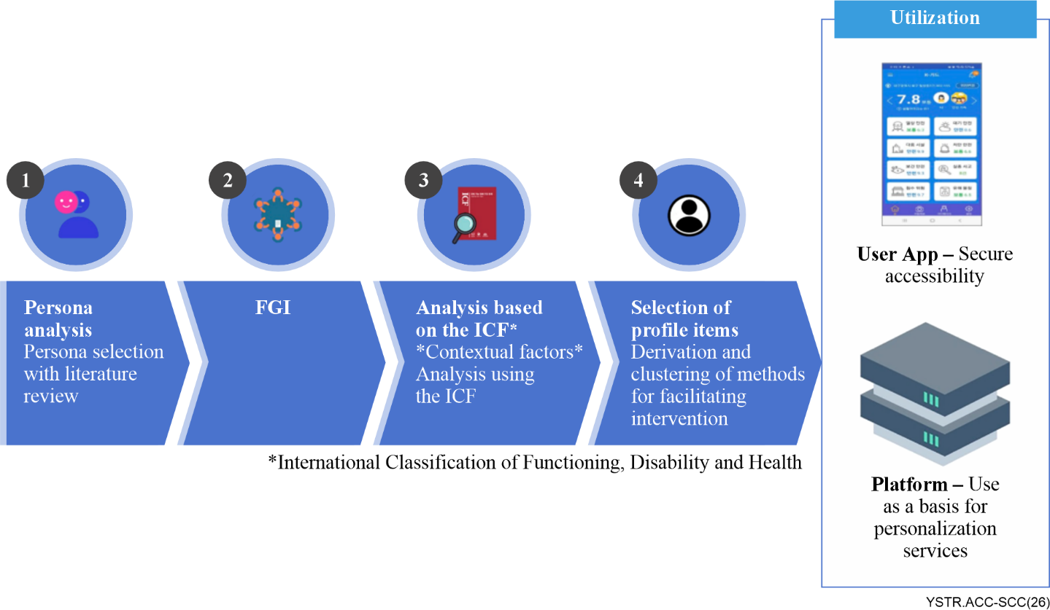
Figure I.1 – The process of deriving accessibility profiles for those vulnerable to safety risks
First, when calculating the individual risk index, which is an indicator of comprehensive safety risk at the current user's location, 13 types of weight settings were applied and analysed according to the user profile. For example, when there is a risk related to walking around, people with physical disabilities using wheelchairs are notified of the risk by setting a greater weight than those without such disabilities. (This aligns with clause 8.2, guideline 6: User personalization and control).
Second, the App's compliance with Korea's Mobile Application Contents Accessibility Guidelines 2.0 [b-KS X 3253] was reviewed to ensure that persons with visual, hearing and physical disabilities do not have any inconvenience in using the mobile App. In particular, the screen reader function of the mobile device was used to allow those with visual disabilities to convert textual content into voice information and provide notifications to persons with hearing disabilities with vibrations. (This aligns with clause 7.2, guideline 3: Screen reader compatibility and clause 8.2, guideline 3: Multimodal information delivery).
Third, through content analysis by experts with developmental disabilities, pictures and text content were improved so that persons with developmental disabilities, the elderly and children could understand the various response information displayed. (This aligns with clause 8.2, guideline 1: Clear and consistent information presentation).
Fourth, for the users of Korean Sign Language, the content of the corresponding information was converted into sign language video content to be used at the user's discretion. (This aligns with clause 8.2, guideline 2: Multi-lingual support and localization and clause 8.2, guideline 4: Alternative text and captions).
Fifth, for content that provides evacuation route information in multi-use facilities, etc., emergency exits and movement information accessible to wheelchair users were customized. (This aligns with clause 8.2, guideline 5: Real-time and accurate data provision).
In the usability evaluation conducted by dividing the subjects into groups of persons without disabilities, those with disabilities and the elderly, positive responses were mainly low in the elderly group. There was no significant difference in the other groups. In the evaluation of the satisfaction and usability of the App, there were no items that showed significant differences compared to other subjects in the group with disabilities.
This study showed the possibility of developing an inclusive safety management system that can satisfy both persons with disabilities and persons without disabilities and confirmed the various needs of those especially vulnerable to safety risks who can benefit from the safety management system.

Appendix II
Exemplar accessible smart sustainable city services

II.1 Accessible public transport service

II.1.1 Introduction
Public transport is a critical urban service that must be usable by everyone, including PWDs and older persons. This example describes an accessible public transport service, illustrated in Figure II.1, which could be a city's smart transit information system and journey planner. The service includes a mobile application and public transit kiosks that provide real-time information on bus, train and subway schedules, routes and service alerts. It is designed from the ground up to accommodate users with diverse abilities, ensuring that navigating the city's transport network is convenient and safe for all commuters.
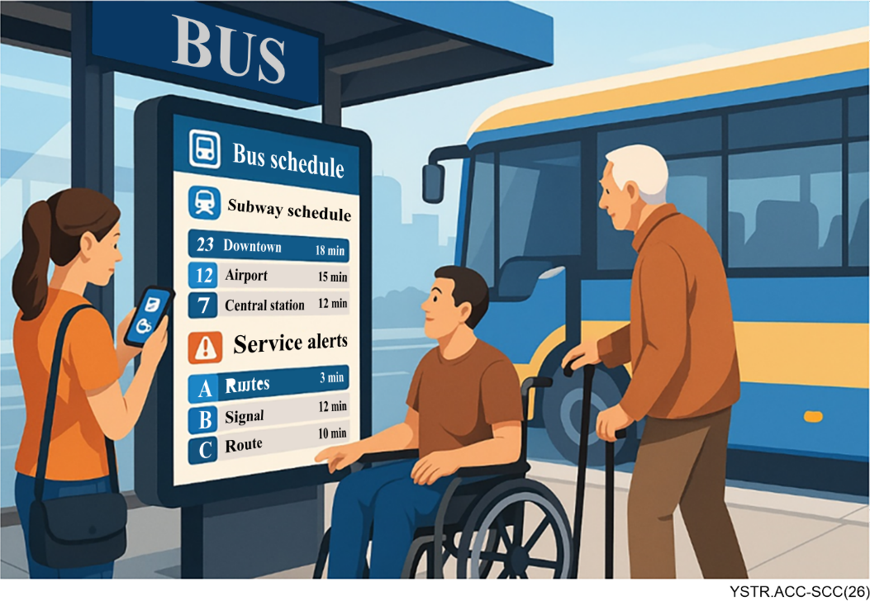
Figure II.1 – Conceptual illustration of an accessible transport service

II.1.2 Accessibility features
First, the public transport application's UI is designed to be highly perceivable and operable by users with various disabilities. It uses a simple layout with large, high-contrast text and intuitive icons, making it easier for users with low vision or cognitive impairment to read schedules and navigate the App. All interactive elements (buttons, menus, maps) are labelled with clear text or icons and the overall interface remains consistent across different parts of the App. This consistency helps users predict how to use new features without confusion, aligning with the interface-layer guideline of a predictable interface (aligned with clause 7.2, guideline 1: Consistent and predictable interface and guideline 5: Colour and contrast).
Second, the service supports multiple input and control methods to accommodate different users. In addition to standard touch interaction, the App can be fully operated via voice commands and keyboard navigation. For example, a user with a mobility impairment or someone who is blind can speak a destination into the App or use a Bluetooth braille keyboard or switch the device to enter information and navigate through options. The ability to use the service without complex touch gestures ensures compliance with the interface layer guideline on keyboard (or alternative) accessibility and makes the transport service convenient for users who cannot easily use a touchscreen (aligned with clause 7.2, guideline 2: Keyboard accessibility).
Third, the information layer is implemented in a multimodal way to ensure all transit data is perceivable to every user. Real-time transit updates (such as an approaching bus or a train delay) are delivered through visual, audio and tactile cues simultaneously. For instance, when a bus is five minutes away, the App displays an on-screen notification with the route number and arrival time, plays a brief auditory announcement or chime, and can send a vibration alert on the user's device. This multimodal notification approach adheres to the guideline of providing information through multiple channels – a deaf user can notice the text or vibration, while a blind user can hear the announcement or feel the haptic cue. At transit stations, digital signage connected to the system might flash route information in large text and play audible announcements in sync, so no traveller misses the message (aligned with clause 8.2, guideline 3: Multimodal information delivery).
Fourth, the service provides rich accessible content about the transit system, going beyond basic schedules. Users can access detailed accessibility information for each transit route and stop. For example, the App clearly indicates which bus lines and train stations are wheelchair-accessible, which stations have working elevators or ramps, and whether there are audio announcements or induction loop systems available for hearing aid users on a given vehicle. If an elevator at a station is out of service or a certain route is temporarily inaccessible (e.g., due to maintenance), the system flags this and suggests alternative routes in real time. All of this information is presented in an easy-to-understand format using both text and universally recognized symbols (such as the wheelchair symbol for accessible facilities), reflecting the information-layer guideline of clear content presentation and real-time accuracy. This helps users with mobility impairments plan their journeys confidently and helps others (like elderly riders or foreigners unfamiliar with the system) to understand the transit options and any barriers (aligned with clause 8.2, guideline 1: Clear information presentation and guideline 5: Real-time and accurate data provision).
Fifth, the service is fully compatible with assistive technologies and offers personalization options. The mobile App is tested with screen readers so that blind users can have timetable and navigation information spoken aloud; all images and icons (such as a map or a bus icon) have descriptive alternative text or labels. The App also supports connectivity with wearable assistive devices. For example, it can send notifications to a paired smart cane or a smartwatch, which might vibrate when the user's bus is arriving. Users are able to adjust settings like text size, colour contrast and languages within the App. They can also choose to receive simplified journey instructions (for those with cognitive disabilities) or detailed step-by-step guidance, depending on preference. By allowing such personalization, the service addresses the guideline of user control over information presentation. In summary, this accessible public transport service exemplifies how a smart sustainable city transit App can incorporate both interface accessibility (intuitive design, multiple input methods) and information accessibility (multimodal, real-time and well-structured content) to serve all members of the public equally (aligned with clause 7.2, guideline 3: Screen reader compatibility and clause 8.2, guideline 6: User personalization and control).

Bibliography
[b-ITU-T F.791] Recommendation ITU-T F.791 (2018), Accessibility terms and definitions.
[b-ITU-T F.921] Recommendation ITU-T F.921 (2018), Audio-based indoor and outdoor network navigation system for persons with vision impairment.
[b-ITU-T F.922] Recommendation ITU-T F.922 (2020), Requirements of information service system for visually impaired persons.
[b-ITU-T F.930] Recommendation ITU-T F.930 (2018), Multimedia telecommunication relay services.
[b-ITU-T H.702] Recommendation ITU-T H.702 (2020), Accessibility profiles for IPTV systems.
[b-ITU-T H-Sup.17] ITU-T H Series Recommendation – Supplement 17 (2014) | ISO/IEC Guide 71:2014, Guide for addressing accessibility in standards.
[b-ITU-T Y.4000] Recommendation ITU-T Y.4000/Y.2060 (2012), Overview of the Internet of things.
[b-ITU-T Y.4204] Recommendation ITU-T Y.4204 (2019), Accessibility requirements for Internet of things applications and services.
[b-ITU-T Y.4211] Recommendation ITU-T Y.4211 (2020), Accessibility requirements for smart public transport services.
[b-ITU-T Y.4219] Recommendation ITU-T Y.4219 (2023), Accessibility requirements for user interface of smart applications supporting IoT.
[b-ITU-T Y.4900] Recommendation ITU-T Y.4900/L.1600 (2016), Overview of key performance indicators in smart sustainable cities.
[b-ISO/IEC TR 29138-1] ISO/IEC TR 29138-1:2018, Information technology – Accessibility considerations for people with disabilities – Part 1: User needs summary.
[b-ISO/TR 22411] ISO/TR 22411:2021, Ergonomics data for use in the application of ISO/IEC Guide 71:2014.
[b-ITU PP Res.175] ITU Plenipotentiary Conference Resolution 175 (Busan, 2014), Telecommunication/information and communication technology accessibility for persons with disabilities and persons with specific needs.
[b-ITU WTDC AP] ITU World Telecommunication Development Conference (2014), Action plan. In: Final Report World Telecommunication Development Conference (WTDC-14), Dubai, United Arab Emirates, 2014-03-30/04-10, pp. 43-144. Available [viewed 2019-01-09] at https://itu.int/en/ITUD/Conferences/WTDC/Documents/D-TDC-WTDC-2014-PDF-E.pdf
[b-ITU WTDC Res.58] ITU World Telecommunication Development Conference Resolution 58 (Rev. Dubai, 2014), Telecommunication/information and communication technology accessibility for persons with disabilities, including persons with age-related disabilities. In: Final Report World Telecommunication Development Conference (WTDC-14), Dubai, United Arab Emirates, 2014-03-30/04-10, pp. 396-410 Available [viewed 2019-01-09] at https://itu.int/en/ITUD/Conferences/WTDC/Documents/D-TDC-WTDC-2014-PDF-E.pdf
[b-KS X 3253] KSX3253:2016, Mobile Application Contents Accessibility Guidelines 2.0.
[b-UNCRPD] United Nations (2006), Convention on the rights of persons with disabilities. New York, NY: United Nations. 37 pp. Available [viewed 2021-02-10] from: https://treaties.un.org/doc/Publication/CTC/Ch_IV_15.pdf
[b-W3C UAAG 2.0] W3C UAAG 2.0 (2015), W3C User Agent Accessibility Guidelines (UAAG). http://www.w3.org/TR/UAAG20/
[b-W3C WCAG 2.2] W3C WCAG 2.2 (2024) Information technology – W3C Web Content Accessibility Guidelines (WCAG) 2.2. http://www.w3.org/TR/WCAG22/
https://itu.int/en/ITUD/Conferences/WTDC/Documents/D-TDC-WTDC-2014-PDF-E.pdf

______________

