Standardization Sector
ITU-T Technical Report
(09/2023)
GSTR-RQ
Roadmap for QoS and QoE in the ITU-T Study Group 12 context
ITUPublications | International Telecommunication Union


Technical Report ITU-T GSTR-RQ
Roadmap for QoS and QoE in the ITU-T Study Group 12 context

Summary
This Technical Report presents a compilation of quality of service (QoS), quality of experience (QoE), and related terms defined by International Telecommunication Union-Telecommunication Standardization Sector (ITU-T) Recommendations, exploring concepts, differences and relationships.
The goal is to provide a roadmap for these concepts in the ITU-T Study Group 12 context, identifying possible definitions' adjustments and clarifying the application of QoE terminology and which aspects characterize QoE assessment methods.

Note
This is an informative ITU-T publication. Mandatory provisions, such as those found in ITU-T Recommendations, are outside the scope of this publication. This publication should only be referenced bibliographically in ITU-T Recommendations.

Change Log
This document contains Version 1 of the ITU-T Technical Report on "Roadmap for QoS and QoE in the ITU-T Study Group 12 context" approved at the ITU-T Study Group 12 meeting held in Mexico City, 19-28 September 2023.

Editor: | Isis De Andrade Lima  Anatel  Brazil | E-mail: isis.lima@anatel.gov.br
 | Danilo Tavares  Anatel  Brazil | E-mail: danilo.tavares@anatel.gov.br

© ITU 2024
All rights reserved. No part of this publication may be reproduced, by any means whatsoever, without the prior written permission of ITU.
Table of Contents
Page
1 Scope 1
2 References 1
3 Definitions 2
3.1 Terms defined elsewhere 2
3.2 Terms defined in this Technical Report 3
4 Abbreviations and acronyms 3
5 Context overview 3
6 Evolution of the QoS concept from the end user's perspective 4
6.1 QoS subdivisions and aspects 7
7 Standards for QoE definition 8
8 Measurements and estimation process for QoE 11
8.1 QoE assessment methods characteristics 12
8.2 Application of QoE assessment concept 12
9 Other references on QoE concepts and definitions 13
9.1 QoE influencing factors 14
9.2 QoE conceptual models 14
10 Conclusions 16
10.1 Overlapping terms and definitions 16
10.2 Clarifications on QoE assessment 17
10.3 Four point-of-view conceptual model 17
10.4 ITU-T Recommendations to be revised 18
Annex A – QoS aspects defined in ITU-T Recommendations 21
Bibliography 22

Technical Report ITU-T GSTR-RQ
Roadmap for QoS and QoE in the ITU-T Study Group 12 context

1 Scope
This Technical Report presents a compilation of quality of service (QoS), quality of experience (QoE), and related terms defined by International Telecommunication Union-Telecommunication Standardization Sector (ITU-T) Recommendations, exploring concepts, differences and relationships.
The goal is to provide a roadmap for these concepts in the ITU-T Study Group 12 context, identifying possible definitions' adjustments and clarifying the application of QoE terminology and which aspects characterize QoE assessment methods.
The following discussions are approached:
I Evolution of QoS and related concepts from end-user's perspective;
II Standards on QoE definitions;
III Measurements and estimation process for QoE;
IV Other references on QoE concepts and definitions.

2 References
[ITU-T E.800] Recommendation ITU-T E.800 (2008), Definitions of terms related to quality of service.
[ITU-T E.800 Suppl. 9] ITU-T E-series Recommendations – Supplement 9 (2021), Supplement 9 to ITU-T E.800-series Recommendations – Guidelines on regulatory aspects of quality of service.
[ITU-T E.802] Recommendation ITU-T E.802 (2007), Framework and methodologies for the determination and application of QoS parameters.
[ITU-T E.803] Recommendation ITU-T E.803 (2022), Quality of service parameters for supporting service aspects.
[ITU-T E.804] Recommendation ITU-T E.804 (2014), Quality of service aspects for popular services in mobile networks.
[ITU-T G.1000] Recommendation ITU-T G.1000 (2001), Communications Quality of Service: A framework and definitions.
[ITU-T G.1011] Recommendation ITU-T G.1011 (2016), Reference guide to quality of experience assessment methodologies.
[ITU-T G.1035] Recommendation ITU-T G.1035 (2021), Influencing factors on quality of experience for virtual reality services.
[ITU-T G.Sup73] ITU-T G-series Recommendations – Supplement 73 (2021), Influencing factors on quality of experience for multiview video (MVV) services.
[ITU-T P.10/G.100] Recommendation ITU-T P.10/G.100 (2017), Vocabulary for performance, quality of service and quality of experience.
[ITU-T P.910] Recommendation ITU-T P.910 (2023), Subjective video quality assessment methods for multimedia applications.
[ITU-T P.1201] Recommendation ITU-T P.1201 (2012), Parametric non-intrusive assessment of audiovisual media streaming quality.
[ITU-T P.1202] Recommendation ITU-T P.1202 (2012), Parametric non-intrusive bitstream assessment of video media streaming quality.
[ITU-T P.1203] Recommendation ITU-T P.1203 (2017), Parametric bitstream-based quality assessment of progressive download and adaptive audiovisual streaming services over reliable transport.
[ITU-T P.1204] Recommendation ITU-T P.1204 (2023), Video quality assessment of streaming services over reliable transport for resolutions up to 4K.
[ITU-T P.1401] Recommendation ITU-T P.1401 (2020), Methods, metrics and procedures for statistical evaluation, qualification and comparison of objective quality prediction models.
[ISO 9000] ISO 9000:2015, Quality management systems – Fundamentals and vocabulary.
[Brunnström] Brunnström, K., Beker, S.A., De Moor, K., Dooms, A., Egger, S., Garcia, M-N., Hossfeld, T., Jumisko-Pyykkö, S., Keimel, C., Larabi, M-C., Lawlor, B., Le Callet, P., Möller, S., Pereira, F., Pereira, M., Perkis, A., Pibernik, J., Pinheiro, A., Raake, A., Reichl, P., Reiter, U., Schatz, R., Schelkens, P., Skorin-Kapov, L., Strohmeier, D., Timmerer, C., Varela, M., Wechsung, I., You, J., and Zgank, A. (2014) Qualinet White Paper on Definitions of Quality of Experience.
[Laghari] Laghari, K.U.R., Crespi, N., and Connelly, K. (2012), Toward Total Quality of Experience: A QoE Model in a Communication Ecosystem. IEEE Communications Magazine, April 2012.
[Möller] Möller, S., Küpper, A., and Raake, A. (2014), T-Labs series in telecommunications services. Springer. Chapter 4 Factors influencing Quality of Experience.
[Perkis] Perkis, A., Timmerer, C., Barakovic, S., Husic, J.B., Bech, S., Bosse, S., Botev, J., Brunnström, K., Cruz, L., De Moor, K., Saibanti, A.D.P., Durnez, W., Egger-Lampl, S., Engelke, U., Falk, T.H., Gutiérrez, J., Hameed, A., Hines, A., Kojic, T., Kukolj, D., Liotou, E., Milovanovic, D., Möller, S., Murray, N., Naderi, B., Pereira, M., Perry, S., Pinheiro, A., Pinilla, A., Raake, A., Agrawal, S.R., Reiter, U., Rodrigues, R., Schatz, R., Schelkens, P., Schmidt, S., Sabet, S.S., Singla, A., Skorin-Kapov, L., Suznjevic, M., Uhrig, S., Vlahovic, S., Voigt-Antons, J-N., and Zadtootaghaj, S. (2020), QUALINET White Paper on Definitions of Immersive Media Experience (IMEx).
[Rubino] Rubino, G., and Varela, M. (2004), A new approach for the prediction of end-to-end performance of multimedia streams.

3 Definitions

3.1 Terms defined elsewhere
This Technical Report uses the following terms defined elsewhere:
3.1.1 quality [ITU-T G.1000]: The totality of characteristics of an entity that bear on its ability to satisfy stated and implied needs ([ISO 9000]).
3.1.2 quality of service (QoS) [ITU-T G.1000]: The collective effect of service performances, which determines the degree of satisfaction of a user of the service [ITU-T E.800].
3.1.3 QoS requirements of user/customer [ITU-T G.1000]: A statement of the level of quality required by the applications of customers/users of a service, which may be expressed non-technically.
3.1.4 QoS offered/planned by provider [ITU-T G.1000]: A statement of the level of quality expected to be offered to the customer by the service provider.
3.1.5 QoS delivered/achieved by provider [ITU-T G.1000]: A statement of the level of the actual quality achieved and delivered to the customer.
3.1.6 QoS perceived by user/customer [ITU-T G.1000]: A statement expressing the level of quality that customers believe they have experienced.
3.1.7 QoS requirements of user/customer (QoSR) [ITU-T E.800]: A statement of QoS requirements by a customer/user or segment(s) of customer/user population with unique performance requirements or needs.
3.1.8 QoS experienced/perceived by customer/user (QoSE) [ITU-T E.800]: A statement expressing the level of quality that customer users believe they have experienced.
3.1.9 quality of experience (QoE) [ITU-T P.10/G.100]: The degree of delight or annoyance of the user of an application or service. [b-Qualinet 2013].
3.1.10 QoE influencing factors [ITU-T P.10/G.100]: It includes the type and characteristics of the application or service, context of use, user's expectations with respect to the application or service and their fulfilment, the user's cultural background, socioeconomic issues, psychological profiles, emotional state of the user, and other factors whose number will likely expand with further research.
3.1.11 QoE assessment [ITU-T P.10/G.100]: The process of measuring or estimating the QoE for a set of users of an application or a service with a dedicated procedure, and considering the influencing factors (possibly controlled, measured, or simply collected and reported). The output of the process may be a scalar value, a multi-dimensional representation of the results, and/or verbal descriptors. All assessments of QoE should be accompanied by a description of the influencing factors that are included. The assessment of QoE can be described as comprehensive when it includes many of the specific factors, for example, majority of the known factors. Therefore, a limited QoE assessment would include only one or a small number of factors.

3.2 Terms defined in this Technical Report
None.

4 Abbreviations and acronyms
This Technical Report uses the following abbreviations and acronyms:
ITU International Telecommunication Union
ITU-T ITU Telecommunication Standardization Sector
IF Influencing Factors
QoE Quality of Experience
QoS Quality of Service

5 Context overview
Quality of experience (QoE) has become a key concept for telecommunications services providers and regulators, given its importance in helping to understand which aspects are the most relevant for the users, in terms of network performance and relationship with the provider.
Providers and regulators historically relied on objective, technical indicators, which mostly apply to quality of service (QoS) evaluation, providing mainly a picture of the characteristics of the service from a network perspective. As the concept evolved, non-technical indicators were incorporated, in order to also provide a users' perspective of quality, although it did not give direct information about environmental and psychological factors that influence the human perception.
Due to the complexity of understanding these factors, their impact on perception and the differences between quality concepts, the term QoE is often mistakenly applied, especially in the context of quality monitoring and evaluation.
Many QoE and QoS related terms have been defined by different ITU-T Recommendations, providing concepts to explain their relations, and establishing intermediate quality perspectives. However, as telecommunications technologies evolved, users' interactions with services became more intense, many usage profiles emerged creating different levels of expectations, and new questions arose about quality perspectives, concepts, and terms applicability.
Considering the telecommunications services, evolution and studies conducted since the QoS/QoE and related definitions were established by the ITU-T Recommendations, this Technical Report presents a compilation of defined terms and adjustment suggestions, establishing a roadmap on the ITU-T Study Group 12 context. The objective is to eliminate overlapping concepts and clarify the meaning, differences, relationship, and appropriate use for each term.

6 Evolution of the QoS concept from the end user's perspective
This clause presents a historical evolution of definitions regarding quality of service (QoS), from users' perspectives, and related concepts defined by ITU-T Recommendations.
[ITU-T G.1000] recognizes the need to better apply the concept of telecommunications services quality, considering the users' point of view. In this sense, some definitions regarding QoS and its relations with customer's perception are established:
3.1 quality: the totality of characteristics of an entity that bear on its ability to satisfy stated and implied needs ([ISO 9000]).
3.2 quality of service (QoS): the collective effect of service performances, which determines the degree of satisfaction of a user of the service [ITU-T E.800].
3.3 QoS requirements of user/customer: a statement of the level of quality required by the applications of customers/users of a service, which may be expressed non-technically.
3.4 QoS offered/planned by provider: a statement of the level of quality expected to be offered to the customer by the service provider.
3.5 QoS delivered/achieved by provider: a statement of the level of the actual quality achieved and delivered to the customer.
3.6 QoS perceived by user/customer: a statement expressing the level of quality that customers believe they have experienced.
The definitions in items 3.3, 3.4, 3.5 and 3.6 attempted to express QoS from different perspectives, embracing customers' quality requirements (3.3) and perceptions (3.6), and also services providers offered (3.4) and achieved (3.5) quality. The interrelations among them were graphically expressed through the following scheme:
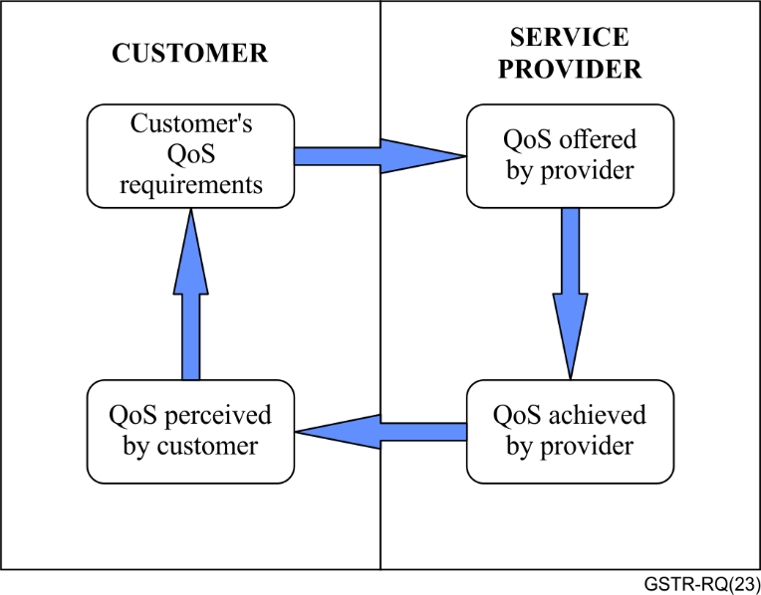
Figure 1 – The four viewpoints of QoS [ITU-T G.1000]
According to those definitions, QoS perceived by the customers is the level of quality they believe they have experienced. Ideally, the QoS achieved/delivered by the service provider would be identical to the one perceived by the end user, which adds a layer of subjectivity to the rather technical approach to measure quality in telecommunications. [ITU-T G.1000] states that QoS perceived can be assessed by customer surveys and from customer's own comments on the levels of service:
5.5.1 Customer's requirements of QoS
QoS requirements by the customer state the level of quality required of a particular service, which may be expressed in non-technical language. The customer is not concerned with how a particular service is provided, or with any aspects of the network's internal design, but only with the resulting end-to-end service quality. From the customer's point of view, quality of service is expressed by parameters.
5.5.4 QoS perceived by the customer
QoS perceived by the users or customers is a statement expressing the level of quality experienced they 'believe' they have experienced. The perceived QoS is expressed usually in terms of degrees of satisfaction and not in technical terms. Perceived QoS is assessed by customer surveys and from customer's own comments on levels of service. Perceived QoS can be used by the service provider to determine customer satisfaction with the service quality. For example, a customer may state that on an unacceptable number of occasions, there was difficulty in getting through the network to make a call and may give it a rating of 2 on a 5-point scale: 5 indicating excellent service. Ideally, there would be 1:1 correspondence between delivered and perceived QoS.
[ITU-T E.800] dialogues with the QoS concepts introduced by [ITU-T G.1000], the relations presented in Figure 1, and their applicability. End-to-end QoS is introduced by [ITU-T E.800] as a concept that depends on the contributions made by all the components shown in Figure 2.
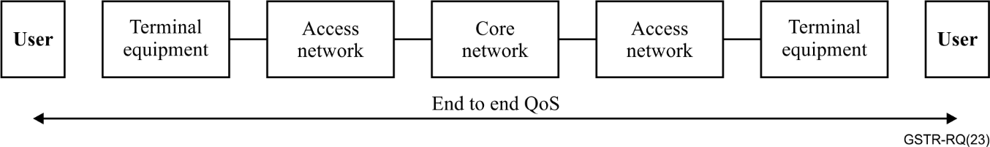
Figure 2 – Schematic contributions to end-to-end QoS [ITU-T E.800]
The definitions related to QoS are the same as [ITU-T G.1000], but some notes bring further details and guidance for the concepts' applicability:
2.1 Quality
The totality of characteristics of an entity that bear on its ability to satisfy stated and implied needs.
NOTE – The characteristics should be observable and/or measurable. When the characteristics are defined, they become parameters and are expressed by metrics (see clauses 2.7 to 2.13 [ITU-T E.800]).
2.2 Quality of service (QoS)
Totality of characteristics of a telecommunications service that bear on its ability to satisfy stated and implied needs of the user of the service.
2.4 QoS offered/planned by service provider (QoSO)
A statement of the level of quality planned and therefore offered to the customer by the service provider.
NOTE – The level of QoS the service provider plans to achieve (and therefore offers) to the customer/user is expressed by target values (or range) for measures of parameters pertinent to a specified service.
2.5 QoS delivered/achieved by service provider (QoSD)
A statement of the level of QoS achieved or delivered to the customer.
NOTE – Achieved or delivered QoS is expressed by metrics for the pertinent parameters for a service.
When it comes to customer perception, [ITU-T E.800] is also linked to terms defined by [ITU-T G.1000]. Additionally, it introduces the terminology "QoS experienced/perceived by customer/user" (QoSE), and brings the following notes:
2.3 QoS requirements of user/customer (QoSR)
A statement of QoS requirements by a customer/user or segment/s of a customer/user population with unique performance requirements or needs.
NOTE – The customer/user needs may be expressed in descriptive terms (criteria) listed in the order of priority, with preferred performance value for each criterion. The service provider then translates these into parameters and metrics pertinent to the service (see [ITU-T E.802]).
2.6 QoS experienced/perceived by customer/user (QoSE)
A statement expressing the level of quality that customers/users believe they have experienced.
NOTE 1 – The level of QoS experienced and/or perceived by the customer/user may be expressed by an opinion rating.
NOTE 2 – QoSE has two main man components: quantitative and qualitative. The quantitative component can be influenced by the complete end-to-end system effects (network infrastructure).
NOTE 3 – The qualitative component can be influenced by user expectations, ambient conditions, psychological factors, application context, etc.
NOTE 4 – QoSE may also be considered as QoSD received and interpreted by a user with the pertinent qualitative factors influencing their perception of the service.
[ITU-T E.800] brings the additional definition of subjective (qualitative) parameters:
2.11 Subjective (qualitative) parameters
Parameters that can be expressed using human judgment and understanding may be classified as subjective or qualitative parameters.
NOTE 1 – Qualitative parameters are expressed by opinion ratings.
NOTE 2 – Example: The ergonomic quality of a mobile handset ('feel good' factor) may be expressed by ratings on a given scale.

6.1 QoS subdivisions and aspects
Additionally, to the concepts related to quality of service (QoS), ITU-T Study Group 12 has worked on understanding which categories and aspects compose QoS. These studies come from the need to include service characteristics related to the relationship between customers and providers and to better analyse results from groups of indicators.
[ITU-T E.800] stated that QoS is determined by network performance (NP) (e.g., bit error rate, latency, etc.) and non-network related performance conditions (e.g., repair time, complaints resolutions time, etc.), as shown in Figure 3. The list of QoS criteria for a specific service would be dependent upon the service and their relevance may vary among the segments of the customer population.
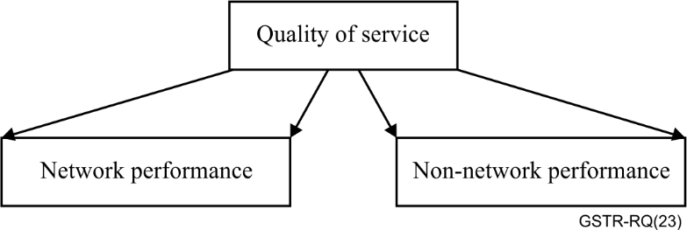
Figure 3 – Quality of service comprises network and non-network criteria [ITU-T E.800]
Recommendations regarding quality of service traditionally focus on network and the application's performance. To cover supporting service aspects, [ITU-T E.803] brings parameters related to provided information, contract characteristics, channels for customer service, complaint management, technical support, charging and billing, etc. The recommendation refers to these as "non-utilization stage" parameters, whereas the service "utilization stage" is related to network and applications effective usage. Other QoS sub-categories appear on models relating to QoE and QoS concepts in [ITU-T E.800 Suppl. 9] and in [ITU-T E.804], respectively shown in Figures 4 and 5.
Table 1 below summarizes different nomenclatures for QoS sub-categories found in ITU-T Recommendations under Study Group 12 responsibility.
Table 1 – QoE related concepts
(Considering ITU-Recommendations definitions and statements)
Recommendation | Model of interactions | QoS sub-categories
[ITU-T E.800] | Figure 2: Quality of service comprises network and non-network criteria | Network performance
 |  | Non-network performance
[ITU-T E.803] | – | Utilization stages
 |  | Non-utilization stages
[ITU-T E.800 Suppl. 9] | Figure 1: Factors influencing customer satisfaction | QoS technical (Network performance + terminal performance)
 |  | QoS non-technical (Point of sale + customer care)
[ITU-T E.804] | Figure 6.2: QoE dimensions | Service factors
 |  | Transport factors
 |  | Application factors
[ITU-T E.803] and [ITU-T E.804] provide further divisions inside the sub-categories shown in Table 1. These subdivisions, or "QoS aspects", are shown in Annex A and may help to understand which stages of the customer and provider's relationship are covered by QoS subcategories.

7 Standards for QoE definition
In the previous clause, it was shown that QoS experienced/perceived by customer/user (QoSE), defined by [ITU-T G.1000], refers to what customers believe they experienced and depends on the subjective or qualitative parameters.
[ITU-T E.800 Suppl. 9] is focused on the regulatory aspects of QoS, but it also brings an interesting perspective on how expectations and satisfaction relate to technical and non-technical QoS, as shown in Figure 4. Nonetheless, the Supplement does not bring an objective definition for the term "customer satisfaction" and how it differs from QoE and/or QoSP/QoSE.
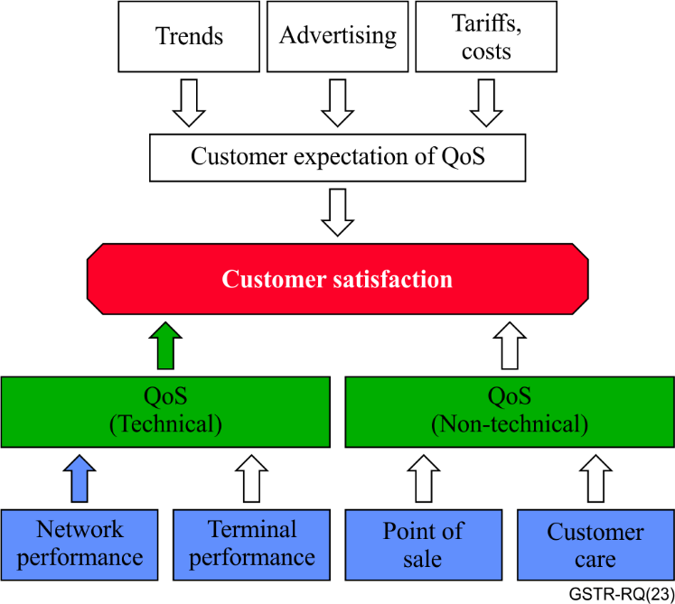
Figure 4 – Factors influencing customer satisfaction [ITU-T E.800 Suppl. 9]
The following graphic scheme, as described in [ITU-T E.804], shows the interdependence relations of the notions that form QoE. It is composed of objective parameters, originated in QoS monitoring, and by subjective components, that influence human behaviour. As a conclusion, then, it can be asserted that QoS is one subpart of QoE, depicting only its technical element.
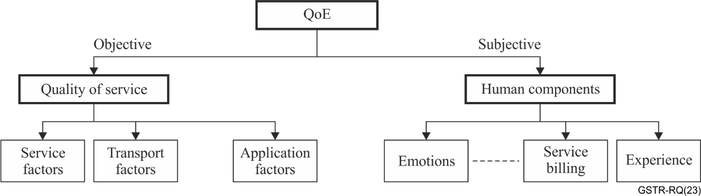
Figure 5 – QoE dimensions [ITU-T E.804]
In terms of formal definition, Recommendation [ITU-T P.10/G.100] – Amendment 1 introduced in 2006 the concept of quality of experience as "the overall acceptability of an application or service, as perceived subjectively by the end-user". The term overall acceptability may imply the use of the concept in more descriptive methods to assess end-users' experience, such as interviews with open-ended questions.
In 2016, the Recommendation [ITU-T P.10/G.100] – Amendment 5, improved the definition of QoE as "the degree of delight or annoyance of the user of an application or service", with the side note that this topic is still evolving, and the definition might suffer alterations in the future. The new definition, using the expression "degree of delight or annoyance" instead of "overall acceptability" has the advantage of better fitting more statistics-oriented approaches. It is also important to notice that the term "as perceived by the end-user" was removed from the definition, increasing its difference from the concept of QoSE.
Clause 6.210 brings from the cited [ITU-T P.10/G.100] recommendation details on the influencing factors:
6.210 QoE influencing factors
Include the type and characteristics of the application or service, context of use, the user's expectations with respect to the application or service and their fulfilment, the user's cultural background, socioeconomic issues, psychological profiles, emotional state of the user, and other factors whose number will likely expand with further research.
Regarding the factors that influence QoE, there is an important similarity with the qualitative factors that were identified as influences to QoSE. Both recognize the effects of the psychological realm on the evaluation of the service, as well as the context of service use. Nonetheless, the QoE influencing factors go further than the one of QoSE, because they cover, directly or indirectly, the background of the end user, like socio-economic and cultural aspects, as well as their expectations towards the service, resulting in a much broader analysis.
On the assessment of QoE, clause 6.211 of the recommendation [ITU-T P.10/G.100] states the following:
6.211 QoE assessment
The process of measuring or estimating the QoE for a set of users of an application or a service with a dedicated procedure, and considering the influencing factors (possibly controlled, measured, or simply collected and reported). The output of the process may be a scalar value, a multi-dimensional representation of the results, and/or verbal descriptors. All assessments of QoE should be accompanied by the description of the influencing factors that are included. The assessment of QoE can be described as comprehensive when it includes many of the specific factors, for example, a majority of the known factors. Therefore, a limited QoE assessment would include only one or a small number of factors.
Observing Figures 1, 4 and 5 in this Recommendation, the differences between QoSE and QoE are not clear. Also, the model established in Figure 1, combined with the definitions brought by respective recommendations, does not dialogue with the model introduced in Figures 4 and 5.
The comparison between Figures 4 and 5 implies that both satisfaction and QoE are composed by objective factors (QoS) and subjective factors.
The following Table 2 provides a compilation of QoSE, QoE, and related concepts as established by ITU Recommendations.
Table 2 – QoE related concepts
(Considering ITU-T Recommendations definitions and statements)
Recommendation | Term | Definition
[ITU-T G.1000]  Notes added by [ITU-T E.800] | QoS experienced/ perceived by customer/ user (QoSE) | A statement expressing the level of quality that customers/users believe they have experienced.  NOTE 1 – The level of QoS experienced and/or perceived by the customer/user may be expressed by an opinion rating.  NOTE 2 – QoSE has two main man components: quantitative and qualitative. The quantitative component can be influenced by the complete end-to-end system effects (network infrastructure).  NOTE 3 – The qualitative component can be influenced by user expectations, ambient conditions, psychological factors, application context, etc.  NOTE 4 – QoSE may also be considered as QoSD received and interpreted by a user with the pertinent qualitative factors influencing their perception of the service.
[ITU-T E.800] | Subjective (qualitative) parameters | Parameters that can be expressed using human judgment and understanding may be classified as subjective or qualitative parameters.  NOTE 1 – Qualitative parameters are expressed by opinion ratings.  NOTE 2 – Example: The ergonomic quality of a mobile handset ('feel good' factor) may be expressed by ratings on a given scale.
[ITU-T P.10/G.100] – Amendment 5/ 2016 | Quality of experience (QoE) | The degree of delight or annoyance of the user of an application or service.
[ITU-T P.10/G.100] (11/2017)  [ITU-T P.10/G.100] – Amendment 1 (06/2019) | QoE influencing factors | Include the type and characteristics of the application or service, context of use, the user's expectations with respect to the application or service and their fulfilment, the user's cultural background, socioeconomic issues, psychological profiles, emotional state of the user, and other factors whose number will likely expand with further research.
[ITU-T P.10/G.100]  (11/2017)  [ITU-T P.10/G.100] – Amendment 1 (06/2019) | QoE assessment | The process of measuring or estimating the QoE for a set of users of an application or a service with a dedicated procedure, and considering the influencing factors (possibly controlled, measured, or simply collected and reported). The output of the process may be a scalar value, a multi-dimensional representation of the results, and/or verbal descriptors. All assessments of QoE should be accompanied by the description of the influencing factors that are included. The assessment of QoE can be described as comprehensive when it includes many of the specific factors, for example, a majority of the known factors. Therefore, a limited QoE assessment would include only one or a small number of factors.
– | Perceived quality | Not defined
– | Experienced quality | Not defined
– | Quality of perception | Not defined
– | Satisfaction | Not defined

8 Measurements and estimation process for QoE
[ITU-T G.1011] exposes guidelines for applying QoE assessment methodologies. It shows that QoE assessment is performed using subjective tests applied to customers. However, it is also possible and sometimes more convenient to estimate QoE based on objective measurements / analysis and associate objective measurable parameters with users' responses.
In this sense, a typical method to directly measure a user's experience for a certain telecommunication service is to ask end-users to rate the experience they had, on a numerical scale that normally varies from 1 to 5 or 1 to 10 (absolute category rating, cf., e.g., [ITU-T P.800] or [ITU-T P.910]). With that information, a mean opinion score (MOS) can be elaborated.
On the other hand, modelling the influence that objective parameters impose on experienced quality makes it possible to estimate values for QoE on a pre-determined scale. As stated in [ITU-T G.1011], the most important thing in this case is to identify the key factors that affect QoE and then relate these parameters to QoE measurement indices through specific quality estimation models. Nonetheless, caution is advised regarding the interpretation of those results, since the accuracy of those evaluations is related to the accuracy of the statistical method employed and to the quality of the subjective research it is originally based on.
One example for building a QoE estimation model is to monitor QoS key indicators during a video streaming and then ask the user to evaluate their experience. If this experiment is repeated with several users with statistical representation for the population, it is possible to apply data analysis and define a relationship between a QoE estimative and QoS indicators.
Although service performance parameters represent a significant portion in quality perception test results, social characteristics such as gender, age, education level, area of residence, service cost, etc. may affect the reported degree of delight or annoyance.

8.1 QoE assessment methods characteristics
Regarding the aspects to be considered when defining which QoE assessment methodology to adopt, [ITU-T G.1011] details the relationship between reliability and validity, different methods for utilitarian and analytics subjective test methods, criteria for estimation models' characterization, content dependency of QoE estimation and measurement approaches for different scenarios. [ITU-T P.1401] also provides guidance on using statistical models to predict subjective judgments on quality using objective parameters.
The method used to assess QoE may depend on the service and application of interest. Gaming, video streaming and phone calls, for example, are different from each other and may implicate distinctive sets of key parameters and observed variables.
Subjective and objective tests have several different methods, which are more suitable for specific applications and scenarios. Some of these methods, in both types of tests, imply high costs to ensure a certain level of validity, and reliability for the desired granularity and periodicity. This trade-off must be considered when defining which method to apply.
Subjective tests usually imply high costs and efforts, since they require interaction with humans. In order to reduce those costs and efforts to carry out such complex research, much effort has been spent on the development of estimation models based on objective tests. However, applying the model presupposes that the key parameters are available for monitoring. Moreover, the relationship between the instrumentally measurable magnitudes and QoE is typically not simple and there are different types of quality estimation and prediction models that have been developed for certain domains of application and system conditions. [ITU-T G.1011] describes different criteria that categorize the models and enable to better determine which model is more suitable for each application.
Thus, some of the most important aspects impacting QoE assessment/estimation methodology choice can be resumed in:
• Parameters that influence experienced quality are service and application dependent;
• Different methods result in different degrees of reliability and validity;
• The desired assessment granularity and periodicity must be compatible with the chosen method limitations;
• Estimation models depend on which objective indicators are available.

8.2 Application of QoE assessment concept
Although definitions for QoS and QoE have been provided in previous recommendations, the terms can be mistakenly applied when making reference to assessment methodologies. These mistakes may occur especially regarding applications focused on quality assessment.
[ITU-T G.1011] states that, since QoE is internal to the user, perceptual quality tests are ultimately the only means of validly and reliably assessing quality. This Recommendation also elucidates that QoE assessment can be of two basic natures: subjective or objective. Subjective QoE assessments are the ones that measure the quality perceived by human subjects directly, whereas the objective ones estimate quality using variables or signals instrumentally measurable but without human variables. However, [ITU-T G.1011] does not explicitly mention the influencing factors on QoE in its description of assessment methodologies.
Thus, the use of the QoE concept is correct if it refers to perceptual quality tests or estimation models tests. Either way, it is necessary to gather information about experienced quality directly from end-users. Thus, it is feasible to say that the assessment methodology estimates QoE if there is some interaction with the end-user obtaining their experience.
When consumers or end users are directly inquired about the quality that they experienced using a certain service or device, it is correct to say that QoE has been measured. In that case, it is possible to survey about the general experience or to inquire about specific features of the service/device. Moreover, as previously demonstrated, after gathering data from QoE of a pool of consumers or end users, it is also possible to estimate such experiences for other consumers or end users, applying statistical models and controlling for other variables that influence QoE. The quality of the estimations and predictions is strongly related to the quality of the sample one has available; the adequacy of the statistical tool used to describe, model, or forecast QoE, and the availability of data of other variables that also influence the quality of the QoE model.
Therefore, the quality of a model that estimates consumers' QoE is based on three pillars:
1) Sample well designed to guarantee statistical representativeness of the measured group;
2) Besides the measure of QoE itself, models should take into account variables that also influence QoE in the specific context of the service or device. Such variables can be categorized into the realms of influencing factors previously mentioned. However, it is important to note that the QoE models will not always have all the information required available. That is a common problem in the empirical analysis.
3) Statistical model that is used to model the data and/or to provide forecasts. Depending on the context and behaviour patterns of the data, traditional linear or non-linear models might be employed. In this regard, significant advances have been made in recent years in the development of machine learning-based methodologies, not only to establish correlations between QoS and QoE, but also to infer the influencing factors, KPIs, and KQIs in various contexts and for different user profiles. Thus, new methods based on artificial intelligence are also increasingly deployed to enhance the accuracy of forecasts of QoE assessments.
[ITU-T E.800 Suppl. 9] states that end-to-end QoS perceived at the user interface, which is basically summarizing the characteristics of the underlying in-service media streams, should not be mistaken for the QoS of non-utilization stages of ICT services, which describe the (customer) "service" surrounding ICT services offered by service providers that are outside the actual usage of services that are of interest and concern to the users.
Finally, objective measurements testing the applications' performance cannot be mistaken with QoE assessment. For example, call setup time, payload, video quality measures, first-call-resolution, etc. correspond to the QoS indicators. These indicators attempt to focus on the most important aspects from the users' point of view but must not be referred to as QoE measurements. They can only be considered QoE estimative if there is an estimation model pre-defined that uses these parameters.

9 Other references on QoE concepts and definitions
As one of the main goals of telecommunications is to enable the exchange of information between humans, the concept of QoE gains relevance as interested parts (e.g., operators, regulators, academia) pursue to understand how much quality the end-users experimented from their contact with the service. Such an important concept must, therefore, have a clear definition and clear guidelines of application.
As many ITU Recommendations mention QoE and relate it to QoS and several applications, it is important that all the recommendations are coherent and are guided by the same definitions. If not, a work of revision must be undertaken, in order to conciliate their content and provide an up-to-date framework of QoE.
This session introduces some relevant academic contributions to the development of the concept of QoE, such as the most common views on the influencing factors on QoE and the visual representations of the interactions among such concepts.

9.1 QoE influencing factors
Regarding QoE influencing factors, literature usually considers realms or sources of influencing factors. [Laghari], for instance, see four categories of influencing factors on QoE in the communication ecosystem environment:
1) Human factors: these factors may include socio-demographic and personal characteristics of individuals. Age, gender, socio-economic status, or level of experience and familiarity with technology are variables that can, for example, describe human factors. Psychological state, personality traits, and preferences may also be of interest when analysing the influence of human characteristics on QoE.
2) System/technology factors: include the factors that influence gadgets and networks, such as the device's age or specification and the performance of the network. The last one is strongly connected to QoS analysis and performance measured through KPIs.
3) Context factors: a broad array of circumstances and environmental elements when a certain telecommunication or application service was used.
4) Business factors: the characteristics of the interaction between the service provider and the consumer or end user. Such factors can be pricing, advertisement, reputation of the company, and customer care.
On the other hand, according to [Möller], the QoE influencing factors (IFs) can be grouped into three categories, human IFs, system IFs, and context IFs. These IFs are defined as follows: "A human IF is any variant or invariant property or characteristic of a human user. The characteristics can describe the demographic and socio-economic background, the physical and mental constitution, or the user's emotional state. System IFs refer to properties and characteristics that determine the technically produced quality of an application or service. Context IFs are factors that embrace any situational property to describe the user's environment in terms of physical, temporal, social, economic, task, and technical characteristics."
These IF categories cannot be treated independently because there is an interrelation between them. It is important to note that the IFs for immersive media experience also consider these same three categories [Perkis]. In [ITU-T G.1035], the influencing factors on the quality of experience for virtual reality services are presented. Also, according to [ITU-T G.Sup73], the QoE influencing factors for multiview video service (MVV) are also human influencing factors, system influencing factors, and context influencing factors.

9.2 QoE conceptual models
Many conceptual models relating aspects that come together to compose QoE can be found in literature. [Möller] and [Laghari] present a similar model, based on the influencing factors (IFs) explained in the previous clause 9.1. These conceptual models show that QoE is a result of the interaction between those factors. The main difference between the models is that [Laghari] includes the concept of business factors. The models are shown in the figures below.
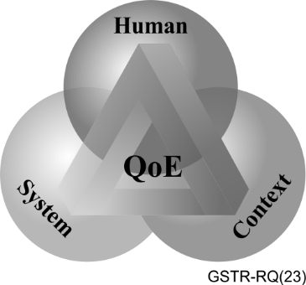
Figure 6 – Groups of factors influencing QoE [Möller]
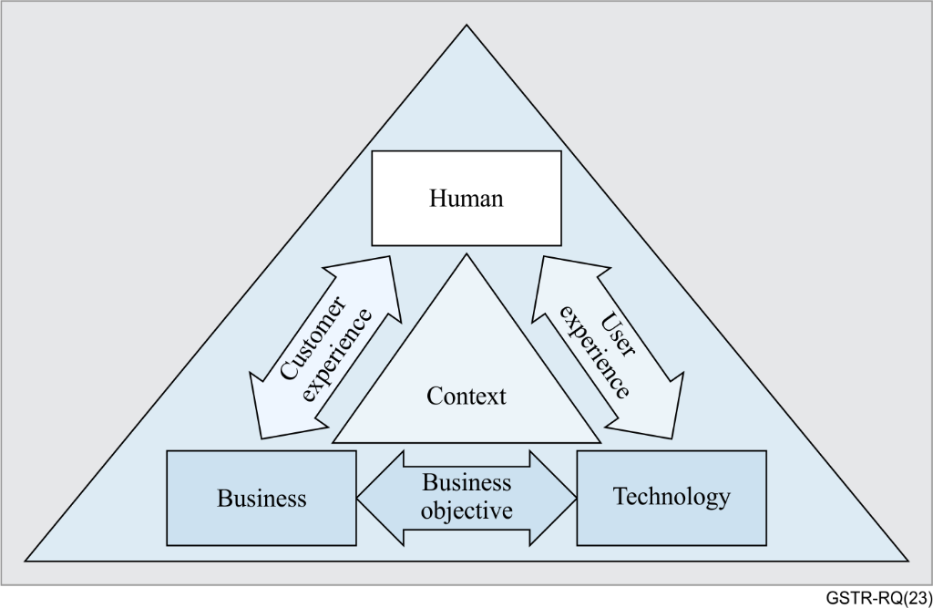
Figure 7 – Communication ecosystem [Laghari]
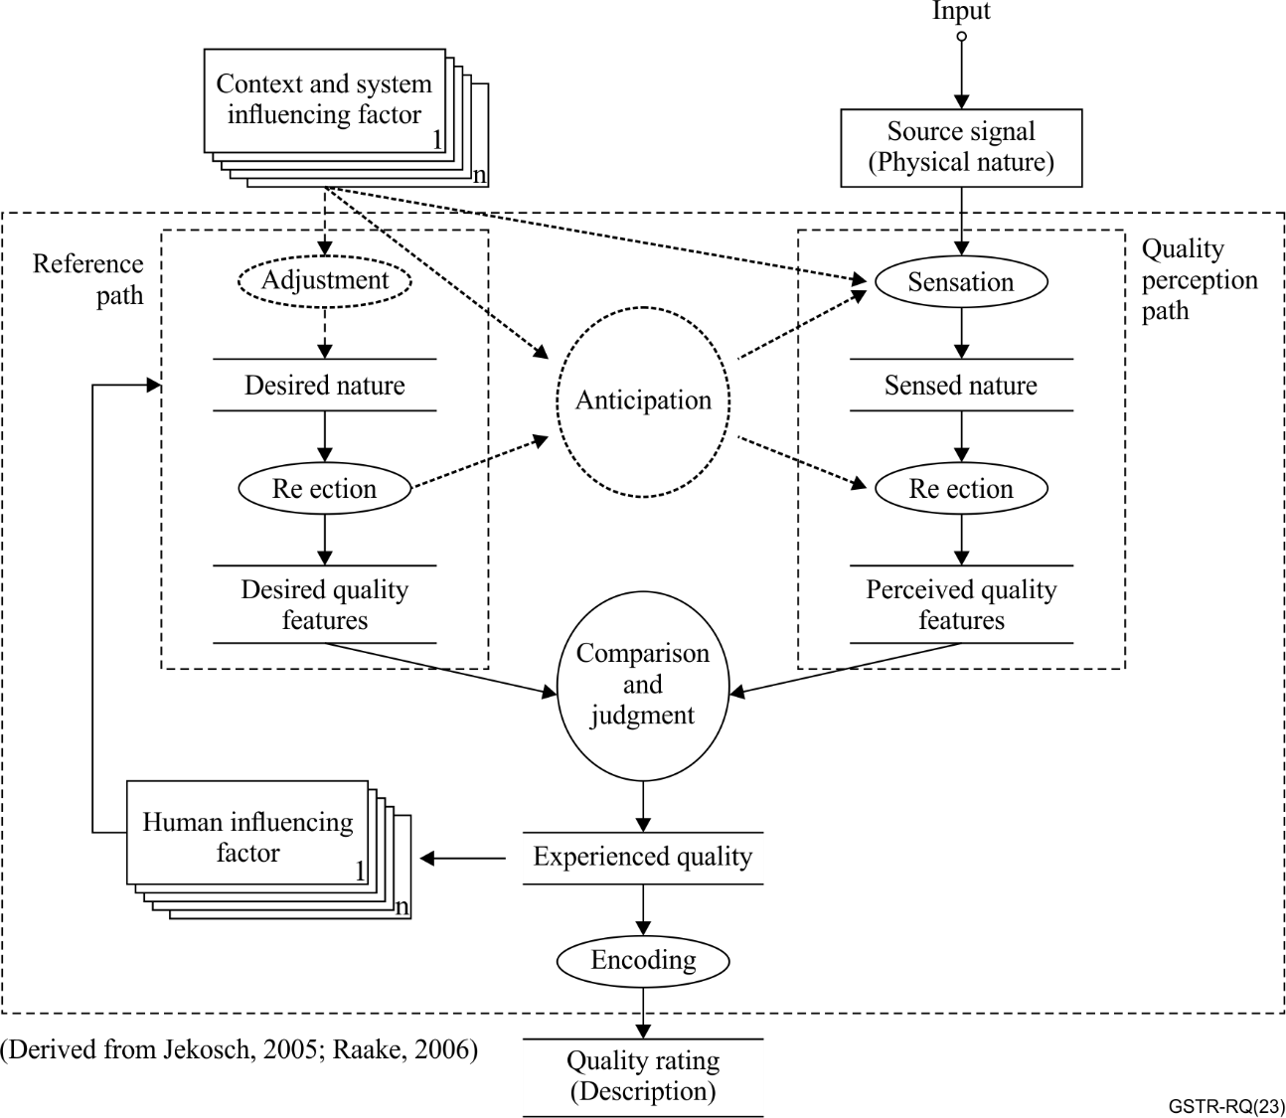
Figure 8 – Quality formation process [Brunnström]
The three conceptual models have one thing in common: none of them tries to depict QoS as some part of the QoE complex interactions model. That is a characteristic that catches the attention when comparing these theoretical models with the ones present in the ITU-T Recommendations.
Analysing which factors are inside each category of influencing factors, we can state that:
i) Quality of service (QoS) aspects during the use of telecommunications services (network availability, network accessibility, accessibility, retainability, integrity) are related to context and system influencing factors;
ii) Quality of service (QoS) aspects during non-utilization stages (previous information, contractual matters, installation, repair, customer care, billing and cancellation) are related to business influencing factors.
That is, although the conceptual models do not directly include QoS results on QoE formation, they include the factors that impact QoS results, such as the network infrastructure and customer care aspects.

10 Conclusions
Based on the historical evolution of definitions by ITU-T Recommendations related to QoS and QoE, explored in this Technical Report and the analysis shown in clause "8. Measurements and estimation process for QoE", the following problems were identified:
1) There are overlapping definitions regarding what is the quality that customers/users perceive, which depends on QoS aspects and subjective/qualitative factors;
2) Confusion between the assessment of:
i) QoE;
ii) non-technical QoS; and
iii) specific applications quality indicators or parameters.
3) Conflicting relationships established by the four-point-of-view model and QoE/satisfaction models.

10.1 Overlapping terms and definitions
The term QoS experienced/perceived by customer/user (QoSE), defined by [ITU-T G.1000], overlaps with the QoE definition. The proposal is to eliminate the QoSE term, as well as the "QoS perceived by customer" term.
Additionally, no conceptual or practical differences were identified between the quality of experience definition and the following terms, which are not defined in ITU-T Recommendations, but are largely applied in their texts:
• Overall quality;‎
• Perceived quality;
• Experienced quality;
• Quality of perception; and
• Satisfaction.
There should be a new definition for QoE, to be included in [ITU-T G.1000]. The new definition should add some reference to the terms mentioned above. Based on the new definition, it should be defined if it is necessary to add a definition specifically for the term "satisfaction".

10.1.1 QoS sub-categories
Table 1 shows there are different terminologies and concepts applied when referring to sub-categories. Some of the terminologies are not clear and may overlap with others:
• Network performance and non-network performance: this terminology may be confusing, since there are aspects related to application performance that are commonly evaluated together with network performance.
• Utilization stages and non-utilization stages: this terminology clearly divides the aspects related to service effective use (network, application, device, etc.) from supporting services (contractual matters, customer service, billing, service provision and repair, etc.).
• QoS technical and QoS non-technical: this terminology is not very clear because there are technical characteristics related to service provision, repair, and other aspects of customer service.
• Service factors, transport factors and application factors: these categories of aspects do not include characteristics of customer service and other aspects of non-utilization stages.
Thus, the proposal is to adopt the terminology "utilization and non-utilization stages", already used in [ITU-T E.803].

10.2 Clarifications on QoE assessment
The proposal is to include clarifications on the use of "QoE assessment" terms as a new section in [ITU-T G.1011]. Also, provide a new definition for QoE assessment. The influencing factors on QoE are to be added to the text, complementing the assessment methods section.
Additionally, it is necessary to choose a terminology for sub-categories of QoS. The proposal is to adopt the terms "utilization" and "non-utilization" stages and include their definitions on [ITU-T E.803].

10.3 Four point-of-view conceptual model
The four point-of-view conceptual model does not include directly subjective factors that influence perception. It also segments QoS considering a cycle between service provider and a customer. This segmentation brings confusion when referring to QoE and end-to-end QoS. In addition, the cycle brings the idea of a continuous process that not necessarily is performed during the service, for instance, the providers do not necessarily update the customer requirements at different times or with a certain frequency.
It is necessary to eliminate the concepts brought by the four point-of-view model and other models shown in this report (Figure 1) and establish a unique perspective relating QoS and QoE in the context of telecommunication services. This approach considers QoS as a unique concept from regulators', providers, and customer perspectives.
Before establishing a relationship between these concepts, it is worth noting that QoE and QoS have different scopes, QoE is applied to different and diverse areas while QoS is mainly focused on telecommunication services. Also, QoS is more related to the physical system performance, and QoE deals with the users' assessment of the service, application, or system. According to Rubino G., Varela M. (2004) [Rubino], the methods used to determine QoS are technological-oriented, and the methods for QoE are multi-disciplinary.
As previously stated, the QoE influencing factors (IFs) are categorized as human, system, business and context factors. These IFs are interrelated, and they cannot be treated isolated. The system IFs can be divided into four sub-categories: Content-related system IFs, media-related system IFs, network-related system IFs, and device-related system IFs. In this context, a relationship between most of the technical aspects of QoS and the system IFs of QoE may be established.
However, some QoS aspects described in [ITU-T E.803] as non-utilization stage, such as commercial support, charging and billing, are not related to system IFs. These aspects of QoS are under the influence of business IFs.
According to the previous statements, QoS and QoE are two different concepts, which have intersections in different aspects. Thus, our aim is to propose a relationship model between QoE and QoS. In this model, the three QoE influencing factors described in [Brunnström], including the business model as part of the context IF, are used in conjunction with [ITU-T E.803] and [ITU-T E.804].
Figure 9 shows the conceptual model, to be used in replacement to the models previously shown in this report, considering a context of telecommunication services.
It's important to do state that the conceptual model depicts the relationship between QoS and QoE as simply as possible, while conveying the very notion of that relationship. In this regard, although one might understand that QoS should also have an arrow pointed directly to QoE, for the sake of simplicity, and considering that this relationship is also mediated by the system and the business IFs, this element is not added to the conceptual model.
Another worth noting point is the fact that the listings at the side of the IFs names are merely examples of categories in which the IFs may be divided. In the specific case of business IF, it has to be clarified that not all categories influence both QoS and QoE. For instance, "advertisement" only influences QoE, to the extent that it helps to form the brand image and the expectations related to the service; on the other hand, "customer service" has an influence on the non-utilization stage of the QoS, once it is an aspect of the service directly associated to the relationship between the customer and the provider. In the case of "billing", one would state yet that it has an indirect relationship with the use of the service (non-utilization stage of QoS), and it seems to be the case once it is also based on the use of the service by the customer. However, it does not represent the technical aspect per se, the reason why is our understanding that the arrows pointing to QoE, and to QoS from business IF are enough to explain these relationships.
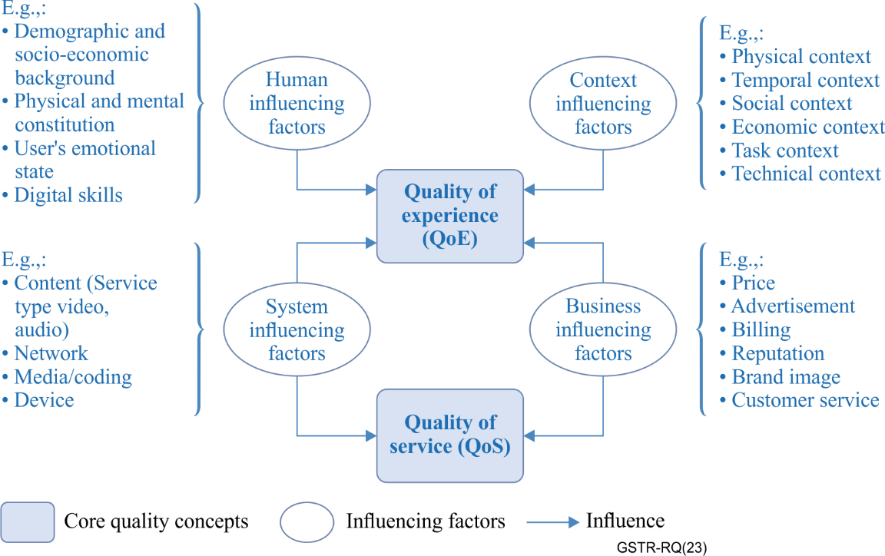
Figure 9 – QoE and QoS conceptual model

10.4 ITU-T Recommendations to be revised
Based on the proposals, the adjustments require the revision of the following Recommendations:
Table 3 – ITU-T Recommendations to be revised
Order for revision | Recommendation | Content to be revised
1 | [ITU-T G.1000] | 1) Exclusion of 4-point of view model and inclusion of new conceptual model.  2) Exclusion of definitions related to the 4-point of view model: QoS perceived by the customer.  3) Inclusion of definitions: QoE; QoE influencing factors; customer satisfaction.  4) Clarifications on definitions related to the 4-point of view model based on the new QoE-QoS conceptual model and new definitions for QoE and QoE influencing factors: 3.3 QoS requirements of user/customer; QoS offered/planned by the provider; QoS delivered/achieved by the provider.  5) Adjustments in the Recommendation due to previous mentioned changes.
 | [ITU-T E.800] | 1) Exclusion of definitions related to the 4-point of view model: QoSE (QoS experienced/perceived by customer/user).  2) Clarifications based on new definitions in G.1000: Subjective (qualitative) parameters.  3) Inclusion of definitions: QoS non-utilization stages; QoS utilization stages.  4) Adjustments in figure "Quality of service comprises network and non-network criteria".  5) Adjustments in the Recommendation due to previous mentioned changes.
2 | [ITU-T E.800 Suppl. 9] | 1) Revision of figure "Factors influencing customer satisfaction" based on new [ITU-T G.1000].  2) Adjustments in the document due to previous mentioned changes.
 | [ITU-T E.804] | 1) Revision of figure "QoE dimensions" based on new [ITU-T G.1000].  2) Adjustments in the Recommendation due to previous mentioned changes.
 | [ITU-T P.10/G.100] | 1) Adjustment of definitions using new definitions established by [ITU-T G.1000]: QoE; QoE assessment; QoE influencing factors.  2) Adjustments in the Recommendation due to previous mentioned changes.
3 | [ITU-T G.1011] | 1) New section about "Application of QoE assessment concept". Revision of terms based on new [ITU-T G.1000], including machine learning methodologies for enhancing the QoE assessment.  2) Adjustments in the Recommendation due to previous mentioned changes and new definitions on [ITU-T G.1000].
 | [ITU-T E.803] | 1) Revision of terms based on new [ITU-T G.1000]. Revision of figure "Quality of service comprises network and non-network criteria".  2) Adjustments in the Recommendation due to previous mentioned changes.

Annex A
QoS aspects defined in ITU-T Recommendations
[ITU-T E.803] and [ITU-T E.804] provide further divisions inside the sub-categories shown in Table 1.
[ITU-T E.803] focuses on aspects related to non-utilization stages, while [ITU-T E.804] defines the aspects for effective use of service. Although the aspects in [ITU-T E.804] were identified for mobile service, it is possible to extrapolate the concept to other services by analogy.
These subdivisions, or "QoS aspects", are shown in Table 4 below and may help to understand which stages of the customer and provider's relationship are covered by QoS subcategories.
Table 4 – QoS aspects
QoS | Recommendation [ITU-T E.803]
Non-utilization stage | Preliminary information on ICT services
 | Contractual matters between ICT service providers and customers
 | Provision of services
 | Service alteration
 | Technical upgrade
 | Documentation of services (operational instructions)
 | Technical support
 | Commercial support
 | Complaint management
 | Network / service management by the customer
 | Repair services
 | Charging and billing
 | Cessation of service
QoS | Recommendation [ITU-T E.804]
Utilization stage | Network availability
 | Network accessibility
 | Service accessibility
 | Service retainability
 | Service integrity

Bibliography

[b-Qualinet 2013] Qualinet White Paper on Definitions of Quality of Experience (2013), Output from the fifth Qualinet meeting, Novi Sad, March 12. <https://www.researchgate.net/publication/235769459_Qualinet_White_Paper_on_Definitions_of_Quality_of_Experience>

_____________

For further references on quality assessment methodologies are provided by the following ITU-T Recommendations: [ITU-T P.1201], [ITU-T P.1202], [ITU-T P.1203], and [ITU-T P.1204].

