 |  | International Telecommunication Union
 |  | ITU-T | Technical Report
 |  | TELECOMMUNICATION  STANDARDIZATION SECTOR  OF ITU |  | (March 2020)
 | NET2030-DF
 | Driving forces and vision towards Network 2030

Summary
This Technical Report aims to provide a holistic vision for Network 2030 and analyses some fundamental driving forces by presenting four new network capability driven use cases and services. Accordingly, future-oriented challenges with potential network requirements are stated as well. Overall, this Technical Report provides an overview of Network 2030, finally leading to the three pillars of Network 2030 in terms of new applications, new services and new infrastructures.
Keywords
Challenges, driving forces, Network 2030, new applications, new infrastructures, new services, requirements, use cases, vision.

NOTE
This is an informative ITU-T publication. Mandatory provisions, such as those found in ITU-T Recommendations, are outside the scope of this publication. This publication should only be referenced bibliographically in ITU-T Recommendations.

© ITU 2020
All rights reserved. No part of this publication may be reproduced, by any means whatsoever, without the prior written permission of ITU.

Table of Contents
Page
1 Scope 1
2 References 1
3 Abbreviations and acronyms 1
4 Background and motivation 2
5 New network capability driven use cases and services 2
5.1 Holographic type communications 2
5.2 Multi-sense synchronized transmission 4
5.3 Time-engineered communications 5
5.4 Emergency-aware services 5
6 Challenges towards Network 2030 6
7 Vision of Network 2030 8
8 Summary and future considerations 9

Technical Report
Driving forces and vision towards Network 2030

1 Scope
This Technical Report aims to provide a high-level vision for future networks in the next decade, i.e., Network 2030. The inherent capabilities of networks and the running principles therein need to be upgraded, enhanced, or even reformulated, driven by future-oriented vision beyond current limits, based on the provision of comprehensive, data-supported gap analysis.
To help shaping the design paradigms of future networks, this Technical Report concisely summarizes some new network capability driven use cases and services and identifies relevant key challenges with associated potential network requirements, which collectively demonstrate an overview of Network 2030.

2 References
[ITU-T Y.2091] Recommendation ITU-T Y.2091 (2011), Terms and definitions for next generation networks.
[FG-NET2030NS] ITU-T FG NET-2030 (2019), New services and capabilities for Network 2030: description, technical gap and performance target analysis.
[FG-NET2030UC] ITU-T FG NET-2030 (2020), Representative use cases and key network requirements for Network 2030.
[FG-NET2030WP] ITU-T FG NET-2030 (2019), Network 2030 – A blueprint of technology, applications and market drivers towards the year 2030 and beyond.
[N17073] ISO/IEC JTC1/SC29/WG11 MPEG2017/N17073 (2017), Requirements on 6DoF (v1).

3 Abbreviations and acronyms
This Technical Report uses the following abbreviations and acronyms:
6DoF Six Degrees of Freedom
EtherCAT Ethernet for Control Automation Technology
HMD Head Mounted Display
HTC Holographic Type Communications
ICT Information and Communication Technologies
IoT Internet of Things
MEC Mobile Edge Computing
PLC Programmatic Logic Controller
POP Points-of-Presence
PROFINET Process Field Net
TSN Time Sensitive Networking

4 Background and motivation
The decade preceding 2020 witnessed not only tremendous data transmitted over networks, but also more importantly the advent of new applications, such as fully autonomous transportation systems, intelligently connected sensors in Internet of things (IoT), and an onset of immersive media in combination with more human senses. Collectively, this trend is creating billions of new connected endpoints, with varying sensitivity to different kinds of resource requirements. It also exposes several challenges in current network technologies, especially in long-distance and large-scale networks.
Many new applications and new network services are expected to emerge or to become fully matured, which further serve as fundamental driving forces to fully integrate human-centric communities and machine-centric systems more intelligently, at a global scale. From a logical point of view, it is observed that new applications normally trigger new services and introduce more demanding requirements for continuously evolving or new network technologies. Thus, upon the completion of a comprehensive, data-supported gap analysis, the inherent capabilities of networks and the running principles therein might need to be upgraded, enhanced, or even reformulated, driven by future-oriented vision.
As a society that is always seeking a better future, every effort is made to enable these new applications with new services to become a reality. The role of the network community is to identify the right set of network technologies with the new capabilities required to deliver these applications. With such motivation, Network 2030 is thus coined to provide a holistic vision towards the networks in the next decade. Particularly, this Technical Report focuses on presenting four new use cases and new services, with concise analysis on their relevant challenges, so that such a future vision can be explicitly elaborated.
The basic structure of this Technical Report is organized as follows: Four new use cases and services with potential network requirements are first described, followed by the concise analysis of challenges. Subsequently, a holistic vision towards Network 2030 is formulated with three pillars.
Note that, this Technical Report aims to provide an overview of Network 2030. Please refer to [FG-NET2030UC] for more detailed description of representative use cases with key requirements and to [FG-NET2030NS] for more analysis on Network 2030.

5 New network capability driven use cases and services

5.1 Holographic type communications
Holographic display technology has made significant advances in recent years, from true hologram-based displays, to different kinds of head mounted display (HMD). With the science and technology to construct and render holograms better understood, the holographic applications are on their way to becoming a reality. Those applications will involve not only the local rendering of holograms but also networking aspects, specifically the ability to transmit and stream holographic data from remote sites, referred to as holographic type communications (HTC).
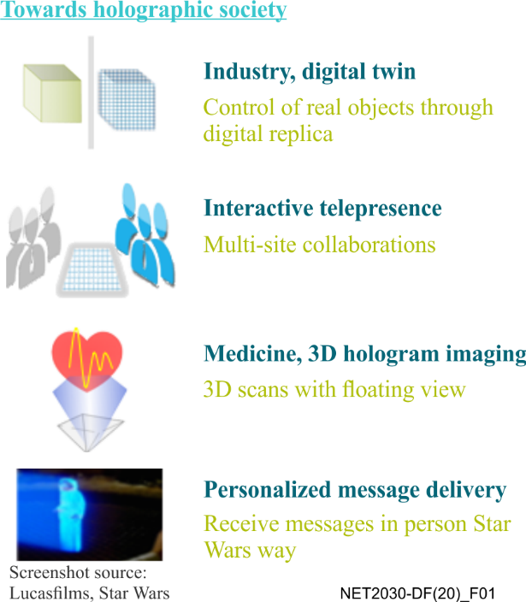
Figure 1 – Examples of HTC applications
Far from being just a technological gimmick, HTC has plenty of useful applications as shown in Figure 1. For example, holographic telepresence will allow remote participants to be projected as holographic presences into a room. Conversely, immersive holographic spaces will render artefacts from a distant location into a room, rendering local users into the remote location. Remote troubleshooting and repair applications will allow technicians to interact with holographic renderings of items at remote and hard-to-reach locations, such as on an oil drilling platform or inside a space probe. Holographic signage which renders holographic content that is centrally managed and distributed presents a natural next step for digital signage. Training and education applications can provide remote students with the ability to engage with the objects and other pupils for active participation in the classroom. In addition, possibilities abound in the areas of immersive gaming and entertainment.
For HTC to become a reality, there are multiple challenges that future networks will need to address. A very high bandwidth is needed due to the large data volumes involved in the transmission of high-quality holograms. The "quality" of a hologram involves not only colour depth, resolution, and frame rate as in video, but it also involves the transmission of volumetric data from multiple viewpoints to account for shifts in tilt, angle, and position of the observer relative to the hologram (collectively known as six degrees of freedom (6DoF) [N17073]). The streaming of underlying volumetric data and image arrays imposes additional synchronization requirements to ensure smooth viewing transitions for the user.
Going beyond the streaming of holographic information itself, some applications may additionally combine holographic images with data from other streams. For example, holographic avatars may be able to combine a holographic image with an avatar. This allows an entity to not only be projected or rendered from a remote site, but to also feed information back to that entity from that remote viewpoint. For example, a video and audio stream may be derived from the point of view of where the hologram is projected. This could be accomplished by superimposing holograms over corresponding cameras, microphones, or other sensors. For this to work, tight synchronization is required across multiple data streams, but the result will be applications that provide an even more realistic sense of user interactivity.
A second set of extensions concerns combining HTC with tactile networking applications, allowing users to "touch" a hologram. This opens up new possibilities for applications such as the ones identified for training and remote repair. Tactile networking applications impose requirements of ultra-low delay (to provide an accurate sense of touch feedback) on underlying networks and, in particular as far as mission-critical applications such as remote surgery are concerned, no tolerance to loss. Coupling tactile networking with HTC introduces additional high-precision synchronization requirements to ensure that all the various data streams are properly coordinated.

5.2 Multi-sense synchronized transmission
When discussing networking applications that involve not only visual (video, holograms) and acoustic (audio) senses, but also touch (tactile), the question then arises: why stop there; what about the other senses? Indeed, to create fully immersive experiences, there should also be the possibility to involve the senses of smell and taste.
Unlike vision and hearing, smell and taste are considered "lower" senses. They generally do not command the focus of attention or guide human activity but are more related to feelings and emotions. These are "near senses" in that their perception involves a direct (chemical) reaction of the agent that is being perceived with a receptor. In contrast, far senses (hearing and sight) allow perception from sources that are remote, with artefacts transmitted by waves, not chemical or physical reactions. The fact that chemical reaction is involved creates a significant hurdle to overcome, namely the problem of how to construct effective actuators. Some limited successes have been achieved using "digital lollipops", devices inserted into the mouth that deliver small currents and differences in temperature to the tongue's papillae (taste sensors) to simulate sensations such as sourness, saltiness, or sweetness. Smell constitutes an even more challenging problem. Some researchers have proposed "transcranial stimulation", i.e., a set of electrical magnets (e.g., incorporated into a headset) to deliver stimuli to areas in the brain responsible for creating sensory sensations.
Even more than the networking industry, the food industry is very interested in breakthroughs in this area. For example, the ability to generate "digital sweetness" enables the opportunities to investigate the reduction of the use of sugars or artificial sweeteners. While true breakthroughs in actuators that convey a digital sense of smell and taste seem at this point far away, assuming this can be achieved, there will clearly be interesting opportunities for potential networked applications. For example, remote learning solutions as well as digital advertising may exploit the fact that memory retention can be improved by association with smells and tastes. Digital experiences can be enhanced, in particular as smells and tastes can evoke or amplify emotions. In this context, certain images could be associated with a certain scent, such as cloud-based medical solutions that could generate bitter tastes from remote locations to prevent the intake of certain foods at certain times as part of a dietary regime.
In contrast to the actuator problem which is to convey a digital sense, the implementation of the requirements by sensory applications on the network can be expected to be reasonably straightforward to provide. To communicate data for taste and smell, it is sufficient to communicate the data that is actually in contact with the taste or smell receptors – the taste and smell in and by itself, not the taste and smell as emitted by any one of many objects in an environment. For example, to communicate a particular taste in a scene, it is not necessary to communicate what every "pixel" of every object potentially taste like. This is different from vision, where every object in a scene will reflect light that is perceived by the end user. There are additional factors, which influence the sensation of taste, such as texture. Given that the number of receptors in a tongue (around 8000) is about 4 orders of magnitude fewer than the number of receptors in an eye's retina (around 150 million), the volume of "taste" data that needs to be transmitted will be dramatically lower than what is required for the communication of images. In addition, as detection of a taste in the human body can take as much as a second, no particular requirements are imposed concerning support for ultra-low latency. Similar considerations apply for scent data, despite the fact that the delay involved in detecting scents by a person is significantly lower. However, when it comes to multi-sense transmission in an integrated manner, including all five senses as a whole, more research in general is definitely needed. As an example, in order to realize future multi-sense immersive applications, demanding challenges in terms of perfect multi-sense synchronization have to be addressed.

5.3 Time-engineered communications
Human intelligence naturally adapts to disruption and unpredictable events and can tolerate some delays in the delivery of information. This is demonstrated in the adaptation to best-effort network services, waiting for reconnections, and retrying upon failures, and the ability to handle voice or video communications that suffer lost packets or considerable jitter. However, during past decades as technology has advanced, our dependence on communication networks has grown. As more devices and gadgets are incorporated in our daily activities, quick responses and real time experiences have become the prime factors for smooth functioning in daily routines.
In particular, taking into consideration market drivers such as industrial automation, autonomous system, and massive networks of sensors where humans are not an endpoint, the time-factor becomes even more significant since most machines are not programmed to adapt: they are purposely built for specific tasks and deterministic control loops. Precision engineering does not require learning, the devices in the system must comply with timeliness. That is why, time-engineered communications with precise data delivery is a prominent theme of Network 2030.
What indicates a higher degree of difficulty is the type of time attributes Network 2030 is concerned with. It is not just about relative characteristics like fast or slow, but is also concerned with the precise time of an event or data delivery.
Energy efficiency and machine utilization are extremely relevant to the economics of manufacturing in industry automation. Utilization is maximized when the wait time of each piece of equipment is close to nil, and energy is saved as retries are eliminated. The connected entities in the industrial Internet, such as programmatic logic controllers (PLCs), sensors, and actuators have to perform with time accuracy in the lower digits of 10 milliseconds (round-trip time), and in some circumstances sub-millisecond accuracy may be required.
Similarly, autonomous traffic systems, even in a small radial distance of two miles, will have connected endpoints in the order of tens of thousands of vehicles, traffic signals, content, and other components. To harmonize the operation of such densely inter-connected machinery, the on-time delivery of information is necessary. In this case, knowing at what exact time the information arrives is useful: anything arriving early or late is meaningless.
The creation of identical digital environments in multi-party applications like online gaming or remote collaborations will require true synchronization of objects in the frame of reference at multiple sites. A new set of challenges emerge when the movement of a physical object will need to be coordinated in time across sites served by communication links that operate with varying latencies.
As the boundaries between digital and real-world objects blur, there is need for a communication system that can coordinate between different sources of information such that all the parties involved have a synchronized view of the application.

5.4 Emergency-aware services
While cyber- and IoT security are becoming the crucial concerns in current information and communication technology (ICT) systems, expectations to protect and safeguard the society from emergency situations by means of technological advancements are anticipated to grow in the next decade. New services with enhanced capabilities are then needed to ensure the safe rescue of the subjects in any place, at any time, in the event of any kind of emergency.
Identifying those capabilities is also one of the primary goals of Network 2030. Looking ahead, the critical safety operations need to consider all the aspects of the subjects who are in the emergency area. For example, to always have location available until rescued, pointing it at the subject's networked device with reference to an area map, accessed via a safe-path navigation capability, and providing the necessary courses of action.
In particular, Network 2030 must identify how a subject associated with a terminal (such as a phone or a tablet device) will use services developed by specialists of those emergency situations for this subject and for this type of emergency. Obviously, the time centric services mentioned earlier are the enablers; in addition, further studies are necessary as to what is required to develop such services over heterogeneous, independent network infrastructures. The problem that such services could solve becomes more acute and more urgent every year for both developed and developing countries. This is due to natural causes and to the main directions of world development, including trends of globalization, urbanization, cross-country cooperation, flow of goods and population and so forth. Hence, the systems requiring emergency-aware services need to have a reliable and robust network infrastructure with full coverage, meanwhile, some advanced features are also expected such as remote holographic presence, augmented reality and virtual reality, and tactile networking capabilities.

6 Challenges towards Network 2030
The general goal of Network 2030's studies is to have networks ready for the market verticals that will utilize emerging technologies towards the year 2030. Network 2030 extrapolates from what is known about technologies and develops a vision of the new applications, new services, and new infrastructures. For this, a few challenges of importance to address towards building this future vision are outlined.
• Rich service-network interaction: Failure to find an ordered and healthy relationship between the applications and the network has been a sticking point. Connectivity is just one of the workflows involved in application logic. It is a service consumed, with reachability being the only explicit means of setting up the application behaviour in the networks. However, a number of services offered by networks are not obvious to the end user. These include reliability of the network fabric, broadcast or multicast, integrity and security of the data delivered, and network level awareness of congestion, capacity, and latency. Accommodating such capabilities directly in the networks has been much of the focus of industry for the past thirty years. Due to lack of direct support for such services through proper interfaces to the network, application developers face challenges, designing for every conceivable possibility of network failures and outages. Many of these services are controlled over end-to-end interfaces between the endpoints using the transport layer which is another example of free-form evolution aiming to solve the challenges of the network through enhanced assistance from the network.
• Readiness for holographic and multi-sense media: The amount of data necessary to stream holographic media can easily approach the scale of gigabytes per second even after compression. The challenge with commoditizing holographic media-aware applications (holo-apps) involves several stake-holders. Almost every conceivable use of holograms requires network connectivity. Besides on-premises generation and display of holograms, the applications will need to locally render a dynamic and complex remote setting. For an enduser, it is not just a bandwidth problem. There is an additional demand from networks to provide reliability and timeliness to eliminate any jitter since that will immediately degrade an interactive application's behaviour. It is even tougher for network service providers as they plan for such bandwidths for a possibly very large number of subscribers. All this imposes challenges in terms of protocol design and service customization for high-density metropolises. Here, exploiting edge-caching will not help with real-time traffic directly, but will certainly offload capacity by moving not-so-live data to the edges. Yet the biggest challenge is more fundamental, i.e., what "on-the-wire" capabilities need to be added to the networks, so that applications could ask for holographic streams with specific characteristics.
• Precision of time in services: Most market segments are striving to be operationally autonomous and automated, both being time-bound functions. The fact that automation in factories aims to eliminate down time, improve quality, and be cost-efficient relies heavily on every single sensor, actuator, cyber physical system and robot to perform with extreme accuracy to the order of few milliseconds. Similarly, self-driving cars are highly-desired, but the safety of passengers in the vehicles and the surrounding environment are absolutely necessary. Unlike flying planes with flight plans in autopilot mode, road driving has many more unpredictable events to respond to often in the orders of a few milliseconds. The accuracy of the time delta between the event's occurrence and notification determines the safe outcome of the action taken by the self-driving systems. Both automated and autonomous systems certainly have a higher dependence on time. Time is critical to scenarios such as automotive, factory floors, and audio/video productions, and networks to support these scenarios are built separately with purpose-built protocol stacks such as TSN, PROFINET, and EtherCAT. A challenge of these purpose-built protocol stacks is the lack of generalized support for time-based services in large scale networks. This is absolutely necessary to demonstrate the potential of a fully automated future, in which manufacturers can adapt quickly with shorter lead times.
• Enhanced access network capabilities: Access networks have traditionally been a facility to merely access the Internet, with a more recent evolution for services being located in the many cloud platforms that make up the (mostly web) services used by everyone. Inter-domain networking or local points-of-presence (POPs) provide the service capability towards those customers connected to the customer/access network. However, the proliferation of ever more powerful computing and communication resources at the 'edge' of the network has turned such access networks into a possibly rich service provisioning and access platform. Hyper-local services, such as interactive virtual reality scenarios and many others, do not require connectivity to distant service platforms but, instead, often perform better with local service access due to decreased latency when accessing a nearby service instance. While efforts like Mobile Edge Computing (MEC) in ETSI and other 5G-oriented efforts address service termination in access networks, reconciling those approaches with the ones used for many years in (data centre based) Internet services is still crucial for a truly end-to-end and access network agnostic service deployment solution for Network 2030.
• Moving beyond best-effort and coarse-grained QoS to guaranteed QoS: Incubating a new set of network services that enable smooth deployment of applications is the driving theme. While extensions towards quality of service (QoS) have been studied extensively, standardized, as well as implemented, many networks still support best-effort or limited number of QoS levels, without being able to offer specifically tailored network treatments. However, for a number of future use cases, guarantees for timely delivery, both in bounding latency and jitter, will be necessary for the successful realization of the use cases. A holistic approach for a full end-to-end realization of such use cases is still missing.
• A seamless coexistence of heterogeneous network infrastructures: Networks overall, not only at the edge, have become increasingly richer in terms of technology, ownership and end user participation. Quite likely there will be many public and private networks. New technologies further widen the constraints for transmitting packets through the utilization of infrastructure-based wireless, wireless mesh, satellite, fixed line technologies (such as fibre optics), all of which must be accompanied by the fundamental packet transfer solution, while adhering to the underlying ownership relations when traversing those different networks. Consequently, the end-to-end realization of services across those heterogeneous environments needs strong consideration for Network 2030 and is an increasing departure from the structures of networks as seen today.

7 Vision of Network 2030
The challenges that were set out previously will need thorough consideration in order to move towards the new use cases for Network 2030. With this in mind, Network 2030 can be characterized as a network that:
i. Supports many new applications that will drive the digital society towards 2030 and beyond, including new media enabled holographic visualization everywhere, and many more envisioned scenarios, with suitable application-network interaction that allows for specializing service delivery to the needs of the applications. Network 2030 will provide a rich interaction between the applications and the infrastructures beyond basic datagram delivery.
ii. Enables various verticals through means of tight resource control with strict time awareness and guaranteed new services. Network 2030 will have moved beyond the best-effort and coarse-grained QoS paradigm, providing extreme high-bandwidth and rich time-engineered communication services for new use cases.
iii. Supports much richer interconnectivity of future infrastructures, driven by the proliferation of continuously evolving connectivity manners, including satellite and aerial networks, and end user provided networks, as well as by new ownership structures, including private and public networks. Network 2030 will have embraced heterogeneous networks and associated devices at the level of infrastructure integration and communication service support.
At the access and edge network level, a high-performance interconnection of ever-richer access and edge networks will be utilized by new verticals with stricter, as well as more varying boundaries for latency and capacity. Network 2030 will embrace this edge/access proliferation, accompanied with a thinned yet function-rich interconnection between those ever-richer edges of the network.
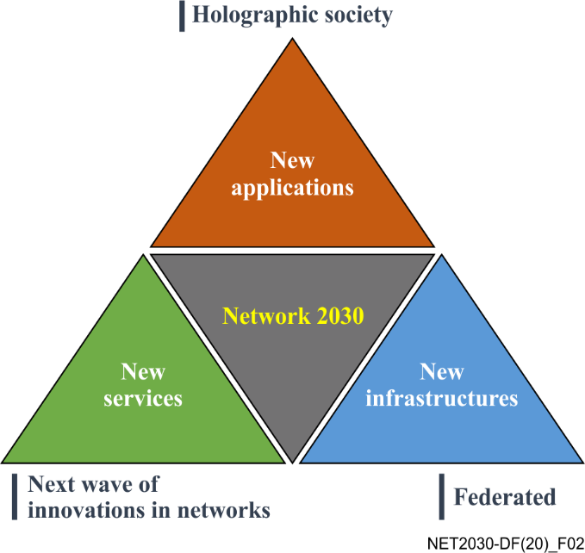
Figure 2 – Network 2030 vision
As a result, the vision of Network 2030 is illustrated in Figure 2, which shows the artefact that enables new applications within the emerging society. This future digital society is envisioned to be empowered by holographic, multi-sense, precision-timing, and other new technologies and network capabilities, through a wave of innovations to provide new services over federated or new infrastructures. New applications, new services and new infrastructures constitute the three pillars of Network 2030.

8 Summary and future considerations
As mentioned previously, lots of new applications are emerging in the near future, such as interactive immersive media teleportation with specific requirements, as well as precision in time for all data transmission. Meanwhile, more cases are also expected, for instance, hyper-scale of interconnected things, services and people, full automation in all networks with pervasive intelligence and so forth. In this new era, it will be necessary to deliver information in fractional units of time between machines, robots and their virtual counterparts to support operations safely, following the fusion trend of digital and real worlds.
In addition, one of the key differences between today's networks and future networks towards 2030, is that the latter will involve new technologies, in both hardware and software. These networks will need to be interoperable with the current and forthcoming generations of networks, such as Beyond 5G (B5G), 6G, space-terrestrial integrated networks, and other potential networks. Then, the Network 2030 can be regarded as a visionary concept, both above and across different types and generations of existing and upcoming technologies.
Although essential challenges have been presented above, there are still a lot of remaining issues worthy of further considerations. For example, the hyper-scale interconnection trend means it is unlikely that a single operator or content provider will be able to manage the entire process in the near future, from researching and testing through to wide implementation and deployment. Meanwhile, the boundary between IT and telecommunications is disappearing. The proliferation of individual public and private networks, in many cases created and delivered by non-traditional converged service platforms, further amplifies the complex nature of networking well into the future. As a result, the successful development of Network 2030 and beyond requires access to large scale physical and virtual development and testing facilities, with embedded state of the art measurement with full automation and intelligence.
Furthermore, without cross-industry and cross-sector collaboration, there is a real risk that future network technology deployment is undertaken in an un-coordinated way, where the impacts are evidenced in live network failures, continued silo approaches, performance issues, lowered productivity, and through impediments to the adoption of digital services, and the undermining of public confidence. Thus, strategic collaboration among stakeholders, including operators, technology companies, vendors, service providers, academia, standards bodies and forums, and government agencies, will be essential, as well as access to the necessary facilities and resources to mature the future networks' capabilities.
In summary, this Technical Report describes the vision for Network 2030, presenting a preliminary study on future-oriented capability driven use cases with challenges, as well as describing the three pillars of Network 2030.

___________

Quantitative and/or qualitative data
https://www.itu.int/en/ITU-T/focusgroups/net2030/Documents/Deliverable_NET2030.pdf
https://www.itu.int/en/ITU-T/focusgroups/net2030/Documents/Technical_Report.pdf
https://www.itu.int/pub/T-FG-NET2030-2020-SUB.G1
http://www.nimesha.info/lollipop.html#dtl
Sarian V., Nazarenko A. Mass service of individualized control for the population rescue in the event of all kinds of emergency situation, 2019.
https://www.design-reuse.com/articles/46536/an-introduction-to-time-sensitive-networking.html
https://en.wikipedia.org/wiki/PROFINET
https://www.ethercat.org/default.htm
https://www.etsi.org/technologies/multi-access-edge-computing

