|  |  |  |  |  |
| --- | --- | --- | --- | --- |
|  | | **International Telecommunication Union** | | |
|  | |  | | |
| **ITU-T** | **Technical Paper** | |
| TELECOMMUNICATION STANDARDIZATION SECTOR OF ITU | | (2 December 2011) |
|  | SERIES H: AUDIOVISUAL AND MULTIMEDIA SYSTEMS Infrastructure of audiovisual services – Communication procedures | | | |
|  | **HSTP-CONF-H762 Conformance testing specification for H.762** | | | |
|  |  | | | |

Summary

This Technical Paper defines the conformance testing items for ITU-T Rec. H.762 "*Lightweight Interactive Multimedia Environment (LIME)*". It gives testing properties and the sample codes to be tested. It is intended to be included in the Annex of [ITU-T H.762] when the testing procedures are deemed complete.

Keywords

IPTV, conformance, conformance testing, IPTV terminal device, IPTV basic services

Change Log

This document contains Version 3 of the ITU-T Technical Paper on "*Conformance testing specification for H.762*" approved at the ITU-T Study Group 16 meeting held in Geneva, 21 November – 2 December 2011.

|  |  |  |
| --- | --- | --- |
| **Editors:** | Masahito KAWAMORI NTT Japan | Tel: +81 468 59 2517 Fax: +81 46 855 3495 Email: [kawamori.masahito@lab.ntt.co.jp](mailto:kawamori.masahito@lab.ntt.co.jp) |
|  | Fernando Masami MATSUBARA Mitsubishi Electric Japan | Tel: +81 467 41 2035 Fax: +81 467 41 2287 Email: [Matsubara.Masami@eb.MitsubishiElectric.co.jp](mailto:Matsubara.Masami@eb.MitsubishiElectric.co.jp) |

**Contents**

Page

1 Scope 1

2 References 1

3 Definitions 1

3.1 Terms defined elsewhere 1

3.2 Terms defined in this document 1

4 Abbreviations and acronyms 1

5 Conventions 2

6 Introduction 2

7 LIME-HTML 2

7.1 Structural elements 2

7.1.1 Document element 2

7.1.2 Head: HEAD 2

7.1.3 Title: TITLE 2

7.1.4 Body: BODY 2

7.2 Hypertext element 2

7.2.1 Anchor: A 2

7.2.2 Link: LINK 2

7.3 Text elements 2

7.3.1 Line break: BR 2

7.3.2 Paragraph: P 2

7.3.3 Grouping elements: the DIV and SPAN elements 3

7.4 Form elements 3

7.4.1 Input field: INPUT 3

7.5 OBJECT element 3

7.6 Associated meta-information: META 3

7.7 The SCRIPT element 3

7.8 The STYLE element 3

7.8.1 Attributes 3

7.9 Monomedia 3

7.9.1 Audio objects 3

8 LIME-CSS 4

8.1 Syntax and basic data types 4

8.2 Properties 4

8.3 Box model 4

8.4 Visual formatting model 4

8.5 Visual formatting model details 5

8.6 Visual effects 5

8.7 Colours and backgrounds 5

8.8 Fonts 5

8.9 Text 5

8.10 Navigation and focus 5

8.11 Extended properties for IPTV 5

9 LIME-DOM 5

9.1 Accessing through ID 5

9.2 Accessing current event 5

9.3 Accessing current focus 5

10 LIME-Script 6

10.1 Native objects 6

10.2 Browser pseudo-object 6

10.3 Methods for IPTV 7

10.3.1 Content 7

10.3.2 License related interfaces 7

10.3.3 Customer service related 7

10.3.4 Service related interfaces 8

11 Communication functions and cookies 8

Annex A Test Suites 9

A.1 Software for Test Suite 0 9

A.1.1 Basic element test 9

A.1.2 Object element test series 0 9

A.1.3 Navigation and focus test series 0 9

A.1.4. DOM test series 0 10

A.1.5 Media (VOD) test series 0 10

Appendix I H.762 conformance checklist 11

I.1 Attributes 11

I.2 used-key-list 16

I.3 Media types used in LIME 17

I.4 Display control of Linear IPTV streaming 18

I.5 Display control of VOD streaming 18

I.6 Use of LIME-CSS in LIME 18

I.7 Use of LIME-Script 20

I.8 Profile of built-in objects 20

I.9 Extensions to ECMAScript 24

I.10 Use of DOM in LIME 26

I.11 DOM HTML interface group 28

I.12 DOM interface specific to LIME-DOM 32

I.13 Profile of the DOM interface for LIME-DOM 32

I.14 Interface for LIME interrupt event 36

I.15 Profile of LIME Interrupt event 36

I.16 LIMECSS2 Properties interface for LIME-DOM 37

Appendix II H.762 sample test codes 40

II.1 Test Sample 0 40

II.2 Test Sample 1 48

**List of Tables**

| Page |
| --- |
| Table 8.4- The 'border-top-color, border-right-color, border-left-color, border-bottom-color' properties 4  Table I-1: HTML Attributes used in LIME-HTML document 11  Table I-2: used-key-list 16  Table I-3: Values Applicable to <key-group> 16  Table I-4: Relationship among Remote Control Keys, Key Codes and Access Keys 16  Table I-5: List of Media Types and Mono-media schemes 17  Table I-6: Use of Attribute for Displaying Stream 18  Table I-7: Use of Attribute for Displaying Stream 18  Table I-8: Profile of CSS properties in LIME 18  Table I-9: Profile of the LIME-Script Built-in Objects 20  Table I-10: Browser pseudo object of LIME-Script 24  Table I-11: DOM core fundamental interfaces 26  Table I-12: DOM core basic interface attributes of LIME-DOM 27  Table I-13: Profile of DOM HTML Interface Group 28  Table I-14: Profile of Attributes and Methods of DOM HTML Interface Group 29  Table I-15: Profile of Interface (DOM Interface Group) 32  Table I-16: Profile of Attributes and Methods (DOM Interface Group) 33  Table I-17: Profile of Interfaces for LIME Interrupt Event 36  Table I-18: Correspondence between interrupt event and type attribute of LIMEEvent 36  Table I-19: Profile of LIMECSS2Properties Interface 37 |

**List of Figures**

| Page |
| --- |
| Figure I.1-1: Reference image, test sample 0 code snippet 1 43  Figure I.1-2: Reference image, test sample 0 code snippet 2 47  Figure I.2-1: Reference image, test sample 1 code snippet 1 50  Figure I.2-2: Reference image, test sample 1 code snippet 2 51  Figure I.2-3: Reference image, test sample 1 code snippet 3 52  Figure I.2-4: Reference image, test sample 1 code snippet 4 53  Figure I.2-5: Reference image, test sample 1 code snippet 5 54  Figure I.2-6: Reference image, test sample 1 code snippet 6 (white background) 55  Figure I.2-7: Reference image, test sample 1 code snippet 7 56  Figure I.2-8: Reference image, test sample 1 code snippet 8 57  Figure I.2-9: Reference image, test sample 1 code snippet 9 58  Figure I.2-10: Reference image, test sample 1 code snippet 10 59  Figure I.2-11: Reference image, test sample 1 code snippet 11 60  Figure I.2-12: Reference image, test sample 1 code snippet 12 61  Figure I.2-13: Reference image, test sample 1 code snippet 13 62  Figure I.2-14: Reference image, test sample 1 code snippet 14 63  Figure I.2-15: Reference image, test sample 1 code snippet 15 64  Figure I.2-16: Reference image, test sample 1 code snippet 16 65  Figure I.2-17: Reference image, test sample 1 code snippet 17 66  Figure I.2-18: Reference image, test sample 1 code snippet 18 68  Figure I.2-19: Reference image, test sample 1 code snippet 19 69  Figure I.2-20: Reference image, test sample 1 code snippet 20 70  Figure I.2-21: Reference image, test sample 1 code snippet 21 71  Figure I.2-22: Reference image, test sample 1 code snippet 22 73  Figure I.2-23: Reference image, test sample 1 code snippet 23 75  Figure I.2-24: Reference image, test sample 1 code snippet 24 77  Figure I.2-25: Reference image, test sample 1 code snippet 25 79  Figure I.2-26: Reference image, test sample 1 code snippet 26 81  Figure I.2-27: Reference image, test sample 1 code snippet 27 82  Figure I.2-28: Reference image, test sample 1 code snippet 28 83  Figure I.2-29: Reference image, test sample 1 code snippet 29 84  Figure I.2-30: Reference image, test sample 1 code snippet 30 2  Figure I.2-31: Reference image, test sample 1 code snippet 31 4  Figure I.2-32: Reference image, test sample 1 code snippet 32 6  Figure I.2-33: Reference image, test sample 1 code snippet 33 8  Figure I.2-34: Reference image, test sample 1 code snippet 34 10  Figure I.2-35: Reference image, test sample 1 code snippet 35 12  Figure I.2-36: Reference image, test sample 1 code snippet 36 14  Figure I.2-37: Reference image, test sample 1 code snippet 37 16 |

ITU-T Technical Paper HSTP.CONF-H762

Conformance testing specification for H.762

Introduction

This document defines the conformance testing items for ITU-T Rec. H.762 "*Lightweight Interactive Multimedia Environment (LIME)*". It gives testing properties and the sample codes to be tested.

# Scope

This document defines the conformance testing items for ITU-T Rec. H.762 "Lightweight Interactive Multimedia Environment (LIME)".

# References

[ITU-T Rec. H.721] ITU-T Recommendation H.721 (2009), *IPTV terminal devices: Basic model*.

[ITU-T Rec. H.762] ITU-T Recommendation H.762 (2011), *Lightweight interactive multimedia environment (LIME) for IPTV services*.

[ITU-T Rec. H.763.1] ITU-T Recommendation H.763.1 (2010), *Cascading style sheets for IPTV services*.

# Definitions

For further study.

## Terms defined elsewhere

N/A

## Terms defined in this document

N/A

# Abbreviations and acronyms

This Technical Paper uses the following abbreviations and acronyms:

|  |  |
| --- | --- |
| BML | Broadcasting markup language |
| CSS | Cascading style sheets |
| DOM | Document Object Model |
| HTML | Hypertext markup language |
| LIME | Lightweight interactive multimedia environment |
| NA | Not Applicable |
| UA | User agent |
| SVG | Scalable vector graphics |
| URI | Universal resource identifier |
| W3C | World Wide Web Consortium |
| XML | Extensible markup language |

# Conventions

N/A

# Introduction

This document describes those points of [ITU-T H.762] that should be tested for conformance and interoperability. The details of the testing are to be done using the test suites provided in the Annex of this document. Testing procedures and sequences are for further study.

# LIME-HTML

A LIME-HTML document defines the structural properties of LIME content. Note that any non-structural element needs to have its style specified in order to be displayable. The specification of style is done using LIME-CSS.

## Structural elements

### Document element

The LIME-HTML document, whose root is <bml>, consists of a head <head> and a body <body>. The head contains the title and other optional elements. The body is a text flow consisting of paragraphs and other elements.

### Head: HEAD

The head of an LIME-HTML document is a collection of information about the document.

### Title: TITLE

Every LIME-HTML document is recommended to contain a TITLE element.

### Body: BODY

The BODY element contains the text flow of the document, including headings, paragraphs, objects, etc.

## Hypertext element

### Anchor: A

The A element indicates a hyperlink anchor.

### Link: LINK

The LINK element represents a hyperlink.

## Text elements

### Line break: BR

The BR element specifies a line break between words

### Paragraph: P

The P element indicates a paragraph. In LIME-HTML, P element is the general purpose element that contains textual information. The exact indentation, leading space, etc. of a paragraph is not specified and is a function of style sheets.

### Grouping elements: the DIV and SPAN elements

The DIV and SPAN elements, in conjunction with the id and class attributes, offer a generic mechanism for adding structure to documents. These elements define content to be inline (SPAN) or block-level (DIV) but impose no other presentational idioms on the content.

## Form elements

### Input field: INPUT

The INPUT element represents a field for user input.

## OBJECT element

LIME-HTML's multimedia features may allow authors to include images and video. The OBJECT element allows LIME-HTML authors to specify an object.

## Associated meta-information: META

The META element is an extensible container for use in identifying specialized document meta-information.

## The SCRIPT element

The SCRIPT element places a script, in general assumed to be LIME-Script, within a document. This element may appear once in the HEAD of an LIME-HTML document. The script may be defined within the contents of the SCRIPT element or in an external file. In LIME-HTML, the script element is declared as having #PCDATA content. As a result, < and & will be treated as the start of markup, and entities such as &lt; and &amp; will be recognized as entity references by the XML processor to < and & respectively. Wrapping the content of the script element within a CDATA marked section avoids the expansion of these entities.

## The STYLE element

The STYLE element allows authors to put style sheet rules in the head of the document. LIME-HTML permits one STYLE element in the HEAD section of a document. In LIME-HTML, the style element is declared as having #PCDATA content. As a result, < and & will be treated as the start of markup, and entities such as &lt; and &amp; will be recognized as entity references by the XML processor to < and & respectively. Wrapping the content of the style element within a CDATA marked section avoids the expansion of these entities.

### Attributes

For further study.

## Monomedia

The following monomedia objects should be supported:

* JPEG
* PNG
* MNG
* Video objects: As described in [ITU-T H.721]

### Audio objects

As described in [ITU-T H.721].

# LIME-CSS

The following CSS functions should be supported, as described in [ITU-T H.763.1].

## Syntax and basic data types

* Selectors
* Universal selector
* Type selectors
* Class selectors
* ID selectors
* The dynamic pseudo-classes: ':active' and ':focus'

## Properties

* Summary of the applicability of properties to elements

Table 8.4- The 'border-top-color, border-right-color,   
border-left-color, border-bottom-color' properties

|  | div | P | br | span | A | input | object | Body |
| --- | --- | --- | --- | --- | --- | --- | --- | --- |
| Width | Y | Y | - | - | - | Y | Y | - |
| Height | Y | Y | - | - | - | Y | Y | - |
| line-height | - | Y | * | * | * | Y | - | - |

NOTE: *shows the value is fixed. -shows the property is not applicable to the element

**Properties applicable to :focus and :active classes**

|  | div | P | br | span | A | input | object | Body |
| --- | --- | --- | --- | --- | --- | --- | --- | --- |
| Width | Y | Y | - | - | - | Y | Y | - |
| Height | Y | Y | - | - | - | Y | Y | - |
| line-height | - | - | - | - | - | - | - | - |

* Assigning property values, Cascading, and Inheritance
* Media types

## Box model

* Margin properties: 'margin'
* Padding properties: 'padding-top', 'padding-right', 'padding-bottom', 'padding-left'
* Border properties

## Visual formatting model

* The 'display' property
* Choosing a positioning scheme: 'position' property
* Box offsets: 'top', 'left'
* Layered presentation

## Visual formatting model details

* Content width: the 'width' property
* Content height: the 'height' property

## Visual effects

* Overflow: the 'overflow' property
* Visibility: the 'visibility' property

## Colours and backgrounds

* Colour: the 'color-index' property
* Background colour: the 'background-color-index' property
* Grayscale-color-index
* Background properties: 'background-image'

## Fonts

* Font family: the 'font-family' property
* Font boldness: the 'font-weight' property
* Font size: the 'font-size' property

## Text

* Alignment: the 'text-align' property
* Letter and word spacing: the 'letter-spacing' property
* Whitespace: the 'white-space' property
* line-height property

## Navigation and focus

## Extended properties for IPTV

* used-key-list
* resolution
* display-aspect-ratio

# LIME-DOM

The following for accessing document object is required to be supported.

## Accessing through ID

document.getElementById("ID")

## Accessing current event

document.currentEvent

## Accessing current focus

document.currentFocus

# LIME-Script

The following objects of LIME-Script, as described in [ITU-T H.762] are required to be supported.

## Native objects

* Object
* Boolean
* Array
* Function
* String
* Date
* Number

## Browser pseudo-object

|  |  |
| --- | --- |
| * sleep( ) * setInterval( ) * clearTimer( ) * pauseTimer( ) * resumeTimer( ) * setCurrentDateMode( ) * random( ) * subDate( ) * addDate( ) * formatNumber( ) * trasmitTextDataOverIP ( ) | * reloadActiveDocument( ) * getBrowserVersion( ) * getActiveDocument( ) * lockScreen( ) * unlockScreen( ) * getBrowserSupport( ) * launchDocument( ) * quitDocument( ) * getBrowerStatus( ) * playRomSound( ) |

## Methods for IPTV

The following methods specifically for IPTV services are required to be supported.

### Content

|  |  |  |  |  |
| --- | --- | --- | --- | --- |
| ● | launchIPTVContent( ): to launch an IPTV content | | | |
|  | Syntax: |  |  |  |
|  |  | Number launchIPTVContent(input String content_uri  ,input String ret_uri  ,input Number start_npt  [,input String license_id]) | | |

### License related interfaces

|  |  |  |  |  |
| --- | --- | --- | --- | --- |
| ● | getIPTVLicense( ): to get a license for content | | | |
|  | Syntax: |  |  |  |
|  |  | Number getIPTVLicense(input String drm_system  ,input String id  ,input Array license_id) | | |

|  |  |  |  |  |
| --- | --- | --- | --- | --- |
| ● | getIPTVLicenseInfo( ): to get information related to the specified license | | | |
|  | Syntax: |  |  |  |
|  |  | Array getIPTVLicenseInfo(input String license_id  ,input Number search_type) | | |

|  |  |  |  |  |
| --- | --- | --- | --- | --- |
| ● | getDRMID( ): to get the client identifier for the specified content protection mechanism。 | | | |
|  | Syntax: |  |  |  |
|  |  | String getDRMID (input String drm_system) | | |

### Customer service related

|  |  |  |  |  |
| --- | --- | --- | --- | --- |
| ● | setContentPackageInfo( ): set the information about the purchased content package | | | |
|  | Syntax: |  |  |  |
|  |  | Number setContentPackageInfo (input String id  ,input Date valid_start_date  [,input Date valid_end_date]) | | |

|  |  |  |  |  |
| --- | --- | --- | --- | --- |
| ● | updatePackageLicenseInfo ( ): to update all the package information | | | |
|  | Syntax: |  |  |  |
|  |  | Number updatePackageLicenseInfo(input String id) | | |

|  |  |  |  |  |
| --- | --- | --- | --- | --- |
| ● | setIPTVServiceRegistrationInfo( ): set the information related to the basic IPTV service, i.e. Linear TV and VOD | | | |
|  | Syntax: |  |  |  |
|  |  | Number setIPTVServiceRegistrationInfo(  input String id  ,input String key  ,input Date expire_date  [,input String license_uri  ,input String signature  ,input String certificate_uri]) | | |

|  |  |  |  |  |
| --- | --- | --- | --- | --- |
| ● | checkIPTVServiceRegistrationInfo( ): to look up the information related to the basic IPTV service, i.e. Linear TV and VOD | | | |
|  | Syntax: |  |  |  |
|  |  | Array checkIPTVServiceRegistrationInfo(input String id) | | |

### Service related interfaces

For parental control

|  |  |  |  |  |
| --- | --- | --- | --- | --- |
| ● | checkParentalCtrlPassword( ): to set the password for parental control | | | |
|  | Syntax: |  |  |  |
|  |  | Number checkParentalCtrlPassword ( ) | | |

# Communication functions and cookies

Communication functions and cookies as described in [ITU-T H.762] are required to be supported.

Annex A  
  
Test Suites

A.1 Software for Test Suite 0

A.1.1 Basic element test

| No. | File name | Description |
| --- | --- | --- |
| 1 | docstr0.lime | TBD |
| 2 | body-element-test.lime | TBD |
| 3 | body-element-test0.lime | TBD |
| 4 | body-element-test1.lime | TBD |
| 5 | p-element-test.lime | TBD |
| 6 | p-element-test0.lime | TBD |
| 7 | br-element-test0.lime | TBD |
| 8 | div-element-test.lime | TBD |
| 9 | div-element-test1.lime | TBD |
| 10 | Span-element-test0.lime | TBD |
| 11 | Span-element-test1.lime | TBD |
| 12 | a-element-test0.lime | TBD |
| 13 | a-element-test1.lime | TBD |
| 14 | Input-element-test.lime | TBD |
| 15 | Input-element-test1.lime | TBD |
| 16 | link-css.lime | TBD |

A.1.2 Object element test series 0

| No. | File name | Description |
| --- | --- | --- |
| 1 | object-element-test.lime | TBD |
| 2 | object-element-test1.lime | TBD |
| 3 | object-element-test2.lime | TBD |

A.1.3 Navigation and focus test series 0

| No. | File name | Description |
| --- | --- | --- |
| 1 | nav-focus-link.lime | TBD |
| 2 | nav-focus.lime | TBD |

A.1.4. DOM test series 0

| No. | File name | Description |
| --- | --- | --- |
| 1 | DOM-accessKey-test.lime | TBD |
| 2 | DOM-object-test1.lime | TBD |
| 3 | DOM-p-test1.lime | TBD |
| 4 | DOM-test1.lime | TBD |

A.1.5 Media (VOD) test series 0

| No. | File name | Description |
| --- | --- | --- |
| 1 | media-sample1-a.lime | TBD |
| 2 | media-sample1-b.lime | TBD |

Appendix I  
  
H.762 conformance checklist

The following is a preliminary checklist for basic terminal device conformance testing. It is intended to be gradually incorporated to the main text of this draft recommendation as contributions on testing procedures are made.

I.1 Attributes

The following HTML attributes are used in a LIME-HTML document.

Table I-1: HTML Attributes used in LIME-HTML document

| Elements | Attributes | Operation | Restrictions for operation |
| --- | --- | --- | --- |
| Common Attributes / Core Attributes | | |  |
|  | Id | R1 | Character string with a maximum of 128 bytes |
|  | Class | R1 |  |
|  | Title | - |  |
| I18N Attributes | | |  |
|  | xml:lang | R2 |  |
| Events Attributes | | |  |
|  | Onclick | R1 |  |
|  | Ondbclick | - |  |
|  | Onmousedown | - |  |
|  | Onmouseup | - |  |
|  | Onmouseover | - |  |
|  | Onmousemove | - |  |
|  | Onmouseout | - |  |
|  | Onkeypress | - |  |
|  | Onkeydown | R1 |  |
|  | Onkeyup | R1 |  |
| Style Attributes | | |  |
|  | Style | R1 |  |
| Core Modules / Structure Module | | |  |
| Body | %Common.attrib |  |  |
|  | %Core.attrib | R1 |  |
|  | %I18n.attrib | R2 |  |
|  | %Events.attrib | - |  |
|  | %Style.attrib | R1 |  |
| Head | %I18n.attrib | R2 |  |
|  | Profile | - |  |
| Title | %I18n.attrib | R2 |  |
| Text Module | | |  |
| Br | %Core.attrib | R1 |  |
|  | %Style.attrib | R1 |  |
| Div | %Common.attrib | R1 |  |
| P | %Common.attrib | R1 |  |
| Span | %Common.attrib | R1 |  |
| Hypertext Module | | |  |
| A | %Common.attrib | R1 |  |
|  | Accesskey | R1 |  |
|  | Charset | R2 |  |
|  | Href | R1 |  |
|  | Hreflang | - |  |
|  | Rel | - |  |
|  | Rev | - |  |
|  | tabindex | - |  |
|  | type | - |  |
| Forms Module | | |  |
| Input | %Common.attrib |  |  |
|  | %Core.attrib | R1 |  |
|  | %I18n.attrib | R2 |  |
|  | %Events.attrib | R1 | Cannot be specified when "inputmode attribute" is "direct" or "indirect" |
|  | %Style.attrib | R1 |  |
|  | accesskey | R1 |  |
|  | checked | - |  |
|  | disabled | R1 |  |
|  | readonly | R1 |  |
|  | maxlength | R1 | From 1 to 40 |
|  | alt |  |  |
|  | name | - |  |
|  | size | - |  |
|  | src | - |  |
|  | tabindex | - |  |
|  | accept | - |  |
|  | type | R1 | Either "text" or "password" |
|  | value | R1 |  |
|  | inputmode | R1 |  |
|  | charctertype | R1 |  |
| Client-side Image Map | | |  |
| a& | cords | - |  |
| shape | - |  |
| input& | usemap | - |  |
| object& | usemap | - |  |
| Server-side Image Map | | |  |
| input& | ismap | - |  |
| Object Module | | |  |
| Object | %Common.attrib | R1 |  |
| archive | - |  |
| classid | - |  |
| codebase | - |  |
| codetype | - |  |
| data | R1 |  |
| declare | - |  |
| height | - |  |
| name | - |  |
| standby | - |  |
| tabindex | - |  |
| type | R1 |  |
| width | - |  |
| Target Mdule | | |  |
| a& | target | - |  |
| Intrinsic Events Module | | |  |
| a& | onblur | R1 |  |
| onfocus | R1 |  |
| body& | onload | R1 |  |
| onunload | R1 |  |
| input& | onfocus | R1 |  |
| onblur | R1 |  |
| onselect | - |  |
| onchange | R1 |  |
| Metainformation Module | | |  |
| Meta | %I18n.attrib | R2 |  |
|  | http-equiv | - |  |
| name | R1 |  |
| content | R1 |  |
| scheme | - |  |
| Scripting Module | | |  |
| script | charset | R2 |  |
| type | R2 |  |
| src | R1 |  |
| defer | - |  |
| xml.space | - |  |
| Style Sheet Module | | |  |
| Style | %I18n.attrib | R2 |  |
| type | R2 | Fixed to "text/css" |
| media | R2 | Fixed to "tv" |
| title | - |  |
|  | xml:space | - |  |
| Link Module | | |  |
| Link | %Common.attrib | - |  |
| charset | R2 |  |
| href | R1 |  |
| hreflang | - |  |
| media | R2 | Fixed to "tv" |
| rel | R2 | Fixed to "stylesheet" |
| rev | - |  |
| type | R2 | Fixed to "text/css" |
| LIME Module | | |  |
| Bml | %I18n.attrib | R2 |  |
| version | - |  |
| xmlns | - |  |
| Bevent | id | R1 |  |
| Beitem | id | R1 |  |
| type | R1 | One of the following is taken: "TimerFired", "CCStatusChanged", "MediaStopped", "DataButtonPressed" |
| onoccur | R1 |  |
| es_ref | R1 |  |
| message_group_id | R1 | It is "0" or "1". When omitted, specification of "0" is assumed |
| message_id | R1 |  |
| message_version | R1 |  |
| module_ref | R1 |  |
| language_tag | R1 |  |
| register_id | - |  |
| service_id | - |  |
| event_id | - |  |
| peripheral_ref | - |  |
| time_mode | R1 | The following is taken: "absolute" |
| time_value |  |  |
| object_id | R1 | Only the object element ID that indicates data transmitted by carousel and type attribute is either "audio/X-arib-mpeg2-aac" |
| subscribe | R1 |  |
| iframe& | align | - |  |
| body& | invisible | R1 |  |
| div& | accesskey | R1 |  |
| onfocus | R1 |  |
| onblur | R1 |  |
| p& | accesskey | R1 |  |
| onfocus | R1 |  |
| onblur | R1 |  |
| span& | accesskey | R1 |  |
| onfocus | R1 |  |
| onblur | R1 |  |
| a& | effect | - |  |
| bdo& | orientation | - |  |
| object& | streamposition | R1 | The frame number is specified (type="image/X-arib-mng") when the monomedia that refers to the relevant object element is MNG. In case of other media, it is "0" |
| streamlooping | R2 | Fixed to "1" |
| streampositionnymerator | - |  |
| streampositiondenominator | - |  |
| streamstatus | R1 | An initial value must be specified depending on the monomedia referenced by the relevant object element |
| streamlevel | - |  |
| remain | R1 | Applicability depends on the monomedia referenced by the object element |
| accesskey | R1 |  |
| onfocus | R1 |  |
| onblur | R1 |  |

I.2 used-key-list

Table I-2: used-key-list

| **Items** | **Features** |
| --- | --- |
| Value of <key-group> | "special-1" is used for VOD playback control key group |
| Key code | To be eventually added in the Vendor dependent keys (key code 150 -) |
| Access key characters | Not specified |
| Behaviour | When an LIME document contains a description of playback control procedure, it is desirable to mask "special-1", the VOD playback control <key-group>, to avoid confusion of the user. When masked, events from the VOD Playback control keys are received by the LIME browser. Since key codes depend on implementation, it is not recommended that such key information is included in a LIME content. |

Table I-3: Values Applicable to <key-group>

| **Value of <key-group>** | **Semantics** | |
| --- | --- | --- |
| Basic | Up, Down, Right, and Left arrow keys, Enter key, and Back key | |
| data-button | Keys for operations for data broadcasting (e.g. Red, Green, Blue, and Yellow colour keys) |  |
| numeric-tuning | Channel keypad (0 to 9, or 0 to 12) |  |
| Other-tuning | Other channel keys (e.g. Up/Down and Direct Selection) |  |
| special-1 | Special Key 1 |  |
| special-2 | Special Key 2 |  |
| special-3 | Special Key 3 |  |
| special-4 | Special Key 4 |  |
| Misc | Keys except the above keys and Power key (e.g. Volume control keys) |  |

Table I-4: Relationship among Remote Control Keys, Key Codes and Access Keys

| **Remote control key** | **Key code** | **Access key character** |
| --- | --- | --- |
| up arrow | 1 | N/A |
| down arrow | 2 | N/A |
| left arrow | 3 | N/A |
| right arrow | 4 | N/A |
| 0,1,2,3,4,5,6,7,8,9,10,11,12 | 5-17 | N/A |
| "Enter" | 18 | N/A |
| "Back" | 19 | "X" |
| "Data" | 20 | N/A |
| Color key (Blue) | 21 | "B" |
| Color key (Red) | 22 | "R" |
| Color key (Green) | 23 | "G" |
| Color key (Yellow) | 24 | "Y" |
| Data button 1 | 25 | "E" |
| Data button 2 | 26 | "F" |
| Data button 3 | 27 | N/A |
| Data button 4 | 28 | N/A |
| Reserved for ARIB data broadcast standard | 29-99 | reserved |
| "Bookmark" key | 100 | N/A |
| Reserved for future extended features | 101-149 | reserved |
| Vendor-dependent | 150- | Not defined |

I.3 Media types used in LIME

Table I-5: List of Media Types and Mono-media schemes

| Scheme | Media Type | Used | Operation (referenced by Object/ Element) | Remarks |
| --- | --- | --- | --- | --- |
| http:, https: | multipart/mixed | Yes | ‑ |  |
|  | text/css | Yes | ‑ |  |
|  | text/X-arib-bml; charset=" " | Yes | ‑ |  |
|  | text/X-arib-ecmascript; charset=" " | Yes | ‑ |  |
|  | image/jpeg | Yes | Yes |  |
|  | image/X-arib-png | Yes | Yes |  |
|  | image/X-arib-mng | Yes | Yes |  |
|  | audio/X-arib-mpeg2-aac | Yes | Yes |  |
|  | application/X-arib-bmlclut | Yes | ‑ |  |
|  | application/X-arib-btable | Yes | ‑ |  |
|  | application/X-arib-resourceList | Yes | ‑ |  |
|  | application/X-arib-contentPlayControl | Yes | Yes |  |
| Arib: | application/X-arib-mpeg2-tts | Yes | Yes |  |
| romsound: | audio/X-arib-romsound | Yes | ‑ |  |

I.4 Display control of Linear IPTV streaming

Table I-6: Use of Attribute for Displaying Stream

| **type attribute** | **Streamposition** | **streamstatus** | **Streamlooping** |
| --- | --- | --- | --- |
| application/X-arib-mpeg2-tts | Not used | play stop | 1 (fixed) |

I.5 Display control of VOD streaming

Table I-7: Use of Attribute for Displaying Stream

| **Type** | **Streamposition** | **streamstatus** | **Streamlooping** |
| --- | --- | --- | --- |
| application/X-arib-contentPlayControl | Read only | play/stop/pause | 1 (Fixed) |

I.6 Use of LIME-CSS in LIME

Table I-8: Profile of CSS properties in LIME

| **Property** | **Operation** |  | **Property** | **Operation** |
| --- | --- | --- | --- | --- |
| Selector | |  | Visual formatting model | |
| * | R1 |  | Position | R1 |
| E | R1 |  | Left | R1 |
| EF | - |  | Top | R1 |
| E:focus | R1 |  | Width | R1 |
| E:active | R1 |  | Height | R1 |
| E:myclass | R1 |  | z-index | R1 |
| #myid | R1 |  | line-height | R1 |
| Value assignment/ Inheritance | |  | vertical align | - |
| @import | - |  | Display | R1 |
| !important | - |  | Bottom | - |
| Media type | |  | Right | - |
| @media | R1 |  | Float | - |
| Box model | |  | Clear | - |
| margin-top | - |  | Direction | - |
| margin-right | - |  | unicode-bidi | - |
| margin-bottom | - |  | min-width | - |
| margin-left | - |  | max-width | - |
| Margin | R1 |  | min-height | - |
| padding-top | R1 |  | max-height | - |
| padding-right | R1 |  | Other visual effects | |
| padding-bottom | R1 |  | Visibility | R1 |
| Padding-left | R1 |  | Overflow | R1 |
| Padding | - |  | Clip | - |
| border-top-width | - |  | Generated content / Auto numbering list | |
| border-right-width | - |  | Content | - |
| border-bottom-width | - |  | Quotes | - |
| border-left-width | - |  | counter-reset | - |
| border—width | R1 |  | counter-increment | - |
| border-top-color | - |  | marker-offset | - |
| border-right-color | - |  | list-style-type | - |
| border-bottom-color | - |  | list-style-image | - |
| border-left-color | - |  | list-style-position | - |
| border-color | - |  | list-style | - |
| border-top-style | - |  | Page media | |
| border-right-style | - |  | "@page" | - |
| border-bottom-style | - |  | Size | - |
| border-left-style | - |  | Marks | - |
| border-style | R1 |  | page-break-before | - |
| border-top | - |  | page-break-after | - |
| border-right | - |  | page-break-inside | - |
| border-bottom | - |  | Page | - |
| border-left | - |  | Orphans | - |
| Border | - |  | Widows | - |
| Background | |  | User interface | |
| Background | - |  | outline-color | - |
| background-color | - |  | outline-width | - |
| background-image | R1 |  | outline-style | - |
| background-repeat | R1 |  | Outline | - |
| background-position | - |  | Cursor | - |
| background-attachment | - |  | Voice style sheet | |
| Font | |  | Volume | - |
| Color | - |  | Speak | - |
| font-family | R1 |  | pause-before | - |
| font-style | - |  | pause-after | - |
| font-size | R1 |  | Pause | - |
| font-variant | - |  | cue-before | - |
| font-weight | R1 |  | cue-after | - |
| Font | - |  | Cue | - |
| font-stretch | - |  | play-during | - |
| font-size-adjust | - |  | Azimuth | - |
| Text | |  | Elevation | - |
| text-indent | - |  | speech-range | - |
| text-align | R1 |  | voice-family | - |
| text-decoration | - |  | Pitch | - |
| text-shadow | - |  | pitch-range | - |
| letter spacing | R1 |  | Stress | - |
| word-spacing | - |  | Richness | - |
| text-transform | - |  | speak-punctuation | - |
| white-space | R1 |  | peak-numeral | - |
| Pseudo class/ Pseudo element | |  | Extended property | |
| :link | - |  | Clut | R1 |
| :visited | - |  | color index | R1 |
| :active | R1 |  | background-color-index | R1 |
| :hover | - |  | border-color-index | - |
| :focus | R1 |  | border-top-color-index | R1 |
| :lang | - |  | border-right-color-index | R1 |
| :first-child | - |  | border-bottom-color-index | R1 |
| :first-line | - |  | border-left-color-index | R1 |
| :first-letter | - |  | outline-color-index | - |
| :before | - |  | resolution | R1 |
| :after | - |  | display-aspect-ratio | R1 |
| Table | |  | grayscale-color-index | R1 |
| caption-side | - |  | nav-index | R1 |
| border-collapse | - |  | nav-up | R1 |
| border-spacing | - |  | nav-down | R1 |
| table-layout | - |  | nav-left | R1 |
| empty-cells | - |  | nav-right | R1 |
| speak-header | - |  | used-key-list | R1 |

I.7 Use of LIME-Script

TBD.

I.8 Profile of built-in objects

Table I-9: Profile of the LIME-Script Built-in Objects

| **Built-in object** | **Method/Property** | **Operation** | **Remarks** |
| --- | --- | --- | --- |
| (global) | |  |  |
|  | NaN | R1 |  |
|  | Infinity | - |  |
|  | eval(x) | - |  |
|  | parseInt(string, radix) | R1 |  |
|  | parseFloat(string) | - |  |
|  | escape(string) | - |  |
|  | unescape(string) | - |  |
|  | isNaN(number) | R1 |  |
|  | isFinite(number) | - |  |
| Object | |  |  |
|  | Prototype | R1 |  |
|  | Object([value]) | R1 |  |
|  | new Object([value]) | R1 |  |
| Object.prototype | |  |  |
|  | Constructor | R1 |  |
|  | toString( ) | R1 |  |
|  | valueOf( ) | R1 |  |
| Function | |  |  |
|  | Prototype | R1 |  |
|  | Length | R1 |  |
|  | Function(p1,p2,…pn,body) | - |  |
|  | new Function(p1,p2,…pn,body) | - |  |
| Function.prototype | |  |  |
|  | Constructor | R1 |  |
|  | toString( ) | R1 |  |
| Array | |  |  |
|  | Prototype | R1 |  |
|  | Length | R1 |  |
|  | Array(item0, item1, …) | R1 |  |
|  | new Array(item0, item1,…) | R1 |  |
|  | new Array([len]) | R1 |  |
| Array.prototype | |  |  |
|  | Constructor | R1 |  |
|  | toString( ) | R1 |  |
|  | join([separator]) | R1 |  |
|  | reverse( ) | R1 |  |
|  | sort([comparefn]) | R1 |  |
| String | |  |  |
|  | Prototype | R1 |  |
|  | Length | R1 |  |
|  | String([value]) | R1 |  |
|  | new String([value]) | R1 |  |
|  | String.fromCharCode(char0[,char1, …]) | R1 |  |
| String.prototype | |  |  |
|  | Constructor | R1 |  |
|  | toString( ) | R1 |  |
|  | valueOf( ) | R1 |  |
|  | charAt(pos) | R1 |  |
|  | charCodeAt(pos) | R1 |  |
|  | indexOf(searchString, position) | R1 |  |
|  | lastIndexOf(searchString, position) | R1 |  |
|  | split(separator) | R1 |  |
|  | substring(start[,end]) | R1 |  |
|  | toLowerCase( ) | R1 |  |
|  | toUpperCase( ) | R1 |  |
| Boolean | |  |  |
|  | Prototype | R1 |  |
|  | Boolean([value]) | R1 |  |
|  | new Boolean([value]) | R1 |  |
| Boolean.prototype | |  |  |
|  | Constructor | R1 |  |
|  | toString( ) | R1 |  |
|  | valueOf( ) | R1 |  |
| Number | |  |  |
|  | Prototype | R1 |  |
|  | MAX_VALUE | R1 |  |
|  | MIN_VALUE | R1 |  |
|  | NaN | R1 |  |
|  | NEGATIVE_INFINITY | - |  |
|  | POSITIVE_INFINITY | - |  |
|  | Number([value]) | R1 |  |
|  | new Number([value]) | V |  |
| Number.prototype | |  |  |
|  | Constructor | R1 |  |
|  | toString([radix]) | R1 |  |
|  | valueOf( ) | R1 |  |
| Math | |  |  |
|  | E | - |  |
|  | LN10 | - |  |
|  | LN2 | - |  |
|  | LOG 2E | - |  |
|  | LOG 10E | - |  |
|  | PI | - |  |
|  | SQRT1 2 | - |  |
|  | SQRT2 | - |  |
|  | abs(x) | - |  |
|  | acos(x) | - |  |
|  | asin(x) | - |  |
|  | atan(x) | - |  |
|  | atan2(y, x) | - |  |
|  | cos(x) | - |  |
|  | exp(x) | - |  |
|  | floor(x) | - |  |
|  | log(x) | - |  |
|  | max(x, y) | - |  |
|  | min(x, y) | - |  |
|  | pow(x, y) | - |  |
|  | random( ) | - |  |
|  | round(x) | - |  |
|  | sin(x) | - |  |
|  | sqrt(x) | - |  |
|  | tan(x) | - |  |
| Date | |  |  |
|  | Prototype | R1 |  |
|  | Date([year, month [, date [, hours [, minutes [, seconds [, ms]]]]]]) | R1 |  |
|  | new Date([year, month [, date [, hours [, minutes [, seconds [, ms]]]]]]) | R1 |  |
|  | Date(value) | - |  |
|  | new Date(value) | - |  |
|  | Date.parse(string) | - |  |
|  | Date.UTC([year, month [, date [, hours [, minutes [, seconds [, ms]]]]]]) | - |  |
| Date.prototype | |  |  |
|  | Constructor | R1 |  |
|  | toString( ) | R1 |  |
|  | valueOf( ) | - |  |
|  | getTime( ) | - |  |
|  | getYear( ) | - |  |
|  | getFullYear( ) | R1 |  |
|  | getUTCFullYear( ) | R1 |  |
|  | getMonth( ) | R1 |  |
|  | getUTCMonth( ) | R1 |  |
|  | getDate( ) | R1 |  |
|  | getUTCDate( ) | R1 |  |
|  | getDay( ) | R1 |  |
|  | getUTCDay( ) | R1 |  |
|  | getHours( ) | R1 |  |
|  | getUTCHours( ) | R1 |  |
|  | getMinutes( ) | R1 |  |
|  | getUTCMinutes( ) | R1 |  |
|  | getSeconds( ) | R1 |  |
|  | getUTCSeconds( ) | R1 |  |
|  | getMilliseconds( ) | R1 |  |
|  | getUTCMilliseconds( ) | R1 |  |
|  | getTimezoneOffset( ) | R1 |  |
|  | setTime(time) | - |  |
|  | setMilliseconds(ms) | R1 |  |
|  | setUTCMilliseconds(ms) | R1 |  |
|  | setSeconds(sec, [, ms]) | R1 |  |
|  | setUTCSeconds(sec, [, ms]) | R1 |  |
|  | setMinutes(min [, sec, [, ms]]) | R1 |  |
|  | setUTCMinutes(min [, sec, [, ms]]) | R1 |  |
|  | setHours(hour [, min [, sec, [, ms]]]) | R1 |  |
|  | setUTCHours(hour [, min [, sec, [, ms]]]) | R1 |  |
|  | setDate(date) | R1 |  |
|  | setMonth(mon [, date]) | R1 |  |
|  | setUTCMonth(mon [, date]) | R1 |  |
|  | setFullYear(year [, mon [, date]]) | R1 |  |
|  | setUTCFullYear(year [, mon [, date]]) | R1 |  |
|  | setYear(year) | - |  |
|  | toLocaleString( ) | R1 |  |
|  | toUTCString( ) | R1 |  |
|  | toGMTString( ) | - |  |

I.9 Extensions to ECMAScript

Table I-10: Browser pseudo object of LIME-Script

|  | Function | Operation | Remarks |
| --- | --- | --- | --- |
| EPG functions | |  |  |
|  | epgGetEventStartTime( ) | R1 |  |
|  | epgGetEventDuration( ) | R1 |  |
|  | epgTune( ) | R1 |  |
|  | epgTuneToDocument( ) | R1 |  |
|  | epgIsReserved( ) | R1 |  |
|  | epgReserve( ) | R1 |  |
|  | epgCancelReservation( ) | R1 |  |
|  | epgRecIsReserved( ) | R1 |  |
|  | epgRecReserve( ) | R1 |  |
|  | epgRecCancelReservation( ) | R1 |  |
| Interaction channel communication-TCP/IP | |  |  |
|  | setISPParams( ) | R1 |  |
|  | getISPParams( ) | R1 |  |
|  | connectPPP( ) | R1 |  |
|  | connectPPPWithISPParams( ) | R1 |  |
|  | disconnectPPP( ) | R1 |  |
|  | getConnectionType( ) | R1 |  |
|  | isIPConnected( ) | R1 |  |
|  | sendTextMail( ) | optional |  |
|  | sendMIMEMail( ) | optional |  |
|  | trasmitTextDataOverIP ( ) | R1 |  |
|  | setCacheResourceOverIP( ) | optional |  |
| Operational control functions | |  |  |
|  | reloadActiveDocument | R1 |  |
|  | getNPT( ) | R1 |  |
|  | getProgramRelativeTime( ) | R1 |  |
|  | isBeingBroadcast( ) | R1 |  |
|  | lockModuleOnMemory( ) | R1 |  |
|  | unlockModuleOnMemory( ) | R1 |  |
|  | setCachePriority( ) | R1 |  |
|  | getIRDID( ) | R1 |  |
|  | getBrowserVersion( ) | R1 |  |
|  | getProgramID( ) | R1 |  |
|  | getActiveDocument( ) | R1 |  |
|  | lockScreen( ) | R1 |  |
|  | unlockScreen( ) | R1 |  |
|  | getBrowserSupport( ) | R1 |  |
|  | launchDocument( ) | R1 |  |
|  | launchDocumentRestricted ( ) | R1 |  |
|  | quitDocument( ) | R1 |  |
|  | launchExApp( ) | optional |  |
|  | getFreeContentsMemory( ) | R1 |  |
|  | isSupportedMedia( ) | R1 |  |
|  | detectComponent( ) | R1 |  |
|  | lockModuleOnMemoryEx( ) | R1 |  |
|  | unlockModuleOnMemoryEx( ) | R1 |  |
|  | unlockAllModulesOnMemory( ) | R1 |  |
|  | getLockedModuleInfo( ) | R1 |  |
|  | getBrowerStatus( ) | R1 |  |
|  | isResidentAppVersion( ) | R1 |  |
|  | isRootCertificateExisting( ) | R1 |  |
|  | getRootCertifiacteInfo( ) | R1 |  |
|  | startResidentApp( ) | optional |  |
| Receiver audio control | |  |  |
|  | playRomSound( ) | R1 |  |
| Timer functions | |  |  |
|  | sleep( ) | R1 |  |
|  | setInterval( ) | R1 |  |
|  | clearTimer( ) | R1 |  |
|  | pauseTimer( ) | R1 |  |
|  | resumeTimer( ) | R1 |  |
|  | setCurrentDateMode( ) | R1 |  |
| External character functions | |  |  |
|  | loadDRCS( ) | R1 |  |
| Other functions | |  |  |
|  | random( ) | R1 |  |
|  | subDate( ) | R1 |  |
|  | addDate( ) | R1 |  |
|  | formatNumber( ) | R1 |  |
| Closed caption display control functions | |  |  |
|  | setCCDisplayStatus( ) | R1 |  |
|  | getCCDisplayStatus( ) | R1 |  |
|  | getCCLanguageStatus( ) | R1 |  |

I.10 Use of DOM in LIME

Table I-11: DOM core fundamental interfaces

| Interface | Operation |
| --- | --- |
| Basic interface group | |
| DOMException | - |
| DOMImplementation | R1 |
| DocumentFragment | - |
| Document | R1 |
| Node | R1 |
| NodeList | - |
| NamedNodeMap | - |
| CharacterData | R1 |
| Attr | - |
| Element | R1 |
| Text | R1 |
| Comment | - |
| Extended interface group | |
| CDATASection | R1 |
| DocumentType | - |
| Notation | - |
| Entity | - |
| EntityReference | - |
| ProcessingInstruction | - |

Table I-12: DOM core basic interface attributes of LIME-DOM

| Interface | Attribute/Method | Operation | Restriction |
| --- | --- | --- | --- |
| DOMImplementation |  |  |  |
|  | hasFeature( ) | R1 |  |
| Document |  |  |  |
|  | Doctype | - |  |
|  | Implementation | R1 | R |
|  | documentElement | R1 | R |
|  | createElement( ) | - |  |
|  | createDocumentFragment( ) | - |  |
|  | createTextNode( ) | - |  |
|  | createComment( ) | - |  |
|  | createCDATASection( ) | - |  |
|  | createProcessingInstruction( ) | - |  |
|  | createAttribute( ) | - |  |
|  | createEntityReference( ) | - |  |
|  | getElementByTadName( ) | - |  |
| Node |  |  |  |
|  | nodeName | - |  |
|  | nodeValue | - |  |
|  | nodeType | - |  |
|  | parentNode | R1 | R |
|  | childNodes | - |  |
|  | firstChild | R1 | R |
|  | lastChild | R1 | R |
|  | previousSibling | R1 | R |
|  | nextSibling | R1 | R |
|  | Attributes | - |  |
|  | ownerDocument | - |  |
|  | insertBefore | - |  |
|  | replaceChild | - |  |
|  | removeChild | - |  |
|  | appendChild | - |  |
|  | hasChildNodes( ) | - |  |
|  | cloneNode( ) | - |  |
| CharacterData |  |  |  |
|  | Data | R1 | RW |
|  | Length | R1 | R |
|  | substringData( ) | - |  |
|  | append Data( ) | - |  |
|  | insert Data( ) | - |  |
|  | delete Data( ) | - |  |
|  | replace Data( ) | - |  |
| Element |  |  |  |
|  | tagName( ) | R1 | R |
|  | getAttribute( ) | - |  |
|  | setAttribute( ) | - |  |
|  | removeAttribute( ) | - |  |
|  | getAttributeNode( ) | - |  |
|  | setAttributeNode( ) | - |  |
|  | removeAttributeNode( ) | - |  |
|  | getElementsByTagName( ) | - |  |
|  | normalize( ) | - |  |
| Text |  |  |  |
|  | splitText( ) | - |  |
| CDATASection |  |  |  |

I.11 DOM HTML interface group

Table I-13: Profile of DOM HTML Interface Group

| **Interface** | **Operation** |  | **Interface** | **Operation** |
| --- | --- | --- | --- | --- |
| HTMLCollection | - |  | HTMLDListElement | - |
| HTMLDocument | R1 |  | HTMLOListElement | - |
| HTMLElement | R1 |  | HTMLUListElement | - |
| HTMLBlockquoteElement | - |  | HTMLLIElement | - |
| HTMLPreElement | - |  | HTMLButtonElement | - |
| HTMLHeadingElement | - |  | HTMLFieldSetElement | - |
| HTMLHRElement | - |  | HTMLFormElement | - |
| HTMLDivElement | R1 |  | HTMLInputElement | R1 |
| HTMLParagraphElement | R1 |  | HTMLLabelElement | - |
| HTMLQuoteElement | - |  | HTMLLegendElement | - |
| HTMLBRElement | R1 |  | HTMLOptGroupElement | - |
| HTMLModElement | - |  | HTMLOptionElement | - |
| HTMLAnchorElement | R1 |  | HTMLSelectElement | - |
| HTMLBaseElement | - |  | HTMLTextAreaElement | - |
| HTMLLinkElement | - |  | HTMLTableCaptionElement | - |
| HTMLTableColElement | - |  | HTMLFrameSetElement | - |
| HTMLTableElement | - |  | HTMLFrameElement | - |
| HTMLTableSectionElement | - |  | HTMLIFrameElement | - |
| HTMLTableCellElement | - |  | HTMLMetaElement | R1 |
| HTMLTableRowElement | - |  | HTMLTitleElement | R1 |
| HTMLImageElement | - |  | HTMLScriptElement | R1 |
| HTMLAreaElement | - |  | HTMLStyleElement | R1 |
| HTMLMapElement | - |  | HTMLBodyElement | R1 |
| HTMLObjectElement | R1 |  | HTMLHeadElement | R1 |
| HTMLParamElement | - |  | HTMLHtmlElement | R1 |

Table I-14: Profile of Attributes and Methods of DOM HTML Interface Group

| **Interface** | **Attribute/Method** | **Operation** | **Restriction** |
| --- | --- | --- | --- |
| Document |  |  |  |
|  | Title | - |  |
|  | Referrer | - |  |
|  | Domain | - |  |
|  | uRL | - |  |
|  | Body | - |  |
|  | Images | - |  |
|  | Applets | - |  |
|  | Links | - |  |
|  | Forms | - |  |
|  | Anchors | - |  |
|  | Cookie | - |  |
|  | open( ) | - |  |
|  | close( ) | - |  |
|  | write( ) | - |  |
|  | writeln( ) | - |  |
|  | getElementById( ) | R1 |  |
|  | getElementsByName( ) | - |  |
| HTMLElement |  |  |  |
|  | Id | R1 | R |
|  | Title |  |  |
|  | Lang |  |  |
|  | Dir |  |  |
|  | className | R1 | R |
| Node |  |  |  |
| HTMLDivElement |  |  |  |
| HTMLParagraphElement |  |  |  |
| HTMLBRElement |  |  |  |
|  | Accesskey | R1 | R |
|  | Charset | - |  |
|  | Cords | - |  |
|  | Href | R1 | RW |
|  | Hreflang | - |  |
|  | Name | - |  |
|  | Rel | - |  |
|  | Rev | - |  |
|  | Shape | - |  |
|  | tabIndex | - |  |
|  | Target | - |  |
|  | Type | - |  |
|  | blur( ) | R1 |  |
|  | focus( ) | R1 |  |
| HTMLInputElement |  |  |  |
|  | defaultValue | R1 | R |
|  | defaultChecked | - |  |
|  | Form | - |  |
|  | Accept | - |  |
|  | Accesskey | R1 | R |
|  | Alt | - |  |
|  | Checked | - |  |
|  | Disabled | R1 | RW |
|  | maxLength | R1 | R |
|  | Name | - |  |
|  | readOnly | R1 | RW |
|  | Size | - |  |
|  | Src | - |  |
|  | tabIndex | - |  |
|  | Type | R1 | R |
|  | useMap | - |  |
|  | Value | R1 | RW |
|  | blur( ) | R1 |  |
|  | focus( ) | R1 |  |
|  | select( ) | - |  |
|  | click( ) | - |  |
| HTMLObjectElement |  |  |  |
|  | Form | - |  |
|  | Code | - |  |
|  | Archive | - |  |
|  | Codebase | - |  |
|  | codeType | - |  |
|  | Data | R1 | RW (NOTE) |
|  | Declare | - |  |
|  | Height | - |  |
|  | Name | - |  |
|  | Standby | - |  |
|  | tabIndex | - |  |
|  | Type | R1 | R |
|  | useMap | - |  |
|  | Width | - |  |
| HTMLMetaElement |  |  |  |
|  | Content | R1 | R |
|  | httpEquiv | - |  |
|  | Name | R1 | R |
|  | Scheme | - |  |
| HTMLTitleElement |  |  |  |
|  | Text | R1 | R |
| HTMLScriptElement |  |  |  |
|  | Text | - |  |
|  | htmlFor | - |  |
|  | Event | - |  |
|  | Charset | - |  |
|  | Defer | - |  |
|  | Src | - |  |
|  | Type | - |  |
| HTMLStyleElement |  |  |  |
|  | Disabled | - |  |
|  | Media | - |  |
|  | Type | - |  |
| HTMLBodyElement |  |  |  |
| HTMLHeadElement |  |  |  |
|  | Profile | - |  |
| HTMLHtmlElement |  |  |  |
|  | Version | - |  |

I.12 DOM interface specific to LIME-DOM

I.13 Profile of the DOM interface for LIME-DOM

Table I-15: Profile of Interface (DOM Interface Group)

| **Interface** | **Operation** |
| --- | --- |
| LIMEDocument | R1 |
| LIMEElement | R1 |
| LIMEBlockquoteElement | - |
| LIMEPreElement | - |
| LIMEHeadingElement | - |
| LIMEHRElement | - |
| LIMEDivElement | R1 |
| LIMESpanElement | R1 |
| LIMEParagraphElement | R1 |
| LIMEQuoteElement | - |
| LIMEBRElement | R1 |
| LIMEModElement | - |
| LIMEAnchorElement | R1 |
| LIMELinkElement | - |
| LIMEDListElement | - |
| LIMEOListElement | - |
| LIMEUListElement | - |
| LIMELIElement | - |
| LIMEButtonElement | - |
| LIMEFieldSetElement | - |
| LIMEFormElement | - |
| LIMEInputElement | R1 |
| LIMELabelElement | - |
| LIMELegendElement | - |
| LIMEOptGroupElement | - |
| LIMEOptionElement | - |
| LIMESelectElement | - |
| LIMETextAreaElement | - |
| LIMETableCaptionElement | - |
| LIMETableColElement | - |
| LIMETableElement | - |
| LIMETableSectionElement | - |
| LIMETableCellElement | - |
| LIMETableRowElement | - |
| LIMEImageElement | - |
| LIMEAreaElement | - |
| LIMEMapElement | - |
| LIMEObjectElement | R1 |
| LIMEFrameSetElement | - |
| LIMEFrameElement | - |
| LIMEIFrameElement | - |
| LIMEBodyElement | R1 |
| LIMEBmlElement | R1 |
| LIMEBeventElement | R1 |
| LIMEBeitemElement | R1 |
| LIMEListTableElement | - |
| LIMEItemElement | - |

Table I-16: Profile of Attributes and Methods (DOM Interface Group)

| **Interface** | **Attribute/Method** | **Operation** | **Remarks** |
| --- | --- | --- | --- |
| LIMEDocument |  |  |  |
|  | currentFocus | R1 | R |
|  | currentEvent | R1 | R (NOTE 2) |
| LIMEDivElement |  |  |  |
|  | Style | - |  |
|  | normalStyle | R1 | RW (NOTE 1) |
|  | focusStyle | R1 | RW (NOTE 1) |
|  | activeStyle | R1 | RW (NOTE 1) |
|  | accessKey | R1 | R |
|  | focus( ) | R1 |  |
|  | blur( ) | R1 |  |
| LIMESpanElement |  |  |  |
|  | Style | - |  |
|  | normalStyle | R1 | RW (NOTE 1) |
|  | focusStyle | R1 | RW (NOTE 1) |
|  | activeStyle | R1 | RW (NOTE 1) |
|  | accessKey | R1 | R |
|  | focus( ) | R1 |  |
|  | blur( ) | R1 |  |
| LIMEParagraphElement |  |  |  |
|  | Style | - |  |
|  | normalStyle | R1 | RW |
|  | focusStyle | R1 | RW |
|  | activeStyle | R1 | RW |
|  | accessKey | R1 | R |
|  | focus( ) | R1 |  |
|  | blur( ) | R1 |  |
| LIMEBRElement |  |  |  |
|  | Style | - |  |
|  | normalStyle | R1 | RW |
|  | focusStyle | - |  |
|  | activeStyle | - |  |
| LIMEAnchorElement |  |  |  |
|  | Style | - |  |
|  | normalStyle | R1 | RW |
|  | focusStyle | R1 | RW |
|  | activeStyle | R1 | RW |
|  | Effect | - |  |
| LIMEInputElement |  |  |  |
|  | Style | - |  |
|  | normalStyle | R1 | RW |
|  | focusStyle | R1 | RW |
|  | activeStyle | R1 | RW |
| LIMEObjectElement |  |  |  |
|  | Style | - |  |
|  | normalStyle | R1 | RW |
|  | focusStyle | R1 | RW |
|  | activeStyle | R1 | RW |
|  | classId | - |  |
|  | accessKey | R1 | R |
|  | Remain | R1 | RW |
|  | streamPosition | R1 | RW |
|  | streamStatus | R1 | RW |
|  | streamLooping | - |  |
|  | streamSpeedNumerator | - |  |
|  | streamSpeedDenominator | - |  |
|  | streamLevel | - |  |
|  | setSpeed( ) | - |  |
|  | movePosition( ) | - |  |
|  | hasAssociatedIndex( ) | - |  |
|  | assignToLocalEvnet( ) | - |  |
|  | assignToNodePlayMode( ) |  |  |
|  | getMainAudioStream( ) | R1 |  |
|  | setMainAudioStream( ) | R1 |  |
|  | focus( ) | R1 |  |
|  | blur( ) | R1 |  |
| LIMEBodyElement |  |  |  |
|  | Invisible | R1 | RW |
|  | Style | - |  |
|  | normalStyle | R1 | RW |
|  | focusStyle | - |  |
|  | activeStyle | - |  |
| LIMEBmlElement |  |  |  |
|  | Style | - |  |
|  | normalStyle | - |  |
|  | focusStyle | - |  |
|  | activeStyle | - |  |
| LIMEBeventElement |  |  |  |
| LIMEBeitemElement |  |  |  |
|  | Type | R1 | R |
|  | esRef | R1 | RW |
|  | messageGroupId | R1 | R |
|  | messageId | R1 | RW |
|  | messageVersion | R1 | RW |
|  | moduleRef | R1 | RW |
|  | languageTag | R1 | RW |
|  | Registered | - |  |
|  | serviced | - |  |
|  | Eventide | - |  |
|  | timeMode | R1 | R |
|  | timeValue | R1 | RW |
|  | objected | R1 | RW |
|  | Subscribe | R1 | RW |

I.14 Interface for LIME interrupt event

I.15 Profile of LIME Interrupt event

Table I-17: Profile of Interfaces for LIME Interrupt Event

| **Interface** | **Attribute/Method** | **Operation** | **Remarks** |
| --- | --- | --- | --- |
| LIMEEvent |  |  |  |
|  | Type | R1 | R |
|  | Target | R1 | R |
| LIMEIntrinsicEvent |  |  |  |
|  | keyCode | R1 | R |
| LIMEBeventEvent |  |  |  |
|  | Status | R1 | R |
|  | privateData | R1 | R |
|  | esRef | R1 | R |
|  | messageId | R1 | R |
|  | messageVersion | R1 | R |
|  | messageGroupId | R1 | R |
|  | moduleRef | R1 | R |
|  | languageTag | R1 | R |
|  | Registered | - |  |
|  | Serviced | - |  |
|  | Eventide | - |  |
|  | Object | R1 | R |

Table I-18: Correspondence between interrupt event and type attribute of LIMEEvent

| **Interrupt event** | **type value** |
| --- | --- |
| Remote control key was pressed | "keydown" |
| Remote control key was released | "keyup" |
| Element was determined by pressing Enter key or access key | "click" |
| Focus was set | "focus" |
| Focus is out of position | "blur" |
| Document was loaded | "load" |
| Document unloading was noticed in advance | "unload" |
| When the focus on an input element is out, the change of the value attribute of the concerning input element is detected | "change" |
| Event message was received | "EventMessageFired" |
| Module update was detected | "ModuleUpdated" |
| Module was locked | "ModuleLocked" |
| Timer set by beitem caught fire | "TimerFired" |
| Process such as getNPT( ) was enabled | "NPTReferred" |
| Monomedia presentation was stopped | "MediaStopped" |
| data_event_id update was detected | "DataEventChanged" |
| Display status of caption is changed | "CCStatusChanged" |
| Main audio stream is changed | "MainAudioStreamChanged" |
| Data button was pressed | "DataButtonPressed" |
| Execution of global codes was started. Or the functions specified by executing setTimeout( ) and setInterval( ) was started | Undefined |

I.16 LIMECSS2 Properties interface for LIME-DOM

Table I-19: Profile of LIMECSS2Properties Interface

| **Attribute** | **Operation** | **Remarks** |  | **Property** | **Operation** | **Remarks** |
| --- | --- | --- | --- | --- | --- | --- |
| Box model | | |  | backgroundImage | ‑ |  |
| marginTop | ‑ |  |  | backgroundRepeat | ‑ |  |
| marginRight | ‑ |  |  | backgroundPosition | ‑ |  |
| marginBottom | ‑ |  |  | backgroundAttachment | ‑ |  |
| marginLeft | ‑ |  |  | Font | | |
| margin | ‑ |  |  | Color | ‑ |  |
| paddingTop | R1 | R |  | fontFamily | R1 | RW |
| paddingRight | R1 | R |  | fontStyle | ‑ |  |
| paddingBottom | R1 | R |  | fontSize | R1 | RW |
| paddingLeft | R1 | R |  | fontVariant | ‑ |  |
| padding | ‑ |  |  | fontWeight | R1 | RW |
| borderTopWidth | ‑ |  |  | Font | ‑ |  |
| borderRightWidth | ‑ |  |  | fontStretch | ‑ |  |
| borderBottomWidth | ‑ |  |  | fontSizeAdjust | ‑ |  |
| borderLeftWidth | ‑ |  |  | Text | | |
| borderWidth | R1 | R |  | textIndent | ‑ |  |
| borderTopColor | ‑ |  |  | textAlign | R1 | R |
| borderRightColor | ‑ |  |  | textDecoration | ‑ |  |
| borderBottomColor | ‑ |  |  | textShadow | ‑ |  |
| borderLeftColor | ‑ |  |  | letterSpacing | R1 | R |
| borderColor | ‑ |  |  | wordSpacing | ‑ |  |
| borderTopStyle | ‑ |  |  | textTransform | ‑ |  |
| borderRightStyle | ‑ |  |  | Whitespace | ‑ |  |
| borderBottomStyle | ‑ |  |  | Table | | |
| borderLeftStyle | ‑ |  |  | captionSide | ‑ |  |
| borderStyle | R1 | R |  | borderCollapse | ‑ |  |
| borderTop | ‑ |  |  | borderSpacing | ‑ |  |
| borderRight | ‑ |  |  | tableLayout | ‑ |  |
| borderBottom | ‑ |  |  | emptyCells | ‑ |  |
| borderLeft | ‑ |  |  | speakHeader | ‑ |  |
| border | ‑ |  |  | User interface | | |
| Visual Format model | | |  | outlineColor | ‑ |  |
| position | ‑ |  |  | outlineStyle | ‑ |  |
| Left | R1 | RW |  | outlineWidth | ‑ |  |
| Top | R1 | RW |  | Outline | ‑ |  |
| Width | R1 | RW |  | Cursor | ‑ |  |
| height | R1 | RW |  | Voice style sheet | | |
| z-index | ‑ |  |  | Volume | ‑ |  |
| lineHeight | R1 | R |  | Speak | ‑ |  |
| verticalAlign | ‑ |  |  | pauseBefore | ‑ |  |
| display | ‑ |  |  | pauseAfter | ‑ |  |
| bottom | ‑ |  |  | Pause | ‑ |  |
| Right | ‑ |  |  | cueBefore | ‑ |  |
| cssFloat | ‑ |  |  | cueAfter | ‑ |  |
| Clear | ‑ |  |  | Cue | ‑ |  |
| direction | ‑ |  |  | playDuring | ‑ |  |
| unicodeBidi | ‑ |  |  | Azimuth | ‑ |  |
| maxHeight | ‑ |  |  | Elevation | ‑ |  |
| minHeight | ‑ |  |  | speechRate | ‑ |  |
| maxWidth | ‑ |  |  | voiceFamily | ‑ |  |
| minWidth | ‑ |  |  | Pitch | ‑ |  |
| Other visual effects | | |  | pitchRange | ‑ |  |
| visibility | R1 | RW |  | Stress | ‑ |  |
| overflow | ‑ |  |  | Richness | ‑ |  |
| Clip | ‑ |  |  | speakPunctuation | ‑ |  |
| Generated content/Autonumbering/List | | |  | speakNumeral | ‑ |  |
| content | ‑ |  |  | LIME extension | | |
| quotes | ‑ |  |  | borderColorIndex | ‑ |  |
| counterReset | ‑ |  |  | borderTopColorIndex | R1 | RW |
| counterIncrement | ‑ |  |  | borderRightColorIndex | R1 | RW |
| markerOffset | ‑ |  |  | borderLeftColorIndex | R1 | RW |
| listStyleType | ‑ |  |  | borderBottomColorIndex | R1 | RW |
| listStyleImage | ‑ |  |  | backgroundColorIndex | R1 | RW |
| listStylePosition | ‑ |  |  | colorIndex | R1 | RW |
| listStyle | ‑ |  |  | grayscaleColorIndex | R1 | RW |
| Page media | | |  | outlineColorIndex | ‑ |  |
| Size | ‑ |  |  | Clut | R1 | R |
| Marks | ‑ |  |  | Resolution | R1 | R |
| pageBreakBefore | ‑ |  |  | displayAspectRatio | R1 | R |
| pageBreakAfter | ‑ |  |  | navIndex | R1 | R |
| pageBreakInside | ‑ |  |  | navUp | R1 | R |
| Page | ‑ |  |  | navDown | R1 | R |
| orphans | ‑ |  |  | navLeft | R1 | R |
| widows | ‑ |  |  | navRight | R1 | R |
| Background | | |  | usedKeyList | R1 | RW |
| background | ‑ |  |  |  |  |  |
| backgroundColor | ‑ |  |  |  |  |  |

Appendix II  
  
H.762 sample test codes

II.1 Test Sample 0

Test sample 0 code snippet 1

|  |
| --- |
| <bml>  <head><style><![CDATA[  body {background-color-index:4;}  .dl {  margin: 0;  border-width: 5px;  border-style: solid;  border-color-index: 0;  padding: 5px;  }  .dt {  background-color-index:9;  margin: 0;  width: 50px;  height: 28px;  border-width: 5px;  border-style: solid;  border-color-index: 0;  color-index:7;  text-align:center;  }  .dd {  text-align:right;  margin: 0;  border-width: 10px;  border-style: solid;  border-color-index: 0;  padding: 5px;  width: 34px;  height: 27px;  }  .ul {  margin: 0;  border-width: 10px;  border-style: solid;  border-color-index: 0;  padding: 0;  }  .li {  color-index:0;  height: 9px;  width: 5px;  margin: 0;  border-width: 5px;  border-style: solid;  border-color-index:0;  padding: 1px;  background-color-index:60;  }  #bar {  background-color-index:0;  color-index:7;  width: 41px;  border-width: 5px;  border-style: solid;  border-color-index:0;  margin: 0;  }  #baz {  margin: 0;  border-width: 5px;  border-style: solid;  border-color-index:0;  padding: 5px;  width: 10px;  height: 10px;  background-color-index:0;  color-index:7;  }  .form {  margin: 0;  display: inline;  }  .blockquote {  margin: 0;  border-width: 5px;  border-style: solid;  border-color-index:0;  padding: 1px;  width: 5px;  height: 9px;  float: left;  background-color-index:0;  color-index: 0;  }  .address {  font-style: normal;  background-color-index:60;}  .h1 {  background-color-index:0;  color-index:7;  float: left;  margin: 0;  border-width: 5px;  border-style: solid;  border-color-index:0;  padding: 1px;  width: 10px;  height: 10px;  font-weight: normal;  font-size: 16px;  }  p {font-size:16px;}  a {color-index:4;}  div { border-color-index: 7;}  ]]></style>  </head>  <body>  <div class="dl" style="width:510px;height:410px;left:20px;top:20px;background-color-index:7;">  <p class="dt" style="width:75px;height:310px;left:5px;top:5px;">toggle</p>  <div class="dd" style="width:380px;height:300px;left:100px;top:5px;">  <div classs="ul" style="width:400px;height:300px;left:5px;top:0px;">  <p class="li" style="width:75px;height:113px;left:5px;top:10px;">the way</p>  <p class="li" id="bar" style="width:160px;height:100px;left:100px;top:10px;">  <p style="width:160px;height:100px;left:0px;top:0px;">the world ends</p>  <div class="form" style="width:160px;height:80px;left:0px;top:20px;">  <p style="width:160px;height:50px;left:0px;top:10px;"> bang </p>  <input type="radio" id="foo" maxlength="1" value="*" style="width:60px;height:30px;left:70px;top:0px;nav-index:0;nav-down:1;"/>  <p style="width:160px;height:80px;left:0px;top:50px;"> whimper  <input type="radio" name="foo2" value="+" maxlength="1" style="width:60px;height:30px;left:70px;top:0px;nav-index:1;nav-up:0;"/></p>  </div><!-- end of form -->  </p>  <p class="li" style="width:75px;height:113px;left:280px;top:10px;">I grow old</p>  <p class="li" id="baz" style="width:120px;height:120px;left:5px;top:140px;">pluot?</p>  </div> <!-- end of ul-->  <div class="blockquote" style="width:60px;height:140px;left:160px;top:140px;">  <p class="address" style="width:50px;height:120px;left:0px;top:5px;">bar maids</p>  </div> <!-- end blockquote -->  <p class="h1" style="width:120px;height:120px;left:240px;top:140px;">sing to me, erbarme dich</p>  </div><!-- end of dd-->  </div><!-- end of dl-->  <p style="top:355px;left:30px;width:490px;height:80px;background-color-index:7;">  This is an emulation of W3C Acid Test1 by LIME-CSS of ITU-T H.762.  The original test can be found <a href="http://www.w3.org/Style/CSS/Test/CSS1/current/test5526c.htm">here</a>.  All implementations of conformant LIME-CSS agents should be able to render the document elements above. </p>  </body>  </bml> |

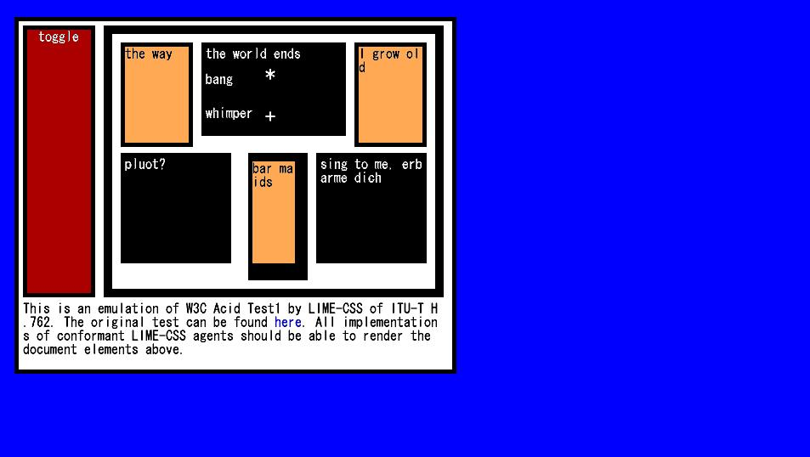

Figure I.1-1: Reference image, test sample 0 code snippet 1

Test sample 0 code snippet 2

|  |
| --- |
| <bml>  <head>  <title>Color Sample</title>  <style><![CDATA[  body {  background-color-index:7;  /* background-image:url(grid-bg.jpg);*/  }  p {width:50px;  height:50px;  border-style:solid;  border-width:1px;  border-top-color-index:30;  border-left-color-index:30;  border-bottom-color-index:30;  border-right-color-index:30;  font-size: 16px;}  #title {width:270px;height:30px;  border-style:none;  font-size: 32px;}  ]]>  </style>  </head>  <body>  <p id="title" style="top:20px;left:360px;">Sample of Common Colors</p>  <div style="left:80px;top:80px;width:800px;height:400px;">  <p id="0" style="background-color-index:0;left:0px;top:0px;" />  <p id="1" style="background-color-index:1;left:50px;top:0px;" />  <p id="2" style="background-color-index:2;left:100px;top:0px;" />  <p id="3" style="background-color-index:3;left:150px;top:0px;" />  <p id="4" style="background-color-index:4;left:200px;top:0px;" />  <p id="5" style="background-color-index:5;left:250px;top:0px;" />  <p id="6" style="background-color-index:6;left:300px;top:0px;" />  <p id="7" style="background-color-index:7;left:350px;top:0px;" />  <p id="8" style="background-color-index:8;left:400px;top:0px;" />  <p id="9" style="background-color-index:9;left:450px;top:0px;" />  <p id="10" style="background-color-index:10;left:500px;top:0px;" />  <p id="11" style="background-color-index:11;left:550px;top:0px;" />  <p id="12" style="background-color-index:12;left:600px;top:0px;" />  <p id="13" style="background-color-index:13;left:650px;top:0px;" />  <p id="14" style="background-color-index:14;left:700px;top:0px;" />  <p id="15" style="background-color-index:15;left:750px;top:0px;" />  <p id="16" style="background-color-index:16;left:0px;top:50px;" />  <p id="17" style="background-color-index:17;left:50px;top:50px;" />  <p id="18" style="background-color-index:18;left:100px;top:50px;" />  <p id="19" style="background-color-index:19;left:150px;top:50px;" />  <p id="20" style="background-color-index:20;left:200px;top:50px;" />  <p id="21" style="background-color-index:21;left:250px;top:50px;" />  <p id="22" style="background-color-index:22;left:300px;top:50px;" />  <p id="23" style="background-color-index:23;left:350px;top:50px;" />  <p id="24" style="background-color-index:24;left:400px;top:50px;" />  <p id="25" style="background-color-index:25;left:450px;top:50px;" />  <p id="26" style="background-color-index:26;left:500px;top:50px;" />  <p id="27" style="background-color-index:27;left:550px;top:50px;" />  <p id="28" style="background-color-index:28;left:600px;top:50px;" />  <p id="29" style="background-color-index:29;left:650px;top:50px;" />  <p id="30" style="background-color-index:30;left:700px;top:50px;" />  <p id="31" style="background-color-index:31;left:750px;top:50px;" />  <p id="32" style="background-color-index:32;left:0px;top:100px;" />  <p id="33" style="background-color-index:33;left:50px;top:100px;" />  <p id="34" style="background-color-index:34;left:100px;top:100px;" />  <p id="35" style="background-color-index:35;left:150px;top:100px;" />  <p id="36" style="background-color-index:36;left:200px;top:100px;" />  <p id="37" style="background-color-index:37;left:250px;top:100px;" />  <p id="38" style="background-color-index:38;left:300px;top:100px;" />  <p id="39" style="background-color-index:39;left:350px;top:100px;" />  <p id="40" style="background-color-index:40;left:400px;top:100px;" />  <p id="41" style="background-color-index:41;left:450px;top:100px;" />  <p id="42" style="background-color-index:42;left:500px;top:100px;" />  <p id="43" style="background-color-index:43;left:550px;top:100px;" />  <p id="44" style="background-color-index:44;left:600px;top:100px;" />  <p id="45" style="background-color-index:45;left:650px;top:100px;" />  <p id="46" style="background-color-index:46;left:700px;top:100px;" />  <p id="47" style="background-color-index:47;left:750px;top:100px;" />  <p id="48" style="background-color-index:48;left:0px;top:150px;" />  <p id="49" style="background-color-index:49;left:50px;top:150px;" />  <p id="50" style="background-color-index:50;left:100px;top:150px;" />  <p id="51" style="background-color-index:51;left:150px;top:150px;" />  <p id="52" style="background-color-index:52;left:200px;top:150px;" />  <p id="53" style="background-color-index:53;left:250px;top:150px;" />  <p id="54" style="background-color-index:54;left:300px;top:150px;" />  <p id="55" style="background-color-index:55;left:350px;top:150px;" />  <p id="56" style="background-color-index:56;left:400px;top:150px;" />  <p id="57" style="background-color-index:57;left:450px;top:150px;" />  <p id="58" style="background-color-index:58;left:500px;top:150px;" />  <p id="59" style="background-color-index:59;left:550px;top:150px;" />  <p id="60" style="background-color-index:60;left:600px;top:150px;" />  <p id="61" style="background-color-index:61;left:650px;top:150px;" />  <p id="62" style="background-color-index:62;left:700px;top:150px;" />  <p id="63" style="background-color-index:63;left:750px;top:150px;" />  <p id="64" style="background-color-index:64;left:0px;top:200px;" />  <p id="65" style="background-color-index:65;left:50px;top:200px;" />  <p id="66" style="background-color-index:66;left:100px;top:200px;" />  <p id="67" style="background-color-index:67;left:150px;top:200px;" />  <p id="68" style="background-color-index:68;left:200px;top:200px;" />  <p id="69" style="background-color-index:69;left:250px;top:200px;" />  <p id="70" style="background-color-index:70;left:300px;top:200px;" />  <p id="71" style="background-color-index:71;left:350px;top:200px;" />  <p id="72" style="background-color-index:72;left:400px;top:200px;" />  <p id="73" style="background-color-index:73;left:450px;top:200px;" />  <p id="74" style="background-color-index:74;left:500px;top:200px;" />  <p id="75" style="background-color-index:75;left:550px;top:200px;" />  <p id="76" style="background-color-index:76;left:600px;top:200px;" />  <p id="77" style="background-color-index:77;left:650px;top:200px;" />  <p id="78" style="background-color-index:78;left:700px;top:200px;" />  <p id="79" style="background-color-index:79;left:750px;top:200px;" />  <p id="80" style="background-color-index:80;left:0px;top:250px;" />  <p id="81" style="background-color-index:81;left:50px;top:250px;" />  <p id="82" style="background-color-index:82;left:100px;top:250px;" />  <p id="83" style="background-color-index:83;left:150px;top:250px;" />  <p id="84" style="background-color-index:84;left:200px;top:250px;" />  <p id="85" style="background-color-index:85;left:250px;top:250px;" />  <p id="86" style="background-color-index:86;left:300px;top:250px;" />  <p id="87" style="background-color-index:87;left:350px;top:250px;" />  <p id="88" style="background-color-index:88;left:400px;top:250px;" />  <p id="89" style="background-color-index:89;left:450px;top:250px;" />  <p id="90" style="background-color-index:90;left:500px;top:250px;" />  <p id="91" style="background-color-index:91;left:550px;top:250px;" />  <p id="92" style="background-color-index:92;left:600px;top:250px;" />  <p id="93" style="background-color-index:93;left:650px;top:250px;" />  <p id="94" style="background-color-index:94;left:700px;top:250px;" />  <p id="95" style="background-color-index:95;left:750px;top:250px;" />  <p id="96" style="background-color-index:96;left:0px;top:300px;" />  <p id="97" style="background-color-index:97;left:50px;top:300px;" />  <p id="98" style="background-color-index:98;left:100px;top:300px;" />  <p id="99" style="background-color-index:99;left:150px;top:300px;" />  <p id="100" style="background-color-index:100;left:200px;top:300px;" />  <p id="101" style="background-color-index:101;left:250px;top:300px;" />  <p id="102" style="background-color-index:102;left:300px;top:300px;" />  <p id="103" style="background-color-index:103;left:350px;top:300px;" />  <p id="104" style="background-color-index:104;left:400px;top:300px;" />  <p id="105" style="background-color-index:105;left:450px;top:300px;" />  <p id="106" style="background-color-index:106;left:500px;top:300px;" />  <p id="107" style="background-color-index:107;left:550px;top:300px;" />  <p id="108" style="background-color-index:108;left:600px;top:300px;" />  <p id="109" style="background-color-index:109;left:650px;top:300px;" />  <p id="110" style="background-color-index:110;left:700px;top:300px;" />  <p id="111" style="background-color-index:111;left:750px;top:300px;" />  <p id="112" style="background-color-index:112;left:0px;top:350px;" />  <p id="113" style="background-color-index:113;left:50px;top:350px;" />  <p id="114" style="background-color-index:114;left:100px;top:350px;" />  <p id="115" style="background-color-index:115;left:150px;top:350px;" />  <p id="116" style="background-color-index:116;left:200px;top:350px;" />  <p id="117" style="background-color-index:117;left:250px;top:350px;" />  <p id="118" style="background-color-index:118;left:300px;top:350px;" />  <p id="119" style="background-color-index:119;left:350px;top:350px;" />  <p id="120" style="background-color-index:120;left:400px;top:350px;" />  <p id="121" style="background-color-index:121;left:450px;top:350px;" />  <p id="122" style="background-color-index:122;left:500px;top:350px;" />  <p id="123" style="background-color-index:123;left:550px;top:350px;" />  <p id="124" style="background-color-index:124;left:600px;top:350px;" />  <p id="125" style="background-color-index:125;left:650px;top:350px;" />  <p id="126" style="background-color-index:126;left:700px;top:350px;" />  <p id="127" style="background-color-index:127;left:750px;top:350px;" />  </div>  </body>  </bml> |

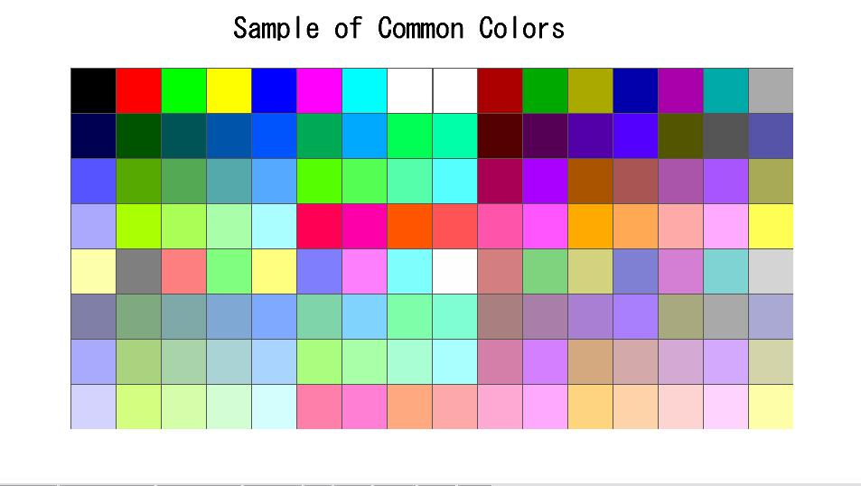

Figure I.1-2: Reference image, test sample 0 code snippet 2

II.2 Test Sample 1

Test sample 1 code snippet 1

|  |
| --- |
| <bml>  <head>  <style><![CDATA[  body {background-color-index: 0;}  input {  margin: 0;  border-width: 5px;  border-style: solid;  border-color-index: 2;  padding: 0;  text-align:left;  top:30px;  width: 160px;  height: 90px;  float: left;  background-color-index: 12;  color-index: 22;  font-size:16px;  }  a { top:330px;  width: 155px;  height: 90px;  background-color-index:1;  color-index:7;  }  span {background-color-index:3;  color-index:0;  font-size:20px;}  p {  left:50px; top:350px; width:80px; height:20px;  background-color-index:4;  font-size:16px;  }  p.textline {  font-size:20px;  font-weight:bold;  left:150px;width:200px;height:60px;  background-color-index:2;  }  #message {  left:50px;top:0px;font-size:16px;  font-weight:normal;  padding-top:2px;  padding-left:7px;  padding-right:6px;  padding-bottom:2px;  width:707px;height:54px;  }  #border {width:170px;height:360px;left:560px;top:65px;  color-index:1;  background-color-index:7;  grayscale-color-index:56 61;  border-width:20px;  border-style:solid;  border-top-color-index:10;  border-left-color-index:20;  border-right-color-index:30;  border-bottom-color-index:40;  }  #padding {  width:200px;height:105px;left:360px;top:352px;font-size:20px  padding-top:10px;  padding-left:20px;  padding-right:30px;  padding-bottom:40px;  background-color-index:60;  }  p.box {  border-width:10px;  background-color-index:9;  color-index:7;  width:175px;height:60px;left:360px;  }  ]]></style>  </head>  <body>  <div style="width:865px;height:500px;left:10px;top:10px;background-color-index:15">  <p class="long" style="width:90px;height:280px;left:50px;top:65px;">  </p>  <p id="message" class="textline">  This is a nonsensical document, but syntactically valid for <span> ITU-T H.762 (LIME)</span> CSS.  The user agents should be able to render the document elements in this paragraph.  Once you have finished evaluating this test, you can go to the <a href="sample.bml">this page</a>.  </p>  <div class="image" style="width:200px;height:200px;left:150px;top:65px;background-color-index:1">  <input max="100" value="input password"/></div>  <p id="padding" class="textline" style="width:150px;height:90px;top:352px;font-size:20px">  Lorem ipsum dolor sit amet, consectetaur <br/>adipisicing elit, sed do eiusmod tempor incididunt </p>  <p class="box" style="top:65px;border-style:solid;text-align:left;padding-top:2px;"><![CDATA[solid box  left-aligned]]></p>  <p class="box" style="top:150px;border-style:dashed;text-align:center;padding-top:10px;"><![CDATA[dashed box  center-aligned]]></p>  <p class="box" style="top:250px;border-style:dotted;text-align:right;padding-top:20px;"><![CDATA[dotted box  right-aligned]]></p>  <p class="textline" style="height:75px;top:270px;font-size:16px"><![CDATA[font size 16px text;  font-weight bold ]]></p>  <p class="textline" style="height:64px;top:350px;font-size:24px;"><![CDATA[font size 24px ]]></p>  <p class="textline" style="190px;height:60px;top:420px;font-size:30px;"><![CDATA[font size 30px]]></p>  <p id="border"><![CDATA[border sample]]></p>  <p>paragraph</p>  </div>  </body>  </bml> |

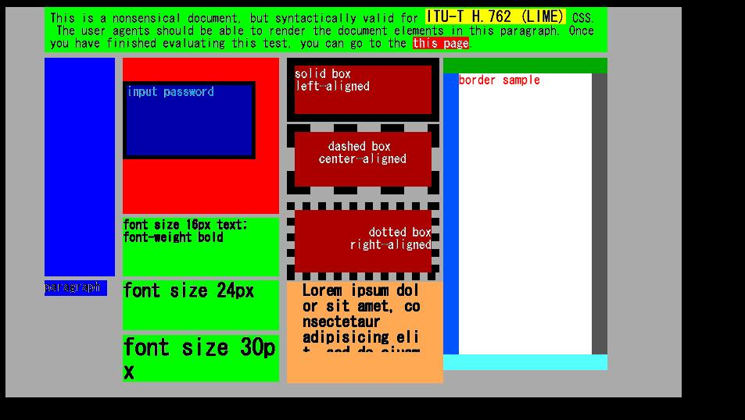

Figure I.2-1: Reference image, test sample 1 code snippet 1

Test sample 1 code snippet 2

|  |
| --- |
| <bml>  <head>  <title></title>  </head>  <body>  <p style="top:100px;left:100px;width:260px;height:72px;color-index:7;">Hello, <a href="world.html">world!!!</a></p>  </body>  </bml> |

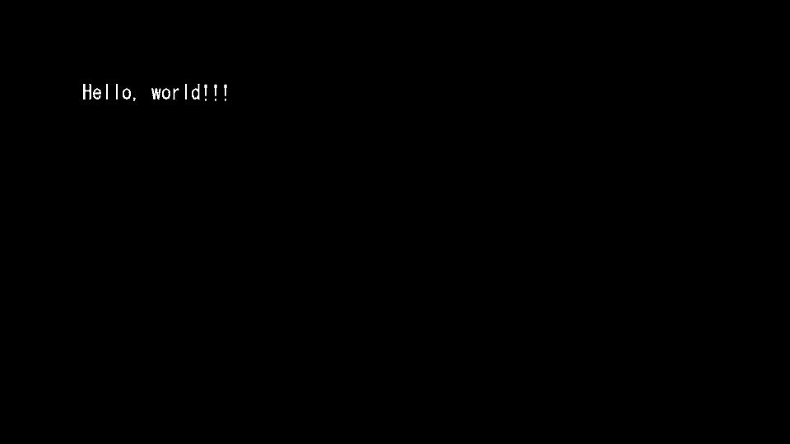

Figure I.2-2: Reference image, test sample 1 code snippet 2

Test sample 1 code snippet 3

|  |
| --- |
| <bml>  <head>  <title></title>  </head>  <body>  <p style="top:100px;left:100px;width:260px;height:72px;color-index:7;">Hello, <a href="world.html" style="color-index:4">world!!!</a></p>  </body>  </bml> |

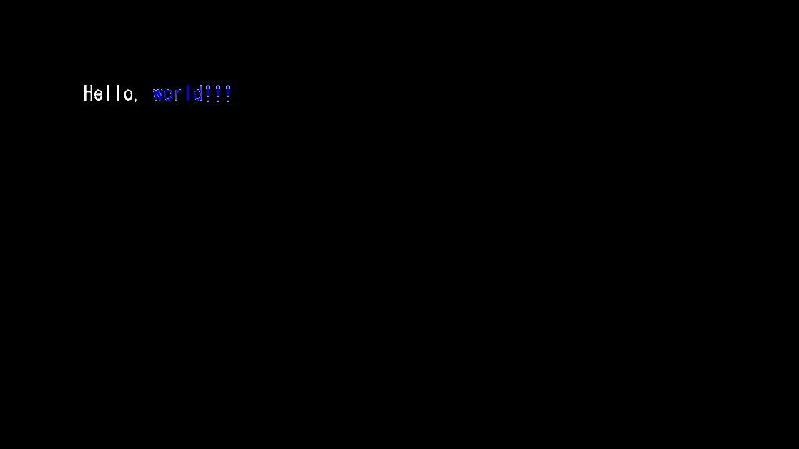

Figure I.2-3: Reference image, test sample 1 code snippet 3

Test sample 1 code snippet 4

|  |
| --- |
| <bml>  <head>  <title></title>  </head>  <body>  Hello, World!!! This should not be shown. Background color is black.  </body>  </bml> |



Figure I.2-4: Reference image, test sample 1 code snippet 4

Test sample 1 code snippet 5

|  |
| --- |
| <bml>  <head>  <title></title>  </head>  <body>  This should not be shown.  </body>  </bml> |



Figure I.2-5: Reference image, test sample 1 code snippet 5

Test sample 1 code snippet 6

|  |
| --- |
| <bml>  <head>  <title></title>  </head>  <body style="background-color-index:7;">  Hello, World!!! This should not be shown. The background color is white.  </body>  </bml> |



Figure I.2-6: Reference image, test sample 1 code snippet 6 (white background)

Test sample 1 code snippet 7

|  |
| --- |
| <bml>  <head>  <title></title>  </head>  <body>  <p style="top:100px;left:100px;width:560px;height:72px;color-index:7;">  Hello, world!!!<br/>This should appear in another line.  </p>  </body>  </bml> |

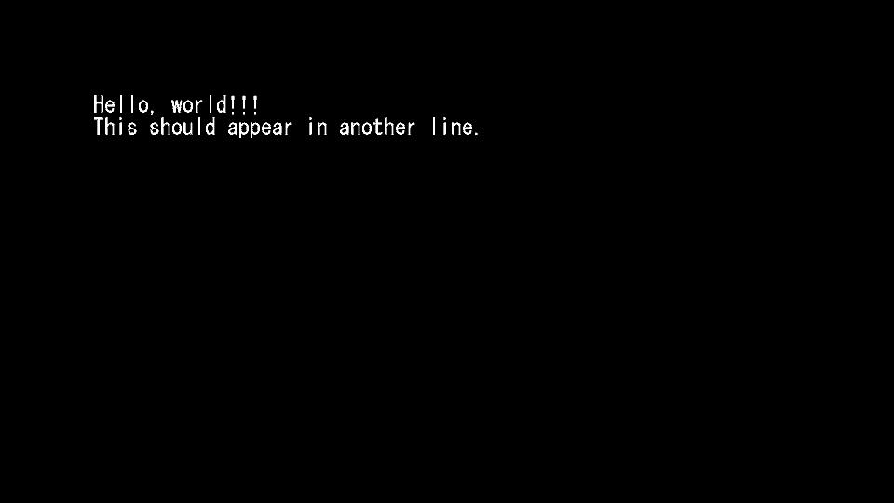

Figure I.2-7: Reference image, test sample 1 code snippet 7

Test sample 1 code snippet 8

|  |
| --- |
| <bml>  <head>  <title>DIV element test 0</title>  </head>  <body>  <div style="left:50px;top:50px;width:500px;height:100px;background-color-index:3;">  This is a div element. This should be in black.  </div>  </body>  </bml> |

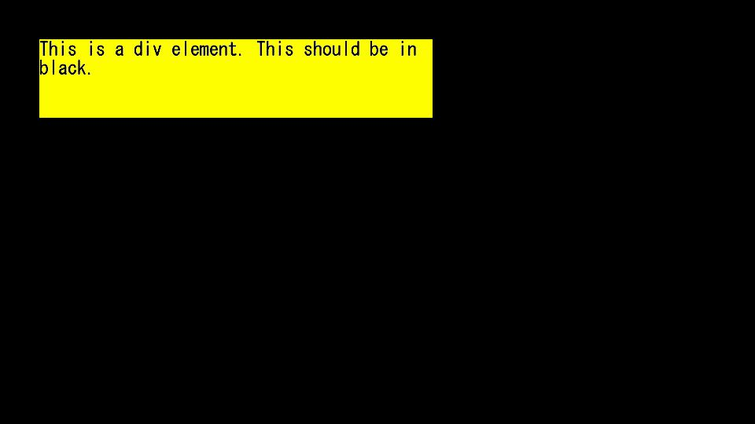

Figure I.2-8: Reference image, test sample 1 code snippet 8

Test sample 1 code snippet 9

|  |
| --- |
| <bml>  <head>  <title>DIV element test</title>  </head>  <body style="background-color-index:7;">  <div style="left:50px;top:50px;width:500px;height:200px;background-color-index:3;color-index:7;">  This is a div element. This should be in black.In div, color-index cannot be assigned.  <p style="left:25px;top:100px;width:450px;height:72px;text-align:center;color-index:4;background-color-index:2;">  but p element should be used. <br/>This should be in blue.</p>  </div>  </body>  </bml> |

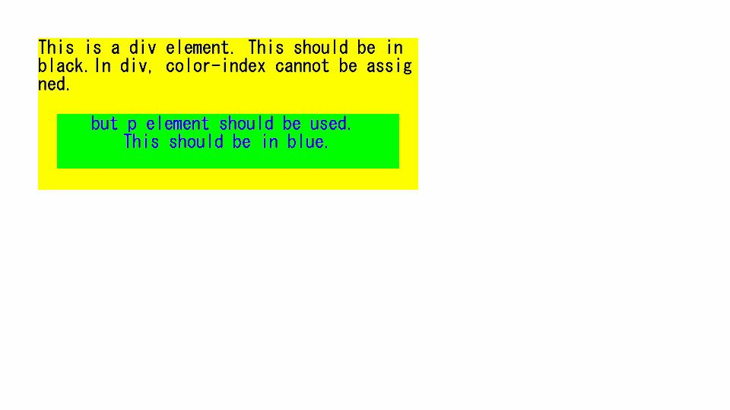

Figure I.2-9: Reference image, test sample 1 code snippet 9

Test sample 1 code snippet 10

|  |
| --- |
| <bml>  <head>  <title>Structural Elements</title>  </head>  <body>  This should not be shown.  </body>  </bml> |



Figure I.2-10: Reference image, test sample 1 code snippet 10

Test sample 1 code snippet 11

|  |
| --- |
| <bml>  <head>  <title></title>  <style><![CDATA[  p {width:60px;height:20px;}  input {top:30px;width:450px;height:25px;text-align:center;background-color-index:2;  border-style:solid;border-width:2px;}  :focus {background-color-index:3;}  :blur {background-color-index:0;}  ]]></style>  </head>  <body>  <div style="left:50px;top:50px;width:500px;height:100px;background-color-index:7;">  <p style="left:10px;top:0px;"></p>  <input value="This is input" maxlength="40" style="left:20px;nav-index:0;" />  </div>  </body>  </bml> |

|  |  |
| --- | --- |
| 1  **(a) Initial state** | 1  **(b) State after focusing** |

Figure I.2-11: Reference image, test sample 1 code snippet 11

Test sample 1 code snippet 12

|  |
| --- |
| <bml>  <head>  <title></title>  <style><![CDATA[  body {used-key-list:numeric-tuning}  input {top:30px;width:450px;height:25px;text-align:center;background-color-index:2;  border-style:solid;border-width:2px;}  :focus {background-color-index:3;}  :blur {background-color-index:0;}  ]]></style>  </head>  <body>  <div style="left:50px;top:50px;width:500px;height:100px;background-color-index:7;">  <input value="input value can be numbers" maxlength="40" style="left:20px;nav-index:0;"/>  </div>  </body>  </bml> |

|  |  |
| --- | --- |
| 1  **(a) Initial state** | 1  **(b) State after numeric entry** |

Figure I.2-12: Reference image, test sample 1 code snippet 12

Test sample 1 code snippet 13

|  |
| --- |
| <bml>  <head>  <title>Link to an external CSS</title>  <link href="a.css"/>  </head>  <body>  <p> This should appear in green.</p>  </body>  </bml> |

Contents of referred to **a.css** file:

|  |
| --- |
| body {background-color-index:7;}  p {top:30px;width:450px;height:25px;color-index:2;} |

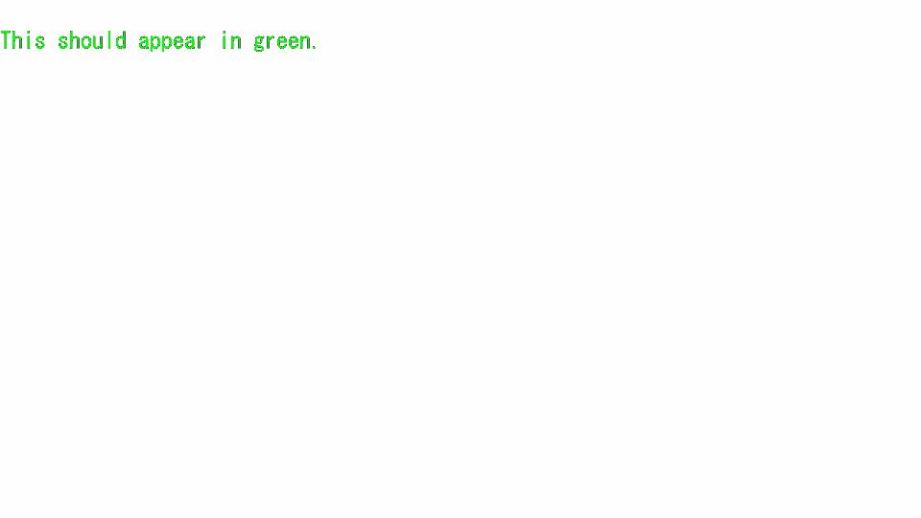

Figure I.2-13: Reference image, test sample 1 code snippet 13

Test sample 1 code snippet 14

|  |
| --- |
| <bml>  <head>  <title></title>  <style><![CDATA[  body {background-color-index:15;}  p {font-size:24px;width:260px;height:72px;}  ]]></style>  </head>  <body>  <p style="top:100px;left:100px;background-color-index:7;">Hello <br/>world</p>  <p style="left:100px;top:200px;background-color-index:2;"><![CDATA[Hello <br/>world ]]></p>  <p style="left:400px;top:300px;background-color-index:3;">  <![CDATA[  Hello  world  ]]></p>  </body>  </bml> |

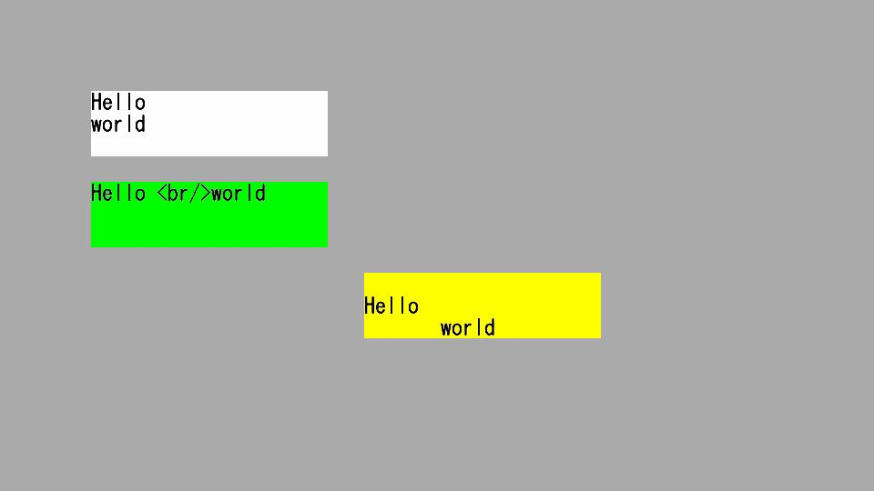

Figure I.2-14: Reference image, test sample 1 code snippet 14

Test sample 1 code snippet 15

|  |
| --- |
| <bml>  <head>  <title></title>  </head>  <body>  <p style="top:100px;left:100px;width:260px;height:72px;color-index:7;">Hello, world!!!</p>  </body>  </bml> |



Figure I.2-15: Reference image, test sample 1 code snippet 15

Test sample 1 code snippet 16

|  |
| --- |
| <bml>  <head>  <title></title>  </head>  <body>  <p style="top:100px;left:100px;width:560px;height:72px;color-index:7;">Hello, world!!!<span style="font-weight:bold">This should appear in bold.</span></p>  </body>  </bml> |

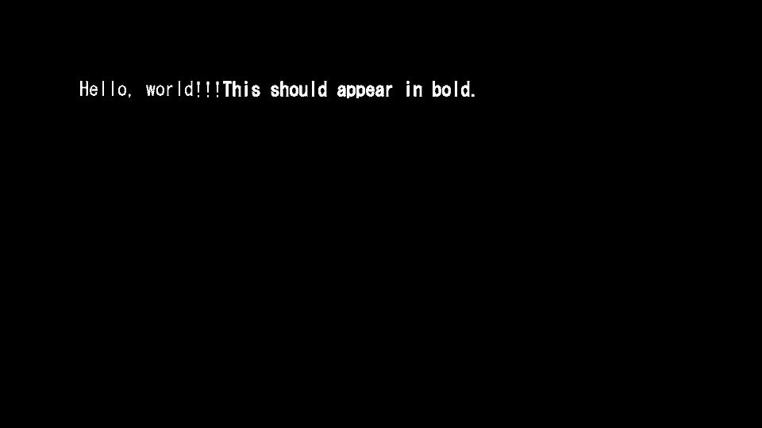

Figure I.2-16: Reference image, test sample 1 code snippet 16

Test sample 1 code snippet 17

|  |
| --- |
| <bml>  <head>  <title></title>  </head>  <body>  <p style="top:100px;left:100px;width:260px;height:72px;color-index:7;">Hello, <span>world!!!</span></p>  </body>  </bml> |



Figure I.2-17: Reference image, test sample 1 code snippet 17

Test sample 1 code snippet 18

|  |
| --- |
| <bml>  <head>  <title>Access Key Test </title>  <style><![CDATA[  .button {top:50px;height:24px;width:80px;text-align:center;  border-style:solid;border-width:2px;}  :focus {color-index:7;}  :blur {color-index:0}  #display {text-align:center;background-color-index:15;color-index:0;  width:270px;height:100px;}  ]]></style>  <script><![CDATA[  function getAccessKey( ){  document.getElementById("display").firstChild.data= document.currentEvent.target.id;  }]]></script>  </head>  <body style="background-color-index:7;">  <p id="status">Push color button</p>  <p id="blue" class="button" style="left:110px; background-color-index:4;"  onfocus="getAccessKey( );" accesskey="B">Blue</p>  <p id="red" class="button" style="left:210px;background-color-index:1;"  onfocus="getAccessKey( );" accesskey="R">Red</p>  <p id="green" class="button" style="left:310px;background-color-index:2;"  onclick="getAccessKey( );" accesskey="G">Green</p>  <p id="yellow" class="button" style="left:410px;background-color-index:3;"  onclick="getAccessKey( );" accesskey="Y">Yellow</p>    <p id="display" style="top:100px;left:150px"><![CDATA[]]></p>  </body>  </bml> |

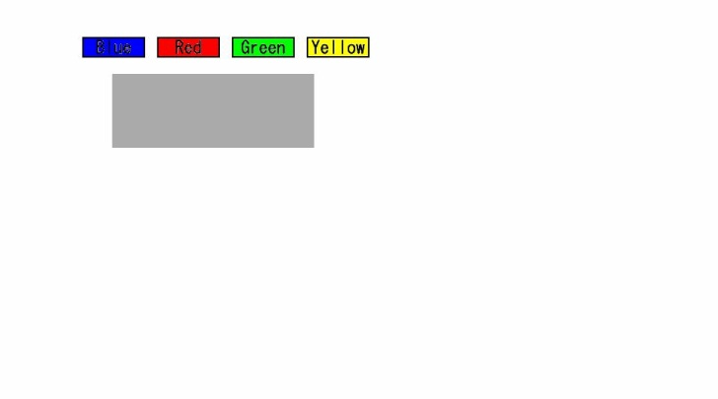 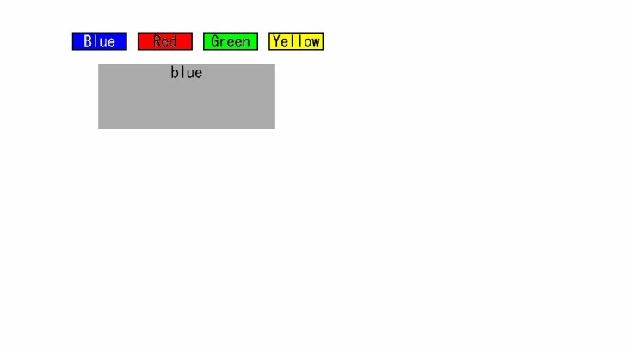

**(a) Initial state (b) State after "Blue" selected**

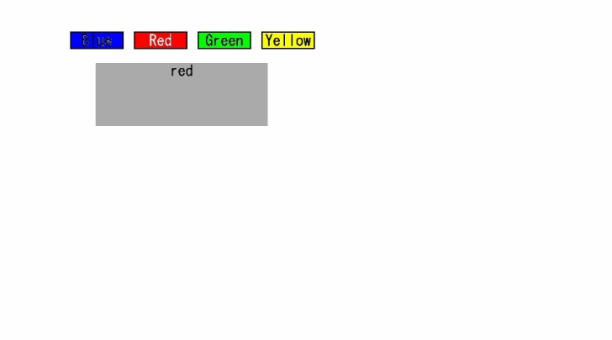 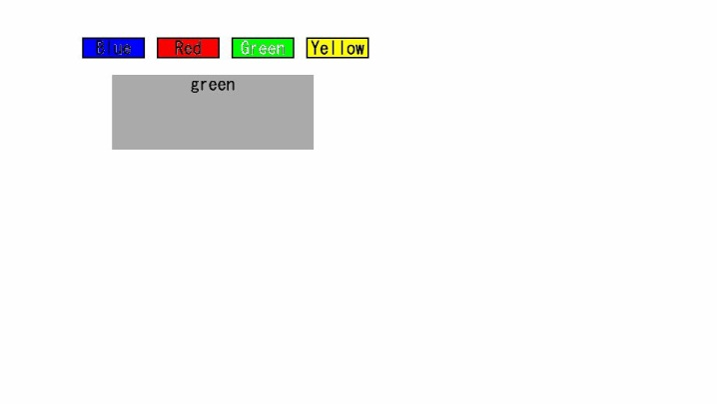

**(c) State after "Red" selected (d) State after "Green" selected**

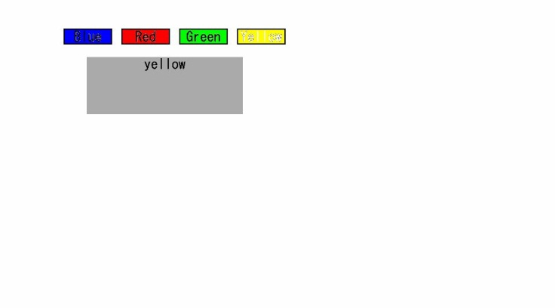

**(e) State after "Yellow" selected**

Figure I.2-18: Reference image, test sample 1 code snippet 18

Test sample 1 code snippet 19

|  |
| --- |
| <bml>  <head>  <title>Object element test 1:JPEG</title>  <style><![CDATA[  ]]></style>  <script><![CDATA[  document.getElementById("graphics").data="ITU-Logo.JPG";  ]]></script>  </head>  <body style="background-color-index:3;">  <div style="left:50px;top:50px;width:800px;height:400px;background-color-index:7">  <object id="graphics" data="" type="image/jpeg" style="width:189px;height:77px;left:20px;top:10px;"/>  </div>  </body>  </bml> |



Figure I.2-19: Reference image, test sample 1 code snippet 19

Test sample 1 code snippet 20

|  |
| --- |
| <bml>  <head>  <title>DOM test 1:P element</title>  <style><![CDATA[  p {font-size:24px;top:200px;left:10px;width:960px;height:72px;}  ]]></style>  <script><![CDATA[  document.getElementById("paragraph").firstChild.data="Accessing the first child node of 'p' element\n by its ID through LIME-DOM interface";  ]]></script>  </head>  <body style="background-color-index:7">  <p id="paragraph"> <![CDATA[ This text should not be shown. ]]></p>  </body>  </bml> |

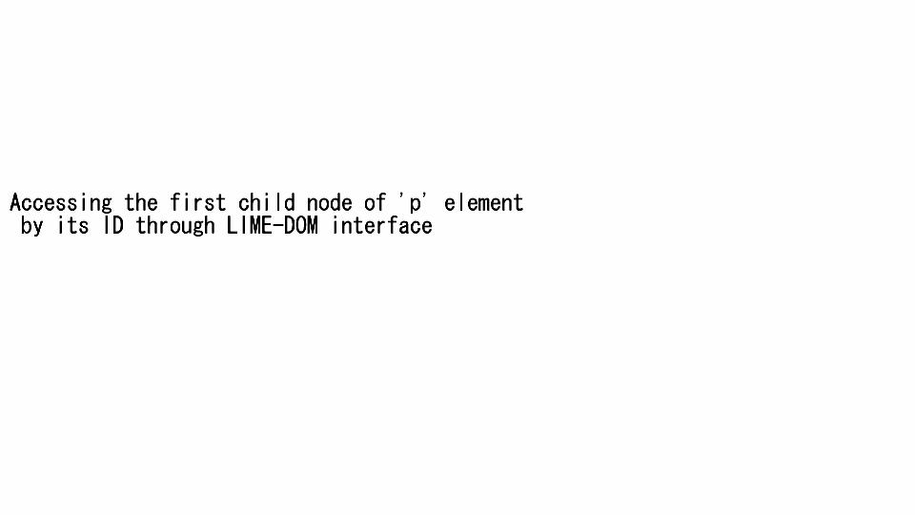

Figure I.2-20: Reference image, test sample 1 code snippet 20

Test sample 1 code snippet 21

|  |
| --- |
| <bml>  <head>  <title>DOM test 1:JPEG</title>  </head>  <body style="background-color-index:7">  <div style="left:0px;top:0px;width:960px;height:500px">  <object data="lime-large.JPG" type="image/jpeg" style="width:369px;height:252px;left:300px;top:150px;"/>  <object data="ITU-Logo.JPG" type="image/jpeg" style="width:189px;height:77px;left:20px;top:10px;"/>  </div>  </body>  </bml> |

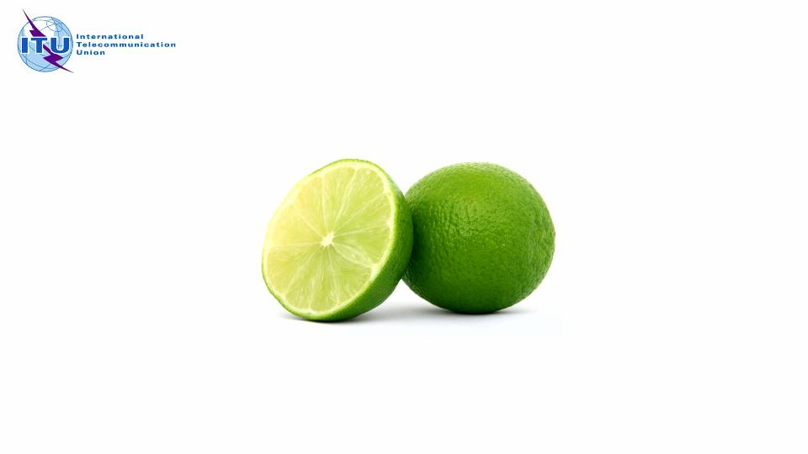

Figure I.2-21: Reference image, test sample 1 code snippet 21

Test sample 1 code snippet 22

|  |
| --- |
| <bml>  <head>  <title>Media Test 0: (VOD)</title>  <style><![CDATA[  body {  background-color-index:7;  resolution:960x540;  display-aspect-ratio:16v9;  }  p.title {  font-size:20px;  color-index:15;  grayscale-color-index:171 167;  text-align:center;  }  .button  {  width:240px;  height:271px;  }  #buttons  {  left:0px;  top:0px;  width:960px;  height:540px;  }  ]]></style>  </head>  <body id="body">  <div id="basePane" style="top:0px;width:960px;height:540px;visibility:visible;">  <div style="left:100px;top:18px;width:760px;height:20px;">  <p id="txt_title" class="title" style="width:760px;height:20px;color-index:0;"><![CDATA[Multimedia (Video) test 0]]></p>  </div>  <div style="top:100px;left:54px;width:720px;height:405px">  <object id="vod" type="application/X-arib-contentPlayControl" data="http://oki.iptvf.jp:12345/pgw/resolvecontent?contract_id=0000000000&cid=01fhcx0001&drmid=0000000000000aaa&purchase_id=0000000000&promo=on&crypt=no"  streamstatus="play" style="top:0px;left:0px;width:720px;height:405px;visibility:visible;" />  </div>  </div>  <div style="left:10px;top:0px; width:960px; height:540px">  <object data="ITU-Logo.JPG" type="image/jpeg" style="width:189px;height:77px;left:0px;top:10px;"/>  <object data="small-lime.JPG" type="image/jpeg" style="width:189px;height:77px;left:100px;top:360px;"/>  </div>  <div id="buttons">  <object id="tv_left_bu" class="button"  style="left:29px;top:248px;width:252px;height:103px;"  type="image/X-arib-png"  data="arrow_up.png"  />  <object id="bd" class="button"  style="left:29px;top:298px;width:252px;height:103px;"  type="image/X-arib-png"  data="arrow_down.png"  />  <object id="br" class="button"  style="left:85px;top:248px;width:252px;height:103px;"  type="image/X-arib-png"  data="arrow_right.png"  />  </div>  <div style="left:50px;top:280px;width:760px;height:20px;">  <p id="" class="title" style="width:760px;height:120px;color-index:7;"><![CDATA[This text in white should appear on the video]]></p>  </div>  </body>  </bml> |

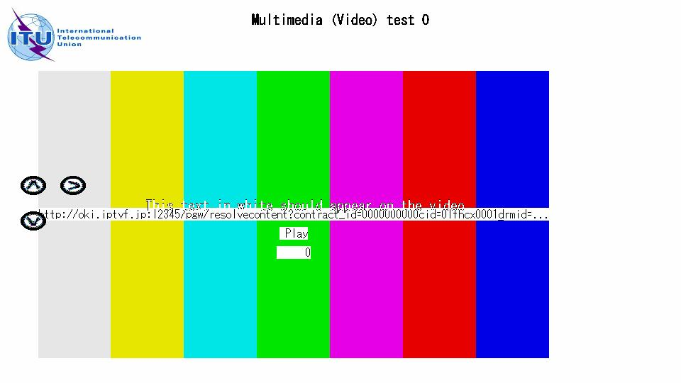

Figure I.2-22: Reference image, test sample 1 code snippet 22

Test sample 1 code snippet 23

|  |
| --- |
| <bml>  <head>  <title>Media Test 1: full-display (VOD)</title>  <style><![CDATA[  body {  background-color-index:7;  resolution:960x540;  display-aspect-ratio:16v9;  }  p.title {  font-size:20px;  color-index:15;  grayscale-color-index:171 167;  text-align:center;  }  .button  {  width:240px;  height:271px;  }  #buttons  {  left:0px;  top:0px;  width:960px;  height:540px;  }  ]]></style>  </head>  <body id="body">  <div id="basePane" style="top:0px;width:960px;height:540px;visibility:visible;">  <div style="left:100px;top:18px;width:760px;height:20px;">  <p id="txt_title"  class="title"  style="width:760px;height:20px;color-index:0;">  <![CDATA[Multimedia (Video) test 1 -Full Display]]>  </p>  </div>  <div style="top:0px;left:0px;width:960px;height:540px">  <object id="vod" type="application/X-arib-contentPlayControl" data="http://oki.iptvf.jp:12345/pgw/resolvecontent?contract_id=0000000000&cid=01fhcx0001&drmid=0000000000000aaa&purchase_id=0000000000&promo=on&crypt=no" streamstatus="play" style="top:0px;left:0px;width:960px;height:540px;visibility:visible;" />  </div>  </div>  <div style="left:10px;top:0px; width:960px; height:540px">  <object data="ITU-Logo.JPG" type="image/jpeg" style="width:189px;height:77px;left:0px;top:10px;"/>  <object data="small-lime.JPG" type="image/jpeg" style="width:70px;height:74px;left:100px;top:360px;"/>  </div>  <div id="buttons">  <object id="tv_left_bu" class="button"  style="left:29px;top:248px;width:36px;height:27px;"  type="image/X-arib-png"  data="arrow_up.png"  />  <object id="bd" class="button"  style="left:29px;top:298px;width:36px;height:27px;"  type="image/X-arib-png"  data="arrow_down.png"  />  <object id="br" class="button"  style="left:85px;top:248px;width:252px;height:103px;"  type="image/X-arib-png"  data="arrow_right.png"  />  </div>  <div style="left:50px;top:180px;width:760px;height:20px;">  <p id="" class="title"  style="width:760px;height:120px;color-index:7;">  <![CDATA[Video test: Full Display. This text in white should appear on the video]]>  </p>  </div>  </body>  </bml> |

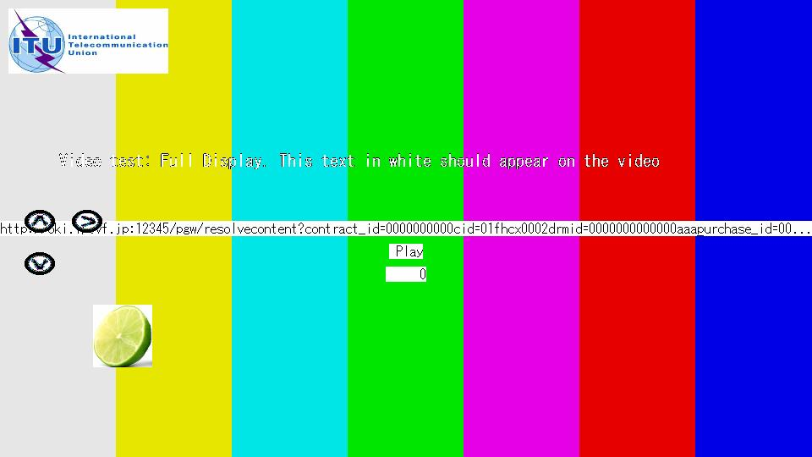

Figure I.2-23: Reference image, test sample 1 code snippet 23

Test sample 1 code snippet 24

|  |
| --- |
| <bml>  <head>  <title></title>  <style><![CDATA[  p {top:150px;  width:70px;  height:25px;  color-index:7;  text-align:center  }  p:focus {color-index:0;}  ]]></style>  </head>  <body>  <p style="left: 50px;background-color-index:4;" accesskey="B">BLUE</p>  <p style="left:150px;background-color-index:1;" accesskey="R">RED</p>  <p style="left:250px;background-color-index:2;" accesskey="G">GREEN</p>  <p style="left:350px;background-color-index:3;" accesskey="Y">YELLOW</p>  </body>  </bml> |

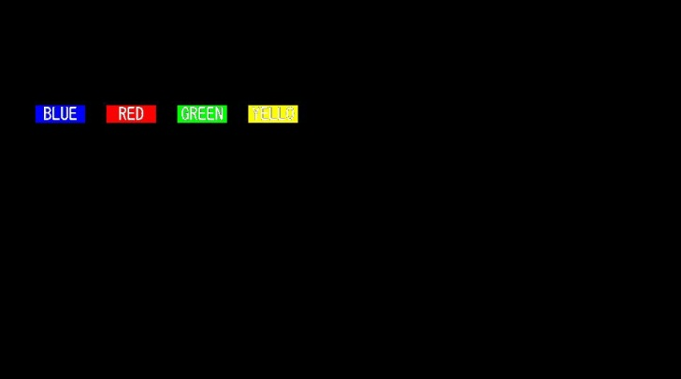 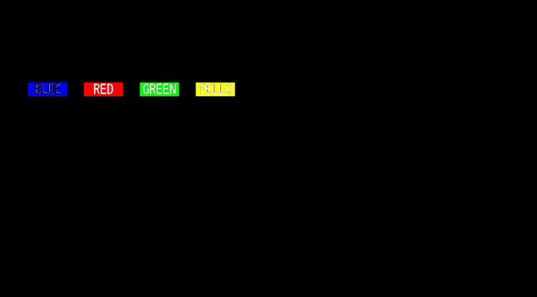

(a) Initial state (b) State after "BLUE" selected

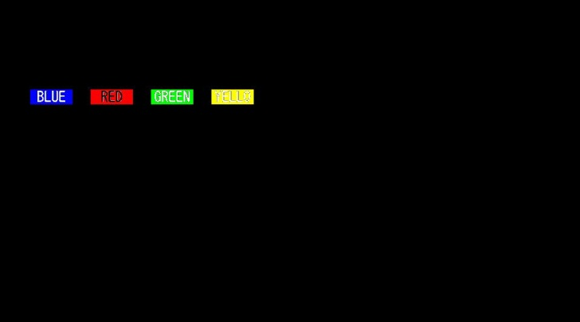 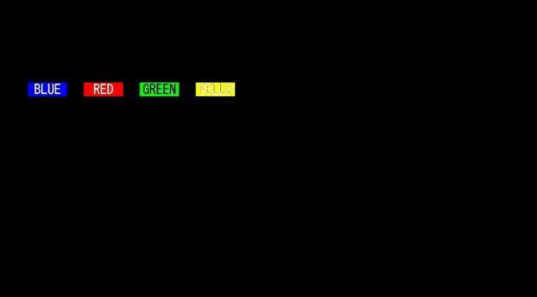

(c) State after "RED" selected (d) State after "GREEN" selected

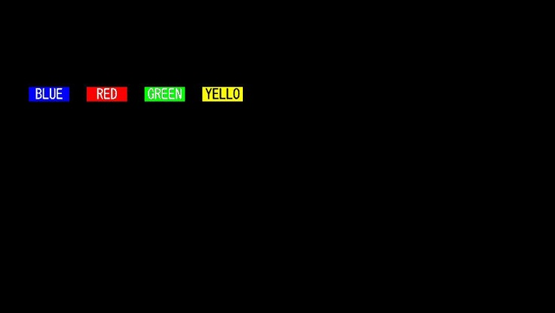

(e) State after "YELLOW" selected

Figure I.2-24: Reference image, test sample 1 code snippet 24

Test sample 1 code snippet 25

|  |
| --- |
| <bml>  <head>  <title></title>  <style><![CDATA[  p {width:100px;height:100px;text-align:center;background-color-index:2;}  p:focus {background-color-index:3;}  ]]></style>  <script><![CDATA[  function func( ){}  ]]></script>  </head>  <body>  <p style="left:300px;top:200px;nav-index:0;nav-up:1;nav-down:3;nav-right:2;nav-left:4;"><![CDATA[ Center]]></p>  <p style="left:300px;top:50px;nav-index:1;nav-up:1;nav-down:0;nav-right:2;nav-left:4;"><![CDATA[ Top ]]></p>  <p style="left:450px;top:200px;nav-index:2;nav-up:1;nav-down:3;nav-right:2;nav-left:0;"><![CDATA[ Right]]></p>  <p style="left:300px;top:350px;nav-index:3;nav-up:0;nav-down:3;nav-right:2;nav-left:4;"><![CDATA[ Bottom]]></p>  <p style="left:150px;top:200px;nav-index:4;nav-up:1;nav-down:3;nav-right:0;nav-left:4;"><![CDATA[ Left]]></p>  </body>  </bml> |

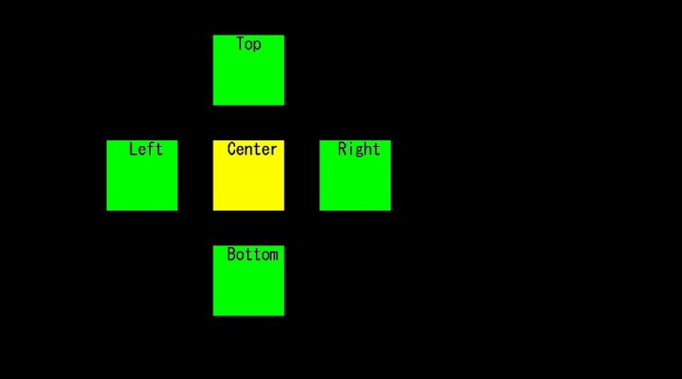 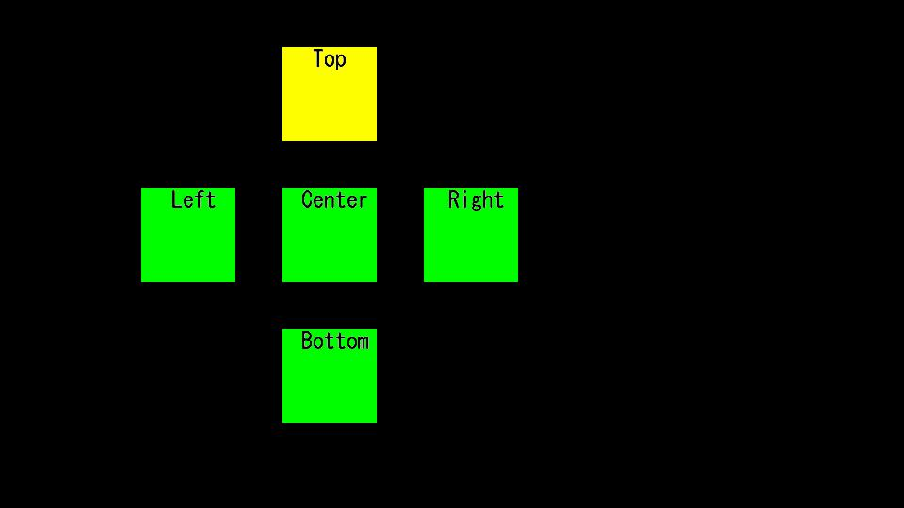

**(a) Initial state (b) State after *Up* key selected**

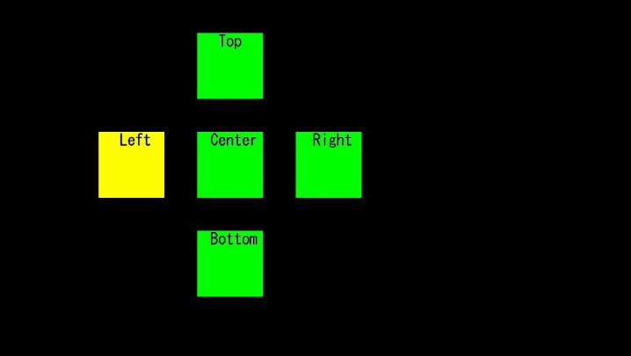 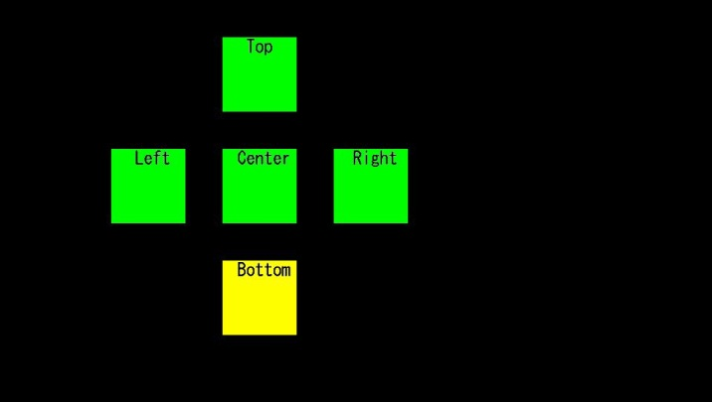

**(c) State after *Left* key selected (d) State after *Down* key selected**

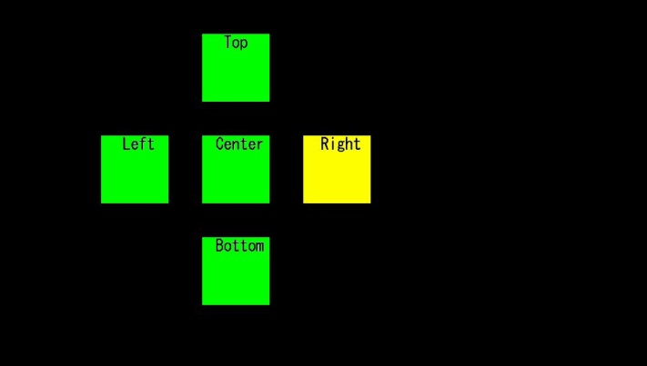

**(e) State after *Right* key selected**

Figure I.2-25: Reference image, test sample 1 code snippet 25

Test sample 1 code snippet 26

|  |
| --- |
| <bml>  <head>  <title></title>  <style><![CDATA[  p {text-align:center;}  a {font-weight:bold;}  a:focus {background-color-index:3;}  a:blur {background-color-index:7;}  a:active{color-index:1;}  ]]></style>  </head>  <body>  <p style="left:250px;top:100px;width:350px;height:270px;background-color-index:7;"><br/>  This is  <a style="left:300px;top:200px;nav-index:0;nav-up:0;nav-down:1;"><![CDATA[Link 1]]></a> of 5.<br/><br/>  This is  <a style="left:300px;top:250px;nav-index:1;nav-up:0;nav-down:2;"><![CDATA[Link 2]]></a> of 5.<br/><br/>  This is  <a style="left:300px;top:300px;nav-index:2;nav-up:1;nav-down:3;"><![CDATA[Link 3]]></a> of 5.<br/><br/>  This is  <a style="left:300px;top:350px;nav-index:3;nav-up:2;nav-down:4;"><![CDATA[Link 4]]></a> of 5.<br/><br/>  This is  <a style="left:300px;top:400px;nav-index:4;nav-up:3;nav-down:4;"><![CDATA[Link 5]]></a> of 5.<br/><br/>  </p>  </body>  </bml> |

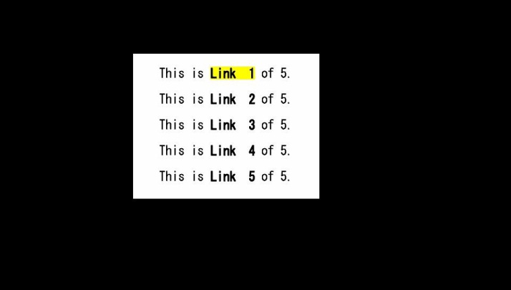 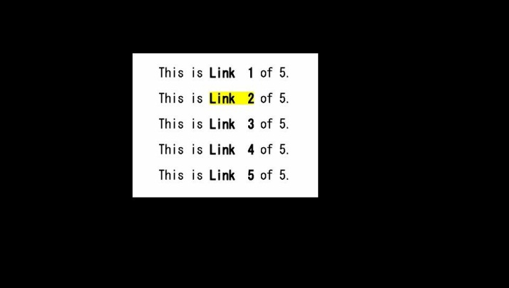

**(a) Initial state (b) State after *Down* key pressed once**

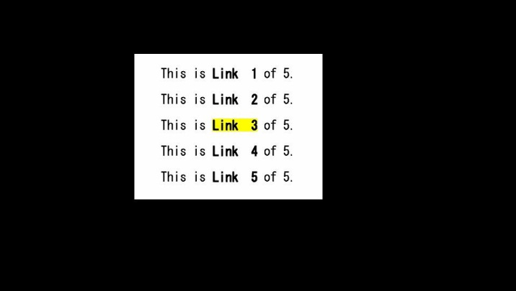 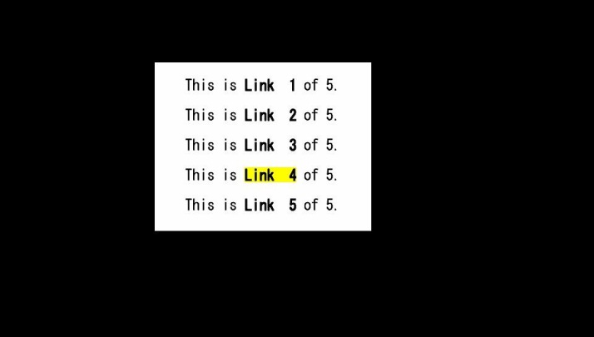

**(c) State after *Down* key pressed twice (d) State after *Down* key pressed thrice**

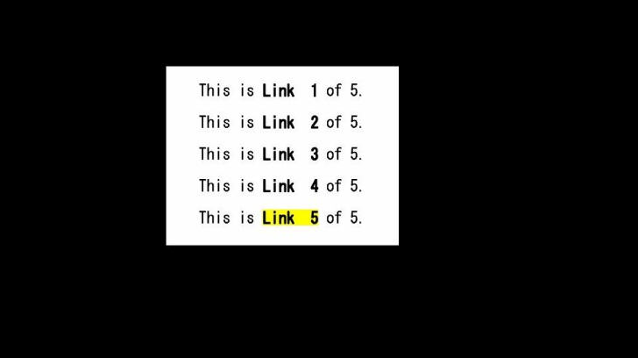

**(e) State after *Down* key pressed four times**

Figure I.2-26: Reference image, test sample 1 code snippet 26

Test sample 1 code snippet 27

|  |
| --- |
| <bml>  <head>  <title>Object element test 0</title>  </head>  <body>  <div style="left:0px;top:0px;width:960px;height:540px">  <object style="left:50px;top:50px;width:500px;height:100px;background-color-index:3;">  This is an object element. This should not be shown.  </object>  </div>  </body>  </bml> |



Figure I.2-27: Reference image, test sample 1 code snippet 27

Test sample 1 code snippet 28

|  |
| --- |
| <bml>  <head>  <title>Object element test 1:JPEG</title>  </head>  <body style="background-color-index:7">  <div style="left:0px;top:0px;width:960px;height:500px">  <object data="lime-large.JPG" type="image/jpeg" style="width:369px;height:252px;left:300px;top:150px;"/>  <object data="ITU-Logo.JPG" type="image/jpeg" style="width:189px;height:77px;left:20px;top:10px;"/>  </div>  </body>  </bml> |



Figure I.2-28: Reference image, test sample 1 code snippet 28

Test sample 1 code snippet 29

|  |
| --- |
| <bml>  <head>  <title>Object element test 2:PNG</title>  <style><![CDATA[  body{  clut:url(default.clt);  background-color-index:7;  }  ]]></style>  </head>  <body>  <div style="left:0px; top:0px; width:960px; height:540px">  <object type="image/X-arib-png" data="small-lime.png" style="left:500px;top:0;width:139px;height:147px;"/>  <object type="image/X-arib-png" data="ITU-Logo_small.png" style="left:29px;top:28px;width:252px;height:103px;"/>  </div>  </body>  </bml> |

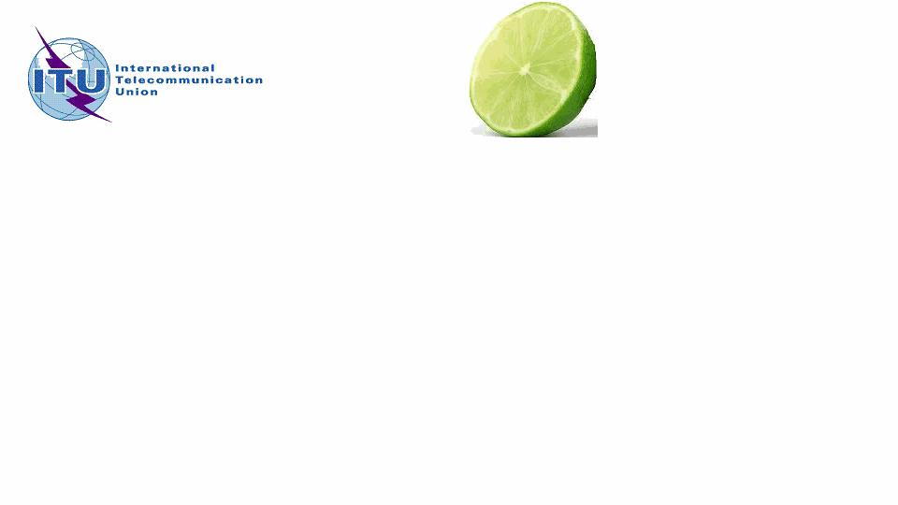

Figure I.2-29: Reference image, test sample 1 code snippet 29

Test sample 1 code snippet 30

|  |
| --- |
| <bml>  <head>  <title>browser Pseudo Object Test: show version active document, and refresh</title>  <style><![CDATA[  body {background-color-index:7;}  .button {width:340px;height:32px;}  p:focus {background-color-index:2;}  p.button {text-align:left;color-index:0;line-height:30px;font-size:20px;}  #display { font-size:20px;background-color-index:16;color-index:7;  top:30px;left:30px;width:780px;height:400px;}  ]]></style>  <script><![CDATA[  function main(){  printlnd("browser version is: "+browser.getBrowserVersion());  printlnd("active document is: "+browser.getActiveDocument());  }  function refresh(){  browser.reloadActiveDocument();  }  function printlnd(str){  var obj = document.getElementById("display");  obj.firstChild.data += str + "\r\n";  }  ]]></script>  </head>  <body onload="main();">  <p id="p01" class="button" style="top:10px;left:0px:color-index:0;" onclick="refresh();" accesskey="R">Push Red button to refresh</p>  <p id="display" style="top:150;left:50"><![CDATA[]]></p>  </body>  </bml> |

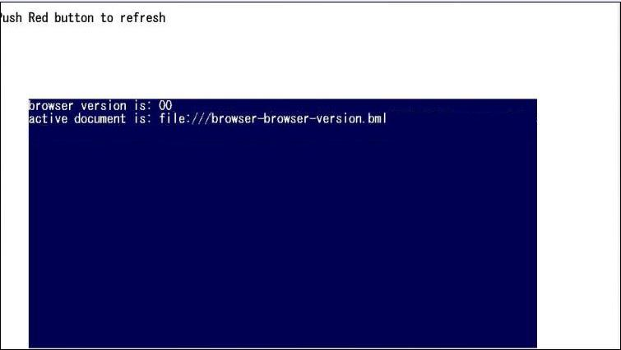

Figure I.2-30: Reference image, test sample 1 code snippet 30

Test sample 1 code snippet 31

|  |
| --- |
| <bml>  <head>  <title>browser Pseudo Object Test: subDate() and addDate()</title>  <style><![CDATA[  body {background-color-index:7;}  .button {width:340px;height:32px;}  p:focus {background-color-index:2;}  p.button {text-align:left;color-index:0;line-height:30px;font-size:20px;}  #display { font-size:20px;background-color-index:16;color-index:7;  top:30px;left:30px;width:780px;height:400px;}  ]]></style>  <script><![CDATA[  function main(){  var today= new Date();  var yend= new Date(today.getFullYear(),11,31);  printlnd("\tCurrent UTC time is: "+today);  printlnd("\tDays left till the end of this year: "+ browser.subDate(yend,today,4));  printlnd("\tThe time one week later is: "+ browser.addDate(today,7,4));  }  function refresh(){  browser.reloadActiveDocument();  }  function printlnd(str){  var obj = document.getElementById("display");  obj.firstChild.data += str + "\r\n";  }  ]]></script>  </head>  <body onload="main();">  <p id="p01" class="button" style="top:10;left:0:color-index:0;" onclick="refresh();" accesskey="R">Push Red button to refresh</p>  <p id="display" style="top:150;left:50"><![CDATA[]]></p>  </body>  </bml> |

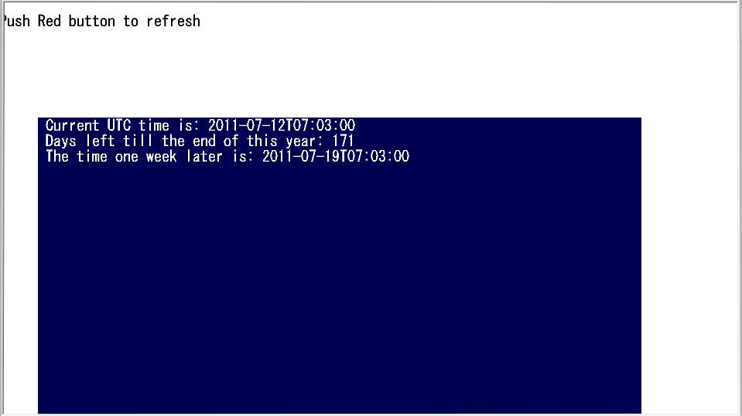

Figure I.2-31: Reference image, test sample 1 code snippet 31

Test sample 1 code snippet 32

|  |
| --- |
| <bml>  <head>  <title>Browser Object test -- browser.formatNumber() </title>  <style><![CDATA[  body {  background-color-index:0;  resolution:960x540;  display-aspect-ratio:16v9;  }  #title { font-size:20px;background-color-index:0;color-index:7;top:10px;left:100px;width:800px;height:180px;text-align:left;}  #display { font-size:20px;background-color-index:16;color-index:7;top:150px;left:100px;width:600px;height:180px;}  ]]>  </style>  <script><![CDATA[  function pushedButton(){  var no= browser.random(5000000);  var obj = document.getElementById("display");  obj.firstChild.data += browser.formatNumber(no)+" " ;  }  ]]>  </script>  </head>  <body>  <!--  formatNumber()  Formats a numeric value by inserting "," every three digits and returns the result as a character string.  Syntax  String formatNumber( input Number value )  Argument  value Numeric value to be formatted and converted into a character string  Return values  Formatted character string : Success  null : Failure  Description  This function formats a numeric value by inserting "," every three digits and returns the result as a character string. For example, it is used to format monetary values. If value is an invalid value, it is treated as '0' (zero).  -->  <p id="title" style=""><![CDATA[formatNumber() Test: displays a random number over 1000,  each time Red button is pushed.  The number is formated by inserting "," every three digits  Please push Red button]]></p>  <p class="button" id="red" style="left:90px;top:460px;height:22px;width:27px" onclick="pushedButton();" accesskey="R"/>  <p id="display" style=""><![CDATA[]]></p>  </body>  </bml> |

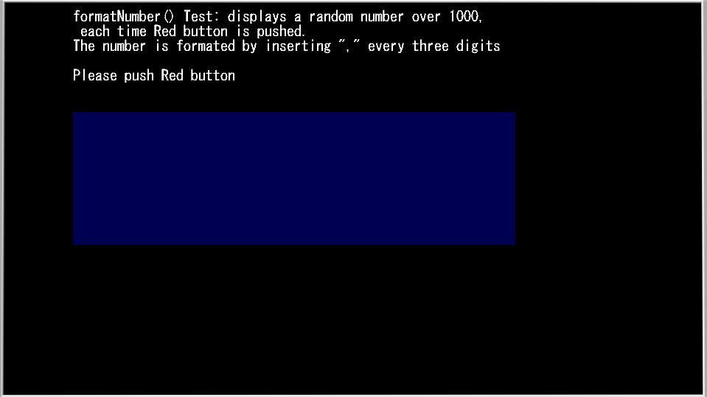

Figure I.2-32: Reference image, test sample 1 code snippet 32

Test sample 1 code snippet 33

|  |
| --- |
| <bml>  <head>  <title>browser Pseudo-Object-Test:launchDocument</title>  <style>  <![CDATA[  p {height:16px;color-index:2;grayscale-color-index:15 15}  p:focus{background-color-index:7}  ]]>  </style>  <script ><![CDATA[    function jump(){  browser.launchDocument("remotefile.bml", "cut");  }  ]]></script>  </head>  <body>    <p style="top:152px;left:221px;width:200px;height:28px;nav-index:0;nav-down:1" onclick="jump();">Hit 'Enter'</p>    </body>  </bml>  The file "remotefile.bml" referenced in the above sample is shown below.  <bml>  <head>  <title>Hello World Sample: Remote</title>  <style><![CDATA[  p {left:200px;top:420px;  width:320px;height:20px;  background-color-index:2;  }  ]]></style>  <script><![CDATA[ ]]>  </script>  </head>  <body style="background-color-index:7";>  <p id="text">This is from a remote file</p>  </body>  </bml><bml>  <head>  <title>Object element test 2:PNG</title>  <style><![CDATA[  body{  clut:url(default.clt);  background-color-index:7;  }  ]]></style>  </head>  <body>  <div style="left:0px; top:0px; width:960px; height:540px">  <object type="image/X-arib-png" data="small-lime.png" style="left:500px;top:0;width:139px;height:147px;"/>  <object type="image/X-arib-png" data="ITU-Logo_small.png" style="left:29px;top:28px;width:252px;height:103px;"/>  </div>  </body>  </bml> |

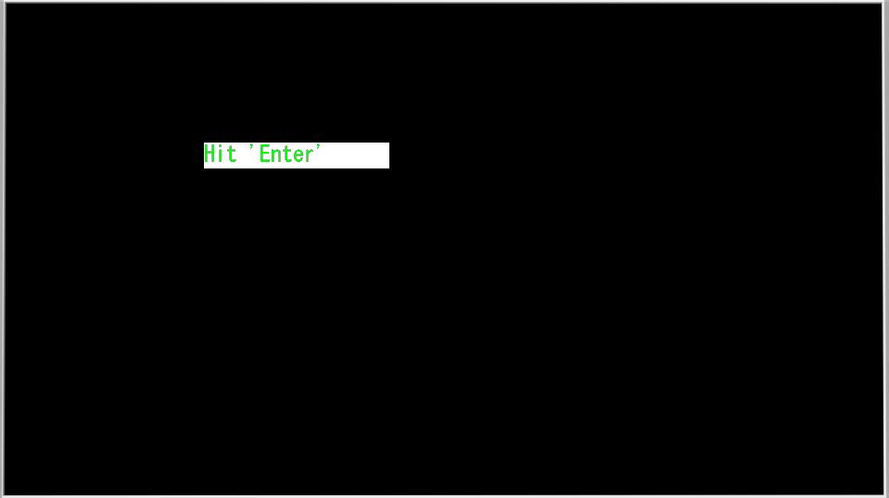

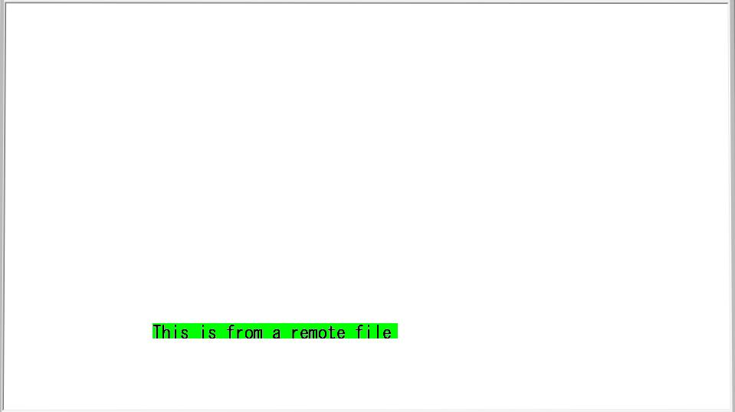

Figure I.2-33: Reference image, test sample 1 code snippet 33

Test sample 1 code snippet 34

|  |
| --- |
| <bml>  <head>  <title>browser Pseudo-Object-Test:launchDocument</title>  <style>  <![CDATA[  p {height:16px;color-index:2;grayscale-color-index:15 15}  p:focus{background-color-index:7}    ]]>  </style>  <script ><![CDATA[    function jump(){  browser.launchDocument("localfile.bml", "cut");  }  ]]></script>  </head>  <body>    <p style="top:152px;left:221px;width:200px;height:28px;nav-index:0;nav-down:1" onclick="jump();">Hit 'Enter'</p>    </body>  </bml>  The file "localfile.bml" referenced in the above sample is shown below.  <bml>  <head>  <title>Hello World Sample</title>  <style><![CDATA[  p {left:200px;top:420px;  width:300px;height:20px;  background-color-index:2;  }  ]]></style>  <script><![CDATA[ ]]>  </script>  </head>  <body style="background-color-index:7";>  <p id="text">This is from a local file</p>  </body>  </bml> |

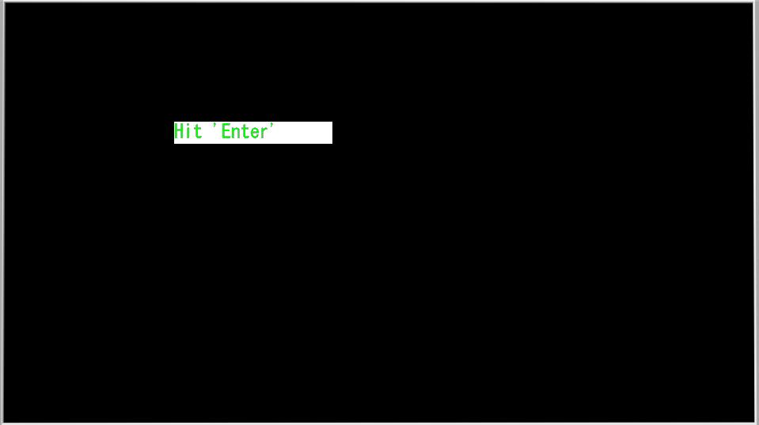

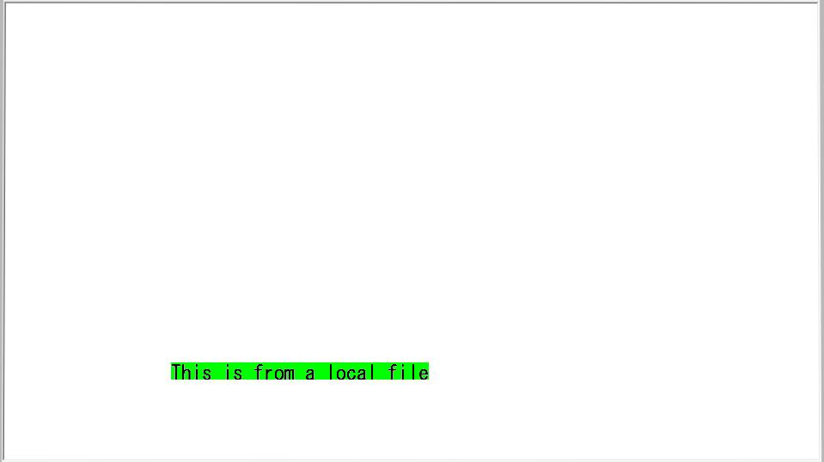

Figure I.2-34: Reference image, test sample 1 code snippet 34

Test sample 1 code snippet 35

|  |
| --- |
| <bml>  <head>  <title>Browser Object test -- browser.random() </title>  <style><![CDATA[  body {  background-color-index:0;  resolution:960x540;  display-aspect-ratio:16v9;  }  #title { font-size:20px;background-color-index:0;color-index:7;top:10px;left:100px;width:800px;height:180px;text-align:left;}  #display { font-size:20px;background-color-index:16;color-index:7;top:100px;left:100px;width:600px;height:180px;}  ]]>  </style>  <script><![CDATA[  function pushedButton(){  var no= browser.random(10);  var obj = document.getElementById("display");  obj.firstChild.data += no+"; " ;  }  ]]>  </script>  </head>  <body>  <p id="title" style=""><![CDATA[Random() Test: displays a random number from 1 to 10 inclusive,  each time Red button is pushed.  Please push Red button]]></p>  <p class="button" id="red" style="left:90px;top:460px;height:22px;width:27px" onclick="pushedButton();" accesskey="R"/>  <p id="display" style=""><![CDATA[]]></p>  </body>  </bml> |

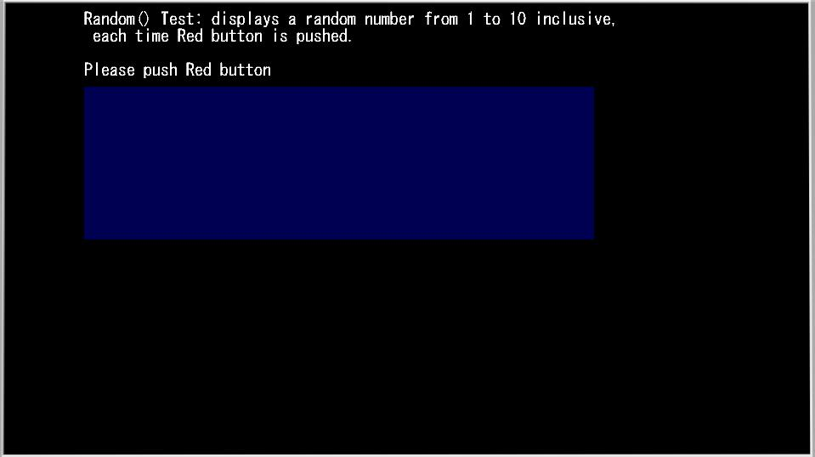

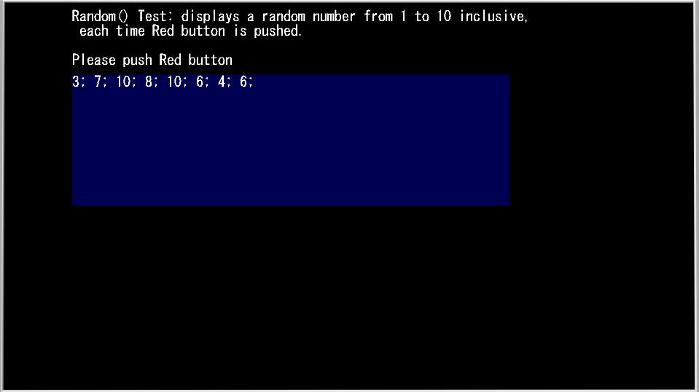

Figure I.2-35: Reference image, test sample 1 code snippet 35

Test sample 1 code snippet 36

|  |
| --- |
| <bml>  <head>  <title>browser Object test -- Test of Timer functions: setInterval(), resumeTimer(), pauseTimer(), and clearTimer()</title>  <style><![CDATA[  * {font-size:20px;}  #status {left:310px;top:30px;width:500px;height:24px;color-index:7;}  #title {left:10px;top:5px;width:700px;height:24px;color-index:7;}  .button {top:55px;height:21px;width:80px;text-align:center;border-style:solid;border-width:2px;}  #display { font-size:20px;background-color-index:16;color-index:7;top:30px;left:30px;width:380px;height:460px;}  ]]></style>  <script><![CDATA[  var cnt = 0;  var CounterID = NaN;  function startCounter(){  if(!isNaN(CounterID)){ browser.clearTimer(CounterID);} else { CounterID = browser.setInterval("count();", 1000, 0);}  print("Counter[" + CounterID + "] has been STARTed");  }  function pauseCounter(){  var v = browser.pauseTimer(CounterID);  print("Counter[" + CounterID + "] has been PAUSEed, returning "+v);  }  function resumeCounter(){  var v = browser.resumeTimer(CounterID);  print("Counter[" + CounterID + "] has been RESUMEd, returning "+v);  }  function stopCounter(){  var v = browser.clearTimer(CounterID);  print("Counter[" + CounterID + "] has been STOPped, returning "+v);  }  function count(){  cnt++;  alert("\tCounter[" + CounterID + "] couning the interval "+cnt);  }  function print(str){  document.getElementById("status").firstChild.data = str+"\r\n";  }  function alert(str){  var obj = document.getElementById("display");  obj.firstChild.data += str+"\r\n" ;  }  ]]></script>  </head>  <body style="background-color-index:0;">  <p id="title"><![CDATA[Test of setInterval(), resumeTimer(), pauseTimer(), and clearTimer()]]></p>  <p id="status"><![CDATA[Please push the color buttons; ]]></p>  <p class="button" style="left:140px;background-color-index:14;" onclick="startCounter();" accesskey="B">1.Start </p>  <p class="button" style="left:240px;background-color-index:1;" onclick="pauseCounter();" accesskey="R">2.Pause</p>  <p class="button" style="left:340px;background-color-index:2;" onclick="resumeCounter();" accesskey="G">3.Resume</p>  <p class="button" style="left:440px;background-color-index:3;" onclick="stopCounter();" accesskey="Y">4.Stop</p>  <p id="display" style="top:100px;left:150px"><![CDATA[]]></p>  </body>  </bml> |

|  |  |
| --- | --- |
| 03-07-timer-0  **(a) Initial screen** | 03-07-timer-1  **(b) Counter started** |
| 03-07-timer-2  **(c) Counter paused** | 03-07-timer-3  **(d) Counter operation resumed** |
| 03-07-timer-4  **(e) Stopped counter** | |
| Figure I.2-36: Reference image, test sample 1 code snippet 36 | |

Test sample 1 code snippet 37

|  |
| --- |
| <bml>  <head>  <title>browser Pseudo-Object-Test:transmitTextDataOverIP</title>  <style><![CDATA[  * {font-size:20px;}  body {background-color-index:0;used-key-list:basic data-button numeric-tuning;}  div {left:80px;top:40px;width:600px;height:520px;}  input {width:50px;height:20px;border-style:solid;border-width:2px;}  #status {left:100px;top:50px;width:600px;height:420px;background-color-index:15;color-index:0;}  #title {left:10px;top:5px;width:700px;height:24px;color-index:7;}  ]]></style>  <script><![CDATA[  function myonload(){  //-- The following variables should be specified according to the test environment; --  var serverURL = "127.0.0.1";  var fileName = "test.txt";  //------  var obj = document.getElementById("status");  var val = 2;  var ret = browser.transmitTextDataOverIP("http://"+ serverURL+"/"+fileName,val,"EUC-JP");  if( ret[0] == 1 ){  obj.firstChild.data = "Returned Value: \n"+ ret[2];  }else{  obj.firstChild.data = "Transaction failed: "+ret[0]+":"+ret[1]+":"+ret[2];  }  }  ]]></script>  </head>  <body onload="myonload();">  <p id="title"><![CDATA[transmitTextDataOverIP test:]]></p>  <p id="status"><![CDATA[]]></p>  </body>  </bml> |

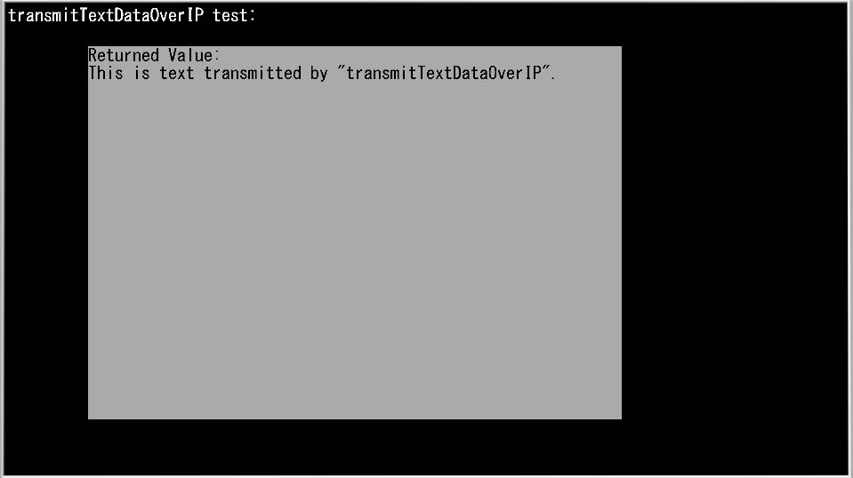

Figure I.2-37: Reference image, test sample 1 code snippet 37

___________________