Standardization Sector
ITU-T Technical Report
(01/2025)
YSTR.Ambient IoT
Analysis on requirements and use cases of ambient power-enabled Internet of things
ITUPublications | International Telecommunication Union


Technical Report ITU-T YSTR.Ambient IoT
Analysis on requirements and use cases of ambient power-enabled
Internet of things

Summary
In Internet of things (IoT) systems, a large number of physical terminals may not have the space to hold batteries or bear the cost of batteries, such scenarios include but are not limited to, fast-moving consumer goods, logistics packages, product line packaging, warehouse goods inventory, etc. Large-scale scenarios may involve up to more than ten thousand IoT nodes, which battery-powered IoT devices are not able to support in terms of cost, size, and power mode.
An ambient power-enabled IoT is an IoT that enables IoT services by harvesting ambient energy to power the IoT devices. Instead of using batteries to power the devices, the ambient-IoT devices are capable of harvesting ambient energy to power electronic modules. The ambient power can be provided by distributed power transfer nodes (e.g., existing network infrastructure, dedicated power transfer devices) or natural power (e.g., light, vibration, or thermal energy).
This Technical Report conducts an analysis on potential requirements and use cases of ambient power-enabled IoT.

Keywords
Ambient power-enabled IoT, energy harvesting.

Note
This is an informative ITU-T publication. Mandatory provisions, such as those found in ITU-T Recommendations, are outside the scope of this publication. This publication should only be referenced bibliographically in ITU-T Recommendations.

© ITU 2025
All rights reserved. No part of this publication may be reproduced, by any means whatsoever, without the prior written permission of ITU.

Table of Contents
Page
1 Scope 1
2 References 1
3 Definitions 1
3.1 Terms defined elsewhere 1
3.2 Terms defined in this Technical Report 1
4 Abbreviations and acronyms 2
5 Overview of ambient power-enabled IoT 2
5.1 Currently available commercial technologies and ongoing research for ambient power-enabled IoT 3
5.2 Ongoing standardization activities on ambient power-enabled IoT 4
5.3 Potential application scenarios of ambient power-enabled IoT 5
6 Analysis and challenges on potential requirements of ambient power-enabled IoT 6
6.1 Analysis on potential requirements of ambient power-enabled IoT components and topologies 6
6.2 Analysis on potential requirements of ambient power-enabled IoT devices 8
6.3 Challenges of ambient power-enabled IoT 9
7 Use cases of ambient power-enabled IoT 10
7.1 Use case of smart warehouse and logistics 10
7.2 Use case of personal assets searching 11
7.3 Use case of indoor positioning 12
Bibliography 13

Technical Report ITU-T YSTR.Ambient IoT
Analysis on requirements and use cases of ambient power-enabled
Internet of things

1 Scope
This Technical Report conducts an analysis on potential requirements and use cases of ambient power-enabled Internet of things (IoT).
The scope of this Technical Report includes:
– Overview of ambient power-enabled IoT.
– Analysis on potential requirements of ambient power-enabled IoT.
– Use cases of ambient power-enabled IoT.

2 References
[ITU-T Y.4000] Recommendation ITU-T Y.4000/Y.2060 (2012), Overview of the Internet of things.
[ITU-T Y.4101] Recommendation ITU-T Y.4101/Y.2067 (2017), Common requirements and capabilities of a gateway for Internet of things applications.

3 Definitions

3.1 Terms defined elsewhere
This Technical Report uses the following terms defined elsewhere:
3.1.1 ambient-IoT device [b-3GPP TR 22.840]: An ambient power-enabled Internet of things device is an IoT device powered by energy harvesting, being either battery-less or with limited energy storage capability (e.g., using a capacitor).
3.1.2 ID tag [b-ITU-T Y.4406]: A physical object which stores one or more identifiers and optionally application data such as name, title, price, address, etc.
3.1.3 Internet of things (IoT) [ITU-T Y.4000]: A global infrastructure for the information society, enabling advanced services by interconnecting (physical and virtual) things based on existing and evolving interoperable information and communication technologies.
NOTE 1 – Through the exploitation of identification, data capture, processing and communication capabilities, the IoT makes full use of things to offer services to all kinds of applications, whilst ensuring that security and privacy requirements are fulfilled.
NOTE 2 – From a broader perspective, the IoT can be perceived as a vision with technological and societal implications.
3.1.4 sensor [b-ITU-T Y.4105]: An electronic device that senses a physical condition or chemical compound and delivers an electronic signal proportional to the observed characteristic.
3.1.5 tag-based identification [b-ITU-T Y.4406]: The process of specifically identifying a physical or logical object from other physical or logical objects by using identifiers stored on an ID tag.

3.2 Terms defined in this Technical Report
None.

4 Abbreviations and acronyms
This Technical Report uses the following abbreviations and acronyms:
5G 5th Generation Mobile Communication Technology
Ambient-IoT Ambient Power-enabled Internet of Things
AC Alternating Current
BLE Bluetooth Low Energy
CSD Criteria for Standards Development
DAS Distributed Antenna System
DC Direct Current
IoT Internet of Things
LNA Low Noise Amplifier
LoRa Long Range Radio
LPWAN Low Power Wide Area Network
LTE Long Term Evolution
mTTC Massive Thing Type Communication
mMTC Massive Machine Type Communication
NFC Near Field Communication
PAR Project Authorization Request
RAN Radio Access Network
RF Radio Frequency
RFID Radio Frequency Identification
SA Service & System Aspects
TSG Technical Specification Group
UE User Equipment
WLAN Wireless Local Area Network
WUS Wake-Up Signal

5 Overview of ambient power-enabled IoT
The goal of Internet of things (IoT) is to realize ubiquitous connectivity among humans, machines, and objects. However, most IoT devices are powered by batteries, and the replacement or charging of the battery limits the applicability of IoT. This is especially true when considering massive deployments of hundreds of thousands of devices, such scenarios including, but not being limited to, package tracking in smart logistics, personnel tracking in smart parks, assets inventory in smart warehouses, personal objects finding in smart homes, busbar monitoring in smart grids, etc.
In many scenarios, identification is a basic IoT service where the customer or company manager needs to identify assets or things for management purposes. Considering these scenarios may involve up to more than ten thousand things, the implementation of battery-powered IoT devices for identification is unrealistic, due to device cost, size and maintenance problems. In addition, battery-powered IoT devices also raise environmental concerns since the devices use huge amounts of batteries.
To address these concerns, the ambient-IoT has emerged. An ambient-IoT is an IoT enabling IoT services by harvesting ambient energy to power the IoT devices. Instead of using batteries to power the devices, the ambient-IoT devices are capable of harvesting ambient energy to power their internal electronic modules. The ambient power can be provided by distributed power transfer nodes (e.g., existing network infrastructure, or dedicated power transfer devices) or natural power (e.g., light, vibration, or thermal energy).
This battery-less feature enables ambient-IoT devices to possess very small form factors (e.g., tags or labels) to perform IoT services, allowing ambient-IoT devices to be deployed on narrow or non-flat surfaces. Commercialization of related technological features is already active. Products such as radio frequency identification (RFID) [b-RFID] and near field communication (NFC) [b-NFC] are already very mature, and new technologies such as Wiliot's IoT pixels [b-IoTPixel], OPPO's zero-power tag [b-ZpIoT] and Ericsson's zero-energy tactile textiles [b-ZeIoT] have also emerged. Standards development organizations such as the Institute of Electrical and Electronics Engineers (IEEE) and the 3rd Generation Partnership Project (3GPP) have also initiated the standard process on wireless local area network (WLAN)-based ambient-IoT and cellular-based ambient-IoT. This worldwide interest shows that ambient-IoT has the potential to enable more objects to connect to the Internet and significantly expand the application scenarios of IoT.
This Technical Report provides an introduction of the current state of ambient-IoT in terms of currently available technological solutions, ongoing research, and recent and ongoing standardization activities in the area. This Technical Report also analyses the requirements of ambient-IoT and use cases to illustrate the market needs.

5.1 Currently available commercial technologies and ongoing research for ambient power-enabled IoT

5.1.1 Ambient power harvesting technologies
One of the most important technologies of ambient-IoT is energy harvesting. With energy collection from the environment, ambient-IoT devices can further extend communication range and expand more functions. Common energy harvesting methods, including radio waves, solar, thermal, and vibration energy, have been used by several companies in prototypes or commercialized products based on these technologies:
• RF energy: The most common solution of ambient-IoT is radio wave energy harvesting. The antenna of the device collects the radio wave at the selected frequency into useful electrical energy. It uses an antenna to pick up these signals, and then converts the radio frequency (RF) signal from alternating current (AC) to direct current (DC) through an integrated rectifier circuit. Taking passive RFID as an example, an RFID tag could harvest −24 dBm radio wave (at 900 MHz) to nearly 1 μW to support demodulation, decode, and uplink communication of the tag. Many companies have proposed technology to harvest energy from different RF signals, such as Wi-Fi [b-WirelessPower] and Bluetooth [b-IoTPixel].
• Solar energy/light: Solar or light energy is another available solution for the power supply of ambient-IoT devices. From outdoor sunlight to indoor artificial illuminating equipment, light energy harvesting has a wide range of possible sources. Solar power can be transformed into useful electrical energy through photovoltaic cells with a 10-40% conversion efficiency, which makes this technology suitable for outdoor IoT services. As solar power is normally only available in the daytime, several companies have developed indoor solutions for ambient-IoT and these solutions often require additional light transmitters [b-AirCord], or a highly efficient power converter [b-EnOcean]. Such products can charge surrounding devices such as smart door locks, digital signage, and sensors to provide IoT service.
• Thermal energy: The difference between temperatures can also be used for energy harvesting. Many industry scenarios consist of engines and pumps, the operation of such equipment is always accompanied by high temperature, and the temperature difference between the equipment surface and environment can be converted into electrical power by taking advantage of the Seebeck or Thomson effect. Though conversion efficiency of this technology is below 10% [b-Nadaf], the output power can still support overheating alarms, engine temperature detection, etc. The harvested energy level is highly dependent on the temperature difference, thus this type of ambient-IoT is often deployed in industrial environments [b-Perpetuum] or extreme environments [b-Prometheus].
• Vibration energy: Vibration energy comprises many types of ambient power, such as pressure, friction, and contact energy. Representative application scenarios are wearable devices where humans frequently move [b-ZpIoT] and industries where machines produce abundant vibrations [b-FINSIOT]. However, even though vibration energy has acceptable harvesting efficiency, it is not suitable for static objects.

5.1.2 Ultra-low power consumption communication technologies
Backscatter communication
A technology known as backscatter communication can significantly reduce the power consumption of communications. A backscatter device can send information by re-modulating and passively reflecting incident signals from ambient signal sources, without requiring power-hungry transceivers to generate a carrier signal [b-ITU-R M.2516-0].
When an ambient signal exists, the device can pick up the signal, rectify a portion of the signal into DC to energize the device and reflect another portion of the signal with a different amplitude (high amplitude represented as 1 and low amplitude represented as 0) to deliver information [b-Niu].
Research such as backscatter long range radio (LoRa) [b-Guo], backscatter Wi-Fi [b-Dehbashi], and backscatter Bluetooth [b-Ensworth] has been carried out over the past decade, and demonstrated that existing communication systems can be optimized to sub-10 mW level power consumption by using backscatter communication.
Wake-up signal
A technology known as wake-up signal (WUS) was introduced in 3GPP Rel. 18 [b-3GPP TR 38.869] to meet the requirements of both long battery life and low latency. By using a wake-up signal to trigger the main radio and a separate receiver that has the ability to monitor the wake-up signal with ultra-low power consumption, the user equipment (UE) can be turned off or set to deep sleep at most of its life cycle and can wake up only when it is triggered, therefore, improving energy efficiency as well as better user experience.

5.2 Ongoing standardization activities on ambient power-enabled IoT
Two standardization organizations are developing studies on ambient power-enabled IoT:
• 3rd Generation Partnership Project (3GPP): 3GPP has brought ambient-IoT into 5th generation mobile communication technology (5G)-Advanced technical system. 3GPP has established study items to conduct relevant studies in both technical specification group (TSG): SA (TSG Service & System Aspects) and RAN (TSG Radio Access Network). The 3GPP SA1 working group has established the Ambient-IoT project to identify potential use cases, deployment scenarios, key service requirements, and critical performance indicators. SA1 concluded its work in Dec. 2023 delivering technical report [b-3GPP TR 22.840]. The 3GPP SA2 working group also started research on network architecture, identification, subscription, registration and services in Jan. 2024.
Based on the SA1 research of use cases, the RAN working group discussed the impact of these aspects on network architecture and device types, and this work was approved in Sept. 2023 as technical report [b-3GPP TR 38.848]. The RAN working group also started a new Ambient-IoT study item in Dec. 2023, the research including, but not being limited to, evaluation methodology, ambient-IoT device architecture, solutions for ambient-IoT (physical layer, protocol stack and signaling procedure, RAN architecture aspects, waveform, etc.), and coverage evaluations.
• Institute of Electrical and Electronics Engineers (IEEE): A technical interest group focused on ambient power-enabled (AMP) IoT was established during the IEEE 802.11 meeting in May 2022. This technical interest group mainly focused on ambient-IoT working under the current WLAN network structure, and concluded its work in March 2023 delivering the AMP technical report, which included use cases, requirements, prototypes, and technical and economic feasibility analysis. Following the TIG, the IEEE 802.11 AMP Study Group (SG) was formed in March 2023. The objective of the SG is to develop a project authorization request (PAR) and criteria for standards development (CSD) for an 802.11 standard project on WLAN AMP communication. Discussions within the AMP SG cover aspects such as transmit and receive architectures, deployment topologies, and operational frequency bands. Based on the work in the AMP SG, the AMP technical report has been further updated [b-IEEE]. A PAR and CSD were finally approved by IEEE 802 LAN/MAN in March 2024.

5.3 Potential application scenarios of ambient power-enabled IoT
Due to the feature of energy harvesting, ambient-IoT devices can operate without batteries or at least not using batteries as the main power source, thus ambient-IoT is appropriate for scenarios with requirements of battery restrictions, maintenance-free, and massive thing type communications. This clause only introduces the high-level application scenarios, the details of application scenarios are described in clause 7 as use cases.
• Battery-restricted scenario: Current IoT technology cannot work in some specific scenarios, such as high-voltage power grid monitoring and oil pipeline monitoring, because extreme environmental impacts can lead to battery failure, often resulting in fires, explosions, and the release of toxic gases. In such environments, batteries are not allowed for safety issues but the ambient-IoT devices can harvest energy from the environment, then directly consume the energy or store the energy in a capacitor instead of in a battery. Thus, the industry does not need expensive explosion proof modifications of devices.
• Maintenance-free scenario: Battery-powered IoT devices require periodic charging or replacement, which is extremely difficult for deployments with a large number of IoT devices. The replacement of batteries could be a large expenditure and human resources waste, and the replaced batteries are also hazardous for the environment. Due to the energy harvesting feature, an ambient-IoT device can constantly charge itself from ambient power, instead of depending on a finite life battery. Once the ambient-IoT device is installed on the intended place, it can work with the ambient power supply automatically, and this can be beneficial for deploying devices in remote areas, or areas with limited human resources.
• Massive thing type communications (mTTC): In massive machine type communication (mMTC) scenarios, most communications are built between electronic devices (e.g., cell phones, refrigerators, etc.), but many non-electronic things (e.g., desks, keys, mails, packages, etc.) are not connected to the network, and these non-electronic things have similar tracking and monitoring requirements to machines. However, unlike machines, these objects cannot be easily integrated with a communication module due to the size, cost, and power consumption restrictions. In vertical applications, scenarios such as cold chain, warehouse, and logistics often consist of over 100 000 non-electronic things required to be tracked or inventoried. The high complexity of 5G, long term evolution (LTE), and low power wide area network (LPWAN) devices makes it impossible to deploy in such scenarios. However, ambient-IoT devices can be ultra-low complexity since the energy is mainly used for identifier transmission. The ambient-IoT will have limited processing and storage capabilities, short-codeword, and low complexity channel encoding methods, along with power harvesting technologies, which reduce the size and cost of ambient-IoT devices and make it possible and affordable to deploy on any surface of any thing.

6 Analysis and challenges on potential requirements of ambient power-enabled IoT

6.1 Analysis on potential requirements of ambient power-enabled IoT components and topologies
The main concept of the ambient-IoT is that devices can harvest energy from ambient, instead of finite-time batteries. The ambient energy can be distinguished into three different types: natural, auxiliary, and dedicated energy.
The natural ambient energy type refers to natural energy or energy from target objects, such as heat or vibration of the engines, and sunlight. These energies are usually uncontrollable and unstable, thus this type can only be used in specific scenarios.
The auxiliary ambient energy type refers to RF energy from network infrastructures, such as the carrier wave from cellular base stations, Wi-Fi routers, or Bluetooth gateways. This type of energy is usually more controllable, but unstable due to penetration loss or the impact of the metal environment, and the balance of coding efficiency and power efficiency also needs to be considered. Therefore, the ambient-IoT devices may only directly interact with the communication network in an ideal environment, and indirectly interact with the communication network through a gateway or UE in other cases, in order to receive enough RF energy. The above two energy types demonstrate the ideal ambient-IoT, where only ambient-IoT devices and lightweight protocols are needed. However, due to the unstable characteristics of natural energy and auxiliary energy, the dedicated ambient energy type is needed. An optional charging node may be needed for additional energy provision, with the charging node that may be set up independently or integrated with the gateway to provide dedicated energy for ambient-IoT devices.
With respect to the IoT reference model described in [ITU-T Y.4000], the ambient-IoT consists of additional components along with related topologies in the device layer. The additional components and topologies are shown in Figure 1.
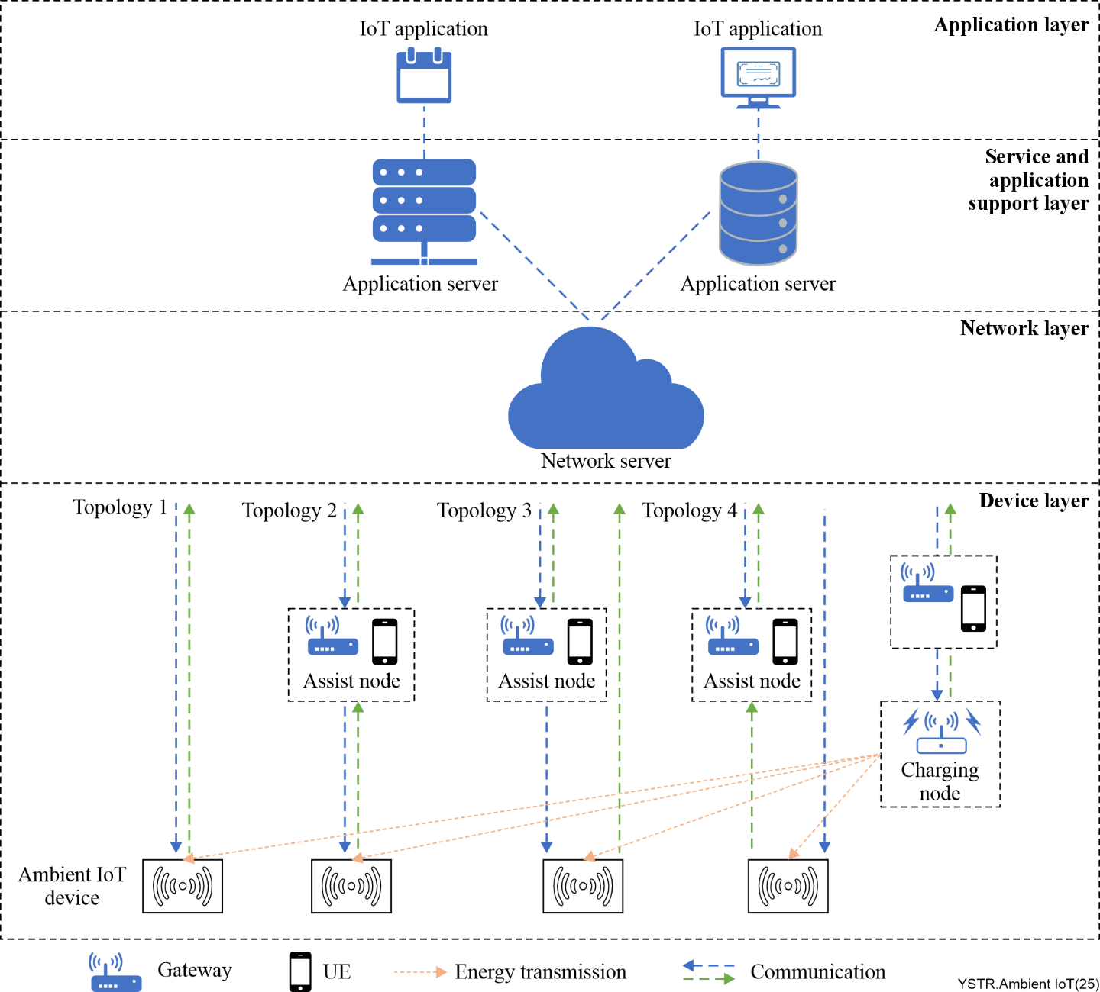
Figure 1 – Additional components and topologies of Ambient-IoT
As shown in Figure 1, ambient-IoT consists of the following three new components in the device layer:
• Ambient-IoT device: The ambient-IoT devices are driven by harvested ambient energy, and support lightweight IoT applications, such as identification, sensing, and positioning applications.
• Assist node: An assist node can be a UE or gateway or an independent device. The ambient-IoT devices (with different protocols) can connect to communication networks through one or multiple assist nodes. The assist node has similar capabilities to the gateway as specified in [ITU-T Y.4000] and [ITU-T Y.4101], but in the cases of topology 3 and topology 4, the assist node may only serve as a relay to bridge network and devices, thus the capabilities of the assist node could be simplified compared to the gateway capabilities. The assist node may have an optional enhanced capability, acting as a charging node to charge the ambient-IoT device or assist the ambient-IoT device in performing frequency shift capability.
• Charging node: An optional charging node can be set up intentionally to provide stable and controllable energy to the ambient-IoT device, thus helping the ambient-IoT device to perform longer-range communications, frequency shifts and more complicated tasks.
The ambient-IoT supports multiple topologies. The ambient-IoT devices can connect to the communication network directly (topology 1) or through assist nodes (topology 2). Due to the limited capability of the ambient-IoT devices, an assist node can act as a relay to further extend the communication distance.
Unlike battery-powered or wired devices, ambient-IoT devices may not have enough power in some cases to support amplifiers for both uplink and downlink, thus different communication distances between uplink and downlink may exist. In such cases, the ambient-IoT devices can establish a direct connection with the network for one of the communication links (uplink or downlink), and connect through assist nodes for the other link (topologies 3 and 4).
In some scenarios, where even the assist nodes are not enough for the ambient-IoT devices, an optional charging node can be used to provide stable and controllable energy, the charging node being either controlled by the assist node or directly controlled by the communication network.

6.2 Analysis on potential requirements of ambient power-enabled IoT devices

6.2.1 Ambient-IoT device
Based on the use cases specified in [b-IEEE] and [b-3GPP TR 22.840], the most essential application for ambient-IoT is tag-based identification [b-ITU-T Y.4406], which usually requires very low data rate (e.g., less than 100 kbit/s). The basic function of an ambient-IoT device is to act as the ID tag [b-ITU-T Y.4406], in order to provide tag-based identification services. In some cases, ambient-IoT devices may also have lightweight sensing features, but these may only be used for simple monitoring of the environment or asset, instead of remote control or video transmission. In order to support tag-based identification and lightweight sensing features, only small packets (e.g., less than 200 bits) transmission is required.
Since the goal of ambient-IoT is the massive connection of things, the size and cost of ambient-IoT devices needs to be minimized, thus this type of ambient-IoT device is required to be of ultra-low complexity, and without any complicated components (e.g., crystal, low noise amplifier (LNA), or amplifier). Due to this limited structure, backscatter communication could be an appropriate option. RF energy harvesting can also be helpful to achieve ultra-low complexity, because the communication and energy harvesting can both acquire radio waves from antennas, while other energy types often require dedicated components (e.g., solar panel). However, due to the small size restriction, the energy that can be harvested is very limited, and μW level power consumption can be considered as the design target for such device types. In summary, the devices should have features such as ultra-low complexity, ultra-low power consumption, very small form factor, and battery-less (i.e., not using conventional battery) power.
However, in some cases, ambient-IoT devices may perform more complicated tasks, such as monitoring or actuating, which require higher volume bi-directional data exchange between the network and the devices. For outdoor scenarios, long-range communication may also be needed, and this device type may consist of more complicated components (e.g., amplifier, LNA, filter). In such cases, higher power consumption (~1 mW) can be expected for such a device type. This type of device needs harvesting of energy types with more power, such as solar, vibration, and thermal energy harvesting, or harvesting of multiple energy types. In order to support these capabilities, batteries may be needed for this device type, but it is required they are rechargeable from ambient energy, instead of manually recharging or maintenance. Therefore, a different type of ambient-IoT device with enhanced features is required. Since this type of device requires more energy, backscatter communication, and active communication can be supported at the same time.
NOTE – Compared to backscatter communication, active communication refers to device-originated autonomous communication. The device does not need wait to hear the external signal. Instead, the device "actively" generates the internal signal due to the pre-defined configuration and sends it out to the network for interaction.
At least the above two types of ambient-IoT devices should be considered for different application scenarios and they can be denoted as "low-end" and "high-end" device types depending on features.

6.2.2 Ambient-IoT charging node
In some cases, the energy harvested from the surrounding environment is enough to power up the ambient-IoT devices and maintain stable performance. However, the natural energy may be very limited and sometimes unstable and uncontrollable, thus an additional charging node may be needed to provide additional energy to the ambient-IoT device. The energy emitted from the charging node includes, but is not limited to, radio wave, heat and light. The radio wave can be also used to help the device in performing frequency shift. In order to support the ambient-IoT device's reliable connectivity with the network, management and performance measurement of the emitted energy may be required, which allows the charging node to be aware of the status of the devices and to adjust the energy level in a timely manner. A charging node which emits RF energy should be under network control, as the emitted energy may cause interference with the communication radio wave or other services.

6.2.3 Ambient-IoT assist node
Compared to battery-powered or wired devices, ambient-IoT devices may not have enough power to support both uplink and downlink communication at the same distance. Therefore, an assist node is needed to serve as relay to bridge ambient-IoT devices (or charging nodes) and networks. With respect to topology 3 and topology 4 of ambient-IoT as described in clause 6.1, the assist node may actually need to support only a unidirectional link with ambient-IoT devices.

6.3 Challenges of ambient power-enabled IoT
The following challenges are identified with respect to the support of the potential requirements presented in clause 6.2:
• Deployment complexity: For wired or battery-powered IoT devices, there is a need to deal only with communication paths, while for ambient-IoT devices there is also a need to deal with energy transfer paths (e.g., the path for RF power transfer or light power transfer). Moreover, an ambient-IoT may consist of additional charging nodes. These additional paths and devices of the ambient-IoT lead to a more complicated deployment.
• Energy limitations: Ambient-IoT devices have limited energy resources, the ambient power is not stable and can be affected by the environment, so ambient-IoT devices easily lose communication links. However, to be useful in practice, ambient-IoT devices must have backup energy storage or energy management mechanisms to maintain the communication link while ambient power is temporarily down. The ambient-IoT also requires communication mechanisms to ensure communication continuity.
• Extremely simplified device architecture: The device architecture of ambient-IoT must be extremely simplified in order to reduce power consumption and cost, which implies a challenge for large data transmission and complex capabilities (e.g., high processing capability).
• Diversity of communication technologies: In a service process, there may be multiple different communication protocols covering different areas, the ambient-IoT devices need to consider the compatibility of different communication protocols. However, the ambient-IoT devices may not have enough energy or capability to support multiple communication modes. Communication technologies share similar protocols (e.g., Bluetooth Classic and Bluetooth low energy (BLE)), can also share some components to reduce the cost and complexity of multi-mode devices. However, due to the backscatter, a communication node only communicating passively multi-mode sharing of the same antenna and components can cause conflict, thus the multi-standby mechanism and multi-active mechanism are a challenge. Different communication technologies (e.g., 4G and Wi-Fi) lead to extra antennas and components, which implies an even greater challenge in terms of the cost and power of communication.

7 Use cases of ambient power-enabled IoT
This clause summarizes the typical use cases that will benefit from ambient-IoT and the relevant requirements to fulfil the goals of various services.

7.1 Use case of smart warehouse and logistics
In smart warehouse and logistics scenarios [b-3GPP TR 22.840], the ambient-IoT devices can be attached to each package or mail, helping those objects communicate with the network directly, instead of manually checking.
As shown in Figure 2, ambient-IoT devices attach to items of different values and usage, such as pallet containers and individual packages, the devices record unique IDs and other essential information of the package, and this information can be transmitted to the network to help inventory and tracking.
In the main warehouse, the inventory procedure is divided into verification and unloading, gate-in inventory, inventory, gate-out inventory, and checking and loading. When a package enters the warehouse, the ambient-IoT devices establish communication with the network, send their own identity and corresponding package information to the network, and then store that information in the database. The network is able to distinguish indoor and outdoor due to the position of network infrastructure, and sends the obtained information to the management platform, as well as recording this information as an inventory list. Next, the management platform starts inventory tasks periodically according to this list, and updates according to the received information. When a package is ready to be shipped out, the management platform will check the information of each package to avoid incorrect shipments.
During transportation, the manager can track each individual package or container through the network based on the inventory information, and lost packages can be found immediately after being dropped or taken from the transportation vehicle.
When packages arrive at the distribution centre, the inventory procedure will repeat again to guarantee the amount and identity of packages.
During this whole process, users can also track their packages through different applications.
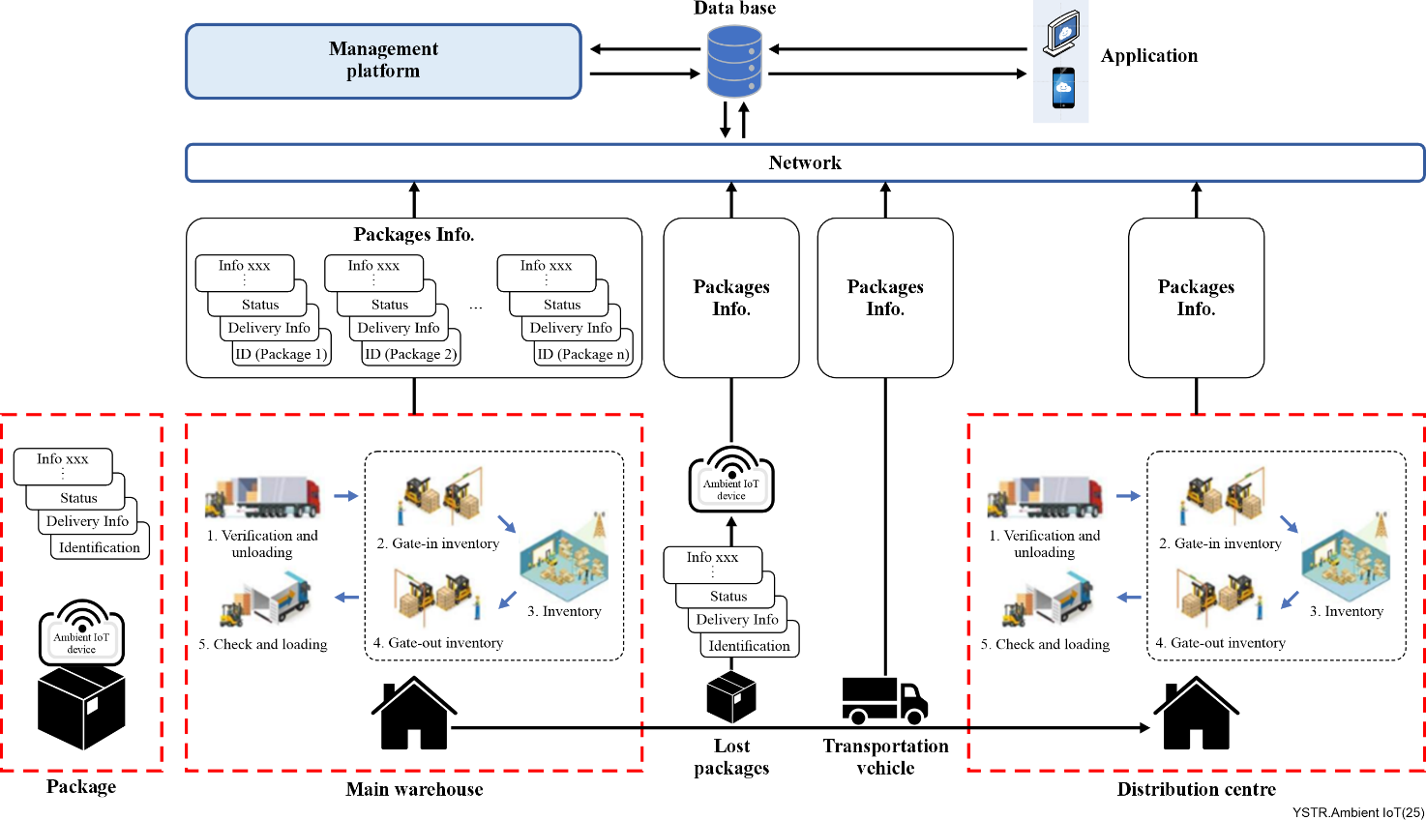
Figure 2 – Use case of smart warehouse and logistics

7.2 Use case of personal assets searching
Figure 3 illustrates a use case of personal assets searching.
Many personal assets such as keys, passports, ID cards, wallets, and books can be easily lost, and it can be hard to track or position them. The ultra-low energy consumption and maintenance-free features of ambient-IoT devices allow the ambient-IoT device to attach to non-electrical objects as an electrical ID, and help these objects connect to the network.
When the user attaches the ambient-IoT devices to assets, the UE or the network establishes communication with the ambient devices and binds the IDs with the user. During the search, the user can track the assets through a UE or the network infrastructure (e.g., router, access point, distributed antenna system (DAS)), then the user can first locate the rough area of the assets when the network infrastructure receives the signals of the corresponding ambient-IoT devices, and then can use the UE to narrow down the area according to the signal strength, getting closer to the target assets until they are found.
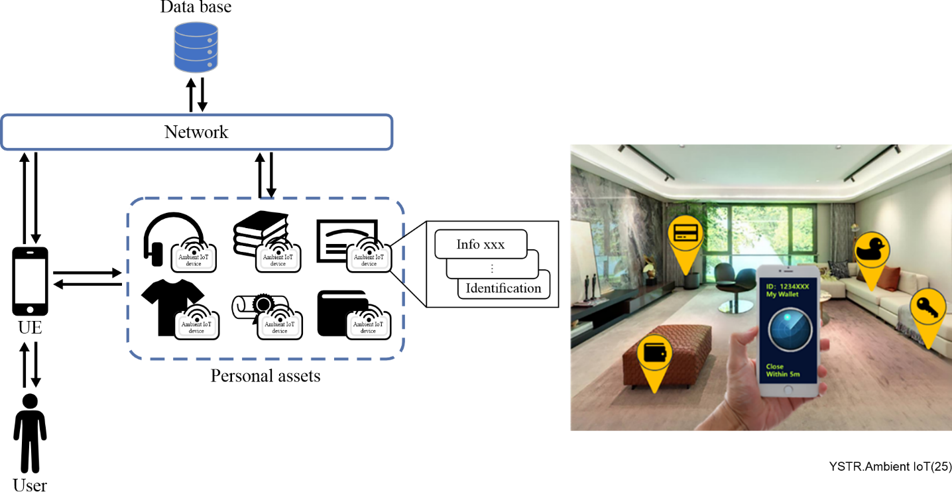
Figure 3 – Use case of personal assets searching

7.3 Use case of indoor positioning
Figure 4 illustrates a use case of indoor positioning.
For indoor positioning, massive tags can be densely deployed indoors for location reference. Such reference tags can help to establish a navigation and positioning system in wide indoor areas, such as giant shopping malls, car-parks, museums, etc. Such areas often provide various services, and customers may have trouble finding a target location and moving from one location to another, because these areas can occupy tens to hundreds of thousands m².
The reference tags can be evenly distributed with high density within the entire area, so that customers can use UEs to communicate with the tags to acquire locations, and navigate to the target locations.
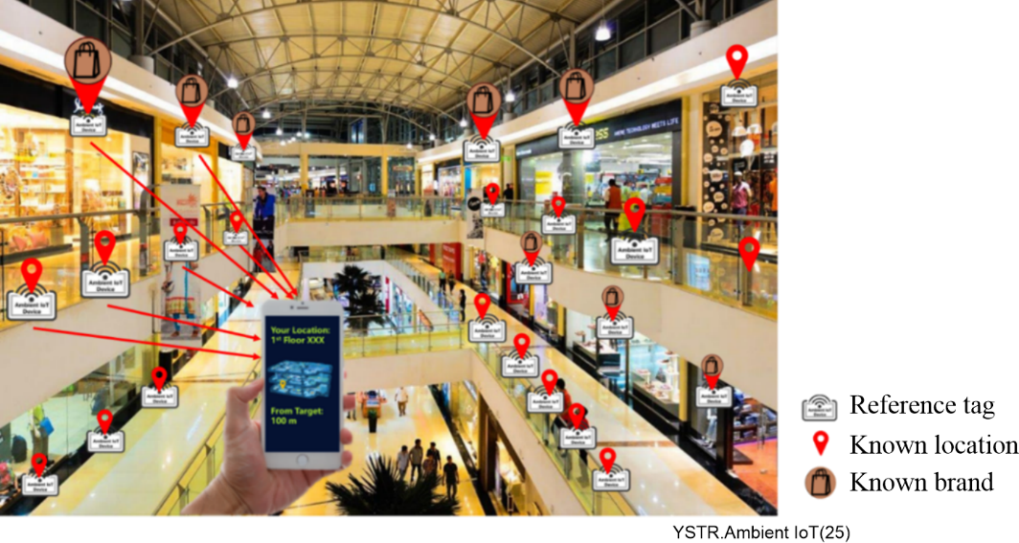
Figure 4 – Use case of indoor positioning

Bibliography

[b-ITU-T Y.4105] Recommendation ITU-T Y.4105/Y.2221 (2010), Requirements for support of ubiquitous sensor network (USN) applications and services in the NGN environment.
[b-ITU-T Y.4406] Recommendation ITU-T Y.4406/Y.2016 (2009), Functional requirements and architecture of the NGN for applications and services using tag-based identification.
[b-ITU-R M.2516-0] Report ITU-R M.2516-0 (2022), Future technology trends of terrestrial International Mobile Telecommunications systems towards 2030 and beyond.
[b-3GPP TR 22.840] 3GPP TR 22.840, Study on Ambient power-enabled Internet of Things.
[b-3GPP TR 38.769] 3GPP TR 38.769, Study on Solutions for Ambient IoT (Internet of Things).
[b-3GPP TR 38.848] 3GPP TR 38.848, Study on Ambient IoT (Internet of Things) in RAN.
[b-3GPP TR 38.869] 3GPP TR 38.869, Study on low-power wake-up signal and receiver for NR (Release 18).
[b-AirCord] Wicharge, AirCord, https://www.wi-charge.com/products
[b-Dehbashi] F. Dehbashi, A. Abedi, T. Brecht, and O. Abari (2021), Verification: Can WiFi backscatter replace RFID? in Proc. ACM MobiCom, New Orleans, LO, USA, Oct., pp. 97–107.
[b-Ensworth] J. F. Ensworth and M. S. Reynolds (2017), BLE-Backscatter: Ultralow-Power IoT Nodes Compatible With Bluetooth 4.0 Low Energy (BLE) Smartphones and Tablets, in IEEE Transactions on Microwave Theory and Techniques, vol. 65, no. 9, pp. 3360-3368, Sept.
[b-EnOcean] EnOcean, Energy Harvesting, https://www.enocean.com/en/technology/energy-harvesting/
[b-FINSIOT] FINSIOT, Industry Monitoring,
https://finsiot.com/Product-Center/Core-platform/IndustrialMonitoring/
[b-Guo] X. Guo et al. (2020), Aloba: Rethinking ON–OFF keying modulation for ambient LoRa backscatter, in Proc. ACM SenSys, Virtual Event, Japan, Nov., pp. 192–204.
[b-IEEE] Technical Report on support of AMP IoT devices in WLAN.
[b-IoTPixel] Wiliot, Wiliot IoT Pixels, https://www.wiliot.com/product/iot-pixels
[b-Nadaf] N. Nadaf and P. A (2021), Review on Waste Heat Energy Harvesting using TEG: Applications and Enhancements, 8th International Conference on Smart Computing and Communications (ICSCC), Kochi, Kerala, India, pp. 334-339.
[b-NFC] NFC Forum, Technical Overview, https://nfc-forum.org/learn/nfc-technology/
[b-Niu] J. -P. Niu and G. Y. Li (2019), An Overview on Backscatter Communications, in Journal of Communications and Information Networks, vol. 4, no. 2,
pp. 1-14, June.
[b-Perpetuum] Emerson, Prometheus, https://perpetuapower.com/emerson/
[b-Prometheus] Matrix Industries, Prometheus, https://www.matrixindustries.com/prometheus
[b-RFID] RAIN, What is RAIN RFID, https://rainrfid.org/what-is-rain-rfid/
[b-WirelessPower] Powercast, Wireless Power / Charging, https://www.powercastco.com/wireless-power/
[b-ZeIoT] Ericsson, Designing a sensor-driven world: the research take on zero-energy devices, https://www.ericsson.com/en/blog/2023/5/zero-energy-devices-sensor-driven-world
[b-ZpIoT] OPPO, OPPO Illustrates a Zero-Battery Future Powered by Wireless Signals with Zero-Power Communication White Paper, https://www.oppo.com/en/newsroom/press/oppo-releases-zero-power-communication-whitepaper/

____________

