|  |  |  |  |  |
| --- | --- | --- | --- | --- |
|  | | **International Telecommunication Union** | | |
|  | |  | | |
| **ITU-T** | **Technical Report** | |
| TELECOMMUNICATION STANDARDIZATION SECTOR OF ITU | | (15 September 2017) |
|  |  | | | |
|  | **YSTR-M2M-DG.CoAP**  **oneM2M – Developer guide of CoAP binding and long polling for temperature monitoring** | | | |
|  |  | | | |



|  |
| --- |
| Technical Report ITU-T YSTR-M2M-DG.CoAP  oneM2M – Developer guide of CoAP binding and long polling for temperature monitoring |

|  |
| --- |
| Summary  This Technical Report provides a simple use case for guiding development of applications using functionalities provided by a oneM2M service platform. |

|  |
| --- |
| History  This document contains Version 0 of the ITU-T Technical Report on "oneM2M-Developer guide of CoAP binding and long polling for temperature monitoring" approved at the ITU-T Study Group 20 meeting held in Geneva, 4-15 September 2017. |

|  |
| --- |
| Keywords  CoAP, developer guidance, oneM2M.  © ITU 2018  All rights reserved. No part of this publication may be reproduced, by any means whatsoever, without the prior written permission of ITU. |

**Table of Contents**

Page

1 Scope 1

2 References 1

3 Terms and definitions 1

3.1 Terms defined elsewhere 1

3.2 Terms defined in this Technical Report 1

4 Abbreviations and acronyms 1

5 Conventions 1

6 Use case 1

7 Functional architecture 2

8 Procedures and call flows 3

8.1 Overviews 3

8.2 Call flows 4

9 Implementation 8

9.1 Implementation assumption 8

9.2 Roles of entities 9

9.3 Procedures 9

10 Conclusions 16

Bibliography 17

Technical Report ITU-T YSTR-M2M-DG.CoAP

oneM2M – Developer guide of CoAP binding and long polling  
for temperature monitoring

# 1 Scope

This Technical Report provides a simple use case for guiding application development using functionalities provided by a oneM2M service platform as follows:

– Objective of the use case;

– The architecture of the use case mapped into an oneM2M service platform;

– The execution procedures for implementation of the use case; and

– Implementation details of the use case: constrained application protocol (CoAP) and javascript object notation (JSON) serialization.

# 2 References

[ITU-T Y.4500.1] Recommendation ITU-T Y.4500.1 (2018), *oneM2M – Functional architecture*.

[ITU-T Y.4500.8] Recommendation ITU-T Y.4500.8 (2018), *oneM2M – CoAP protocol binding*.

[ITU-T Y.4500.11] Recommendation ITU-T Y.4500.11 (2018), oneM2M – *Common terminology*.

# 3 Terms and definitions

This Technical Report uses the terms and definitions given in [ITU-T Y.4500.11].

# 4 Abbreviations and acronyms

For the purposes of the present Technical Report, the abbreviations given in [ITU-T Y.4500.11] and the following apply:

ADN Application Dedicated Node

AE Application Entity

CoAP Constrained Application Protocol

CSE Common Services Entity

IN-CSE Infrastructure Node-CSE

MN-CSE Middle Node-CSE

# 5 Conventions

None.

# 6 Use case

This clause briefly describes the use case from a perspective of service being provided by the oneM2M platform. The physical device components are introduced in the current clause.

The use case described enables the temperature monitoring function as well as related remote control of actuators via a smartphone or smart tab which embeds an application that gains access to a oneM2M service platform.

An overview of the temperature monitoring use case is shown in Figure 6-1.

– The temperature sensors and actuators are deployed anywhere they as needed, and are connected to a gateway;

– The gateway is connected to the cloud or a remote server via the necessary communication technologies allowing the temperature sensors and actuators to be managed remotely;

– The cloud or remote server provides a set of services that enable the smartphone to manage the temperature sensors and actuators such as collecting sensor data, and switching the actuators on/off, etc.;

– The smartphone (or a smart tab) hosts an application used to manage the temperature sensors and actuators. This application should support functions to discover deployed devices, retrieve sensor data, and send control commands to actuators. For example, if temperature sensor data indicates the possibility of a fire disaster, then the actuator can be triggered to provide water spray or a fire alarm.

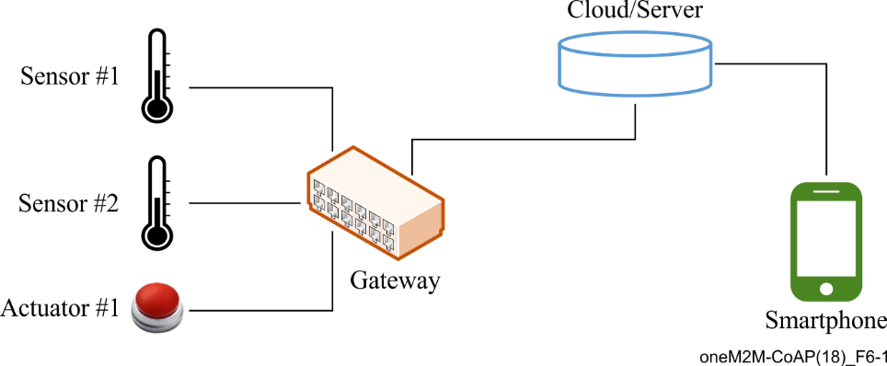

Figure 6-1 – Overview of temperature monitoring use case

# 7 Functional architecture

This clause describes the architecture of this use case with components represented by the oneM2M entity roles.

In oneM2M, two basic types of entities are defined. One is an application entity (AE) and the other is a common services entity (CSE). Therefore, in this use case:

– The sensor, actuator, and the smartphone each host an AE. The AE which resides in the application dedicated node (ADN) is called ADN-AE.

– An infrastructure node CSE (IN-CSE) is hosted in the cloud or server, and a middle node CSE (MN‑CSE) is hosted on the gateway.

This architecture is shown in Figure 7-1.

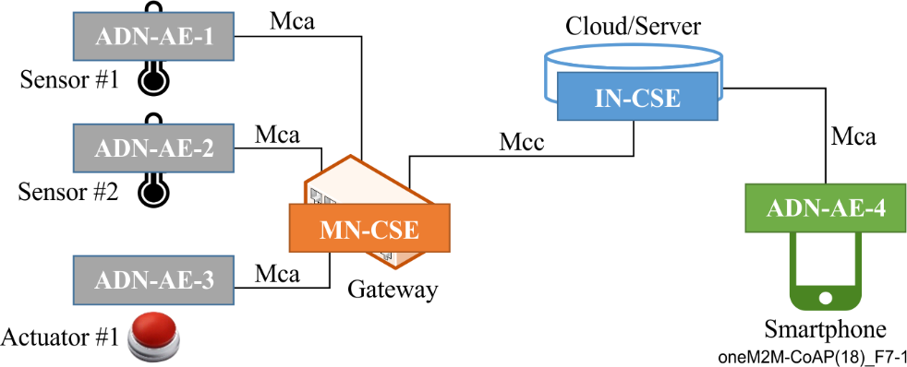

Figure 7-1 – oneM2M functional architecture of temperature monitoring use case

The oneM2M defined Mca reference point is used to interface an AE and CSE, and the oneM2M defined Mcc reference point is used to interface CSEs. Therefore, in this use case:

– The reference point used between the temperature sensor AE, actuator AE and the gateway MN‑CSE or smartphone AE and IN-CSE is Mca;

– The reference point used between the gateway MN-CSE and IN-CSE is Mcc.

In summary, applications used in the current use case are classified as follows:

1) ADN-AE-1: an application embedded in *Sensor#1* with capabilities to monitor *Sensor#1* and interact with the gateway MN-CSE through *Mca* reference point;

2) ADN-AE-2: an application embedded in *Sensor#2* with capabilities to monitor *Sensor#2* and interact with the gateway MN-CSE through *Mca* reference point;

3) ADN-AE-3: an application embedded in *Actuator#1* with capabilities to control *Actuator#1* and interact with the gateway MN-CSE through *Mca* reference point;

4) ADN-AE-4: an application embedded in the smartphone device with capabilities to interact directly with the oneM2M service platform IN-CSE through *Mca* reference point and thereby remotely monitor and control *Sensor#1, Sensor#2* and *Actuator#1*.

# 8 Procedures and call flows

## 8.1 Overviews

In this scenario, a user can use the smartphone application to monitor the temperature data of applications embedded in *Sensor#1* and *Sensor#2.* Furthermore, the actuator application embedded in *Actuator#1* can also be managed by the smartphone application. To realize these functions, the deployment of the oneM2M standard in the present use case requires procedures that are classified as follows:

1) **Registration**:the current procedure contains sensor and actuator applications registration, gateway, and smartphone application registration;

2) **Initial resource creation**: the current procedure contains container resource creation;

3) **Discovery and retrieval**: the current procedure contains discovery and retrieval of sensor applications using resource identities through a smartphone application.

In some use cases, if the actuator application embedded in *Actuator#1* is non-server capable, which means it cannot be notified by the gateway (MN-CSE), then oneM2M defines the <pollingChannel> resource which represents a channel that can be used for such a situation [ITU-T Y.4500.1]. Clause 8 also provides relevant procedures and call flows using the <pollingChannel> resource:

4) **PollingChannel resource creation**:the current procedure contains pollingChannel resource creation;

5) **Actuator switch on/off**: the actuator application that is discovered by and connected to the smartphone application is able to be switched via the polling channel.

## 8.2 Call flows

### 8.2.1 Registration

The first step is sensor and actuator application registration, gateway, and smartphone application registration. Typically, sensors and actuators will register applications with the gateway, and then the gateway will register with the oneM2M service platform. The smartphone applications can register with the oneM2M service platform anytime, as needed.

Call flows regarding the registration phase, depicted in Figure 8.2.1-1, are ordered as follows:

1) Sensor applications (ADN-AE1 and ADN-AE2) register with the gateway (MN-CSE);

2) Actuator applications (ADN-AE3) register with the gateway (MN-CSE);

3) Gateway (MN-CSE) registers with the oneM2M service platform (IN-CSE);

4) Smartphone application (ADN-AE4) registers with the oneM2M service platform (IN-CSE).

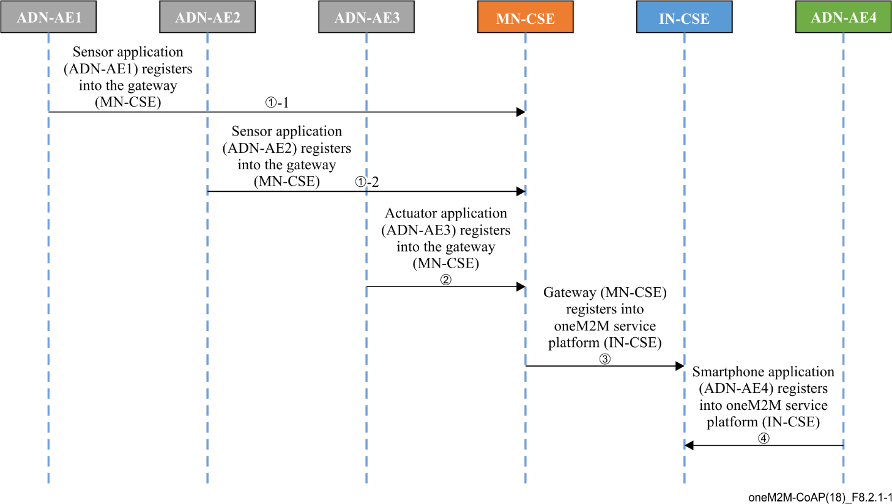

Figure 8.2.1-1 – Registration phase call flows

After the initial resource creation process, the resource tree of MN-CSE and IN-CSE is depicted in Figure 8.2.1-2.

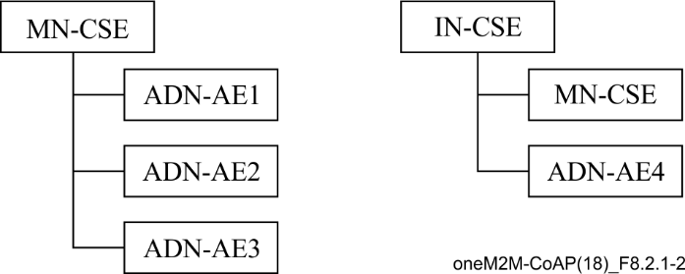

Figure 8.2.1-2 – Resource tree of MN-CSE and IN-CSE

### 8.2.2 Initial resource creation

After registration, it is necessary to create container resources to store the data from sensors on the gateway. Call flows regarding the initial resource creation phase, depicted in Figure 8.2.2-1, are ordered as follows:

1) Two container resources are created in the gateway (MN-CSE) to store the sensor data under the registered sensor application ADN-AE1 and ADN-AE2, respectively;

2) A container resource is created under ADN-AE3 as a repository of work status of the actuator ADN-AE3.

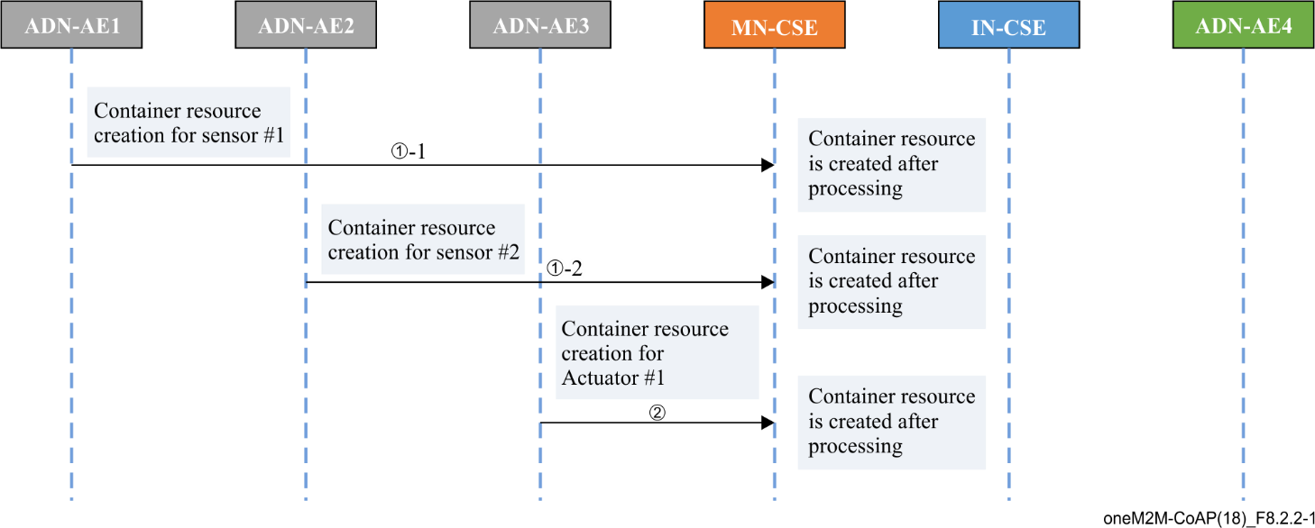

Figure 8.2.2-1 – Initial resource creation phase call flows

### 8.2.3 Discovery and retrieval

Call flows regarding the discovery and retrieval of resources depicted in Figure 8.2.3-1 are ordered as follows:

1) The smartphone application (ADN-AE4) periodically sends a RETRIEVE request including the parameter *filterUsage* and specific filter criteria condition(s) as a query string for discovery of resources stored in the MN-CSE of the gateway;

2) The gateway (MN-CSE) responds to the smartphone application (ADN-AE4) with URIs of the discovered resources under ADN-AE1, ADN-AE2, if any;

3) The smartphone application (ADN-AE4) sends RETRIEVE requests for retrieval of the latest data from discovered sensor resources, in this example, which is from container1 of ADN‑AE1;

4) The gateway (MN-CSE) responds to the smartphone application (ADN-AE4) with the latest data of *Sensor#1*.

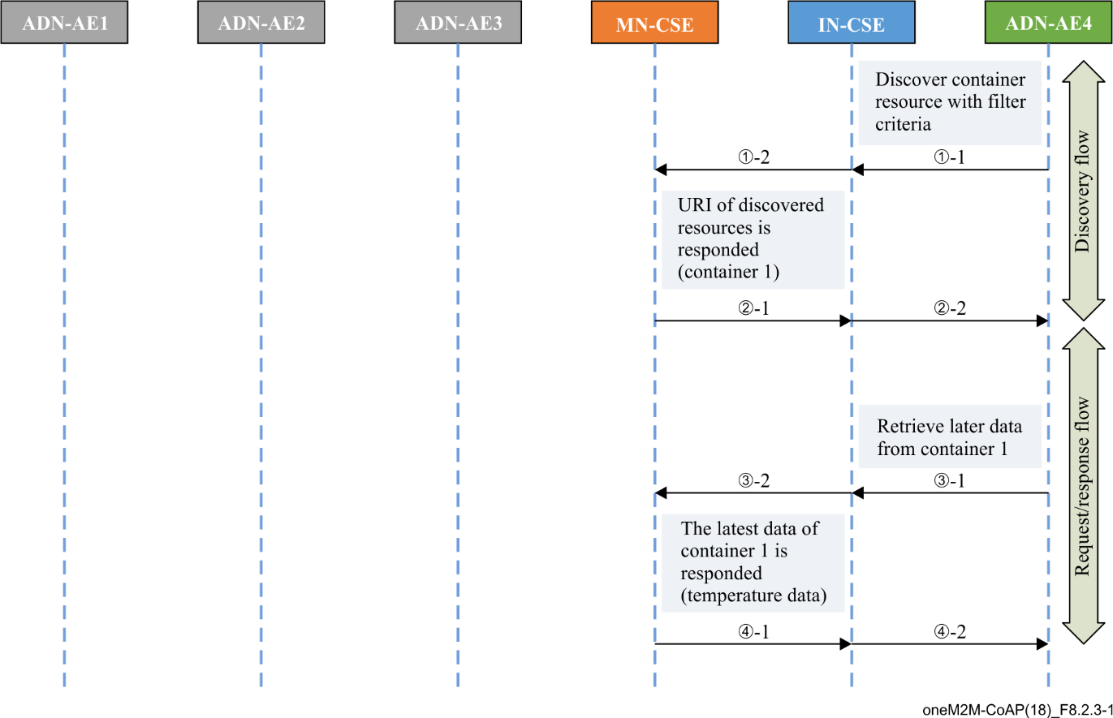

Figure 8.2.3-1 – Discovery and retrieval phase call flows

### 8.2.4 PollingChannel resource creation

As mentioned in clause 8.1, in some use cases, the actuator application cannot be notified by the gateway (MN-CSE).Thus*,* oneM2M defines the <pollingChannel> resource which represents a channel that can be used for such a situation [ITU-T Y.4500.1]. Clause 8.2.4 povides pollingChannel resource creation, as shown in Figure 8.2.4-1 below.

1) A pollingChannel resource is created in the gateway (MN-CSE) to store the actuator status under the registered actuator application ADN-AE3. A pollingChannel resource creation request is initialized by ADN-AE3 target to ADN-AE3 in the MN-CSE. As a result, ADN‑AE3 can poll any type of request(s) that targets to itself.

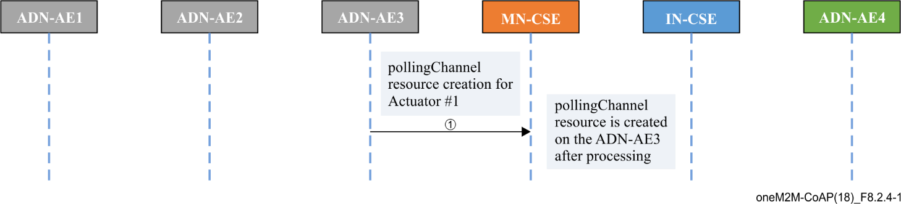

Figure 8.2.4-1 – Initial resource creation phase call flows

It is assumed that applications of *Sensor#1* and *Sensor#2* are registered with the MN-CSE via the process described in clause 8.2.2. Thus, after the pollingChannel resource creation process, the resource tree of the MN-CSE is depicted in Figure 8.2.4-2.

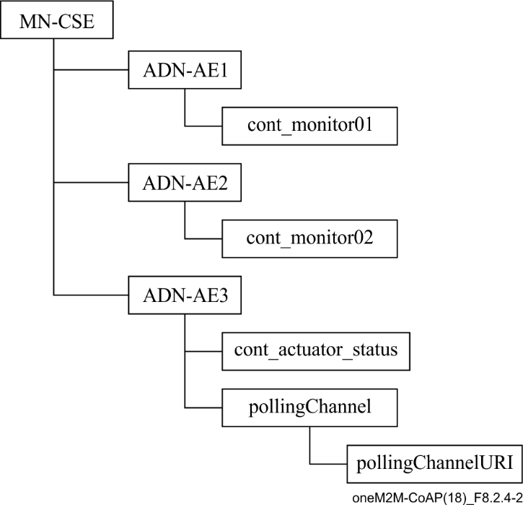

Figure 8.2.4-2 – Resource tree of MN-CSE

### 8.2.5 Actuator switch via polling channel

Thus far, a user can monitor temperature data of *Sensor#1* and *Sensor#2* by the procedures detailed in clauses 8.2.1, 8.2.2 and 8.2.3. If the data of any temperature sensor is above a given threshold, which may indicate a possibility of fire disaster, then the actuator is able to be controlled remotely through the smartphone application accessing the oneM2M service platform and the gateway, in order to achieve some safety management. In clause 8.2.4, the actuator applications are registered with the gateway (MN-CSE), the smartphone application can discover the actuator application though the same process as in clause 8.2.3. This clause provides the switch process via the polling channel.

A call flow for remote control is depicted in Figure 8.2.5-1 and the steps are ordered as follows:

1) The ADN-AE3 sends a RETRIEVE request periodically to the gateway in order to retrieve requests, which are marked as REQ1;

2) When the user updates the actuator state on the smartphone, the ADN-AE4 generates a contentInstance create request representing an updated state of actuator ADN-AE3 to the container of ADN-AE3, which is marked as REQ2;

3) The gateway (MN-CSE) internally processes the RETRIEVE request and response to the ADN‑AE3 with the REQ2 in the content parameter;

4) After processing, e.g., turning on a water spray, then the ADN-AE3 sends a NOTIFY request REQ3 to the gateway (MN-CSE) carrying the UPDATE response "RESP2" in the content parameter, to indicate the switching request was successfully performed;

5) The gateway (MN-CSE) sends an UPDATE response to the smartphone application (ADN‑AE4), to indicate that the status of the actuator was successfully updated;

6) The gateway (MN-CSE) sends a NOTIFY response to the actuator application (ADN-AE3), to indicate that the response was successfully sent.

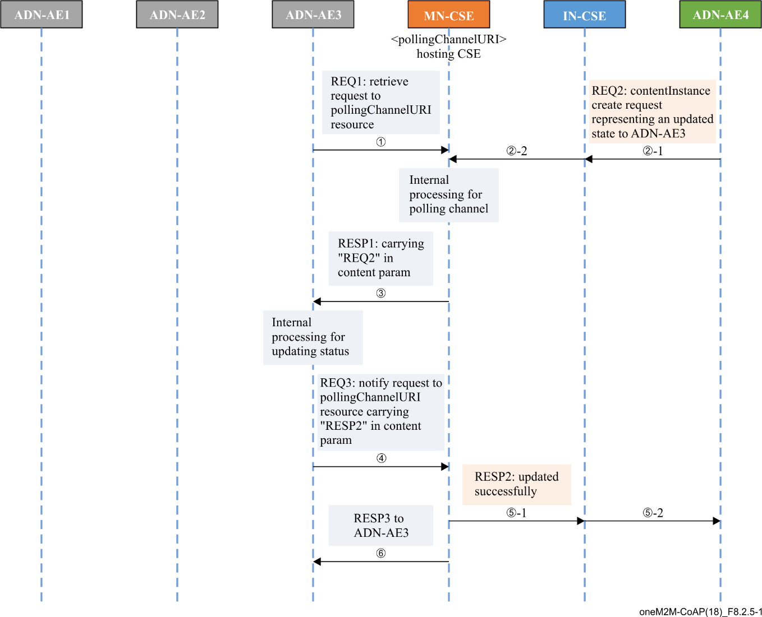

Figure 8.2.5-1 – Actuator remote control phase call flows

# 9 Implementation

## 9.1 Implementation assumption

Assumptions presented below ensure the use case can be correctly implemented.

– Security is not considered in the current use case;

– CoAP binding of oneM2M primitives is used in the current use case, required features according to [ITU-T Y.4500.8];

– JSON serializations of oneM2M primitives is used in the current use case;

– Short names for the representation of resources and attributes are used in the current use case.

Each oneM2M entity including AEs and CSE are addressable with correct host addresses that can be IP addresses or fully qualified domain name (FQDN) addresses resolved to IP addresses by domain name system (DNS) network services according to addressing rules specified in oneM2M standards.

The IN-CSE and MN-CSE entities presented in this use case are addressable with the following identifiers, using service provider (SP)-relative structured format.

– IN-CSE:

• CSE-ID: /in-cse

• Resource ID: cse127865gu57fa

• ResourceName of IN-CSE's CSEBase resource: server

– MN-CSE:

• CSE-ID: /mn-cse

• Resource ID: cse463432er91er

• ResourceName of CSEBase resource: gateway.

## 9.2 Roles of entities

### 9.2.1 oneM2M service platform (IN-CSE)

The oneM2M service platform is modelled as an IN-CSE and is responsible for:

– handling the requests fromsmartphone ADN-AE4 and gateway MN-CSE.

### 9.2.2 Sensor applications (ADN-AE1 and ADN-AE2)

Each of the sensor applications are modelled as an ADN-AE and are responsible for:

– initializing the sensor device;

– registering with the MN-CSE;

– creating container resources in the MN-CSE;

– creating content resources under containers Sensor#1 and Sensor#2 with data.

### 9.2.3 Actuator application (ADN-AE3)

The actuator application is modelled as an ADN-AE3 and is responsible for:

– initializing the actuator device;

– registering with the MN-CSE;

– creating a polling channel resource in the MN-CSE.

### 9.2.4 Smartphone application (ADN-AE4)

The smartphone application is modelled as an ADN-AE4, which directly communicates with the oneM2M service platform IN-CSE and is responsible for:

– initializing the monitor and control application;

– registering the smartphone application with the IN-CSE;

– discovering and displaying;

– accepting and executing actuator control commands.

## 9.3 Procedures

### 9.3.1 Registration and resource creation

The following example shows a sensor application ADN-AE1 registration request and response in clause 8.2.1 using CoAP with JSON serialization.

CoAP Request:

Method: 0.02(POST)   
Uri-Host: mn.provider.com:5683

Uri-Path: ~

Uri-Path: mn-cse

Uri-Path: gateway

Content-Type: application/vnd.onem2m-res+json

oneM2M-TY: 2

oneM2M-FR: C

oneM2M-RQI: 0001

{

"m2m:ae":

{

"rn": "adn-ae1",

**"api": "001.com.company.temsensor",**

**"rr": true**

}

}

CoAP Response:

2.01 Created

oneM2M-RSC: 2001

oneM2M-RQI: 0002

Location-Path: /mn-cse/ae137849axcfrd

{

"m2m:ae":

{

"ty": "2",

"ri": "ae23456789hgfga",

"pi": "cse127865gu57fa",

"ct": "20170327T31415",

"lt": "20170327T31415",

"et": "20170927T66666",

"aei": "CAE23456789"

}

}

Next, the following example shows a container create request and response in the procedure of clause 8.2.2 using CoAP with JSON serialization. Result content parameter *rcn* is used and set to 0 to indicate no response is preferred for the CREATE request.

CoAP Request:

Method: 0.02(POST)   
Uri-Host: mn.provider.com:5683

Uri-Path: ~

Uri-Path: mn-cse

Uri-Path: gateway

Uri-Path: adn-ae1

Content-Type: application/vnd.onem2m-res+json

oneM2M-TY:3

oneM2M-FR: Cadn-ae1

oneM2M-RQI:0002

Uri-Query: rcn=0

{

"m2m:cnt":

{

"rn": "container1"

}

}

CoAP Response:

2.01 Created

oneM2M-RSC: 2001

oneM2M-RQI: 0002

Location-Path: /mn-cse/cont1895qpzlj

Then, the creation of a contentInstance resource under the container of ADN-AE1 with initial content is shown in the following procedure. The following example shows a contentInstance create request and response using CoAP with JSON serialization:

CoAP Request:

Method: 0.02(POST)   
Uri-Host: mn.provider.com:5683

Uri-Path: ~

Uri-Path: mn-cse

Uri-Path: gateway

Uri-Path: adn-ae1

Uri-Path: container1

Content-Type: application/vnd.onem2m-res+json

oneM2M-TY: 4

oneM2M-FR: Cadn-ae1

oneM2M-RQI: 0003

{

"m2m:cin":

{

"cnf": "text/plains:0",

"con": "23"

}

}

CoAP Response:

2.01 Created

oneM2M-RSC: 2001

oneM2M-RQI: 0003

Location-Path: /mn-cse/cin1232gtpaea

{

"m2m:cin":

{

"ty": 4,

"ri": "cin03243dsfas",

"pi": "cont1895qpzlj",

"ct": "20170327T31415",

"lt": "20170327T31415",

"et": "20170927T66666",

"st": 1,

"cs": 2

}

}

According to similar procedures, ADN-AE2, ADN-AE3 and necessary resources can register with the gateway as well. Then the gateway can register with the oneM2M service platform. The smartphone applications can register with the oneM2M service platform anytime as needed. Following such resource creation procedures, ADN-AE3 creates a <container> (cont_actuator_status) as its direct child as well as a <subscription> resource is created under the <container> resource (cont_actuator_status).

### 9.3.2 Discovery and retrieve

As mentioned in clause 9.2.3, the smartphone application (ADN-AE4) periodically sends a RETRIEVE request including the parameter *filterUsage* and specific filter criteria condition(s) as a query string for discovery of resources stored in the MN-CSE of gateway. It is assumed that the <Container1> resource with label "temp1" is created on MN-CSE.

The discovery of containers for each sensor registered with the MN-CSE by the smartphone AE is shown in the following procedure:

CoAP Request:

Method: 0.01(GET)   
Uri-Host: in.provider.com:5683

Uri-Path: ~

Uri-Path: in-cse

Uri-path: server

Uri-path: gateway

Content-Format: 50(application/json)

oneM2M-FR: Cadn-ae4

oneM2M-RQI: 0004

Uri-Query: fu=1

Uri-Query: ty=3

Uri-Query: lbl="temp1"

CoAP Response:

2.05 OK

oneM2M-RSC: 2000

oneM2M-RQI: 0004

{

"m2m:uril":

[

"gateway/adn-ae1/container1"

]

}

The smartphone application retrieves URIs representing containers registered with the MN-CSE from the response message, e.g., gateway/adn-ae1/container1 which is the CSE-relative structured resource URI format of container.

The smartphone application can retrieve the sensor data from ADN-AE1. If the response is preferred to be returned with a JSON representation, the following is a CoAP request message example:

CoAP Request:

Method: 0.01(GET)   
Uri-Host: in.provider.com:5683

Uri-Path: ~

Uri-Path: in-cse

Uri-Path: server

Uri-Path: gateway

Uri-Path: adn-ae1

Uri-Path: container1

Content-Format: 50(application/json)

oneM2M-FR: Cadn-ae4

oneM2M-RQI:0005

CoAP Response:

2.05 OK

oneM2M-RSC: 2000

oneM2M-RQI: 0005

Content-format: application/vnd.onem2m-res+json

{

"m2m:cin":

{

"ty": 4,

"ri": "cin0276fd56fd",

"pi": "cont1895qpzlj",

"ct": "20170327T31415",

"lt": "20170327T31415",

"et": "20170927T66666",

"st": 1,

"cnf": "text/plain:0",

"cs": 2,

"con": "23"

}

}

### 9.3.3 Long polling

As mentioned in clause 8.2.4, for using long polling procedures, ADN-AE3 creates <pollingChannel> resource under its <AE> resource on MN-CSE. <pollingChannelURI> is a virtual resource and made automatically by hosting CSE during creating parent <pollingChannel>. The following example shows <pollingChannel> resource create request and response using HTTP with JSON serialization.

HTTP Request:

POST /~/mn-cse/gateway/adn-ae3?rcn=0 HTTP/1.1

Host: mn.provider.com:8080

X-M2M-Origin: Cadn-ae3

Content-Type: application/vnd.onem2m-res+json;ty=15

X-M2M-RI: mncse-12345

{

"m2m:pch":

{

"rn":"pch_actuator01"

}

}

HTTP Response:

201 Created

X-M2M-RSC: 2001

X-M2M-RI: mncse-12345

Content-Location: /mn-cse/pch7890afer34

ADN-AE3 also generates a container and a contentInstance resource under the ADN-AE3 to store the work status of the actuator ADN-AE3, following a procedure similar to that defined in clause 9.3.1. It is assumed that a subscription to this container resource has been created where a notificationURI attribute is set to the resource identifier of <pollingChannel>.

Then user can subscribe or make a change of the actuator state on the gateway. When users make a change to the actuator state via the smartphone user interface, the smartphone application (ADN‑AE4) performs a new contentInstance creation procedure carrying the new state in request and targeting to the ADN-AE3.

If the contentInstance create request body is represented in JSON, the following is a HTTP request message example:

HTTP Request:

POST /~/mn-cse/gateway/adn-ae3/cont_actuator_status?rcn=0 HTTP/1.1

Host: mn.provider.com:8080

X-M2M-Origin: Cadn-ae4

Content-Type: application/vnd.onem2m-res+json; ty=4

X-M2M-RI: mncse-11123

{

"m2m:cin":

{

"cnf": "text/plains:0",

"con": "ON"

}

}

HTTP Response:

201 Created

X-M2M-RSC: 2001

X-M2M-RI: mncse-11123

Content-Location: /mn-cse/cin7893setj34

The gateway will then generate a notification based on the notification event criteria that is a new contentInstance creation under the subscribed container resource (cont_actuator_status). Usually the actuator (ADN-AE3) sends periodically a Retrieve request to the <pollingChannelURI> resource on the gateway in order to retrieve the notification target to itself.

If the request body is represented in JSON, the following is a HTTP request message example:

HTTP Request:

GET /~/mn-cse/gateway/adn-ae3/pch_actuator01/pcu HTTP/1.1

Host: mn.provider.com:8080

X-M2M-Origin: Cadn-ae3

X-M2M-RI: mncse-11223

HTTP Response:

200 OK

X-M2M-RSC: 2000

X-M2M-RI: mncse-11223

{

"m2m:sgn":

{

"nev":{

"rep":

{

"cin":

{

"cnf": "text/plain:0",

"con": "ON"

}

},

"net": [3]

},

"sur":"/mn-cse/sub856463ahyvc28"

}

}

After retrieving the notification, the state of the actuator (ADN-AE3) can be updated automatically. Then the ADN-AE3 sends a request to the gateway to indicate that the previous notification was successfully performed.

# 10 Conclusions

The current use case is realized by following the high-level procedures such as registration of smart devices, gateway with the oneM2M service platform, container resource creation, content instance retrieval, and using polling channel for actuator switch.

XML serialization and HTTP binding of oneM2M primitive, as well as other implementation examples are intended to be covered in other developer guides.

Bibliography

[b-ITU-T Y.4500.4] Recommendation ITU-T Y.4500.4 (2018), *oneM2M – Service layer core protocol specification*.

_____________