Standardization Sector
ITU-T Technical Report
(07/2024)
DSTR-STUDY_IMT2020MVNOs
5G related policy considering MVNOs
ITUPublications | International Telecommunication Union


Technical Report ITU-T DSTR-STUDY_IMT2020MVNOs
5G related policy considering MVNOs

Summary
This Technical Report seeks to study the various economic and policy aspects related to IMT2020 technologies taking into consideration mobile virtual network operators (MVNOs). In addition, it presents an overview of 5G deployment and MVNOs, a detailed review of MVNO conceptual models as well as drivers and barriers to MVNO rollout. The report also presents various case studies from Member States in order to inform best practices.

Keywords
5G, MVNOs.

Note
This is an informative ITU-T publication. Mandatory provisions, such as those found in ITU-T Recommendations, are outside the scope of this publication. This publication should only be referenced bibliographically in ITU-T Recommendations.

Change Log
This document contains Version 1 of the ITU-T Technical Report DSTR-STUDY_IMT2020MVNOs on "5G related policy considering MVNOs" approved at the ITU-T Study Group 3 meeting held in Geneva, 9-18 July 2024.

Editor: | Zuhair Al-Zuhair  Communication & Information Technology Regulatory Authority (CITRA)  Kuwait | Tel: +965 22330777  E-mail: z.alzuhair@citra.gov.kw

© ITU 2024
All rights reserved. No part of this publication may be reproduced, by any means whatsoever, without the prior written permission of ITU.

Table of Contents
Page
1 Scope 1
2 References 1
3 Definitions 1
3.1 Terms defined elsewhere 1
3.2 Terms defined in this Technical Report 1
4 Abbreviations and acronyms 1
5 Overview of mobile virtual network operators (MVNOs) 3
6 5G deployment and MVNOs 4
6.1 MVNOs in 5G NSA 4
6.2 MVNOs in 5G SA 4
7 Conceptual models of MVNOs in 5G SA 5
7.1 Light "VMNO" 5
7.2 Full VMNO 6
7.3 Evolved interconnection model 7
8 Policy, regulatory and economic aspects of MVNOs 8
8.1 Drivers and enablers of MVNOs 8
8.2 Factors that inhibit MVNOs rollout 9
9 Regional case studies 10
9.1 Japan 10
9.2 India 11
9.3 Kenya 12
9.4 Zimbabwe 15
9.5 Brazil 16
10 Conclusion 16

Technical Report ITU-T DSTR-STUDY_IMT2020MVNOs
5G related policy considering MVNOs

1 Scope
The transition from 4G to 5G services will transform the way in which telecommunications/information and communication technology (ICT) ecosystems function worldwide, as 5G transformative potential is reshaping existing business models across the length and breadth of every sector. To fully harness the enormous potential shown by 5G, stakeholders must proactively realign existing practices to ensure that the benefits of 5G are availed of without extensive complexities and disruption. At policy and regulatory level, the basic necessities required for 5G wireless networks such as guaranteed availability of spectrum and provision of support infrastructure have to be provided in a fair, responsible and seamless manner. The progressive development of 5G wireless technologies offers a unique opportunity to drastically broaden the boundaries and adaptability of wireless networks, which in turn will have significant ramifications on broadband competitiveness, efficiency, and development. 5G is set to transform the business models of both mobile network operators (MNOs) and mobile virtual network operators (MVNOs). Policy makers have a critical role to play in order to create an enabling environment that allows the full potential of emerging technologies and future networks. By addressing the key issues mentioned above, governments can pave the way for a successful 5G transition, driving economic growth, innovation, and social progress.

2 References
[ITU-T Y.3100] Recommendation ITU-T Y.3100 (2017), Terms and definitions for IMT-2020 network.
[ITU-T Y.3103] Recommendation ITU-T Y.3103 (2018), Business role-based models in IMT-2020.

3 Definitions

3.1 Terms defined elsewhere
This Technical Report uses the following term defined elsewhere:
3.1.1 network slice [ITU-T Y.3100]: A logical network that provides specific network capabilities and network characteristics.

3.2 Terms defined in this Technical Report
This Technical Report defines the following term:
3.2.1 mobile virtual network operator (MVNO): A wireless communication services provider that does not own the wireless network infrastructure over which it provides services to its customers.

4 Abbreviations and acronyms
This Technical Report uses the following abbreviations and acronyms:
3GPP 3rd Generation Partnership Project
5GC Core network for IMT-2020, known as "5G Core network"
API Application Programming Interface
ASP Applications Service Provider
BSS/OSS Business Support System/Operation Support System
BTS Base Transceiver System
BSC Base Station Controller
CERRE Centre on Regulation in Europe
CSP Contents Services Provider
DECT Digital Enhanced Cordless Telecommunications
DSLAM Digital Subscriber Line Access Multiplexer
EMB Enhanced Mobile Broadband
en-gNodeB NR wireless base station connected to EPC and eNodeB with certain RP
eNodeB E-UTRA Wireless base station
EPC Core network for IMT-Advanced, known as "Evolved Packet Core"
E-UTRA Evolved Universal Terrestrial Radio Access
gNodeB NR wireless base station
GMSC Gateway Mobile Switching Centre
HSS Home Subscriber Server
IoT Internet of Things
IP Internet Protocol
LAN Local Area Network
LTE Long Term Evolution
MIC Ministry of Internal affairs and Communications
mMTC massive Machine Type Communications
MNO Mobile Network Operator
MSC Mobile Switching Centre
MVNE Mobile Virtual Network Enabler
MVNO Mobile Virtual Network Operator
ng eNodeB E-UTRA wireless base station connected to 5GC and gNodeB with certain RP
NFP Network Facilities Provider
NR New Radio
NRA National Regulatory Authority
NSA 3GPP 5G-SRIT, known as "Non-Standalone"
NSO Network Service Operator
PGW Packet Gateway
PSTN Public Switch Telephone Network
RIT Radio Interface Technology
RP Reference Point
RSU Remote Switching Unit
QoS Quality of Service
SA 3GPP 5G-RIT, 5Gi and DECT 5G-SRIT, known as "Standalone"
SLA Service Level Agreement
SRIT Set of Radio Interface Technology
SSA Secondary Switching Area
TAX Trunk Automatic Exchange
TRAI Telecom Regulatory Authority of India
TSP Telecom Service Provider
UE User Equipment
UL Unified License
URLLC Ultra Reliable and Low Latency Communications
VAS Value Added Services
VoIP Voice over Internet Protocol
VMNO Virtual Mobile Network Operator
VNO Virtual Network Operator

5 Overview of mobile virtual network operators (MVNOs)
The definition of mobile virtual network operator (MVNO) is widely accepted as a licensed mobile telecommunications operator without radio spectrum licenses and radio facilities (i.e., base stations) of its own that piggybacks on a host mobile network operator (MNO) with those radio resources. MVNO businesses can be broken down into several categories. Figure 1 shows the typical classification of MVNO businesses.
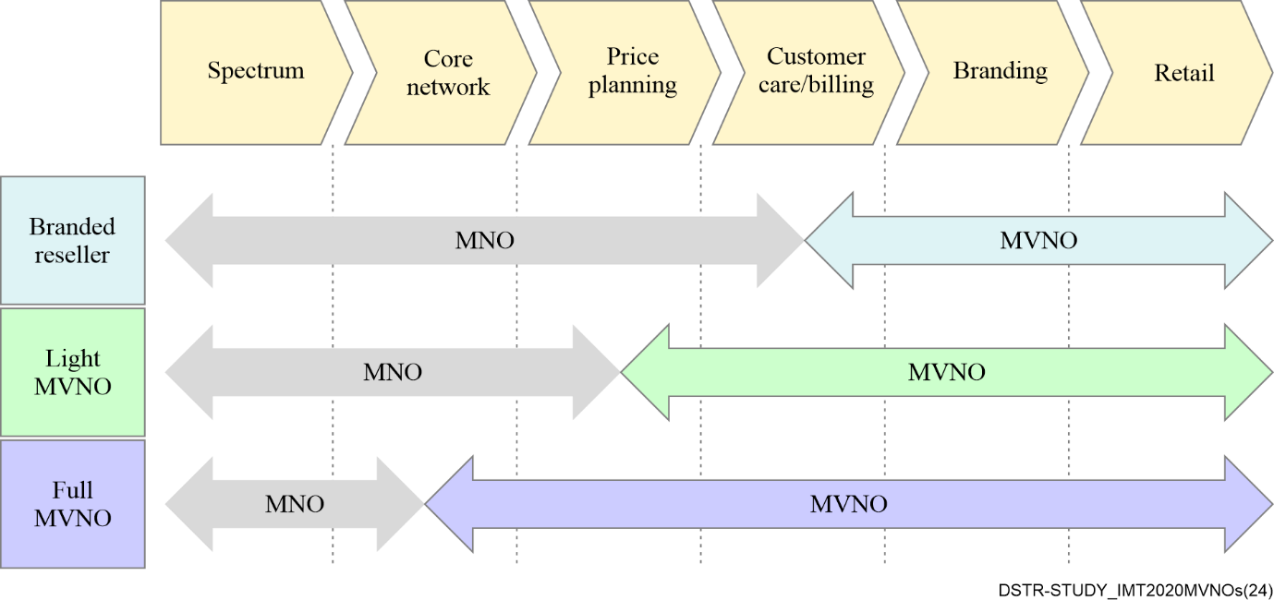
Figure 1 – The typical classification of MVNOs
MVNOs have been seen in many countries since approximately 2000. In those countries, MVNOs continue to play their anticipated role as not only providers of a variety of diversified mobile services for niche markets but also as actors for healthy competition in entire mobile markets, which have been fundamentally liable to oligopoly from finite resources of spectrum. Furthermore, they also fulfil an innovator role because of their tendency to be relatively independent from geographical boundaries, physical networks, and existing mobile market structures.
This definition and these anticipated roles of MVNOs have not been, and will not be, affected by the evolution of mobile technology. However, the progress of network virtualization and network softwarization towards 5G will urge MVNOs to change their current ways of doing business and how they piggyback on their host MNOs. The social acceptance of Internet of things (IoT) applications will require the deep engagement of various MVNOs with a high degree of flexibility. Therefore, to formulate appropriate policies, some of which are illustrated in clause 8, that are adapted to each domestic mobile market, regulators need to recognize what happens now in relation to MVNOs and the progress of network virtualization/softwarization.

6 5G deployment and MVNOs
It is often said that there are two steps towards 5G, "non-standalone" (NSA) as an earlier deployment and "standalone" (SA) as later one. NSA is now ready to be deployed, and indeed NSA has already been deployed by mobile network operators (MNOs) in many countries, and is applicable by many MVNOs in those countries.

6.1 MVNOs in 5G NSA
In 5G NSA architecture, 5G deployment will be very limited, both in terms of its radio facilities and core networks. All 5G radio facilities (en-gNodeB) will be hosted by evolved packet core (EPC) with minimal software upgrades.
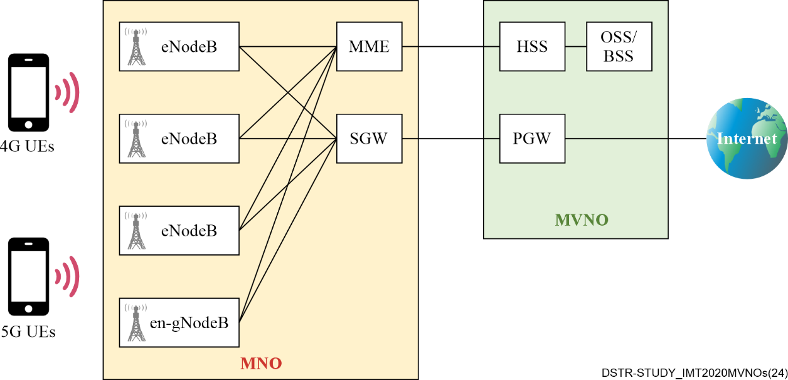
Figure 2 – Anticipated interconnection model of MVNOs in 5G NSA
Figure 2 shows how an MVNO can be hosted by an MNO in 5G NSA, in a manner quite similar to that with 4G or earlier technologies. Some EPC nodes like the packet gateway (PGW) or home subscriber server (HSS) might be operated by the MVNO itself under a commercial agreement with the host MNO as necessary to ensure the flexibility of services. In such cases, physical interconnections divide a core network into two parts.

6.2 MVNOs in 5G SA
In contrast to 5G NSA, 5G SA does not require EPC, as all gNodeBs will be switched to a 5G core network (5GC), and likewise for upgraded 4G radio facilities (ng eNodeB). 5GC is expected to be built up as software-based functions on the computing resource platform, like cloud-based applications, using virtualization technology.
A logical network composing a 5GC, also known as a 'network slice' or simply a 'slice', can be distinguished to provide operators flexibility to create networks customized according to diverse requirements from the perspective of functionality, performance, isolation, etc. The customer's requirement for mobile service could be complicated, and well-placed in-between three representative services of 5G: enhanced mobile broadband (EMB), ultra reliable and low latency communications (URLLC), and massive machine type communications (mMTC). These dedicated flexibilities for the customers' requirements are important so that an MNO can configure a customized 5GC for a certain application/use-case to ensure the requirement of quality of service (QoS) from one end user equipment (UE) to the other end (application server). Figure 3 shows MVNOs in 5G SA.
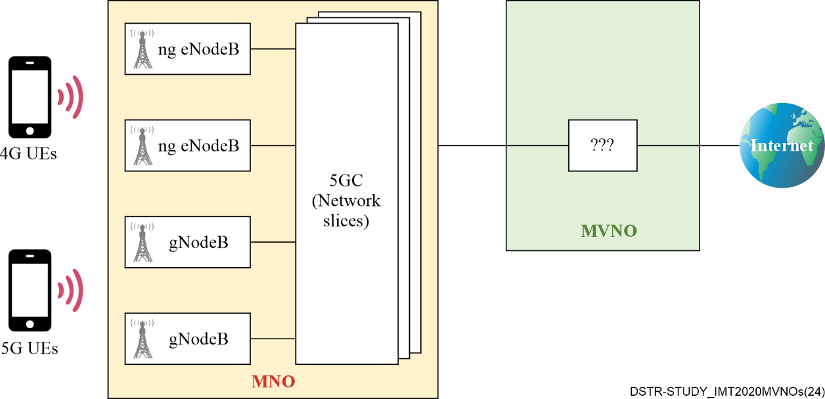
Figure 3 – MVNOs in 5G SA
From the MVNO point of view, these flexibilities are also imperative, as an MVNO can then offer various and innovative services dedicated to specific customers. However, current interconnection models of piggybacking could undermine an MVNO's flexibilities because cooperation between the MNO's part and the MVNO's part of the 5GC is essential for the end-to-end QoS guarantees that are requested by the customers.
Consequently, all MVNO stakeholders must forge different cooperation models between MVNOs and their host MNOs, or improve the current interconnection models thoroughly in order to allow MVNOs to ensure end-to-end QoS guarantees.

7 Conceptual models of MVNOs in 5G SA

7.1 Light "VMNO"
The Centre on Regulation in Europe (CERRE), the European regulatory think tank, argues in its White Paper published in September 2019 that full MVNOs ("so-called deep-MVNOs typically own a part of the signalling and routing control infrastructure" in the original document. There is no internationally united definition of "full MVNO" yet.) may no longer be possible in the fully virtualized infrastructure of 5G. As an alternative, CERRE calls for the introduction of a new conceptual operator model called the virtual mobile network operator (VMNO), under which VMNOs are granted access to the application programming interfaces (APIs) provided by the host MNO to enable them to manage their own slice with the same level of flexibility as that of the host MNO. This would enable VMNOs to offer adequate QoS levels for dedicated applications that provide high-value mobile solutions for particular industries or across industries (verticals).
Figure 4 shows the anticipated structure of VMNOs (for the sake of expediency, these are called "light VMNOs" in the figure and in this Report) and host MNOs.
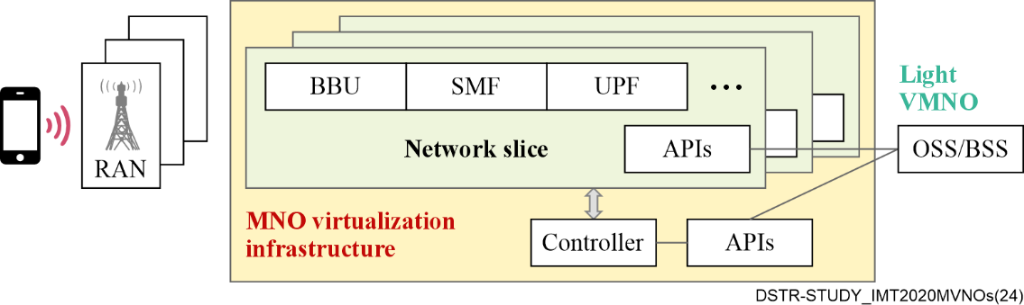
Figure 4 – Anticipated light VMNO structure
This structure allows light VMNOs to manage their virtualized core network on the host MNO's virtualization infrastructure through APIs. At least two sets of APIs will be required, one for managing core network functions on an individual slice and one for managing slices themselves, including the ability to create new slices, delete unused slices, etc. In this sense, the light VMNO is expected to play the role of not only network slice provider but also network slice management and orchestration provider both defined in [ITU-T Y.3103].

7.2 Full VMNO
The Telecom Services Association, one of four Japanese telecommunications industry associations, called for the addition of another type of virtual telecommunications operator on 5G SA called full VMNO, with reference to the light VMNO concept originated by CERRE.
The base technology for the full VMNO concept is spectrum sharing. Even so, full VMNOs could also be enabled from the progress of virtualization. Figure 5 illustrates the structure of a full VMNO.
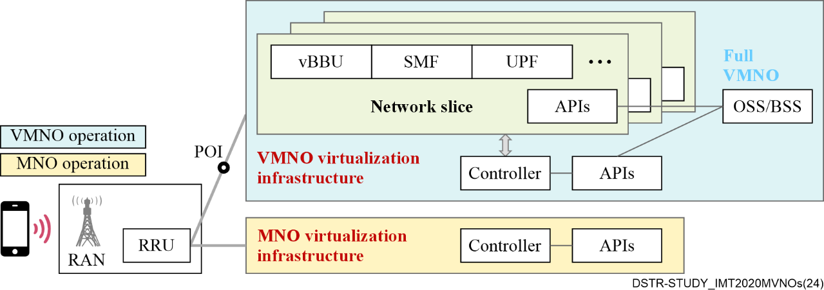
Figure 5 – Anticipated full VMNO structure
The difference between a light VMNO and the full VMNO concept proposed by the Telecom Services Association lies in ownership of the virtualization infrastructure. Light VMNO fully depends on the host MNO's infrastructure, while full VMNO is independent of the MNO's infrastructure except for the radio part. This would give full VMNOs an opportunity to cooperate commercially with other wireless network operators with technical and operational independence from their host MNO. Having this independence is a benefit of full MVNOs in the current generation.

7.3 Evolved interconnection model
Full MVNO in the current generation is technically based on the standardization of international roaming. Figure 6 shows current logical interconnections between home and visited operators in a current LTE roaming scenario, and full MVNO architecture in the current long term evolution (LTE) generation in comparison.
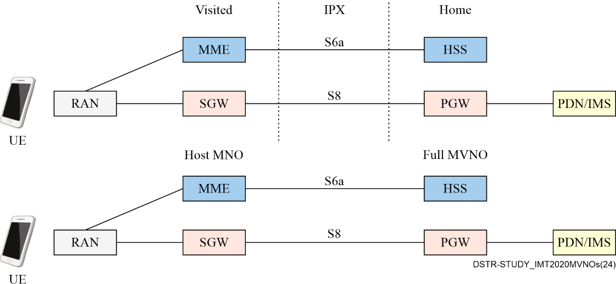
Figure 6 – International roaming and full MVNO piggybacking in 4G LTE
It is intuitive then to utilize 5G SA international roaming architectures as the technological basis of MVNOs in 5G SA. Figure 7 shows the network diagram of 5G SA roaming under study.
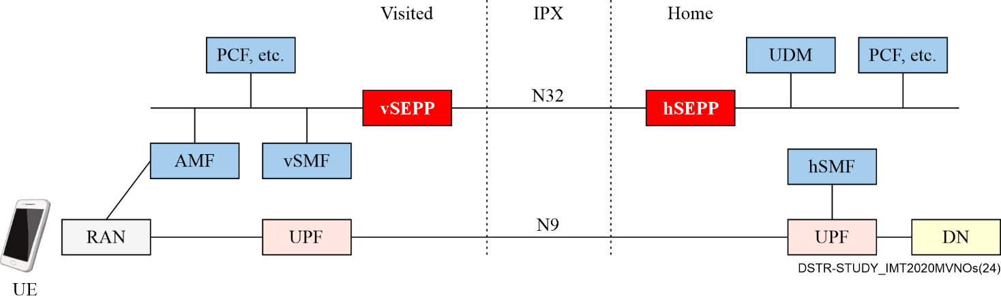
Figure 7 – International roaming architecture in 5G SA
There is as yet no commercialized use-case of 5G SA international roaming, so an MVNO and their host MNO should carefully observe the progress of the standardization work and its commercial deployments, so that they can utilize it as their own piggybacking measure. In addition, it is necessary to realize that managing/coordinating slices between both sides is out of scope of 5G SA international roaming so far. So, an MVNO based on this model should prudently negotiate with their host MNO how to operate slices across both networks if they wish to offer advanced and unprecedented mobile connectivity services with slice, for their customers' requirements from the perspective of functionality, performance, isolation, etc.

8 Policy, regulatory and economic aspects of MVNOs
The concept of MVNOs is to bring in optimization of telecom resources used, innovative business models at service delivery layer, and provision of value addition and differentiation in collaboration with MNOs.

8.1 Drivers and enablers of MVNOs
MVNOs ideally provide an alternative to additional MNOs which comes with a lot of regulatory issues including the headache of spectrum scarcity. MVNO regulation is relatively simple compared to regulating a whole new MNO as they, to a large extent, rely on market forces – unlike the regulation of alternative MNOs, which is complex and driven primarily by the scarcity of spectrum, the substantial capital-intensive costs involved, and the fundamental impact that telecommunications have on the economic and social fabric of any market.
The emergence of the MVNO model in a market is driven by a number of factors:
a) Mature consumer market that is highly segmented, creating opportunities in niche/segmented markets that require unique and integrated offerings.
b) A strategic decision by an MNO looking to extend its existing operations and target niche or underserved segments through a second or perhaps multiple brands.
c) Competitive pressure to continue to invest in improving the network leaving little room to concentrate on marketing and distribution channels.
d) Slowing growth of subscriptions thus making wholesale a more attractive revenue source to the mobile operators than the retail headache.
e) Emerging innovative products fuelled by integration of voice and data products such as video, music, and gaming making mobile a viable and numerous media content channel.
f) Market opportunities for customer acquisition by non-mobile companies e.g., banks based on their existing core competencies such as content, brand extensions or efficient distribution channels.
g) Mobile operators often find it difficult to succeed in all customer segments. MVNOs are a way to implement a more specific marketing mix, whether alone or with partners. They can also help attack specific, targeted segments given that MVNOs have a thorough knowledge of their market segment, allowing them to cater to that segment in a far more personal, relevant way than large-scale MNOs can.
h) Many mobile operators have capacity, product and segment needs. An MVNO strategy can generate economies of scale for better network utilization, including utilizing multiple networks provided by multiple MNOs for the sake of maximalising spectrum efficiency and network redundancy, especially in the case of full MVNO.
i) High churn from MNOs as MVNOs propositions may be more attractive to existing MNO customers leading to mass migration.
j) MVNOs can effectively target the IoT market by offering specialized connectivity solutions tailored to the unique requirements of various devices and applications.
The optimal timing for introduction of MVNOs in many markets depends primarily on the level of market saturation, as measured by mobile penetration, and the level of market concentration, as measured by the distribution of existing players' market share. However, in addition to the driving factors highlighted above, national regulatory authorities (NRAs) can take specific steps to create an enabling environment for the sustainable deployment of various MVNO models.
Typically, MVNOs may be considered as a type of active infrastructure sharing which may or may not require the shared use of radio frequency spectrum. Regulatory frameworks focused on promoting equitable and non-discriminatory access can therefore create favourable conditions for the roll out of MVNOs. However, in the face of increasing 5G deployment and adoption, there is a need to review traditional policy and regulatory frameworks to incorporate the new dimensions of access and infrastructure sharing in a 5G era while ensuring guaranteed availability of spectrum and shared infrastructure in a fair and responsible manner. Specifically, the following enablers can be beneficial for forward-looking frameworks to facilitate MVNO rollout:
– Non-discriminatory access to network infrastructure: Regulatory frameworks that mandate MNOs to provide fair and non-discriminatory access to their network infrastructure ensure that MVNOs can utilize existing infrastructure without facing barriers imposed by incumbent operators, thereby fostering competition and service diversity.
– Spectrum sharing policies: Clear policies and guidelines for spectrum sharing that allow MVNOs to access necessary radio frequencies, either through leasing arrangements or dynamic spectrum access models would ensure that spectrum is used efficiently and that smaller players have the opportunity to enter the market and innovate.
– Simplified licensing procedures: A streamlined licensing process for MVNOs would reduce administrative burdens and accelerate market entry. This could include the introduction of unified or light licensing regimes that are more adaptable to different MVNO models and business models, thus encouraging more entrants into the market.
– Support for network slicing: Enabling MVNOs to leverage network slicing capabilities of 5G networks, would allow them to offer customized and differentiated services over shared physical infrastructure. Regulatory support for network slicing can therefore promote innovation and tailored service offerings, meeting diverse consumer and enterprise needs.
– Incentives for infrastructure sharing: Providing incentives for MNOs and other infrastructure owners to engage in active infrastructure sharing with MVNOs would make it economically attractive for MNOs to share their network resources, thereby lowering the entry barriers for MVNOs. This can include financial incentives, tax benefits, or regulatory forbearance.

8.2 Factors that inhibit MVNOs rollout
Factors that inhibit MVNOs rollout include:
a) Intense market competition and saturation, where established MNOs often dominate, making it difficult for MVNOs to carve out a niche and attract customers.
b) MVNOs are sometimes at a disadvantage due to their dependency on MNOs for network access and infrastructure. MVNOs depend on the agreements with MNOs and this reliance can create vulnerabilities and limit the MVNOs' ability to control service quality and pricing. Moreover, MNOs control the physical infrastructure, giving them significant leverage in negotiations.
c) The host MNOs may consider MVNOs as threat which can cannibalize the MNO's current offerings. MVNO will bring in more competition which could further lower the average revenue generated per user (ARPU).
d) The MVNO model is highly dependent on value added services (VAS) for earning profitable revenue, which in turn depends on 3G, 4G and 5G network availability.
e) Slowing penetration growth for MNOs as MVNOs become aggressive marketers and the new frontier for growth leaving MNOs stagnant and probably concentrating on infrastructure.
f) Increasing customer acquisition costs as competition become difficult and aggressive marketing becomes the only way. Distribution channels have to be close to customers hence increased cost.
g) MVNO can trigger price wars and undermine profitability of all players and driving the mobile market towards lower ARPU.
h) Though MVNO can increase MNOs network utilization, it can also cause serious network congestion problems which leads to reductions in service quality.
i) Lack of brand recognition: MVNOs may have difficulty building brand recognition and customer loyalty compared to larger, well-established MNOs.
j) Lack of an enabling licensing framework in some jurisdictions.
k) Lack of technology know-how and other requisite skills by the MVNOs.
The IMT-2020 networks with its unique features such as network slicing, optimization for specific service level agreements (SLA) and QoS can offer a huge landscape for MVNOs. The role of MVNOs in the 5G deployment scenario has to be explored and the experiences of some countries in this subject can serve as a guide for other countries to plan the policies and regulations concerning MVNOs.

9 Regional case studies

9.1 Japan
During the public consultation held by the Ministry of Internal affairs and Communications (MIC) in September 2019 to consider how to ensure adequate MVNO access to MNO networks in 5G, Telecom Services Association posed two concepts of VMNO simultaneously.
The MNOs that participated in the consultation made the following statements:
– Prior to the negotiations between MNOs and MVNOs, MNOs would like to clarify the MVNOs' request related to their services to be realized and practical architecture for connection by means of the open 5G SA functions. Further, it is appropriate in principle to entrust business-based discussion to related operators firstly so that various players are able to create new value flexibly using their ingenuity and inventiveness, which is from the perspective of cultivating innovation and bolstering international competitiveness, including that of domestic vendors and the creation of innovation. Related parties should not have discussions anticipating unspecified future technologies.
– When considering the openness of MNO networks, examination of regulations should be executed if necessary, based on the contents of the MVNO guideline that respects the consensus building from the subject discussion between related operators while looking at the progress of technical standardization and related technical consideration by each MNO, and, as for the basic framework of unbundling, taking into account of the second class operators' infrastructure investment and incentive to innovation.
– In terms of full VMNOs, careful discussion is required because there are various concerns about serious risks – e.g., unplanned network interruptions, loss of service quality and security risks, due to lack of network management integrity, including capacity planning for the radio facilities, network admission controls based on SLAs, etc., if the core network is out of the MNO's control.
On the concept of both full VMNOs and light VMNOs for virtual telecommunications operators on 5G SA, the necessity of further consideration is recognized as stated in the report of the consultation published in February 2020 to ensure fair competition among MNOs and MVNOs to enable MVNOs to develop high-value services in accordance with 5G features.
Further discussion took place between the Telecom Services Association and three major MNOs (NTT DOCOMO, KDDI and SoftBank) from March to May 2021. The conclusion of this discussion contained a total of five possible models, including two concepts of VMNO, one wholesale model with a minimum flexibility, and two evolved interconnection models (one is based on the technical standardization for international roaming, the details are shown in clause 7.3).
In response to this conclusion, MIC urged both MVNOs and MNOs to discuss individually in accordance with their commercial MVNO agreements, to deepen their mutual understanding, to remedy asymmetry of information across both sides, and to seek a way forward on how MVNOs can launch their 5G SA services with the least delay from MNO's 5G SA launch.

9.2 India
The Government of India has issued guidelines for granting of a unified license for virtual network operators. After considering the recommendations of the Telecom Regulatory Authority of India (TRAI) on VNOs, the Indian Government has decided to grant a unified license (UL) VNO. The basic features of UL (VNO) are as follows:
i) VNOs are treated as extensions of network service operator (NSOs) of telecom service providers (TSPs) and they would not be allowed to install equipment interconnecting with the network of other NSOs.
ii) Applicants can apply for a UL (VNO) along with VNO authorization for any one or more of services listed below:
– Unified license VNO (all services)
– Access service (service area-wise)
– Internet service (Category-A with all India jurisdiction)
– Internet service (Category-B with jurisdiction in a service area)
– Internet service (Category-C with jurisdiction in a secondary switching area (SSA))
– National long distance (NLD) service
– International long distance (ILD) service
– Global mobile personal communication by satellite (GMPCS) service
– Public mobile radio trunking service (PMRTS) service
– Very small aperture terminal (VSAT) closed user group (CUG) service
– INSAT MSS-reporting (MSS-R) service
– Resale of international private leased circuit (IPLC) service
– Machine to machine (M2M) (Category-A with all India jurisdiction)
– Machine to machine (M2M) (Category-B with jurisdiction in a service-area)
– Machine to machine (M2M) (Category-C with jurisdiction in an SSA/district area).
Some of the notable guidelines are:
1. VNOs that enter the network would do so based on arriving at a mutual agreement between an NSO and a VNO.
2. The terms and conditions of sharing of infrastructure between the NSO and VNO shall be on the basis of mutually accepted terms and conditions between the NSO and the VNO.
3. VNOs shall be permitted to set up their own network equipment viz. base transceiver system (BTS), base station controller (BSC), mobile switching centre (MSC), remote switching unit (RSU), digital subscriber line access multiplexer (DSLAM), local area network (LAN) switches). VNOs shall not be allowed to own/ install equipment of core infrastructure, i.e., gateway mobile switching centre (GMSC), soft switches and trunk automatic exchange (TAX) or equivalent. Therefore, they are not allowed to own/install equipment which are required for interconnection with other NSO(s), viz. GMSCs, soft-switches and TAX. Soft switch is an application programme interface (API) that is used to bridge a traditional public switch telephone network (PSTN) and voice over Internet protocol (VoIP) by linking PSTN to Internet protocol (IP) networks and managing traffic that controls a mixture of voice, fax, data and video. Soft switch is a software-based switching platform based on open systems.
4. VNOs shall also be allowed to create their own service delivery platforms in respect of customer service, billing and VAS.
5. An operator who wishes to provide telecom services to its customers utilizing the underlying network and/or access spectrum of an existing NSO will have to obtain UL (VNO) license.
6. There shall be no restriction on the number of VNOs parented by an NSO.
7. VNOs will be allowed to have agreements with more than one NSO for all services other than access services and such services which need numbering and unique identity of the customers.
8. An NSO shall allocate a numbering range to their VNO(s) from the numbering range allocated to it by the licensor. VNOs shall also utilise the LRN and network codes of the parent NSO for the purpose of routing of calls.
9. There would not be any mandate to an NSO for providing time bound access to its VNO; rather, it shall be left to the mutual agreement between NSO and VNO. However, the Department of Telecommunications/TRAI shall have the right to intervene in the matter as and when required to protect the interest of consumers and the telecom sector.
10. Charging and accounting functions (CAF) verification and number activation shall be the responsibility of a VNO.
11. A VNO shall bear the penalty on account of failure of subscriber verification norms (for its own customers). Other penalties which are beyond the scope of the VNO viz. roll out obligations, core network issues, etc. shall be borne by the NSO as per existing norms defined for them.
12. No spectrum shall be assigned to the VNOs.

9.3 Kenya

9.3.1 MVNO and unified licensing framework
In 2008, the regulator adopted a unified licensing framework (ULF) which sought to address challenges associated with a technology specific licensing regime arising from the technological advancements that led to convergence.
This framework collapsed all the technology specific licenses into three categories with regards to MVNO as follows:
1. Network facilities provider (NFP) – that owns and operates any form of communications infrastructure (based on satellite, terrestrial, mobile or fixed);
2. Applications service provider (ASP) – that provides all forms of services to end users using the network services of a facilities provider. The services are all communication services except services that are content in nature. Resources applicable to this license are numbering resources both for customers and for network nodes; and
3. Contents services provider (CSP) – to provide content related services to end users who are customers of the application service providers. Content service providers use the infrastructure of network facilities providers and the systems of the application service providers to reach their customers. The services offered by content service providers are of information, entertainment, education, health, social, etc., nature that can either be text, voice, video clips delivered to a customer's mobile device on request or as subscribed to by the customer. With these three categories, the existing MNOs were therefore issued with NFP-T1 license to cover the entire infrastructure related component while all other services including subscription of customers are covered under the ASP license.
Upon the adoption of ULF in 2008, the regulator took a position that MVNOs fall under the ASP license since they do not require access spectrum but must register customers. This has remained the position of the regulator with regards to MVNOs and indeed informed a few interested parties that the "issues on the introduction of MVNOs relate to network capacity, interconnection, co-location, and infrastructure sharing among others and that there is a strong link between the viability of this business with the availability of extra/unutilized capacity within the networks of the existing cellular mobile operators and indeed the operators' willingness to make the same available for use by the said MVNOs".
The regulator has further maintained that potential MVNO's wishing to provide the said MVNO services should first approach the existing MNOs with a view to determining whether they have extra network capacity which they are willing to make available for use by an MVNO. Once this has been established the MVNOs would approach the regulator for further consideration on the licensing of the operation.

9.3.2 MVNO models
There are four permitted business models of MVNOs in Kenya and the characteristics of each of these business models and the corresponding licensing requirements are discussed below:

9.3.2.1 Full MVNO
A full MVNO is one that owns or provides network facilities and network services such as mobile switching centres, home location registers ("HLR"), authentication centres and cellular mobile services. Full MVNOs are able to secure their own numbering ranges, offer their own SIM cards and have full flexibility on the design of the services and tariff structures. A key feature that distinguishes a full MVNO from other business models is its ability to operate independently of the MNOs.
A full MVNO may require a network facility provider-Tier 2 (NFP T2) licence in addition to the application service provider (ASP) license in order to build full core infrastructure including the interconnecting backbone infrastructure. Where the full MVNO does not obtain the NFP-T2 license, the MVNO will lease backbone infrastructure from the licensed NFP-T2 operators.
It therefore follows that existing NFP-T2 operators can provide full MVNO services if they establish the relevant core network elements necessary for the provision of cellular mobile services.

9.3.2.2 Enhanced MVNO service providers
Enhanced service providers are those who do not own or provide network facilities but have the ability to secure their own numbering range, operate their own HLR and offer their own SIM cards with their own mobile network code. They are dependent on MNOs for network facilities, as well access to the radio network. These service providers are still able to maintain some independence from MNOs as they are able to differentiate their products.
Enhanced service providers require an ASP licence to provide cellular mobile services and related application services to end users.

9.3.2.3 Enhanced reseller
Enhanced resellers are primarily distributors who resell services provided by MNOs. As with enhanced service providers, enhanced resellers rely on MNOs for access to the radio network and network facilities. The key feature that distinguishes enhanced resellers from enhanced service providers is that enhanced resellers do not have their own SIM cards. While they may still be able to offer their own branded packages, they will not be able to distinguish their services by their MNC. Enhanced resellers are likely to carry out customer care and billing in-house.
Enhanced resellers require an ASP licence to provide cellular mobile services and related application services to end users.

9.3.2.4 Resellers
Resellers merely resell subscriptions to end users. In most cases, resellers are completely dependent on MNOs for every aspect of service provision, billing and customer care. However, end users will not be able to make a distinction between resellers, other forms of MVNOs and MNOs as resellers have a direct relationship with end users. MVNOs that operate as resellers are likely to require an ASP licence.

9.3.3 Mobile virtual network enablers (MVNE)
Mobile virtual network enablers (MVNE), typically known as network enablers, are another party provider focused on the provision of infrastructure that facilitates the launch of MVNO operations. An MVNE can be positioned between a host MNO and an MVNO venture to provide services ranging from value added services and back-office processes to offer definition. MVNEs reduce the entry barriers for MVNO ventures, given that an MVNE aggregates the demand of small players to negotiate better terms and conditions with host MNOs. They pass on some of these benefits to their MVNO partners.
An MVNE in Kenya will be required to obtain both NFP-T2 and ASP licenses to provide cellular mobile services and related application services to end users.

9.3.4 Principles for licensing an MVNO
a) The requirements for an MVNO license are similar to those of ASPs except that there will be an additional requirement that they provide a commitment letter and contract to show that the proposed MNO has accepted to host the proposed MVNO. This will continue to be a requirement until such a time that the regulator will have put in place a regulatory framework that obligates MNOs to take on board MVNOs as and when they come.
b) The existing service provider will also be allowed to provide MVNO services upon submission of the commitment letter and contract as above and upon approval by the regulator.
c) The model chosen by an MVNO will largely depend on the agreement signed with the host MNO and the regulator has no restriction on the model adopted by an ASP except that an MVNE or full MVNO that intends to build interconnecting infrastructure is required to be in possession of ASP and NFP-T2 licenses.
d) MVNO will is authorised to provide services in accordance with ASP licence term 5.2 which states that "the Licensee is authorized to provide the licensed services provided that the Licensee has filed the details of the particular service to be provided and obtained approval from the Authority".
e) The application fees, initial fees and annual fees are similar to those of the ASP license.
In Kenya, the growth of subscribers is up to around 66.7 million as at December 2023, see Figure 8. The telecoms market has a high market concentration with HHI above 5000. These indicators could be considered as an incentive for MVNO markets.
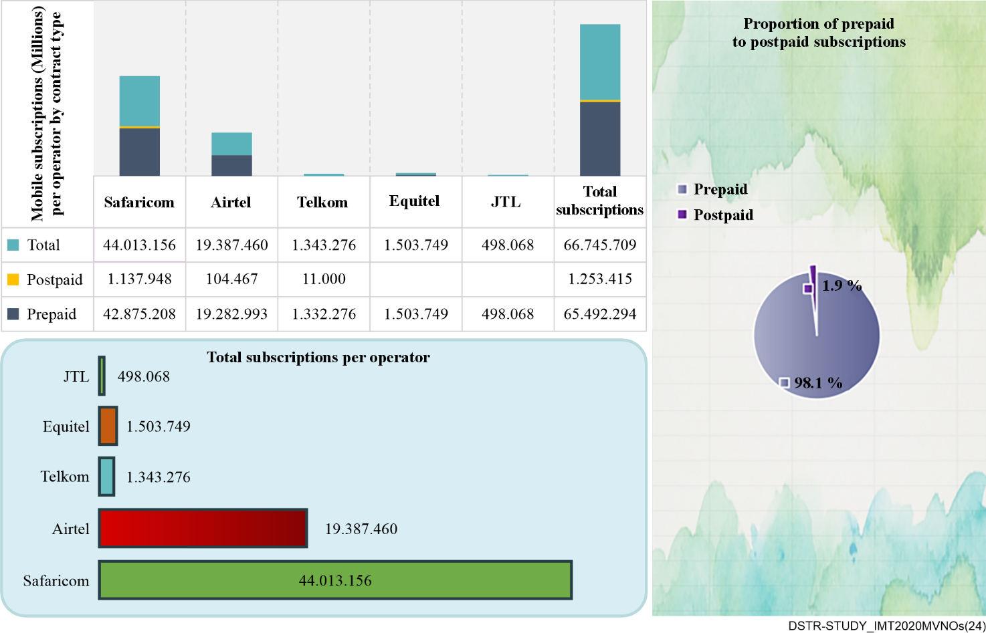
Figure 8 – Kenya telecoms market (Source: Communications Authority of Kenya)
From our analysis, 2 out of 4 MNOs (Telkom Kenya Limited, and Jamii Telecommunication Limited) operate below capacity, therefore there is an opportunity for MVNOs to enter into agreements that enable them to access excess capacity.
Since 2014 the regulator has licenced 10 MVNOs. Equitel is the most active MVNO with slightly over a million subscribers and a market share of 2.2 percent of the total market.

9.4 Zimbabwe
Zimbabwe adopted a Converged Licensing Framework in 2021 through the promulgation of the Postal and Telecommunications (licensing, registration and certification) Regulations of 2021. The framework ushered in service and technology neutrality, which is critical for 5G development. The framework also ushered in mobile virtual network operators (MVNOs) as a license category under the Application Services License category. The framework provides for the following four MVNO operating models:
a) Light MVNO: Under this operating model, an MVNO has ownership of the client and the intelligent network platform and even partial ownership of the VAS platform, ownership of the radio access network and part of the core network remains with the host MNO.
b) Full MVNO: Under this operating model, an MVNO operates like an MNO in virtually all ways except that the MVNO has no ownership of the radio access network. At this end of the spectrum, the full MVNO gets the benefits associated with ownership of the core network infrastructure. This allows the full MVNO to provide additional differentiated services from MNOs as well as achieve a higher degree of independence from the host MNO as the MVNO has full control of other aspects such as interconnection with other operators.
c) MVNE: The mobile virtual network enabler (MVNE) acts as the middleman between MVNOs and host MNOs by providing the infrastructure platform required by MVNOs. As the MVNE can host several MVNOs, the MVNE can negotiate better wholesale agreements with the host MNOs.
d) Branded reseller: Under this operating model, an MVNO offers its own value-added services (VAS) to its customers. The branded reseller model allows the MVNO to enjoy the benefits of operating under its own brand. The branded reseller is responsible for the costs of branding, sales, and distribution and enters into a revenue sharing agreement with the host MNO.
Two mobile virtual network operators have been licensed to date. As with the MNOs, all categories of MVNO are subject to the following regulatory policies amongst others:
– Tariff regulation.
– Competition policy.
– Consumer protection.
– Provision of universal access and service.
Economic and policy regulation is currently targeted at creating an enabling environment for these new players as well as promoting access to essential resources, transparency, innovation and accountability.

9.5 Brazil
In 2010, through the Anatel Resolution n. 550, the bases for exploring the mobile virtual network operator (MVNO) in Brazil were approved. The exploitation of the mobile service through a virtual network can occur in two different ways: Authorization and Accreditation. Both modalities require confirmation from Anatel.
In the Authorization modality, the unique difference of the MVNO provider to an MNO provider is the ownership of radio frequencies. The MVNO provides service is through network sharing with MNOs. In this modality, the MVNO provider is directly responsible to Anatel for regulatory obligations relating to numbering resources, service plan registration, interconnection and consumers.
In the Accreditation modality, the interested party (accredited) has to sign a private contract with an MNO provider or with an MVNO provider in the authorization modality, which must be approved by Anatel. The business model covered by the accreditation modality is established by the company authorized to provide the mobile service and the accredited person does not need to be qualified by Anatel. The company that holds the authorization to provide the mobile service is responsible for regulatory obligations relating to numbering resources, service plan registration, interconnection and consumers.
In both forms, Authorization and Accreditation, a contractual relationship can be maintained with more than one company. The option to develop multiple contracts without the impediments of exclusivity clauses, allows the MVNO operator to adapt the allocation of its resources and the needs of its customers. Furthermore, by opting for an arrangement with multiple networks, the MVNO would be able to mitigate risks associated with dependence on a single source provider.

10 Conclusion
In conclusion, 5G/IMT-2020 represents more than just another step in the evolution of wireless technologies. It will serve as the catalyst for development in the mobile market, not only of MNOs but also of MVNOs. Although the advent of MVNOs in the beginning of the 2000s was spontaneous, it would be beneficial to consider technological standards and telecommunication policies under the presence of two types of operators – MNOs and MVNOs – in this transient period from 4G to 5G and beyond.
This Technical Report highlights the various economic and policy aspects related to IMT-2020 technologies taking into consideration MVNOs. It also reviews the drivers and barriers to MVNOs rollout, various MVNO conceptual models as well as the policies implemented in some Member States as detailed in the case studies. It is essential that an enabling environment is nurtured to promote effective competition, innovation and investment in emerging technologies and markets. Thus, this Technical Report is expected to be of good help and use for promoting MNOs and MVNOs to enhance digital transformation.

___________________

Here and below – the abbreviation of VMNO is introduced only for the purpose of describing the conceptual title from certain companies or to substitute for the traditionally used abbreviation of MVNO.
https://cerre.eu/publications/euambitions-digital/
17th January, 2022/ No. 20-577/2016 AS-I (Vol-III).

