 |  | International Telecommunication Union
 |  | ITU-T | Technical Paper
 |  | TELECOMMUNICATION  STANDARDIZATION SECTOR  OF ITU |  | (09/2020)
XSTP.INNO
Description of the incubation mechanism and ways to improve it

Technical Paper ITU-T XSTP.INNO
Description of the incubation mechanism and ways to improve it
Summary
In accordance with its mandate, ITU-T Study Group 17 (SG17) coordinates security-related work across all ITU-T Study Groups. Security, as described in the Study Group's mandate, evolves at a pace that is much faster than the four-year term that characterizes study periods. There are many forces in action driving a lot of innovation such as:
– Strong-arm race between attackers and defenders;
– The general digitalization mega-trend driving general innovation (artificial intelligence (AI), distributed ledger technology (DLT), etc.);
– A fundamental singularity moment called post-quantum that is approaching;
– A strong change in the policy and regulatory frameworks at country and regional levels (e.g., general data protection regulation (GDPR)).
In this context, SG17 took the initiative to develop a strategy of transformation of security studies through a correspondence group on transformation of security studies called CG-XSS. This correspondence group and the associated special sessions on the transformation of security studies delivered a strategy in three steps where the first step involved the creation of an incubation mechanism to deal with innovation in a much timelier manner.
Whilst this incubation mechanism proved to be successful in the pilot phase, a lot of the documentation describing it got diluted in too many temporary documents. It was therefore felt that there was a fundamental need for a live reference document that can codify this incubation mechanism and incrementally answer the question: "how to bring innovation in cybersecurity standardization in Study Group 17 in a timely manner?"
The purpose of this Technical Paper is precisely to answer this question.
As any mechanism can be improved, it will as well review and analyse what other standards development organizations (SDOs) are doing in terms of innovation, and perhaps it will help SG17 to constantly review and improve this mechanism.

NOTE
This is an informative ITU-T publication. Mandatory provisions, such as those found in ITU-T Recommendations, are outside the scope of this publication. This publication should only be referenced bibliographically in ITU-T Recommendations.

Keywords
Innovation, incubation, mechanisms.

Change Log
This document contains Version 1 of the ITU-T Technical Paper on ''Description of the incubation mechanism and ways to improve it'' approved at the ITU-T Study Group 17 meeting held in Geneva, 22-30 January 2019.

CONTENTS
Page
1 Scope 1
2 References 1
3 Definitions 1
3.1 Terms defined elsewhere 1
3.2 Terms defined in this Technical Paper 1
4 Abbreviations and acronyms 2
5 Introduction 3
5.1 Context 3
5.2 Problem statement 3
5.3 Why the need for an innovation path in SG17? 3
5.4 Why considering an innovation path in SG17 ''now''? 4
5.5 What solution could fulfil this gap? 4
5.6 Who is defining, developing and maintaining this incubation mechanism? 4
6 The incubation mechanism 4
6.1 General description 4
6.1.1 A mechanism in two parts 5
6.2 Incubation mechanism constituencies 6
6.2.1 The incubation work item 6
6.2.2 Candidate incubation new work items 6
6.2.3 Allocation criteria for candidate incubation new work items 7
6.2.4 Selection of NWI candidates for incubation 8
6.2.5 The incubation queue 9
6.3 Incubation mechanism part 1 – Incubation allocation 9
6.3.1 To which entity to attach the allocation part 9
6.3.2 How is the special session of incubation allocation organized? 10
6.4 Incubation mechanism part 2 – Incubation management 10
6.4.1 Determining to which entity to attach the incubation management 10
6.4.2 Incubation co-rapporteur 11
6.4.3 Determining to which question to attach the incubation queue 12
7 Benefits and risks of the incubation mechanism 12
7.1 Benefits of the incubation mechanism 12
7.2 Risks of the incubation mechanism 13
7.2.1 Risk associated with implementing the incubation mechanism 13
7.2.2 Risk associated with not implementing the incubation mechanism 13
7.2.3 Risk of failure to implement now or stopping the incubation process 13
8 Alternatives and gap analysis to introduce innovation in standardization 13
8.1 About innovation in security 13
8.2 Other alternatives in the implementation of an incubation mechanism 14
8.2.1 Centralised versus decentralised 14
8.2.2 Emerging topics on dedicated question 14
8.3 Other mechanisms dealing with innovation within ITU and their relationship to incubation mechanism 14
8.3.1 TSAG hot topic 14
8.3.2 Focus groups 14
8.4 Gap analysis with other SDOs 15
9 Conclusions 15
Annex 1 Template to support the reporting of the incubation mechanism in the incubation question report 17
Annex 2 OASIS process for standards tracks document 19
Bibliography 20

Technical Paper ITU-T XSTP.INNO
Description of the incubation mechanism and ways to improve it

1 Scope
This Technical Paper describes entirely the incubation mechanism established by ITU-T SG17.
It then analyses other ways and mechanisms in ITU and other standards development organizations (SDOs) to accept innovation.

2 References
None.

3 Definitions

3.1 Terms defined elsewhere
None.

3.2 Terms defined in this Technical Paper
This Technical Paper defines the following terms:
3.2.1 allocation criteria: Criteria to be matched by a new work item to be an incubation candidate new work item.
3.2.2 incubation candidate new work item: A new work item that matched the allocation criteria but had not yet been agreed as an incubation new work item.
3.2.3 incubation allocation: The first part of the incubation mechanism which will consent the allocation of the new work items.
3.2.4 incubation co-rapporteur: The co-rapporteur in charge of the management of the incubation queue in the incubation question.
3.2.5 incubation management: The second part of the incubation mechanism where the incubation question manages the incubation queue under the leadership of the incubation co-rapporteur.
3.2.6 incubation mechanism: A mechanism that allows any contribution for a new work item which:
– is valid and is reasonable for SG17 to study
– but does not fit exactly in the current structure of SG17 and
– therefore, cannot find a host question
to be still developed by SG17 until it is finished or allocated to its final question.
3.2.7 incubation mechanism part 1: A synonym for incubation allocation.
3.2.8 incubation mechanism part 2: A synonym for incubation mechanism.
3.2.9 incubation new work item: A new work item that had been identified for incubation allocation.
3.2.10 incubation reallocation: An incubated work item that is moved to its final question.
3.2.11 incubation question: The question hosting the incubation queue and responsible for managing the queue of incubated work items.
3.2.12 incubation queue: A work program dedicated to the incubated work items and supported by the incubation question.
3.2.13 incubated work item: A work item that had been approved to be in the incubation queue.
3.2.14 incubation work item: A work item in the incubation queue.

4 Abbreviations and acronyms
This Technical Paper uses the following abbreviations and acronyms:
AAP Alternative Approval Process
AG Advisory Group
AI Artificial Intelligence
CTO Chief Technology Officer
CxO Chief ''whatever'' Officer
CG Correspondence Group
CG-XSS Correspondence Group on Transformation of Security Studies
DLT Distributed Ledger Technology
FG Focus Group
GDPR General Data Protection Regulation
IEEE Institute of Electrical and Electronics Engineers
IETF Internet Engineering Task Force
ISG Industry Specification Group
JTC Joint Technical Committee
NFV Network Function Virtualization
NWI New Work Item
OASIS Organization for the Advancement of Structured Information
PP18 ITU Plenipotentiary 2018
PWI Preliminary Work Item
SC Sub Committee
SDN Software Defined Network
SDO Standards Development Organization
TAP Traditional Approval Process
TD Temporary Document
TSAG Telecommunication Standardization Advisory Group
WTSA World Telecommunication Standardization Assembly

5 Introduction

5.1 Context
In accordance with its mandate, ITU-T Study Group 17 (SG17) coordinates security-related work across all ITU-T Study Groups. Security, as described in the Study Group's mandate, evolves at a pace that is much faster than the four-year term that characterizes study periods.
There are many forces in action driving a lot of innovation such as:
– Strong arms race between attackers and defenders;
– The general digitalization mega-trend driving general innovation (AI, DLT, etc.);
– A fundamental singularity moment called post-quantum that is approaching;
– A strong change in the policy and regulatory frameworks at country and regional levels (e.g., GDPR).
In this context, SG17 took the initiative to develop a strategy of transformation of security studies through a correspondence group on transformation of security studies called CG-XSS. This correspondence group and the associated special sessions on transformation of security studies delivered a strategy in three steps where the first step involved the creation of an incubation mechanism to deal with innovation in a much timelier manner.
Whilst this incubation mechanism proved to be successful in the pilot phase, a lot of the documentation describing it got diluted in too many temporary documents. It was therefore felt that there was a fundamental need for a live reference document that can codify this incubation mechanism and incrementally answer the question: how to bring innovation in cybersecurity standardization in Study Group 17 in a timely manner?
The purpose of this Technical Paper is precisely to answer this question. As any mechanism can be improved, it will as well review and analyse what other SDOs are doing in terms of innovation and perhaps it will help SG17 to constantly review and improve this mechanism.

5.2 Problem statement
Every four years, the World Telecommunication Standardization Assembly (WTSA) defines the structure and the mandates of all Study Groups for the next four-year study period. As such, the mandate of SG17 is set for the whole study period. Therefore, SG17 might face difficulties to manage and work on new innovative topics that were not anticipated during the previous WTSA.
In the above context, the problem that this document resolves is:
How to bring innovation in cybersecurity standardization in Study Group 17 in a timely manner?

5.3 Why the need for an innovation path in SG17?
Bringing innovation in any Study Group sometimes means that the a topic submitted to the group in a contribution to a meeting might not fit in the current structure and changing the structure is always a difficult and a risky task for a large spectrum of reasons discussed in another Technical Paper [b-TP.sgstruct].
This situation leads to a gap and tension between the willingness to accept valid contributions and let them develop in SG17 versus the need to find for them a place where to develop which was not initially planned in the structure, and changing the structure would take time.
With a number of Sector members wishing to bring in their contributions, it was necessary to find a solution to this problem and relax the pressure to change reactively and perhaps unwisely the structure without any long-term vision.
In fact, because of innovation, 14 contributions on distributed ledger technology (DLT) were presented to one of the SG17 meetings, which resulted in the establishment of a creative ad hoc approach. However, this also led to a big, short-notice change in the agenda of the whole meeting, generating challenges for small delegations.

5.4 Why considering an innovation path in SG17 ''now''?
SG17 evolved incrementally over the years but security evolved at a much faster pace due, as per the above context, to a number of factors, where:
– Strong arms race between attackers and defenders lead to a large range of innovations:
• including the approach of a fundamental singularity moment called post-quantum.
– Digitalization mega-trend driving general innovation (AI, DLT, etc.) which fuelled both:
• the attackers and defenders weaponry and, also;
• created a huge inflation in the attack surface in many ways.
– Increased awareness of:
• all the business constituencies of the importance of security and the need to invest;
• policy makers and regulators across the globe towards security;
• civil society to counterweight security with privacy centric concerns;
• academia which matured a lot and open new frontiers for security.
– Shortage of skills, talents, resources and professionalisation:
• Which accelerates the need for best practices and standards to simplify the jobs.
All of these factors combined together explain why innovation accelerated with investments to a degree that it outpaced the incremental evolution of SG17.

5.5 What solution could fulfil this gap?
ITU-T operates with a number of rules and processes and it became clear that they were limits to find a creative solution. Yet, as discussed in [b-TP.sgstruct], making the comparison that a study group is like a company was compelling enough to inspire a solution from industry.
Indeed, when organizations need to launch a new business, it typically comes with a number of risks, sometimes the solution used is to incubate the innovation until it is solid enough that the organization can qualify what to really do with this new business: spinoff a new company, rearrange business units, etc.
The approach taken by businesses regarding start-ups lead them to also create the concept of incubators.
Inspired by these approaches, the idea of an incubation mechanism for SG17 started to gain acceptance until it became a reality. Once the principle was agreed, the question that needed to be addressed was how to design it and implement it, which this Technical Paper aims to do.

5.6 Who is defining, developing and maintaining this incubation mechanism?
This mechanism is defined, developed and maintained by the Study Group itself under a correspondence group called the transformation of security studies (CG-XSS).

6 The incubation mechanism

6.1 General description
The incubation mechanism is a mechanism that allows any contribution for a new work item which
– is valid and is reasonable for SG17 to study;
– but does not fit exactly in the current structure of SG17 and
– therefore, cannot find a host question;
to still be developed by SG17 until it is finished or allocated to its final question.

6.1.1 A mechanism in two parts
Application of the mechanism implies the requirement that candidate new work items can be placed in a staging area in SG17.
This means that this mechanism needs:
– A way to allocate the candidate new work items into this staging area;
– That this staging area acts an incubation queue where the candidate new work items are inserted, managed like any new work item in any normal work programme, and reallocated to their final question.
Where:
– the staging area is the incubation queue;
– a work item in the incubation queue is referred to as an incubated work item;
– a new work item candidate for incubation is referred to as incubation new work item;
– the co-rapporteur in charge of the management of the incubation queue is known as the incubation co-rapporteur;
– the question carrying the incubation queue and the incubation management is known as the incubation question.
It is recognized that the incubation mechanism will consist of two parts during SG17 meetings:
– ''The incubation mechanism part 1'' will designate the allocation of the new work items and will also be called ''incubation allocation''
– ''The incubation mechanism part 2'' will designate the management of the queue and the new work items and will also be called ''incubation management''.
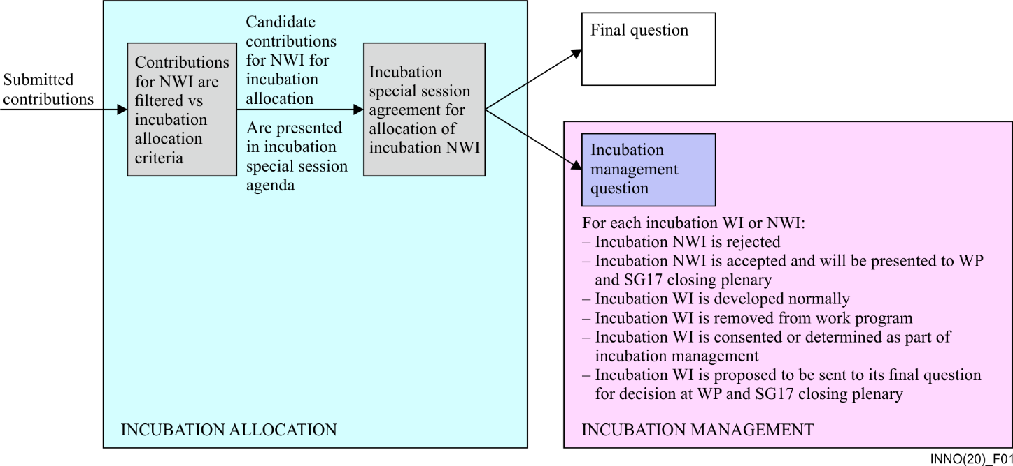
Figure 1 – General flow of the incubation mechanism in two parts: allocation and management
It is understood too that each part needs to be hosted by an entity:
– The allocation part needs to be attached to SG17 as it concerns allocations that may need arbitrations across the Study Group between questions and it needs to be handled as early as possible in the Study Group.
– The management part needs to be attached to a question as this is mostly management of a work programme and requires the skills of a rapporteur.

6.2 Incubation mechanism constituencies

6.2.1 The incubation work item
An incubation work item is a normal a work item that is placed in the incubation queue where work items can be of various types such as:
– Normative ITU-T documents such as Recommendations and Annexes as per [b-ITU-T A.1] and [b-ITU-T A.12]
– Non-normative ITU-T documents such as Technical Reports and Technical Papers as per [b-ITU-T A.13]
There are various approval processes as per [b-ITU-T WTSA-16 Res. 1]:
– Traditional Approval Process (TAP) (for Recommendations);
– Alternative Approval Process (AAP) (for Recommendations);
– Agreement (for Supplements, Technical Reports and Technical Papers).
It should be noted and recalled that:
– If a Recommendation was initially set to TAP it cannot be changed to AAP later;
– If a Recommendation was initially set to AAP it can be changed to TAP later.
It is observed that as an innovation path is being followed, it is a good practice to encourage Technical Papers as contributions for new work items in the incubation queue as they can be used as a feasibility study which is a lightweight way to qualify potential future contributions and help delegates to familiarize themselves with a certain topic before standardization is engaged and contributions for new work items for Recommendations are submitted.

6.2.2 Candidate incubation new work items
A candidate new work item is one that is difficult to be allocated to a specific question. Table 1 shows some examples where a potential new work item would be acceptable as such, but which would be difficult to place in a specific existing question.
Table 1 – Examples of potential new work items candidate for incubation
Reason | Example of a potential new work item topic that would fall in the category
Question's mandate does not cover the topic | Artificial intelligence
Question's mandate is too restrictive for the topic | Q8 does not cover big data
Question's mandate has a dependency with another SDO that forbids the scope of the contribution | Q3 has specific agreements with ISO that may limit what it can cover
ITU received a mandate that forbids the topic | Ad spam is at the edge of security and content
The topic can legitimately be supported by multiple questions because the topic was never properly recognized, positioned in SG17, or because there are overlaps between questions | Big data appeared in Q2, Q7, Q8?  Should SDN/NFV be paired with Q6 or Q8?
The topic can exist in the question mandate, but the real meaning of the contribution shows a misalignment | Relates to the allocation of KT quantum work item. Were the right reasons really considered to put it in Q2? Should it be more explicit about the architecture implications regarding middleboxes first?
The first line of Table 1 shows a true canonical example of a new work item being proposed on an innovation that is valid, but no question has a mandate to support it yet.
What is interesting is that innovation will lead some new work items to be in the scope of SG17 as it is today, but the structure does not fit or other reasons are creating frictions to get this new work item to its final destination.
This leads to the requirement to produce a list of clear criteria to select candidate new work items.

6.2.3 Allocation criteria for candidate incubation new work items
Table 2 lists the criteria to allocate new work items as candidate incubation new work items.
Table 2 – Allocation criteria for candidate incubation new work items
Criteria | Category | Description | Comments |  | Example
C1 | Innovation | There are no Questions that can host this new work item and the contributor is sending this NWI to ALL/17 or to Q4/17 for incubation. |  | This happens when the topic covered is about a next big thing which is not yet covered by any Question. The contributor wants to bring innovative subject to SG17. This is one of the main reasons why the incubation process is created. Allow innovation to come in and later, when the structure is fixed, move the work item to its final Question. |  | New work item is about artificial intelligence, currently not covered by any Question of SG17.
C2 | Too many target Questions | There are multiple Questions that can host this new work item. | This happens when there are overlaps between Questions and it is difficult to agree what is the right Question, probably because the Question text needs to be reviewed and there is a 'chicken and egg situation' by which this cannot be done yet (CG-XSS S2 or S3 steps not completed yet, TSAG did not approve, perhaps PP18 impacts, etc.) |  | It already happened in the allocation of big data work items between Q2, Q7 and Q8 or SDN/NFV between Q6 and Q8, etc.
C3 | Semantic Mismatch | The new work item is proposing a Question but the Question real semantic or capabilities do not match the NWI. | This happens if a contributor specifies a Question but the topic of his NWI is not yet covered by the Question and the future structure of the CG-XSS might bring the topic to another Question in the future. |  | In theory today Q8 does not cover big data and so new work items that are about big data should be sent to the incubation process.
C4 | SDO dependency | The new work item has a dependency with another SDO that temporarily forbids the scope of its contribution. | This happens when the contributor is unaware of the specific formal relationships between ITU and other SDOs, yet the NWI is valid and it needs some cycles with the other SDO. |  | Q3 has specific agreements with ISO that limit what it can cover.
C5 | NWI semantic misalignment | The contributor provided a partial rationale for its new work item and a review of the full semantic of the NWI can allow its allocation in multiple Questions or to no Question because it is about a next big thing. | This happens if the contributor did not review all the implications of his NWI and in fact a real reformulation with more support to its NWI makes it candidate to multiple or no Questions. |  | Relates to the allocation of KT quantum work item. Were the right reasons to put it in Q2 really considered? Should it not be more explicit about the architecture implications regarding middleboxes first?
C6 | ITU mandate restrictions | The new work item is falling into a grey area of decision if it is falling into a mandate restriction of the ITU or not. | There are perhaps conditions that SG17 might want to keep the topic because it takes time to validate if this is within the scope or restrictions of ITU mandate or if the ITU mandate might change (e.g., in relations to PP18 or WTSA, etc.) |  | Example COP related, content related NWI, etc.

6.2.4 Selection of NWI candidates for incubation
Selection of NWI candidates for incubation should take certain considerations into account.
In order to avoid:
– That the responsibility of the selection of the NWI candidates for incubation is left to one individual (Chairman of the special session on incubation allocation) in order to avoid or reduce:
• Potential arbitrariness;
• Mistakes;
• Misinterpretations of the NWI.
– Lengthy special session on incubation.
As well as in order to encourage:
– A thorough preparation of the meeting;
– A thorough understanding of the NWI at SG17 level versus at Question level.
The following process will achieve the selection:
a) Establish a mechanism to facilitate input from all delegations on possible candidate contributions to be considered for incubation.
b) TSB to add a new column to the NWI TD titled 'incubation', leaving the fields empty for each NWI.
c) SG17 management meeting to set a NWI and incubation assessment meeting a few days before the SG17 management meeting to:
a) identify NWI for the special session on incubation;
b) identify potential coordination issues;
c) update and publish the NWI TD accordingly (in particular new incubation column).
d) SG17 management meeting to add the review of the updated NWI TD to its agenda:
a) Potentially to amend the document through consensus;
b) Approve the document.
e) The NWI TD is the main input document to the special session on incubation.
NOTE – As the incubation mechanism is supported by an incubation Question, contributors of any proposed NWI can ask questions or provide clarifications on the NWI TD about their NWI via normal email to the incubation Question mailing list at any time.

6.2.5 The incubation queue
The incubation queue is a specialized work program consisting of incubated work items.
– The incubation queue is a normal work program and as such the incubated work items:
– Are there if it was agreed normally by SG17 plenary meeting;
– Are represented normally in the database of the work program;
– Are being developed normally by contributions and by updating TDs;
– Are determined or consented and then approved normally;
– Or can be removed from the work program.
– In addition to a normal work program an incubated work item:
– Can be reallocated to an existing (and/or new) question.
– It is recommended to review the incubation queue as:
– Its counter of incubated work items is a good measurement of the fit of the Study Group structure to the reality of what standardisation requires:
• No incubated work items mean that the Study Group structure fits the requirements of standardisation in the limits of the ITU mandates, limits and constraints;
• A few incubated work items show that the Study Group structure starts to degrade;
• Many incubated work items show that the Study Group structure is not adapted.
– An analysis of its content incubated work items is visible in the queue, they demonstrate that the Study Group ''captured'' a valuable set of work that may trigger the generation of a new question or the adaptation of an existing question but in any case, this decision will now be with a decreased risk because there is a good comprehensive view on what needs to be considered for standardization.

6.3 Incubation mechanism part 1 – Incubation allocation

6.3.1 To which entity to attach the allocation part
The incubation mechanism part 1 is the allocation part and is attached to SG17 directly as it needs to do arbitrations between questions according to the clear list of allocation criteria above.
The allocation part is carried by a special session just after the opening plenary of SG17.

6.3.2 How is the special session of incubation allocation organized?
Given the growing size of SG17 it is expected that each question sends at least one of its rapporteur, co-rapporteur or associate rapporteur.
Prior to the meeting, the special session chairman:
– Participates in the selection process of the NWI TD to select the NWI candidates to the incubation mechanism;
– Creates an agenda and submit it as a TD including:
– Provides the current state of the incubation and the incubation queue with all work items in it;
– Includes the agreed above NWI TD as input document to the special sessions and to seek agreement on each NWI candidate;
– Provides the lists of identified contributions as candidate to be selected for the incubation mechanism.
During the meeting, the special session chairman:
– Provides any updates on the incubation mechanism;
– Asks the audience if any work items in the current incubation queue are claimed by any question. If any work item is proposed, the chair should ask for meeting agreement;
– Ask the audience if there are any missing contributions that should be considered;
– Goes through the proposed list and for each candidate.
– Discuss the reasons why this item is in the candidate list;
– Obtain either meeting agreement to send this candidate to incubation queue or to allocate it to a final agreed question.
– Discuss any other topics.
After the meeting, the special session chairman:
– Delivers immediately a communication to all the rapporteurs of the changes by using the SG17 rapporteur list (in this study period t17sg17rap@itu.lists.int) and in particular Q1 as it relates to the state of new work items allocations.
– Identify if any work items were agreed to be dequeued from the incubation queue and allocated to a final question;
– Transmits the table of NWI allocation to both the rapporteurs of the incubation question and the coordination question;
so that:
– The incubation question can adapt its agenda;
– The coordination question can prepare its coordination meeting with potential changes from TSB allocation documents to facilitate SG17 work.
Delivers the special session report as soon as possible to formalize the changes.

6.4 Incubation mechanism part 2 – Incubation management

6.4.1 Determining to which entity to attach the incubation management
The incubation queue needs to be attached to a question as this is the only entity which is able to manage a work program.
To support this work, the question needs to be supported by a co-rapporteur in charge of the incubation mechanism management, the incubation co-rapporteur.

6.4.2 Incubation co-rapporteur
As the incubation queue can receive arbitrary contribution on very edge innovation topics this imposes some requirements on rapporteurs who are managing the incubation queue.
The candidates follow all up-to-date values of a selection with no discrimination of any kind.
The core requirements for candidates are:
– Proven experience as rapporteur in or outside ITU;
– High expertise in core security;
– High expertise in innovation management and associated topics.
The incubation co-rapporteur does:
– A normal job as any other co-rapporteur managing a work program;
– In addition, the incubation co-rapporteur while:
– participating in question meeting:
– Informs the participant of any confirmed question being created, modified, or deleted by SG17 and new SG17 structure updates accordingly;
– participating in the question report:
– Informs SG17 about the current count of work items in the incubation queue and identifies the work items;
– Optionally propose to mark incubated work items with a ⁺ (like the * to mark TAP work items) in any required SG17 report;
– Identifies the incubated work items in a table in the report;
– Obtain consensus for potential incubated work items to be allocated in their final question to be approved in SG17 closing plenary;
– Alerts SG17 if any of the following happens:
– The incubation queue is too large;
– There is need for more resources or specific skills to manage the queue on specific topics;
– Analyses the incubation queue to seek if there are any suggestions for SG17 to consider potentially proposing a modification or the creation of a question;
– Finally, the incubation co-rapporteur is encouraged to participate in the relevant correspondence group about the short, mid, and long-term transformation of SG17.
As by nature, the incubation mechanism is a way to innovate, it is expected that the probability that contributors and editors will be new to ITU-T or even to standardization as a whole is very high and in practice it proved correct. As such it is particularly important that the incubation co-rapporteur pays particular attention to supporting newcomers and should leverage:
– Any materials provided by ITU, ITU-T and SG17 to support newcomers;
– Specific support tailored to the needs of the newcomers in the context of their contribution versus the knowledge of the rest of the study group;
– Proactivity to identify relevant existing Recommendations, ITU-T terms and definitions databases, resources to the attention of the newcomers;
– Proactivity in introductions with other delegates as well as TSB staff to help the newcomers build a network of peers and knowledge to support the development of their innovative incubated work items.

6.4.3 Determining to which question to attach the incubation queue
The rationale for selecting the incubation question flows in the SG17 structure and distribution of experts during the 2017-2020 study period as listed below:
– As new questions cannot be created, a ''Question 0'' as incubation question cannot be established. However, a ''Question 0'' could be interpreted as covering the scope of ''Emerging technologies'' could have multiple benefits at the expense of creating a new question;
– Q1 could take work items in its current set-up as there are no experts in this question, this is a coordination question. The incubation new role requires expertise to do the peer reviews and offer normal good conditions for the work item to develop. Yet should there be a solid incubation co-rapporteur 1) experts would be present where the work is being done and 2) it would regroup the incubation queue and management with the coordination question;
– None of Q3, Q5, Q6, Q7, Q8, Q9, Q10, Q11, Q12, Q13 or Q14 can carry the role because they presently have a specific purpose (right or wrong does not matter here) and are specialized unless there is an option for a distributed incubation queue mechanism versus a central queue mechanism, but this would require embracing a very specific structure of SG17 with a number of assumptions:
– Principle of stable long-term working parties;
– Principle of 'mother' question in each working party.
This would resolve some problems of workload but would make the incubation allocation probably much harder.
– Remains Q2 on architecture and frameworks and Q4 cybersecurity.
Both Q2 and Q4 are reasonable candidates to host, at this stage, the incubation question.
However, looking deeper, it is noted that there is a requirement on expertise to give a good review, support for the work item development. Indeed, just looking at the above examples in previous clauses, it is evident that there is need for significant expertise in core security versus architecture. Ideally, both types of expertise would be required, and it might happen in the future that both occur together, or that a switch takes place depending on what the new structure of SG17 might be.
So, with this new requirement in mind, it becomes clear that Q4 is right now the best candidate, but with Q2 next in line.
It was therefore proposed to Q4 that it hosts the incubation role and mechanism at this stage, bearing in mind that the future structure of SG17 may change this allocation.

7 Benefits and risks of the incubation mechanism

7.1 Benefits of the incubation mechanism
The main benefit of this proposal is to:
– Allow decorrelation of transformation of the SG17 structure versus the adoption of new work items that do not fit the SG17 structure;
– Simplify the flow of SG17 meetings by bringing forward the allocation part;
– Accept key innovation in SG17 in a much more agile manner;
– Therefore:
– Give proper time to the relevant correspondence groups to carry out their job and make recommendations regarding the long-term transformation of SG17 and the evolution of its structure;
– Facilitate the work on the development of thoroughly validated new work items without delay, and support legitimate requests from Sector members.
– Furthermore:
– Offer a good tool for SG17 to significantly accelerate innovation;
– At the same time, be conservatist and cautious in terms of its future big bets and new structure;
– Use this new tool to help to communicate effectively to hire new members and encourage participation.

7.2 Risks of the incubation mechanism
As for all proposals, nothing comes with only advantages, and it is important to be aware that there are risks too.

7.2.1 Risk associated with implementing the incubation mechanism
There are risks associated with implementing the incubation mechanism (also called 'risk of doing'). The main ones are:
– R1 The queue grows too fast and is difficult to manage versus resources;
– R2 Special expertise required is not available;
– R3 The incubation mechanism is exploited to delay work.
Mitigation suggestions:
– R1 can be mitigated by the possibility of the co-rapporteur to alert SG17 through normal reporting;
– R2 can be mitigated by the growing number of experts joining ITU-T but in case of severe shortage on a specific topic SG17 will need to campaign to attract the relevant new members;
– R3 can be mitigated by SG17 members and by discussions. SG17 has a strong family spirit as a community.

7.2.2 Risk associated with not implementing the incubation mechanism
The risk of not implementing the incubation mechanism means that there would be no flexibility to allow the team to develop new work items in good conditions mechanism (also called 'risk of not doing'). This would significantly increase the coordination level, and would eventually lead to more arbitrariness in new structure decisions. In fact, it would significantly hinder the work of SG17 and it will require a major 'step function' to get out of a dangerous 'plateau effect'.

7.2.3 Risk of failure to implement now or stopping the incubation process
The situation would block as changes to Questions would not be allowed. It would also block participants' position and in general would make it much harder to establish trust in the process and to allow evolution. This would cause a delay of six months for any decisions and would not resolve anything. Chances are that it would actually lead to a major crisis.

8 Alternatives and gap analysis to introduce innovation in standardization

8.1 About innovation in security
Innovation is a normal element of any technological evolution and the result of various forces. Yet in security, those forces have the specific nature of an arms race between attackers and defenders in the context of a technological war between key actors.
Standardization being one of the places where these forces materialize, it is therefore natural to observe a pressing need to innovation at a high rhythm in security in standardization.
This will happen at various stages, in pre-standardization and then in standardization itself. Yet, with each SDO having its own governance, it might be more or less easy to introduce an efficient approach to innovation in standardization and in particular in security.
Identifying other mechanisms and ways to approach innovation in security can:
– Position the incubation mechanism in a bigger spectrum of innovation approaches;
– Inform on how to maintain and/or develop the incubation mechanism.

8.2 Other alternatives in the implementation of an incubation mechanism
For future development of this mechanism several alternatives could have been taken for its implementation.

8.2.1 Centralised versus decentralised
Depending on the model of structure adopted by the Study Group, the incubation mechanism can be implemented 'centrally' meaning attached to one incubation question as implemented at present or it could have been dispatched across a few questions.
Indeed, should there be a study group with empowered working parties, there could have one 'mother question' per working party that could host an incubation queue for the working party. As such it would be a good way to distribute the emerging and innovation topics across the study groups to balance potential work-load issues.

8.2.2 Emerging topics on dedicated question
Another alternative is for the study group to dedicate a full question solely to emerging topics which would be one specialization of a centralization approach. The incubation mechanism would still be useful especially because of its incubation allocation part 1 as an important immediate first step after the opening plenary which allowed to agree all ambiguous cases and allow a smooth execution of all meetings so far.

8.3 Other mechanisms dealing with innovation within ITU and their relationship to incubation mechanism

8.3.1 TSAG hot topic
The rapporteur group for standardization strategies (RG-SS) under TSAG took the task to collect and aggregate proposed 'hot topics' from any of ITU-T entities in addition to ITU-T CTO and CxO meetings.
Whilst 'hot topics' do not seem to be explicitly defined, some delegates interpreted the hot topics as topics in relation to innovation with the idea to make this list visible and shared in particular for study groups to have a chance to potentially coordinate and collaborate on joints topics.
The incubation mechanism can be a source of information from the study group to TSAG to declare new 'hot topics', 'sub hot topics' or enrich the qualification of existing ones and so could participate into informing any potential outgoing liaison statement from the study group to TSAG.

8.3.2 Focus groups
Focus groups are defined by [b-ITU-T A.7] and provide a way to manage innovation for the objective of pre-standardization.
In comparison, the incubation mechanism is a tactical and lightweight instrument for the study group to manage innovation that is ready for standardization as well as to develop analysis for potential future work through non-normative work items.

8.4 Gap analysis with other SDOs
Table 3 provides a high-level view of the main approaches, if any, of some other SDOs to innovation.
Table 3 – High-level view on how innovation is dealt with by different SDOs (non-exhaustive)
SDO | Mechanisms to deal with innovation | Acronym | Status | Comments
ITU-T | Focus group at SG level | FG | In place
ITU-T | Focus group at TSAG level | FG | In place
ITU-T | Incubation mechanism | None | In pilot | Considered by other SGs
ISO | Advisory group | AG | New | Transformed from another concept
ISO | Preliminary work item | PWI | In place | ISO/IEC JTC1/SC27 introduced a concept of ''Preliminary Work Item'' (PWI) as a replacement for ''Study Period'' (SP).  PWI seem to be interpretable as an incubation mechanism in SC27 and this can also echo to SG17's incubation mechanism.
IETF | Bar bird of a feature | Bar BoF | In place
IETF | Bird of a feature | BoF | In place
ETSI | Industry specification groups | ISGs | In place | More information on ETSI committee structures can be found at https://www.etsi.org/about/our-operations
OASIS | None | N/A | In place | OASIS has a very pragmatic way to accept any valuable suggestion, see Annex 2.

9 Conclusions
The incubation mechanism successfully finished its pilot phase for around 2 years which tested all of its features.
It had been adopted by SG17 and is part of a proposal to be allocated to a new emerging question for the next study period 2021-2024.
It provided significant benefits to the Study Group in particular, allowed:
– key innovative new standards to be developed, e.g., QKD, QRNG;
– very peaceful and lean SG17 meetings regarding a number of exceptions in NWI allocation to be managed immediately after the opening plenary so as early as possible during the meeting, allowing for a well-managed meeting;
– flexibility for delegates to progress their work items, for rapporteur to observe the work and understand the fitness to their questions;
– to re-value the wise benefits of providing Technical Papers and Technical Reports before doing pure normative work, thus allowing the community to familiarize itself with topics that are innovative in nature and in different manners;
– a lot of agility to allow innovation and transformation while avoiding the constraints of the creation of a new entity, either in the Study Group (creation or change of a new question) or outside (creation of a Focus Group);
– for the Study Group to work proactively towards a strategic approach versus having to change, while in operation, its structure and potentially jeopardize fundamental changes or increase operational rigidity;
– It is an elegant indirect indicator if the structure of the Study Group is adequate or needs changes;
– to consider potential structural changes with the facts in the queue as they are identified and developing versus having to make a bet with no evidences so it is decreasing significantly the transformation risks and helps the qualification of the reach of the potential changes.
This approach may be considered by other Study Groups in a growing complexification of the technical standardization as a flexible and lightweight instrument to not only accept innovation but to allow a safe path to transformation.

Annex 1
Template to support the reporting of the incubation mechanism in the incubation question report
The following text is a template text to be included in the incubation question report to document the status and assessment of the incubation mechanism for consideration in the working party closing plenary and then potentially in the study group closing plenary.
This template assumes that Q4/17 is the incubation question for the sake of clarity.
Q4 incubation mechanism report
Q4 hosts the incubation management part of the incubation mechanism as described in Technical Paper XSTP.inno, Description of the incubation mechanism and ways to improve it.
Q4 Rapporteur(s) in charge of incubation management in this SG17 meeting
Q4 Rapporteur(s) in charge of incubation management in this SG17 meeting is (are):
Firstname, Name, Affiliation, Country
Status of the incubation queue
The incubation queue contains [8] work items under development as of [19 July 2019]
Table 4 – Status of the incubation queue
TD | Work Item | Title
[TD1981 | TP.inno | Description of the incubation mechanism and ways to improve it
TD1982 | TP.sgstruct | Strategic approaches to the transformation of security studies
TD1950 | TR.sec-qkd | Technical report on security framework for quantum key distribution in telecom network
TD2250 | X.cg-QKDN | Use of cryptographic functions on a key generated in Quantum Key Distribution networks
TD2228 | X.qrng-a | Quantum noise random number generator architecture
TD1880 | X.rdmase | Requirements and Guidelines for Dynamic Malware Analysis in a Sandbox Environment
TD2248 | X.sec-QKDN-km | Security requirements for quantum key distribution – key management
TD2249 | X.sec-QKDN-ov | Security requirements for quantum key distribution networks – overview]
Consensus on work items to be reallocated to their final questions
Q4 had meeting agreement to present the following work items to be proposed for reallocation to their final question at the working party closing plenary and the SG17 closing plenary.
Table 5 – Incubation reallocation
Work item | Title | To be moved to question
Assessment of the incubation queue
The Q4 Rapporteur have the opportunity to write any assessment of the incubation queue here for example:
– Is the queue manageable, or too big, etc.
– Is there a need for specific experts among the group of rapporteurs of Q4 to manage new work items on topic X;
– Is there an interesting trend developing in the queue where the Q4 Rapporteur want to suggest a potential new question or other structure or coordination or anything relevant.

Annex 2
OASIS process for standards tracks document
OASIS has a very pragmatic approach to innovation, by simplifying and not differentiating it. Figure 2 shows the OASIS process for standards tracks document and in particular ''Create Working Draft'' at the bottom of the diagram.
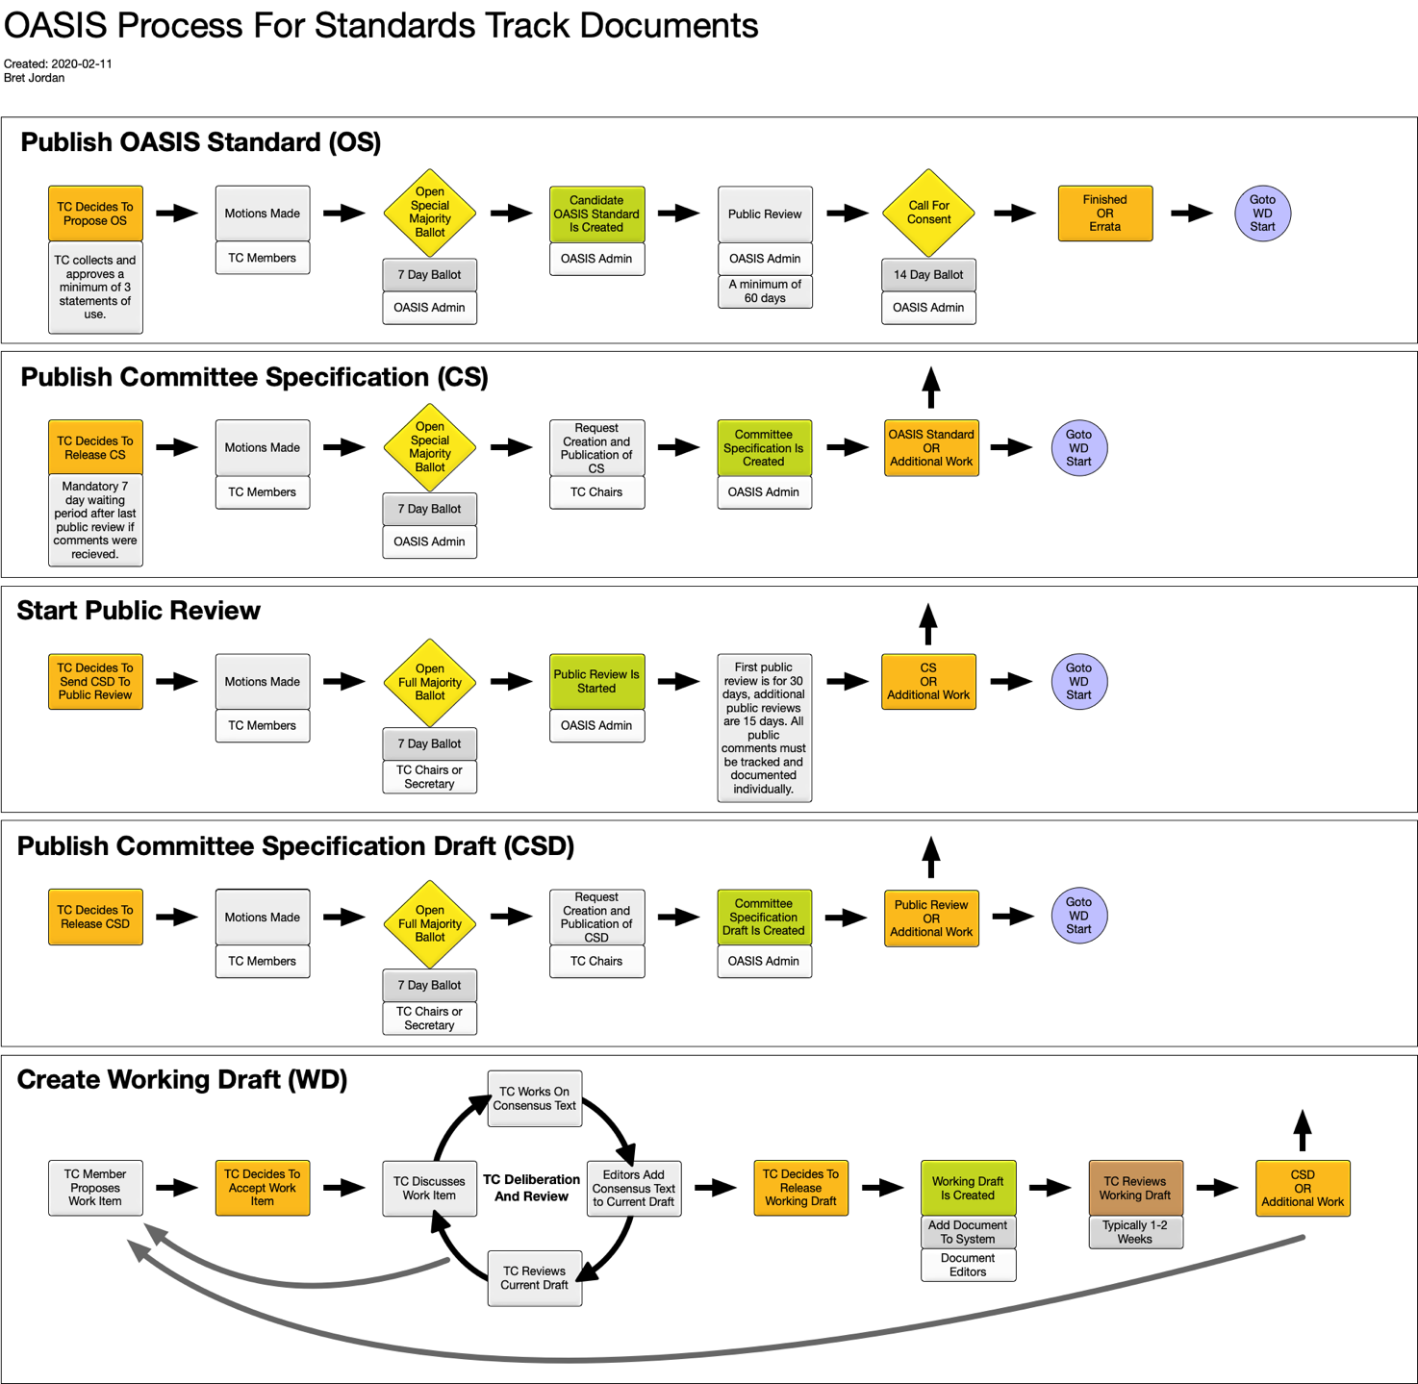
Figure 2 – OASIS process for standards track documents

Bibliography
[b-TP.sgstruct] ITU-T Technical Paper (2019), Strategic approaches to the transformation of security studies.
[b-ITU-T A.1] Recommendation ITU-T A.1 (2019), Working methods for study groups of the ITU Telecommunication Standardization Sector.
[b-ITU-T A.7] Recommendation ITU-T A.7 (2016), Focus groups: Establishment and working procedures.
[b-ITU-T A.12] Recommendation ITU-T A.12 (2016), Identification and layout of ITU-T Recommendations.
[b-ITU-T A.13] Recommendation ITU-T A.13 (2019), Non-normative ITU-T publications, including Supplements to ITU-T Recommendations.
[b-ITU-T WTSA-16 Res. 1] ITU-T WTSA-16 Resolution 1 (2016), Rules of procedure of the ITU Telecommunication Standardization Sector.

_______________________

