 |  | International Telecommunication Union
 |  | ITU-T | Technical Paper
 |  | TELECOMMUNICATION  STANDARDIZATION SECTOR  OF ITU |  | (13 December 2013)
SERIES L:
CONSTRUCTION, INSTALLATION AND PROTECTION OF TELECOMMUNICATION CABLES IN PUBLIC NETWORKS
 | Verification experiments related to increase of efficiency of air-conditioning and control technologies at a data centre

Summary
This Technical Paper refers to the Best Practices defined in Recommendation ITU-T L.1300. More precisely, this Technical Paper firstly provides an overview of verification experiments related to increase of efficiency of air-conditioning and control technologies. The results of such verification experiments are then provided and finally an estimation of their applicability to real data centres is reported.
Keywords
Best practice, data centre, energy efficient, information and communication technology and climate change (ICT & CC).
Change Log
This document contains Version 1 of the ITU-T Technical Paper on “Verification experiments related to increase of efficiency of air-conditioning and control technologies at a data centre” approved at the ITU-T Study Group 5 meeting held in Lima, 2-13 December 2013.

Editor: | Gianluca Griffa  Telecom Italia  Italy | Tel: +39 331 600 1341  Email: gianluca.griffa@telecomitalia.it

Contents
Page
1 Scope 5
2 Definitions 5
3 Abbreviations 5
4 Background and purpose 6
5 Overview of experiments 6
5.1 Control method 6
5.1.1 ICT load consolidation control 7
5.1.2 ICT linked air-conditioning control 8
5.1.3 Remote load distribution 9
5.2 Experiment items 10
5.3 System for experiments 10
5.3.1 Simulated data centres 10
5.3.2 Simulated operational system 13
5.3.3 Control system 14
5.3.4 Measurement system 14
6 Results of experiments 15
6.1 Experiment (1) 15
6.2 Experiment (2) 16
6.3 Experiment (3) 16
6.4 Experiment (4) 17
6.5 Experiment (5) 18
6.6 List of power consumption and CO2 emissions 20
7 Estimate if applying to actual data centres 22
7.1 Estimate for 500 racks 22
7.2 Annual estimate 23
8 Conclusion 25
References and Bibliography 26

List of Tables
Page
Table 1 – List of experiment items 10
Table 2 – Outdoor air conditions in data centre 1 10
Table 3 – Specification for experimental laboratories 11
Table 4 – Specification for ICT devices 11
Table 5– List of measurement items 14
Table 6 – Power consumption of Experiment (1)-(4) (integral power consumption per day) 20
Table 7 – Power consumption of Experiment (5) (integral power consumption per day) 21
Table 8 – Daily CO2 emission of experiment (1)-(5) 22
Table 9 – Power consumption of 500 racks 22
Table 10 – Number of hours of each operating status [hour] 23
Table 11 – Power consumption of each operation status [kW] 24
Table 12 – Comparison of annual power consumption 24
Table 13 – Comparison of annual power consumption [MWh] 24

List of Figures
Page
Figure 1 – Overview of controls 7
Figure 2 – Overview of remote load distribution 7
Figure 3 – Example of server power consumption characteristics 7
Figure 4 – Flow of ICT load consolidation control 8
Figure 5 – Example of server fan characteristics 8
Figure 6 – Flow of ICT linked air-conditioning control 9
Figure 7 – Relation between data centre workload and power consumption 9
Figure 8 – Relation between workload allocation and power consumption 9
Figure 9 – Outline of experimental room 11
Figure 10 – Appearance of experimental room 12
Figure 11 – System diagram of air conditioning and heat source in experimental room 1 12
Figure 12 – System diagram of air conditioning and heat source in experimental room 2 13
Figure 13 – Daily workload data 14
Figure 14 – Overview of control system 14
Figure 15 – Power consumption of experiment (1) 16
Figure 16 – Power consumption of experiment (2) 16
Figure 17 – Power consumption of experiment (3) 17
Figure 18 – Power consumption of experiment (4) 17
Figure 19 – Load distribution table 18
Figure 20 – Power consumption of experiment (5) - high temperature 19
Figure 21 – Power consumption of experiment (5) - medium temperature 19
Figure 22 – Power consumption of experiment (5) - low temperature 20
Figure 23 – Comparison of power consumption of Experiment (1)-(4) 21
Figure 24 – Comparison of power consumption of Experiment (5) 21
Figure 25 – Approximation of workload data 23

ITU-T Technical Paper
Verification experiments related to increase of efficiency of air-conditioning and control technologies at a data centre
Summary
This Technical Paper describes verification experiments related to increase of efficiency of air-conditioning and control technologies at a data centre based on Recommendation ITU-T L.1300.
Keywords
Best practice, data centre, energy efficient, information and communication technology and climate change (ICT & CC).

1 Scope
This Technical Paper describes verification experiments related to increase of efficiency of air-conditioning and control technologies at a data centre based on Recommendation ITU-T L.1300. The scope of this Technical Paper includes:
– an Overview of verification experiments related to increase of efficiency of air-conditioning and control technologies;
– results of verification experiments; and
– estimate if applying to actual data centres.

2 Definitions
This Technical Paper uses the following terms:
2.1 climate change [b-IPCC]: Climate change refers to a change in the state of the climate that can be identified (e.g., by using statistical tests) by changes in the mean and/or the variability of its properties, and that persists for an extended period, typically decades or longer. Climate change may be due to natural internal processes or external forcing, or to persistent anthropogenic changes in the composition of the atmosphere or in land use. Note that the Framework Convention on Climate Change (UNFCCC), in its Article 1, defines climate change as: 'a change of climate which is attributed directly or indirectly to human activity that alters the composition of the global atmosphere and which is in addition to natural climate variability observed over comparable time periods'. The UNFCCC thus makes a distinction between climate change attributable to human activities altering the atmospheric composition, and climate variability attributable to natural causes.
2.2 greenhouse gas [b-ISO 14064-1]: Gaseous constituent of the atmosphere, both natural and anthropogenic, that absorbs and emits radiation at specific wavelengths within the spectrum of infrared radiation emitted by the Earth's surface, the atmosphere and clouds.

3 Abbreviations
CPU Central Processing Unit
GHG Greenhouse Gas
PUE Power Usage Effectiveness
VM Virtual Machine

4 Background and purpose
It is predicted that the power consumption in data centres in the world will keep on increasing in the future, and reduction of power consumption is required from the viewpoints of influence over global warming issues and operation costs. On the other hand, it appears that various operational systems of businesses will make transition to cloud service, and it is forecasted that variation of the workload in data centres by the time of the day becomes large. Against such problems, elimination of wasteful power consumption is studied by allocation of necessary calculation resources and cooling capacity as matched with the variation of the workload.
By conducting verification experiments, the power saving effect is verified on a simulated data centre, applied energy-saving technologies that integrated control of ICT devices and air-conditioning equipment against workload variation. Furthermore, the energy-saving effect of a case where the application is expanded to two data centres is also verified.
This experiment was executed as a verification of the technique for the reduction of the energy consumption of the data centre, contributing to reduction of GHG and control of Climate Change, by Ministry of Internal Affairs and Communications Japan and FUJITSU Ltd. in FY 2011.

5 Overview of experiments

5.1 Control method
The power consumption reducing effect is verified on three control technologies indicated below by these verification experiments. Figure 1 and Figure 2 show an overview of control method.
(1) ICT load consolidation control
Executes workload consolidation control so that server power consumption can be reduced against workload variation.
(2) ICT linked air-conditioning control
Executes air-conditioning control so that air-conditioner power consumption can be reduced in correspondence to the heat value from servers.
(3) Remote load distribution
Executes workload distribution so that the entire power consumption can be reduced in such an environment that two data centres located in a distance to each other have identical calculating functions and are able to execute distributed processing of the workload.
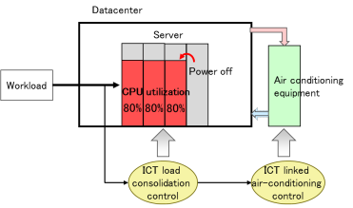
Figure 1 – Overview of controls
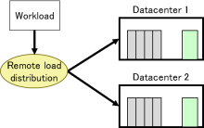
Figure 2 – Overview of remote load distribution

5.1.1 ICT load consolidation control
A server is consuming a certain amount of electric energy in general even if it is in an idle state with zero workload as shown in Figure 3. Under these circumstances, the total power consumption of the entire server group is reduced by concentrating the workload to partial servers and by turning off the power for servers, the workload to which becomes 0. The workload is allocated to servers so that the CPU usage rate of a server becomes 60 to 80%.
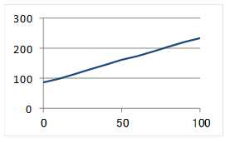
Figure 3 – Example of server power consumption characteristics
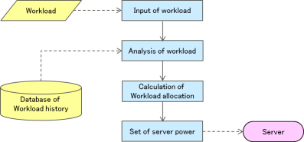
Figure 4 – Flow of ICT load consolidation control

5.1.2 ICT linked air-conditioning control
In the conventional air-conditioning control, the air-conditioner supply temperature and airflow are fixed, and the supply temperature and airflow that are required against maximum heat value and fan airflow are set. On the contrary, this control sets the air-conditioner supply temperature and airflow so the energy what is minimum required for cooling the heat generated by the server.
Outdoor air cooling systems was used for the experiments, and the cold aisle was separated from the hot aisle. Accordingly, air-conditioner characteristics and conditions such as what are indicated below are provided.
• The air-conditioner supply temperature is almost linked with the server inlet air temperature.
• It is necessary that the air-conditioner supply airflow is set at a level that is higher than the total airflow of server fans.
• The power consumption is higher in the case where the air-conditioner supply airflow is made higher than the case where the air-conditioner supply temperature is turned down.
The power consumption by the air-conditioning system depends on the air-conditioner power consumption and the server fan power consumption. The server fan power consumption can be minimized by keeping the inlet air temperature at a certain level or less as shown in Figure 5. The air-conditioner supply temperature is controlled so that the server inlet air temperature is kept at a certain level or less, and the air-conditioner supply airflow is controlled at a level that is higher than the fan airflow at this occasion, in these experiments.
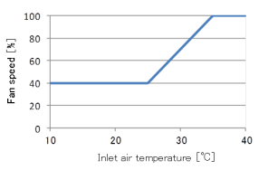
Figure 5 – Example of server fan characteristics
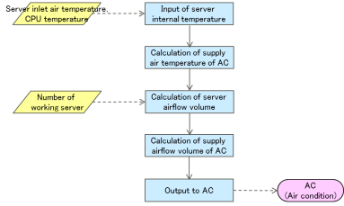
Figure 6 – Flow of ICT linked air-conditioning control

5.1.3 Remote load distribution
Two data centres are of different power consumption levels against the workload (server heat value) by the differences in air-conditioning equipment and open air conditions, as shown in Figure 7. Based on this relation, the workload is distributed to these two data centres so that the total power consumption of two data centres is minimized as shown in Figure 8. The power for the air-conditioner was not turned off in these experiments even while the workload is zero.
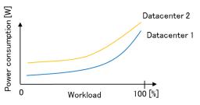
Figure 7 – Relation between data centre workload and power consumption

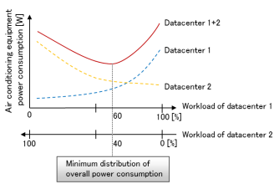
Figure 8 – Relation between workload allocation and power consumption
(Where the overall workload is expressed as 100)

5.2 Experiment items
Experiments were conducted on five control methods shown in Table 1 during the verification experiments. Experiments 1 to 4 were conducted using one simulated data centre, and experiment 5 was conducted using two simulated data centres. Outdoor air condition was changed at experiment 5. Outdoor air condition was decided by reference to a climate at Sapporo in Japan.
Each experiment continues for two days (48 hours) or longer, and the power consumption of ICT devices and air-conditioning equipment was measured.
Table 1 – List of experiment items
No. | ICT load consolidation control | ICT linked air-conditioning control | Remote load distribution | Outdoor air condition
 |  |  |  | Data centre 1 | Data centre 2
1 |  |  |  | Middle
2 | ✓ |  |  | Middle
3 |  | ✓ |  | Middle
4 | ✓ | ✓ |  | Middle
5-1 | ✓ | ✓ | ✓ | High | Natural
5-2 | ✓ | ✓ | ✓ | Middle | Natural
5-3 | ✓ | ✓ | ✓ | Low | Natural
Table 2 – Outdoor air conditions in data centre 1
 | Temperature (℃) | Humidity (%)
High temperature | 22 | 75
Middle temperature | 12 | 66
Low temperature | 7 | 62

5.3 System for experiments

5.3.1 Simulated data centres
Experimental laboratory 1 and experimental laboratory 2 shown in Figure 9 were used as simulated data centres. Table 1 indicates specifications for these experimental laboratories. Furthermore, Figure 10 shows photos indicating external appearances of experimental laboratory 1 and experimental laboratory 2.
As ICT devices, actual servers and simulated servers that simulate the server heat value and airflow were used in each experimental laboratory. ICT devices were of the same configuration in two experimental laboratories. The configuration of ICT devices in experimental laboratories is shown in Table 3. One simulated server is able to generate heat of about 4kW, and one simulated server generated heat value and airflow of ten servers in the experiments.
Regarding air-conditioning systems, the air-conditioning heat source system diagram for experimental laboratory 1 and the same for experimental laboratory 2 are shown respectively in Figure 11 and Figure 12. A data centre of good cooling efficiency was simulated using an outdoor air cooling system in experimental laboratory 1. Open air temperature and humidity can be artificially generated. Each of experimental laboratory 1 and experimental laboratory 2 was partitioned so as not to allow mixing of air flow between the cold aisle and hot aisle.
Table 3 – Specification for experimental laboratories
 | Room 1 | Room 2
Area | About 7m×5m | About 6.4m×4.8m
Number of racks | 8 | 8
Air cooling | General cooling and outdoor air cooling | General cooling

Table 4 – Specification for ICT devices
 | Room 1 | Room 2
ICT devices | 6 servers,  1 storage,  2 network switches | 5 servers,  1 storage,  2 network switches
Number of simulated servers | 16 | 16
Total heat value | 48kW | 48kW
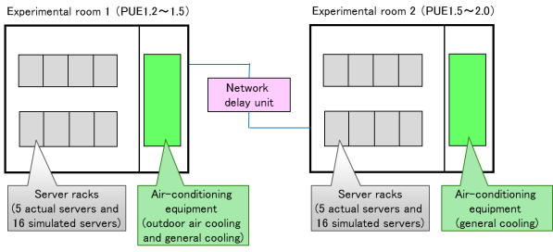
Figure 9 – Outline of experimental room
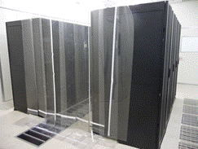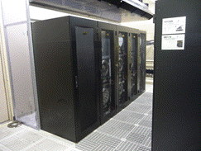
(a) Experimental room 1 | (b) Experimental room 2
Figure 10 – Appearance of experimental room
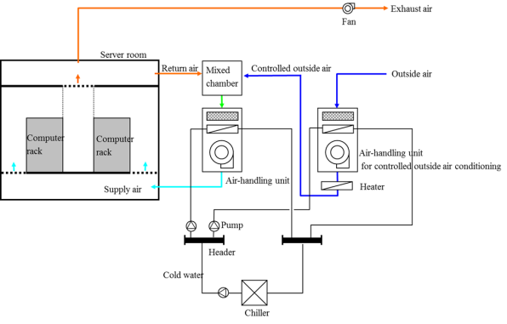
Figure 11 – System diagram of air conditioning and heat source in experimental room 1
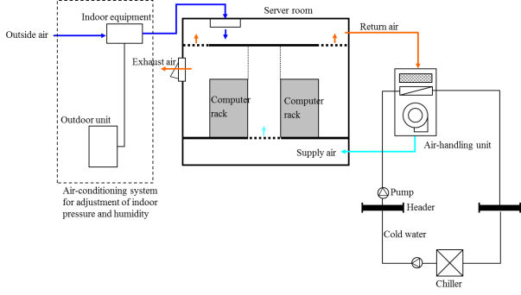
Figure 12 – System diagram of air conditioning and heat source in experimental room 2

5.3.2 Simulated operational system
As a business system that operates in the data centres, a typical Web application, an in-house document retrieval system was used. This system allows employees to retrieve documents spread across the company (including product information, reports, meeting minutes, proposals, and estimates) in a batch, using some keywords. In this experiment, a virtualization system was configured assuming a general data centre, and retrieval servers owned by four companies operate on a VM (virtual machine). The capacity of the storage device in which retrieval databases were stored was 3TB.
In this system, the workload was adjusted based on the number of retrieval requests, and as the daily variation pattern of the workload, it was assumed that the workload varied with routine works and was the highest in the daytime. Additionally, retrieval databases were updated through nightly batch processing. Figure 13 shows the daily workload data of the accumulated requests coming from four companies. This experiment started from the workload data as of 6:00 a.m. and was repeated two times for two days.
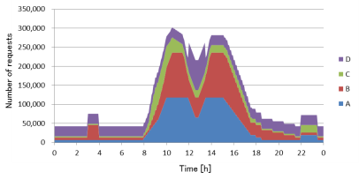
Figure 13 – Daily workload data

5.3.3 Control system
Figure 14 shows the configuration of the control system. The input parameters for control include the amount of the workload and the measured inlet air temperature and CPU temperature of the racks. The ICT load consolidation control results in controlling on/off of the server through the VM control unit and specifying the heat value and airflow to the simulated server. The ICT linked air-conditioning control results in specifying the supply temperature and airflow to the air conditioner.

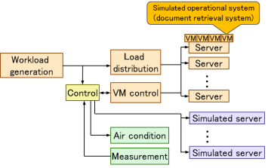
Figure 14 – Overview of control system

5.3.4 Measurement system
Table 5 shows the main measurement items. In this experiment, data was collected at intervals of 30 seconds, which was sent to the control system and recorded and stored in a data logger.
Table 5– List of measurement items
Item | Place | Target | Device
Power consumption | Experimental laboratory | Rack | Electricity meter
Power consumption | Experimental laboratory | Lighting | Electricity meter
Power consumption | Air-conditioning equipment | General air cooling, pump | Electricity meter
Power consumption | Air-conditioning equipment | Air blower | Electricity meter
Power consumption | Air-conditioning equipment | Chiller, cold water pump | Electricity meter
Temperature | Experimental laboratory | Rack (in, out) | Temperature sensor
Temperature | Experimental laboratory | Wall surface | Temperature sensor
Temperature | Open air | Open air | Temperature sensor
Temperature | Air-conditioning equipment | Supply air, inlet air | Temperature sensor
Temperature | Air-conditioning equipment | Heat quantity of cold water | Temperature sensor
Humidity | Experimental laboratory | Rack (in, out) | Humidity sensor
Humidity | Experimental laboratory | Wall surface | Humidity sensor
Humidity | Open air | Open air | Humidity sensor
Humidity | Air-conditioning equipment | Supply air, inlet air | Humidity sensor
Airflow and water volume | Air-conditioning equipment | Supply air, inlet air | Airflow sensor
Airflow and water volume | Air-conditioning equipment | Heat quantity of cold water | Water flow sensor

6 Results of experiments

6.1 Experiment (1)
Experiment (1) verified the efficiency of the conventional method, without applying both the ICT load consolidation control and the ICT linked air-conditioning control methods. The load was allocated to the servers evenly, and the air-conditioning supply temperature and airflow were fixed. The supply temperature and airflow of the air-conditioner were set to 24°C and 20000m3/h, respectively.
Figure 15 shows the measured data of the power consumption of the ICT devices and the air-conditioner, as well as the overall power consumption. This shows that the variation of the power consumption of ICT devices was small, which decreased by around 20% even when the workload was low. The power consumption of the air-conditioner was approximately constant and about 8.5kW on average.
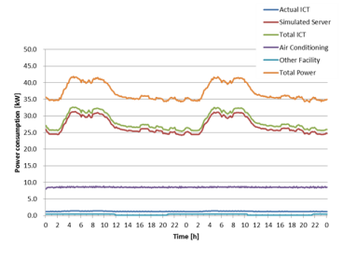
Figure 15 – Power consumption of experiment (1)

6.2 Experiment (2)
Experiment (2) verified the effect of power consumption reduction by applying the ICT load consolidation control method only. The supply temperature and airflow of the air-conditioner were set to the same values as Experiment (1).
Figure 16 shows the measured data of the power consumption. Because of the ICT load consolidation control, the power consumption of the ICT devices was able to be reduced by 80% or more during workload being low. In contrast, the power consumption of the air-conditioner was the same as Experiment (1).
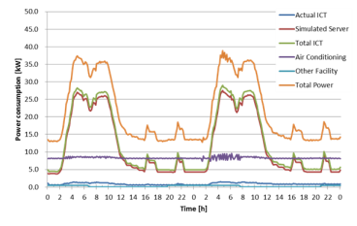
Figure 16 – Power consumption of experiment (2)

6.3 Experiment (3)
Experiment (3) verified the effect of power consumption reduction by applying the ICT linked air-conditioning control method only. The supply temperature of the air-conditioner was set to 23°C to maintain the inlet air temperature of the racks at 25°C or less. In addition, the supply airflow was set to approximately 16000m3/h so as to be greater than the total airflow of the server fan.
Figure 17 shows the measured data of the power consumption. The power consumption of the ICT devices was almost the same as Experiment (1). The power consumption of the air-conditioner was about 4.8 kW on an average or smaller than Experiments (1) and (2) due to lowered supply airflow.
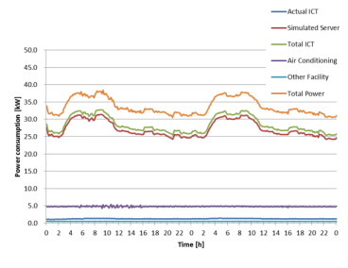
Figure 17 – Power consumption of experiment (3)

6.4 Experiment (4)
Experiment (4) verified the effect of power consumption reduction by applying both the ICT load consolidation control and the ICT linked air-conditioning control methods. The supply temperature of the air-conditioner was set to the same value as Experiment (3). On the other hand, the supply airflow was able to be reduced up to 7000m3/h during workload being low because the number of operating servers was less than Experiment (3) due to the ICT load consolidation control.
Figure 18 shows the measured data of the power consumption. The power consumption of the ICT devices was the same as Experiment (2). The power consumption of the air-conditioner was about 2.9 kW on an average during workload being low, which was lower than Experiment (3).
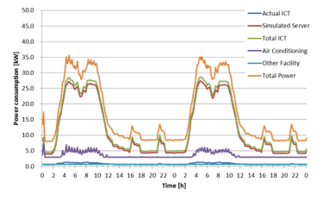
Figure 18 – Power consumption of experiment (4)

6.5 Experiment (5)
Experiment (5) used two experimental rooms, and each room applied both the ICT load consolidation control and the ICT linked air-conditioning control methods. This experiment verified the effect of power consumption reduction through remote load distribution to allocate the workload optimally to the two experimental rooms. Twice the number of requests than Figure 13 was used as the workload data. In addition, a 50-ms delay in communication between Experimental room 1 and Experimental room 2 was added.
Figure 19 shows the load distribution table for remote load distribution. By measuring of the characteristics of air-conditioning power consumption of each experimental room, this table was determined the allocation proportion to minimize the total air-conditioning power consumption of the two experimental rooms for the number of retrieval requests.
In this experiment, the outdoor air temperature conditions of Experimental room 1 were changed from high to medium and low. The data of the measured power consumption at each temperature is shown in Figure 20, Figure 21, and Figure 22. At high temperatures, as the load was allocated to Experimental room 2 first in accordance with the load distribution table, the power consumption was generally higher in Experimental room 2 than in Experimental room 1. On the other hand, at medium and low temperatures, as the allocation proportion to Experimental room 1 was higher, the power consumption of Experimental room 1 was higher than Experimental room 2.
In order to investigate the impact of a delay in communication, the same experiment was performed with a delay time in communication of 0ms. When compared with the experiment result using a 50-ms delay, as this experiment showed no significant difference, it is assumed that control is scarcely affected by a delay.
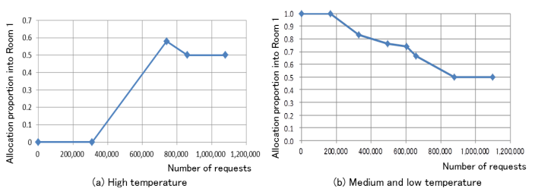
Figure 19 – Load distribution table
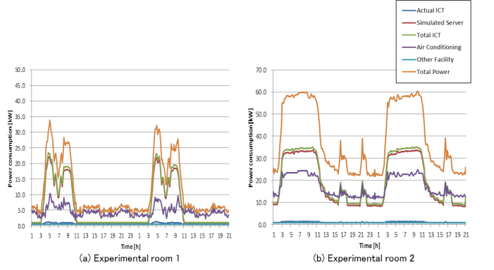
Figure 20 – Power consumption of experiment (5) - high temperature
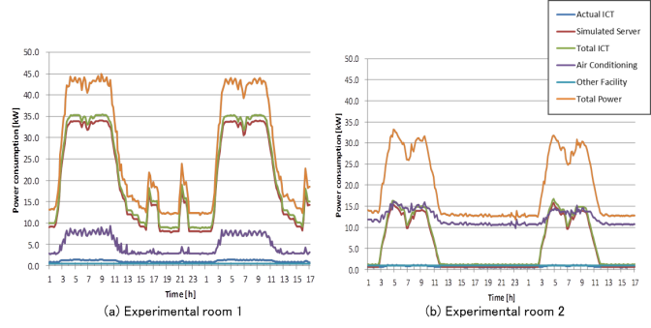
Figure 21 – Power consumption of experiment (5) - medium temperature
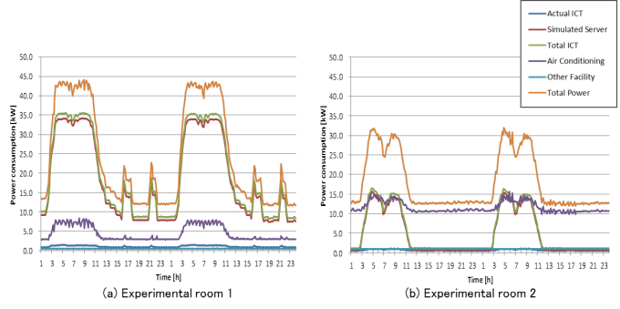
Figure 22 – Power consumption of experiment (5) - low temperature

6.6 List of power consumption and CO2 emissions
Table 6 and Figure 23 show the list of the daily power consumption in Experiments (1)–(4).
Table 7 and Figure 24 show the list of the daily power consumption in Experiment (5).
Table 6 – Power consumption of Experiment (1)-(4) (integral power consumption per day)
 | ICT device [kWh] | Facility [kWh] | Total [kWh]
Experiment (1) | 677.3 | 212.6 | 889.8
Experiment (2) | 307.2 (54.7) | 205.2 (3.5) | 512.4 (42.5)
Experiment (3) | 682.1 (-0.6) | 125.9 (40.9) | 808.0 (9.3)
Experiment (4) | 308.1 (54.6) | 99.1 (53.2) | 407.2 (54.2)
( ): a reduction rate [%] to Experiment (1)
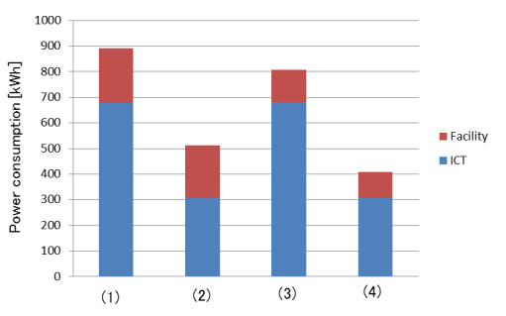
Figure 23 – Comparison of power consumption of Experiment (1)-(4)
Table 7 – Power consumption of Experiment (5) (integral power consumption per day)
 | Experimental room 1 |  |  | Experimental room 2 |  |  | Sum
 | ICT device | Facility | Total | ICT device | Facility | Total | Sum
High | 132.5 | 118.8 | 251.3 | 480.5 | 425.3 | 905.8 | 1,157.1
Medium | 472.6 | 122.1 | 594.8 | 124.5 | 306.4 | 430.9 | 1,025.7
Low | 469.9 | 116.3 | 586.2 | 124.0 | 299.8 | 423.8 | 1,010.0
[kWh]
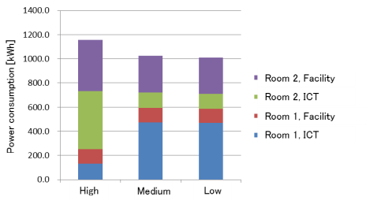
Figure 24 – Comparison of power consumption of Experiment (5)
Table 8 shows the daily CO2 emissions in Experiments (1)–(5). The following value announced by The Ministry of the Environment of Japan is used as CO2 emission factor for the power consumption.
CO2 emission factor: 0.375 kg-CO2/kWh (Tokyo Electric Power Company in FY 2010)
Table 8 – Daily CO2 emission of experiment (1)-(5)
 |  | Power consumption [kWh] | CO2 emission [kg-CO2]
Experiment (1) |  | 889.8 | 333.7
Experiment (2) |  | 512.4 | 192.2
Experiment (3) |  | 808.0 | 303.0
Experiment (4) |  | 407.2 | 152.7
Experiment (5) | High | 1,157.1 | 433.9
Experiment (5) | Medium | 1,025.7 | 384.6
Experiment (5) | Low | 1,010.0 | 378.8

7 Estimate if applying to actual data centres

7.1 Estimate for 500 racks
A data centre configuration for the estimation is as follows:
- 500 server racks
- 2 floors
- 260 server racks on 1st floor
- 240 server racks on 2nd floor
- 10 server racks in 1 line
As to air-cooling system, an alignment of a cold aisle and a hot aisle, an aisle capping of a hot aisle, a free access of a floor and a ceiling chamber are assumed.
There are 20 servers in a server rack. Maximum heat value of a server rack is 6 kW.
Air-conditioning equipment is same as Experimental room 1. 63 air-conditioning equipment for 500 server racks are set. Outdoor air condition is the medium temperature in Sapporo.
Based on the Experiment results, some estimates are made for the cases in which the conventional method is applied like Experiment (1), and the ICT load consolidation control and ICT linked air-conditioning control methods (simply referred to as “control” in this section) are applied like Experiment (4).
Table 9 shows the estimation results. This indicates that the reduction rate is almost the same as the Experiment results.

Table 9 – Power consumption of 500 racks
 | ICT device | Facility | Total
Conventional method | 42,331 | 13,394 | 55,725
With control | 19,256 (54.5) | 6,243 (53.4) | 25,499 (54.3)
[kWh]

7.2 Annual estimate
The following two estimates are made as an annual estimate: estimate for the data centre with 500 racks mentioned in the previous section, and estimate for remote load distribution in Experiment (5) assuming the two data centres.
As shown in Figure 25, the workload data is classified into two time periods: a high-load period and a low-load period.
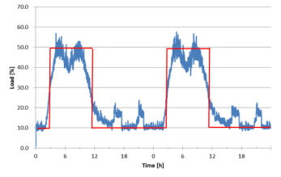
Figure 25 – Approximation of workload data
(1) Estimate for one data centre
Assuming Sapporo as the location condition of data centres, the hourly operating status of the air-conditioner is obtained from the data of annual outdoor temperature and humidity in Sapporo. The operating status of the air-conditioner is classified by being divided into two operations: operation with outdoor air-conditioning only and operation with the combined use of general air-conditioning that uses a refrigerator and outdoor air-conditioning. The operating status of the air-conditioner depends on not only the outdoor temperature and humidity but also the server heat generation and air-conditioning control method, the air-conditioner used in this experiment, however, can be classified only by the outdoor temperature and humidity. Table 10 shows the number of hours for each operating status of the air-conditioner for one year.
Table 10 – Number of hours of each operating status [hour]
Outdoor air-conditioning |  | Outdoor and general air-conditioning
High load | Low load | High load | Low load
1,355 | 4,489 | 733 | 2,183
In addition, the power consumption of each operating status of the air-conditioner is estimated for two cases using the experiment data: one in which the conventional method is applied with no control, another with control. Table 11 shows the estimated values.
Table 11 – Power consumption of each operation status [kW]
 | Outdoor air-conditioning |  | Outdoor and general air-conditioning
 | High load | Low load | High load | Low load
Without control | 9 | 9 | 16 | 16
With control | 5 | 3 | 12 | 7
The above values are applied to 500 racks to calculate the annual power consumption. For comparison, another estimate is made for the data centre in which the workload data is assumed as constantly highly loaded (average CPU usage of 50%). These results are shown in Table 12.
In this table, the values converted into CO2 emissions are also listed. The CO2 emission factor in Sapporo is determined as below based on the actual emission factor used by Hokkaido Electric Power Company announced by the Ministry of the Environment of Japan.
CO2 emission factor: 0.353 kg-CO2/kWh (Hokkaido Electric Power Company in FY 2010)
The above shows that, when the workload can be both high and low, the reduction rate is greater than the daily experimental results. This is because the load is low on Saturdays and Sundays; therefore the proportion of the low-load period increases by about 9%. Additionally, when the workload is high, the reduction rate decreases, which reveals that the control effect depends on the workload.
Table 12 – Comparison of annual power consumption
Annual workload | Control method | Power consumption [MWh] |  |  | CO2 emission  [kg-CO2]
Annual workload | Control method | ICT | Facility | Total | CO2 emission  [kg-CO2]
High load + low load | Conventional | 15,304 | 6,253 | 21,557 | 7609K
High load + low load | Controlled | 5,739(62.5) | 2,792(55.3) | 8,531(60.4) | 3011K
High load | Conventional | 16,973 | 6,253 | 23,226 | 8199K
High load | Controlled | 15,330(9.7) | 4,045(35.3) | 19,375(16.6) | 6839K
(2) Estimate for the two data centres
The two data centres are referred to as Data centre 1 and Data centre 2, respectively, and Data centre 1 has the same configuration as the above; that is, the assumed location is Sapporo and the number of racks is 500, using both the outdoor air-conditioning and the general air-conditioning. In data centre 2, the assumed location is Tokyo and number of racks is 500, using general air-conditioning only, and estimates are made under the same conditions as Experiment (5). For comparison, both remote load distribution and equal load allocation are estimated.
Table 13 shows the power consumption estimated for remote load distribution and equal load allocation. The effect of power consumption reduction of air-conditioning is higher in high-load periods in which power consumption is reduced by approximately 6%.
Table 13 – Comparison of annual power consumption [MWh]
 | ICT | Air-conditioning |  |  | Sum
 | ICT | High load | Low load | Total | Sum
Remote distribution | 11,478 | 3,340 | 6,551 | 9,891 | 21,369
Equal allocation | 11,478 | 3,584 | 6,734 | 10,318 | 21,796

8 Conclusion
The verification experiments help making the findings on the following power-saving control technology in cooperation with the ICT devices and the air-conditioning equipment.
(1) ICT load consolidation control can reduce the power consumption of the ICT devices by aggregating the calculation load to specific servers and turning off the servers in the idle state. Especially when the workload is low, the power consumption can be reduced significantly.
(2) ICT linked air-conditioning control can reduce the power consumption of both the server and the air-conditioning equipment by controlling the supply temperature of the air-conditioning equipment to maintain the minimum speed of the server fan as well as by minimizing the supply airflow of the air-conditioning equipment according to the airflow of the server fan. Cooperation with ICT load consolidation control can reduce the whole airflow of the server fan due to shutdown of the server, which can reduce further the supply airflow of the air-conditioning equipment.
(3) Remote load distribution can optimize the total power consumption of the air-conditioning equipment of the two experimental rooms by appropriately allocating the workload to these rooms. Especially a higher effect can be expected in reducing the power consumption when the workload is high.
(4) As the result of the estimate to measure the effect of power consumption reduction when a data centre with 500 racks operates for one year, it is revealed that, when the average CPU usage is 10% at night or on weekends and the average CPU usage is 50% during the daytime on weekdays, the overall power consumption of the data centres can be reduced by approximately 60%. If the average CPU usage is 50% throughout the day, the overall power consumption of the data centres can be reduced by approximately 16%. Additionally, as the result of the estimate assuming that each data centre is located in Sapporo and Tokyo, applying remote load distribution can reduce the power consumption of the air-conditioning equipment by up to 6% compared to equal load allocation.

References and Bibliography
[ITU-T L.1300] Recommendation ITU-T L.1300 (2011), Best practices for green data centres.
[b-IPCC] IPCC Working Group 1 Report (2007), Glossary of Terms used in the IPCC Fourth Assessment Report.
[b-ISO 14064-1] ISO 14064-1 (2006), Greenhouse gases – Part 1: Specification with guidance at the organization level for quantification and reporting of greenhouse gas emissions and removals.

_________________

