 |  | International Telecommunication Union
 |  | ITU-T | Technical Paper
 |  | TELECOMMUNICATION  STANDARDIZATION SECTOR  OF ITU |  | (13 December 2013)
SERIES L:
CONSTRUCTION, INSTALLATION AND PROTECTION OF TELECOMMUNICATION CABLES IN PUBLIC NETWORKS
 | Case study of reduction of air-conditioning energy by optical fibre based thermometry

Summary
This Technical Paper refers to the Best Practices defined in Recommendation ITU-T L.1300. More precisely, this Technical Paper reports a case study related to the reduction of the energy spent for air-conditioning through the use of optical fibre based thermometry. A general description of the temperature measurement is firstly provided; then the optimization process for the air-conditioning is highlighted. Finally, the results of temperature measurements through optical fibre sensors are shown.
Keywords
Best practice, data centre, energy efficient, information and communication technology and climate change (ICT & CC).

Change Log
This document contains Version 1 of the ITU-T Technical Paper on “Case study of reduction of air-conditioning energy by optical fibre based thermometry” approved at the ITU-T Study Group 5 meeting held in Lima, 2-13 December 2013.

Editor: | Gianluca Griffa  Telecom Italia  Italy | Tel: +39 331 600 1341  Email: gianluca.griffa@telecomitalia.it

Contents
Page
1 Scope 4
2 Definitions 4
3 Abbreviations 4
4 Introduction 4
5 General description of temperature measurement using optical fibre sensors 5
5.1 Principle and system configuration 5
5.2 Features 6
6 Optimizing air-conditioning environment of datacentres 7
7 Case studies 7
7.1 Basic optical fibre layout 7
7.2 A trial at a compact server room 7
7.3 A trial at a large datacentre 9
References and Bibliography 13

List of Tables
Page
Table 1 – Summary of improvements for air-conditioning 9

List of Figures
Page
Figure 1 – Energy consumption ratio in datacentres 5
Figure 2 – Principle of temperature measurement by optical fibre 6
Figure 3 – A typical optical fibre layout in a datacentre 7
Figure 4 – Server room layout 8
Figure 5 – Changes in temperature distribution depending on air flow direction 9
Figure 6 – A photograph of the target datacentre (Numazu) 10
Figure 7 – Result of rising for temperature setting of air-conditioner 10
Figure 8 – Air flow around servers in a server rack 11
Figure 9 – Installed position of floor grills 11
Figure 10 – Improvement of temperature distribution 12

ITU-T Technical Paper
Case study of reduction of air-conditioning energy by optical fibre based thermometry
Summary
This Technical Paper describes case study of reduction of air-conditioning energy by optical fibre based thermometry based on Recommendation ITU-T L.1300.
Keywords
Best practice, data centre, energy efficient, information and communication technology and climate change (ICT & CC).

1 Scope
This Technical Paper describes case study of reduction of air-conditioning energy by optical fibre based thermometry based on Recommendation ITU-T L.1300. The scope of this Technical Paper includes:
– a general description of temperature measurement using optical fibre sensors;
– optimizing air-conditioning environment of datacentres; and
– case studies of temperature measurement using optical fibre sensors.

2 Definitions
This Technical Paper uses the following terms:
None.

3 Abbreviations
None.

4 Introduction
Information and communication technology (ICT) systems, which support the ICT society, have been expanding remarkably in recent years due to the spread of the Internet infrastructure and deployment of high-performance servers and other high-end computing systems. This trend has been accompanied by a dramatic increase in the floor space of datacentres and the number of servers that they accommodate, resulting in a significant increase in the power consumption of datacentres.
A datacentre has many servers, generally from a few tens to several thousands, and the working servers generate a considerable amount of waste heat. As a result, air conditioning systems using large-scale air-conditioning equipment have become essential for cooling these servers and keeping the room temperature below the specified value. The power required for air-conditioning, however, has risen to about 40% of the total power consumed by datacentres (Figure 1). Hence, in order to achieve an energy-efficient datacentre, reduction of air-conditioner power consumption is unavoidable.
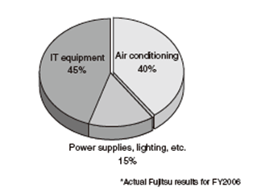
Figure 1 – Energy consumption ratio in datacentres
Achieving energy-efficient air conditioning requires not only the deployment of high-efficiency air-conditioning equipment, but also optimization of the cooling conditions at the target locations. The temperature settings in server rooms are often rather low to prevent server overheating, despite the fact that excessive cooling results energy loss. There is also concern that cooling efficiency would decrease due to temperature increase of the cooling air that would suck back exhaust heat for various reasons at points (server intake panels) designed to supply chilled air.
Thus, to achieve energy conservation by optimizing the air-conditioning system, an accurate and detailed temperature distribution in the vicinity of servers must be obtained. Temperature measurements have traditionally been performed using discrete temperature sensors like thermocouples, thermistors, and platinum resistance thermometer bulbs, and integrated-circuit-type temperature sensors. However, taking into consideration the temperature measurement of a few hundred to several thousand servers, it is impractical to utilize discrete sensors due to several limitations which include high construction cost, difficulty in installation of signal-circuits, difficulty in shortening of measurement time, and so on. Accordingly, to achieve a temperature measurement technique that can handle such a large array of servers, an optical-fibre-based temperature measurement technique has been developed, and tested to prove its usability to reduce the energy consumption in datacentres.

5 General description of temperature measurement using optical fibre sensors

5.1 Principle and system configuration
Raman-scattering light measurement is widely used in optical-fibre-based thermometric sensing methods. Raman- scattering light is generated in a transparent substance when irradiated with a strong LASER stimulating light. Raman scattering consists of two types of light rays called anti-Stokes light and Stokes light. Anti-Stokes light has a 50 nm shorter wavelength than the injected light, and it is sensitive to the temperature changes in the optical fibre. Stokes light has a 50 nm longer wavelength than the injected light and it is not so sensitive to temperature changes. By measuring the intensity ratio of these two types of light, we can determine the temperature distribution along the entire length of an optical fibre
In more detail, a LASER light in the form of short pulses with several nanosecond pulse width is injected into an optical fibre. Then, while the light propagates through the optical fibre, the backscattering intensity of Raman-scattering light generated at various locations in the optical fibre is measured together with the delayed propagation time. The principle behind this technology is shown in Figure 2. The change in intensity versus propagation time is plotted (Figure 2, upper right). Signal conversions from light intensity to temperature and propagation time to fibre distance (Figure 2, lower right) gives the temperature distribution along the fibre. The distances of locations are computed by multiplying the delayed propagation time of the Raman scattering light by the speed of the light propagation in the optical fibre (about 2 x 108 m/s). In a 10-km-long optical fibre, for example, excitation light takes about 50μs to arrive at the other end, which means that temperature information along the entire 10 km of the optical fibre can be obtained within about 100μs.
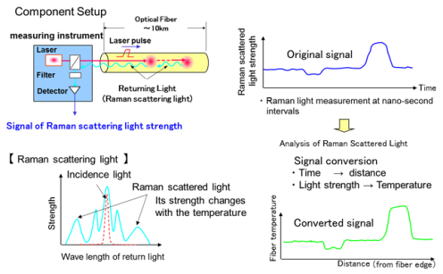
Figure 2 – Principle of temperature measurement by optical fibre
The temperature distribution measurement in optical fibres using Raman scattering light is considered to be very promising in real time multipoint thermometry.

5.2 Features
Optical-fibre-based thermometry has some excellent features described below;
- Real-time multi-point measurement
Since the temperature measurement is carried out based on an optical process, up to 10,000 temperature data points along the fibre laid on target areas can be obtained within every 30 sec intervals.
- High resolution & high accuracy
Maximum resolution is 10 cm, and accuracy is +/-1℃.
- Capability to visualize temperature distribution
By utilizing high resolution thermometry given above, the temperature distribution in a datacentre can be obtained as thermographic image data. A user can easily understand the thermal environment of the datacentre, and this would help to improve the air-conditioning efficiency.

6 Optimizing air-conditioning environment of datacentres
According to the temperature distribution, the air-conditioning environment can be improved to a more energy efficient one by optimising several air-conditioning parameters. For example, air flow direction, flow rate, and temperature control settings are the most effective parameters for improving the energy efficiency.

7 Case studies

7.1 Basic optical fibre layout
Representative optical fibre layout is shown in Figure 3. Rack installation pattern is almost rectangular along each front side and back side door frames. Optical fibre laid on the front side door is more important to monitor the temperature of the inlet cooling air to each server. Optical fibres on each door were connected together at the base of each server rack to make a single optical fibre circuit. Fibre laying on the celling was done in a parallel pattern with a spacing of 30 - 50 cm and 10 - 30 cm above from the top of server racks.
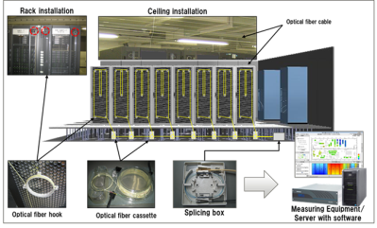
Figure 3 – A typical optical fibre layout in a datacentre

7.2 A trial at a compact server room
A trial on site temperature measurements and improvement of air-conditioning environment was conducted at a small server room; Fujitsu Kyushu Office. The server room was equipped with 14 server racks and 2 indoor air-conditioner units (Figure 4).
First, a conventional air-conditioning system was studied (Figure 4-(A)). From the data, it was found that the cold air blew out from the air-conditioner was almost strait and parallel to the longitudinal direction of the server room. In this condition, supplied cold air get mixed with the hot exhaust from the servers, and the cooling efficiency of the severs was found to be rather low. Then, tuning of the wind direction and temperature setting were done while monitoring the temperature distribution by the optical fibre thermometry system.
Case 1: By changing the cold air direction as shown in Figure 5-(B), cooling efficiency was improved; this made it possible to increase the air-conditioner temperature. In this case, power consumption of air-conditioning system was reduced by 11%.
Case 2: Without changing the cold air flow direction of Case 1, one air-conditioner was stopped (Figure 5-(C)). Here, we found that it is possible to supply cold air below 28℃ to all servers. From these two changes, it was possible to reduce the power consumption by 36% compared with the conventional conditions.
Case 3: Another air-conditioner was stopped while keeping all the other conditions of the case 2 unchanged (Figure 5-(D)). In this case, air-conditioning power consumption reduction was reached to 23%. Results of the above improvements are summarized in Table 1.
Tuning of wind direction can be completed within 30 minutes for all cases. After tuning, it took 1 to 2 hours for measuring and verifying power consumption of the air conditioner.
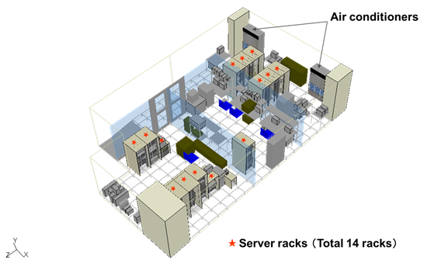
Figure 4 – Server room layout
Figure 5 – Changes in temperature distribution depending on air flow direction
Table 1 – Summary of improvements for air-conditioning
Cooling Condition |  | Set Temp. of AC#1 | Set Temp. of AC#2 | Air Flow Drection | Total Power Consumption of ACs(kW) |  | Reduction Rate
 |  |  |  |  | Indoor Unit | Outdoor Unit | Reduction Rate
Conventional |  | 22°C | 23°C | Mixed with hot exhaust | 5.6 |  | –
 |  |  |  |  | 2.3 | 3,3 | –
Case1 | Change of air flow direction | 24°C | 24°C | Supplied to cold aisle | 5.0 |  | 11%
 |  |  |  |  | 2.3 | 2.7 | 11%
Case2 | Stop AC#2 | 24°C | Shutdown | Supplied to cold aisle | 3.6 |  | 36%
 |  |  |  |  | 1.2 | 2.4 | 36%
Case3 | Stop AC#1 | Shutdown | 24°C | Supplied to cold aisle | 4.3 |  | 23%
 |  |  |  |  | 1.2 | 3.1 | 23%

7.3 A trial at a large datacentre
Another trial was done in a large datacentre; Fujitsu Numazu Cloud Centre.
Optical fibre sensors were laid on more than 30 racks and more than 170 m2 ceiling area (Figure 68).
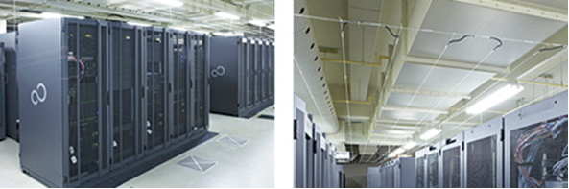
Figure 6 – A photograph of the target datacentre (Numazu)
In this datacentre, the initial set temperature of the air-conditioner was 19℃, and it was found that there were several overcooled server racks (Figure 7, left). The set temperature was gradually raised, and temperature distribution of all of the server racks and ceiling area was continuously measured to check whether abnormal temperature rise has occurred. When the set temperature reached to 2℃ above the original value (19℃), some overheated spots appeared on the front side door of server racks (Figure 7, right). To prevent function failure, this approach was interrupt immediately, and the cause of this problem was investigated.
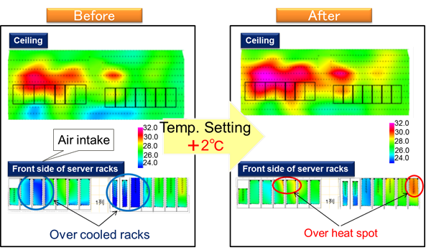
Figure 7 – Result of rising for temperature setting of air-conditioner
By detailed examination around the server racks, 2 types of problems were identified.
(1) Hot exhaust backflow
We found that there were some vacant spaces in some server racks near to the hot spots. It is believed that hot exhaust returned to the front side through these vacant spaces (Figure 8, left).
(2) Insufficient cooling air flow
Cooling air was supplied through several floor grills to the each server rack. We noticed that the floor grills had been placed unevenly. This led to insufficient cooling of the servers adjacent to the troubled server racks (Figure 9, left).
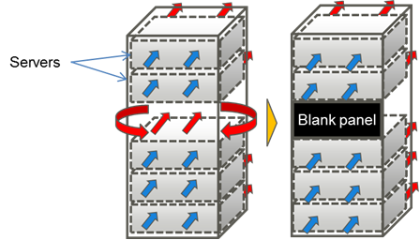
Figure 8 – Air flow around servers in a server rack
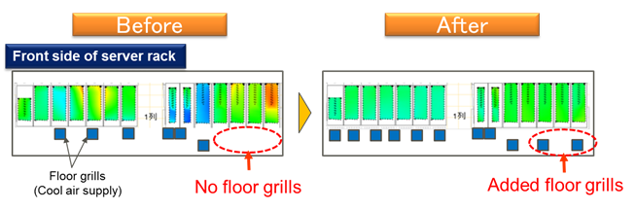
Figure 9 – Installed position of floor grills
Improvement of air flow was carried out as follows:
- Blank panels were installed to the vacant spaces in the server racks.
- The number of floor grills was increased, and installing positions were adjusted while checking the temperature distribution continuously.
As a result, highly uniformed temperature distribution on each server rack was achieved, and the set temperature was able to increase further. As the final result, the datacentre set temperature was able to increase by 5.5℃ (Figure 10). Although this study was conducted in only a part of the datacentre, the power consumption reduction of air-conditioning system of the entire datacentre was estimated to be about 6%.
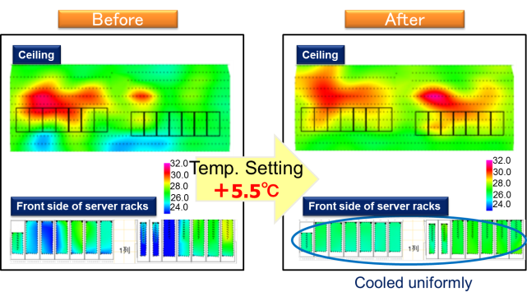
Figure 10 – Improvement of temperature distribution

References and Bibliography
[ITU-T L.1300] Recommendation ITU-T L.1300 (2011), Best practices for green data centres.

_________________

