Standardization Sector
ITU-T Technical Report
(10/2025)
GSTP-MTN
Description of metro transport networks
ITUPublications | International Telecommunication Union


Technical Report ITU-T GSTP-MTN
Description of metro transport networks

Summary
Technical Report ITU-T GSTP-MTN provides an overview of the metro transport network (MTN) technology including network requirements, application scenarios, characteristics of MTN and introduction of ITU-T MTN related standards.

Keywords
fgMTN, MTN, overview, requirements, technical characteristics.

Note
This is an informative ITU-T publication. Mandatory provisions, such as those found in ITU-T Recommendations, are outside the scope of this publication. This publication should only be referenced bibliographically in ITU-T Recommendations.

© ITU 2026
All rights reserved. No part of this publication may be reproduced, by any means whatsoever, without the prior written permission of ITU.

Table of Contents
Page
1 Scope 1
2 References 1
3 Definitions 2
3.1 Terms defined elsewhere 2
3.2 Terms defined in this Technical Report 2
4 Abbreviations and acronyms 2
5 The network requirements of MTN 5
5.1 5G backhaul requirements 5
5.2 Dedicated line service requirements 7
5.3 Important industry private network requirements 8
5.4 Existing SDH replacement requirements 10
6 Technical characteristics of MTN 11
6.1 MTN design concept 11
6.2 MTN architecture and key technology 12
6.3 fgMTN architecture and key technologies 21
7 Introduction of MTN and fgMTN related ITU-T Recommendations 25
8 MTN application scenarios 26
8.1 5G and dedicated line multi-services transport network applications 26
8.2 Important industry private network applications 29
8.3 Existing SDH replacement network applications 31
Bibliography 33

Technical Report ITU-T GSTP-MTN
Description of metro transport networks

1 Scope
The purpose of this Technical Report is to assist the industry in understanding metro transport network (MTN) technology and highlighting the relevant ITU-T MTN standards. It provides an overview of MTN technology including network requirements, application scenarios, characteristics of MTN and introduction of ITU-T MTN related standards.

2 References
[ITU-T G.781] Recommendation ITU-T G.781 (2026), Synchronization layer functions for frequency synchronization based on the physical layer.
[ITU-T G.800] Recommendation ITU-T G.800 (2016), Unified functional architecture of transport networks.
[ITU-T G.808.4] Recommendation ITU-T G.808.4 (2024), Linear protection for fine grain metro transport network (fgMTN) and fine grain optical transport network (fgOTN).
[ITU-T G.8262.1] Recommendation ITU-T G.8262.1 (2025), Timing characteristics of enhanced synchronous equipment clocks.
[ITU-T G.8272] Recommendation ITU-T G.8272 (2025), Timing characteristics of primary reference time clocks.
[ITU-T G.8272.1] Recommendation ITU-T G.8272.1 (2024), Timing characteristics of enhanced primary reference time clocks.
[ITU-T G.8273.2] Recommendation ITU-T G.8273.2/Y.1368.2 (2023), Timing characteristics of telecom boundary clocks and telecom time synchronous clocks for use with full timing support from the network.
[ITU-T G.8274] Recommendation ITU-T G.8274 (2025), Architecture and requirements for packet-based time and phase distribution.
[ITU-T G.8275.1] Recommendation ITU-T G.8275.1 (2026), Precision time protocol telecom profile for phase/time synchronization with full timing support from the network.
[ITU-T G.8300] Recommendation ITU-T G.8300 (2020), Characteristics of transport networks to support IMT-2020/5G.
[ITU-T G.8310] Recommendation ITU-T G.8310 (2020), Architecture of the metro transport network.
[ITU-T G.8312] Recommendation ITU-T G.8312 (2020), Interfaces for metro transport networks.
[ITU-T G.8312.20] Recommendation ITU-T G.8312.20 (2024), Overview of fine grain MTN.
[ITU-T G.8321] Recommendation ITU-T G.8321 (2022), Characteristics of metro transport network equipment functional blocks.
[ITU-T G.8331] Recommendation ITU-T G.8331 (2022), Metro transport network linear protection.
[ITU-T G.8350] Recommendation ITU-T G.8350 (2022), Management and control of metro transport networks.
[ITU-T G.8371] Recommendation ITU-T G.8371 (2025), Synchronization aspects of metro transport network.
[ITU-T G.suppl.69] Recommendation ITU-T G. suppl.69 (2020), Migration of a pre-standard network to a metro transport network.
[IEEE 802.3] IEEE 802.3-2022, IEEE Standard for Ethernet.

3 Definitions

3.1 Terms defined elsewhere
None.

3.2 Terms defined in this Technical Report
None.

4 Abbreviations and acronyms
This Technical Report uses the following abbreviations and acronyms:
5G-R 5G-Railway
5GC 5G Core
AI Adapted Information
AM Alignment Marker
AMP Asynchronous Mapping Procedure
AP Access Point
APS Automatic Protection Switching
AR Augmented Reality
BIP Bit Interleaved Parity
CBR Constant Bit Rate
CI Characteristic Information
CRC Cyclic Redundancy Check
DC Data Centre
DM Delay Measurement
eMBB enhanced Mobile Broadband
EoM End of Message
ePRC enhanced PRC
ePRTC enhanced PRTC
ERP Effective Radiated Power
eSEC enhanced Synchronous Equipment Clock
ETH Ethernet
EVPN Ethernet Virtual Private Network
FE Fast Ethernet
FEC Forward Error Correction
fgCPU fine grain CBR clients Payload Unit
fgCS fine grain Calendar Slot
fgMTN fine grain MTN
fgMTNP fine grain MTN Path
fgMU fine grain Multiplex Unit
FlexE Flex Ethernet
FP Forwarding Point
FwEP Forwarding End Point
GE Gigabit Ethernet
GMP Generic Mapping Procedure
gNodeB next Generation Node B
GNSS Global Navigation Satellite System
IoT Internet of Things
IP Internet Protocol
IPG Inter-packet Gap
L2VPN Layer 2 Virtual Private Network
L3VPN Layer 3 Virtual Private Network
M2M Machine-to-Machine
MAC Media Access Control
MEC Multi-access Edge Computing
MIoT Mobile Internet of Things
mMTC massive Machine-Type Communication
MPLS Multi-Protocol Label Switching
MPLS-TP Multi-Protocol Label Switching-Transport Profile
MSTP Multi-Service Transport Platform
MTN Metro Transport Network
MTNP MTN Path
MTNS MTN Section
MTTFPA Mean Time To False Packet Acceptance
NGMN Next Generation Mobile Networks
NNI Network Node Interface
NR New Radio
OAM Operations, Administration, and Maintenance
OH Overhead
OTN Optical Transport Network
OTSiG Optical Tributary Signal Group
PCRF Policy and Charging Rules Function
PCS Physical Coding Sublayer
PHY Physical layer
PPS Pulse Per Second
PRC Primary Reference Clock
PRTC Primary Reference Time Clock
PTP Precision Time Protocol
QoS Quality of Service
RAN Radio Access Network
RS Reconciliation sublayer
SDH Synchronous Digital Hierarchy
SDN Software-Defined Networking
SLA Service Level Agreement
SMF Session Management Function
SMS Short Message Service
SoM Start of Message
SPN Slicing Packet Network
SR Segment Routing
SSM Synchronization Status Message
STM Synchronous Transport Module
SyncE Synchronous Ethernet
T-BC Telecom Boundary Clock
T-GM Telecom Grandmaster
T-TSC Telecom Time Synchronous Clock
TDD-LTE Time Division Duplex-Long Term Evolution
TDM Time Division Multiplexing
ToD Time of Day
ToS Type of Service
UDM Unified Data Management
UPF User Plane Function
uRLLC ultra-Reliable and Low-Latency Communication
VIP Very Important Person
VPN Virtual Private Network
VR Virtual Reality
WDM Wavelength Division Multiplexing

5 The network requirements of MTN

5.1 5G backhaul requirements
The main driving force behind metro transport networks evolution is the generational changing requirements of mobile backhaul services. In the era of 1G (1st generation, the first-generation mobile communication technology) and 2G (2nd generation), the main services are voice and short message service (SMS). Technologies based on time division multiplexing (TDM) circuit switching, such as synchronous digital hierarchy (SDH) and multi-service transport platform (MSTP), which provided fixed data pipelines, became the mainstream technologies for mobile backhaul. In the era of 3G (3rd generation) and 4G (4th generation), data services such as Internet and video became the dominant services. The network expansion model based on fixed TDM pipelines is difficult to support business growth. Two packet switching technologies, IP/MPLS (multi-protocol label switching) and MPLS-TP (multi-protocol label switching-transport profile), emerged as the mainstream technologies for mobile backhaul.
In IMT-2020 (namely 5G) era, the demand for high network data rates has further increased, and the network evolved towards multi-service and multi-scenario applications. These services include enhanced mobile broadband (eMBB) services with higher bandwidth and lower latency, mMTC (massive machine-type communication) services that support a massive number of user connections, and uRLLC (ultra-reliable and low-latency communication) services with extremely high reliability and low latency.
Consequently, mobile backhaul networks for 5G require large bandwidth, low latency, network slicing, flexible network scheduling, and high-accuracy synchronization.
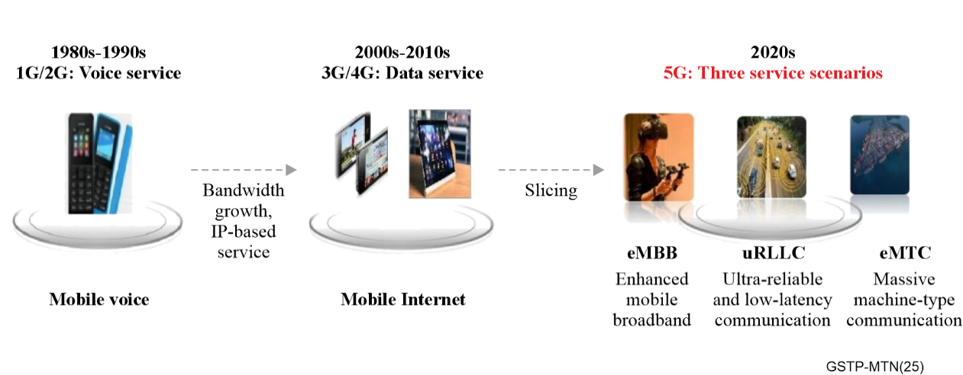
Figure 5-1 – Evolution of mobile communication

5.1.1 Large bandwidth
The introduction of broader spectrum resources and new radio (NR) access network (RAN) technologies in 5G have significantly increased the bandwidth of next generation node B (gNodeB). Consequently, the transmission network and interfaces needed to evolve to meet the requirements for ultra-large bandwidth transmission.
In 5G, low-frequency bands are used for wide-area coverage, while high-frequency bands are primarily used for blind spot and hotspot coverage. Generally, the low-frequency bandwidth of the spectrum resources is 100 MHz, and the high-frequency bandwidth is 800 MHz. The cell bandwidth can be estimated based on factors such as bandwidth, spectrum efficiency, and overhead (OH) encapsulation. Then the peak and average bandwidth of a typical S111 gNodeB can be calculated according to next generation mobile networks (NGMN) recommendations. Both as theoretical calculation and actual scenarios, the backhaul bandwidth for a single 5G low-frequency station exceeds 5 Gbit/s, and the backhaul bandwidth for a single high-frequency station is close to 20 Gbit/s, representing 10-100 times increase in bandwidth.

5.1.2 Low latency
The latency requirements of 5G backhaul is mainly dictated by the end-to-end latency requirements of eMBB and uRLLC services. For example, augmented reality (AR)/virtual reality (VR) services in eMBB services have high latency requirements of about 10 ms.
The most stringent latency requirement for uRLLC ultra-low-latency services that include Internet of vehicles (e.g., assisted driving, etc.), industrial Internet (e.g., industrial control/machine arm, etc.), power grid, remote healthcare, finance, etc., is around 1 ms.
To achieve such demanding latency requirements, it is necessary not only to optimize the network architecture, but also to reduce the forwarding latency of the backhaul equipment to achieve the latency requirements of 5G services.

5.1.3 Network slicing
The requirements for 5G services vary significantly across several dimensions, including bandwidth, latency, reliability, energy consumption, customer service, and operational billing, etc. For example, 4K/8K mobile video services require ultra-high data rates; touch-interactive applications require ultra-low latency; machine-to-machine/Internet of things (M2M/IoT) applications require high-density connections; self-driving requires high reliability and ultra-low latency; and mobile broadband services require ultra-high mobility. To meet the diverse requirements of these services, the 5G network architecture is different from the traditional 4G network architecture and instead, 5G network utilizes virtualization techniques for network slicing resources. The restructured functions of the network elements are dynamically chained, according to the actual requirements of the services, to provide appropriate network resources and functionalities for individual users, specific services, or even particular data flows.
The transport network needs to accurately support the logical abstraction of network resources from the physical network to form the required virtual network resources, and finally organize them into the desired network slices. Network slices can be divided into hard slices and soft slices based on their capabilities. Hard slices generally use TDM or wavelength division multiplexing (WDM) technologies to ensure that the network has the capabilities of physical isolation, high security, and reliable transmission. Soft slices generally use packet-based L2 VPN, L3 VPN, or EVPN technologies to provide differentiated isolation and assurance for services.
Therefore, 5G networks need to meet the requirements for both low-latency deterministic forwarding and physical isolation for vertical industries and high-value government and enterprise customers, as well as the requirements for carrying high-bandwidth and high-volume bursty Internet traffic. By offering both soft and hard slicing, 5G networks can meet the diverse requirements of various services.

5.1.4 Flexible network scheduling
In the 5G era, the density of gNodeBs has increased, thus the inner-station collaboration and the traffic among gNodeBs increases. Meanwhile, the 5G mobile network adopts a service-based architecture, with cloudified core network functions and decentralized data centre (DC). This leads to an increased demand for traffic between DCs, in addition to the traffic from gNodeBs to core network. Therefore, the transport network needs to support flexible scheduling between gNodeBs, core network clouds, and DCs.

5.1.5 High-accuracy synchronization
For time division duplex-long term evolution (TDD-LTE) systems supporting basic services, the time synchronization requirement over the air interface for gNodeBs is within ±1.5 μs. If adjacent gNodeBs are not synchronized, inter-slot interference and uplink-downlink slot interference may occur.
For 5G NR systems handling basic services, the air interface time synchronization requirement remains ±1.5 μs, while services such as carrier aggregation demand stricter synchronization accuracy, reaching ±130 ns. Among 5G's diverse services, gNodeB positioning imposes the most stringent time synchronization requirements. A positioning accuracy of around 3 metres necessitates synchronization errors between gNodeBs providing positioning services, to be less than 10 ns.

5.2 Dedicated line service requirements
With the continuous development of 5G network and other dedicated network applications, it is not just 5G (eMBB, URLLC, mobile Internet of things (MIoT)) that require network slicing but the multi vertical industries customers also require differentiation.
The MTN transport network is a multi-service network and will be shared between 5G services and other types of services. The dedicated line market is an important application which MTN must support. In addition to common Ethernet (ETH) private line services, some financial services, government services, and enterprise services have higher requirements on isolation, security, and reliability. Additionally, financial services have more stringent requirements on low latency. Therefore, operators need to precisely match customer service requirements in terms of bandwidth, isolation, latency, reliability, and security, and provide customized dedicated line services for specific customers.
In addition, as the industry digital transformation advances, dedicated line service connections tend to extend to core business scenarios, such as enterprise production and control. Branches of industry users are now spread across different metropolitan areas. Therefore, it is also required to provide differentiated performance guarantee for cross-domain dedicated line services spanning multiple cities and provinces, with high-reliability and end-to-end physical isolation feature.

5.2.1 Financial dedicated line services
High security and high reliability are the most basic and core requirements of the financial industry for transport network. For example, the access mode for financial institutions connecting to the financial private network must be strictly isolated from other services. At present, the headquarters or branches of a bank are connected to the financial private network via the SDH lines, as shown in Figure 5-2.
For financial dedicated lines, the kind of transaction services has small bandwidth ranging from 2 Mbit/s to 100 Mbit/s but with extremely high security requirements and should be strictly isolated from other services.
Given that SDH devices have been phased out of the network, and the requirements have been increasing for high security, high reliability, timeline and flexible bandwidth for financial services, operators need to provide a new-generation of transport technology with physical isolation, deterministic low latency, high reliability and hitless bandwidth adjustment capabilities that fully guarantee the bandwidth and service level agreement (SLA) of financial services, and ensuring a real-time transaction and data security.
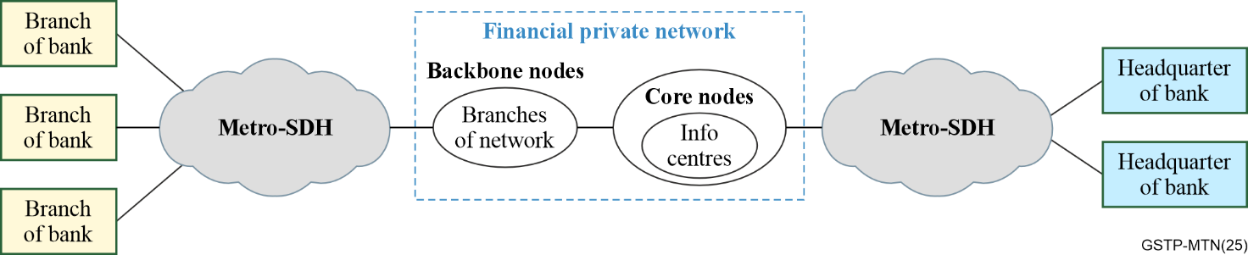
Figure 5-2 – Access of financial institutions to financial private network

5.2.2 Government dedicated line services
Strict physical isolation to ensure data security is the core requirement of government services for the transport network. The bandwidth for government dedicated lines is mainly 1 Gbit/s or below. For example, a government network of a province, the bandwidth requirement from town to county is about 100 Mbit/s, from county to city is about 1 Gbit/s, and from city to province is about 2 Gbit/s. Therefore, a small bandwidth hard pipeline is adaptable for carrying government services with small bandwidth but offering high security and reliability would meet government services requirements.

5.2.3 Large enterprise dedicated line services
Large enterprise dedicated line customers mainly refer to large infrastructure enterprises, multinational enterprises, and large Internet enterprises, etc. They are one of the most important customers to the operators. The large enterprise dedicated line customers have many types of services, some of which require high security requirements, and need high-quality dedicated line services to meet their strict physical isolation requirements.
The services of large enterprises are mainly divided into cloud services, voice/video, office, production, and so on. Among them, production and control services are the core business of enterprises, which require high security and isolation of the transport network, and bandwidth ranges are from 2 Mbit/s to 100 Mbit/s. With many cloud-based applications of enterprises, cloud-based applications involving production are growing rapidly, and have demanding requirements for service isolation, latency, and reliability.

5.3 Important industry private network requirements

5.3.1 The power grid communications network requirements
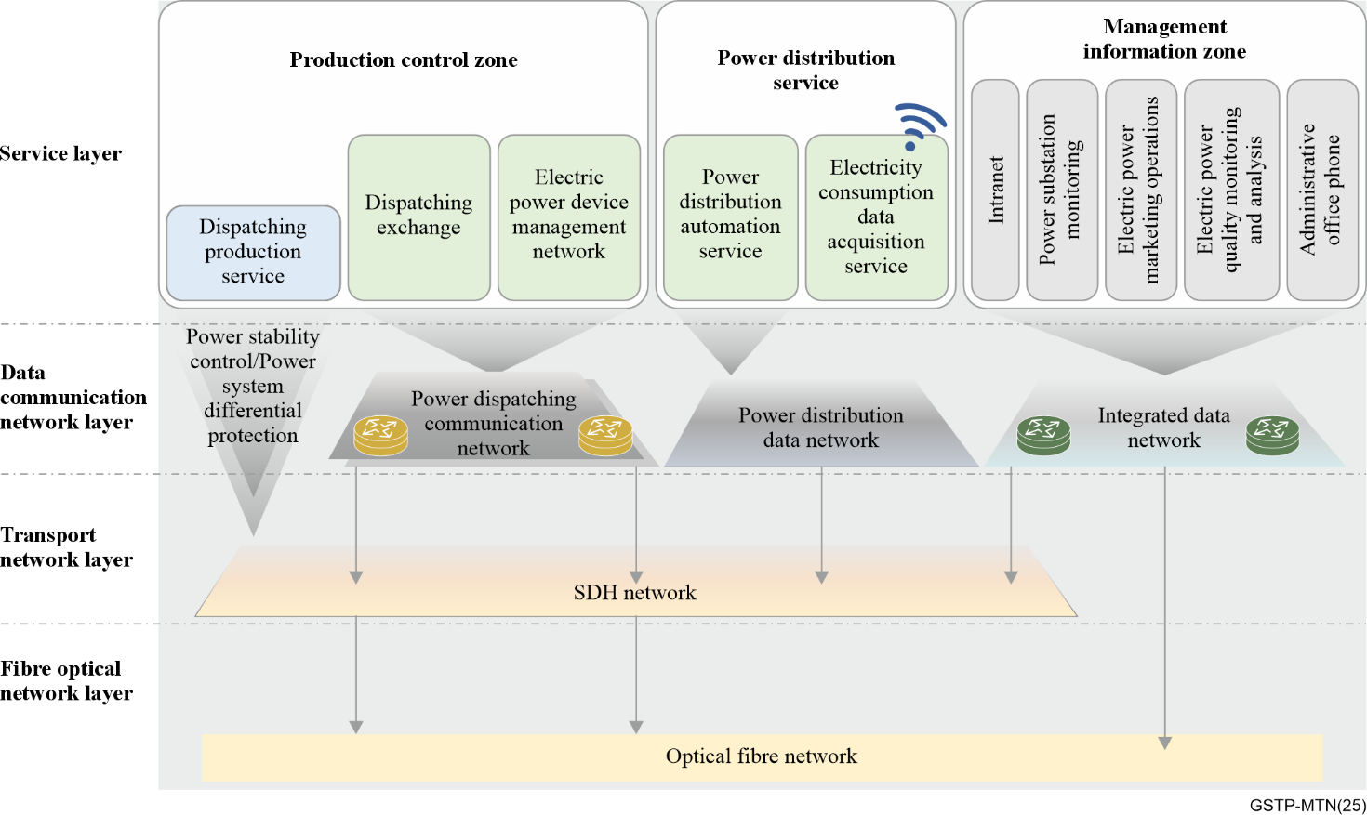
Figure 5-3 – Example of existing power grid communications network
According to the characteristics of power grid production, operation, and enterprise management and operation, the services carried by the power grid communication network can be classified into production control zone and management information zone. Figure 5-3 provides an example of existing power grid communication network. It includes service layer, data communication network layer, transport network layer and fibre optical network layer. Data communication network can be classified into power dispatching communication network, power distribution data network and integrated data network based on the services it carries. These data communication networks utilize mainly SDH transport network.
With the vigorous development of the smart grid and IoT technologies, the data communication service applications are growing explosively, especially after the emerging of intelligent terminal. Services such as real-time exchange of power grid status information, network-based video surveillance, and multimedia interactive information management converge more data to the centralized control centre, dispatch centre, and data disaster recovery centre.
At the same time, the new power system requires real-time status awareness, real-time collection of measurement information, accurate load prediction, orderly management and control of "source network load" and collaborative interaction for power distribution services. The monitoring and control system of the new power system is moving towards integration of operation and distribution information and distributed collaborative control of equipment.
In a foreseeable future, power grid communication networks will have the following characteristics. Firstly, although the growth rate of small-granularity services from 2 Mbit/s to 10Mbit/s will slow down, the increment and inventory is still large. Legacy interfaces will exist for a long time for differential protection services and power stability control services. Secondly, with the acceleration of digital transformation of power grids, the bandwidth requirements of data communication networks will continue to grow rapidly. The bandwidth requirements of single-point access will reach 1 Gbit/s or more. Moreover, the instantaneous bandwidth bursts of services are large, and the peak information rate is high. Thirdly, power production services have higher security and reliability requirements. Services have specific requirements on physical isolation. Some applications also have requirements for low jitter performance of the power grid communication network. Fourthly, the comprehensive development of power distribution automation service has created the requirement of integrated transport solution for both power distribution data network and transport network.

5.3.2 The railway private communications network requirements
The railway private communication network primarily provides the carriage of operational safety services such as dispatch communication and operation control for trains, offering reliable high-speed communication between moving trains and ground systems. Railway wireless communication services are generally categorized into three types: train control and train dispatching, train monitoring and detection, and train operation and maintenance application. Since the railway lines often traverse multiple regions, the train control and dispatching services normally necessitate spanning across multiple domains.
Wireless dispatch voice services and wireless data services both belong to the train control/train dispatching category of services. They mainly provide basic voice communication, group calls, priority calls, and support for safety-related train operation applications among dispatchers, drivers, train operation support personnel, and train operation command personnel. These services are related to train operation safety and have very high requirements for reliability and security of communications. They are the core services of railway private wireless communications. The bandwidth demand for these services is relatively low, not exceeding 20 Mbit/s. The end-to-end one-way latency requirement is also low, less than 100 ms. They require high reliability and security and are typical low-bandwidth, deterministic low-latency, high-reliability, and high-security services. Table 5-1 shows the typical railway services requirements.
Table 5-1 – 5G Smart railway communications service requirement
Application scenario classification | Scenario description | Overall requirement description | Communications requirement
Application scenario classification | Scenario description | Overall requirement description | Delay | Bandwidth | Availability
Train control | Train control data | Train control information and vehicle communications | < 100 ms | 10-200 kbit/s | 99.999%
Train control | Train dispatching service | Train dispatching video, voice, and group call | < 100 ms | 3-20 Mbit/s | 99.99%
Monitoring detection | IoT awareness | Vehicle-mounted monitoring, rail IoT, station IoT, | < 100 ms | 50-100 kbit/s | 99.9%
Monitoring detection | Video surveillance | Trackside video, site video surveillance, bridge video surveillance, and dangerous road section video surveillance | < 100 ms | 10-20 Mbit/s | 99.9%
Operations maintenance | Maintenance and maintenance communications | Fault diagnosis information, train operation information, and software upgrade and maintenance | < 200 ms | 2-10 Mbit/s | 99%

5.3.3 The mine private communications network requirements
The mining industry has vast potential for the application of intelligent technologies and a broad development prospect. It is vigorously promoting the intelligent construction of the mining industry and fully leveraging the important supporting role of new technologies, new equipment, and new processes that ensure safe production can significantly reduce the number of workers in complex and high-risk positions. This is an important approach to advance towards unmanned and minimally manned operations. To achieve unmanned, minimally manned, remote, and intelligent underground mining, it is essential to deploy wired and wireless networks with high bandwidth, low latency, and high bandwidth access capacity in the mine shafts.

5.4 Existing SDH replacement requirements
SDH/MSTP is the transport technology for the 2G era. SDH equipment has limited capacity, with the maximum common SDH port rate being 10Gbps, and resources are already saturated. SDH equipment has been in operation for many years, and due to the decline of the SDH equipment production, spare parts are difficult to obtain. Therefore, SDH/MSTP equipment is in the process of being phased out from the networks by various operators. Facing 5G, operators and industry customers need a new generation of transport technology that can achieve strict physical isolation like SDH/MSTP and is suitable for the transport of low-bandwidth services.

6 Technical characteristics of MTN

6.1 MTN design concept
With the development of mobile communications, mobile backhaul has become a focus of transport technology evolution and competition. IMT-2020 introduced the vision of new mobile services such as eMBB, URLLC, and mMTC. Consequently, mobile backhaul networks for IMT-2020 require large bandwidth, low latency, network slicing, flexible network scheduling, and high-accuracy synchronization. The most direct challenge for mobile backhaul networks is to support both logical and physical isolation. Logical isolation is required to support Internet protocol (IP) services offering flexible and efficient transport. Physical isolation is required to support high-value service offering physical-isolated and low latency transport. The flexible transport technology solely based on packet switching or rigid transport technology solely based on TDM cannot meet the above challenges. Therefore, a new transport technology that can combine packet services and time division multiplexing (TDM) is urgently needed.
ITU-T developed the MTN technology with the concept of "hard slicing", "high efficiency" and "flexible" transport for IMT2020 mobile backhaul network. Hard slicing refers to the TDM secured pipes, high efficiency refers to low cost based on the Ethernet chips and optical modules, and flexible refers to the affinity with packet flexible routing and statistical multiplexing. MTN embodies a new mode of carrying heterogeneous and differentiated integrated services that focus on packet services based on slices. In this process, the key is how to implement the convergence of packet-based technology and TDM based technology.
ITU-T creatively developed a new idea of "endogenous TDM in packet technology". That is, the TDM layered network is inserted into the physical coding sublayer (PCS) of the Ethernet. By such an approach, the TDM function is added to the Ethernet switching chip to achieve seamless integration of packet and TDM. The implementation of "endogenous TDM in packet technology" addressed three technical challenges.
• To be compatible with Ethernet chips, TDM multiplexing and cross-connection functions must be implemented without impacting the Ethernet signal structure. That is, the TDM network is completely independent of the upper and lower layers in the PCS of the Ethernet.
• To implement TDM switching, rich overhead functions should be introduced for telecom grade operations, administration, and maintenance (OAM), and it potentially increases the overall signal rate. However, in order to reuse the Ethernet optical module, the PHY signal rate should be maintained.
• After TDM switching is introduced into Ethernet PCS layer, the Ethernet media access control (MAC) layer and the physical layer (PHY) are decoupled. At the same time, the problem of bit error spread emerges. Since the Ethernet physical layer requires the mean time to false packet acceptance (MTTFPA) (i.e., mean time to receive error packets) should be beyond 10 billion years. The system design should meet this requirement as well and avoiding any bit error spread issue is introduced by the decoupling.
To address these three technical challenges, MTN adopted three technologies.
• The first one is to implement timeslot and containerization based on Ethernet 64B/66B blocks as atomic switching units, so as to build a TDM layered network while maintaining the Ethernet signal structure.
• Secondly, an OAM 66B block is used to construct a layered network overhead. It acquires overhead bandwidth by replacing the idle block within the original block stream. By doing so, it enabled TDM overhead management function while maintaining the Ethernet optical module signal rate unchanged.
• Thirdly, the new bit error check mechanism, bit error identification mechanism, and bit error spread suppression mechanism are introduced to the Ethernet physical layer, so that the MTTFPA design goal can be meet.
These three key technologies have become the fundamental mechanisms of the MTN layered network and thus MTN emerged as the new transport technology defined by the ITU-T to succeed SDH and optical transport network (OTN) technologies.
MTN has the following main four technical features:
First of all, MTN supports software-defined networking (SDN) centralized management and control. Based on the SDN concept, an open, agile, and efficient network operation system is implemented in MTN. This enables not only automatic service deployment, but also network self-optimization that detects network status and performs real-time optimization.
Secondly, MTN supports telecom-grade fault detection and performance management. It provides telecom-grade hierarchical OAM fault detection and performance management capabilities. The OAM functions include connectivity detection and management, packet loss rate detection, delay and jitter measurement for any network connection and service on the MTN network.
Thirdly, MTN supports network-level reliable protection switching. It provides network-level hierarchical protection and supports preconfigured protection switching mechanisms based on the forwarding plane of a device. When a fault is detected on the forwarding plane, fast protection switching is performed. In addition, the network status can be updated in real time based on the SDN control plane. After detecting the network status change, MTN network can automatically recompute the optimal path for services.
Fourthly, MTN supports both logical network slicing and physical network slicing by incorporating SDN technologies, packet switching capability and TDM circuit switching capability. It decouples network facilities from application networks, and presents differentiated mobile backhaul network capabilities for different service quality requirements of vertical industries, multi-service transport and cloud-network synergy. Based on the service requirements such as network slices, bandwidth and latency, the SDN controller schedules services to appropriate resources based on different forwarding plane technologies and different network devices.

6.2 MTN architecture and key technology

6.2.1 MTN architecture
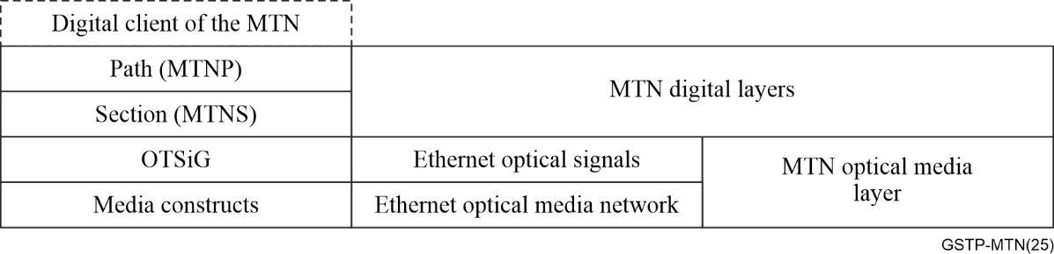
Figure 6-1 – MTN layer structure
The metro transport network (MTN) consists of two non-recursive digital layer networks: the MTN path (MTNP) layer and the MTN section (MTNS) layer. The rates and formats used in the MTN are defined in [ITU-T G.8312].
The MTNS is supported by an MTN optical media layer. The MTN media layer provides fixed point-to-point connections between Ethernet interfaces. The layer structure of the MTN is shown in Figure 6-1.
The MTNP layer provides channel forwarding, as described in clause 6.3.1 of [ITU-T G.800]. The only server layer defined for the MTNP is the MTNS. An instance of a MTNP layer network cannot be a client or server for another instance of a MTNP layer network.
The only client defined for the MTNS layer is the MTNP layer. The MTNS layer provides fixed point to point connectivity for its MTNP layer clients at bitrates in multiples of ~5 Gb/s.
The server layer for the MTNS layer is provided by any of the Ethernet physical layers that use the encoding defined in clause 82 of [IEEE 802.3].
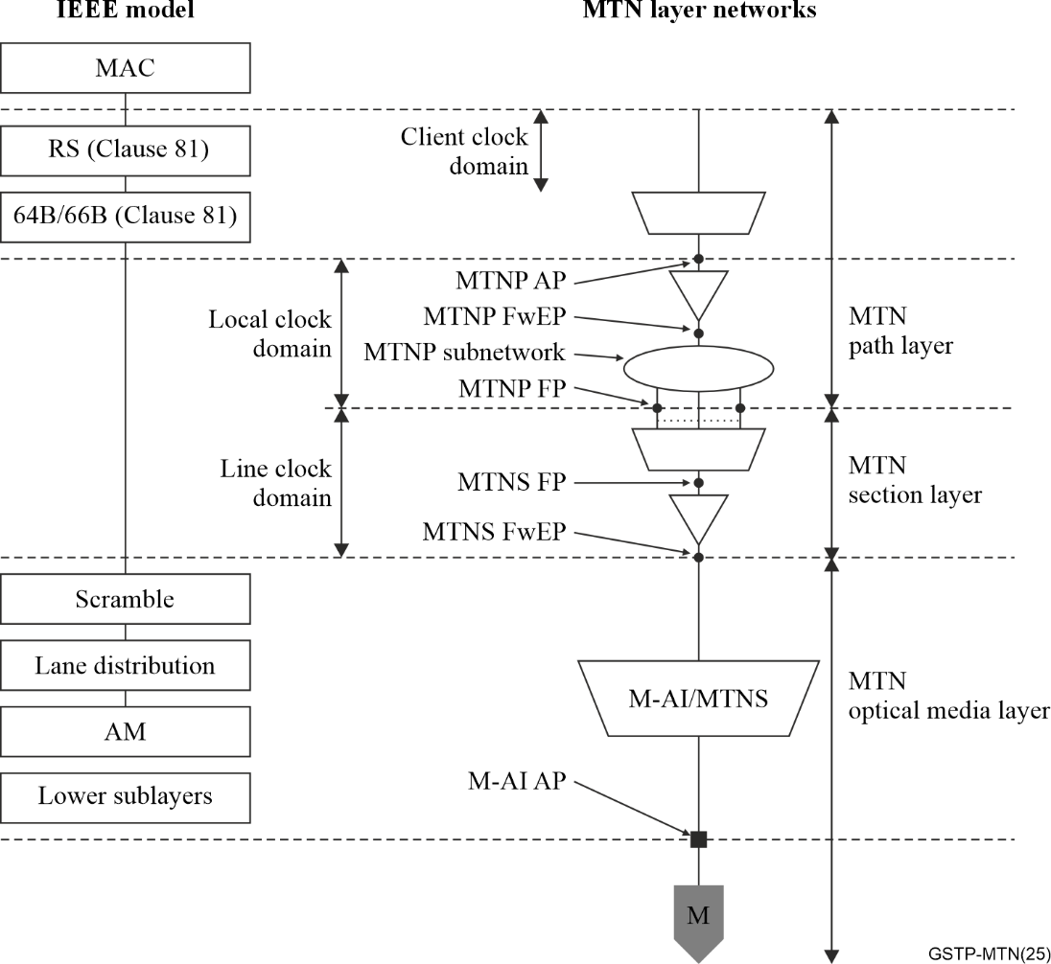
Figure 6-2 – Relationship of MTN to [IEEE 802.3] Ethernet
Figure 6-2 provides more detail about the relationship between the MTN layer networks and Ethernet as defined in [IEEE 802.3]. The MTN path to Ethernet client adaptation is defined by reference to [IEEE 802.3]. The adapted information (AI) at the MTNP_AP consists of a sequence of [IEEE 802.3] clause 82-compliant 64B/66B blocks. The adaptation of the MTN section to media is described by [IEEE 802.3]. The CI at the MTNS forwarding end point (FwEP) consists of a stream of [IEEE 802.3] clause 82-compliant 64B/66B blocks. The use of [IEEE 802.3] clause 82-compliant 64B/66B blocks allows the MTN section layer to be carried over Ethernet PHYs that use [IEEE 802.3] clause 82 PCS. Therefore, MTN can be fully compatible and reuses [IEEE 802.3] physical interface and corresponding optical module.
Since the MTN client signal is converted into a 66B block stream after 66B coding at the upper layer of the PCS, all IP packet header information (such as a source IP address, a destination IP address, and a type of service (ToS)), Ethernet frame header information (such as MAC address and Ethernet frame type) are all encoded into the payload area of 66B blocks. MTN network will transparently transport all these blocks without any modification, and any packet layer information is invisible in the MTN layer network. This makes MTN perfectly compatible with any L2/L3 packet technology.
In the meanwhile, existing packet switching chips can be easily expanded to support MTN due to its Ethernet compatibility. Such chipset could support both packet switching and TDM circuit switching at the same time.

6.2.2 MTN key technologies

6.2.2.1 MTN section layer frame structure
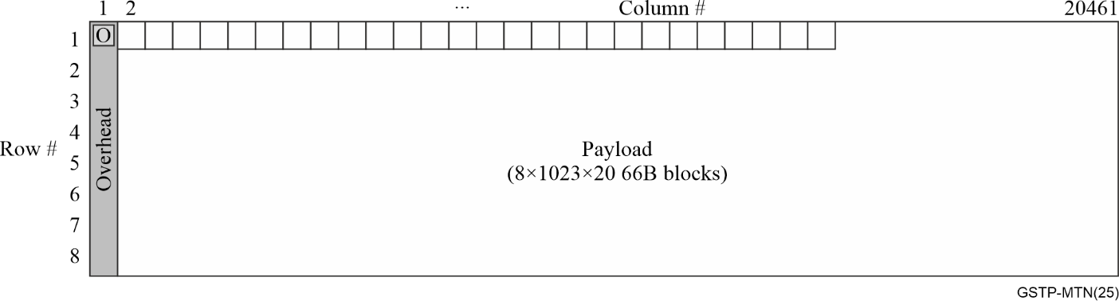
Figure 6-3 – MTNS frame structure
Figure 6-3 shows the 100G MTNS frame structure. MTNS frame consists of 163688 66B blocks. Each frame is divided into eight rows, and the first 66B block of each row is the MTNS overhead block. Each overhead block is followed by 20460 66B block. For the 100G MTNS frame, each block of these 20460 blocks represents a timeslot, and repeats from timeslot 1 to timeslot 20 for 1023 times. For the 50G MTNS frame, each block of these 20460 blocks represents a timeslot, and repeats from timeslot 1 to timeslot 10 for 2046 times. The first overhead block of each MTNS frame uses control block type 0×4B and O code 0×5 as the frame start point identification. The timeslot bandwidth is about 5 Gbit/s, and the accurate rate can be found in clause 8 of [ITU-T G.8312].
When MTN uses 100GBASE-R PHY, 200GBASE-R PHY, or 400GBASE-R PHY as its optical media layer, each PHY would include one, two or four 100G MTNS frame instance. When MTN uses 50GBASE-R PHY as its optical media layer, each PHY would include one 50G MTNS frame instance.

6.2.2.2 MTN section layer multiplexing and demultiplexing
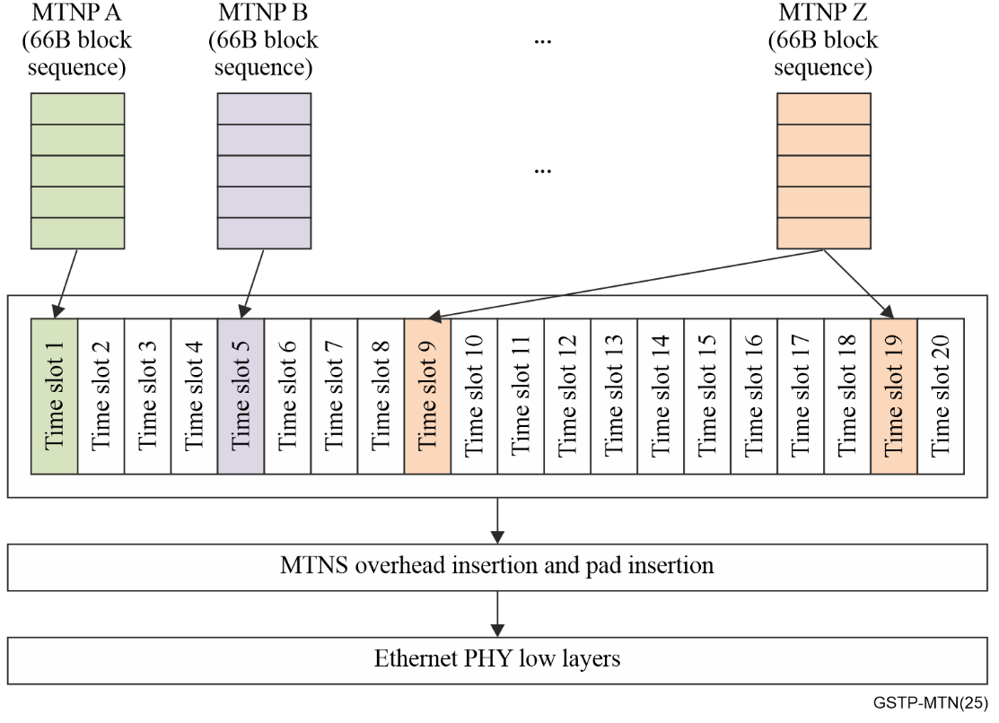
Figure 6-4 – MTN section layer multiplexing function illustration
The function of MTN section layer multiplexing is illustrated in Figure 6-4. Different MTNPs are multiplexed into the MTNS frame structure. An MTNP is mapped into the pre-configured timeslots in a block-by-block manner. After the multiplexing, MTNS overhead is inserted. Certain pad blocks will be inserted as well depending on the type of Ethernet PHYs. The MTNS demultiplexing function is a reverse of the multiplexing process.
For simplification, the bandwidth of a MTNP is represented as N×5Gbit/s, N is the number of timeslots that the MTNP occupies. The actual bandwidth of a MTNP is N×5.15568 Gbit/s ± 100 ppm. The detail calculations can be found in [ITU-T G.8312].

6.2.2.3 MTN section layer error marking mechanism
For [IEEE 802.3] PHYs with forward error correction (FEC), four 64B/66B blocks are transcoded into one 256B/257B block before FEC encoding on the transmit side and transcoded back into 64B/66B blocks on the receiver side after FEC decoding. The 257B blocks are aggregated into FEC codewords based on the FEC algorithm that is used. When the FEC decoder fails to correct errors in a FEC codeword, [IEEE 802.3] specifies that some or all of the 64B/66B blocks that are transcoded out of the 256B/257B blocks in that FEC codeword will be marked with invalid synchronization headers (0b11). In the case of 50G and 100G PHYs, not every 66B block is marked.
MTNS uses the calendar slot structure to channelize the Ethernet PHY(s) to support multiple MTNP, each of which is carrying a separate MAC client. This partial error marking mechanism might result in bit error and escapes the MAC frame cyclic redundancy check (CRC) error detection and render the packet with the bit error acceptable, and thus makes the application system unreliable.
In order to avoid such a situation, every 66B block in the codeword is marked as an error (i.e., set to EBLOCK_R) in MTNS when the Reed-Solomon decoder determines that an FEC codeword contains errors that have not been corrected or an invalid 256B/257B is discovered. The MTNS error marking mechanism allows a more reliable network and makes the MTTFPA of MTN beyond 10 billion years.

6.2.2.4 MTN path layer overhead insertion and extraction mechanism
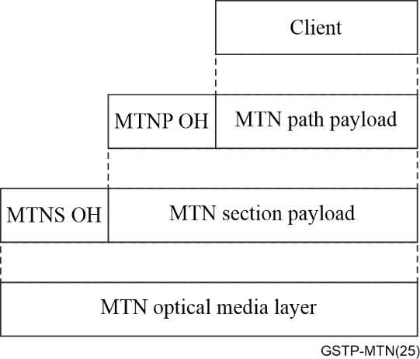
Figure 6-5 – Information containment relationship for MTN
Figure 6-5 shows the information containment relationship for MTN. MTN section layer and MTN path layer have its own overhead. Similar to MTNS overhead, MTNP overhead uses an ordered set control block as the identification, i.e., control block type 0×4B and O code 0×C. Since MTNP overhead is encoded into a block, MTNP overhead is also called as MTNP OAM block. After carefully calculation, MTNP overhead acquires the required bandwidth by replacing the native idle blocks existing in the client signal. By doing so, MTN achieves telecom grade OAM capability without increasing the optical media layer bit rate or shrinking the maximum client signal bit rate, so that the Ethernet optical media layer signal rate can be maintained and the Ethernet optical modules can be reused.
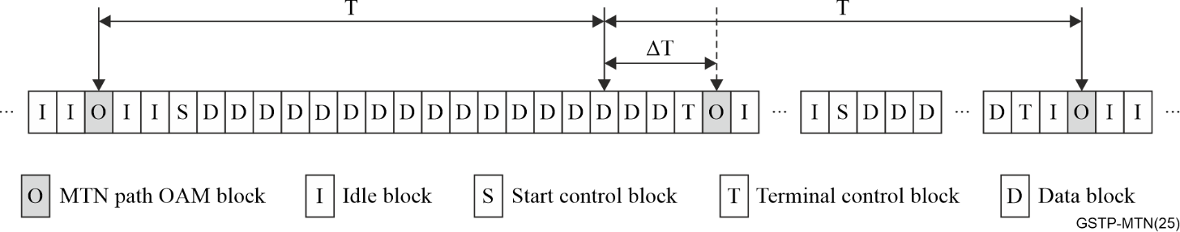
Figure 6-6 – MTNP OAM block insertion illustration
Usually at the nominal insertion point, there is an idle block, the MTNP OAM block can be inserted immediately. Sometimes, the actual insertion of each OAM block is delayed from the nominal insertion point so that the OAM block falls in the interpacket gap as shown in Figure 6-6. Delaying insertion of a block does not change the nominal insertion point of the next block, so that the MTNP OAM block regular insertion period can be guaranteed. The MTNP OAM block is extracted based on the 66B block being an ordered set with O code 0×C. Blocks matching this signature are extracted from the received block sequence and processed as OAM blocks.

6.2.2.5 MTN path layer overhead format
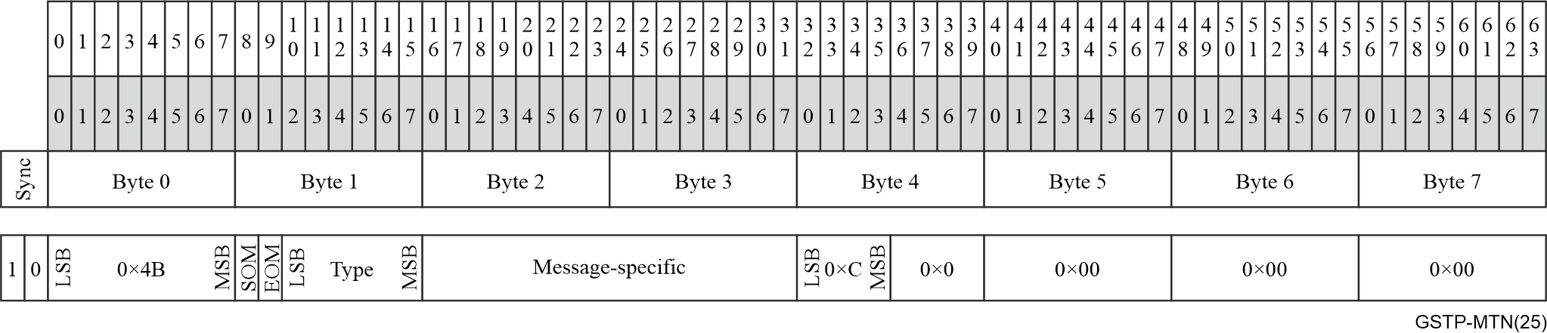
Figure 6-7 – MTNP OAM block structure
MTNP overhead information would be encoded into MTNP OAM block, which is shown in Figure 6-7. Different MTNP overhead information is differentiated in the "type-length-value" message manner for flexibility and future scalability. By incorporating SOM, EOM, type and message-specific field, MTNP overhead includes the error detection, connectivity verification, one-way delay measurement (DM), two-way delay measurement, client signal type indication and protection switching. It should be noted that, to facilitate reassembly of the messages, the message type is included in each block, and each block also contains start of message (SoM) and end of message (EoM) indications. The length of a message is implicitly known based on the type and is not directly encoded into the block.
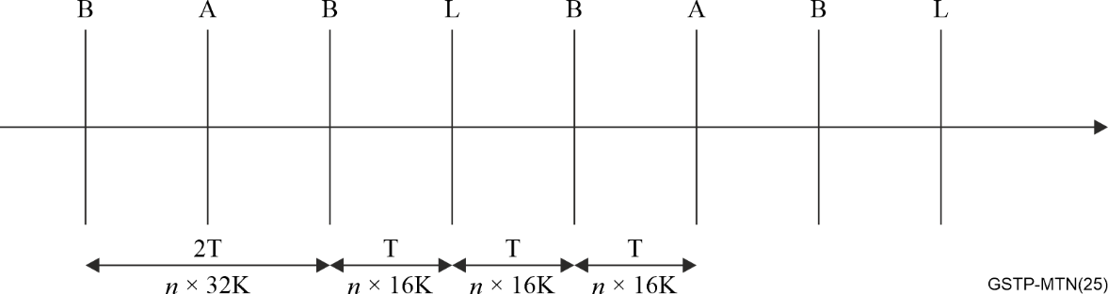
Figure 6-8 – Pattern of insertion opportunities
All the MTNP OAM blocks are inserted into the client block sequence with a nominal period of T = n × 16K blocks, where n is the number of 5 Gbit/s calendar slots that the MTNP occupies and K = 1024. Based on its priority and performance requirements, different OAM messages are classified into three classes. They are B (basic message), A (APS message) and L (low priority message). The insertion follows a regular pattern of opportunities as shown in Figure 6-8.
As a predecessor of the MTN technology, there exists substantial implementations and deployments of a pre-standard technology (known as slicing packet network (SPN)). SPN is defined with a set of technologies from L0 to L3. [ITU-T G.8312] "Interfaces for MTN" corresponds to the SPN slicing channel layer. See [b-CCSA-2019-1213T-YD] in the Bibliography for a detailed description of SPN. Figure 6-9 provides the general block format of SPN path OAM. The MTN migration scenarios can be found in [ITU-T G.sup.69].
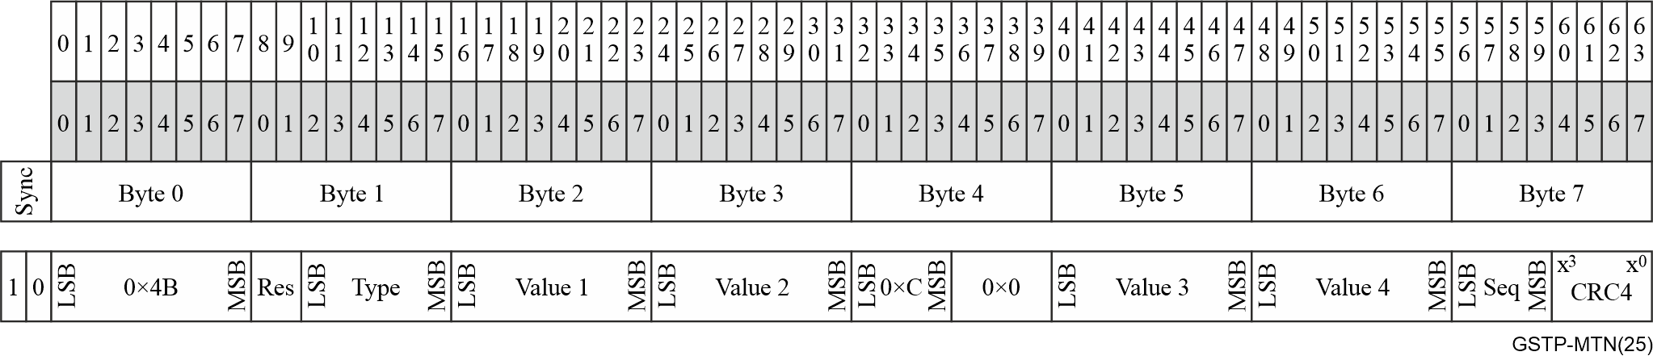
Figure 6-9 – General block format of SPN path OAM

6.2.2.6 MTN path layer error detection mechanism
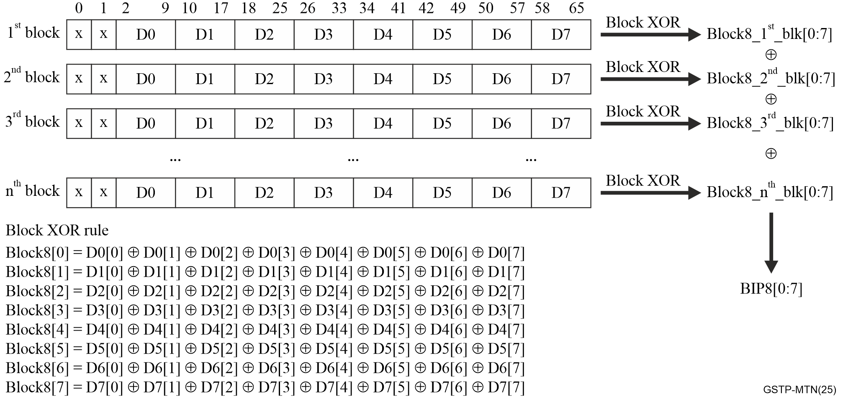
Figure 6-10 – Parity calculation illustration
Since MTN reuses Ethernet optical modules and Ethernet PHY protocol, there would be idle block insertion or deletion in the MTNP signal at the intermediate node. This is because MTN uses idle insertion and deletion for compensating frequency offset between two adjacent devices. It would result in idle blocks having different numbers and different locations for a given client signal at the source node and sink node. Therefore, the traditional parity check mechanism will not work and needs to be enhanced. MTN applies a byte-based bit interleaved parity (BIP) calculation algorithm to avoid idle insertion or deletion impact on parity calculation result. Figure 6-10 illustrates the parity calculation mechanism in the MTNP overhead.
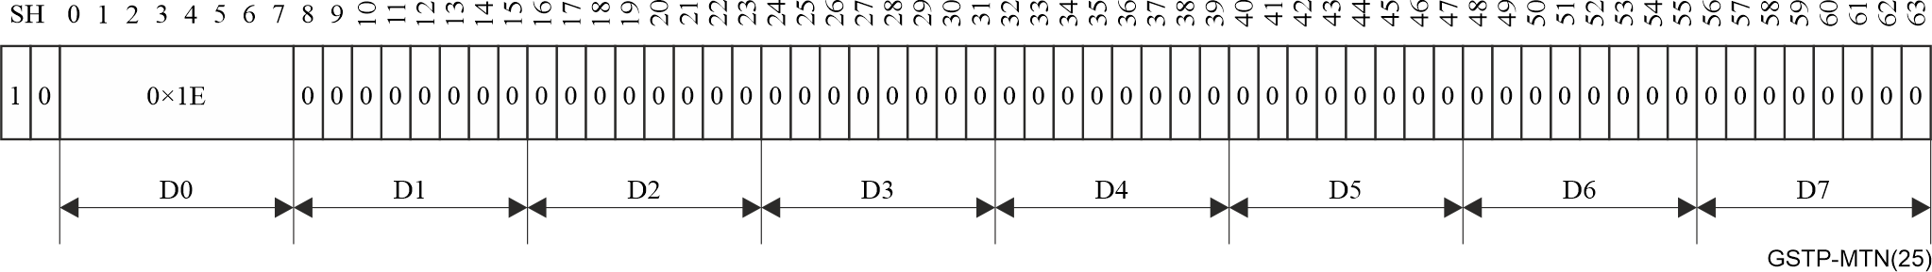
Figure 6-11 – Idle block format
Figure 6-11 shows the idle block format. The sync header is 0b10, the control block type field is 0×1E, and the rest bits are all zeroes. By using the byte-based BIP calculation algorithm, the parity word for idle block is all zeroes. Thus, the idle block insertion or deletion will not impact the parity calculation result.

6.2.2.7 MTN path layer circuit switching
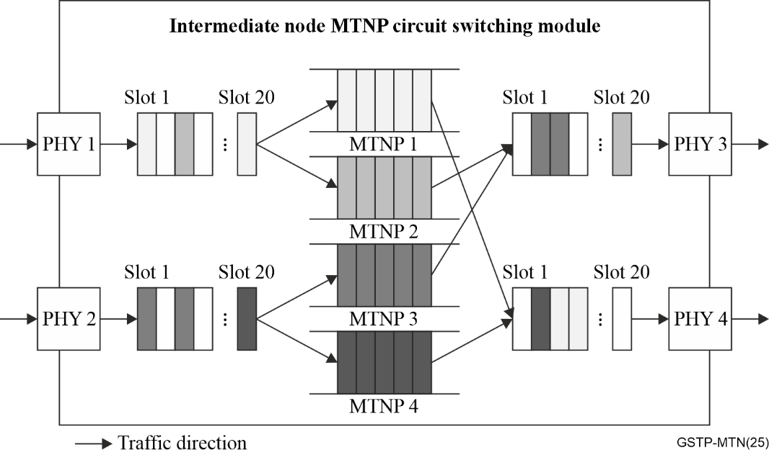
Figure 6-12 – Implementation example of MTNP circuit switching
At an intermediate node, MTN path layer performs circuit switching. The MTNP characteristic information (CI) is extracted from the n calendar slots to which it is assigned on the ingress MTNS, and the MTNP characteristic information is inserted into the n calendar slots to which it is assigned on the egress MTNS. Figure 6-12 provides an implementation example of MTNP circuit switching.
At intermediate node, the n calendar slots and their positions occupied by any given MTNP are fixed. They do not change over time but are only decided by configuration. This would bring two advantages for MTN. First, since MTNP does not perform sensing on any packet header information, it will not perform any time-consuming packet operation such as table look-up and packet assembling/de-assembling. Only a couple of 66B blocks are buffered in the intermediate node for a given MTNP. Therefore, MTNP can provide ultra-low latency and jitter at the microsecond level and sub-microsecond level respectively. Secondly, since MTNP occupies the same number of fixed calendar slots at the ingress and egress, the switching resource at the intermediate node can be guaranteed. This enables physical isolation between different MTNPs and different services.

6.2.2.8 MTN Ethernet packet client mapping
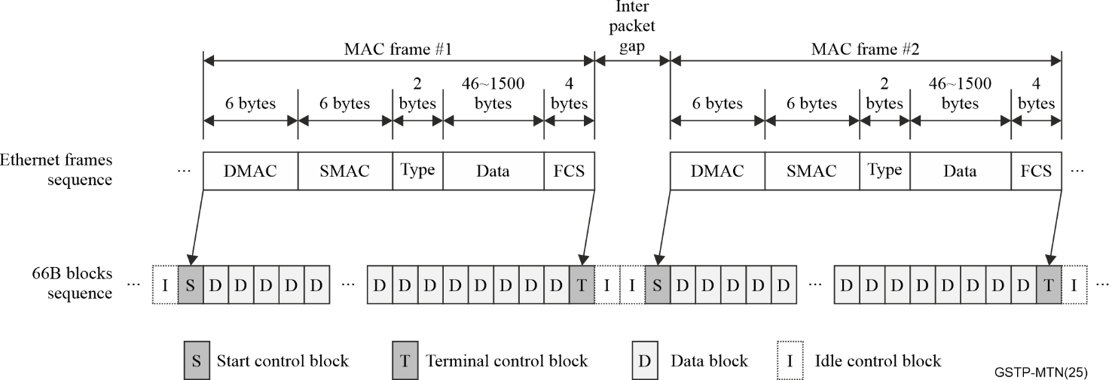
Figure 6-13 – Illustration of Ethernet packet transcodes to 66B blocks
When the MTN carries Ethernet client signals, the MTN ingress node transcodes the Ethernet frames into a sequence of 66B blocks. The 66B blocks sequence is transmitted through an MTN path which occupies one or more specific timeslots at the MTN section layer. This mapping process is specified in clauses 81 and 82.2.4 of [IEEE 802.3].
Figure 6-13 illustrates the 66B transcoding result. After transcoding, each Ethernet frame becomes a string of 66B blocks which consist of a start control block, several data blocks and a terminal control block. Usually, adjacent Ethernet frames would have an inter-packet gap (IPG), which would be transcoded to idle control blocks.

6.2.2.9 MTN synchronization

6.2.2.9.1 MTN synchronization requirements
MTN supports the physical layer frequency synchronization and precision time protocol (PTP) phase/time synchronization. MTN synchronization requirements come from but not limited to the following applications:
1) 5G wireless transport: MTN standard is established to meet the requirements of 5G wireless transport in [ITU-T G.8300], which should meet the requirements of time synchronization and frequency synchronization of wireless base stations.
2) One-way delay measurement: One-way delay measurement (DM) as defined in [ITU-T G.8312] clauses 8.2.2.2.2 and 8.2.2.2.3 needs time synchronization.
3) Timing service for industries: The MTN network requires time synchronization to meet the time synchronization requirements of the fgMTN or MTN clients. These clients could be, for example, from power, finance or transportation industries.

6.2.2.9.2 MTN synchronization architecture
The frequency synchronization of MTN is distributed by the physical layer. And the phase/time synchronization of MTN is distributed by PTP.
MTN synchronization uses full-timing distribution architecture defined in [ITU-T G.8274]. MTN PTP clocks in MTN synchronization networks which are telecom grandmaster (T-GM) with performance as specified in [ITU-T G.8272] or [ITU-T G.8272.1], and T-BC and telecom time synchronous clock (T-TSC) with performance as specified in [ITU-T G.8273.2].
The overall synchronization network is shown in Figure 6-14. The first MTN T-BC gets time synchronization from a T-GM that is integrated into the primary reference time clock (PRTC) / enhanced PRTC (ePRTC), via Ethernet interfaces (e.g., 1GE, 10GE, etc.). Other MTN T-BCs distribute time synchronization via MTN interfaces (e.g., 50GBASE-R, 100GBASE-R, 200GBASE-R and 400GBASE-R as defined in [ITU-T G.8312], or a grouping of these interfaces).
MTN synchronization network also supports a stand-alone T-GM, which gets time synchronization from an ePRTC/PRTC via 1pulse per second+time of day (1PPS+TOD).
The frequency distribution is not necessarily congruent with the time distribution for MTN, and MTN nodes can also get frequency reference from another enhanced primary reference clock (ePRC/PRC) synchronization chain as shown in Figure 6-14.
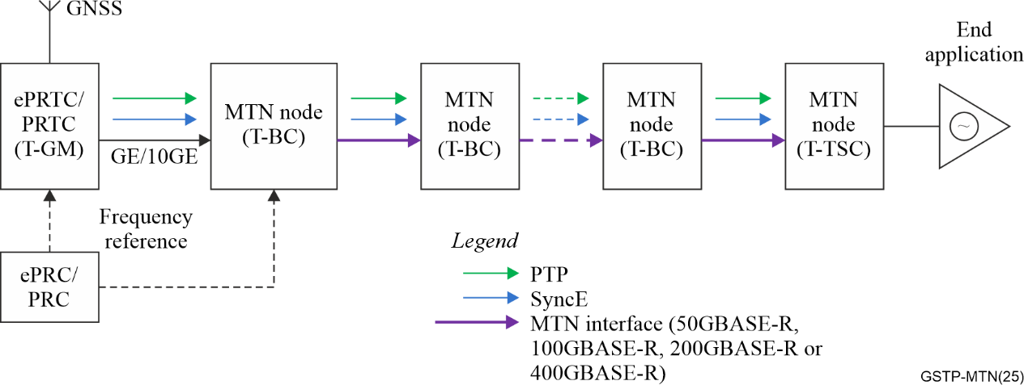
Figure 6-14 – MTN synchronization network illustration

6.2.2.9.3 PTP profile for MTN
MTN networks shall use [ITU-T G.8275.1] for PTP time synchronization, specific information for MTN is described in Annex I of [ITU-T G.8275.1]. The PTP messages are Ethernet encapsulation and carried by the overhead of MTN frame. Each MTN node shall implement T-BC (telecom boundary clock) function and support the hop-by-hop time synchronization. This means that each MTN node synchronizes its input time reference via the receiving PTP port, and output time reference to next node via the transmitting PTP port.
For synchronous Ethernet (SyncE), the synchronization status message (SSM) message carried by the MTN is Ethernet encapsulation as well and shall follow the definition of [ITU-T G.781]. Similarly, with PTP, the SSM message is also carried by the overhead of MTN frame. Each MTN node shall implement enhanced synchronous equipment clock (eSEC) function specified by [ITU-T G.781] and support the hop-by-hop physical layer frequency synchronization. Besides the transmission of frequency synchronization to next node, the eSEC function of MTN node also provides the physical layer frequency signal to its T-BC function, which is used to maintain the accurate time when the input PTP time signal is lost.

6.2.2.9.4 MTN clock specification
The clock of MTN nodes follow the eSEC enhanced synchronous equipment clock (eSEC) specification defined in [ITU-T G.8262.1] for physical layer frequency synchronization.
MTN node supports the T-BC class C specification defined by [ITU-T G.8273.2] for time synchronization, which includes the maximum timer error per MTN node is within ±30 ns.
MTN node is also able to support T-BC Class D specification defined in [ITU-T G.8273.2], which recommends the maximum time error after a low-pass measurement filter per MTN node to be within ±5 ns.

6.3 fgMTN architecture and key technologies

6.3.1 fgMTN architecture
To transport low bit rate and constant bit rate (CBR) services the MTN evolved to provide a further path layer called a fine grain metro transport layer (fgMTN). Consequently, the MTN structure evolved from two to three digital layer networks: the fine grain MTN path (fgMTNP) layer, the MTN path (MTNP) layer and the MTN section (MTNS) layer. The fgMTN path signals are mapped/multiplexed into the MTNP layer as illustrated in Figure 6-15.
The functional architecture of fgMTN layer and the relationship between the MTN path and fgMTN path layer networks are defined in [ITU-T G.8310].
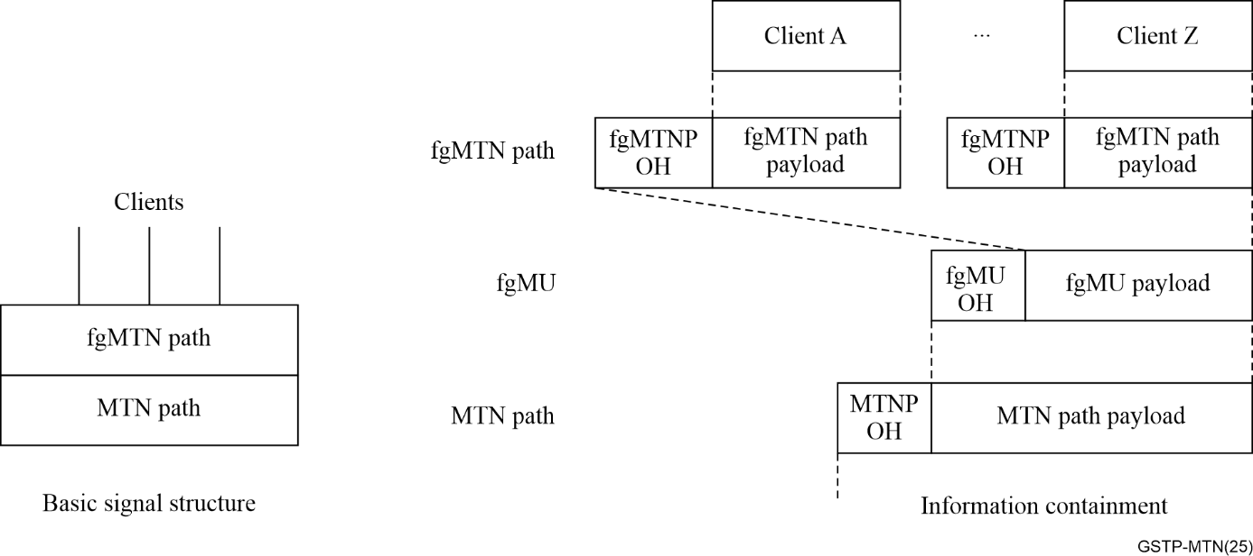
Figure 6-15 – Structure and information containment relationships for fgMTN

6.3.2 Key technologies

6.3.2.1 Frame structure

6.3.2.1.1 fgMU structure
To ensure that fine grain services exclusively occupy fine grain calendar slot (fgCS) with strict physical isolation, while also guaranteeing low latency, low jitter, and efficient carriage, the fgMTN adopts a TDM mechanism to cyclically transmit fine grain multiplex unit (fgMU) frames. The number and position of calendar slots in each frame are strictly fixed, meaning that each calendar slot has a fixed transmission cycle. This enables the division of the 5 Gbps granularity of the MTN path into smaller fgCS. The network performs cross-connections of data streams based on the client blocks, providing end-to-end slice-based channels.
To ensure compatibility, fgMTN adopts the same 64/66B encoding format as the MTN path layer. The design of the fgMU frame structure encapsulates the overhead and the payload, which includes multiple calendar slots, into a fixed-length sequence of S block, D block, and T block.
As illustrated in Figure 6-16, the fgMU is a 992-block packet that begins with a /S/ block (block type 0×78), ends with a /T/ block (block type 0×FF), and has 990 data blocks between the /S/ and /T/. Using the [IEEE 802.3] clause 82 block definitions allows the fgMU to be carried transparently over an MTNP path in the same manner as an Ethernet client packet.
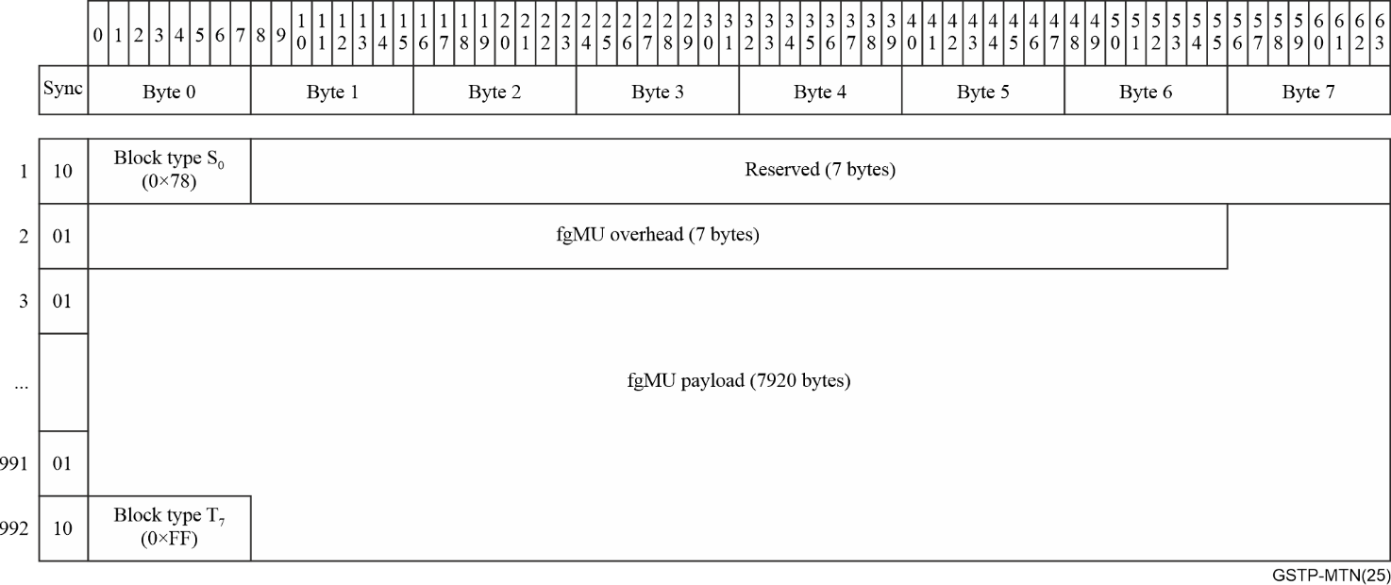
Figure 6-16 – fgMU structure

6.3.2.1.2 fgCPU structure
The CBR based clients are first mapped into the payload area of the fine grain CBR clients payload unit (fgCPU). Then the fgCPU packets are mapped into the fgMTNP in a similar manner as mapping 64B/66B coded clients into fgMTNP. The fgCPU consists of a /S/ control block, a group of /D/ blocks and a /T/ block. Two methods of mapping CBR clients into fgCPU are defined according to the application scenario.

6.3.2.1.2.1 Mapping CBR clients into fgCPU using asynchronous mapping procedure (AMP)
As illustrated in Figure 6-17, the fgCPU is a packet that begins with a /S/ block (block type 0×78), ends with a /T/ block (block type 0×FF), and has n data blocks between the /S/ and /T/. The value of n is fixed when fgCPU used to carry a specific CBR client. n is 13 for carrying E1 client and 121 for carrying synchronous transport module (STM)-1 client.
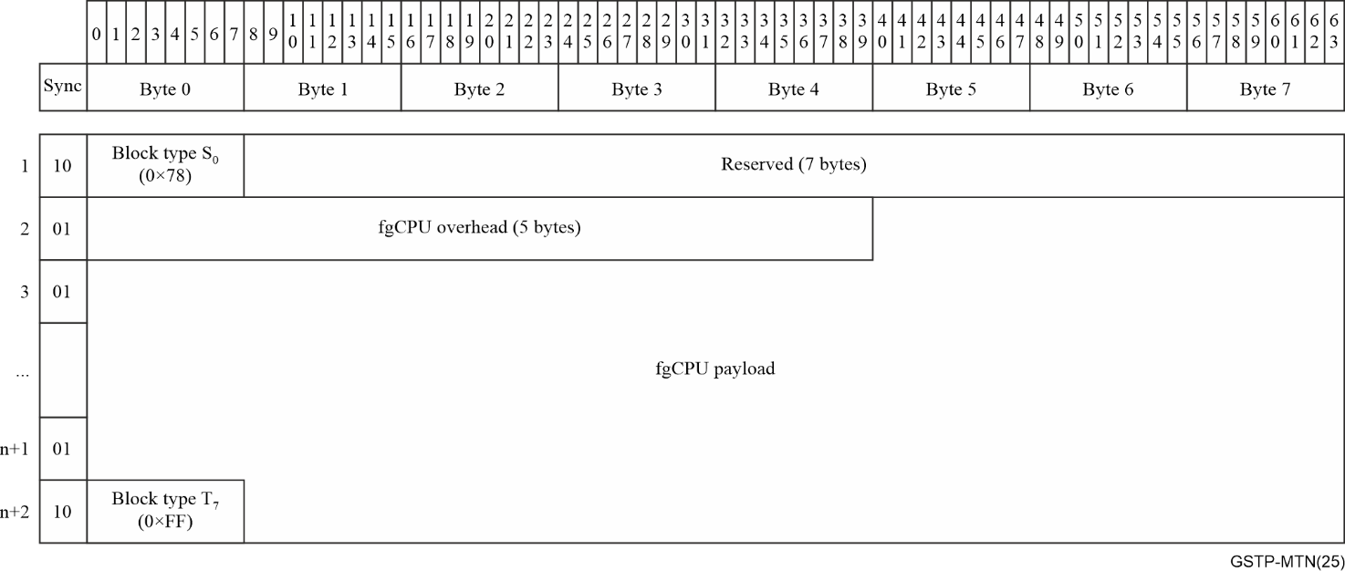
Figure 6-17 – AMP-based fgCPU structure

6.3.2.1.2.2 Mapping CBR clients into fgCPU using generic mapping procedure (GMP)
As illustrated in Figure 6-18, the fgCPU is a 510-block packet that begins with a /S/ block (block type 0×78), ends with a /T/ block (block type 0×FF), and has 508 data blocks between the /S/ and /T/. The value of n data blocks between the /S/ and /T/ is 508 for all CBR clients.
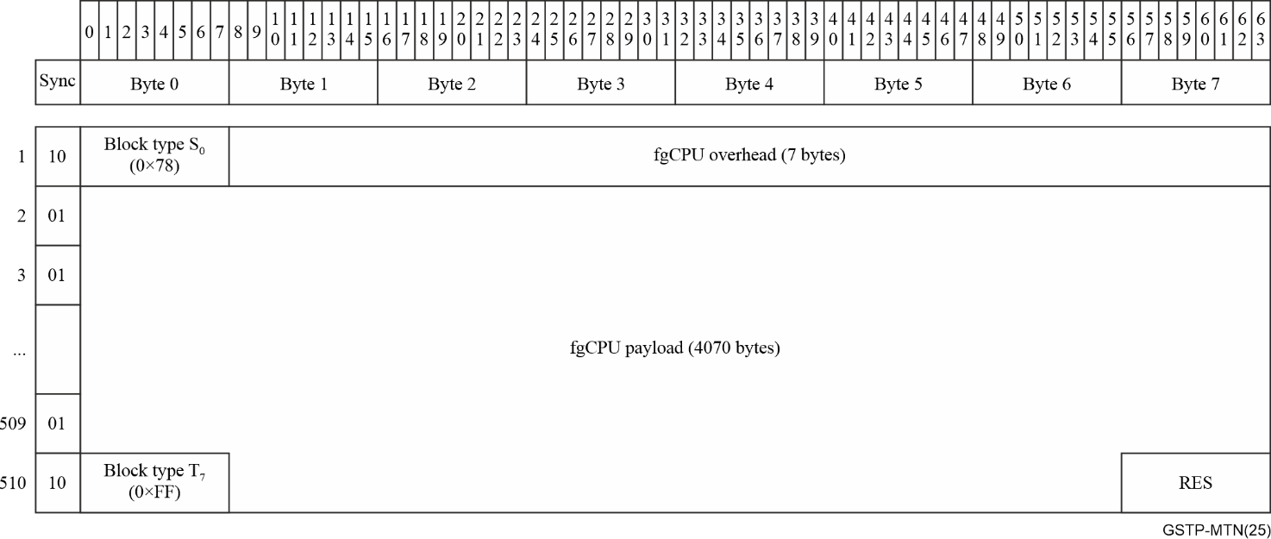
Figure 6-18 – GMP-based fgCPU structure

6.3.2.2 fgMTN path OAM
To enhance the reliability of fine grain technology, fgMTN path OAM inherits the technical advantages of the MTN path layer OAM and it has adopted a comprehensive OAM mechanism. This mechanism supports end-to-end connectivity, error detection, client signal information, delay measurement, and carrier-grade protection switching for each fgMTN path. Unlike traditional TDM and packet technologies, fgMTN path innovatively utilizes the idle resources in IPG to transmit OAM with the client signal blocks without occupying additional bandwidth. Thereby maximizing network bandwidth utilization.

6.3.2.3 Hitless bandwidth adjustment
Adjusting the calendar slots and bandwidth of fgMTN path is one of the more practical demands following the large-scale deployment of fgMTN. However, the physical isolation slicing provided by existing 5G transport technologies fails to ensure hitless transmission during bandwidth or calendar slots adjustments. As a result, such adjustments are typically performed at fixed times, reducing the timely demand satisfaction and the flexibility of service configuration. This limitation also hinders the dynamic resources management, forcing some users to rent dedicated line services with a higher bandwidth than their actual needs, leading to additional cost and bandwidth consumption.
fgMTN enables hitless online adjustment of end-to-end channel bandwidth and calendar slots without disrupting the normal transmission of customer services. This capability enhances the timeline and flexibility of bandwidth and calendar slot resources allocation. During hitless bandwidth adjustment, the overhead of the fgMU carries calendar slot negotiation and configuration information. It facilitates handshake, configuration update, and bandwidth synchronization adjustment between adjacent nodes, while supporting simultaneous adjustment of multiple calendar slots with the same service channel.

6.3.2.4 1+1 linear protection switching
The 1+1 linear protection switching mechanism is used in fgMTN path to enhance the reliability and availability of services. The protection mechanism is based on the generic linear protection specifications and defined in [ITU-T G.808.4], which supports both unidirectional and bidirectional switching and provides a redundant service path. In case of a failure in the primary (working) path, traffic can be switched to the secondary (protection) path within 50 ms.

7 Introduction of MTN and fgMTN related ITU-T Recommendations
The functional architecture of MTN and fgMTN layer and the relationship between the MTN and fgMTN layer networks are defined in [ITU-T G.8310]. It considers the characteristic information (CI) of the client, the client/server layer associations, network topology, the network structure, and the layer network functionalities that provide multiplexing, routing, supervision, performance assessment and network survivability for the client.
The rates, frame structure, functionality of the overhead and the client mappings of MTN and fgMTN are defined in [ITU-T G.8312]. MTN leverages existing and emerging pluggable Ethernet modules and reuses flex Ethernet (FlexE) implementation logic.
The operation of a 1+1 end-to-end uni/bidirectional linear protection switching schemes for MTN path layer, including the automatic protection switching (APS) protocol is defined in [ITU-T G.8331]. The operation of a 1+1 end-to-end uni/bidirectional linear protection switching scheme for the fine grain metro transport network (fgMTN) layer network, including the automatic protection switching (APS) protocol is defined in [ITU-T G.808.4].
The metro transport network (MTN) and fine grain metro transport network (fgMTN) functionality of network elements is defined in [ITU-T G.8321], which is based on the architecture of MTN and fgMTN defined in [ITU-T G.8310] and incorporates the interfaces for metro transport networks and the fine grain MTN path defined in [ITU-T G.8312].
The management and control requirements, and an information model for managing transport functions in MTN equipment and system are defined in [ITU-T G.8350].
An overview of the functions provided by the fine grain MTN (fgMTN) layer network is provided in [ITU-T G.8312.20]. The application scenarios involved in fgMTN and the hypothetical reference model are also described. Additionally, the functional requirements such as TDM hard isolation, deterministic latency of fgMTN are also introduced.
The synchronization aspects of MTN transport network, including requirements, synchronization architecture, messaging encapsulation, timestamp generation, and PTP profiles for are defined in [ITU-T G.8371].
The scenarios for migrating existing slicing packet networks (SPNs) to metro transport networks (MTNs) are described in [ITU-T G.sup.69]. Scenarios include carrying SPN path layer connections over MTN section layers, or for carrying MTN path layer connections over SPN section layers. The SPN standard CCSA-2019-1213T-YD is referenced in the Bibliography of this technical report.
The standards of MTN and fgMTN are summarized in Table 7-1.
Table 7-1 – The summary of MTN and fgMTN standards
Recommendation | Title
ITU-T G.8310 | Architecture of the metro transport network
ITU-T G.8312 | Interfaces for metro transport networks
ITU-T G.8312.20 | Overview of fine grain MTN
ITU-T G.8321 | Characteristics of metro transport network equipment functional blocks
ITU-T G.8331 | Metro transport network linear protection
ITU-T G.8350 | Management and control of metro transport networks
ITU-T G.808.4 | Linear protection for fine grain metro transport network (fgMTN) and fine grain optical transport network (fgOTN)
ITU-T G.8371 | Synchronization aspects of metro transport network
ITU-T G.Suppl.69 | Migration of a pre-standard network to a metro transport network

8 MTN application scenarios

8.1 5G and dedicated line multi-services transport network applications
MTN is widely deployed for 5G backhaul and dedicated lines for smart government, financial, power grid, transportation, etc. It is becoming a multi-service converged transport network with full-process networking capabilities across backbone, metropolitan, and access networks.
MTN for 5G backhaul network may implement a hierarchical ring network topology to connect gNodeBs and 5G core (5GC). A typical rate hierarchy of the metropolitan access-aggregation-core ring may be 10GE/50G MTN - 100G/N × 100G MTN- N × 100G/200G/400G MTN, as shown in the Figure 8-1.
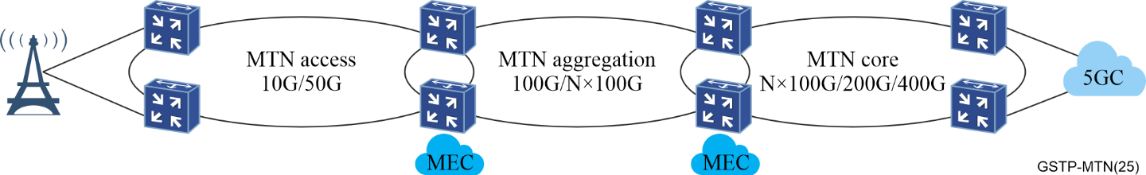
Figure 8-1 – An example of 5G backhaul network application
As a multi-service converged transport network, MTN also carry dedicated lines for government affairs, financial customers, and large enterprises utilizing fgMTN with TDM physical isolation characteristics. As dedicated networks are being widely deployed, they involve the interconnection between metropolitan networks as well as the connection between metropolitan networks and backbone networks to construct end-to-end physical isolation channel. Thus, dedicated lines may have both inter-domain and cross-domain network slicing application scenarios. A typical application for MTN transporting a multi-service is shown in Figure 8-2.
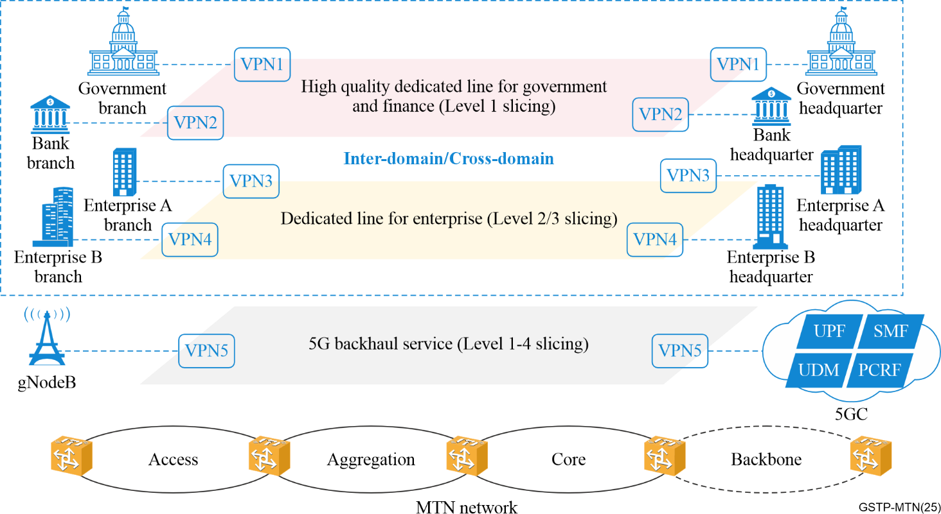
Figure 8-2 – A typical application of multi-services bearing MTN network
MTN supports the following four types of network slicing resources and their combinations at the network node interface (NNI) side, while the services may be accessed by wireline or 5G.
• PHY supports L1-based physical isolation of network resources based on different 50G/100G/200G/400G Ethernet physical interface or MTN segment layer groups.
• MTN layer supports physical isolation of network resources based on L1 TDM channels through MTN interfaces or MTN channels, and the bandwidth can be flexibly configured to N×5 Gbit/s.
• Within each MTN interface or MTN channel, logical isolation of network resources for layer 2 virtual private network / layer 3 virtual private network (L2VPN/L3VPN) can be achieved by different packet forwarding tunnels (such as segment routing (SR) tunnels) at the packet layer.
• Within each packet forwarding tunnel at the packet layer, logical isolation of network resources can be provided by the dedicated or shared L2VPN/L3PVN and quality of service (QoS) scheduling mechanisms.
A typical application of MTN slicing isolation is shown in Table 8-1. Note that industry customers service may be accessed through MTN wireline or 5G.
Table 8-1 – A typical application of the different slicing isolation in MTN network
Slicing types | Network slicing service types | Transmission resource isolation and multiplexing characteristics of network slicing |  |  | Examples of applicable MTN slicing scenarios
Slicing types | Network slicing service types | Physical isolation network resources | Logical isolation network resources at the packet layer | Multiplexing relationship for physical and logical isolation | Examples of applicable MTN slicing scenarios
Level 1 | Highest- priority physical isolation network slicing | MTN/fgMTN channel | Dedicated SR packet tunnel + Dedicated VPN | 1 to 1 | Dedicated network slicing for very important person (VIP) industry customers with the highest isolation and low latency requirements
Level 2 | High- priority logical and physical isolation network slicing | MTN/fgMTN interface | Dedicated SR packet tunnel + Dedicated VPN | 1 to many | Dedicated network slicing for VIP industry customers
Level 3 | Medium-priority logical isolation network slicing | MTN  interface | Dedicated SR packet tunnel + Dedicated VPN | 1 to many | Dedicated network slicing for general industry customers
Level 4 | Low-priority logical isolation network slicing | MTN  interface | SR packet tunnel + VPN | 1 to many | 5G eMBB network slicing

8.2 Important industry private network applications

8.2.1 The applications of power gird private communication network
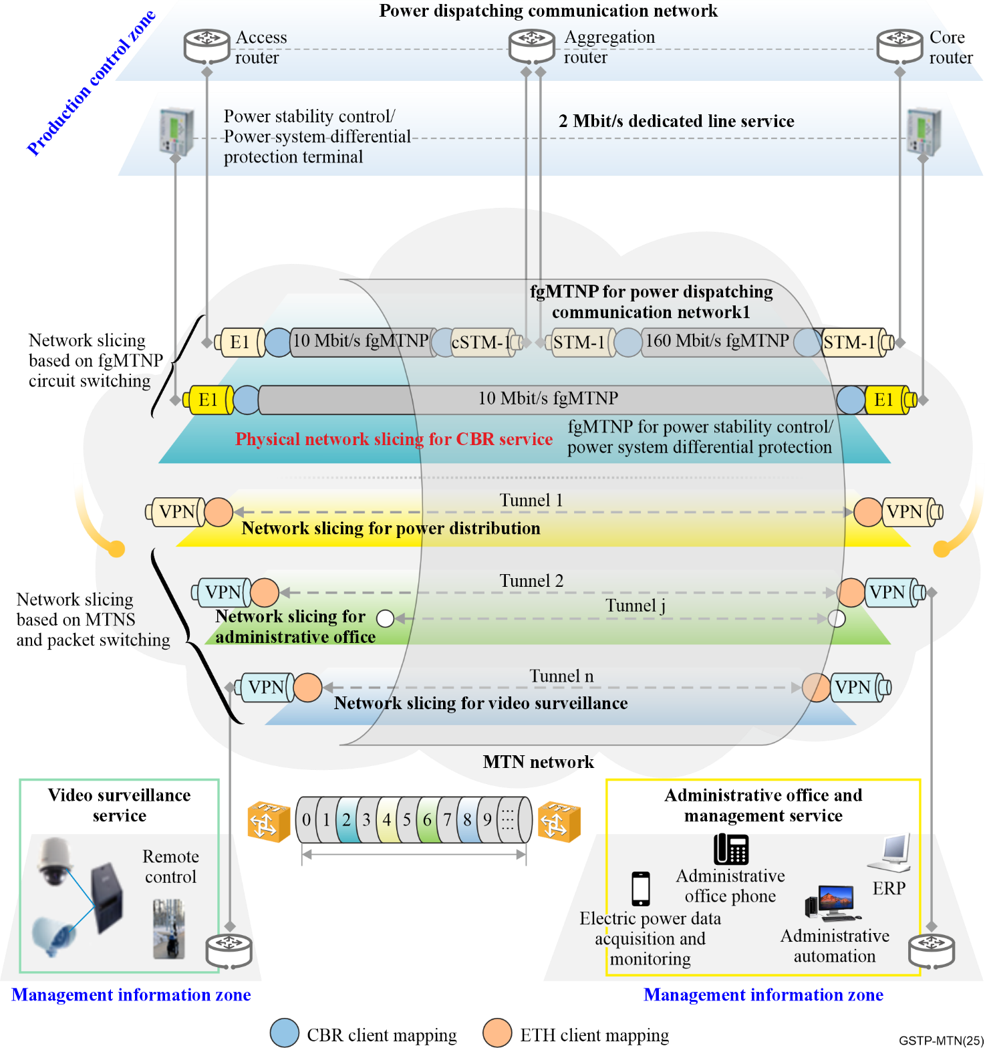
Figure 8-3 – A typical application of MTN in power grid communication network
MTN network and technologies provide efficient transport without interference for services related to power production control zone and management information zone. Figure 8-3 provides an application example of MTN in power grid communication network. The production control related services are transported through user network interface as E1 and STM-1. Furthermore, MTN network has evolved to support fgMTN technology to provide transport of 10 Mbit/s fgMTNP or 160 Mbit/s fgMTNP independently for E1 or STM-1. By doing so, MTN network provides end-to-end physical isolation for production control related services. The management information related services are transported through user network interface similar to the Ethernet. Additionally, MTN network leverages the functionality of the MTNS layer and incorporates packet switching technology to provide flexible and highly efficient service transport. In addition, MTN network can be further extended to power distribution communication network and offer main substation and power distribution substation services as an integrated bearer solution.

8.2.2 The applications of railway private communication network
5G meets the requirements of mobility (500 km/h), large bandwidth (eMBB), low latency and high reliability (uRLLC), large connection (mMTC), and slicing technologies. 5G-railway (5G-R) is envisaged to become the next-generation railway wireless communications technology and meet new requirements for smart railways.
According to the application objectives, smart railway communication services can be categorized into three types: train control and train dispatching, train monitoring and detection, and train operation and maintenance applications.
A typical network architecture for a smart railway is depicted in Figure 8-4. The train control and dispatching services often span across multiple domains, such as multiple metro domains or between metro domain and backbone domain.
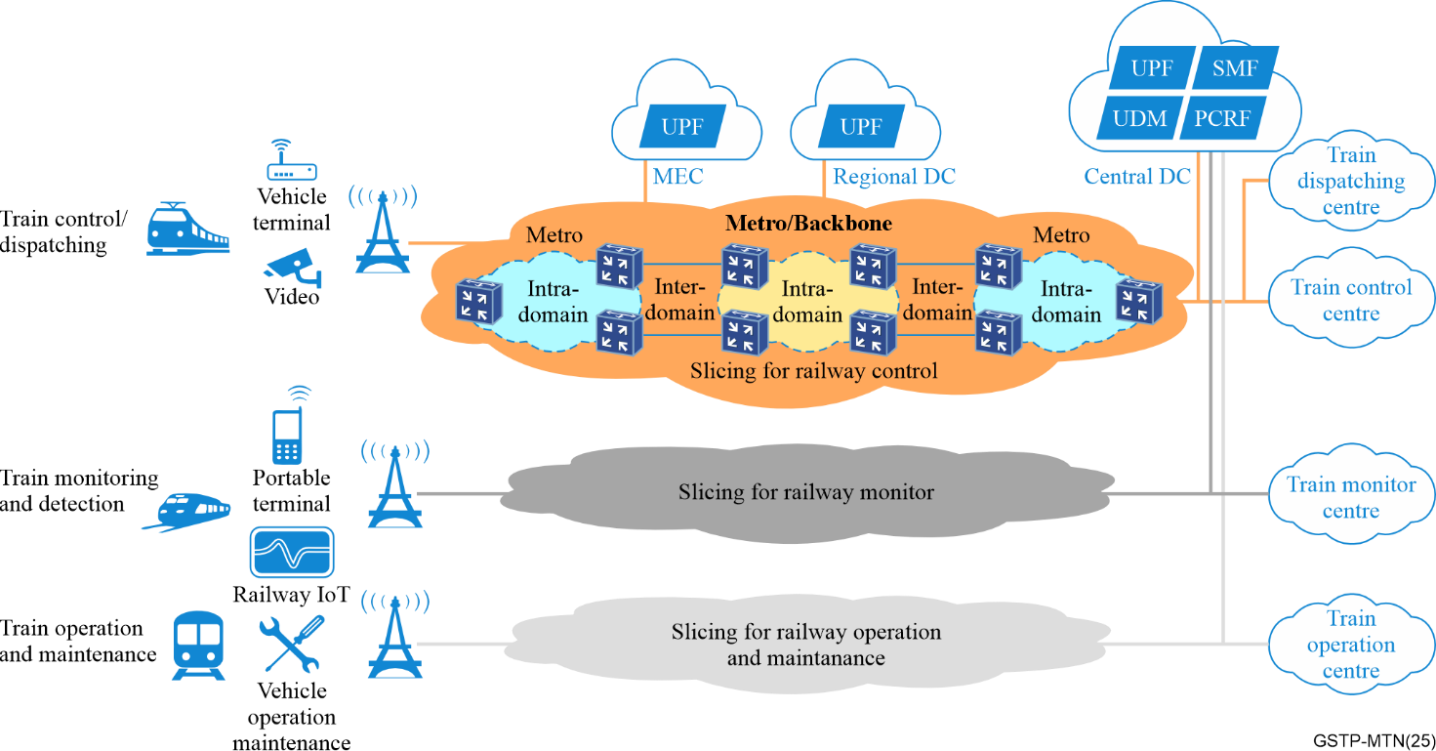
Figure 8-4 – A typical network architecture for a smart railway
For each train, control and dispatching information relating to the control of train and automatic driving is a fine grain bandwidth service with higher demands for latency determinacy and communication reliability. To ensure high security and operation reliability, highly reliable and physically isolated communication channels for each train must be provided to ensure real-time and effective transmission of control information.

8.2.3 The applications of mine private communication network
The mine private communication network primarily targets two major application scenarios:
1) In unmanned mining scenarios, remote control systems, along with supporting control sensors and video surveillance terminals, are installed on the engineering machinery. These systems utilize communication networks to transmit real-time site conditions back to the control centre. Based on remote control consoles and video surveillance platforms, the remote operation of the engineering machinery is achieved and thus enabling the operation of unmanned mining process and meeting the requirements for safe production.
2) In high-definition video surveillance scenario, high-definition video surveillance terminals, infrared cameras, and other data acquisition devices are installed underground. Relying on the communication networks both underground and on the surface, and based on machine vision information, edge computing, and monitoring analysis platforms, the system enables intelligent recognition of unsafe factors such as abnormal personnel behaviour, equipment failures, and sudden environmental changes, as well as voice alarm reminders. This achieves the visualization of on-site operations.
A typical network architecture for a mine network is depicted in Figure 8-5. Various underground business systems are uniformly carried through the ring network. Isolated business systems are accessed through different slices. Then, all types of services are aggregated onto the MTN ring network equipment, which can also carry the backhaul of 5G private network wireless signals.
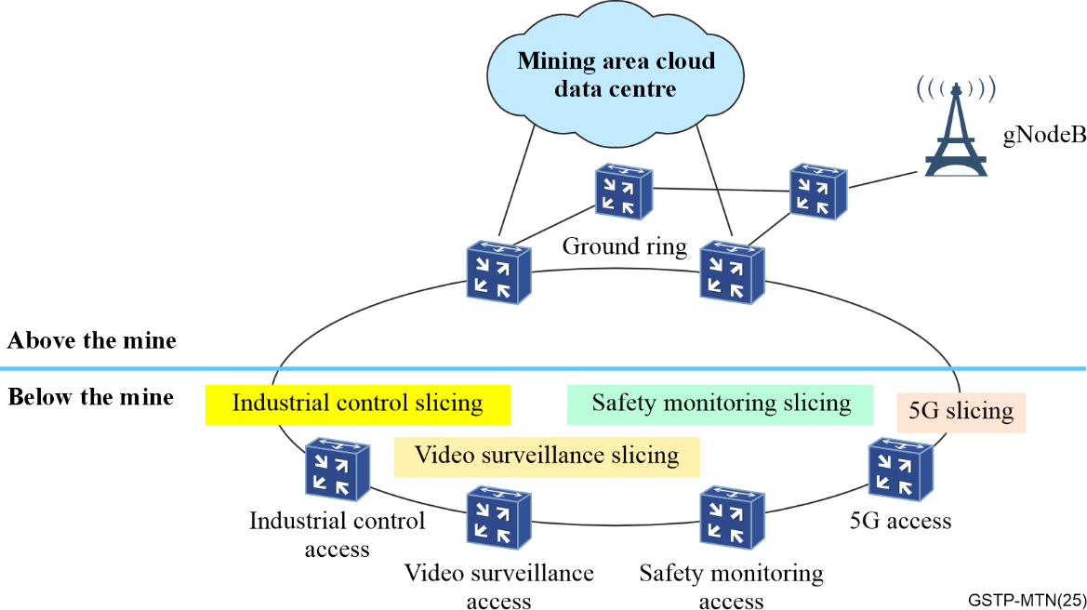
Figure 8-5 – A typical MTN network architecture for a mine network

8.3 Existing SDH replacement network applications
The existing SDH network can be replaced directly by a new MTN network, as shown in Figure 8-6. First, a new MTN network should be established. Subsequently, all services from the existing SDH network should be migrated to the MTN network. In the new MTN network, E1 and STM-1 CBR services are mapped into fgMTN paths, enabling reliable and efficient service transmission.
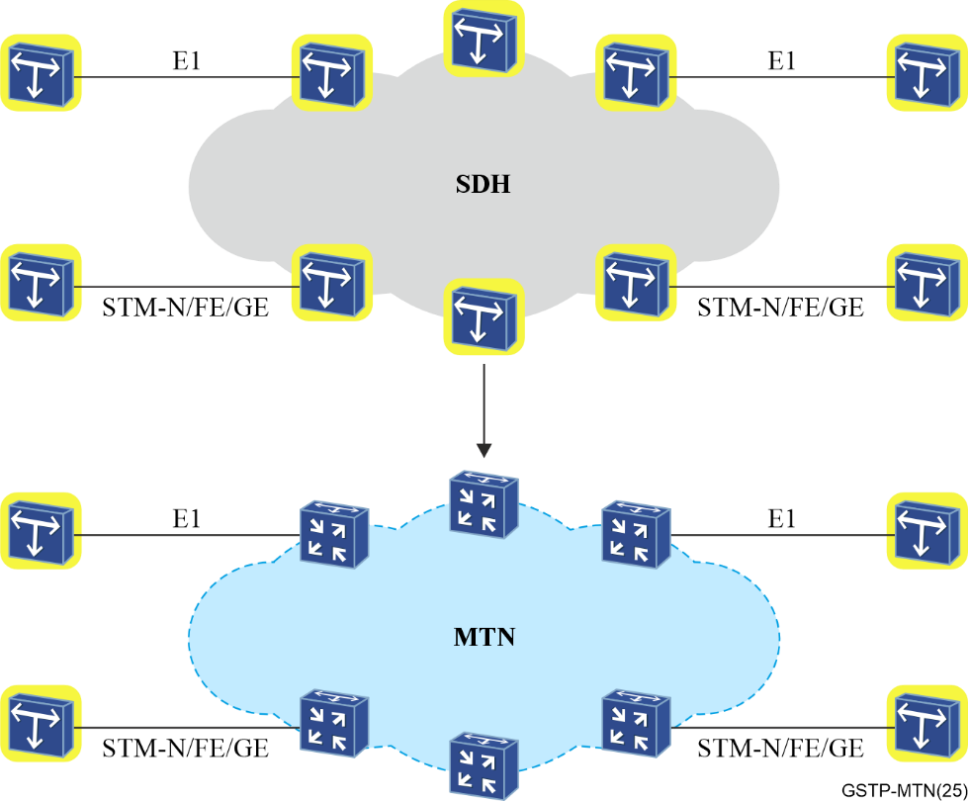
Figure 8-6 – An example of the existing SDH network replaced by a new MTN network
The existing SDH network can also be gradually replaced by an MTN network, as shown in Figure 8-7. Depending on the requirements, certain nodes in the SDH network can be replaced with MTN nodes. This allows services from the legacy SDH network to be transmitted over the hybrid network, while packet-based services can be delivered with greater efficiency. This solution not only resolves the bandwidth bottleneck issue inherent in SDH networks but also preserves the physical isolation properties of SDH, offering an integrated approach for multi-service transmission.
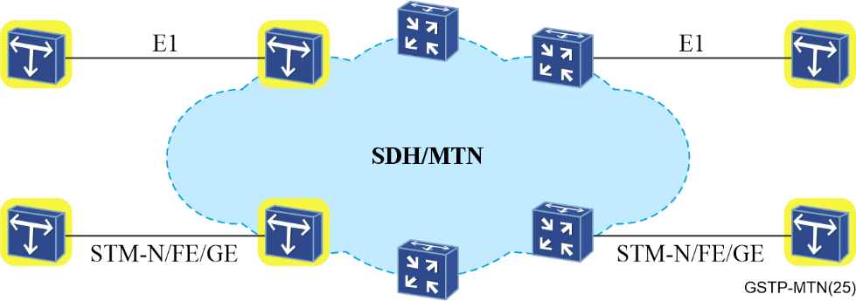
Figure 8-7 – An example of the existing SDH network gradually replaced by an MTN network

Bibliography

[b-CCSA-2019-1213T-YD] CCSA-2019-1213T-YD (2019), General Technical Requirements for Slicing Packet Network (SPN).
<https://www.ccsa.org.cn/>

___________

