Standardization Sector
ITU-T Technical Report
(10/2025)
GSTR-ION-2030
Technical Report on international optical networks towards 2030 and beyond
ITUPublications | International Telecommunication Union


Technical Report ITU-T GSTR-ION-2030
Technical Report on international optical networks towards 2030 and beyond

Executive Summary
Overview
ION-2030 is a strategic framework developed by ITU-T Study Group 15 to guide the evolution of international optical networks. It supports emerging technologies and societal goals including IMT-2030, artificial intelligence (AI), data centres, and broadband access. The report targets analysts, chief technology officers (CTOs) and product managers aiming to define capabilities, usage scenarios and a standardization roadmap for next-generation optical networks.

Key trends
1) IMT-2030: Emphasizes ubiquitous intelligence, immersive multimedia, digital twins, smart industries and sustainability. Optical networks must support high bandwidth, low latency and precision synchronization.
2) AI: AI enhances network operations via multimodal models, digital twins, autonomous agents, and energy-saving mechanisms. Optical networks also enable edge AI and AI-as-a-service.
3) Data centres: Require ultra-high bandwidth (400G/800G+), low-latency and energy-efficient optical links with synchronization for distributed computing.
4) Broadband access: Transition from copper to fibre with advanced passive optical network (PON) technologies supporting gigabit and 10G+ services, integrated with in-premises networks and Internet of things (IoT).

ION-2030 capabilities
1) Enhanced connectivity: Tbit/s line capacity, sub-ms latency, high reliability and deterministic service assurance.
2) New capabilities: Integrated sensing (distributed fibre optic sensing (DFOS), feed forward), computing, AI agents, energy efficiency (pico-Joules/bit) and quantum-resistant security.

Architectures and technologies
1) IMT-2030: backhaul/fronthaul, 100GE–1.6TE interfaces.
2) AI: AI-native optical networks, distributed computing, digital twins.
3) Data centres: ROADM/OXC switching, CPO/LPO/OCS for energy efficiency.
4) Broadband access: VHSP PON (200G+), Wi-Fi fronthauling, AI-enhanced networks.
5) ISAC: DFOS and feedforward sensing for infrastructure protection.

Standardization roadmap
1) Collaboration with ITU-R, SG13, 3GPP, BBF, IEEE, ETSI, OIF, IETF.
2) Continuous evolution post-2030 to support sustainability and innovation.

Conclusion
ION-2030 presents a comprehensive vision for future optical networks, integrating AI, sensing, computing and sustainability. It lays the foundation for global standardization and deployment, enabling inclusive digital transformation and supporting the United Nations sustainable development goals.

Note
This is an informative ITU-T publication. Mandatory provisions, such as those found in ITU-T Recommendations, are outside the scope of this publication. This publication should only be referenced bibliographically in ITU-T Recommendations.

© ITU 2026
All rights reserved. No part of this publication may be reproduced, by any means whatsoever, without the prior written permission of ITU.

Table of Contents
Page
1 Scope 1
2 References 1
3 Introduction 1
3.1 Trends of IMT-2030 2
3.2 Trends of artificial intelligence (AI) 2
3.3 Trends of data centres 4
3.4 Trends of broadband access 4
4 Trends of ION-2030 5
4.1 Motivation and goals 5
4.2 Technology trends 5
5 Design principles and characteristics of ION-2030 6
5.1 Overarching design principles 6
5.2 Key characteristics and features of ION-2030 6
6 Capabilities of ION-2030 8
6.1 Enhanced and new capabilities of ION-2030 8
6.2 Capabilities of optical networks 9
7 Enabling optical network architectures and technologies 10
7.1 ION-2030 for IMT-2030 10
7.2 ION-2030 for AI and AI for ION-2030 12
7.3 ION-2030 for data centres 14
7.4 ION-2030 for broadband access 17
7.5 ION-2030 for integrated sensing and communication (ISAC) 20
8 Considerations for standards development 21
8.1 Relationships 21
8.2 Timelines 21
Appendix – Acronyms 22

Technical Report ITU-T GSTR-ION-2030
Technical Report on international optical networks towards 2030 and beyond

1 Scope
This Technical Report describes the framework and overall objectives of the future development of international optical networks for 2030 and beyond (ION-2030), as well as the associated roadmaps and timelines, to address the requirement of international mobile telecommunications towards 2030 and beyond (IMT-2030), AI, data centre (DC) and broadband access.

2 References
[ITU-T G Suppl. 88] Recommendation ITU-T G Suppl. 88 (2025), Point to multipoint passive optical access system requirements and transmission technologies above 50 Gbit/s per wavelength.
[ITU-T G Suppl. 92] Recommendation ITU-T G Suppl. 92 (2025), Synchronization for data centres.
[ITU-T G.672] Recommendation ITU-T G.672 (2025), Characteristics of multi-degree reconfigurable optical add/drop multiplexers.
[ITU-T G.9991] Recommendation ITU-T G.9991 (2019), High-speed indoor visible light communication transceiver – System architecture, physical layer and data link layer specification.
[ITU-T M.2160] Recommendation ITU-T M.2160 (2023), Framework and overall objectives of the future development of IMT for 2030 and beyond.
[IEEE SA P1588.1] IEEE SA (2024), Standard for a Precision Clock Synchronization Protocol for Networked Measurement and Control Systems.

3 Introduction
The primary motivation for international optical networks towards 2030 and beyond (ION-2030) is to accelerate the building of the inclusive information society envisioned in the United Nation's Sustainable Development Goals (SDGs). In this regard, ION-2030 is similar to and complementary to the ITU-R's IMT-2030 initiative, but covers the future development of optical network to support four areas: IMT-2030, AI, data centre interconnection, and broadband access. Common societal goals across those four areas include:
1) Sustainability: The network advances low-carbon development and minimizes environmental impact.
2) Connecting the unconnected: Enable access to information resources via optical networks (esp. access).
3) Enhanced security and resilience: Ensure information confidentiality and always-on connectivity.
4) Ubiquitous connectivity: A converged architecture across, both terrestrial and submarine links supports seamless interconnection and global coverage. It intends to connect all meaningfully rural and remote communities, further extending into sparsely populated areas.
5) Inclusivity: Enterprises and households enjoy differentiated but reliable services.
6) Innovation: Breakthroughs in optical networking, sensing, and AI-based technologies.
7) Digital health and well-being: Facilitate the digital health services.
Common technology trends across the four areas include:
8) Ubiquitous intelligence: Intelligence will be present in every part of the communication system. This includes AI-driven multi-agent systems that automate network lifecycle functions.
9) Ubiquitous computing: Data processing in the network infrastructure is required.

3.1 Trends of IMT-2030
According to [ITU-T M.2160], the trends of IMT-2030 are divided into user and application trends and technology trends. The following user and application trends are considered:
– Immersive multimedia and multi-sensory interactions: Human-centric communication is expected to provide an immersive experience through multi-sensory interactions and in-depth integration between the physical and digital worlds.
– Digital twin and virtual world: Precise real-time representations or digital twins.
– Smart industrial applications: Efficient use of resources and energy, optimizations of manufacturing, automated product delivery, etc.
– Integration of sensing and communication: Becoming a key enabler for a wide range of use cases, such as high-precision positioning and localization of devices and objects, high-resolution and real-time 3D mapping, digital twins and industrial automation.
The following technology trends are considered:
– AI-native air interface and air network: to enhance the performance of radio interface functions.
– Integration of sensing and communication functions: to give new capabilities, enable innovative services and applications, and provide solutions with a higher degree of sensing accuracy.
– Computing services and data services: including processing data at the network edge close to the data source.
– Device-to-device wireless communication: to provide extremely high throughput, ultra‑accuracy positioning and low latency.
– Enhanced spectrum utilization: efficiently managing resources through different technologies such as advanced carrier aggregation and distributed cell deployments.
– High energy efficiency: from both the user device and the network perspectives.
– Real-time communications: to achieve extremely low latency via accurate time and frequency information shared in the terrestrial network and fine-grained, proactive and on‑time radio access.
– Security and resilience: to be ensured when allowing the legitimate exchange of sensitive information through network entities.
The overall trends of IMT-2030 could impact the features of optical networks, including large bandwidth, low latency, high flexibility, energy-efficiency, and network intelligence.

3.2 Trends of artificial intelligence (AI)
The trends of AI are divided into AI for ION-2030 and ION-2030 for AI.

3.2.1 AI for ION-2030
Multi-modal: Multimodal AI can process multiple types of data, such as texts, images, and sound, which is a step closer to mimicking the human ability to process diverse sensory information. It can improve diagnostic accuracy and help network administrators to easily complete related complicated network management tasks.
Combination of large and tiny model: Large and tiny models are used in a hybrid way across multiple scenarios. Large models are expensive, consuming more space and power, while tiny models are far less resource-intensive but also less accurate. The combination of large and tiny models impacts the architecture of transport networks, such as the placement of the AI computing, and the coordination and boundary between large and tiny models.
Agent: Agent mechanism is a significant improvement in optical network management by creating systems that can act autonomously to achieve specific objectives. These systems can perform complex tasks without constant human intervention, increasing efficiency and reducing the workload for optical network administrators. Agent can also adapt to new information and changing environments, making them particularly valuable for handling dynamic and unpredictable optical network issues.
Digital Twin: A network digital twin involves creating a comprehensive digital replica of a physical network by modelling all essential elements, including network entities and fibre links. This system establishes a real-time, interactive mirror of the physical network. Through bidirectional, real-time interaction between the physical layer and the digital twin, it enables simulation, performance evaluation, and iterative optimization throughout the entire lifecycle of the optical network.
Sensing: Sensing is a new feature of the next generation of optical networks. AI could assist in various sensing applications, such as branch fibre recognition, prediction of service quality for different channels, earthquake detection, and traffic counting.
Performance improvement: Versatile AI models and algorithms considering customers' differentiated service requirements could improve bandwidth allocation and utilization efficiency in optical networks.
Intelligent operation: AI can be applied to analyse tremendous amounts of data, which would reduce operations labour, and increase efficiency.
Power saving: AI-based energy-saving technologies can reduce energy consumption through intelligent traffic prediction and dynamic resource scheduling. For example, in access networks, controlling optical network unit (ONU) deep-sleep mechanisms during low-traffic periods could improve energy efficiency.

3.2.2 ION-2030 for AI
Edge AI refers to processing data right where it is collected. It allows for faster and more efficient AI applications, especially in environments where real-time responses are needed. Edge AI could reduce latency between data generation and action, improve privacy by keeping data locally, and be energy efficient by reducing the need for data transmission and cloud processing power.
AI as a service: Here AI is a generalized service platform for various customers. The integration of AI as a Service into optical networks enhances operational efficiency and enables intelligent, dynamic services. By leveraging AI capabilities, optical networks can address challenges such as traffic congestion, latency-sensitive applications, network security, and resource optimization.
ION-2030 foundation for AI: The intrinsic characteristics of optical networks – ultra-high bandwidth, deterministic low latency, high reliability, and dynamic elasticity – provide the fundamental transport capabilities required by AI workloads. These features ensure reliable and real-time data exchange across distributed computing clusters, enabling efficient large-scale model training, cross-domain inference, and intelligent collaboration among edge, metro, and core resources.
AI-native networks refer to a new paradigm where AI is not merely an add-on feature but is deeply embedded into the optical network. Given the continuous growth in network scale and the complexity of services it carries, the application of AI technologies throughout the full lifecycle is required to achieve optimized network planning and enhanced operational efficiency, thus enabling network intelligence.

3.3 Trends of data centres
Data centres are evolving into intelligent computing hubs that require ultra-high bandwidth, low latency, and lossless transmission to support large-scale AI workloads. The trends in data centres include:
High-capacity interconnection: Distributed model training involves massive intra and inter-site data exchange. 400G/800G+ per wavelength and beyond are required to support this.
Low-latency and high-reliability transport: Optical links offer deterministic low-latency performance together with sub-50ms telecom-grade protection and fast restoration, to provide remote direct memory access (RDMA) capabilities needed to scale AI workloads.
Flexible and elastic bandwidth provisioning: AI tasks are increasingly dynamic and migratory. Optical networks could enable on-demand reconfiguration and bandwidth allocation, aligning with the resource orchestration requirements of those workloads.
Energy-efficient transport infrastructure: Optical transmission significantly reduces energy consumption per bit. When combined with all-optical switching technologies, and advanced packaging techniques such as linear pluggable optics (LPO) and linear receive optics (LRO), it contributes to the overall sustainability of AI infrastructure.
Higher integration: Optical-electronic co-packaging and chip-to-chip optical interconnects reduce power consumption and latency while increasing bandwidth density.
Higher intelligence: AI can enhance the operational efficiency of optical interconnections in intelligent computing centres by enabling adaptive resource scheduling, high-reliability link failure recovery, and flexible network orchestration tailored to diverse service needs.
Synchronization: Time synchronization is needed within data centres at sub-microsecond-level precision to support AI and distributed computing demands. Critical for RDMA efficiency, congestion-free high-performance computation, and low-latency databases, it enables deterministic data forwarding and precise delay measurement and optimization of network performance. [ITU-T G Suppl. 92], the new Supplement G Suppl. DCSync, deals with synchronization for data centres. The IEEE IM/ST/PNCS Working Group is currently developing a new time synchronization protocol [IEEE SA P1588.1], one primary use case of which is for data centre time synchronization.

3.4 Trends of broadband access
As recently described in ITU-T Technical Paper "Broadband access & in-premises network", broadband access has experienced significant advancement over the last thirty years going from copper to fibre. Passive optical network (PON) technology, and especially GPON, enabled high-speed broadband access. Due to the huge communication capacity of optical fibre the access network can now provide users with gigabit or even 10 Gbit broadband services. In addition, generations of PON technologies have also been widely employed in non-residential settings such as mobile backhaul/fronthaul, campus networks, factories, schools, and other verticals. High-speed, reliable, and secure fibre broadband access networks have become indispensable critical infrastructure for the operation of modern society, akin to other utilities.
At the same time, in-premises network technologies covering the last several meters have used wireless (Wi-Fi), copper wire, visible light, and optical fibre technologies to support 10 Gbit backhaul connections to access points (APs).

4 Trends of ION-2030

4.1 Motivation and goals
In addition to the motivation and trends in clause 3, ION-2030 goals include:
Interworking: Convergence of network, and computing resources, as well as data centre interconnection (DCI), data centre access (DCA), and intra-data centre network (DCN) enhances digital infrastructure efficiency.
Standardization and interoperability: Open management frameworks and standards ensure interoperability.
Specifically for AI, there are two ION-2030 aspects:
1) AI for ION-2030: This encompasses the use of AI for the capabilities of ION-2030.
2) ION-2030 for AI: This refers to how ION-2030 networking can enable Edge AI and AI services.

4.2 Technology trends
The key optical network trends include:
• High bandwidth (information rates) – bandwidth evolution covering transport, access and in-premises networks, to support the IMT-2030, data centres, AI and broadband.
• Low latency – supporting IMT-2030 and DC inter-connections, and industrial applications.
• High reliability – providing automatic path protection and restoration with resistance to fibre cuts or signal faults.
• High efficiency – utilizing energy and resource-efficient network architectures and technologies.
• High flexibility – reconfigurable optical routing elements, flexible access with elastic SLAs.
• High accuracy synchronization – supporting IMT-2030 and mission-critical applications, enhancing the reliability and resiliency of synchronization over optical network.
• Service assurance – assuring the quality of service (QoS) of all services, especially the emerging AI services, are met with end-to-end network coordination and optimization.
• Highly autonomous intelligence: providing intelligent automatic fault tracing, performance monitoring, and automatic business distribution capabilities.
• Seamless wavelength rerouting – enables lossless AI workloads under multiple optical-layer failures to enhance the network reliability and reduce the overall costs.
• Enhanced network operations: leveraging AI/ML and/or simulation technologies to plan and initialize transport network, optimize transport network performance, and maintain and operate transport network.
The key technologies include:
• Service awareness – being aware of the QoS requirements and the service level agreement (SLA) of all services to be carried over optical networks.
• Physical layer technologies – including 1.6 Tb/s-class coherent optical transceivers, wideband optical amplification, reconfigurable optical add-drop multiplexers (ROADM) and distributed fibre optic sensing (DFOS), 100GE fronthaul interface, 800GE/1.6TE backhaul interface, satellite free-space optical communication, intelligent optoelectronic physical layer sensing, optoelectronic physical layer energy saving.
• Optical transport network (OTN) technologies – featuring agile bandwidth adjustment, B1T‑OTN, intelligent management of coherent pluggable transceivers.
• Metro transport network (MTN) – featuring 800GE/1.6TE interface, cooperative multimodal channels and control mechanism, service-triggered flexible connection establishment and adjustment, service-oriented intelligent management and control (MC), intelligent energy-efficient technologies.
• Optical Access and in-premises network technologies.
• Optical technologies for radio networks and systems.
• Optical technologies between terrestrial networks and non-terrestrial networks.
• Network architecture incorporating AI and digital twins.
• Network architecture coordinating with IMT-2030.
• Synchronization technologies – enhanced synchronization clocks such as T-BC Class C and D, enhanced primary reference time clock (ePRTC) and coherent network PRTC (cnPRTC). High-accuracy synchronization technologies will be used to support networks, coordinated multiple input multiple output (MIMO) application and data centres.
Increasing integration with networking includes:
• Integration with sensing. This provides new capabilities and enhanced performance reduce overall cost, size and power consumption.
• Integration with computing. It is expected to include data processing at the network edge for real-time responses, low data transport costs, high energy efficiency and scaling out device computing capability for advanced application computing workloads.
• Integrating with artificial intelligence. This is expected to improve the efficiency of network operations such as power management.

5 Design principles and characteristics of ION-2030

5.1 Overarching design principles
ION-2030 is expected to be built on overarching aspects, sustainability, connecting the unconnected, security and resilience, and ubiquitous intelligence, which act as design principles commonly applicable to all usage scenarios. These distinguishing design principles of the ION-2030 align well with IMT‑2030's overarching goals and technology trends already stated in clause 3.

5.2 Key characteristics and features of ION-2030
The characteristics and key features for ION-2030 involve the improvement of fundamental connection capabilities, as shown in the inner circle in Figure 1, which includes:
• Large bandwidth (information rates): Bandwidth evolution covers end-to-end transport networks, including fronthaul, backhaul (from access layer to core layer) and backbone optical transport network, to support IMT-2030's large capacity requirements arising from immersive communication. 10 Gbit/s and beyond access capability per user in optical access network (OAN), and from 2.5 Gbit/s to 10 Gbit/s and beyond system capability in the fibre in-premises (FIP) network.
• Low latency: Lower end-to-end service transport latency is needed to support the IMT‑2030's low latency requirements. For emerging applications (e.g., immersive XR, remote multi-sensory telepresence, and holographic communications) with mixed traffic of data flows, such as video, audio, and other environment data, in a time-synchronized manner, low relative transport latency among multiple data flows should be guaranteed. Cross-station collaboration also places stringent requirements for cross-station transport latency.
• High reliability: Providing high service reliability through network slicing for traffic identification, resource partitioning and hierarchical protection mechanisms for ensuring end-to-end transport reliability. Also, providing high service reliability through network slicing, resource partitioning, and end-to-end protection, to support emerging services. E.g., telemedicine, industrial control, and enterprise cloud migration.
The second category involves the integration of several new features for enabling new usage scenarios, as shown in the middle circle in Figure 1, which include:
• Full flexibility: Flexible connection establishment and re-arrangement, smart and dynamic bandwidth allocation, and coordination of computing capability; support flexible capacity, flexible modulation, flexible power budget and more flexible features. The flexible collaboration between multi-dimensional connection channels and between end-to-end networks is expected to achieve the high alignment needed for multi-dimensional services.
• Distributed intelligence: AI agents embedded in network devices (e.g., network terminal or residential gateway (RG)) enable natural and comprehensive human-computer dynamic interactions. The network or application capabilities can be utilized by AI agent according to the necessity of tasks assigned by users. The intelligent management of optical networks such as self-monitoring, self-organization, self-optimization, and self-healing can be achieved by using AI. ION-2030 can also serve as the optical network infrastructure for providing services to AI applications.
• Energy efficiency: Environmental concerns are becoming increasingly important. Operators and manufacturers are strengthening the industrialization of energy-saving mechanisms. By integrating with intelligent management and developing energy-saving process mechanisms to automatically perform energy-saving operations, improved energy efficiency is expected to lower the network's carbon footprint while maintaining high performance.
• Service-oriented management and control: Service-oriented management and control contain intelligent service perception and service-triggered flexible connection establishment, to support IMT-2030's diversified service requirements arising from the integration of communication with sensing and AI.
• Multi-level granularity is required due to the demands for fine traffic differentiation and support of customized channels for multi-dimensional services for IMT-2030. According to the demand of the service, quality of experience (QoE) of service can be guaranteed via accurate resource allocation in terms of throughput, latency/jitter, loss, availability, security, etc.
• Integrated sensing: Sensing methodologies via fibre, Wi-Fi etc., providing information for intelligent digital services.
• Enhanced synchronization: High time synchronization accuracy is fundamental to IMT‑2030 networks, including communication services, inter-station collaboration, positioning services, and precise delay measurement services. Additionally, for data centre networks, high-accuracy time synchronization is able to increase the efficiency of AI training service and user experience of distributed data centre network.
• Enhanced security: Emerging full digitalization demands of industrial manufacturing and vertical industries, and in-door privacy require enhanced security. Technologies including optical link encryption, quantum attack prevention, and application-layer end-to-end protection need to be considered to further improve the network security.
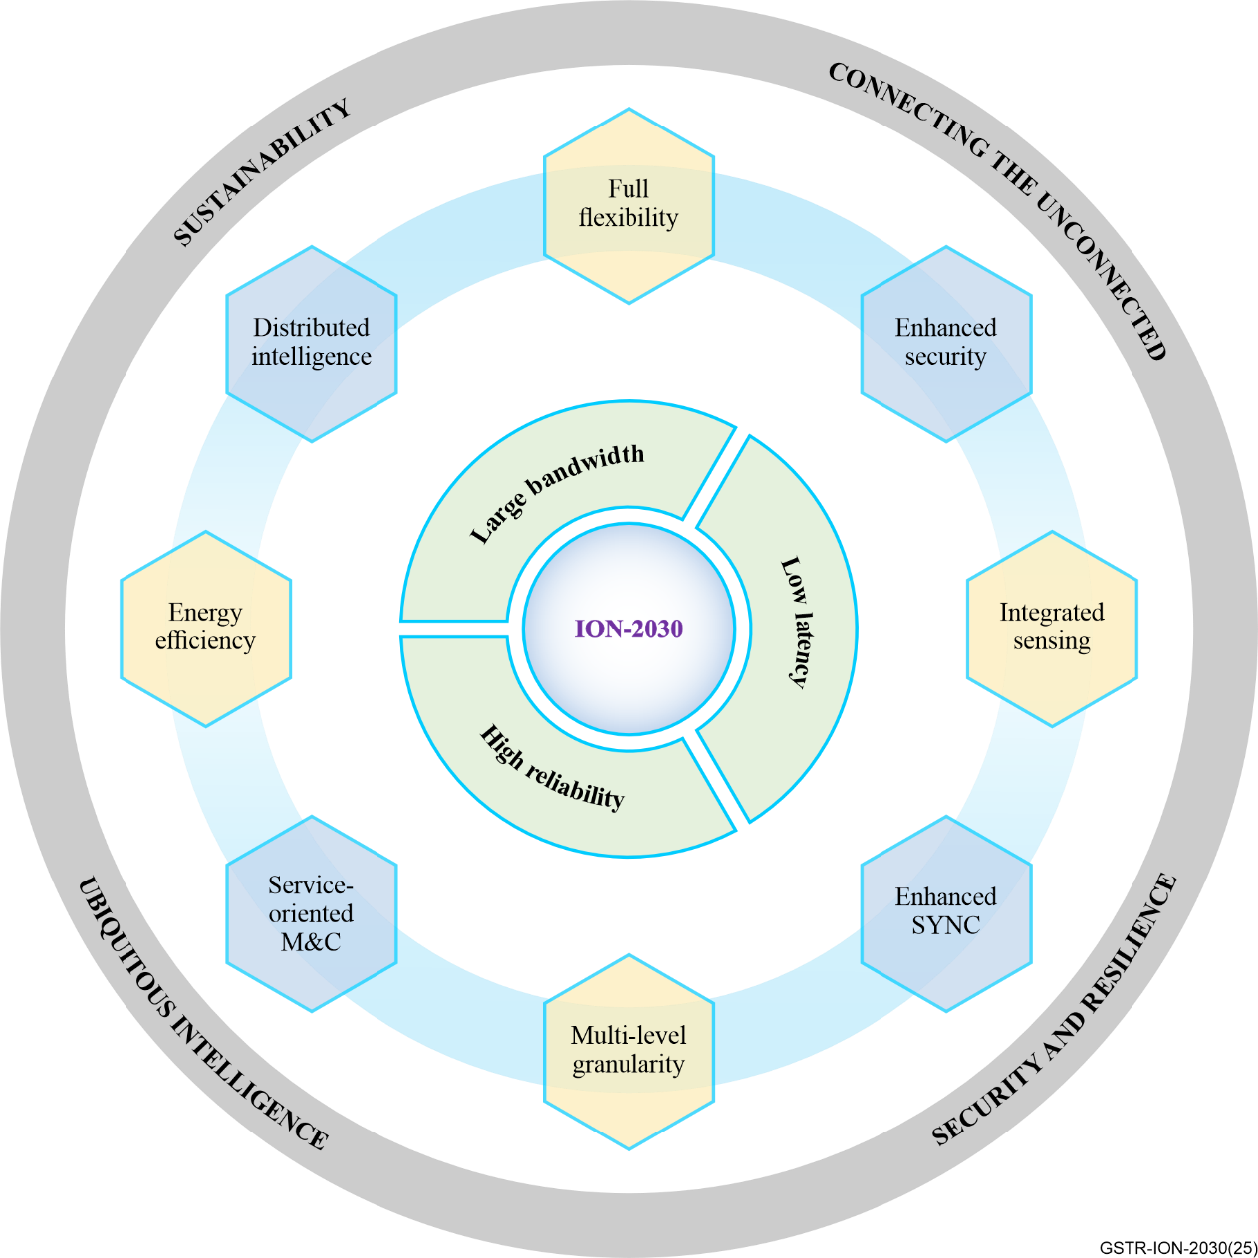
Figure 1 – The key characteristics and features for ION-2030

6 Capabilities of ION-2030

6.1 Enhanced and new capabilities of ION-2030
ION-2030 is expected to provide the following enhanced and new capabilities to support expanded and new usage scenarios.
• Enhanced optical connectivity capabilities: ION-2030 will support enhanced connectivity capabilities including large capacity (single-wavelength rate, frequency range and line capacity), long transmission distance, low latency, low jitter/latency variation, high reliability, high accuracy synchronization, automatic service provisioning, fault management and performance management, etc. through core/metro/access transport networks, Fibre in-premises networks, and their management and control (MC) systems.
• New capabilities with integrated new features: ION-2030 could support new capabilities by integrating sensing, computing and AI model capability. Energy-efficient properties and network security also need to be supported for sustainability.

6.2 Capabilities of optical networks
The enhanced connectivity capabilities of optical network include:
• Optical network capacity
– Single-wavelength rate. This refers to the maximum data transmission rate supported by a single optical wavelength or optical channel line rate. It is a key metric for evaluating the transmission efficiency of an individual wavelength channel. The target line rate of some core networks is expected to be 800 Gbit/s, while the target line rates of some metro networks are expected to reach 1600 Gbit/s by 2030. The target line rate of IMT-2030 fronthaul networks would reach 100 Gbit/s, while the target line rate of backhaul networks' access layer, aggregation layer, and core layer are 100 Gbit/s, 400 Gbit/s, and 800~1600 Gbit/s.
– Frequency range. This refers to the range of electromagnetic frequencies or wavelengths covered by the operating wavelengths in a wavelength division multiplexing (WDM) system. It is expected that by 2030, these systems could utilize both the C-band and L-band, and may be expanded to S-band or other potential wavelength bands, provided significant technological breakthroughs are achieved.
– Line capacity. This refers to the total data transmission capability of a WDM system, determined by: single-wavelength rate (per-channel line rate, e.g., 400G/800G/1.6T), number of wavelengths (channels) multiplexed in the system, spectral efficiency (bits/sec/Hz, reflecting modulation and coding efficiency). With the adoption of S+C+L bands and 800G per wavelength, the target line capacity by 2030 could be 48 Tb/s. Metro networks which utilize 800G PM-16QAM modulation across the C+L bands, could support up to 80 wavelengths with 64 Tb/s line capacity. If S-band optical amplifiers achieve commercial maturity by 2030, 1.6 Tb/s per wavelength channel WDM systems could be implemented using S+C+L bands, enabling 96 Tb/s line capacity. Additionally, if spatial multiplexing technology is employed, the line capacity can be further multiplied.
– In general, 10 Gbit/s and beyond access capability per user is the target in optical access networks to reach, and from 2.5 Gbit/s to 10 Gbit/s and beyond in fibre in-premises networks. The research target of service capacity in optical access networks per PON port is at least 200 Gbit/s. The legacy N1, N2 and C+ optical distribution networks (ODNs) should at least be supported. On the high end, the target optical power budget requirement is Class D/E2 of 20 to 35 dB.
– Terrestrial free space optics (FSO) have applications in access networks and bit rates are expected to increase from the 1-10 Gbit/s rates today. Li-fi (e.g., [ITU-T G.9991]) is also a wireless technology positioned for indoor/building networks.
• Latency and latency variation refers to the transport network equipment process latency and fibre transmission latency.
– The target one-way transport latency of fronthaul networks would be less than 100 μs.
– The target one-way latency of backhaul networks would be less than 1ms in metro.
– The cross-station one-way transport latency would be less than 100 μs for cross-station collaboration such as cell-free MIMO.
– The target latency for optical access network from transmission convergence (TC) layer to TC layer (without fibre) should be at least less than 40 μs in downstream and less than 90 μs in upstream.
– The target latency variation capability introduced by TC layer is less than 10 μs.
– For fibre in-premises network, the target latency capability of the control plane in the optical layer (RTT) should be at least less than 64 μs. The latency capability (RTT) of the data plane in the optical layer should be less than 40 μs in downstream and less than 90 μs in upstream.
• Synchronization accuracy refers to the time and frequency synchronization accuracy for communication services, inter-station collaboration, positioning services, precise delay measurement services, and DC services. Optical transport network can provide high-accuracy time synchronization with the microsecond or sub-microsecond level to support services.
• Service-oriented MC refers to the ability to provide intelligent service perception, service-triggered flexible connection establishment, and service-oriented end-to-end SLA guarantees to support multi-dimensional service integration including the ability to support end-to-end service-oriented cross-network and cross-layer collaboration between multi-dimensional connection channels for multi-dimensional services.
• Reliability in optical networks relates to the successful transmission of traffic within a predetermined time duration with a given probability. The target of reliability would be 1‑10⁻⁶ ~ 1-10⁻⁷.
The new capabilities of optical network include:
• Integrated sensing: In optical networks, the integrated sensing capability could monitor network, device, service, cable, fibre, ODN, Wi-Fi and environment, and sensing data could be used for network operation and environmental analysis.
• Integrated Intelligence: Network intelligence-related capabilities refer to the ability to provide enhanced optical network operation functionalities throughout AI model and agent, DT, etc. These functionalities include AI enhanced close-loop intent processing, service provisioning, fault location, performance optimization, high network reliability, etc, which end-to-end cover the transport, access and home network. Moreover, AI agents and services in optical networks would request flexible dynamic resource allocation and services for AI traffic in fixed broadband access networks.
• Integrated computing: After integrating sensing and AI model capabilities in optical networks, more data needs to be collected and processed for stronger analysis and prediction. Therefore, network control systems and network devices need to be configured with corresponding computing capabilities.
• Energy efficiency: Building green networks and enabling green nodes are core characteristics of sustainable development. It refers to the quantity of information bits transmitted or received, per unit of energy consumption (in picojoule/bit). User and traffic load can be predicted, and energy-saving parameters can be adjusted in real-time to improve energy efficiency.
• Security: Security-related capabilities refer to the ability to preserve confidentiality, integrity, and availability of information, such as user data and signalling, such as providing traffic isolation between multiple services through network resource partitioning. It is also envisioned that the optical network could support encryption protocols and key transmission, even network endogenous security mechanisms in 2030.

7 Enabling optical network architectures and technologies

7.1 ION-2030 for IMT-2030

7.1.1 Architecture and technologies for IMT-2030 backhaul
The architecture of IMT-2030 terrestrial backhaul includes ring and mesh topologies, which can be deployed in access, aggregation, and core networks as shown in Figure 2. Interfaces rates are detailed in Table 1:
Table 1 – Interface rates depending on network type
Network | Target interface rates
Access | 100GE or larger
Aggregation | 400GE
Core | 800GE ~ 1.6TE
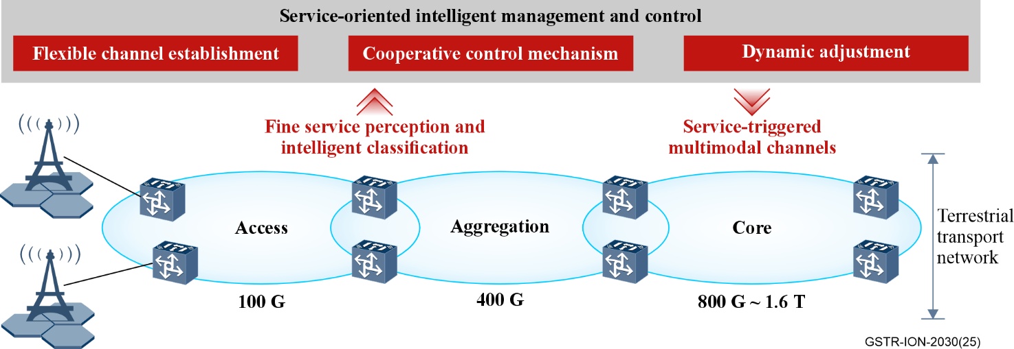
Figure 2 – Backhaul network architecture for IMT-2030
Technologies involved in Figure 2 include:
• Core interfaces. 800GE/1.6TE interface are needed to handle the increasing traffic from access and aggregation toward the core network.
• Service-oriented flexible connection and intelligent management technologies. The multi‑dimensional service integration and distributed collaborative network architecture for IMT-2030 introduces the dynamic traffic characteristics and diversified transmission requirements, requiring backhaul networks to provide the flexible connection establishment and dynamic control of multimodal transmission channels.
• Fine service perception and intelligent classification.
• Service-triggered flexible establishment of multimodal channels.
• Cooperative control mechanism of multimodal channels. A centralized controller and distributed signalling based on a global view realizes the unified control of TDM and packet channels.
• Energy-efficient technologies such as:
– Optoelectronic physical layer: flexible frame design for spatial-temporal energy saving.
– Intelligent network resource allocation: results in energy efficiency improvement.
– Networking layer: Enable energy-saving coordination through bidirectional information exchange with the radio access network (RAN) side, such as RAN-aware load balancing.
• High accuracy synchronization: The optical network enables the delivery of high accuracy frequency and time signals to the IMT-2030 wireless network. This is achieved through a combination of physical and packet layers.

7.1.2 Architecture and technologies for IMT-2030 fronthaul
With the increase of air-interface bandwidth and the increase of base station density, the data rates of IMT-2030 fronthaul will further increase. Considering IMT-2030 fronthaul needs to balance cost and high-performance requirements, a 100GE interface would be a balance point between cost and bandwidth requirements.
The enabling technologies for the IMT-2030 fronthaul include:
• 100GE and higher rate fronthaul interface.
• New optical interfaces and form factors such as co-packaged optics (CPO) / LPO / LRO.
• Simplified coherent and digital subcarrier technology.
• Radio-over-fibre (RoF) transmission technology.
• Scalable management for fronthaul.
• Enhanced Synchronization technologies.

7.2 ION-2030 for AI and AI for ION-2030
Figure 3 shows an AI-era optical network (AI-ON) architecture with ubiquitous AI, including both "AI for ION-2030" and "ION-2030 for AI". The term "AI for ION-2030" involves applying AI techniques to enhance the performance, management, and operation of ION-2030 itself, treating the network as the beneficiary of AI capabilities. The term "ION-2030 for AI" refers to the use of ION‑2030 infrastructure for computation and data processing to support AI tasks. The integration of AI and ION-2030 also creates a unified, intelligent system that not only enhances both AI applications and optical network functionalities but also enable new value-adding applications.
Distributed AI computing resources for delivering AI services and meeting different latency requirements can be placed at points in optical networks. A latency-bounded tiered architecture is illustrated in Figure 3 for far-edge, near-edge, and cloud AI processing to respectively meet the requirements of real-time, near-real-time, and non-real-time AI applications. These resources can be placed in optical line terminals (OLTs), edge data centres, and regional/cloud data centres, ensuring the different latency requirements of a wide variety of applications in a cost-efficient and power-efficient manner.
Power has a large impact on the operating costs of AI. AI computing resources significantly influence the planning and construction of electric power infrastructure, dispatching, and pricing. In order to achieve more efficiency power usage, a real-time, highly reliable and secure communication between power dispatching centres and data centres needs to be supported in ION-2030.
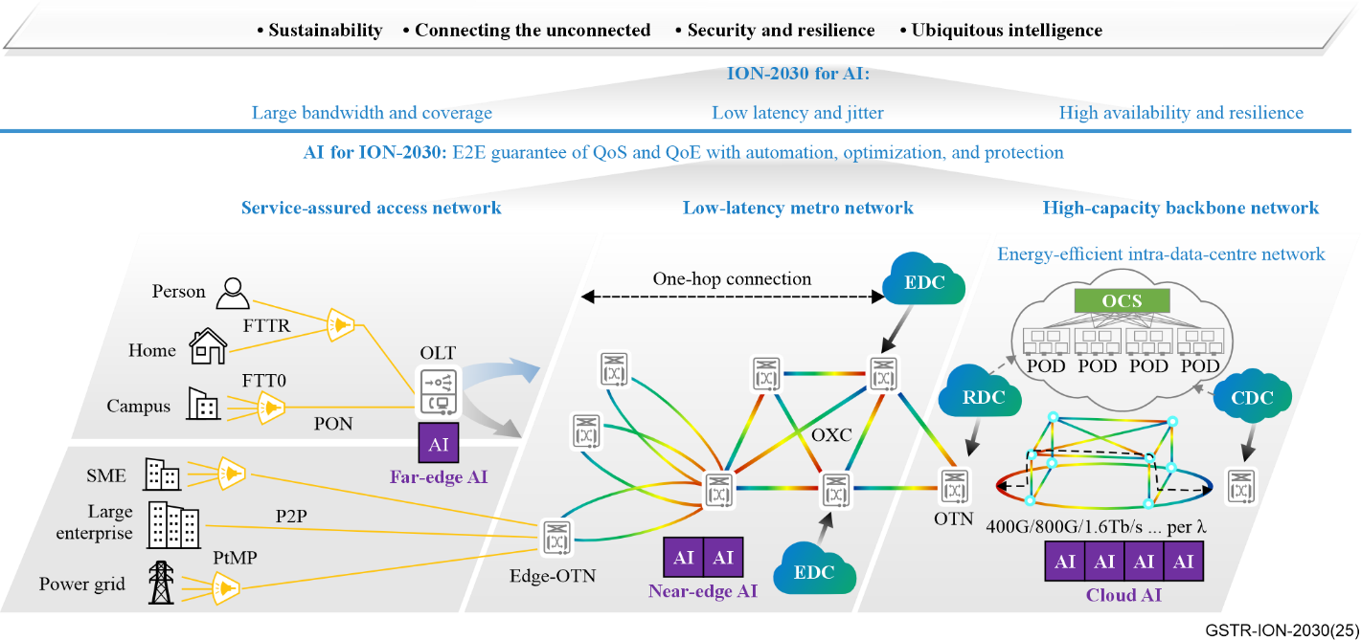
Figure 3 – Illustration of an AI-era optical network (AI-ON) architecture with ubiquitous AI, including both AI for ION-2030 and ION-2030 for AI

7.2.1 AI to enhance ION-2030 operations
Figure 4 shows the AI-native optical network composed by intelligent network elements, AI-native MC systems, and AI-driven service platforms. It integrates technologies such as digital twins, ISAC, and AI to form a layered native optical intelligence architecture, including network intelligence, operational intelligence and business intelligence. It promotes the intelligent transition of network elements from "passive response" to "active perception-decision-optimization", the intelligent transformation of optical networks from "manual intervention" to "intention-driven, autonomous closed-loop", and the transformation of services from "responsive service" to "active service", thereby fully empowering the full lifecycle and full process application of optical networks "planning, construction, maintenance, optimization and operation".
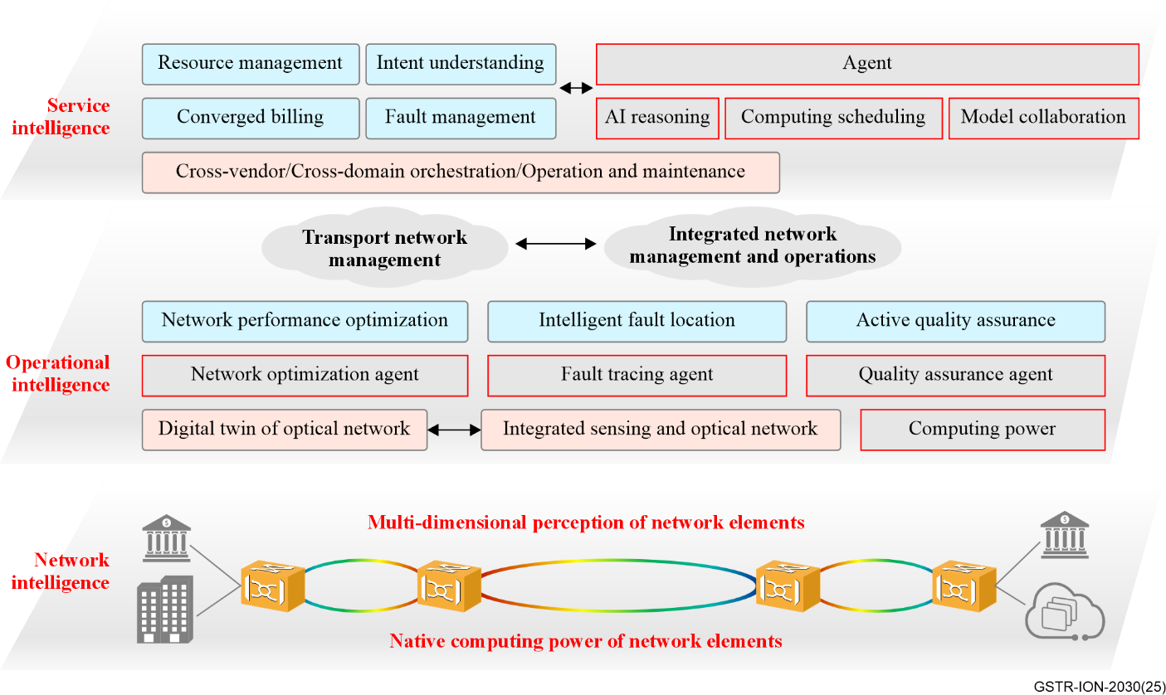
Figure 4 – Illustration of AI-native optical network architecture
To achieve a fully intelligent optical network, the following critical capabilities of intelligence must be enhanced:
• Sensing: Network elements require multi-dimensional, accurate, and timely state perception.
• Computing: Needed for real-time processing, massive data analytics, and scalable model training and inference infrastructure.
• Modelling: Domain-specific modelling enables fully lifecycle automation for optical networks.
• Digital twin simulation: Based on collected data, network digital twin can be constructed to do simulation, and further justify the operations such as network planning, construction, maintenance, optimization and operation.
• Network management agent (NMA): Enhances the automation in MC and accurately analyse the intent and automatically generates tasks to different modules, as a network coordinator.

7.2.2 ION-2030 to enhance AI applications
AI demands drive transport networks toward ultra-flexible, data-aware, high accuracy synchronization, and intelligent infrastructures. ION-2030 provides high-bandwidth connections for centralized Cloud AI processing while simultaneously supporting ultra-low latency edge AI deployment through distributed computational orchestration. Distributed training of graphic processing unit (GPU) clusters requires a large amount of communication overhead, and network performance could be a bottleneck restricting Al arithmetic enhancement. This computing is accomplished in and across data centres and is discussed in clause 7.3.

7.3 ION-2030 for data centres
To support the diverse demands of cloud-computing and AI applications, including large-scale training, distributed inference, and real-time data scheduling, an optical intelligent network that spans access, across and within intelligent computing centres is needed as shown in Figure 5. It is composed of data centre interconnection (DCI), intra-data centre network (DCN), data centre access (DCA). With management-control systems, these enable a high-performance, scalable, and flexible optical network foundation for cloud-computing and AI workloads.
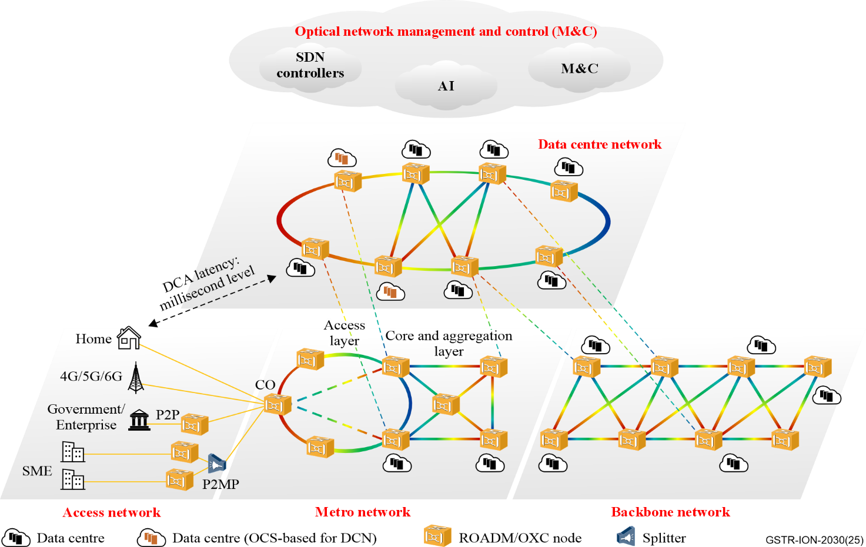
Figure 5 – Target architecture of ION-2030 for data centres
Technology requirements and capabilities include:
• A variety of information rates are needed from separate perspectives: 10 Gbit/s to the user, 100 Gbit/s to site. The capacity could be ~1 Tb/s per λ and ~100T/s per fibre.
• Low-latency connections are required between DCs, at the millisecond level.
• Lossless and agile restoration/protection could be applied to achieve the reliability demand in the DC.
• Enhanced synchronization is used to support applications in DC, with higher precision, reliability, securities and scalabilities.
• Multi-dimensional data could be considered for service provisioning.
• ROADM-based dynamic wavelength setup across DCI and DCA links reduces O-E-O conversions across metro and long-haul DCI links, significantly lowering transport-layer energy cost.
• Optical circuit switching (OCS): Enables dynamic optical layer switching with near-zero idle power, minimizing the energy overhead of large intra-DC switching fabrics. Within DCs it achieves lossless, high-throughput chip-to-cluster interconnect.
• RDMA-aware transport nodes to support low-latency, zero-packet-loss training/inference traffic.
• End-to-end optical stitching from chip to rack, and then to cluster and inter-DC.
• Optical bandwidth slicing based on workload priority and SLA.
• CPO: Integrates optical engines with switching ASICs to eliminate high-loss electrical interfaces, lowering interconnect power and improving bandwidth density.
• LPO/LRO: Removes DSP modules to simplify design, reduce power, and enable low-latency short-reach connectivity.
• Coherent-lite transmission: Simplified coherent technology with reduced DSP power, suitable for medium-reach inter-DC transport.
• Wavelength-on-demand and lightpath reuse: Dynamically provisions/recycles wavelengths based on real-time traffic, avoiding lightpath over-provisioning.
• AI-aware bandwidth scheduling: Allocates optical resources adaptively according to workload type and bandwidth requirement, ensuring network efficiency under varying traffic demands. These interact with MC systems.
• Real-time load monitoring and power-aware orchestration: Enhances SDN controllers with telemetry-driven decision making to minimize network energy under dynamic load.
Addressing these are work items underway in the ITU-T and include: hollow-core fibre, B1T-OTN, fine grain optical transport network (fgOTN), quantum key distribution, and digital twin to deliver a wide variety of AI services with QoS assurance.

7.3.1 Architecture and technologies for DCI
Ultra-high-bandwidth direct connections between intelligent computing centres across metropolitan areas can be provided using optical networking (e.g., ROADMs). Within data centres, all-optical circuit switches (OCS) can be used to connect computing racks/clusters. As AI tasks are dynamic, agile control is used so that optical connectivity among multiple clusters can be efficiently used for the duration of the task(s).
For collaborative operation involving multiple AI data centres, efficiency during AI training and inference is highly sensitive to any packet losses induced by failures of interconnect networks. To address this problem, hitless protection switching is expected to achieve packet-loss-free property when any network failures occur.
The goal of DCI is to build an ultra-broadband, highly reliable optical transport network between geographically distributed AI data centres as shown in Figure 6. The capabilities listed above in 7.3 can be used to achieve this.
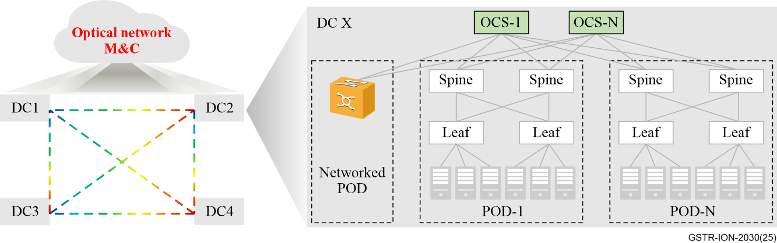
Figure 6 – Architectures for ION-2030 DCI and DCN

7.3.2 Architecture and technologies for intra-data centre network (DCN)
Within large-scale data centres, optical circuit switches (OCSs) can be deployed in AI data centres to connect compute nodes, thereby improving energy efficiency by reducing the need for over-provisioned electrical switches. Thus, OCS integration delivers resilient, high-performance, and power-efficient network fabrics tailored for dynamic AI workloads.
In the future, OCS switches may be deployed further:
• Down into spine and leaf switches to realize flow switching or even packet switching.
• Deployed between OTN equipment and spine switch, between spine and leaf switches, and between leaf switch and AI server to enhance the protection capability within DCN.
• Down into rack-level or chip-level domains to realize super-pods.

7.3.3 Architecture and technologies for data centre access (DCA)
The goal of DCA is to build a low-latency DC-centric network architecture that provides flexible, agile, secure and reliable service capabilities. An all-optical network based on ROADMs can be established to ensure flexible configuration and agile scheduling of services, thus reducing electrical-layer switching and regeneration and also minimizing network latency and costs. Low-latency access to computing resources at metro, regional, and national DCs can be provided to meet the requirements of future computing networks.

7.3.4 Convergence of DCN, DCI and DCA
The convergence of DCN, DCI, and DCA forms a unified optical network architecture that enables end-to-end service-level coordination for AI workloads. From the MC perspective, an integrated orchestration system could manage optical paths across DCN, DCI, and DCA domains. This capability supports real-time visibility, intent-driven configuration, and dynamic traffic scheduling.
This converged architecture allows optical resources to be allocated and reconfigured on demand across distributed intelligent computing centres, improving network utilization, energy efficiency, and service elasticity.

7.3.5 ION-2030 for energy efficiency of distributed AI data centres
Driven by the rapid development of AI-generative content technology, computing resources are widely required by various users such as enterprise. Energy availability has led to distributed AI training using optical networks and technology.
Firstly, optical circuit switch (OCS) can be used to replace the electrical switch at the spine layer of interior DC. This not only reduces power consumption brought by optical modules, but also achieves physical isolation among different tenants for data security and enable computing resource sharing.
Secondly, clients are not willing to expose their core/private data. Pipeline-parallel training can be a useful approach to address this issue, it only transmits intermediate values between the user and data centres. OCS technology can connect lightweight computing resources inside the campus for different users.
Thirdly, for the interconnect between users and DCs, [ITU-T G.672] illustrates an energy-efficient low-latency metro network connecting users and data centres through a meshed core network and access rings.
AI workloads, especially model training and inference, require massive compute and bandwidth resources, leading to increased power consumption. Requirements and technologies listed at the beginning of clause 7.3 are part of how ION-2030 addresses the compute needs.

7.4 ION-2030 for broadband access

7.4.1 Architecture of access and in-premises network
A typical architecture of broadband access and in-premises network is shown as Figure 7.
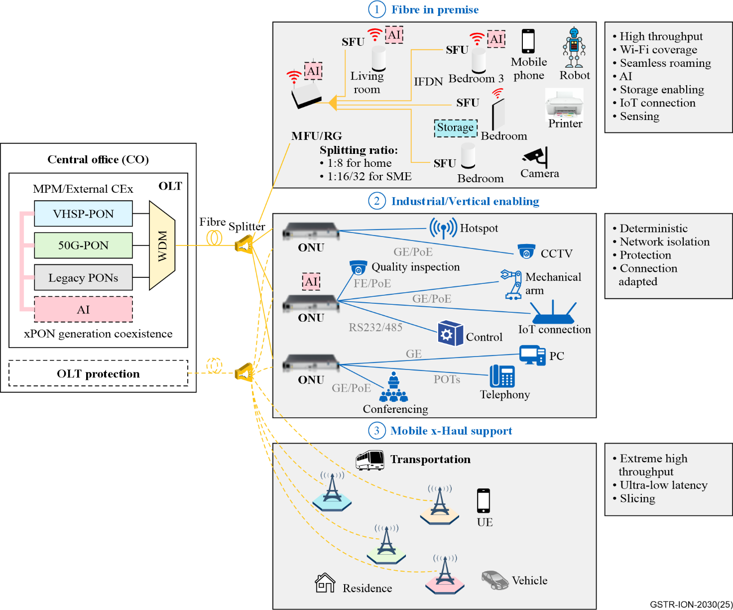
Figure 7 – Broadband access and in-premises network architecture
Towards 2030, the main scenarios for broadband network development are to support home/business broadband, industrial/verticals access, and mobile backhaul/fronthaul.
• In home/business broadband, high throughput is required for the subscribed access while the in-premises network should provide quality-ensured network with AI enabling, storage enhancement sensing or IoT interconnection.
• In industrial or vertical scenario, deterministic bandwidth/latency, network isolation, fibre protection and adaptive connectivity are important, especially for manufacturing.
• In x-haul (back-, mid-, front-haul), dedicated throughput supporting several synchronization performance levels (up to tight synchronisation) is required for mobile operation. In fronthaul, extremely high throughput and ultra-low latency are essential.

7.4.2 Key technologies in optical access network
The next generation of optical access networks will develop towards higher bandwidth, lower latency, greater flexibility, higher energy efficiency and environmental protection. The optical access network for 2030 may have the following key technologies:
• Ultra large bandwidth PON technology: For example, VHSP, supports a service capacity of at least 200 Gbit/s (2×100 Gbit/s), enabling smooth evolution of existing PON systems.
• Lower PON latency technology: With the development of IMT-2030 and the Internet of things (IoT), optical access networks need to support lower latency to meet latency-sensitive applications.
• Higher flexibility and multi-service (e.g., fixed access mobile fronthaul and backhaul) integration and bearer technology.
• ODN sensing technology: optical access network needs sensing capability in ODN, to better support ODN fault diagnosis, environmental sensing, support intelligent network operation and maintenance, and improve network efficiency and reliability.
• Coexistence technology of VHSP with existing PONs: VHSP promises speeds far beyond those of previous generations such as G-PON, XGS-PON, HS-PON. It should aim to coexist with them to ensure a smooth transition and protect existing investments.
• Bidirectional point-to-point interfaces on a single fibre: point-to-point interfaces continue to evolve, especially in bidirectional mode over a single optical fibre. This approach saves fibre usage, reduces infrastructure costs, and increases network capacity and flexibility.
• New optical fibre technologies: new optical fibre characterized by low latency, low nonlinearities, and high-power handling, e.g., hollow-core fibre, need to be considered as key technologies for optical access infrastructure using point-to-point connectivity (single fibre in bidirectional mode).
In addition to these, enhanced interoperability between OLT (optical line terminal) and ONU (optical network unit), and on OLT northbound interfaces is also important. The integration of new management mechanisms, such as telemetry, supervision, and inventory, are guided by the broadband forum (BBF). Standardized interfaces enable equipment to integrate with automated management tools (including AI tools) that work with OLT and ONU data. Coordinated management and control between optical access network and fibre in-premises networks is needed so that OLTs can visualize and manage both access and in-premise network.

7.4.3 Key technologies in fibre in premise
With the evolution of network service, networking demand requiring higher throughput, low latency, mass connection of IoT devices, intelligence of computing for residential gateway (RG) or access point (AP):
• Networking technology through fibre infrastructure. Fibre-based-in-premises networking technologies is the key for wireless (such as wi-fi) backhauling offering "unconstrained" throughput for in-premises connection, achieving 10 Gbit/s and beyond.
• Wi-Fi for end user device connection. This includes IEEE 802.11bn (ultra-high reliability) or IEEE 802.11bq (Integrated millimetre wave) intended to offer 10 Gbit/s and beyond connection for broadband applications. The main feature of multilink operation among unlicensed bands (2.4 GHz, 5 GHz, 6 GHz and 45-70 GHz) and multi-AP coordination would enable avoidance of interference and congestion to achieve high reliable wireless link.
• Fibre and WLAN coordination technologies provide dedicated low latency channel (around tens of milliseconds), enabling deterministic control of AP behaviour for reliable multi-AP coordination for WLAN.
• Unified IoT connectivity and ecosystem via specific protocol will enable the development of various IoT devices. In particular, the low-power connection technologies including Wi-Fi related, Bluetooth, Sparklink, Unified device model and interworking mechanism are important for IoT devices interconnect within in-premises.
• Multi-dimensional sensing by leveraging Wi-Fi (e.g., channel state information), millimetre-wave radar or LiDAR (cloud point information), camera (vision information), etc. to implement object recognition & positioning, human body monitoring, invasion detection, and so on.
• Integrated multi-functions (including storage, sensing, computing, cloud) with communication and coordination among these functions create new capability beyond communication.
• Flexible and low-cost fibre deployment technology will accelerate the availability of the fibre within in-premises. This includes ease fibre deployment tools and guideline, robust fibre and fibre component with enhance capability of bending, fire protection, remote powering, long-term stability, visibility, etc.
• Coordinated management technology for RG/ main fibre unit (MFU) and AP/SFU: the RG/MFU acts as the central management element to collect management information from individual AP / sub fibre unit (SFU) and enables configuration accordingly. The RG/MFU can also forward management information to OLT or receive configuration from OLT.

7.4.4 AI in optical networks for access and home
AI in broadband is one of the most important technical evolutions, introducing smart applications, enabling better network performance and requiring new network capabilities. It can provide dynamic network provisioning, tuning, optimization, and management.
There three characteristics in broadband:
• Agentic AI as a service: includes AI + cloud disk (enabling AI searching, image retouching, etc.), AI + cloud computer (enabling AI document sorting, etc.), AI + wellness (enabling AI wellness assistant, etc.), AI + health (enabling AI fitness, action recognition, etc.), AI + care (enabling AI monitoring of old/young people, pet and so on. AI service deployment can leverage the distributed computing power of different network devices. The AI service requires network device or terminal (such as OLT, ONU, MFU, SFU) acts as the perception and interaction centre and converts original inference data into semantic tokens (events/intents).
• Quality on demand: Application-level experience can be guaranteed through hierarchical application joint scheduling by OAN and/or FIP, based on advanced technologies such as slicing.
• Self-optimizing network: improve network operation, administration and maintenance (OAM) efficiency via proactive prediction. It could recognize user's potential demand, and potential customer marketing.

7.4.5 Roadmap of access network technologies
Broadband access and in-premises networks aim to provide faster and wider broadband network connections through technological advances to support increasingly diverse data services. The evolution is described in terms of the phases in ITU-T Technical Paper "Broadband access & in‑premises network".
For 2030 and beyond, [ITU-T G Suppl. 88] (ex G Suppl. VHSP) of optical access network was launched to study the system requirements and characteristics of optical transmission above 50 Gbit/s per wavelength, and sensing considerations for the PON system. The VHSP systems are expected as the next generation following the 50 Gbit/s PON systems.
For optical fibre in-premises network, a higher throughput over 10 Gbit/s via fibre link is under study. Moreover, Wi-Fi fronthauling technologies based on fibre link are also discussed. A new advanced architecture based on splitting Wi-Fi baseband may be considered.

7.5 ION-2030 for integrated sensing and communication (ISAC)
In ION-2030, ISAC technology has benefits for multiple scenarios, including:
• Network operation and maintenance: state of polarization (SOP) monitoring of feedforward-based sensing can compare polarization changes to identify optical network risks; backscattering-based DFOS can assist in early warning of optical cable degradation.
• Infrastructure protection: the integration of feedforward-based fast OTDR and AI can detect flash faults caused by optical power fluctuation; backscattering-based distributed acoustic sensing can capture vibrations from construction machinery in real time and issue warnings.
• Sensing as a service, the two technologies collaboratively support cross-industry applications.
ISAC realizes the integrated "transmission-sensing" capability of optical networks through two major technical pathways – backscattering-based distributed fibre optic sensing (DFOS) and feedforward-based sensing.
Backscattering-based DFOS relies on three scattering mechanisms in optical fibres. It infers environmental parameters by detecting changes in the frequency and power of backscattered light. Classified by wavelength deployment, it can be divided into two types: in-band and out-of-band. It has advantage in full-link distributed sensing, enabling continuous parameter measurement along the fibre. However, it is limited by weak scattered light power and vulnerability to spectral overlap interference from communication signals. Moreover, optical amplifier isolators block backscattered light, requiring segment-by-segment measurement for multi-span links.
Feedforward-based sensing reuses the forward transmission mode of communication fibres and relies on the digital signal processing (DSP) capability of coherent optical communication systems. It extracts the phase and nonlinear characteristics of optical signals and achieves sensing without additional hardware. It allows seamless integration, directly reuse existing infrastructure such as OTN equipment and erbium-doped fibre amplifiers (EDFA); and also achieves high precision, phase-based sensing enables deformation monitoring, and end-to-end multi-span link monitoring can be achieved via power profile estimation (PPE) technology without segment-by-segment operations.
The future evolution of ISAC technology includes optimization of technical performance, more standardization, massive data management, and multi-vendor collaboration.

8 Considerations for standards development

8.1 Relationships
The ITU-T SG15 work on ION-2030 is expected to be in collaboration with other ITU standards activities and other organizations and standard develop organizations (SDOs), including those whose input is sought, and others that are cooperative:
1) Requirement input relationship: The standards activities of ION-2030 for IMT-2030 (including backhaul & fronthaul) in ITU-T SG15 receive the requirements input of IMT‑2030 from ITU-R, 3rd generation partnership project (3GPP), O-RAN and AI-RAN, etc. The standards activities of AI for optical network receive the requirement input from ITU-T SG13 on AI for IMT-2030 and Focus Group on AI-Native Network (FG-AINN).
2) Cooperative relationship with other SDOs: The standards activities of the optical transport network on B1T OTN, MTN, ION-2030 for AI and AI for ION-2030, ION-2030 for DC may cooperate with IEEE802.3, optical interworking forum (OIF), TMF and Internet engineering task force (IETF). The standards activities of optical access network and in-premises networks may cooperate with BBF. The standards activities of AI for the optical network may cooperate with IETF and OIF. The standards activities of network security of ION-2030 may cooperate with ITU-T SG17, IETF and IEEE 802.1.

8.2 Timelines
In planning for the standards development of ION-2030, it is important to consider the timelines associated with the requirement maturity of main applications, industry readiness level of supporting technologies, which depends on several factors:
– main user trends, application requirements and industry demand;
– technical capabilities and supporting technology and system development;
– standards development and their enhancement;
– optical fibre and spectrum matters;
– regulatory considerations.
These factors are interrelated, and have been addressed within ITU-T SG15 by relevant and responsible Questions, while deployment in different areas would consider various practical aspects such as the cost of additional infrastructure investment, the time for customer adoption of services, etc.
Contributions to ION-2030 are invited to areas delineated in this Technical Report: ION-2030 for IMT‑2030, ION-2030 for AI and AI for ION-2030, ION-2030 for data centres, ION-2030 for broadband access. As contributions are received, work items within SG15 may be initiated accordingly.

Appendix
Acronyms
AI Artificial Intelligence
AP Access Point
BBF Broadband Forum
cnPRTC Coherent Network PRTC
CPO Co-Packaged Optics
DC Data Centre
DCA Data Centre Access
DCI Data Centre Inter-connection
DCN intra-Data Centre Network
DFOS Distributed Fibre Optic Sensing
DSP Digital Signal Processing
ePRTC Enhanced Primary Reference Time Clock
fgOTN fine grain Optical Transport Network
FIP Fibre In-Premises
FSO Free Space Optics
GPU Graphic Processing Unit
IMT-2030 International Mobile Telecommunications towards 2030 and beyond
ION-2030 International Optical Networks towards 2030 and beyond
IoT Internet of Things
ISAC Integrated Sensing and Communication
LPO Linear Pluggable Optics
LRO Linear Receive Optics
MC Management and Control
MFU Main Fibre Unit
MIMO Multiple Input Multiple Output
MTN Metro Transport Network
NMA Network Management Agent
OAM Operation, Administration and Maintenance
OAN Optical Access Network
OCS Optical Circuit Switch
ODN Optical Distribution Network
OIF Optical Interworking Forum
OLT Optical Line Terminal
ONU Optical Network Unit
OTN Optical Transport Network
PON Passive Optical Network
PRTC Primary Reference Time Clock
QoE Quality of Experience
QoS Quality of Service
RAN Radio Access Network
RDMA Remote Direct Memory Access
RG Residential Gateway
ROADM Reconfigurable Optical Add-Drop Multiplexers
RoF Radio-over-Fibre
RTT Round-Trip Time
SDO Standard Develop Organization
SFU Sub Fibre Unit
SLA Service Level Agreement
TC Transmission Convergence
WDM Wavelength Division Multiplexing

______________

