Standardization Sector
ITU-T Technical Paper
(03/2025)
GSTP-BAIN
Broadband access and in-premises networks
ITUPublications | International Telecommunication Union


Technical Paper ITU-T GSTP-BAIN
Broadband access and in-premises networks

Summary
Technical Paper ITU-T GSTP-BAIN reviews the technologies described by ITU-T access network (AN) and in-premises networking standards ("ITU-T Recommendations"). These systems are the basis of all modern access and in-premises networks. The architecture, roadmap, and technology dictionary are described with the aim of providing practical guidance to administrations, operators and suppliers in planning, constructing, and implementing modern broadband access and in-premises networks.

Keywords
50G-PON, access, broadband, digital subscriber line (DSL), fibre-in-the-premises (FIP), free space optics (FSO), G.fast, G.fin, G.hn, G.p2pf, home network, in-premises networks, passive optical network (PON), point-to-point, VDSL, visible light communication (VLC), XG(S)-PON.

Note
This is an informative ITU-T publication. Mandatory provisions, such as those found in ITU-T Recommendations, are outside the scope of this publication. This publication should only be referenced bibliographically in ITU-T Recommendations.

© ITU 2025
All rights reserved. No part of this publication may be reproduced, by any means whatsoever, without the prior written permission of ITU.
Table of Contents
Page
1 Scope 1
2 References 1
3 Abbreviations and acronyms 5
4 Introduction 7
5 Roadmap of access and in-premises network technology 9
5.1 Overview 9
5.2 Architecture of access and in-premises network 9
5.3 Roadmap of access network technologies 10
5.4 Roadmap of in-premises network technologies 13
5.5 Web-based ANT standards overview 16
5.6 Summary 16
6 Technology dictionary 18
6.1 Optical access system for fibre access networks 18
6.2 Broadband access over metallic conductors 28
6.3 Hybrid fibre-copper access (FTTep) 30
6.4 In-premises network technologies 31
7 Conformance and interoperability certification of equipment and performance testing 39

Technical Paper ITU-T GSTP-BAIN
Broadband access and in-premises networks

1 Scope
This Technical Paper gives a valuable overview of the technologies forming modern access and in-premises networks, based primarily on ITU-T access network and in-premises networking standards ("ITU-T Recommendations"). The corresponding architecture, roadmap, and technology dictionary are also introduced for offering practical guidance to administrations, operators and suppliers in planning and implementing the mentioned technologies.

2 References
[ITU-T G.652] Recommendation ITU-T G.652 (2024), Characteristics of a single-mode optical fibre and cable.
[ITU-T G.657] Recommendation ITU-T G.657 (2024), Characteristics of a bending-loss insensitive single-mode optical fibre and cable.
[ITU-T G.982] Recommendation ITU-T G.982 (1996), Optical access networks to support services up to the ISDN primary rate or equivalent bit rates.
[ITU-T G.983.1] Recommendation ITU-T G.983.1 (2005), Broadband optical access systems based on Passive Optical Networks (PON).
[ITU-T G.984.1] Recommendation ITU-T G.984.1 (2008), Gigabit-capable passive optical networks (GPON): General characteristics.
[ITU-T G.984.2] Recommendation ITU-T G.984.2 (2019), Gigabit-capable Passive Optical Networks (G-PON): Physical Media Dependent (PMD) layer specification.
[ITU-T G.984.3] Recommendation ITU-T G.984.3 (2014), Gigabit-capable passive optical networks (G-PON): Transmission convergence layer specification.
[ITU-T G.984.5] Recommendation ITU-T G.984.5 (2022), Gigabit-capable passive optical networks (G-PON): Enhancement band.
[ITU-T G.984.6] Recommendation ITU-T G.984.6 (2008), Gigabit-capable passive optical networks (GPON): Reach extension.
[ITU-T G.985] Recommendation ITU-T G.985 (2003), 100 Mbit/s point-to-point Ethernet based optical access system.
[ITU-T G.986] Recommendation ITU-T G.986 (2010), 1 Gbit/s point-to-point Ethernet-based optical access system.
[ITU-T G.987] Recommendation ITU-T G.987 (2012), 10-Gigabit-capable passive optical network (XG-PON) systems: Definitions, abbreviations and acronyms.
[ITU-T G.987.1] Recommendation ITU-T G.987.1 (2016), 10-Gigabit-capable passive optical networks (XG-PON): General requirements.
[ITU-T G.987.2] Recommendation ITU-T G.987.2 (2023), 10-Gigabit-capable passive optical networks (XG-PON): Physical media dependent (PMD) layer specification.
[ITU-T G.987.3] Recommendation ITU-T G.987.3 (2025), 10-Gigabit-capable passive optical networks (XG-PON): Transmission convergence (TC) layer specification.
[ITU-T G.987.4] Recommendation ITU-T G.987.4 (2012), 10-Gigabit-capable passive optical networks (XG-PON): Reach extension.
[ITU-T G.988] Recommendation ITU-T G.988 (2022), ONU management and control interface (OMCI) specification.
[ITU-T G.989] Recommendation ITU-T G.989 (2015), 40-Gigabit-capable passive optical networks (NG-PON2): Definitions, abbreviations and acronyms.
[ITU-T G.989.1] Recommendation ITU-T G.989.1 (2013), 40-Gigabit-capable passive optical networks (NG-PON2): General requirements.
[ITU-T G.989.2] Recommendation ITU-T G.989.2 (2019), 40-Gigabit-capable passive optical networks 2 (NG-PON2): Physical media dependent (PMD) layer specification.
[ITU-T G.991.1] Recommendation ITU-T G.991.1 (1998), High bit rate digital subscriber line (HDSL) transceivers.
[ITU-T G.991.2] Recommendation ITU-T G.991.2 (2003), Single-pair high-speed digital subscriber line (SHDSL) transceivers.
[ITU-T G.992.1] Recommendation ITU-T G.992.1 (1999), Asymmetric digital subscriber line (ADSL) transceivers.
[ITU-T G.992.3] Recommendation ITU-T G.992.3 (2009), Asymmetric digital subscriber line transceivers 2 (ADSL2).
[ITU-T G.992.4] Recommendation ITU-T G.992.4 (2002), Splitterless asymmetric digital subscriber line transceivers 2 (splitterless ADSL2).
[ITU-T G.992.5] Recommendation ITU-T G.992.5 (2009), Asymmetric digital subscriber line 2 transceivers (ADSL2)– Extended bandwidth ADSL2 (ADSL2plus).
[ITU-T G.993.2] Recommendation ITU-T G.993.2 (2019), Very high speed digital subscriber line transceivers 2 (VDSL2).
[ITU-T G.993.5] Recommendation ITU-T G.993.5 (2019), Self-FEXT cancellation (vectoring) for use with VDSL2 transceivers.
[ITU-T G.994.1] Recommendation ITU-T G.994.1 (2021), Handshake procedures for digital subscriber line transceivers.
[ITU-T G.996.1] Recommendation ITU-T G.996.1 (2001), Test procedures for digital subscriber line (DSL) transceivers.
[ITU-T G.996.2] Recommendation ITU-T G.996.2 (2018), Single-ended line testing for digital subscriber lines.
[ITU-T G.997.1] Recommendation ITU-T G.997.1 (2019), Physical layer management for digital subscriber line transceivers.
[ITU-T G.997.2] Recommendation ITU-T G.997.2 (2019), Physical layer management for G.fast transceivers.
[ITU-T G.997.3] Recommendation ITU-T G.997.3 (2021), Physical layer management for MGfast transceivers.
[ITU-T G.998.1] Recommendation ITU-T G.998.1 (2005), ATM-based multi-pair bonding.
[ITU-T G.998.2] Recommendation ITU-T G.998.2 (2018), Ethernet-based multi-pair bonding.
[ITU-T G.998.3] Recommendation ITU-T G.998.3 (2005), Multi-pair bonding using time-division inverse multiplexing.
[ITU-T G.998.4] Recommendation ITU-T G.998.4 (2018), Improved impulse noise protection for digital subscriber line (DSL) transceivers.
[ITU-T G.999.1] Recommendation ITU-T G.999.1 (2019), Interface between the link layer and the physical layer for digital subscriber line (DSL) transceivers.
[ITU-T G.9700] Recommendation ITU-T G.9700 (2019), Fast access to subscriber terminals (G.fast) - Power spectral density specification.
[ITU-T G.9701] Recommendation ITU-T G.9701 (2019), Fast access to subscriber terminals (G.fast) – Physical layer specification.
[ITU-T G.9710] Recommendation ITU-T G.9710 (2020), Multi-gigabit fast access to subscriber terminals (MGfast) - Power spectral density specification.
[ITU-T G.9711] Recommendation ITU-T G.9711 (2021), Multi-gigabit fast access to subscriber terminals (MGfast) – Physical layer specification.
[ITU-T G.9804.1] Recommendation ITU-T G.9804.1 (2019), Higher speed passive optical networks – Requirements.
[ITU-T G.9804.2] Recommendation ITU-T G.9804.2 (2021), Higher speed passive optical networks – Common transmission convergence layer specification.
[ITU-T G.9804.3] Recommendation ITU-T G.9804.3 (2021), 50-Gigabit-capable passive optical networks (50G-PON): Physical media dependent (PMD) layer specification.
[ITU-T G.9805] Recommendation ITU-T G.9805 (2022), Coexistence of passive optical network systems.
[ITU-T G.9806] Recommendation ITU-T G.9806 (2020), Higher-speed bidirectional, single fibre, point-to-point optical access system (HS-PtP).
[ITU-T G.9807.1] Recommendation ITU-T G.9807.1 (2023), 10-Gigabit-capable symmetric passive optical network (XGS-PON).
[ITU-T G.9807.2] Recommendation ITU-T G.9807.2 (2017), 10 Gigabit-capable passive optical networks (XG(S)-PON): Reach extension.
[ITU-T G.9930] Recommendation ITU-T G.9930 (2024), Point-to-point fibre in the premises.
[ITU-T G.9940] Recommendation ITU-T G.9940 (2023), High speed fibre-based in-premises transceivers – system architecture.
[ITU-T G.9941] Recommendation ITU-T G.9941 (2024), High speed fibre-based in-premises transceivers – physical layer specification.
[ITU-T G.9942] Recommendation ITU-T G.9942 (2024), High speed fibre-based in-premises transceivers - Data link layer.
[ITU-T G.9949] Recommendation ITU-T G.9949 (2025), Wireless local area network management control interface (WMCI) for in-premises network.
[ITU-T G.9960] Recommendation ITU-T G.9960 (2023), Unified high-speed wireline-based home networking transceivers - System architecture and physical layer specification.
[ITU-T G.9961] Recommendation ITU-T G.9961 (2023), Unified high-speed wireline-based home networking transceivers – Data link layer specification.
[ITU-T G.9962] Recommendation ITU-T G.9962 (2023), Unified high-speed wire-line based home networking transceivers - Management specification.
[ITU-T G.9963] Recommendation ITU-T G.9963 (2023), Unified high-speed wireline-based home networking transceivers – Multiple input/multiple output specification.
[ITU-T G.9964] Recommendation ITU-T G.9964 (2023), Unified high-speed wireline-based home networking transceivers – Power spectral density specification.
[ITU-T G.9972] Recommendation ITU-T G.9972 (2010), Coexistence mechanism for wireline home networking transceivers.
[ITU-T G.9976] Recommendation ITU-T G.9976 (2021), Supporting ultra-high-definition video service over G.hn.
[ITU-T G.9977] Recommendation ITU-T G.9977 (2016), Mitigation of interference between DSL and PLC.
[ITU-T G.9978] Recommendation ITU-T G.9978 (2018), Secure admission in a G.hn network.
[ITU-T G.9979] Recommendation ITU-T G.9979 (2018), Implementation of the generic mechanism in the IEEE 1905.1a-2014 standard to include applicable ITU-T Recommendations.
[ITU-T G.9991] Recommendation ITU-T G.9991 (2019), High-speed indoor visible light communication transceiver – System architecture, physical layer and data link layer specification.
[ITU-T G Suppl. 45] Supplement 45 to ITU-T G-series Recommendations (2022), Power conservation in optical access systems.
[ITU-T G Suppl. 49] Supplement 49 to ITU-T G-series Recommendations (2020), Rogue optical network unit (ONU) considerations.
[ITU-T G Suppl. 66] Supplement 66 to ITU-T G-series Recommendations (2020), 5G wireless fronthaul requirements in a passive optical network context.
[ITU-T G Suppl. 71] Supplement 71 to ITU-T G-series Recommendations (2023), Optical line termination capabilities for supporting cooperative dynamic bandwidth assignment.
[ITU-T G Suppl. 74] Supplement 74 to ITU-T G-series Recommendations (2021), Network slicing in a passive optical network context.
[ITU-T G Suppl. 75] Supplement 75 to ITU-T G-series Recommendations (2021), 5G small cell backhaul/midhaul over TDM-PON.
[ITU-T G Suppl. 78] Supplement 78 to ITU-T G-series Recommendations (2022), Use case and requirements of fibre-to-the-room for small business applications.
[ITU-T G Suppl. 79] Supplement 79 to ITU-T G-series Recommendations (2023), Latency control and deterministic capability over a PON system.
[ITU-T G Suppl. 80] Supplement 80 to ITU-T G-series Recommendations (2024), Use case and requirements of fibre-based in-premises networking for home application (FIP4H).
[ITU-T G Suppl. 82] Supplement 82 to ITU-T G-series Recommendations (2024), Enhanced optical line termination with information technology functions.
[ITU-T GSTP-FTTR] Technical Paper GSTP-FTTR (2021), Use cases and requirements of fibre-to-the-room (FTTR).
[IEEE 802.1X] IEEE 802.1X (2020), IEEE Standard for Local and Metropolitan Area Networks--Port-Based Network Access Control.
[IEEE 802.3] IEEE 802.3 (2022), IEEE Standard for Ethernet.

3 Abbreviations and acronyms
This Technical Paper uses the following abbreviations and acronyms:
ACO-OFDM AC-biased Orthogonal Frequency Division Multiplexing
ADSL Asymmetric Digital Subscriber Line
AN Access Network
ANSI American National Standards Institute
ANT Access Network Transport
APC Application Protocol Convergence
AP Access Point
BPON Broadband Passive Optical Network
CU Central Unit
DCO-OFDM DC-biased Orthogonal Frequency Division Multiplexing
DLL Data Link Layer
DM Domain Master
DSL Digital Subscriber Line
DSLAM Digital Subscriber Line Access Multiplexer
DSP Digital Signal Processor
DU Distributed Unit
EP End Point
ETSI European Telecommunications Standards Institute
FDD Frequency Division Duplexing
FEXT Far-End Crosstalk
FIP Fibre In-Premises
FTTB Fibre-to-The-Building
FTTC Fibre-to-The-Curb
FTTep Fibre-to-The-extension point
FTTH Fibre-to-The-Home
FTTR Fibre-to-The-Room
G.fast Fast Access to Subscriber Terminals
GM Global Master
GPON Gigabit-capable Passive Optical Network
HDSL High bit rate Digital Subscriber Line
HSP Higher Speed PON
IEEE Institute of Electrical and Electronics Engineers
IFDN Indoor Fibre Distribution Network
IPTV Internet Protocol TV
ISDN Integrated Services Digital Network
LLC Logical Link Control
MAC Media Access Control
MCE MFU Controller Entity
MDI Medium-Dependent Interface
MFU Main Fibre Unit
MGfast Multi-Gigabit fast access to subscriber terminals
MIB Management Information Base
MIMO Multiple-Input Multiple-Output
MME MFU Management Entity
NG-PON2 Next Generation Passive Optical Network 2
ODN Optical Distribution Network
OEHC Optical and Electrical Hybrid Cables
OFDM Orthogonal Frequency Division Multiplexing
OLT Optical Line Terminal
OMCI ONU Management and Control Interface
ONU Optical Network Unit
PCS Physical Coding Sub-Layer
PHY Physical Layer
PLC Power Line Communication
PMA Physical Medium Attachment
PMD Physical Medium Dependent
PMI Physical medium independent interface
POF Plastic Optical Fibre
PON Passive Optical Network
POTS Plain Old Telephone Service
PSD Power Signal Density
PSTN Public Switched Telephone Network
PtMP Point-to-Multi-Point
PtP Point-to-Point
RGW Residential Gateway
RU Radio Unit
SFU Sub Fibre Units
SHDSL Single-pair High-speed Digital Subscriber Line
SISO Single-Input-Single-Output
SME Small and Medium Enterprise
SNI Service Node Interface
SU Subtended Unit
TC Transmission Convergence
TDD Time Division Duplexing
TDM Time Division Multiplexing
TG Task Group
TV Television
TWDM Time and Wavelength Division Multiplexing
UNI User Network Interface
VDSL Very High Speed Digital Subscriber Line
VLC Visible Light Communication
WDM Wavelength Division Multiplexing
WLAN Wireless Local Area Network
XG(S)-PON XG-PON or XGS-PON
XG-PON Asymmetric 10-Gigabit Passive Optical Network
XGS-PON Symmetric 10-Gigabit Passive Optical Network

4 Introduction
The access and in-premises networks are experiencing rapid technological change, unprecedented subscriber growth rates, a proliferation of new products and solutions, and entries into the market by a wide range of new service providers. The markets for access and in-premises technology need coordinated international standardization and the ITU-T has played a leading role in this respect.
ITU-T Study Group 15 is the global leader in the standardization of transport elements, access networks (AN) and in-premises networking. Participation in ITU's standardization activities is open to all, and experts in this field are invited to join to advance the modern communications networks. Over the past few decades, several technologies have been developed. These include digital subscriber line (DSL), passive optical network (PON), and various home networking technologies.
As a general term for a digital subscriber line, xDSL is a series of high-speed access systems mainly for home users, that adopt digital modulation and demodulation technology. They were intended for residential use, can coexist with the telephone service network (public switched telephone network (PSTN)) or integrated services digital network (ISDN) for providing traditional voice (plain old telephone service (POTS)) through a splitter. As the earliest widely used broadband communication technology, xDSL was the mainstream broadband access technology solution in the world before the PON-based fibre-to-the-home (FTTH) technology.
American national standards institute (ANSI) released the first asymmetric digital subscriber line (ADSL) technical standard T1.413 in 1995 and T1.413 issue 2 in 1998. Since then, ITU-T SG15 Q4 has become the most influential xDSL standard organization. A series of 5 generations of standards have been released in the nearly 30 years of xDSL development history to meet different applications, such as business (high bit rate DSL, or HDSL, and symmetric-high speed DSL, or single-pair high-speed digital subscriber line (SHDSL)) and residential broadband (asymmetric DSL, or ADSL, and very high speed digital subscriber line, or (VDSL)) using the legacy PSTN physical plant. The more recent generations fast access to subscriber terminals (G.fast) and multi-gigabit fast access to subscriber terminals (MGfast) meet the fibre-to-the-distribution-point application, to cover the last copper pair or coax segment to the home, where such is not practically feasible to serve with a PON-based FTTH solution.
Passive optical network (PON) is a technology that uses a point-to-multipoint optical distribution network for information transmission over optical fibre. The point-to-multipoint physical topology is especially applicable to fixed access networks. A PON system generally consists of an optical line terminal (OLT) at the central office (CO), an optical network unit (ONU) at the user side, and a passive optical distribution network (ODN) connecting the OLT and the ONU. In a PON system, multiple ONU devices share the same optical fibre medium to communicate with an OLT. Common media sharing technologies are time division multiplexing (TDM) multiple access, wavelength division multiple access (WDM), and time and wavelength division multiplexing (TWDM). Currently, the mainstream PON systems gigabit-capable passive optical network (GPON) and XG(S)-PON) that have been deployed in volume adopt the TDM multiple access technology.
APON (ATM PON), whose layer 2 protocol is ATM, was considered the first generation PON system in the world. In 1995, the full service access network (FSAN) organization was established by seven of the world's major network operators. With the effort of FSAN members, the APON Recommendation was progressed in ITU-T and approved as [ITU-T G.983.1]. APON technology can provide uplink and downlink rates of 155 Mbit/s. In 2001, FSAN and ITU-T upgraded and revised the APON specification and renamed it BPON (Broadband PON). The downlink rate it can provide is 622 Mbit/s. Due to shortcomings such as high implementation cost and low efficiency, APON and BPON have not been widely deployed globally.
In 2003, ITU-T SG15 Q2 started the GPON recommendation G.984 series, and this has become the most deployed PON system so far. After that, ITU-T Q2 has defined another 4 PON systems in recent 20 years, they are asymmetric 10-gigabit passive optical network (XG-PON), symmetric 10-gigabit passive optical network (XGS-PON), next generation passive optical network 2 (NG-PON2) and higher speed PON (HSP) (50 Gbit/s PON), respectively.
In addition to improving system capacity and line rate, ITU-T SG15 Q2 is still continuously improving the performance of PON networks. For example, G.sup.PONlatency is defined to enable PON systems that support low latency and deterministic latency variation. G.sup.PONslicing is defined to enable PON system that can be sliced and provide diversified network services for different businesses. G.sup.VHSP is newly launched to study very high speed PON technologies above 50 Gbit/s per wavelength (and also including the PON sensing technologies) to support the long evolution of higher speed PON.
ITU-T SG15 Q3 (Technologies for in-premises networking and related access applications) focuses on developing wireline backhauling technologies for the last several meters in-premises wireless connection (such as Wi-Fi, Li-Fi). A series of recommendations (G.hn) developed for achieving a unified copper-based wireline protocol (same media access control (MAC) with different physical layer (PHY) in order to adapt to different medium, like twisted pair, coax, powerline) provides gigabit per second connection in in-premises and extension networks. Time-domain division multiplexing is adopted. It can be further extended for a dedicated access scenario if copper media is available. The G.hn technology is also used for visible light communication (i.e., G.vlc), where a multi-point-to-multi-point (PtMP) communication takes place in a shared medium. In addition, silica fibre is the ideal transmission medium with long lifetime, lossless channel, etc., for fixed communication. To satisfy the evolving demand of in-premises broadband (higher throughput, lower latency, greener, etc.), fibre-based in-premises network is promising. The standards for fibre-based in-premises networks include both point-to-multi-point (PtMP) and point-to-point (PtP) topologies. Recommendations for the (PtMP) topology (i.e., G.fin) are developed to enable 2.5 gigabit and 10 gigabit in-premises backhauling connections for access points (AP). Specifically, a fibre and wireless coordination scheme is developed to exchange any potential control message with extremely low latency. This could act as the coordination channel for the air interface between different access points. A fibre in premises recommendation for the PtP topology (i.e., G.p2pf) is also defined which leverages traditional 1G and 10G optical Ethernet technologies for short distance communication to subtended Wi-Fi access points within the premises.

5 Roadmap of access and in-premises network technology

5.1 Overview
The earliest access network mainly used copper wires to provide telephone voice services. Then, in the 1990s, with the rapid development of DSL technologies, broadband Internet access services were provided to users through existing telephone lines. In the 2000s, with the rapid development and maturity of PON technology, especially GPON, more and more users began to achieve high-speed broadband access through optical fibre. Due to the huge communication capacity of optical fibre and the rapid development of high-speed PON technologies, the access network can now provide users with gigabit or even 10 gigabit broadband services. At the same time, in-premises network technology focuses on developing wireline backhauling technologies for the last several meters in-premises wireless connection (such as Wi-Fi, Li-Fi). Its technologies include copper wire technology, visible light technology, optical fibre technology, etc. Especially with the rapid development of fibre to the premises, in-premises networks can support 10 gigabit backhauling connections for access points. Due to the continuous development of access networks and in-premises networks, users can enjoy faster and more convenient broadband network services.

5.2 Architecture of access and in-premises network
An example of the architecture of broadband access and in-premises network is shown in Figure 5-1.
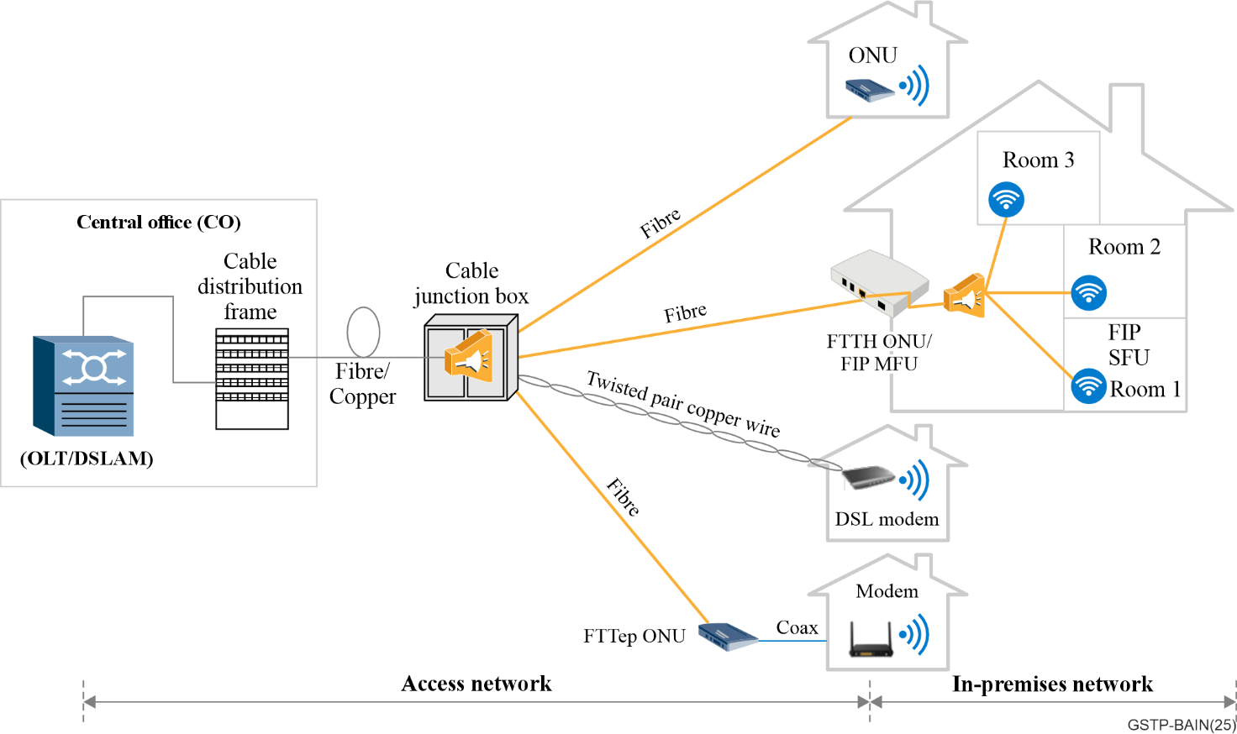
Figure 5-1 – An example broadband access and in-premises network architecture

5.3 Roadmap of access network technologies

5.3.1 Optical access network
In the past 20 years, a variety of optical access systems have been developed in ITU-T SG15 Q2. The most popular systems are commonly known as passive optical network (PON) and operate over an optical distribution network (ODN) composed of [ITU-T G.652] / [ITU-T G.657] compatible optical fibre and passive optical splitters, connecting the optical line terminal (OLT) at the central office (CO) side to the optical network unit (ONU) at the customer side.
ITU-T SG15 Q2 published G.984 series of GPON standards around 2005. The GPON system uses single-fibre bidirectional transmission, with one wavelength in each direction. The downstream nominal wavelength is 1 490 nm and the upstream nominal wavelength is 1 310 nm. The downstream bit rate of GPON is 2.488 Gbit/s, and the upstream bit rate is 1.244 Gbit/s. It generally can support a split ratio of 1:64 and a transmission distance of 20 km. In the FTTH scenario, if concurrency is not considered and users are fully configured with the maximum split ratio (each PON port is connected to 64 users), GPON can provide a downstream guaranteed bandwidth of about 30 Mbit/s for each user. In the actual live network, considering the actual taking ratio and the statistical multiplexing gain in the time division multiple access, GPON usually can provide users with broadband services of tens of Mbit/s to hundreds of Mbit/s.
A few years after GPON standards were published, GPON has been widely deployed in the market, providing hundreds of Mbit/s fibre broadband services for hundreds of millions of users around the world. In 2010 and 2016, ITU-T SG15 Q2 published asymmetric 10G-PON (XG-PON) and symmetric 10G-PON (XGS-PON) standards. Same with GPON, XG(S)-PON also uses one wavelength in both the upstream and downstream directions, and the nominal downstream wavelength is 1 577 nm, the nominal upstream wavelength is 1 270 nm. Therefore, it can support coexistence with previous GPON users by the WDM method, achieving a smooth upgrade. The downstream bit rate of XGS-PON and XG-PON is 9.953 Gbit/s, the upstream rate of XG-PON is 2.488 Gbit/s, and the upstream rate of XGS-PON is 9.953 Gbit/s. When the split ratio is 1:64, XG(S)-PON can provide about 150 Mbit/s guaranteed bandwidth for each user. Considering the actual installation rate on the live network and the statistical multiplexing gain of TDM, XG(S)-PON generally can provide gigabit broadband services to users. To support the continuous evolution of optical broadband access networks, single-wavelength symmetric 50G-PON standard was published in 2023. 50G-PON supports a downstream rate of 49.7664 Gbit/s and two upstream rates of 49.7664 Gbit/s and 24.88 Gbit/s. In addition, 50G-PON can support triple generation coexistence with GPON/XG(S)-PON on the same optical fibre ODN. In this way, the existing network can be smoothly upgraded to 50G-PON without affecting the original GPON and XG(S)-PON users. 50G-PON is expected to provide users with broadband services of several Gbit/s or even 10 Gbit/s.
All above GPON, XG(S)-PON, and 50G-PON are single-channel PON systems that adopt time division multiplexing multiple access technology. Besides those, ITU-T SG15 Q2 also defines PON systems NG-PON2 and 50G TWDM-PON based on time/wavelength hybrid division multiplexing technology. NG-PON2 can support 4 to 8 wavelength channels in the downstream/upstream, and the line rate of each channel is 9.953 Gbit/s or 2.488 Gbit/s. Therefore, NG-PON2 can support a maximum system capacity of about 80 Gbit/s in the downstream and upstream. NG-PON2 can provide 4 times to 8 times the bandwidth compared to XGS-PON and can allocate different wavelengths to different types of customers, allowing operators to provide comprehensive access services based on NG-PON2. The 50G TWDM-PON standard was started in February 2018, and the standard is still under study to this day.
At the same time, Q2 is currently further studying beyond 50 Gbit/s PON technology (VHSP) to support the continued evolution of 50G-PON/50G TWDM-PON systems.
The abovementioned PON system evolution roadmap is illustrated graphically in Figure 5-2.
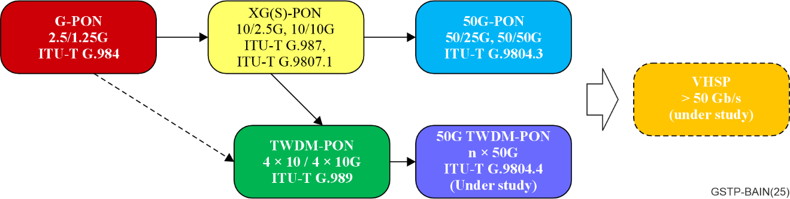
Figure 5-2 – Roadmap of the splitter based optical passive network standard in ITU-T SG15
These systems work to minimize the cost per subscriber by sharing the OLT, ODN, and system capacity over many users. Therefore, current splitter based PON systems have been widely deployed around the world to provide high-speed broadband access to hundreds of millions of users.
Besides that, for higher capacity special services, point-to-point (PtP) access systems have been defined. This family of systems operates over a single fibre strand, employing bidirectional transmission. In addition, there are common issues and features that tend to be more generic and apply to multiple systems. Examples include the management of access systems, handling rogue ONUs, PON low latency control, PON slicing, and the coexistence of multiple systems. Q2 has developed many recommendations and supplements to describe these aspects.

5.3.2 DSL and beyond
ANSI released the first ADSL technical standard T1.413 in 1995 and T1.413 issue 2 in 1998. Since then, a series of 5 generations of ITU-T standards have been released in the nearly 30 years of xDSL development history. The performance differences are accomplished by changing the power levels and spectrum characteristics, advanced modulation techniques, channel bonding, noise cancellation with vectoring, and noise management.
HDSL [ITU-T G.991.1] is considered as the first-generation DSL technology, based on earlier symmetric DSL (SDSL) technology developed in the European telecommunications standards institute (ETSI). It provides 1.544 Mbit/s/2.048 Mbit/s symmetric Internet access for enterprise users at very low latency. A later version of SHDSL [ITU-T G.991.2] supported up to 6 Mbit/s.
The second-generation ITU-T xDSL standards that support high-speed Internet access are ADSL series standards, including [ITU-T G.992.1] (ADSL) released in July 1999. [ITU-T G.992.3] (ADSL2) in 2002, [ITU-T G.992.4] (splitter less ADSL) in 2002, and [ITU-T G.992.5] (ADSL2plus) in 2003. ADSL/ADSL2 uses the upstream spectrum of 25 kHz to 138 kHz (based on POTS), 120 kHz to 276 kHz (based on ISDN), and the downstream spectrum of 138 kHz to 1.104 MHz (based on POTS) and 276 kHz to 1.104 MHz (based on ISDN). Provides an uplink rate of about 1.2 Mbit/s and a downlink rate of about 8-12 Mbit/s. ADSL2plus doubles the spectrum to 2.204 MHz, providing 25 Mbit/s downstream bandwidth and 2.5 Mbit/s upstream bandwidth. To meet the requirements of low-delay services such as VoIP and low-packet loss services, the ADSL provides fast and interleaved differentiated delay channels. The former provides a transmission delay of about 4 ms, and the latter provides good protection against impulse noise. The cost is that the latency is up to 20 ms. The ADSL/ADSL2 coverage distance can reach 6 km, and the ADSL2plus coverage distance is about 3 km. The mainstream deployment mode is CO or fibre-to-the-curb (FTTCurb).
To support the implementation of ADSL (and later technologies), ITU-T SG15 Q4 defines a series of supporting standards, including [ITU-T G.994.1] (handshake) handshake protocol, [ITU-T G.997.x] (ploam) physical layer OAM management protocol, test standard [ITU-T G.996.1], single-ended line test standard [ITU-T G.996.2], [ITU-T G.998.x] multi-line bonding protocol and [ITU-T G.999.1] link-PHY interface protocol.
To meet bandwidth requirements for HD video services, ITU-T released the third generation of xDSL standards, including [ITU-T G.993.2] (VDSL2), released in February 2006, [ITU-T G.998.4] (Impulse noise protected VDSL2), and [ITU-T G.993.5] (Vectored VDSL2), both released in June 2010. VDSL2 uses the 25 kHz-17.66 MHz or 25 kHz-30 MHz spectrums. The former provides 50 Mbit/s upstream and 100 Mbit/s downstream bandwidth, and the latter supports symmetric 100 Mbit/s access. Because the telephone line adopts the unshielded twisted pair, far-end crosstalk (self-crosstalk or far-end crosstalk (FEXT)) between different users in the same cable bundle (bundle) exists between the same service. Because of the crosstalk, the actual VDSL2 bandwidth is much lower than the nominal speed. To solve this problem, ITU-T develops the vectoring technology (a FEXT-cancellation technology for joint transmission and reception between multiple users). Based on this, [ITU-T G.993.5] includes two specifications. One is the so-called profile 17a, which supports self-crosstalk cancellation on 17.66 MHz VDSL2 to implement 100 Mbit/s downstream and 50 Mbit/s upstream access in actual deployment. The other is the profile 35b, which supports self-crosstalk cancellation of 35 MHz VDSL2 to achieve 300 Mbit/s downstream access in actual environments. The mainstream deployment mode of vectored VDSL2 is fibre-to-the-curb (FTTC). The typical coverage distance ranges from 300 m to 500 m and the maximum coverage distance does not exceed 1.5 km. On the basis of ADSL supporting ATM cell bearing, VDSL2 adds packet TC to carry Ethernet packets.
To provide up to 1 Gbit/s access capability, ITU-T released the fourth-generation G.fast standards [ITU-T G.9700] (spectrum) and [ITU-T G.9701] (transceiver) in December 2014 to expand the DSL spectrum to 106 MHz or 212 MHz. The former can achieve a total upstream and downstream bandwidth of 1 Gbit/s@100 Mbit/s, and the latter can achieve a symmetric bandwidth of 1 Gbit/s. Different from previous generations of DSL technologies that use FDD for upstream and downstream transmission, G.fast uses TDD, and the upstream and downstream bandwidths can be set and adjusted as required. Due to the high working frequency, crosstalk between users is much greater than that between VDSL2 users. Therefore, vectoring is also used in G.fast. G.fast is mainly deployed in fibre to the distribution point (FTTdp) (typical distance: 100 m) and FTTC (no more than 300 m).
The fifth-generation DSL technologies MGfast [ITU-T G.9710] (spectrum) and [ITU-T G.9711] (transceiver) were released in February 2020. MGfast further expands the spectrum to 424 MHz to support a total rate of 8 Gbit/s aggregated data rate in the upstream and downstream directions. MGfast supports both upstream and downstream TDD duplex and PtMP multiple access, implementing access and home network convergence in fibre-to-the-building (FTTB) scenarios.
DSL's advantage of using the legacy PSTN physical plant is offset by several factors. The subscriber's data rate reduces as the distance from the network operator's DSL access multiplexer, or digital subscriber line access multiplexer (DSLAM), to the subscriber's DSL modem increases. Today, it is typical to place a fibre-fed DSLAM in a remote cabinet location (using VDSL), or in a distribution point or building basement (using fibre extension technologies as G.fast or MGfast), thus reducing the loop length to the subscriber, see Figure 5-3. These technologies are addressed by different ITU-T Recommendations, see clause 6.2.
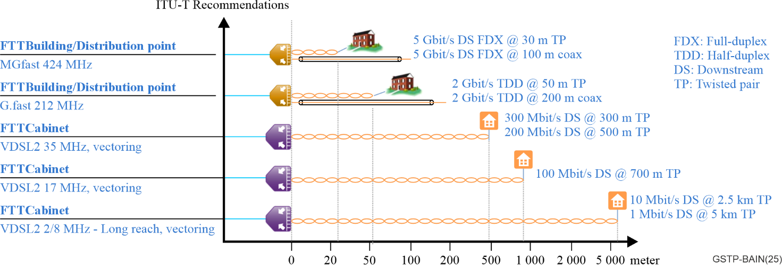
Figure 5-3 – Loop length versus data rate combinations as in use today

5.4 Roadmap of in-premises network technologies
The foundation of G.hn recommendation [ITU-T G.9960] (10/2009), Unified high-speed wire-line based home networking transceivers – Foundation) was published in 2009, enabling up to 200 MHz bandwidths with OFDM adapting to the fading channel of copper medium (twisted pair, coax & power line). This provides tens to hundreds of Mbit/s in real applications due to the various attenuations of copper. The corresponding data link layer [ITU-T G.9961] (06/2010) and multiple-input multiple-output (MIMO) specification [ITU-T G.9963] (12/2011) were then developed. The technology was considered to be extended to support step-index polymer/plastic optical fibres (POF) (within 640-660 nm wavelength) in the amendment of [ITU-T G.9960] (12/2011). An extension on coax with 2 GHz bandwidth (depends on the availability) was considered in the updated G.hn recommendation of 2020, leading to several Gbit/s in a real environment. The roadmap of the in-premises network standard in ITU-T SG15 is shown as Figure 5-4.
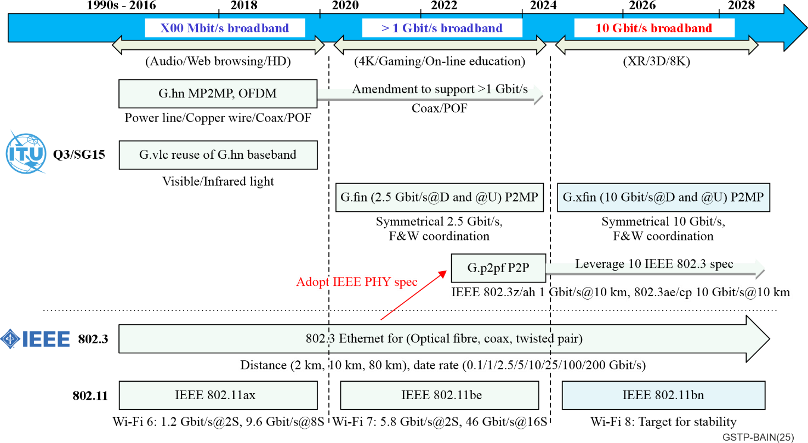
Figure 5-4 – Roadmap of the in-premises network standard in ITU-T SG15
To leverage the G.hn ecosystem, visible light communication (VLC) recommendation ([ITU-T G.9991] (03/2019)) High-speed indoor visible light communication transceiver – System architecture, physical layer and data link layer specification) was published by adopting the G.hn PHY as DC-biased orthogonal frequency division multiplexing (DCO-OFDM).
With the evolution of network service and networking requirements (such as backhauling) requiring higher throughput, a stable Gbit/s connection for each access point (AP) was achieved through silica fibre. G.fin 0 system architecture considered symmetric 2.5 Gbit/s data rate based on PtMP fibre topology, defined in [ITU-T G.9940] (2023). The corresponding PHY ([ITU-T G.9941] (2024)) and DLL ([ITU-T G.9942] (2024)) were then developed. To upgrade to a 10 Gbit/s technology, the G.xfin recommendations were started in 2024. Simultaneously, G.p2pf recommendation re-uses the Institute of Electrical and Electronics Engineers (IEEE) 802.3 recommendation for PtP fibre topology.

5.4.1 Unified medium networking technologies, i.e., G.hn
As shown in Figure 5-5, G.hn core ITU-T Recommendations include:
• [ITU-T G.9960] – System architecture and physical layer specification
• [ITU-T G.9961] – Data link layer specification
• [ITU-T G.9962] – Management specification
• [ITU-T G.9963] – Multiple input/multiple output specification
• [ITU-T G.9964] – Power spectral density specification
Multiple versions were developed to cover more wireline medium, a flexible DLL mechanism and an extended power signal density (PSD) for higher frequencies in baseband.
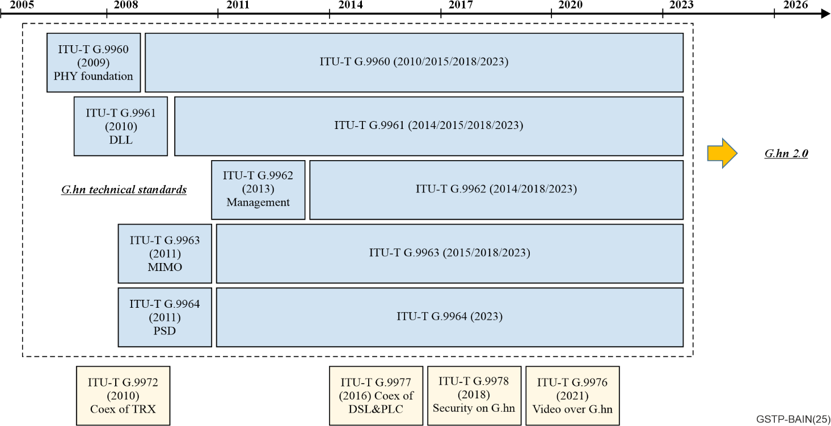
Figure 5-5 – Roadmap of G.hn standard in ITU-T SG15
G.hn additional features ITU-T Recommendations were also considered to fulfil the dedicated needs addressing coexistence between home networking transceiver ([ITU-T G.9972] – Coexistence mechanism for wireline home networking transceivers), mitigation of interference between DSL and power line communication (PLC) ([ITU-T G.9977] – Mitigation of interference between DSL and PLC), high definition video bearing over G.hn ([ITU-T G.9976] – Supporting ultra-high-definition video service over G.hn) and security enhancement ([ITU-T G.9978] – Secure admission in a G.hn network), etc.

5.4.2 Fibre-based in-premises networking
As shown in Figure 5-6, fibre in-premises (FIP) network concept was first mentioned in ITU Technical Paper (GSTP-HNAFS, Architecture, functions and services of home network, 04/2021). After that, use cases and system requirements had been studied for home and small and medium enterprise (SME) scenarios in the following Technical Paper and Supplements ([ITU-T GSTP-FTTR], Use cases and requirements of fibre-to-the-room (FTTR), [ITU-T G Suppl. 78], Use case and requirements of fibre-to-the-room for small business applications, [ITU-T G Suppl. 80], Use case and requirements of fibre-based in-premises networking for home application (FIP4H)), guiding the technical recommendation of fibre in-premises network.
The recommendations of system architecture, physical layer and data link layer based on PtMP fibre topology were then developed. Simultaneously, [IEEE 802.3] optical Ethernet specifications were considered for PtP topology. Now, the group is focusing on developing the management and control specification to achieve fibre and wireless local area network (WLAN) coordination. The projects include G.wmci and the management of G.fin.
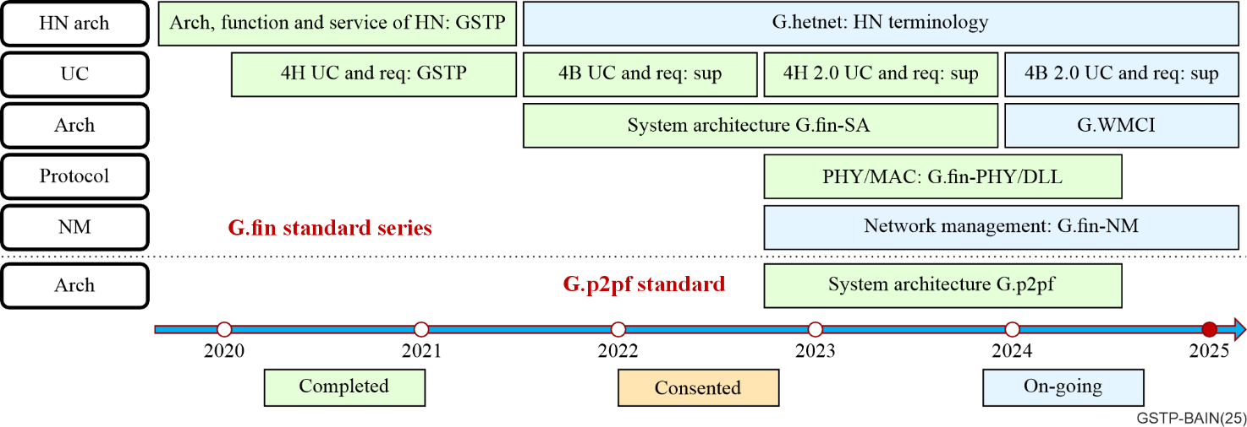
Figure 5-6 – Roadmap of the in-premises fibre network standard in ITU-T SG15

5.4.3 In-door optical wireless communication
The first standard group of in-door optical wireless communication was established as 802.15.7 TG task group in IEEE in 2009.
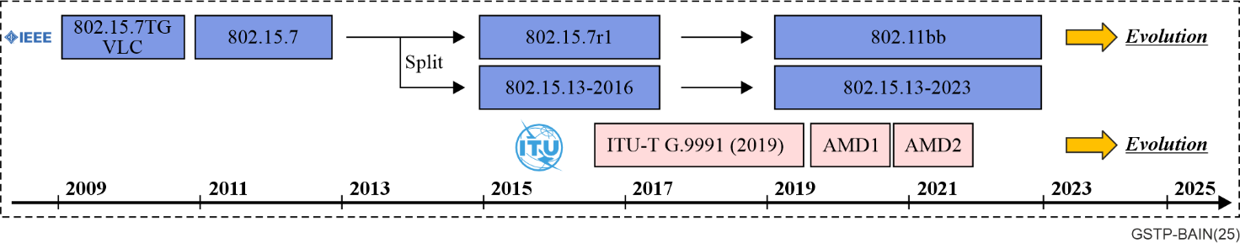
Figure 5-7 – Roadmap of the in-door optical wireless communication in ITU-T SG15
Since 2020 (see Figure 5-7), three main broadband standards for light communications have been active:
1) 802.15.13-2023 was published, theoretically covering a 2 Gbit/s data rate for a single stream with a PHY similar to the ITU-T G.hn 200 MHz coax profile.
2) 802.11bb was published in 2023 intending to reuse the Wi-Fi MAC. Additionally, 802.11a is leveraged in 802.11bb for interoperability or low speed.
3) ITU-T G.vlc recommendation, also named [ITU-T G.9991], re-uses the G.hn baseband as a DCO-OFDM scheme for achieving adapted optical wireless communication. An alternative PHY based on an AC-biased orthogonal frequency division multiplexing (ACO-OFDM) scheme is also specified.

5.5 Web-based ANT standards overview
A web-based ANT standards overview was developed to classify the existing ANT standards using inputs and published standards from ITU-T Study Group 15 and other ITU Study Groups, as well as from other standards development organizations (SDOs), forums and consortia.
The web-based ANT standards overview is part of the web-based ITU-T standards landscape – Topic/root "Access network transport standards" and is available on the ITU-T SG15 website at: https://www.itu.int/itu-t/landscape/?topic=tx356x357&group=g&search_text=.

5.6 Summary
Broadband access and in-premises network comprise solutions either for copper cables and fibre cables technologies, and also some other in-premises technologies (e.g., Wi-Fi, VLC, etc.). Broadband access and in-premises networks aim to provide people with faster and wider broadband network connections through technological advances to support increasingly diverse data services, from the initial several kbit/s telephone voice services, megabit-level Internet services, gigabit-level high-definition video services, to ultra-high-definition video, VR, cloud services, metaverse and other higher-demand services. The evolution is described in terms of the phases shown at Figure 5-8.
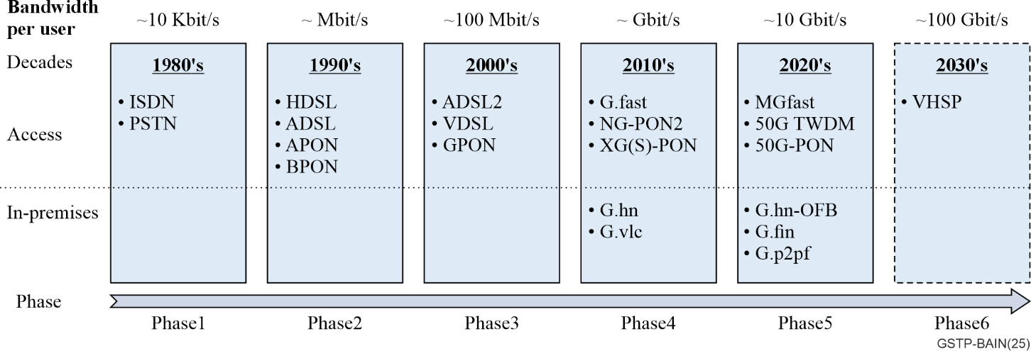
Figure 5-8 – Broadband access and in-premises network technologies evolution
Phase 1 (1980s)
The first phase of access network was PSTN and ISDN. Voice band modems are used to provide dial-up data access over the PSTN, originally intended to provide telephone voice service. Voice band modem and ISDN can provide kbit/s data service. These technologies date back to the 1980s.
Phase 2 (1990s)
In the 1990s, the DSL technology developed rapidly. The HDSL and ADSL standards were defined and widely deployed. The HDSL and ADSL standards can provide Mbit/s level broadband services to every end user. For fibre technology, in the late 1990s, APON and BPON standards were defined successively. APON and BPON were based on the ATM protocol and can provide several ten Mbit/s average bandwidth to every end user. However, due to high cost and low bandwidth efficiency, large-scale deployment has not been achieved.
Phase 3 (2000s)
In the 2000s, the second-generation ADSL supported higher downstream data rates and became more suited for the transport of content-rich web access and Internet protocol television (IPTV) services. Operating on the existing telephone wire infrastructure from the central office, in overlay with the PSTN service, contributed to its global success. In the mid-2000s, VDSL targeted residential services from a remote cabinet location, taking data rates into the few 100s of Mbit/s.
In the mid-2000s, the ITU-T G.984 recommendation series defined GPON systems with the maximum downstream capacity of 2.5 Gbit/s and the upstream capacity of 1.25Gbit/s. GPON uses a point-to-multipoint architecture and passive optical distribution devices to provide services for multiple users. Typically, it can support a split ratio of 1:64 and a fibre transmission distance of 20 km. It can generally provide users with a guaranteed bandwidth of tens of Mbit/s and a peak bandwidth of up to hundreds of Mbit/s. Since GPON technology is a new type of fibre access technology, it has the advantages of high speed, high bandwidth, high reliability, low cost, and high efficiency, making it the most widely deployed broadband access technology. So far, hundreds of millions of users have received high-speed Internet access services through GPON.
Phase 4 (2010s)
In the 2010s, with the wide deployment of fibre technologies, copper technologies started to be replaced or limited to be a fibre-extension technology, preserving the fibre-like end-user experience. G.fast provided up to 1 Gbit/s access capability over a few 100s of meters, to reach the fibre extension point located nearby the user premises or in the building basement, over copper pairs or coaxial cable.
With the rapid maturity of 10G optical devices and the continuous development of broadband service needs, ITU-T defined the XG-PON and XGS-PON recommendations for asymmetric/symmetric PON systems based on a single wavelength of 10 Gbit/s, and the 40G TWDM-PON recommendations for a multi-channel hybrid 10 Gbit/s time-division and wavelength-division system. XG(S)-PON and 40G TWDM-PON are both compatible with the ODN of the previous GPON network. The operators can keep the original GPON users unchanged, and smoothly upgrade to a higher-speed 10 Gbit/s PON system through a wavelength division method. Both XG(S)-PON and 40G TWDM-PON can provide Gbit/s level service to the end users.
For in-premises networks, the foundation of ITU-T G.hn recommendations (G.996x series) had been completed in the 2010s, enabling throughput exceeding 1 Gbit/s over wireline connections (including twisted pair, coax, and power line) for supporting Wi-Fi backhauling. The protocol was further adopted for visible light communication recommendations (G.999x series) by using the channel adaptive modulation of G.hn technology.
Phase 5 (2020s)
The most recent and last copper technology MGfast increased data rates further to multi Gbit/s with PtMP multiple access from the fibre extension point, mainly targeting coaxial cable and implementing access and home network convergence in FTTB scenarios.
In the late 2010s, due to the rapidly growing maturity of 25 Gbit/s and 50 Gbit/s optical components and the development of digital signal processor (DSP) technology, 50 Gbit/s per wavelength technology began to support applications in the PON field. In the early years of the 2020s, the ITU-T published the 50G-PON recommendation [ITU-T G.9804.3], which can support 50 Gbit/s in downstream and several line rates up to 50 Gbit/s in upstream. 50G-PON can support triple generation coexistence with both GPON and XG(S)-PON based on the upstream wavelength option 3, which can enable operators to evolve to 50G-PON with existing GPON and XG(S)-PON users untouched. 50G-PON can provide 10 Gbit/s level service to the end users. Multiple channel 50 Gbit/s TWDM-PON recommendation has also been launched but is still under study.
To match the increased throughput of the access network up to 10 Gbit/s level, the fibre in-premises network is the ideal candidate based on fibre deployment. ITU-T recommendations G.994x series defined a fibre in-premises system based on PtMP fibre topology, providing a symmetric data rate for both north-to-south and east-to-west streaming. 2.5 Gbit/s was first developed, and 10 Gbit/s generation is under consideration. Based on the optical link, fibre and wireless controlling mechanisms ([ITU-T G.9949]) are studied to provide coordinated Wi-Fi transmission via a fibre link. In addition, to leverage the optical Ethernet technologies, [ITU-T G.9930] describes the system architecture and application scenario based on the PtP fibre link. The extended operation frequency band up to 2 GHz for G.hn enables higher throughput wireline solutions up to 10 Gbit/s.
Phase 6 (2030s)
After the second version of [ITU-T G.9804.3] 50G-PON recommendation was released, ITU-T SG15 Q2 launched the Supplement G.sup.VHSP to study the system requirements and characteristics of optical transmission above 50 Gbit/s per wavelength, and sensing considerations for the PON system. The VHSP systems are expected as the next generation following the 50 Gbit/s PON systems (50G-PON and 50G TWDM-PON) and targeted for market application after the year 2030.
A higher throughput of over 10 Gbit/ via fibre link can be achieved based on the current short distance optical communication by both IMDD or coherent technologies. Moreover, Wi-Fi fronthauling technologies based on fibre link are also discussed in ITU-T SG15 Q3. This brings benefits to facilitate a new advanced architecture based on splitting the Wi-Fi baseband.

6 Technology dictionary

6.1 Optical access system for fibre access networks

6.1.1 Gigabit-capable passive optical networks (GPON)
Over time, several generations of PON systems have been developed. Early work included systems based on 50 Mbit/s [ITU-T G.982], 155 Mbit/s and 622 Mbit/s ITU-T G.983 series transmission. The first system to achieve truly worldwide acceptance was gigabit PON(GPON), which is a single wavelength pair system with 2.5 Gbit/s in downstream and 1.25 Gbit/s in upstream. The system architecture of GPON is shown in Figure 6-1.
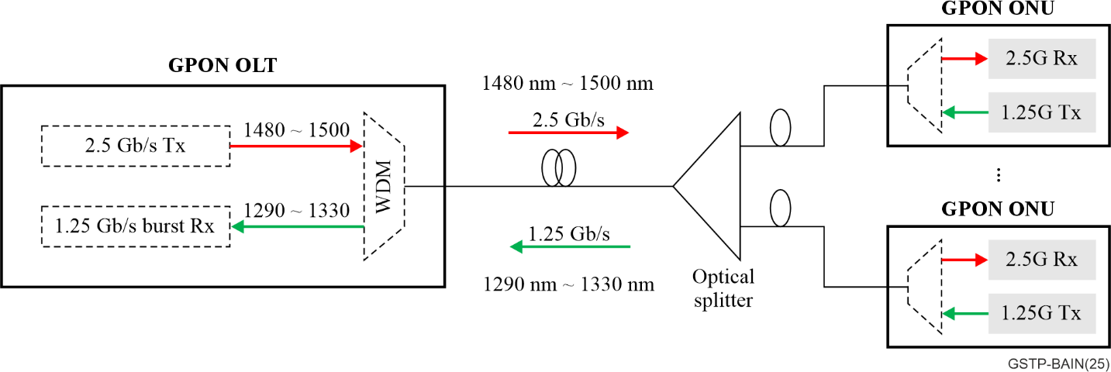
Figure 6-1 – GPON system architecture
GPON recommendations are defined in the ITU-T G.984 series, which is diagrammed in Figure 6-2. The red callout numbers are discussed in the text below.
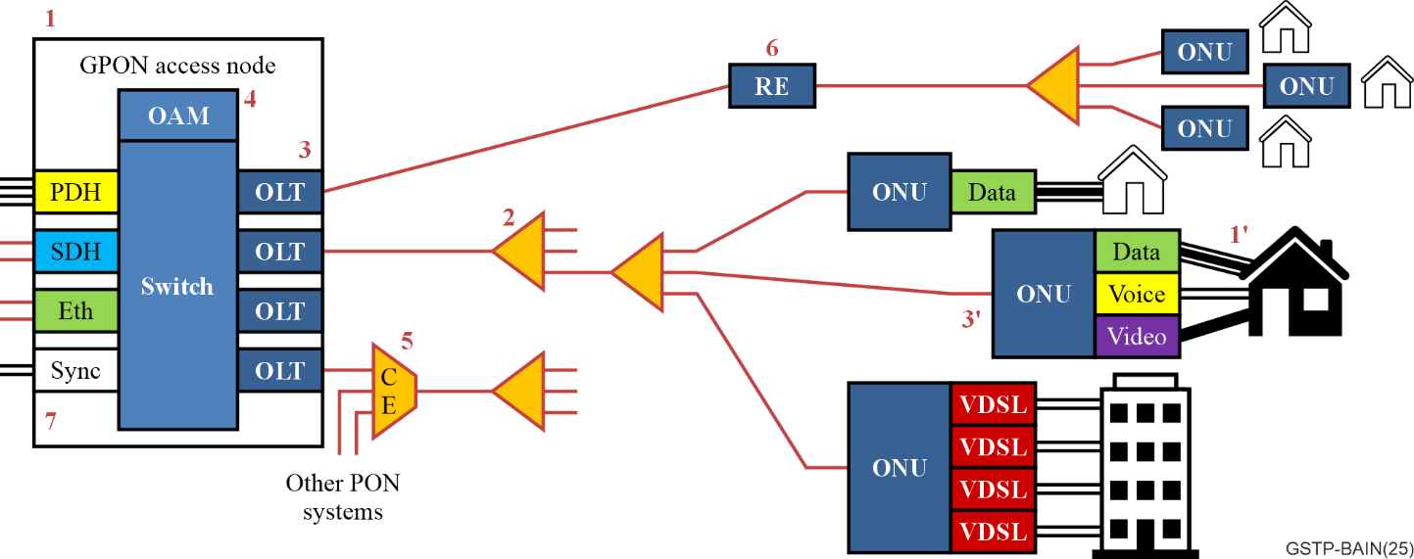
Figure 6-2 – The Gigabit-capable PON standard series diagram
1) The system's general characteristics are described in [ITU-T G.984.1], which provides examples of services, user network interfaces (UNIs) and service node interfaces (SNIs) that are required by network operators. In addition, it shows the principal deployment configuration. [ITU-T G.982] and ITU-T G.983.x series characteristics are reused when possible. The G-PON system is a full-service access network, and the extreme diversity of optical network unit (ONU) types and form factors is a key part of this. The simplest ONU would have a single data UNI. More elaborate ONUs can have multiple UNIs for the range of services consumed by a single user or multiple users.
2) Physical media dependent (PMD) layer specification is given in [ITU-T G.984.2]. This covers systems with nominal line rates of 2 488.32 Mbit/s downstream and 1 244.16 Mbit/s upstream. The PMD is designed to operate bidirectionally over a single strand of single mode optical fibre ([ITU-T G.652]). The downstream wavelength is 1 490 nm, and the upstream wavelength is 1 310 nm.
3) The transmission convergence (TC) layer specification in [ITU-T G.984.3] provides the system's frame format and media access control (MAC) method, including dynamic bandwidth allocation (DBA). It describes the ranging and activation processes, and the physical layer management (physical layer operation administration and maintenance - PLOAM) functionality that supports them. Security and authentication are also described. The detailed behaviour of the ONU is specified, enabling ONU conformance testing. This makes the interoperability of different vendor's ONUs on a single PON possible.
4) The ONU management and control interface (OMCI) specification is defined in [ITU-T G.988]. This defines the managed entities of a protocol independent management information base (MIB) that models the exchange of information between the OLT and ONUs, not only for G-PON, but all PON systems standardized after G-PON. The MIB describes the range of UNIs that ONUs may support.
5) Network upgrade considerations are given in [ITU-T G.984.5], reserving wavelength ranges for additional service signals to be overlaid via WDM in GPONs, to maximize the value of ODNs. [ITU-T G.9805] generically describes the methods and parameters for PON coexistence for ODN sharing.
6) Reach extension is outlined in [ITU-T G.984.6], giving the architecture and interface parameters for extended reach systems using reach extension devices, including regenerators or optical amplifiers. The reach is up to 60 km, with loss budgets of 27.5 dB in both spans.
7) Synchronization and timing have long been supported as part of the G-PON system. More recent amendments to [ITU-T G.984.3] and [ITU-T G.988] have included methods for transferring precision timing information over the PON system, avoiding the inherent TDMA timing asymmetry.

6.1.2 10-Gigabit-capable passive optical networks (XG(S)-PON)
The next generation of systems are 10-Gigabit-capable passive optical networks, which are based on 10 Gbit/s single wavelength pair technology. There are two systems: 10 Gbit/s asymmetric system (XG-PON) and a 10 Gbit/s symmetric system (XGS-PON). The architecture of XG(S)-PON is shown in Figure 6-3.
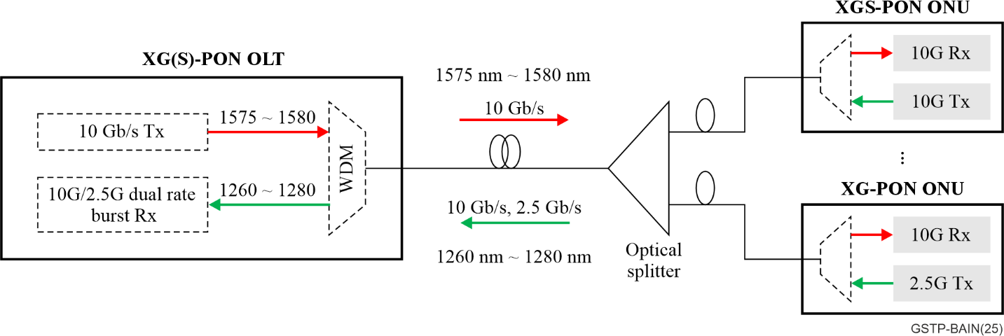
Figure 6-3 – XG(S)-PON system architecture
XG-PON is based on 2.5 Gbit/s in upstream, and XGS-PON is based on 10 Gbit/s in upstream. An XGS-PON OLT can also support XG-PON ONU by a 10G/2.5G dual rate burst mode receiver in the OLT.
XG-PON recommendations are defined in [ITU-T G.987] (e.g., [ITU-T G.987.1], [ITU-T G.987.2], [ITU-T G.987.3]), and all XGS-PON Recommendations are defined in one document [ITU-T G.9807.1]. The Recommendations diagram of XG(S)-PON is shown in Figure 6-4.
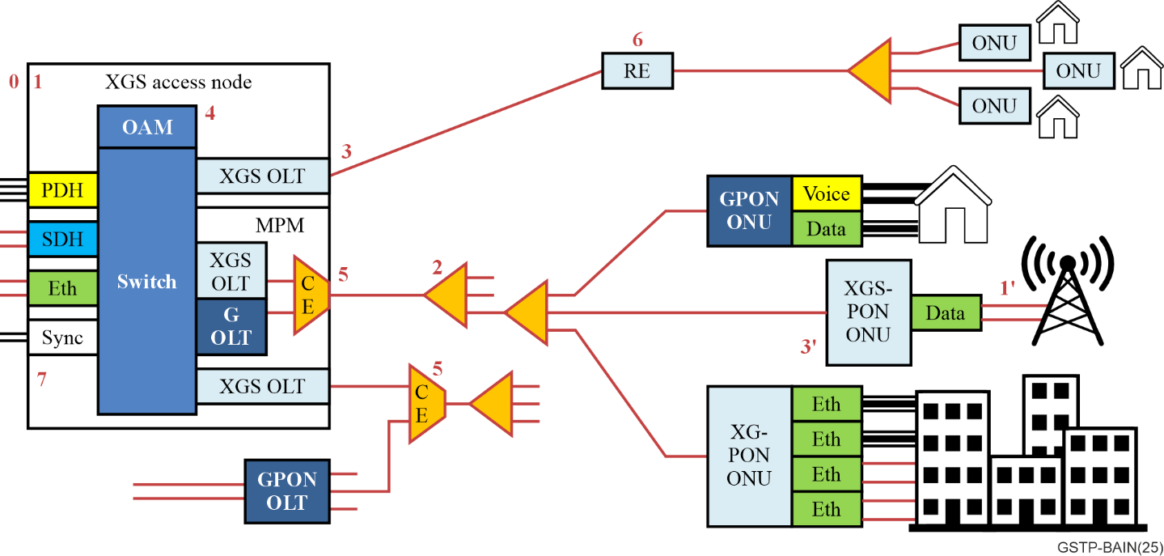
Figure 6-4 – 10 Gbit/s capable (XG) and 10 Gbit/s Symmetric (XGS)
PON recommendation series
0) The definitions, acronyms, and conventions for these systems are defined in [ITU-T G.987] and [ITU-T G.9807.1], clauses 3-5. This establishes the terminology for these systems and delineates their topologies.
1) The general requirements of XG-PON and XGS-PON are described in [ITU-T G.987.1] and [ITU-T G.9807.1] Annex A. This once more provides examples of services, UNIs and SNIs that are required by network operators. In addition, it shows the principal deployment configuration. The most important requirement is the backward compatibility with the existing ODN. As a full-service access network, ONU interface diversity continues to be important. The higher capacity of XG(S)-PON opens new possibilities, such as 4G cell sites and various enterprises. Existing G-PON ONUs can remain in service alongside the XG(S)-PON ONUs, allowing for easier system upgrades.
2) The requirements and specifications for the PMD layer are defined in [ITU-T G.987.2] and [ITU-T G.9807.1] Annex B. Both XG and XGS systems operate at 10 Gbit/s downstream, and upstream at 2.5 and 10 Gbit/s, respectively. The PMD is designed to operate bidirectionally over a single strand of single mode optical fibre [ITU-T G.652]. The basic wavelength plan specifies 1 577 nm downstream and 1 270 nm upstream, which allows coexistence with G-PON and NG-PON2, and time division multiplex (TDM) coexistence between XG-PON and XGS-PON ONUs. The optional wavelength plan specifies 1490 nm downstream and 1 310 nm upstream.
3) The TC layer specifications are given in [ITU-T G.987.3] and [ITU-T G.9807.1] Annex C. As before, the frame format and media access control methods are given, which are largely based upon the G-PON system with field size adjustments for 10G operation. It describes the ranging and activation processes, DBA, and PLOAM. Security, power saving, protection, and rogue mitigation are described. As before, the behaviour of the ONU is specified in detail, allowing for ONU conformance testing.
4) The OMCI is specified in [ITU-T G.988], which is described in clause 6.1.7 of this Recommendation.
5) Coexistence is specified in [ITU-T G.9805], which is described in clause 6.1.7. of this Recommendation.
6) Reach extension is specified in [ITU-T G.987.4] and ITU-T G.9807.2]. In addition to all the features in [ITU-T G.984.6], wavelength converting, continuous mode, 1:N and combination systems are described.
7) Synchronization and timing are supported as part of the XGS-PON system. [ITU-T G.9807.1] Annex C describes methods for transferring precision timing information over the PON system. This is important for various wireless applications.

6.1.3 40-Gigabit-capable passive optical networks (NG-PON2)
Alongside the development of the single channel 10 Gbit/s systems, there was interest in reaching higher capacity multi-channel systems based on wavelength stacking of TDM-PON. This results in the time and wavelength division multiplexed (TWDM) PON architecture, as shown in Figure 6-5.
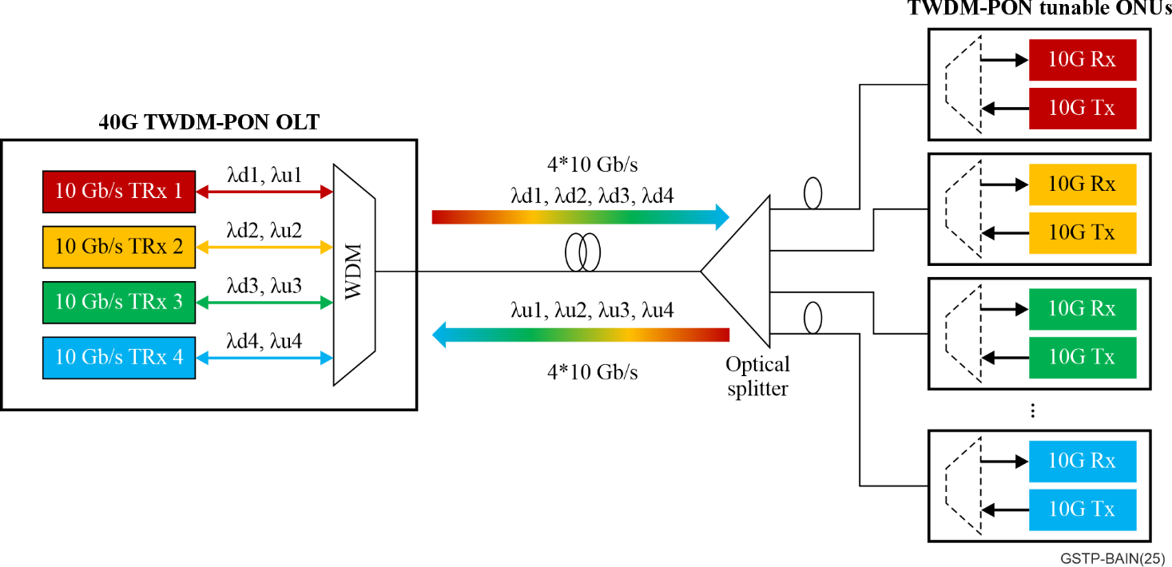
Figure 6-5 – 40 Gbit/s TWDM-PON system architecture
The 40 Gbit/s TWDM-PON recommendations are mainly defined in ITU-T G.989 series; the recommendation diagram is shown as Figure 6-6.
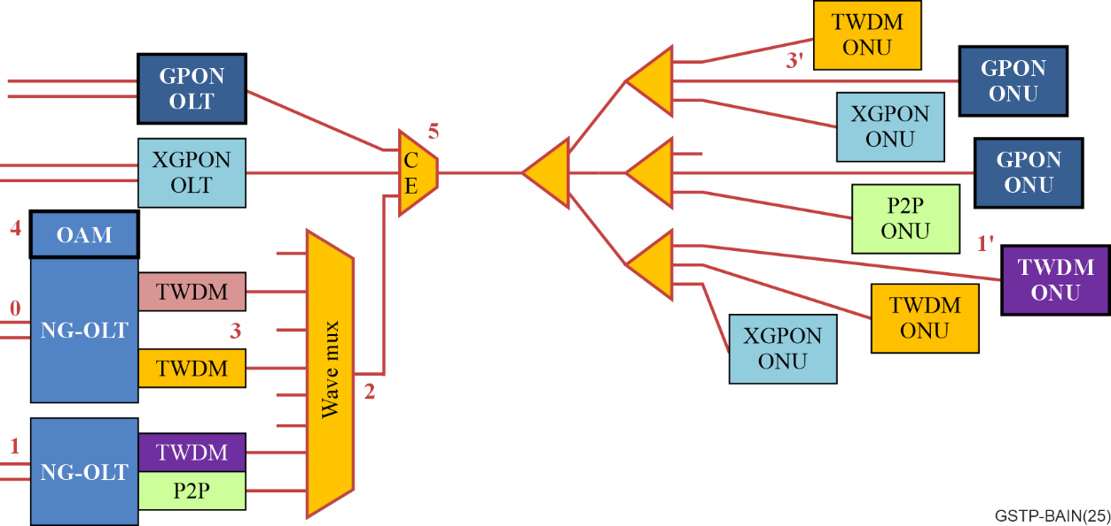
Figure 6-6 – 4 x10 Gbit/s TWDM-PON (NG-PON2) recommendations diagram
0) The definitions, abbreviations, and conventions are given in [ITU-T G.989]. This establishes the common terminology used in the NG-PON2 system.
1) The general requirements are given in [ITU-T G.989.1]. This provides examples of services, UNIs, and SNIs that are required. In addition, it shows the principal deployment configuration. Wherever possible, this Recommendation maintains characteristics from the [ITU-T G.987] and G.9807-series of Recommendations. The NG-PON2 system contains both a TWDM capability as well as a PtP capability. Several OLT styles are supported (single chassis, multi-chassis, integrated multichannel line cards, and pay-as-you-grow pluggable line cards). As always, NG-PON2 is a full-service access network, and a key part of that is the extreme diversity of ONUs coexisting on a common PON. G-PON and XG(S)-PON legacy ONUs are supported, as well as TWDM ONUs (with tunable burst mode optics) and PtP ONUs (with tunable continuous mode optics). Each of those ONU types can then support many different UNIs, making NG-PON2 the "Swiss army knife" of PONs.
2) The PMD layer specifications are given in [ITU-T G.989.2]. This covers systems with nominal line rates of 10 Gbit/s in the downstream direction and either 10 Gbit/s or 2.5 Gbit/s in the upstream direction, as well as other rates. The PMD is designed to operate bidirectionally over a single strand of single mode optical fibre [ITU-T G.652]. The TWDM-PON downstream wavelengths are in the L-band and the upstream wavelengths are in the C-band. The PtP wavelengths are entirely in the L-band. A channel grid is defined in these bands, which is physically realized in the wavelength multiplexer (WM) device. The ODN is composed of fibres and passive optical splitters and connectors. NG-PON2 can also be extended to support 8 channels with a maximal 80 Gbit/s system capacity (8 × 10 Gbit/s).
3) The TC layer specification is given in ITU-T G.989.3. This defines the frame format and media access control method, and all the usual functions that have been described in previous PON generations. New additions here are the many new PLOAM messages to handle the set-up and operation (e.g., tuning) of the multi-channel system. Support for multiple TWDM-PON OLTs sharing the same ODN is described, as well as new forms of wavelength protection. As with previous systems, detailed ONU behaviour is described, enabling conformance testing that promotes multi-vendor ONU interoperability.
4) The OMCI is specified in [ITU-T G.988], which is described in clause 6.1.7 of this Technical Paper.
5) Coexistence is specified in [ITU-T G.9805], which is described in clause 6.1.7 of this Technical Paper.

6.1.4 50-Gigabit-capable passive optical networks (50G-PON) and HSP-PON
Given the advances of technology, higher speed PONs (HSP) came into focus, which can support 50 Gbit/s transmission over a single pair of wavelengths. The first ITU-T higher speed PON system is 50G-PON, illustrated in Figure 6-7.
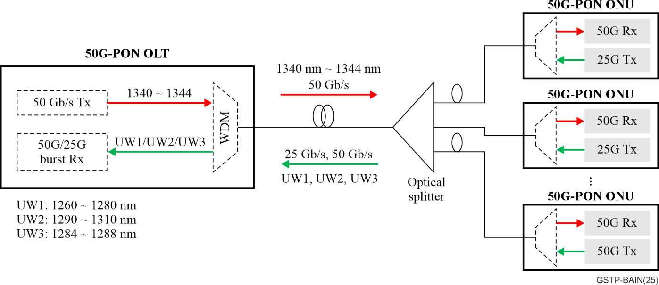
Figure 6-7 – 50G-PON system architecture
50G-PON recommendations are defined in ITU-T G.9804 series. Figure 6-8 shows the higher speed PON recommendations diagram.
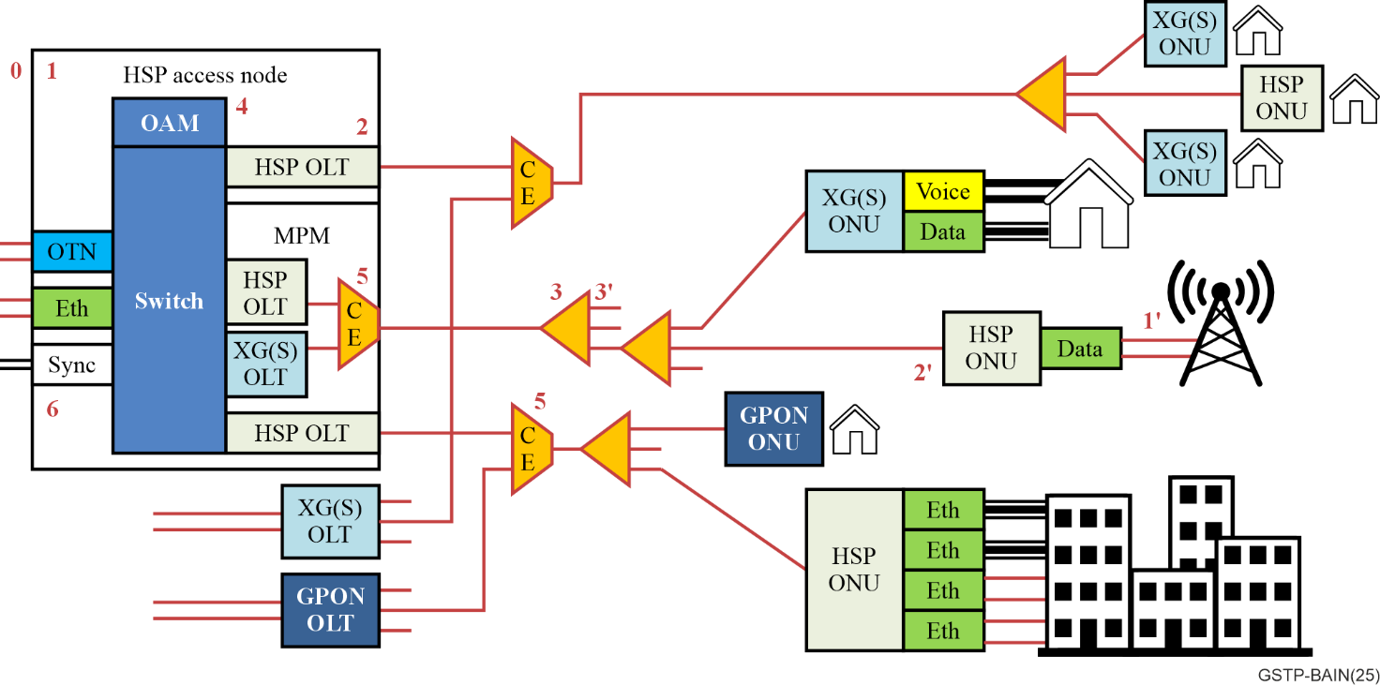
Figure 6-8 – Higher speed PON recommendations diagram
0) The definitions, acronyms, and conventions are defined in [ITU-T G.9804.1] clauses 3-5. As always, this establishes the terminology to be used in this series.
1) The system requirements are given in [ITU-T G.9804.1], giving examples of services, UNIs, and SNIs that are required by network operators. The increasingly complex deployment configurations are illustrated. Once more, the most important requirement is the backward compatibility with existing optical distribution networks (ODNs) that comply with G.984.x, G.98(0)7.x and G.989.x series. The HSP system is a full-service access network supporting a diverse set of ONU types and form factors. In addition to all the existing applications, the higher capacity of HSP opens new possibilities. Examples of these are serving diverse 5G cell sites and various enterprises. Existing G/XG(S)-PON ONUs can remain in service alongside the HSP ONUs, allowing for easier upgrades.
2) The common TC layer specifications are given in [ITU-T G.9804.2]. The HSP frame format and media access control method, which are based upon those of XG(S)-PON and NG-PON2. The protocol units and information exchange between the OLT and ONUs are generalized to be future proof. It includes all the usual features from previous PON systems. Major improvements include a better forward error correction (FEC) capability as well as enhanced security features. As always, ONU conformance and interoperability is a key objective of these specifications. There are conformance and interoperability testing programs organized by the Broadband forum (BBF).
3) The PMD layer specifications for 50 Gbit/s single channel HSP are given in [ITU-T G.9804.3]. This covers systems with nominal line rates of 50 Gbit/s in the downstream, and the upstream line rate options are 50 Gbit/s, 25 Gbit/s. The PMD is designed to operate bidirectionally over a single strand of single mode optical fibre [ITU-T G.652]. The wavelength plan specifies the downstream wavelength at 1342 nm, and upstream wavelengths as option 1 (1 260 ~ 1 280 nm), option 2 (1 300 nm), and option 3 (1 286 nm). Option 1 or option 2 allows wavelength division multiplex (WDM) double coexistence with G-PON or XG(S)-PON, respectively, while option 3 enables triple coexistence.
4) The OMCI is specified in [ITU-T G.988], which is described in clause 6.1.7. of this Recommendation.
5) Coexistence is specified in [ITU-T G.9805], which is described in clause 6.1.7. of this Recommendation.
It should be noted that a multi-channel version of this system will also be defined, which is 50 Gbit/s TWDM-PON. The PMD layer of the 50 Gbit/s TWDM-PON will be described in a future ITU-T Recommendation. The architecture of this multi-channel higher speed PON system is expected to be similar to Figure 6-6. The main difference is that the line rate per channel will be 50 Gbit/s. This document remains was under study at the time of publication.

6.1.5 Point to multipoint passive optical access system above 50 Gbit/s per wavelength
In order to support the continued development of optical access networks, ITU-T SG15 Q2 started a new supplement G.sup.VHSP in September 2022 to study the very high speed PON(VHSP) technologies. This Supplement is expected to describe the system requirements and characteristics of optical transmission above 50 Gbit/s per wavelength between the optical line termination (OLT) and the optical network unit (ONU).
– System requirements for VHSP, and candidate VHSP technologies.
– PON ODN sensing use case and candidate sensing technologies.
This project is still under study. VHSP is expected to be the next optical access system after higher speed PON (e.g., 50G-PON and 50G TWDM-PON).

6.1.6 High speed point to point systems
While splitter based PON systems have remained the workhorse of the optical access industry, there are some applications that require higher capacities or better quality of service than PON can provide. These may be served using PtP fibre access systems. These are described in [ITU-T G.986] and [ITU-T G.9806], and are illustrated in Figure 6-9.
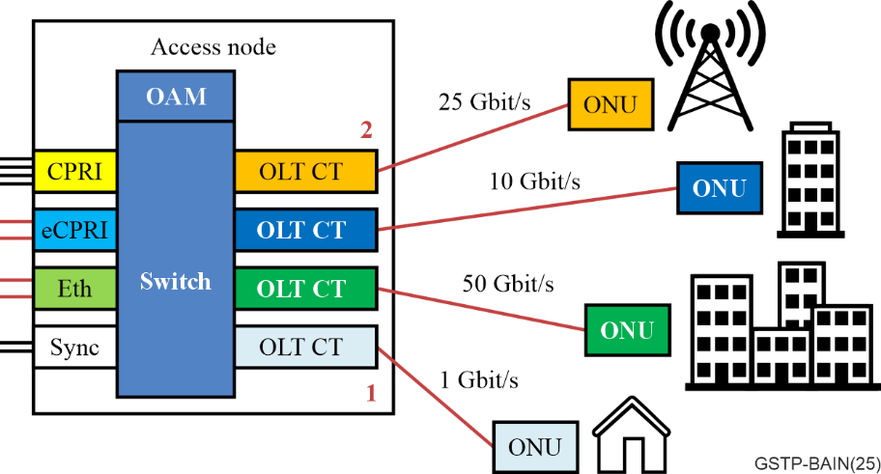
Figure 6-9 – Point to point bidirectional optical access systems
Over time, the speed of PtP optical access has increased. The first system operated at 100 Mbit/s and was described in [ITU-T G.985].
1) The 1 Gbit/s point-to-point Ethernet based optical access system is described in [ITU-T G.986]. This describes the full stack of specifications and protocols for Ethernet-based fibre access. The ODN for this system is a single strand of [ITU-T G.652] or [ITU-T G.657] optical fibre, loss budgets of 0 to 15 dB, 5 to 20 dB, and 10 to 25 dB are defined as classes S, A, and B; respectively. Multiple wavelengths are used to achieve bidirectional transmission. The physical layer specification defines the wavelengths of operation to be 1 490 nm downstream and 1 310 nm upstream. In addition, the operation, administration and maintenance (OAM) functions are specified. These allow the network operator to perform some level of supervision of the access system without impacting the user's services.
2) The higher-speed bidirectional, single fibre, point-to-point optical access systems (HS-PtP) are described in [ITU-T G.9806]. The initial publication of this supported 10 Gbit/s, operating at wavelengths of 1 330 nm downstream and 1 270 nm upstream. Amendment 1 added 25 Gbit/s and Amendment 2 added 50 Gbit/s, both operating at 1 314 nm down and 1 289 nm up. Amendment 3 added 100 Gbit/s, operating at 1309 nm down and 1 305 nm up. All of these operate over a similar ODN as the predecessor system. New classes are defined, such as class S_{Lower} (0 to 10 dB), S_{Upper} (5 to 15 dB), B_{Lower} (10 to 20 dB), and B- (10 to 23 dB).
Once again, the embedded OAM features are described to enable operators to better control and manage their access network. In addition, a silent start feature is defined that prevents PtP ONUs from transmitting unless they first receive a valid signal from the network. This prevents inadvertent rogue operation on PONs. A PtP ID field is added to the protocol to assist in field operations and fibre identification. Power saving aspects such as automatic rate adjustment are also covered.
In addition, the optical specification in [ITU-T G.9806] are nearly identical to those from [IEEE 802.3]. This enables the industry to make one set of products to serve both markets, which should reduce the cost and operational complexity.

6.1.7 Optical access common aspects
As all these systems have been developed, several aspects have been identified. These have led to the development of several generic documents that address these aspects independently from the underlying systems. The following list gives a brief summary of each.
• ITU-T G.988 ONU management and control interface
This describes everything about how an OLT equipment can manage its subtending ONUs. An important feature of the OMCI is that the OLT acts as a proxy for all its ONUs. In this way, the element management system only needs to manage one OLT rather than 4000 ONUs. This greatly improves scalability. The basic connectivity of the OMCI is a one-to-one connection between each ONU and its representation in the OLT. The OLT maintains a copy of each ONU's MIB, and one of the tasks of the OMCI is to synchronize the MIBs. Because the OLT has this MIB, an ONU can be pre-provisioned even before it is attached to the PON or equipped with new line-cards. This expedites deployment.
• ITU-T G.9805 Coexistence of PON systems
Building on the fact that the PON generations use separate wavelength plans, this describes two methods of coexistence using either an external coexistence element (CEx) or a multi-PON module (MPM) to interconnect multiple PON generations on a common ODN. This enables the reuse of deployed fibre and splitters so that operator networks can evolve to higher capacity. The optical specifications of the CEx are given for a range of deployment scenarios.
Especially when upgrading using an OLT MPM, no external coexistence element is necessary at the OLT side, since its function has been integrated inside the OLT optical module for each PON port. Hence, no extra space or associated engineering operation are required to achieve coexistence. This upgrade method is very convenient for operators and is preferred by operators around the world. It has now become the mainstream method for upgrading GPON to XG(S)-PON. Figure 6-10 shows the architecture diagram of multi-generation PON coexistence through MPM in the OLT.
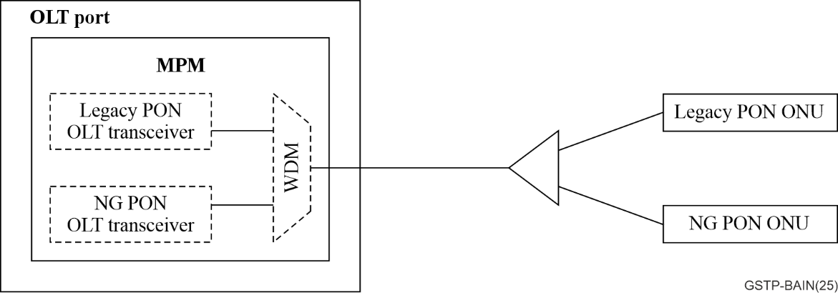
Figure 6-10 – Architecture diagram of multi-generation PON coexistence through MPM
• [ITU-T G Suppl. 79] Latency control and deterministic capability over a PON system
This describes the latency control and deterministic capability of passive optical network (PON) systems. It reviews feasible technologies of latency control and optimization technologies over a PON and discusses possible future expansion on a PON system, including use cases and requirements, technologies for latency control and deterministic improvement, and possible extensions in the future.
• [ITU-T G Suppl. 45] Optical access system power conservation
This considers how to save power consumption in the optical access system, during both regular operation (reducing basic load) and during power failures (extending battery life). Various methods are described. The most extreme is ONU deep sleep, where all power is turned off until the user reactivates. Power shedding is where the ONU turns off some of the lower priority UNIs. Cyclic sleep is a process where the ONU deactivates parts of its PON interface periodically to save power. There are also possibilities of switching to the lowest data rate suitable for the offered load.
• [ITU-T G Suppl. 49] Rogue ONU considerations
This provides additional guidelines relative to the applicable existing passive optical network (PON) systems, addressing the issue of rogue optical network units (ONUs), their prevention, detection, isolation and mitigation. ONUs can emit light inappropriately in several ways, either by sending a normally formed burst at the incorrect time, or by transmitting continuously. This Supplement raises awareness of rogue condition causes and prevention, rogue ONU detection, rogue ONU isolation, identification, and mitigation.
• [ITU-T G Suppl. 66] 5G wireless fronthaul in a PON context
This describes the interconnection of wireless central unit (CU), distributed unit (DU), and radio unit (RU) equipment using PON technology. Four use case scenarios are analysed: a) CU to DU PON; b) DU to RU PON; c) cascaded PONs; and d) parallel PONs. This also examines the different functional splits, including the F1 (high-layer split) is defined by the 3rd Generation Partnership Project (3GPP) and the Fx (low-layer split). Transport requirements for many scenarios are estimated.
• [ITU-T G Suppl. 71] Cooperative DBA
This considers the problem of efficiently carrying burst low latency traffic over a PON efficiently. This is relevant in the transport of wireless fronthaul traffic over TDMA-PONs. Normal DBA cannot respond fast enough, so the cooperative DBA works by having the wireless system given the OLT signalling messages that allow it to send pre-emptive bandwidth allocations. In this way, the arriving wireless upstream traffic has the necessary timeslots without waiting.
• [ITU-T G Suppl. 74] Network slicing in a PON
This considers the concept of network slicing where network resources are divided into virtual groupings (slices), and how it would apply to PON networks. Slicing can be applied to OLT or ONU equipment, creating virtual OLTs or ONUs. It is also applied to the PON itself, allowing the creation of virtual PONs, each with its own service and management system.
• [ITU-T G Suppl. 75] 5G wireless backhaul over TDM-PON
This enumerates the various requirements arising from IMT-2020/5G small cell systems, concentrating on the backhaul and radio access point (RAP) midhaul portions of the network. Small cell (SC) scenarios and related requirements are suggested as guidance. These are compared with the capabilities of the current and future time-division multiplexing-passive optical network.
• [ITU-T G Suppl. 82] Enhanced optical line termination with IT functions
This describes the enhanced optical line termination (eOLT) with information technology (IT) capabilities, such as computation and storage. It also describes the emerging application scenarios and use cases such as intelligent energy saving, intelligent Wi-Fi coordination, and app flow application connection, together with the eOLT architectures. The architecture of eOLT enhanced in terms of awareness, computation, connection, storage, and control under the conception of a fixed access network intelligent engine (FIE), which would introduce intelligence into the device-level functions. Additionally, the Supplement also considers the requirements for eOLT equipment with enhanced IT capabilities. These improvements aim to meet the architectural demands of the intelligent era.

6.2 Broadband access over metallic conductors

6.2.1 HDSL and SHDSL (ITU-T G.991.x series – 1998 to 2005)
This first series of Recommendations on DSL targeted business services. They are characterized by a single carrier baseband system using the same frequencies in upstream and downstream directions. They provide symmetric services with very low latency.
High bit rate digital subscriber line (HDSL) targeted efficient provisioning of bit synchronous services, e.g., 1.544 Mbit/s and 2.048 Mbit/s on twisted wire-pairs. Single-pair high-speed digital subscriber line (SHDSL) targeted duplex operation over mixed gauge two-wire twisted metallic pairs, with multi-pair operation and signal regenerators for extended reach applications. SHDSL transceivers are capable of supporting selected symmetric data rates in the range of 192 kbit/s to 2312 kbit/s using a trellis coded pulse amplitude modulation (TCPAM) line code, with extensions allowing data rates up to 5 696 kbit/s.

6.2.2 ADSL (ITU-T G.992.x series – 1999 to 2010)
This second series of Recommendations targeted residential services from the central office. The first ADSL supported 6.144 Mbit/s downstream and 640 kbit/s upstream data rate, using higher frequencies than the PSTN signals, up to 1.1 MHz. ADSL2plus is the extended bandwidth version of the second generation of ADSL (ADSL2). ADSL2plus supports a data rate of 16 Mbit/s downstream (instead of 8 Mbit/s downstream in ADSL2) and 800 kbit/s upstream. The support of higher downstream data rates made ADSL2plus more suited for the transport of (multi-channel) IPTV services.
The ADSL technology relies on multi-carrier modulation, frequency division duplexing (FDD), forward error correction (trellis and reed-solomon coding) and interleaving for (impulse) noise protection.

6.2.3 VDSL (ITU-T G.993.x series – 2006 to 2019)
This third series of Recommendations targeted residential services from a remote cabinet location and specified a broadband access technology that supports transmission at an aggregate data rate (the sum of upstream and downstream rates) from 50 to 400 Mbit/s, depending on the profile used. Profiles have been defined as:
• Profile 8 uses spectrum up to 8 MHz for an aggregate net data rate of up to 50 Mbit/s.
• Profile 12 uses spectrum up to 12 MHz for an aggregate net data rate of up to 70 Mbit/s.
• Profile 17 uses spectrum up to 17 MHz for an aggregate net data rate of up to 100 Mbit/s.
• Profile 30 uses spectrum up to 30 MHz for an aggregate net data rate of up to 200 Mbit/s.
• Profile 35 uses spectrum up to 35 MHz for an aggregate net data rate of up to 400 Mbit/s.
The VDSL technology relies on multi-carrier modulation, frequency division duplexing, forward error correction (trellis and Reed-Solomon coding) and interleaving for (impulse) noise protection, vectoring for noise cancellation, and upstream power back-off to facilitate subscriber modems at very different distances from the DSLAM.

6.2.4 G.fast (ITU-T G.9701 – 2019 to 2022)
This Recommendation specifies a broadband access technology that supports transmission at an aggregate data rate (the sum of upstream and downstream rates) up to approximately 2 Gbit/s. The main characteristics of the G.fast technology are listed below.

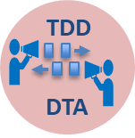 | • Half-duplex (Time-division-duplexing)  • Easy service rate split down/up  • Dynamic based on instant traffic needs  • Independent / coordinated
 | • Impulse noise protection  • Data retransmission  • Repetitive and isolated signal erasures
 | • End user self-installation  • Deployment made easier (no truck-roll)  • VoIP replacing POTS on access wiring  • Operate in the presence of bridged taps
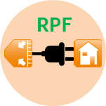 | • Reverse power feeding (power DPU from the CPE/premises)  • Defined for point-to-point operation  • Addressed in collaboration with ETSI ATTM
 | • Spectrum notching for electromagnetic immunity  • Narrowband radio interference  • ITU-R defined bands for restricted emission
 | • Noise cancellation (Far-end crosstalk)  • Pre/post-compensate useful signal with predicted noise  • Receiver sees "noise-free" signal  • Higher channel capacity due to lower noise level
 | • Frequency and time synchronization  • Some apps/deployments need precise network timing  • Deliver "wallclock" at user side with ~10s of nanoseconds precision to network-wide time

6.2.5 MGfast (ITU-T G.9711 – 2021 to 2022)
This Recommendation specifies a broadband access technology that supports transmission at an aggregate data rate (the sum of upstream and downstream rates) up to approximately 8 Gbit/s (for full duplex (FDX) mode) and 4 Gbit/s (for time division duplexing (TDD) mode). MGfast inherits the main characteristics of fast access to subscriber terminals (G.fast) and adds more as listed below.

 | • Up to 5 Gbit/s operation per direction  • Maximize the reach and coverage of a 'universal' 1 Gbit/s symmetric service  • Co-existence with G.fast
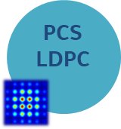 | • Low density parity check (LDPC) coding  • Probabilistic constellation shaping  • Gap-to-capacity of < 2dB  • 5-10% data rate increase
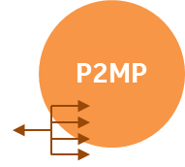 | • Point-to-multipoint operation over twisted pair or coax  • DPU resource sharing over multiple CPE  • Flexible bandwidth reassignment – each CPE uses part of the spectrum  • CPE authentication with [IEEE 802.1X]
 | • Support for full-duplex (FDX) on twisted pair and coax; nearly doubles the data rate capacity on coax.  • Simultaneous downstream and upstream transmission also requires vectoring to cancel near-end crosstalk  • Data rate increase and RTT latency decrease
 | • Multiple QoS classes configured per individual line  • Per QoS class configuration of maximum latency  • Ultra low-latency services (<1 ms)  • Differentiation through flexible combining of requested and proactive retransmissions
 | • Discontinuous time and frequency operation  • Reduces the complexity of large-scale vectoring systems  • Enables power savings – especially at the DPU  • Reserve part of the time slots and higher frequencies for (unvectored) use by one line at a time, as required/implied by the traffic needs of individual users

6.3 Hybrid fibre-copper access (FTTep)
Broadband access may be provided via fibre from the local serving access (e.g., ITU-T G.984x, ITU-T G.9807x) to an optical-to-electrical conversion device and then over metallic wires (e.g., [ITU-T G.993.2], [ITU-T G.9701], ITU-T G.996x) for the last few hundred meters to the customer premises. In some cases, this can be a lower cost solution than fibre all the way to the premises. Broadband Forum TR-419i2 describes broadband access using hybrid fibre-copper, also known as "Fibre to the Extension Point" (https://www.broadband-forum.org/pdfs/tr-419-2-0-0.pdf). An example of a hybrid fibre-copper access architecture is shown in Figure 6-11.
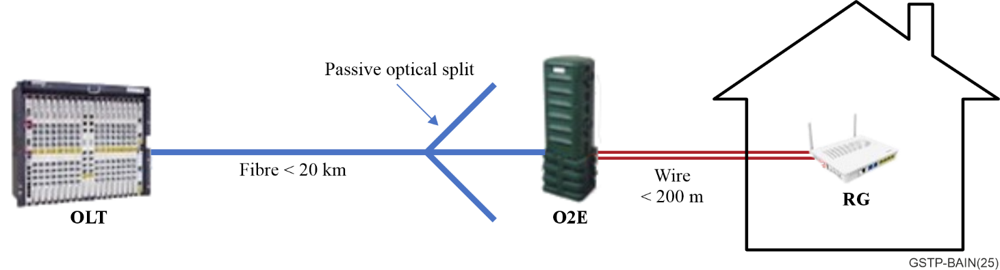
Figure 6-11 – An example of hybrid fibre-copper access architecture

6.4 In-premises network technologies

6.4.1 G.hn
The ITU-T G.hn family of ITU-T Recommendations provides the framework for the description of a complete in-premises communication system that may work over multiple physical media (power lines, phone lines, coaxial and plastic optical fibre).
Figure 6-12 shows the relationship between the different documents of the ITU-T G.hn family of Recommendations.
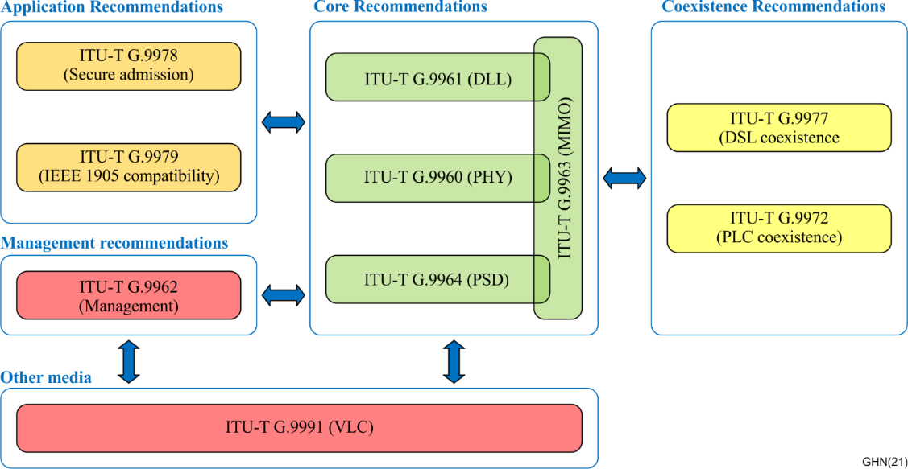
Figure 6-12 – Relationship between the different Recommendations of ITU-T G.hn family
These Recommendations are divided into four main groups:
• ITU-T G.hn core Recommendations, including the description of the physical and DLL layers, and describing the physical parameters to be used during the operation of an ITU-T G.hn transceiver both in single-input-single-output (SISO) and MIMO modes.
• ITU-T G.hn management Recommendations, describing how the rest of the system interacts with the control plane of ITU-T G.hn systems.
• Application Recommendations, describing how to integrate ITU-T G.hn subsystems in larger networks.
• Coexistence Recommendations, specifying how ITU-T G.hn systems coexist and share resources with other systems operating over the same or a different physical medium.
A set of several ITU-T G.hn nodes that operate over the same physical medium establishes an ITU-T G.hn domain. This domain may be established over any type of wiring (power lines, coaxial cables, phone lines, and plastic optical fibre).
Each ITU-T G.hn domain may include up to 250 ITU-T G.hn nodes, one of which is designated as the domain master (DM), which coordinates the operation of all nodes in the domain. All other nodes in the domain are called "end-point nodes" (EP) or simply "nodes". The DM is responsible for assigning a schedule that meets the traffic constraints of the EPs and uses in the most efficient way the available channel resources.
Each of the nodes of the ITU-T G.hn domain interfaces through an Ethernet interface, "A-interface" to the external world. The frames entering through the A interface are processed and encapsulated into physical ITU-T G.hn frames that are sent through the ITU-T G.hn channel to the receiver ITU-T G.hn node.
When an ITU-T G.hn network is composed of multiple domains. The global master (GM) function provides coordination of resources, priorities, and operational characteristics between neighbour domains of an ITU-T G.hn network. The GM is a high-level management function that communicates with the management entities of the DMs and that may also convey the relevant inter-domain coordination functions.
Generic architecture of an ITU-T G.hn network is presented in Figure 6-13.
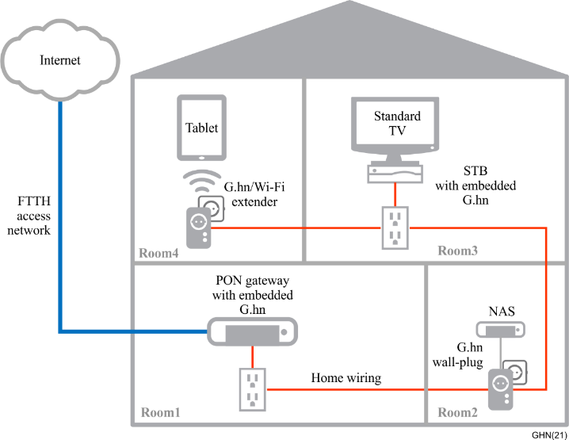
Figure 6-13 – Generic architecture of ITU-T G.hn network
In practice, a classical residential home network scenario using an ITU-T G.hn home network is shown in Figure 6-14.
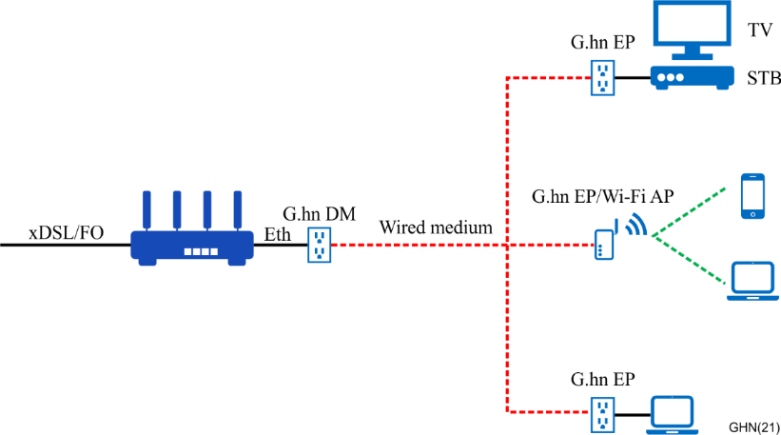
Figure 6-14 – Example of a typical ITU-T G.hn home network deployment
The protocol reference model of a home network transceiver is presented in Figure 6-15.
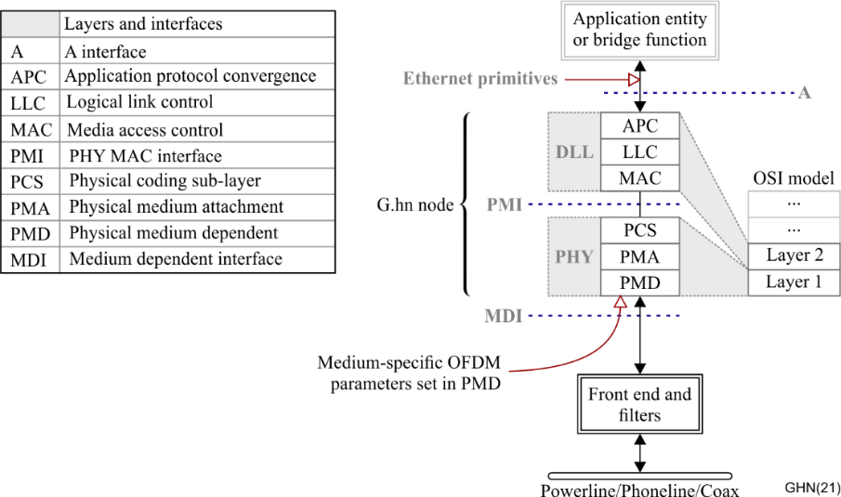
Figure 6-15 – ITU-T G.hn node reference model
The DLL is composed of the following functional sub-layers:
• The application protocol convergence (APC) sub-layer provides an interface with the application entity (AE), which operates with an application-specific protocol (for example, Ethernet). The APC also provides the data rate adaptation between the application entity and the ITU-T G.hn transceiver;
• The logical link control (LLC) sub-layer coordinates the transmission of nodes in accordance with requests from the DM. It is responsible for establishing, managing, resetting and terminating all connections of the node within the domain. The LLC also facilitates QoS constraints of the flow, defined for its various connections;
• The MAC sub-layer manages access of the node to the medium using various medium access protocols.
The PHY sub-layers are:
• The physical coding sub-layer (PCS) provides data rate adaptation (data flow control) between the MAC and PHY and encapsulates transmit MPDUs into the PHY frame while it also adds PHY-related control and management overhead;
• The physical medium attachment (PMA) sub-layer provides encoding of PHY frame content for transmission over the medium;
• The physical medium dependent (PMD) sub-layer modulates and demodulates PHY frames for transmission over the medium using orthogonal frequency division modulation (OFDM). By implementation, the PMD may include medium-dependent adaptors for different media (coaxial, power line, and phone line).
It includes three main reference points:
• Application interface (A-interface) that interfaces the ITU-T G.hn subsystem with the upper layers. So far, only an Ethernet-based A interface is described in the Recommendation but it may be extended in the future (e.g., for IoT applications);
• Physical medium-independent interface (PMI) that interfaces the DLL layer responsible for maintaining the links between ITU-T G.hn nodes and the physical layer, responsible for sending frames across the medium;
• Medium-dependent interface (MDI) that describes how to inject the ITU-T G.hn physical frames in one of the mediums defined by the Recommendation.

6.4.2 G.fin
G.fin is a fibre in-premises networking Recommendation set based on PtMP fibre infrastructure, including a series of ITU-T recommendations:
• [ITU-T G.9940]: "High speed fibre-based in-premises transceivers – system architecture".
• [ITU-T G.9941]: "High speed fibre-based in-premises transceivers – physical layer specification".
• [ITU-T G.9942]: "High speed fibre-based in-premises transceivers – data link layer".
• ITU-T G.9943: "High speed fibre-based in-premises transceivers – network management". (Draft Recommendation at the time of publication.)
• ITU-T G.9944: "WLAN management control interface (WMCI) for in-premises network". (Work in progress at the time of publication.)
G.fin project intends to provide beyond gigabit networking for multiple AP scenarios. [ITU-T G.9940] specifies the system architecture and general requirements of high-speed fibre-based in-premises networking systems (G.fin). As shown in Figure 6-16, a system using G.fin includes a main fibre unit (MFU), an indoor PtMP fibre distribution network (IFDN), and sub fibre units (SFUs). A G.fin-based network can be used in both a home network or a small and medium enterprise. IFDN may support remote powering of SFUs, simultaneously distributing optical signals and electrical power to SFU(s) using optical and electrical hybrid cables (OEHCs) and optical and electrical hybrid splitter (OEHSs). If only one SFU needs to be connected, the IFDN does not include any splitters, creating a direct link between the MFU and SFU.
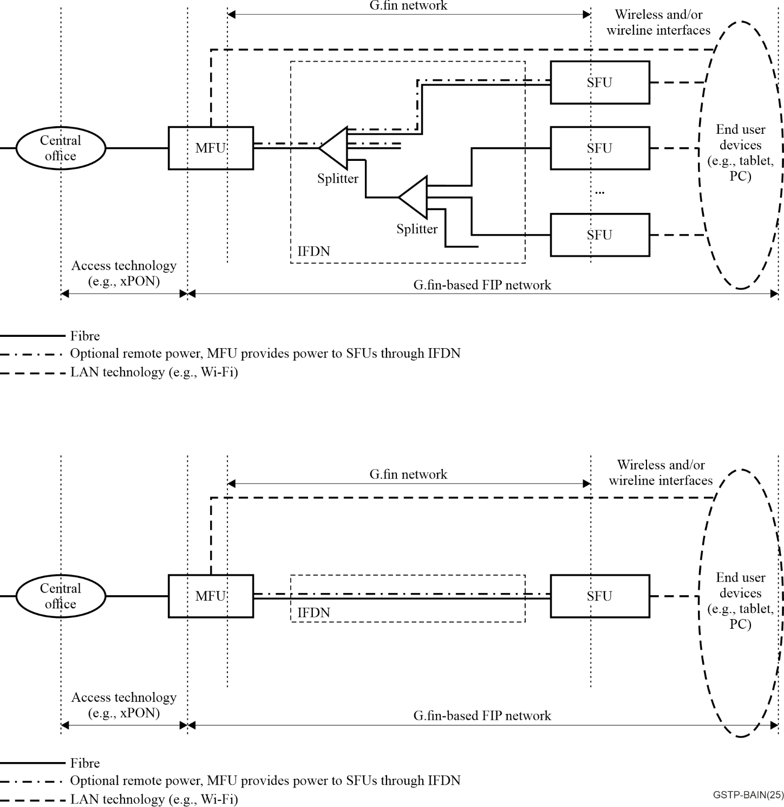
Figure 6-16 – G.fin based in-premises network
The functional architecture of a G.fin network (shown in Figure 6-17) consists of a management plane, a control plane, and a data plane. The MFU conducts centralized management via the MFU management entity (MME) and control via the MFU controller entity (MCE) on the entire G.fin network.
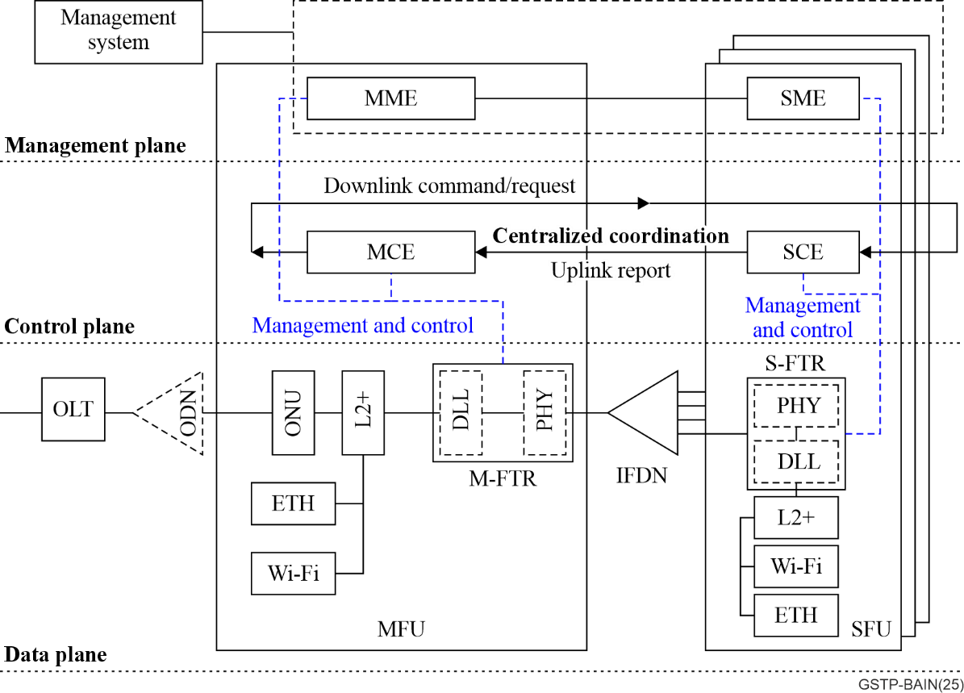
Figure 6-17 – Functional architecture of a G.fin-based FIP network
• Data plane:
The data plane provides connectivity for exchanging service data, management data, and control data. G.fin defines a data exchange rate of symmetric 2.5 Gbit/s. The G.fin system defines optical link types (Ra/Rb) adapted to home and SME scenarios. The technology specifications of the physical layer and data link layer are defined in [ITU-T G.9941] and [ITU-T G.9942], respectively. Table 6-1 shows the optical link budget and wavelength set of G.fin, in which the Ra and Rb is designed for home and SME environments respectively.
Table 6-1 – Optical link budget and wavelength set of G.fin
Optical link type | Link budget | Splitting ratio | Wavelength set
Optical link type | Link budget | Splitting ratio | 2.5/2.5 Gbit/s
Ra | 0-18 dB (home) | 1:8 | Up: 1 310 ± 10 nm  Down: 1 490 ± 10 nm
Rb | 13-28 dB (SME) | 1:32 | Up: 1 310 ± 10 nm  Down: 1 490 ± 10 nm
• Control plane:
The control plane, shown in Figure 6-18, is based on the centralized coordination network architecture. A controller located in the MFU allows centralized status collection, and sending of centralized network control commands, through the latency-controlled fibre transmission channel provided by G.fin technology. The management and control interface running over the G.fin link for WLAN coordination will be specified in ITU-T G.9944.
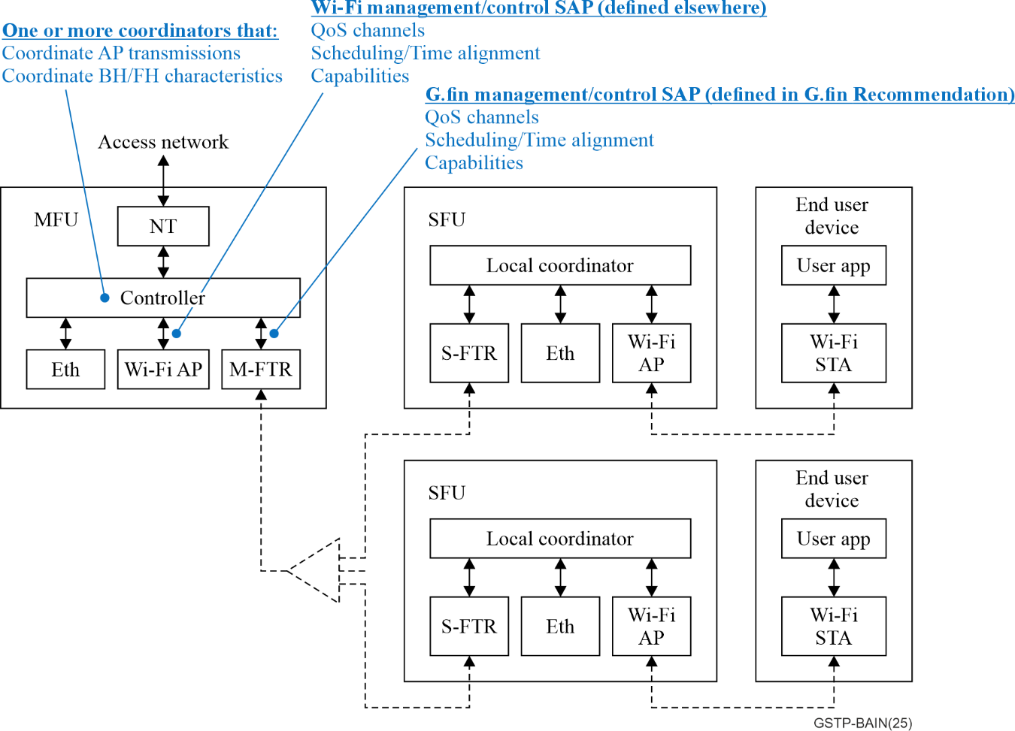
Figure 6-18 – Centralized coordination network architecture
• Management plane:
As shown in Figure 6-19, a network based on G.fin may be in parallel managed using OMCI (e.g., [ITU-T G.988]) or any IP-based protocol (e.g., TR-069/TR-369). Management functions includes system visualization, system configuration, collection of stem performance metrics, fault management, and security. The detailed management architecture and interface are specified in draft ITU-T G.9943.
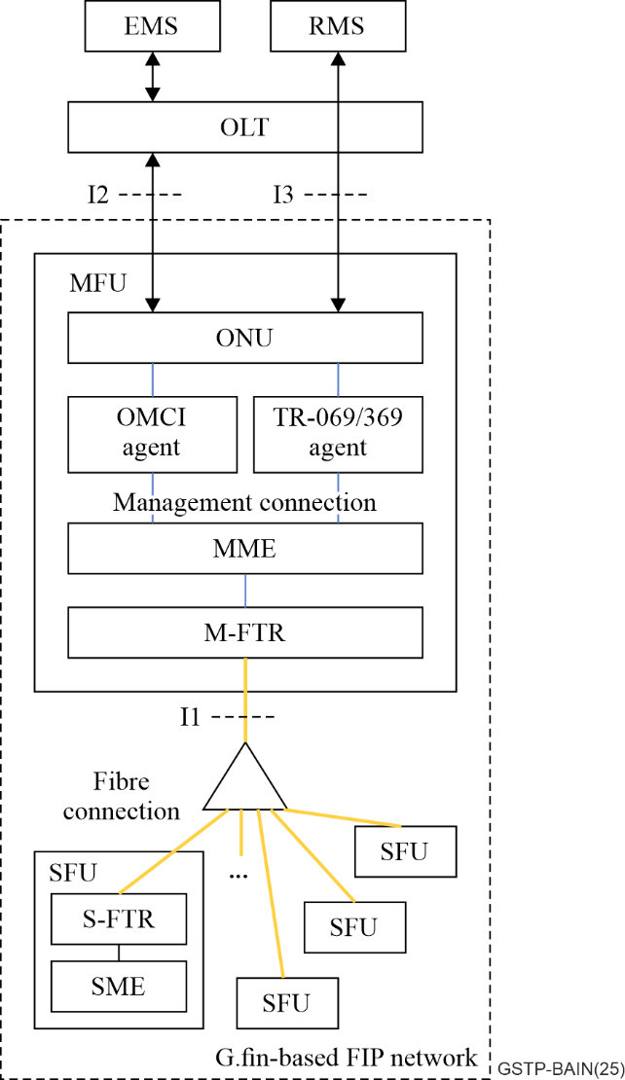
Figure 6-19 – An example of management schemes of G.fin-based FIP network

6.4.3 G.p2pf
[ITU-T G.9930] specifically addresses the network topology consisting of multiple point-to-point fibres between a residential gateway (RGW) and subtended units (SUs). This Recommendation specifies the system architecture and requirements for high-speed point-to-point-fibre-based in-premises transceivers.
Figure 6-20 shows a fibre-in-the-premises network using a G.p2pf network relative to the broadband access network (e.g., PON). Such a network includes a residential gateway (RGW), an indoor fibre distribution network (IFDN), and subtended units (SUs), including access points (APs).
The access network technology is outside the scope of this Recommendation. For the purpose of illustration, the network architecture is shown with xPON access technology, where the optical network unit (ONU) is integrated in the RGW, and the RGW is connected to SUs through an IFDN.
The home technology connecting an SU to an end user device is outside the scope of this Recommendation. For the purpose of illustration, the network architecture is shown with SUs including Wi-Fi access points (APs).
The RGW and SUs provide wireless (e.g., WLAN) and wireline network (e.g., Ethernet) interfaces for end user devices (e.g., laptop, smartphone). Adaptation devices such as a set top box can also be connected to the RGW or SUs and provide network service (e.g., IPTV) for end user devices (e.g., TV).
The RGW is the network termination point for the access network and the starting point of the in-premises network. It is the converging point for data, management and control in the G.p2pf-based FIP network, providing point-to-point (PtP) optical connections to SUs.
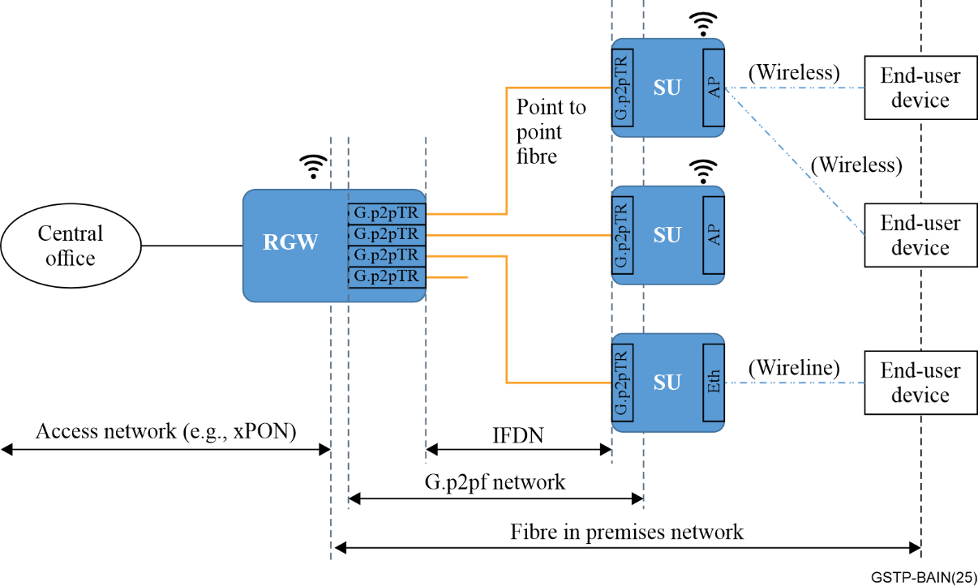
Figure 6-20 – Illustration of a G.p2pf-based FIP network
The fibre-in-the-premises (FIP) network based on G.p2pf may be used in one of two main environments, a home network or a small and medium enterprise (SME), supporting different services and requiring dedicated network capabilities.
[ITU-T G.9930] leverages the IEEE 802.3 optical Ethernet technologies. Table 6-2 summarizes the different PHY options specified by this Recommendation with their corresponding Ethernet standard references.
Table 6-2 – Summary of G.p2pf PHY options
G.p2pf PHY option | Nominal line rate | Single or dual fibre | Fibre length supported by IEEE 802.3 | Optical link budget defined in IEEE 802.3 | Wavelength (nm) | Referenced IEEE 802.3 Ethernet clauses | Ethernet PMD types
Option 1 | 1 Gbit/s | Dual fibre | 10 km | 8 dB | 1270-1355 | [IEEE 802.3] clause 38 | 1000BASE-LX
Option 2 | 1 Gbit/s | Single fibre | 10 km | 5.5 dB | DS:  1 480-1 500  US:  1 260-1 360 | [IEEE 802.3] clause 59 | 1000BASE-BX10
Option 3 | 10 Gbit/s | Dual fibre | 10 km | 6.3 dB | 1 260-1 355 | [IEEE 802.3] clause 52 | 10GBASE-LR
Option 4 | 10 Gbit/s | Single fibre | 10 km | 6.3 dB | DS:  1 320-1 340  US:  1 260-1 280 | [IEEE 802.3] clause 158 | 10GBASE-BR10

7 Conformance and interoperability certification of equipment and performance testing
Laboratory testing of conformance and interoperability of equipment based on ITU-T Recommendations is specified by the Broadband Forum and Homegrid Forum. A list of the conformance and interoperability activities for ITU-T Recommendations is provided in ITU-T TD-WP1/15-248.
Published Broadband Forum Technical Reports related to the ANT Recommendations can be found following URL https://www.broadband-forum.org/technical-reports.
Broadband Forum Test Plans related to ANT can be found at following URL https://www.broadband-forum.org/test-plans.
Performance and Functional Testing of solutions based on ITU-T ANT Recommendations are specified by the ETSI ISG F5G TEST WG (see the Work Items at the ETSI ISG F5G portal (portal.etsi.org)).
Published ETSI ISG F5G Specifications and Reports related to the ANT Recommendations can be found following URL https://www.etsi.org/committee/f5g.
Information on conformance and interoperability for the [ITU-T G.9960] (G.hn) Recommendations by the Homegrid Forum may be found at: https://homegridforum.org/g-hn-home-networking-certification/.
___________

