|  |  |  |
| --- | --- | --- |
|  | | Standardization Sector |
| ITU-T Technical Paper | |
| (07/2023) | |
|  | **FSTP-ACC-Rural** | |
|  | Use cases of accessibility to multimedia systems in rural and out-of-home environments | |

|  |  |
| --- | --- |
| **ITUPublications** | **International Telecommunication Union** |

|  |
| --- |
| Technical Paper ITU-T FSTP-ACC-Rural  Use cases of accessibility to multimedia systems in rural and  out-of-home environments |

|  |
| --- |
| Summary  Technical Paper ITU-T FSTP-ACC-Rural describes the use cases of an interactive mobile digital unit in rural and out-of-home environments, especially in developing countries. The purpose of this Technical Paper is to describe the architecture and use cases of such a unit, which is to be used for overcoming the barriers that are a common denominator in developing countries, such as lack of infrastructures, connectivity and electricity. Such a unit is expected to provide inclusion of persons with disabilities, with auditory processing disorders and visual impairment, while promoting faster comprehension of the content delivered. |

|  |
| --- |
| Keywords  Accessibility, developing countries, interactive mobile digital unit, rural areas, satellite communication, wireless communication. |

Note

This is an informative ITU-T publication. Mandatory provisions, such as those found in ITU-T Recommendations, are outside the scope of this publication. This publication should only be referenced bibliographically in ITU-T Recommendations.

Change Log

This document contains Version 1 of the ITU-T Technical Paper on "Use cases of accessibility to multimedia systems in rural and out-of-home environments" approved at the ITU-T Study Group 16 meeting held in Geneva, 10-21 July 2023.

|  |  |  |
| --- | --- | --- |
| **Editors**: | DaynAmade Kamaleon – Eventos Tecnológicos Mozambique | Tel.: +258843014038 E-mail: [dayn@tabletcomunitario.org](mailto:dayn@tabletcomunitario.org) |
|  | Iris de Brito Kamaleon – Eventos Tecnológicos Mozambique | Tel.: +351916702444 E-mail: [irismdebrito@tabletcomunitario.org](mailto:irismdebrito@tabletcomunitario.org) |

© ITU 2023

All rights reserved. No part of this publication may be reproduced, by any means whatsoever, without the prior written permission of ITU.

**Table of Contents**

Page

1 Scope 1

2 References 1

3 Definitions 1

3.1 Terms defined elsewhere 1

3.2 Terms defined in this Technical Paper 1

4 Abbreviations and acronyms 1

5 Introduction 2

6 Description of interactive digital mobile unit 3

6.1 Transmission 3

6.2 Topology description 4

6.3 Description of the equipment 6

7 Service use cases 7

7.1 E-learning in agriculture and farming 7

7.2 Inclusive digital literacy 8

7.3 Accessible financial education 8

7.4 Digital rural banking 8

8 Accessibility 10

8.1 Auditory processing disorder 11

8.2 Visual impairment 11

8.3 Motor disability 11

Bibliography 12

Technical Paper ITU-T FSTP-ACC-Rural

Use cases of accessibility to multimedia systems in rural and   
out-of-home environments

# 1 Scope

This Technical Paper describes the use cases of an interactive mobile digital unit in rural and out-of-home environments, especially in developing countries. The purpose of this Technical Paper is to describe the architecture and use cases of such a unit, which is to be used for overcoming the barriers that are a common denominator in developing countries, such as lack of infrastructures, connectivity and electricity. Such a unit is expected to provide inclusion of persons with disabilities, with auditory processing disorders and visual impairment, while promoting faster comprehension of the content delivered.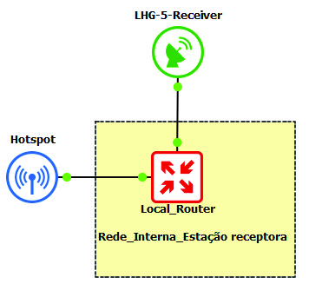

# 2 References

[ITU-T F.790] Recommendation ITU-T F.790 (2007), *Telecommunications accessibility guidelines for older persons and persons with disabilities*.

[ITU-T F.791] Recommendation ITU-T F.791 (2018), *Accessibility terms and definitions*.

[ITU-R S.725] Recommendation ITU-R S.725 (1992), *Technical characteristics for very small aperture terminals (VSATs)*.

# 3 Definitions

## 3.1 Terms defined elsewhere

This Technical Paper uses the following term defined elsewhere:

**3.1.1 very-small-aperture terminal** [ITU-R S.725]: A two-way satellite ground station with a dish antenna that is smaller than 3.8 metres.

## 3.2 Terms defined in this Technical Paper

This Technical Paper defines the following terms:

**3.1.1 automated teller machine (ATM)**:An electronic telecommunications device that enables customers of financial institutions to perform financial transactions, such as cash withdrawals, deposits, funds transfers, balance inquiries or account information inquiries.

**3.1.2 interactive digital mobile unit (IDMU)**: An audiovisual and interactive mobile unit using photovoltaic technology to provide electricity, Internet connection, interactive multimedia services, etc.

**3.1.3 know your client (KYC)**: The process of identifying and verifying the client's identity when opening an account and periodically over time.

# 4 Abbreviations and acronyms

This Technical Paper uses the following abbreviations and acronyms:

ATM Automated Teller Machine

dBI Decibel Isotropic

GSM Global System for Mobile communications

ICT Information and Communication Technology

IDMU Interactive Digital Mobile Unit

KYC Know Your Client

LAN Local Area Network

PoE Power over Ethernet

PVC Polyvinyl Chloride

SIM Subscriber Identification Module

USSD Unstructured Supplementary Service Data

VSAT Very-Small-Aperture Terminal

# 5 Introduction

To overcome the barriers that are a common denominator in developing countries, such as lack of infrastructures, connectivity and electricity, an audiovisual and interactive mobile unit using photovoltaic technology was designed to reduce the digital divide and improve teaching and learning processes. The interactive digital mobile unit (IDMU) has been researched and designed for multiple situations and scenarios. The unit consists of a 5100 × 1800 × 2500 cm crate with five 250 W solar panels kit totalizing an installed capacity of 1.25 kW and a 3 kW hybrid inverter. On one side of the unit there is a 100-inch screen – expandable to 200 inches – that is equipped with anti-glare to guarantee the best outdoor experience without sun reflection. This large screen can also be used as a white board. On this side a monitoring screen can also be found. On the opposite side, four 32-inch touch screens with virtual keyboards were incorporated.

The IDMU comprises all of the safety requirements for transport in difficult road access areas as well as for hot or cold temperatures. All the equipment is adequately protected. Amongst the advantages, the following can be highlighted:

a) not dependent on access to the electricity grid, so that it can be powered-up from solar panels and generators for full functionality;

b) the versatility of transport allows it to reach remote rural communities even with difficult road access;

c) Internet connectivity using satellite or global system for mobile communications (GSM) allowing access in areas not covered by mobile Internet providers;

d) it can be used as an Internet access point to users with their own devices;

e) screens are equipped with interactive pens to guarantee continuation of hand-writing habits;

f) accessories and peripherals can be attached – such as printers for paper and PVC, fingerprint scanners, web cameras;

g) enables the use of any software including educational games for better understanding of users.

The IDMU has its own cooling equipment system, is of a temperature resistant design and has a remote monitoring system. It can use solar power, generator or battery power and can be towed by any automobile, agricultural tractor or by animal traction. It allows the possibility of "providing scenario-based and linkage-based communication services" by being adapted to the socio-economic reality and local context of these communities.

As such, more people have access to multimedia services and systems, including the elderly. It also allows users to share a fixed ICT device incorporated into the unit with guaranteed continued and sustainable use in open air in these areas where infrastructures such as electricity networks are lacking.

This architecture is expandable to target persons with disabilities "to meet this wide variety in capabilities in the original design of telecommunication services and systems, so that an increasing number of users can make use of the mainstream telecommunication services".

# 6 Description of the interactive digital mobile unit (IDMU)

Figure 1 shows how the original user-friendly platform design makes mainstream telecommunication services and systems accessible to disconnected communities in rural areas of developing countries.

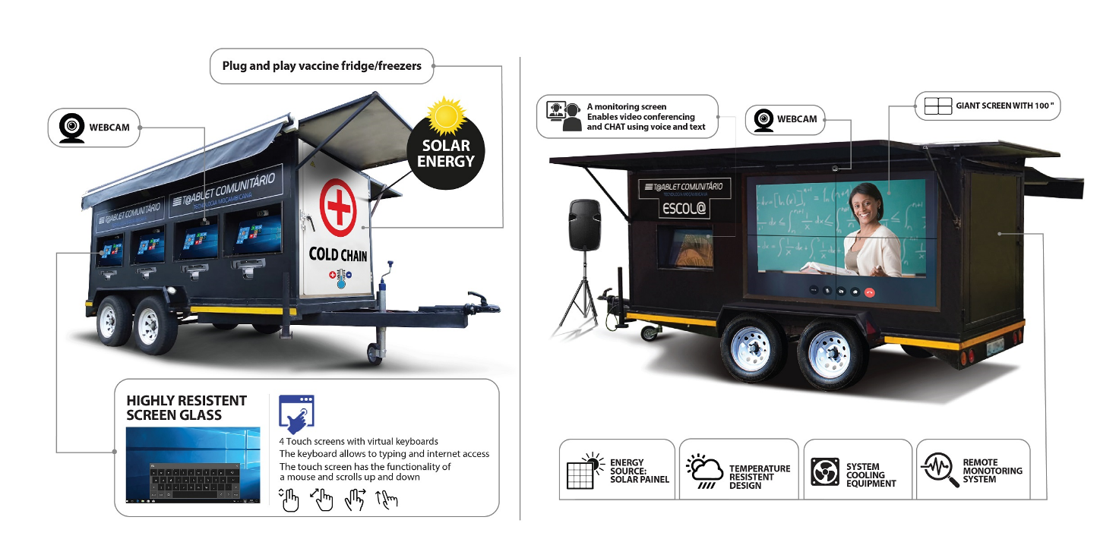

Figure 1 – IDMU (sides A and B)

## 6.1 Transmission

Using wireless antennas and wireless local area network (LAN) routers as "hotspots", various establishments, stores, houses, or individual devices can be connected to the Internet. In summary, in the IDMU, as two antennas are installed for signal transmission and receiving antenna, in addition to all of the advantages listed in clause 5, it is possible 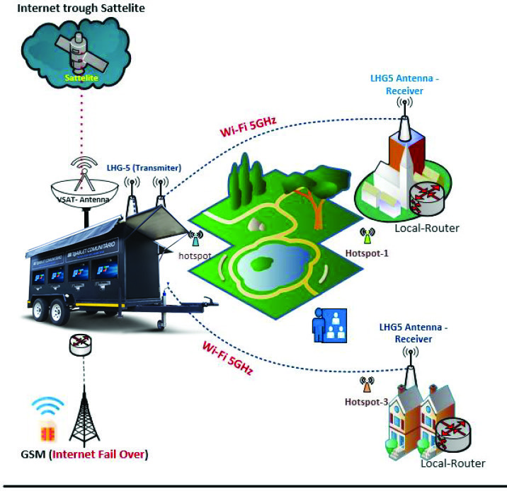to create a digital ecosystem in remote communities, as shown in Figure 2.

Figure 2 – IDMU signal transmission diagram

## 6.2 Topology description

The Internet signal reaches the IDMU via satellite, and as a redundancy there is also an Internet signal via GSM (SIM card) mobile network provided through the signal of local mobile operators. A very-small-aperture terminal (VSAT) antenna is installed in the caravan that receives the satellite signal for the provision of Internet, and then feeds the caravan router to broadcast the Internet signal to users inside the caravan.

Two transmitting antennas are connected to the caravan router, each of which has the function of transmitting the Internet signal at a frequency in the order of 5 GHz and an auxiliary router with wireless capabilities for the provision of Internet via wireless LAN to the people in proximity around the IDMU, as illustrated in Figure 3.

Figure 3 – Internal network of the interactive digital mobile unit

At each receiving station, as shown in Figure 4, an antenna of the same type is installed for the reception of the Internet signal as well as a wireless LAN router or access point for the provision of the Internet signal to people who are close to the infrastructure (such as a school, hospital, or municipality).

Figure 5 shows a final network topology.

Figure 4 – Internal network of the interactive digital mobile unit

Figure 5 – Topology - final network schema

## 6.3 Description of the equipment

**Antenna** – A compact and lightweight link antenna with an integrated dual polarization of 24.5 dBi, capable of establishing point-to-point links up to 10 kilometres away is usually preferred. Grid design is expected to ensure wind protection. The antenna comes with a pre-installed operating system, eliminating the need to install additional software for configuration. Figure 6 shows views of an antenna.

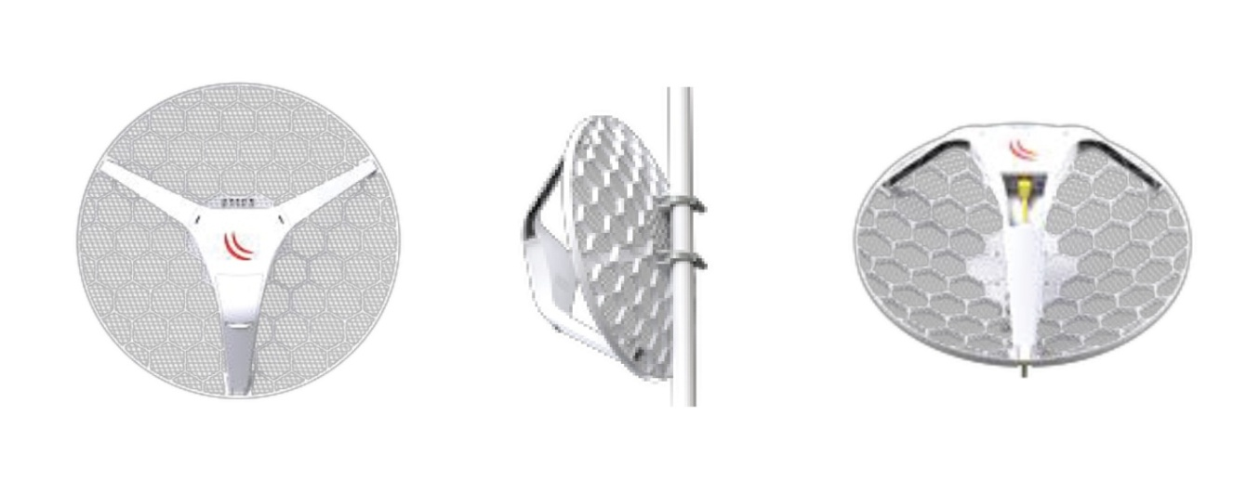

Figure 6 – Example views of antenna

**Hotspot and local router** – A router with Gigabit ports accompanied by two antennas for wireless transmission in two frequency modes (2.4 GHz and 5 GHz) for outdoor and indoor environments is often used. The router usually supports power over Ethernet (PoE) and can connect or be connected by other devices without the need for a transformer. The router can operate in two bands and is able to cover up to 150 square metres of land so that it can be used in crowded environments and environments subject to interference from other possible frequencies. Figure 7 shows examples of possible hotspots and local routers.

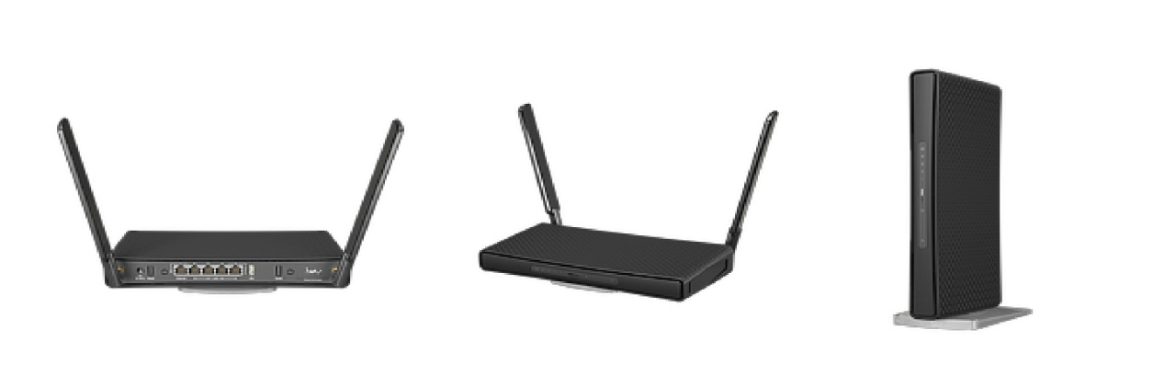

Figure 7 – Examples of possible hotspots and local routers

# 7 Service use cases

## 7.1 E-learning in agriculture and farming

Farmers for example, with over three decades of farming experience, were unaware of modern practices and were quick to apply modern farming practices that were broadcasted to help increase their productivity. The information and teachings were broadcast in a digital format, that was inclusive to people with disabilities (auditory processing disorder and visual impairment) and continued access to ICT was provided with quizzes on four interactive monitors, operating simultaneously with different audience members. The aim of the above activity was to empower all farmers with techniques to increase productivity using telecommunications in rural communities, regardless of their literacy levels and physical conditions. The exposure to new methods of farming processes can be crucial for the maintenance of crops for longer by applying more modern and cost-effective techniques. The gains in efficiency can be beneficial for the farmer and the rural community as a whole.

Digital cholera campaigns were deployed in areas with growing cholera rates to raise awareness on how to treat water and teach communities basic hygiene methods to protect themselves and their families from cholera. Six months after the campaigns had taken place, these communities reported a significant drop in cholera cases as a result of their improved hygiene and water treatment practices. The impact of improved health due to better sanitary practices is a major success that an interactive mobile digital school can have in a rural setting.

The IDMUs can reach remote areas that are completely disconnected from ICT devices including access to television. Before initiating our one way and two-way broadcasting to educate communities about COVID-19, these remote communities were plagued with misinformation and had only heard of COVID-19 through rumours. After our deployment, we noticed an immediate change in behaviour, with these same communities being more committed to avoid the spread of the virus and more willing to cover their nose and mouth in public spaces. The impact in the delivery of such urgent health sensitive information assisted in the dissemination of prevention measures throughout the communities and beyond them. With access to visual illustrations it was possible for them to also transmit what they have learned to other community members and provide reliable information from a credible source.

## 7.2 Inclusive digital literacy

Children aged between 10 to 16 years of age were provided with a school curriculum that was converted into digital format. When comparing this group to a similar age group of students that continued to learn the same school curriculum using the traditional teaching format, it was clear that students with access to e-learning learned much faster with digital tutorials. Reading and pronunciation campaigns were rolled out by providing preloaded e-books on our audio and visual interactive unit. Students had a choice of books to read which were inclusive for people with disabilities using an **integrated mechanism**.

Providing access to educative content in a format that was easier for students to comprehend made them more optimistic for the future and susceptible to seek further guidance to explore their professional aptitude via vocational tests. Students were much more engaged with this e-learning facility, and the results were positive. Once the learner engages with the material in an interactive way, he can explore the boundaries of his own knowledge compared to simply reading from a textbook. In this scenario, for people with auditory processing disorder a combination of texts and sign language were used to enable students to continue learning and improving their reading and gesture communication. Activities with the highest attendance, engagement and grades took place when educative videos were broadcasted simultaneously with digital activities such as virtual academic games on the broadcasted topics in order to foster a fun and friendly e-learning environment.

## 7.3 Accessible financial education

It is well-known that many communities may have GSM connectivity, but still lack data services. Through our audio and visual interactive platform, it became easier for previously sceptic community members to do financial transactions using unstructured supplementary service data (USSD) gateway. Through our inclusive broadcasting method**,** communities managed to change their attitude (towards storing money at home or buried underground) and understand that their money was safer in the bank and also could be monitored using their communication tools and mobiles when accessing USSD. As a result, there was a noticeable increase of banking transactions and deposits in the communities that benefitted from the financial education broadcasts. The impact of having more money circulating in the community was clearly a boost to the local economy and could attract other services into the area as well new methods of accepting payment for goods and services.

Educative content on family planning was provided to teenagers using short novels to disseminate information in a manner that caught their attention and interest to change their behaviour in the short and long term. Storytelling in a digital format proved more effective in enabling teens to make their own judgment about the benefits of family planning without forcing those ideals upon them. In such a context, it is imperative to prepare and design educative contents in collaboration with anthropologists, sociologists and psychologists to maximize the impact of the short video sketches. Persons with disabilities, auditory processing disorders and visual impairment were reached under the same format mentioned on **integrated mechanism**.The delivery of the same content to disabled members of the community has also been implemented. The input provided by them can also be put into the balance to ensure that the younger generation is fully aware and represented.

## 7.4 Digital rural banking

Across the world, particularly in developing countries, rural communities face the challenge of not being able to access formal financial services. Even though extending financial services to the poor has been shown to reduce poverty, and has long been considered a critical element of policy responses directed at the poor, the fact is that people in rural areas have limited options in this regard. This is due to the relatively high cost of establishing traditional bank branches in remote areas that result mainly from the lack of infrastructures in these regions.

Citizens from the remote communities are often aware of the existence of a financial ecosystem, but have no information regarding the products and services they could benefit from. The revenue generated from their activities – which consist primarily of agriculture, farming and fishing – are often stashed under a mattress or buried, which increases the risk of loss with the occurrence of rain, fire or other adversities.

Moreover, researchers from Yale university – in collaboration with Duke University and the University of Warwick – have conducted a study on innovative solutions that leverage broad geographic distribution and low banker-to-client ratios to offer credit, insurance, and savings products and a randomized controlled trial to measure the impacts of these services on poverty reduction, entrepreneurship, agricultural investments, social networks, mental health, and female empowerment [b-Yale]. The results of this large-scale experimental impact evaluation of improved access to formal financial services for rural populations show that the provision of these services are associated with an 8% reduction in poverty and reduced psychological stress. The rich data produced by the study also shows that credit access has positive effects on non-agricultural self-employment and labour demands, demonstrating that rural banking can reduce poverty through both direct and indirect channels.

IDMUs can offer a comprehensive solution that bridges the digital divide in developing countries, with the potential to make financial services available in an effective way to the rural communities.

The proposed methodology consists of a broad approach which encompasses i) an awareness campaign about financial inclusion; as well as ii) tutorials on how to use specific banking solutions/financial services; and iii) the advantages of being a part of the formal financial system. This methodology is based on a novel, transformative, patented innovation in which the comparative advantage resides in not being dependant on the availability of infrastructure while making a myriad of digital tools and online services accessible to disadvantaged communities in an inclusive and user-friendly way.

As described in Table 1, it consists of a container built with recycled plastic (200 kilograms of recycled plastic is used per unit built) on a road trailer that can be towed by any vehicle or animal traction overcoming topographic challenges of road access to rural areas. It is powered by solar energy, equipped with satellite broadband and a GSM network, and a 13.5 kWh capacity battery with an autonomy of up to 12 hours – which makes it fully operational in the absence of infrastructure.

| Table 1 – Description of an IDMU community tablet | |
| --- | --- |
| Screen Shot 2023-05-06 at 15.03.20.png | Screen Shot 2023-05-06 at 15.03.34.png |
| **Community tablet – Side A**  Description: 100-inch screen used for different purposes, including (but not limited to) online lessons and training, video-conferences, educational videos for groups of up to a hundred people; a 32‑inch screen to monitor and manage the contents streamed on the large screen and/or facilitate direct interaction between the audience and the interlocutor. It also features a printer. | **Community tablet – Side B**  Description: four 32-inch interactive touchscreen monitors with web cameras and four printers are installed (interactive cabins). The monitors have all the functionalities of a touch screen computer and are for the individual use of the beneficiaries. The platform is user-friendly, including for persons with disabilities (e.g., for the deaf and hard-of-hearing with captioning or for those with visual impairment through a voice-to-text system) and the screens are adjustable for persons on wheelchairs. |

### 7.4.1 Implementing rural banking

This clause describes a use case of how an inclusive rural banking can be implemented on an IDMU.

1) On the large screen – a group of 100 people can simultaneously be educated on financial services, customer care and the underlying procedures of the financial system through tailored awareness and didactic activities.

2) On individual interactive cabins:

Cabins 1 and 2 are used for know your client (KYC) procedures and client registration through biometric capture. A document scanner can be used to facilitate opening the digital wallet account;

Cabins 3 and 4 comprise automated teller machines (ATMs) that are installed to complete bank transactions from withdrawing or depositing money in the digital wallet, to checking the account balance, or transferring money between accounts/digital wallets.

### 7.4.2 Operational details

Connectivity: Satellite and GSM

Digital security: high standards of cyber security protocol.

Money safe security: tainted activation on brake in attempt

The above methodology contributes to the integration of rural communities into a formal financial system while serving as a vehicle to convert physical money into digital. As a result, it also contributes to:

a) Improving life standards of the rural communities by cutting distances to access financial services;

b) Facilitating financial transactions;

c) Promoting financial digital transformation.

# 8 Accessibility

"Accessibility" to multimedia goes beyond the interaction with the platform. It also (and mainly) entails conveying the intended message in a way that is perceptible by all members of the community, regardless of age, literacy level, gender or any other characteristic potentially considered exclusive, including disabilities. Because access to reliable information is crucial for the well-being of the populations, this interactive mobile unit uses a blend of digital audio, touch screens, video, sign language speech/word recognition and text to present content using GSM satellite connectivity. It also enables inclusion of persons with disabilities, with auditory processing disorders and visual impairment, while promoting faster comprehension of the content delivered.

In addressing these challenges, we have implemented educational campaigns in some Mozambican communities to broadcast one-way and two-way communications in partnership with the *Government of the Republic of Mozambique*,in particular with the *Minister of Science, Technology and Higher Education, Minister of Education, Minister of Health and University Eduardo Mondlane*. These collaborations help disseminate technology in areas previously not considered for digital initiatives. Our 2-way outdoor video conference communication broadcast allows remote engagement with the communities, but in the absence of means of data connectivity, the group and individual engagements are maintained through artificial intelligence (AI) enhancing virtual reality.

Amongst the most important considerations to be made when standardizing content for effective broadcasting, are aligning content with local culture, habits, and religion in order to maximize its acceptance and ease of comprehension in the target community. With regards to the deployment of information, administration and management of ICT accessibility, the most effective modes of operation are divided into ten different activities. Integrated mechanisms are applied to accommodate every single person including illiterate and people with disabilities and can be divided into four (4) sets as described below:

1) Touch screen text = selection of text in quizzes – mostly used by general population including illiterate and people with auditory processing disorders.

2) Touch screen with images and sign language = Selection of images in quizzes – mostly used by people who are illiterate and those with auditory processing disorders.

3) Touch screen by voice/text = Voice triggers word recognition – mostly used in quizzes for illiterate people and those with visual impairments.

4) Non touch screen = Sign language – sign language is a support for people with low perception capabilities or those with auditory processing disorders.

The most effective strategies used during this period for capacity building of people with auditory processing disorders and visual impairments are described in clauses 8.1 to 8.3.

## 8.1 Auditory processing disorder

As a good practice, a summary of all the topics was provided in large text, illustrative images and sign language after every session on large digital screens to allow the audience to recap key learnings before testing their levels of understanding. Text in preferred language, videos with sign language (hand shape, palm orientation and facial expression) images and text were also used in digital quizzes with auto correct features. Multiple choice quizzes allowed users to choose the correct answer by using the touch screen functionality and to receive feedback or an auto correction by text or images, enabling continued access, interactivity and engagement with ICT after broadcasting.

## 8.2 Visual impairment

In this regard, audio in their preferred language was most effective. Additionally, digital quizzes were equipped with voice-word recognition trigger features that have a pre-programmed local language. This allowed further learning, interactivity and engagement with ICT after broadcasting, by asking participants a question and giving 3 possible spoken answers to allow the user to choose the correct answer using speech, followed by spoken feedback or a spoken auto correction.

## 8.3 Motor disability

A wheelchair makes a lot of difference in the life of its users. There are a lot of positive differences if you look from the viewpoint of the person for whom wheelchair is the only mode of mobility. However, there are lots of daily life problems that every wheelchair user has to face. To make our platform more inclusive and accessible to as many people as possible, the touch screens are adjustable in height so that people with mobility challenges that move around in wheelchairs can easily reach them.

Bibliography

[b-Yale] Yale Economic Growth Center – *Rural Banking: Evaluating the Returns to a New Model*, (2023).   
<https://egc.yale.edu/ie/projects/rural-banking>

___________