|  |  |  |  |  |
| --- | --- | --- | --- | --- |
|  | | **International Telecommunication Union** | | |
|  | |  | | |
| **ITU-T** | **Technical Paper** | |
| TELECOMMUNICATION STANDARDIZATION SECTOR OF ITU | | (3 July 2020) |
|  |  | | | |
|  | FSTP.ACC-ALD  Overview of assistive listening systems | | | |
|  |  | | | |

Summary

This Technical Paper provides the technical and operational characteristics for wireless connectivity of hearing aids to public, home and personal audio services. It also covers interoperability of assistive listening devices with hearing aids and consumer electronics.

Note

This is an informative ITU-T publication. Mandatory provisions, such as those found in ITU-T Recommendations, are outside the scope of this publication. This publication should only be referenced bibliographically in ITU-T Recommendations.

Keywords

Accessibility, assistive listening device (ALD), assistive listening system (ALS), hard of hearing, hearing aid, interoperability, wireless accessibility of hearing aids

Change log

This document contains Version 1 of the ITU-T Technical Paper on "*Overview of assistive listening systems*" approved at the ITU-T Study Group 16 virtual meeting held 22 June – 3 July 2020.

|  |  |  |
| --- | --- | --- |
| **Editors:** | Brian Copsey G3ict USA | E-mail: [bc@copsey-comms.com](mailto:bc@copsey-comms.com) |
|  | Lidia Best G3ict USA | E-mail: [lidia.best@ties.itu.int](mailto:lidia.best@ties.itu.int) |

**Table of Contents**

Page

1 Scope 1

2 References 1

3 Definitions 1

4 Abbreviations 2

5 Background 2

5.1 Hearing Loops (inductive loop) and telecoils 4

5.2 FM systems 5

5.3 IR systems 6

5.4 Future systems 6

6 Technical overview of assistive listening devices 7

6.1 Induction-loop system (often referred to as telecoil) 7

6.2 Magnetic field strength 9

6.3 Infrared systems 11

6.4 FM systems 11

6.5 Devices operating at VHF and UHF frequencies 11

6.6 Bluetooth systems 12

6.7 Cochlear implants 13

7 Overview of interoperability between assistive listening devices 19

7.1 Introduction 19

7.2 T-Coil 19

7.3 FM systems 19

7.4 Bluetooth 20

7.5 Bluetooth broadcast 20

7.6 TRS 20

7.7 Infrared (IR) systems 20

7.8 Software control of ALDs 20

8 Interference issues 20

8.1 T-Coil and body worn loops 20

8.2 FM systems 20

8.3 Bluetooth 20

Appendix I Current standards and regulations in Europe 21

I.1 [IEC 60118-4]:2014 21

I.2 [IEC 62489-1]:2010 and its amendments 1 (2014) and 2 (2017) 21

I.3 [IEC 62489-2]:2014 21

I.4 European Union 21

Bibliography 22

Technical Paper ITU-T FSTP.ACC-ALD

Overview of assistive listening systems

# 1 Scope

This Technical Paper provides the technical and operational characteristics for wireless connectivity of hearing aids to public, home and personal audio services. It also covers interoperability of assistive listening devices with hearing aids and consumer electronics.

# 2 References

[ITU-T H.871] Recommendation ITU-T H.871 (2019), *Safe listening guidelines for personal sound amplifiers*.

[ITU-R M.1076-1] Recommendation ITU-R M.1076-1 (02/2015), *Wireless communication systems for persons with impaired hearing*.

[ETSI EN 300-422-4] ETSI EN 300 422-4 V2.0.2 (2017), *Wireless Microphones; Audio PMSE up to 3 GHz; Part 4:Assistive Listening Devices including personal sound amplifiers and inductive systems up to 3 GHz; Harmonised Standard covering the essential requirements of article 3.2 of Directive 2014/53/EU*. <<https://www.etsi.org/deliver/etsi_en/300400_300499/30042204/02.00.02_20/en_30042204v020002a.pdf>>

[ETSI EN 303 348] ETSI EN 303 348 V1.1.2 (2017), *Induction loop systems intended to assist the hearing impaired in the frequency range 10 Hz to 9 kHz; Harmonised Standard covering the essential requirements of article 3.2 of Directive 2014/53/EU*.   
<<https://www.etsi.org/deliver/etsi_en/303300_303399/303348/01.01.02_60/en_303348v010102p.pdf>>

[ETSI TR 102 791] ETSI TR 102 791 V1.1.1 (2012), *Electromagnetic compatibility and Radio spectrum Matters (ERM); System Reference Document; Short Range Devices (SRD); Technical characteristics of wireless aids for hearing impaired people operating in the VHF and UHF frequency range*. <<https://www.etsi.org/deliver/etsi_tr/102700_102799/102791/01.01.01_60/tr_102791v010101p.pdf>>

[IEC 60118-4] IEC 60118-4 (2014), *Electroacoustics – Hearing aids – Part 4: Induction-loop systems for hearing aid purposes – System performance requirements*.   
<<https://webstore.iec.ch/publication/798>>

[IEC 62489-1] IEC 62489-1:2010, AMD1:2014 and AMD2:2017 Consolidated version (2017), *Electroacoustics – Audio-frequency induction loop systems for assisted hearing – Part 1: Methods of measuring and specifying the performance of system components*.   
<<https://webstore.iec.ch/publication/62119>>

[IEC 62489-2] IEC 62489-2 (2014), *Electroacoustics – Audio-frequency induction loop systems for assisted hearing – Part 2: Methods of calculating and measuring the low-frequency magnetic field emissions from the loop for assessing conformity with guidelines on limits for human exposure*. <<https://webstore.iec.ch/publication/7099>>

# 3 Definitions

None.

# 4 Abbreviations

This Technical paper uses the following abbreviations:

ABI Auditory Brainstem Implant

AFILS Audio Frequency Induction Loop System

ALD Assistive Listening Device

ALS Assistive Listening Systems

AMI Auditory Midbrain Implant

AMIPCL AMI Power Communication Link

BS Base Station

CEPT European Conference of Postal and Telecommunications Administrations

CI Cochlear Implant

DACI Direct Acoustic Cochlear Implant

dB decibels

DSP Digital Signal Processing

EIRP Equivalent (or "effective") Isotropically Radiated Power

FCC Federal Communications Commission

HA Hearing Aid

HAI Hearing Assistive implant

HoH Hard of Hearing

IR Infrared

ISM Industrial, Scientific and Medical

kpps kilo (1000) pulses per second

MEI Middle Ear Implant

RMS Root Mean Square

SLD Signal Listener Distance

SNR Signal to Noise Ratio

SRD Short Range Device

T-coil Telecoil

UE User Equipment

WPT Wireless Power Transmission

# 5 Background

Each person's hearing is different and a hearing aid is tuned to the individual's hearing response using an audio test which produces an audiogram of a person's hearing thresholds. The problem for the vast majority of hard of hearing (HOH) persons is clarity not volume. In order to assist "clarity", it is best to capture the speaker's words as near to their mouth as possible. Various forms of wireless systems do this by having the speaker or speakers speak into microphones which may be wired or wireless, and which transmit the speech via "wireless" systems to those members of the meeting or classroom who are hard of hearing. This can be done using a number of methods.

To hear and understand speech, HOH persons depend on both amplification and the signal-to-noise ratio (SNR). When there is a high level of noise, amplification does not help much; we have to improve the SNR to understand the speech. One of the most effective ways to improve SNR is to catch the voice of the speaker at the point where it has the highest power. This point is as close as possible to the source, which is his/her mouth.

For example, [b-Zanin-et-al] found in their research that normal hearing children in the classroom attained a mean speech perception score of 80.1%, whereas the children with hearing aids or cochlear implants attained a mean score of only 24.3%. Results from this study are consistent with the findings of previous studies on speech intelligibility ability of students with hearing impairment in both simulated and actual classroom environments ([b-Finitzo-Hieber- et-al], [b-Neuman-et-al]). Given the poor SNR that can be found in mainstream classrooms, these results are of significant concern ([b-Crandell- et-al], [b-Larsen-et-al]).

The findings of this study support the need for appropriate strategies to address the difficulties faced by people who experience hearing loss. It also provides the argument that, despite recent technological advancements in hearing aids and cochlear implant technology, these devices are not yet able to overcome the effect of background noise and reverberation on speech intelligibility.

The research described in [b-Zanin-et-al] found that a remote microphone placed in front of the speaker and of the target loudspeaker, results in significant improvements in speech perception. Therefore, assistance listening devices (ALDs) need to be provided to people with hearing impairment to overcome the risk of missing important information from the speaker caused by poor speech perception ability in a noisy or large room environment.

Assistive listening systems (ALSs) take their input from the voice of the speaker with a microphone close to their mouth, and transmit the voice wirelessly to a receiver unit near or on the HOH person. This receiver unit can connect to the HOH person's hearing aids or transmit the voice of the speaker by earphones directly to the ears of the listener. See Figure 1.

Figure 1 – Illustration of signal to listener distance

Every ALS should have the following components:

– a microphone that transform the voice of the speaker to electronic signal;

– amplifier to amplify the signal;

– transmitter to transmit the signal by wire, or wirelessly;

– a receiver to receive the signal and transfer it to the user;

– direct connection to HA, personal loop, ear-hook, earphones, etc.

The most widespread ALSs today for large venues are:

– hearing loop (or just loop),

– FM system (or just FM),

– IR system (or just IR).

These three systems are wireless, one-to-many systems. Digital one-to-many systems are on the horizon. For example, a new "broadcast" Bluetooth protocol, which is still not available for real-time situations and for many hearing aid users is not possible to connect to.

The three systems (loop, FM and IR) are based on electromagnetic waves, the difference is in the frequency and in the modulation used.

The various connection mechanisms for ALDs are illustrated in Figure 2.

Figure 2 – Connection possibilities for ALDs

## 5.1 Hearing Loops (inductive loop) and telecoils

This is the only truly universal worldwide system and the majority of hearing aids or cochlear implants are capable of using its transmission using a T-coil position or program. Systems can be a permanent installation, portable or temporary.

This system includes the following components:

1) a microphone (or microphones) to collect the voice of the speaker;

2) the signal from a microphone is amplified by an amplifier and sent to a hearing loop;

3) The hearing loop can be of several types:

a) a long wire around the room. It can be on the floor or on the ceiling.

b) In large venues, it is not always enough to put the long wire around the room, in order to ensure good reception a number of sub loops may be required. The receiving side is a small coil (called "telecoil") that many hearing aids and cochlear implants have inside them. Usually they have a special program that uses the telecoil. In older hearing aids there was a switch labelled "T", to switch to the telecoil (T mode).

c) For HOH persons without hearing aids, it is possible to have a telecoil in a small box that is connected to a regular earphone that the persons can put on his ears.

The installation of a hearing loop can be complicated, especially in large venues, but, once it is done correctly to international standard [IEC 60118-4], it is very easy and convenient to use by hearing aid users.

There are two types of personal neck loops (see Figure 3):

a) a personal hearing loop or a neck loop, is a small wire loop that you can put on your neck;

b) a silhouette, or ear hook, is a very small device that you just hang on your ear.

Figure 3 – Illustration of personal FM/ neck loop system

## 5.2 FM systems

FM systems usually include two units:

– FM transmitter: The transmitter is connected to the microphone that collects the voice of the speaker.

– FM receiver: The receiver receives the FM transmission from the transmitter and converts it to a signal that can be heard with a personal hearing loop, an ear hook or with regular headphones.

An FM system is usually used in one of the following ways:

1) as a personal FM system, i.e., where there is one speaker and one listener.

For example, when a HOH person goes to a lecture and wants to hear the speaker better. In this case, he can connect the FM transmitter to the microphone of the lecturer and the FM receiver stays with the HOH person.

2) A public FM system: this is a one-to-many system, with one (or more) speakers, and many listeners.

For example, in a large venue, when several persons from the listeners are HOH persons and they need to hear better, like in the classroom scenario illustrated in Figure 4. Each one of the HOH persons can get on the receiver and use it with a personal loop or with regular headphones if they did not have a hearing aid.

In the same way, FM can be used also in a small group.



Figure 4 – Classroom FM system

## 5.3 IR systems

These systems are used mainly in large venues and especially museums. The principle of operation is similar to that of an FM system, with the important difference that a line of sight is needed all the time between the transmitter and the receiver, so the transmitters should be in a high position where it is easier to maintain a line of sight.

## 5.4 Future systems

TRS transmit speech or audio over a digital radio link to ALD receivers. ALSs will be used by the hearing impaired in public spaces such as airports, railway stations, churches and theatres: the TRS transmitter is connected to the audio programme or public address systems, and the ALD receiver is worn by the users or integrated into users' hearing aids.

Depending on available spectrum and coexistence requirements, systems expected to operate in approximately 200 kHz, 400 kHz and 600 kHz occupied bandwidth are outlined. The transmitter and receiver duty cycle are inversely proportional to the bandwidth, which means that the amount of spectrum resource used is roughly independent of the bandwidth, but the receiver power consumption is proportional to the duty cycle.

This means that a 600 kHz system would allow receivers to consume approximately 1/3 of the power of a 200 kHz system, which is highly beneficial in power-limited applications such as hearing aids[1]. A wider bandwidth also decreases end-to-end delay, which is of benefit to many audio applications where the audio must maintain lip-sync with the talker in order to maximise intelligibility.

However, it is not always possible to maintain lip-sync in airports and railway stations where the sound is coming from a public announcement system, but 600 kHz systems may be necessary where more than one language needs to be transmitted.

Below are the technical parameters for wireless communication systems for access for hard of hearing people to the public services assumed in this technical paper.

# 6 Technical overview of assistive listening devices

## 6.1 Induction-loop system (often referred to as telecoil)

The benefit of a hearing loop system is that whilst hearing instrument(s) worn by a person with impaired hearing can provide a useful improvement to the effectiveness of hearing conversations within 2 m of the listener, they are not so effective when listening to speech or music at a distance. This is because the microphone of the hearing instrument picks up the wanted speech or music together with the general noise and reverberation of the room and the unwanted speech of other conversations.

A basic large-area hearing loop system comprises a cable in the form of a loop, often laid around the perimeter of the room, hall, church, theatre, etc. in which the hearing loop system is to be provided. One or more microphones or other source(s) of sound signals, such as a radio receiver or CD player are connected to a specially designed audio amplifier that produces an audio-frequency electric current in the loop cable, causing a magnetic field to be produced in the vicinity of the loop. This magnetic field is a reproduction of the signal(s) into the amplifier and can be picked up by suitable hearing instruments and receivers near the loop. Availability of these is normally indicated with the sign shown in Figure 5.

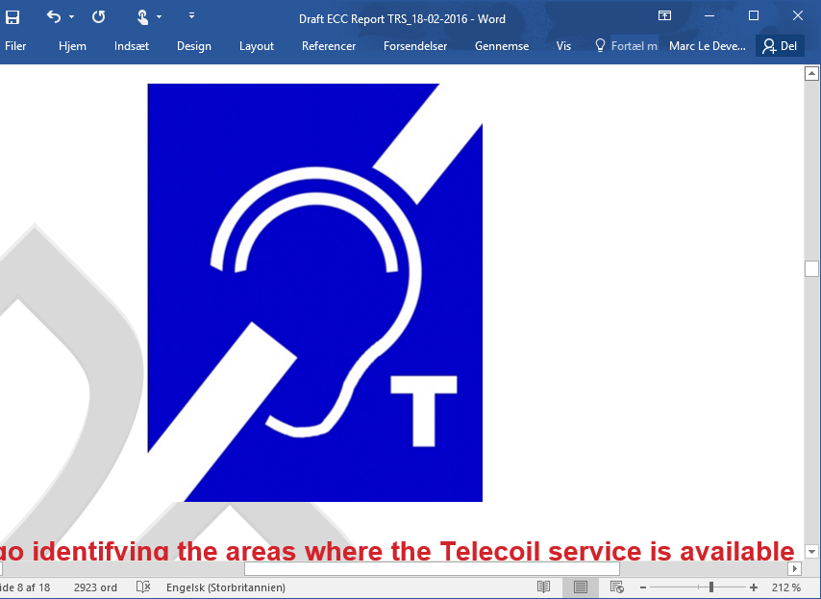

Figure 5 – Public sign for hearing loop presence

Small-area hearing loop systems include portable systems with integral loops and systems for counters and fixed help point systems designed to cover a very localised space and where the field outside the confines of the loop are used by the hearing instrument.

The majority of hearing instruments in use today are equipped with a telecoil, which picks up the transmitted magnetic field. Use of the telecoil is often enabled by selecting the "T" position or programme of the hearing instrument. In newer hearing instruments, the "T" input may be assigned to a user- selectable program that can be selected by (typically) operating a small push-button on the hearing instrument. To receive hearing loop system transmissions without a hearing instrument, a special "loop listener" is required.

The frequency range of human hearing is conventionally considered to be 20 Hz to 20 kHz. However, the extremes of this range are of lesser importance for intelligibility and so are not transmitted by a hearing loop system which operates between 10 Hz and 9 kHz. Compliance with [IEC 60118-4] requires a hearing loop system frequency response of 100 Hz to 5 kHz (±3 dB) with respect to the response at 1 kHz for hearing loop systems designed for hearing instrument use, but wider frequency responses up to 9 kHz may be required for non-hearing instrument use (e.g., tour guides) and for future developments of hearing instrument technology. See Figure 6.

Figure 6 – Audio frequency induction loop system (AFILS) typical spectrum usage

While the coupling between remote microphones and hearing instruments (or other listening devices) may be achieved by means of wires, infrared radiation or radio transmission, magnetic induction provides a simple and internationally accepted means by which the very large user base of hearing instruments with the uncomplicated and affordable T (telecoil) can receive the transmissions without the need for additional equipment. Additional equipment carries a dual disadvantage of stigmatising the user and creating an additional administrative burden for the management of the building.

Inductive systems rely on coupling an audio amplifier, e.g., for the microphone of a speaker in a lecture hall or a teacher in a classroom, directly to an induction loop system which directly transmits the rather low frequency audio signal as a radiated time varying magnetic field. Induction loop systems use a large coil antenna integrated in the floor of a large room for radiating the magnetic field. Once properly installed and given that the listener's hearing aids include "T" coils, an inductive loop system is undoubtedly the most convenient and possibly the most cost-effective ALS. To hear the audio, all a person has to do is enter the looped area and switch his/her personal hearing aids to the telecoil position. As long as the person's hearing aids include "T" coils, he or she always has an assistive device "receiver" available.

However, this technology also has some technical drawbacks which limit the range of applications of this technology. The physics of inductive coupling requires the receiving coil (T-Coil) to be perpendicularly oriented to the field of the sending coil or induction loop. This is sometimes difficult to achieve because the orientation of the induction loop is fixed, and the orientation of the T-Coil depends on how it is built into the hearing instrument and the person's orientation. Furthermore, the inductive transmission strongly depends on the distance between the sender and receiver which sometimes results in a weak signal. The receiver also always remains within the loop in order to receive a signal. External interferences (from power lines or fluorescent lights, computer monitors, copiers, fax machines, cell phones, etc.) creating background noises or distortions in the hearing instrument, are difficult to remove. Next, in school environments, several different systems are required for different classrooms. When applying two different systems in neighbouring classrooms it often is difficult to avoid spill over from one induction loop system to the next although recently technological progress has been made for reducing this problem. Furthermore, induction loop systems are not portable and can only be applied where they have been pre-installed.

## 6.2 Magnetic field strength

A correctly designed and installed hearing loop system complying with the requirements of [IEC 60118-4] with a 1 kHz sinewave input signal will be capable of producing an average magnetic field strength of 100 mA/m and a maximum magnetic field strength of 400 mA/m within the space where listeners' heads (and therefore hearing instruments) are expected to be. It should vary by no more than ±3 dB for a large-area hearing loop system and by no more than ±8 dB for small-area systems, measured with a true RMS meter with a 125 ms averaging time. The 400 mA/m upper level allows for the highest peaks in the programme material (speech or music).

Figure 7 – Small area counter hearing loop driver

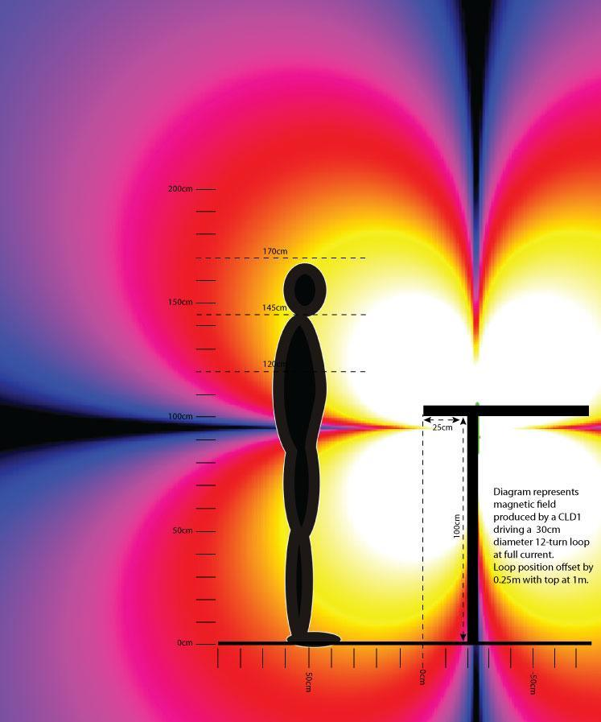

Figure 8 – FM systems

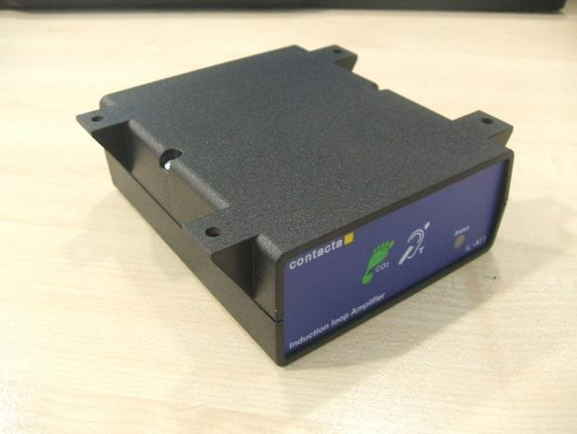

Figure 9 – Small-area hearing loop driver, typically installed under a counter

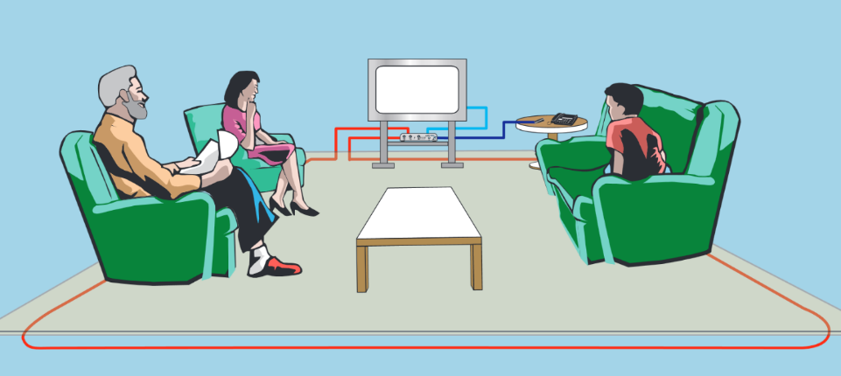

Figure 10 – Large-area domestic hearing loop

Figure 11 – Large-area domestic hearing loop driver

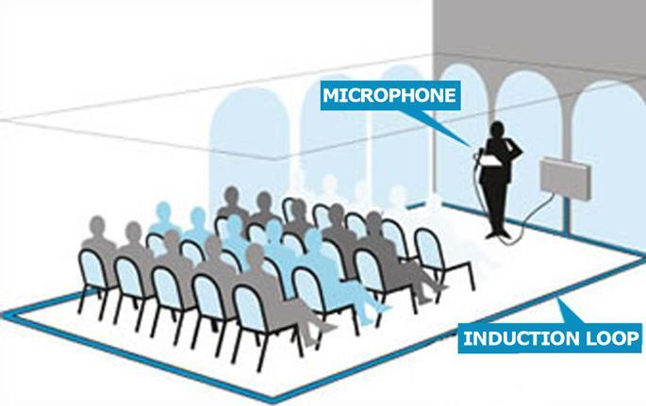

Figure 12 – Large-area meeting room hearing loop installation

## 6.3 Infrared systems

These are line of sight systems which can often be found in museums, each user requires a receiver which will normally have an audio output via headphones or small speakers; they do not directly connect to a hearing aid. Systems can be hired but please check that the coverage area is adequate for your event.

An IR system transmits audio signals via invisible infrared light waves. The frequency of infrared light falls somewhere between 700 nm and 1000+ nm; visible light waves fall between 400 nm and 700 nm. The specific bandwidth of the IR carrier varies among manufacturers; it may be as narrow as 50 nm wide, or considerably broader and perhaps be visible as a faint reddish glow [ETSI TR 102 791]. The audio signal, from any source, is used to frequency modulate an RF subcarrier which in turn is impressed upon, and essentially amplitude modulates, the IR carrier. An FM/AM double modulation of the IR light wave is the result. All IR systems are composed of three basic components: the transmitter (also called the modulator), the emitter and the IR receiver. The modulator processes the audio signal so that it can be transmitted via infrared light. For optimal transmission, the receiver has to be in a direct line of sight with the emitter which limits the distance or range of application of such systems. In large theatres or lecture halls, arrays of transmitters have to be installed in order to guarantee good sound quality on each seat. Furthermore, people should not be moving around a lot. Thus, in a home environment, for watching TV this might be a suitable solution while for a child in a classroom setting, other solutions probably allow more flexibility and thus should be preferred.

## 6.4 FM systems

Personal FM systems were first introduced for use by children who are deaf or hard of hearing in educational settings the middle and late 1960s. The initial systems were using the commercial Broadcast FM band 88 MHz to 108 MHz, and since the technology had already proven its importance to children in classrooms, a different portion of the radio spectrum had to be designated for wireless FM systems. In 1971, the FCC allocated the 72 MHz to 76 MHz band for use with audio enhancement devices for hard of hearing people. Much later, the 216 MHz to 217 MHz band was added which, because of the smaller wavelength, offered many additional technical advantages. In 2005, both the European Commission and CEPT have issued Decisions for harmonized use in Europe of parts of the band 169.4 MHz to 169.8 MHz for aids for hard of hearing people.

## 6.5 Devices operating at VHF and UHF frequencies

At present, a typical ALS comprises:

– a multi-frequency FM transmitter (body worn or handheld) with direct channel synchronization, entirely new multi-talker network possibility for team teaching environments or a Bluetooth connection to a mobile phone;

– a miniaturized multi-frequency receiver with flexible channel management. The receiver can be directly connected to the hearing aid or worn around the neck.

– In the school environment, a third component can be added to an FM System: an automatic channel synchronizer mounted on the wall of a room for all students entering that room.

During recent years, digitally operating hearing aid devices as well as digital ALSs operating at UHF frequencies have been placed on the market. Due to the lack of worldwide harmonized spectrum for these devices, hearing instruments' manufacturers have been forced to find appropriate solutions in the available 900 MHz and 2.4 GHz industrial, scientific and medical (ISM) bands.

NOTE – In Europe the 900 MHz ISM band is not available. Instead, the band 863-865 MHz is used for wireless audio applications.

The hearing aid devices, which are operating in these bands are body worn medical devices (in and around the ear). They can be described as body worn therapeutic medical devices used to provide improved medical treatment of a patient. The ALSs and the accessories for hearing aids can be also classified as medical devices or non-medical devices depending on their connection to the hearing instruments and their intended use.

Table 1 – Frequency bands of operation of FM transmitters

|  |  |  |
| --- | --- | --- |
| Region/Country | Class | Frequencies |
| Europe | Radio microphones and ALS | 169.4-169.8 MHz +173.965-174.015 MHz, plus parts of 174-216 MHz |
| USA, Canada | Low power radio services transmitters | 216-217 MHz |
| China | Wireless microphones | 189.9-223 MHz |
| Australia, New Zealand | Low interference potential devices | 173-174 MHz |
| Japan | Specified low power radio equipment | 169.4-169.8 MHz |

This large variety of frequencies has put the industry under pressure to further develop the FM technology to be able to cover as wide as possible a frequency range with only one type equipment and thus eliminating the need to change the transmitter when travelling for business or leisure. Additionally, different worldwide restrictions of the transmitter power level, channel bandwidth and spacing are further increasing the complexity of the regulatory situation and provide additional barriers to the access needs of hard of hearing users.

Figure 13 – Typical components of a personal FM system

## 6.6 Bluetooth systems

Many manufacturers now have available systems using the 2.4 GHz frequencies which are either built into the hearing aid or uses a neck loop to integrate the sound into the hearing aid, currently they are primarily for connection to mobile phones and are manufacturer specific. The major problem is that the 1.5V cells in an ALD do not have sufficient capacity to run the classic Bluetooth protocol and a new protocol is under development; however, one manufacturer has now built an ALD using classic Bluetooth and such systems will allow a conference style use.

## 6.7 Cochlear implants

Hearing assistive implant (HAI) technologies offer solutions for profound hearing loss for moderate conductive or sensorineural hearing losses.

Mainly there are five types of hearing assistive implant technologies. These technologies are described as middle ear implant (MEI), direct acoustic cochlear implant (DACI), cochlear implant (CI), auditory brainstem implant (ABI) and transcutaneous bone conduction implant.

Figure 14 – Positioning of implantable hearing solutions

Figure 15 – Functional block diagram of a typical HAI system (cochlear implant)

### 6.7.1 The closely coupled inductive loop

The hearing assistive implant (HAI) system contains an external portion that is referred to as the primary device and an implantable portion that is referred to as the secondary device. Both devices have coils (inductive loop) that are closely coupled and only a small layer of skin separates the primary coil from the secondary coil. The coupling factor varies typically between 0.1 and 0.4 for respectively 16 mm to 1 mm (centre to centre).

Figure 16 – A typical HAI system showing inductively coupled coils

Power as well as data is transferred from the primary device (LP-HAI-PP/PC) to the secondary implant device (LP-HAI) via the closely coupled coils over a same frequency. The primary and secondary coils are mostly concentric and their alignment is coaxial. Coaxial alignment is assisted by the presence of the magnets placed in the centre of the coil devices. Coaxial alignment gives the highest coupling factor for a given skin flap thickness, and hence best power efficiency. The data of the forward link is often modulated on the power carrier or may be time multiplexed (slots) with a dedicated power carrier slot and data timeslot as shown in Figure 17 for an auditory midbrain implant (AMI).

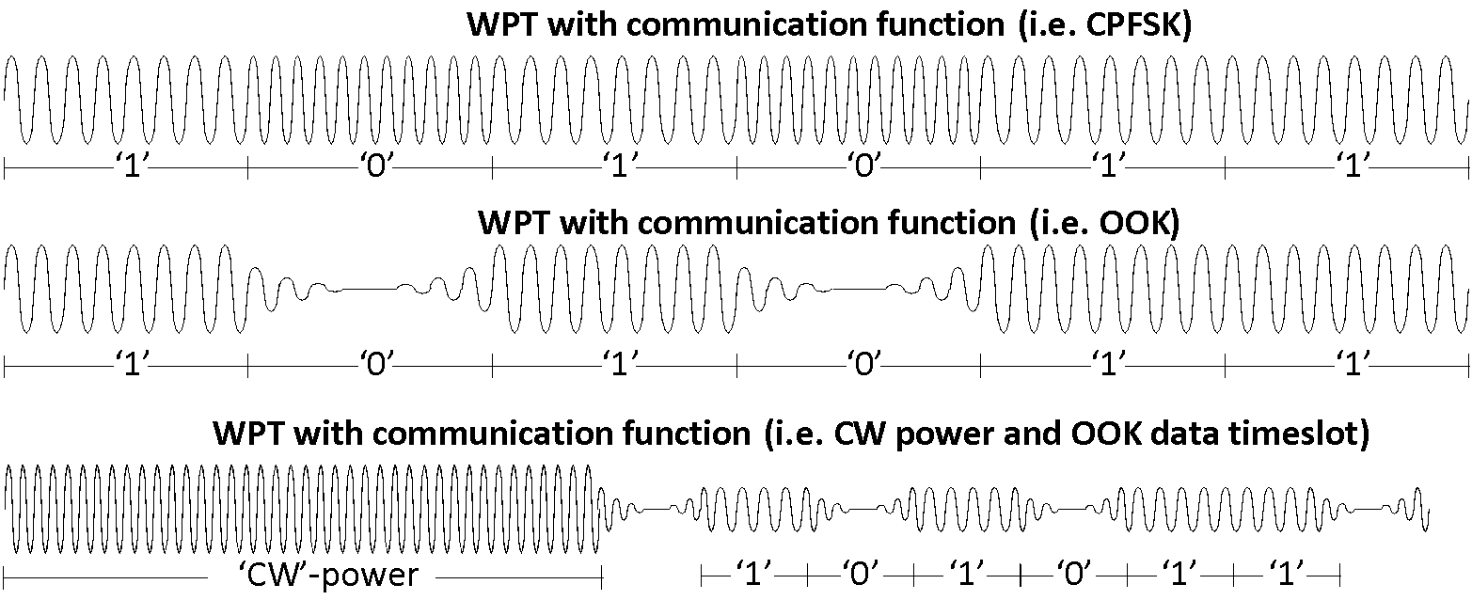

Figure 17 – The AMI power communication link, where the radiocommunication function coexists with the power transfer

The forward link is characterised as a wireless power transmission (WPT) system and could be regarded as radio equipment since including inherent radiocommunication functionality or radio determination via the WPT interface.

For conventional[2] HAI systems without an implant battery, it is impossible to remove or isolate the wireless power transmission from the communication function as the LP-HAI has no local power source.

The power carrier and data operate generally at the same frequency. However, for time-multiplexed systems the power carrier may operate at a different frequency than the data and here an isolated assessment is needed for the power and data timeslot.

### 6.7.2 Range of operating frequencies

The permitted range of operating frequencies denotes the respective frequency range for accommodation of the fundamental WPT frequency of the transmitter or the primary device. The typical operating frequencies with the respective typical data rates and stimulation rates (pulse per second) of existing HAI products on the market today are listed:

Table 2 – Operating frequency of existing HAI products

|  |  |  |  |  |  |
| --- | --- | --- | --- | --- | --- |
| Manufacturer | Operating frequency | Forward data rate | Stimulation rate (kpps) | Implant types | Remarks |
| Cochlear | 2.5 MHz | – | 4 kpps | N22 | Older implant series |
| Cochlear | 5 MHz | 0.5 Mbit/s (1 Msps) | 32 kpps | CI24M, CI24R, CI24RE, CI512, CI522, CI532, ABI541, CI612, CI622, CI632 |  |
| Cochlear | 13.56 MHz | <0.1 Mbit/s | N/A | Carina | Implant with rechargeable battery |
| Med-el | 12 MHz | 0.6 Mbit/s | 51 kpps | Synchrony, Synchrony ABI, Concert, Sonata |  |
| Nurotron | 16 MHz | 0.9 Mbit/s | 40 kpps | CS-10A |  |
| Oticon Medical | 4 MHz | – | 19 kpps | Digisonic SP, Digisonic EVO, Digisonic ABI, | Older implant series |
| Oticon Medical | 6 MHz | – | 24 kpps | Neuro Zti CLA, Neuro Zti EVO |  |

### 6.7.3 The external hearing use case

The external hearing use case relies on an external body worn sound processor (HAI-PP) containing a primary coil that is inductively coupled to the HAI. The HAI-PP provides a forward link to the HAI that contains power as well as (but not limited to) stimulation data that is derived from the environmental sound via the hearing algorithm. The HAI may have a small battery, a small tank capacitor and part of a conventional HAI system. This use case does not exclude trickle charging of the HAI battery.

Figure 18 – Conventional HAI systems transfer configuration, control, identification, programming, and monitoring and stimulation signals in combination with WPT

The radiocommunication function of these HAI systems must coexist with the power, or in other words the forward data communication function cannot exist by itself without power transmission. The communication function includes configuration, control, identification, programming, monitoring and stimulation signals in combination with WPT and referred as the AMI power and data communication link (AMIPDCL). The wireless power transfer is below 0.5 Watt.

The back link is referred to as the AMI telemetry communication link (AMITCL) and includes configuration, control, identification and monitoring. The back link is impedance loaded or pulsed at the same frequency of the forward link. Back links at different frequencies are out of scope (and deferred to other standards, SRDocs, TRs).

Table 3 – HAI system physical proportions versus wavelength and the WPT power

| Description | Limits |
| --- | --- |
| Use case | External hearing |
| Primary coil diameter | ≤ 40 mm |
| Secondary coil diameter | ≤ 40 mm |
| Wavelength operation frequency (< 30 MHz) | > 10 m |
| Shape of coils | Mostly concentric |
| Positioning of coils | Mostly coaxial |
| Clearance between coils (Planar) | ≤ 20 mm |
| Power class | < 0.5W |

### 6.7.4 VHF and UHF systems

Current systems employing VHF and UHF FM (sub-2 GHz) radio transmission are capable of providing communication over distances greater than those using the radio induction-field system, as they employ transmission via a radiation field which decays less rapidly with distance than does an induction field. Consequently, VHF and UHF radio transmission systems require that each transmission in any locale, such as a school classroom and its environs, be assigned a separate frequency channel.

VHF and UHF reception is generally less susceptible to interference from natural and manmade noise than reception at lower frequencies, and systems employing VHF and UHF radio transmission will be useful in many circumstances to avoid local problems of interference which affect the operation of the radio induction-field system.

Radiocommunication systems intended only for short-range communication can produce high field strengths at their required working distances, without radiating significant levels of power. Exploitation of the resulting possibilities of shared spectrum usage can result in improved spectrum utilization, and may allow large numbers of channels to be made available; for example to satisfy the requirements of large schools for any children with impaired hearing which is increasingly a requirement of national legislation and an objective for children above five weeks old in many countries.

Equipment may take a number of physical forms from add on receivers for behind the ear systems to belt mounted units and necklace units. Currently narrowband FM systems predominate for teaching systems with Bluetooth connectivity for mobile phones and some domestic equipment using radio local area network (LAN) technology for connection to multimedia terminals.

A scarcity of spectrum has meant that the narrowband fixed frequency channel equipment using a 100% duty cycle is not suitable for sharing with other services or short range devices (SRDs); therefore development of more spectrum efficient techniques such as frequency hopping and control from a remote database are currently under development. One such system is shown below.

### 6.7.5 Overview of the system

Wireless audio systems considered here transmit speech or audio from a microphone, over a digital radio link, to a receiver. An assistive listening system for use by the person with hearing loss in public spaces such as airports, railway stations, churches and theatres, where the transmitter is connected to the audio programme or public address system and the receiver is worn by deaf users, or integrated into users' hearing aids. Showing on the lower point of the screens is access to information about the time schedule or any emergency information, and in specific areas identified by a similar logo to one shown in Figure 5.

The use of digital technology, e.g., with 4GFSK modulation and low bit-rate audio coding, provides a balance between the need for good audio quality (a requirement to maintain intelligibility and minimise user fatigue), spectrum efficiency and range. These systems can work well between 150 MHz and about 2 GHz.

Depending on the available spectrum and coexistence requirements, systems expected to operate in approximately 200 kHz, 400 kHz and 600 kHz occupied bandwidth are outlined. The transmitter and receiver duty cycle is inversely proportional to the bandwidth, which means that the amount of spectrum resource used is roughly independent of the bandwidth, but the receiver power consumption is proportional to the duty cycle.

This means that a 600 kHz system would allow receivers to consume approximately 1/3 of the power of a 200 kHz system, which is highly beneficial in power-limited applications such as hearing aids. Wider bandwidth also decreases end-to-end delay, which is of benefit to many audio applications where the audio must maintain lip-sync with the talker in order to maximise intelligibility.

Below are the technical parameters for wireless communication systems for access for hard of hearing people to public services. The most appropriate channel bandwidth/parameters set should be chosen in accordance with coexistence requirements for the radio frequency band in which such a system would be realized.

Table 4 – TRS/ALD technical characteristics

|  |  |  |
| --- | --- | --- |
| Parameter | Unit | Value |
| Maximum EIRP for base station | dBm | 3 |
| Reference bandwidth | kHz | 600 |
| Antenna pattern | − | See Figure 19 |
| Duty cycle | % | 100 |
| Activity factor | % | 12.5 |
| Antenna gain | dBi | −15 for a user equipment (UE), representative for a small hearing aid |
| +6.4 boresight TRS Base Station (BS) or personal hub.  From Figure 1 the assumed antenna gain towards the satellite is −6 dBi without shielding. |
| TRS antenna height | m | 2.5 – 3 |
| Receiver thermal noise | dBm | −121 |
| Receiver noise figure | dB | 10 |
| Receiver noise floor | dBm | −111 |
| Receiver height | m | 1.6 |
| *I*/*N* protection criterion | dB | −10 |
| Interference protection level | dBm | −121 |

Figure 19 – TRS antenna radiation pattern

Table 5 – Calculated number of 600 kHz bandwidth TRS on one 600 kHz channel – Scenario 1

|  |  |  |  |  |  |
| --- | --- | --- | --- | --- | --- |
| Activity factor | Assumptions | Protection criteria 1% & wall loss 6 dB | Protection criteria 6% & wall loss 6 dB | Protection criteria 1% & wall loss 20 dB | Protection criteria 6% & wall loss 20 dB |
| 100% | Tx: 3 dBm, Gs: 46 dBi | 59 | 352 | 1472 | 8831 |
| Tx: 5 dBm, Gs: 41 dBi | 117 | 701 | 2937 | 17621 |
| Tx: 5 dBm, Gs: 46 dBi | 37 | 222 | 929 | 5572 |
| Tx: 12.5 dBm, Gs: 41 dBi | 21 | 125 | 522 | 3133 |
| 12% | Tx: 3 dBm, Gs: 46 dBi | 488 | 2930 | 12266 | 73593 |

# 7 Overview of interoperability between assistive listening devices

## 7.1 Introduction

Assistive listening devices (ALDs) have been with us for many years, and the T-coil system, the mainstay of worldwide hearing assistance, started in 1927.

Historically, hearing aids consisted of little more than basic "miniature audio amplifiers" placed in or behind their ear(s) solely boosting the incoming sounds. As semiconductor technology has evolved and become miniaturized, hearing impaired people enjoy extremely sophisticated digital systems incorporating a range of communication capabilities.

State-of-the-art technology uses specialized digital signal processing (DSP) technology that is advanced enough to fulfil the stringent mechanical (ultra-miniature) and power consumption (only one small single cell battery) requirements that are specified for modern hearing aid devices. DSPs manipulate the incoming sound spectrum mathematically, converting it into a digital representation; programmable software then manipulates this digital representation to achieve:

– background noise reduction;

– correction of patient specific deficiencies;

– enhancement of sound cues and other listening parameters used by the brain to reconstruct normal hearing.

An added positive factor was the worldwide availability of the 2.4 GHz spectrum for short range devices which provided a platform or ALDs.

This paper provides an overview of current technologies, facilities and interoperability.

## 7.2 T-Coil

Currently the T-coil system is the only system which will work on any T-Coil equipped hearing aid worldwide; this is required by legislation in a number of countries both for mobile phone and public buildings and they can be found in many shops and places of entertainment.

Mobile phone manufacturers and operators have sought to remove such legislation and replace the interoperability requirement with Bluetooth. To date this has been rejected.

NOTE – The legislative and interoperability requirements are subject to further study.

## 7.3 FM systems

Other than interoperability imposed by contracts, mainly governmental for education, normally achieved by a common "shoe" to take the transceiver there is no interoperability either between manufacturers or even between a manufacturer's models. Accessories such as TV streamers usually need replacing when changing models in most cases.

## 7.4 Bluetooth

The protocol currently only allows for connection to a single device via individual pairing.

Current market offerings from manufacturers have only interoperability with (most) mobile phones and again accessories are normally for a single model.

## 7.5 Bluetooth broadcast

This profile for Bluetooth (<https://www.bluetooth.com/learn-about-bluetooth/bluetooth-technology/le-audio/>) has been under development since 2012; its objective is twofold: to allow multiple devices to be connected, and to provide a common development platform. At the time of approval of this document, this technology was still under development.

## 7.6 TRS

Currently under development in Europe, it will have multiple channels and be targeted to such areas as railway station information boards where multiple languages can be of use; also for home entertainment where stereo is one option.

## 7.7 Infrared (IR) systems

A close-range directional system which again has no common standards and varies amongst manufacturers.

## 7.8 Software control of ALDs

Many manufacturers have introduced apps to allow selection of volume and other options on their devices; currently there is no common protocol and the facility is manufacturer specific.

# 8 Interference issues

All and any radio system can be subject to interference from several sources; some common issues are identified below.

## 8.1 T-Coil and body worn loops

These will pick up signals from a wide range of electrical devices such as inductive cooking hobs and large transformers (such as can be found in some streets or stations), and also various security systems found in shops and other places such as airports. Some lighting such as LED can also cause interference.

## 8.2 FM systems

These transmit and receive on a range of frequencies and will suffer interference if there is a physically adjacent transmitter on a similar frequency. For some older systems using the 169 MHz band adjacent taxicab transmitters gave occasional interference.

## 8.3 Bluetooth

Bluetooth was originally developed for military use and it is very good at shifting its channel to avoid interference. With the introduction of mobile phone systems in the adjacent spectrum considerable compatibility testing was undertaken and no problems were found.

Appendix I  
  
Current standards and regulations in Europe

## I.1 [IEC 60118-4]:2014

[IEC 60118-4] specifies requirements for the field strength in audio-frequency induction loops for hearing aid purposes, which will give adequate signal-to-noise ratio without overloading the hearing aid. The standard also specifies the minimum frequency response requirements for acceptable intelligibility.

Methods for measuring the magnetic field strength are specified, and information is given on appropriate measuring equipment, information that should be provided to the operator and users of the system, and other important considerations.

## I.2 [IEC 62489-1]:2010 and its amendments 1 (2014) and 2 (2017)

[IEC 62489-1] applies to the components of audio-frequency induction loop systems for assisted hearing. It may also be applied to such systems used for other purposes, as far as it is applicable. This standard is intended to encourage accurate and uniform presentation of manufacturers' specifications, which can be verified by standardized methods of measurement.

## I.3 [IEC 62489-2]:2014

[IEC 62489-2] is intended for assessment of human exposure to low-frequency magnetic fields produced by the system, by calculation and by in-situ testing. This standard does not deal with other aspects of safety, for which IEC 60065 applies, or with EMC.

## I.4 European Union

Three documents should be consulted for the European context:

– [ETSI EN 303 348] concerning the EU Radio Equipment Directive regulates frequencies used by T-Coil and their placing on the market;

– [ETSI EN 300-422-4] for the radio aspects of ALDs; and

– European Accessibility Act [b-EAA].

Bibliography

[b-Crandell-et-al] Crandell, C.C. & Smaldinom, J.J. (2000). *Classroom acoustics for children with normal hearing and with hearing impairment*. Language Speech and Hearing Services in Schools, 31, 362–370. <<https://doi.org/10.1044/0161-1461.3104.362>>

[b-EAA] European Accessibility Act

<<https://eur-lex.europa.eu/eli/dir/2019/882/oj>>

[b-Finitzo-Hieber- et-al] Finitzo-Hieber, T. & Tillman, T.W. (1978), *Room acoustics effects on monosyllabic word discrimination ability for normal and hearing impaired children*. Journal of Speech, Language, and Hearing Research, 21, 440–458.

<<https://doi.org/10.1044/jshr.2103.440>>

[b-IFHOH-B] International Federation of HoH (2017), *Future Loops Declaration, Berlin*.   
<<https://docs.wixstatic.com/ugd/4e728a_87b19b9597804fd1a3fcdb9f50af9c82.pdf>>

[b-IFHOH-W] International Federation of Hard of Hearing (2016), *Washington Declaration on Hearing Loops and T-coils*.

<<https://www.ifhoh.org/wd-2016>>

[b-Larsen-et-al] Larsen, J.B. & Blair, J.C. (2008), *The effect of classroom amplification on the signal-to-noise ratio in classrooms while class is in session*. Language Speech and Hearing Services in Schools, 39, 451–460.

<<https://doi.org/10.1044/0161-1461(2008/07-0032)>>

[b-Neuman-et-al] Neuman, A.C., Wroblewski, M., Hajicek, J. & Rubinstein, A. (2012), *Measuring speech recognition in children with cochlear implants in a virtual classroom*. Journal of Speech, Language, and Hearing Research, 55, 532–540.

<<https://doi.org/10.1044/1092-4388(2011/11-0058)>>

[b-Zanin-et-al] Zanin, J. & Rance G. (2016), *Functional hearing in the classroom: assistive listening devices for students with hearing impairment in a mainstream school setting*. International Journal of Audiology, 55, 12, 723-729.

<<https://doi.org/10.1080/14992027.2016.1225991>>

___________________

1. A single 1.5 V cell is typically used.
2. Conventional: The HAI systems released under the EC Radio and Telecommunications Terminal Equipment (R&TTE) directive 1999/5/EC, <https://eur-lex.europa.eu/legal-content/en/ALL/?uri=CELEX:31999L0005>.