Standardization Sector
ITU-T Technical Paper
(10/2025)
HSTP.DLT-PCP
Framework and requirements for distributed ledger technology-based sharing service and management of private charging piles
ITUPublications | International Telecommunication Union


Technical Paper ITU-T HSTP.DLT-PCP
Framework and requirements for distributed ledger technology-based sharing service and management of private charging piles

Summary
With the rapid growth of charging infrastructure, private charging piles (PCPs) often remain underutilized due to long idle times. Technical Paper ITU-T HSTP.DLT-PCP provides a general framework for distributed ledger technology (DLT)-based sharing service and management of PCPs, and, accordingly, describes the stakeholders and the related functional requirements and processes. It aims to improve the utilization of these charging resources by facilitating their sharing and optimizing the use of existing infrastructure.

Keywords
Charging service, distributed ledger technology, electric vehicle, private charging pile.

Note
This is an informative ITU-T publication. Mandatory provisions, such as those found in ITU-T Recommendations, are outside the scope of this publication. This publication should only be referenced bibliographically in ITU-T Recommendations.

© ITU 2026
All rights reserved. No part of this publication may be reproduced, by any means whatsoever, without the prior written permission of ITU.
Table of Contents
Page
1 Scope 1
2 References 1
3 Definitions 1
3.1 Terms defined elsewhere 1
3.2 Terms defined in this Technical Paper 1
4 Abbreviations and acronyms 1
5 Conventions 2
6 Background 2
7 Stakeholders of DLT-based sharing service and management of PCPs 2
8 Framework for DLT-based sharing service and management of PCPs 4
8.1 DLT layer 4
8.2 Service and management layer 5
9 Functional requirements for DLT-based sharing service and management of PCPs 5
9.1 DLT layer 5
9.2 Service and management layer 6
10 Process of DLT-based sharing service and management of PCPs 7
10.1 User registration and verification 7
10.2 PCP registration and verification 8
10.3 Search and discovery 8
10.4 Bookings and reservations 8
10.5 Payment processing 9
10.6 Charging sessions 9
10.7 Rating and feedback 9
10.8 Data analytics 9
Appendix I – Use cases of sharing service and management of PCPs 11
I.1 Common use case 11
I.2 The shared home-EV charger solution in the UK 11
I.3 The Share&Charge project in Germany 12
I.4 The sharing of EV charging stations in the United States 12
I.5 The development of PCP sharing in China 13
Bibliography 14

Technical Paper ITU-T HSTP.DLT-PCP
Framework and requirements for distributed ledger technology-based sharing service and management of private charging piles

1 Scope
This Technical Paper provides a general framework for distributed ledger technology (DLT)-based sharing service and management of private charging piles (PCPs) and, accordingly, describes the stakeholders and the related functional requirements and processes.
This Technical Paper is used as the guidance for the design, development and implementation of DLT‑based sharing service and the management of PCPs or related products for electric vehicles (EVs).

2 References
[ITU-T F.751.0] Recommendation ITU-T F.751.0 (2020), Requirements for distributed ledger systems.
[ITU-T F.751.2] Recommendation ITU-T F.751.2 (2020), Reference framework for distributed ledger technologies.
[ITU-T F.751.9] Recommendation ITU-T F.751.9 (2023), Trusted execution environment based confidential computing on distributed ledger technology systems.

3 Definitions

3.1 Terms defined elsewhere
This Technical Paper uses the following terms defined elsewhere:
3.1.1 distributed ledger [b-ITU-T X.1400]: A type of ledger that is shared, replicated, and synchronized in a distributed and decentralized manner.
3.1.2 distributed ledger technology [b-ISO 22739]: Technology that enables the operation and use of distributed ledgers.
3.1.3 electric vehicle [b-ISO 15118-1]: All road vehicles, including plug-in hybrid road vehicles (PHEVs), that derive all or part of their energy from on-board rechargeable energy storage systems (RESS).
3.1.4 power grid [b-ITU-T F.751.5]: The whole consisting of substations of various voltages and transmission and distribution lines in the power system.
3.1.5 smart contract [b-ITU-T X.1400]: A program written on a distributed ledger system which encodes the rules for specific types of distributed ledger system transactions in a way that can be validated, and triggered by specific conditions.

3.2 Terms defined in this Technical Paper
None.

4 Abbreviations and acronyms
This Technical Paper uses the following abbreviations and acronyms:
DLT Distributed Ledger Technology
EV Electric Vehicle
ID Identity
IoT Internet of Things
P2P Person to Person
PCP Private Charging Pile
PHEV Plug-in Hybrid Road Vehicle
QR Quick Response
RESS Rechargeable Energy Storage System
RFID Radio Frequency Identification
TEE Trusted Execution Environment

5 Conventions
None.

6 Background
As the global focus shifts towards sustainable energy and the dual carbon goals of reducing emissions and enhancing energy efficiency, EVs have become increasingly popular. This surge in EV adoption highlights the urgent need for accessible and efficient charging infrastructure. However, the development of public charging piles has not kept pace with the rapid growth of EVs. Many PCP owners, such as residential users and businesses, are often left with underutilized charging resources, while EV drivers face challenges in finding convenient charging options. This mismatch creates an opportunity for a sharing service of PCPs that can optimize resource utilization and enhance charging accessibility.
Despite the potential benefits of PCP sharing, several challenges must be addressed to create a functional and efficient system. Key issues include the lack of a reliable platform for connecting charging pile owners with EV users, concerns over payment and billing transparency, and the need for secure management of user data and transactions. Additionally, the variability in charging pile availability and the diverse needs of EV users complicate the matching process. Without a robust solution, these challenges can hinder the widespread adoption of the sharing services of PCPs, limiting their effectiveness and appeal.
The introduction of DLT offers a promising solution to the challenges faced by the sharing services of PCPs. DLT can create a decentralized and transparent platform that securely connects charging pile owners with EV users, facilitating real-time availability updates and efficient booking processes. By utilizing smart contracts, transactions can be automated, ensuring transparent billing and reducing the risk of disputes. Furthermore, DLT enhances data security and privacy, allowing users to maintain control over their information while participating in the network. Overall, the integration of DLT can streamline operations, foster trust among users and drive the successful adoption of sharing service and management of PCPs in the evolving landscape of electric mobility.
More use cases of sharing service and management of PCPs are illustrated in Appendix I.

7 Stakeholders of DLT-based sharing service and management of PCPs
The development and deployment of a DLT-based sharing service and management of PCPs in the EV ecosystem involves a variety of stakeholders, each playing a crucial role in ensuring the system operates efficiently, transparently and securely. As shown in Figure 1, from EV owners seeking accessible charging solutions to regulatory bodies ensuring compliance with industry standards, the collaboration between these stakeholders enables a decentralized and effective service.
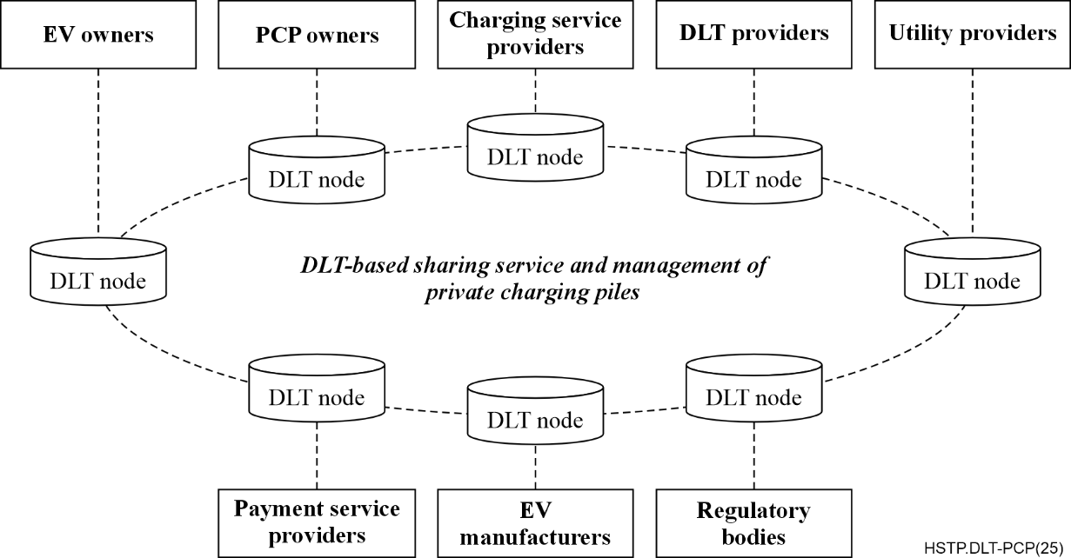
Figure 1 – Stakeholders of DLT-based sharing service and management of PCPs
The stakeholders involved in the DLT-based sharing service and management of PCPs are as follows:
– EV owners: These are the owners of EVs. They are the primary users of the sharing service of PCPs and trade with charging pile owners via smart contracts to obtain charging services through PCPs, with factors like location, price and reputation influencing the process.
– PCP owners: These are individuals or businesses owning PCPs. They can lease their charging piles through the sharing service, optimizing their underutilized resources and earning income while offering charging services to EV owners.
– Charging service providers: They are companies that manage the platform facilitating the sharing service of PCPs. These providers ensure the seamless connection between EV owners and PCP owners, handling booking, payments and platform maintenance.
– DLT providers: These are entities responsible for implementing and maintaining the DLT infrastructure. They ensure the security, transparency and immutability of data and transactions within the platform.
– Utility providers: These are the organizations supplying electricity to the charging piles, typically through power grids. They ensure a reliable power supply for the charging infrastructure, especially during high-demand periods.
– Payment service providers: These are financial institutions or platforms processing transactions within the sharing service of PCPs. They handle the secure transfer of funds, ensuring transparent billing and a smooth payment experience for both EV owners and PCP owners.
– EV manufacturers: These are companies that produce EVs. They may work with the sharing service of PCPs to ensure compatibility between their vehicles and the charging piles, promoting seamless integration for EV owners.
– Regulatory bodies: They are local, regional or national bodies that set rules and regulations for EVs and charging infrastructure. Regulatory bodies ensure the system's compliance with energy efficiency, safety and environmental standards.

8 Framework for DLT-based sharing service and management of PCPs
The framework for DLT-based sharing service and management of PCPs is illustrated in Figure 2. It is divided into two layers, which are further detailed as:
– DLT layer: This provides the DLT basic functions required to support the sharing of PCPs, including P2P service, distributed ledger, consensus mechanism, smart contract, privacy computing, and on-chain and off-chain collaboration.
– Service and management layer: This provides support for the service and management process of PCP sharing, including user management, PCP management, booking and reservation, rating management, payment management and data analytics.
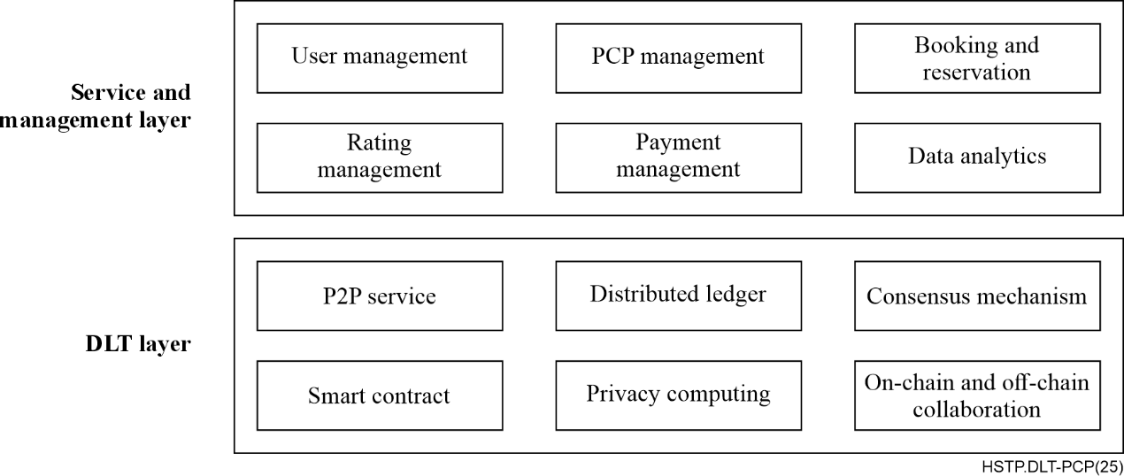
Figure 2 – Framework for DLT-based sharing service and management of
PCPs

8.1 DLT layer
The DLT layer is comprised of the following functional modules:
– P2P service: This enables direct interaction between users and charging piles, decentralizing the booking and transaction management process. It reduces intermediary costs and enhances system reliability and scalability.
– Distributed ledger: This records all transactions, ensuring data transparency, immutability and decentralization. It builds trust in the system by preventing data tampering and ensuring all transactions are traceable.
– Consensus mechanism: This validates transactions using open algorithms, ensuring that only legitimate transactions are recorded, preventing double-spending and fraud.
– Smart contract: This automatically executes predefined terms, reducing manual intervention. It ensures that transactions are executed as agreed, enhancing automation and trust between users.
– Privacy computing: This enhances security by protecting sensitive data from unauthorized access and tampering. It utilizes encryption and authentication protocols to ensure the confidentiality of transactions and smart contract logic. Additionally, it boosts the network's resilience by creating a secure environment for executing critical operations.
– On-chain and off-chain collaboration: This enables increased scalability, faster transactions and integration with existing DLT systems. It involves processing transactions and storing data both on the chain (on-chain) and outside the chain (off-chain), allowing for efficient and flexible DLT applications.

8.2 Service and management layer
The service and management layer is comprised of the following functional modules:
– User management: This is responsible for handling user registration, authentication and profile management. This module ensures that users can securely create accounts and log in, while also providing the ability to edit and update personal information. Through effective user management, the system maintains essential user data and enhances overall user experience.
– PCP management: This allows charging pile owners to register and manage their charging stations. It includes functionalities for entering details such as location, availability, charging speed and pricing. This module ensures that charging pile information is accurate and up to date, enabling users to easily find and utilize available charging resources.
– Booking and reservation: This facilitates the process of searching for, reserving and managing charging slots. Users can search for available charging piles based on various criteria such as location and availability, and make immediate or scheduled bookings. This module streamlines the reservation process, ensuring that EV drivers can efficiently secure charging times that suit their needs.
– Rating management: This enables EV drivers to provide feedback and ratings for charging pile owners based on their experiences. This module fosters a culture of transparency and accountability by allowing users to share their thoughts on the service quality. Additionally, it provides charging pile owners with valuable insights into customer satisfaction, helping them improve their services.
– Payment management: This handles secure payment processing for users, integrating various payment methods. It ensures that transactions are processed smoothly and securely, while also allowing users to view their transaction history. This module is crucial for maintaining trust and convenience in financial interactions within the system.
– Data analytics: This provides insights into usage patterns, peak times and user demographics, for both charging pile owners and the system itself. It generates performance reports that help charging pile owners assess their service effectiveness and identify areas for improvement. This module uses data to inform decision-making and optimize the overall operation of the charging network.

9 Functional requirements for DLT-based sharing service and management of PCPs

9.1 DLT layer
The functional requirement for P2P service, consensus mechanisms, smart contracts and distributed ledger modules is as follows:
– It should comply with clauses 7 and 8 of [ITU-T F.751.0] and clause 7 of [ITU-T F.751.2].
The functional requirement for the privacy computing module is as follows:
– It should adopt the trusted execution environment (TEE) solution for DLT system and comply with clause 8 of [ITU-T F.751.9].
The functional requirements for the on-chain and off-chain collaboration module are as follows:
– It should maintain the data integrity across both on-chain and off-chain sources to prevent discrepancies and ensure trustworthiness.
– It should synchronize on-chain and off-chain data to ensure consistency and accuracy across the system.
– It should ensure that the collaboration between on-chain and off-chain is scalable, to handle increasing data volumes as the user base and charging piles grow.
– It should implement secure methods for transferring data between on-chain and off-chain environments to protect sensitive information.
– It should support cross-platform compatibility, allowing smooth interaction between various technologies and platforms with on-chain and off-chain systems.

9.2 Service and management layer
The functional requirements for the user management module are as follows:
– It should securely register and authenticate user accounts using industry-standard encryption and authentication methods.
– It should update and manage user personal information, ensuring accuracy and relevance.
– It should allow users to recover their accounts through secure password reset and recovery options.
– It should define and manage user roles and permissions, ensuring different access levels for regular users, admins and charging pile owners.
– It should securely store user data and comply with privacy and data protection regulations.
The functional requirements for the PCP management module are as follows:
– It should register and manage charging stations by charging pile owners, ensuring accurate and up-to-date information.
– It should allow charging pile owners to update key details, such as location, availability, pricing and charging speed.
– It should reflect charging pile availability in real time, providing users with up-to-date status information.
– It should support categorization of charging piles by type, location and service features, enabling efficient user searches.
– It should notify charging pile owners of bookings, cancellations and maintenance requests, to ensure smooth operations.
The functional requirements for the booking and reservation module are as follows:
– It should search for available charging piles based on location, availability and other filters.
– It should support both immediate and scheduled reservations for users, providing flexibility in booking.
– It should allow users to modify or cancel their bookings within predefined time frames, ensuring convenience and flexibility.
– It should send real-time notifications to users about their reservation status (confirmation, cancellation, changes, etc.).
– It should streamline the reservation process, ensuring quick, straightforward booking without unnecessary steps or confusion.
The functional requirements for the rating management module are as follows:
– It should allow users to rate charging pile services based on their experience, providing valuable feedback to charging pile owners.
– It should allow users to leave written reviews in addition to ratings, to improve service transparency.
– It should aggregate ratings and reviews to provide an overall score for each charging pile, reflecting its quality of service.
– It should notify charging pile owners of new ratings and reviews, allowing them to respond and improve services.
– It should protect the rating system against fraud or abuse, ensuring fair and accurate user feedback.
The functional requirements for the payment management module are as follows:
– It should integrate multiple secure payment methods (e.g., credit cards and mobile wallets) to ensure convenience for users.
– It should process payment transactions securely using encryption and compliance with financial regulations.
– It should allow users to view a history of their transactions, including payments, refunds and receipts.
– It should support automated payment for reservations and services, ensuring efficiency and reducing manual intervention.
– It should provide real-time payment confirmation and alerts to both users and charging pile owners.
The functional requirements for the data analytics module are as follows:
– It should track and analyse usage patterns, including peak usage times and charging preferences.
– It should provide charging pile owners with performance reports and insights into their service effectiveness, user feedback and operational trends.
– It should provide demographic insights about users to inform marketing and service improvement strategies.
– It should identify trends in charging demand, enabling better resource planning and management.
– It should allow the generation of custom reports, enabling both system administrators and charging pile owners to make data-driven decisions.

10 Process of DLT-based sharing service and management of PCPs
The full process of DLT-based sharing service and management of PCPs are mainly comprised of eight sub-processes: user registration and verification, PCP registration and verification, search and discovery, booking and reservation, payment processing, charging session, rating and feedback, and data analytics, which are further detailed in clauses 10.1 to 10.8.

10.1 User registration and verification
This process authenticates EV owners and charging pile owners before they access the system. Key steps include:
– User registration: Users create an account by filling out an online form with essential information, such as name, email, phone number and EV details. This data forms the basis for their profile and initiates the verification process.
– Identity (ID) verification: Users upload identification documents (e.g., government-issued IDs or driver's licences) for authenticity checks. Automated tools may be used to verify these documents to ensure they are legitimate, thereby enhancing system security.
– Data validation: The system cross-references user information with external databases to confirm accuracy. Discrepancies, such as mismatched names or invalid IDs, are flagged, ensuring only trustworthy individuals access the system.
– Verification outcome: Users receive notifications about their registration status. Approved users get confirmation and access instructions, while rejected users are informed of the reasons for denial, promoting transparency.
– Onboarding: Approved users log in for the first time and complete their profiles, including payment information and charging preferences. This onboarding process enhances the user experience and ensures users can effectively navigate the system.

10.2 PCP registration and verification
This process ensures that charging pile owners are registered before they access the system, which is similar to user registration and verification. Key steps include:
– PCP information submission: Charging pile owners initiate the registration by filling out an online form that collects essential information, such as location, type, power rating and availability of the PCP. This information is critical for creating the charging pile's profile within the system.
– ID verification: After submitting the information, charging pile owners must upload identification documents (e.g., business licences or personal IDs). Automated tools verify the authenticity of these documents to ensure that only legitimate owners can register their charging piles.
– Data validation: The system cross-references the submitted charging pile information with external databases to confirm accuracy and legitimacy. Any discrepancies, such as incorrect location data or invalid identification, are flagged to maintain the integrity of the charging pile registry.
– Verification outcome: Once the verification process is complete, owners receive notifications regarding their registration status. Approved owners receive confirmation and instructions on how to manage their charging pile, while rejected owners are informed of the reasons for denial, ensuring transparency in the process.
– Onboarding: Approved owners log in to the system for the first time and are guided, through a series of prompts, to complete their profiles, including setting pricing, availability and maintenance details for their charging piles. This onboarding process enhances the user experience and ensures owners can effectively manage their charging piles within the system.

10.3 Search and discovery
This process allows users to find available charging piles that meet their needs. Key steps include:
– Initiate search: Users begin by entering their current location and specific preferences (such as charging speed or type) into the system to initiate a search for available charging piles nearby.
– Display results: The system generates and displays a list of charging piles that match the search criteria, presenting essential information such as the location, charging type, availability status and estimated wait times.
– View details: Users can select individual charging piles from the list, to view detailed information, including specifications, user ratings, amenities and any associated costs, helping them make informed choices.

10.4 Bookings and reservations
This process enables users to reserve a charging pile for their desired time. Key steps include:
– Select PCP: After reviewing the search results, users choose a specific charging pile that fits their needs and click to proceed with the booking process, initiating a smart contract that outlines the terms of the reservation.
– Choose time slot: Users then select their preferred time slot for charging, ensuring it aligns with their schedule and confirming the availability of the chosen charging pile during that period.
– Confirm reservation: Users review the booking details, including the selected charging pile and time, and confirm the reservation. The smart contract is executed, providing users with a booking confirmation that includes all related information and any specific instructions for accessing the charging pile.

10.5 Payment processing
This process facilitates secure payment transactions for reservations made by users. Key steps include:
– Initiate payment: After confirming their reservation, users are prompted to proceed with payment, where they can choose their preferred payment method, such as credit card, digital wallet or other options, with the transaction details recorded on the distributed ledger.
– Process transaction: The system securely processes the payment by employing encryption and security measures to protect sensitive user information and ensure a safe transaction, all while maintaining a transparent record on the DLT nodes.
– Payment confirmation: Upon successful completion of the transaction, users receive an immediate confirmation of payment, which includes a receipt detailing the transaction amount, date, and any relevant booking information for their records, all verified through the distributed ledger.

10.6 Charging sessions
This process allows users to utilize the charging pile during their reserved time. Key steps include:
– Access PCP: Upon arrival at the charging pile, users access it using the designated method, such as scanning a quick response (QR) code through the app or using a radio frequency identification (RFID) card, ensuring a smooth entry into the charging service, with access recorded on the distributed ledger.
– Monitor charging: During the charging session, the system provides real-time updates on the charging status, including the current charge level, estimated time remaining, and notifications for any issues that may arise.
– End session: Once the charging is complete, users receive a notification to disconnect their EV. The system finalizes the session, updates the smart contract to reflect the completed service, and may prompt users to provide feedback on their experience.

10.7 Rating and feedback
This process encourages users to share their experiences after using the charging service. Key steps include:
– Provide rating: After completing the charging session, users are prompted to rate on a scale their experience with the charging pile, reflecting their level of satisfaction with the service.
– Submit feedback: Users have the opportunity to provide additional comments or feedback regarding their experience, including any suggestions for improvement or specific issues encountered during the session.
– Owner response: Charging pile owners receive notifications about the ratings and feedback submitted by users, allowing them to respond directly to any concerns or comments, thus fostering better communication and service improvement.

10.8 Data analytics
This process involves analysing data to improve service quality and user experience. Key steps include:
– Collect data: The system automatically gathers data related to user interactions, charging session metrics and feedback submitted, creating a comprehensive dataset for analysis.
– Analyse trends: The collected data is analysed to identify trends in user behaviour, peak usage times and preferences, helping to understand how the service is utilized and where improvements are needed.
– Generate insights: The system generates actionable insights based on the analysis, informing decisions for service enhancements, operational adjustments and strategies to improve user satisfaction and engagement.

Appendix I
Use cases of sharing service and management of PCPs

I.1 Common use case
When an EV is running low on power, the user urgently needs to locate a charging station. However, they may discover that no public charging piles are available nearby or that there is a lengthy wait for access.
Using the navigation system provided by map operators, the EV user can identify several shared PCPs in the vicinity. In this scenario, depicted in Figure I.1, the user has the option to navigate to one of these selected PCPs. Additionally, they can reach out online to the owner of the charging pile to negotiate terms and complete the EV charging process.
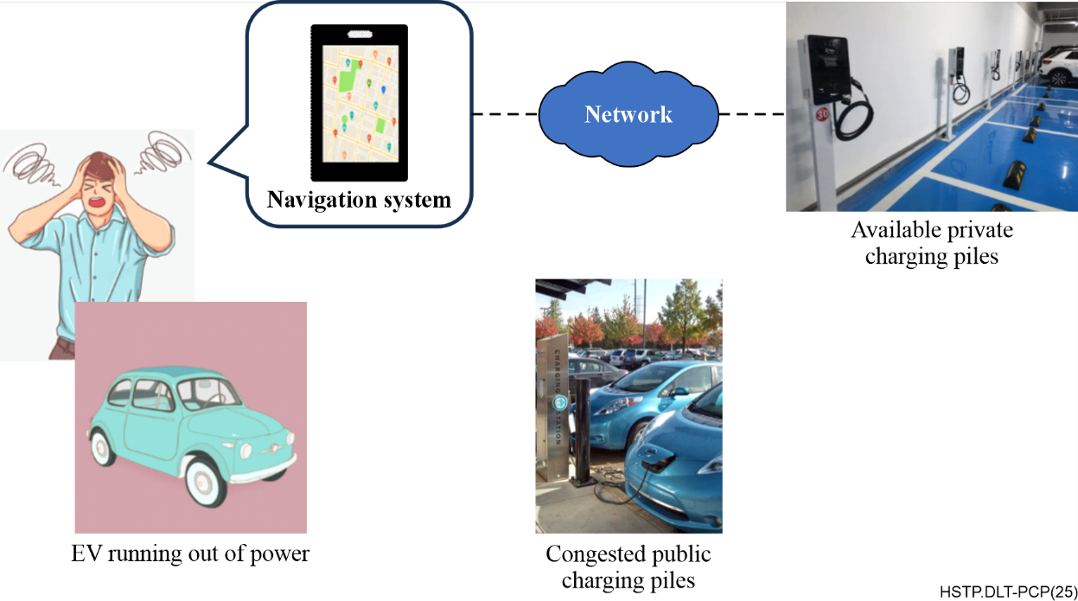
Figure I.1 – Finding alternative charging solutions for EV users

I.2 The shared home-EV charger solution in the UK
The UK government has a target of installing 300 000 public charging points by 2030. However, as of January 2023, only around 37 000 public charging points are available. The government is failing to keep pace with the growth in EV sales, which increased from 190 000 in 2021 to 327 000 in 2022. The lack of charging infrastructure is a barrier to EV adoption, as drivers are concerned about not being able to find a place to charge their vehicles.
Shared home-EV chargers offer a decentralized and community-driven approach to charging solutions. Platforms like www.joosup.com and www.chargie.com facilitate the sharing of private charging stations among EV owners, creating a network that compliments public charging infrastructure. This model taps into the existing resources of individuals who have home charging capabilities and are willing to share them with fellow EV users. The added benefit of platforms such as these is they provides reliable, bookable and highly affordable EV charging, making it accessible to all.
For example, www.chargie.com plays an important role in community charging in the UK by providing a platform that makes it easy for EV drivers to find and use private charging points, while also providing a revenue opportunity for charging point owners. The platform encourages neighbourly sharing and helps to increase the availability of EV charging infrastructure in the UK.

I.3 The Share&Charge project in Germany
The Share&Charge project in Germany is a DLT-based EV charging platform designed to address the challenges of insufficient EV charging infrastructure and payment transparency. Developed by Innogy, a subsidiary of RWE, in collaboration with Internet of things (IoT) company Slock.it, the platform uses Ethereum's smart contracts to enable the sharing and transparent transactions of charging stations.
As described in the common use case, users can find nearby shared charging stations via a smartphone app, where they can view pricing information. Charging is facilitated through a smart socket connection, allowing users to confirm transactions and access charging data directly from their mobile devices.
The platform allows private and commercial charging station owners to rent out their chargers and set their own rates, enabling direct transactions between EV owners and charging station operators without third-party involvement. This P2P model increases the efficiency of charging infrastructure usage while reducing the financial burden on government budgets.
Additionally, Share&Charge incorporates cryptocurrency payment options, providing EV owners with more flexible payment methods, although this feature is not yet widely adopted. The success of the project has led to a similar initiative being launched in the United States, further expanding its reach and impact.
In terms of implementation, Share&Charge has established hundreds of DLT-based charging stations in Germany. Users must register through the app and verify their accounts, and can deposit fiat currency into a digital wallet for automatic payments via the Ethereum blockchain upon connecting to a charging station. Pricing is optimized in real-time based on local grid demands, ensuring a traceable and transparent process.

I.4 The sharing of EV charging stations in the United States
The EV market in the United States is experiencing significant growth, driven by increasing consumer demand, advancements in technology and supportive government policies aimed at reducing carbon emissions. As more individuals and businesses transition to EVs, the need for accessible and convenient charging solutions becomes paramount. This burgeoning market has led to the development of various platforms that facilitate the sharing of private charging stations, enhancing the overall charging infrastructure. Among these platforms are www.evmatch.com, www.chargepoint.com and www.plugshare.com, each playing a unique role in promoting EV charging accessibility.
EVMATCH is a platform designed to facilitate the sharing of EV charging stations among private users. It connects EV owners with individuals or businesses that have charging stations available for use. The platform emphasizes community engagement, allowing users to find nearby chargers, reserve them in advance, and even earn money by sharing their own charging stations. EVMATCH aims to enhance the accessibility of charging infrastructure, particularly in areas where public charging options may be limited.
ChargePoint is one of the largest networks of EV charging stations, offering a comprehensive solution for both public and private charging needs. While it primarily focuses on commercial and public charging solutions, ChargePoint also supports private charging station owners by providing them with the tools to manage their chargers. Users can find ChargePoint stations via the mobile app, monitor charging sessions and access various payment options. ChargePoint's extensive network and user-friendly interface make it a popular choice for EV owners looking for reliable charging solutions.
PlugShare is a community-driven platform that provides a comprehensive map of EV charging stations, including both public and private options. Users can search for charging locations, read reviews and check real-time availability. PlugShare allows private charging station owners to list their chargers, enabling them to share their facilities with other EV drivers. The platform fosters a sense of community among EV users by encouraging sharing and collaboration, making it easier for drivers to find charging solutions wherever they go.
In summary, these platforms collectively contribute to the growing ecosystem of EV charging by promoting the sharing of private charging stations and enhancing the overall accessibility of charging infrastructure in the United States.

I.5 The development of PCP sharing in China
In China, there are also many cases of PCP sharing. These use cases mainly utilize the idle hours of PCPs by allowing them to be opened for use by other EV owners in need of charging.
For example, Beijing Huashang Sanyou New Energy Technology Co., Ltd. has launched the "Yuyichong" app, which allows private pile owners to share their charging stations with nearby EV owners who lack access to charging facilities. This initiative addresses issues such as insufficient community parking spaces and challenges in installing charging piles. This use case has received support from national policies, as the Chinese government is encouraging new approaches such as "nearby parking space sharing" and "multiple vehicles sharing one pile".
Additionally, State Grid Changzhou Electric Vehicle Service Co., Ltd. has introduced a "private pile sharing" service on its platform, aiming to utilize idle PCP resources to meet the growing demand for EV charging. Similarly, WM-Motor has rolled out a "private pile sharing" service in the Beijing-Tianjin-Hebei region, allowing users to open up their home charging stations during idle times for other EV users to use for a fee.
Shanghai is also exploring the "private pile sharing" model, with multiple companies offering services that enable PCPs to become "shared chargers", facilitating access for other vehicles. This approach not only enhances the utilization of charging stations but also generates extra income for the owners.
However, the PCP sharing model faces several challenges, including issues related to low charging power, incompatible vehicle interfaces, and limitations due to the lack of interoperability among platforms. Therefore, promoting the development of this sharing model requires coordinated efforts between the government, enterprises and individuals, along with enhanced public awareness and market-driven incentives through appropriate subsidies. Given the challenges and complexities involved, it is becoming increasingly urgent to establish relevant standards for PCP sharing, as proposed in this Technical Paper.

Bibliography

[b-ITU-T F.751.5] Recommendation ITU-T F.751.5 (2022), Requirements for distributed ledger technology-based power grid data management.
[b-ITU-T X.1400] Recommendation ITU-T X.1400 (2020), Terms and definitions for distributed ledger technology.
[b-ISO 15118-1] ISO 15118-1:2019, Road vehicles – Vehicle to grid communication interface – Part 1: General information and use-case definition.
[b-ISO 22739] ISO 22739:2024, Blockchain and distributed ledger technologies – Vocabulary.
___________

