 |  | International Telecommunication Union
 |  | ITU-T | Technical Paper
 |  | TELECOMMUNICATION  STANDARDIZATION SECTOR  OF ITU |  | (30 April 2021)
HSTP.CONF-H870
Testing of personal audio systems for compliance with ITU-T H.870 (2018)

Summary
This Technical Paper describes the testing of the compliance of various personal audio systems/devices to the essential/mandatory and optional features of Recommendation ITU-T H.870 (2018).

Note
This is an informative ITU-T publication. Mandatory provisions, such as those found in ITU-T Recommendations, are outside the scope of this publication. This publication should only be referenced bibliographically in ITU-T Recommendations.

Keywords
Conformance testing, safe listening, H.870.

Change Log
This document contains Version 1 of the ITU-T Technical Paper HSTP.CONF-H870 "Testing of personal audio systems for compliance with ITU-T H.870" approved at the ITU-T Study Group 16 meeting held online, 19-30 April 2021.

Editors: | Shelly Chadha  WHO | E-mail: chadhas@who.int
 | Ian Wiggins  Nottingham University, UK | E-mail: ian.wiggins@nottingham.ac.uk

Table of Contents
Page
1 Scope 1
2 References 1
3 Definitions 1
3.1 Terms defined elsewhere 1
3.2 Terms defined in this Technical Paper 2
4 Abbreviations 2
5 Conventions 3
6 Background 3
7 Conformance table 5
7.1 Acoustic dosimeter functionality 5
7.2 Communication 7
Appendix I – Example of testing process of dosimetry functionality 10
Appendix II – Mandatory and recommended features and examples of application 12
Bibliography 15

Technical Paper ITU-T HSTP.CONF-H870
Testing of personal audio systems for compliance with ITU-T H.870

1 Scope
This Technical Paper describes the testing of the compliance of various personal audio systems/devices to the essential/mandatory and optional features of [ITU-T H.870].

2 References
The following ITU-T Recommendations and other references contain provisions which, through reference in this text, constitute provisions of this Technical Paper. At the time of publication, the editions indicated were valid. All Recommendations and other references are subject to revision; users of this Technical Paper are therefore encouraged to investigate the possibility of applying the most recent edition of the Recommendations and other references listed below. A list of the currently valid ITU-T Recommendations is regularly published. The reference to a document within this Technical Paper does not give it, as a stand-alone document, the status of a Recommendation.
[ITU-T H.870] Recommendation ITU-T H.870 (2018), Guidelines for safe listening devices/systems.
[ITU-T P.10] Recommendation ITU-T P.10 (2017), Vocabulary for performance, quality of service and quality of experience.
[ITU-T P.360] Recommendation ITU-T P.360 (2006), Efficiency of devices for preventing the occurrence of excessive acoustic pressure by telephone receivers and assessment of daily noise exposure of telephone users.
[EN 50332-1] CENELEC EN 50332-1 (2013), Sound system equipment: Headphones and earphones associated with personal music players. Maximum sound pressure level measurement methodology – Part 1: General method for "one package equipment".
[EN 50332-2] CENELEC EN 50332-2 (2013), Sound system equipment: Headphones and earphones associated with personal music players – Maximum sound pressure level measurement methodology – Part 2: Matching of sets with headphones if either or both are offered separately or are offered as one package equipment but with standardised connectors between the two allowing to combine components of different manufacturers or different design.
[EN 50332-3] CENELEC EN 50332-3 (2017), Sound system equipment: Headphones and earphones associated with personal music players – Maximum sound pressure level measurement methodology – Part 3: Measurement method for sound dose management.
[IEC 62368-1] IEC 62368-1:2018, Audio/video, information and communication technology equipment – Part 1: Safety requirements.

3 Definitions

3.1 Terms defined elsewhere
This Technical Paper uses the following terms defined elsewhere:
3.1.1 calculated sound dose [IEC 62368-1]: One week rolling estimate of sound exposure expressed in percent of the maximum regarded as safe.
3.1.2 dBA [ITU-T H.870]: Decibels of sound pressure level measured using the A-weighting network; a level intended to measure low-intensity noise (around 40 phon loudness level) but that has also become commonly used for measuring occupational and environmental noise exposures.
3.1.3 head and torso simulator (HATS) [ITU-T P.10]: Manikin extending downward from the top of the head to the waist, designed to simulate the sound pick-up characteristics and the acoustic diffraction produced by a median human adult and to reproduce the acoustic field generated by the human mouth.
3.1.4 personal audio system (PAS) [ITU-T H.870]: A system of a personal audio device and a listening device.
3.1.5 personal audio device (PAD) [ITU-T H.870]: A portable device designed to be worn on the body or fit in the clothing pocket. It is designed to allow the user to listen to various forms of media. An example of a personal audio device is a personal media player (PMP).
3.1.6 personal audio system (PAS) [ITU-T H.870]: A system of a personal audio device and a listening device.
3.1.7 (sound) dose [ITU-T H.870]: The total quantity of sound received by the human ear during a specified period. In the context of this Recommendation, it is the same as sound exposure (see 3.1.8). The unit of (sound) dose is Pa²h.
3.1.8 sound exposure [EN 50332-3]: A-weighted sound pressure, 𝑝𝐴, squared and integrated over a stated period of time between t2 and t1:
𝐸 = ∫𝑡2(𝑝𝐴(𝑡))2d𝑡
3.1.9 sound pressure level [b-ITU-R V.574-5]: The logarithm, generally expressed in decibels, of the ratio of sound pressure and a reference pressure, often 20 μPa.
𝑆𝑃𝐿 = 20 log₁₀ $(\frac{p}{pA})$

3.2 Terms defined in this Technical Paper
This Technical Paper defines the following term:
3.2.1 acoustic dosimeter functionality: The measurement system within the personal audio system for measurement of sound exposure and sound dose.

4 Abbreviations
This Technical Paper uses the following abbreviations and acronyms:
CSD Calculated Sound Dose
dBA Decibels of sound pressure level measured using the A-weighting network
dBV Decibels or dB referenced to 1 Volt
HATS Head and Torso Simulator
M Mandatory
O Optional
PAD Personal Audio Device
PAS Personal Audio System
R Recommended
RMS Root Mean Squared

5 Conventions
In this Technical Paper:
5.1 Three types of compliance are used:
– Mandatory (M): elements of the baseline Recommendation that are required to be implemented.
NOTE – In Tables 7-1 and 7-2, mandatory elements are indicated in bold.
– Recommended (R): elements of the baseline Recommendation that are not mandatory but strongly recommended to be implemented.
– Optional (O): elements of the baseline Recommendation that are not mandatory but considered of value to the user.
5.2 In clause 7, the conformance table includes the methodology of testing. Indicator for compliance is reflected as:
– Questions that have to be answered for compliance are indicated in italics.
– Responses are indicated as:
o Yes: which refers to a single question posed under methodology of testing
o Yes, for all: which refers to more than one question posed under methodology of testing

6 Background
Globally, over a billion young people (12-35 years old) are at risk of hearing loss due to their unsafe listening practices, i.e., listening to music over their personal audio systems, at a loud volume and for prolonged time-periods [b-WHO, 2015]. Given the fact that the prevalence of hearing loss is anticipated to rise sharply in the coming decades, this poses a significant public health challenge [b-WHO, 2018]. To address this, the WHO launched the "Make Listening Safe" initiative in 2015 [b-WHO, 2015]. This initiative focusses on:
– The development, promotion and implementation of the [ITU-T H.870] ([b-WHO-ITU, 2019)], Guidelines for safe listening devices/systems.
– Communication campaigns and materials for changing listening behaviours in the target populations.
– Developing and promoting adoption of a regulatory framework for control of exposure to sound in entertainment venues.
The guidelines for safe listening devices/systems [ITU-T H.870] form a key part of WHO's strategy for ear and hearing care, as part of implementing the World Health Assembly Resolution WHA70.13 [b-WHO, 2017]. The purpose of these guidelines is to promote safe listening practices among users of personal audio devices/systems with the aim to prevent the occurrence of hearing loss as a result of use of these technologies.
The guidelines include a number of mandatory and optional recommendations relating to:
– Estimation of sound output and listening time to estimate the calculated sound dose for the listener.
– Ability of user to select one of two modes, i.e., standard level for adults (reference exposure equal to 1.6 Pa²h per 7 days) or standard level for children (reference exposure equal to 0.51 Pa²h per 7 days).
– Providing information on the calculated sound dose and personal usage to the user along with warnings, messages and cues for action through the device interface.
– Providing information on safe listening and risks associated with unsafe listening.
– Volume limiting option.
– Parental control option.
This Technical Paper is meant as a complement to the ITU-T H.870 guidelines. The purpose is to:
– Assist manufacturers of personal audio devices/systems in determining compliance of their devices with the ITU-T H.870 guidelines through a checklist.
– Provide a framework for testing the compliance of devices, for the purpose of inclusion in the ITU repository and the issue of a safe listening QR code.

7 Conformance table
Tables 7-1 and 7-2 provide details on testing the mandatory and optional features of [ITU-T H.870].
Appendix II provides a list of mandatory and recommended features along with some examples of their implementation.

7.1 Acoustic dosimeter functionality
Table 7-1 provides details on testing the mandatory and optional features of the acoustic dosimeter functionality.
Table 7-1 – Procedures for verification of the dosimeter functionality
 | Type | No. | Features | [ITU-T H.870] clause | Methodology for testing | Indicator for compliance
 | M | 1.1 | System to track the user's exposure time, sound level and % | 8.1 | To verify the dosimeter functionality:  – Set the PAD to play at a given output level  – Measure how long it takes to reach 100% sound allowance  – Assess whether the time taken falls within an acceptable range  Refer to Appendix I for example on testing methodology.  • Does the time until the dose estimate reaches 100% CSD comply with tolerances as described in [EN 50332-3]? | Yes
 | M | 1.2 | Media playback | 7.1
 | R | 2.1 | Two modes of reference exposure | 7.1 | Check each mode separately where the intended user of the device (adult or child) is not specified.  • Are the two modes available and functioning? | Yes
 | R | 2.2 | Choice of mode | 7.1 | Note the choice of mode at the time of first use of the device.  • Are the two mode choices presented?  Reset the device.  • Is the choice presented again?  Go into settings and look for the option to change the mode setting (with respect to safe listening features) of the device.  • Is it possible to change the mode through the settings? | Yes, for all the steps
 | O | 3. | Volume-limiting option | 13.1 | Look at the settings option with respect to audio.  • Is there a volume limiting option available in these settings?  • Is the option set as the default option on the device? | Yes, for all
 | O | 4 | Password-protected volume control | 13.2 | Look at the settings option with respect to audio.  • Is there a volume control option, whereby the maximum sound output can be fixed and locked in the settings? | Yes
 | O | 5 | Acute or transient noises | 14 | • Has the manufacturer confirmed that reasonable steps have been taken to minimize any risk of hearing damage due to acute or transient sounds?  NOTE – Definitive pass/fail criteria are for further study. E.g., using the methodology in [ITU-T P.360] (2006) on efficiency of devices for preventing the occurrence of excessive acoustic pressure by telephone receivers and assessment of daily noise exposure of telephone users. | Yes

7.2 Communication
Table 7-2 provides the features and methodology for communication testing.
Table 7-2 – Features and methodology for communication testing
 | Type | No. | Features | [H.870] clause | Methodology for testing | Indicator for compliance
 | M | 6.1 | Information and messages on safe listening | 11.2.1 | Play music on the system (PAD and earphone/headphone) at a high-volume for a period of time.  Follow the path indicated within the device with a visual interface to gain access to personal usage information.  Is personal usage information on listening parameters, i.e., use of daily/weekly sound allowance given through the device? | Yes
 |  |  | Personal usage information | 11.2.1.1
 | O | 6.2 | Additional information on personal usage | 11.2.1.1 | Review again the display of information as was done for 6.1. Review the information available to user  • Is there information display on:  a) the average sound level for the day and week?  b) the time for which the user has listened in hours and minutes over the day and the week? | Yes, for all
 | O | 6.3 | Daily summary | 11.2.1.2 | Use the device over 2-3 days.  • Do you receive a daily summary message giving your parameters for the previous day? | Yes
 | M | 7.1 | Warnings and cues for actions | 11.2.1.2 | Let the signal play on the system till 100% dose is reached.  • Does the device give a warning message upon reaching 100% dose?  • Is it accompanied by cues for action?  • Does the warning indicate that continuing to listen at the same volume will pose a risk for the listener's hearing? | Yes, for all
 | O | 7.2 | Additional messages | 11.2.1.2 | Play the device again and note at what levels you receive messages.  • Are there additional messages, e.g., when reaching 50% or 80% of the dose? | Yes
 | O | 7.3 | Functionality of cues for action | 11.2.1.2 | Let the signal play on the system till 100% dose is reached.  Review the options provided to the user  • Are there detailed options similar to those listed below?  o automatic safe volume option, by which the device automatically changes the volume to a safe volume level;  o direct access to volume settings;  o set up of default volume limits;  o remind later;  o ignore and continue.  Check their functionality.  • Are they all functional? | Yes
 | O | 7.4 | Volume-limiting functionality | 11.2.1.2 | Following the cues (indicated in 7.3), do not select any of the given options.  • Does the average volume reduce automatically? | Yes
 | M | 8.1 | Information display and access | 11.2.2 | In devices with screens, access the safe listening information.  • Is information on safe listening, its benefits, and risks of unsafe listening provided? | Yes
 | R | 8.2 | Information display and access – icon | 11.2.2 | • Is there a clear icon on the home screen that indicates information on safe listening?  • Does this icon lead to display of information on safe listening, its benefits, and risks of unsafe listening? | Yes, for all
 | O | 8.3 | Informational tutorial | 11.2.2 | Is there a pathway available through which a user can learn about the safe listening features of their device and how to use them?  • Does the tutorial also include links to webpages where user can find more information? | Yes, for all
 | M | 9.1 | The instruction/user manual | 11.2.3.1 | • Does the manual clearly state that unsafe listening practices with the use of this device could lead to permanent hearing loss? | Yes
 | O | 9.2 | The instruction/user manual: detailed information | 11.2.3.1 | Does the user manual:  • clearly outline how the allowance-assessment system works and refer to its uncertainty?  • clearly indicate that information on the device does not take into account additional sources of sound exposures either from other audio devices or environmental sound exposure?  • provide information regarding hearing protections from loud environmental sounds, in order to minimize the risk of hearing loss?  • give details of the volume-limiting functions and cues for action? | Yes, for all
 | O | 10 | Device packaging | 11.2.3.2 | • Is information about safe listening features of the device included on or in the packaging? | Yes
 | O | 11 | Manufacturer website | 11.2.3.3 | • Is there display of information on the manufacturer's website, regarding what is safe listening and its benefits, as well as the risks posed by unsafe listening? | Yes

Appendix I
Example of testing process of dosimetry functionality
Appendix I provides an example of the testing process of the dosimetry functionality.
The following steps give the outline of the process:
1. Media path identification and set-up as outlined in clauses 6.2.3 and 8.1.3 of [ITU H.870]
1.1. Load a file containing the simulated programme signal into the PAS to be tested [EN 50332-1].
1.2. Determine if the PAD/PAS is to be measured at an electrical analogue or headphone acoustic output.
1.2.1. If analogue, connect a 32Ω resistive load to each channel of the PAD headphone output and a true RMS voltmeter. If needed, configure the PAD to output played media over the analogue output.
1.2.2. If headphone, use the headphone provided as part of the combined PAS, or else a sample headphone of any model which the PAD is compatible with, having a stored value for electro-acoustic sensitivity. Set up a head and torso simulator (HATS) whose ear simulator outputs are connected to equipment which can determine the A-weighted level after diffuse-field correction as outlined in clause II.4 of [ITU H.870] .
2. Confirm the intended market for the PAD/PAS according to clause 7.1 of [ITU H.870].
Guidelines for safe listening distinguish between a PAD/PAS that is intended to be used by adults or by children. In some instances, the intended user group may not be specified, and the PAD/PAS has the ability to do either. In that case both implementations should be tested.
2.1. If the intended users are adults (Mode 1) then 100% CSD = 1.6 Pa²h and the default (optional) volume limit when applied is 80 dBA.
2.2. If the intended users are children (Mode 2) then 100% CSD = 0.51 Pa²h and the default (optional) volume limit when applied is 75 dBA.
3. Test of dosimeter functionality according to clause 8.1.3 of [ITU H.870] and 6.4 of [EN 50332-1].
3.1. Adjust the volume controls of the PAD/PAS to the maximum setting. Adjust any tone or equalization controls to a neutral setting.
3.2. If measuring the PAS output acoustically, seat the headphone on the HATS to maximize the sound pressure level detailed in 6.2. of [EN 50332-1].
3.2.1. Reset the CSD measurement in line with the manufacturer's verification procedure guidance.
3.2.2. Start playing the simulated programme signal and simultaneously start a timer. Monitor the CSD value.
3.2.3. If measuring the PAS output acoustically, measure the level in dBA (diffuse-field referred) at each of the HATS ears, averaging over time as specified. If measuring the PAD output electrically, measure the output voltage in dBV. In each case, calculate the energetic average of the left and right values and denote the average as L₁. The energetic average is calculated using the equation:
$$L_{1}={\text{10 × log}}_{10}\left(\frac{{10}^{(Left ear value in dB / 10)}+{10}^{(Right ear value in dB / 10)}}{2}\right)$$
3.2.4. Verify that the PAD displays accumulated sound dose, average listening level corresponding to the value in clause 3.2.3 of [ITU-T H.870] to within the defined error margin and elapsed time since reset that approximately matches the timer being used according to clause 11.2.1.1 of [ITU H.870]. The error margins are those found in [EN 50332-3] namely ±3 dB for acoustical measurements and ±1 dB for electrical measurements.
3.2.5. Note the elapsed time T₁ in minutes at which the CSD measurement indicates 100% dose. The indication shall include both a warning and cue for action as outlined in clause 11.2.1.2(a) of [ITU-H.870].
3.3. If measuring the PAS output acoustically, repeat steps 3.2.1 through 3.2.5 four more times (reseating the headphone on the HATS each time) and arithmetically average the five resulting values L₁ to L₅ to get a single overall value L_{mean}. Arithmetically average the five elapsed time values T₁ to T₅ to get a single overall elapsed time T_{mean}. If measuring the PAS output electrically then L_{mean} = L₁ and T_{mean} = T₁.
3.4. On the last seating of the headphone, when the cue for action appears, do not acknowledge the message. If the PAD/PAS implements the (optional) volume-limiting feature as outlined in clause 11.2.1.2 of [ITU H.870] , continue playing the programme simulation signal and verify that the measured output level has been automatically reduced to the relevant default volume limit given in step 2 (or alternative volume limit set explicitly by the user), within the error margin described in step 3.2.4.
3.5. Compute the time T_{100%@max} at which a 100% sound exposure dose is theoretically reached at level L_{mean} using the 100% CSD value from § 2. If measuring the PAS output acoustically use the equation:
$$T_{100\%@max}=60×\frac{100\% CSD}{{10}^{{\left(L_{mean}–94\right)}/{10}}}.$$
If measuring the PAS output electrically use the equation:
$$T_{100\%@max}=60×\frac{100\% CSD}{{10}^{{\left(L_{mean}+22.48\right)}/{10}}}.$$
Verify that the measured T_{mean} is equal to T_{100%@max} within the tolerances given in [EN 50332-3]:
– For acoustical measurements (based on ±3 dB time equivalents):
$$0.5×T_{100\%@max}≤T_{mean}≤2×T_{100\%@max}$$
– For electrical measurements (based on ±1 dB time equivalents):
$$0.7943×T_{100\%@max}≤T_{mean}≤1.2589×T_{100\%@max}$$
If following the recommendation given in clause 8.1.3 of [ITU H.870] to verify dosimeter functionality as volume control settings are varied, proceed to step 3.6. (Note – A similar procedure may be followed to verify dosimeter functionality as programme content level is varied.)
3.6. Lower the output volume of the PAD/PAS by 3 dB relative to the last measured value L. If an exact 3 dB adjustment is not possible given the volume control on the PAD/PAS, then the nearest volume setting which results in a level at least 3 dB less than L shall be used. Reset the CSD measurement, simultaneously start a timer, then measure the output level reduction ∆L relative to L (for an exact 3 dB reduction in level, $∆L=-3$ dB) and the elapsed time to 100% CSD. The elapsed time shall be
$$T_{100\%@max}×{10}^{{–∆L}/{10}}$$
to within error margins given in clause II.12 of [ITU-T H.870].

Appendix II
Mandatory and recommended features and examples of application
This appendix outlines mandatory and recommended features and examples of application. Table II.1 presents a summary of the mandatory and recommended features for compliant ITU-T H.870 implementations. Figures II.1 to II.4 show examples of applications of various features numbered in Tables 7-1 and 7-2 of this Technical Paper.
Table II.1 – Summary of the mandatory and recommended features
Type | No. (clause 7) | Features | [ITU-T H.870] clause
M | 1.1 | System to track the user's exposure time, sound level and % | 8.1
M | 1.2 | Media playback | 7.1
R | 2.1 | Two modes of reference exposure | 7.1
R | 2.2 | Choice of mode | 7.1
M | 6.1 | Personal usage information | 11.2.1.1
M | 7.1 | Warnings and cues for actions | 11.2.1.2
M | 8.1 | Information display and access | 11.2.2
R | 8.2 | Information display and access -icon | 11.2.2
M | 9.1 | The instruction/user manual | 11.2; 11.2.3

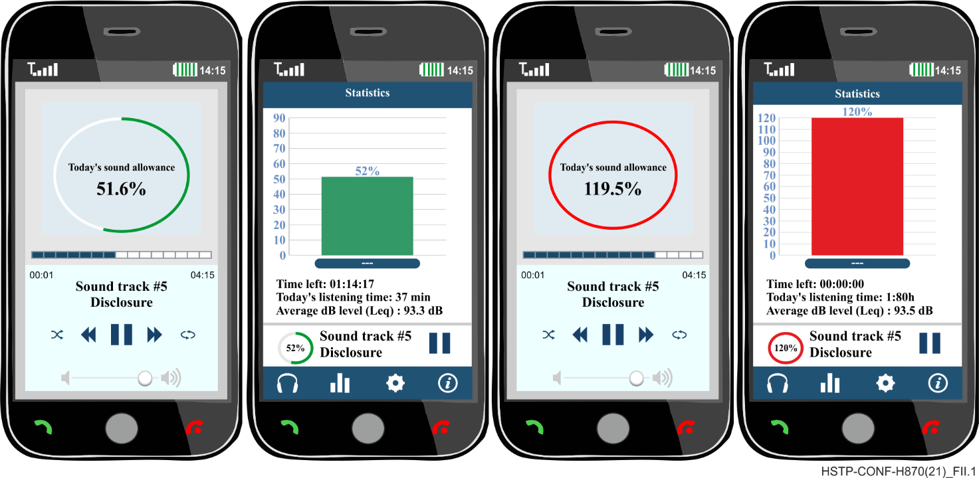
Figure II.1 – Example of implementation of personal usage information
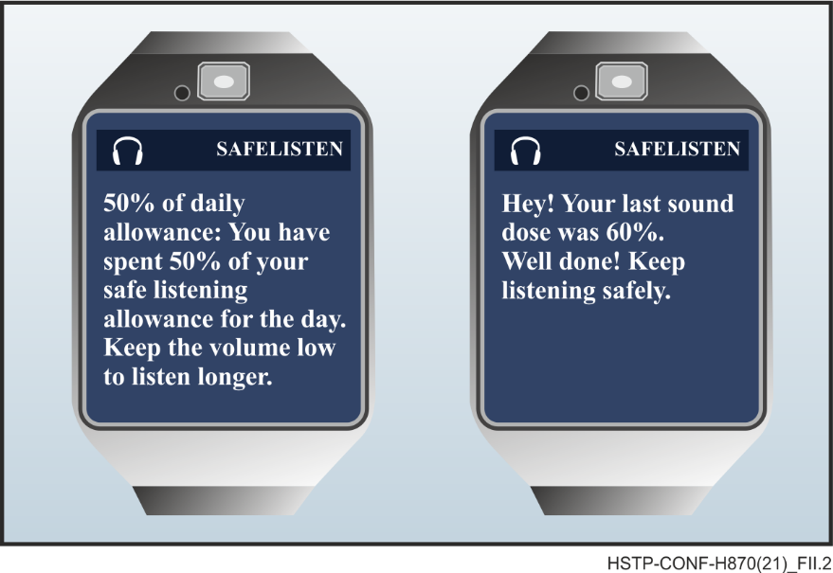
Figure II.2 – Example of implementation of warnings and cues for actions
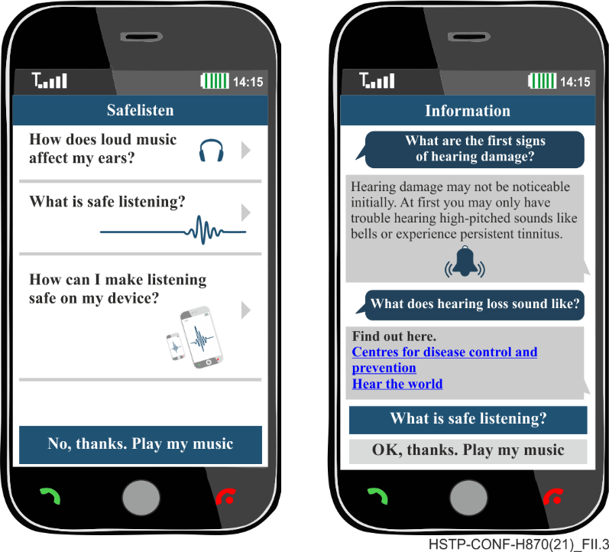
Figure II.3 – Example of implementation of information display and access
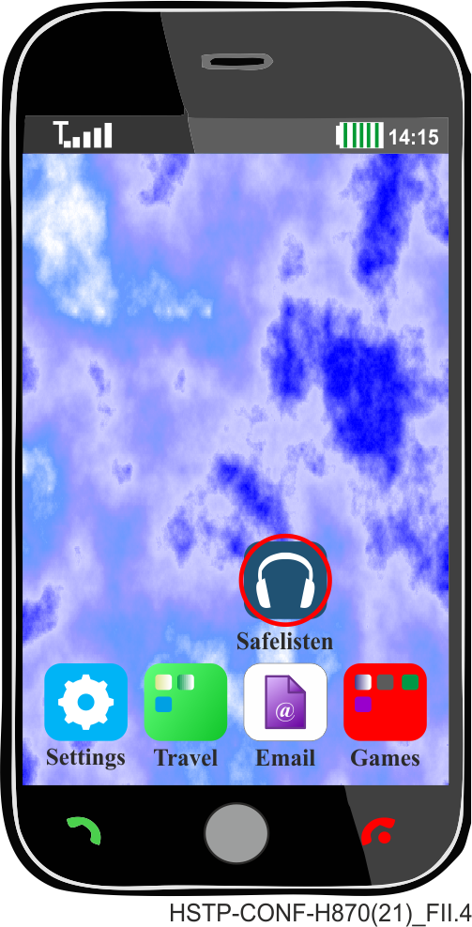
Figure II.4 – Example of implementation of information display and access -icon

Bibliography

[b-ITU-T P.380] Recommendation ITU-T P.380 (2003), Electro-acoustic measurements on headsets.
[b-ITU-T P.381] Recommendation ITU-T P.381 (2020), Technical requirements and test methods for the universal wired headset or headphone interface of digital mobile terminals.
[b-ITU-R V.574-5] Recommendation ITU-T V.574-5 (2015), Use of the decibel and the neper in telecommunications.
[b-WHO, 2015] WHO (2015), New WHO-ITU Standard aims to prevent hearing loss among 1.1 billion young people.
[b-WHO, 2017] WHA70.13 (2017), Prevention of deafness and hearing loss.
[b-WHO, 2018] World Health Organization (2018), Deafness and hearing loss, <http://www.who.int/news-room/fact-sheets/detail/deafness-and-hearing-loss>
[b-WHO-ITU, 2019] WHO-ITU (2019), Safe listening devices/systems.
<https://apps.who.int/iris/bitstream/handle/10665/280085/9789241515276-eng.pdf>

___________________

