Standardization Sector
ITU-T Technical Report
(09/2025)
ESTR.AICNHM
Artificial intelligence for communications: Towards natural disaster management
ITUPublications | International Telecommunication Union


Technical Report ITU-T ESTR.AICNHM
Artificial intelligence for communications: Towards natural disaster management

Summary
Technical Report ITU-T ESTR.AICNHM focuses on AI-based communications systems for application before, during, and immediately after a natural disaster. This Technical Report aims to provide an overview of the current state of the art by surveying scientific literature, reviewing the relevant technologies presented at workshops of FG-AI4NDM, and investigating use cases derived from the various topic groups. Technical and social aspects are explored, including the development of AI-based communications systems, the inclusion of stakeholders in the development process, the role of ethical considerations in the development process, and the implementation of such technologies. Accordingly, the benefits and challenges of AI-based relative to traditional technologies with a focus on several communities are discussed.

Keywords
AI chatbots, artificial intelligence, disasters, disaster management, disaster recovery, hazard maps, multi-hazard communications, natural disaster response.

Note
This is an informative ITU-T publication. Mandatory provisions, such as those found in ITU-T Recommendations, are outside the scope of this publication. This publication should only be referenced bibliographically in ITU-T Recommendations.

© ITU 2026
All rights reserved. No part of this publication may be reproduced, by any means whatsoever, without the prior written permission of ITU.

Table of Contents
Page
1 Scope 1
2 References 1
3 Definitions 1
3.1 Terms defined elsewhere 1
3.2 Terms defined in this Technical Report 2
4 Abbreviations and acronyms 2
5 Overview and state of the art 3
6 Communications systems that can leverage AI: Description and system-specific suggestions 7
6.1 Alerts and early warning systems 9
6.2 Forecasts 11
6.3 Hazard maps 13
6.4 Decision support systems 17
6.5 Dashboards and applications (apps) 19
6.6 AI chatbots 22
7 Suggestions applicable to various types of AI for natural disaster management (NDM) communication systems 24
8 Topic group (TG) use cases 31
9 Conclusion 31
Annex A – List of use-cases 33
Appendix I – Key concepts 90
I.1 Geospatial mapping 90
I.2 Vulnerability 90
I.3 Susceptibility 91
Bibliography 93

Technical Report ITU-T ESTR.AICNHM
Artificial intelligence for communications: Towards natural disaster management

1 Scope
The Focus Group on AI for Natural Disaster Management (FG-AI4NDM) was established by ITU in December 2020 in partnership with the World Meteorological Organization (WMO) and the UN Environment Program (UNEP). FG-AI4NDM's objective is to help lay the groundwork for best practices in the use of AI for assisting with data collection and handling, improving modelling across spatiotemporal scales, and providing effective communication.
With growing amounts of data available, from sensors to social media, AI can be a game changer, strengthening the ability to prepare and respond to disasters in getting information faster and more accurately, increasing understanding, and providing situational awareness. In order to facilitate interpretation of detection and forecasting results, AI insights need to be translated and visualised according to the end-user needs. Therefore, it is critical that stakeholders, from local communities to emergency system managers, be included in the design and evaluation of alerts and early warning systems, forecasts, hazards maps, decision support systems, dashboards, chatbots, and other AI-enhanced communication tools.
This Technical Report focuses on AI-based communications systems for application before, during, and immediately after a natural disaster. This Technical Report aims to provide an overview of the current state of the art by surveying scientific literature, reviewing the relevant technologies presented at workshops of FG-AI4NDM, and investigating use cases derived from the various topic groups. Technical and social aspects are explored, including the development of AI-based communications systems, the inclusion of stakeholders in the development process, the role of ethical considerations in the development process, and the implementation of such technologies. Accordingly, the benefits and challenges of AI-based relative to traditional technologies with a focus on several communities are discussed.

2 References
[ITU-T J.193] Recommendation ITU-T J.193 (2004), Requirements for the next generation of set-top-boxes.
[ITU-T Q.931] Recommendation ITU-T Q.931 (1998), ISDN user-network interface layer 3 specification for basic call control.
[ITU-T X.1303] Recommendation ITU-T X.1303 (2007), Common alerting protocol (CAP 1.1).

3 Definitions

3.1 Terms defined elsewhere
This Technical Report uses the following terms defined elsewhere:
3.1.1 alerting [ITU-T Q.931]: This message is sent by the called user to the network and by the network to the calling user, to indicate that the called user alerting has been initiated.
3.1.2 emergency alert system [ITU-T J.193]: A system, within which the next generation set-top-box (NG-STB) participates, that allows a service provider to distribute public emergency alarms and information about the public emergency to all of the customers attached to the cable network.

3.2 Terms defined in this Technical Report
None.

4 Abbreviations and acronyms
This Technical Report uses the following abbreviations and acronyms:
911 US Emergency Management Number
AI Artificial Intelligence
BERT Bidirectional Encoder Representations from Transformers
CAP Common Alerting Protocol
C-DOT Centre for Development of Telematics
CNN Convolutional Neural Networks
DRR Disaster Risk Reduction
DSS Decision Support System
EENA European Emergency Number Association (112)
EM-DAT Emergency Events Database
EWS Early Warning Systems
FEMA Federal Emergency Management Agency
GDACS Global Disaster Alert and Coordination System
GHSI Global Health Security Index
GNSS Global Navigation Satellite System
IBM International Business Machines
IoT Internet of Things
IPAS Integrated Public Alert System
LSTM Long Short-Term Memory
Meteo European Weather Alerts
MHEWS Multi-Hazard Early Warning Systems
ML Machine Learning
NDM Natural Disaster Management
NG-STB Next Generation Set-Top-Box
NLP Natural Language Processing
NRI National Risk Index
NWS National Weather Service
ORI Operations Risk Insights
PoI Points of Interest
PPP Public Private Partnership
RPAS Remotely Piloted Aircraft System
SVI Social Vulnerability Index
SVM Support Vector Machine
TWC The Weather Company
USGS United States Geological Survey
VS Volcano Seismic
WMO World Meteorological Organization

5 Overview and state of the art
The development of any AI-based communication system – whether it is used to detect a natural disaster in real time and to trigger an alert, to forecast an event in near-real time for an early warning system, to forecast an event with a longer lead time to enable evacuations and other mitigation measures, to produce a hazard map, or to develop a multi-hazard (or hazard agnostic) communications tool (e.g., decision support system, dashboard, or chatbot) – is dependent on the availability of data (and treatment of these data) and decisions regarding the training and testing of the AI-based algorithm. In the technical reports being developed within the FG-AI4NDM's Working Groups on "Data for AI" and "AI for modelling" detailed information is being provided about the common approaches to data and for AI-based model development. As detailed in "AI for modelling," when referring to AI, the working groups largely investigate the application of machine learning (ML) as the most common algorithms used. This Technical Report describes how these AI-based models can be used to enhance communications technologies. Figure 1a demonstrates the key inputs and outputs for the three technical reports. Figure 1b, meanwhile, provides a rough overview of the topics covered within the three technical reports.
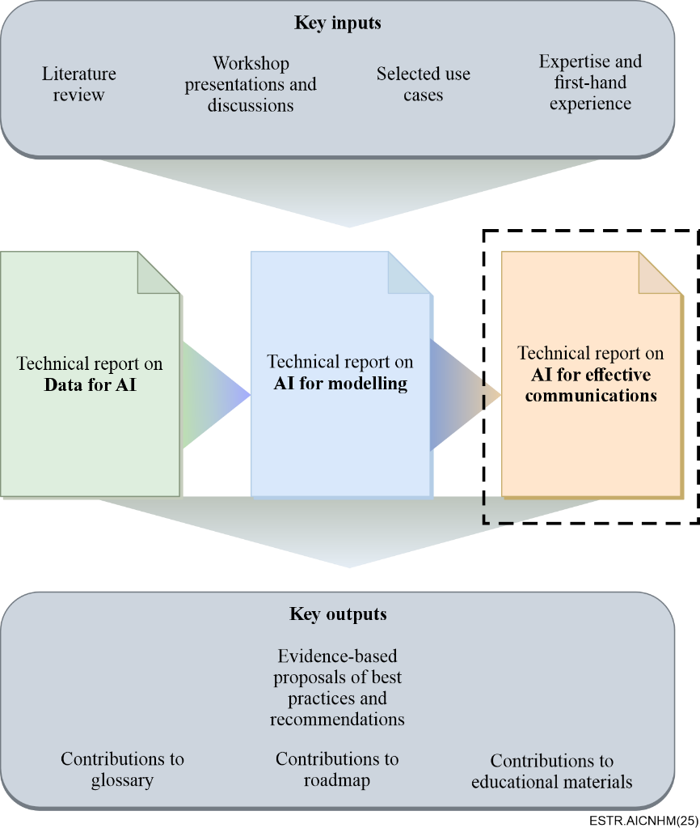
Figure 1a – Key inputs and outputs for the three technical reports within FG-AI4NDM
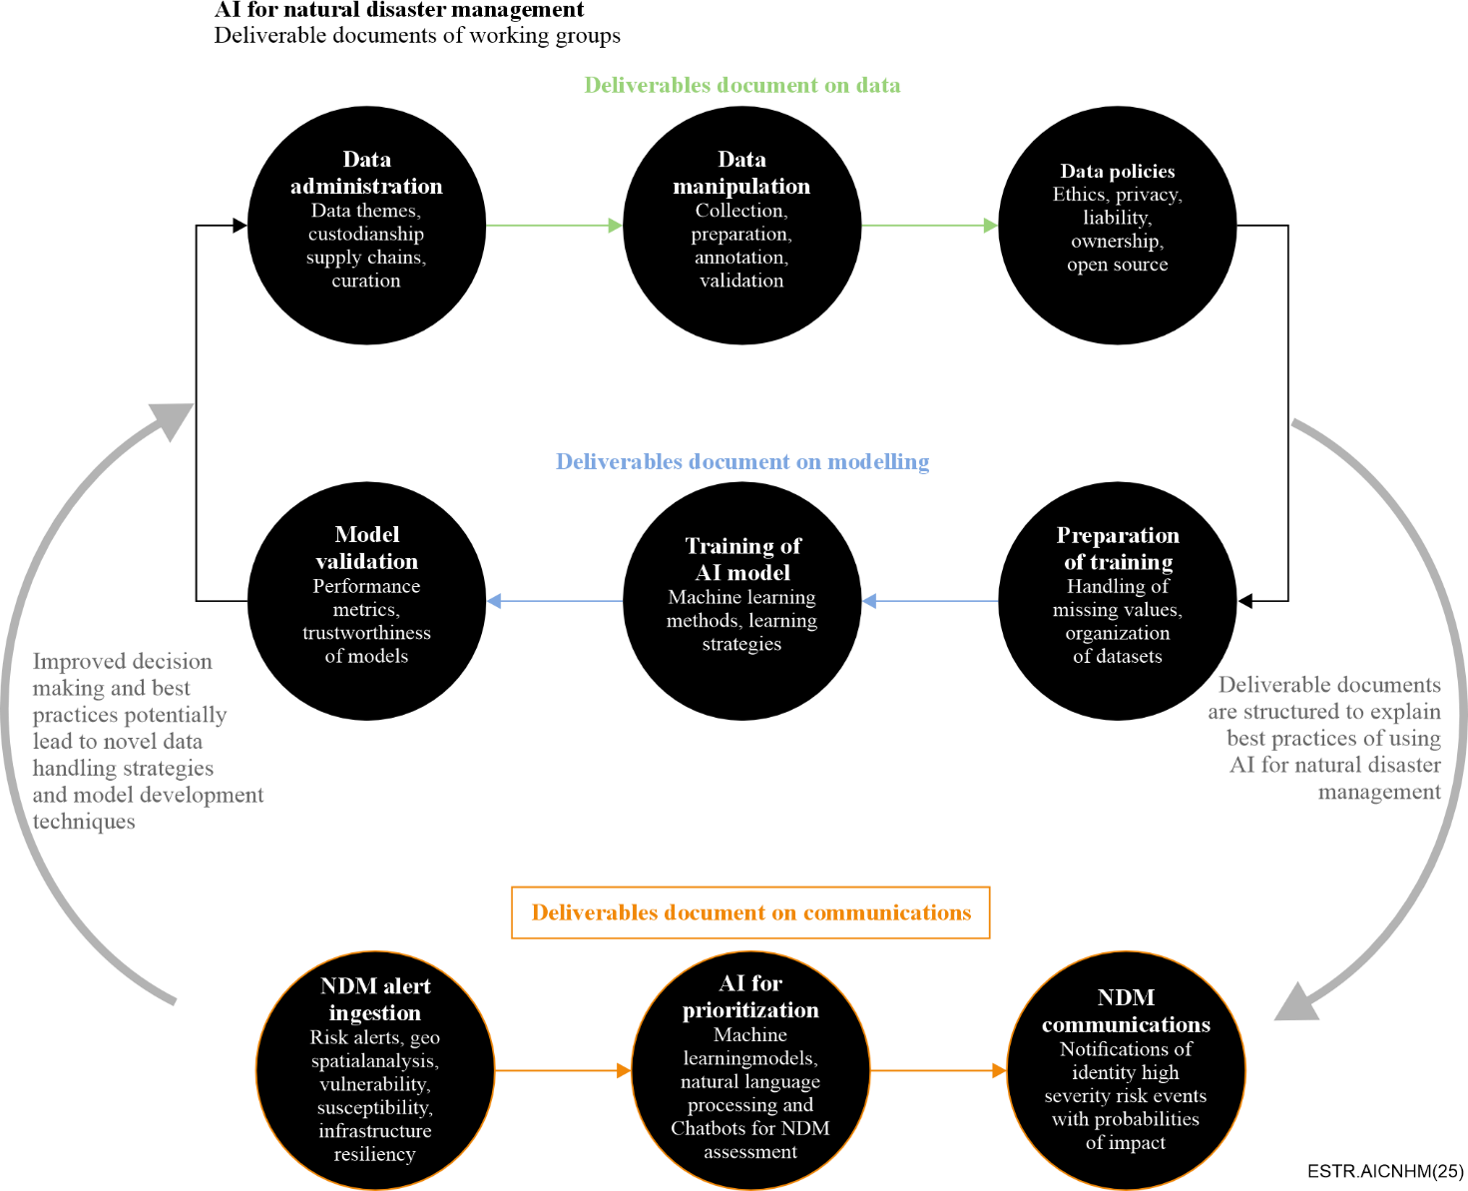
Figure 1b – Overview of the topics in the three technical reports
To open this Technical Report, a preliminary literature review on recent research and applications in AI-based communications tools is conducted. This review expands on [b-Ogie] and considers methodologies and categorization by [b-Ogie] and [b-Sun]. The IEEE Xplore, Web of Science, and Scopus databases were searched to find relevant papers on the topic published during 2018-2021. The growing number of publications per year (see Figure 2) indicates a very active field of research and development.
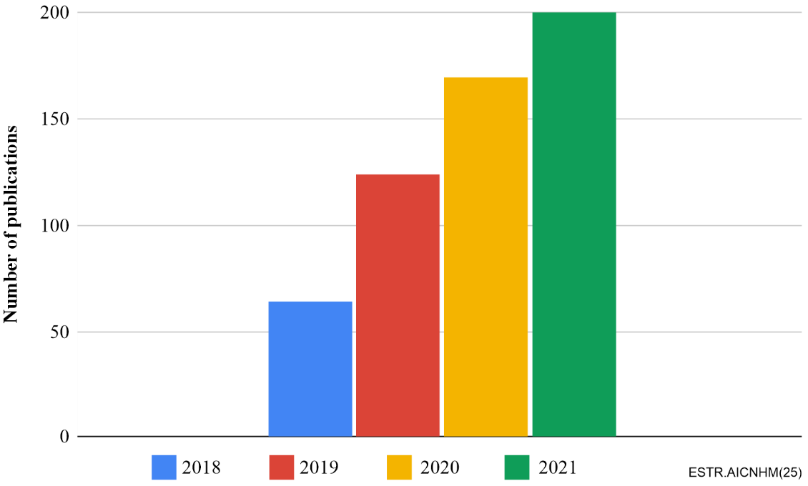
Figure 2 – Number of articles published between 2018 and 2021
Among the natural hazard types investigated in these papers, floods are dominant, followed by earthquakes (within volcano-seismic hazards in Figure 2), and to a similar number by wildfires and landslides (within mass movement in Figure 3). A smaller number of research papers focus on drought; biohazards including insect pests and vector-borne diseases; severe storm events including hurricanes, typhoons, cyclones, tornadoes and hailstorms; tsunamis and volcanic eruptions (within volcano-seismic hazards); avalanches (within mass movement); and a combination of hazards ("multihazard").
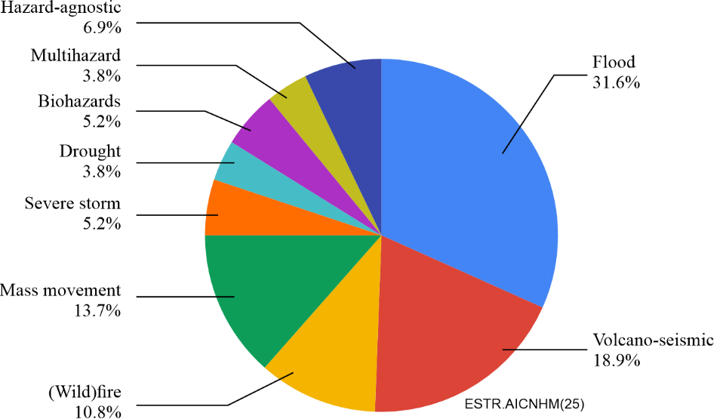
Figure 3 – Hazard types targeted in an application of AI for natural disaster management (NDM) with a focus on communication elements
Several methods are applicable to all or a large number of hazards (e.g., utilizing social media to communicate or doing a social media analysis to improve existing disaster management strategies).
Based on data from the emergency events database (EM-DAT) from the Université catholique de Louvain (UCL), the greatest economic impact from natural disasters from 2000 through 2017 was caused primarily by the following disaster types: storms (including cyclones), earthquakes, and floods (Figure 4). Similarly, storms, earthquakes, extreme temperatures, and floods caused the most deaths during this time frame.
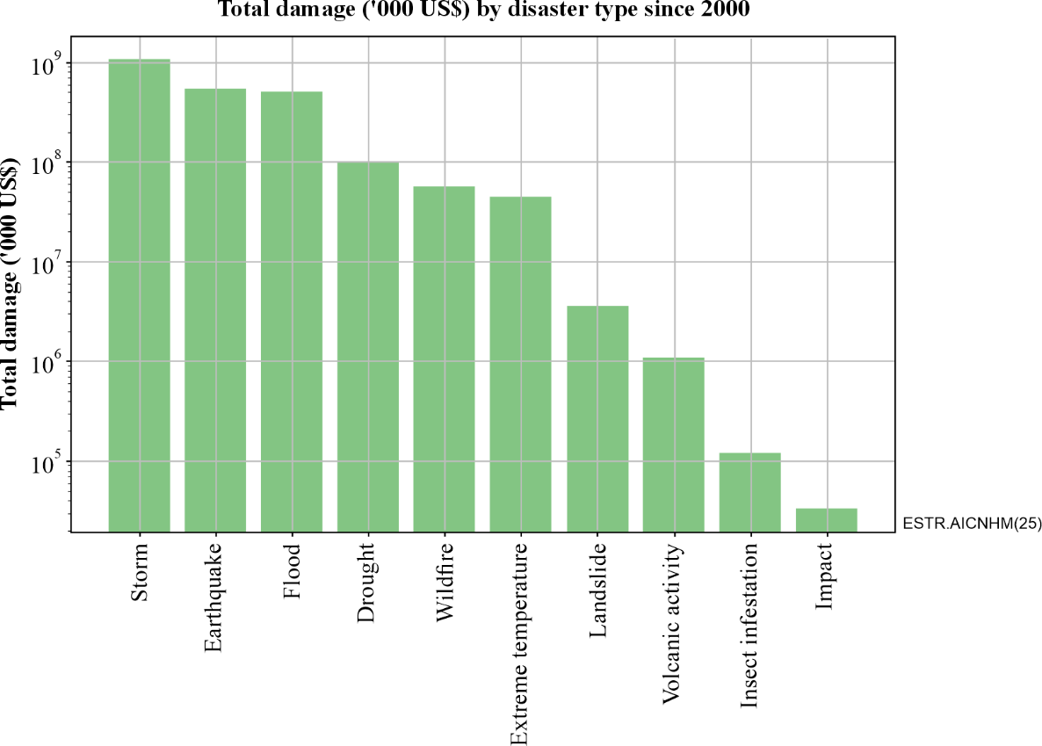
Figure 4 – Total damage by disaster type on a log scale as per EM-DAT (2000 to 2017)
(Source: EM-DAT – The international disaster database)
Preliminary findings from the survey suggest that research focus is motivated largely by socioeconomic impact and to a smaller extent is also facilitated by the applicability and maturity of a particular method within a certain domain: for example, wildfire detection using image data is commonly achieved through the application of convolutional neural networks (CNN), whereas short-term predictions or monitoring of volcanic eruptions seems to be at the exploratory stage testing and comparing various ML methods. These findings are based on a corpus of 590 articles (reviewed by abstract for all and in depth for a large part). Among the communication elements included, early warning systems are the most targeted. Forecasts are counted as part of a multi-element communication system or if alerting is part of a forecast (system) (Figure 5).
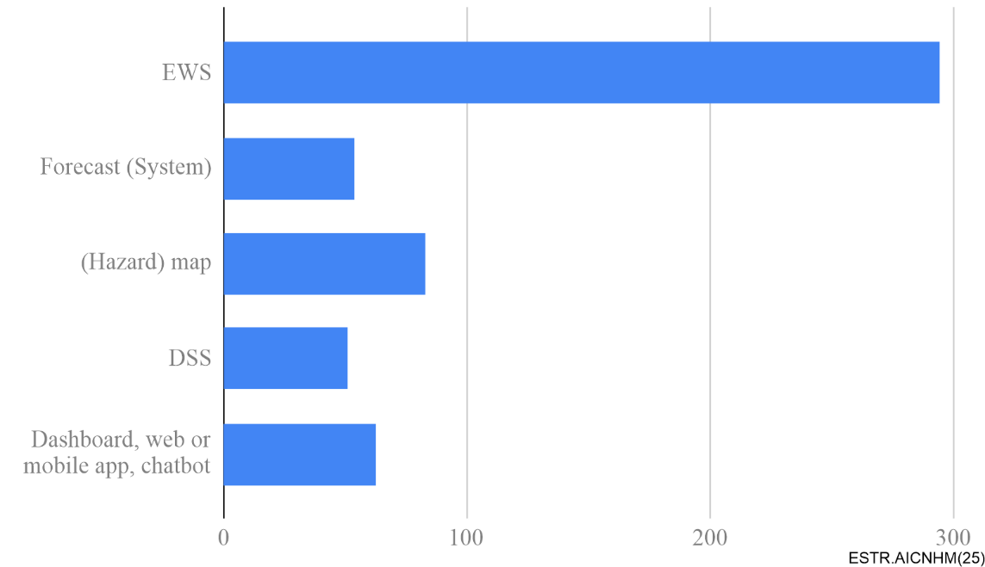
Figure 5 – Communication systems or elements targeted in application of AI for NDM
Research is funded on a national as well as international level, often in collaboration with the UN or government agencies, industry partners, and other stakeholders. For example, on the intergovernmental level in Europe, the European Commission, through the European Union civil protection mechanism recently granted funding for projects in this field, such as ARTION [b-ARTION] and AIDERS [b-AIDERS] (see clauses 6.3 and 8).
An example of how intergovernmental organizations are embracing emerging technologies to aid in disaster management is the AI chatbot initiated by UNESCO (see clauses 6.6 and 8).

6 Communications systems that can leverage AI: Description and system-specific suggestions
As AI technologies for natural disaster management (NDM) become more trustworthy through transparency and explainability, the following outcomes can be realized:
• Improve public safety by identifying where the more significant risks may impact the most populated areas in more vulnerable locations.
• Grow community resilience by identifying regions that are historically more susceptible to severe risks.
• Reduce the economic impact of natural disasters (e.g., through early warnings) by helping asset and property owners prepare for disasters.
• Protect assets by relocating those of high value (where possible) out of the path of a storm, wildfire, or other hazard.
• Save lives by rapidly targeting relief efforts to meet the needs of the most vulnerable populations.
Selected communications systems that can leverage AI for natural disaster management are described in detail in the ensuing clauses and targeted suggestions are provided.
For the purpose of this Technical Report, the use-cases listed in Table 1 were taken into consideration. (See clause 8 and Annex A for further information).
Table 1 – List of use-cases
Topic group | Title of use-case
TG-AI for earthquake monitoring, detection, and forecasting | Earthquake disaster mitigation through AI on smart seismic networks
TG-AI for earthquake monitoring, detection, and forecasting | Probing seismogenesis for fault slip and earthquake hazards
TG-AI for flood monitoring and detection | Flash flooding monitoring system in Mexico
TG-AI for flood monitoring and detection | Satellite images and machine learning for mapping flood
TG-AI for flood monitoring and detection | Using ML to reconstruct flooded area under clouds in optical satellite images: the Mozambique use case
TG-AI for flood monitoring and detection | Exploring deep learning capabilities for surge predictions in coastal areas
TG-AI for geodetic enhancements to tsunami monitoring and detection | Enabling natural hazards risk information sharing using derived products of export-restricted real-time global navigation satellite system (GNSS) data for detection of ionospheric total electron disturbances
 | Building a coupled earthquake-tsunami-TEC simulator in a parallel HPC environment
TG-AI for insect plague monitoring and detection | Identification and classification of pest infested coniferous forest using AI
TG-AI for insect plague monitoring and detection | Artificial intelligence modelling tools for monitoring desert locust (AI‑locust): breeding grounds, hatching time, population and spatio-temporal distribution
TG-AI for landslide monitoring and detection | Landslides of masses of soil and rock: Intelligent risk management in areas highly threatened by climate change
TG-AI for landslide monitoring and detection | Geographical data science applied to landslide and debris flow hazard in the Colombian Andes
TG-AI for landslide monitoring and detection | Soft computing paradigm for landslide monitoring and disaster management
TG-AI for snow avalanche monitoring and detection | AI for snow avalanche monitoring and detection
TG-AI for snow avalanche monitoring and detection | Limitations of predicting snow avalanche hazards in large data sparse regions
TG-AI for wildfire monitoring and detection | An intelligent big data analysis system for wildfire management
TG-AI for wildfire monitoring and detection | Multimodal databases and artificial intelligence for airborne wildfire detection and monitoring
TG-AI for vector borne disease forecasting | AI and vector-borne diseases
TG-AI for volcanic eruption forecasting | Towards forecasting eruptions using machine learning of volcano seismic data
TG-AI for volcanic eruption forecasting | Real-time volcano-independent seismic recognition as volcano monitoring tool
TG-AI for hail and windstorm hazard mapping | Unified methodology for windstorm and hailstorm hazard modelling and mapping
TG-AI for multihazard communications technologies | Utilizing AI & probabilistic modelling for strategic resilience
TG-AI for multihazard communications technologies | AI enabled citizen-centric decision support system for disaster managers
TG-AI for multihazard communications technologies | Proposal of an AI chatbot use case as a multihazard communication technologies
TG-AI for multihazard communications technologies | AIDERS: Real-time artificial intelligence for DEcision support via remotely piloted aircraft system (RPAS) data analyticS
TG-AI for multihazard communications technologies | Situational awareness system for disaster response using space-based AI (SARA)
TG-AI for multihazard communications technologies | Multi-hazard use case for operations risk insights and day one relief for natural disaster response.

6.1 Alerts and early warning systems
Alerts and early warning systems (EWS) are tools that can save lives and infrastructure and assist disaster managers and government authorities in disaster management. EWS can be decomposed into four key elements: risk information, continuous monitoring to provide (near) real-time detection and (short lead time) forecasts, reliable communications media to disseminate warning messages in a systematic manner to targeted populations [b-UNDP], and clear instructions on how targeted populations should respond [b-NIDM].
Risk information encompasses details about the natural hazard, exposure and vulnerability [b-Trogrlić]. Hazard maps are a tool that can provide such risk information. To learn more about how AI can create (and can leverage) hazard maps (see clauses 6.3 and 8). Among the topic group use cases (clause 8), there are ample examples of how AI is being used to support continuous monitoring and (near) real-time detection of natural hazards. As acknowledged in [b-WMO], monitoring and detection are critical for the timely generation of warnings that provide communities an opportunity to react. The use case proponents name a higher speed and accuracy of (near) real-time detection and (short lead time) forecasts as advantages of AI. Furthermore, a distributed learning approach can offer robustness against network failures. These use cases are analysed to derive the best practices at the end of this clause. It is also worth noting that several use cases describe the application of AI for forecasting natural hazards at longer lead times. These are described in clauses 6.2 and 8.
Although, no use case in clause 8 (and Annex A) shows how AI can support the last two key elements, these are critical for transmitting warnings and guiding responses. Consequently, information and communication technologies (ICTs) are an integral component of single-hazard as well as multi-hazard early warning systems (MHEWS). By managing and delivering messages to those in affected areas and at the national or international level, actions can be taken to lessen the impacts of the natural hazard. However, careful consideration is needed when selecting communications media and the warning message content. In regions where most of the population has a cell phone, mobile communication can be useful for sending and receiving warnings (for example, Sunamganj, Bangladesh [b-Cumiskey]). Other approaches include social media, flags, radio, television, as well as door-to-door visits from volunteer networks [b-Marchezini]. According to the WMO [b-WMO], however, multiple communication media should be used in parallel and undergo regular maintenance with backup systems to avoid mishaps [b-Giles]. With regard to the warning message content, it should be trusted, understandable, and relevant for the target audience. This can benefit from having a recognized authoritative voice to transmit warnings. In addition, raw detection or forecast information (including uncertainties) should be translated and catered to the target audience [b-Trogrlić]. To guide this process, engaging with the target audience can provide insights into their needs.
In terms of instructions for the response, it is advised to follow a standardized warning dissemination process. For example, countries like the United States of America (U.S.), Canada, Federal Republic of (Germany), and the Republic of (Italy) have implemented a national-level MHEWS based on the common alerting protocol (CAP) [ITU-T X.1303], which is a simple but general format for exchanging all-hazard emergency alerts and public warnings over all kinds of ICT networks. International bodies like the World Meteorological Organization (WMO), United Nations Development Programme (UNDP), the United Nations Office for Disaster Risk Reduction (UNDRR), and the International Telecommunications Union (ITU) are collaborating with the nations in this direction. A complementary system is implemented in the Republic of (India) known as the integrated public alert system (IPAS) [b-ET], it enables national, provincial, and local governments to establish an alerting mechanism by simultaneously disseminating location-specific alerts and advisories over multiple dissemination media like SMS, cell broadcast, social media, mobile app, Internet, website, TV, radio, really simple syndication (RSS) feed, coastal siren, and satellite communication. This helps IPAS to reach the entire population of India. For better coordination and cooperation among relevant stakeholders, IPAS brings all the alert generating and forecasting agencies, alert authorizing agencies, and alert disseminating agencies under a single umbrella for timely warning dissemination and reducing manual intervention.
In summary, some components of alert systems and EWS can benefit from AI. However, due to the complexity of these systems, careful consideration should be made when implementing AI and when designing other aspects of the system including the choice of communications media, warning message, and instructions for response.
Best practice(s): For those using AI in alerts and EWS, it is suggested to:
Consider how AI will be integrated into the alert and the EWS. When replacing traditional methods, new complexities and uncertainties may arise that need to be interpreted and communicated.
Across all use cases, main challenges relate to the availability of sound and representative data. For example, an earthquake EWS will not function reliably if recorded signals fall outside of the range of training data magnitude and frequency (see, e.g., the use case entitled "Earthquake disaster mitigation through AI on smart seismic networks"). In "AI enabled citizen-centric decision support system for disaster managers," the availability and correctness of the data is noted as an issue.
Best practice(s): For those using AI in an alerting system, it is also suggested to:
Follow a standardized warning dissemination protocol. Standards such as the common alerting protocol (CAP) provide a simple XML structure to convey key data and information about any kind of emergency.
The topic group use case entitled "AI enabled citizen-centric decision support system for disaster managers" uses the common alerting protocol (CAP) standard for creating, sharing, and integrating alerts via a common information sharing platform.

6.2 Forecasts
Forecasting has a significant role in natural disaster management for possible scenario investigation, risk estimation, and decision making. Machine learning models can be used to predict the intensity and location of impending natural disasters. These forecasts and their associated probabilities can be utilized as an integral part of a communication system to provide local, regional, and country-based alerts of a possible crisis.
Forecasting as part of a mitigation strategy primarily focuses on identifying and detecting hazards and risks using AI/ML to generate vulnerability / susceptibility maps (e.g., for landslides [b-Zhou-1], forest fires [b-Sachdeva], flooding [b-Tehrany], and precipitation [b-Huang]), and to predict potential damage and impacts (e.g., vulnerability assessment [b-Wang]). Preparedness studies and activities aimed at identifying likely damage locations and developing evacuation strategies (e.g., impending hurricane trajectories and storms [b-Ghosh], ice jams [b-Zhao], floods [b-Yaseen], volcanic eruptions [b-Parra], fires [b-Muhammad], and earthquake warnings [b-Reilly]) are referred to as disaster identification and early warning support.
The ways that AI can support forecasting include using AI to downscale numerical weather predictions as presented during the focus group workshop on 15 March 2021, to develop a fog forecasting model based on the meteorological aerodrome report (METAR) visibility data from the last 20-40 years at the daily and seasonal scale as presented during the focus group workshop on 30 August 2021, to support hail forecasting (whereby ML, classifiers, and transfer learning are combined with the reanalysis data [b-Hersbach]), and to assist in the automatic detection and prediction of snow avalanches [b-Thüring]. Among the topic group use cases (clause 8), there are many additional examples of how AI is being used in forecasting.
The high complexity of AI/ML algorithms remains a challenge, especially for forecast model interpretation and validation, which is further complicated by the fact that AI methods can learn spurious relationships [b-Lapuschkin] and [b-Lazer]. The latter is particularly important in the application of physical systems, where some of the learned relationships may be inconsistent [b-Kashinath]. Research has shown that in some disciplines (e.g., weather forecasting) breakthroughs in AI/ML modelling are required to compare with physical models [b-Schultz]. Apart from their limitations in representing physical systems, many AI methods tend to overfit, calling into question their generalisation capabilities [b-Szegedy], which can lead to overconfident forecasts [b-Jospin] and make them potentially unsuitable for high-risk domains [b-Goan]. Finally, AI/ML algorithms are highly dependent on the data at hand, and there may be difficulties in extrapolation if events or decisions are not captured in the data. For instance, if the training data are unbalanced or misrepresentative, or there is a large data gap, the AI/ML model can pick up on the bias and draw "wrong" conclusions from it (which may or may not be obvious in the outcome) [b-Norori]. A further obstacle presents itself when large databases do not use the same standard (i.e., data standards and interoperability; see the technical report on "Data for AI" for more details), which can lead to implicit biases and limit access [b-Madianou], thus posing a particular challenge for interdisciplinary research. To address some of the above issues, initiatives have been taken to combine AI with causal inference [b-Schölkopf], as many causality and machine learning difficulties are fundamentally linked, and to improve the interpretability of AI methods [b-McGovern]. In addition, methods have been proposed to quantify the uncertainty in the forecast structure of AI; for instance, by creating large ensembles [b-Ganaie], [b-Zhou-2] or using stochastic components [b-Mullachery]. The combination of Bayesian theory [b-van de Schoot] and neural networks, for instance, has helped to improve the interpretability of neural networks while increasing their robustness against overfitting. This has led to successful applications in the fields of climate [b-Amos], [b-Hauser], and [b-Khan], medical diagnosis [b-Gal], and autonomous driving [b-McAllister].
Best practice(s): For those using AI in forecasts, it is suggested to:
Use, establish, and enrich benchmark datasets. Constructing benchmarking datasets and complementing existing ones used for determining the generalisation capacity and robustness of AI pipelines for forecasting is the real touchstone of the disaster management collaborative efforts.
This suggestion can also apply to other communication tools and is explored in greater detail in the technical reports on "Data for AI" and "AI for modelling." An example of a benchmarking dataset of relevance for forecasting is the "WeatherBench: A benchmark data set for data-driven weather forecasting" [b-Rasp].
Best practice(s): For those using AI in forecasts, it is also suggested to:
Promote transparency of forecasting information systems. As one of the most critical parts in forecasting is the reliable sharing and confirmation of information and forecast products, it is important that transparency and reproducibility are part of the overall solution. In this way, AI biases, data gaps, and the very high potential for scientific and algorithmic improvement will not be hindered, but promoted between stakeholders, thus delivering more robust and evolving products.
Regarding transparency and reproducibility, the digital twins major forecasting components of global scale within the European Union are bound to follow the findability, accessibility, interoperability, and reusability (FAIR) principles.
Best practice(s): For those using AI in forecasts, it is also suggested to:
Embody transfer learning and cross-domain capacities. It is very helpful to implement and include methodologies that enable transfer learning and fusion techniques in spatial and temporal representations for disaster forecasting. In this way, AI-based solutions can be further tested and implemented in different parts of the world, while being subject and bench-tested to real-world diversity.
In the transfer learning domain, the earthquake forecasting and early warning methodologies in the study by [b-Münchmeyer] show promising results. The topic group use case called "Unified methodology for windstorm and hailstorm hazard modelling and mapping," gives another example of transfer learning. To develop an AI methodology for hailstorm and windstorm risk assessment for Georgia, it makes use of transfer learning to rectify a lack of observational data in the study area.
Best practice(s): For those using AI in forecasts, it is also suggested to:
Incorporate climate change factors. Climate change has a significant impact on many natural disasters.
Heatwaves, droughts, and heavy precipitation are hazards amplified by climate change [b-Mukherjee], [b-Perkins-Kirkpatrick], and [b-IPCC]. Introducing climate change information or factors can thus be beneficial for forecasting performance [b-Tan]. An example showing the importance of including climate change factors can be found in the study of [b-Ayyad]. Here, an AI model was developed to efficiently simulate a large ensemble of possible storm scenarios to quantify long-term average recurrence floods introduced by tropical cyclones.

6.3 Hazard maps
Hazard maps show areas that are vulnerable to a certain type of hazard (e.g., via recurrence intervals) through a likelihood reference, typically at a certain level of return period expressed as a probability. Hazard maps are often produced using some form of a geographical information system (GIS) software (e.g., Esri ArcMap, QGIS, MapGIS, including Python and R-GIS modules) or online GIS web map service, using ISO and OGC data and model standards such as tiff and jpeg 2000 to post-process, and visualise recorded data or outputs of a numerical model computation representing a given hazard process. These models are forced with design or statistical inputs that drive the hazard, such as design rainstorms and/or discharge return periods in the case of a flood hazard model. In a GIS environment, a user can also create standard workflows (see Figure 6) by employing multi-source disaster data to generate value-added disaster information required by decision-makers, ranging from data preparation and analysis, additional modelling, post-processing of results, and sharing data for collaboration within a user community. For an alerting authority using GIS as a mapping tool, there may be CAP support such as the Esri supported CAP connector.
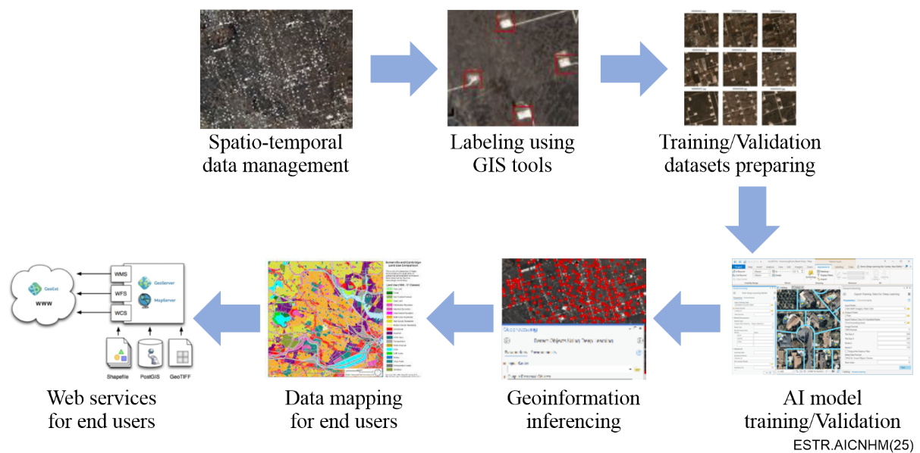
Figure 6 – GIS workflow using AI to visualise geoinformation
(Source: China university of geosciences)
Alongside traditional numerical modelling of hazards, machine learning models have gained massively in popularity, for a number of reasons. Recent advances in computational efficiency and cloud computing architecture coupled with a massive proliferation of geospatial big data have led to considerable progress in the field of machine learning. Many different ML models exist and can be used with varying degrees of accuracy to predict and map hazards, either for a single hazard type or multi-hazards. The level of accuracy of inference with ML models typically depends on the level of training data available. [b-Yousefi] presents an ML modelling framework for multi-hazards mapping and modelling using models that include support vector machine (SVM), boosted regression tree (BRT), and generalised linear model (GLM). This report models the probabilities of snow avalanches, landslides, wildfires, land subsidence, and floods. A team at Google Inc. has recently developed an ML-based modelling framework to forecast and alert flood hazards. They forecast river level with long short-term memory (LSTM) networks and linear models, thereby providing a machine learning alternative to hydraulic modelling of flood inundation hazard [b-Nevo]. [b-Bentivoglio] provides a good review on existing deep learning methods for flood mapping for instance, also many other review papers for other types of hazards exist in recent scientific literature. A very popular method in ML, in particular for hazard mapping using remotely sensed images, is the so-called UNet, which is a convolutional neural network.
Many topic group use cases leverage AI to assist with hazard mapping. For example, in "Using ML to reconstruct flooded area under clouds in optical satellite images: the Mozambique use case," it is demonstrated how floods can be mapped in optical satellite images (see clause 8). The ML model, FloodSENS, is based on the well-known UNet architecture and uses Sentinel-2 (S-2) flood images and derivative layers from digital elevation models relating to topography and waterflow to map flooding even below partial cloud cover. The algorithm further employs a squeeze and excitation network to extract information about the importance of the different input layers. FloodSENS is trained on a large number of expertly labelled S-2 flood images across different biomes, events, and locations to ensure acceptable transferability. Internal application testing and validation shows, unexpectedly, varying degrees of performance and accuracy. Overall, on average, FloodSENS performs at least as well as any robust and calibrated traditional band ratio index (>90% correct prediction), and in some cases outperforms such, and even maps below low cloud cover and correctly includes flood impact areas from dried out areas by following debris lines. Figure 7 shows an example application of FloodSENS for the devastating 2022 Islamic Republic of (Pakistan) floods.
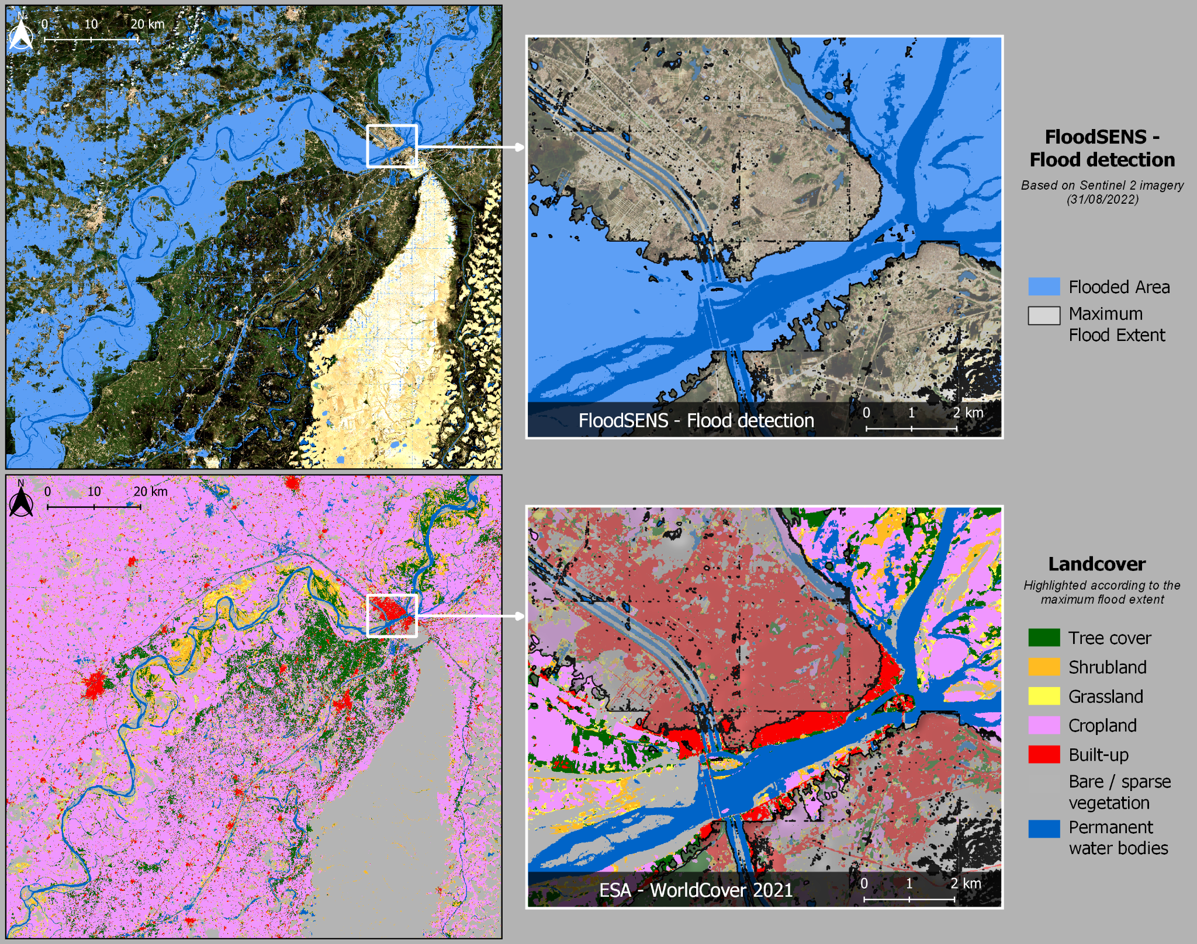
Figure 7 – Map of the 2022 Pakistan floods,
Hazard maps (whether or not based on AI) can be incorporated into other systems to enhance situational awareness and aid in preparedness, response, or recovery operations, for example in dashboards (see clause 8) or platforms. In the topic group use case called "AIDERS: Real-time artificial intelligence (AI) for DEcision support via RPAS data analyticS," the platform utilises AI algorithms during NDM [b-AIDERS] and provides maps for situational awareness for first responders as shown in Figure 8. AIDERS aims at developing application-specific algorithms and a novel mapping platform that harnesses the large volume of data that first responders are now able to collect through heterogeneous sensors onboard remotely piloted aircraft system (RPAS) units and converting these data into actionable decisions for improved emergency responses. This includes details regarding disaster evolution, the possible dangers that first responders might face during their mission, and information of possible cascading effects that can increase the disaster's magnitude. All the above are critical for fast and safe emergency response during a disaster and they become feasible with the use of cutting-edge AI technologies and novel tools that need to be further developed and tested in the field by first responders.
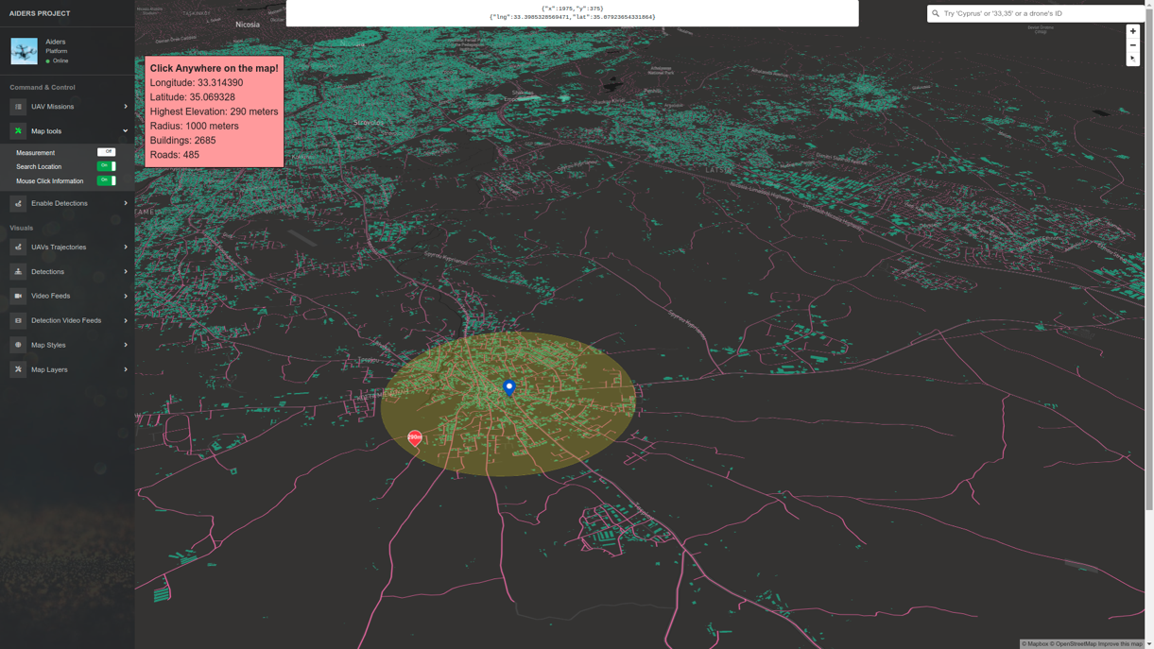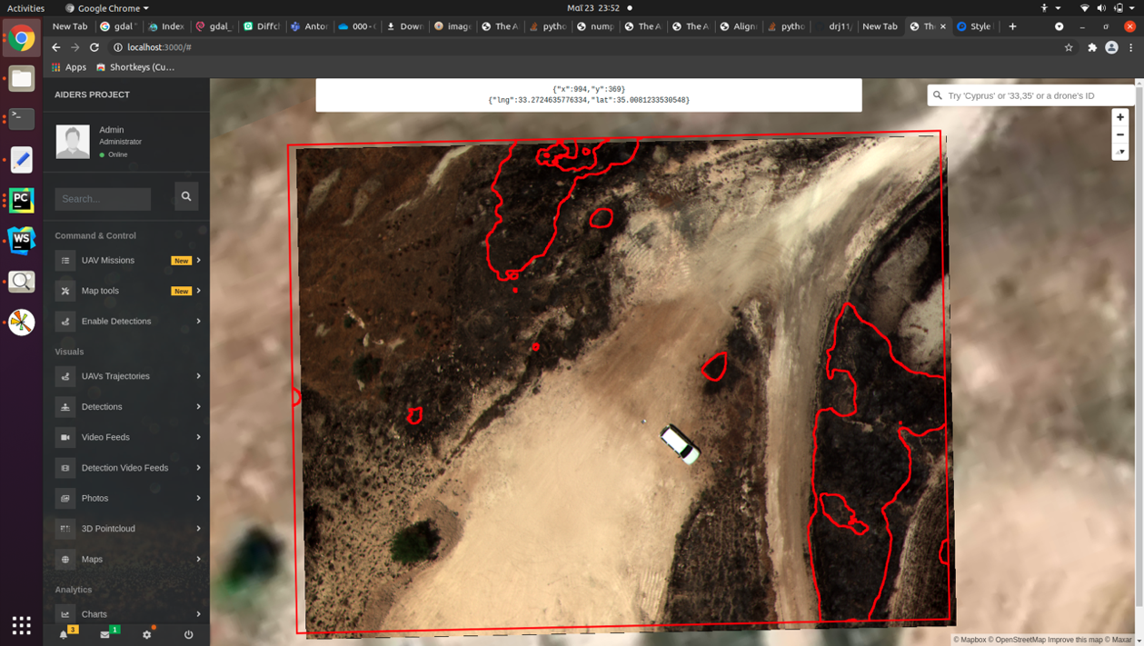
Figure 8 – The AIDERS platform

Best practice(s): For those using AI in hazard maps, it is suggested to:
Ensure a large enough database is available. Having a sufficiently large database is required to ensure adequate splitting between training and validation data.
For example, in the topic group use case called "An intelligent big data analysis system for wildfire management" from China Academy of Information and Communications Technology (CAICT) in the Republic of (China), training and testing data were acquired from popular image datasets (e.g., ImageNet) as well as remote sensing satellites, monitoring devices and social media.
Best practice(s): For those using AI in hazard maps, it is also suggested to:
When using supervised learning, ensure accurate labelling represents a large variety of cases. Such a large variety of cases is crucial for achieving a well-trained supervised model.
For example, in the topic group use case called "An intelligent big data analysis system for wildfire management," several forest fire experts and botanists were used to label remote sensing images.
Best practice(s): For those using AI in hazard maps, it is also suggested to:
Ensure the final hazard map presented, using a GIS, adequately and accurately depicts the ML result, especially when showing uncertainties in mapping.
For instance, the topic group use case entitled "Situational awareness system for disaster response using space-based AI (SARA)" puts the results of their UNet-based satellite image analysis on a GIS map that highlights the most vulnerable areas before a natural disaster. An example map using FloodSENS (related to the topic group use case "Using ML to reconstruct flooded area under clouds in optical satellite images: the Mozambique use case") is shown in Figure 7.

6.4 Decision support systems
Building on the data generated from an alert system or EWS, a decision support system (DSS) can help disaster managers by, for example, assisting with community outreach and acquisition of situational awareness. Data integration from multiple sources, modelling and assessment skills, and effective dialogue and information distribution are all critical components that drive decision-making and can support decision-makers during the entire process of disaster management. Two examples of AI-supported DSS can be found among the topic group use cases.
Human as well as contextual factors including impact area assessments, socio-demographic characteristics of the intended users, and technological infrastructure capabilities should be taken into consideration for effective decision making. As highlighted in clause 6.1, the warning message reaching a targeted population should be simple and understandable. Especially in countries having multiple languages, the warning should reach individuals in their native language. Automatic translation systems can be helpful in translating message content but performing accurate translation is a challenging task. Similarly, text-to-speech systems can be used to spread warning information in audio form from text messages and speech-to-text recognition systems can be used by the public to get information related to any disaster situations. Here, language technology solutions including language translation, detection, and speech-to-speech machine translation (SSMT) systems can benefit from AI and be helpful in disaster management operations.
When it comes to acquiring situational awareness, social media is increasingly recognized as an important resource for relevant information. Prior research has shown that there is a wide variety of situational awareness information communicated by the public through posts on social media platforms during disasters [b-Purohit-1]. This is because social media empowers the public to serve as invaluable human sensors for timely sharing of useful observations about the evolving disaster situation, besides being consumers of information from the official agencies and other users. Examples of relevant information shared by the public from social media include damage reports and requests for (and offers to) help, as well as emotional support for the affected community [b-Purohit-1] and [b-Castillo]. However, the relevant information is often buried in the big 'crisis' data [b-Castillo] that are noisy, unstructured and multimodal (text, images, videos), and need to be rapidly filtered. Here, AI-based information extraction, filtering, and ranking systems can be designed to address this big crisis data challenge to support emergency management agencies. For instance, social media posts sent by the public to the social media accounts of the official agencies during a disaster can be analysed for serviceability characteristics and ranked automatically using an AI model trained using supervised and transfer learning methods [b-Purohit-2]. See [b-Purohit-1] (for extensive details, refer to [b-Castillo]) for examples of social media mining and a survey of techniques to process social media data.
Best practice(s): For those using AI in decision support systems, it is suggested to:
Identify communication channels and cater outgoing information (e.g., warning messages) to the targeted population. Depending on the targeted population, different types of communication channels can be appropriate. Furthermore, the outgoing information may or may not be accessible (due to, for example, local dialects).
Examples of use cases that follow this suggestion include "AI enabled citizen-centric decision support system for disaster managers." Here, it is shown that communication channels are diverse, including SMS, Internet, radio, tv and social media. In addition, an automated translation system is used to provide warning information in indigenous languages. Meanwhile, "AIDERS: Real-time artificial intelligence for DEcision support via RPAS data analyticS" lists dashboards and the emergency services network as their key communication channels.
Best practice(s): For those using AI in decision support systems, it is also suggested to:
Identify sources of information relevant to the target user when using AI to provide situational awareness. Depending on the target user, the type of situational awareness (and relevant information) can vary.
Examples of use cases that follow this suggestion include "AI enabled citizen-centric decision support system for disaster managers." This tool is intended for many different types of users and, therefore, considers risk alert sources, geospatial mapping, and infrastructure indicators. In addition, a message content analyser is used to determine the effectiveness of the warning messages. Meanwhile, "AIDERS: Real-time artificial intelligence for DEcision support via RPAS data analyticS," which is geared toward first responders and incident commanders, derives information from heterogeneous sensors on remotely piloted aircraft systems.
Best practice(s): For those using AI in decision support systems, it is also suggested to:
Enable seamless information sharing for understanding disaster dynamics with multi-stakeholder coordination. Real-time information sharing across entities from multiple sources forms the constitutive part of intelligent decision making, requiring multi-agency coordination and cooperation.
The topic group use case entitled "AI enabled citizen-centric decision support system for disaster managers" provides a common information sharing platform to all stakeholders and uses the common alerting protocol (CAP) standard for creating, sharing, and integrating the data.

6.5 Dashboards and applications (apps)
Dashboards are tools that assist to prioritize areas where relief should be targeted and regions that should be monitored. By providing complete visibility to the underlying input and output variables that contribute to the severity assessment from AI for natural disaster management (NDM) models, users can make informed decisions. Several examples of dashboards can be found among the topic group use cases. One of these examples, Operations Risk Insights (ORI), is explored in greater detail below. Additional examples (from Mayday.ai, presented during the focus group workshop on 24 October 2022; and from OroraTech, presented during the focus group workshop on 16 March 2022) are described for comparison.
Figure 9 provides an overview of inputs and outputs that can be used for an AI-based dashboard (as well as some other types of multihazard AI-based communications tools). It shows that the capability of an AI-based dashboard can be founded on comprehensive machine learning models that augment user decision-making by consuming and analysing several inputs, and then identifying the most severe natural disasters. Inputs may include Internet of things (IoT) sensor data, risk alerts from other data sources, vulnerability measures, news sources (including social media), susceptibility records, geospatial mapping products, as well as infrastructure and resiliency metrics (see key concepts in the Appendix I for more information). Risk alert sources can be public or private. The former are typically country or regional alert services that provide alert details including the location, timing, duration, and intensity of the alert that is forecasted and actual disaster impacts. Ideally, these alerts comply with the World Meteorological Organization (WMO) endorsed standards for alert reporting such as common alerting protocol (CAP); providing statements, watches, and warnings as a risk alert occurs. Data feeds from alert services are then ingested using the really simple syndication (RSS), a web feed standard for near-real-time or periodic data ingestion.
The primary output for the ORI machine learning model is high severity risk events and the probability of impact to points of interest (POI) see Figure 10. These natural disaster alerts include transparency to the inputs used to provide the severity assessment, such as: the source of the alert, the time frame, the geospatial location of impact, and the vulnerability and susceptibility of the area of impact to the disaster type.
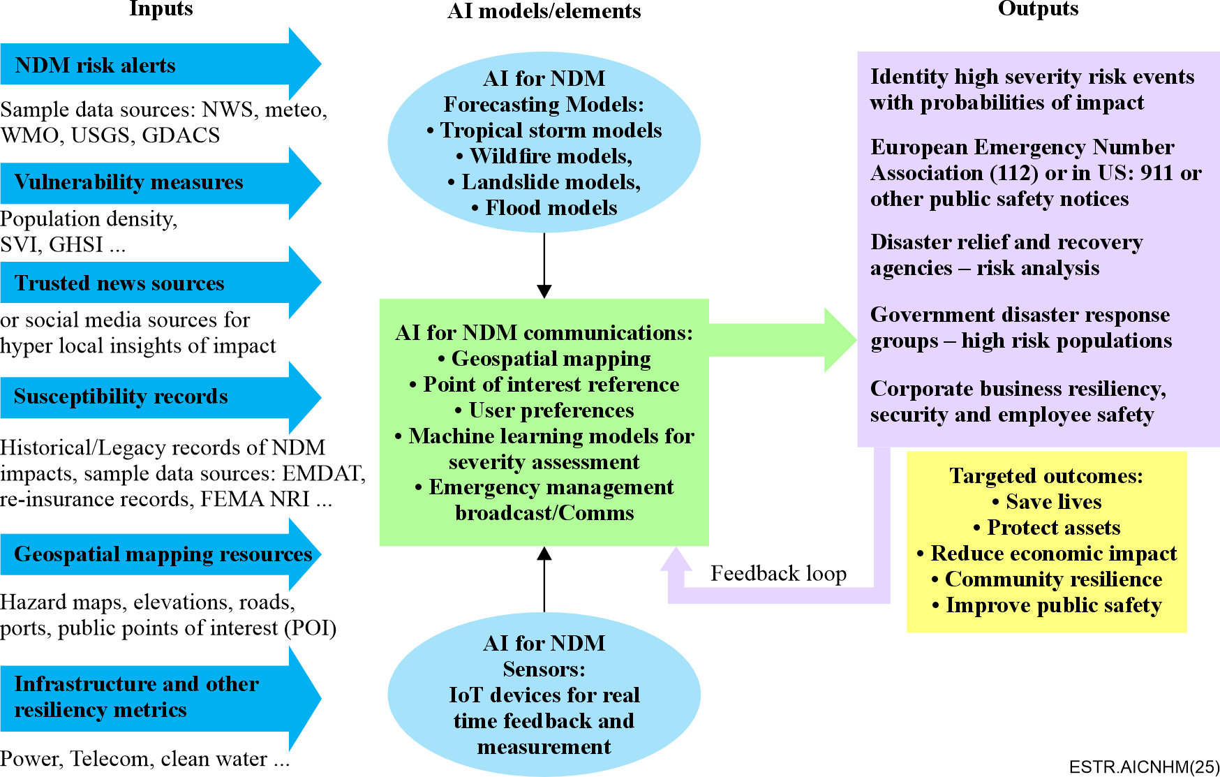
Figure 9 – Suggested inputs, outputs, AI models and targeted outcomes when using AI in dashboards
In Figure 10, a relatively low severity flood alert is identified by ORI for a region in upstate New York, U.S. Therefore, monitoring the risk is appropriate, but no risk mitigation action is required, since it has a moderate severity risk rating. The machine learning models for severity assessment use logistic regression with implemented explainability to arrive at a numerical probability indicating the most severe impacting alerts. For example, using ML models based on a subset of the input sources highlighted in Figure 9, an AI application can identify a high (red), medium (orange), or lower (yellow) severity risk alert. Other AI elements that may be applied include natural language processing for ingesting, filtering, and associating trusted news sources to specific natural disasters.
ORI can be customised to the needs of different stakeholders who can identify their points of interest (PoI) (e.g., the location of a hospital or a school, a disaster relief centre for a disaster recovery leader, telecommunications towers, network hubs and routers required to facilitate communication, or assets in motion). For example, ORI provides Day One Relief, Good360, and Save the Children with customised hurricane and storm alerts as well as layered data sets to generate map overlays that increase situational awareness [b-Parker]. Hazard maps can be overlaid with PoIs to assist with decision making. By using hazard maps to identify the historical references to flood zones or areas prone to volcanoes, mudslides, or wildfires in the past, AI for NDM users can assess the impact from active or forecasted events. Likewise, elevation or infrastructure (roads, ports, airports, landing strips, or seaports) details are essential for aiding users to evaluate evacuation routes. Information concerning the number of power outages within a region, by provider, and the status of the telecommunication services is necessary to understand public and disaster response efforts within a region. Likewise, the availability of clean water from municipal or local sources is additional data needed to prioritize the types of supplies needed to recover from a crisis.
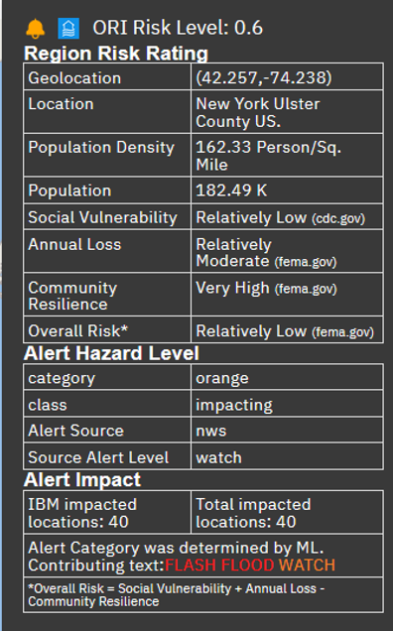
Figure 10 – ORI dashboard risk alerting
Another AI-based dashboard is provided by Mayday.ai. It has mobile and web interfaces built on an agnostic AI fusion engine that leverages a combination of change detection techniques, computer vision, and natural language processing to digest image, text and audio data. With its rapid scan and detect technology, the engine detects events every 5 minutes in the continental United States, and every 10 minutes in other parts of the world. The notifications include the date, time, location, as well as imagery and other corresponding evidence. Users are informed throughout the events' lifecycles (risk, detection, post event intelligence). AI is used to improve accuracy, reduce latency, and enable dynamic adaption as it matures with its schemas fused from different sensors working together. Traditional models are expected to potentially become irrelevant rather quickly given the randomness that climate change has introduced, this is particularly true in weather and forecasting. While AI is seen as a great enabler in many industries, and an innovation that can be used in good or bad ways, its challenges will be around data usage and lifecycles, and the arenas in which it will become a force multiplier.
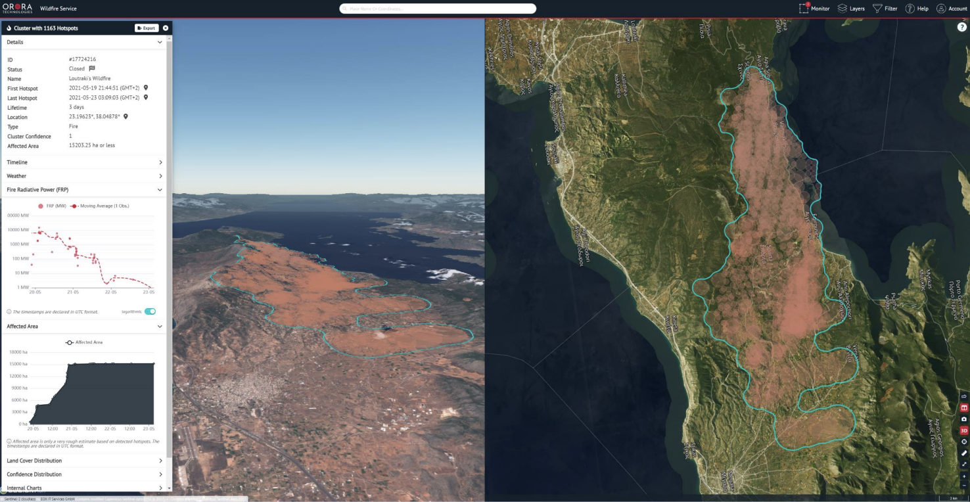
Figure 11 – Loutraki's wildfire, Hellenic Republic (Greece) (May 2021)
(Source: OroraTech wildfire solution)
A third example, presented in Figure 11, comes from OroraTech. This global wildfire intelligence solution, including risk assessment, early detection, real-time monitoring, and damage analysis, leverages 20+ external and proprietary satellite sources to monitor more than 160 million hectares of forest. The wildfire solution provides timely information about hotspots to emergency service managers and other users on a global scale. The mapping system aggregates near-real-time multi-spectral, hotspot and auxiliary data from various satellite data sources to detect areas producing high levels of infrared radiation to allow users to identify potential fire locations. These data are fused within a cloud-based platform and displayed through a web interface for use on desktop and mobile devices. Artificial intelligence is used, for example, to significantly improve the resolution of the outlines of a current fire front. The algorithm recognizes patterns of active fires based on a trained deep convolutional neural network (DCNN).
Best practice(s): For those using AI in dashboards and apps, it is suggested to:
Allow for system flexibility for a variety of users and information needed. Depending on the user of a dashboard or app (whether it uses AI or not), the input and output data can vary.
Examples of use cases that follow this suggestion include "Multi-hazard use case for operations risk insights and day one relief for natural disaster response." This system is intended for use by disaster response NGOs, businesses, and supply chain and resiliency leaders. Since the needs of these users can vary, ORI is customisable; including data such as risk alerts, historical risk susceptibility records, geospatial maps and infrastructure, and are able to highlight different points-of-interest. In "Situational awareness system for disaster response using space-based AI (SARA)," the intended users are emergency responders, municipality operators and citizens.

6.6 AI chatbots
Chatbots consist of computer programs intended to simulate dialogues with human users [b-Adamopoulou]. Through interaction with users, chatbots can understand complex forms of communication (including context) and adjust responses depending on the nature of the conversation. Chatbots have also proven valuable in reducing customer service costs due to their ability to provide assistance around the clock, reducing the need for specific servicing making their use an effective first point of contact.
Chatbots utilize AI methods such as natural language processing (NLP) and natural language understanding (NLU) to interpret and mimic human conversation, taking the form of image, voice, or text. AI is used to align customer inputs to programmed entities by identifying the utterance (a phrase or command used by the customer), its associated intent (the purpose of the customer's query), and the entity (specific definition of the intent, e.g., location or date). For example, NLP makes it possible for a chatbot to read text, hear and interpret speech, measure sentiment, and determine which parts are important. When chatbots are connected to technologies such as NLU, they can learn more complex ways of simulating human conversation such as maintaining context, managing a dialogue, and adjusting responses based on what comes up in a conversation. One AI-based chatbot is listed among the topic group use cases.
The United Nations Educational, Scientific and Cultural Organization's (UNESCO) AI chatbots provide an example of an application in disaster risk reduction. In 2020, UNESCO launched the strengthening disaster prevention approaches in eastern Africa (STEDPEA) project in 10 African countries, they are the Union of the (Comoros), Republic of (Djibouti), State of (Eritrea), Federal Democratic Republic of (Ethiopia), Republic of (Kenya), Republic of (Madagascar), Republic of (Rwanda), Republic of (South Sudan), Tanzania and Republic of (Uganda). The overarching purpose of this project, which was presented by UNESCO at the focus group workshop on 30 August 2021, is to support the development and integration of science-evidenced AI-based innovations, citizen science, and gender-responsive actions into strategies and action plans for disaster risk reduction (DRR) in schools, higher education, communities, and public sector institutions of eastern Africa. One of its main components involves the development and integration of modern technologies and citizen science into DRR strategies and plans in Kenya, Rwanda, South Sudan, Tanzania, and Uganda. In collaboration with the Japanese meteorological service company Weathernews Inc. and the Internet communication service company LINE Corporation, an AI chatbot mobile application (hereafter referred to as the STEDPEA chatbot) was developed for citizens and policymakers to send and receive information before, during, and after the occurrence of various natural disasters in the target countries. The STEDPEA chatbot, which is described in greater detail below, contains components of the "SOCial dynamics observation and victims support Dialogue Agent platform for disaster management" (SOCDA), which was developed by Japan's national institute of information and communications technologies (NICT), and which is featured in the topic group use case entitled "Proposal of an AI chatbot use case as a multihazard communication technology."
The STEDPEA chatbot uses NLP technology to: 1) understand and sort the information that is submitted by users so that the authorities can grasp and visualise the scope and intensity of the damage; and 2) determine the information that best answers the user's enquiry, such as location of shelters, supplies and food distribution. The natural language processing (NLP) technology is directly linked to the texts communicated by/to the users through the LINE messaging app platform. Currently, the STEDPEA chatbot uses a geographical map, meteorological information, and any information that local authorities wish to disseminate to the public, such as shelter status and food distribution. In the future and if linked in advance, the chatbot can also forward warnings issued by national and local meteorological departments or governments. In this sense, with efficient public private partnership (PPP) mechanisms, the STEDPEA chatbot will enable: 1) an optimized communication between citizens and authorities; 2) a constant sharing and distributing of information regarding disaster, evacuation and recovery; and 3) the utilization of recorded data and experience for future disaster analysis and prediction.
The main functions of the STEDPEA chatbot can be divided in three stages:
• Functions for before natural disasters: The STEDPEA chatbot supports the dissemination of weather forecasts and warning alerts for citizens to take actions if needed. During normal times and before the occurrence of natural disasters, the individuals may report, via the STEDPEA chatbot, changes or damages in the landscape and/or around the city. This information is essential for national/local authorities to be prepared and prevent further casualties and structural collapses during such events.
• Functions for during natural disasters: Authorities need to have an instant overview of the geographical distribution and intensity of the damages during catastrophes. The STEDPEA chatbot communicates with the users to collect this information via texts and photos with their respective locations. These "disaster reports" are then reviewed to support an accurate grasping of the damage and recovery situations by decision-makers.
• Functions for after natural disasters: In the minutes that follow a disaster, the survivors can communicate with the STEDPEA chatbot to receive assistance and public information concerning the evacuation routes, location of shelters, supplies and food distribution, etc. This information is crucial for a fast recovery and the rehabilitation of communities and individuals.
Thanks to AI technology, a chatbot is able to organize and sort an enormous amount of information in a short period of time, as well as visualise it on a map. This is effective in not only reducing the amount of time to obtain the latest information, but also in relieving local authorities of the time and manpower that they would need to respond to phone calls and enquiries, helping them to focus their resources on more important tasks during an emergency response. Nevertheless, it must be noted that users may have some difficulty in selecting and utilizing the information as the amount of information available on the chatbot increases.
In general, AI chatbots can be used by local governments to disseminate information effectively and speedily, helping them grasp the situation in the area while maximizing their resources. An AI chatbot is also very useful as people can get the information needed to make informed decisions, supporting the protection of their lives and livelihoods while promoting effective recovery.
Best practice(s): For those using AI in chatbots, it is suggested to:
Evaluate the effectiveness of the device. Evaluating the effectiveness of a chatbot is suggested even if the device does not leverage AI. Through acquiring feedback from those using the chatbot, issues can be detected and managed early.
For instance, during the pilot phase of UNESCO's STEPDEA chatbot, feedback was acquired from 150 individuals in randomly selected districts of Rwanda. In developing the "Ask Diana" chatbot for water-related disaster management, the system went through a usability test as well as a 6-month field test [b-Tsai]. Furthermore, for the Portuguese disaster support dynamic knowledge chatbot (DisBot), feedback was acquired from field experts throughout the chatbot development [b-Boné].
Best practice(s): For those using AI in chatbots, it is also suggested to:
Consider adoption challenges. To facilitate adoption, consider chatbot implementation into already widely used (municipal) applications versus development of a stand-alone system or app.
In developing the "Ask Diana" chatbot for water-related disaster management, the system was given an "intuitive mobile-device-based user interface" to encourage adoption [b-Tsai]. In the "DisBot" chatbot, the user interface was embedded into the municipality's mobile app [b-Boné].
Best practice(s): For those using AI in chatbots, it is also suggested to:
Identify the target population. Check if high-quality NLP datasets and pre-trained algorithms for less commonly spoken languages exist or can be established.
For instance, when evaluating the UNESCO STEPDEA chatbot, it was found that there were some issues related to local (village level) dialects.

7 Suggestions applicable to various types of AI for natural disaster management (NDM) communication systems
The use cases and other examples highlighted in this report show how artificial intelligence can enhance our understanding of natural disasters and support early warning and disaster relief. However, as AI is not yet part of the modus operandi in natural disaster management, several topics relating to establishment of best practices, inclusion of social considerations, benefits (or lack thereof) and challenges of using AI to reach communities (e.g., inclusive systems and accessibility) should be evaluated. This clause opens the discussion by proposing best practices – taking into account recommendations already published such as those in responsible AI for disaster risk management: working group summary [b-AI4DRM] – and providing examples from the topic group use cases, from presentations at focus group workshops and from literature.
Best practice(s): For those using AI in communication systems for NDM, it is suggested to: Consider the value added by AI. The value added by AI should outperform risks introduced by AI (if any).
Examples of use cases that follow this suggestion include "Enabling natural hazards risk information sharing using derived products of export-restricted real-time GNSS data for detection of ionospheric total electron disturbances." This use case applies AI to improve the tracking capability of tsunami waves in the open ocean, which can contribute to an EWS. In the use case entitled "Multi-hazard use case for operations risk insights and day one relief for natural disaster response," AI is expected to improve detection and forecasting of severe events that impact the points-of-interest for their dashboard users. In another use case entitled "Situational awareness system for disaster response using space-based AI (SARA)," AI is used to rapidly detect vulnerable or critical locations. Meanwhile, in the dashboard from Mayday.ai, AI is used to improve accuracy, reduce latency and enable dynamic adaptation. Other use cases apply AI to enhance the speed and accuracy of earthquake detections and to reduce vulnerability to network failures. No risks potentially introduced through the use of AI were identified that could outweigh the added value.
Best practice(s): For those using AI in communication systems for NDM, it is also suggested to: Consider the challenges surrounding AI. An AI-powered system (as well as traditional technologies) relies on functioning infrastructure and the availability of good-quality data. Any failure can impact the integrity of the system.
Examples of use cases that follow this suggestion include "Flash flooding monitoring system in Mexico," which recognizes that the reliability of the monitoring system can be compromised by theft of sensors. Other use cases identify data-related challenges. For instance, "Multi-hazard use case for operations risk insights and day one relief for natural disaster response" notes that the output of ML models is only as good as the breadth and quality of the input data. It can be impacted by inconsistent reporting of events and differences in the granularity of data. In the use case entitled "Situational awareness system for disaster response using space-based AI (SARA)," the proponents note that the transferability of the system can be limited by data.
Best practice(s): For those using AI in communication systems for NDM, it is also suggested to: Proceed with caution. As AI-powered tools are not yet widely used in NDM, lessons learned around unintended consequences are not readily available.
It is advised to conduct full life-cycle threat assessments of all new applications of AI or ML technologies [b-AI4DRM] to identify potential unintended harms. If risks are considerable or unclear, priority should be given to alternative or traditional approaches.
An example of a use case that follows this suggestion is entitled "Using ML to reconstruct flooded area under clouds in optical satellite images: the Mozambique use case." Here, the proponents aim to produce a "live model, that is continuously fine-tuned on a growing database of cases and study sites, and which will improve iteratively its transferability." In another topic group use case, known as "Real-time volcano-independent seismic recognition as volcano monitoring tool," it is suggested that diverse technologies that can perform the same task should be compared and evaluated. Finally, in the use case called "Probing seismogenesis for fault slip and earthquake hazards," experts from Los Alamos national laboratory caution that "these are scientific grade outputs and require extensive testing before implementing as a hazard assessment tool."
Best practice(s): For those using AI in communication systems for NDM, it is also suggested to: Aim for transparency. In setting up a new system or tool, open-source and open-data approaches should be preferred where possible, alongside community capacity support in the co-creation of machine learning projects.
Examples of use cases that follow this suggestion are "Earthquake disaster mitigation through AI on smart seismic networks" and "AI and vector-borne diseases." In both, publicly available data are used to train the AI-based model. Another example of a use case that provides transparency is "Exploring deep learning capabilities for surge predictions in coastal areas." Here, the model and time series are made publicly available.
Aiming for transparency also relates to the next suggestion.
Best practice(s): For those using AI in communication systems for NDM, it is also suggested to: Share relevant information and facilitate evaluation. Users, decision-makers, and the public should have access to the information necessary to evaluate the outcomes of a machine learning system and to understand the limits (when, where, and in which context) of system application.
An example of a use case that follows this suggestion is entitled "Satellite images and machine learning for mapping flood." Here, the methods include "[to] evaluate interpretability [and to] interpret the data obtained with CNN." The use case called "Limitations of predicting snow avalanche hazards in large data sparse regions" identifies "communicating the complex data and uncertainties to avalanche forecasters" as a key challenge when creating an AI-based avalanche forecasting system. In the use case called "Landslides of masses of soil and rock: Intelligent risk management in areas highly threatened by climate change," the proponent notes that "it is very important that the maps be offered to the community in public portals (government websites) with enough help for their easy interpretation accompanied [by] awareness campaigns […] about the responsibility of the citizens themselves in the face of the landslide disaster: in the rainy season how to read early signs, and pay attention to sound indications, calls or messages, or announcements in the media."
Best practice(s): For those using AI in communication systems for NDM, it is also suggested to: Draw on the effective principles from other domains such as ethics. Concerns around ethics and bias and examples of unintended consequences of AI applications in other domains can point to issues relevant for AI in NDM.
"Ethical AI" is an umbrella term that houses a vast set of definitions such as "transparency," "non-maleficence," "responsibility," and "trust" [b-Jobin]. It evaluates AI tools and systems against ethical norms which can differ between groups, communities, and societies but ultimately forms the standard by which a group identifies which actions are to be considered as right or wrong [b-Hogenhout]. Ethical concerns for AI in communications look at who is served by the developed tools – as well as excluded – through cultural, geo-political, and socio-economic frameworks [b-EPRS] and [b-Gevaert]. In NDM, ethical concerns include cultural awareness [b-Appleby-Arnold]; data/data colonialism [b-Madianou]; and the preservation of individual autonomy, dignity, and agency during periods of risk [b-Louis-Charles]. Ethical guidelines for how to proceed responsibly in uncertain settings are important to help establish shared norms and practices [b-AI4DRM].
An example of a use case that addresses some ethical considerations is "Enabling natural hazards risk information sharing using derived products of export-restricted real-time GNSS data for detection of ionospheric total electron disturbance." Within the description of the use case, it was stated that there were "no concerns about personal identifiable information." Similarly, the use case called "Artificial intelligence modelling tools for monitoring desert locust (AI-locust): Breeding grounds, hatching time, population and spatio-temporal distribution" confirms that no human data were collated, analysed or published. They also followed "international standards" and abided by "FAIR and open data principles."
It is important however to recognize that principles are not enough [b-AI4DRM], which leads to a follow-on suggestion.
Best practice(s): For those using AI in communication systems for NDM, it is also suggested to: Establish warning systems, oversights and failsafes. There are many reasons that a communication system for NDM can fail, whether AI is implemented or not. Through failsafes, it is possible to protect against the most consequential threats that are (or are not) anticipated.
Some issues include data transmission [b-Havskov], an underestimation of the magnitude of events (e.g., earthquakes [b-Nature] and [b-Hooper] or tsunamis [b-Singhvi]), or communication infrastructure (e.g., as seen in the July 2021 floods [b-Jordans]).
Some approaches being taken to bolster the resilience of earthquake early warning systems are by decentralizing where data analysis occurs. In the use case entitled "Earthquake disaster mitigation through AI on smart seismic networks," for example, waveform classification and analysis occurs on the smart seismic sensors. By distributing the risk of a single point of failure (the data centre) across the sensor network, the entire system becomes more robust. This aligns well with the recommendation of [b-Nakamura], who emphasizes the importance of keeping the early warning system independent of other systems and who suggests processing digitized waveforms without storing data to avoid system failures from overload. However, as [b-Wetterhall] caution in their description of the European flood alert system, it is "virtually impossible to build a completely failsafe system."
Best practice(s): For those using AI in communication systems for NDM, it is also suggested to: Identify and liaise with target audiences and stakeholders to cultivate a human-centric design. By clearly identifying and working with the target user, it is possible to integrate them in the development of the AI-based communications tools and to ensure that the final product meets their needs.
Examples of use cases that follow this suggestion include "Earthquake disaster mitigation through AI on smart seismic networks." This use case lists national earthquake early warning centres (in Japan and Taiwan, Province of China.), insurance companies, research institutes, house owners and public institutes as key stakeholders. In "AI enabled citizen-centric decision support system for disaster managers," disaster managers are listed as the target users. Meanwhile, "AIDERS: Real-time artificial intelligence for DEcision support via RPAS data analyticS" focuses on the needs of first responders and incident commanders. Other use cases acknowledge and work with civil protection organizations, first responders including firefighting agencies, government disaster agencies and leaders, and the general public.
In addition to the examples drawn from the use cases, below are three detailed examples that illuminate approaches, challenges, and benefits to using a human-centric design when implementing AI in NDM.
1) UNESCO operates at the interface between natural and social sciences, education, culture, and communication and helps Member States construct a global culture of resilience. Acknowledging the potential to support data collection and monitoring, hazard forecasting, disaster modelling/reconstruction/reporting, and accessible communication before/during catastrophes, UNESCO fosters knowledge exchange to improve and develop science, technology, and innovation (STI) for DRR. One of UNESCO's takes on STI has involved the enhancement and application of AI in one of the most disaster-prone regions worldwide: eastern Africa. In early 2020, the UNESCO Nairobi office and the government of Japan engaged in the conceptual shift towards risk management and awareness at national and local levels. One of the main challenges of this project has been the coordination and testing with different stakeholders of the functions of the STEDPEA chatbot (see clause 6.6) since many of the stakeholders were not used to the related software and the applications. An additional issue concerns the limited use of smartphones and Internet access in local communities, which may affect the building and upgrading of essential local risk knowledge within the mobile application. During the master trainings, it was also discussed that local languages should be included in the chatbot to reach audiences with limited education or from indigenous communities. Weather forecasts are critical for using the STEDPEA chatbot, but not every area in the target countries has a meteorological station. Despite these challenges, it is believed that the STEDPEA chatbot will not only promote an informed public but also prevent disaster behaviour and thinking.
2) Data in advanced AI algorithms can have a transformative effect on the operation of first responders. In particular, AI tools can be employed at all levels of the first responders' chain, from the highest operational planning levels to the level of the frontline first responders. Warning systems, DSS, decision-making systems, as well as automated robotic devices based on AI, can be used to support first responders' operations. The spatial dynamics of natural hazards are driven by complex interactions that are difficult to foresee and can be compounded by cascading effects and the speed at which natural disasters propagate. Novel AI technology can enable collective intelligence and situational awareness. For example, during a fire, firefighters can gain better situational awareness and make better decisions by having access to a visualisation of the propagation of a fire, receiving live video from the scene, or by having an estimation on the number of buildings or people in danger. Real-time deployment of evacuation plans, which takes into account aspects like traffic prediction, disaster evolution, or the map of the area is another task that can be supported by AI. In addition to helping first responders mitigate disasters and their effects, AI can also help protect them from danger. For example, in a contamination event, first responders are at high risk of exposure while operating in areas where water is present. It is, therefore, critical to be able to extract knowledge and suggest actions in order to forecast the evolution of the disaster, and assess the risk for each individual first responder that operates in the affected area.
3) Insurance companies facilitate risk mitigation by pooling the risk of a large group of policyholders. Thus, insurance companies have an interest to efficiently and accurately estimate the financial impact for the insurance company itself (i.e., accumulation risk assessment) and the policyholders during and between events. During an event, AI-based satellite image recognition and social media analyses can be used to determine the event footprint and the damage for each policyholder in the insurance portfolio. Between events, ML algorithms enable the large-scale collection and processing of property data. This allows the insurance company to determine a risk-neutral price and to conduct portfolio optimizations (i.e., risk accumulation assessment and risk diversification). In recent years, parametric insurance products have become more popular because of automated claims payments. A presentation during the 30 August 2021 workshop of the focus group, showcased how machine learning methods can be used to estimate risks of natural hazards. Despite this example, the potential of applying sophisticated ML modelling techniques in the definition and measurement of the claims' payment trigger is still largely untapped.
Best practice(s): For those using AI in communication systems for NDM, it is also suggested to: Protect against unintended consequences of data-derived insights and biases. As the volume of data used in AI tools increases, so does the ability to draw insights into user behaviour. This newfound level of awareness can be beneficial insofar as establishing more accurate patterns and predictions that can enhance disaster management. However, unintended consequences can occur due to the underrepresentation of particular groups in datasets as well as the targeted outcomes determined by AI models.
For example, Kate Crawford [b-Crawford] pointed out how during a natural disaster, users who reported on the situation on platforms such a Twitter were those who were not most severely impacted by the disaster itself but those with a high level of tweets. Therefore, research on user behaviour if sourced from such places will not have access to rich, high-quality data as initially believed. Additionally, whilst citizen science and participation ought to be encouraged, the exchange should be bilateral and with consent; notwithstanding the fact that during times of risk and disaster the trade-off between privacy and access to resources can be compromised.
An example of a use case that considers privacy is the "Proposal of an AI chatbot use case as a multihazard communication technology." This use case acknowledges that the SNS (Twitter) data that are analysed for disaster information could contain personal information. In the near-real-time global landslide incident reporting tool described by [b-Pennington] and presented by the lead author at the 24 October 2022 focus group workshop, Twitter data are a key source of information. The authors attempt to protect user privacy by downgrading geolocational data. An example of a use case that addresses the underrepresentation of the particular groups in the datasets is the use case called "Artificial intelligence modelling tools for monitoring desert locust (AI-locust): Breeding grounds, hatching time, population and spatio-temporal distribution." Here, special consideration is paid to social data (age, sex, and the level of vulnerability).
Best practice(s): For those using AI in communication systems for NDM, it is also suggested to:
Intentionally include intersectional considerations. Differences in cultures and societies around demographic information can greatly alter how tools are accessed and understood.
If there are no considerations to make provision for such differences, then the delivery of the tool will be lacking. Concepts such as "digital colonialism" address the attitudes and divides (usually from a "global north" and "global south" perspective), but should also include fundamental assumptions made about on how accessible the communication tool is, including the digital literacy of particular regions or access to a stable Internet connection (in general, let alone during disasters), and the types of devices that are popular as well [b-Madianou], [b-Sandvik]. All of these factors, as well as many more impact effective communication and are further exacerbated along the lines of gender, income level, rural environments and education levels.
Examples of use cases that consider aspects of this suggestion include "Earthquake disaster mitigation through AI on smart seismic networks." This use case distributes affordable seismic monitoring devices, which can be used to enhance observational networks. Another use case, which is called "Landslides of masses of soil and rock: Intelligent risk management in areas highly threatened by climate change," notes that, "in the southern Mexican Pacific in many poor areas there are a lack of facilities such as the Internet or the cell phone." Some researchers outside of the focus group have addressed this issue by distributing monitoring devices to end users. For instance, 240 mobile phones were given to officers, seed producers, and lead farmers in Kenya and Tanzania to enable the use of an AI-based pest and disease application [b-PlantVillage NURU].
Best practice(s): For those using AI in communication systems for NDM, it is also suggested to:
Consider social science aspects of communication. Effectively communicating with users during times of safety differs from times of risk. Tools that do not communicate with the population at large will still have to consider cultural differences on how risk and crisis are managed around the world. Additionally, how that information is then interpreted and shared with the public in a manner that is perceived as trustworthy is also a consideration to be made and may even require a reworking of the current gold standard rather than its removal. The complexity of the tools, which may also be in a language different than the one practiced by the local communities, could undermine community engagement.
For example, the use case called "Proposal of an AI chatbot use case as a multihazard communication technology" notes that handling dialects can be challenging when using AI to analyse text. A similar challenge is faced by those translating warnings without AI, as demonstrated by [b-Trujillo-Falcón]. The authors note that "previous studies suggest that [...] Spanish translations [of weather watches, warnings and advisories] do not communicate the same level of urgency as their English counterparts."
Best practice(s): For those using AI in communication systems for NDM, it is also suggested to:
Develop the capacity of local communities. A community-based approach to NDM can enable local communities to take ownership of the proposed AI-based communications solutions.
The importance of a community-based approach was emphasized in the presentation by the director of the Resilient America Program at the focus group workshop on 15 March 2021. Such an approach is also championed in the use case called "Artificial intelligence modelling tools for monitoring desert locust (AI-locust): Breeding grounds, hatching time, population and spatio-temporal distribution." Here, the proponents note that they "will engage with communities [and] reach out to technical staff in ministries and government agencies to organize sessions for strengthening their capacity." An example outside the focus group in the health domain by BBC Media action [b-BBC Media Action] demonstrates how ICT in combination with community work can enable front line workers and lead to overall improved engagement.
Best practice(s): For those using AI in communication systems for NDM, it is also suggested to:
Cultivate diverse, interdisciplinary and local teams. AI-based algorithms are often developed by geoscience or ML experts in an academic setting, where development is not always tied to the inclusion of end user needs. Also, data scientists and machine learning practitioners may not have the necessary background or expertise to fully evaluate potential risks, while DRR practitioners are not necessarily experts on AI/ML.
Overly narrow backgrounds, skill sets, and life experiences are among the reasons that potential harms ML projects, are not identified early in development processes [b-AI4DRM]. Diversifying teams and drawing on local knowledge are measures to tackle these inherently interdisciplinary projects and to improve the likelihood that potential negative impacts are mitigated.
Examples of use cases that consider aspects of this suggestion include the use case entitled "AI for snow avalanche monitoring and detection." This use case indicates that core users and stakeholders – from local avalanche safety services and avalanche forecasters to companies that sell detection systems and researchers – were actively engaged in the development of the system. In the use case called "Unified methodology for windstorm and hailstorm hazard modelling and mapping," local government agencies in Georgia were engaged in the project.
Best practice(s): For those using AI in communication systems for NDM, it is also suggested to:
Engage with young populations. The widespread adoption of social media platforms for communication among youth presents both challenges and opportunities for effective disaster communication to be considered.
According to a survey [b-Shearer] by Pew research centre in August – September 2020, just within the U.S., about half of the adult population (53%) receives news from one of the social media platforms such as Facebook and Twitter. This pattern of reliance on social media for communicating about disaster event updates provides an opportunity to disseminate relevant information timely and rapidly [b-Purohit-1]. However, one of the key challenges to currently address such social media-based communication is the credibility and trustworthiness of information and the information sources [b-Lorini]. This challenge presents an opportunity to design novel AI-based solutions to learn the critical features of the information quality that can help differentiate trustworthy information from official agencies [b-Castillo]. Further, AI-based solutions can help discover relevant patterns for viral content that engage the youth from specific geographies effectively, and thus predictive models can be developed to assist crisis communication specialists in effective messaging on social media.
This suggestion is aligned with aspects of the use case entitled "Proposal of an AI chatbot use case as a multihazard communication technology." The proponents note that "anyone can easily post information on SNS, so it is also recognized that false rumours and unverified information can easily confuse/mislead the real world and that it is not easy to obtain the desired information." In the use case called "AI enabled citizen-centric decision support system for disaster managers," the model categorizes information received into actionable classes from social networks and other agencies.

8 Topic group (TG) use cases
As shown in Figure 1a, a key source of information used to derive best practices is the topic group use cases. These use cases were acquired through an open call for proposals that was put on the focus group website in advance of meetings A (16-17 March 2021), B (24-25 June 2021), C (31 August-2 September 2021), D (20 October 2021), E (26-28 January 2022), and F (7-9 June 2022). To facilitate the systematic analysis of the use case proposals (for relevance, maturity, etc.), proponents were provided a template. Specifically, the proponents were requested to provide a project summary (a half page that describes the project and aspect being considered – data for AI, AI for modelling, or AI for communications – for a given natural disaster type), a two-page project plan, a one-page outline of milestones, and a one-page description of impacts. For the project summary, information about the research question and context, the method, the data, and the evaluation were requested. These use case proposals were presented by the proponents at the respective focus group meeting. Following a discussion, the focus group decided whether to adopt the use case for inclusion in its activities. In total, 31 use cases were adopted. In the next step, the proponents of these 31 use cases were requested to complete a detailed questionnaire containing questions pertinent to the three working group technical reports (on "Data for AI," on "AI for modelling," and on "AI for effective communications"). Out of the 31 use cases, 27 provided responses to these detailed questionnaires. An excerpt of these original responses can be found in the Annex A.

9 Conclusion
This Technical Report systematically explores how AI can be used to support effective communication in natural disaster management (NDM). After a literature review and a detailed description of the selected communication tools in the NDM (derived from the literature, presentations at focus group workshops, and topic group use cases), the report identifies key benefits and challenges to applying AI and proposes best practices. These insights may provide guidance for those developing, implementing, or evaluating AI-based communications tools for NDM. Through following these best practices when applying AI technologies for communications in NDM, positive outcomes can include improved public safety, greater community resilience, reduced economic impacts of natural disasters, and protection of exposed populations.
Limitations of this report can be ascribed to the focus group scope and resources. As per the focus group terms of reference, the scope includes "atmospheric, hydrologic, geophysical, oceanographic, or biologic" hazards, but excludes extra-terrestrial and man-made hazards (unless those man-made hazards "are deemed to be clearly influenced by [natural hazard] processes"). The scope is also restricted to the preparedness and response disaster management phases. These restrictions reflect the time constraints; unlike multiple-year projects, the planning horizon for this focus group has been one year with extension uncertainty. These factors limited the number and breadth of use cases in the focus group that then could be analysed in the report. In terms of resources, the focus group (including WG-Communications, which drafted this report) largely consists of dedicated volunteers who brought in their expertise; areas outside this expertise may not be (appropriately) covered. However, despite these limitations, WG-Communications has developed an invaluable resource for those in the space of AI and communications for NDM with respect to the state of the art. Furthermore, many of the best practices contained in this report (e.g., human-centric approaches) can be applied for other communication technologies (both inside or outside of NDM; both with and without AI).

Annex A
List of use-cases
a) TG-AI for earthquake monitoring, detection and forecasting
"Earthquake disaster mitigation through AI on smart seismic networks"
High-level questions | Responses
1. General information about the use case
a. Please provide the name of the associated topic group (e.g., TG-AI for flood monitoring and detection). | TG-AI for earthquake monitoring, detection and forecasting.
b. Please provide the name of the use case from the proposal (e.g., Flash flooding monitoring system in Mexico). | Earthquake disaster mitigation through AI on smart seismic networks.
c. Please provide a short description of the use case. | A lot of details can be retrieved from the MSc. thesis "A hybrid deep-learning approach for reliable real-time assessment of high magnitude earthquakes" by Viola Hauffe (Otto-von-Guericke-University Magdeburg, Germany).  This project tackles earthquake preparedness by developing artificial neural networks to be deployed on affordable smart seismic household sensors. The purpose of these is to (1) quickly identify if a signal is a seismic event or a different source of noise (2) analyse the vulnerability of a building within which the sensor is installed, and (3) analyse a potential structural damage while and after a significant earthquake has occurred.
d. Please provide a short description of the datasets. | Continuous time series recorded by publicly available seismic stations (hosted at https://geofon.gfz-potsdam.de) and seismic data acquired by QuakeSaver GmbH. The data sets are continuously recording 100 samples per second accelerometer data.
e. Please provide a short description of the model/method. | Deep convolutional neural networks trained on the aforementioned continuous data to detect events, locate clustered events and pick first onsets of events recorded by the stations.
f. Please provide a short description of communications technologies that benefit or result from this use case. | The described technology allows the improvement of early earthquake warning in terms of speed and robustness against network failure due to the distributed computation (no single point of failure). Also, in case of an event only relevant information from a large number of stations can be transmitted (time of first onset, maximum shaking intensity, damage reports) in a highly compressed data format.
2. Communications-related questions
a. Please provide details about the model inputs. For instance, if this use case directly contributes to a disaster alert communication system, what information is input in the model (e.g., risk alert sources, historical risk susceptibility records, geospatial mapping, or infrastructure indicators)? If this use case indirectly contributes to improved disaster communication, what information is used in the model? | Currently, this approach is not in production. We aim at implementing at least the single station event detection neural network on seismic sensors in early 2023. The extraction event source information based on single station (or small sub-net) data will need more experimenting and testing.  We collaborate with national earthquake early warning centres in Japan and Taiwan and are confident that AI based event detection can soon feed into and support the location of early warning earthquake systems.
b. Please provide details about the model elements. For instance, what AI model elements are applied for natural disaster management communications (e.g., chatbots, NLP, ML, deep learning models, or customising alerts to user preferences). If this use case produces a forecast, how can it be analysed for emergency communication purposes? If this use case provides real-time detection of events (e.g., via sensor networks), how can it be used for emergency communication purposes? | The two elements anticipated are rapid earthquake detection (first step), and (rapid earthquake source information retrieval (second step).
c. Please provide information about the communications AI outputs. For instance, what are the key AI-based outputs provided for communications? Who are the target users and stakeholders for the communications tool (e.g., disaster relief agencies, emergency number operators, government disaster response leaders, corporate resiliency and security leaders, or the general public)? How can this contribute to effective disaster communications of severe risks? | Target users are early warning earthquake centres, insurance companies, research institutes, house owners and public institutions.
Based on your use case and your understanding of the other use cases in your topic group, what are the challenges when using AI for this application and what recommendations can you offer to someone who intends to apply AI? | The main problem in seismological applications of AI with respect to early warning is the bias of magnitude and frequency. Large mega thrust events are very rare as data but are the most interesting aspect.
"Probing seismgenesis for fault slip and earthquake hazards"
High-level questions | Responses
1. General information about the use case
a. Please provide the name of the associated topic group (e.g., TG-AI for flood monitoring and detection). | TG-AI for earthquake monitoring, detection and forecasting.
b. Please provide the name of the use case from the proposal (e.g., Flash flooding monitoring system in Mexico). | Probing seismogenesis for fault slip and earthquake hazards.
c. Please provide a short description of the use case. | For active seismic fault systems, particularly when located near dense urban environments, predicting instantaneous and future characteristics of fault slip has long been a fundamental goal of geoscientists from an earthquake hazards perspective, but also to improve the basic understanding of fault mechanics. However, on natural faults the repeat cycles for all but the smallest earthquakes can span timescales on the order of decades to hundreds of years. Thus, in-situ geophysical measurements as input for data-driven ML models are generally not available or sufficiently complete for more than a portion of a single earthquake cycle. Transfer learning for AI models is the focus of this case use and may provide a tractable means of bringing the success of data-driven machine-learning approaches for predicting fault-slip characteristics in the laboratory to natural fault systems in the Earth.
d. Please provide a short description of the datasets. | Laboratory experiment data is routinely collected and a viable source of information, to train models for application to nature fault systems. Numerical simulation data is available which matches the laboratory results, and more simulations are needed to broaden the variance in the numerical results. With future applications to faults in seismically active regions, obtaining sufficient training data is a challenge. In Earth systems data generally only exists for a portion of an interseismic slip cycle on a fault. Many data exist for continuous recording, but repeating seismic cycles at a single location, i.e., multiple large magnitude events within a decade, is not generally available. Transfer learning applications and cross-training techniques with the laboratory and numerical data are the solution to produce deep learning models of the necessary data to learn the seismic cycle. The trained model is applied to the regional network seismic data.
e. Please provide a short description of the model/method. | The model combines data recorded in a laboratory setting to simulate earthquake rupture and numerical models to describe earthquake rupture. These data are combined in a convolutional encoder-decoder modelling framework to train the deep learning model with the numerical simulation data, and then apply the transfer learning with the laboratory data to fine tune the model. The final model is applied to the new laboratory data to test if the evolving material properties are described directly from the input waveforms.
f. Please provide a short description of communications technologies that benefit or result from this use case. | N/A
2. Communications-related questions
a. Please provide details about the model inputs. For instance, if this use case directly contributes to a disaster alert communication system, what information is input in the model (e.g., risk alert sources, historical risk susceptibility records, geospatial mapping, or infrastructure indicators)? If this use case indirectly contributes to improved disaster communication, what information is used in the model? | The models are in the testing phase and are designed to indirectly describe the instantaneous characteristics of the system. Thus far, the prototype models are applied to the laboratory and numerical simulation data. Specific case studies are in progress for application to the Earth systems.
b. Please provide details about the model elements. For instance, what AI model elements are applied for natural disaster management communications (e.g., chatbots, NLP, ML, deep learning models, or customising alerts to user preferences). If this use case produces a forecast, how can it be analysed for emergency communication purposes? If this use case provides real-time detection of events (e.g., via sensor networks), how can it be used for emergency communication purposes? | These are forecast model designs to estimate the occurrence of an event. Thus far, the prototype models are applied to laboratory and numerical simulation data. Specific case studies are in progress for application to the Earth systems.
c. Please provide information about the communications AI outputs. For instance, what are the key AI-based outputs provided for communications? Who are the target users and stakeholders for the communications tool (e.g., disaster relief agencies, emergency number operators, government disaster response leaders, corporate resiliency and security leaders, or the general public)? How can this contribute to effective disaster communications of severe risks? | These are scientific grade outputs and require extensive testing before implementing them as a hazard assessment tool.
Based on your use case and your understanding of the other use cases in your topic group, what are the challenges when using AI for this application and what recommendations can you offer to someone who intends to apply AI? | The main challenge is designing a data set and model that generalizes to all the applications, which is not necessarily the primary goal if a location specific model is applicable.
b) TG-AI for flood monitoring and detection
"Flash flooding monitoring system in Mexico"
High-level questions | Responses
1. General information about the use case
a. Please provide the name of the associated topic group (e.g., TG-AI for flood monitoring and detection). | TG-AI for flood monitoring and detection.
b. Please provide the name of the use case from the proposal (e.g., Flash flooding monitoring system in Mexico). | Flash flooding monitoring system in Mexico.
c. Please provide a short description of the use case. | The use case explores artificial intelligence to synthesize the streams of instrumental (including sensor) data in real-time and detect features indicative of floods in Mexico. Using the emergency water information network (EWIN) - IoT network in Colima, we have three types of data (water level, weather station data and soil moisture) to train machine learning models. The results of these machine learning models are compared with those of hydrological/hydraulic models, and performance metrics include root mean squared error (RMSE). Such a system can be used to improve early warning systems. The study area is in Colima, Mexico, from 2018 to the present.
d. Please provide a short description of the datasets. | Our dataset includes the following information: device name, date, water level, soil moisture, standard depth, perimeter, hydraulic radius, area, velocity, and flow for 2019, 2020 and 2021. We have 3 286 062 records and the collection period started on the 13 of June 2019 to the 26 of September 2021 with approximately 656 days.
e. Please provide a short description of the model/method. | In process.
f. Please provide a short description of communications technologies that benefit or result from this use case. | Technologies 3G or 4G and LoRa are used for this use case. However, 5G and other wireless technologies such as Sigfox, Wi-Fi, or even Zigbee can be employed.
2. Communications-related questions
a. Please provide details about the model inputs. For instance, if this use case directly contributes to a disaster alert communication system, what information is input in the model (e.g., risk alert sources, historical risk susceptibility records, geospatial mapping, or infrastructure indicators)? If this use case indirectly contributes to improved disaster communication, what information is used in the model? | This use case is for an early warning system. We use a dashboard to improve the early warning system communication. Specifically, flash floods include the following model inputs: Geographical position, water level, soil moisture, standard depth, perimeter, hydraulic radius, area, velocity, and have the flow model output.
b. Please provide details about the model elements. For instance, what AI model elements are applied for natural disaster management communications (e.g., chatbots, NLP, ML, deep learning models, or customising alerts to user preferences). If this use case produces a forecast, how can it be analysed for emergency communication purposes? If this use case provides real-time detection of events (e.g., via sensor networks), how can it be used for emergency communication purposes? | A dashboard represents three alert levels: normal, warning and danger. The water level sensors, weather stations, and soil moisture sensors are used to monitor and detect flash floods.  The dashboard is used for emergency communication purposes.
c. Please provide information about the communications AI outputs. For instance, what are the key AI-based outputs provided for communications? Who are the target users and stakeholders for the communications tool (e.g., disaster relief agencies, emergency number operators, government disaster response leaders, corporate resiliency and security leaders, or the general public)? How can this contribute to effective disaster communications of severe risks? | The AI output is a dashboard with three alert levels: normal, warning and danger. Our main targets are civil protection organizations such as the state civil protection unit, municipal civil protection units, and first responders.
Based on your use case and your understanding of the other use cases in your topic group, what are the challenges when using AI for this application and what recommendations can you offer to someone who intends to apply AI? | Our topic group has several flash flood monitoring and detection alternatives, such as satellites, drones and IoT technology. One challenge is the theft of infrastructure in developing countries such as Mexico. In our case, it is necessary to deploy a vast number of sensors, often located in places of difficult access or danger.
"Satellite images and machine learning for mapping flood"
High-level questions | Responses
1. General information about the use case
a. Please provide the name of the associated topic group (e.g., TG-AI for flood monitoring and detection). | TG-AI for flood monitoring and detection.
b. Please provide the name of the use case from the proposal (e.g., Flash flooding monitoring system in Mexico). | Satellite images and machine learning for mapping flood.
c. Please provide a short description of the use case. | In Mexico, different regions suffer from floods every year affecting economic activities, human health, agriculture, livestock, among others. This makes it important to monitor water bodies and areas affected by floods to help reduce risks and make decisions in response to these disasters. Consequently, obtaining data that is very useful for mapping risk areas is very useful for agriculture, fishing, population settlement and different human activities. There are satellites that generate large amounts of data on the Earth, and tools for processing large volumes of images that are very useful for monitoring floods, detecting forest areas, crop areas and bodies of water, classification of land use, among others. Machine learning, particularly deep learning has been used for the analysis of satellite images with satisfactory results, which has allowed the development of methods for land cover classification, flood detection, etc. In this research proposal, the mapping of the flooded areas and bodies of water is proposed, in the Los Ríos region of the state of Tabasco, made up of the municipalities of Balancán, Emiliano Zapata and Tenosique, in the period 2018 - 2022, through images from Sentinel-1 and Sentinel-2 satellites and deep learning algorithms. This is done in order to collaborate in reducing the damage caused by floods and considerably reduce direct and indirect economic losses in municipalities vulnerable to this phenomenon.
d. Please provide a short description of the datasets. | SAR Sentinel-1 and Multispectral Sentinel-2 images will be used in this study. Images will be collected from the study area, from the municipalities of Balancán, Tenosique and Emiliano Zapata for the years 2018, 2019, 2020, 2021 and part of 2023. The Google Earth engine platform will be used for this purpose.
e. Please provide a short description of the model/method. | The methodology proposed for mapping floods using SAR and multispectral satellite images and deep learning consists of five stages: 1) input data, obtain datasets of images from the sentinel satellite, 2) Sentinel images selection: It is proposed to combine Sentinel-1 and Sentinel-2 images, 3) Images preprocessing: In order to obtain a collection of cleaner and sharper images, 4) Deep learning model, use convolutional neural networks (CNN) to analyse images, 5) Evaluate interpretability, interpret the data obtained with CNN, and 6) finally classify the images to mapping the flood areas.
f. Please provide a short description of communications technologies that benefit or result from this use case. | Satellite technologies: Sentinel-1 and Sentinel 2 images. Machine learning algorithms (deep learning). Hardware for data processing and algorithm training, graphics processing unit, GPU, and TensorFlow.
2. Communications-related questions
a. Please provide details about the model inputs. For instance, if this use case directly contributes to a disaster alert communication system, what information is input in the model (e.g., risk alert sources, historical risk susceptibility records, geospatial mapping, or infrastructure indicators)? If this use case indirectly contributes to improved disaster communication, what information is used in the model? | This use case uses as input the sample points that are downloaded to the Google Earth engine (GEE) platform and the Copernicus open access hub using polygons or points. The sample data is for each season of each year (three seasons: 1) North, November – February; 2) dry, March – May; and 3) temporary, June – September). Sample data is stored in variables where data labels (with common properties) are added. The spatial resolution in metres is also entered to perform the analysis. To avoid overtraining with the random forest (RF), classification and regression tree (CART) and support vector machine (SVM) algorithms, the training data is divided into 70% for training and 30% for testing.
b. Please provide details about the model elements. For instance, what AI model elements are applied for natural disaster management communications (e.g., chatbots, NLP, ML, deep learning models, or customising alerts to user preferences). If this use case produces a forecast, how can it be analysed for emergency communication purposes? If this use case provides real-time detection of events (e.g., via sensor networks), how can it be used for emergency communication purposes? | The flood mapping of the south-eastern region of Mexico will be using machine learning: Deep learning, specifically convolutional neural networks. It will be an online web interface where the areas prone to flooding, places of risk for livestock, agriculture and human settlements, changes in water bodies will be displayed.
c. Please provide information about the communications AI outputs. For instance, what are the key AI-based outputs provided for communications? Who are the target users and stakeholders for the communications tool (e.g., disaster relief agencies, emergency number operators, government disaster response leaders, corporate resiliency and security leaders, or the general public)? How can this contribute to effective disaster communications of severe risks? | The output using deep learning (DL) will be maps of risk areas, flood-prone areas, flood-prone areas and the analysis of changes in water bodies so that municipal, state and federal government agencies can:  • Establish better policies for population settlements.  • Structure better forecasting processes and strategies in cases of contingencies due to floods, reducing the economic losses caused by floods.  • Establish disclosure mechanisms with the information resulting from this project, through the corresponding government agencies to prevent the different affected sectors from the presence of floods.  • Develop government forecasting strategies that reduce the impact of floods in marginalized areas.  • Collaborate in reducing the number of people affected by floods.  The application will put in the hands of governments and NGOs relevant information that would reduce the damage and facilitate the analysis and incorporation of better solutions to these natural phenomena that are part of the impact caused by climate change.
Based on your use case and your understanding of the other use cases in your topic group, what are the challenges when using AI for this application and what recommendations can you offer to someone who intends to apply AI? | Pending.
"Using ML to reconstruct flooded area under clouds in optical satellite images: the Mozambique use case"
High-level questions | Responses
1. General information about the use case
a. Please provide the name of the associated topic group (e.g., TG-AI for flood monitoring and detection). | TG-AI for flood monitoring and detection.
b. Please provide the name of the use case from the proposal (e.g., Flash flooding monitoring system in Mexico). | Using ML to reconstruct flooded area under clouds in optical satellite images: the Mozambique use case.
c. Please provide a short description of the use case. | The machine learning algorithm developed by the RSS-Hydro team requires as inputs a cloud-covered low-resolution optical (e.g., Sentinel-2) satellite flood image and auxiliary data, both during the training and the inference phase. During training, the model additionally requires a ground-truth flood map. Auxiliary data, for example, digital elevation model and derived datasets such as slope and topographic wetness, help the FloodSENS algorithm to learn the correlation between flooded areas and their surrounding topography.
d. Please provide a short description of the datasets. | Within this study we categorize feature data into two different types:  • Static data, such as the Copernicus digital elevation model (DEM), has been acquired or generated for a particular point in time, generally before a given flood event.  • Continuous data, such as Sentinel-2 images, generally exist in the form of time series, and have a cycle that covers pre- and post-event dynamics.  Technically these data sources come with specific properties concerning the flood mapping. Considering as an example the properties of a static DEM for the mapping of a dynamic event, which are not reflected in the dataset, this DEM still offers indirectly fluvial forms that can serve as proxy, even if acquired totally independently of such event. On the other hand, a Sentinel-2 time series might suffer from impenetrable cloud cover after flood events, rendering the data obsolete even if available.  Two types of input data are required for training and deployment; optical data and static auxiliary data.
e. Please provide a short description of the model/method. | It is important to note that at this stage in the project, all the pre-processing part as well as the data for the training and references is completed. We are now at the stage where we train the model architecture on different use cases and test it for generalisation.  The ML algorithm will go through two separate phases namely training and inference. Training an effective algorithm is the main challenge and the next three sub chapters are focusing on training related aspects of the project. In a first instance a static trained algorithm will be deployed on WASDI, meaning once deployed the weights are frozen and will not be changing.  A major source of the information lies in the propagation auxiliary data. Tiling them could be enough for good results since the auxiliary dataset of the flow accumulation numbers is in itself a propagation of information from other tiles (in the same hydrological basin).  Our goal is to grow our model. This means, we have a live model, that is continuously fine-tuned on a growing database of cases and study sites, and which will iteratively improve its transferability.
f. Please provide a short description of communications technologies that benefit or result from this use case. | N/A
2. Communications-related questions
a. Please provide details about the model inputs. For instance, if this use case directly contributes to a disaster alert communication system, what information is input in the model (e.g., risk alert sources, historical risk susceptibility records, geospatial mapping, or infrastructure indicators)? If this use case indirectly contributes to improved disaster communication, what information is used in the model? | For the pilot verification of the FloodSENS app by the two customer representatives, the team has established two testbed use cases. The two use cases illustrated below have been selected based on ongoing discussions with both the customer segment representatives with the objective to be representative and in line with their respective needs:  – For the UN World Food Programme (WFP), representing the humanitarian sector: an area in Mozambique.  – For Willis Towers Watson (WTW), representing the re-insurance and financial risk assessment sectors: an area in Europe.
b. Please provide details about the model elements. For instance, what AI model elements are applied for natural disaster management communications (e.g., chatbots, NLP, ML, deep learning models, or customising alerts to user preferences). If this use case produces a forecast, how can it be analysed for emergency communication purposes? If this use case provides real-time detection of events (e.g., via sensor networks), how can it be used for emergency communication purposes? | The final version of FloodSENS will be a trained machine learning algorithm that is deployed on WASDI, an online web-interface for Earth observation applications. This chapter elaborates on all the relevant design choices for both training the algorithm as well as deploying it.
c. Please provide information about the communications AI outputs. For instance, what are the key AI-based outputs provided for communications? Who are the target users and stakeholders for the communications tool (e.g., disaster relief agencies, emergency number operators, government disaster response leaders, corporate resiliency and security leaders, or the general public)? How can this contribute to effective disaster communications of severe risks? | For the humanitarian sector, it is important to have the FloodSENS app validated in an area of large-scale, prolonged flooding, impacting vulnerable communities while for the (re)insurance market, it is important to achieve acceptable performances in an area of high magnitude flooding impacting exposed high-value infrastructure assets.
Based on your use case and your understanding of the other use cases in your topic group, what are the challenges when using AI for this application and what recommendations can you offer to someone who intends to apply AI? | Pending.
"Exploring deep learning capabilities for surge predictions in coastal areas"
High-level questions | Responses
1. General information about the use case
a. Please provide the name of the associated topic group (e.g., TG-AI for flood monitoring and detection). | TG-AI for flood monitoring and detection.
b. Please provide the name of the use case from the proposal (e.g., Flash flooding monitoring system in Mexico). | Exploring deep learning capabilities for surge predictions in coastal areas.
c. Please provide a short description of the use case. | This use case applies tide station data (from GESLA2) and atmospheric conditions (from ERA5) to train four types of deep learning models (artificial neural networks, convolutional neural networks, long short-term memory layer, and a combination of the latter two) to predict hourly storm surge ensembles at a global scale. The models are assessed using minimum absolute error as the selected loss function as well as a continuous ranked probability score for the ensemble of models.
d. Please provide a short description of the datasets. | For the predictand variable, we used observed sea levels from the global extreme sea-level analysis version 2 database (GESLA2). We selected stations with a high temporal frequency (15 minutes to one hour) which resulted in 736 stations spread globally. This dataset is already controlled for potential errors and has been used in many coastal studies. We extracted the storm surge from the total sea levels by detrending sea levels and subsequently applying a harmonic analysis.  For the predictor variables, we extracted the selected atmospheric variables (mean sea level pressure, meridional, zonal wind at 10 m) from the most recent European centre for medium-range weather forecasts (ECMWF) high resolution climate reanalysis dataset, ERA-517. This global dataset has a spatial resolution of 0.25° and an hourly temporal resolution. While it is documented to have some biases, its increased temporal and spatial resolution resulted in considerable improvements in performance over its predecessor ERA Interim.
e. Please provide a short description of the model/method. | In our study, we compared four neural network (NN) models. The input layer is connected to the following hidden layer:  • Artificial neural network (ANN) a fully connected layer with a l2 kernel regularizer.  • Long short-term memory (LSTM) a stateless LSTM layer with a hard sigmoid recurrent activation function.  • Convolutional neural network (CNN) a 2D convolution layer. Each filter has a kernel size of 3 × 3 with the same padding and the convolution step is followed by a max-pooling layer with a kernel size of 2 × 2.  • ConvLSTM a 2D convolution layer following a stateless LSTM layer with a hard sigmoid recurrent activation function. Each filter has a kernel size of 3 × 3 with the same padding and the convolution step is followed by a max-pooling layer with a kernel size of 2 × 2.  All of the NN models are activated using the ReLu activation function as is common in NNs. In the cases of the LSTM and ConvLSTM, a hard sigmoid function is used for the recurrent activation. The last hidden layer is a fully connected layer with a l2 weight regularizer and a dropout is added. We select the Adam optimizer algorithm for the learning rate optimization algorithm and train the NN model to minimize the mean absolute error, the selected loss function, between observed and predicted surge. The output layer with one node only, represents the predicted surge levels.
f. Please provide a short description of communications technologies that benefit or result from this use case. | Forecasting systems and critical infrastructure.
2. Communications-related questions
a. Please provide details about the model inputs. For instance, if this use case directly contributes to a disaster alert communication system, what information is input in the model (e.g., risk alert sources, historical risk susceptibility records, geospatial mapping, or infrastructure indicators)? If this use case indirectly contributes to improved disaster communication, what information is used in the model? | This use case indirectly contributes to improved disaster communication by providing some understanding and predictions of coastal storm surge, an important source of coastal flooding.  Input (predictor) variables are the mean sea level pressure (MSLP), the hourly gradient of the MSLP (Δ MSLP), the meridional and zonal wind 10-m wind components (U and V), and the wind speed magnitude from the ERA5 dataset of ECMWF.
b. Please provide details about the model elements. For instance, what AI model elements are applied for natural disaster management communications (e.g., chatbots, NLP, ML, deep learning models, or customising alerts to user preferences). If this use case produces a forecast, how can it be analysed for emergency communication purposes? If this use case provides real-time detection of events (e.g., via sensor networks), how can it be used for emergency communication purposes? | In our study, we compared four separate neural network (NN) models applied for each location: ANN, LSTM, CNN and ConvLSTM.  This case study produces a nowcast, in which the models are trained on historical data, but can be applied on new data from the same datasets.  In this current form, this data cannot be used to inform directly on risk. Total sea level in which the tide levels are added should be added to the predicted storm surge levels.
c. Please provide information about the communications AI outputs. For instance, what are the key AI-based outputs provided for communications? Who are the target users and stakeholders for the communications tool (e.g., disaster relief agencies, emergency number operators, government disaster response leaders, corporate resiliency and security leaders, or the general public)? How can this contribute to effective disaster communications of severe risks? | This model can be used to improve coastal adaptation and management.
Based on your use case and your understanding of the other use cases in your topic group, what are the challenges when using AI for this application and what recommendations can you offer to someone who intends to apply AI? | The main challenge is not to "misuse" the model and apply it for purposes outside of its original design / application.  While some models can be modified for other applications, it is often difficult to do so from unforeseen logistical applications (for example, data is not updated frequently enough, etc.).
c) TG-AI for geodetic enhancements to tsunami monitoring and detection
"Deep learning detection of elasto-gravity signals for earthquake and tsunami early warning"
For this use case, no completed questionnaire was received by the submission deadline. Therefore, the details of this use case have been omitted during the derivation of best practices in this Technical Report.
"Enabling natural hazards risk information sharing using derived products of export-restricted real-time GNSS data for detection of ionospheric total electron disturbances"
High-level questions | Responses
1. General information about the use case
a. Please provide the name of the associated topic group (e.g., TG-AI for flood monitoring and detection). | TG-AI for geodetic enhancements to tsunami monitoring and detection.
b. Please provide the name of the use case from the proposal (e.g., Flash flooding monitoring system in Mexico). | Enabling natural hazards risk information sharing using derived products of export-restricted real-time GNSS data for detection of ionospheric total electron disturbances.
c. Please provide a short description of the use case. | Tsunamis can trigger internal gravity waves (IGWs) that propagate to the ionosphere, causing a perturbation in the natural total electron content (TEC). These perturbations are often referred to as traveling ionospheric disturbances (TIDs) and are detectable through the global navigation satellite system (GNSS) signals. In this interdisciplinary work, we describe a framework for leveraging slant total electron content (sTEC) produced by the VARION (Variometric approach for real-time ionosphere observation) algorithm and convolutional neural networks (CNNs) in a process which trains a generalized model for TID detection, which is applicable across various atmospheric conditions and geographic areas.
d. Please provide a short description of the datasets. | Slant total electron content (sTEC) time-series data produced by the VARION (Variometric approach for real-time ionosphere observation) algorithm was used for initial trials. Future versions of this work will leverage data from the GUARDIAN system.
e. Please provide a short description of the model/method. | Time-series sTEC data is transformed into images using an approach called the Gramian angular difference fields (GADFs). These images are subsequently used to train a convolutional neural network (CNN), a type of deep learning network that leverages computer vision techniques. This combined methodology of using GADFs together with a CNN, results in an approach that is robust to the missing data.
f. Please provide a short description of communications technologies that benefit or result from this use case. | N/A
2. Communications-related questions
a. Please provide details about the model inputs. For instance, if this use case directly contributes to a disaster alert communication system, what information is input in the model (e.g., risk alert sources, historical risk susceptibility records, geospatial mapping, or infrastructure indicators)? If this use case indirectly contributes to improved disaster communication, what information is used in the model? | The output of this AI based approach would be used as part of a broader tsunami warning system by acting as a data product to be consumed by the broader product or another downstream data product or alerting system (via a data stream or an application programming interface (API)).
b. Please provide details about the model elements. For instance, what AI model elements are applied for natural disaster management communications (e.g., chatbots, NLP, ML, deep learning models, or customising alerts to user preferences). If this use case produces a forecast, how can it be analysed for emergency communication purposes? If this use case provides real-time detection of events (e.g., via sensor networks), how can it be used for emergency communication purposes? | No AI elements are used in communications. AI is only used to detect tsunami generated TIDs. As already stated, the predictions from this system provide new open ocean capabilities not previously realized.
c. Please provide information about the communications AI outputs. For instance, what are the key AI-based outputs provided for communications? Who are the target users and stakeholders for the communications tool (e.g., disaster relief agencies, emergency number operators, government disaster response leaders, corporate resiliency and security leaders, or the general public)? How can this contribute to effective disaster communications of severe risks? | Outputs: real-time predictions of whether TIDs are generated by tsunami waves, with approximate latitude and longitude coordinates of the detected TID. Target user: broader or downstream tsunami warning system, and eventually the general public and the emergency responders. This capability contributes to effective communication of severe risks by providing an improved tracking capability for tsunami waves which is applicable in the open ocean.
Based on your use case and your understanding of the other use cases in your topic group, what are the challenges when using AI for this application and what recommendations can you offer to someone who intends to apply AI? | Continued data curation and educating scientists on the importance of providing funding, support and continued labelling of data to ensure the effective use of AI systems.
"Building a coupled earthquake-tsunami-TEC simulator in a parallel HPC environment"
High-level questions | Responses
1. General information about the use case
a. Please provide the name of the associated topic group (e.g., TG-AI for flood monitoring and detection). | TG-AI for geodetic enhancements to tsunami monitoring and detection.
b. Please provide the name of the use case from the proposal (e.g., Flash flooding monitoring system in Mexico). | Building a coupled earthquake-tsunami-TEC simulator in a parallel HPC environment.
c. Please provide a short description of the use case. | The project here represents the advancements made towards the creation of a neural network-based tsunami warning system which can produce fast inundation forecasts with high accuracy. This was done by first improving the waveform resolution and accuracy of tsunami squares, an efficient cellular automata approach to wave simulation. It was then used to create a database of precomputed tsunamis in the event of a magnitude 9+ rupture of the cascadia subduction zone. Our approach utilized a convolutional neural network which took wave height data from buoys as the input and proved successful as maps of maximum inundation could be predicted for the town of Seaside, California, or with a median error of ∼0.5 m. Other hypothetical configurations of buoys were tested and compared to determine the lowest number of buoys necessary in order to make such a prediction.
d. Please provide a short description of the datasets. | For this project, three datasets were created via simulation. These include a dataset of 3 000 earthquakes, 3 000 tsunamis, and 3 000 inundation maps. The earthquakes range in magnitude from 8.9 to 9.4. The tsunami simulations were used to generate time series wave height data from buoys and acted as the input for the neural network. The inundation maps acted as the output for the neural network.
e. Please provide a short description of the model/method. | A convolutional neural network (CNN) was utilized to predict inundation maps by analysing off-shore wave height data collected by buoys. Datasets for training and testing data were simulated. In addition to existing buoys, various hypothetical configurations of buoys were tested to determine the most optimal amount and placement of said buoys. This was done using a sensitivity test to determine which buoys were prioritized more by the neural network.
f. Please provide a short description of communications technologies that benefit or result from this use case. | N/A
2. Communications-related questions
a. Please provide details about the model inputs. For instance, if this use case directly contributes to a disaster alert communication system, what information is input in the model (e.g., risk alert sources, historical risk susceptibility records, geospatial mapping, or infrastructure indicators)? If this use case indirectly contributes to improved disaster communication, what information is used in the model? | Real-time model input are wave height time series from various open ocean buoys. Training and test set inputs are simulated wave height time series from various buoy locations.
b. Please provide details about the model elements. For instance, what AI model elements are applied for natural disaster management communications (e.g., chatbots, NLP, ML, deep learning models, or customising alerts to user preferences). If this use case produces a forecast, how can it be analysed for emergency communication purposes? If this use case provides real-time detection of events (e.g., via sensor networks), how can it be used for emergency communication purposes? | A convolutional neural network was used. The prediction this network makes is an inundation map for a particular city along the coast. It can be used in the aid of an emergency response.
c. Please provide information about the communications AI outputs. For instance, what are the key AI-based outputs provided for communications? Who are the target users and stakeholders for the communications tool (e.g., disaster relief agencies, emergency number operators, government disaster response leaders, corporate resiliency and security leaders, or the general public)? How can this contribute to effective disaster communications of severe risks? | Outputs: inundation map for a particular city along the coast.  Target user: government disaster response leaders
Based on your use case and your understanding of the other use cases in your topic group, what are the challenges when using AI for this application and what recommendations can you offer to someone who intends to apply AI? | The most important part of any project involving AI is having a sound database to train your model with.
d) TG-AI for insect plague monitoring and detection
"Identification and classification of pest infested coniferous forest using AI"
High-level questions | Responses
1. General information about the use case
a. Please provide the name of the associated topic group (e.g., TG-AI for flood monitoring and detection). | TG-AI for insect plague monitoring and detection.
b. Please provide the name of the use case from the proposal (e.g., Flash flooding monitoring system in Mexico). | Identification and classification of pest infested coniferous forest using AI.
c. Please provide a short description of the use case. | In this use case, we aim at developing a system that uses deep learning (DL) and UAV-acquired forest images that can identify individual tree health conditions (defoliation rate) in areas of hundreds or thousands of hectares to comprehensively evaluate the health of diverse forest ecosystems.
d. Please provide a short description of the datasets. | The data of the tree health were divided into training and testing datasets for DL classification.
e. Please provide a short description of the model/method. | The use case uses deep neural network to automatically identify different categories of the tree healths including 1) Healthy, no defoliation; 2) Very low, < 10% defoliation; 3) Low, 10-25% defoliation; 4) Medium, 26-50% defoliation; 5) High, 51-75% defoliation; and 6) Very high (Dead), > 75% defoliation.
f. Please provide a short description of communications technologies that benefit or result from this use case. | This project presents the development of an automatic tree health classification method based on UAV-acquired very high-resolution images for training of a deep learning model that is unprecedented in terms of practical application and generalisation potential.
2. Communications-related questions
a. Please provide details about the model inputs. For instance, if this use case directly contributes to a disaster alert communication system, what information is input in the model (e.g., risk alert sources, historical risk susceptibility records, geospatial mapping, or infrastructure indicators)? If this use case indirectly contributes to improved disaster communication, what information is used in the model? | The input currently consists of single images. In a continued use case, drone images should be used as input information. However, this is not yet the case.
b. Please provide details about the model elements. For instance, what AI model elements are applied for natural disaster management communications (e.g., chatbots, NLP, ML, deep learning models, or customising alerts to user preferences). If this use case produces a forecast, how can it be analysed for emergency communication purposes? If this use case provides real-time detection of events (e.g., via sensor networks), how can it be used for emergency communication purposes? | Deep learning models.  This use case provides real-time detection of events and is not applicable for emergency communication purposes.
c. Please provide information about the communications AI outputs. For instance, what are the key AI-based outputs provided for communications? Who are the target users and stakeholders for the communications tool (e.g., disaster relief agencies, emergency number operators, government disaster response leaders, corporate resiliency and security leaders, or the general public)? How can this contribute to effective disaster communications of severe risks? | No communication outputs of the AI
Based on your use case and your understanding of the other use cases in your topic group, what are the challenges when using AI for this application and what recommendations can you offer to someone who intends to apply AI? | Require numerous data for each degree of infestation which is not easy to get in the case of a natural hazard.
"Artificial intelligence modelling tools for monitoring desert locust (AI-locust): Breeding grounds, hatching time, population and spatio-temporal distribution"
High-level questions | Responses
1. General information about the use case
a. Please provide the name of the associated topic group (e.g., TG-AI for flood monitoring and detection). | TG-AI for insect plague monitoring and detection.
b. Please provide the name of the use case from the proposal (e.g., Flash flooding monitoring system in Mexico). | Artificial intelligence modelling tools for monitoring desert locust (AI-locust): Breeding grounds, hatching time, population dynamics and patio-temporal distribution.
c. Please provide a short description of the use case. | The use case aims to develop an early warning and decision support system for monitoring desert locusts for sustainably managing its impact in eastern Africa and Sahel-Maghreb regions. The use case will build an innovative platform essentially based on the use of cross-cutting artificial intelligence (AI) tools and algorithms (e.g., artificial neuro fuzzy) and means of near-real-time and long-term (> 30 years) Earth observation tools viz., satellite-based systems. We will use readily available climate, soil and vegetation datasets, and AI-analytics to forecast desert locust outbreaks. The use case will utilize long-term desert locust observations that are readily available from the desert locust information service – Food and Agriculture Organization (DLIS-FAO) hub and other sources. Specifically, the use case will predict locust breeding grounds, hatching time, spatial distribution, and forecast its outbreaks. We will roll out the AI-model outputs to assess the site-specific risk of locust breeding and predict future migratory patterns and the intensity of the desert locusts; improve the locust monitoring system; determine the economic, food security, health, and environmental burden of the locust invasion. We will also study the impact of climate change on locust resurgence.
d. Please provide a short description of the datasets. | The use case will combine datasets from various sources for AI-analytics. Specifically, we will use long-term (> 30 years) satellite-based monthly rainfall, temperature, wind speed, vegetation variables; and edaphic factors to predict and forecast desert locust breeding sites and outbreaks. The rainfall and temperature datasets are freely available from Envi Dat (https://www.envidat.ch/#/metadata/chelsa_cmip5_ts). The Envi Dat provides mean monthly maximum and minimum temperatures, as well as the monthly precipitation at ~5 km spatial resolution globally for the years 1850-2100. While the wind speed will be obtained from the World Clim database (https://www.worldclim.org/data/worldclim21.html) and the edaphic factors include soil moisture (1985-2021) and sand content at 0-20 cm depth at 4 km spatial resolution from Terr Climate (https://climate.northwestknowledge.net/TERRACLIMATE/index_directDownloads.php). All these variables will be pre-processed and harmonized at 5 × 5 km resolution. The desert locust observations (adult and nymph occurrence data) are available from the DLIS-FAO data hub (https://locust-hub-hqfao.hub.arcgis.com/). This dataset compiles ground survey observations spanning 36 years, from 1985 to 2021, covering ~ 29 million km². We will use records for both desert locust nymphs and adult's occurrence for 36 years (1985 and 2021). The desert locust data will be explored using open data science approaches and procedures. A grid of different sizes (5 × 5, 10 × 10, …, 50 × 50 km) will be applied to the entire study area which covers the desert locust occurrence observation points. Data sets within the grid that provide the most spatio-temporal desert locust observations over the 36 years will be used for calibrating the AI-modelling experiment. Socio-economic and other variables will be sources from individual countries' databases.
e. Please provide a short description of the model/method. | The proposed use case will employ different machine learning (ML) and AI analytics to predict desert locust breeding grounds and forecast its outbreak. Specifically, we will use the maximum entropy (Maxent) approach to assess the suitable habitats for desert locust breeding grounds. The MaxEnt model is a machine learning model that uses the entropy approach to predict species distribution. The MaxEnt model outputs (desert locust suitability maps) together with the climate, soil, and vegetation variables is to be utilized to develop the AI-based model (AI-locust). We will use the artificial neuro-fuzzy algorithm for developing the AI-model. Among multiple hybrid modelling approaches, the evolutionary adaptive-network-based fuzzy inference system (GA-ANFIS) that integrates the benefit of the fuzzy logic, neural network (NN) and genetic algorithm (GA) appears to be the most promising due to its high degree of diagnostic accuracy, which is justified by its application in various fields. This technique will be widely used in our use case.
f. Please provide a short description of communications technologies that benefit or result from this use case. | Our main communication tools will be scientific, publications, policies briefs, reports, interviews, etc. We further plan to use mobile and digital technology to disseminate our findings.
2. Communications-related questions
a. Please provide details about the model inputs. For instance, if this use case directly contributes to a disaster alert communication system, what information is input in the model (e.g., risk alert sources, historical risk susceptibility records, geospatial mapping, or infrastructure indicators)? If this use case indirectly contributes to improved disaster communication, what information is used in the model? | Real-time monitoring systems are useful in implementing critical strategies related to the spread of insect pests such as locust. The present use case on desert locust invasion is reliant on multiple input data from across a wide variety of domains that include not only occurrence and surveillance data, but also administrative, demographic, socioeconomic, and environmental data amongst others. In this context our proposal will be using different types of datasets obtained from diverse sources. The focus is to try as much as possible to assemble different data types from diverse sources and origins and develop tools and methods for extracting knowledge from these data.  Climate data: Weather data to study potential climate contribution on the spread of locusts will be sourced from different platforms like the WorldClim data platform (https://worldclim.org/), the National oceanic and atmospheric administration (NOAA) climate prediction centre. These weather variables will include the following: temperature, humidity, rainfall, sunlight hours, pressure, wind speed, cloud cover and ultraviolet index.  Social data: Population data desegregated by age, sex, and level of vulnerability will be used.  The desert locust observations (adult and nymph occurrence data) are available from the DLIS-FAO data hub (https://locust-hub-hqfao.hub.arcgis.com/). This dataset compiles ground survey observations spanning 36 years, from 1985 to 2021, covering ~29 million km². We will use records for both desert locust nymphs and adult's occurrence for 36 years (1985 and 2021)
b. Please provide details about the model elements. For instance, what AI model elements are applied for natural disaster management communications (e.g., chatbots, NLP, ML, deep learning models, or customising alerts to user preferences). If this use case produces a forecast, how can it be analysed for emergency communication purposes? If this use case provides real-time detection of events (e.g., via sensor networks), how can it be used for emergency communication purposes? | Usually, AI models are made of 3 main elements, the inputs, the output and the processing unit. The processing unit is where all computations are made and it varies depending on how the algorithm is built. Considering an AI artificial neural network (ANN), the inputs for the ANN models included desert locust physiology, average weekly rainfall, average weekly temperatures, and lagged weekly pest population densities of the pest and other variables. The number of nodes in the hidden layer (processing unit) will be determined through grid search, with the combination yielding the lowest bootstrap root mean squared error (RMSE). The output can be your target variable such as next year of occurrence, or population density among others. An important part of the ANN is the training of models, which is required to subdivide data into training and test sets. The training phase included training the ANN models using a training dataset, while tuning the hyper-parameters to obtain models with the best predictive ability. The hyper-parameters in ANN models included the number of nodes in the hidden layers, activation function, threshold, and the learning rate. In ANN model training, the probability of overfitting increases as the number of neurons are increased while under-fitting occurs if the neurons are few. To avoid overfitting, the number of neurons (M) in the hidden layer according to Kolmogorov theorem should be M = 2P + 1 where P is the number of input variables. On this basis, the number of nodes in the hidden layer will be determined through varying the nodes from 1 to 20 at a step of 1, at specific learning rates. The learning rates were varied from 0.001 to 1 with a step of 0.001 using the sigmoid activation function.
c. Please provide information about the communications AI outputs. For instance, what are the key AI-based outputs provided for communications? Who are the target users and stakeholders for the communications tool (e.g., disaster relief agencies, emergency number operators, government disaster response leaders, corporate resiliency and security leaders, or the general public)? How can this contribute to effective disaster communications of severe risks? | Outputs obtained from this use case will influence the short-term outcomes, which in turn will enable the beneficiaries to understand and be receptive to the evidence that the AI tools will produce. At the higher level, the use case will contribute to the broader network of stakeholders helping to establish a mechanism for translating knowledge to evidence-based decision-making. We aim to involve a wide community of national and international actors to buy-in and stimulate the intake of the use case findings to deliver long term outputs and outcomes. We will engage with communities, stimulate demand for service and the use of the developed tools through active networking and proactive influencing. We will reach out to technical staff in ministries and government agencies to organize sessions for strengthening their capacity and enhance the use and application of the developed tools to stimulate impact at scale. Our intention is to make the tool become the workbench for evaluating, measuring, and understanding determinants and components effects in the pathway of complex agriculture and livestock production systems. We will use network mechanisms to advocate the use case outputs at a high level for better impact. The findings of our use case will be published in an open-access journal of high publicity and impact. Multiple communication channels such as seminars, policy briefs, conferences, and emails will also be used to share the research results with policymakers, donors, the scientific community, and other relevant stakeholders.
Based on your use case and your understanding of the other use cases in your topic group, what are the challenges when using AI for this application and what recommendations can you offer to someone who intends to apply AI? | The main challenge is having access to good quality data. Today, many AI tools and algorithms exist and are very powerful to extract knowledge from data and produce raisable outputs which can help in decision making and then transform the society. We should establish and nurture solid teamwork, disseminate best practices in data management which are aligned with the findable, accessible, interoperable, reusable (FAIR) and open data principles and promote policies that are favourable to the use and application of advanced analytics for knowledge discovery.
e) TG-AI for landslide monitoring and detection
"Landslides of masses of soil and rock: Intelligent risk management in areas highly threatened by climate change"
High-level questions | Responses
1. General information about the use case
a. Please provide the name of the associated topic group (e.g., TG-AI for flood monitoring and detection). | TG-AI for landslide monitoring and detection.
b. Please provide the name of the use case from the proposal (e.g., Flash flooding monitoring system in Mexico). | Landslides of masses of soil and rock: Intelligent risk management in areas highly threatened by climate change.
c. Please provide a short description of the use case. | To handle the complex dynamics of the factors involved -with temporal and spatial dependence- data science (factorial analysis, fuzzy clustering, and CART) and artificial intelligence neural networks (NN) are used to study landslides events (as cause-effects) from geology, geomorphology, geotechnics, and climate data (the threat is rainfall -extreme-). The neural model shows remarkable capacities to spatially quantify the impact of geomorphological, anthropic, and hydric variables on mass removal processes. Mud and debris flows, as well as other destructive processes in mountainous areas are associated with the existence of rural developments and civil infrastructures to define integral risk scenarios and to measure the impact of deforestation (and other harmful human activities) on a natural environment stability. Based on the results, vulnerability and exposure maps are constructed (at useful scales) for the poorest southern states of Mexico, but the methodology is general and can be extrapolated to other world regions.
d. Please provide a short description of the datasets. | According to the universe of descriptors, this research is based on information from government offices, academic/research institutions and civil organizations linked to the NDM. The main source of data is the CENAPRED (National Centre for Prevention of Disasters), institution that compiles information from the army, navy, civil protection offices and the national university (UNAM) in questionnaires that describe the process in an organized way (footprint, approximate volume slide, materials on the foot, date, etc.). The CENAPRED is also in charge of reviewing and publishing geological, geotechnical and relief maps, among others. To categorize the threat (rain) we have agreements with the Mexican government to open the information from the hydrometeorological stations in the studied areas.
e. Please provide a short description of the model/method. | Once the area (poorest southern regions in Mexico) and the events (hurricane and cyclone season in the Mexican pacific) are descriptive, the information is analysed with data science to define the best representation of the variables. At this stage a CART is used for getting the most efficient training set for the intelligent models. For example, examples of geographical situations that slide, compared with the number of situations that do not force the modeler to define the best proportion of the YES/NO occurrence (slide) for the neural network (NN). Also, the CART is used for integrating boundaries or limits of the application. Then a neural network (multilayer feed-forward, quick propagation, supervised learning) is trained to predict i) if a "patch", or a group of them, slides (a patch is the best spatial unit to characterize the environment and to measure the effects of the hydrometeorological phenomenon), ii) to characterize the inputs effects, and iii) to define the dependence between the rainfall and the event. These patches are conceptualized as 3D (voxels) and are communicated in 2D (pixels, maps) where each unit is filled with information of the exposition and susceptibility.
f. Please provide a short description of communications technologies that benefit or result from this use case. | The first communication is through high-resolution static hazard maps (that could be migrated to dynamic ones). The alert system of the Mexican government is benefited with the model outputs because it informs when the rainfall is approaching high levels, so the risk of sliding in susceptible areas will also be high and the specialized team must be mobilized. The disaster manager receives alarm messages to different recipients, and it should use different communication mediums. The model gradually qualifies the warning messages, being the most important ones sent directly to the targeted populations. Since the studied areas are poor regions, the communication follows the restrictions of infrastructure and security.
2. Communications-related questions
a. Please provide details about the model inputs. For instance, if this use case directly contributes to a disaster alert communication system, what information is input in the model (e.g., risk alert sources, historical risk susceptibility records, geospatial mapping, or infrastructure indicators)? If this use case indirectly contributes to improved disaster communication, what information is used in the model? | The proposed intelligent methodology can deal with the landslide phenomenon and the associated slope deformation hazards. The intelligent simulator works with geotechnical (information from boreholes), geologic (information from regional maps), hydrological (information from European weather alerts (Meteo) stations), and anthropic conditions (information from urban and infrastructure plots) characterized in an adaptive scale (patches) according to the zones prone to mass displacement. The resulting parametric analysis can be translated into specific vulnerability maps once a series of simulations -risk scenarios- are studied to verify -and quantify- how some changes in natural conditions and anthropic interventions can transform the landslides susceptibility of the region. The components maps' (particularly exposition and susceptibility) are very effective to transmit alerts. The actions that promote and direct the efforts to mitigate the impact of the phenomena are directed to the more threatened communities. In the southern Mexican pacific in many poor areas there are a lack of facilities such as the Internet or cell phone. This is why it has been proposed that a people network with a satellite phone be installed around the scholar centres or religious buildings and the installation of sirens (audible signals). When the community is in the mountains and canyons that are difficult to access and the rain is approaching extreme values, rescue plans from the municipal capitals and the closest reception centres for each community are activated.  All this is possible because government authorities are shared and trained on the information on the maps and the response algorithm is concentrated in one of the weather stations.
b. Please provide details about the model elements. For instance, what AI model elements are applied for natural disaster management communications (e.g., chatbots, NLP, ML, deep learning models, or customising alerts to user preferences). If this use case produces a forecast, how can it be analysed for emergency communication purposes? If this use case provides real-time detection of events (e.g., via sensor networks), how can it be used for emergency communication purposes? | Result of applying neural network (NN) and CART to the database are the customised alerts according to each communities' necessities. In this use case the landslide forecast is developed to study the scenarios under different rainfall levels and to define the risk components maps, i.e., to declare the areas that must be rescued, be alert or monitored more closely for emergency communication and derived actions. In this project a qualification of real-time detection of rainfall (via the sensor networks in selected meteo stations) inside the fuzzy system is provided. This system is installed in the central meteo-station (the best communicated, with more economic and human resources).
c. Please provide information about the communications AI outputs. For instance, what are the key AI-based outputs provided for communications? Who are the target users and stakeholders for the communications tool (e.g., disaster relief agencies, emergency number operators, government disaster response leaders, corporate resiliency and security leaders, or the general public)? How can this contribute to effective disaster communications of severe risks? | As is mentioned before, the AI-based outputs for communications are the risk components maps. As they are built using information about deforestation, roads, streams, slopes, among others, citizens and government authorities must use them for defining better disaster management programmes, reorganize the human settlements, prevent deforestation (or contribute to the repair of the natural environment) and distance communities from the course of flows and currents.  To the extent that communities and governments recognize internal weaknesses and aggravating external conditions, they will be able to work in favour of security. That is why it is very important that the maps be offered to the community in public portals (government websites) with enough help for their easy interpretation accompanied with awareness campaigns that are launched on the responsibility of the citizens themselves in the face of a landslide disaster: in the rainy season how to read early signs, and pay attention to sound indications, calls or messages or announcements in the media.
Based on your use case and your understanding of the other use cases in your topic group, what are the challenges when using AI for this application and what recommendations can you offer to someone who intends to apply AI? | One of the greatest challenges to study landslides is the survey of the events. The supervised training of neural networks with "real" cases allows us to discover relationships between very important parameters that conventional models (those that calculate the susceptibility to landslide based on topography, relief, and surface geo-materials) cannot handle. Constructing risk maps based on few or wide-ranging parameters means that the information is not useful for micro-regions or small communities that are strongly threatened. For this, it is necessary to summon sufficient and competent authorities to go to the field and fill out the questionnaires that the disaster prevention centres have built to study this phenomenon. Unfortunately, this is not always possible, either because of the difficulty in reaching the affected sites or because of the economic limitations to bring observation crews. Also, the data has biases from various sources that the modeller must understand and deal with the appropriate tools. Another important consideration is that the meteorological stations selected to manage the diffuse system (alerts) must be maintained and operated in optimal conditions, so it must be protected from vandalism, supplied with energy, and financed so that it works and communicates without loss of information.  On the modelling side, the inputs and outputs constitute a challenge by themselves since they have different natures. Some are vectors relative to depth, for some their meaning is in the plane, in others the categorization is too general (regional maps) and when it is lowered to small areas it loses resolution or relevance and must be discarded. Some of the parameters change on time and this must be introduced in the model. On the other hand, when the displaced volume is measured, sufficiently precise tools are not always available, and the data may cause inconsistencies in the model.  Also, and very important is that this project is based on information cause-effect from a historical perspective, i.e., using simple and easy to get information from past events. In order to increase the predictive capabilities of the model, it is necessary to instrument specific geo-situations where movements are expected and from which closer symptoms could be obtained (displacement monitors, humidity, for example), behaviours more related to the dynamics could be observed and survey of more comprehensive scenarios could be developed. Through the histories thus recorded, the understanding of the susceptibility and the beginning of the movement because of intense rains could be improved.
"Geographical data science applied to landslide and debris flow hazard in the Colombian Andes"
High-level questions | Use case
1. General information about the use case
a. Please provide the name of the associated topic group (e.g., TG-AI for flood monitoring and detection). | TG-AI for landslide monitoring and detection.
b. Please provide the name of the use case from the proposal (e.g., Flash flooding monitoring system in Mexico). | Geographical data science applied to landslide and debris flow hazard in the Colombian Andes.
c. Please provide a short description of the use case. | Landslides are one of the most naturally occurring phenomena with the highest human and economic losses around the world, and the reason for the susceptibility and hazard assessment is a fundamental tool for land use planning. There is a wide range of artificial intelligence algorithms in recent literature with completely different approaches to establish the relationship between the independent variable (predictors) and the dependent variable (landslide inventory). In the present study, a wide range of algorithms were used for the La Miel creek basin, in the Colombian Andes, and the methodology implemented for this type of data-based modelling is presented in detail and step by step. The results obtained show that the assembled boosting models present the best values in terms of performance and predictability. Contrasting with the linear parametric models, pointing dataset was derived from two sources: (see below)
d. Please provide a short description of the datasets. | 1) 5 m × 5 m digital elevation model from ArcGIS, the variables of slope, aspect, roughness, profile curvature, plane curvature, standard curvature, elevation, stream power index (SPI), topographic wetness index (TWI) and flow accumulation were obtained.  2) The landslide inventory was obtained from the photo-interpretation of aerial images of the area at a scale of 1:10000 and the historical events reported by the Colombian geological service through SIMMA (Information system of mass movements) in the basin area.
e. Please provide a short description of the model/method. | The models used to predict the susceptibility maps were: stochastic gradient boosting, random forest, support vector machines, XGBoost, decision tree, AdaBoost, linear discriminant analysis, artificial neural network, logistic regression, and K-nearest neighbours (KNN) algorithm.
f. Please provide a short description of communications technologies that benefit or result from this use case. | The main result of the project is the mass movement susceptibility map, with the best model built with the available data. This map can be used by decision makers as an input for a more complete risk analysis involving temporal and economic factors, and eventually in the land-use planning.
2. Communications-related questions
a. Please provide details about the model inputs. For instance, if this use case directly contributes to a disaster alert communication system, what information is input in the model (e.g., risk alert sources, historical risk susceptibility records, geospatial mapping, or infrastructure indicators)? If this use case indirectly contributes to improved disaster communication, what information is used in the model? | Model inputs were derived from two sources:  1) 5 m × 5 m digital elevation model from ArcGIS, the variables of slope, aspect, roughness, profile curvature, plane curvature, standard curvature, elevation, stream power index (SPI), topographic wetness index (TWI) and flow accumulation were obtained.  2) The landslide inventory that was obtained from the photointerpretation of aerial images of the area at a scale of 1:10000.
b. Please provide details about the model elements. For instance, what AI model elements are applied for natural disaster management communications (e.g., chatbots, NLP, ML, deep learning models, or customising alerts to user preferences). If this use case produces a forecast, how can it be analysed for emergency communication purposes? If this use case provides real-time detection of events (e.g., via sensor networks), how can it be used for emergency communication purposes? | This project does not contemplate alerts of any kind; the results can be used as an input for land use planning.
c. Please provide information about the communications AI outputs. For instance, what are the key AI-based outputs provided for communications? Who are the target users and stakeholders for the communications tool (e.g., disaster relief agencies, emergency number operators, government disaster response leaders, corporate resiliency and security leaders, or the general public)? How can this contribute to effective disaster communications of severe risks? | The result is a landslide susceptibility map which is used by government decision makers to plan and manage the territory. It can be used to avoid building and guide the development of the city in areas of high probability of occurrence of the event and thus communicate through the land use plan the levels of risk.
Based on your use case and your understanding of the other use cases in your topic group, what are the challenges when using AI for this application and what recommendations can you offer to someone who intends to apply AI? | The most important thing to keep in mind when applying AI to this type of problem is that the database must be robust and effectively represent the reality of the target variable. In our case, we consider it fundamental to perform a proper photointerpretation and to be sure of the incorporation of the historical databases that have events. If there is no good landslide inventory, there simply will not be good results, since in machine learning it is well known that "trash in, trash out", thus, if we do not have a solid base, we will only receive bad results.  Regarding the implementation of the algorithms it is important to keep in mind that when using geospatial data we are working with big data, due to the high amount of pixels that raster images have, so it is vital to oversample or under-sample, since it is an unbalanced problem (the pixels of mass movements are much smaller than those that are not), this affects the learning of the model because if the dataset is not balanced with some technique it will predict only the cells that are not landslides, which would not have any relevance.  On the other hand, performing these subsampling techniques has a huge impact on the computational cost of the algorithms, so they are highly recommended to be performed.
"Improving landslide prediction by machine learning and deep learning"
For this use case, no completed questionnaire was received by the submission deadline. Therefore, the details of this use case have been omitted during the derivation of best practices in this Technical Report.
"Soft computing paradigm for landslide monitoring and disaster management"
High-level questions | Use case
1. General information about the use case
a. Please provide the name of the associated topic group (e.g., TG-AI for flood monitoring and detection). | TG-AI for landslides monitoring.
b. Please provide the name of the use case from the proposal (e.g., Flash flooding monitoring system in Mexico). | Soft computing paradigm for landslide monitoring and disaster management.
c. Please provide a short description of the use case. | The remote sensing of disasters such as landslides is one of the most important forms of gathering information prior to the occurrence of a catastrophe. The use case is the usage of the space-borne technique for creation of landslide susceptibility maps (LSM) for the region of Nainital, India using machine learning algorithms.
d. Please provide a short description of the datasets. | In our study of the region of Nainital, the landslide inventory map (LIM) has been downloaded for the region from the Buksh portal provided by the geological survey of India at a scale of 1:100000. Geological data of various regions in India can be downloaded from this portal.
e. Please provide a short description of the model/method. | The machine learning algorithms of maximum likelihood, ISO and random forest are used for the creation of the landslide susceptibility map of Nainital.
f. Please provide a short description of communications technologies that benefit or result from this use case. | Not applicable
2. Communications-related questions
a. Please provide details about the model inputs. For instance, if this use case directly contributes to a disaster alert communication system, what information is input in the model (e.g., risk alert sources, historical risk susceptibility records, geospatial mapping, or infrastructure indicators)? If this use case indirectly contributes to improved disaster communication, what information is used in the model? | The model developed in this use case uses information from existing information of previous landslides. The LSM created can be used to build the landslide monitoring system.
b. Please provide details about the model elements. For instance, what AI model elements are applied for natural disaster management communications (e.g., chatbots, NLP, ML, deep learning models, or customising alerts to user preferences). If this use case produces a forecast, how can it be analysed for emergency communication purposes? If this use case provides real-time detection of events (e.g., via sensor networks), how can it be used for emergency communication purposes? | Unsupervised machine learning techniques such as ISO clustering, supervised machine learning technique named maximum likelihood estimation algorithm and supervised ensemble based random forest (RF) have been used in this use case. The information that the LSM provides can act as a warning information for the administration to take necessary steps before the landslides occur. This system does not provide real-time information.
c. Please provide information about the communications AI outputs. For instance, what are the key AI-based outputs provided for communications? Who are the target users and stakeholders for the communications tool (e.g., disaster relief agencies, emergency number operators, government disaster response leaders, corporate resiliency and security leaders, or the general public)? How can this contribute to effective disaster communications of severe risks? | The information of landslide prone areas is helpful for the general public, disaster relief agencies, and government leaders to plan for the mitigation of landslide risks.
Based on your use case and your understanding of the other use cases in your topic group, what are the challenges when using AI for this application and what recommendations can you offer to someone who intends to apply AI? | Using the AI based machine learning models to build LSM requires accurate and sufficient data for training. The amount of data used in the training also matters while assessing the efficiency of the model. Too many or too few landslide points might lead to overfitting and underfitting problems respectively. There are different sources from which the dataset of landslide inventory and DEM can be downloaded. Verification of these data sources for correctness is important before using it in our implementation.
f) TG-AI for snow avalanche monitoring, detection and forecasting
"AI for snow avalanche monitoring and detection"
High-level questions | Use case
1. General information about the use case
a. Please provide the name of the associated topic group (e.g., TG-AI for flood monitoring and detection). | TG-AI for snow avalanche monitoring, detection and forecasting.
b. Please provide the name of the use case from the proposal (e.g., Flash flooding monitoring system in Mexico). | AI for snow avalanche monitoring and detection.
c. Please provide a short description of the use case. | In this use case, we focus on the use of AI to improve avalanche detection methods to obtain more accurate and reliable avalanche data. Such AI methods are poised to drastically change operational avalanche forecasting.
d. Please provide a short description of the datasets. | We use data from ground-based detections systems (radar, infrasound and seismic) and avalanche observations from automatic camera systems and field surveys.
e. Please provide a short description of the model/method. | We intend to use machine learning models (e.g., random forest) to automatically detect avalanche signals.
f. Please provide a short description of communications technologies that benefit or result from this use case. | Results from our work will be used in operational avalanche forecasting, will be published in open access papers, and will be disseminated to avalanche professionals in courses.
2. Communications-related questions
a. Please provide details about the model inputs. For instance, if this use case directly contributes to a disaster alert communication system, what information is input in the model (e.g., risk alert sources, historical risk susceptibility records, geospatial mapping, or infrastructure indicators)? If this use case indirectly contributes to improved disaster communication, what information is used in the model? | We use observations of avalanches from automatic cameras and field surveys as ground truth data to label events and train our models.
b. Please provide details about the model elements. For instance, what AI model elements are applied for natural disaster management communications (e.g., chatbots, NLP, ML, deep learning models, or customising alerts to user preferences). If this use case produces a forecast, how can it be analysed for emergency communication purposes? If this use case provides real-time detection of events (e.g., via sensor networks), how can it be used for emergency communication purposes? | We plan to use machine learning models (e.g., random forest model) to detect avalanches in near real-time. The goal is not to develop a warning system but to provide information on events that just occurred.
c. Please provide information about the communications AI outputs. For instance, what are the key AI-based outputs provided for communications? Who are the target users and stakeholders for the communications tool (e.g., disaster relief agencies, emergency number operators, government disaster response leaders, corporate resiliency and security leaders, or the general public)? How can this contribute to effective disaster communications of severe risks? | The key stakeholders are local avalanche safety services, avalanche forecasters, companies that sell detection systems and researchers.  Having real-time information on avalanche activities can help improve the decision-making process (close a road, evacuate houses, etc.). In particular, it can help reduce closure times.
Based on your use case and your understanding of the other use cases in your topic group, what are the challenges when using AI for this application and what recommendations can you offer to someone who intends to apply AI? | The main challenge in our field is obtaining reliable ground truth data to train our models. Avalanches are relatively rare events and mostly occur during periods of bad visibility.
"Limitations of predicting snow avalanche hazards in large data sparse regions"
High-level questions | Use case
1. General information about the use case
a. Please provide the name of the associated topic group (e.g., TG-AI for flood monitoring and detection). | TG-AI for snow avalanche monitoring, detection and forecasting.
b. Please provide the name of the use case from the proposal (e.g., Flash flooding monitoring system in Mexico). | Limitations of predicting snow avalanche hazards in large data sparse regions.
c. Please provide a short description of the use case. | Our use case explores relationships in snow avalanche datasets including observation, model, and expert assessment data with findings that highlight limitations of using AI methods to predict avalanches in large data-sparse regions.
d. Please provide a short description of the datasets. | Our data includes expert assessments of avalanche danger and character from western Canada as well as relevant snowpack and weather datasets (both from field observations and model generated datasets).
e. Please provide a short description of the model/method. | We explore relationships with classification trees (e.g., conditional inference trees).
f. Please provide a short description of communications technologies that benefit or result from this use case. | Our work has informed operational avalanche forecasters about inconsistencies in their assessments and supported the development of dashboards that illustrate uncertainties in their datasets.
2. Communications-related questions
a. Please provide details about the model inputs. For instance, if this use case directly contributes to a disaster alert communication system, what information is input in the model (e.g., risk alert sources, historical risk susceptibility records, geospatial mapping, or infrastructure indicators)? If this use case indirectly contributes to improved disaster communication, what information is used in the model? | Inputs include weather and snowpack data from field observations and are generated by physical models (NWP and snow cover), as well as information from past avalanche hazard assessments.
b. Please provide details about the model elements. For instance, what AI model elements are applied for natural disaster management communications (e.g., chatbots, NLP, ML, deep learning models, or customising alerts to user preferences). If this use case produces a forecast, how can it be analysed for emergency communication purposes? If this use case provides real-time detection of events (e.g., via sensor networks), how can it be used for emergency communication purposes? | Our model produces classification trees to illustrate relationships in our datasets. With further refinement, these trees could be applied in avalanche forecasting to predict avalanche hazards and help select appropriate risk treatment measures.
c. Please provide information about the communications AI outputs. For instance, what are the key AI-based outputs provided for communications? Who are the target users and stakeholders for the communications tool (e.g., disaster relief agencies, emergency number operators, government disaster response leaders, corporate resiliency and security leaders, or the general public)? How can this contribute to effective disaster communications of severe risks? | The key stakeholders are public avalanche forecasters who provide information to backcountry recreationists but can also be used by those who manage avalanche hazards for transportation, backcountry ski tourism, ski areas, and industrial activities in the mountains.
Based on your use case and your understanding of the other use cases in your topic group, what are the challenges when using AI for this application and what recommendations can you offer to someone who intends to apply AI? | Our challenge is obtaining ground truth data that describes the true likelihood of avalanches across space and time. We also deal with challenges of communicating the complex data and uncertainties to avalanche forecasters.
g) TG-AI for wildfire monitoring and detection
"An intelligent big data analysis system for wildfire management"
High-level questions | Use case
1. General information about the use case
a. Please provide the name of the associated topic group (e.g., TG-AI for flood monitoring and detection). | TG-AI for wildfire monitoring and detection.
b. Please provide the name of the use case from the proposal (e.g., Flash flooding monitoring system in Mexico). | An intelligent big data analysis system for wildfire management.
c. Please provide a short description of the use case. | Our existing work is to build an intelligent big data analysis system for fire management, which uses IoT equipment and AI technology to monitor potential fire risks in real time and assess the risks in key areas. This system has been applied in China's provincial regions and is extending to forest fire management.
d. Please provide a short description of the datasets. | Training and testing data mainly come from public and private datasets, which include popular image datasets like ImageNet, common objects in context (COCO) and data collected from remote sensing satellites, monitoring devices and social media. AI models pre-trained on top datasets like ImageNet, COCO and dataset for object detection in aerial images (DOTA) display high accuracy in wildfire detecting.  Datasets of remote sensing forest images and monitoring pictures are important in risk assessment, which contain forest terrain, plant species, dryness, tree density and distribution, as well as plant growth and leaf oil composition. Now tremendous existing data sources like DOTA, RSSCN7, which include remote sensing data for forest and trees guarantee the accuracy of wildfire predicting models.
e. Please provide a short description of the model/method. | By applying computer vision (CV) and natural language processing (NLP) techniques, AI systems can help to reduce wildfire loss significantly.  In detail, the wildfire AI system includes an object detection model, image classification model, image segmentation model, etc.  Additionally, AI systems can assess wildfire damage and generate restoration plans precisely after a disaster. For the purposes of this proposal, however, we are focusing on wildfire detection and risk mapping.
f. Please provide a short description of communications technologies that benefit or result from this use case. | There are several IoT equipment (remote sensing satellites, monitors, social media apps, etc.) for supporting the wildfire detection and risk assessment system. These communication technologies enable to reduce labour and business costs by predicting wildfire risk and marking high risk areas in advance, reporting wildfire immediately, predicting wildfire spread, guiding fight wildfire accurately, and rescuing trapped people quickly and safely.
2. Communications-related questions
a. Please provide details about the model inputs. For instance, if this use case directly contributes to a disaster alert communication system, what information is input in the model (e.g., risk alert sources, historical risk susceptibility records, geospatial mapping, or infrastructure indicators)? If this use case indirectly contributes to improved disaster communication, what information is used in the model? | The model inputs for forest fire detection are images for forest terrain, plant species, dryness, tree density and distribution, plant growth, leaf oil composition and remote sensing data for forest and tree.
b. Please provide details about the model elements. For instance, what AI model elements are applied for natural disaster management communications (e.g., chatbots, NLP, ML, deep learning models, or customising alerts to user preferences). If this use case produces a forecast, how can it be analysed for emergency communication purposes? If this use case provides real-time detection of events (e.g., via sensor networks), how can it be used for emergency communication purposes? | The project's model elements contain computer vision (CV) and natural language processing (NLP) techniques, AI systems can help to reduce wildfire loss significantly.  In detail, the wildfire AI system includes an object detection model, image classification model, image segmentation model and so on, which can reduce labour and business costs by predicting wildfire risk and marking high risk areas in advance, reporting wildfire immediately, predicting wildfire spread and guiding fight wildfire accurately, and rescuing trapped people quickly and safely. What's more, AI systems can assess wildfire damage and generate restoration plans precisely after a disaster. For the purposes of this proposal, however, we are focusing on wildfire detection and risk mapping.
c. Please provide information about the communications AI outputs. For instance, what are the key AI-based outputs provided for communications? Who are the target users and stakeholders for the communications tool (e.g., disaster relief agencies, emergency number operators, government disaster response leaders, corporate resiliency and security leaders, or the general public)? How can this contribute to effective disaster communications of severe risks? | Intelligent models such as risk prediction model and wildfire detection model will be built in multiple wildfire management scenarios. It is expected to become useful in the forest regions of China. In the future, the intelligent system for wildfire will be deployed in many places, which can accurately and in real-time monitor the wildfire risk.  Target users and stakeholders: government disaster response leaders and disaster relief agencies.  Through continuous experiments and AI model development, it can be concluded that neural networks are offered as techniques for the wildfire detection system and risk mapping.
Based on your use case and your understanding of the other use cases in your topic group, what are the challenges when using AI for this application and what recommendations can you offer to someone who intends to apply AI? | The application of artificial intelligence for natural disasters, especially for fire management, is still in the exploratory stage, the application is relatively scattered, the available data and standard AI model is lacking. Therefore, there are many challenges that we have to face. Based on the experience of AI systems for wildfire management, we hope to summarize a system architecture to provide reference for AI application and research in natural disaster in the future, including innovative core applications, data requirement, and standard AI method.
"Wildland fire detection and strategic intelligence from camera and satellite data analysed using AI"
For this use case, no completed questionnaire was received by the submission deadline. Therefore, the details of this use case have been omitted during the derivation of best practices in this Technical Report.
"Multimodal databases and artificial intelligence for airborne wildfire detection and monitoring"
High-level questions | Responses
1. General information about the use case
a. Please provide the name of the associated topic group (e.g., TG-AI for flood monitoring and detection). | TG-AI for wildfire monitoring and detection.
b. Please provide the name of the use case from the proposal (e.g., Flash flooding monitoring system in Mexico). | Multimodal databases and artificial intelligence for airborne wildfire detection and monitoring.
c. Please provide a short description of the use case. | AI methods for wildfire detection and monitoring and data annotation pipelines.
d. Please provide a short description of the datasets. | Multimodal datasets comprising thermal and visible range data for airborne.
e. Please provide a short description of the model/method. | Deep neural networks using transfer learning and interpretable fuzzy modelling approaches.
f. Please provide a short description of communications technologies that benefit or result from this use case. | N/A
2. Communications-related questions
a. Please provide details about the model inputs. For instance, if this use case directly contributes to a disaster alert communication system, what information is input in the model (e.g., risk alert sources, historical risk susceptibility records, geospatial mapping, or infrastructure indicators)? If this use case indirectly contributes to improved disaster communication, what information is used in the model? | N/A
b. Please provide details about the model elements. For instance, what AI model elements are applied for natural disaster management communications (e.g., chatbots, NLP, ML, deep learning models, or customising alerts to user preferences). If this use case produces a forecast, how can it be analysed for emergency communication purposes? If this use case provides real-time detection of events (e.g., via sensor networks), how can it be used for emergency communication purposes? | N/A
c. Please provide information about the communications AI outputs. For instance, what are the key AI-based outputs provided for communications? Who are the target users and stakeholders for the communications tool (e.g., disaster relief agencies, emergency number operators, government disaster response leaders, corporate resiliency and security leaders, or the general public)? How can this contribute to effective disaster communications of severe risks? | N/A
Based on your use case and your understanding of the other use cases in your topic group, what are the challenges when using AI for this application and what recommendations can you offer to someone who intends to apply AI? | N/A
h) TG-AI for vector borne disease forecasting
"AI and vector-borne diseases"
High-level questions | Responses
1. General information about the use case
a. Please provide the name of the associated topic group (e.g., TG-AI for flood monitoring and detection). | TG-AI for vector borne disease forecasting.
b. Please provide the name of the use case from the proposal (e.g., Flash flooding monitoring system in Mexico). | AI and vector-borne diseases.
c. Please provide a short description of the use case. | In this use-case, field data from surveillance efforts for mosquitoes which are able to transmit diseases to humans (i.e., act as vectors of disease) are used to train machine learning models. The models are able to predict the patio-temporal distribution and seasonality of certain mosquito species, which in turn can aid in vector control strategies. The ultimate aim is to mitigate the risk of vector-borne disease outbreaks.
d. Please provide a short description of the datasets. | Climate data (e.g., CMIP6 or ERA5), land-use harmonization (LUH2), and population density data can be used to patio-temporally characterize a grid for which field surveillance data are available, in order to train the models and perform predictions.
e. Please provide a short description of the model/method. | The field surveillance data are summarized into monthly presence / absence form for each grid cell/month, which are characterized by the climate, land-use and population density data. A binary classification machine learning model is then trained on this data, to predict whether a grid cell in a specific point in time has the appropriate conditions for the vector to survive (i.e., predict habitat suitability).
f. Please provide a short description of communications technologies that benefit or result from this use case. | The models create forecasts of vector habitat suitability with a monthly temporal resolution, which stakeholders can use for policy decision support.
2. Communications-related questions
a. Please provide details about the model inputs. For instance, if this use case directly contributes to a disaster alert communication system, what information is input in the model (e.g., risk alert sources, historical risk susceptibility records, geospatial mapping, or infrastructure indicators)? If this use case indirectly contributes to improved disaster communication, what information is used in the model? | The inputs for the model provided a long-term view of the transitions of grid-cell on a global grid in terms of climate, land-use and population density. It is, therefore, not intended for emergency alerts, but rather for long-term planning of vector control, surveillance strategy and policy decision-making.
b. Please provide details about the model elements. For instance, what AI model elements are applied for natural disaster management communications (e.g., chatbots, NLP, ML, deep learning models, or customising alerts to user preferences). If this use case produces a forecast, how can it be analysed for emergency communication purposes? If this use case provides real-time detection of events (e.g., via sensor networks), how can it be used for emergency communication purposes? | The model provides long-term forecasts of the seasonality and geographical distribution of suitable habitats for the tiger mosquito. It can be communicated to the relevant health authorities of high-risk regions for policy and strategy advice.
c. Please provide information about the communications AI outputs. For instance, what are the key AI-based outputs provided for communications? Who are the target users and stakeholders for the communications tool (e.g., disaster relief agencies, emergency number operators, government disaster response leaders, corporate resiliency and security leaders, or the general public)? How can this contribute to effective disaster communications of severe risks? | The target users and stakeholders are health authorities, agencies and institutes which organize and carry out surveillance and control for vectors that are able to carry human diseases.
Based on your use case and your understanding of the other use cases in your topic group, what are the challenges when using AI for this application and what recommendations can you offer to someone who intends to apply AI? | Since vectors of diseases have a diverse biology and, especially tiger mosquitoes have been demonstrated to adapt to their local environment extremely effectively, the biological variability has to be taken into account and it is extremely difficult to obtain reliable data from several regions plagued by such problems, such as Africa, Asia and Latin America. A centralized repository for data gathering and management and established common protocols for surveillance and data reporting are crucial for researchers to be able to formulate effective AI models, which are tailor-made for specific regions and vector species.
i) TG-AI for volcanic eruption forecasting
"Towards forecasting eruptions using machine learning of volcano seismic data"
High-level questions | Responses
1. General information about the use case
a. Please provide the name of the associated topic group (e.g., TG-AI for flood monitoring and detection). | TG-AI for volcanic eruption forecasting.
b. Please provide the name of the use case from the proposal (e.g., Flash flooding monitoring system in Mexico). | Towards forecasting eruptions using machine learning of volcano seismic data.
c. Please provide a short description of the use case. | We try to locate volcanic tremor associated with the 2018 lower east rift zone eruption in Hawaii.
d. Please provide a short description of the datasets. | We use earthquake catalogues and provide volcanic tremor locations.
e. Please provide a short description of the model/method. | We train a regression model based on seismic amplitudes (features) and earthquake locations (target). We then locate the tremor associated with the 2018 lower east rift zone eruption using this model.
f. Please provide a short description of communications technologies that benefit or result from this use case.
2. Communications-related questions
a. Please provide details about the model inputs. For instance, if this use case directly contributes to a disaster alert communication system, what information is input in the model (e.g., risk alert sources, historical risk susceptibility records, geospatial mapping, or infrastructure indicators)? If this use case indirectly contributes to improved disaster communication, what information is used in the model? | It could be used as a disaster alert communication system, but we would first need to test in other volcanic/seismic settings.
b. Please provide details about the model elements. For instance, what AI model elements are applied for natural disaster management communications (e.g., chatbots, NLP, ML, deep learning models, or customising alerts to user preferences). If this use case produces a forecast, how can it be analysed for emergency communication purposes? If this use case provides real-time detection of events (e.g., via sensor networks), how can it be used for emergency communication purposes? | The model uses machine learning (ML). If the algorithm is running in real-time, it can be used to detect changes in the position of the source of tremor. Scientists can analyse the results and provide an alert in case necessary.
c. Please provide information about the communications AI outputs. For instance, what are the key AI-based outputs provided for communications? Who are the target users and stakeholders for the communications tool (e.g., disaster relief agencies, emergency number operators, government disaster response leaders, corporate resiliency and security leaders, or the general public)? How can this contribute to effective disaster communications of severe risks? | Observatories are the main target users.
Based on your use case and your understanding of the other use cases in your topic group, what are the challenges when using AI for this application and what recommendations can you offer to someone who intends to apply AI? | The results are promising but we would like to test how they would apply in areas monitored with less sensors.
"Real-time volcano-independent seismic recognition as volcano monitoring tool"
High-level questions | Responses
1. General information about the use case
a. Please provide the name of the associated topic group (e.g., TG-AI for flood monitoring and detection). | TG-AI for volcanic eruption forecasting.
b. Please provide the name of the use case from the proposal (e.g., Flash flooding monitoring system in Mexico). | Real-time volcano-independent seismic recognition as volcano monitoring tool.
c. Please provide a short description of the use case. | Proposal of a real-time seismic-based monitoring system for any volcano using statistical models built by other volcanoes with the ultimate aim of forecasting eruptions and detecting dangerous volcano seismic (VS) events (such as collapses, floods, explosions, etc.) for people living nearby.
d. Please provide a short description of the datasets. | Waveform data bases (DBs) labelled (a.k.a. manually classified in VS types) of ~10 volcanoes and open-access data from Internet servers of seismic networks.
e. Please provide a short description of the model/method. | Statistical classification models, built by the labelled DBs, are used to classify continuous VS data remotely retrieved from a monitoring network of one given volcano. Automatic VS catalogues are built by the classification output and are analysed to detect eruption precursor patterns and VS events involving population safety.
f. Please provide a short description of communications | Even if they are not scheduled in the project, a subsystem of SMS cell phone warnings (in case of dangerous VS event detection) could be designed, as already exists in other monitoring systems.
2. Communications-related questions
a. Please provide details about the model inputs. For instance, if this use case directly contributes to a disaster alert communication system, what information is input in the model (e.g., risk alert sources, historical risk susceptibility records, geospatial mapping, or infrastructure indicators)? If this use case indirectly contributes to improved disaster communication, what information is used in the model? | This proposal gives scientific insights of the current volcano state and real-time information of their related VS events marked as dangerous (eruptions, explosions, lahars, collapses) for people living near the volcano. Hence, inputs are the detected VS events involving risk population. As an application based on this extracted knowledge, an early warning system (EWS) is scheduled to be designed. The communication protocol depends on the EWS integration at each volcano observatory, but, in general, risk alerts based on the post-study of detected VS classes should be the type of information given. Common alert information relies on an alert semaphore's flashing level of population risks, but the changes in these levels are often ruled by political/scientific committees.
b. Please provide details about the model elements. For instance, what AI model elements are applied for natural disaster management communications (e.g., chatbots, NLP, ML, deep learning models, or customising alerts to user preferences). If this use case produces a forecast, how can it be analysed for emergency communication purposes? If this use case provides real-time detection of events (e.g., via sensor networks), how can it be used for emergency communication purposes? | At this step no AI is used for communications. It is out of the objectives of this proposal. A subsystem for automatic analysis of the VULCAN. Ears-volcano-independent seismic recognition (VI.VSR) output is scheduled to be implemented. This encompasses the time-window of eruption onset and reliability index of the forecast. An emergency protocol can use this information directly to measure the alert level. Besides the eruption forecasts, critical VS events involving population risks could be detected by the VI.VSR system (as lahars, pyroclastic flows or ashfall). Once detected, the intensity, location and path of these critical VS events should be quantified and studied to measure the population risk of nearby villages and cities. This subsystem is out of the scope of this proposal.
c. Please provide information about the communications AI outputs. For instance, what are the key AI-based outputs provided for communications? Who are the target users and stakeholders for the communications tool (e.g., disaster relief agencies, emergency number operators, government disaster response leaders, corporate resiliency and security leaders, or the general public)? How can this contribute to effective disaster communications of severe risks? | AI outputs are: onset eruption window times and its forecast reliability index, and detection of critical VS events.  Target users: firstly, should be an expert committee of scientists to measure the emergency level. If the level is critical, a local committee involving government leaders, disaster management institutions to communicate and coordinate the actions to take in an eventual evacuation.
Based on your use case and your understanding of the other use cases in your topic group, what are the challenges when using AI for this application and what recommendations can you offer to someone who intends to apply AI? | Main challenge (in our proposal, and I assume in others which are similar) is the availability of reliable, open access labelled data to be used to design the AI system. A QA on these DBs is crucial. This QA process may be controlled or taken into account under a standardized protocol. In spite of that, the recommendations are clear:  – Open data, open-access and open software.  – Standardization of evaluation indexes for AI, recognition-based systems (as F1-score, accuracy or similar metrics).  – Open-access resources and corpus to compare and evaluate diverse technologies performing the same tasks.
j) TG-AI for hail and windstorm hazard mapping
"Unified methodology for windstorm and hailstorm hazard modelling and mapping"
High-level questions | Responses
1. General information about the use case
a. Please provide the name of the associated topic group (e.g., TG-AI for flood monitoring and detection). | TG-AI for hail and windstorm hazard mapping.
b. Please provide the name of the use case from the proposal (e.g., Flash flooding monitoring system in Mexico). | Unified methodology for windstorm and hailstorm hazard modelling and mapping.
c. Please provide a short description of the use case. | AI-based software tool that predicts the probability of observing a convective event for a specific day at a given location under certain atmospheric conditions.
d. Please provide a short description of the datasets. | Tabular dataset of more than 50 years of reported events in the US including location, time, intensity, etc.  Reanalysis data providing historical hourly estimates of a large number of atmospheric, land and oceanic climate variables.
e. Please provide a short description of the model/method. | The models used are binary classifiers (yes or no) of different types. Each classifier is given a score depending on its performance, and an ensemble classifier is created using the outputs of the original ones weighted by their scores.
f. Please provide a short description of communications technologies that benefit or result from this use case. | Effective communication of the risks derived from severe convective events to society and stakeholders in the shape of maps of probability of occurrence and return periods.
2. Communications-related questions
a. Please provide details about the model inputs. For instance, if this use case directly contributes to a disaster alert communication system, what information is input in the model (e.g., risk alert sources, historical risk susceptibility records, geospatial mapping, or infrastructure indicators)? If this use case indirectly contributes to improved disaster communication, what information is used in the model? | In the current use case where the tool is used to build hazard maps, the model is used to predict whether a day could develop severe convection or not, using historical reanalysis data. The same methodology could be applied for early warning and risk alerts if the AI model is trained with numerical weather prediction model outputs applied for forecasting.
b. Please provide details about the model elements. For instance, what AI model elements are applied for natural disaster management communications (e.g., chatbots, NLP, ML, deep learning models, or customising alerts to user preferences). If this use case produces a forecast, how can it be analysed for emergency communication purposes? If this use case provides real-time detection of events (e.g., via sensor networks), how can it be used for emergency communication purposes? | The only communication output of the models (classificatory) are maps and charts.
c. Please provide information about the communications AI outputs. For instance, what are the key AI-based outputs provided for communications? Who are the target users and stakeholders for the communications tool (e.g., disaster relief agencies, emergency number operators, government disaster response leaders, corporate resiliency and security leaders, or the general public)? How can this contribute to effective disaster communications of severe risks? | Windstorms and hailstorms hazard maps are produced based on the AI model predictions. These output maps depict probability of occurrence and return period for each hazard binned by intensity. This kind of information is valuable for emergency managers and responders, urban planners, insurers, etc.
Based on your use case and your understanding of the other use cases in your topic group, what are the challenges when using AI for this application and what recommendations can you offer to someone who intends to apply AI? | The main challenges are first, to build the labelled data set for model training using sparse and sketchy observational datasets; second, to overcome the extreme data imbalance using resampling techniques.
"Predicting hail with Boost in Switzerland"
For this use case, the proponent withdrew the use case. Therefore, the details of this use case have been omitted during the derivation of best practices in this Technical Report.
k) TG-AI for multihazard communications technologies
"Utilizing AI & probabilistic modelling for strategic resilience"
High-level questions | Responses
1. General information about the use case
a. Please provide the name of the associated topic group (e.g., TG-AI for flood monitoring and detection). | TG-AI for multi-hazard communications technologies.
b. Please provide the name of the use case from the proposal (e.g., Flash flooding monitoring system in Mexico). | Utilizing AI & probabilistic modelling for strategic resilience.
c. Please provide a short description of the use case. | One Concern combines AI / machine learning and probabilistic modelling with data from the natural and manmade environment to create a digital twin of target regions. The digital twin is used to predict damage to the built environment from natural disasters.
d. Please provide a short description of the datasets. | Data comes from four sources: data vendors (e.g., CoreLogic, Stated); open source directly related (e.g., available from municipalities); open source indirectly related (e.g., satellite images); and direct collection.
e. Please provide a short description of the model/method. | The model uses K-nearest neighbour and statistical imputation to fill in the missing building features. It uses ML techniques (e.g., principal component analysis (PCA) and logistic regression) to predict damage probabilities in given building features and hazard intensities. Random forest is used to detect potential flood levee locations to construct synthetic levee data for locations with missed ground truth data.
f. Please provide a short description of communications technologies that benefit or result from this use case. | One Concern uses automated emails to communicate about predicted damage during and following a disaster. More broadly, telecommunications infrastructure could be included in the modelling of the digital twin, enabling the estimation of technological resilience.
2. Communications-related questions
a. Please provide details about the model inputs. For instance, if this use case directly contributes to a disaster alert communication system, what information is input in the model (e.g., risk alert sources, historical risk susceptibility records, geospatial mapping, or infrastructure indicators)? If this use case indirectly contributes to improved disaster communication, what information is used in the model? | This use case indirectly contributes to improved disaster communication by enabling prioritization of recovery efforts and resources. The required inputs are weather data, United States geological survey (USGS) shake Maps, and building characteristics. Historical damage data is also used to train the damage prediction model.
b. Please provide details about the model elements. For instance, what AI model elements are applied for natural disaster management communications (e.g., chatbots, NLP, ML, deep learning models, or customising alerts to user preferences). If this use case produces a forecast, how can it be analysed for emergency communication purposes? If this use case provides real-time detection of events (e.g., via sensor networks), how can it be used for emergency communication purposes? | ML components are embedded (as explained above) in the probabilistic models that generate relevant resilience analytics.
c. Please provide information about the communications AI outputs. For instance, what are the key AI-based outputs provided for communications? Who are the target users and stakeholders for the communications tool (e.g., disaster relief agencies, emergency number operators, government disaster response leaders, corporate resiliency and security leaders, or the general public)? How can this contribute to effective disaster communications of severe risks? | N/A
Based on your use case and your understanding of the other use cases in your topic group, what are the challenges when using AI for this application and what recommendations can you offer to someone who intends to apply AI? | The primary challenge for our use cases arises from the fact that we cannot directly validate all the resilience analytics. ML can be used to synthesize data and generate simulations based on the hybrid physics-based/ML approach. Unsupervised AI/ML and even non-hybrid, supervised AI/ML do not work in this space given the fragmented and incomplete nature of the data. A mix of hybridized modelling and subject-matter expertise is essential to iterate (in a Bayesian manner) useful models to quantify resilience in a consistent, comparable, and benchmarkable manner.
"AI enabled citizen-centric decision support system for disaster managers"
High-level questions | Responses
1. General information about the use case
a. Please provide the name of the associated topic group (e.g., TG-AI for flood monitoring and detection). | TG-AI for multi-hazard communications technologies.
b. Please provide the name of the use case from the proposal (e.g., Flash flooding monitoring system in Mexico). | AI enabled citizen-centric decision support system for disaster managers.
c. Please provide a short description of the use case. | The use case explores how AI can assist disaster managers to use communication tools in an effective way. Using data from the centre for development of telematics (C-DOT) developed with an integrated alert system and other media types, the decision support system provides text classification, prediction, and transfer learning through neural network and supervised learning approaches to:  a) Filter information: the model categorizes received information into actionable classes for disaster managers from social networks and other agencies.  b) Predict alert scope: the model informs the disaster manager of the best way to target a message to different recipients and with different communication mediums.  c) Message content analyser: the model to determine the effectiveness of warning messages to be sent to the targeted populations.
d. Please provide a short description of the datasets. | The system uses alert feeds from PAN India integrated alert system developed by C-DOT. The data is also prepared from social networking feeds for filtering information. For predicting alert scope, tele-density and other infrastructure, data is taken from a respective concerned organization's sources in India.
e. Please provide a short description of the model/method. | The system uses various supervised learning algorithms as well as natural language processing based pre-trained models like bidirectional encoder representations from transformers (BERT).
f. Please provide a short description of communications technologies that benefit or result from this use case. | The decision support system will benefit the disaster managers in the effective utilization of communication media such as SMS, Internet based notifications, radio, TV, social media, etc. for alerting vulnerable populations.
2. Communications-related questions
a. Please provide details about the model inputs. For instance, if this use case directly contributes to a disaster alert communication system, what information is input in the model (e.g., risk alert sources, historical risk susceptibility records, geospatial mapping, or infrastructure indicators)? If this use case indirectly contributes to improved disaster communication, what information is used in the model? | The model inputs include risk alert sources, geospatial mapping, as well as infrastructure indicators. Yes, the use case contributes to improved disaster communication since it assists disaster managers in the selection of efficient communication channels as well as provide disaster warning impact analysis.
b. Please provide details about the model elements. For instance, what AI model elements are applied for natural disaster management communications (e.g., chatbots, NLP, ML, deep learning models, or customising alerts to user preferences). If this use case produces a forecast, how can it be analysed for emergency communication purposes? If this use case provides real-time detection of events (e.g., via sensor networks), how can it be used for emergency communication purposes? | The system makes use of NLP, ML, and deep learning models. The use case provides the impact analysis of any warning via the integrated alert system to the targeted public and does not currently use sensor-based detection of events.
c. Please provide information about the communications AI outputs. For instance, what are the key AI-based outputs provided for communications? Who are the target users and stakeholders for the communications tool (e.g., disaster relief agencies, emergency number operators, government disaster response leaders, corporate resiliency and security leaders, or the general public)? How can this contribute to effective disaster communications of severe risks? | The primary output includes the information report to the disaster managers regarding the impact of warning to be disseminated to the vulnerable population along with the categorized filtered information from social networks to act upon.  Through this, disaster managers will have insight about severe risks of disasters and can take efficient decisions for effective disaster communications.
Based on your use case and your understanding of the other use cases in your topic group, what are the challenges when using AI for this application and what recommendations can you offer to someone who intends to apply AI? | The main challenge is the data availability and correctness of the available data with respect to the ground situation.
"Proposal of an AI chatbot use case as a multihazard communication technologies"
High-level questions | Responses
1. General information about the use case
a. Please provide the name of the associated topic group (e.g., TG-AI for flood monitoring and detection). | TG-AI for multi-hazard communications technologies.
b. Please provide the name of the use case from the proposal (e.g., Flash flooding monitoring system in Mexico). | Proposal of an AI chatbot use case as a multihazard communication technologies.
c. Please provide a short description of the use case. | The NICT solution contains:  1) DISAANA: a disaster information analyser, which uses natural language processing (Question and answering) to discover relevant information from Japanese SNS data (Twitter).  2) D-SUMM: an information summarizer, which uses the "BERT" natural language processing model to derive situational awareness for a specified area.  3) SOCDA: a chatbot system, which uses a rule-based method to distribute and collect disaster information about victims, damage areas, and evacuation places, and communicates with the first responders. Collected texts are analysed by both DISAANA and D-SUMM, and a big-picture of a damaged area can be drawn with the collected disaster-related information.  DISAANA and D-SUMM are freely available at https://disaana.jp/ and they have proven to be useful for disaster response of local governments in actual disasters.  SOCDA is also freely available at LINE ID: @socda and it is in the process of conducting a demonstration test. In addition, some local governments in Japan have started to use commercial versions of SOCDA that are customised to each local government.
d. Please provide a short description of the datasets. | Japanese SNS (Twitter and LINE) messages and manually created texts that simulate SNS messages in disaster situations. We prepared a training dataset by annotating these messages to build an ML model.
e. Please provide a short description of the model/method. | Supervised machine learning methods, especially support vector machines (SVMs) and BERT are used. We have been using SVMs until now, but we are now developing it into deep learning such as BERT.
f. Please provide a short description of communications technologies that benefit or result from this use case. | By appealing as a fast-paced medium, SNS can benefit from this use case. Chatbot technology also results from this use case.
2. Communications-related questions
a. Please provide details about the model inputs. For instance, if this use case directly contributes to a disaster alert communication system, what information is input in the model (e.g., risk alert sources, historical risk susceptibility records, geospatial mapping, or infrastructure indicators)? If this use case indirectly contributes to improved disaster communication, what information is used in the model? | In DISAANA and D-SUMM, SNS (Twitter) posts (texts) are analysed in real-time.  In SOCDA, location information, which is indicated by a user as related to the disaster-related information, is handled in addition to texts.  AI models analyse the posted texts.
b. Please provide details about the model elements. For instance, what AI model elements are applied for natural disaster management communications (e.g., chatbots, NLP, ML, deep learning models, or customising alerts to user preferences). If this use case produces a forecast, how can it be analysed for emergency communication purposes? If this use case provides real-time detection of events (e.g., via sensor networks), how can it be used for emergency communication purposes? | D-SUMM case: An AI model is used to extract disaster-related information from Twitter posts.  SOCDA case: A chatbot is used to collect disaster-related information from users. An AI model, which is the same for D-SUMM, is used to extract disaster-related information from the posts of users.  In these cases, both AI models are the same. The latest version of this model uses BERT.
c. Please provide information about the communications AI outputs. For instance, what are the key AI-based outputs provided for communications? Who are the target users and stakeholders for the communications tool (e.g., disaster relief agencies, emergency number operators, government disaster response leaders, corporate resiliency and security leaders, or the general public)? How can this contribute to effective disaster communications of severe risks? | In D-SUMM, an AI summarizes the disaster reports from a specified area in a compact format and enables the rescue workers to quickly grasp the disaster situation from a macro perspective. The summarized information output by D-SUMM is not only useful for rescue workers but also victims. The summarized information is useful for their quick decision making.
Based on your use case and your understanding of the other use cases in your topic group, what are the challenges when using AI for this application and what recommendations can you offer to someone who intends to apply AI?
"AIDERS: Real-time artificial intelligence for DEcision support via RPAS data analyticS"
High-level questions | Responses
1. General information about the use case
a. Please provide the name of the associated topic group (e.g., TG-AI for flood monitoring and detection). | TG-AI for multi-hazard communications technologies.
b. Please provide the name of the use case from the proposal (e.g., Flash flooding monitoring system in Mexico). | AIDERS: Real-time artificial intelligence for DEcision support via RPAS data analyticS.
c. Please provide a short description of the use case. | The AIDERS project aims at developing application-specific algorithms and a novel mapping platform that will harness the large volume of data that first responders are now able to collect through heterogeneous sensors (including visual, thermal, and multispectral cameras, LIDAR, CBRN sensors, etc.) on-board remotely piloted aircraft system (RPAS) units and converting that data into actionable decisions for improved emergency response.
d. Please provide a short description of the datasets. | The AIDERS project uses datasets for training and testing its AI solution acquired from multiple sensors attached as payloads to the RPAS units. The datasets include (red, green and blue (RGB) images, thermal images, multispectral images, elevation, structural data from lidar sensors, and multi-gas detection data from the CBRNE sensors.
e. Please provide a short description of the model/method. | The AIDERS project utilizes machine learning models such as the darknet framework for training, and the tiny version of the YOLOv4 neural network model for real-time object detection.
f. Please provide a short description of communications technologies that benefit or result from this use case. | Dashboards and emergency services networks (ESN) are benefited from the AIDERS use case.
2. Communications-related questions
a. Please provide details about the model inputs. For instance, if this use case directly contributes to a disaster alert communication system, what information is input in the model (e.g., risk alert sources, historical risk susceptibility records, geospatial mapping, or infrastructure indicators)? If this use case indirectly contributes to improved disaster communication, what information is used in the model? | Top-down aerial images captured from UAV are used as an input to train the convolutional neural network.
b. Please provide details about the model elements. For instance, what AI model elements are applied for natural disaster management communications (e.g., chatbots, NLP, ML, deep learning models, or customising alerts to user preferences). If this use case produces a forecast, how can it be analysed for emergency communication purposes? If this use case provides real-time detection of events (e.g., via sensor networks), how can it be used for emergency communication purposes? | The YOLOv4 object detection model is used for detecting in real time various types of objects (e.g., cars, people) and is based on a single convolutional neural network (CNN). The CNN divides an image into regions and then predicts the boundary boxes and probabilities for each region. It simultaneously predicts multiple bounding boxes and probabilities for those classes. YOLO sees the entire image during training and test time, so it implicitly encodes contextual information about classes as well as their appearance.
c. Please provide information about the communications AI outputs. For instance, what are the key AI-based outputs provided for communications? Who are the target users and stakeholders for the communications tool (e.g., disaster relief agencies, emergency number operators, government disaster response leaders, corporate resiliency and security leaders, or the general public)? How can this contribute to effective disaster communications of severe risks? | The AIDERS AI toolkit as outputs provide a map-based application with details about obstacle detections from the RPAS units (i.e., people, vehicles, etc.), it enables rapid mapping of the incident area and also critical information such as area population, critical infrastructure status, topography and weather. The target users of the AIDERS AI toolkit are first responders and incident commanders and by using the AIDERS AI toolkit enables them to have rapid situational awareness of the area to generate effective plans disaster management.
Based on your use case and your understanding of the other use cases in your topic group, what are the challenges when using AI for this application and what recommendations can you offer to someone who intends to apply AI? | The main challenge is the appropriate data acquisition by the RPAS units during emergencies that are then used by the AI solution to provide the necessary output.
"Situational awareness system for disaster response using space-based AI (SARA)"
High-level questions | Responses
1. General information about the use case
a. Please provide the name of the associated topic group (e.g., TG-AI for flood monitoring and detection). | TG-AI for multi-hazard communications technologies.
b. Please provide the name of the use case from the proposal (e.g., Flash flooding monitoring system in Mexico). | Situational awareness system for disaster response using space-based AI (SARA).
c. Please provide a short description of the use case. | The use case explores the potential of satellite images, meteorological data and AI to increase the situational awareness against natural disasters. The output is a geographical information system (GIS) map showing the most vulnerable areas in a region (e.g., a city) before the event, which can be conveyed into dashboards for early warning and immediate response.
d. Please provide a short description of the datasets. | High-resolution satellite images are acquired for the study area. Typical images have from 4 to 8 spectral bands (ranging from blue to infrared) and a resolution between 0.5 and 3 metres/pixel.  Meteorological dataset consisting of hourly weather data (wind and precipitation) will be investigated in future.  Infrastructure datasets (building locations, roadways, emergency stations, etc.) are shapefiles with geographical coordinates and attributes.
e. Please provide a short description of the model/method. | The main model for satellite image analysis is a UUNet-based deep learning model. The model characterizes tree structure and land use properties.  In future, we will design a new strategy to make the training procedure less dependent on data via self-learning and consistent learning with unlabelled data, for example using cross-pseudo regression technique (CPR).
f. Please provide a short description of communications technologies that benefit or result from this use case. | Highly vulnerable geographical locations are conveyed into a GIS dashboard for early warning and immediate response by emergency responders and municipality operators.
2. Communications-related questions
a. Please provide details about the model inputs. For instance, if this use case directly contributes to a disaster alert communication system, what information is input in the model (e.g., risk alert sources, historical risk susceptibility records, geospatial mapping, or infrastructure indicators)? If this use case indirectly contributes to improved disaster communication, what information is used in the model? | The use case indirectly contributes to a better alert communications system by quickly detecting up to date vulnerable or critical locations.  The inputs to the model are satellite images and infrastructure attributes (locations of roads, traffic data on roads, building footprints, etc.).  Quality check of the predicted locations is performed by emergency responders to assess the seasonality of the results.
b. Please provide details about the model elements. For instance, what AI model elements are applied for natural disaster management communications (e.g., chatbots, NLP, ML, deep learning models, or customising alerts to user preferences). If this use case produces a forecast, how can it be analysed for emergency communication purposes? If this use case provides real-time detection of events (e.g., via sensor networks), how can it be used for emergency communication purposes? | The overall framework provides near real-time detection of vulnerable areas prone to natural disasters. AI models are used to analyse the satellite images and extract information that can be used for calculating vulnerability.  In future, we will investigate the possibility of adding a short temporal horizon forecast, depending on the available weather data forecast.  The final outcome (GIS map) can be used for better preparedness.
c. Please provide information about the communications AI outputs. For instance, what are the key AI-based outputs provided for communications? Who are the target users and stakeholders for the communications tool (e.g., disaster relief agencies, emergency number operators, government disaster response leaders, corporate resiliency and security leaders, or the general public)? How can this contribute to effective disaster communications of severe risks? | The targets are emergency responders, municipality operators and citizens. The outcome contributes to early warning and better preparedness (e.g., resource allocation, preventive restoration). In general, it allows an updated awareness of the area's resilience prior to the hurricane or natural disaster in general.
Based on your use case and your understanding of the other use cases in your topic group, what are the challenges when using AI for this application and what recommendations can you offer to someone who intends to apply AI? | One of the challenges is the transferability: make sure that an approach built for a use case can still work (in case with little modifications) with another use case. Shortage of data to train models is often also a limitation.
"Multi-hazard use case for operations risk insights and Day One Relief for natural disaster response"
High-level questions | Responses
1. General information about the use case
a. Please provide the name of the associated topic group (e.g., TG-AI for flood monitoring and detection). | TG-AI for multi-hazard communications technologies.
b. Please provide the name of the use case from the proposal (e.g., Flash flooding monitoring system in Mexico). | Multi-hazard use case for operations risk insights and Day One Relief for natural disaster response.
c. Please provide a short description of the use case. | ORI aggregates global, country, regional, or local risk alert data from many trusted sources. ORI applies natural language processing and machine learning to identify higher impact risks
d. Please provide a short description of the datasets. | ORI uses alert feeds from the global disaster alert and coordination system (GDACS), United States geological survey (USGS), The Weather Company (TWC), NWS, Meteo (European weather alerts) and many other WMO based national alert services. Plus, ORI ingests and analyses news feeds from thousands of trusted news sources.
e. Please provide a short description of the model/method. | ORI uses natural language processing for finding and aligning new data to high and medium severity risk events. ORI uses a support vector machine (SVM) – linear programming-based machine learning model for high model result transparency.
f. Please provide a short description of communications technologies that benefit or result from this use case. | ORI uses automated email and slack based user notifications. Aggregated alert, severity and geospatial location details can also be obtained via API.
2. Communications-related questions
a. Please provide details about the model inputs. For instance, if this use case directly contributes to a disaster alert communication system, what information is input in the model (e.g., risk alert sources, historical risk susceptibility records, geospatial mapping, or infrastructure indicators)? If this use case indirectly contributes to improved disaster communication, what information is used in the model? | ORI utilizes each of the cited model inputs for risk severity communications (e.g., risk alert sources, historical risk susceptibility records, geospatial mapping, or infrastructure indicators). Yes, the ORI use case directly contributes to improved disaster communication for disaster response NGO leaders, businesses, supply chain or IT resiliency leaders.
b. Please provide details about the model elements. For instance, what AI model elements are applied for natural disaster management communications (e.g., chatbots, NLP, ML, deep learning models, or customising alerts to user preferences). If this use case produces a forecast, how can it be analysed for emergency communication purposes? If this use case provides real-time detection of events (e.g., via sensor networks), how can it be used for emergency communication purposes? | ORI uses NLP, ML, chatbots and customisation options to align to user preferences. ORI provides and prioritizes some forecasted alerts such as hurricane tracks, flood warnings and wildfire prone conditions. By assigning red (high severity), orange (medium severity) and yellow (low severity) to each alert, users can make a judgment on which alerts to monitor and which to analyse deeper for mitigation. ORI does not use sensor-based detection of events at this time – it is primarily for helping disaster relief leaders to prioritize which crisis to respond to first.
c. Please provide information about the communications AI outputs. For instance, what are the key AI-based outputs provided for communications? Who are the target users and stakeholders for the communications tool (e.g., disaster relief agencies, emergency number operators, government disaster response leaders, corporate resiliency and security leaders, or the general public)? How can this contribute to effective disaster communications of severe risks? | The alert severity reports with the associated news, aligned to user preferences is the primary AI output for ORI. Current users include NGO disaster relief agencies and corporate resiliency leaders for HR, supply chain, IT and business operations. By providing user dashboards, email notices or slack notices to identify which key points of interest are at risk – users are more responsive and resilient to crises than those without this service.
Based on your use case and your understanding of the other use cases in your topic group, what are the challenges when using AI for this application and what recommendations can you offer to someone who intends to apply AI? | The main challenges to overcome are the inconsistent reporting and granularity of data globally to develop and maintain an application such as ORI. Specifically, a good county or district level of data granularity is available for the US, much of Europe and other developed countries. But less developed countries typically only have details at a country level. Thus, deep insights and forecasts are much more challenging for parts of Africa, SE Asia, South America and other regions.

Appendix I
Key concepts
In this appendix, a few important key concepts are explained such as the inputs to consider when implementing an effective communication system. Several of these concepts are beyond the scope of the focus group but nevertheless deserve attention.

I.1 Geospatial mapping
Geospatial mapping is required to identify the intersection of the location of a risk event over time with one or more points of interest. For example, is a hospital in the forecasted track of a tornado or hurricane? How close is a critical cell tower to the epicentre of a category 6.5 earthquake? Is a data centre within the geospatial area identified for a flood warning?

I.2 Vulnerability
Knowing the location and intensity of risk alerts is essential, but also important are the vulnerability measures for the area of impact from the alert. For example, the impact of an earthquake in a highly resilient community located in Japan will be very different from a highly populated, vulnerable area in Haiti.
Vulnerability measures are not limited to the population density of a geospatial region. Preferably, these metrics should be in as low a level of granularity as possible (country vs state vs district / county or even postal code). The social vulnerability index (SVI) is a U.S. centre for disease control (CDC) indicator of vulnerability at a county (district) level. SVI encompasses the relative socioeconomic standing, minority status, language index, housing composition, disability index, transportation index, and an overall index. The closer the overall index is to a 1.0, the more vulnerable the community is assessed to be. Likewise, the global health security index (GHSI) is the first comprehensive assessment and benchmarking of health security and related capabilities across the 195 countries that make up the states parties to the international health regulations (IHR). Elements of the GHSI are on a scale of 0 to 100. The countries with a lower GHSI are the most vulnerable. These indicators provide disaster responders who are unfamiliar with a country or region greater insights into what to expect for the resiliency of an area of disaster impact.
Social vulnerability refers to the potential negative effects on communities caused by external stresses on human health. Such stresses include natural or human-caused disasters. Reducing social vulnerability can decrease both human suffering and economic loss.
Through the SVI, the CDC index ranks each county using 15 social factors (e.g., unemployment, disability) and further groups them into four related themes. Within the European Union, the social progress index (SPI) measures social progress for each region and is calculated using social and environmental indicators. Furthermore, there is the global health security index (GHSI), which is prepared by Johns Hopkins centre for health security, the nuclear threat initiative (NTI) (Figure 12). Similar to SVI for the U.S., GHSI ranks countries based on how prepared they are for biological risk factors such as pandemics and floods. [b-IBM]
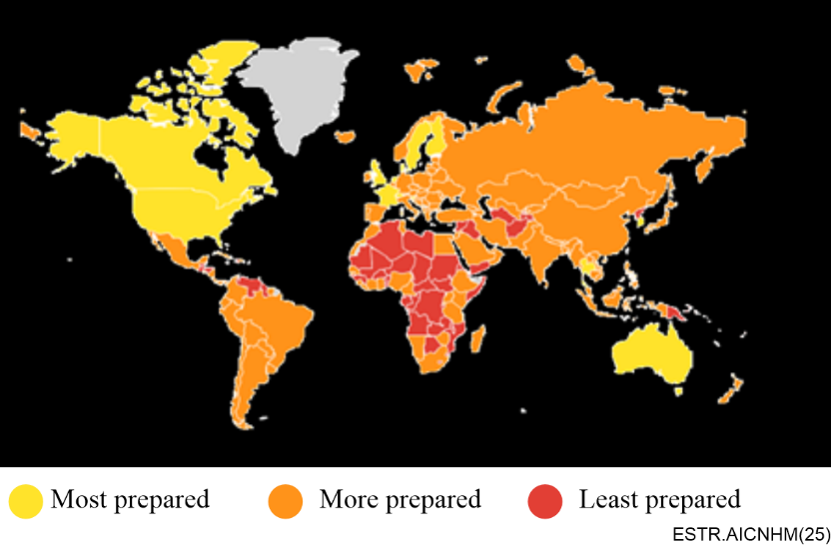
Figure 12 – Vulnerability indicator of relative health security risk by country based on the global health security index (GHSI)
(Source: IBM)

I.3 Susceptibility
Susceptibility records provide historical indicators of how prone a region is to a natural disaster type. By ingesting and analysing NDM impact records that provide the location, number of people impacted, number who perished, including the economic impacts from a natural disaster, one can assess the areas that are more prone to these disasters versus other regions. Climate change will impact the location and severity of these impacts. However, historical records are important inputs for machine learning models and can help indicate the likelihood of a severe impact in the future. These records include:
• the emergency events database (EM-DAT) created and maintain by the centre for research on the epidemiology of disasters (CRED);
• the federal emergency management agency (FEMA) national risk index (NRI), which indicates how prone a county is to floods, earthquakes, or other disaster types; and
• reinsurance records and details, which are key indicators for how likely a region is to be exposed across a wide variety of disaster types.
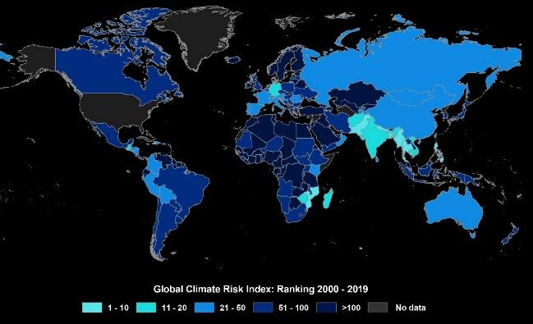
Figure 13 – Susceptibility indicator of relative climate risk by country based on the global climate risk index (GCRI)
(Source: IBM)
The susceptibility of each U.S. based location is given by FEMA's U.S. national risk index (NRI). The NRI shows the communities that are most at risk to natural hazards. It is made possible through a collaboration between FEMA and dozens of partners in academia; local, state and federal government; and the private industry. NRI leverages the best available data sources to provide a holistic view of community-level risk nationwide by combining multiple hazards with socioeconomic and built environmental factors. It calculates a baseline relative risk measurement for each U.S. county and census tract for 18 natural hazards, which is based on expected annual loss, social vulnerability and community resilience. Furthermore, the global climate risk index (GCRI), which is prepared by germanwatch.org, analyses and ranks to what extent countries and regions have been affected by impacts of climate related extreme weather events – storms, floods, heatwaves, etc. (Figure 13).

Bibliography
[b-Adamopoulou] Adamopoulou, E. and Mousepads L. (2020), Chatbots: History, technology, and applications, Machine Learning with Applications, 2, 100006. <https://doi.org/10.1016/j.mlwa.2020.100006>
[b-AI4DRM] Responsible Artificial Intelligence for Disaster Risk Management Working Group Summary. (2021), Soden, R., Wagenaar, D., and Tijssen, A.
<https://www.gfdrr.org/en/publication/responsible-artificial-intelligence-disaster-risk-management>
[b-AIDERS] AIDERS (n.d.), Investigation the potential of AI in emergency response. <https://www2.kios.ucy.ac.cy/aiders/>
[b-Amos] Amos, M., Sengupta, U., Young, P., and Hosking, J.S. (2021), A continuous vertically resolved ozone dataset from the fusion of chemistry climate models with observations using a Bayesian neural network. <https://doi.org/10.31223/X5N91S>
[b-Appleby-Arnold] Appleby-Arnold, S., Brockdorff, N., Yakovlev, I., and Zdravko Vic, S. (2018), Applying cultural values to encourage disaster preparedness: Lessons from a low-hazard country, International Journal of Disaster Risk Reduction, 31, pp. 37-44. <https://doi.org/10.1016/j.ijdrr.2018.04.015>
[b-ARTION] ARTION (n.d.), Disaster Management AI Knowledge Network. <https://www2.kios.ucy.ac.cy/ARTION/>
[b-Ayyad] Ayyad, M., Hajj, M.R., and Marsooli, R. (2022), Machine learning-based assessment of storm surge in the New York metropolitan area, Scientific Reports, 12, 19215. <https://doi.org/10.1038/s41598-022-23627-6>
[b-BBC Media Action] BBC Media Action (2015), Has Mobile Kunju improved family health outcomes in Bihar, India? <https://www.bbc.co.uk/mediaaction/publications-and-resources/research/summaries/asia/india/mobile-kunji-bihar/>
[b-Bentivoglio] Bentivoglio, R., Isufi, E., Jonkman, S.N., and Taormina, R. (2022), Deep learning methods for flood mapping: a review of existing applications and future research directions, Hydrology and Earth System Sciences, 26, pp. 4345-4378. <https://doi.org/10.5194/hess-26-4345-2022>
[b-Bone] Boné, J., Ferreira, J.C., Ribeiro, R., and Cadet, G. (2020), Disroot: A Portuguese Disaster Support Dynamic Knowledge Chatbot, Applied Sciences, 10(24), 9082. <https://doi.org/10.3390/app10249082>
[b-Castillo] Castillo, C. (2016), Big Crisis Data: Social Media in Disasters and Time-Critical Situations, Cambridge University Press. <https://www.researchgate.net/publication/310250723_Big_Crisis_Data_Social_Media_in_Disasters_and_Time-Critical_Situations>
[b-Crawford] Crawford, K. (2013), The Hidden Biases in Big Data. Harvard Business Review. <http://blogs.hbr.org/2013/04/the-hidden-biases-in-big-data/>
[b-Cumiskey] Cumiskey, L., Werner, M., Meijer, K., Fakhruddin, S.H.M., and Hassan, A. (2015), Improving the social performance of flash flood early warnings using mobile services, International Journal of Disaster Resilience in the Built Environment, 6(1), pp. 57-72. <https://doi.org/10.1108/IJDRBE-08-2014-0062>
[b-EPRS] European Parliament, Directorate-General for Parliamentary Research Services, Fox-Skelly J., Bird, E., Jenner, N., Winfield, A., Weitkamp, E., and Larbey, R. (2020), The ethics of artificial intelligence: Issues and initiatives. <https://data.europa.eu/doi/10.2861/6644>
[b-ET] Economic Times Brand Equity. (2021), C-DOT developing tech to tap all media for broadcasting disaster alerts. <https://brandequity.economictimes.indiatimes.com/news/digital/c-dot-developing-tech-to-tap-all media-for-broadcasting-disaster-alerts/86359861>
[b-Gal] Gal, Y., Islam, R., and Ghahramani, Z. (2017), Deep Bayesian Active Learning with Image Data. <https://arxiv.org/pdf/1703.02910.pdf>
[b-Ganaie] Ganaie, M.A., Hu, M., Malik, A.K., Tanveer, M., and Suganthan, P.N. (2021), Ensemble deep learning: A review. <https://arxiv.org/abs/2104.02395>
[b-Gevaert] Gevaert C.M., Carman, M., Rosman, B., Georgiadou, Y., and Soden, R. (2021), Fairness and accountability of AI in disaster risk management: Opportunities and challenges, Patterns, 2(11), 100363. <https://doi.org/10.1016/j.patter.2021.100363>
[b-Giles] Giles, J., and Marris, E. (2004), Indonesian tsunami-monitoring system lacked basic equipment, Nature. <https://doi.org/10.1038/news041229-4>
[b-Ghosh] Ghosh, T., and Krishnamurti, T.N. (2018), Improvements in Hurricane Intensity Forecasts from a Multimodal Superensemble Utilizing a Generalized Neural Network Technique, Weather and Forecasting, 33(3), pp. 873-885. <https://doi.org/10.1175/WAF-D-17-0006.1>
[b-Goan] Goan, E., and Fookes, C. (2020), Bayesian Neural Networks: An Introduction and Survey, Case Studies in Applied Bayesian Data Science, Lecture Notes in Mathematics, Springer. <https://arxiv.org/pdf/2006.12024.pdf>
[b-Hauser] Hauser, T., Keats, A., and Tarasov, L. (2012), Artificial neural network assisted Bayesian calibration of climate models, Climate Dynamics, 39, pp. 137-154. <https://doi.org/10.1007/s00382-011-1168-0>
[b-Havskov] Havskov, J., Otte Möller, L., Rakoczy, A., and Bormann, P. (2012), Seismic Networks. New Manual of Seismological Observatory Practice 2 (NMSOP-2), Potsdam: Deutschers GeoForschungsZentrum GFZ, pp. 1‑65. <https://doi.org/10.2312/GFZ.NMSOP-2_ch8>
[b-Hersbach] Hersbach, H. et al. (2020), The ERA5 Global Reanalysis. Quarterly Journal of the Royal Meteorological Society, 146(730), pp. 1999-2049. <https://doi.org/10.1002/qj.3803>
[b-Hogen Hout] Hogenhout, L. (2021), A Framework for Ethical AI at the United Nations, UN Office for Information and Communications Technology. <https://unite.un.org/news/unite-paper-framework-ethical-ai-united-nations>
[b-Hooper] Hooper, J. (2012), Italian scientists convicted for 'false assurances' before earthquake, The Guardian.
<https://www.theguardian.com/world/2012/oct/22/italian-scientists-jailed-earthquake-aquila>
[b-Huang] Huang, Y., Jin, L., Zhao, H-S., and Huang, X-Y. (2018), Fuzzy neural network and LLE Algorithm for forecasting precipitation in tropical cyclones: comparisons with interpolation method by ECMWF and stepwise regression method, Natural Hazards, 91, 201-220.
<https://doi.org/10.1007/s11069-017-3122-x>
[b-IBM] IBM (2019), Surviving Natural Disasters: Technology to the rescue. <https://www.ibm.com/blogs/digital-transformation/in-en/blog/surviving-natural-disasters-technology-to-the-rescue/>
[b-IPCC] IPCC. (2022), Portner, H-O., Roberts, D.C., Tignor, M.M.B., Pelczarski, E., Riesenbeck, K., Alegría, A., Craig, M., Langsdorf, S., Löschke, S., Möller, V., Okem, A., Rama, B., Climate Change 2022: Impacts, Adaptation and Vulnerability, Working Group II Contribution to the Sixth Assessment Report of the Intergovernmental Panel on Climate Change. <https://www.ipcc.ch/report/ar6/wg2/downloads/report/IPCC_AR6_WGII_FrontMatter.pdf>
[b-Jobin] Jobin, A., Ienca, M., and Vayena, E. (2019), The global landscape of AI ethics guidelines. Nature Machine Intelligence, 1, 389-399. <https://doi.org/10.1038/s42256-019-0088-2>
[b-Jordans] Jordans, F. (2021), Residents of flood-stricken German towns say they got inadequate warning of deluge, Los Angeles Times. <https://www.latimes.com/world-nation/story/2021-07-24/residents-of-flood-hit-german-towns-tell-of-short-lead-time>
[b-Jospin] Jospin, L.V., Laga, H., Boussaid, F., Buntine, W., and Bennamoun, M. (2022), Hands-On Bayesian Neural Networks – A Tutorial for Deep Learning Users, IEEE Computational Intelligence Magazine, 17(2), pp. 29-48. <https://doi.org/10.1109/MCI.2022.3155327>
[b-Kashinath] Kashinath, K. et al. (2021), Physics-informed machine learning: case studies for weather and climate modelling, Philosophical Transactions of the Royal Society A, 379(2194). <https://doi.org/10.1098/rsta.2020.0093>
[b-Khan] Khan, M. S. and Coulibaly, P. (2010), Assessing Hydrologic Impact of Climate Change with Uncertainty Estimates: Bayesian Neural Network Approach, Journal of Hydrometeorology, 11(2), pp. 482-495. <https://doi.org/10.1175/2009JHM1160.1>
[b-Lapuschkin] Lapuschkin, S., Wäldchen, S., Binder, A., Montavon, G., Samek, W., and Müller, K-R. (2019), Unmasking Clever Hans predictors and assessing what machines really learn, Nature Communications, 10, 1096. <https://doi.org/10.1038/s41467-019-08987-4>
[b-Lazer] Lazer, D., Kennedy, R., King, G., and Vespignani, A. (2014), The Parable of Google Flu: Traps in Big Data Analysis, Science, 343(6176), pp. 1203-1205. <https://doi.org/10.1126/science.1248506>
[b-Lorini] Lorini, V., Castillo, C., Peterson, S., Rufolo, P., Purohit, H., Pajarito, D., Albuquerque, J.P.D., Buntain, C., Grajales, D.F.P. (2021), Social Media for Emergency Management: Opportunities and Challenges at the Intersection of Research and Practice. <https://www.researchgate.net/publication/351879549_Social_Media_for_Emergency_Management_Opportunities_and_Challenges_at_the_Intersection_of_Research_and_Practice>
[b-Louis-Charles] Louis-Charles, H.M., Howard, R., Remy, L., Nibbs, F., and Turner, G. (2020), Ethical Considerations for Postdisaster Fieldwork and Data Collection in the Caribbean. American Behavioral Scientist, 64(8), pp. 1129-1144. <https://doi.org/10.1177/0002764220938113>
[b-Madianou] Madianou, M. (2021), Nonhuman humanitarianism: when 'AI for good' can be harmful, Information, Communication & Society, 24(6), pp. 850-868. <https://doi.org/10.1080/1369118X.2021.1909100>
[b-Marchezini] Marchezini, V., Trajber, R., Olivato, D., Muñoz, V.A., de Oliveira Pereira, F., and Oliveira Luz, A.E. (2017), Participatory Early Warning Systems: Youth, Citizen Science, and Intergenerational Dialogues on Disaster Risk Reduction in Brazil, International Journal of Disaster Risk Science, 8, pp. 390-401. <https://doi.org/10.1007/s13753-017-0150-9>
[b-McAllister] McAllister, R., Gal, Y., Kendall, A., van der Wilk, M., Shah, A., Cipolla, R., Weller, A. (2017), Concrete Problems for Autonomous Vehicle Safety: Advantages of Bayesian Deep Learning, International Joint Conferences on Artificial Intelligence Organization, pp. 4745-4753. <https://doi.org/10.24963/ijcai.2017/661>
[b-McGovern] McGovern, A., Lagerquist, R., Gagne II, D.J., Jergensen G.E., Elmore, K.L., Homeyer, C.R., Smith, T. (2019), Making the Black Box More Transparent: Understanding the Physical Implications of Machine Learning, Bulletin of the American Meteorological Society,100(11), pp. 2175-2199. <https://doi.org/10.1175/BAMS-D-18-0195.1>
[b-Muhammad] Muhammad, K., Ahmad, J., and Baik, S.W. (2018), Early fire detection using convolutional neural networks during surveillance for effective disaster management, Neurocomputing, 288, pp. 30-42. <https://doi.org/10.1016/j.neucom.2017.04.083>
[b-Mukherjee] Mukherjee, S., Mishra, A., and Trenberth, K.E. (2018), Climate Change and Drought: a Perspective on Drought Indices, Current Climate Change Reports, 4, pp. 145-163. <https://doi.org/10.1007/s40641-018-0098-x>
[b-Mullachery] Mullachery, V., Khera, A., and Husain, A. (2018), Bayesian Neural Networks, arXiv. <https://arxiv.org/abs/1801.07710>
[b-Münchmeyer] Münchmeyer, J., Bindi, D., Leser, U., and Tilmann, F. (2021), Earthquake magnitude and location estimation from real time seismic waveforms with a transformer network, Geophysical Journal International, 226(2), pp. 1086-1104. <https://doi.org/10.1093/gji/ggab139>
[b-Nakamura] Nakamura, Y., and Saita, J. (2007), UrEDAS, the Earthquake Warning System: Today and Tomorrow, Earthquake Early Warning Systems, pp. 249-281. <https://doi.org/10.1007/978-3-540-72241-0_13>
[b-Nature] Nature (2008), Early-warning system underestimates quake, 451, p. 511. <https://doi.org/10.1038/451511b>
[b-Nevo] Nevo, S. et al. (2022), Flood forecasting with machine learning models in an operational framework, Hydrology and Earth System Sciences, 26(15), pp. 4013-4032. <https://doi.org/10.5194/hess-26-4013-2022>
[b-NIDM] National Institute of Disaster Management (2014), East Asia Summit Earthquake Risk Reduction Centre. <https://nidm.gov.in/easindia2014/err/pdf/themes_issue/technology/early_warnings.pdf>
[b-Norori] Norori, N., Hu, Q., Aellen, F.M., Faraci, F.D., and Tzovara, A. (2021), Addressing Bias in Big Data and AI for Health Care: A Call for Open Science, Patterns, 2(10), 100347. <https://doi.org/10.1016/j.patter.2021.100347>
[b-Ogie] Ogie, R.I., Rho, J.C., and Clarke, R.J. (2018), Artificial Intelligence in Disaster Risk Communication: A Systematic Literature Review. <https://doi.org/10.1109/ICT-DM.2018.8636380>
[b-Parker] Parker, C. (2020), Nonprofits and artificial intelligence join forces for COVID-19 relief. EdNC.
<https://www.ednc.org/nonprofits-and-artificial-intelligence-join-forces-for-covid-19-relief/>
[b-Parra] Parra, J., Fuentes, O., Anthony, E., and Kreinovich, V. (2017), Use of Machine Learning to Analyze and – Hopefully – Predict Volcano Activity, Acta Polytechnica Hungarica, 14(3), pp. 209-221. <https://doi.org/10.12700/APH.14.3.2017.3.12>
[b-Pennington] Pennington, C.V.L., Bossu, R, Ofli, F., Imran, M., Qazi, U., Roch, J., and Banks, V.J. (2022), A near-real-time global landslide incident reporting tool demonstrator using social media and artificial intelligence, International Journal of Disaster Risk Reduction, 77, 103089. <https://doi.org/10.1016/j.ijdrr.2022.103089>
[b-Perkins-Kirkpatrick] Perkins-Kirkpatrick, S.E., and Lewis, S.C. (2020), Increasing trends in regional heatwaves, Natural Communications, 11, 3357. <https://doi.org/10.1038/s41467-020-16970-7>
[b-Piralilou] Piralilou, S.T., et al. (2019), Landslide Detection Using Multi-Scale Image Segmentation and Different Machine Learning Models in the Higher Himalayas, Remote Sensing, 11(21), 2575. <https://doi.org/10.3390/rs11212575>
[b-PlantVillage NURU] PlantVillage NURU. (2019), AI for pest & disease monitoring, CGIAR Platform for Big Data in Agriculture 2017 and 2019 Inspire Challenge Winner. <https://bigdata.cgiar.org/inspire/inspire-challenge-2017/pest-and-disease-monitoring-by-using-artificial-intelligence/>
[b-Purohit-1] Purohit, H., and Peterson, S. (2020), Social Media Mining for Disaster Management and Community Resilience, Big Data in Emergency Management: Exploitation Techniques for Social and Mobile Data, pp. 93-107. <https://doi.org/10.1007/978-3-030-48099-8_5>
[b-Purohit-2] Purohit, H., Castillo, C., Imran, M., and Pandey, R. (2018), Social-EOC: Serviceability Model to Rank Social Media Requests for Emergency Operation Centres, IEEE. <https://doi.org/10.1109/ASONAM.2018.8508709>
[b-Rasp] Rasp, S., Dueben, P.D., Scher, S., Weyn, J.A., Mouatadid, S., and Thuerey, N. (2020), WeatherBench: A Benchmark Data Set for Data-Driven Weather Forecasting, Journal of advances in modelling earth systems.
<https://agupubs.onlinelibrary.wiley.com/doi/pdf/10.1029/2020MS002203>
[b-Reilly] Reilly, J., Dashti, S., Ervasti, M., Bray, J.D., Glaser, S.D., and Bayen, A.M. (2013), Mobile Phones as Seismologic Sensors: Automating Data Extraction for the iShake System, IEEE Transactions on Automation Science and Engineering. 10(2), pp. 242-251. <https://doi.org/10.1109/TASE.2013.2245121>
[b-Sachdeva] Sachdeva, S., Bhatia, T., and Verma, A.K. (2018), GIS-based evolutionary optimized gradient boosted decision trees for forest fire susceptibility mapping, Natural Hazards, 92, pp. 1399-1418.
<https://doi.org/10.1007/s11069-018-3256-5>
[b-Sandvik] Sandvik, K.B. (2019), Making Wearables in Aid: Digital Bodies, Data and Gifts, Journal of Humanitarian Affairs, 1(3), pp. 33-41. <https://doi.org/10.7227/JHA.023>
[b-Schölkopf] Schölkopf, B. (2019), Causality for machine learning. https://www.datascienceassn.org/sites/default/files/Causality%20for%20Machine%20Learning.pdf
[b-Schultz] Schultz, M.G., Betancourt, C., Gong, B., Kleinert, F., Langguth, M., Leufen, L.H., Mozaffari, A., and Stadtler, S. (2021), Can deep learning beat numerical weather prediction? Philosophical Transactions of the Royal Society A. Mathematical, Physical and Engineering Sciences, 379(2194). <https://doi.org/10.1098/rsta.2020.0097>
[b-Shearer] Shearer, E., and Mitchell, A. (2021), News Use Across Social Media Platforms in 2020, Pew Research Centre. <https://www.pewresearch.org/journalism/2021/01/12/news-use-across-social-media-platforms-in-2020/>
[b-Singhvi] Singhvi, A., Saget, B., and Lee, J.C. (2018), What Went Wrong With Indonesia's Tsunami Early Warning System, The New York Times. <https://www.nytimes.com/interactive/2018/10/02/world/asia/indonesia-tsunami-early-warning-system.html>
[b-Sun] Sun, W., Bocchini, P., and Davison, B.D. (2020), Applications of artificial intelligence for disaster management. Natural Hazards, 103, pp. 2631-2689. <https://doi.org/10.1007/s11069-020-04124-3>
[b-Szegedy] Szegedy, C., Zaremba, W., Sutskever, I., Bruna, J., Erhan, D., Goodfellow, I., and Fergus, R. (2013), Intriguing properties of neural networks. arXiv:1312.6199. <https://arxiv.org/abs/1312.6199>
[b-Tan] Tan, L., Guo, J., Mohanarajah, S., and Zhou, K. (2021), Can we detect trends in natural disaster management with artificial intelligence? A review of modeling practices. Natural Hazards. 107, pp. 2389-2417.
<https://doi.org/10.1007/s11069-020-04429-3>
[b-Tehrany] Tehrany, M.S., Pradhan, B., and Jebur, M.N. (2013), Spatial prediction of flood susceptible areas using rule based decision tree (DT) and a novel ensemble bivariate and multivariate statistical models in GIS. Journal of Hydrology. 504, pp. 69-79. <https://doi.org/10.1016/j.jhydrol.2013.09.034>
[b-Thüring] Thüring, T., Schoch, M., van Herwijnen, A., and Schweizer, J. (2015), Robust snow avalanche detection using supervised machine learning with infrasonic sensor arrays. Cold Regions Science and Technology, 111, pp. 60-66. <https://doi.org/10.1016/j.coldregions.2014.12.014>
[b-Trogrlić] Trogrlić, R.S, van den Homberg, M., Budimir, M., McQuistan, C., Sneddon, A., and Golding, B. (2022), Early Warning Systems and Their Role in Disaster Risk Reduction, Towards the "Perfect" Weather Warning, pp. 11-46. <https://doi.org/10.1007/978-3-030-98989-7_2>
[b-Trujillo-Falcón] Trujillo-Falcón, J. et al. (2022), ¿Aviso o Alerta? Developing Effective, Inclusive, and Consistent Watch and Warning Translations for U.S. Spanish Speakers, Bulletin of the American Meteorological Society. 103(12), pp. 2791-2803. <https://doi.org/10.1175/BAMS-D-22-0050.1>
[b-Tsai] Tsai, M-H., Chen, J.Y., and Kang, S-C. (2019), Ask Diana: A Keyword-Based Chatbot System for Water-Related Disaster Management, Water, 11(2), p. 234. <https://doi.org/10.3390/w11020234>
[b-UNDP] United Nations Development Programme (UNDP) (2018), Five Approaches to Build Functional Early Warning Systems. <https://www.adaptation-undp.org/sites/default/files/resources/undp_brochure_early_warning_systems.pdf>
[b-van de Schoot] van de Schoot, R. et al. (2021), Bayesian statistics and modelling, Nature Reviews Methods Primers, 1(1). <https://doi.org/10.1038/s43586-020-00001-2>
[b-Wang] Wang, Z., Lam, N.S.N., Obradovich, N., and Ye, X. (2019), Are vulnerable communities digitally left behind in social responses to natural disasters? An evidence from Hurricane Sandy with Twitter data, Applied Geography, 108, pp. 1-8. <https://doi.org/10.1016/j.apgeog.2019.05.001>
[b-Wetterhall] Wetterhall, F. et al. (2013), HESS Opinions: Forecaster priorities for improving probabilistic flood forecasts, Hydrology and Earth System Sciences, 17(11), pp. 4389-4399. <https://doi.org/10.5194/hess-17-4389-2013>
[b-WMO] World Meteorological Organization (2018), Multi-Hazard Early Warning Systems: A Checklist. <https://public.wmo.int/en/our-mandate/focus-areas/natural-hazards-and-disaster-risk-reduction/mhews-checklist>
[b-Yaseen] Yaseen, Z.M., El-shafie, A., Jaafar, O., Afan, H.A., and Sayl, K.N. (2015), Artificial intelligence based models for stream-flow forecasting: 2000-2015. Journal of Hydrology, 530, pp. 829-844. <https://doi.org/10.1016/j.jhydrol.2015.10.038>
[b-Yousefi] Yousefi, S., Pourghasemi, H.R., Emami, S.N., Pouyan, S., Eskandari, S., and Tiefenbacher, J.P. (2020), A machine learning framework for multi-hazards modeling and mapping in a mountainous area, Scientific Reports, 10, 12144. <https://doi.org/10.1038/s41598-020-69233-2>
[b-Zhao] Zhao, L., Hicks, F.E., and Fayek, A.R. (2012), Applicability of multilayer feed-forward neural networks to model the onset of river breakup, Cold Regions Science and Technology, 70, pp. 32-42. <https://doi.org/10.1016/j.coldregions.2011.08.011>
[b-Zhou-1] Zhou, C., Yin, K., Cao, Y., Ahmed, B., Li, Y., Catani, F., and Pourghasemi, H.R. (2018), Landslide susceptibility modeling applying machine learning methods: A case study from Longju in the Three Gorges Reservoir area, China, Computers & Geosciences, 112, pp. 23-37. <https://doi.org/10.1016/j.cageo.2017.11.019>
[b-Zhou-2] Zhou, Z-H. (2012), Ensemble Methods: Foundations and Algorithms (1st. ed.), CRC Press. <https://www.researchgate.net/publication/235323860_Ensemble_Methods_Foundations_and_Algorithms>
___________

This has been derived from a preliminary literature survey covering articles published between 2018 and 2021.
This Figure is derived from a preliminary literature survey covering articles published between 2018 and 2021.
For example, please see the FG-AI4NDM topic group use cases entitled "Earthquake disaster mitigation through AI on smart seismic networks"; "Flash flooding monitoring system in Mexico"; "Enabling natural hazards risk information sharing using derived products of export-restricted real-time GNSS data for detection of ionospheric total electron disturbances"; "Building a coupled earthquake-tsunami-TEC simulator in a parallel HPC environment"; "Identification and classification of pest infested coniferous forest using AI"; "Artificial intelligence modelling tools for monitoring desert locust (AI-locust): Breeding grounds, hatching time, population dynamics and spatio-temporal distribution"; "An intelligent big data analysis system for wildfire management"; "Multimodal databases and artificial intelligence for airborne wildfire detection and monitoring"; "Real-time volcano-independent seismic recognition as volcano monitoring tool"; and "AI enabled citizen-centric decision support system for disaster managers" in clause 6. Please note that several of these use cases can be categorized as examples of AI-based (near) real time detection as well as another type of communication system (e.g., hazard map).
As shown in the topic group use cases entitled "Earthquake disaster mitigation through AI on smart seismic networks" and "Building a coupled earthquake-tsunami-TEC simulator in a parallel HPC environment".
As shown in the topic group use case entitled "Earthquake disaster mitigation through AI on smart seismic networks".
Early Warnings for All – What Does Success Look Like?: https://wmo.int/media/magazine-article/early-warnings-all-what-does-success-look.
https://www.itu.int/en/ITU-T/Workshops-and-Seminars/20210315/Documents/Kei%20Yoshimura.pdf?csf=1&e=pdFlvm
https://www.itu.int/en/ITU-T/Workshops-and-Seminars/2021/0830/Documents/Kriti_Shruti.pdf
For example, please see the topic group use cases entitled "Probing seismogenesis for fault slip and earthquake hazards"; "Artificial intelligence modelling tools for monitoring desert locust (AI-locust): Breeding grounds, hatching time, population dynamics and spatio-temporal distribution"; "AI for snow avalanche monitoring and detection"; "Limitations of predicting snow avalanche hazards in large data sparse regions" from Simon Horton; "AI and vector-borne diseases"; "Towards forecasting eruptions using machine learning of volcano seismic data"; and "Unified methodology for windstorm and hailstorm hazard modelling and mapping" in clause 6. Please note that several of these use cases can be categorized as examples of AI-based forecasting as well as another type of communication system (e.g., hazard map).
For example: https://cordis.europa.eu/programme/id/H2020_LC-GD-9-3-2020.
For example, please see the topic group use cases entitled "Satellite images and machine learning for mapping flood"; "Using ML to reconstruct flooded area under clouds in optical satellite images: the Mozambique Use Case"; "Exploring deep learning capabilities for surge predictions in coastal areas"; "Artificial intelligence modelling tools for monitoring desert locust (AI-locust): Breeding grounds, hatching time, population, and spatio-temporal distribution"; "Landslides of masses of soil and rock: Intelligent risk management in areas highly threatened by climate change"; "Geographical data science applied to landslide and debris flow hazard in the Colombian Andes"; "Soft computing paradigm for landslide monitoring and disaster management"; "An intelligent big data analysis system for wildfire management"; "Multimodal databases and artificial intelligence for airborne wildfire detection and monitoring"; "Unified methodology for windstorm and hailstorm hazard modelling and mapping" from Alejandro Marti; "AIDERS: Real-time artificial intelligence for DEcision support via RPAS data analyticS"; and "Situational awareness system for disaster response using space-based AI (SARA)" in clause 6. Please note that several of these use cases can be categorized as examples of AI for hazard mapping as well as another type of communication system (e.g., Decision support system).
https://incubed.esa.int/portfolio/floodsens/
Floods have been detected using the ML algorithm FloodSENS. The flood extent has been used to analyse land cover in the affected areas using the most recent ESA WorldCover classification.
The designations employed and the presentation of material on this map do not imply the expression of any opinion whatsoever on the part of ITU and of the Secretariat of the ITU concerning the legal status of the country, territory, city or area or its authorities, or concerning the delimitation of its frontiers or boundaries
This platform enables first responders to gain situational awareness during NDM. This example pertains to wildfire management.
For example, please see the topic group use cases entitled "AI enabled citizen-centric decision support system for disaster managers" and "AIDERS: Real-time artificial intelligence for DEcision support via RPAS data analyticS" in clause 6. Please note that these use cases can be categorized as examples of AI for DSS as well as another type of communication system (e.g., hazard map).
For example, please see the topic group use cases entitled "Situational awareness system for disaster response using space-based AI (SARA)"; and "Multi-hazard use case for operations risk insights and day one relief for natural disaster response" in clause 6. Please note that these use cases can be categorized as examples of AI for dashboards / apps as well as another type of communication system (e.g., hazard map).
https://www.itu.int/en/ITU-T/Workshops-and-Seminars/2022/1024/Documents/Kian%20Mirshahi.pdf
https://aiforgood.itu.int/event/artificial-intelligence-for-natural-disaster-management/
Examples of these services include: the WMO, the US national weather service (NWS), Meteoalarm (an aggregator of risk alerts across Europe), the US geological survey (USGS) for earthquake notification, and the global disaster alert and coordination system (GDACS) for more severe event details.
For example, please see the topic group use case entitled "Proposal of an AI chatbot use case as a multihazard communication technology" in clause 6. Please note, however, that other topic group use cases might also contain a chatbot component within their greater communication system.
https://www.itu.int/en/ITU-T/Workshops-and-Seminars/2021/0830/Documents/Soichiro%20Yasukawa.pdf
This information was acquired through a conversation with experts from UNESCO.
This information was acquired through a conversation with experts from UNESCO.
https://www.itu.int/en/ITU-T/Workshops-and-Seminars/2021/0830/Documents/Roland%20Schobi.pdf
See the technical report on "Data for AI."
See the technical report on "AI for modelling."
https://www.itu.int/en/ITU-T/Workshops-and-Seminars/2022/1024/Documents/Catherine%20Pennington%20.pdf
https://www.itu.int/en/ITU-T/Workshops-and-Seminars/20210315/Documents/Steven%20Stichter_20210315_ITU_AI-disaster-mgmt_S4_NAS-Stichter.pdf?csf=1&e=l9tLQZ
Given the rapid development of AI-based technologies, research needs to be continued in key areas for employing technologies for NDM. Other examples of emerging technologies with the potential to advance AI for NDM communications are quantum machine learning and knowledge graphs as per recent publications.
The designations employed and the presentation of material on this map do not imply the expression of any opinion whatsoever on the part of ITU and of the Secretariat of the ITU concerning the legal status of the country, territory, city or area or its authorities, or concerning the delimitation of its frontiers or boundaries.
The designations employed and the presentation of material on this map do not imply the expression of any opinion whatsoever on the part of ITU and of the Secretariat of the ITU concerning the legal status of the country, territory, city or area or its authorities, or concerning the delimitation of its frontiers or boundaries.

