 |  | International Telecommunication Union
 |  | ITU-T | Technical Report
 |  | TELECOMMUNICATION  STANDARDIZATION SECTOR  OF ITU |  | (05/2019)
DSTR-DFSUAAFR
Digital financial services – Review of DFS user agreements in Africa: A consumer protection perspective

Summary
This Technical Report explains the findings from an analysis of DFS user agreements in nine African countries, and attempts to give an understanding of the overall consumer experience and whether or not there is a disconnect between contract provisions and the legal and regulatory provisions governing digital financial services (DFS). The Report highlights key findings, and makes a number of recommendations for action by the appropriate regulator in the various markets examined. Countries need to take these considerations into account as they continue to nurture their DFS markets so as to safeguard customers from harmful practices and ensure trust in the market.
Keywords
Africa, consumer protection, digital financial services, user agreements.
Change Log
This document contains the ITU-T Technical Report on "Review of DFS user agreements in Africa: A consumer protection perspective" agreed at the ITU-T Study Group 3 meeting held in Geneva, 23 April – 2 May 2019.

CONTENTS
Page
1 Scope 4
2 References 4
3 Terms and definitions 5
3.1 Terms defined elsewhere 5
3.2 Terms defined here 5
4 Abbreviations 5
5 Introduction 5
6 Key highlights 5
7 Language of agreement and transparency of communications 6
6.2 Provider obligations 7
6.3 Consumer obligations 11
6.4 Complaints handling 13
7 Conclusions and recommendations 16
Annex 1 – DFS contracts reviewed 18
Annex 2 – Summary of findings 20

List of Figures
Figure 1 – Fraud & funds protection 7
Figure 2 – Third-party sharing 8
Figure 3 – Reversal 9
Figure 4 – Change of terms and conditions with notice 10
Figure 5 – PIN safety 11
Figure 6 – Dormancy period 12
Figure 7 – Customer funds at death 12
Figure 8 – In-house dispute resolution 13
Figure 9 – Mandatory arbitration 15
Figure 10 – Legal fees indemnity 16

List of Boxes
Box 1 – Language and transparency of communications 6
Box 2 – Fees and charges 7
Box 4 – Changes to terms and conditions 10
Box 5 – Complaint handling 14
Box 6 – Mandatory arbitration 15

Technical Report ITU-T DSTR-DFSUAFR
Digital Financial Services – Review of DFS user agreements in Africa:
A consumer protection perspective
Summary
The success of digital financial services (DFS) in developing countries and its contribution to increasing financial access to previously unserved and underserved populations is indisputable. Even though the exponential growth of DFS is praiseworthy, it has caused a number of spill-over effects, some of which are not so laudable. In this regard, one key area that is worthy of examination relates to the consumer experience with user agreements. User agreements are standard form contracts that spell out the terms and conditions of use, and quite a few are unduly burdensome for consumers. Others may actually cause direct harm to consumers.
This Technical Report explains the findings from an analysis of DFS user agreements in nine African countries, and attempts to give an understanding of the overall consumer experience and whether or not there is a disconnect between contract provisions and the legal and regulatory provisions governing DFS. The Report highlights key findings, and makes a number of recommendations for action by the appropriate regulator in the various markets examined. Countries need to take these considerations into account as they continue to nurture their DFS markets so as to safeguard customers from harmful practices and ensure trust in the market.
The summary of findings below indicates that consumers face a number of challenges as they use DFS, including:
i) Lengthy contracts: Some contracts run quite long, which discourages consumers from reading them. Findings from behavioural science further support this conclusion. Consequently, this throws doubt as to whether there is truly a meeting of the minds when consumers enter into user agreements with providers.
ii) Fees and charges associated with transactions, including for money transfers, bill payments, interest on loans, and unstructured supplementary service data (USSD) charges for transactions are not always stated in the agreements. Thus, consumers may not be aware of the cost of services prior to entering these binding arrangements.
iii) Language barriers: Contracts are predominantly in English, which is not spoken by a large number of the populations at issue. Furthermore, these contracts often use complex legal language and consequently even those consumers who are fluent in English may still fail to understand the true implications of the provisions.
iv) Providers stipulate a number of obligations towards customers in these agreements. Areas such as fraud and funds protection are of concern. Of the agreements reviewed, only 50 per cent of agreements outlined specific obligations related to fraud and funds protection. Moreover, the customer must notify the provider as a pre-condition for providers to address incidences of fraud, when consumers may not be in the best position to identify a fraud.
v) Over 80 per cent of contracts contain clauses permitting providers to share information with third parties, such as credit reference bureaus, provider agents and subsidiaries, and also "for reasonable commercial purposes related to the provision of services". This is quite vague and may give providers overbroad licence to share consumer data, which raises privacy concerns. Management of privacy and data protection is further complicated by the lack of specific data protection legislation in the jurisdictions reviewed. Consumers have to rely on provisions contained in various pieces of legislation that do not comprehensively protect them.
vi) Half of the contracts included clauses requiring consumers to indemnity providers for legal fees incurred in pursuing a legal matter related to their offer of service to the consumer. Such clauses could result in customers avoiding pursuing redress, even where they have a valid complaint, for fear that they may accrue legal fees that they cannot afford.
vii) Clauses governing a change of terms and conditions by providers can be problematic, such as those that result in customers being legally required to accept terms and conditions that are retroactively introduced, whether they have read and agreed to these new terms or not.
The contracts reviewed provide a useful snapshot of practices in the area of DFS user agreements and it is possible that the findings may not apply across the board in the various jurisdictions. However, regulators and policy makers would do well to carry out a more detailed analysis, looking at a greater number of contracts and potentially conducting consumer surveys in order to establish whether the issues highlighted are indeed representative of the challenges consumers are encountering in their respective markets. If they are encountering these challenges, the recommendations detailed in this Technical Report will be a useful starting point for revamping the DFS landscape.
In addition to the contract specific concerns highlighted above, an examination of the country legal frameworks revealed that in some instances, laws/regulations might need greater specificity in order to ensure that consumers are better protected. It was observed that in instances where providers may not be directly flouting laws or regulations, the existing provisions as framed have the net effect of causing consumer harm. For example, with regard to provisions requiring transparency of fees and charges: Often the law will state that providers need to make consumers aware of the fees prior to signing on to contracts or purchasing services, but the provisions do not specially require that this should be stipulated in the user agreement itself. As such, a provider may technically be complying, as they make this information available in another location (on their website for instance), but customers may not be able to access these sources, especially those who do not have access to the Internet. This means that they are not informed of the associated charges at the point where they accept contract terms and conditions.
Overall, to ensure improved consumer experience as they navigate the DFS landscape, the following is needed:
• User agreements that are consumer friendly in terms of language, length of contracts and transparency of provisions.
• Greater scrutiny by regulators of these provider agreements. They might look at how providers word their obligations to ensure that consumers are not facing undue burdens and they might also generally analyse agreements to ensure key areas of consumer protection are captured in the agreement.
• Legislative amendments, as required, to improve protection for DFS consumers.
• Consumer education and awareness to help them understand their legal rights and how to navigate redress when those rights are violated.

1 Scope
See Summary.

2 References
None.

3 Terms and definitions

3.1 Terms defined elsewhere
None.

3.2 Terms defined here
None.

4 Abbreviations
DFS Digital Financial Services
MNO Mobile Network Operator
SMS Short Message Service
USSD Unstructured Supplementary Service Data

5 Introduction
The delivery of financial services through digital means has been lauded as a key ingredient for the rise in financial inclusion numbers in many developing countries. Through this avenue, products and services such as money transfer, credit and insurance have become much more accessible to previously under-served populations. As a prerequisite to enjoying these services, consumers are required to enter into contracts with the relevant DFS providers in their markets. However, in some cases, these agreements may contain provisions that are unfair or perilous for customers, putting them at risk of significant economic loss. More specifically, contract clauses are sometimes: (1) unclear or difficult to understand, especially as they are usually written in complex or technical language; (2) too onerous; (3) very lengthy; (4) have crucial terms missing; and (5) in contravention of legislation or regulation. However, not all contract clauses are of concern. Some agreements do try to incorporate provisions that protect consumers.
A total of 18 contracts were selected from nine countries in Africa, namely: Ghana, Kenya, Malawi, Nigeria, South Africa, Tanzania, Uganda, Zambia and Zimbabwe.
These contracts were analysed along the following main themes:
• Language of agreement/transparency of communications
• Provider obligations
• Consumer obligations
• Dispute resolution/recourse.
This Technical Report summarizes findings on these specific themes, across the nine countries where contracts were reviewed.
As part of the country-specific analysis, examples of contract provisions which appear to be in conflict with domestic legislation/regulation have also set off in boxes. While this analysis addresses potential compliance issues, readers are cautioned that the final word on the legality of a contract clause must be decided by the appropriate courts.

6 Key highlights
The country-specific analyses revealed some good practices and areas of concern, as discussed below.

7 Language of agreement and transparency of communications
The language used in all the contracts is English, which is not universally spoken in each country. In addition, given literacy rates in some of the countries, which providers could be expected to know, significant portions of the population will be unable to read the provisions. Even where the agreements can be read, given the frequent use of complex legal language, the true implications of the agreements may not be fully understood. See Box 1 for sample clauses from user agreements that may be considered in conflict with domestic legal and regulatory requirements.
Another challenge that was identified by the review was regarding the length of contracts. A majority of the agreements are several pages long. Studies from behavioural science demonstrate that consumers will not read lengthy agreements. This raises the question whether there is truly a meeting of the minds when customers enter into these agreements.
Fees and charges associated with transactions, including for money transfers, bill payment, interest on loans and USSD charges for transactions, are sometimes not disclosed in the agreements. Instead, customers are referred to provider tariffs on websites or to publications that are available from other sources, including at provider branches, customer care centres and agent outlets. A scan of a number of provider websites makes clear that additional details on product offers and other terms are often not contained in the contracts but instead in other places. See also Box 2 for example user agreements deemed suspect with regard to a failure to transparently communicate prices.
The net result is that consumers may not be aware of the costs of services and other important contract terms and it may not be possible for them to discover what those terms are by accessing sources like websites, particularly for those who use short message service (SMS) orUSSD, or for those who do not have access to the Internet.
In addition to the above, it was also observed that providers do not always disclose the consequences of default for credit products; yet, this is a key term that customers should be made aware of before they accept a loan facility.
Malawi and Uganda
• Malawi, Consumer Protection Act (2003)
26-(1) Standard form contracts or agreements shall (b) be drafted in the official language and in characters readable at single sight by any normal sighted person: and
(c) where the contract is entered into locally, have a written translation into the national local language and shall be read and explained to an illiterate, blind, mute and similarly disabled consumer in a language he understands.
27(3) For the purposes of this section, an unfair consumer contract means a contract which (e) if in case of a written consumer contract, if the contract is expressed in a language not ordinarily understood by the consumer.
• Uganda, Financial Consumer Protection Guidelines issued by the Bank of Uganda to address the needs of illiterate consumers-
Comment:
The contracts available in both Malawi and Uganda were in English and it could therefore be argued that they are not written in a language comprehensible to all customers, particularly those who are illiterate. Also for DFS products, it is unclear whether oral explanations are being provided to illiterate and disabled consumers.
Box 1 – Language and transparency of communications
Uganda: The Mobile Money Regulations 12 (b) – At mobile money account opening, the consumer shall obtain a copy of the agreement with the service provider. The agreement shall be explained by the agent clearly and in plain language. The terms and conditions provided by the mobile money service provider shall highlight to the consumer the relevant fees, charges, penalties and any other consumer liabilities or obligations in the use of mobile money services. The mobile money customers should be able to access the service fees chargeable from their phones.
Comment:
The agreements reviewed (Utl M-sente and MTN Uganda) did not highlight to the consumer the fees, charges, and penalties.
Box 2 – Fees and charges

6.2 Provider obligations
Some contracts state obligations that providers owe to consumers including: Fraud and funds protection; data protection and privacy, including when customer information is shared with third parties; procedures for reversal of erroneous transactions; and whether consumers are given advance notice of changes to contract terms. The following is a discussion of how often such obligations are stated and, when they are, what is provided.

6.2.1 Fraud and funds protection
Consumers often lose money through fraudulent activity perpetrated by third parties or even by provider employees or agents. The contracts were examined to establish whether they incorporated provider obligations with regard to fraud and funds protection.

Figure 1 – Fraud and funds protection
As demonstrated in the chart of Figure 1, only half of the agreements stipulated specific obligations relating to fraud and funds protection. Examples of such provisions include providers suspending services or closing accounts where they suspect or become aware of fraudulent activity in relation to a customer’s account.
Notification by customers is a crucial precondition for providers to address cases of fraud. Agreements specify, for instance, that customers will be held responsible for transactions conducted without their authorization unless they bring this fact to the attention of the provider. Even where customers provide notice of fraud, provider obligations only kick in after they receive such notices, with a disclaimer of liability for any losses or damages suffered by customers prior to such notifications.

6.2.2 Third-party sharing
Data privacy and protection is another key area of concern. The results from the review show that 83 per cent of the contracts reviewed had clauses that permit the provider to share information with third parties, such as credit reference bureaus, law enforcement agencies (both domestic and international), regulators, provider agents, lawyers, auditors and subsidiaries.
Sharing of customers’ personal information is also permitted in some cases "for reasonable commercial purposes related to the provision of services". This very vague phrasing may give providers room to share with undisclosed categories of third parties, raising customer privacy concerns.

Figure 2 – Third-party sharing
Third-party sharing is especially a concern because providers in some jurisdictions have sold sensitive customer personal information, including financial information.
Management of issues of privacy and data protection by customers is further complicated because many countries on the African continent lack specific data protection legislation. As a result, customers in a majority of these countries have to rely on provisions contained in various pieces of legislation that may not comprehensively protect them. See also Box 3, which is an example of a clause from a user agreement that may fall short of legal requirements in the jurisdiction.
Uganda: Mobile Money Regulations, Regulation 12(c) Data protection-
(i) A mobile money service provider, as well as its agents, shall uphold privacy and confidentiality of customer information and data;
(ii) The conditions under which customer information and data will be kept shall be disclosed before the customer enters into agreement with the mobile money service provider.
Comment:
Contracts reviewed (Utl M-sente and MTN Uganda) did not include affirmations that providers would keep customer information confidential/protected, nor to with which entities consumer data would be shared.
Box 3 – Data protection

6.2.3 Reversal of transactions
Human error can result in customers making mistakes when they are effecting transactions. Yet, only 6 per cent of the contracts reviewed had a clause advising customers about whether and how they could reverse erroneous transactions. Some contracts provide that the customer could reverse transactions in the case of payments to the wrong person, as long as the other party had not yet withdrawn the amount in question. The problem is that fraudulent actors may promptly cash out, leaving no recourse for victimized customers who can ill-afford to bear such loses.
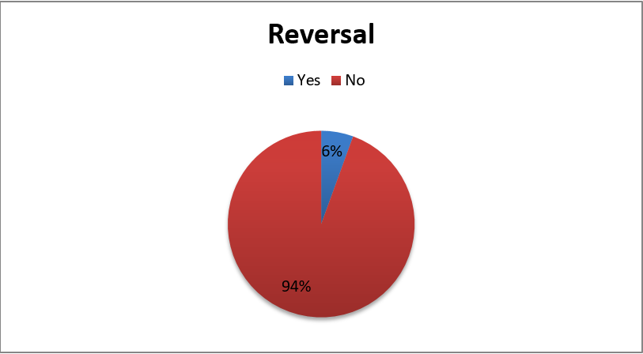
Figure 3 – Reversal

6.2.4 Variations of contract terms
Providers often reserve the right to modify terms and conditions, including those relating to fees and costs, after the initial acceptance of terms by a customer.
As shown in Figure 4, for a significant majority of the contracts reviewed, 72 per cent, there was no clause stating that customers would be given prior notice of a change of terms. This large percentage is of concern as it suggests that many providers may be introducing contract changes that customers are not aware of, which could be eroding consumer rights or protections that were available in the original contracts, and which might have caused customers to not enter the contracts if they had been disclosed in the first place.

Figure 4 – Change of terms and conditions with notice
In certain provider contracts, customers are asked to accept the possibility that there will be changes in advance, even as they clearly would not know the nature of such changes at the time they agree to be bound by the contract. Other contracts make the customer responsible for checking provider websites regularly in order to look out for any new changes, which would clearly be burdensome, especially if notice that changes have been made has not been given to the customer. This leaves customers being legally required to accept terms and conditions that are subsequently introduced, whether they have read and agreed to them or not.
See Box 4 for an example of a user agreement in Tanzania that may be deemed inconsistent with the spirit of domestic law on the issue of notifying the consumer of a change in the terms and conditions.

Tanzania Legal and Regulatory Provision: E-Money Regulations 2015, section 44:
(1) An electronic money issuer shall display and disclose charges and fees for its services to its customers and any changes thereof.
(2) An electronic money issuer shall notify its customers the fees and charges before imposing such fees or charges.
(3) The notice to customer shall-
(a) be delivered through electronic media and displays in a conspicuous place at the electronic money issuer’s offices and agents outlets;
Comment:
The regulations require changes relating to fees to be notified to customers before these are imposed. In the contracts reviewed, there was no mention of the provider giving prior notice to the customer. In fact, for example, the Tigo Pesa clause provides at clause 4.2 that Tigo reserves the right to vary the charges and tariffs at its discretion and without notice to the Subscriber.
Box 4 – Changes to terms and conditions

6.3 Consumer obligations

6.3.1 PIN security
A majority of the provider contracts (61 per cent) stipulate that customers should keep their PIN securely. Further, provider contracts state that all transactions are presumed to have been generated by the consumer if instructions come from their phone number and the correct PIN is entered. Some contracts even caution customers not to disclose their PIN to provider employees at customer care centres or to provider agents at outlets.

Figure 5 – PIN safety

6.3.2 Dormant accounts
In some jurisdictions, such as Kenya and Tanzania, the law requires that funds be paid to the government if an account has been dormant for a specified period of time, in some cases five years. Yet, provisions relating to management of dormant accounts were only present in 28 per cent of the contracts reviewed, with providers employing varying definitions of dormancy. In the event of inactivity in such accounts, funds may be transferred into a trust or holding account and customers have a right to claim their balances. In fact, in Kenya, Nigeria, Tanzania, Uganda and Zambia, regardless of whether the account is active or considered dormant, the mobile money funds must be held in a trust or escrow type account by law. However, if the customer requests the funds prior to the law requiring that the funds escheat to the state, then the credit balances should be paid to the customer upon presentation of proper identification. Otherwise, those funds may be lost or subject to a government claims process.
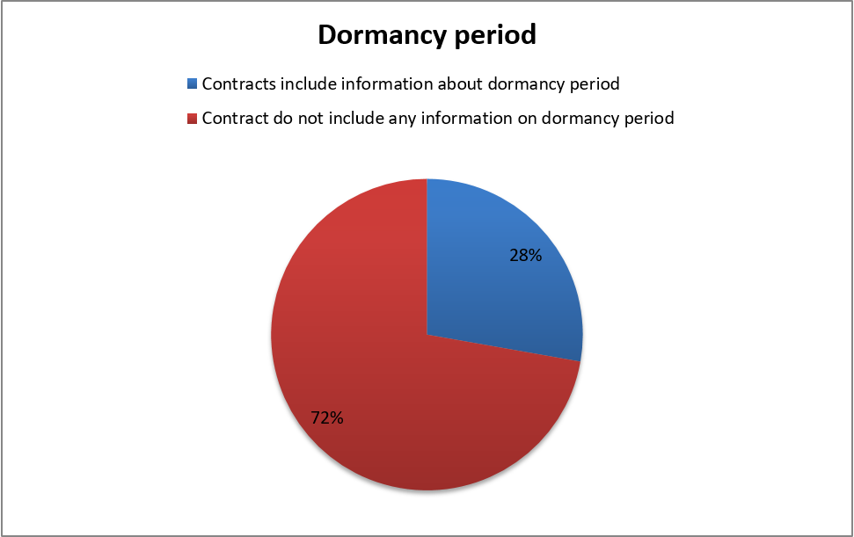
Figure 6 – Dormancy period
Customer death: Although several contracts discussed dormancy and subsequent treatment of the funds left on the account, 83 per cent of all the contracts reviewed did not address what happens to funds in the event of the death of a customer. Therefore, it is unclear how heirs and estate executors can access these funds after the death of the account owner. One way to handle this could be to allow accounts to be held jointly with a right of survivorship, or for the account opener to name a beneficiary on the account if this is permitted under local law.
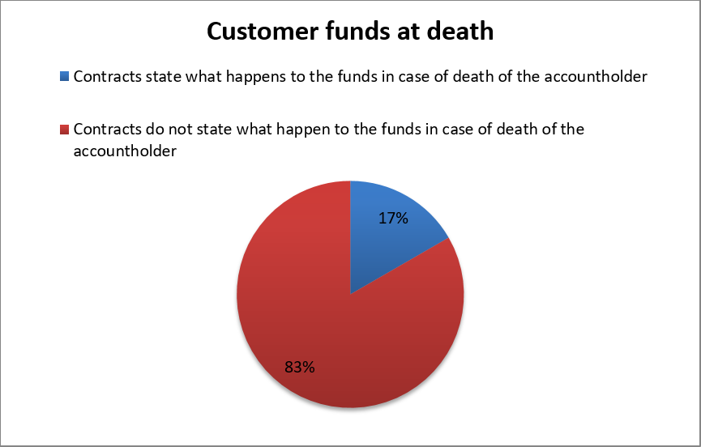
Figure 7 – Customer funds at death

6.4 Complaints handling

6.4.1 In-house dispute resolution
Recourse mechanisms can build consumer trust in the system if they operate efficiently and respond to consumer concerns and problems (Chapman & Mazer 2013). From the contract review, provider contracts described an in-house dispute resolution mechanism in only 39 per cent of the agreements. This means that for the most part, customers will not know how to go about resolving disputes. As a result, customers may unnecessarily accept loses or burden government agencies with complaints that could have been resolved more efficiently and promptly directly with the provider.
See Box 5 for an example of contract clauses related to complaints handling that may not adhere to the legal and regulatory requirements in Uganda and Nigeria.
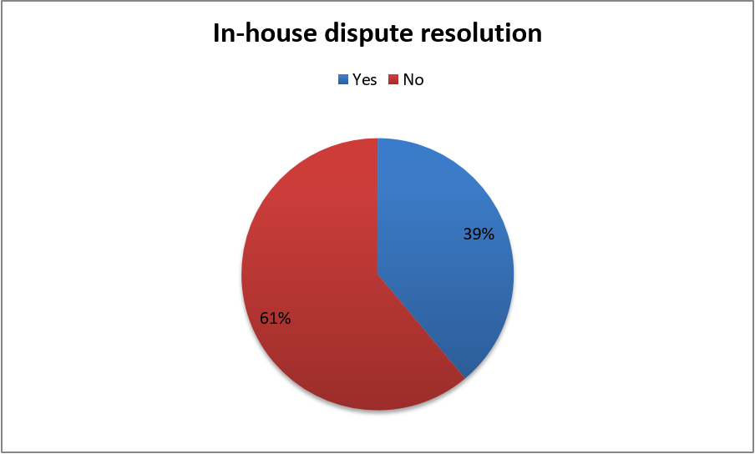
Figure 8 – In-house dispute resolution
Uganda mobile money regulations
Under Section 12(d) Complaints handling and consumer recourse, mobile money service providers shall ensure that appropriate and effective procedures for receiving, considering and responding to complaints are put in place. The complaints handling procedure shall ensure that:
(iii) A dedicated toll free telephone line for complaint resolution is provided;
Nigeria, Consumer Protection Framework:
2.7.1 Complaints Channels – Financial institutions shall have multiple channels (including electronic and non-electronic channels) for consumers to lodge complaints. Examples of complaints channels may include provision of dedicated email addresses, telephone numbers, help desk, web chat etc. Such channels shall be toll-free, easily accessible and available to consumers or their agents at all times.
Comment:
• In Uganda, for the contracts reviewed, one provider, MTN-Uganda, provided a helpline number but did not specify whether or not it is toll-free.
• In Nigeria, for the contracts reviewed, the Teasy Mobile agreement provided for a customer service hotline, but did not state whether it is toll-free. When in doubt, consumers are unlikely to use the hotline for fear of incurring charges. On the other hand, the Stanbic Mobile Money contract did not mention a customer hotline at all.
• While the laws do not specifically require contractual disclosures regarding complaint handling, it would be beneficial to consumers if they did.
Box 5 – Complaint handling

6.4.2 Mandatory arbitration
A small number of contracts (17 per cent) make arbitration the mandatory mode for addressing customer disputes. In a number of jurisdictions, this is an unfair contract term.
Arbitration and other alternative dispute resolution mechanisms are increasingly becoming the preferred means for resolving disputes in some developing countries, as they generally take a much shorter time to conclude at less expense in comparison to court-centred legal redress. However, the concern is that some consumers cannot effectively take advantage of this option because a distant location, such as the capital city, is designated as the arbitration venue. In one contract that was reviewed, the arbitration venue was a city in another country altogether. Such provisions serve to effectively restrict consumer access to avenues that might otherwise provide a quick and easy method for dispute resolution. See Box 6 for examples of problematic arbitration clauses.
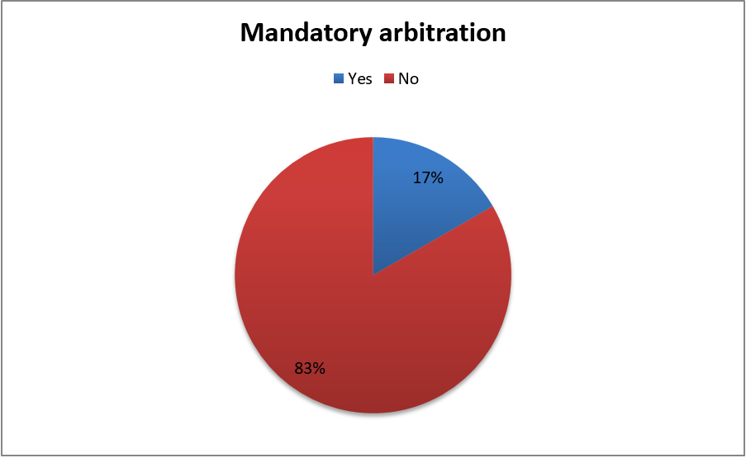
Figure 9 – Mandatory arbitration

Kenya legal and regulatory provision: Consumer Protection Act section 88 (1)
Any term or acknowledgment in a consumer agreement or a related agreement that requires or has the effect of requiring that disputes arising out of the consumer agreement be submitted to arbitration is invalid insofar as it prevents a consumer from exercising a right to commence an action in the High Court given under this Act.
Comment:
The contracts reviewed in Kenya (M-PESA & M-Shwari) mandate arbitration: the language "shall be referred to Arbitration" is employed. If the contract drafter intended to offer arbitration only as a first option, then it should be specified and clearly explained that arbitration is available as one option to resolve consumer disputes, in addition to the judicial mechanisms available. There is a risk that unqualified arbitration language could mislead consumers regarding their rights.
Box 6 – Mandatory arbitration

6.4.3 Legal fees indemnity
Half of the provider contracts reviewed contain a clause requiring the consumer to indemnify the provider for any legal fees incurred in pursuing a legal matter related to their offer of service to the consumer. This clause is written so broadly as to cover the providers’ own legal costs for defending itself against a potentially valid consumer complaint. Thus, consumers, presuming they understand the meaning of the indemnity clauses, could be required to pay the legal fees of the provider even if the consumer had a founded complaint: this is a lose-lose scenario for the consumer and a barrier to accessing justice.
Such provisions are unfair to consumers, especially those from low-income backgrounds, as they may shy away from instituting legal proceedings against providers on account of a fear of fees that they could accrue as a consequence.

Figure 10 – Legal fees indemnity
A note on third party digital lenders
Another noteworthy concern relates to the rise of third party digital lenders who offer loans to customers via mobile phone applications. Because they are not banks or mobile network operators (MNOs), they may fall outside of current regulatory frameworks that apply to traditional lenders and, therefore, could take advantage of this regulatory gap to engage in conduct that could be detrimental to consumers. For instance, this may mean that these digital lenders are exempt from prohibitions on including unfair or risky contract clauses in contracts.

7 Conclusions and recommendations
Consumer contracts that were reviewed present a number of challenges as discussed above. The following recommendations are made to address the identified risk areas:
1) Language and transparency of communications:
a) Local language contracts should be provided, especially where there is one major language spoken in a jurisdiction besides English, e.g., in East Africa, Swahili is often stipulated as a second national language.
b) Alternative formats, such as Braille, large print and oral disclosures should be available for customers who are illiterate or have disabilities, e.g., blindness.
c) The first page of agreements given to customers or a separate cover page should highlight and summarize key contract terms, e.g., charges/fees, complaint handling process, PIN security, fraud and funds protection, consequences of default, and dormancy period.
2) Provider obligations
a) Providers should be required to include a term in the contract requiring that customers be notified of all changes to contract terms before they take effect.
b) There should be as many channels for providing customer contractual notifications as possible – especially including the mechanisms through which customers interact with the provider, such as SMS channels and agent outlets, in addition to websites and newspapers.
c) Providers should be required to include clauses on data privacy and protection in contracts, such as what customer information is being collected, how it will be used, whether and under what circumstances it will be disclosed to third parties including legal/regulatory requirements, the matters about which customers can exercise choice regarding their information and how they can exercise such choice, data security measures that have been employed, and customers’ ability to access and correct their records.
3) Consumer obligations:
a) Take reasonable steps to avoid entering into contracts with customers who are not legally eligible to contract, such as due to age or infirmity, and, where applicable law permits minors to enter into credit arrangements, providers should make sure that parents/guardians have authority to terminate such agreements and potentially have to co-sign or at least provide their consent to the agreement.
b) With regard to DFS products, consumers should be encouraged to take the time to read and understand terms and conditions prior to accepting them. Where communications devices used by customers do not easily permit disclosures, and instead refer to websites, creative methods should be employed to educate consumers about the terms of agreements to avoid situations in which they accept but are unaware of terms that are detrimental.
c. Providers should limit or end the use of outside links/URLs in agreements.
4) Dispute resolution:
a) Call centre numbers should be stated in the contract and it should be clear whether or not calls to them are toll free.
b) In-house dispute resolution mechanisms should be described.
c) Venue for arbitration – customers should be allowed to commence arbitration proceedings from locations convenient to where they reside.
d) Legal fees – clauses requiring the provider to be indemnified for legal fees should be removed to enable low-income customers to effectively access recourse mechanisms.
5) Contracts should be as complete as possible: In some contracts, customers are asked to make reference to other documents with regard to specific terms. Any other documents should be readily available to the consumer, such as by being attached to the contract.
6) Contracts should clearly indicate the instances in which the consumer is liable for his or her own loss of funds due to fraud (e.g., not keeping PIN private).
7) Contracts should clearly indicate whether funds reversals are possible and, if so, the protocol for reversing a transaction.
8) Contracts should indicate whether the provider has a policy on funds dormancy and indicate what the procedure is to avoid loss of funds due to dormancy or the death of the account holder (e.g., noting a next of kin on the account as holding right of survivorship).

Annex 1
DFS contracts reviewed

Country | Terms and conditions reviewed | Review date | Links
Kenya | M-pesa (Safaricom) | 10/08/2016 | https://www.safaricom.co.ke/images/Downloads/Terms_and_Conditions/CUSTOMER_TERMS_March_2012.pdf
 | M-shwari (CBA/Safaricom) | 11/08/2016 | http://www.safaricom.co.ke/images/Downloads/Terms_and_Conditions/M-SHWARI_TERMS_AND_CONDITIONS.pdf
Ghana | Airtel Money Bosea | 12/08/2016 | http://africa.airtel.com/wps/wcm/connect/africarevamp/ghana/airtel_money/home/business/terms-and-conditions
 | Tigo Cash | 15/08/2016 | https://www.tigo.com.gh/tigocash/terms
Malawi | Easybank online | 25/08/2016 | https://www.nbs.mw/index.php/2015-10-22-13-36-29/aboutus/terms-and-conditions
 | Airtel Money | 25/08/2016 | http://africa.airtel.com/wps/wcm/connect/AfricaRevamp/Malawi/Airtel_Money/Home/Personal/Terms-and-Conditions
Nigeria | Teasy Mobile | 16/08/2016 | http://teasymobilemoney.com/terms-conditions/
 | Stanbic Mobile Money | 17/08/2016 | https://web.909wallet.com/Home/Terms
South Africa | GetBucks | 18/08/2016 | https://za.getbucks.com/terms
 | WeChat Wallet | 18/08/2016 | https://wechat.co.za/wechat-wallet-user-agreement/
Tanzania | Tigo Pesa | 22/08/2016 | https://www.tigo.co.tz/terms-and-conditions
 | Timiza (Jumo) | 22/08/2016 | https://www.google.co.uk/url?sa=t&rct=j&q=&esrc=s&source=web&cd=1&ved=0ahUKEwj6vebn6cfRAhVpAcAKHVtDBt4QFggkMAA&url=http%3A%2F%2Fafrica.airtel.com%2Fwps%2Fwcm%2Fconnect%2F9105e6db-d3a7-4591-b7fa-25ea008c05f5%2FTIMIZA%2BCash%2BLoan%2BTerms%2Band%2BConditions.pdf%3FMOD%3DAJPERES%26attachment%3Dtrue%26id%3D1452503154305&usg=AFQjCNFOYcWPifvlr_qPesuvDycsQXugVQ&sig2=mTSFuTumHx5fpynrp3LTeQ
Uganda | Utl-M-Sente | 23/08/2016 | http://www.utl.co.ug/wp-content/uploads/2012/04/UTL_SIM_Registration_Form.pdf
 | MTN- Uganda | 23/08/2016 | https://www.mtn.co.ug/Mobile%20Money/How%20to%20use/Documents/MTN-Mobile-Money-Consumer-Terms.pdf
Zambia | MTN Kongola (Jumo) | 24/08/2016 | http://tc.jumo.world/mzmc
 | Airtel Money | 24/08/2016 | http://africa.airtel.com/wps/wcm/connect/AfricaRevamp/Zambia/AirtelMoney/Terms+of+Use
Zimbabwe | Steward Bank | 19/08/2016 | https://www.stewardbank.co.zw/customer-service/contacts/mobile-banking-terms-and-conditions
 | EcoCash | 19/08/2016 | https://www.econet.co.zw/ecocash/customer-terms-and-conditions

Annex 2
Summary of findings
i. Language of agreement/transparency of communications
Country | Name of terms and conditions reviewed | Is the language of user agreement English | Is the language itself simple and easy to read if you speak English? | Are costs, fees, or schedules of fees (or links to this) evident in the agreement | If this is a credit product, is collateral taken? | Are consequences of default for credit products clearly spelled out? | Are there any limitations on cash withdrawals?
Kenya | M-pesa (Safaricom) | Yes | No* | No | N/A | N/A | Yes
 | M-shwari (CBA/Safaricom) | Yes | No* | No | Yes | Yes | Yes
Ghana | Airtel Money Bosea | Yes | No* | No | Yes | Yes | Yes
 | Tigo Cash | Yes | No* | No | N/A | N/A | No*
Malawi | Easybank online | Yes | No* | No | N/A | N/A | Yes
 | Airtel Money | Yes | No* | No | N/A | N/A | No*
Nigeria | Teasy Mobile | Yes | No* | No | N/A | N/A | Yes
 | Stanbic Mobile Money | Yes | No* | No | N/A | N/A | No*
South Africa | GetBucks | Yes | No* | No | No* | No* | No*
 | WeChat Wallet | Yes | No* | No | N/A | No* | No*
Tanzania | Tigo Pesa | Yes | No* | No | N/A | N/A | Yes
 | Jumo -- Timiza Wakala | Yes | No* | No | No* | Yes | No*
Uganda | Utl-M-Sente | Yes | No* | No | N/A | N/A | No*
 | MTN-Uganda | Yes | No* | No | N/A | N/A | No*
Zambia | MTN Kongola (Jumo) | Yes | No* | No | No* | Yes | No*
 | Airtel Money | Yes | No* | No | N/A | N/A | No*
Zimbabwe | Steward Bank | Yes | No* | No | N/A | N/A | No*
 | EcoCash | Yes | No* | No | N/A | N/A | Yes
NOTE – Explanatory text related to asterisks in the different columns |  |  | No*-- Those with low literacy levels may find it difficult to understand the language used |  | *No -- contract is silent | *No -- contract is silent | *No -- contract is silent
 |  |  |  |  | N/A --  mobile money product | N/A --  mobile  money product
ii. Provider obligations
Country | Name of terms and conditions reviewed | Does the agreement state that the provider has any obligations with regard to fraud/funds protection | Does the agreement state that the provider has any obligations protection or privacy of client information? | Does the agreement state that the user’s financial information will be shared with a credit bureau or third party? | Is there a means to reverse a transaction in the event of user error? | Can the provider change the terms and conditions, including costs? | If the provider can change the terms and conditions, including costs, must notice be provided to the customer?
Kenya | M-pesa (Safaricom) | No | Yes | Yes | Yes | Yes | No
 | M-shwari (CBA/Safaricom) | No | No | Yes | No | No | No*
Ghana | Airtel Money Bosea | Yes | No | Yes | No | Yes | No
 | Tigo Cash | No | No | Yes | No | No | No
Malawi | Easybank online | Yes | No | Yes | No | Yes | Yes
 | Airtel Money | Yes | No | Yes | No | Yes | No
Nigeria | Teasy Mobile | Yes | No | Yes | No | Yes | No
 | Stanbic Mobile Money | No | No | Yes | No | Yes | No
South Africa | GetBucks | No | Yes | Yes | No | Yes | Yes*
 | WeChat Wallet | Yes | Yes | Yes | No | Yes | Yes
Tanzania | Tigo Pesa | No | Yes | Yes | No | Yes | No
 | Jumo -- Timiza Wakala | No | No | Yes | No | Yes | No
Uganda | Utl-M-Sente | No | No | No | No | No | No
 | MTN- Uganda | Yes | No | No | No | Yes | No*
Zambia | MTN Kongola (Jumo) | No | No | Yes | No | Yes | No*
 | Airtel Money | Yes | Yes | Yes | No | Yes | No*
Zimbabwe | Steward Bank | Yes | No | No | No | Yes | Yes
 | EcoCash | Yes | Yes | Yes | No | Yes | Yes
iii. Consumer requirements
Country | Name of terms and conditions reviewed | Does agreement state consumer needs to be a certain age? | Do the terms and conditions specify PIN safety requirements? | Do the terms and conditions specify when funds become dormant? | Do the terms and conditions specify what happens to dormant funds? | Do the terms and conditions specify what happens to their funds when a customer dies?
Kenya | M-pesa (Safaricom) | Yes | Yes | Yes | Yes | Yes
 | M-shwari (CBA/Safaricom) | Yes | No | No | No | No
Ghana | Airtel Money Bosea | Yes | Yes | No | No | No
 | Tigo Cash | No | Yes | No | Yes | No
Malawi | Easybank online | No | Yes | No | No | No
 | Airtel Money | No | Yes | No | Yes | No
Nigeria | Teasy Mobile | Yes | Yes | Yes | Yes | Yes
 | Stanbic Mobile Money | Yes | Yes | No | No | No
South Africa | GetBucks | No* | No | No | No | No
 | WeChat Wallet | No* | Yes | No | No | No
Tanzania | Tigo Pesa | Yes | No | Yes | Yes | No
 | Jumo -- Timiza Wakala | Yes | Yes | No | No | No
Uganda | Utl-M-Sente | No | No | Yes | Yes | No
 | MTN-Uganda | Yes | No | No | Yes | No
Zambia | MTN Kongola (Jumo) | Yes | Yes | No | No | No
 | Airtel Money | Yes | No | No | Yes | No
Zimbabwe | Steward Bank | Yes | No | No | No | No
 | EcoCash | Yes | Yes | Yes | No | Yes
iv. Complaints, dispute resolution
Country | Name of terms and conditions reviewed | Does the contract indicate what the in house complaints procedure is for resolution of disputes? | Does the contract state that there is customer service hot line? | Is there a charge to call the customer service hot line? | Is the capital city selected as the venue for resolution of disputes that cannot be resolved in house? | Does the agreement limit consumer’s access to the judicial system? | Is there a mandatory arbitration clause? | Does the provider seek indemnification for provider’s legal fees?
Kenya | M-pesa (Safaricom) | Yes | Yes | Not stated | Yes | No | Yes | No
 | M-shwari (CBA/Safaricom) | Yes | Yes | Not stated | Yes | No | Yes | Yes
Ghana | Airtel Money Bosea | Yes | Yes | Not stated | No* | No | No | Yes
 | Tigo Cash | No | Yes | Not stated | No | No | No | No
Malawi | Easybank online | Yes | Yes | Not stated | No | No | No | No
 | Airtel Money | No | Yes | Not stated | No | No | No | Yes
Nigeria | Teasy Mobile | Yes | Yes | Not stated | Yes | No | No | Yes
 | Stanbic Mobile Money | No | No* | Not stated | No | No | No | Yes
South Africa | GetBucks | No | No | Not stated | No | No | No | No
 | WeChat Wallet | Yes | Yes | Not stated | No | No | No | Yes
Tanzania | Tigo Pesa | No | Yes | Not stated | No | No | No | No
 | Jumo -- Timiza Wakala | No | No | N/A | No | No | No | No
Uganda | Utl-M-Sente | No | Yes | No | No | No | No | No
 | MTN -- Uganda | Yes | Yes | Yes | Yes | No | Yes | Yes
Zambia | MTN Kongola (Jumo) | No | No | N/A | No | No | No | No
 | Airtel Money | No | No | N/A | No | No | No | Yes
Zimbabwe | Steward Bank | No | No* | No | No | No | No | No
 | EcoCash | No | No* | Not stated | No | No | No | Yes
NOTE – N/A -- as there is no mention of a hotline.

