|  |  |  |
| --- | --- | --- |
|  | | Standardization Sector |
| ITU-T Technical Report | |
| (01/2025) | |
|  | **JSTR.atsc-imatv** | |
|  | ATSC 3.0 and 1.0 integrated-MATV system over digital terrestrial television broadcasting | |

|  |  |
| --- | --- |
| **ITUPublications** | **International Telecommunication Union** |

|  |
| --- |
| Technical Report ITU-T JSTR.atsc-imatv  ATSC 3.0 and 1.0 integrated-MATV system over digital terrestrial television broadcasting |

|  |
| --- |
| Summary  In theRepublic of Korea, where over 60% of the population resides in high-rise apartment complexes and similar shared housing, it is common for terrestrial broadcasting to be watched through a master antenna television (MATV) system. With both advanced television systems committee (ATSC) 1.0 and ATSC 3.0 broadcasting in widespread use, it is becoming necessary to adapt MATV systems to provide a transition path towards the eventual shutoff of ATSC 1.0 services. As residential penetration of ATSC 3.0 receivers has not yet been fully achieved, the adaptation of MATV systems to provide backward compatibility will ensure that viewers of ATSC 1.0 service will not lose access to digital terrestrial television broadcasting (DTTB) service when ATSC 1.0 services are terminated.  Technical Report ITU-T JSTR.atsc-imatv presents a conceptual solution to this transition need. |

|  |
| --- |
| Keywords  ATSC, ATSC 1.0, ATSC 3.0, DTTB, MATV, UHDTV. |

Note

This is an informative ITU-T publication. Mandatory provisions, such as those found in ITU-T Recommendations, are outside the scope of this publication. This publication should only be referenced bibliographically in ITU-T Recommendations.

© ITU 2025

All rights reserved. No part of this publication may be reproduced, by any means whatsoever, without the prior written permission of ITU.

**Table of Contents**

Page

1 Scope 1

2 References 1

3 Definitions 1

3.1 Terms defined elsewhere 1

3.2 Terms defined in this Technical Report 1

4 Abbreviations and acronyms 1

5 Conventions 2

6 Introduction 2

7 Description of the implementation case of integrated MATV system 4

7.1 Field test facilities 4

7.2 Field test results for verification of integrated MATV system 7

8 Summary 9

Technical Report ITU-T JSTR.atsc-imatv

ATSC 3.0 and 1.0 integrated-MATV system over digital terrestrial television broadcasting

# 1 Scope

This Technical Report presents a conceptual solution for the transition needed from ATSC 1.0 to ATSC 3.0. The integrated master antenna television (MATV) system described herein incorporates the following elements:

• appropriate multiplexing arrangements (component, service, higher level protocols);

• service availability considerations;

• protection against digital transmission errors;

• delivery control of different compressed programme bit streams and/or packet streams, i.e., ROUTE/DASH, moving picture experts group (MPEG)-2 transport stream (TS) or MMT, on the output channel of television distribution systems.

# 2 References

[ITU-R BT.2468-1] Recommendation ITU-R BT.2468-1 (2021), *Guidance for selection of system parameters and implementation of second generation DTTB systems.*

[ATSC A/300] ATSC Advanced Television Systems Committee (2024), *ATSC Standard: A/300:2024-04, ATSC 3.0 System.*

[ATSC A/370] ATSC Advanced Television Systems Committee (2024), *ATSC Recommended Practice:* *Conversion of ATSC 3.0 Services for Redistribution.*

# 3 Definitions

## 3.1 Terms defined elsewhere

None.

## 3.2 Terms defined in this Technical Report

None.

# 4 Abbreviations and acronyms

This Technical Report uses the following abbreviations and acronyms:

AC3 Audio Codec 3

ATSC Advanced Television Systems Committee

DTTB Digital Terrestrial Television Broadcasting

FEC Forward Error Correction

HDTV High-Definition Television

HEVC High Efficiency Video Coding

MATV Master Antenna Television (system)

MER Modulation Error Ratio

MPEG Moving Picture Experts Group

MPEG-H MPEG High efficiency coding and media delivery in heterogeneous environments

NUC Non-Uniform Constellations

SFN Single Frequency Network

SNR Signal-to-Noise Ratio

TS Transport Stream

TxID Transmitter Identification

UHF Ultra High Frequency

UHDTV Ultra-High-Definition Television

VSB Vestigial Side Band

# 5 Conventions

None.

# 6 Introduction

In the Republic of Korea, where over 60% of the population resides in high-rise apartment complexes and similar shared housing, it is common for terrestrial broadcasting to be watched through a master antenna television (MATV) system. With both ATSC 1.0 and ATSC 3.0 broadcasting in widespread use, it is becoming necessary to adapt MATV systems to provide a transition path towards the eventual shutoff of ATSC 1.0 services. As residential penetration of ATSC 3.0 receivers has not yet been fully achieved, adaptation of MATV systems to provide backward compatibility will ensure that viewers of ATSC 1.0 services will not lose access to digital terrestrial television broadcasting (DTTB) services when ATSC 1.0 services are terminated. The choice of transmission parameters for ATSC 3.0 can be found in [ITU-R BT.2468-1] and [ATSC A/300].

Furthermore, as DTTB is an efficient means of content distribution across a wide geographic area, an integrated MATV system builds on this transmission efficiency by servicing a large number of multiple dwelling units, as well as improving signal quality.

This Technical Report presents a conceptual solution to this transition need.

In 2024, in the Republic of Korea, there are two types of traditional MATV systems:

– ATSC 1.0 MATV, which redistributes the received (distorted) ATSC 1.0-based high-definition television (HDTV) signal as a clean ATSC 1.0-based HDTV signal; and

– ATSC 3.0 MATV, which redistributes the received (distorted) ATSC 3.0-based ultra-high-definition television (UHDTV) signal as a clean ATSC 3.0-based UHDTV signal.

Figure 1 shows the overall concept of the traditional MATV system.

Figure 1 – The concept of the traditional MATV system

First, ATSC 3.0-based UHDTV broadcast signals are received and distributed to the MATV systems via rooftop antennas. Subsequently, an MATV system generates improved-quality ATSC 3.0-based UHDTV signals and redistributes them to individual households. This flow represents the fundamental concept of the MATV system.

Meanwhile, the shutdown of ATSC 1.0-based HDTV broadcasting in the Republic of Korea is planned to commence in 2027. After the shutdown of ATSC 1.0-based broadcasting, households without ATSC 3.0-based TVs would render the HDTV service-oriented MATV system obsolete. Consequently, a solution is essential to enable individuals without ATSC 3.0-based TVs to receive ATSC 3.0-based services.

To solve this issue, a new MATV system has been developed and verified. As shown in Figure 2, the developed integrated-MATV system receives the ATSC 3.0-based terrestrial UHDTV broadcast signal and then converts it into both ATSC 3.0-based UHDTV and ATSC 1.0-based HDTV signals simultaneously. When it converts the ATSC 3.0 signal to the ATSC 1.0 signal, video and audio transcoding (high efficiency video coding (HEVC) to MPEG-2 video and MPEG high efficiency coding and media delivery in heterogeneous environments (MPEG-H) to Audio codec 3 (AC3) conversions) is also performed. By doing so, even households without UHDTV receivers can continue watching terrestrial broadcasting after the shutdown of ATSC 1.0-based HDTV broadcasting. A recommended solution for the conversion of ATSC 3.0 signals to ATSC 1.0 signals is described in [ATSC A/370]. The MATV system deployed in the Republic of Korea implemented use case 3 shown therein in Figure 2, which describes the local conversion and distribution of the signal within an apartment complex equipped with an MATV system.

Figure 2 – The concept of the ATSC 3.0 and 1.0 integrated-MATV system

# 7 Description of the implementation case of the integrated MATV system

## 7.1 Field test facilities

Integrated-MATV systems were installed in seven apartment complexes in the Republic of Korea, and a field test was conducted for system verification. Figure 3 shows field test facilities installed in the management offices of each apartment complex. A wideband ultra-high frequency (UHF) antenna was installed on the rooftop (multiple households); the rooftop antenna receives an ATSC 3.0-based UHDTV broadcast signal, which is then delivered to the integrated-MATV system.

The integrated-MATV system converts this signal into ATSC 3.0-based UHDTV and ATSC 1.0‑based HDTV signals simultaneously, as shown in Figure 4. For this purpose, the integrated‑MATV system includes an ATSC 3.0 demodulator and modulator, a media converter, and an ATSC 1.0 modulator. The media converter performs the functions below (see Figure 4):

– HEVC-to-MPEG-2 video transcoding;

– MPEG-H-to-AC3 audio transcoding;

– ATSC 3.0-to-ATSC 1.0 protocol conversion;

– MPEG-2 TS stream multiplexing and media sync.

The converted signals are distributed to the monitoring system and individual households. The monitoring system is used to check the proper functioning of the integrated-MATV system remotely in real-time. Figure 5 shows the captured screen of the monitoring system's web interface, displaying the operational status of integrated-MATV systems installed in seven regions (highlighted by red points). Figure 6 provides detailed information on the collected monitoring data, such as received power, signal-to-noise ratio (SNR), modulation error ratio (MER), and forward error correction (FEC) block errors for the ATSC 3.0 signal.

Figure 3 – Field test facilities

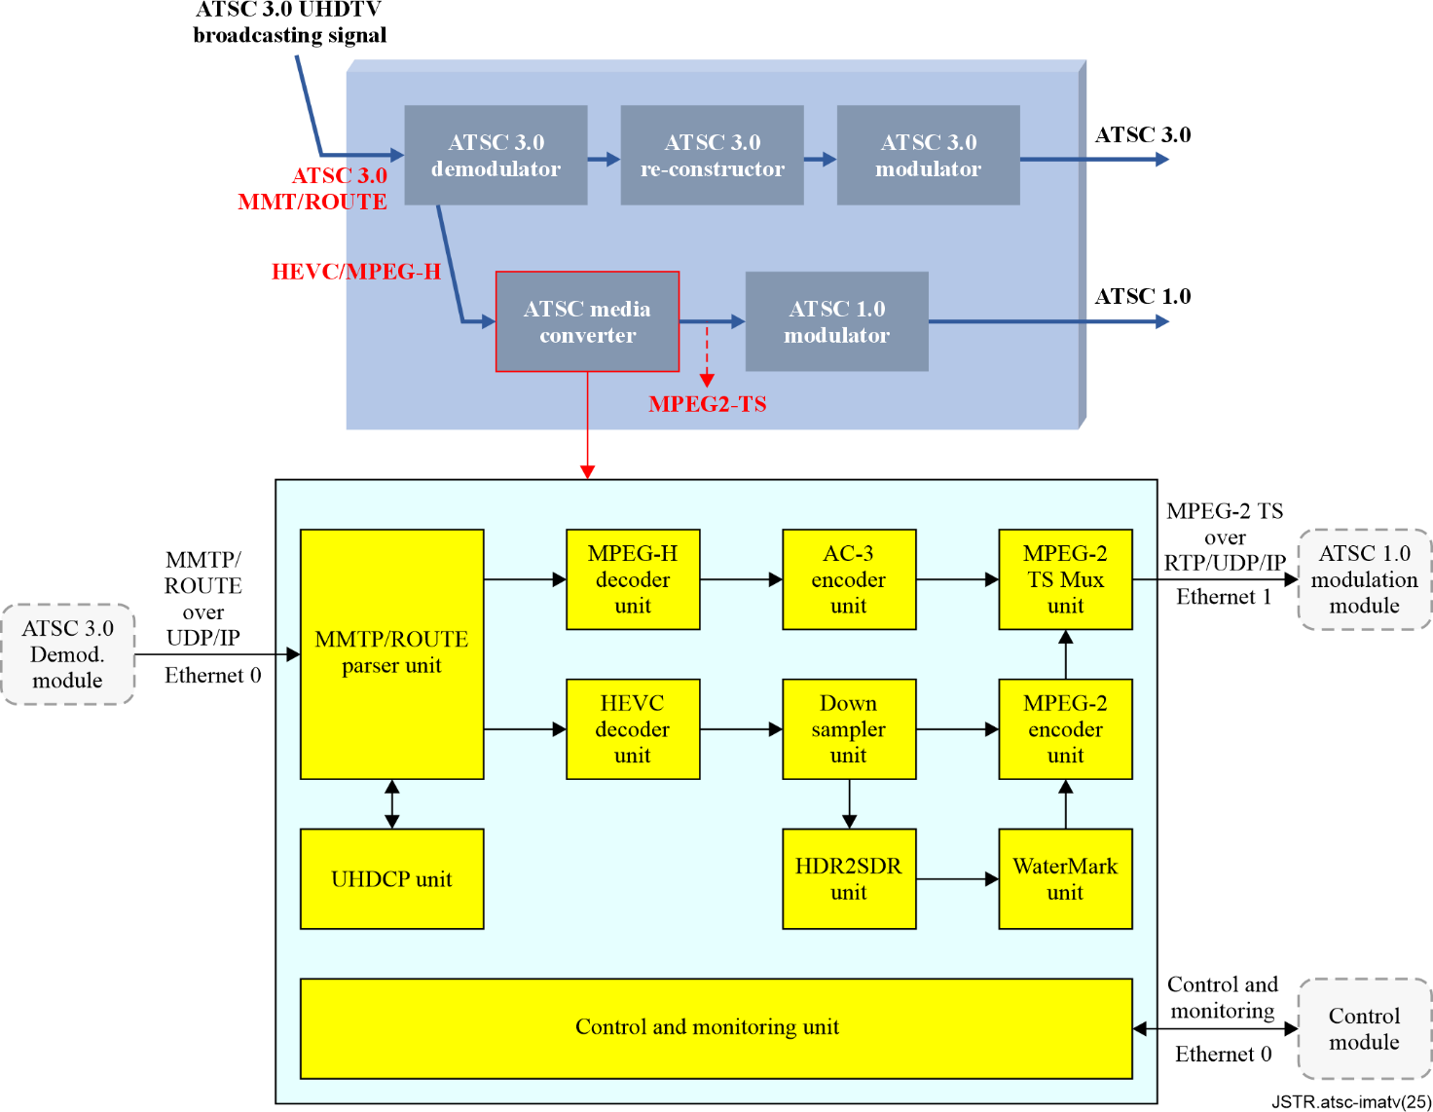

Figure 4 – The functional modules of the integrated-MATV system

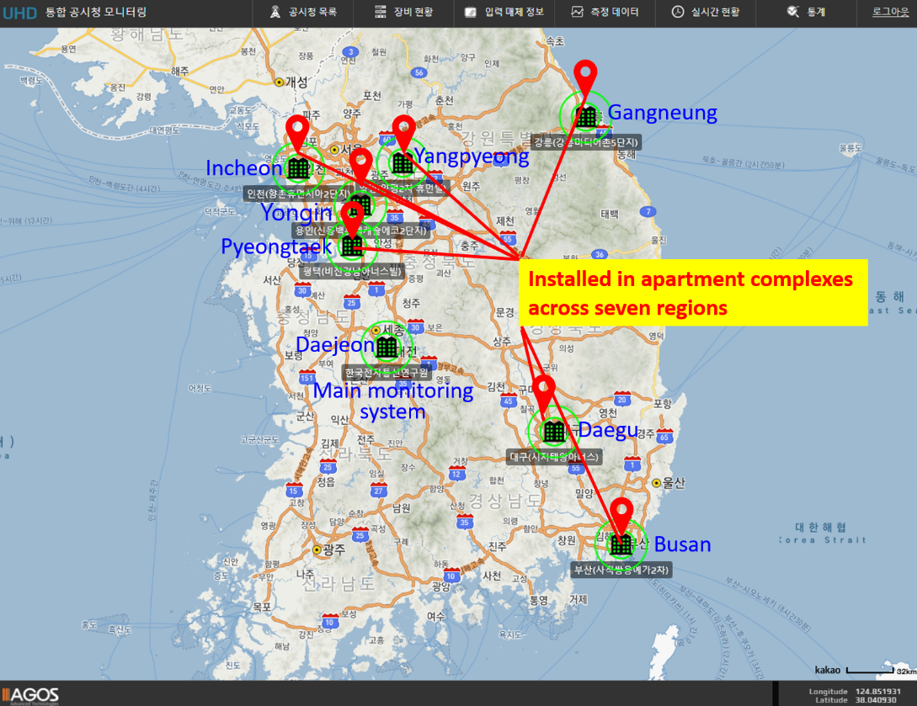

Figure 5 – Field test regions in the monitoring web interface[1]

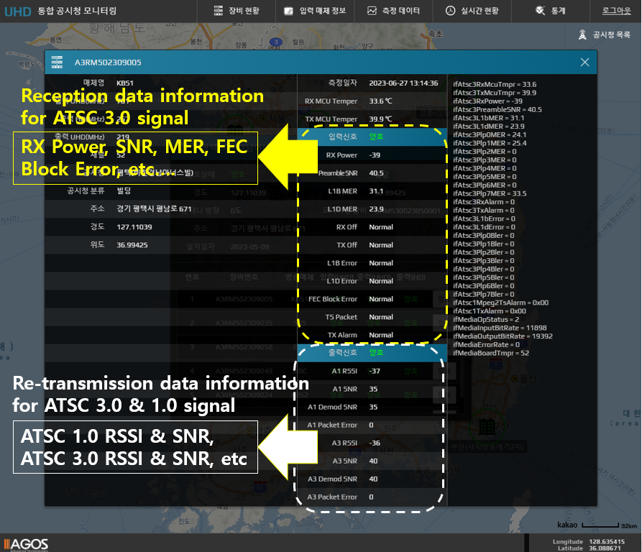

Figure 6 – Detailed information on monitoring data

## 7.2 Field test results for verification of integrated MATV system

Field tests were carried out to verify that the integrated-MATV system operates smoothly in the single frequency network (SFN) environment. Integrated-MATV systems were installed in seven apartment complexes in the Republic of Korea. Four apartments were selected from Seoul-metropolitan areas such as Incheon, Pyeongtaek-si, Yongin-si, and Yangpyeong-gun. The remaining apartments were chosen from Busan, Daegu, and Gangneung-si. Field tests were conducted for the major broadcasting channels in the Republic of Korea, namely Korean broadcasting system (KBS1), KBS2, munhwa broadcasting corporation (MBC), educational broadcasting system (EBS), and Seoul broadcasting system (SBS), at each test point.

### 7.2.1 Input of integrated-MATV system

Figures 7 and 8 show the field test results in the Yongin-si area. In this example, the operational network provided by KBS, offering ATSC 3.0 UHDTV services on UHF channel 56 (768 MHz), was utilized. The transmitter identification (TxID) signals were buried at a 24 dB injection level, i.e., the TxID signals were emitted at a power level 24 dB lower than the broadcast service signals. Figure 7 shows the simultaneous detection of two distinct TxID signals from each single frequency network (SFN) transmitter in this region, providing evidence of the SFN environment. The two SFN transmitters (Tx1 and Tx2), which emit different TxID signals, are 12.2 km and 24.3 km away from the receiving point, respectively, and the time delay between the two signals is 37.5 us.

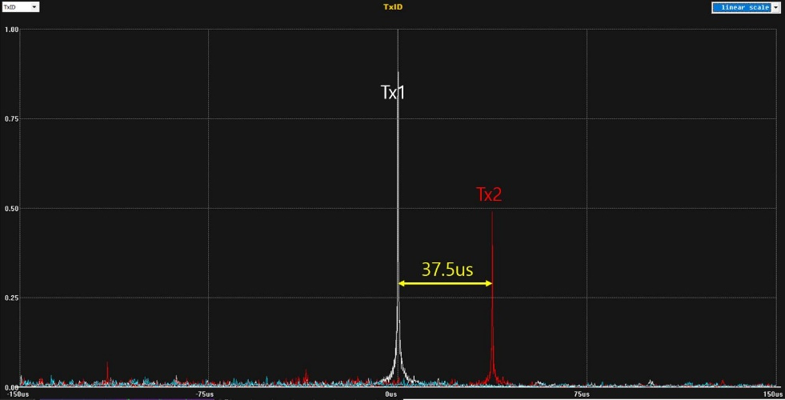

Figure 7 – SFN channel profile in the Yongin-si area (detected by TxID signal)

Figure 8 shows the characteristics of the received on-air ATSC 3.0-based UHDTV signal. The on‑air ATSC 3.0-based UHDTV signal is delivered to the integrated-MATV system via a UHF directional antenna. The received signal power is −57 dBm, and signal to noise ratio (SNR) is 22 dB at the directional antenna output. In addition, the received signal shows 64-non-uniform constellations (NUC) and 256-NUC delivered through two subframes. The received signal shows a channel profile with one dominant multipath and a frequency response. The constellations are not clean, and the frequency response is not flat due to the SFN.

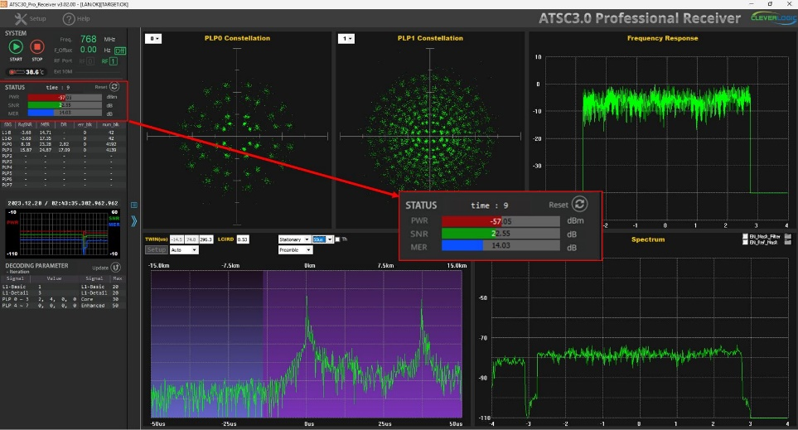

Figure 8 – Signal characteristics of input to integrated-MATV system (measured at antenna stage)

### 7.2.2 ATSC 3.0 output of integrated-MATV system

The analysis results of the ATSC 3.0 output in the integrated-MATV system are shown in Figure 9. The integrated-MATV system transmits the ATSC 3.0 signal at the signal power of −37 dBm on the 249 MHz channel. The measured ATSC 3.0 signal at the randomly selected household has a signal power of −38 dBm, SNR of 37 dB, and clean 256-NUC. The result shows that the integrated-MATV provides better and cleaner signal quality.

|  |  |
| --- | --- |
| **(a) Program of UHDTV output** | **(b) Constellations** |
|  |  |

Figure 9 – An example of a remodulated ATSC 3.0 signal in an integrated-MATV system

### 7.2.3 ATSC 1.0 output of integrated-MATV system

The analysis results of the ATSC 1.0 output in the integrated-MATV system are shown in Figure 10. The integrated-MATV system emits the ATSC 1.0 signal at the signal power of −37 dBm on the 291 MHz channel. The measured ATSC 1.0 signal at the randomly selected household has a signal power of −38 dBm, SNR of 34 dB, and clean 8-vestigial side band (VSB) constellations. The results show that the measured signal quality is good enough to provide a clean ATSC 1.0 signal.

|  |  |
| --- | --- |
| **(a) Program of HDTV output** | **(b) Constellations** |
|  |  |

Figure 10 – An example of a remodulated ATSC 1.0 signal in an integrated-MATV system

# 8 Summary

To address potential issues arising after the shutdown of ATSC 1.0-based HDTV broadcasting, the new integrated-MATV system has been developed and verified. The integrated-MATV system was installed in apartment complexes in seven different regions, and its performance has been monitored and analysed remotely. The test results show that the developed integrated-MATV system worked effectively in the real field, even in the single frequency network (SFN) environments. The integrated-MATV system will play a dominant role in expanding the ATSC 3.0-based UHDTV broadcasting coverage area. Furthermore, the integrated-MATV system will effectively support the shutdown of ATSC 1.0 in the Republic of Korea.

______________

1. The designations employed and the presentation of material on this map do not imply the expression of any opinion whatsoever on the part of ITU and of the Secretariat of the ITU concerning the legal status of the country, territory, city or area or its authorities, or concerning the delimitation of its frontiers or boundaries.