|  |  |  |
| --- | --- | --- |
|  | | Standardization Sector |
| ITU-T Technical Report | |
| (05/2024) | |
|  | **JSTR-WiFiTV** | |
|  | Secondary distribution of digital television and audiovisual content to portable devices using the wireless local area network | |

|  |  |
| --- | --- |
| **ITUPublications** | **International Telecommunication Union** |

|  |
| --- |
| Technical Report ITU-T JSTR-WiFiTV  Secondary distribution of digital television and audiovisual content to portable devices using the wireless local area network |

|  |
| --- |
| Summary  The Technical Report addresses aspects related to delivering television (TV) and other audiovisual signals to smartphones and other portable devices using the wireless local area network (WLAN) / Wi-Fi constituting the last mile of secondary distribution TV networks. The scope of this report is intended to cover the last mile connection via the WLAN/Wi-Fi interconnected with conventional TV transmission modes of satellite, cable or terrestrial.  This concept has high value propositions in rural areas, public utility places such as railway stations and airports, and even in moving vehicles such as buses, taxis, etc.  The Technical Report covers the network architecture, transcoding requirements, other technical requirements, mechanism to facilitate local content distribution, local advertisement insertion, logging end user statistics and case studies. It does not cover radio communication broadcasting. |

|  |
| --- |
| Keywords  Converged assess node, secondary distribution, smartphone, Wi-Fi, WLAN. |

Note

This is an informative ITU-T publication. Mandatory provisions, such as those found in ITU-T Recommendations, are outside the scope of this publication. This publication should only be referenced bibliographically in ITU-T Recommendations.

Change Log

The ITU-T Technical Report JSTR-WiFiTV on "Secondary distribution of digital television and audiovisual content to portable devices using the wireless local area network" was agreed by ITU-T Study Group 9 on 17 May 2024.

|  |  |  |
| --- | --- | --- |
| **Editor**: | Avinash Agarwal Ministry of Communications India | Tel.: +91-9868171222 E-mail: [avinash.70@gov.in](mailto:avinash.70@gov.in) |
|  | Pallab Dutta Centre for Development of Telematics India | Tel.: +91-9343795475 E-mail: [pallab@cdot.in](mailto:pallab@cdot.in) |

© ITU 2025

All rights reserved. No part of this publication may be reproduced, by any means whatsoever, without the prior written permission of ITU.

**Table of Contents**

Page

1 Scope 1

2 References 1

3 Definitions 1

3.1 Terms defined elsewhere 1

3.2 Terms defined in this Technical Report 1

4 Abbreviations and acronyms 1

5 Introduction 2

6 Network architecture for secondary distribution using Wi-Fi or WLAN 2

7 Converged access node requirements 3

7.1 Integrated receiver decoder 3

7.2 Video and media server 3

7.3 Web server 4

7.4 End-user browser 4

8 Transcoding requirements 4

9 Local content distribution 4

10 Local advertisement insertion 6

11 End user statistics logging 7

12 Case studies 7

13 Concluding remarks 8

Bibliography 9

Technical Report ITU-T JSTR-WiFiTV

Secondary distribution of digital television and audiovisual content to portable devices using the wireless local area network

# 1 Scope

The Technical Report addresses aspects related to delivering free-to-view television and other audiovisual signals to smartphones and other portable devices using the WLAN/Wi-Fi constituting the last mile of secondary distribution TV networks. The scope of this report is intended to cover the last mile connection via the WLAN/Wi-Fi interconnected with conventional TV transmission modes of satellite, cable or terrestrial.

The objective of the Technical Report is to collect information that may drive future standardization to enhance the use of widely available Wi-Fi networks and WLANs for the last mile delivery of linear television and audiovisual content to portable devices in a manner that is cost-effective for end users and does not overload mobile networks.

# 2 References

None.

# 3 Definitions

## 3.1 Terms defined elsewhere

None.

## 3.2 Terms defined in this Technical Report

None.

# 4 Abbreviations and acronyms

This Technical Report uses the following abbreviations and acronyms:

AAC Augmentative and Alternative Communication

AVC Advanced Video Coding

DTV Digital Television

DVB Digital Video Broadcasting

GPON Gigabit Passive Optical Network

HEVC High Efficiency Video Coding

IRD Integrated Receiver Decoder

LAN Local Area Network

MPEG Moving Picture Experts Group

MPTS Multiple Program Transport Steam

OLT Optical Line Terminal

ONT Optical Network Terminal

OTT Over the Top

SPTS Single Program Transport Stream

SSID Service Set Identifier

TV Television

UDP User Datagram Protocol

VLAN Virtual Local Area Network

WLAN Wireless Local Area Network

# 5 Introduction

Mobile handsets, tablets and laptops are becoming the preferred devices for viewing linear television and audiovisual content. This however, consumes a lot of mobile data and is costly for consumers. Also, many concurrent users may create network congestion in typical mobile networks, thus limiting the quality of service. Harnessing digital satellite and digital cable platforms requires the receiving device to have an integrated or separate digital video broadcasting (DVB) receiver module (e.g., DVB-T2/S2). This is not feasible for smartphones and other mobile devices.

The solution exists in using a converged access node as middleware, which receives the linear television and other signals through conventional modes such as satellite, cable or terrestrial, and then distributes them using Wi-Fi or other wireless local area networks (WLANs). The end users can then view the television or other audiovisual content on their portable devices without consuming mobile data and without requiring any additional hardware or plugin.

This concept has high value propositions in rural areas, public utility places such as railway stations and airports, and even in moving vehicles such as buses, taxis, etc.

The proposed Technical Report aims to provide guidance on technical aspects and case studies.

# 6 Network architecture for secondary distribution using Wi-Fi or WLAN

A converged access node consists of various network components responsible for operations such as reception, demodulation, encoding, etc.

[b-ITU-T J.282] defines the architecture of IP-based video signal distribution systems. IP transmission technologies allow the use of various physical media.

[b-ITU-T J.388] defines a system for real-time video/audio transmission over an IP-based network.

Cable/terrestrial/satellite content is received, demodulated, decoded, and finally selectively streamed in appropriate formats over the WLAN. A local content server is hosted for various offline services.

The content is served in a format that can be consumed by end users using browsers in smartphones and laptops by accessing a web portal through the WLAN/Wi-Fi without using any special player. Additionally, the end user can switch to regular over-the-top (OTT) services if the access point has been connected to the internet backhaul network.

The network diagram is shown in Figure 1 and functional blocks are shown in Figure 2.

Figure 1 – Network diagram (Source: [b-TEC57040])

Figure 2 − Functional blocks (Source: [b-TEC57040])

# 7 Converged access node requirements

## 7.1 Integrated receiver decoder

An integrated receiver decoder (IRD) should be able to connect to a cable or antenna feed. A dish antenna on the ground at the node location should receive the downlinked signals from the satellite signals. Terrestrial signals can similarly be received via a smaller antenna. An amplification device at the antenna should amplify and convert the signals to a suitable band before consumption by IRD devices for demodulation.

An IRD should convert the signals to baseband signals containing multiple digital TV (DTV) or radio channels. It should be noted that the IRD is usually tuned only for a particular frequency and can only receive a certain number of channels. Hence, multiple IRDs may be required.

## 7.2 Video and media server

Streams generated by an IRD are not playable by any industry standard browser directly and would need encoding by a video server block. Encoding details are discussed in clause 9.

Also, it should be ensured that the audio/video content is consumed by the end user without having to rely on any kind of specialized software or plugin. Having to install third party plugins or players is not only an inconvenience but also a risk factor for the user.

The video server block should be able to solve the above problem by transcoding the user datagram protocol (UDP) stream into a form ingestible by a media server. The media server further converts this stream into files which can be hosted over the web and played in a web browser.

## 7.3 Web server

The function of a web server can be two-fold:

a. To act as an HTML/web server for serving the audio/video content generated in the previous step to the end-users' browser;

b. To learn from the user viewership statistics and come up with a list of the most watched/desired channels.

The channels are thus selectively streamed initially for a period of time followed by a self-learning algorithm which determines the most desired/watched channels at a given location. After the algorithm converges to a decisive list over time, the channels are finalized.

This brings down the cost of reliance on the number of demodulating devices. As conveyed in clause 7.1 on IRDs, the number of such devices can be many, however, the same is not required by all and the algorithm within the web server's business logic layer can be designed efficiently to minimise the number of such devices required.

## 7.4 End-user browser

A smartphone/laptop/tab user should be able to consume the content without having to install any special application or plugin.

After connecting to the WLAN/Wi-Fi, the user would access the web portal using an appropriate link. The user should be able to navigate through the content served by the algorithm referred to in the previous step easily. The user shall be able to then play content of the served channels directly through the browser.

# 8 Transcoding requirements

The video codecs such as MPEG-2, H.264/AVC and H.265/HEVC etc., and audio codecs such as MPEG-1 audio, mp3, AAC and AC3 etc., are widely used codecs as inputs in multiple program transport steams (MPTS). Other codecs for input may also be supported.

The video server shall support de-multiplexing and transcoding of individual single program transport streams (SPTS) to H.264, H.265 video codecs and AAC audio codecs. The transcoded streams may further be ingested by the media server block for streaming using DASH/HLS protocols.

# 9 Local content distribution

Local content, such as video and audio can be distributed via supported such as mp4, AV1 for video and mp3 for audio.

There is no limitation or restriction of content file size or numbers of content files.

Local content is populated into the system based on customer requirements and place of installation like schools or public places, etc. The relevant local content stored in the system is made available to end users. End users can watch the content on their portable devices through a browser. The system supports audio, video and readable content in multiple languages. Users can playback and resume the content as per their need.

For example, the following types of local content can be provided in the system.

1. Education

In this service, the school education content will be populated based on class, language and subject selected (Figure 3). The available audio, video and readable content will be displayed. The selected content will be played/displayed in the browser.

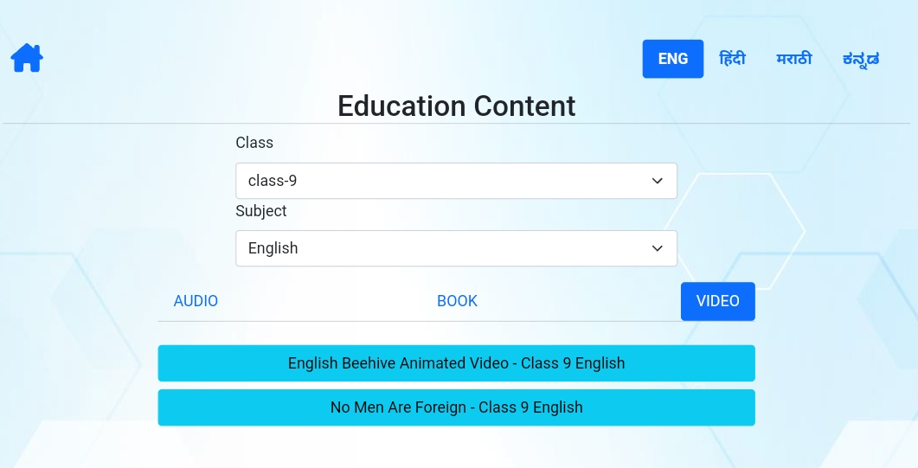

Figure 3 – Education content

2. Serials, celebrity talks

In this category of local content, the popular serials, celebrity talks (e.g., monthly addresses by the Indian Prime Minister under the programme series titled "Mann Ki Baat") in program contents are stored in the local system. Based on the year selected, the available content for every month is displayed (Figure 4). The supported content is audio in this case. As illustrated in figures 4 and 5, this content is made available in various languages such as English, Hindi, Marathi, etc.

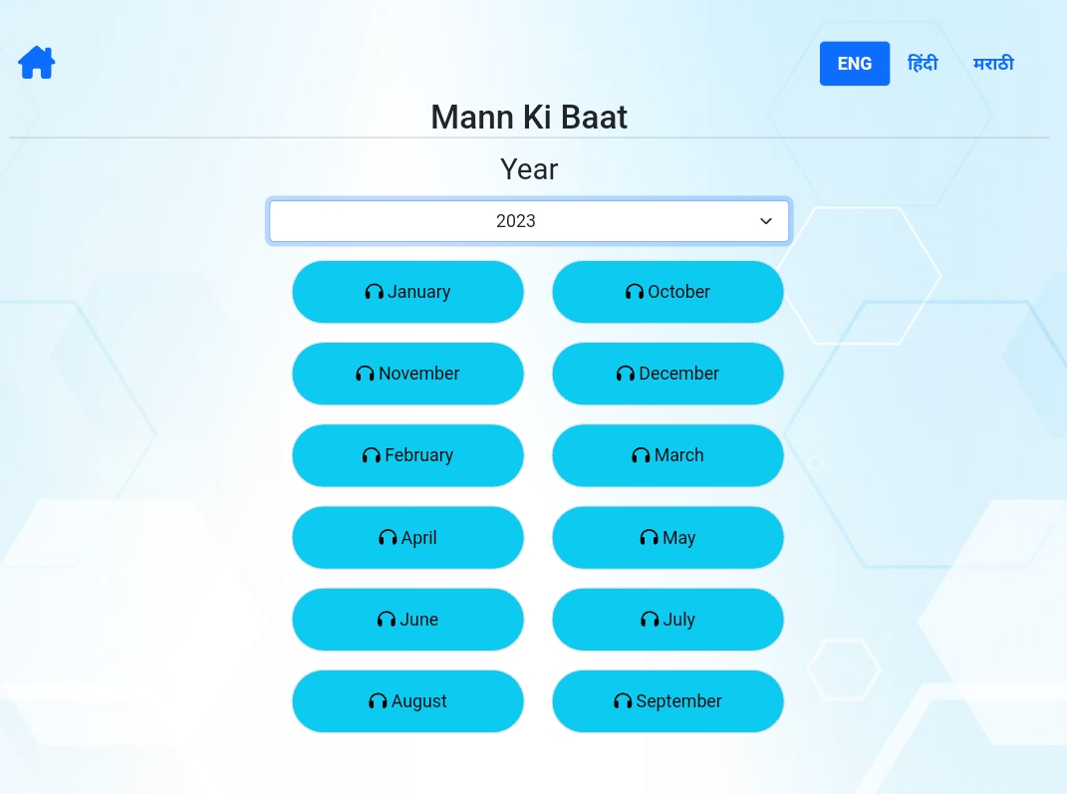

Figure 4 – Popular programmes (Mann Ki Baat) content

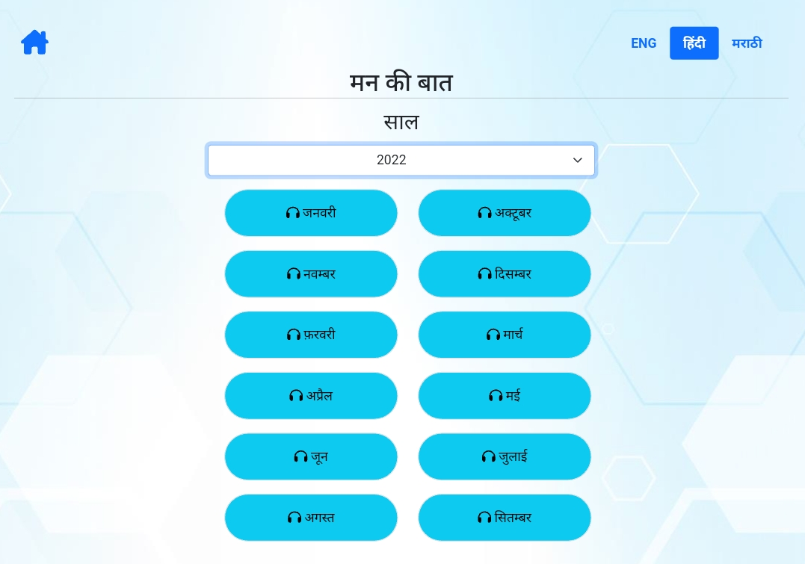

Figure 5 – Popular programmes (Mann Ki Baat) content – Hindi language

3. Infotainment

In this service the informative content related to places, knowledge and entertainment content is populated (Figure 6). The content supported formats are audio, video and pdf.

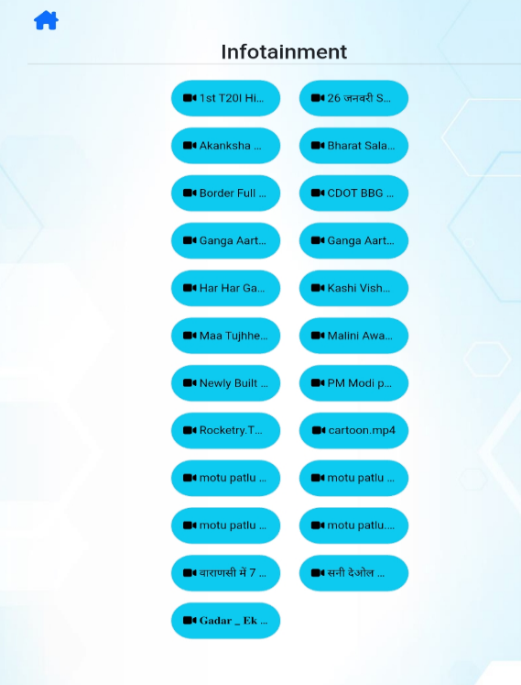

Figure 6 – Infotainment content

# 10 Local advertisement insertion

Advertisements can be inserted locally at the equipment site, either at a dedicated channel or when a channel is being switched (changed) by the end user.

The system supports local/custom advertisements or any promotional content to enable various business cases. The system can support various ad formats such as static banners, image, video, native content and interactive overlays, etc.

The advertisements can be preloaded into the system and can be invoked before the content in played or in-between when it is being played. The advertisements can be played based on the user's content watching profile, geographical location and other contextual parameters. The frequency of the playing of advertisements and number of advertisements are based on the user's viewing duration and patterns. When an advertisement is playing, the closing timer will be displayed. In instances where a long duration advertisement or multiple advertisements are playing, the "skip ad" option will be offered. The statistics of the advertisements played can be monitored for further use towards monetization.

# 11 End user statistics logging

The system shall support the logging of end-user statistics in a database. Parameters like number of live users, view minutes per channel, clients per channels, etc. may be captured. Data shall be presented in various formats such as pie charts, bar charts or tables (Figure 7). The system shall also provide the option for the viewing of statistics on daily, monthly or on custom date range basis.

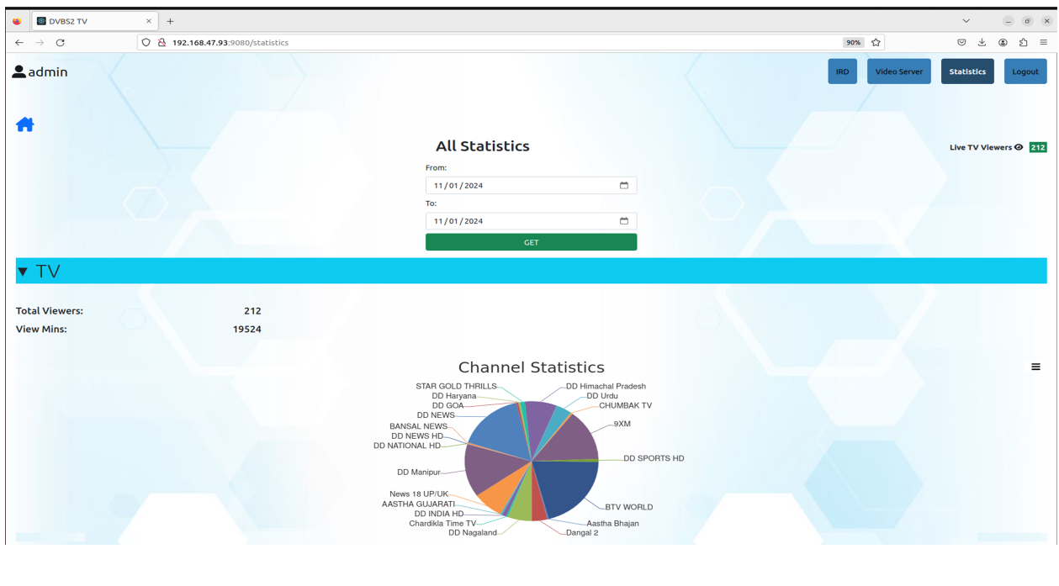

Figure 7 – User statistics

# 12 Case studies

Field trials were conducted successfully in a number of locations in India. In some, the trial was conducted with external Wi-Fi access points, while in some other cases, trials were conducted via a gigabit passive optical network (GPON) where end users were connected to the optical network terminal (ONT) and the system was installed in the optical line terminal (OLT)/Cluster of OLT locations.

Two main field trials were conducted for the system. One in Varanasi, Uttar Pradesh, India and other in Bidar, Karnataka, India.

In the Varanasi trial, the system was installed in a cluster OLT location of the GPON and the end users were connected to the ONT. End users' portable devices were connected to the ONT via Wi‑Fi. A separate virtual local area network (VLAN) was configured for the TV service. The same Wi-Fi access point with the same service set identifier (SSID) was used for accessing TV services as well as internet broadband services. Around 300 ONTs were configured for this trial. The set-up is illustrated in Figure 8.

Figure 8 – Trial in Varanasi, Uttar Pradesh, India

In the Bidar trial, Wi-Fi access points were used as outdoor units. An area of approximately 300 m radius in all four directions of the Panchayat office was covered with multiple outdoor Wi-Fi access points using a mesh configuration (Figure 9). End users' portable devices were connected to the Wi‑Fi access points using the same SSID and were able to access TV services as well as broadband services almost seamlessly.

Figure 9 – Trial in Bidar, Karnataka, India

# 13 Concluding remarks

With the increasing proliferations of mobile phones, especially smart phones, content consumption is no longer confined to stationary set-top-box (STB) and TVs. Smart phones and other portable devices are becoming a major mode of content consumption. However, internet backhaul connectivity is not always stable, especially in rural areas. In such scenarios, secondary distribution of digital television and audiovisual content to portable devices using the wireless local area network is an extremely useful proposition and poses a practical solution. The solution provides (limited) mobility to the end users without any additional hardware or software required while using their portable devices. This is a practical approach towards the direct-to-mobile (D2M) concept within the existing ecosystem and could be adopted for more field proliferations in the future.

Bibliography

[b-ITU-T J.282] Recommendation ITU-T J.282 (2006), *Architecture of multi-channel video signal distribution over IP-based networks*.

[b-ITU-T J.388] Recommendation ITU-T J.388 (2010), *Real-time video and audio transmission system over IP networks*.

[b-TEC57040] Telecommunication Engineering Centre Standard TEC57040:2023, *Converged Gateway Node For Delivering Broadcast Content To Portable Devices Through Wireless LAN*.

___________