 |  | International Telecommunication Union
 |  | ITU-T | Technical Paper
 |  | TELECOMMUNICATION  STANDARDIZATION SECTOR  OF ITU |  | (24 November 2021)
JSTP-IPVB-ACC
Analysis of the cost and complexity of IP video broadcast (IPVB) technology

Summary
In recent years, high-definition video services based on a large bandwidth, such as 4K, 8K, VR, etc., have developed rapidly, and each of them requires a bandwidth exceeding 35 Mbps or even up to 100 Mbps. Accordingly, this leads to the requirement of huge downlink transmission bandwidths and poses a great challenge to the existing broadcast transmission networks.
The recommended IP video broadcast (IPVB) technology can greatly increase the bandwidth of downlink programmes and relieve the bandwidth pressure with low-cost and low-complexity features. It broadcasts IP-based video streams over CATV networks to all subscribers in a downlink direction. In IPVB, IP-based video streams are delivered through multicast channels which are identified by multicast IP addresses and UDP port numbers.
In this document, the characteristics of IPVB technology are compared and discussed from the aspects of network complexity and construction costs.
Note
This is an informative ITU-T publication. Mandatory provisions, such as those found in ITU-T Recommendations, are outside the scope of this publication. This publication should only be referenced bibliographically in ITU-T Recommendations.

Keywords
IPVB, IP, complexity, cost

Change Log
This document contains Version 1 of the ITU-T Technical Paper on "Analysis of the cost and complexity of IPVB technology" agreed at the ITU-T Study Group 9 meeting held virtually, 15-24 November 2021.

Editor: | Xuejun Zhang  Beijing Jishi Huitong Technology. Co.,Ltd.  China | Tel: +86-13910844165  E-mail: zhangxuejun@jishihuitong.com

Table of Contents
Page
1 Scope 1
2 Comparison between DVB-C broadcast model and IPVB broadcast model 1
2.1 The DVB-C broadcast model 1
2.2 The IPVB broadcast model 1
2.3 Conclusion 2
3 Comparison between RF overlay and IPVB combined with PON 2
3.1 RF overlay 2
3.2 IPVB combined with PON 3
3.3 Conclusion 4
4 Summary 5

List of Tables
Page
Table 1 – Key data in DVB-C broadcast system 1
Table 2 – Key data in IPVB broadcast system 2
Table 3 – Costs of mainly unique equipment of RF overlay 3
Table 4 – Costs of mainly equipment of IPVB combined with PON 4
Table 5 – Key data for comparison 5

List of Figures
Page
Figure 1 – The DVB-C broadcast model of traditional CATV networks 1
Figure 2 – The broadcast model of IPVB system 2
Figure 3 – System structure of RF overlay 3
Figure 4 – System structure of IPVB combined with PON 4

Technical Paper ITU-T JSTP-IPVB-ACC
Analysis of the cost and complexity of IPVB technology

1 Scope
This Technical Paper analyses the characteristics of IP video broadcast (IPVB) technology in realizing high-traffic IP video broadcasts from the two aspects of complexity of network architecture and technology and costs of construction.

2 Comparison between DVB-C broadcast model and IPVB broadcast model

2.1 The DVB-C broadcast model
The DVB-C broadcast model of traditional CATV networks is shown in Figure 1.
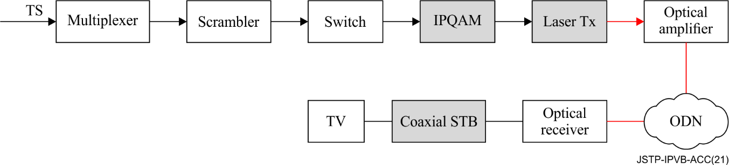
Figure 1 – The DVB-C broadcast model of traditional CATV networks
DVB-C broadcast technology employs RF subcarriers to broadcast programmes. It is stable and secure with excellent performance of anti-interference. DVB-C technology is mature and reasonable in cost. But due to the limitation of a single RF channel bandwidth, it requires multichannel binding technology to transmit 8K, VR and other high bit rate video, which leads to an increase in the complexity on the receiving end. On the other hand, the use of RF modulation technology restricts the broadcasting services only to TV STBs. The broadcast programmes cannot be decoded directly by IP-based devices, such as mobile phones, computers and other multiscreen interaction devices.
In a DVB-C broadcast system, we have listed some key data in Table 1.
Table 1 – Key data in DVB-C broadcast system
Price of 1 GE IPQAM | 2,150 $
Price of directly modulated laser Tx | 290 $
Maximum optical input power | 19 dBm
Optical reception power | −12 dBm

2.2 The IPVB broadcast model
The structure of an IPVB broadcast model is shown in Figure 2.
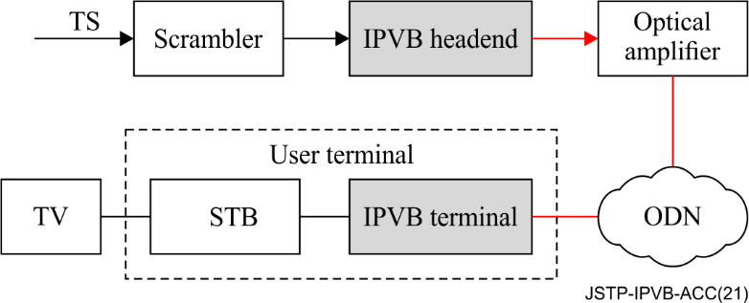
Figure 2 – The broadcast model of IPVB system
IPVB is a one-way broadcast system. It broadcasts service information without the need for either the QAM modulation or demodulation of a DVB-C system. In IPVB systems, the IP streams use a multicast packet format and are directly modulated onto the 1550 nm light wave. In the physical layer, the broadcast transmission is realized through the distribution of optical power. The broadcast programmes can be accepted directly by IP-based devices. This transmission model is more efficient and much less complex than a DVB-C system.
In an IPVB one-way system, the IPVB headend is just a 10GE switch. We have listed some key data in Table 2.
Table 2 – Key data in IPVB broadcast system
IPVB headend | 1450 $
Maximum optical input power | 26 dBm
Optical reception power | −17 dBm

2.3 Conclusion
As a developing technology, IPVB's industrial chain is not as mature as that of DVB-C technology. It features in the high bandwidth as it eliminates the bandwidth restriction coming from the RF subcarrier modulation in a DVB-C system; and in simplicity and high IP adaptability as it employs IP stream direct modulation instead of the complex IPQAM modulation.
By comparing the data in Tables 1 and 2, we can see the cost of an IPVB one-way system is lower than that of a DVB-C broadcast system, and the supported subscribers of an IPVB one-way system is nearly 4 times that of a DVB-C broadcast system based on the data of maximum optical input power and optical reception power.

3 Comparison between RF overlay and IPVB combined with PON

3.1 RF overlay
RF overlay is a typical implementation technology for CATV networks. Its system structure is shown in Figure 3.
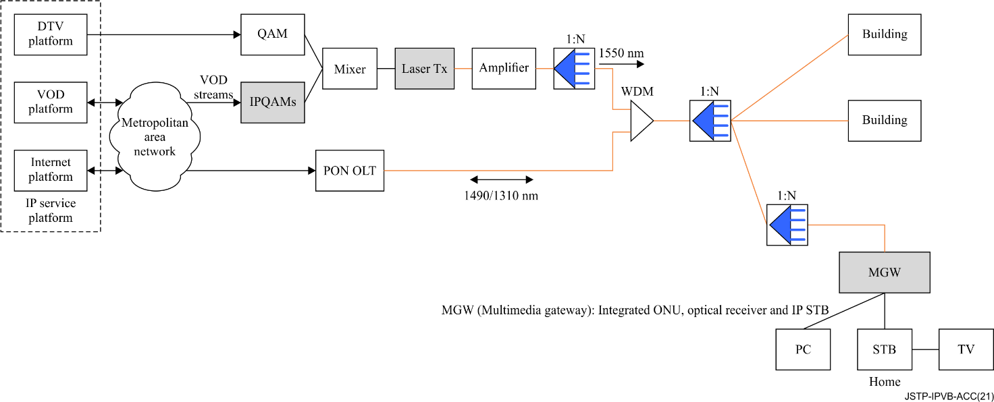
Figure 3 – System structure of RF overlay
An RF overlay system is a CATV network solution scheme that is based on RF broadcast technology and PON technology, the broadcast services and VOD video streams are transmitted through RF broadcast technology, and the bidirectional interaction services are transmitted through PON technology.
In this solution scheme, we suppose that there are 100,000 subscribers, the concurrent rate is 20%, and the average bandwidth of a single on-demand video programme is 6 Mbps.
Based on the above assumptions, the number of on-demand subscribers is 100,000*20%=20,000 and the total bandwidth of on-demand video streams needed is 20,000*6 Mbps=120 Gbps. The estimated costs of mainly unique equipment of an RF overlay scheme are shown in Table 3.
Table 3 – Costs of mainly unique equipment of RF overlay
Equipment | Unit price ($) | Number of needed equipment | Total cost of coverage ($)
IPQAM(4GE) | 6,400 | 30 | 200,400
Directly modulated Laser Tx | 280 | 30
MGW | 50

3.2 IPVB combined with PON
IPVB systems can provide bidirectional interaction services by combining with bidirectional networks. In order to compare with an RF overlay more accurately, we select adding an IPVB system to a PON network as a CATV network solution scheme. This scheme system structure is shown in Figure 4.
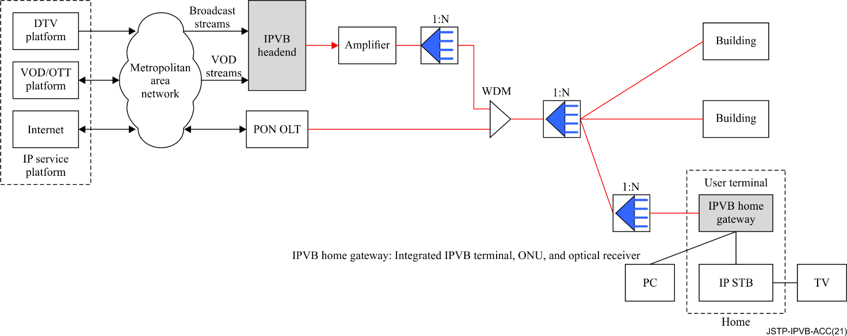
Figure 4 – System structure of IPVB combined with PON
In this system, the broadcast services and on-demand downlink streams data such as VOD/OTT streams that is transmitted through a broadcast channel of IPVB, and the bidirectional internet data is transmitted through a PON channel.
In this solution scheme, we also suppose that there are 100,000 subscribers, the concurrent rate is 20%, and the average bandwidth of a single on-demand video programme is 6 Mbps.
Based on the above assumptions, the number of on-demand subscribers is 100,000*200%=20,000, the total bandwidth of on-demand video streams needed is 20,000*6 Mbps=120 Gbps.
In an IPVB bidirectional system, the IPVB headend is a 10 GE SDN device. The downlink bandwidth of an IPVB broadcast channel is 10 Gbps; we allocate 3 Gbps for broadcast programme transmission and 7 Gbps for on-demand programme transmission by configuring the IPVB headend.
The estimated costs of mainly unique equipment based on an IPVB scheme are shown in Table 4.
Table 4 – Costs of mainly equipment of IPVB combined with PON
Equipment | Unit price ($) | Number of needed equipment | Total cost of coverage ($)
IPVB headend | 2,784 | 17 | 47,328
User terminal | 35.57

3.3 Conclusion
Based on our hypothesis model of 100,000 subscribers and a 20% concurrent rate built above, combined with the data of Table 3 and Table 4, we have some key data listed in Table 5.
Table 5 – Key data for comparison
Scheme name | RF overlay | IPVB combined with PON
Total on-demand video streams bandwidth | 120GE | 120GE
Total numbers of on-demand subscribers | 20,000 | 20,000
Total price ($) | 200,400 | 47,328
From Table 5, we can see that the total cost of IPVB combined with a PON scheme is lower than an RF overlay scheme.

4 Summary
IPVB has unique characteristics of IP broadcast baseband transmission; its complexity is less than IPQAM modulation and its unique equipment has a lower cost than IPQAM equipment. So, we can describe that IPVB is a low complexity and low cost CATV networks system.

______________

