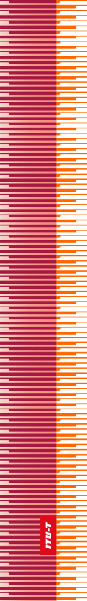 |  | International Telecommunication Union
 |  | ITU-T
TELECOMMUNICATION
STANDARDIZATION SECTOR
OF ITU
WORLD TELECOMMUNICATION STANDARDIZATION ASSEMBLY
Hammamet, 25 October – 3 November 2016

 | Resolution 88 – International mobile roaming

FOREWORD
The International Telecommunication Union (ITU) is the United Nations specialized agency in the field of telecommunications, information and communication technologies (ICTs). The ITU Telecommunication Standardization Sector (ITU-T) is a permanent organ of ITU. ITU-T is responsible for studying technical, operating and tariff questions and issuing Recommendations on them with a view to standardizing telecommunications on a worldwide basis.
The World Telecommunication Standardization Assembly (WTSA), which meets every four years, establishes the topics for study by the ITU-T study groups which, in turn, produce Recommendations on these topics.
The approval of ITU-T Recommendations is covered by the procedure laid down in WTSA Resolution 1.
In some areas of information technology which fall within ITU-T's purview, the necessary standards are prepared on a collaborative basis with ISO and IEC.

© ITU 2016
All rights reserved. No part of this publication may be reproduced, by any means whatsoever, without the prior written permission of ITU.

resolution 88 (Hammamet, 2016)
International mobile roaming
(Hammamet, 2016)
The World Telecommunication Standardization Assembly (Hammamet, 2016),
considering
a) the results of the ITU High-Level Workshop on international mobile roaming (IMR), held in Geneva on 23-24 September 2013;
b) the results of the ITU Global Dialogue on IMR, held in Geneva on 18 September 2015;
c) that the tasks undertaken in the ITU Telecommunication Standardization Sector (ITU-T) cover Recommendations, conformity assessment and matters having policy or regulatory implications;
d) that the economy is increasingly dependent on reliable, cost-effective, competitive and affordable mobile communications technology on a global scale;
e) that wholesale IMR tariffs are decoupled from underlying costs, which may have an effect on retail rates, including inconsistent and arbitrary charges;
f) that a competitive international telecommunication market may not exist if significant differences persist between national prices and IMR prices;
g) that there are differences in costs between countries and regions,
noting
a) that Recommendation ITU-T D.98 is an agreement concluded between Member States and Sector Members in 2012;
b) that Recommendation ITU-T D.97 contains possible approaches to the reduction of excessive roaming rates, highlighting the need to encourage competition in the roaming market, educate consumers and consider appropriate regulatory actions such as the introduction of caps on roaming rates,
resolves
that ITU-T Study Group 3 must continue to study the economic effects of IMR rates,
instructs the Director of the Telecommunication Standardization Bureau
1 to organize initiatives, in collaboration with the Director of the Telecommunication Development Bureau (BDT), to raise awareness of the benefits to the consumer of lowering IMR rates;
2 to propose cooperative approaches to foster the implementation of Recommendations ITU-T D.98 and ITU-T D.97, and to lower IMR rates among the Member States, by promoting capacity-building programmes, workshops and guidelines for international cooperation agreements,

invites Member States
1 to take measures towards the implementation of Recommendations ITU-T D.98 and ITU-T D.97;
2 to collaborate in the efforts to lower IMR rates by taking regulatory measures when applicable.

