Standardization Sector
ITU Focus Group Technical Specification
(06/2024)
ITU Focus Group on metaverse
Methodology on assessment of GHG emissions of metaverse
Working Group 8: Sustainability, Accessibility & Inclusion
ITUPublications | International Telecommunication Union


Technical Specification ITU FGMV-50
Methodology on assessment of GHG emissions of metaverse
Summary
This Technical Specification deals with the environmental impact assessment of metaverse applications and solutions, including metaverse service, ICT networks, supporting ICT infrastructure and digital devices. This Technical Specification will complement existing [ITU‑T L.1410] "Methodology for environmental life cycle assessments of information and communication technology goods, networks and services".
Keywords
Digital devices, energy consumption, greenhouse gas emissions, ICT infrastructures metaverse, ICT networks, services.
Note
This is an informative ITU-T publication. Mandatory provisions, such as those found in ITU-T Recommendations, are outside the scope of this publication. This publication should only be referenced bibliographically in ITU-T Recommendations.
Change Log
This document contains Version 1.0 of the ITU Technical Specification on "Methodology on assessment of GHG emissions of metaverse" approved at the 7th meeting of the ITU Focus Group on metaverse (FG-MV) held on 12–13 June 2024.
Acknowledgements
This Technical Specification was researched and written by Shuguang Qi (MIIT, China), Mengdi Wang (MIIT, China), Anders Andrae (Huawei, China) and Paolo Gemma (Huawei, China) as a contribution to the ITU Focus Group on metaverse (FG-MV). The development of this document was coordinated by Nevine Tewfik (MCIT, Egypt) and Pilar Orero (UAB, Spain), as FG-MV Working Group 8 Co-Chairs, and Shuguang Qi (MIIT, China) as Chair of Task Group on sustainability.
Additional information and material relating to this report can be found at: https://www.itu.int/go/fgmv. If you would like to provide any additional information, please contact tsbfgmv@itu.int.

Editor & TG Chair: | Qi Shuguang  CAICT  China | Tel.: +86 10 58846069  E-mail: qishuguang@caict.ac.cn
Editor: | Wang Mengdi  CAICT  China | Tel.: +86 10 58846077  E-mail: wangmengdi@caict.ac.cn
Editor: | Anders Andrae  Huawei  China | Tel.: +46 739 200 533  E-mail: anders.andrae@huawei.com
Editor: | Paolo Gemma  Huawei  China | E-mail: paolo.gemma@huawei.com
WG8 Co-Chair: | Pilar Orero  UAB  Spain | E-mail: pilar.orero@uab.cat
WG8 Co-Chair: | Nevine Tewfik  MCIT  Egypt | E-mail: ntewfik@mcit.gov.eg

© ITU 2025
FGMV-06 (2023-10)
ii
Some rights reserved. This publication is available under the Creative Commons Attribution-Non Commercial-Share Alike 3.0 IGO licence (CC BY-NC-SA 3.0 IGO; https://creativecommons.org/licenses/by-nc-sa/3.0/igo).
If you wish to reuse material from this publication that is attributed to a third party, such as tables, figures or images, it is your responsibility to determine whether permission is needed for that reuse and to obtain permission from the copyright holder. The risk of claims resulting from infringement of any third-party owned material in the publication rests solely with the user.

Table of Contents
Page
1 Scope 1
2 References 1
3 Definitions 1
3.1 Terms defined elsewhere 1
3.2 Terms defined in this Technical Specification 2
4 Abbreviations and acronyms 2
5 Conventions 2
6 The necessity of GHG assessment of metaverse 2
7 Methodological framework 3
7.1 General requirements 4
7.2 Goal and scope definition 4
8 GHG emission assessment of metaverse 5
8.1 GHG emission assessment of digital devices 5
8.2 GHG emission assessment of infrastructure 6
8.3 GHG emission assessment of ICT networks 7
8.4 GHG emission assessment of metaverse services 8
Bibliography 12

Technical Specification ITU FGMV-50
Methodology on assessment of GHG emissions of metaverse

1 Scope
This Technical Specification provides methodologies to assess the greenhouse gas (GHG) emissions of metaverse applications and solutions, ICT networks, infrastructure and digital devices. This Technical Specification will define the application of life cycle assessment (LCA) on metaverse.
This Technical Specification can be used to quantify the environmental impact in term of GHG emission of metaverse defined in other documents developed by the focus group on metaverse.
NOTE – The defined methodologies complement existing methodologies developed by ITU-T existing Recommendations especially [ITU-T L.1410] "Methodology for environmental life cycle assessments of information and communication technology goods, networks and services", as well as provide the GHG accounting and calculation method to metaverse services.

2 References
[ITU-T L.1410] Recommendation ITU-T L.1410 (2014), Methodology for environmental life cycle assessments of information and communication technology goods, networks and services.
[ITU-T L.1420] Recommendation ITU-T L.1420 (2012). Methodology for energy consumption and greenhouse gas emissions impact assessment of information and communication technologies in organizations.

3 Definitions

3.1 Terms defined elsewhere
This Technical Specification uses the following terms defined elsewhere:
3.1.1 greenhouse gases (GHGs) [ITU-T L.1410]: For the purposes of this methodology, GHGs are the seven gases listed in the Kyoto Protocol:
– carbon dioxide (CO₂)
– methane (CH₄)
– nitrous oxide (N₂O)
– hydrofluorocarbons (HFCs)
– perfluorocarbons (PFCs)
– sulphur hexafluoride (SF₆)
– nitrogen trifluoride (NF₃).
NOTE – See [b-GHG Protocol CS], glossary.
3.1.2 ICT goods [ITU-T L.1410]: Tangible goods deriving from or making use of technologies devoted to or concerned with:
• the acquisition, storage, manipulation (including transformation), management, movement, control, display, switching, interchange, transmission or reception of a diversity of data;
• the development and use of the hardware, software, and procedures associated with this delivery; and
• the representation, transfer, interpretation, and processing of data among persons, places, and machines, noting that the meaning assigned to the data is preserved during these operations.
3.1.3 ICT Infrastructure (facility) [b-ITU-T L.1302]: Equipment that supports the ICT equipment, e.g., power delivery components and cooling system components
3.1.4 life cycle [b-ITU/T L.1061]: Consecutive and interlinked stages of a product system, from raw material acquisition or generation from natural resources to final disposal.
3.1.5 metaverse [b- FGMV-20]: An integrative ecosystem of virtual worlds offering immersive experiences to users that modify pre-existing and create new value from economic, environmental, social and cultural perspectives.
NOTE – A metaverse can be virtual, augmented, representative of, or associated with the physical world.

3.2 Terms defined in this Technical Specification
None.

4 Abbreviations and acronyms
This Technical Specification uses the following abbreviations and acronyms:
AR Augmented Reality
BS Base Station
CPE Customer Premise Equipment
EoLT End-of-life Treatment
GHG Green House Gas
LCA Life Cycle Assessment
LCI Life Cycle Inventory
LCIA Life Cycle Impact Assessment
LTE Long-term Evolution
VR Virtual Reality

5 Conventions
In this Technical Specification: the keyword "is required to" indicates a requirement that must be followed strictly and from which no deviation is permitted if conformance to this document is to be claimed.
The keyword "is recommended" indicates a requirement that is recommended but not absolutely required. Thus, this requirement needs not be present to claim conformance.
The keywords "optionally" and "may" indicate an optional requirement that is permissible, without implying any sense of being recommended.
These terms are not intended to imply that the vendor's implementation must provide the option and that the feature can be enabled optionally by the network operator/service provider. Rather, it means that the vendor may provide the feature optionally and still claim conformance with the specification.

6 The necessity of GHG assessment of metaverse
To contribute to the ongoing efforts carried out within the United Nations Framework Convention on Climate Change [b-UNFCCC] and to tackle climate change, the Focus Group on metaverse developed this Technical Specification that would complement the existing ITU standard on measurement methodology of goods, networks and services to assess the environmental impact of metaverse services (including software), ICT networks, ICT infrastructure and digital devices. [ITU-T L.1410]
The development of the metaverse has raised some concerns regarding its environmental impact as the metaverse is claimed to substantially cut CO2 emissions by replacing physical goods with digital ones, reducing physical mobility and conducting simulations in cyberspace. However, the metaverse ecosystems themselves are resource-intensive with a high carbon footprint.
This created the need to estimate the GHG emission of metaverse considering its effect on infrastructure expansion rather than a decrease.

7 Methodological framework
This Technical Specification has been developed to complement [ITU-T L.1410] for the environmental assessment of the life cycle impact of metaverse service, ICT networks, ICT infrastructure and digital devices.
The structure of this Technical Specification for metaverse services, ICT networks, ICT infrastructure and digital devices is shown in Figure 1.
The figure indicates, for the different parts composing the metaverse (e.g, metaverse service, ICT infrastructure, ICT network and digital devices), which requirement of the life cycle assessment (LCA) methodologies needs to be considered.
The LCA methodologies defines requirements on:
• Life cycle interpretation
• Comparative assertion between ICT and not ICT service
• General requirements: high level requirements of assessment, see clause 7.1.
• Goal and scope definition: requirements of the functional unit, system boundaries and data quality, see clause 7.2.
• Life cycle inventory (LCI): requirements for data collection, calculation and allocation, see clause 7.3 of [ITU-T L.1410].
• Life cycle impact assessment (LCIA): requirements for impact assessment, see clause 7 of [ITU-T L.1410].
• Life cycle interpretation: requirements for the interpretation of results and calculation of secondary effects, see [ITU-T L.1410].
• Reporting: requirements for reporting, see [ITU-T L.1410].
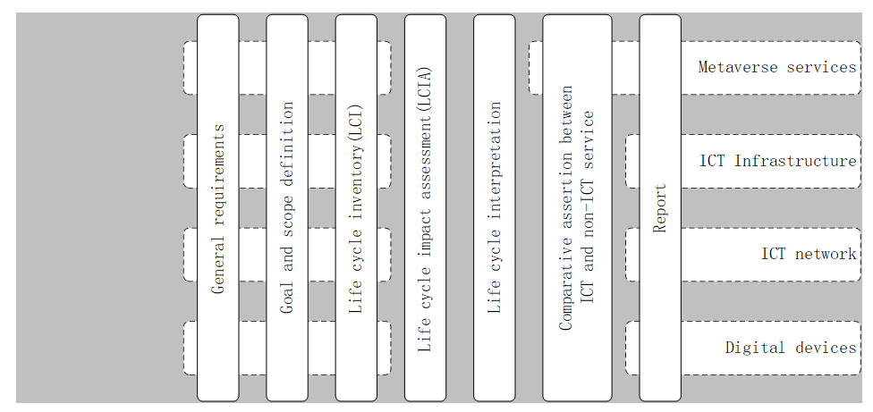
Figure 1 – Structure of GHG emission assessing method for metaverse

7.1 General requirements
When performing an ICT-related LCA assessment, the requirements of this Technical Specification are required to be applied, as well as those of [ITU-T L.1410].

7.2 Goal and scope definition
Schematically, four main levels of targeted product systems exist:
• Digital devices (ICT devices and supporting digital devices)
• ICT Infrastructures
• ICT Networks (networks used in metaverse)
• Metaverse services (services provided by metaverse).
All these systems use digital devices, which follow the life cycle stages introduced in clause 7.2.1 and are further described in subsequent clauses.

7.2.1 Life cycle stages
The following four high-level life cycle stages are required to apply product system defined in clause 7.2 and are required to be assessed as applicable:
• Goods raw material acquisition, which is composed of:
– raw material extraction
– raw material processing
• Production, which is composed of:
– goods production (including refurbishment)
– support goods production.
• Use, which is composed of:
– digital devices use
– ICT infrastructure use
– operator support activities
– service provider support activities.
• End-of-life treatment (EoLT), which is composed of:
– preparation for extended operating lifetime
– digital-specific EoLT
– other EoLT.

7.2.2 Identification and description of different components in metaverse
It is required to clearly identify the digital devices, ICT infrastructure, ICT network and metaverse service system listed in clause 7.2. It is required that the product system is listed and described, as well as their relevant functions and characteristics to clearly identify the LCA assessment boundary.

7.2.2.1 Digital devices
The digital devices to be considered in LCA assessment includes smart phone tablets, body-mounted devices and body-worn devices.

7.2.2.2 ICT Infrastructure
ICT Infrastructure is considered to be:
• The ICT infrastructure (facility) equipment that supports the ICT site and network, e.g., power delivery components and cooling system components.
• ICT equipment and ICT sites, e.g. access equipment, base stations, data centres and telecommunication rooms that are all important infrastructures that support metaverse services.

7.2.2.3 ICT Networks
ICT networks can be seen as a system composed of different types of ICT devices.
For the purposes of this Technical Specification, it is required that the following functional unit be applied, where applicable:
• Annual network use
It is recommended to define the annual network use with respect to a traffic scenario to make it possible to define the reference flow, i.e., the number of different node types needed to perform the intended function.
A time observation of one year is defined for ICT networks used in clause 6.2.2.2 of [ITU-T L.1410] to avoid seasonal fluctuation on ICT network utilization and corresponding GHG emission fluctuation.

7.2.2.4 Metaverse services
For the purposes of this Technical Specification, it is required that the following functional be applied as appropriate.
• Annual service use
It is required to define corresponding realistic use scenarios. It is also required to define the annual service use with respect to the usage scenario to make it possible to specify the reference flow, i.e., a series of digital devices involved with a metaverse service.

8 GHG emission assessment of metaverse

8.1 GHG emission assessment of digital devices
Figure 2 describes the detailed life cycle of a digital device. It is recommended that the system boundary of the ICT digital device encompasses all life cycle stages specified in clause 7.2.1 and in [ITU-T L.1410]. It is recommended to apply [ITU-T L.1410] to the GHG emission assessment methodology of digital devices used in the metaverse.
As reported in clause 7.2.1, the life cycle stage of an LCA study for digital devices is required to cover: goods raw material acquisition (material input), production, distribution, use and the end-of-life process as shown in Figure 2. The detailed requirement for digital devices used in the metaverse are contained in clause 6.2.3.3 of [ITU-T L.1410] on ICT goods.
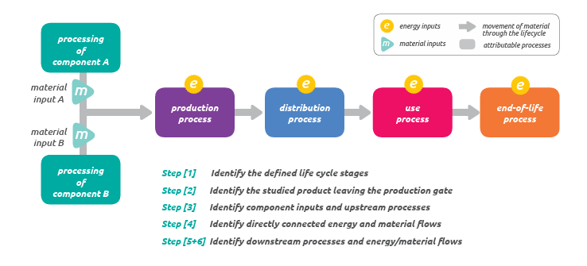
Figure 2 – The whole life cycle of ICT digital devices [b-GHG Protocol Product Standard]

8.2 GHG emission assessment of infrastructure
The ICT infrastructure includes base stations, data centres and telecommunication rooms. Figure 3 describes the production process for infrastructure and its detailed life cycle. This includes: material acquisition pre-processing, production, distribution and storage, use, and end-of-life. In Figure 3, some parts of the life cycle phases are expanded. Further, with respect to digital devices, the installation phase is considered as it is relevant for infrastructure realization.
Scope 1 and Scope 2 emissions of ICT infrastructure should be evaluated with [ITU-T L.1420]. Scope 3 emissions of ICT infrastructure could be evaluated according to [b‑ITU‑T L Suppl. 57]
. 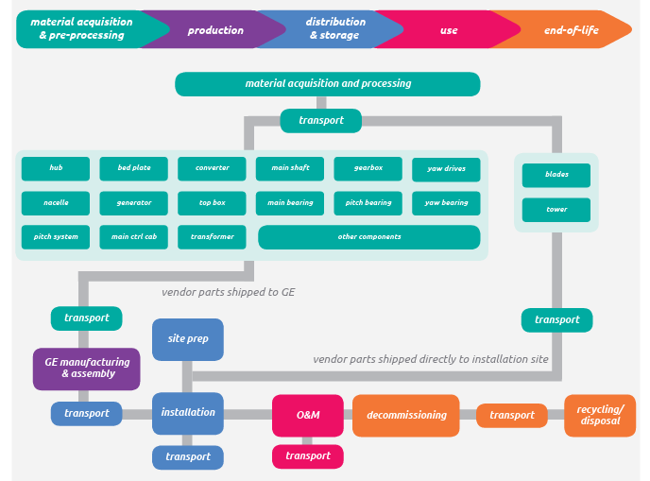
Figure 3 – The whole life cycle of infrastructure [b-GHG PPS]

8.3 GHG emission assessment of ICT networks
As the ICT network operation depends on types of software, including the software program needed to run the primary subscription service, as outlined in applicable standards (e.g., 3GPP for LTE), the impact from the development of such software should be included in the assessment. The assessment of ICT network GHG emissions should be carried out according to [ITU-T L.1410].
In particular, the ICT network energy consumption is calculated as the sum of all ICT devices and supporting infrastructure energy consumption values obtained as described above. ICT network emission assessments are often challenging and may need to rely on previous LCA results for the different ICT devices and infrastructures.
For the following kinds of ICT networks, the environmental load of the use stage should be calculated as follows:
For the assessment of fixed access networks, a constant value is generally applicable for the use stage energy-related environmental load (e.g., per subscriber), as the goods are connected to the access network whether or not the subscriber is using it. However, when power-saving features are used, a fixed value may not be applicable.
For the mobile access network, the assessment needs to consider the temporal variation in both traffic load and different power save modes. Additionally, different base stations (BSs) experience different overall loads, which also needs to be considered in the impact assessment. For further details, refer to [ITU-T L.1410].

8.4 GHG emission assessment of metaverse services

8.4.1 General principles
The operation of ICT networks could be described as the operation of several metaverse services working in parallel, among which there is the primary subscription service which allows the transfer of voice and data, as well as different applications. Thus, to calculate the impact of a metaverse service, it is generally necessary to assess the ICT network, as outlined in the previous clause, and if necessary (i.e., in a multi-service situation) allocate an appropriate amount of this impact to the metaverse service under study.
It is required that the system boundary requirements defined for ICT networks be applied to metaverse services but with some additions, listed below.
In addition to the use of digital devices, ICT infrastructure and ICT networks, metaverse services may also have additional impacts associated with application software development, use of consumables, infrastructure for sales and logistics, associated travel and transport (in addition to those already included for the digital devices and ICT networks) which are also required to be included where applicable. Often, these activities are part of the overall service provider activities.
It is required to assess the impact of the data centres and BSs where the service is operated. It is also recommended to consider the associated activities of the service provider. Service provider support activities consist of, for example, offices and business travel, like operator support activities and may also include the activities listed above.
Important data that defines the hardware associated with the service is stored in a number of servers, and storage and network goods units. Their energy consumption and the data centre’s overhead energy consumption for cooling and power systems (including backup power) needs to be considered as well.
The usage of metaverse services provided by ICT networks needs to be established based on the actual use scenario of metaverse services. If the actual scenario is unavailable, an estimated use scenario can be used, which for example, covers the energy consumption, any waste disposal or emissions due to the services during the period in which the services are provided.
It is optional to include the production/realization of the data centre infrastructure, for example, the construction of the data centre building, cooling and power infrastructure.
NOTE – If the metaverse service offers the possibility to replace an already existing service reference product system (e.g., an e-health solution replacing hospital visits), a comparative study that includes the reduced impact from this change has to be carried out to get a more complete understanding of the impact of the service. [b-ITU-T L.1480] provides information and a detailed description of how to make the comparative study.

8.4.2 GHG emission check list
The following checklist needs to be considered in the system boundary setting of metaverse services, including their associated goods and networks, to identify activities associated with their life cycle and usage.
These checklist items may also be used to structure data and reporting, but other structures are also possible.
1) ICT hardware
This checklist item refers to the life cycle impact of digital devices and ICT networks, for instance, PCs, printers, base stations or core nodes. The use of materials and energy consumption is required to be considered at each life cycle stage. See previous clauses (7.2.1, 7.2.2.1 digital devices and 7.2.2.3 ICT networks) for details.
2) ICT software
This checklist item refers to the life cycle impact (including design, development and use) of ICT software (e.g., individual software, packages, middleware and operating systems). Examples of software impact are the use of electricity and paper by the designers.
NOTE – In practice, it may be hard to assess the use of software and hardware separately.
3) Consumables and other supportive products
This checklist item refers to the life cycle impact of consumables and other supportive products needed for the utilization of the metaverse. The supportive products include for instance, information printouts, information media (e.g., CDs and DVDs) and printer cartridges.
4) Site infrastructure (Facilities)
This checklist item refers to the life cycle impact of facilities providing ICT-related services for the assessed ICT sites and associated goods, e.g., cooling and power supply. Depending on the scope of the assessment, buildings could also be considered. Examples of sites are base station sites and data centres.
5) Transport (movement of goods)
This checklist item refers to the impact of transportation of all the goods within the ICT product system boundary except ones included in: 1) "ICT hardware" or 2) "ICT software". Examples of such goods are the courier of documents and delivery of newspapers. This includes the use of fuels as well as fuel supply chains of trucks, trains, planes, and so on.
NOTE – Except for the fuel supply chain, only the use stage needs to be considered for transport.
6) Travel (movement of people)
This checklist item refers to the impact of travel and is not related to ICT hardware and software. This checklist item includes, professional travel (operators of metaverse platform, infrastructure and network maintenance people) and travel by customers depending on the scope and purpose of the study. It includes the use of fuels as well as the fuel supply chains of cars, trains, buses, and so on.
7) Storage of goods
This checklist item refers to the storage of products not related to ICT hardware and software, such as digital devices and document archives, etc., in an applicable storage place. This implies that the energy consumption for cooling and lighting should be considered.
8) Working environment
This checklist item refers to the use of working environments by the personnel of an organization for business purposes not related to ICT hardware and software. This checklist item deals mainly with the use of buildings; therefore, the building life cycle could also be considered. The associated impact includes the energy consumption from cooling or heating systems, lighting and PCs, etc. This checklist item includes all utilization of the working environment applicable to all the other checklist items.
NOTE – The office could sometimes be located in a factory or in a private home. Production areas of factories belong to checklist item 1.
Annex K of [ITU-T L.1410] defines a method which is required to be considered for assessing the environmental impact of the working environment.
The intention of the eight checklist items above is to ensure that all relevant impacts are considered for all life cycle stages when defining the impact from a product system viewpoint. These are typical items to be considered, but other items may also be considered, depending on the study.
For example, the assessment of a telepresence service may include ICT hardware (telepresence audio sets, networks, and servers), ICT software (telepresence software), site infrastructure (facility for servers), travel (business trip for setting telepresence system and having meetings) and a working environment (cooling and lightning of the meeting room) may be needed to considered.
Energy consumption, material inputs and environmental releases are required to be assessed in accordance with the system boundary. The checklist items above are recommended to be considered to structure energy, material inputs and environmental releases.

8.4.3 Data collection
Often, LCAs are challenging and may need to rely on previous LCA results for the different digital devices, ICT infrastructure and ICT networks based on that data from studies that are compliant with this Technical Specification and [ITU-T L.1410] will take precedence if available. Use time, goods type, data traffic and network access type provide important statistical data that needs to be collected.

8.4.4 Estimation of life cycle carbon footprint of metaverse services
Data calculation for metaverse services is largely related to allocating an appropriate amount of network data to the targeted service.
The life cycle carbon footprint of the studied metaverse service (C_{metaverse service}) can be estimated by the following equations:
CFixed&Wireless Access Customer Premise Equipment = t × ∑_{j}(P_{j} × PUE_{j} × CF_{lo}) (1)
CMetro&Core&Wireless Access Equipment in Networks = V × ∑_{j}(P_{j}/C_{j} × PUE_{j} × CF_{lo}) (2)
C_{Data Centres} = V × ∑_{j}(E_{j,Data centres})/P_{Data centres}) × (P_{glo}/T_{glo}) × CF_{lo} (3)
C_{End User Equipment} = ∑_{e} (sh_{e} × t_{e}/LT_{e} × (Emb_{e} + E_{LT,e} × CF_{lo})) (4)
C_{metaverse service}= CFixed&Wireless Access Customer Premise Equipment + CMetro&Core&Wireless Access Equipment in Networks + C_{Data Centres} + C_{End User Equipment} (5)
where:
CFixed&Wireless Access Customer Premise Equipment = Carbon footprint of the Fixed&Wireless Access CPE {kgCO₂ per metaverse service}
CMetro&Core&Wireless Access Equipment in Networks = Carbon footprint of the Metro and Core and Wireless Access networks {kgCO₂ per metaverse service}
C_{Data Centres} = Carbon footprint of the Data Centres {kgCO₂ per metaverse service}
C_{End User Equipment} = Carbon footprint of the end-user equipment {kgCO₂ per metaverse service}
t = Duration of metaverse service {h}
P_{j} = Power consumption of Equipment type j {kW}
PUE_{j} = Overhead factor for inclusion of electricity consumption of supporting functions for Equipment type
V = data volume processed by the network per functional unit for the metaverse service at hand {GB}
C_{j} = throughput rate of Equipment j [GB/s, Gb/s divided by 8]
E_{j,Data centres} = Electricity consumption of Equipment j in data centres at hand {kWh/year}
P_{Data centres} = Total power consumption of data centres at hand {kW}
T_{glo} = Total Global Data Centre IP Traffic {GB/year}
P_{glo} = Total Power consumption of Global Data Centres {kW}
e = End User Equipment type e
sh_{e} = Share of End User Equipment type e to fulfill the functional unit{h}
t_{e} = Time of usage of End User Equipment type e {h}
LT_{e} = Lifetime electricity consumption of End User Equipment type e {h}
Emb_{e} = Embedded carbon of End User Equipment type e {kg CO₂e}
E_{LT,e} = Lifetime electricity consumption of End User Equipment type e {kWh}
CF_{lo} = Carbon footprint of local electricity mix {kgCO₂e/kWh}
The estimation reported in equation 5 contains network contribution (equations 1 and 2) and data centre contribution (equation 3); this equation considers only the emission due to energy consumption. As for these types of systems that are the predominant part, see [ITU-T L.1410] and [b-ITU-T L.1470] for details and explanation.
The different items reported in equations 1 to 4 are required to be calculated using the methodology described in [ITU-T L.1410] and considering the description given in clauses 6 and 7 of this Technical Specification, in particular in clause 7.2.

Bibliography

[b-ITU-T L.1061] Recommendation ITU-T L.1061 (2023), Circular public procurement of information and communication technologies.
[b-ITU-T L.1302] Recommendation ITU-T L.1302 (2015), Assessment of energy efficiency on infrastructure in data centres and telecom centres.
[b-ITU-T L.1470] Recommendation ITU-T L.1470 (2020), Greenhouse gas emissions trajectories for the information and communication technology sector compatible with the UNFCCC Paris Agreement.
[b-ITU-T L.1480] Recommendation ITU-T L.1480 (2022), Enabling the Net Zero transition: Assessing how the use of information and communication technology solutions impact greenhouse gas emissions of other sectors.
[b-ITU-T L Suppl. 57] ITU-T L-series Recommendations – Supplement 57 (2023), ITU‑T L.1420 – Scope 3 guidance for telecommunication operators.
[b-ITU FGMV-20] ITU Focus Group Technical Report FGMV-20 (2023), Definition of metaverse.
[b-GHG PPS] Product Life Cycle Accounting and Reporting Standard. https://ghgprotocol.org/sites/default/files/standards/Product-Life-Cycle-Accounting-Reporting-Standard_041613.pdf
[b-GHG Protocol CS] Greenhouse Gas Protocol Corporate Standard (2004), A Corporate Accounting and Reporting Standard.
https://ghgprotocol.org/corporate-standard
[b-UNFCCC] United Nations Framework Convention on Climate Change.
https://unfccc.int/
_____________

