Standardization Sector
ITU Focus Group Technical Report
(06/2024)
ITU Focus Group on metaverse

Guidance on how to build a metaverse for all: Part II – Survey
Working Group 8: Sustainability, Accessibility & Inclusion
ITUPublications | International Telecommunication Union


Technical Report ITU FGMV-48
Guidance on how to build a metaverse for all: Part II – Survey
Summary
The primary objective of this Technical Report is to report on the findings from the first United Nations (UN) survey of government, business and academic leaders on metaverse development. This Report offers an initial understanding of the current metaverse development. The TR also identifies the key challenges that hinder the achievement of equity, accessibility and inclusivity within the metaverse, and proposes suggestions to ensure equity, accessibility, and inclusivity are incorporated in metaverse development by default.
Keywords
Accessibility, digital divide, diversity, equity, inclusivity, metaverse, UN SDGs.
Note
This is an informative ITU-T publication. Mandatory provisions such as those found in ITU-T Recommendations lie outside the scope of this Technical Report, which should only be referenced bibliographically in ITU-T Recommendations.
Change log
This document contains Version 1.0 of the ITU Technical Report on "Guidance on how to build a metaverse for all: Part II – Survey" approved at the 7th meeting of the ITU Focus Group on metaverse (FG-MV) held on 12-13 June 2024.
Acknowledgements
This Technical Report was researched and written by Christina Yan Zhang (The Metaverse Institute) and Pilar Orero (Universitat Autònoma de Barcelona, Spain) as a contribution to the ITU Focus Group on metaverse (ITU-T FG-MV).
The authors want to thank Ms Nevine Tewfik (Ministry of Communications and Information Technology, Egypt), Yong Jick Lee (Center for Accessible ICT, Rep. of Korea), Paola Cecchi-Dimeglio (Harvard Law School, USA), Sarah Anne McDonagh, Estella Oncins Noguer (Universitat Autònoma de Barcelona, Spain), Brian Huijts (Ministry of Economic Affairs and Climate Policy, Netherlands), Achraf Othman (Mada Qatar Assistive Technology Center, Qatar) for their great support and guidance alongside the journey.
The authors would also like to thank the following experts for their assistance: Shin Gak Kang (Electronics and Telecommunications Research Institute, Rep. of Korea), Andrey Perez (Brazil), Hideo Imanaka (NICT, Japan), Per Fröjdh (Ericsson, Sweden), Shane He (Nokia, Finland), Vincent Affleck (United Kingdom), Yuntao Wang (China Academy of Information and Communication Technology, China), Leonidas Anthopoulos (University of Thessaly, Greece), Manuel Barreiro (Aston Group, Mexico), Cristina Martinez (European Commission, Brussels), Stella Kipsaita (Communications Authority, Kenya), Natalia Bayona (World Tourism Organization, Spain), Salma Arafa (World Tourism Organization, Saudi Arabia), Younghwan Choi (ETRI, Rep. of Korea), Xiaomi An (Renmin University of China, China), Ismael Arribas (Kunfud, Spain), James Kunle Olorundare (Nigerian Communications Commission, Nigeria), Zekun Wang (China Telecom, China), Marcelo Moreno (Fraunhofer IIS, Germany), Hideki Yamamoto (Oki Electric Industry Co., Ltd., Japan), Yuan Zhang (China Telecom, China), Wilmer Azurza Neyra (Ministry of Transport and Communications of the Administration, Peru), Wook Hyun (Electronics and Telecommunications Research Institute, Rep. of Korea), Naying Hu (China Academy of Information and Communication Technology, China), Muhammad Khurram (King Saud University, Saudi Arabia), Ahmed Said (National Telecom Regulatory Authority, Egypt), Khaled Koubaa (Medeverse), and Shuguang Qi (China Academy of Information and Communication Technology, China).
Additional information and materials relating to this report can be found at: https://www.itu.int/go/fgmv. If you would like to provide any additional information, please contact Cristina Bueti at tsbfgmv@itu.int.
Editor & WG8 Co-Chair: | Pilar Orero  UAB  Spain | E-mail: pilar.orero@uab.cat
Editor: | Christina Yan Zhang  The Metaverse Institute | E-mail: christina@metaverse-institute.org
WG8 Co-Chair: | Nevine Tewfik  MCIT  Egypt | E-mail: ntewfik@mcit.gov.eg
Task Group Co-Chair: | Paola Cecchi-Dimeglio  Harvard University | E-mail: pcecchidimeglio@law.harvard.edu
Task Group Co-Chair: | Yong Jick Lee  Center for Accessible ICT  Korea (Rep. of) | E-mail: ylee@caict.re.kr

© ITU 2026
FGMV-06 (2023-10)

ii

Some rights reserved. This publication is available under the Creative Commons Attribution-Non Commercial-Share Alike 3.0 IGO licence (CC BY-NC-SA 3.0 IGO; https://creativecommons.org/licenses/by-nc-sa/3.0/igo).
If you wish to reuse material from this publication that is attributed to a third party, such as tables, figures or images, it is your responsibility to determine whether permission is needed for that reuse and to obtain permission from the copyright holder. The risk of claims resulting from infringement of any third-party owned material in the publication rests solely with the user.

Table of contents
Page
1 Scope 1
2 References 1
3 Definitions 1
3.1 Terms defined elsewhere 1
3.2 Terms defined in this Technical Report 1
4 Abbreviations and acronyms 1
5 Conventions 1
6 Introduction 1
7 Methodology 2
7.1 Research hypothesis 2
7.2 Research objectives 2
7.3 Research questions 2
7.4 Survey instrument development 2
7.5 Survey response 4
7.6 Validity 4
7.7 Data analysis 4
8 Survey findings 4
9 Discussion 6
10 Limitations 7
11 Conclusion 8
Appendix I – Discussion of the survey results 9
I.1 Main use cases of the metaverse 9
I.2 Advantages of the metaverse 9
I.3 Challenges on the adoption of the metaverse 10
I.4 Content and services in the metaverse 11
I.5 Digital divide and connectivity 12
I.6 Diversity, equity and inclusion (DEI) in the metaverse 13
I.7 Lack of understanding of the metaverse 16
I.8 Lack of relevant skills for the metaverse 16
I.9 Risks posed by the metaverse 17
I.10 International representation of metaverse governance 18
I.11 Lack of confidence in choosing an avatar to reflect digital identity 18
I.12 Future adoption of the metaverse 19
Bibliography 20

Technical Report ITU FGMV-48
Guidance on how to build a metaverse for all: Part II – Survey

1 Scope
This Technical Report provides findings from the "Guidance on how to build a metaverse for all" survey. It provides the reflection of the current state of developing accessible products and services in the metaverse for all, including challenges and suggestions.

2 References
None.

3 Definitions

3.1 Terms defined elsewhere
This Technical Report uses the following terms defined elsewhere:
3.1.1 accessibility [b-ITU-T F.791]: The degree to which a product, device, service or environment (virtual or real) is available to as many people as possible.
3.1.2 metaverse [b-ITU FGMV-20]: An integrative ecosystem of virtual worlds offering immersive experiences to users, that modify pre-existing and create new value from economic, environmental, social and cultural perspectives.
NOTE – A metaverse can be virtual, augmented, representative of, or associated with the physical world.

3.2 Terms defined in this Technical Report
None.

4 Abbreviations and acronyms
This Technical Report uses the following abbreviations and acronyms:
DEI Diversity, Equity, Inclusion
ICT Information and Communications Technology
SDG Sustainable Development Goals
UN United Nations

5 Conventions
None.

6 Introduction
The idea of the metaverse, a persistent, interconnected network of 3D virtual worlds, has captured the imagination of many. ITU Focus Group on metaverse (FG-MV) defines the metaverse as "An integrative ecosystem of virtual worlds offering immersive experiences to users, that modify pre-existing and create new value from economic, environmental, social and cultural perspectives." [b-ITU FGMV-20]
Concerns exist about equitable access and inclusivity in this nascent digital frontier. To address these concerns and guide the development of a metaverse for all, the International Telecommunication Union (ITU) conducted the first-ever United Nations (UN) survey on the topic.
This Report presents the results of an online survey conducted by ITU between 3 November 2023, and 11 January 2024; the survey aims to offer "Guidance on how to build a metaverse for all". The survey sought to understand the current state of metaverse development and identify key challenges to achieving equity, accessibility and inclusivity. It is divided into three interconnected parts:
• Addressing the digital divide;
• Ensuring accessibility;
• Ensuring diversity, equity, and inclusion.
This Technical Report provides the reflection of the current state of developing accessible products and services in the metaverse for all.

7 Methodology
The survey used a self-administered, online questionnaire to gather data from a diverse and geographically dispersed group of stakeholders, including UN agencies, the ITU global tech community, and metaverse enthusiasts. It was designed carefully and underwent pilot testing for clarity and comprehensiveness. Quantitative and qualitative data analysis methods are used to provide meaningful insights into the challenges and opportunities for creating a universally accessible and inclusive metaverse.

7.1 Research hypothesis
The research hypothesis of the report is as follows:
Does effectively overcoming technical challenges, promoting awareness about diversity, inclusion and equity principles, and prioritising diversity, inclusion, and equity from the outset into the foundation of the metaverse help to achieve its widespread adoption and fulfil its potential for economic growth, social inclusion and global collaboration within the next decade?

7.2 Research objectives
The research aims to investigate the digital divide, accessibility and inclusivity challenges within the metaverse in order to identify solutions that promote equitable participation, foster diversity and inclusion, and empower various groups to shape the virtual world.

7.3 Research questions
Based on the research objectives of the research, the following research questions are developed.
1) How does the digital divide in access to technology and infrastructure affect equitable participation in the metaverse, and what solutions can help bridge this divide?
2) What strategies can empower individuals from diverse backgrounds to participate actively in shaping the development and governance of the metaverse, fostering a more diverse, inclusive and equitable virtual space?

7.4 Survey instrument development
Online surveys offer a robust method for gathering data from a geographically dispersed population, allowing for the inclusion of diverse stakeholders in the metaverse, including:
• UN agencies: Representatives from various UN bodies were invited to participate, providing insights from a global development perspective.
• ITU global tech community: The ITU's vast network of technology professionals from its 193 member states was included, as well as individuals from more than 900 companies, universities, research institutes, and international organizations.
• Metaverse stakeholders: The survey further targeted members of metaverse-related communities and membership organizations, capturing perspectives directly from those invested in the metaverse's development.
This survey aims to explore the issues of accessibility and inclusion on metaverse. There are 48 questions in total. These include:
• Participant background: This initial section comprised nine questions designed to gather demographic information about the participants. These questions included inquiries regarding the participants' organizational affiliation, level of seniority, geographical location (country), educational background, and relevant industry sector. This data provides valuable context for interpreting responses to subsequent sections and assessing the representativeness of the sample.
• Bridging the digital divide in the metaverse: The first substantive section of the survey, containing 14 questions, centred on the critical challenge of the digital divide within the metaverse context. Here, the focus shifted to exploring the existing disparities in access to technology and infrastructure that could hinder metaverse participation for a significant portion of the global population. Questions in this section have addressed issues such as current use of the metaverse, challenges to access the metaverse, and new opportunities brought about by the metaverse, governance of the metaverse, skills and competence, and so on.
• Accessibility considerations for the metaverse: Encompassing seven questions, this section delved into the specific accessibility features needed to ensure an inclusive metaverse experience for individuals with disabilities. The survey questions here addressed various accessibility considerations, aiming to identify design elements and functionalities that would enable users with diverse impairments to fully engage with the metaverse.
• Fostering diversity, equity, and inclusion (DEI) in the metaverse: This section, containing 11 questions, explored strategies for promoting a metaverse that reflects the richness and diversity of the real world. The focus here centred on the principles of DEI within the metaverse, which inquired about mechanisms for ensuring a diverse range of voices are heard and empowered to shape the development of the inclusive metaverse.
This well-structured survey instrument, with its targeted sections, effectively gathers data on critical aspects related to accessibility, inclusivity, and equity within the metaverse. The information gleaned from these various sections will likely contribute to the overall research objectives.
The content and structure of the survey have received extensive comments from the 500+ experts that are participating in the ITU Focus Group on metaverse. The survey draft has been discussed at three levels (task group, working group and focus group) of the ITU metaverse Focus Group (FG-MV) and revised multiple times over a period of six (6) months. A pilot testing is conducted once the survey is live among key members of the Working Group 8 (WG8) of the FG-MV to ensure efficiency of the survey design. Minor modifications are made based on the feedback received.
The survey instrument is combining closed-ended, open-ended, ranking, rating scale, and semantic differential scale questions. This is the most suitable tool for metaverse research, offering a mix of predefined answers for efficient data collection and opportunities for respondents to provide deeper insights. The survey which takes 15 minutes to complete, is conducted anonymously and voluntarily, with collected data used by the ITU exclusively for research purposes and retained for five years.

7.5 Survey response
The survey was disseminated through a multipronged approach:
• ITU newsletters: Emails from the ITU global network of technology professionals from its 193 Member States was included.
• Metaverse community promotion: E-mails and social media posts (LinkedIn, Twitter) were utilized to promote the survey within relevant metaverse communities.
• Targeted emails: A LinkedIn newsletter reached out to its 6 963 subscribed members of metaverse-hype or hope, potentially introducing them to the survey.
The final sample size consisted of 182 valid responses. The survey had been sent to ITU's membership, which comprises 193 Member States and more than 1 000 industry and academia members. The survey has also been promoted through social media including by a metaverse LinkedIn newsletter with 6 963 subscribed members. In that regard, the response rate is less than 3 per cent, which is too low to yield significant quality analysis.

7.6 Validity
The online survey format offers several advantages for ensuring data validity. First, the survey instrument has been carefully pre-tested with a pilot group to address any ambiguities or misunderstandings in the questions. Additionally, the survey design established scales and measures to assess accessibility, inclusivity, and equity, facilitating comparisons with existing research.
Furthermore, the diverse target audience mitigates bias by incorporating a wide range of perspectives. Representatives from UN agencies offer insights on global development goals, while the ITU global tech community provides expertise on technical aspects. Finally, the inclusion of metaverse stakeholders directly involved in the field ensures the survey captures the experiences and concerns of those most invested in the metaverse's future.

7.7 Data analysis
Following data collection, this analysis of the survey responses employs a combination of quantitative and qualitative techniques, tailored to address the specific goals outlined in the report.
• Quantitative analysis through both descriptive statistics and cross-tabulation: Descriptive Statistics: Summarise closed-ended responses using measures like frequency counts, percentages, and central tendency (mean, median) to understand overall trends and participant demographics.
• Data visualisation: Use visuals like bar charts, pie charts and scatter plots to effectively communicate key findings from quantitative analysis.
• Integration and interpretation through combine findings: Integrate insights from quantitative and qualitative analysis to create a comprehensive picture of participant perspectives.

8 Survey findings
This study investigates the perceptions and experiences of leaders from various UN entities, governments, industry, and academic organizations regarding metaverse. The survey garnered responses from a diverse group in terms of position, geographic location, and age. Among a total of 182 valid responses:
• 45% of the respondents (79 respondents) were from senior management (24%, 42 respondents) or chief executive level (e.g., CEO, CFO) within organisations (21%, 37 respondents) at large institutions (e.g., UN agencies, ITU Member States, information and communications technology (ICT) companies, universities, research institutions).
• 47% of the respondents (83 respondents) were from Europe and the Commonwealth of Independent States (CIS). 27% of the respondents (48 respondents) were from the Asia and Pacific region. The rest of the respondents were from the Americas (15%, 26 respondents), with a small portion from Africa (7%, 12 respondents), and the Arab region (5%, 9 respondents).
• 57% of the respondents (100 respondents) were aged between 35–54 years old.
• 66% of the respondents (116 respondents) were male, and 33% (59 respondents) female, with the exception of 1% (2 respondents) who preferred not to say.
• 98% (175 respondents) were highly educated with a university degree. 35% (62 respondents) had a bachelor's degree only, while 46% respondents (81 respondents) had a postgraduate degree as well, and 18% (32 respondents) also had a PhD degree.
• 31% of respondents, (54 respondents) worked in the telecom sector, 23% (40 respondents) were working in the public sector or government administration, and 20% (34 respondents) worked in education.
By observing the survey's results, it showed a metaverse in an early stage of development. The respondents agree that the technology has great potential, but its current state is one of limited adoption and use cases. The results highlighted numerous barriers to wider acceptance, including low awareness, technical limitations, and concerns regarding data privacy, inclusivity, and accessibility.
And yet, optimism remains high, with respondents anticipating significant metaverse opportunities in the next decade. This Technical Report looks at the questions of the survey; the following five themes are identified:
1) Limited adoption: Understanding the factors hindering current use and the existing gap between promise and reality. The adoption of the metaverse is still at an early stage. Only 27% of respondents (42 respondents) said they use immersive technologies at least weekly or monthly, while 63% (99 respondents) rarely or never use them. There is a small but dedicated group of people who use immersive technologies to access the metaverse on a regular basis. 17% of respondents (26 respondents) said they do so weekly, and 10% (16 respondents) said they use them daily.
2) Require diverse use cases: Illustrating scenarios where the metaverse is already making its mark, hinting at its potential across different sectors. People see the potential for the metaverse to transform how people work and learn, allowing for more immersive and collaborative experiences. 47% of respondents (73 respondents) thought its main use case is or will be for working or learning remotely. Entertainment and gaming came second at 18% (27 respondents), with social use in third place at 14% (22 respondents). But, only 6% of respondents (10 respondents) thought the metaverse is or will be best used for shopping or commerce; and only 4% (6 respondents) picked creativity or expression.
3) Require attractive advantages: Examining the unique benefits the metaverse offers compared to traditional digital experiences. 94% of respondents (145 respondents) believe that the metaverse offers advantages for their countries or communities, suggesting that this group is optimistic about the potential of technology. Many see the metaverse as a catalyst for job creation and prosperity – 72% of respondents (111 respondents) said they believed in its potential for economic growth and development. People also express a desire to use these technologies to help overcome physical and social barriers, creating a more equitable world. 63% of respondents (97 respondents) believed the metaverse can foster social inclusion and empower marginalized communities. 53% (82 respondents) recognise its potential to promote cultural diversity and exchange. The metaverse is envisioned as a platform for connection and understanding across cultures, fostering collaboration and global unity.
4) Address key challenges: Highlighting the key hurdles that need to be overcome for wider adoption.
a) On a country or community level, the following key challenges are reported:
• Data privacy and security (77%, 118 respondents)
• Digital dependency and addiction (60%, 92 respondents)
• Social polarisation and conflicts (50%, 77 respondents)
• Digital colonialism and exploitation (40%, 62 respondents).
b) On an individual level to use the metaverse, the following key challenges are reported:
• Lack of suitable metaverse content and services, such as tools, games, social networks, and marketplaces (57%, 89 respondents)
• Cost of the equipment or services needed to access the metaverse (54%, 84 respondents)
• Digital identity uncertainty (27%, 37 respondents)
• Lack of user skills or knowledge of the metaverse (23%, 36 respondents).
5) Promote future adoption: Some solutions for the future growth of the metaverse identified in the survey include:
• Bridging the digital divide (71%, 109 respondents): Investments in metaverse education and development of affordable and accessible devices are crucial.
• Improved Internet infrastructure (62%, 96 respondents): Expanding Internet access and coverage will support wider adoption of the metaverse.
• Diversity, equity, and inclusion (DEI) (73%, 95 respondents): Increased education about DEI best practices and ensuring diverse representation in metaverse development are essential.
• Global governance (44%, 66 respondents): Collaboration and clear international guidelines are needed to establish a fair and balanced governance structure for the metaverse.
• The survey results suggest that among business and government leaders, there is a strong expectation that this technology will come to fruition within a decade or so. 47% (73 respondents) of respondents predicted that in 10 years' time, they will be using the metaverse every day. Another 26% (40 respondents) said they would expect to be using it at least weekly, while another 5% estimated they might use it once a month. Taken together, 78% of this group (121 respondents) said they expected to be making regular use of the metaverse in 2033.
Delving into these areas offers a more comprehensive understanding of the metaverse's current state and its trajectory towards the future.

9 Discussion
With the metaverse still in its early stages, there are many opportunities to shape its future. The survey results suggest political, business, and academic leaders who responded to the survey recognise its economic potential, but there are substantial obstacles to widespread adoption. Concerns about data privacy, inclusivity and accessibility also remain key barriers [b-Park]. In addition, the communication sector's thought leaders agreed that diversity, equity and inclusion issues are as much of a priority in the metaverse as in the real world.
The survey's key findings include:
• Awareness and understanding: Many people still lack basic understanding of the metaverse, hindering its growth.
• Limited adoption: Immersive technologies used to access the metaverse are not yet mainstream.
• Content and services: Current content and services are perceived as lacking, requiring more diversity and relevance.
• Digital divide: There are concerns about excluding those without access to devices, infrastructure, or skills.
• Inclusivity: While awareness of the importance of DEI is high, current levels are perceived as unsatisfactory.
• Digital identity: Many lack confidence in creating avatars that reflect their true identities.
Challenges and suggestions
• Bridging the knowledge gap: Education and resources are crucial to raise awareness and understanding.
• Improving accessibility: Affordable devices, accessible content, and infrastructure development are essential.
• Focusing on DEI: Education on DEI issues may be a greater priority than insisting all institutions have policies and enforcement.
• Expanding content and services: Tailoring content to specific needs and promoting innovation are key.
• Developing user-friendly tools: Intuitive interfaces and avatar creation options are crucial.
In conclusion, this Technical Report makes three clear suggestions for building a truly inclusive and accessible metaverse:
a) Overcoming technical hurdles: Making the metaverse accessible to all requires technological advancements that address limitations for users with diverse abilities.
b) Promoting awareness: Educating creators and users about DEI principles is crucial for fostering a welcoming and equitable virtual space.
c) Prioritizing DEI from the outset: Embedding DEI considerations into the very foundation of the metaverse is essential to avoid replicating inequalities from the real world.

10 Limitations
This study sheds light on accessibility and inclusivity challenges within the metaverse by surveying diverse stakeholder groups. However, the research design possesses inherent limitations that warrant consideration when interpreting the findings. Firstly, it is difficult to give the total number of respondents it has reached. Secondly, although the specific LinkedIn group promotion reached a total of 6 963 members, the overall response rate likely falls well below 3% based on this single data point. This low response rate raises concerns about the generalizability of the findings to the broader population interested in the metaverse, as it suggests a potential bias towards those who are already highly engaged with the technology and potentially over-represents their perspectives. Thirdly, the absence of reported participant demographics (e.g., age, location, disability status) hinders the assessment of sample representativeness.
Future research can address these limitations by employing more rigorous sampling methods. Additionally, researchers can explore alternative data collection methods like in-depth interviews with users from diverse backgrounds to capture a wider range of perspectives. Finally, incorporating technical evaluations and user testing alongside surveys can provide a more holistic understanding of accessibility challenges within the metaverse.

11 Conclusion
This Technical Report analyses the results from the first UN survey on "Guidance to build a metaverse for all". It proposes three clear suggestions for building a truly inclusive and accessible metaverse such as overcoming technical hurdles, promoting awareness about DEI principles, and prioritising DEI from the outset into the very foundation of the metaverse.
Considering the development of the metaverse is fast evolving, the work on guidance to build a metaverse for all will also need to be updated on a regular basis. This Report will lay a good foundation for all stakeholders of the global metaverse communities such as the UN, governments, NGOs, businesses and academics to come together and ensure the adoption of a "Public-private-people-planet" partnership, which helps to prioritise the needs of people as the centre for all digital future.

Appendix I
Discussion of the survey results

I.1 Main use cases of the metaverse
The metaverse can be a social gateway with diverse possibilities. A total of 154 people answered the question, "For what purposes do you, or would you use the metaverse?". 47% of respondents (73 people) thought that its main use case is or will be for working or learning remotely. Entertainment and gaming came second at 18% (27 people), with social use in third place at 14% (22 people). But, only 6% (10 people) of respondents thought that the metaverse is or would be best used for shopping or commerce, and only 4% (6 people) picked creativity or expression.
A small percentage of respondents said they would not use the metaverse at all.
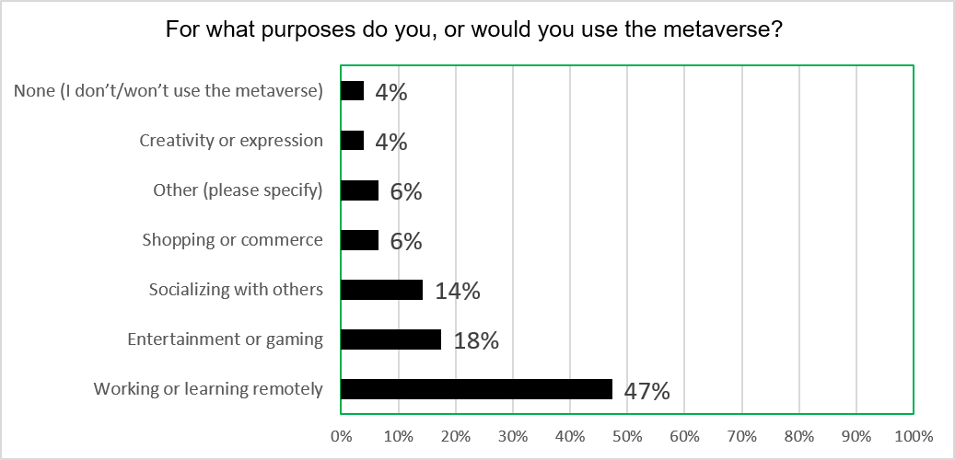
Figure I.1 – Use cases of the metaverse

I.2 Advantages of the metaverse
As the metaverse edges closer to reality, it is important for the public to have a holistic and realistic perception of what the metaverse can do to benefit them. A total of 155 people answered the question, "What are the opportunities or advantages that the metaverse can offer for your country or community?". In this survey, 72% of respondents (111 people) said they believed in its potential for economic growth and development, indicating that many see it as a catalyst for job creation and prosperity.
But the vision extends beyond the economy. 63% of respondents (97 people) believed the metaverse can foster social inclusion and empower marginalized communities.
Further reinforcing this sentiment, 53% (82 people) recognise its potential to promote cultural diversity and exchange. The metaverse, then, is envisioned as a platform for connection and understanding across cultures, fostering collaboration and global unity.
Interestingly, environmental sustainability appears less prominent (37%, 58 people). Those who believe that these technologies have a role to play in addressing the climate crisis and/or other ecological concerns may have an educational and/or awareness-raising challenge to persuade others who do not believe that metaverse can be used for addressing environment issues.
Only a small proportion of respondents (6%, 10 people) believe the metaverse offers none of these advantages. With 94% (145 people) respondents believe that the metaverse offers advantages for their countries or communities.
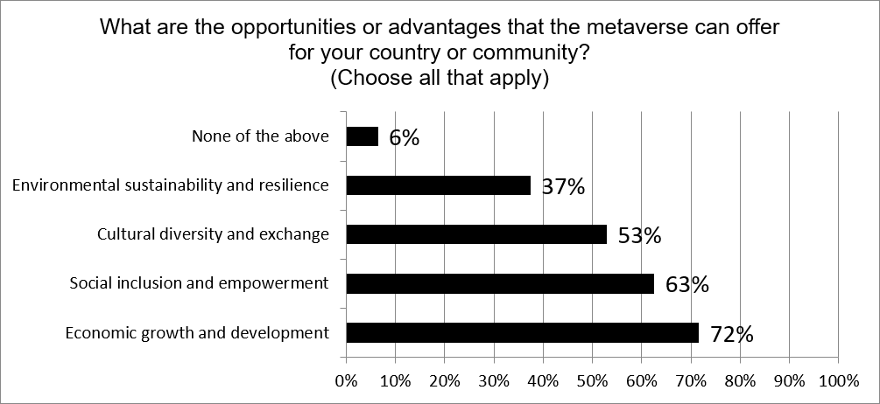
Figure I.2 – Advantages and opportunities of the metaverse

I.3 Challenges on the adoption of the metaverse
If it is to fulfil its potential to enhance lives, the metaverse faces another critical hurdle: user adoption. Several challenges currently impede widespread participation. There are 155 people who answered the question, "What are the main challenges or barriers for you to access or participate in the metaverse?".
Firstly, there is a lack of metaverse content and services: 57% of our respondents (89 people) felt that there are not yet enough compelling things to do or see in the metaverse, suggesting a need for more diverse and engaging content and applications. Secondly, the high cost of equipment needed to access the metaverse (VR headsets, computers, even Internet access in some regions) remains a significant hurdle, cited by 54% of respondents (84 people). Thirdly, about 41% of our respondents highlighted privacy or security as a worry.
About 24% of respondents (37 people) saw accessibility and usability as challenges, which could encompass various factors like physical limitations, lack of technical know-how, or user interface design issues. Furthermore, 23% of respondents (36 people) felt that they lacked the necessary skills or knowledge to use the metaverse effectively, highlighting a potential need for educational resources and user-friendly onboarding experiences. Finally, about 21% (32 people) were concerned about potential ethical or social problems in the metaverse.
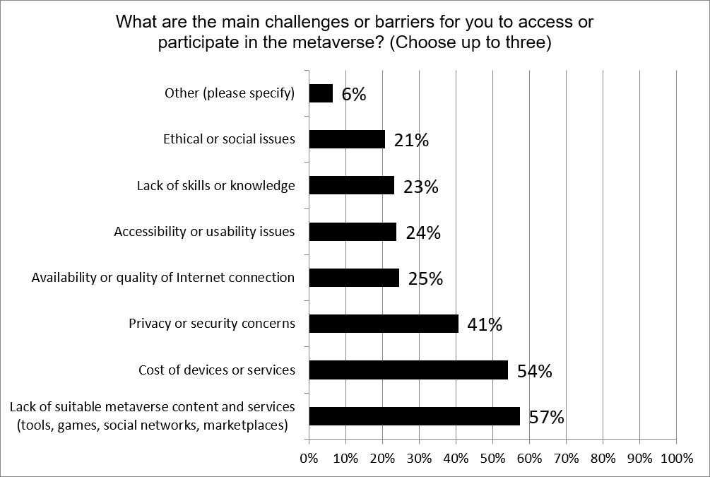
Figure I.3 – Barriers to participating in the metaverse

I.4 Content and services in the metaverse
While the developers and proponents of the metaverse promise transformative experiences, the survey reveals a crucial barrier to widespread adoption: a disconnect between current content and the needs of users and their communities. A total of 152 people answered the question "How relevant or suitable are the content and services that are available or designed for your country or community in the metaverse?".
45% of respondents (68 people) are sceptical of what the metaverse currently provides. 35% of respondents (53 people) believe that current content and services lack relevance or suitability for their communities, and 10% (15 people) report that they are not suitable at all.
On the positive side, 45% (68 people) report that current offerings are "somewhat" relevant and suitable, while another 10% (15 people) believe they are very much so.
Nevertheless, the near 50/50 split between respondents who are positive about metaverse content and services, and those who feel it is lacking, suggests there is considerable space for developers, service providers, content creators and other stakeholders to expand their offer.
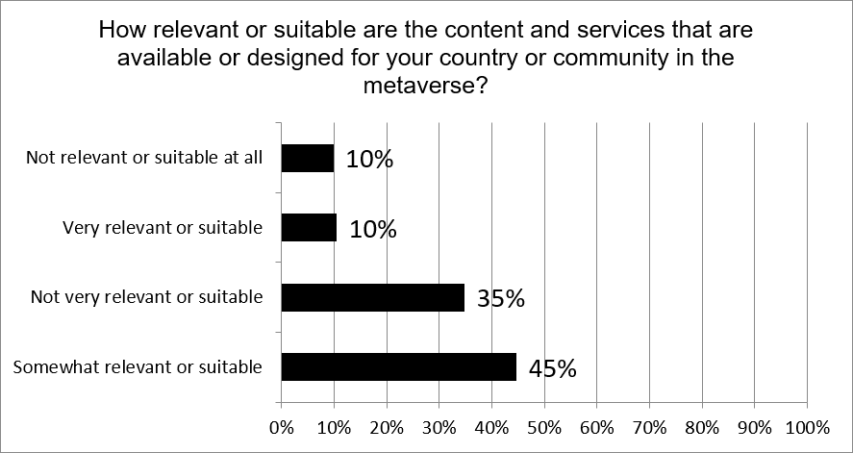
Figure I.4 – The relevance of metaverse content and services

I.5 Digital divide and connectivity
According to the latest figures from the ITU's "Facts and Figures" report for 2023 [b-ITU], about 2.6 billion people, or 33% of the global population, do not use the Internet. This digital divide manifests differently across different populations. In high-income countries, Internet use is close to universal, whereas in low-income countries, only 27% of the population is online. In developed regions such as Europe, there is no appreciable gender divide, while in Africa, 42% of men but only 32% of women use the Internet. Across the world, young people are more likely to be online; 79% of people aged 15–24 use the Internet, while only 65% of the rest of the global population does so.
Owing to its generally higher barriers to entry (e.g., the cost and access to immersive technology; and the requirement for high-quality digital infrastructure), it is likely such divides will be exacerbated in the metaverse. A total of 152 people answered the question "How important do you think it is to address the digital divide in the metaverse?" This was recognised by our respondents, 68% (103 people) said it is very important to address the metaverse's digital divide. The remaining respondents think that it is either somewhat important or not very important, but no one thinks that it is not important at all.
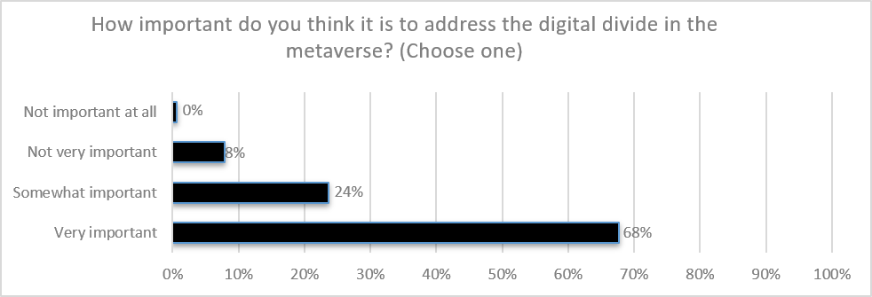
Figure I.5 – The importance of the digital divide in the metaverse
This survey also asked respondents to choose between a number of actions likely to help reduce this digital divide. There are 154 people who answered the question, "What solutions or actions will be most effective in reducing the digital divide in the metaverse?" User education, and the need for accessible and affordable devices, were the most popular – each picked by 71% of respondents (109 people). This encompasses subsidized equipment, data plans, and Internet access, making metaverse participation more feasible for more people. And it is equally important to train individuals on using metaverse technologies and navigating virtual environments effectively. This could involve workshops, educational resources, and community-driven initiatives.
62% of respondents (96 people) said improving Internet infrastructure and coverage would help to solve the issue. This acknowledges the limitations of the Internet access in certain areas. Meanwhile, 53% of respondents also highlighted the importance of robust privacy and security measures (82 people).
On this question, the survey results showed a clear skew toward the above practical steps as priorities for action. 75% (116 people) picked out innovation and social impact initiatives (41%, 63 people), or diversity/inclusion in metaverse development (34%, 53 people). This suggests that with the metaverse ecosystem still in the early stages of development, leaders and policymakers are prioritising technological implementation over issues of representation.
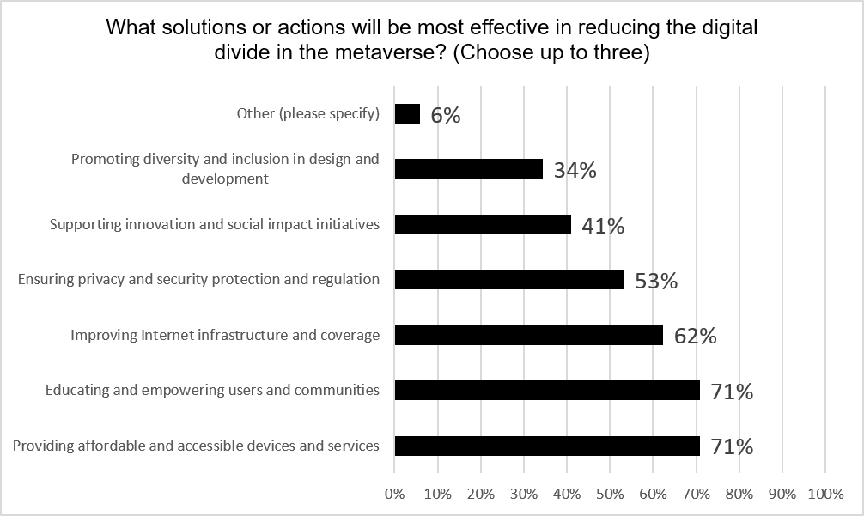
Figure I.6 – Reducing the digital divide in the metaverse

I.6 Diversity, equity and inclusion (DEI) in the metaverse
Overall, survey respondents were optimistic that the metaverse offers an opportunity for greater inclusivity. A total of 144 people responded to the question, "How inclusive do you think the metaverse is for people from different backgrounds, identities, and abilities?" 74% (106 people) said it either already is "somewhat" or "very" inclusive for people from different backgrounds, identities, and abilities. Just 4% (6 people) said that it is not inclusive at all.
However, combining this with the larger group (22%, 32 people) who felt the metaverse is "not very inclusive", indicates around a quarter of these decision-makers feel there is potential for exclusion and discrimination in this emerging virtual space.
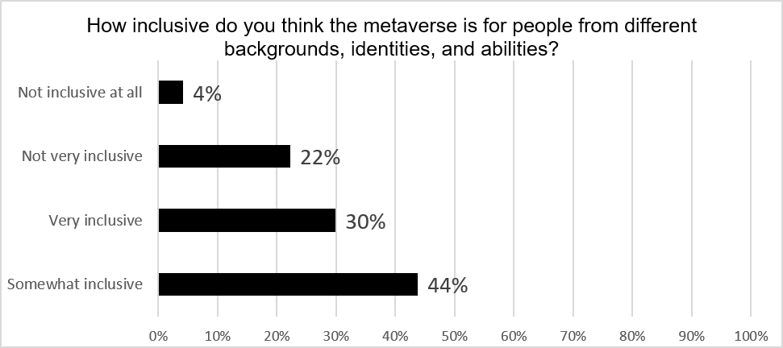
Figure I.7 – Inclusivity of the metaverse
A total of 132 people answered the question, "How satisfied are you with the current level of DEI in the metaverse?" Interestingly, around half of the respondents (51.5%, 101 people) described themselves as satisfied with the above situation, while the other half (48.5%, 64 people) said they were dissatisfied.
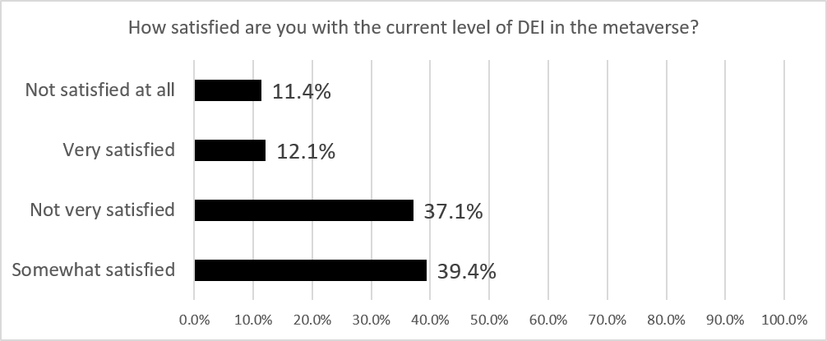
Figure I.8 – Satisfaction with current levels of DEI in the metaverse
On the question of, "How important do you think it is to ensure diversity, equity and inclusion (DEI) in the metaverse?" 136 people responded. A large and clear majority of respondents (95%, 130 people) agreed on the importance of ensuring diversity, equity and inclusion (DEI).
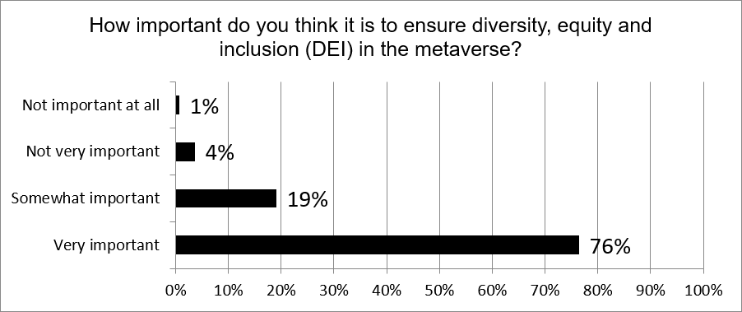
Figure I.9 – The importance of DEI in the metaverse
Taken together, the results point toward a disconnect between aspirations and reality: while 76% (104 people) believe that diversity, equity, inclusion (DEI) in the metaverse is "very important", only 12% (16 people) are "very satisfied" with its current state.
The survey also asked respondents to identify the greatest challenges or barriers to ensuring DEI in the metaverse. On the question, "What are some of the challenges or barriers to ensuring DEI in the metaverse?" 130 people responded. Their responses may help suggest priority areas for action. 73% (95 people) said there was insufficient awareness or education about DEI best practices, while 61% (79 people) said there was insufficient representation of diverse groups in the development of software and services.
The numbers identifying a lack of DEI standards and policies, and/or a lack of accountability and enforcement of them, were smaller – at around half of the respondents.
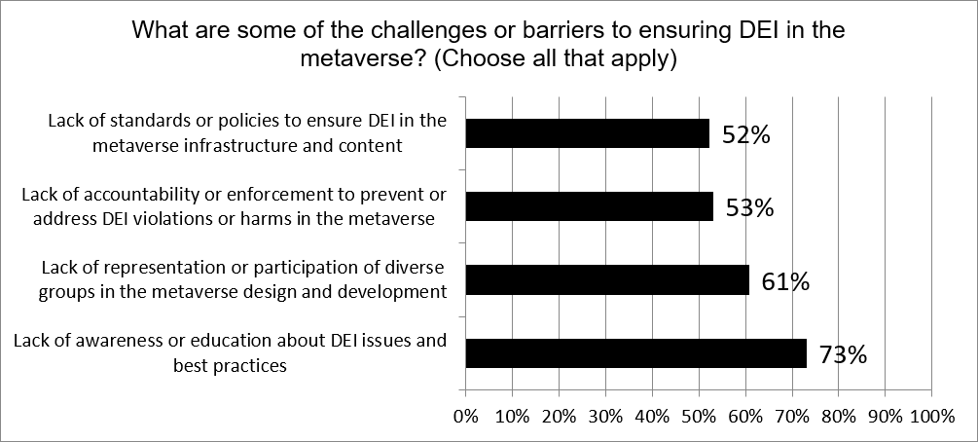
Figure I.10 – Barriers to ensuring DEI in the metaverse

I.7 Lack of understanding of the metaverse
The metaverse faces a critical hurdle: a lack of understanding among the public. It is a relatively new concept, with the term coined in the 1990s but only recently coming to widespread attention, most significantly with Facebook Inc.'s decision to rename itself Meta Platforms, Inc. in 2021 and explicitly describe itself as a "social metaverse company" [b-Egliston].
As originally portrayed in science fiction, the metaverse was envisaged as a single ecosystem – a globally interconnected virtual-reality Internet – and it is still often conceptualized this way today, as a desirable future state. However, technology companies are currently focused on developing their own software and solutions – their own individual "metaverses", in the plural – which means that there is no single, widely-used platform or set of features that people can associate with the metaverse [b-Kraus].
In our results on the question "What is your level of familiarity with the concept and features of the metaverse?" To which 155 people answered, 84% (130 people) described themselves as either "very familiar" or "somewhat familiar" with the concept and features of the metaverse. While this is a high proportion, it should be remembered that our respondents consist of senior executives, policymakers, and other thought leaders in this field.
While only 16% (25 people) of our respondents indicate they are "not very familiar" or "not familiar at all" with the metaverse, there is likely to be some selection bias inherent in our survey.
So, while the figures suggest good awareness overall among this engaged group, there is unlikely to be any cause for complacency. There is still a long way to go before the metaverse concept becomes mainstream [b-Kraus].
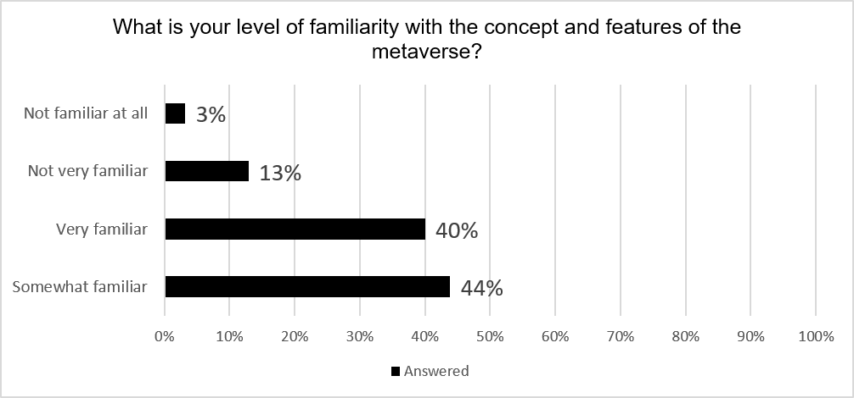
Figure I.11 – Familiarity with the concept and features of the metaverse

I.8 Lack of relevant skills for the metaverse
Looking at this group's own preparedness for using the metaverse, the survey data paints a similar picture. On the question of, "How skilled or competent are you in using the devices and platforms that enable you to access the metaverse?" 154 people responded. Our respondents have a relatively high degree of confidence in their own skills, but there is a significant minority (25%, 38 people) who describe themselves as "not very" or "not at all" skilled or competent.
And while 31% (47 people) believe they are competent to access the metaverse, 45% (69 people) describe themselves as only "somewhat" competent.
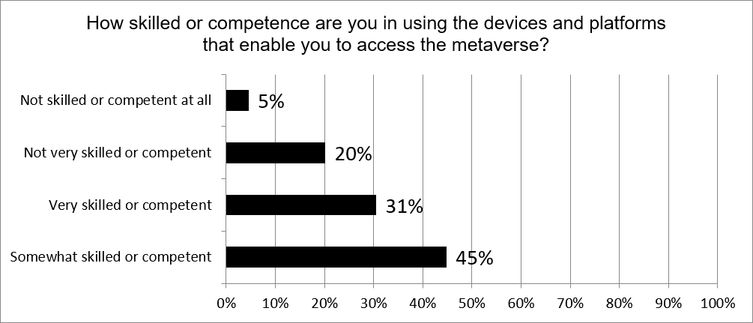
Figure I.12 – Respondents' assessment of their competence in using metaverse devices/platforms

I.9 Risks posed by the metaverse
Even once technological and skills barriers are overcome, there are many risks inherent in participation in the metaverse. The survey asked our respondents to rank several of the most prominent. On the question of, "What are some of the challenges or risks that the metaverse can pose for your country or community?" 154 people responded to the question. Picked by 77% (118 people), data privacy and security were the top concerns.
As observed in many places throughout this Report, the metaverse ecosystem is at a very early stage of development, and few experts would claim that it is as immersive or pervasive as it could eventually become. Even so, our respondents are highly cognizant of the risk of digital dependency and addiction: 60% (92 people) flagged this, making it the second-most widely held concern. Considering AR; the blurring of lines between reality and virtual worlds could also lead to problematic escape behaviours, particularly for vulnerable individuals [b-Park].
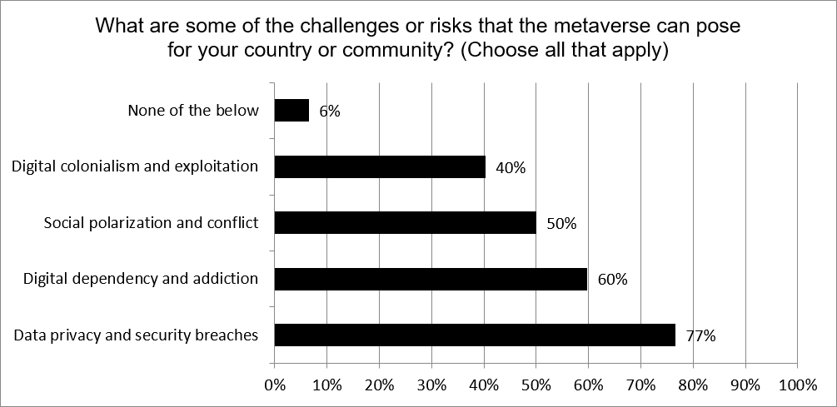
Figure I.13 – Risks and challenges arising from the metaverse

I.10 International representation of metaverse governance
A total of 151 people answered the question, "How involved or influential are your country or community in shaping or governing the metaverse?" 44% (66 people) of our respondents believed their own countries are "not very" or "not at all" involved or influential in shaping the governance of the metaverse.
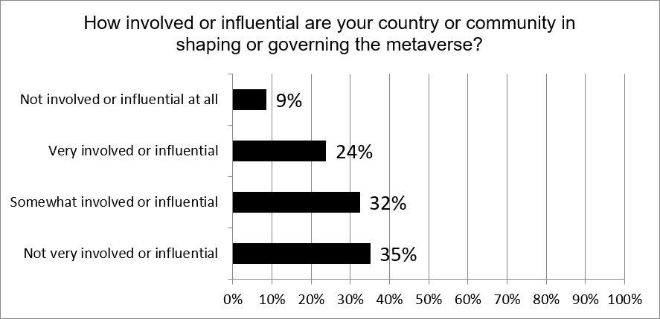
Figure I.14 – Respondents' assessment of the influence their country has on shaping the metaverse

I.11 Lack of confidence in choosing an avatar to reflect digital identity
At the core of the metaverse lies the avatar, a digital representation of our virtual selves. On the question, "How confident are you in creating or choosing a digital avatar that reflects your identity and expression in the metaverse?" 135 people responded. Among the respondents to the survey, a similar split emerges as in the previous questions - while most express confidence about creating or choosing a digital identity for themselves, 27% (37 people) admit to uncertainty.
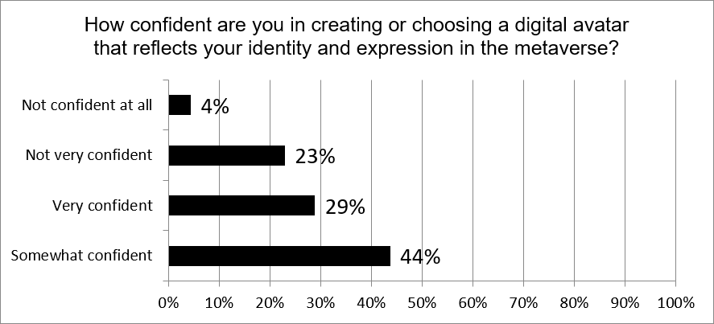
Figure I.15 – Respondents' confidence in creating digital avatars for the metaverse

I.12 Future adoption of the metaverse
In recent years, much media attention has focused on the question not of "if" but "when" the metaverse will come into regular use [b-Akour].
Our survey results suggest that among business and government leaders engaged enough to complete a metaverse survey, there is a strong expectation that this technology will come to fruition within a decade or so. A total of 156 people answered the question on, "10 years from now, how often would you expect to be using such immersive technologies to access the metaverse?" 47% (73 people) of our respondents predicted that in 10 years' time, they will be using the metaverse every day. Another 26% (40 people) said they would expect to be using it at least weekly, while another 5% estimated they might use it once a month. Taken together, 78% of this group (122 people) said they expected to be making regular use of the metaverse in 2033.
As with previous responses, however, the skeptical contingent again accounted for around a quarter of the group. 19% of respondents (30 people) estimated they might be using the metaverse "occasionally" in a decade's time, while 3% (5 people) declared they would "never" use the technology.
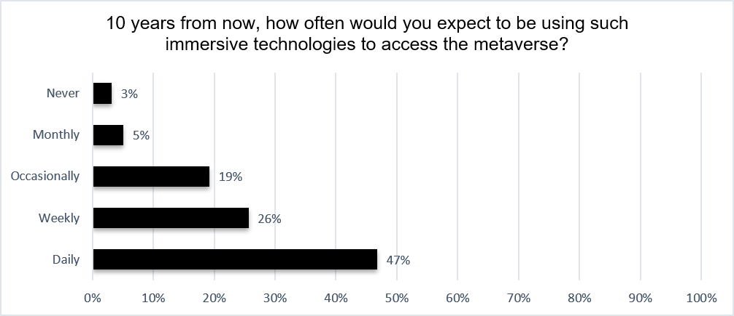
Figure I.16 – Respondents' expectations for metaverse use in 2033
Comparing these results to those for question 1 (current adoption of the metaverse), where 37% (61 people) reported daily, weekly, or monthly use and 63% (99 people) said "occasionally" or "never", this group expects rapid take-up of this technology over the next decade. Respondents are optimistic about the future of the metaverse and believe that it will play a significant role in their lives.

Bibliography
[b-ITU-T F.791] Recommendation ITU-T F.791 (2018), Accessibility terms and definitions.
[b-ITU FGMV-18] ITU Focus Group Technical Report FGMV-18 (2023), Guidance on how to build a metaverse for all – Part I: Legal Framework. Working Group 8: Sustainability, Accessibility & Inclusion.
[b-ITU FGMV-20] Technical Specification ITU-FGMV-20 (2023), Definition of metaverse.
[b-ITU] ITU Facts and Figures (2023), Global offline population steadily declines to 2.6 billion people in 2023.
<https://www.itu.int/itu-d/reports/statistics/2023/10/10/ff23-internet-use/>
[b-Akour] Akour, I.A., Al-Maroof, R.S., Alfaisal, R., and Salloum, S.A. (2022), A conceptual framework for determining metaverse adoption in higher institutions of gulf area: An empirical study using hybrid SEM-ANN approach. Computers and Education: Artificial Intelligence, 3, 100052. <https://www.sciencedirect.com/science/article/pii/S2666920X22000078>
[b-Egliston] Egliston, B., and Carter, M. (2021), Critical questions for Facebook's virtual reality: data, power and the metaverse. Internet Policy Review, 10(4). <https://policyreview.info/articles/analysis/critical-questions-facebooks-virtual-reality-data-power-and-metaverse>
[b-Park] Park, S.-M., and Kim, Y.-G. (2022), A metaverse: Taxonomy, components, applications, and open challenges. IEEE access, Volume 10, pp 4209-4251.
<https://ieeexplore.ieee.org/abstract/document/9667507>
[b-IEA] IEA (2023), Access to electricity.
<https://www.iea.org/reports/sdg7-data-and-projections/access-to-electricity>
[b-Kim] Kim, J. (2021). Advertising in the metaverse: Research agenda. Journal of Interactive Advertising, 21(3), 141-144. <https://www.tandfonline.com/doi/full/10.1080/15252019.2021.2001273>
[b-Kraus] Kraus, S., Kanbach, D.K., Krysta, P.M., Steinhoff, M.M., and Tomini, N. (2022), Facebook and the creation of the metaverse: radical business model innovation or incremental transformation? International Journal of Entrepreneurial Behavior & Research, 28(9), 52-77. <https://www.emerald.com/insight/content/doi/10.1108/ijebr-12-2021-0984/full/html>
[b-Ning] Ning, H., Wang, H., Lin, Y., Wang, W., Dhelim, S., Farha, F., ... & Daneshmand, M. (2023). A Survey on the Metaverse: The State-of-the-Art, Technologies, Applications, and Challenges. IEEE Internet of Things Journal. <https://arxiv.org/abs/2111.09673>
[b-Othman] Othman, A.; Chemnad, K.; Hassanien, A.E.; Tlili, A.; Zhang, C.Y.; Al-Thani, D.; Altınay, F.; Chalghoumi, H.; S. Al-Khalifa, H.; Obeid, M.; (2024). Accessible Metaverse: A Theoretical Framework for Accessibility and Inclusion in the Metaverse. Multimodal Technol. Interact. 8(21), <https://www.mdpi.com/2414-4088/8/3/21>
________________

