Standardization Sector
ITU Focus Group Technical Report
(06/2024)
ITU Focus Group on metaverse

Security for things across metaverses in aspects of data processing and management
Working Group 6: Security, Data & Personally identifiable information (PII) Protection
ITUPublications | International Telecommunication Union


Technical Report ITU FGMV-44
Security for things across metaverses in aspects of
data processing and management
Summary
In Internet of things (IoT) (Recommendation ITU-T Y.4000), each physical/virtual thing (such as sensors, IoT devices, IoT systems, and IoT gateways) manages and processes its data independently, directly by itself or via relevant IoT systems. If a thing is mapped into a metaverse, actively or passively, its data will be transferred into the target metaverse. Usually, a metaverse may manage and process the data of its entities by itself. When there are a large number of entities and data, it may use external computing resources and services to manage and process the relevant data. A thing may be mapped into multiple metaverses. In this case, there are more challenges in managing and processing the data of things, including the need to protect data security.
Technical Report ITU FGMV-44 analyses and provides solutions for security of things across metaverses in terms of data processing and management, including at least relevant technical features, requirements and reference frameworks of security for things across metaverses regarding data processing and management.
Keywords
Data management, data processing, Internet of Things (IoT), metaverse, security, thing.
Note
This is an informative ITU-T publication. Mandatory provisions such as those found in ITU-T Recommendations lie outside the scope of this Technical Report, which should only be referenced bibliographically in ITU-T Recommendations.
Change log
This document contains Version 1.0 of the ITU Technical Report on "Security for things across metaverses in aspects of data processing and management" approved at the 7th meeting of the ITU Focus Group on metaverse (FG-MV) held on 12-13 June 2024.
Acknowledgements
This Technical Report was researched and written by Xiaojun Mu (China Unicom, China), Xiongwei Jia (China Unicom, China), Keng Li (China Information Communication Technologies Group,China) and Heung Youl Youm (Soonchunhyang University, Korea (Republic of)) as contributors to the ITU Focus Group on metaverse (FG-MV). The development of this document was coordinated by Vincent Affleck (DSIT, United Kingdom), as FG-MV Working Group 6 Chair, and Mr Christian Alvarez (UNICEF) and Ms Hanna Linderstål (EARHART Business protection agency), as Chairs of the Task Group on cybersecurity.
Additional information and materials relating to this report can be found at: https://www.itu.int/go/fgmv. If you would like to provide any additional information, please contact Cristina Bueti at tsbfgmv@itu.int.
Editor: | Xiaojun Mu  China Unicom  China | Tel: +86 13292090213  E-mail: muxj@chinaunicom.cn
Editor: | Xiongwei Jia  China Unicom  China | Tel: +86 15611092296  E-mail: jiaxw9@chinaunicom.cn
Editor: | Keng Li  China Information Communication Technologies Group  China | E-mail: kli@fiberhome.com
Editor: | Heung Youl Youm  Soonchunhyang University  Korea (Republic of) | Tel: +82-41-530-1328  E-mail: hyyoum@sch.ac.kr
WG6 Chair: | Vincent Affleck  DSIT  United Kingdom | E-mail: Vincentaffleck2@hotmail.com
TG Co-Chair: | Christian Alvarez  UNICEF | E-mail: calvarez@unicef.org
TG Co-Chair: | Hanna Linderstål  EARHART Business protection agency | E-mail: hanna.linderstal@earhart.se

© ITU 2026
Some rights reserved. This publication is available under the Creative Commons Attribution-Non Commercial-Share Alike 3.0 IGO licence (CC BY-NC-SA 3.0 IGO; https://creativecommons.org/licenses/by-nc-sa/3.0/igo).
For any uses of this publication that are not included in this licence, please seek permission from ITU by contacting TSBmail@itu.int.
Table of Contents
Page
1 Scope 1
2 References 1
3 Definitions 1
3.1 Terms defined elsewhere 1
3.2 Terms defined in this Technical Report 2
4 Abbreviations and acronyms 2
5 Conventions 3
6 Overview of security for things across metaverses in aspects of data processing and management 3
7 Technical features and requirements of security for things across metaverses in terms of data processing and management 4
7.1 Technical features of security for things across metaverses in terms of data processing and management 4
7.2 Requirements of security for things across metaverses in terms of data processing and management 4
8 Reference framework for security for things across metaverses in terms of data processing and management 5
8.1 Data interoperability between IoT platforms and metaverse platforms 6
8.2 Data interoperability across avatars in one metaverse platform 6
8.3 Data interoperability across different metaverses platforms 6
8.4 Data interoperability with external DPM 7
8.5 Trustworthy data storage 7
8.6 Traditional security methods 7
8.7 Agent(s) 8
8.8 External entities 8
8.9 Reference points 9
9 Security consideration 9
Appendix I – Use cases for security of things across metaverses in terms of data processing and management 10
I.1 Smartwatch data security across metaverses 10
I.2 Games data security across metaverses 11
Bibliography 13

Technical Report ITU FGMV-44
Security for things across metaverses in aspects of
data processing and management

1 Scope
This Technical Report analyses and provides solutions for security of things across metaverses in terms of data processing and management.
The scope of this Technical Report includes:
– Overview of security for things across metaverses in terms of data processing and management.
– Technical features and requirements of security for things when operating across metaverses in terms of data processing and management.
– Reference framework of security for things when operating across metaverses in terms of data processing and management.
Use cases and analysis of the security for things across metaverses in terms of data processing and management are provided in the appendices.

2 References
The following ITU-T Recommendations and other references contain provisions which, through reference in this text, constitute provisions of this Technical Report.
[ITU-T Y.4000] Recommendation ITU-T Y.4000/Y.2060 (2012), Overview of the Internet of things.
[ITU-T Y.4464] Recommendation ITU-T Y.4464 (2020), Framework of blockchain of things as decentralized service platform.

3 Definitions

3.1 Terms defined elsewhere
This Technical Report uses the following terms defined elsewhere:
3.1.1 access control [b-ITU-T X.800]: The prevention of unauthorized use of a resource, including the prevention of use of a resource in an unauthorized manner.
3.1.2 application [b-ITU-T Y.2091]: A structured set of capabilities, which provide value-added functionality supported by one or more services, which may be supported by an API interface.
3.1.3 authentication [b-ISO/IEC 18014-2]: Provision of assurance of the claimed identity of an entity.
3.1.4 avatar [b-ISO/IEC 23005-4]: Entity that can be used as a (visual) representation of the user inside the virtual environments.
3.1.5 blockchain [b-ITU-T X.1400]: A type of distributed ledger which is composed of digitally recorded data arranged as a successively growing chain of blocks with each block cryptographically linked and hardened against tampering and revision.
3.1.6 confidentiality [b-ITU-T X.800]: The property that information is not made available or disclosed to unauthorized individuals, entities, or processes.
3.1.7 data integrity [b-ITU-T X.800]: The property that data has not been altered or destroyed in an unauthorized manner.
3.1.8 decentralized system [b-ITU-T X.1400]: Distributed system wherein control is distributed among the persons or organizations participating in the operation of system.
3.1.9 distributed ledger [b-ITU-T X.1400]: A type of ledger that is shared, replicated, and synchronized in a distributed and decentralized manner.
3.1.10 distributed ledger technology (DLT) [b- ISO 22739]: Technology that enables the operation and use of distributed ledgers.
3.1.11 entity [b-ITU-T X.1252]: Something that has separate and distinct existence and that can be identified in a context.
NOTE – For the purposes of this Recommendation, entity is also used in the specific case of something that is claiming an identity.
3.1.12 Internet of things (IoT) [ITU-T Y.4000]: A global infrastructure for the information society, enabling advanced services by interconnecting (physical and virtual) things based on, existing and evolving, interoperable information and communication technologies.
NOTE 1 – Through the exploitation of identification, data capture, processing and communication capabilities, the IoT makes full use of things to offer services to all kinds of applications, whilst ensuring that security and privacy requirements are fulfilled.
NOTE 2 – In a broad perspective, the IoT can be perceived as a vision with technological and societal implications.
3.1.13 ledger [b-ITU-T X.1400]: Information store that keeps final and definitive (immutable) records of transactions.
3.1.14 personally identifiable information (PII) [b-ISO/IEC 29100]: Any information that (a) can be used to identify the PII principal to whom such information relates, or (b) is or might be directly or indirectly linked to a PII principal.
3.1.15 thing [ITU-T Y.4000]: With regard to the Internet of things, this is an object of the physical world (physical things) or of the information world (virtual things), which is capable of being identified and integrated into the communication networks.

3.2 Terms defined in this Technical Report
None.

4 Abbreviations and acronyms
This Technical Report uses the following abbreviations and acronyms:
AR Augmented Reality
CBOR Concise Binary Object Representation
DPM Data Processing and Management
DPMS Data Processing and Management System
HTTP Hypertext Transfer Protocol
IoT Internet of things
JSON JavaScript Object Notation
MFA Multifactor Authentication
OAuth Open Authorization
OIDC OpenID Connect
OTP One-Time Password
SSO Single Sign-On
VR Virtual Reality
XML Extensible Markup Language

5 Conventions
The keywords "is required to" indicate a requirement that must be followed strictly and from which no deviation is permitted if conformance to this document is to be claimed.
The keywords "is recommended" indicate a requirement that is recommended but is not absolutely required. Thus, this requirement needs not be present to claim conformance. These terms are not intended to imply that the vendor's implementation must provide the option and that the feature can be optionally enabled by the network operator/service provider. Rather, it means that the vendor may optionally provide the feature and still claim conformance with the specification.

6 Overview of security for things across metaverses in aspects of data processing and management
With regard to a standalone and silo metaverse, its entities and their data are only available within it, and there is no consideration for entity roaming to other metaverses. In Internet of things (IoT) [ITU-T Y.4000], each physical/virtual thing (such as sensors, IoT devices, IoT systems, and IoT gateways) manages and processes its data independently, directly by itself or via relevant IoT systems. If a thing is mapped into a metaverse, actively or passively, its data will be transferred into the target metaverse. Usually, avatars in a metaverse may manage and process the data of their entities by themselves. When there are a large number of entities and data, avatars may use external computing resources and services to manage and process relevant data (see Figure 6-1).
The metaverse is a complex cyber-physical-social system that can bridge the gap between the virtual world and the physical world [b-ITU-Journal]. An IoT thing [ITU-T Y.4464] can be connected to or mapped into one or multiple metaverses. In this case, there are more challenges in managing and processing the data of things, including the need to protect data security.
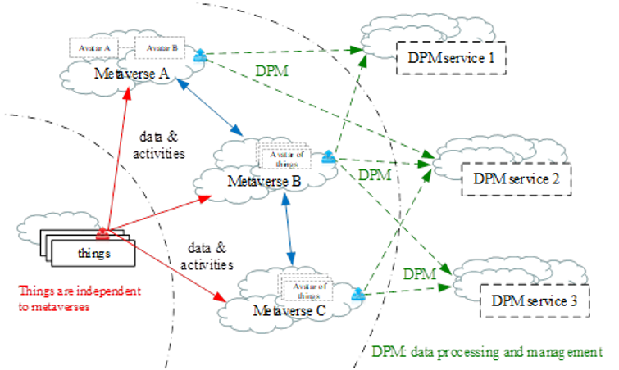
Figure 6-1 – Overview of security for things across metaverses in aspects of
data processing and management

7 Technical features and requirements of security for things across metaverses in terms of data processing and management

7.1 Technical features of security for things across metaverses in terms of data processing and management

7.1.1 Independent data storage
Each physical/virtual thing (e.g., sensors, IoT devices, IoT systems, IoT gateways) stores its data independently, directly by itself or via relevant IoT systems.
Each avatar stores its data independently. When there are a large number of entities and data, they may use external computing resources and services to manage and process relevant data. External computing resources and services are also independent of things and avatars.

7.1.2 Trustworthy data storage
Use trustworthy storage to store data, including the data of things, the data of avatars, and the data of metaverses. Trustworthy storage system(s) guarantee(s) the reliability, confidentiality, integrity, consistency, availability and non-tampering of data.

7.1.3 Trustworthy data computing
The computing processes of things and avatars are independent of each other. Data computing can be performed at the thing and avatar terminals, and if the data volume is large, the external data processing and management (DPM) can be used for data computing.
The data generated during the computing is stored in a trustworthy storage system as required for backup.

7.1.4 Multiple access control methods
There are two ways to access the data of thing(s): autonomous access and gateway access. Full-fledged thing(s) in IoT systems can connect to metaverses directly and constrained thing(s) in IoT systems connect to metaverses by IoT gateways.

7.2 Requirements of security for things across metaverses in terms of data processing and management

7.2.1 Security for things across metaverses in terms of data processing
The data processing across metaverses includes data generation, data transmission and data analysis, mainly including the following aspects:
– It is required to use a unified data format (such as JavaScript object notation (JSON), extensible markup language (XML) or concise binary object representation (CBOR)), and secure communication protocols (such as hypertext transfer protocol (HTTP) or websocket) to ensure that the data exchange across metaverses has good compatibility and parsing.
– It is recommended to design and provide clear and complete API documents to clarify interface requirements to ensure that third-party developers can call services.
– It is recommended to support the identity-authentication protocols across metaverses (such as open authorization (OAuth) or openID connect (OIDC)) to achieve single sign-on (SSO) and cross-platform identification of user identity.

7.2.2 Security for things across metaverses in terms of data management
Lifecycle management provides data collection, storage, utilization, sharing, deletion, and so on, to ensure the transparency and controllability across metaverses.
– It is recommended to establish a data activity log system, to record the whole process of data processing, and support the audit and traceability of data operations.
– It is recommended to monitor data across metaverses in real time to detect and respond abnormal data behaviours.

7.2.3 Security for things across metaverses in terms of data storage
When data is processed across metaverses, external trustworthy storage is used to facilitate data exchange.
– It is recommended that data and records for data exchange and sharing are stored in a secure and tamper-resistant manner with the capability to report on it for audit purposes.
– It is recommended to provide a capability for connecting external storage to accommodate data volume growth in metaverses.

7.2.4 Data encryption algorithms
Cryptography is a tool to provide data security, a discipline which embodies principles, means, and methods for the transformation of data in order to hide its information content, prevent its undetected modification, and/or prevent its unauthorized use.
The data security dimension is composed of transmission data protection and data protection at rest, information flow control, secure session management and PII protection.
– It is required to encrypt data transmitted or stored using secure cryptographic algorithms.
– It is required to provide data security mechanisms to support trusted data transmission and circulation.
– It is recommended to use data encryption, digital signatures, hash function, and data fingerprints to ensure data security.

7.2.5 Access control of metaverse platform
The access control of a metaverse platform is designed to ensure the security of the platform, user privacy and data legality.
– It is recommended to provide authentication and authorization mechanisms to ensure that users can only access the functions and services they are authorized to access.
– It is recommended to implement a multilevel rights system to distinguish different roles such as ordinary users, content creators and administrators; and each role has different access and operation rights.
– It is recommended to provide secure login mechanisms, such as multifactor authentication (MFA), one-time passwords (OTPs), to enhance account security and prevent unauthorized access.

8 Reference framework for security for things across metaverses in terms of data processing and management
Figure 8-1 shows a reference framework for security for things across metaverses in terms of data processing and management. The reference framework mainly includes five parts: data interoperability between IoT platforms and metaverse platforms; data interoperability across avatars in a single metaverse platform; data interoperability across different metaverse platforms; trustworthy data storage; and data interoperability with external DPM. The reference framework also includes traditional security methods, important agents and reference points for connecting external things, avatars of things, entities, external storage, and so on.
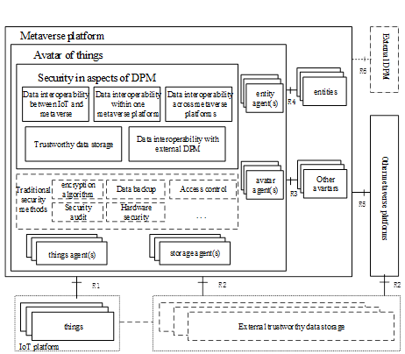
Figure 8-1 – Reference framework for security for things across metaverses in terms of
data processing and management

8.1 Data interoperability between IoT platforms and metaverse platforms
Things in the IoT platform are mapped into metaverse platforms and generate corresponding metaverse avatars. Things in IoT platforms can be mapped to one or multiple metaverse platforms. IoT platforms and metaverse platforms should provide relevant security authentication mechanisms to ensure data interoperability between IoT platforms and metaverse platforms.
The data of IoT and metaverses can be stored on external trustworthy storage, or on the metaverse platform and the IoT platform itself. If the data is stored in external trustworthy storage, the IoT platform and metaverse platform need to provide authentication mechanisms to access the data stored there.

8.2 Data interoperability across avatars in one metaverse platform
In the same metaverse platform, different avatars of a certain thing can interoperate directly. The identity of the avatars contains authentication information. Data interoperability across avatars provides security cooperation ability between multiple avatars in the same metaverse platform, including security capability assessment and security authentication before data migration, secure connection, data backup and security recovery during data migration, and so on.

8.3 Data interoperability across different metaverses platforms
Data interoperability across metaverse platforms includes the ability to collaborate between different metaverse platforms. Authorization and certification are required before enabling data interoperability across metaverses platforms. Data security for DPM across metaverse platforms requires double verification of the metaverse platforms and the avatars.

8.4 Data interoperability with external DPM
Metaverse data can be processed and calculated by the metaverse platform itself. However, when the data volume is large and the computing requirements are high, external DPM resources are needed. The data needs to be encrypted and encapsulated before external processing.

8.5 Trustworthy data storage
The data generated by the IoT platform and metaverse platform can be stored either on the IoT platforms and metaverse platforms or in external trustworthy storage systems. Both things and avatars are configured with data access permissions based on requirements to ensure secure storage of data. Metaverse data may be stored on metaverse platforms or external trustworthy storage according to the policies of metaverse platforms, which provides a reliable and secure connection between metaverse platforms and external trustworthy storages for data transmission and utilization.

8.6 Traditional security methods
The traditional security method provides some basic security mechanisms for things across metaverses in terms of data processing and management. These security mechanisms are some general data security processing methods to help ensure data security across the metaverses.
NOTE – Traditional security methods are out of the scope of this Technical Report.

8.6.1 Encryption algorithm
Encryption algorithms provide full lifecycle encryption and storage of data in metaverse, enable peer-to-peer connection and end-to-end encrypted exchange of sensitive data, prevent private data leakage and man-in-the-middle attacks, and require controllable and traceable data usage records to protect data privacy.

8.6.2 Data backup
When data is lost or damaged, data backup can quickly recover the data to avoid potentially incalculable losses caused by data damage. Backup data can be stored in devices such as the cloud or an external hard drive.

8.6.3 Access control
Authentication and authorization ensure that only the appropriate users have access to enterprise data. Once the users have proven their identities, authorization will determine whether the users have the appropriate permissions to access and interact with specific data. By authorizing users, they can gain permission to read, edit, and write to different resources within the metaverse.

8.6.4 Security audit
Security audit is an approach to monitoring and managing security that monitors activity in the network and detects unusual behaviour to detect and prevent cyberattacks. Security audit usually includes log audit, vulnerability scanning, security checks, and so on.

8.6.5 Hardware security
Hardware-based security involves the physical protection of devices, rather than relying solely on the software installed on the hardware. Hardware security refers to the installation of security modules in the chip to ensure that the device is securely protected.

8.7 Agent(s)

8.7.1 Things agent(s)
Things agents interact with IoT platform, providing capabilities related to security for things, as follows:
– Interacting with things; one things agent can serve one or more things.
– Supporting things to store, use and transfer data across metaverses in a secure and reliable way.
– Supporting things to manage policies related to IoT data processing across metaverses, such as where to store data; how to collect, use and transmit data; how to ensure data security and when to transmit across metaverses, and so on.
– Supporting things to interact with avatars or other entities safely.

8.7.2 Avatar agent(s)
Avatar agents interact with avatars of things from the same or other metaverse platforms, providing capabilities related to security for things across metaverses, as follows:
– Interacting with avatars of things; one avatar agent can serve one or more avatars.
– Supporting avatars to store, use and transfer data across metaverses in a secure and reliable way.
– Supporting avatars to manage policies related to data flows of avatars across metaverses, such as where to store data; how to collect, use, transmit data; how to ensure data security and when to transmit across metaverses, and so on.
– Supporting avatars to interact with each other mutually and safely.

8.7.3 Entity agent(s)
Entity agents interact with external entities, providing capabilities as follows:
– Interacting with external entities (such as things, digital humans and functional components); one entity agent can serve one or more entities.
– Connecting external DPM to process and manage data when connecting to metaverses.

8.7.4 Storage agent(s)
Storage agents interact with external trustworthy storage, providing capabilities as follows:
– Connecting to external trustworthy storage to store and retrieve data across metaverses.
– Connecting to external trustworthy storage to store and retrieve modules for data management and security across metaverses.

8.8 External entities

8.8.1 IoT platforms
The metaverse platform uses IoT sensors and devices to collect and transfer massive real-time data in the physical world to build and update its virtual world. The IoT platform is not only a data acquisition terminal in the real world, but also an interactive interface for users to access the metaverse. Users can interact with the metaverse through IoT devices such as browsing virtual scenes through smart glasses and manipulating virtual items through smart gloves.

8.8.2 External trustworthy storage
External trustworthy storage is used to store data from IoT and metaverse, as well as information generated during data exchange across metaverses. External trustworthy storage provides cross-metaverse data sharing capability, and implements efficient and secure data flow between different metaverse through secure data exchange protocols and interfaces. In general, external trustworthy storage can be achieved through distributed ledger technology.

8.8.3 External DPM
When the amount of data is large or the metaverse platform itself cannot efficiently process the relevant data, external DPM can be used for data processing and management across metaverses.

8.9 Reference points
There is a group of reference points to interact with avatars, including:
– R1: for things to interact with avatars in metaverses.
– R2: for trustworthy storage to store the avatars and some other information related to data management and security across metaverses.
– R3: for avatar to share and exchange data across metaverses.
– R4: for entities to interact with avatars in metaverses.
– R5: for different metaverses to interact directly with each other.
– R6: for metaverse platform to interact externally with DPM.

9 Security consideration
There are many security issues in the protection of things across metaverses in terms of data processing and management. For example: data leakage, authentication and authorization issues, PII challenges, and regulatory challenges. In order to deal with these security issues, a series of measures need to be taken to strengthen the security of data exchange across the metaverses. This includes enhancing data encryption and transmission security, improving identity verification and authorization mechanisms, and strengthening PII technology and policy development.

Appendix I
Use cases for security of things across metaverses in terms of
data processing and management
(This appendix does not form an integral part of this Technical Report.)

I.1 Smartwatch data security across metaverses
Wearable device is an important sensor for metaverse. Smartwatches utilize multiple sensor devices to capture human movements in real time from various parts of the user's body (including ankles, wrists and head) and associate them with their avatars, allowing users to create their avatars using full-body movements. Smartwatches collect a large amount of data, and the processing and management of this data across metaverses is an important application scenario of data management and security across metaverses.

I.1.1 Description
Multiple sensors in a smartwatch manage and process their data independently, either directly or through related IoT systems. In a metaverses application, the sensor is actively or passively mapped to one or more metaverses, and its data is transmitted to the target metaverses. The sensor and metaverses are independent of one another, and in order to ensure the credibility of data transmission the relevant important data of the sensor and metaverses will be stored in trustworthy storage. Typically, a metaverse can manage and process its entity's data by itself. When the number of entities and amount of data is large, external computing resources and services may be used to manage and process the relevant data. External resources (DPM services) and metaverses and thing(s) are independent of each other. The DPM service calculates and processes the data in the metaverse, and the important node information of the processing process (such as processing time and content) is also stored in the trustworthy storage.
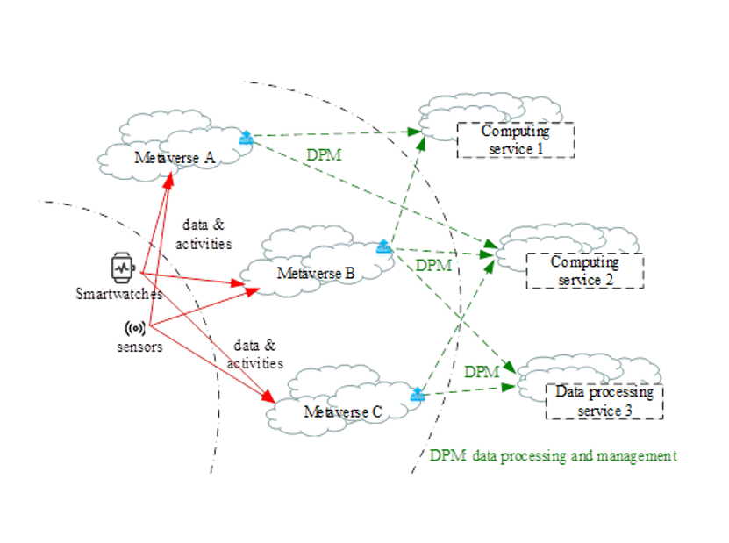
Figure I.1 – Smartwatch data security across metaverses in terms of
data processing and management

I.1.2 Assumptions
The assumptions related to this use case include the following:
– The smartwatch has multiple sensors to collect user action information.
– There are multiple metaverses working independently.
– There are multiple data processing and management systems (DPMS) working independently.
– There is a blockchain or distributed ledger for storing data and processing information.

I.2 Games data security across metaverses
The metaverse is not a single virtual world, there are multiple independent metaverses. Taking the game industry as an example, the current development mode of metaverse games is that one metaverse game corresponds to an independent metaverse, and different games cannot interact with each other, which means that players cannot freely switch between different game worlds, and the items they obtain, such as equipment and skin, can only be used in a certain game. Players cannot move assets across metaverses.

I.2.1 Description
In general, information about the user of the game, including data related to objects or sensors generated by augmented reality (AR) / virtual reality (VR) devices, is mapped to a metaverse game. In the case of an across-metaverse game application scenario, the information in the real world is mapped to multiple independent metaverses, and the target metaverses can manage and process the relevant IoT data by themselves. As the number of users increases, external computing resources will be used to manage and process the relevant data. Across-metaverse games mean that data on different metaverse games can be managed and processed safely using common external resources. The external resources are not unique, but a group of infrastructures that collectively support different metaverses. Specifically, a certain player is connected to metaverse A with his or her environmental information (for example, body temperature, head movement and eye tracking information), which are sensed by IoT devices. When User's avatar moves to metaverse B, the avatar may use external computing resources and services to manage and process relevant data.
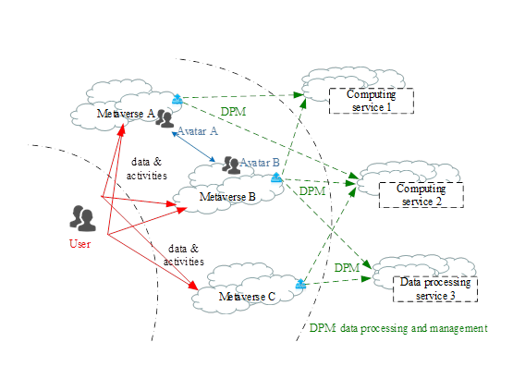
Figure I.2 – Game data security across metaverses in aspects of
data processing and management

I.2.2 Assumptions
The assumptions related to this use case include the following;
– There are multiple game metaverses working independently.
– There are security mechanisms to ensure that the data is mapped across different metaverses.
– Trustworthy storage can be used for storing data and processing information.

Bibliography

[b-ITU-T X.800] Recommendation ITU-T X.800 (1991), Security architecture for Open Systems Interconnection for CCITT applications.
[b-ITU-T X.1252] Recommendation ITU-T X.1252 (2021), Baseline identity management terms and definitions.
[b-ITU-T X.1400] Recommendation ITU-T X.1400 (2020), Terms and definitions for distributed ledger technology.
[b-ITU-T Y.2091] Recommendation ITU-T Y.2091 (2011), Terms and definitions for next generation networks.
[b-ITU-Journal] ITU Journal 2023, Future and evolving technologies, Special issue on Metaverse.
https://www.itu.int/en/journal/j-fet/2023/002/Pages/default.aspx
[b-ISO 22739] ISO 22739:2024, Blockchain and distributed ledger technologies – Terminology.
[b-ISO/IEC 18014-2] ISO/IEC 18014-2:2009, Information technology – Security techniques – Time-stamping services – Part 2: Mechanisms producing independent tokens.
[b-ISO/IEC 23005-4] ISO/IEC 23005-4:2018, Information technology – Media context and control, Part 4: Virtual world object characteristics.
[b-ISO/IEC 29100] ISO/IEC 29100:2011, Information technology – Security techniques – Privacy framework.

______________

