Standardization Sector
ITU Focus Group Technical Report
(06/2024)
ITU Focus Group on metaverse
Interoperability of identity of things across metaverse platforms
Working Group 5: Interoperability
ITUPublications | International Telecommunication Union


Technical Report ITU FGMV-42
Interoperability of identity of IoT device across metaverse platforms
Summary
With regard to Internet of Things (IoT) (Recommendation ITU-T Y.4000), each IoT device may have a single or multiple unique identities in multiple IoT systems. Similarly, each IoT device may also have a single or multiple identities in multiple metaverses. An identity of an IoT device usually includes a unique identifier and a corresponding identity object (Recommendation ITU-T Y.4811).
Although, it may be advantageous for one IoT device to have one unique identity in multiple metaverses, there are challenges: how those metaverses identify, authenticate and authorize the IoT devices when they are roaming across metaverse platforms, and how the trustworthy shared storage system interacts with each other to support identity interoperability across these storages.
This Technical Report describes identity interoperability for IoT devices across metaverse platforms, and provides relevant technical features and a reference framework.
Keywords
Functional requirements, identity, interoperability, Internet of Things, IoT device, metaverse.
Note
This is an informative ITU-T publication. Mandatory provisions, such as those found in ITU-T Recommendations, are outside the scope of this publication. This publication should only be referenced bibliographically in ITU-T Recommendations.
Change Log
This document contains Version 1.0 of the ITU Technical Report on "Interoperability of identity of IoT device across metaverse platforms" approved at the 7th meeting of the ITU Focus Group on metaverse (FG-MV) held on 12-13 June 2024.
Acknowledgements
This Technical Report was developed in WG5 of FG-MV, with inputs from NICT, ETRI, and China Unicom as a contribution to the ITU Focus Group on metaverse (FG-MV). The development of this document was coordinated by Hideo Imanaka (NICT) as FG-MV Working Group 5 (WG5) Chair, and Wook Hyun (ETRI) as WG5 Vice-Chair. In addition, special thanks go to Shin-Gak Kang (FG-MV Chair), the FG-MV management team, and the FG-MV Secretariat.
Additional information and materials relating to this Technical Report can be found at: https://www.itu.int/go/fgmv. If you would like to provide any additional information, please contact Cristina Bueti at tsbfgmv@itu.int.

WG5 Chair: | Hideo Imanaka  NICT  Japan | E-mail: h.imanaka@nict.go.jp
Editor: | Xiongwei Jia  China Unicom  China | E-mail: jiaxw9@chinaunicom.cn
Editor: | Ziqin Sang  CICT  China | E-mail: zqsang@wri.com.cn
Editor: | Keng Li  China Information Communication Technologies Group  China | E-mail: kli@fiberhome.com
Editor: | Xiaojun Mu  China Unicom  China | E-mail: muxj@chinaunicom.cn
Editor: | MiYoung Huh  ETRI  Korea (Republic of) | E-mail: myhuh@etri.re.kr

© ITU 2026
FGMV-06 (2023-10)
ii
Some rights reserved. This publication is available under the Creative Commons Attribution-Non Commercial-Share Alike 3.0 IGO licence (CC BY-NC-SA 3.0 IGO; https://creativecommons.org/licenses/by-nc-sa/3.0/igo).
For any uses of this publication that are not included in this licence, please seek permission from ITU by contacting TSBmail@itu.int.

Table of contents
Page
1 Scope 1
2 References 1
3 Definitions 1
3.1 Terms defined elsewhere 1
3.2 Terms defined in this Technical Report 2
4 Abbreviations and acronyms 2
5 Conventions 2
6 Overview of interoperability of identity of IoT devices across metaverses 3
7 Technical features of identity interoperability for IoT devices across metaverse platforms 4
7.1 ID interoperability between IoT platform and metaverse platforms 5
7.2 ID interoperability across metaverses in the same metaverse platforms 6
7.3 ID interoperability across metaverse platforms 6
8 Functional requirements of ID interoperability for IoT devices across metaverse platforms 6
8.1 Unique identity for IoT devices and corresponding digital entity 6
8.2 Identity identification and authentication 7
8.3 Data security and PII protection mechanisms 7
8.4 Trustworthy storages for identity interoperability 7
8.5 Multiple identity management policies 7
9 Reference framework for identity interoperability for IoT devices across metaverse platforms 8
9.1 Traditional ID management 9
9.2 ID management across metaverses 9
9.3 IoT devices agent(s) 10
9.4 Avatar agent(s) 10
9.5 Storage agent(s) 10
9.6 Reference points 10
9.7 External systems 10
Appendix I – Use cases of IoT devices to be across metaverse platforms 12
I.1 Use case: full-fledged IoT devices to be across metaverse platforms 12
I.2 Use case: constrained IoT devices to be across metaverse platforms 12
Bibliography 14

Technical Report ITU FGMV-42
Interoperability of identity of IoT device across metaverse platforms

1 Scope
This Technical Report describes identity interoperability for IoT device across metaverse platforms, and provides relevant technical features, functional requirements and reference frameworks.
The scope of this Technical Report includes:
– Overview of interoperability of identity of IoT device across metaverse platforms.
– Technical features, requirements of identity interoperability for IoT device across metaverse platforms.
– Reference framework of identity interoperability for IoT device across metaverse platforms.
Use cases and analysis on the identity solutions for IoT device across metaverses are provided in the appendix.
NOTE – The Technical Report will not bring new underlying identity standards for IoT devices, and blockchain itself is outside the scope.

2 References
[ITU-T Y.4000] Recommendation ITU-T Y.4000/Y.2060 (2012), Overview of the Internet of things.
[ITU-T Y.4811] Recommendation ITU-T Y.4811 (2021), Reference framework of converged service for identification and authentication for IoT devices in a decentralized environment.
[ITU FGMV-19] Technical Specification ITU FGMV-19 (2023), Service scenarios and high-level requirements for metaverse cross-platform interoperability.
[ITU FGMV-20] Technical Specification ITU FGMV-20 (2023), Definition of metaverse.
[ITU FGMV-31] Technical Specification ITU FGMV-31 (2024), Requirements, functional framework and capability of IoT for metaverse.

3 Definitions

3.1 Terms defined elsewhere
This Technical Report uses the following terms defined elsewhere:
3.1.1 application [b-ITU-T Y.2261]: A structured set of capabilities, which provide value-added functionality supported by one or more services, which may be supported by an API interface.
3.1.2 blockchain [b-ITU-T X.1400]: A type of distributed ledger which is composed of digitally recorded data arranged as a successively growing chain of blocks with each block cryptographically linked and hardened against tampering and revision.
3.1.3 decentralized system [b-ISO/TC 307]: Distributed system wherein control is distributed among the persons or organizations participating in the operation of system.
3.1.4 device [ITU-T Y.4000]: With regard to the Internet of things, this is a piece of equipment with the mandatory capabilities of communication and the optional capabilities of sensing, actuation, date capture, data storage and data processing.
3.1.5 distributed ledger technology (DLT) [b-ISO/TC 307]: Technology that enables the operation and use of distributed ledgers.
3.1.6 identity [b-ITU-T Y.2720]: Information about an entity that is sufficient to identify that entity in a particular context.
3.1.7 Internet of things (IoT) [ITU-T Y.4000]: A global infrastructure for the information society, enabling advanced services by interconnecting (physical and virtual) things based on, existing and evolving, interoperable information and communication technologies.
NOTE 1 – Through the exploitation of identification, data capture, processing and communication capabilities, the IoT makes full use of things to offer services to all kinds of applications, whilst ensuring that security and privacy requirements are fulfilled.
NOTE 2 – In a broad perspective, the IoT can be perceived as a vision with technological and societal implications.
3.1.8 metaverse [ITU FGMV-20]: An integrative ecosystem of virtual worlds offering immersive experiences to users, that modify pre-existing and create new value from economic, environmental, social and cultural perspectives.
3.1.9 personally identifiable information (PII) [b-ISO/IEC 29100]: Any information that (a) can be used to identify the PII principal to whom such information relates, or (b) is or might be directly or indirectly linked to a PII principal.
3.1.10 thing [ITU-T Y.4000]: With regard to the Internet of things, this is an object of the physical world (physical things) or of the information world (virtual things), which is capable of being identified and integrated into the communication networks.

3.2 Terms defined in this Technical Report
None.

4 Abbreviations and acronyms
This Technical Report uses the following abbreviations and acronyms:
CSIADE Converged Service for IoT Identification and Authentication in Decentralized Environment
DID Decentralized Identifier
DLT Distributed Ledger Technology
DOI Digital Object Identifier
ID Identity
IoT Internet of Things
I/O Input/Output
PII Personally Identifiable Information
SSo Single Sign-On

5 Conventions
None.

6 Overview of interoperability of identity of IoT devices across metaverses
With regard to the Internet of things (IoT), each thing, called an IoT device in this document, is a piece of equipment with the mandatory capabilities of communication and the optional capabilities of sensing, actuation, data capture, data storage and data processing [ITU-T Y.4000]. In the metaverse, IoT devices could obtain real-world environmental data and realize virtual and real interaction. IoT devices can transmit data to the virtual world and interact with and between the virtual world and the physical world [ITU FGMV-31]. Each IoT device has a single or multiple unique identities in multiple IoT systems. An identity (ID) usually includes a unique identifier and a corresponding identity object [ITU-T Y.4811]. The unique identifier identifies the corresponding IoT device, and the corresponding identity object usually includes information to resolve the identity of the IoT device, and to authenticate the IoT device.
Figure 6-1 provides an overview of identity interoperability.
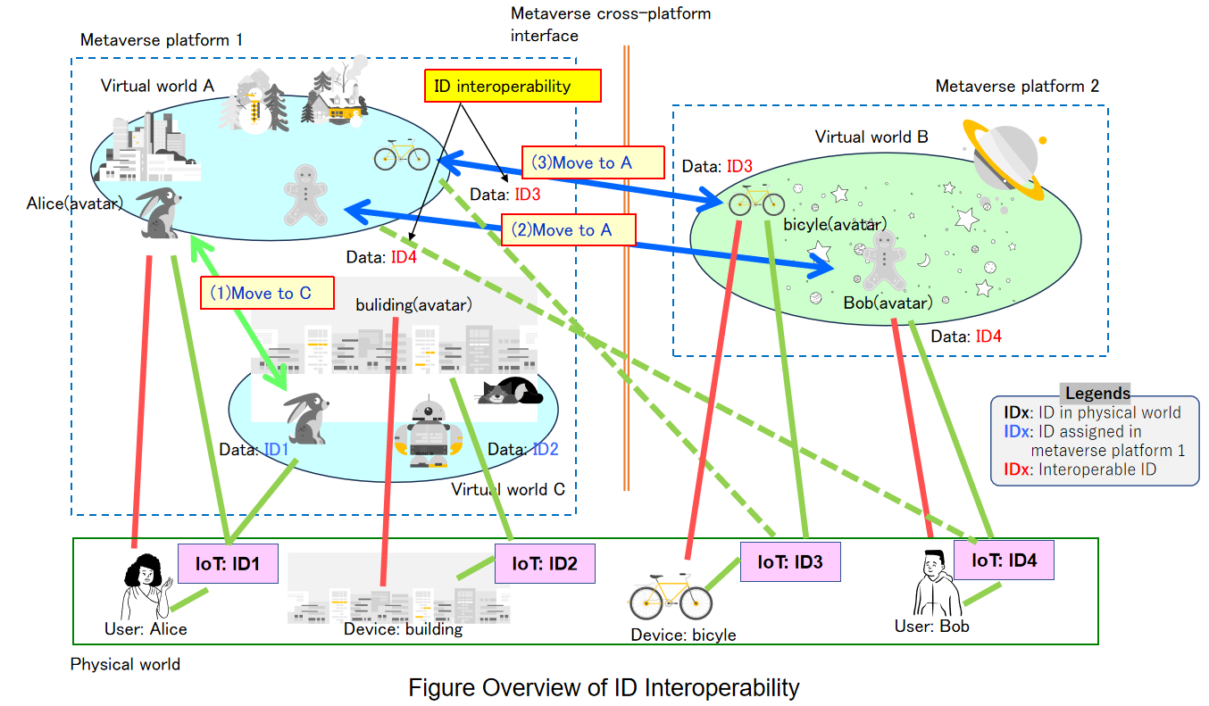
Figure 6-1 – Overview of identity interoperability
In Figure 6-1, there are two metaverse platforms, 1 and 2, and one real world, and there are two virtual worlds (metaverses), A and C, in metaverse platform 1, and one metaverse B in metaverse platform 2.
User Alice is connected to metaverse A (shown by the red line) with her environmental information, for example her body temperature, head movement and eye tracking information (shown by the green line), which are sensed by IoT devices with ID1. When Alice's avatar moves to metaverse C in the same platform, as shown in (1) with the green arrow in the figure, the environmental information can be transferred from the same IoT device by using the same ID, i.e., ID1. Such an ID can be used in the same manner within the same metaverse platform.
User Bob is connected to metaverse B (shown by the red line) and his environmental information (shown by the green line), which is sensed by IoT devices with ID4. When Bob's avatar moves to metaverse A in the different platform, as shown in (2) with the blue arrow in the figure, the environmental information needs to be transferred from the same IoT device (show as the dotted green line). In this case, metaverse A needs to recognize ID4, in order to utilize the IoT device with ID4 from metaverse A. To do this, IDs of IoT devices need to be interoperable.
In the same manner, assets (a bicycle) with ID3 in the figure, as shown in (3) with the blue arrow in the figure, and buildings with ID2 can be used in other metaverses on different platforms by means of ID interoperability, when these are moved to the other metaverses (shown as a dotted green line).
As Figure 6-2 shows, the ID of Alice's avatar in metaverse A, ID1, can be named A-ID1; similarly, Alice's avatar in metaverse C can be named C-ID1, and Bob's avatar in metaverse B can be named B-ID4. There are three scenarios for identity interoperability. The IDs in the physical world interoperate with the IDs in the metaverse, e.g., ID1 and A-ID1 (shown by the green arrow), the interoperability between different virtual worlds in one metaverse platform, e.g., A-ID1 and C-ID1 (shown by the red arrow), and interoperability across metaverse platforms, e.g., A-ID4 and B-ID4 (shown by the blue arrow). This deliverable focuses only on the interoperability across metaverse platforms.
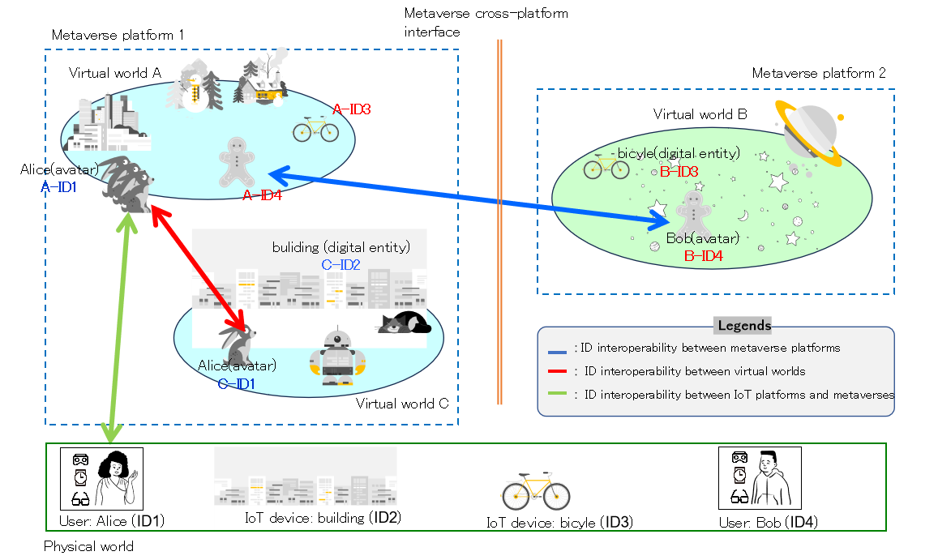
Figure 6-2 – Three scenarios for identity interoperability

7 Technical features of identity interoperability for IoT devices across metaverse platforms
Identity (ID) interoperability refers to the transfer of entities' IDs between different metaverse platforms. Although, it may be advantageous for entities to maintain unified IDs across multiple metaverse platforms [ITU FGMV-19], there are challenges: how the metaverses identify, authenticate and authorize the IoT devices when the digital entities of IoT devices are roaming across metaverse platforms (see Figure 7-1), and how the trustworthy shared storage systems interact with each other to support ID interoperability across the storages.
Figure 7-1 – Technical feature of identity interoperability across metaverse platforms
Figure 7-1 shows the ID interoperability of IoT devices across metaverses mainly includes three cases:
• ID interoperability between IoT platforms and metaverse platforms,
• ID interoperability across different metaverses in the same metaverse platform,
• ID interoperability across metaverse platforms.
The ID of an IoT device is usually stored in trustworthy shared storages (such as distributed ledger technology (DLT) systems) [ITU-T Y.4811]. Metaverses may also entrust their identity-related data to trustworthy shared storages. If a metaverse supports ID interoperability for IoT devices, it should exchange identity-related data with external IoT devices through independent, trustworthy shared storages.
In the case of sharing IDs, if a given IoT device is roaming across metaverses, the IoT devices and the metaverses should exchange shared identity-related data in order to identify and authenticate one another, through the trustworthy shared storages.

7.1 ID interoperability between IoT platform and metaverse platforms
Users and IoT devices generate corresponding digital entities in the metaverses. The ID in the IoT platform and the ID in the metaverse platform are managed independently. ID interoperability between IoT platforms and metaverse platforms can be achieved through external services such as third-party platforms (e.g., blockchain platforms).
An IoT device can be connected to multiple metaverses to generate multiple different digital entities like avatars. IoT devices and their corresponding digital entities in the metaverse are independent of one another. If the IoT device is an access device sensing a user's behaviour, the IoT device can share the same digital entity and ID with the user. If the IoT device and user are independent of each other, the IoT device can generate its own digital entity in the metaverse platform. In order to guarantee a trustworthy exchange of ID data, the ID of an IoT device may be stored in trustworthy shared storages, not in metaverses.

7.2 ID interoperability across metaverses in the same metaverse platforms
In the same metaverse platform, the IoT device information can be transferred from the same IoT device by using the same ID. Independent end-to-end identification and authentication can be supported between digital entities in the same metaverse.
Different digital entities of the same IoT device can be directly identified and authenticated through signatures. Correspondingly, the digital entities of different IoT devices may be assisted by external authentication systems to identify and authenticate. The data generated during ID interoperability across digital entities can be stored in the metaverse or on external trustworthy storage as required.

7.3 ID interoperability across metaverse platforms
The ID interoperability across metaverse platforms requires ID identification and authentication across platforms. Multiple digital entities of one IoT device on different metaverse platforms are independent from one another. The operation of one digital entity in one metaverse platform does not affect other digital entities in the same metaverse or in other metaverses. ID interoperability across metaverse platforms provides a variety of ID identification and authentication mechanisms, and can also invoke external ID identification and authentication systems for ID resolution. The mechanisms and policies for identification and authentication are jointly determined by the participants in metaverse platforms. The identity object [ITU-T Y.4811] contains the information required for identification and authentication. The data generated by the ID interoperability will be stored on multiple metaverse platforms, and can also be stored on external trustworthy storage. The identity object contains information about the data storage.

8 Functional requirements of ID interoperability for IoT devices across metaverse platforms

8.1 Unique identity for IoT devices and corresponding digital entity
All digital entities have a distinguishable identifier to ensure uniqueness within the home metaverse platform. This identifier needs to be globally unique when combined with a metaverse identifier for digital entities across metaverse platforms. One IoT device can have multiple digital entities, and the IoT device may be able to select a digital entity or multiple digital entities to move to the other metaverse depending on the policy of the metaverse platform.
– It is recommended to generate a corresponding digital entity in the metaverse for the IoT device, which has a separate ID if the IoT device is independent of the user according to requirement IDIHR-101 of [FGMV-19].
– It is recommended that the assignment of the unique identifier be carried out using cryptographic techniques to ensure security and prevent tampering according to requirement GENHR-003 of [FGMV-19].
– It is recommended to use traditional IoT device identification methods such as OID, handle, and ECode, or to use new decentralized IoT device identification methods such as DID for ID interoperability across metaverses.
– When an IoT device has one unique identifier, it is required to provide a globally unique identifiers for consistent identification as the digital entity moves to different metaverse platforms.
NOTE – The examples of the unique ID are the MAC address and the digital object identifier (DOI).
– It is recommended that the unique identifier embedded metadata related to the digital entity, such as creation date, originating platform, version information, and other information.

8.2 Identity identification and authentication
Identification and authentication of IoT devices in metaverse platforms are necessary to ensure the ability to securely and transparently record creation, authentication, validation and updating. The candidate technology includes blockchain technology, the unique identifier linked to a user's decentralized digital identity, and a centralized registry or database storing unique identifiers.
For different cross-platform situations, the ID identification and authentication processes for an IoT device and corresponding avatar are also different.
– It is recommended to enable digital entities of IoT devices in a metaverse platform to perform end-to-end identification and authentication with other digital entities in the same or another metaverse platform directly. For ID interoperability between the IoT platform and the metaverse platform, it is recommended to introduce an external system platform to assist with trustworthy identification and authentication between IoT devices and digital entities
– For different virtual worlds in the same metaverse platform, it is recommended that end-to-end identification and authentication be carried out directly between digital entities.
– For different metaverse platforms, ID identification and authentication between digital entities are required to meet the requirements of ID management on different platforms.
– It is required for users to be able to link or unlink their ID to other platforms.
NOTE – If a user is linked to a metaverse platform, the platform can access the profile to which the user has consented.

8.3 Data security and PII protection mechanisms
In the process of ID interoperability, there may be threats such as data leakage and identity theft. Personally identifiable information (PII) protection mechanisms should be provided to improve ID security.
– It is recommended to provide security mechanisms for ID data processing (e.g., storage, transmission, validation) across metaverse platforms.
NOTE – Blockchain technology might be used to securely and transparently record creation, authentication, validation and updating.
– It is recommended to ensure the security of ID storage, including encryption, access control and security audit of identity information.

8.4 Trustworthy storages for identity interoperability
Trustworthy storage is used to store the ID of IoT devices and digital entities, ID authentication information, identity interoperability information, and so on.
– It is recommended to have a capability for connecting external storage to accommodate data volume growth in metaverses.
– It is recommended to ensure maintainable storage for identity, which means the system can be easily upgraded, backed up, and restored to ensure metaverse stability and availability.
– It is recommended to support single sign-on (SSO) across platforms.

8.5 Multiple identity management policies
ID management policy refers to a comprehensive strategy for creating, authenticating, authorizing, monitoring and revoking the IDs of users, devices, applications, and other entities in an effective, secure, and compliant digital environment. For different countries and/or enterprises, the ID management policy might be different. For the metaverse platform, the ID management policy may be jointly decided by the metaverse company, the government and the regulatory authorities.
IoT platforms and metaverses have different ID management policies. ID interoperability follows different management policies, especially across metaverse platforms.
IoT devices in an IoT platform and digital entities in metaverses use the same or different ID management policies. The type of interoperability policy to be used depends on the specific scenario.
– It is recommended to evaluate the reputation of IoT devices that move from other platforms to determine whether to allow the move.
– It is recommended to be able to determine the eligibility for moving based on the criteria of the target metaverse such as the age and appearance of users intending to transfer from other platforms.
– It can optionally check the reputation of the user belonging to another platform through an agreement between platforms according to requirement IDIHR-104 of [FGMV-19].
– It is required that the reputation data be written in a standardized way for the compatibility of reputation evaluation between platforms according to requirement IDIHR-104 of [FGMV-19].
– It is required for metaverse platforms to manage access for digital entities arriving from other platforms based on their identity
NOTE – This identity can be received from other metaverse platforms or obtained in a variety of ways, such as a decentralized identifier (DID) and blockchain.
– It is required to support ID policies of each platform for ID interoperability. ID management policies may be set by governments or by companies.

9 Reference framework for identity interoperability for IoT devices across metaverse platforms
Figure 9-1 is a schematic diagram of the reference framework for ID interoperability across metaverses. ID interoperability across the metaverses includes ID interoperability between IoT platforms and metaverse platforms (R1); ID interoperability between IoT platforms, metaverse platforms, and trustworthy storage (R2); ID interoperability for different avatars in the same metaverse platform (R3); ID interoperability between different avatars across multiple metaverse platforms (R4); ID interoperability between metaverse platforms and external authentication systems (R5); ID interoperability between an IoT device and trustworthy storage (R6).
Figure 9-1 – Reference framework for identity interoperability across metaverse platforms

9.1 Traditional ID management
Traditional ID management provides management services for the whole management process of ID generation, transmission, storage and resolution, as follows:
– generating unique IDs and corresponding ID objects, which can have aliases, but all refer to unique entities;
– providing ID data transmission services, supporting identification and authentication services on different platforms; and
– providing ID endorsement management services. Different platforms have different ID management strategies and policies, and traditional management functions can coordinate and match ID resolution requirements for ID interoperability.
NOTE – The traditional ID management function provides some basic abilities of ID management across metaverses, which are out of the scope of this report.

9.2 ID management across metaverses
Compared with the traditional ID management module, the ID management across metaverses adds the capabilities as follows:
– providing ID management policies for digital entities in metaverses, such as ID generation, identification, transmission, backup;
– providing ID authentication and resolution across metaverses. The metaverse platform may have multiple ID authentication policies, and ID management across metaverses can manage different policies for ID interoperability; and
– providing data management across metaverses. The upload and download of data need to be encrypted or packaged according to the relevant policies, and data across metaverses will be stored on the metaverse platform or in external trustworthy storage according to the policy.

9.3 IoT devices agent(s)
IoT devices agents interact with IoT devices, providing capabilities as follows:
– interacting with IoT devices. One IoT devices agent can serve one or more IoT devices;
– supporting IoT devices to identify and authenticate the digital entity of IoT devices mutually, end-to-end; and
– supporting IoT devices to manage policy related to their identities such as where to store, how to resolve ID and how to interact with digital entities.

9.4 Avatar agent(s)
Avatar agents interact with the digital entity of IoT devices in the same or other metaverse platforms, providing capabilities as follows:
– interacting with the digital entity of IoT devices. One avatar agent can serve one or more IoT devices;
– supporting the digital entity of IoT devices to identify and authenticate other digital entity of IoT devices mutually, end-to-end; and
– supporting the digital entity of IoT devices to manage policies related to their IDs, such as where to store, how to resolve ID, and how to interact with other avatars.

9.5 Storage agent(s)
Storage agents interact with decentralized systems and clouds, providing capabilities as follows:
– connecting trustworthy storage to store and retrieve identity information of digital entities and IoT devices; and
– connecting trustworthy storage to store and retrieve modules for identifying and authenticating identities.

9.6 Reference points
There are a group of reference points for interoperability across metaverses, including:
– R1: for IoT devices to interact with digital entities and to identify and authenticate avatar IDs;
– R2: for trustworthy storage to store the ID and ID object information of avatars;
– R3: for ID interoperability between digital entities in the same metaverse platform;
– R4: for ID interoperability across multiple metaverse platforms;
– R5: for digital entities to interact with external authentication systems for identity endorsement and authentication.
– R6: for trustworthy storage to store the ID and ID object information of digital entities.

9.7 External systems

9.7.1 Attestation system
There may be one or multiple attestation systems deployed by the same or different operators. An attestation system provides capabilities related to ID endorsement, as follows:
– receiving and endorsing IDs of digital entities if requested; and
– creating and endorsing IDs for digital entities if requested, optionally.

9.7.2 ID management and supporting system
In addition to the metaverse platforms, external platforms also provide ID management capabilities, as follows:
– supporting the identification and authentication of the ID of digital entities;
– supporting the management of ID of digital entities of IoT devices;
– supporting the management of policies related to the ID of digital entities of IoT devices; and
– works on the CSIADE specified in [ITU-T Y.4811].

Appendix I
Use cases of IoT devices to be across metaverse platforms
The appendix provides representative use cases of IoT devices to be across metaverses in aspects of interoperability of identity.
NOTE – [ITU-T Y.4811] provides a converged service for IoT identification and authentication in decentralized environment (CSIADE), which can facilitate IoT devices and metaverses in identifying and authenticating each other in IoT decentralized environments.

I.1 Use case: full-fledged IoT devices to be across metaverse platforms
This use case shows how full-fledged IoT devices roam across multiple metaverses.

I.1.1 Description
With the support of CSIADE, the full-fledged IoT devices and metaverses can generate and store their identities in trustworthy shared storages (see Figure I.1).
When full-fledged IoT devices are roaming across metaverses, the metaverses and the full-fledged IoT devices can retrieve and verify the IDs of their counterparts through the CSIADE. After that, they can identify and authenticate each other, and then the metaverses can authorize and perform services for the full-fledged IoT device.
Figure I.1 – Full-fledged IoT devices to be across metaverse platforms

I.1.2 Assumptions
The assumptions related to this scenario include the following:
– It is assumed that metaverse platforms are independent of one another.
– It is assumed that input/output (I/O) devices are independent of metaverse platforms.
– It is assumed that trustworthy shared storages and attestation systems are provided.

I.2 Use case: constrained IoT devices to be across metaverse platforms
This use case shows constrained IoT devices roaming across multiple metaverses.

I.2.1 Description
Constrained IoT devices usually connect to metaverses via IoT gateways. With the support of CSIADE and IoT gateways, the constrained IoT devices and metaverses can generate and store their IDs in trustworthy shared storages (see Figure I.2).
When a constrained IoT device is roaming across metaverses, the metaverses and the IoT gateways (on behalf of the constrained IoT device) can retrieve and verify the IDs of their counterparts through the CSIADE. After that, they can identify and authenticate each other, and then the metaverses can authorize and perform services for the constrained IoT device.
Figure I.2 – Constrained IoT devices to be across metaverse platforms

I.2.2 Assumptions
The assumptions related to this scenario include the following:
– It is assumed that metaverse platforms are independent of one another.
– It is assumed that IoT devices are independent of metaverse platforms.
– It is assumed that trustworthy shared storages and attestation systems are provided.

Bibliography

[b-ITU-T X.1400] Recommendation ITU-T X.1400 (2020), Terms and definitions for distributed ledger technology.
[b-ITU-T Y.2720] Recommendation ITU-T Y.2720 (2009), NGN identity management framework.
[b-ITU-T Y.2261] Recommendation ITU-T Y.2261 (2006), PSTN/ISDN evolution to NGN.
[b-ISO/IEC 29100] ISO/IEC 29100:2024, Information technology – Security techniques – Privacy framework.
[b-ISO/TC 307] ISO DIS 22739, Blockchain and distributed ledger technologies – Terminology.

______________

