Standardization Sector
ITU Focus Group Technical Specification
(06/2024)
ITU Focus Group on metaverse
The reference framework of the industrial metaverse
Working Group 3: Architecture & Infrastructure
ITUPublications | International Telecommunication Union


Technical Specification ITU FGMV-41
The reference framework of the industrial metaverse
Summary
This Technical Specification provides the main framework to implement the industrial metaverse (IMV) from the overall and technical perspectives, including the elemental composition, specific modules and entities of the IMV. At the same time, starting from the infrastructures required by IMV, the industrial perception, industrial control, industrial network, industrial computing and storage, IMV platform, assets and IMV identity management in the IMV domain are included in the detail. In addition to the above content, the Technical Specification also describes digital security, privacy protection, and so on, in order to provide a reference for the development of the IMV.
Keywords
Industrial metaverse, reference framework.
Note
This is an informative ITU-T publication. Mandatory provisions such as those found in ITU-T Recommendations are outside the scope of this publication. This publication should only be referenced bibliographically in ITU-T Recommendations.
Change log
This document contains Version 1.0 of the ITU Technical Specification on "The reference framework of industrial metaverse" approved at the 7th meeting of the ITU Focus Group on metaverse (FG-MV) held on 12–13 June 2024.
Acknowledgements
This Technical Specification was researched and written by Cheng Chi (CAICT, China), Zihang Yin (CAICT, China) and Can Luo (CAICT, China), as a contribution to the ITU Focus Group on metaverse (ITU FG-MV). The development of this document was coordinated by Hideki Yamamoto (OKI, Japan), as FG-MV Working Group 3 Chair.
Additional information and materials relating to this report can be found at: https://www.itu.int/go/fgmv. If you would like to provide any additional information, please contact Cristina Bueti at tsbfgmv@itu.int.

Editor: | Cheng Chi  CAICT  China | Tel.: +86 152100000965  E-mail: chicheng@caict.ac.cn
Editor: | Zihang Yin  CAICT  China | Tel.: +86 13718671705  E-mail: yinzihang@caict.ac.cn
Editor: | Can Luo  CAICT  China | Tel.: +86 15600579159  E-mail: luocan@caict.ac.cn
WG3 Chair: | Hideki Yamamoto  OKI  Japan | E-mail: yamamoto436@oki.com

© ITU 2025
FGMV-06 (2023-10)
ii
Some rights reserved. This publication is available under the Creative Commons Attribution-Non Commercial-Share Alike 3.0 IGO licence (CC BY-NC-SA 3.0 IGO; https://creativecommons.org/licenses/by-nc-sa/3.0/igo).
If you wish to reuse material from this publication that is attributed to a third party, such as tables, figures or images, it is your responsibility to determine whether permission is needed for that reuse and to obtain permission from the copyright holder. The risk of claims resulting from infringement of any third-party owned material in the publication rests solely with the user.

Table of Contents
Page
1 Scope 1
2 References 1
3 Definitions 1
3.1 Terms defined elsewhere 1
3.2 Terms defined in this Technical Specification 3
4 Abbreviations and acronyms 3
5 Conventions 4
6 Overview of the industrial metaverse 4
7 Framework for industrial metaverse domain 6
7.1 Physical world 7
7.2 Industrial metaverse system 7
7.3 Industrial metaverse 9
7.4 Security and personally identifiable information protection 9
8 Functional components of industrial metaverse system 9
8.1 Information infrastructure 11
8.2 Industrial platform infrastructure 12
9 Security considerations 14
Bibliography 15

Technical Specification ITU FGMV-41
The reference framework of the industrial metaverse

1 Scope
The industrial metaverse (IMV) is a subcategory of the metaverse for industry. The IMV realizes the mapping, interaction and integration of the virtual world and the physical world in the industrial field for improving production efficiency and industrial collaboration. The scope of this Technical Specification includes:
− The concept of the IMV;
− The framework of the IMV;
− The functional components of the IMV system;
− The security considerations for the IMV.

2 References
[ITU-T Y.4000] Recommendation ITU-T Y.4000/Y.2060 (2012), Overview of Internet of things.
[ITU-T Y.4401] Recommendation ITU-T Y.4401/Y.2068 (2015), Functional framework and capabilities of the Internet of things.
[ITU FGMV-01] ITU Focus Group Technical Report FGMV-01 (2023), Exploring the metaverse: opportunities and challenges.
[ITU FGMV-06] ITU Focus Group Technical Report FGMV-06 (2023), Guidelines for consideration of ethical issues in standards that build confidence and security in the metaverse.
[ITU FGMV-10] ITU Focus Group Technical Report FGMV-10 (2023), Cyber risks, threats, and harms in the metaverse.
[ITU FGMV-11] ITU Focus Group Technical Report FGMV-11 (2023), Embedding safety standards and the user control of personally identifiable information (PII) in the development of the metaverse.
[ITU FGMV-19] ITU Focus Group Technical Report FGMV-19 (2023), Service scenarios and high-level requirements for metaverse cross-platform interoperability.
[ITU FGMV-29] ITU Focus Group Technical Report FGMV-29 (2024), Reference model for the metaverse based on a digital twin enabling integration of virtual and physical worlds.
[b-WEF] World Economic Forum (2023), Exploring the Industrial Metaverse: A Roadmap to the Future.
https://www3.weforum.org/docs/WEF_Industrial_Metaverse_2023.pdf

3 Definitions

3.1 Terms defined elsewhere
This Technical Specification uses the following terms defined elsewhere:
3.1.1 artificial intelligence (AI) [b-ETSI GR ENI 004]: Computerized system that uses cognition to understand information and solve problems.
3.1.2 augmented reality (AR) [b-ITU-T P.1320]: An environment containing real and virtual sensory components. The augmented reality continuum runs from virtual content that is clearly overlaid on a real environment (assisted reality) to virtual content that is seamlessly integrated and interacts with a real environment (mixed reality).
3.1.3 avatar [b-ITU FGMV-33]: Digital entity that can be used as a (visual) representation of the user inside the virtual environments.
3.1.4 blockchain [b-ITU-T F.751.0]: A type of distributed ledger that is composed of digitally recorded data arranged as a successively growing chain of blocks with each block cryptographically linked and hardened against tampering and revision.
3.1.5 closed loop [b-ITU-T Y.3115]: A type of control mechanism in which the outputs and behaviour of a system are monitored and analysed, and the behaviour of the system is adjusted so that improvements may be achieved towards definable goals.
3.1.6 decentralized identifier (DID) [b-ITU-T X.1403]: A globally unique identifier that does not require a centralized registration authority because it is registered with distributed ledger technology (DLT) or other form of decentralized systems.
3.1.7 digital twin [b-ITU-T Y.4600]: A digital representation of an object of interest.
NOTE – A digital twin may require different capabilities (e.g., synchronization, real-time support) according to the specific domain of application.
3.1.8 extended reality (XR) [b-ITU-T P.1320]: An environment containing real or virtual components or a combination thereof, where the variable X serves as a placeholder for any form of new environment.
3.1.9 industrial internet [b-ITU-T Y.2623]: A kind of industrial application ecology, characterized by convergence of the Internet and the new generation information and communication technologies (ICTs) with industrial systems, which serves as the key comprehensive information infrastructure for industrial intelligent development.
3.1.10 IMT-2020 [b-ITU-R M.2083-0]: Systems, system components, and related aspects that support to provide far more enhanced capabilities than those described in [b-ITU-R M.1645].
NOTE – [b-ITU-R M.1645] defines the framework and overall objectives of the future development of IMT‑2000 and systems beyond IMT-2000 for the radio access network.
3.1.11 IMT-2030 [b-ITU-R M.2516-0]: IMT systems for 2030 and beyond. The development of IMT-2030 and beyond calls for a thorough reconsideration of several types of interaction. The roles of modularity and complementarity of new technological solutions become increasingly important in the development of increasingly complex systems. The use of data and algorithms such as artificial intelligence (AI) will play an important role, and technological complementarities are required to ensure that the technology innovations complement one another.
3.1.12 Internet of things (IoT) [ITU-T Y.4000]: A global infrastructure for the information society, enabling advanced services by interconnecting (physical and virtual) things based on existing and evolving interoperable information and communication technologies.
3.1.13 metaverse [b-ITU FGMV-20]: An integrative ecosystem of virtual worlds offering immersive experiences to users, which modify pre-existing value and create new value from economic, environmental, social and cultural perspectives.
3.1.14 non-fungible token (NFT) [b-ITU-T X.1400]: An entirely unique digital representation of an asset.
3.1.15 RFID tag [b-ITU-T F.511]: Automatic identification and data capture (AIDC) media that can be queried by means of a suitably modulated inductive or radiating electromagnetic signal to transfer information to a centralized, tag-based information system.
3.1.16 supervisory control and data acquisition (SCADA) [b-ITU-T Y.2071]: A computer system that monitors an industrial, infrastructure, or a facility-based control process.
3.1.17 virtual Reality (VR) [b-ITU-T P.1320]: An environment that is fully generated by digital means. To qualify as virtual reality, the virtual environment should differ from the local environment.

3.2 Terms defined in this Technical Specification
This Technical Specification defines the following term:
3.2.1 industrial metaverse (IMV): A subcategory of metaverse for industry, which virtually represents physical industry worlds and is used for industrial activities including industrial design, manufacturing, service and management.
NOTE 1 – There are two types of the IMV, both of which include avatars and virtual objects. One type is realized by the IMV based on a digital twin enabling integration of virtual and physical worlds. The other type is realized that a digital twin does not integrate the physical and the virtual worlds.
NOTE 2 – The nature of the relationship between the physical world and the IMV is one of mutual dependence, of one-way influence or of no links.

4 Abbreviations and acronyms
This Technical Specification uses the following abbreviations and acronyms:
3D Three-Dimensional
AI Artificial Intelligence
AR Augmented Reality
BaaS Blockchain as a Service
CAD Computer Aided Design
CAE Computer Aided Engineering
CRM Customer Relationship Management
DCS Distributed Control System
DID Decentralized Identifier
DLT Distributed Ledger Technology
ERP Enterprise Resource Planning
HMD Head-Mounted Display
IMV Industrial Metaverse
INDI Industrial Information Interactive Infrastructure
INFI Information Infrastructure
IoT Internet of Things
IPC Industrial Personal Computer
IPI Industrial Platform Infrastructure
MES Manufacturing Execution System
NFT Non-Fungible Tokens
PII Personally Identifiable Information
PLC Programmable Logic Controller
RFID Radio Frequency Identification
RTU Remote Terminal Unit
SCADA Supervisory Control and Data Acquisition
SCM Supply Chain Management
VR Virtual Reality
XR Extended Reality

5 Conventions
None.

6 Overview of the industrial metaverse
The industry is an emerging application field of the metaverse. The IMV is a subcategory of metaverse for industry. The IMV appears one of the three key scenarios specified in [ITU FGMV‑01]. Figure 1 shows the three key scenarios.
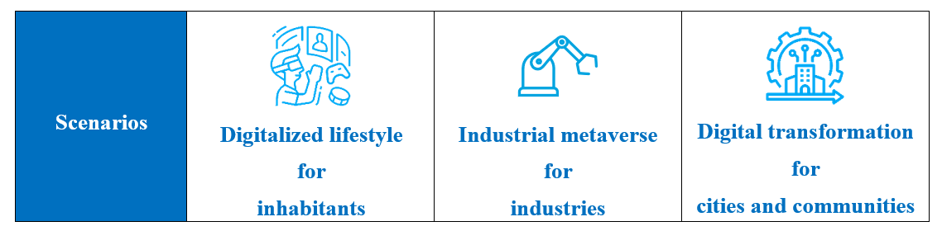
Figure 1 – Three key scenarios of the metaverse [ITU FGMV-01]
IMV supports interaction among users in the industry through their avatars. In the IMV, industrial machines in manufactures, warehouses and industrial systems are represented through their virtual entities.
IMV aims to enhance productivity, efficiency and collaboration and optimize industrial processes, improve product quality, train more diverse workers and promote well-being and safe working conditions.
The IMV domain includes three parts: the IMV, physical world and the IMV system, as shown in Figure 2. The physical world includes industrial resources such as industrial machines in manufacturing and warehouses and users. There are three types of users: workers, supervisors and managers. The IMV is a virtual world based on the physical world through the virtualization of industrial activities and users. Users, who are represented by avatars in the IMV, may construct the closed loop of virtual industrial production in the IMV. The IMV system is the infrastructure of the IMV, which supports the integration of the virtual world and the physical world. the IMV system also supports the industrial platform as a type of infrastructure. The IMV system can be implemented based on [ITU FGMV-29].
The World Economic Forum studied metaverse use cases and applications in industry field and published [b-WEF]. This proposes the specific industrial activities that should be supported by metaverse in industrial field. Table 1 shows that the IMV supports all industrial activities in [b-WEF].
The nature of the relationship between the physical world and the IMV is one of mutual dependence, of one-way influence or of no links. These relationships are decided by the designer of the IMV who considers the physical world, influence and optimization of the virtual world, real-time data synchronization and control, iterative optimization and feedback loop.
An important difference between the IMV and digital twins is that the IMV provides interaction with users through their avatars in the IMV. The IMV provides interaction with avatars and virtual entities of industrial machines in manufacturers, warehouses and industrial systems.
The scope of this Technical Specification includes the concept of the IMV, the framework of the IMV domain, functional components of the infrastructure in the IMV domain and security considerations for the IMV.
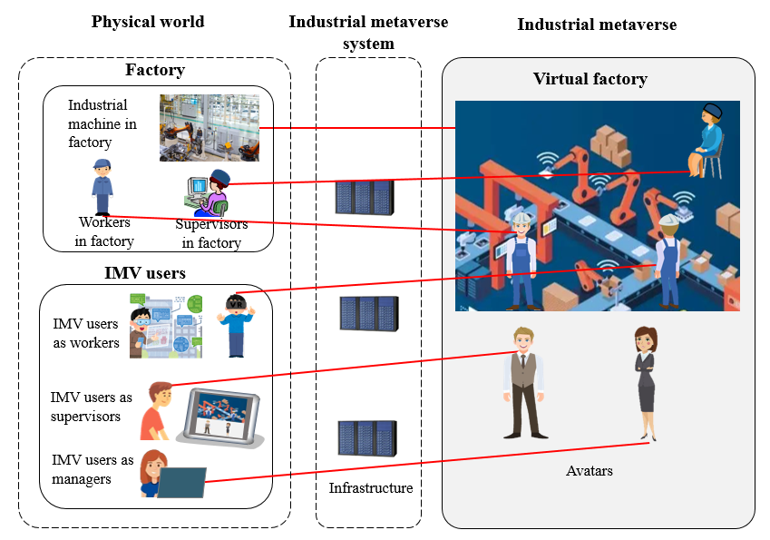
Figure 2 – Overview of industrial metaverse domain
Table 1 – Relationship between the specific industrial activities and the support of industrial metaverse
No. | Specific industrial activity | Category of industrial activity | IMV support
1 | Development and testing (collaborative virtual product and factory prototyping and simulation) | Industrial design | Support
2 | Monitoring, operations and assembly (real-time (remote) monitoring and operations with control of physical production systems and XR-assisted assembly) | Industrial manufacturing | Support
3 | Quality control (automated, AI-supported quality control at each production step) | Industrial manufacturing | Support
4 | Maintenance (remote support, predictive maintenance and XR instructions) | Industrial service | Support
5 | Training (remote, immersive learning in a realistic and interactive virtual environment) | Industrial service | Support
6 | Marketing and sales (immersive virtual product demonstration and showrooms) | Industrial service | Support
7 | Customer support (remote, XR-enhanced support and maintenance for customers) | Industrial service | Support
8 | Operational planning (automated planning of operations in integrated systems in the IMV applications) | Industrial management | Support
9 | Process optimization (AI-enhanced optimization of entire production systems) | Industrial management | Support
10 | Business intelligence (aggregated information and visual analytics for forecasting and decision-making in a single integrated system) | Industrial management | Support
11 | Procurement (virtual simulation and testing of supplies before purchase; AI-supported supply and inventory predictions; supply chain optimization, simulation and increased transparency) | Industrial management | Support
12 | Product recycling (enabling tracking of materials and information on up-, re- and downcycling) | Industrial management | Support

7 Framework for industrial metaverse domain
According to IoT reference model in [ITU-T Y.4000], the IoT functional framework in functional view in [ITU-T Y.4401] and reference model for the metaverse based on a digital twin in [ITU FGMV-29], the IMV domain consists of the following layers: physical layer; industrial information layer; industrial system layer; industrial model layer; and industrial application layer, as shown in Figure 3.
The IMV system is the foundation infrastructure of the IMV domain, which provides the necessary support and platform for various technologies to ensure the smooth operation and functional realization for the IMV. In the IMV domain, the IMV system involves industrial platform infrastructure (IPI), information infrastructure (INFI) and industrial information interactive infrastructure (INDI).
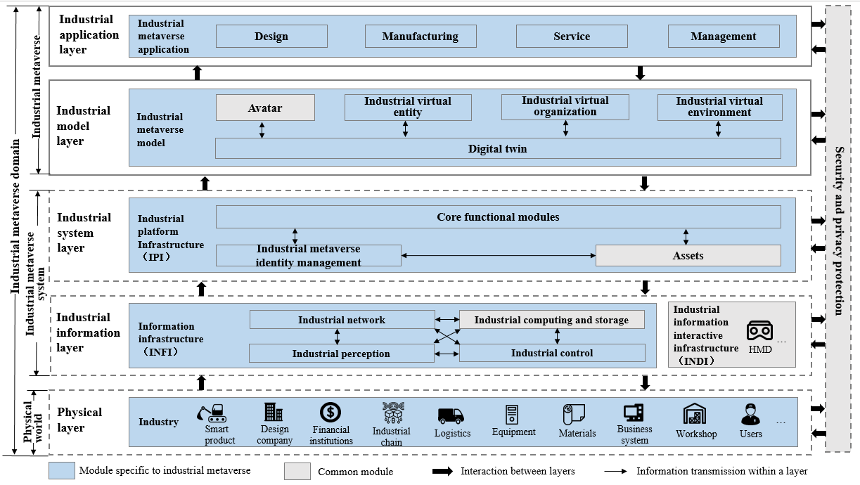
Figure 3 – Overall framework of industrial metaverse domain

7.1 Physical world
In the IMV domain, the physical world refers to industrial product design, manufacturing, logistics and other processes. In Figure 3, these industrial activities are represented by the smart product icon, design company icon, logistics icon and other icons. The IMV system generates, collects, calculates and stores industrial activity data in the physical layer from heterogeneous multisource, and enables real-time mapping and interaction with industrial production in the IMV. The physical world includes the physical layer, which comprises all industrial elements and activities.

7.1.1 Physical layer
The physical layer refers to all elements of industrial production. The elements of industrial production include, for example, users, equipment, materials, design companies and business systems.
There are three types of users in this layer: workers, supervisors and managers. Workers may work in the physical industrial sites and in the remote sites, and supervisors may work in manufacturing sites and may monitor workers in remote sites. Managers can establish a clear, shared company vision and strategy for an IMV.
As the foundation of the other layers, the physical layer focuses on the industrial activities.

7.2 Industrial metaverse system
The IMV system includes the industrial information layer and the industrial system layer, which are composed of the information infrastructure (INFI), industrial information interactive infrastructure (INDI), and industrial platform infrastructure (IPI). The INFI includes industrial perception, industrial control, industrial network, industrial computing and storage infrastructures. According to the concept of metaverse cross-platform interoperability specified in [ITU FGMV-19], IPI includes IMV identity management, assets and core functional modules.

7.2.1 Industrial information layer
The industrial information layer includes industrial network, industrial perception, industrial control, industrial computing and storage and INDI. It realizes the real-time processing, transmission and analysis of industrial data at the physical layer, and provides the operating environment and basic services for the IMV system. The industrial information layer can collect, integrate, calculate and analyse data through data pre-processing to manage data centrally.
The industrial information layer consists of two types of infrastructure:
− Information infrastructure (INFI): INFI includes industrial perception, industrial control, industrial network, industrial computing and storage information infrastructures. The four modules are responsible for data acquisition, transmission, communication, processing and storage in the IMV domain, so ensuring real-time interaction between the IMV and the physical world, and the stable operation of the IMV. INFI carries out innovative exploration, and promotes the construction and development of the IMV.
− Industrial information interactive infrastructure (INDI): INDI is a smart, wearable device, including, the head-mounted display (HMD), smart glasses, augmented reality/virtual reality (AR/VR) devices and haptic devices. The devices link the physical world and the IMV to provide immersive experiences for users.

7.2.2 Industrial system layer
On the basis of acquiring the data from industrial activities, the industrial system layer relies on three-dimensional (3D) modelling software, simulation software, artificial intelligence (AI) algorithms and other modules. The capability of this layer is carrying out synchronous simulation and modelling according to the real-time state of the physical world and feedback and control the physical world to provide simulation, verification, optimization and guidance for various industrial activities.
The IMV establishes the infrastructures characterized by IMV identity management, assets and core functional modules. Core functional modules are new types of infrastructure based on related metaverse technologies, with virtual–physical interaction, content generation and human–machine collaboration to achieve efficient allocation of resource elements, process optimization and re-engineering, and intelligent decision-making in the industrial activities. IMV identity management mainly realizes the association and mapping of virtual and physical identities, which is an important basis for the realization of avatars and digital twins in the IMV. With decentralized identifier (DID) and other digital identity technologies, the IMV identity management module provides enhanced identity management capabilities for users and machines to transcend time and space constraints. The assets are mainly used to capitalize industrial elements, realize the asset attributes of industrial elements, and support the transaction of digital assets in the IMV.
IPI includes three types of infrastructure:
– Core functional modules: Facilitate the coordination of resources in the IMV, offering data-driven industrial intelligence and services, virtual–physical interaction and industrial content generation. It supports the interaction between IMV identity management and assets while also enabling the development of innovative applications with the IMV.
− Industrial metaverse identity management: Realizes the mapping of users, and machines from the physical world into the IMV as avatars and digital twins and establishing social connections among users.
− Assets: Involves capitalizing all elements in the industry, representing and facilitating the transaction of digital assets within the IMV. It encompasses various forms of industrial assets, including virtual properties, intellectual properties and digital currencies.

7.3 Industrial metaverse
The IMV encompasses the industrial model layer and the industrial application layer. Based on the physical world and the IMV system, the IMV is built containing avatars, industrial virtual entities, industrial virtual organizations and industrial virtual environments based on digital twins with social, space-time, economic and governance attributes.

7.3.1 Industrial model layer
The industrial model layer mainly reflects the physical world. Digital twins can serve as a key component for integrating the virtual and physical worlds. As a digital representation of physical objects, digital twins can be the foundation of the virtual worlds. Avatars are mainly the mapping of users, including workers, supervisors and managers. The industrial virtual entities are the mapping of industrial production resources, including materials, equipment and products. The industrial virtual organization refers mainly to the mapping of production entities, including enterprises. The industrial virtual environment refers mainly to the mapping of the production environment, including architecture and parks.

7.3.2 Industrial application layer
The IMV has realized the expansion of the industrial physical world, eliminated time and space constraints and realized the integration and scheduling of physical resources and virtual resources. The application modes are innovated and developed, achieving comprehensive improvement in design, manufacturing, service and management.

7.4 Security and personally identifiable information protection
The IMV concerns a large amount of sensitive data, including the data of production processes, process parameters and equipment status, as well as user data such as user location and personal preferences, which can pose a major threat to the normal operation and trade secrets of industries, and also pose hidden dangers to the privacy of users once leaked or abused. In addition, the distributed and open characteristics of the IMV make security and personally identifiable information (PII) protection more complex and difficult. Therefore, security and PII protection are very significant to the IMV and are the basic conditions for building an IMV ecosystem.

8 Functional components of industrial metaverse system
This clause describes the functional components of the IMV system for achieving the efficient allocation of resource elements, process optimization and re-engineering, and intelligent decision-making in industrial activities. INFI includes industrial perception, industrial control, industrial network, industrial computing and storage, which provide the necessary network and computing support for industrial applications. Table 2 shows the examples for functional components of industrial perception and industrial control. IPI includes core functional modules, assets and IMV identity management, which have special characteristics for implementing the IMV. Table 3 shows examples for the core functional components of IPI. Table 4 shows examples for the functional components of IMV identity management and assets.
Table 2 – Examples for functional components of industrial perception and industrial control
Module | Functional components
Industrial perception | Sensor
Industrial perception | SCADA
Industrial perception | RFID tag
Industrial perception | Positioner
Industrial control | PLC
Industrial control | DCS
Industrial control | RTU
Industrial control | IPC
Table 3 – Examples for core functional components of industrial platform infrastructure (IPI)
Module | Functional components
AI module | Generative algorithm
AI module | Multimodality
AI module | Predictive maintenance
AI module | Intelligent optimization
Data tools | Data modelling
Data tools | Data identification
Data tools | Data analysis
Data tools | Data governance
Industrial software | CAD
Industrial software | CAE
Industrial software | MES
Industrial software | CRM
Industrial software | ERP
Industrial software | SCM
Industrial content generation | Real-time rendering
Industrial content generation | Physical simulation
Industrial content generation | Virtual engine
Industrial content generation | 3D modelling
Blockchain as a Service (BaaS) | Smart contract
Blockchain as a Service (BaaS) | Consensus algorithm
Blockchain as a Service (BaaS) | Privacy computing
Blockchain as a Service (BaaS) | Cross-chain mechanism
Table 4 – Examples for functional components of industrial metaverse identity management and assets
Module | Functional components
IMV identity management | DID
IMV identity management | Industrial internet identification
Assets | Digital wallet
Assets | Cryptocurrency
Assets | NFT

8.1 Information infrastructure

8.1.1 Industrial perception
Industrial perception is a module for the collection, transmission and processing of various data and information in industrial scenarios, which includes sensors, supervisory control and data acquisition (SCADA), Radio frequency identification tag (RFID tag), positioner and so on. Unlike other metaverses, the capabilities of this module are specific to the IMV. Sensor devices can monitor the running status of each device in the production line and transmit the data to the cloud for analysis and processing to help increase production efficiency, reduce failure rates and reduce maintenance costs.
Industrial perception, coordinating with other functional components of the IMV system, provides the following functionalities:
− Receiving data and control instructions from the IPI through the industrial network module;
− Uploading the collected data to the IPI for data analysis, so that the IPI can mine and extract useful information to make corresponding decisions;
− Collecting a large amount of data and information, which can be used as input to the industrial control module for decision-making and control; and
− Uploading the collected data to the industrial computing and storage module for unified management and scheduling.

8.1.2 Industrial control
Industrial control refers to the control and optimization of the management of various items of equipment, devices and systems in industrial scenarios, which include programmable logic controllers (PLCs), distributed control systems (DCSs), remote terminal units (RTUs), and industrial personal computer (IPCs), and so on. This module is the specific infrastructure of the IMV. By collecting the data of the industrial activities, the measured data can be compared with the target value, and the status monitoring, process control, transaction alarm and other functions can be realized. Larger industrial control systems are typically implemented using PLCs and DCSs.
Industrial control, coordinating with other functional components of the IMV system, provides the following functionalities:
− Achieving more accurate and intelligent control and management with data and decision support provided by the IPI through the industrial network;
− Issuing control instructions to the industrial perception module to guide the industrial perception module to carry out corresponding operations and controls through the industrial network; and
− Sending the operating status data of the device and system to the industrial computing and storage; the industrial computing and storage module processes and analyses the data and then returns the results to the industrial control for making more accurate control decisions.

8.1.3 Industrial network
The industrial network is the hub of data transmission and communication in the IMV. It is responsible for establishing and maintaining connections between industrial equipment and systems, ensuring that data can be transferred efficiently and accurately between individual modules.
The industrial network, coordinating with other functional components of the IMV system, provides the following functionalities:
− Providing data transmission channels and communication protocols for the industrial perception module, so that the industrial perception module can transmit the collected data to the IPI in real time for processing and analysis;
− Delivering data and decision support at the IPI to various devices and systems to achieve more intelligent applications and services;
− Responsible for transmitting the data generated by each device and system to industrial computing and storage module for processing; and
− Providing real-time and accurate data transmission and communication support for the industrial control module to avoid the delay and error in the data transmission process, so as to ensure that the industrial control module can make correct decisions and give correct instructions.

8.1.4 Industrial computing and storage
Industrial computing and storage are responsible for processing and storing large amounts of data and information in the IMV. In terms of computing, high-performance computers, edge computing devices and cloud computing needs to meet the industrial data processing and storage requirements in the IMV.
Industrial computing and storage, coordinating with other functional components of the IMV system, provides the following functionalities:
− Providing necessary data storage and computing support to the industrial perception module, so that the industrial perception module can better collect and transmit data through the industrial network;
− Providing necessary data storage and computing support to the IPI, so that IPI can better implement data processing and analysis; and
− Responsibility for processing and analysing large amounts of data collected from various devices and systems, extracting useful information and providing decision support to industrial control modules.

8.2 Industrial platform infrastructure

8.2.1 Core functional modules
The core functional modules provide support to the IMV for various applications and content and are the core of supporting the operation of the IMV. Core functional modules include AI modules, data tools, industrial software, industrial content generation and BaaS.
Core functional modules, coordinating with other functional components of the IMV system, provide the following functionalities:
− Issuing control instructions to the industrial perception module to guide the industrial perception module and carry out corresponding operations and controls;
− Distributing some tasks and requirements to the industrial control module, so that the industrial control module can achieve corresponding control and management;
− Distributing some tasks and requirements to the industrial network module, so that the industrial network module can achieve corresponding communication; and
− Distributing some tasks and requirements to the industrial computing and storage module, so that the industrial computing and storage module can realize the corresponding data processing and storage.
(1) AI module
The AI module refers to the use of AI technology to process and analyse various data and information in the industrial field to achieve goals such as automated decision-making and optimization of production processes.
The AI module includes generative algorithms, multimodality, predictive maintenance, and intelligent optimization and so on. An important application of AI technology in the IMV is predictive maintenance, which determines the state of equipment through, for example, sensor data and historical data, and predicts when maintenance needs to be carried out through AI models. Intelligent optimization is a specific capability of the IMV.
(2) Data tools
The data tools module refers mainly to the tools and software used to process and analyse industrial data for the IMV.
The data tools module includes data modelling, data identification, data analysis and data governance and so on. Data analysis is used to dig and analyse the data collected from various industrial activities. This component uses a variety of algorithms and models to clean, organize, classify and correlate industrial data for summarizing the valuable information and rules form industrial data.
(3) Industrial software
The industrial software module refers to various industrial software used to support the operation of the IMV. The industrial software involves design, manufacturing, operation and management, maintenance services and other industrial processes. The industrial software module has the specific capabilities of the IMV that distinguish it from other metaverses.
The industrial software module includes CAD, CAE, MES, CRM, ERP, SCM.
(4) Industrial content generation
The industrial content generation module refers to generating and producing various virtual content and scenes with various tools and functions in the IMV, so enhancing the sense of immersion and interactive experience. By collecting real-time data on industrial activities, the industrial content generation module is able to update the status of the industrial 3D models in real time, ensuring a high degree of consistency with the physical entities. It also has the specific capability of the IMV.
Industrial content generation includes real-time rendering, physical simulation, virtual engine and 3D modelling.
(5) BaaS
The BaaS module refers to an efficient, safe and convenient cloud service that combines distributed ledger technology (DLT) including blockchain and embeds the DLT framework into the cloud computing platform in the IMV.
The BaaS module includes smart contracts, consensus algorithms, privacy computing and cross-chain mechanisms.

8.2.2 Assets
The assets module is mainly responsible for managing and operating various assets and managing transactions in the IMV.
The assets module includes digital wallet, cryptocurrency and non-fungible token (NFT). A digital wallet refers to asset management and trading, identity authentication, data security, cross-platform interaction and smart contracts in the IMV. It can manage various virtual items, digital assets and other assets, and users can store, transfer and trade assets through digital wallets in the IMV.
The digital wallet, coordinating with identity management modules, provides the following functionality:
− Achieving decentralized identity authentication for ensuring the security and privacy of users combined with the blockchain in the IMV, and realizing the digital asset transactions, as well as the binding of identity management and assets on this basis.

8.2.3 Industrial metaverse identity management
IMV identity management is the management of unique representations for users and entities in the IMV. It can realize multisource heterogeneous identity information aggregation, identity information management and various applications based on trusted digital identity information.
The IMV identity management module includes DID and industrial Internet identification. In the IMV, industrial Internet identification technology provides a unique identification code for each entity in industrial activities so that each entity can be accurately identified and tracked, thus realizing the role of data sharing and traceability management.

9 Security considerations
Security and PII protection are important prerequisites for the development of the IMV. The distributed technology applications refer to DLT, avatar, content production and cross-subject and cross-platform circulation of data, resources and assets. According to the ITU FGMV deliverables [ITU FGMV-06], [ITU FGMV-10] and [ITU FGMV-11], these applications have put forward higher requirements for the security and PII protection of the IMV, involving, for example, safety protection, identity security, transaction security, intellectual property protection and privacy protection. The application of technologies such as PII-preserving computing needs to be considered to ensure the security and trustworthiness of the entire data lifecycle, the ability of users to control data independently and the support of distributed collaborative governance by all entities.

Bibliography

[b-ITU-T F.511] Recommendation ITU-T F.511 (2014), Directory Service – Support of tag-based identification services.
[b-ITU-T F.751.0] Recommendation ITU-T F.751.0 (2020), Requirements for distributed ledger systems.
[b-ITU-T M.3080] Recommendation ITU-T M.3080 (2021), Framework of artificial intelligence enhanced telecom operation and management (AITOM).
[b-ITU-T P.1320] Recommendation ITU-T P.1320 (2022), Quality of experience assessment of extended reality meetings.
[b-ITU-T X.1400] Recommendation ITU-T X.1400 (2021), Terms and definitions for distributed ledger technology.
[b-ITU-T X.1403] Recommendation ITU-T X.1403 (2020), Security guidelines for using DLT for decentralized identity management.
[b-ITU-T Y.2071] Recommendation ITU-T Y.2071 (2015), Framework of a micro energy grid.
[b-ITU-T Y.2623] Recommendation ITU-T Y.2623 (2021), Requirements and framework of industrial Internet networking based on future packet based network evolution.
[b-ITU-T Y.3115] Recommendation ITU-T Y.3115 (2022), AI enabled cross-domain network architectural requirements and framework for future networks.
[b-ITU-T Y.4600] Recommendation ITU-T Y.4600 (2022), Requirements and capabilities of a digital twin system for smart cities.
[b-ITU-R M.1645] Recommendation ITU-R M.1645 (2003), Framework and overall objectives of the future development of IMT-2000 and systems beyond IMT-2000.
[b-ITU-R M.2083-0] Recommendation ITU-R M.2083-0 (2015), IMT vision – Framework and overall objectives of the future development of IMT for 2020 and beyond.
[b-ITU-R M.2516-0] Report ITU-R M.2516-0 (2022), Future technology trends of terrestrial International Mobile Telecommunications systems towards 2030 and beyond.
[b-ITU FGMV-20] ITU Focus Group Technical Report FGMV-20 (2023), Definition of metaverse.
[b-ITU FGMV-33] ITU Focus Group Technical Report FGMV-33 (2024), Glossary for metaverse.
[b-ETSI GR ENI 004] ETSI GR ENI 004 V2.2.1 (2021), Experiential Networked Intelligence (ENI); Terminology for Main Concepts in ENI.

______________

