Standardization Sector
ITU Focus Group Technical Specification
(06/2024)
ITU Focus Group on metaverse
Multimedia aspects of metaverse architecture
Working Group 3: Architecture & Infrastructure
ITUPublications | International Telecommunication Union


Technical Specification ITU FGMV-40
Multimedia aspects of metaverse architecture
Summary
This Technical Specification ITU FGMV-40 provides the reference architecture and functional blocks for multimedia aspects of metaverse architecture.
The scope of this Technical Specification includes:
– the metaverse domain,
– reference architecture and its functional blocks of a metaverse.
The metaverse functional architecture is based on the use of existing network components and technologies, as well as IoT architectures and digital twins. This leads to three possible options for the architectural representations in this Technical Specification.
Keywords
Functional blocks, metaverse, reference architecture, reference points.
Note
This is an informative ITU-T publication. Mandatory provisions such as those found in ITU-T Recommendations lie outside the scope of this Technical Specification, which should only be referenced bibliographically in ITU-T Recommendations.
Change Log
This document contains Version 1.0 of the ITU-T Technical Specification on "Multimedia aspect of metaverse architecture" approved at the 7th meeting of the ITU Focus Group on metaverse (FG-MV) held on 12-13 June 2024.
Acknowledgements
This Technical Specification was researched and written by Hideki Yamamoto (OKI, Japan) as a contribution to the ITU Focus Group on metaverse (ITU FG-MV). The development of this document was coordinated by Hideki Yamamoto (OKI, Japan), as FG-MV Working Group 3 Chair.
Additional information and materials relating to this Technical Specification can be found at: https://www.itu.int/go/fgmv. If you would like to provide any additional information, please contact Cristina Bueti at tsbfgmv@itu.int.

Editor & WG3 Chair | Hideki Yamamoto  OKI  Japan | E-mail: yamamoto436@oki.com

© ITU 2025
Some rights reserved. This publication is available under the Creative Commons Attribution-Non Commercial-Share Alike 3.0 IGO licence (CC BY-NC-SA 3.0 IGO; https://creativecommons.org/licenses/by-nc-sa/3.0/igo).
If you wish to reuse material from this publication that is attributed to a third party, such as tables, figures or images, it is your responsibility to determine whether permission is needed for that reuse and to obtain permission from the copyright holder. The risk of claims resulting from infringement of any third-party owned material in the publication rests solely with the user.

Table of contents
Page
1 Scope 1
2 References 1
3 Definitions 1
3.1 Terms defined elsewhere 1
3.2 Terms defined in this Technical Specification 2
4 Abbreviations and acronyms 2
5 Conventions 3
6 Domain of multimedia aspect of metaverse 4
7 Metaverse architectural approaches 5
7.1 Architectural approaches 5
8 Metaverse functional architecture framework 5
8.1 End-point functions 6
8.2 Application functions 6
8.3 Service control functions 6
8.4 Content delivery and receiving functions 6
8.5 Network functions 7
8.6 Management functions 7
8.7 Content provider functions 7
9 Metaverse architectural overview 7
9.1 End-user functions 11
9.2 Application functions 12
9.3 Service control functions 12
9.4 Content delivery and receiving functions 13
9.5 Network functions 14
9.6 Management functions 15
9.7 Content provider functions 15
9.8 Physical data functions 15
Bibliography 17

Technical Specification ITU FGMV-40
Multimedia aspects of metaverse architecture

1 Scope
The scope of this Technical Specification includes:
– the metaverse domain,
– reference architecture and its functional blocks of a metaverse.
The metaverse functional architecture is based on the use of existing network components and technologies, as well as on IoT architectures and digital twins. This leads to three possible options for the architectural representations in this Technical Specification.

2 References
[ITU-T M.1400] Recommendation ITU-T M.1400 (2015), Designations for interconnections among operators' networks.
[ITU-T Y.1910] Recommendation ITU-T Y.1910 (2008), IPTV functional architecture.
[ITU-T Y.4000] Recommendation ITU-T Y.4000/Y.2060 (2012), Overview of the Internet of things.
[ITU-T Y.4401] Recommendation ITU-T Y.4401/Y.2068 (2015), Functional framework and capabilities of the Internet of things.
[ITU FGMV-20] Technical Specification ITU FGMV-20 (2023), Definition of metaverse.
[ITU FGMV-28] Technical Specification ITU FGMV-28 (2024), Requirements for the metaverse based on digital twins enabling integration of virtual and physical worlds.
[ITU FGMV-29] Technical Specification ITU FGMV-29 (2024), Reference model for the metaverse based on a digital twin enabling integration of virtual and physical worlds.
[ITU FGMV-31] Technical Specification ITU FGMV-31 (2024), Requirements, functional framework and capability of IoT for metaverse.

3 Definitions

3.1 Terms defined elsewhere
This Technical Specification uses the following terms defined elsewhere:
3.1.1 augmented reality (AR) [b-ITU-T P.1320]: An environment containing both real and virtual sensory components. The augmented reality continuum runs from virtual content that is clearly overlaid on a real environment (assisted reality) to virtual content that is seamlessly integrated and interacts with a real environment (mixed reality).
3.1.2 avatar [b-ITU FGMV-33]: Digital entity that can be used as a (visual) representation of the user inside the virtual environments.
3.1.3 digital twin [b-ITU-T Y.4600]: A digital representation of an object of interest.
NOTE – A digital twin may require different capabilities (e.g., synchronization, real-time support) according to the specific domain of application.
3.1.4 extended reality (XR) [b-ITU-T P.1320]: An environment containing real or virtual components or a combination thereof, where the variable X serves as a placeholder for any form of new environment.
3.1.5 Internet of things (IoT) [ITU-T Y.4000]: A global infrastructure for the information society, enabling advanced services by interconnecting (physical and virtual) things based on existing and evolving interoperable information and communication technologies.
NOTE 1 – Through the exploitation of identification, data capture, processing and communication capabilities, the IoT makes full use of things to offer services to all kinds of applications, whilst ensuring that security and privacy requirements are fulfilled.
NOTE 2 – From a broader perspective, the IoT can be perceived as a vision with technological and societal implications.
3.1.6 network provider [ITU-T Y.1910]: The organization that maintains and operates the network components required for IPTV functionality.
NOTE 1 – A network provider can optionally also act as service provider.
NOTE 2 – Although considered as two separate entities, the service provider and the network provider can optionally be one organizational entity.
3.1.7 thing [ITU-T Y.4000]: With regard to the Internet of things, this is an object of the physical world (physical things) or the information world (virtual things), which is capable of being identified and integrated into communication networks.

3.2 Terms defined in this Technical Specification
This Technical Specification defines the following terms:
3.2.1 end point: End user [ITU-T Y.1910] or physical data terminal for metaverse services.
3.2.2 metaverse content provider: The content provider [ITU-T Y.1910] that owns or is licensed to sell avatar or other virtual objects that consist of a metaverse.
NOTE – Virtual objects may be visual in 2D or 3D form, or they may not be visual objects, such as computational modules, to simulate physical world situations.
3.2.3 metaverse service provider: The service provider [ITU-T M.1400] is generally an operator that provides metaverse services to customers and other users, either on a tariff or contract basis. A metaverse service provider can optionally operate a network.
NOTE – Typically, the metaverse service provider acquires or licenses metaverse content from metaverse content providers and integrates it as a metaverse service that is consumed by end users.
3.2.4 physical data terminal device: The terminal device that is not an end point and that inputs or outputs the physical world data for a metaverse service.
NOTE – A physical data terminal device may not be IoT devices [ITU-T Y.4401].

4 Abbreviations and acronyms
This Technical Specification uses the following abbreviations and acronyms:
2D 2-Dimensional
3D 3-Dimensional
AR Augmented Reality
DT Digital Twin
DT-IoT Digital Twin and IoT-based
HMD Head Mounted Display
ID Identification
IoT Internet of Things
MR Mixed Reality
MV Metaverse
Non-DT-with-IoT Non-Digital Twin with IoT
Non-PWC Non-Physical World Connection
OAM&P Operations, Administration, Maintenance and Provisioning
PD Physical Data
QoS Quality of Service
SCP Service and Content Protection
VR Virtual Reality
XR Extended Reality

5 Conventions
In this Technical Specification:
The keywords "is required to" indicate a requirement which must be strictly followed and from which no deviation is permitted, if conformance to this Technical Specification is to be claimed.
The keywords "is recommended" indicate a requirement which is recommended but which is not absolutely required. Thus, this requirement need not be present to claim conformance.
The keywords "can optionally" indicate an optional requirement which is permissible, without implying any sense of being recommended. This term is not intended to imply that the vendor's implementation must provide the option, and the feature can be optionally enabled by the network operator/service provider. Rather, it means the vendor may optionally provide the feature and still claim conformance with this Technical Specification.
In the context of metaverse architecture, "functions" are defined as a collection of functionalities. It is represented by the following symbol:
Functions
In the context of metaverse architecture, a "functional block" is defined as a group of functionalities that has not been further subdivided at the level of detail described in this Technical Specification. It is represented by the following symbol:
Functional block

NOTE – In the future, other groups or other Technical Specifications may possibly further subdivide these functional blocks.
In the context of metaverse architecture, "data sources" are defined as particular sources of content, metadata and content protection information. They are represented by the following symbol:

Data source

6 Domain of multimedia aspect of metaverse
Figure 1 shows the domain of multimedia aspects of a metaverse.
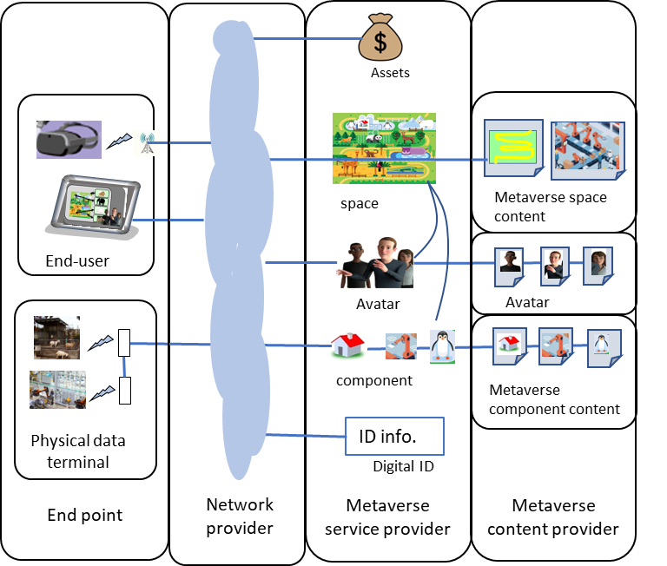
Figure 1 – Metaverse domain
NOTE – In Figure 1, the conventions defined in clause 5 are not used, as this is not a functional architecture diagram.
The four stakeholders, the definitions of which are provided in clause 3, are:
• metaverse content provider
• metaverse service provider
• network provider
• end point.
The functional elements constituting these above stakeholders are described in more detail in clause 9.

7 Metaverse architectural approaches

7.1 Architectural approaches
This Technical Specification identifies three metaverse architecture approaches that enable metaverse service providers to deliver metaverse services:
1) "Non-physical world connection metaverse functional architecture" (non-PWC metaverse): The non-PWC metaverse architecture is based on existing software components and protocols/interfaces. The hardware components, protocols and interfaces used in this metaverse architecture are already in use and hence this approach is a representation of typical existing applications providing metaverse services. This architectural approach can optionally be used as the basis for evolution towards the other metaverse architectures listed below.
2) "Non-digital twin with IoT metaverse functional architecture" (non-DT-with-IoT metaverse): The non-DT-with-IoT metaverse architecture is based on existing software components and IoT protocols/interfaces [ITU-T Y.4401]. The hardware components, protocols and interfaces in this metaverse architecture are used to represent a virtual world by using physical world data. And the hardware components, protocols and interfaces in this metaverse architecture are used to change physical world data and operate objects through virtual world change caused by avatar operation or events in a metaverse. This architectural approach does not use digital twins.
3) "Digital twin and IoT-based metaverse functional architecture" (DT-IoT metaverse): The DT-IoT metaverse architecture utilizes components of the non-DT-with-IoT metaverse architecture and digital twins. IoT protocols/interfaces [ITU-T Y.4401] are used to realise digital twins in a metaverse.
In the following clauses, this Technical Specification identifies the commonalities of the three architectural approaches identified above. This Technical Specification also describes the main functions of each architectural approach. This allows us to facilitate interworking and to identify potential evolutionary paths between these architectural approaches.
NOTE 1 – The digital twin framework in a metaverse, used in this Technical Specification, refers to [ITU FGMV-28] and [ITU FGMV-29].
NOTE 2 – The IoT framework used in this Technical Specification refers to [ITU-T Y.4401]. The metaverse using an IoT framework used in this Technical Specification refers to [ITU FGMV-31].

8 Metaverse functional architecture framework
The metaverse functional architecture framework shown in Figure 2 identifies the principal functional groups for a metaverse. These functional groups provide a more detailed breakdown of the metaverse stakeholders that are defined in the following clause. The stakeholders of metaverse content providers and end users remain the same. The stakeholders of a metaverse service provider and network provider are not used in the architecture as commercial and operational boundaries are not appropriate to an architectural decomposition. The functional groups in the architecture are derived by grouping related functions. These functional groups' boundaries are not always the same as commercial, operational and organizational boundaries. The architecture based on commercial, operational and organizational boundaries is out of the scope of this Specification. Although accounting and asset management functionalities are necessary, they are not currently described in this Specification. These functionalities are for further study.
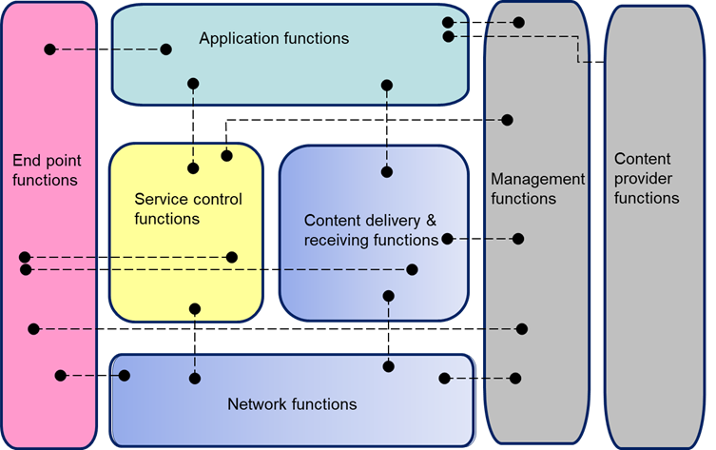
Figure 2 – Metaverse functional architecture framework
The following clauses give a description of each functional group. The related functions in each functional group are further decomposed in clause 9.

8.1 End-point functions
The end-point functions include end-user functions and physical device functions. These functions perform mediation between the end user and the metaverse infrastructure, and perform mediation between the physical world devices and the metaverse infrastructure.

8.2 Application functions
The application functions enable the end-user functions to enter the metaverse as avatars and do some activities. And application functions enable the physical device functions to connect a metaverse by inputting and outputting data from/to the metaverse.

8.3 Service control functions
The service control functions provide the functions to request and release network and service resources required to support metaverse services.
The service control functions can request the content delivery and receiving functions to allocate resources and request network functions to reserve required network bandwidth for the content stream. The service control functions can optionally obtain the end user's current location from the network functions.

8.4 Content delivery and receiving functions
The content delivery and receiving functions receive content and data from the application functions, store, process and deliver it to the end-user functions using the capabilities of the network functions, under the control of the metaverse service control functions. They receive the physical world information and the end user information in end-point functions from the network functions.

8.5 Network functions
The network functions provide IP layer connectivity between the metaverse service components and the end-user functions. The network functions are shared across all services delivered and received by an IP to and from end points.
The network functions contribute to the provision of the quality of service (QoS) required by the metaverse services.
The network functions are based on future network technologies, such as IMT-2020 and IMT-2020 beyond [b-ITU-R M.1645], [b-ITU-R M.2083-0] and [b-ITU-R M.2516-0].

8.6 Management functions
The management functions perform overall system management (i.e., operations, administration, maintenance and provisioning (OAM&P)). The management functions do not include the functions that provision the behaviour within applications or the functions that gather accounting information within applications.
As an example, the installation of a software upgrade to a head mounted display would be a management function.

8.7 Content provider functions
The content provider functions are provided by the entity that owns or is licensed to provide (i.e., sell, rent or give free usage permission) metaverse content or content assets (i.e., owner of the content, metadata and usage rights). Avatars, 2D or 3D models of objects in virtual worlds are included in metaverse content.

9 Metaverse architectural overview
Figure 3-1 provides an overview of the metaverse functional architecture of a DT-IoT metaverse. Functions and functional blocks described in this clause are common to all architectural approaches, as detailed in clause 7, except where stated differently.
Key to figures:
• The rectangular blocks represent functional blocks in the metaverse architecture, as indicated in clause 5.
• The rounded rectangular areas represent the particular grouping of functions, as indicated in clause 5.
• The solid lines represent direct relationships between either functions or functional blocks.
• The dotted lines represent logical associations between end-user functions and either functions or functional blocks located outside the end-user functions.
• Crossed lines do not imply connections, unless explicitly stated.
Figure 3-2 provides an overview of the metaverse functional architecture of a non-DT-with-IoT metaverse. Figure 3-3 provides an overview of the metaverse functional architecture of a non-PWC metaverse.

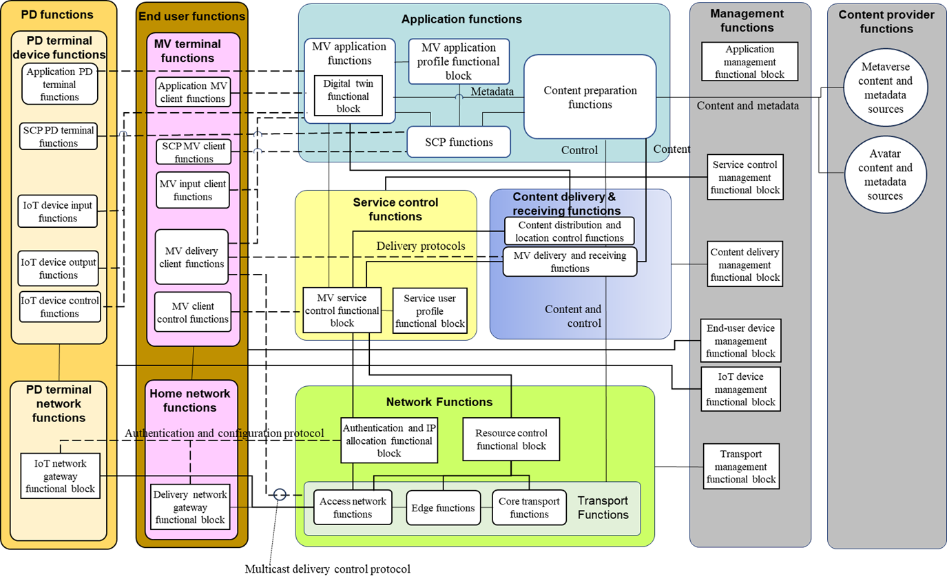
Figure 3-1 – Metaverse architectural overview (DT-IoT metaverse)
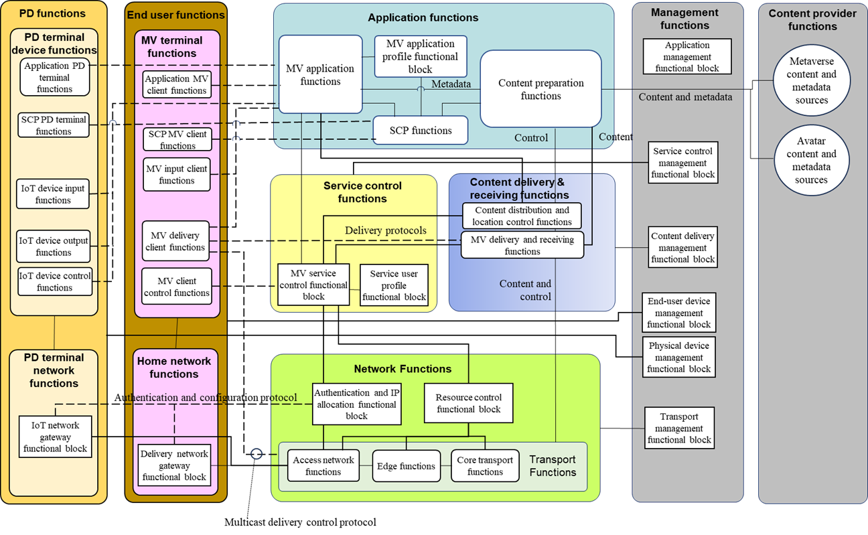
Figure 3-2 – Metaverse architectural overview (non-DT-with-IoT metaverse)
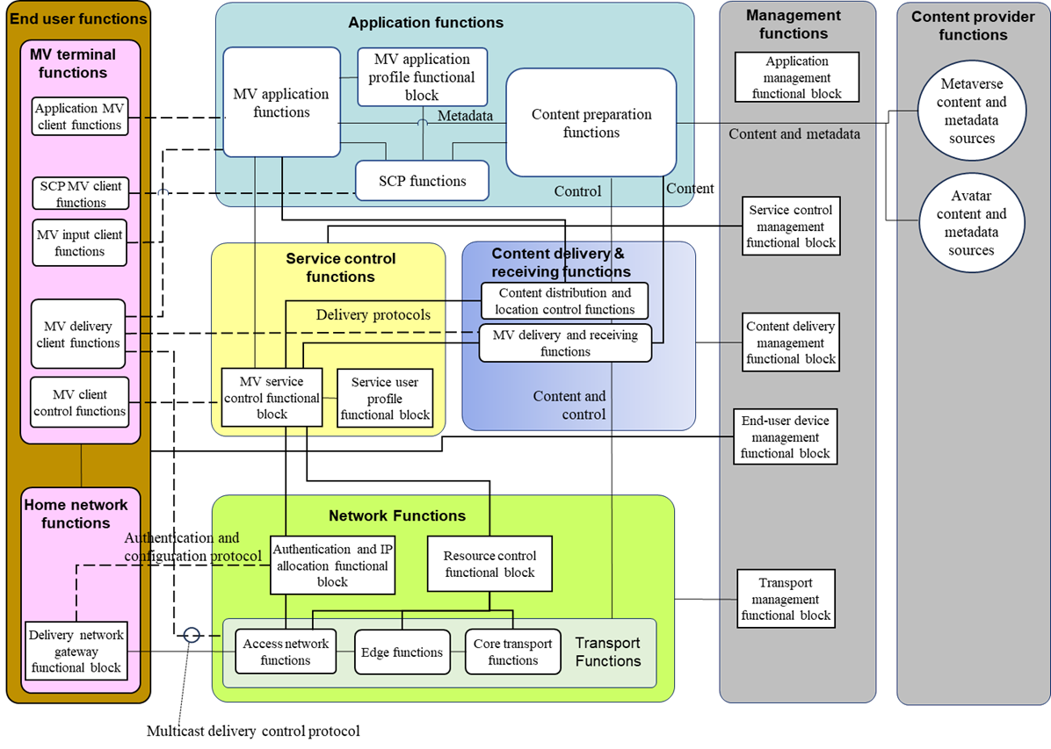
Figure 3-3 – Metaverse architectural overview (non-PWC metaverse)

9.1 End-user functions
The end-user functions are comprised of metaverse terminal functions and home network functions.

9.1.1 Metaverse terminal functions
The metaverse terminal functions are responsible for collecting control commands and sensor data (e.g., head mounted display angle, mouse position) from the end user and interacting with the application functions to obtain metaverse service information (e.g., virtual world information), content licenses and keys for decryption. They interact with the metaverse service control and content delivery and receiving functions to receive the metaverse services and also provide the capability for content reception, decryption and decoding.

9.1.1.1 Application MV client functions
The application MV client functions exchange information with the metaverse application functions to support metaverse services and other interactive applications.

9.1.1.2 Service and content protection metaverse client functions
The service and content protection (SCP) metaverse (MV) client functions interact with SCP functions to provide MV service protection and MV content protection.
The SCP MV client functions verify the usage rights and decrypt and optionally watermark the content.

9.1.1.3 Metaverse input client functions
The metaverse (MV) input client functions collect end user senser data and send them to the metaverse application functions. The end user senser data includes the data of mouse, remote controller, touch panel, camera, microphone, haptic devices, and the head mounted display.

9.1.1.4 Metaverse delivery client functions
The metaverse (MV) delivery client functions receive and control the delivery of the MV content from the content delivery and receiving functions. After receiving the MV content, the MV delivery client functions can optionally use the SCP client functions to decrypt and decode the MV content. The MV delivery client functions also receive the data to control end-user devices such as haptic devices from the content delivery and receiving functions.

9.1.1.5 MV client control functions
The MV client control functions allow the MV terminal functions to initiate metaverse service requests to the metaverse service control functional block in order to prepare for the connection to the content delivery and receiving functions.

9.1.2 Home network functions
The home network functions provide the connectivity between the external network (i.e., external to the home network) and each metaverse terminal device. These functions include IP connectivity, IP address allocation and configuration from the network functions to the metaverse terminal devices. All data, content and control traffic must pass through the home network functions in order to enter or exit the end-user's metaverse terminal device. The home network functions serve as the gateway between the metaverse terminal functions and the network functions.
The home network functions are comprised of the following functional block.

9.1.2.1 Delivery network gateway functional block
The delivery network gateway functional block provides IP connectivity between the external network (i.e., external to the home network) and the metaverse terminal device.
The delivery network gateway functional block manages IP connectivity, obtains IP addresses and configurations for the home network functions and metaverse terminal devices.

9.2 Application functions

9.2.1 Metaverse application functions
The metaverse application functions enable the metaverse terminal functions to select and purchase, if necessary, content.
When receiving requests from metaverse terminal functions, the metaverse application functions perform application authorization and execution of metaverse service logic based on user profile, content metadata and other information retrieved from relevant entities. The metaverse application functions also communicate with content delivery and receiving functions to prepare the delivery of media content to metaverse terminal functions through content delivery and receiving functions.
The metaverse application functions enable PD terminal device functions to collect and send IoT data to IoT devices in the physical world.

9.2.2 Metaverse application profile functional block
The metaverse application profile can optionally include:
• end-user settings, which include information related to the capabilities of the end user's metaverse terminal devices. A metaverse end user may be associated with one or more metaverse terminals with different capabilities;
• global settings (e.g., language preference);
• metaverse service action data which encompass information related to the actions the user can optionally have taken while accessing metaverse services by a head mounted display or remote controllers;
• end-user asset data, which includes amount of assets, type of asset and trading log.

9.2.3 Content preparation functions
The content preparation functions control the preparation and aggregation of content such as avatar data, 2D or 3D object data in a metaverse, live camera streams, stored video, metadata and EPG data, as received from the content provider functions. The metadata of content can optionally include ID of content. The content preparation functions can optionally preprocess (e.g., transcode or edit) the content in advance of passing it to the content delivery and receiving, metaverse application and SCP functions for the many types of end user terminal, which includes smart phone, tablet and PC.
Content preparation may optionally include the insertion of a watermark for the purpose of content tracing. Additionally, it may create content tracing metadata to facilitate subsequent embedding, into the content, of a content-tracing watermark. The content-tracing metadata is appropriate when multiple copies of the protected content will be created and distributed to end users.

9.2.4 Service and content protection (SCP) functions
The SCP functions control the protection of the services and content. Content protection includes control of access to content and the protection of content using methods such as encryption. Service protection includes authentication and authorization of access to services and optionally protection of the services using methods such as encryption.

9.3 Service control functions

9.3.1 Metaverse service control functional block
The metaverse service control functional block provides the functions to handle service initiation, modification and termination requests, perform service access control, establish and maintain the network and system resources required to support the metaverse services requested by the metaverse terminal functions.
The metaverse service control functional block can optionally:
• provide registration, authentication and authorization functions for end-user functions;
• process requests from metaverse application functions and forward them to the content delivery and receiving functions in order that the content delivery and receiving functions select the most appropriate content delivery and storage functions, for delivering content to the end-user functions;
• request the content delivery and receiving functions or metaverse application functions to collect charging information.

9.3.2 Service user profile functional block
The service user profile functional block:
• stores end-user service profile (i.e., metaverse services subscribed to);
• stores subscriber-related data (e.g., who pays the incurred charges);
• stores end-user location data;
• stores end-user presence status (e.g., online/offline);
• performs basic data management and maintenance functions:
– updating and storage of "user subscription data" or "network data" (e.g., the current network access point and network location);
• responses to queries for user profiles for:
– authentication;
– authorization;
– service subscription information;
– subscriber mobility;
– location;
– presence.

9.4 Content delivery and receiving functions
The content delivery and receiving functions perform cache and storage functionalities and deliver the metaverse content according to the request from the end-user functions. The content delivery and receiving functions can optionally process the content.
Multiple instances of storage and delivery functionalities can optionally exist. The content delivery and receiving functions select the suitable one(s). To maintain the same content at the multiple instances, the content delivery and receiving functions control the distribution of content to multiple instances of storage and delivery functionalities.
Content is distributed to the content delivery and receiving functions before or during the service offering process.
Content delivery and receiving functions interact with end-user functions.
Content delivery and receiving functions support unicast, multicast or both mechanisms.

9.4.1 Content distribution and location control functions
The content distribution and location control functions include:
• handling interactions with the metaverse service control functional block;
• controlling the distribution of content from the content preparation functions to the content delivery and storage functions;
• gathering the information regarding content delivery and storage functions, e.g., resource utilization, resource status (e.g., in-service and out-of-service), content distribution information and load status;
• performing the selection of suitable content delivery and storage functions to serve end-user functions according to certain criteria, e.g., the gathered information and the terminal capability.
NOTE – This selection request can optionally be triggered by the metaverse service control functions or the metaverse application functions.

9.4.2 Content delivery and storage functions
The content delivery and storage functions store and cache the content, process it under the control of content preparation functions and distribute it among instances of content delivery and storage functions, based on the policy of content distribution and location control functions.
The content delivery and storage functions are responsible for delivering content to the content delivery client functions using the network functions (e.g., unicast and/or multicast mechanisms).
The content delivery and storage functions include:
• handling interaction with the metaverse service control functional block;
• handling content delivery to end-user functions;
• caching and storing content and associated information;
• insertion, watermarking, transcoding and encryption of the content;
• distributing content within the content delivery and storage functions;
• managing interaction with the content delivery client functions (e.g., trick mode commands);
• reporting status (e.g., load status and availability) to content distribution and location control functions;
• generating charging information.

9.5 Network functions
The network functions are shared across all services delivered by IP to end-user functions. The network functions provide the IP layer connectivity to support metaverse services.

9.5.1 Authentication and IP allocation functional block
The authentication and IP allocation functional block provides the functionality to authenticate the delivery network gateway functional block which connects to the network functions, as well as allocation of IP addresses to the delivery network gateway functional block and optionally to the metaverse terminal functions.

9.5.2 Resource control functional block
The resource control functional block provides control of the resources which have been allocated for the delivery of the metaverse services through the access network, edge and core transport functions.

9.5.3 Transport functions
The transport functions provide IP layer connectivity between the content delivery and receiving functions and the end-user functions. The transport functions include access network functions, edge functions, core transport functions and gateway functions.

9.5.3.1 Access network functions
Access network functions are responsible for: 1) aggregating and forwarding the metaverse traffic sent by the end-user functions into the edge of the core network; and 2) forwarding the metaverse traffic from the edge of the core network towards the end-user functions.

9.5.3.2 Edge functions
Edge functions are responsible for forwarding the metaverse traffic aggregated by the access network functions (as defined in clause 9.5.3.1) towards the core network, and also to forward the metaverse traffic from the core network to the access network functions.

9.5.3.3 Core transport functions
Core transport functions are responsible for forwarding metaverse traffic throughout the core network.

9.6 Management functions
The management functions handle overall system status monitoring and configuration. This set of functions can optionally be deployed in a centralized or distributed manner.
Management functions are comprised of the following functional blocks:
• application management functional block;
• content delivery management functional block;
• service control management functional block;
• end-user device management functional block;
• transport management functional block.

9.7 Content provider functions
Content provider functions provide the content and associated metadata to content preparation functions, which contain the following sources.

9.7.1 Metaverse content and metadata sources
The metaverse content and metadata sources include content protection rights sources, content sources and metadata sources for the metaverse.

9.8 Physical data functions
The physical data (PD) functions are comprised of PD terminal device functions and PD terminal network functions.

9.8.1 Physical data terminal device functions
The physical data terminal device functions are responsible for collecting sensor data (e.g., video data of factory production line, robot arm position in the factory) from IoT device input functions and operating IoT devices by interacting with the application functions to reflect the virtual world change into the physical world. They interact with MV application functions through PD terminal network functions, network functions and content delivery and receiving functions.

9.8.1.1 Application PD terminal functions
The application PD terminal functions exchange information with the metaverse application functions to support metaverse services and other interactive applications by IoT devices in the physical word.

9.8.1.2 Service and content protection physical data terminal functions
The service and content protection (SCP) physical data (PD) terminal functions interact with SCP functions to provide MV service protection and IoT data protection.
The SCP PD terminal functions verify the physical device control rights and decrypt and encrypt data between PD terminal device functions and MV application functions.

9.8.1.3 IoT device input functions
The IoT device input functions collect sensor data and send them to the metaverse application functions thorough PD terminal network functions.

9.8.1.4 IoT device output functions
The IoT device output functions receive the data of IoT devices and control them based on the data and application PD terminal functions. After receiving the data, the IoT device output functions can optionally use the SCP client functions to decrypt and decode the data. The data includes the robot arm control data in a factory. The data is delivered from the content delivery and receiving functions.

9.8.1.5 IoT device control functions
The IoT device control functions allow the PD terminal device functions to initiate metaverse service requests to the metaverse service control functional block in order to prepare for the connection to the content delivery and receiving functions.

9.8.2 PD terminal network functions
The PD terminal network functions include IoT network gateway functional block to gateway collected data through IoT devices and control IoT device to IoT devices.

9.8.2.1 IoT network gateway functional block
The IoT gateway functional block provides IP connectivity between the external network and the IoT devices.
The IoT gateway functional block manages IP connectivity, obtains IP addresses and configurations for network functions and IoT devices.

Bibliography

[b-ITU-T P.1320] Recommendation ITU-T P.1320 (2022), Quality of experience assessment of extended reality meetings.
[b-ITU-T Y.4600] Recommendation ITU-T Y.4600 (2022), Requirements and capabilities of a digital twin system for smart cities.
[b-ITU-R M.1645] Recommendation ITU-R M.1645 (2003), Framework and overall objectives of the future development of IMT-2000 and systems beyond IMT-2000.
[b-ITU-R M.2083-0] Recommendation ITU-R M.2083-0 (2015), IMT vision – Framework and overall objectives of the future development of IMT for 2020 and beyond.
[b-ITU-R M.2516-0] Report ITU-R M.2516-0 (2022), Future technology trends of terrestrial International Mobile Telecommunications systems towards 2030 and beyond.
[b-ITU FGMV-33] Technical Specification ITU FGMV-33 (2024), Glossary for metaverse.
[b-ISO/IEC 23005-4] ISO/IEC 23005-4:2018, Information technology – Media context and control – Part 4: Virtual world object characteristics.

______________

