Standardization Sector
ITU Focus Group Technical Report
(06/2024)
ITU Focus Group on metaverse

Building a people-centred CitiVerse
Working Group 1: General
ITUPublications | International Telecommunication Union


Technical Report ITU FGMV-35
Building a people-centred CitiVerse
Summary
This Technical Report presents the concept of the "CitiVerse" as the cross-sectoral adoption of the metaverse within cities, involving the interaction of digital and physical world objects with a given city's envisioned digital ecosystem. It explores the CitiVerse's potential to drive people-oriented urban digital transformation.
The document provides real-life examples of the application of metaverse technologies in different cities, focusing on cases where cities have put the needs of their inhabitants at the heart of all the services offered in their versions of the CitiVerse.
Despite the expanding application scenarios and potential of the CitiVerse, there is limited literature and research available on the topic, as cities continue to grapple with issues relating to interoperability, digital identity and jurisdiction.
Global platforms such as the International Telecommunication Union (ITU)'s Focus Group on metaverse are paving the way for standardization within this domain, to enable stakeholders to receive the required guidance for the adoption of the CitiVerse in their cities, in alignment with the Sustainable Development Goals (SDGs).
Keywords
Digital transformation; metaverse; CitiVerse; people-centred; smart cities.
Note
This is an informative ITU-T publication. Mandatory provisions such as those found in ITU-T Recommendations lie outside the scope of this Technical Report, which should only be referenced bibliographically in ITU-T Recommendations.
Change log
This document contains Version 1.0 of the ITU Technical Report on "Building a people-centred CitiVerse" approved at the 7th meeting of the ITU Focus Group on metaverse (FG-MV) held on 12−13 June 2024.
Acknowledgements
This Technical Report was researched and written by Christina Yan Zhang (The Metaverse Institute) as a contribution to the ITU Focus Group on metaverse (ITU-T FG-MV). The development of this document was coordinated by Radia Funna (Build n Blaze, LLC.) and Leonidas Anthopoulos (University of Thessaly, Greece) as FG-MV Working Group 1 Co-Chairs, and Shin Gak Kang (Electronics and Telecommunications Research Institute, Rep. of Korea) as FG-MV Group Chair.
The author wishes to thank the following people for their contributions: Nicholas You (Guangzhou Institute for Urban Innovation, China), Rav Roberts (The Metaverse institute), Ahmed El Adl (The Metaverse institute,), Danil Kerimi (The Metaverse institute), Teppo T Rantanen (The City of Tampere, Finland), Okan Geray (Digital Dubai, United Arab Emirates), Yosik Kang (Seoul Digital Foundation, Rep. of Korea), Jongho Kim (Seoul Digital Foundation, Rep. of Korea), Craig Rolando Meyer (Department of Communications and Digital Technologies, South Africa), Luis Nava Guerrero (The City of Queretaro, Mexico), Andy Emmonds (Transport for London, UK), Roland van der Heijden (Municipality of Rotterdam, Netherland), Marc Liberati (Germany), Ernesto Faubel Cubells (Municipality of Valencia, and LDT CitiVerse European Digital Infrastructure Consortium, Spain), and Achraf Othman (Mada Qatar Assistive Technology Center, Qatar).
The author would also like to thank the following experts for their assistance: Andrey Perez (Brazil), Hideo Imanaka (NICT, Japan), Per Fröjdh (Ericsson, Sweden), Shane He (Nokia, Finland), Vincent Affleck (United Kingdom), Yuntao Wang (China Academy of Information and Communication Technology, China), Manuel Barreiro (Aston Group, Mexico), Cristina Martinez (European Commission, Brussel), Stella Kipsaita (Communications Authority, Kenya), Natalia Bayona (World Tourism Organization, Spain), Salma Arafa (World Tourism Organization, Saudi Arabia), Ms Nevine Tewfik (Ministry of Communications and Information Technology, Egypt), Younghwan Choi (ETRI, Rep. of Korea), Yong Jick Lee (Center for Accessible ICT, Rep. of Korea), Xiaomi An (Remin University of China, China), Ismael Arribas (Kunfud, Spain), James Kunle Olorundare (Nigerian Communications Commission, Nigeria), Zekun Wang (China Telecom, China), Marcelo Moreno (Fraunhofer IIS, Germany), Hideki Yamamoto (Oki Electric Industry Co., Ltd., Japan), Yuan Zhang (China Telecom, China), Wilmer Azurza Neyra (Ministry of Transport and Communications of the Administration, Peru), Wook Hyun (Electronics and Telecommunications Research Institute, Rep. of Korea), Naying Hu (China Academy of Information and Communication Technology, China), Muhammad Khurram (King Saud University, Saudi Arabia), Ahmed Said (National Telecom Regulatory Authority, Egypt), Khaled Koubaa (Medeverse, US), and Shuguang Qi (China Academy of Information and Communication Technology, China).
Additional information and materials relating to this report can be found at: https://www.itu.int/go/fgmv. If you would like to provide any additional information, please contact Cristina Bueti at tsbfgmv@itu.int.

Editor & TG Co-Chair: | Christina Yan Zhang  The Metaverse Institute | E-mail: christina@metaverse-institute.org
Editor & WG1 Co-chair: | Radia Funna  Build n Blaze, LLC. | E-mail: rfunna@buildnblaze.com
Editor & WG1 Co-chair: | Leonidas Anthopoulos  University of Thessaly  Greece | E-mail: lanthopo@uth.gr
Editor: | Nicholas You  Guangzhou Institute for Urban Innovation  China | E-mail: nicholas.you@citistates.com
Editor: | Teppo T Rantanen  The City of Tampere  Finland | E-mail: Teppo.Rantanen@tampere.fi
Editor: | Karagyaur Irina  BQ9 | E-mail: irina@bq9.io

Disclaimer
If you wish to reuse material from this publication that is attributed to a third party, such as tables, figures or images, it is your responsibility to determine whether permission is needed for that reuse and to obtain permission from the copyright holder. The risk of claims resulting from infringement of any third-party owned material in the publication rests solely with the user.
This publication is being distributed without warranty of any kind, either expressed or implied. The responsibility for the interpretation and use of this publication lies with the reader. In no event shall ITU be liable for damages arising from its use.

© ITU 2026
Some rights reserved. This publication is available under the Creative Commons Attribution-Non Commercial-Share Alike 3.0 IGO licence (CC BY-NC-SA 3.0 IGO; https://creativecommons.org/licenses/by-nc-sa/3.0/igo).
For any uses of this publication that are not included in this licence, please seek permission from ITU by contacting TSBmail@itu.int.
Table of Contents
Page
1 Scope 1
2 References 1
3 Definitions 1
3.1 Terms defined elsewhere 1
3.2 Terms defined here 1
4 Abbreviations and acronyms 1
5 Conventions 2
6 Concept of people-centred CitiVerse 2
6.1 Smart sustainable cities 2
6.2 From people-centred smart cities to people-centred CitiVerses 3
7 Technologies to power the CitiVerse 7
7.1 Digital twins 7
7.2 Generative AI 8
8 The CitiVerse revolution: the route to digital urbanism and related challenges 8
8.1 Multilingual and multimodal communications 9
8.2 Data access, authenticity and usage of services 9
8.3 IPR 10
8.4 Jurisdiction 10
8.5 Engagement 10
8.6 Accessibility 10
8.7 Informal settlements 10
8.8 Digital literacy 11
8.9 Sustainability 11
8.10 Interoperability 11
9 Survey results on the CitiVerse 11
9.1 The CitiVerse is in an early stage of development 12
9.2 A larger minority of respondents are receptive 13
9.3 The CitiVerse can optimize existing cities while providing new solutions 13
9.4 The CitiVerse needs to be safe, accessible and inclusive 14
9.5 Those developing Citiverse face challenges in skills, security and privacy, and governance 14
10 Framework on people-centred CitiVerse 14
10.1 A public-private-people-planet partnership to implement the CitiVerse 14
10.2 A framework for eight layers of the CitiVerse 15
11 Considerations for CitiVerse 17
12 Standardization and related activities on the CitiVerse 18
13 Conclusion 20
Page
Appendix I – Examples of adoption of CitiVerse worldwide 21
I.1 Dubai, UAE Metaverse Guidelines 21
I.2 Making the CitiVerse a reality: the city of Seoul 21
I.3 Pioneering the CitiVerse: the City of Tampere 24
I.4 Queretaro, Mexico and its CitiVerse project, Queretaro Reborn 26
I.5 The Open Urban Platform with digital twin, Rotterdam, the Netherlands 28
I.6 Meta/CitiVerse use case for volunteering for peace and development 31
I.7 EDIC on local digital twins towards the CitiVerse 33
Appendix II 35
ITU survey on CitiVerse 35
Bibliography 36

Technical Report ITU FGMV-35
Building a people-centred CitiVerse

1 Scope
This Technical Report presents the concept of a "CitiVerse" as the cross-sectoral adoption of the metaverse within cities, involving the interaction of digital and physical world objects with a given city's envisioned digital ecosystem. It explores the CitiVerse's potential to drive people-oriented urban digital transformation for future smart cities designed to foster sustainable urban development using metaverse technologies.
It proposes recommendations and future research directions to ensure the long-term viability of this concept, exploring considerations for pilot projects, public-private partnerships (PPPs), standardization efforts and the development of robust frameworks.

2 References
[FGMV-20] Technical Specification ITU FGMV-20 (2023), Definition of metaverse.

3 Definitions

3.1 Terms defined elsewhere
This Technical Report uses the following terms defined elsewhere:
3.1.1 metaverse [FGMV-20]: An integrative ecosystem of virtual worlds offering immersive experiences to users, that modify pre-existing and create new value from economic, environmental, social and cultural perspectives.
NOTE – A metaverse can be virtual, augmented, representative of, or associated with the physical world.
3.1.2 city [b-ITU-T Y.1600]: An urban geographical area with one (or several) local government and planning authorities.
3.1.3 smart sustainable city [b-ITU-T Y.1600]: A smart sustainable city is an innovative city that uses information and communication technologies (ICTs) and other means to improve quality of life, efficiency of urban operation and services and competitiveness, while ensuring that it meets the needs of present and future generations with respect to economic, social, environmental, as well as cultural aspects.
NOTE – City competitiveness refers to policies, institutions, strategies and processes that determine the city's sustainable productivity.

3.2 Terms defined here
None.

4 Abbreviations and acronyms
This Technical Report uses the following abbreviations and acronyms:
4IR Fourth Industrial Revolution
AI Artificial Intelligence
AR Augmented Reality
BIM Business Information Modelling
DT Digital Twin
FAIR Findable, Accessible, Interoperable and Re-usable
GAI Generative modelling AI
ICT Information and Communication Technology
IoT Internet of Things
IPR Intellectual Property Rights
MIM Minimal Interoperability Mechanism
MR Mixed Reality
PPI Pivotal Point of Interoperability
PPP Public-Private Partnership
PPPPP Public-Private-People-Planet Partnership
SDG Sustainable Development Goal
SDO Standards Development Organization
SSC-MM Smart Sustainable Cities Maturity Model
UDC Urban Digital Community
VR Virtual Reality
XR Extended Reality

5 Conventions
None.

6 Concept of people-centred CitiVerse
There is no clear standardized definition of "CitiVerse", but it could be considered as the cross-sectoral adoption of the metaverse within cities, involving the interaction of digital and physical world objects with a given city's envisioned digital ecosystem. This report explores the CitiVerse's potential to drive people-oriented urban digital transformation for future smart cities designed to foster sustainable urban development using metaverse technologies.
The report also analyses existing opportunities and challenges associated with developing a people-centred CitiVerse and explores how cities of varying sizes, socio-economic characteristics and geographic locations can leverage scalable models to reap the benefits of metaverse technologies.
The report delves into how cities can leverage simulations within the CitiVerse to predict the impact of urban planning decisions. Specifically, the report explores how simulations can inform decision-making on issues like accessibility, public health and environmental sustainability. By addressing these aspects, the report aims to contribute to the ongoing development of a more inclusive, more accessible and sustainable people-centred CitiVerse. Ultimately, this exploration seeks to empower citizens, promote sustainable urban planning and create a more liveable future for all.
Existing frameworks required for the CitiVerse are often related to the development of smart cities. In this section, we will present an evolution from smart cities to CitiVerses around people-centricity.

6.1 Smart sustainable cities
Cities will continue to be the centres of global economic growth for decades to come. Most of this growth will occur in the global south, fuelled by migration and by natural urban population growth. This will create significant infrastructural, environmental and public health-related challenges for governments.
Digital technologies can help meet these challenges. Cities around the world are making use of these to improve the efficiency of their services and provide their inhabitants with an enhanced quality of life, in accordance with the Sustainable Development Goals (SDGs).
ITU, together with another 19 United Nations (UN) entities, defines a smart sustainable city [b−ITU−T Y.1600] as "an innovative city that uses information and communication technologies (ICTs) and other means to improve quality of life, efficiency of urban operation and services and competitiveness, while ensuring that it meets the needs of present and future generations with respect to economic, social, environmental as well as cultural aspects". City competitiveness refers to policies, institutions, strategies and processes that determine the city's sustainable productivity. A "smart sustainable city" is also called a "smart city" by some other standards development organizations (SDOs).
However, not all smart city developments have been successful. First, many early smart city initiatives focused on technological advancements without adequately considering the needs and concerns of all residents. This led to concerns about who benefits and who is left behind, potentially exacerbating existing inequalities. Second, some cities adopted a top-down approach to smart city development. This often lacked meaningful citizen participation, leading to solutions that may not address their actual needs and preferences. Third, the use of data in smart cities raises concerns about privacy, security and ethical use.

6.2 From people-centred smart cities to people-centred CitiVerses
Smart city initiatives have helped cities and communities to analyse and solve many problems. The inherent limitations of current smart city solutions are due to their having been largely confined to a sectoral approach to helping solve, for example, traffic congestion, waste management and energy management. Smart city approaches have rarely been able to solve problems such as health and well-being, affordable housing, job creation, gender inequality and social exclusion, which are arguably some of the key challenges facing cities today.
However, the advent of technologies such as artificial intelligence (AI), the Internet of things (IoT), blockchain, language technologies, digital twins and virtual or mixed reality, offers the promise of transcending this sectoral approach.
The concept of metaverse initially appeared in 1992 in the science fiction novel, Snow Crash, by Neal Stephenson. In general, the metaverse depicts extensive immersive worlds where virtual spaces and reality are linked. Figure 1 highlights the difference between the different types of model representations based on extended reality (XR), augmented reality (AR), mixed reality (MR) and virtual reality (VR) [b-Shi].
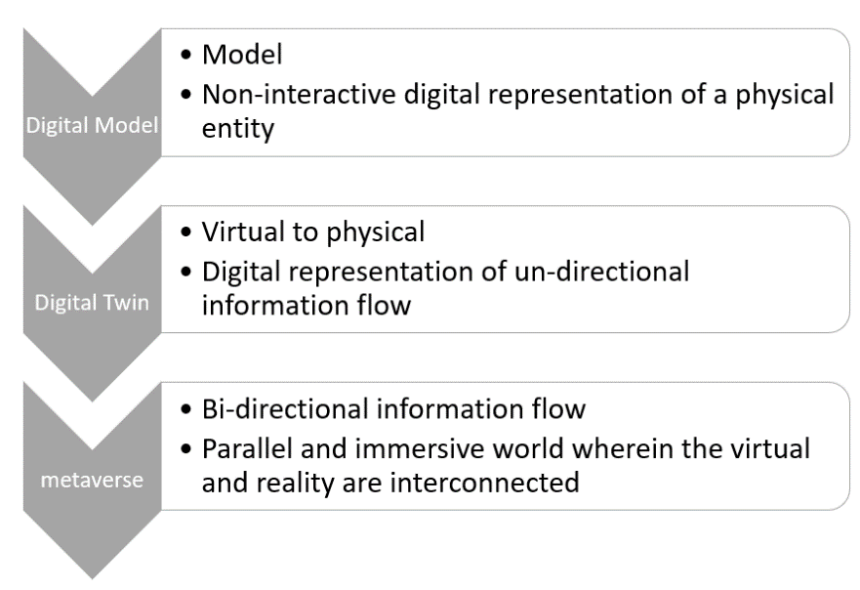
Figure 1 – Difference between model representations [b-Shi]
The ITU Focus Group on metaverse defines the metaverse as:
"An integrative ecosystem of virtual worlds offering immersive experiences to users, that modify pre-existing and create new value from economic, environmental, social and cultural perspectives" [ITU FGMV-20].
When brought together at the city level and made responsive to the needs of individual inhabitants, this can lead to the CitiVerse.
In particular, digital twins offer significant potential for city planning. Imagine a scenario where a virtual city, meticulously designed and built within the metaverse, serves as a testing ground for future urban developments. This interconnected city simulation brings together elected and community leaders, developers, academia, civil society organizations and global experts. It can also involve ordinary citizens or future inhabitants, inviting them to participate in the planning process [b-Attaran].
In this virtual space, all these stakeholders can collectively analyse, evaluate and refine the plans, ensuring that the eventual physical city aligns with their vision and objectives. The immersive nature of the VR environment allows them to experience the city in a highly realistic manner, navigating its streets, interacting with its infrastructure, and engaging with its simulated inhabitants. This first-hand experience will offer valuable insights and feedback.
A virtual testing ground of this kind allows potential problems to be identified and addressed early on, saving significant costs and resources that would otherwise be expended during physical construction and subsequent modifications.
As the metaverse progresses from being a subject of science fiction to practical implementation in cities, it is increasingly being viewed as a means of enhancing inhabitants' participation in urban decision-making, alongside the replication of a given city in whole or in part.
ITU has developed the Smart Sustainable Cities Maturity Model (SSC-MM) (see Figure 2) to help policymakers better develop smart sustainable cities.
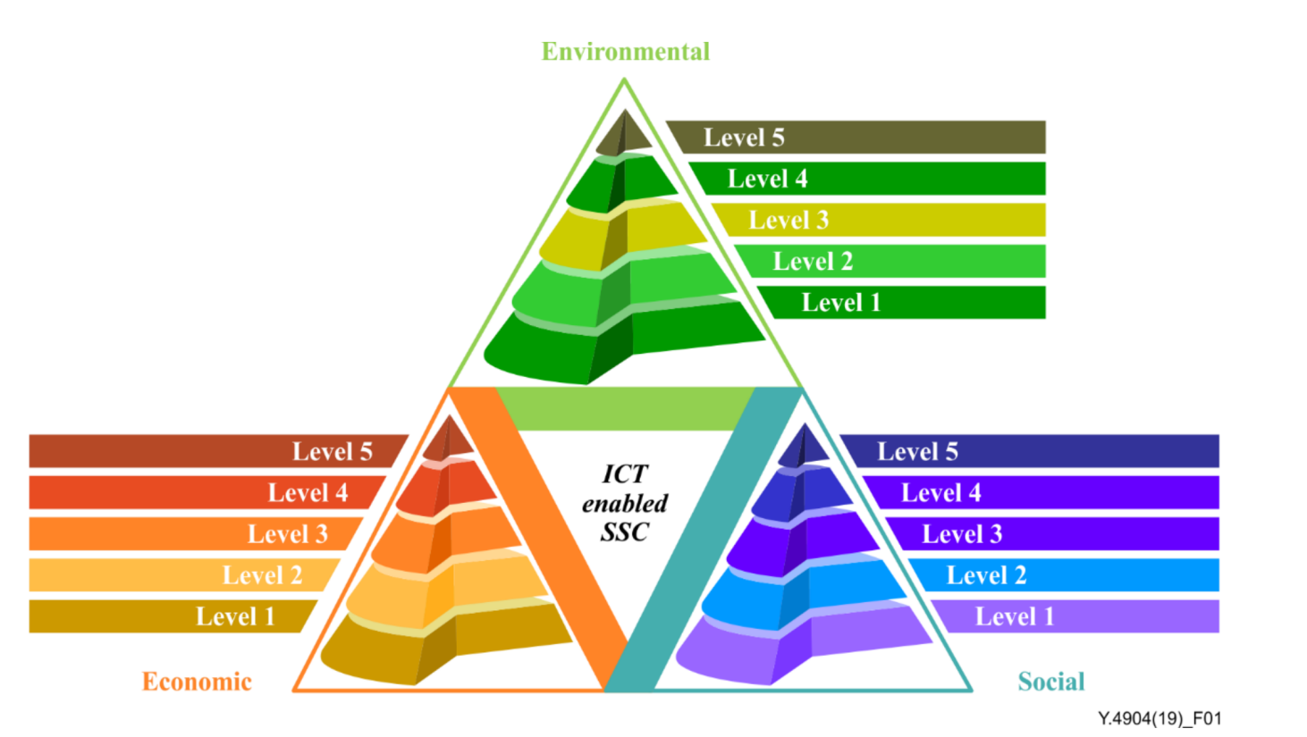
Figure 2 – ITU SSC-MM [b-ITU-T Y.4904]
This ITU-T Recommendation features the SSC-MM as a model, with five maturity levels and three key dimensions, to guide cities' progress towards achieving smart and sustainable development goals. Each dimension has its own maturity levels, and a city's overall SSC maturity is determined by combining these individual assessments [b-ITU-T Y.4904].
Key points of SSC-MM include the following:
• The SSC-MM assesses city performance across three key dimensions:
– Economic: focuses on generating income and employment opportunities.
– Environmental: aims to protect and conserve natural resources.
– Social: evaluates equitable delivery of citizen well-being (safety, health, education, etc).
• Maturity levels: each dimension has five maturity levels, each with specific goals, achievements and key practices. These levels provide a roadmap for continuous improvement. See Figure 3.
• Customization: while the SSC-MM offers a framework, cities can tailor specific topics and achievement levels to their unique contexts [b-ITU-T Y.4904].
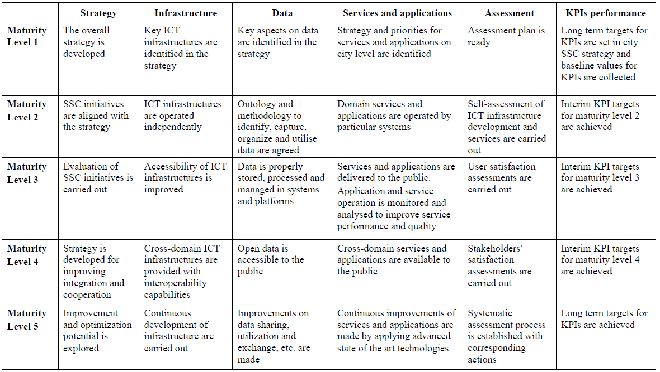
Figure 3 – ITU recommended achievements for each maturity level [b-ITU-T Y.4904]
However, as with any new technology, metaverse-related technologies bring advantages and risks. These include exacerbating the digital divide; the ethical risks related to lack of inclusiveness; a lack of transparency; data theft; surveillance fears and legal issues pertaining to the intersection of cyber and physical systems [b-Yang].
To minimize such risks, it is important to start the process with adequate planning and a shared set of values and principles. Internationally recognized standards and guidelines set by organizations such as ITU and the European Union can help ensure seamless interoperability, compatibility and harmonization of technologies to support the deployment of metaverse and other technologies in the city ecosystem.
Such standards are still a work in progress. There is not yet an international definition of the CitiVerse concept; however, at the time of drafting this Technical Specification, ITU was working on one, which was expected to be published soon. It should be noted that the European Commission is also working on a definition of CitiVerse. A preliminary draft of this definition reads as follows:
"CitiVerse is a series of interconnected and distributed hybrid and virtual worlds representing, and synchronized with, their physical counterparts. It offers new (administrative, economic, social, policy-making, and cultural) virtual goods/services/capabilities to city and community actors such as citizens, represented as digital avatars."
This concept suggests that metaverse-related technologies can impact urban systems such as energy, transport systems, water supply systems, waste management and education [b-NCPFlanders]. Figure 4 provides a snapshot of the envisioned CitiVerse.
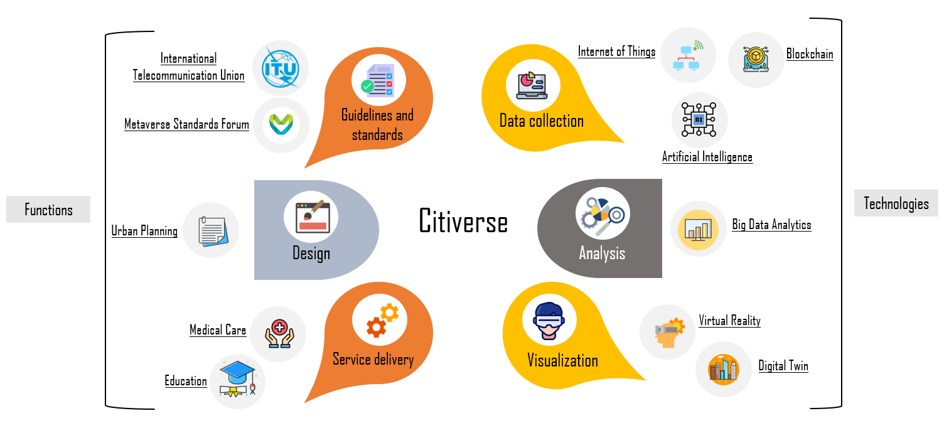
Figure 4 – Snapshot of the envisioned CitiVerse

7 Technologies to power the CitiVerse
There are many technologies that power CitiVerse, some of the most representative of which include technologies that strengthen CitiVerse capabilities, such as digital twin and generative AI technology.

7.1 Digital twins
The concept of "digital twins" has been in place since the 1960s and refers to digital representations of real-world objects, processes or systems. In reference to cities, this might mean urban processes, communications and the processes of democratic participation. Digital twins could provide simulations of how a specific technology could impact across various sectors relevant to city planning.
Various technologies and concepts can be brought together to create digital twins of cities, as follows [b-Attaran]:
• The digital twin: ITU defines digital twin as "A digital representation of an object of interest".
NOTE – A digital twin may require different capabilities (e.g., synchronization, real-time support) according to the specific domain of application" [b-ITU-T Y.4600].
• IoT: ITU defines IoT as "a global infrastructure for the information society, enabling advanced services by interconnecting (physical and virtual) things based on existing and evolving interoperable information and communication technologies". IoT sensors can be used to collect data for the creation of a digital twin system [b-ITU-T Y.2060].
• Big data analytics: the process of parsing data streams to deduce patterns and correlations, which can help organizations make informed decisions, for example, during emergencies [b−Ahmed].
• VR: VR refers to an immersive environment with simulation of scenarios, processes and objects that appear in real-life. VR forms the basis for the visualization of digital twins [b−Li].
• AR: "Augmented reality (AR) is the real-time use of information in the form of text, graphics, audio and other virtual enhancements integrated with real-world objects. It is this 'real world' element that differentiates AR from virtual reality. AR integrates and adds value to the user's interaction with the real world, versus a simulation" [b-Gartner].
• XR: This is an umbrella term used to encompass immersive technologies like VR and AR that can merge the physical and virtual worlds [b-Ahmad].
In general, digital twins mirror real-life assets and therefore require some kind of data acquisition from sensors.
Digital twin representations can be accessed either through fully immersive technologies such as VR or through more conventional smart devices or wearables.

7.2 Generative AI
Advances in machine learning have spurred the development of innovative technologies like generative AI, capable of producing entirely new digital content [b-Hu]. Since November 2022, the launch of ChatGPT and other generative AI applications has attracted worldwide attention. Generative modelling AI (GAI) is an unsupervised or partially supervised machine learning framework that utilizes probabilities to create artefacts resembling human-made works, which include texts, images, audios and videos [b-Abukmeil], [b-Hu], [b-Jovanović], [b-Gui].
Generative AI is rapidly transforming the digital world, particularly in its ability to create 3D assets directly from text descriptions. This technology holds immense potential across various fields, from gaming and entertainment to design and product prototyping, as well as CitiVerse.
The global market for generative AI in 3D content creation is experiencing rapid adoption and investment. Many companies are actively developing text-to-3D solutions, pushing the boundaries of technology and accessibility. For example, generative AI is used to quickly create realistic 3D assets like avatars, objects and environments, thereby reducing development time and costs. These services are provided by Nvidia and Adobe. In Epic Games and Decentraland, users can employ AI to customize their avatars, clothing, and virtual spaces, driving engagement and immersion. Microsoft and Roblox have now use AI-generated narratives and quests to enhance the interactive experience within the metaverse. In the platforms of Minecraft, AI can create vast and dynamic landscapes, cities and elements, increasing exploration and discovery opportunities.
In the same way, generative AI could be used to develop more personalized content, dynamic environments and engaging stories in the CitiVerse. This would boost citizens' satisfaction and engagement with such virtual environments. Easy-to-use AI tools would also empower end users with limited technical skills to contribute to the CitiVerse. For developers, automating content creation reduces development time and financial burdens.
The early days of these tools' development has thrown up its fair share of challenges. Actual or perceived biases in some tools – or even the efforts to correct them, if mishandled – have led to incidents of public backlash. The intellectual property rights (IPR) over content used to train the models is also an unresolved issue. In addition, data privacy requires careful consideration.
Nevertheless, if developed responsibly, generative AI has the potential to revolutionize the CitiVerse with its ability to create personalized, immersive and dynamic experiences.

8 The CitiVerse revolution: the route to digital urbanism and related challenges
CitiVerses can be considered as large-scale, interconnected, data-driven systems that support digital urbanism, which are already under development in several countries around the world. Typically, these systems offer administrative or medical services, or even cultural events, in a digital environment, where users or citizens are represented by digital avatars. As outlined above, such systems can also be used for urban planning and urban design.
Once fully realized, the CitiVerse, as Figure 5 illustrates, is expected to encompass all the important aspects of a given physical city, providing a virtual environment where inhabitants can interact and communicate, while accessing public services such as education, health care and tourism.
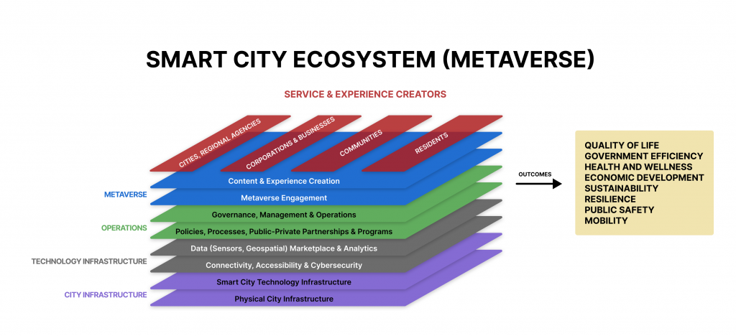
Figure 5 – Integration of metaverse in smart cities: the outcomes [b-Geospatial World]
In order to achieve this vision, however, certain challenges must be met [b-Felice], [b-Zalan]. These include:
• Multilingual and multimodal communications
• Data access, authenticity and usage of services
• IPR
• Jurisdiction
• Engagement
• Accessibility
• Informal settlements
• Digital literacy
• Sustainability

8.1 Multilingual and multimodal communications
One of the pillars of the metaverse is placing humans at the centre of the development. This concept is also inherent to the SDGs, which emphasize "leaving no one behind" and promote diversity and inclusion. By integrating existing online translation technologies (and not forgetting different language modalities such as sign language) into virtual environments, the metaverse offers the prospect of seamlessly inclusive interactions. This could be of particular relevance, for example, to cities seeking to integrate migrants into their social fabric.

8.2 Data access, authenticity and usage of services
Within the CitiVerse, it is important to know who has access to services in the physical city and in its digital ecosystem. In general, this would include the inhabitants; however, in the case of certain sectors such as tourism, access would be created for users outside the current pool of inhabitants. Public authorities need to account for the movement of digital identities between CitiVerses and enable continued data sharing for the same.
Additionally, the CitiVerse will be a goldmine of data from different sources linked to immersive technologies, which need to be processed in accordance with national, regional or local legislations governing data sharing and data storage by third-party providers. Given that within the CitiVerse there will be constant circulation of data and information, it is essential that the dissemination of information is gauged through authentic and secure channels to prevent misuse or limit access to personal data and steer clear of false narratives.

8.3 IPR
IPR issues need to be considered given the multitude of software and platforms comprising the CitiVerse ecosystem, to further underscore the licences required for its sustenance. This will especially be the case with the rise of generative AI, which can create exponential quantities of digital assets within the virtual environment. Who should own the IP for content created by generative AI is still unclear in many jurisdictions. It is important that city governments take this issue into full consideration when planning to explore the use of the CitiVerse.

8.4 Jurisdiction
The interaction of digital identities (including avatars) between two CitiVerse ecosystems could go beyond the traditional territorial borders. While national legislation can be applicable to the physical environment, crimes (such as sexual misconduct) or misdemeanours committed in the digital counterpart of the CitiVerse are more difficult to monitor and penalize, especially with reference to the actions of users outside the jurisdiction of the country in question.

8.5 Engagement
Stakeholder participation in the building of the CitiVerse and the delivery of urban services through it, needs to be the central focus of developing this concept further. The concept of digital citizenship is a useful one to ensure that participatory governance mechanisms for the CitiVerse are oriented towards inhabitants.
Additionally, as with any new and emerging technology, there may be resistance or fear associated with its adoption. The idea of having an avatar in the CitiVerse may also bring up privacy and security concerns.

8.6 Accessibility
Many major cities around the world still grapple with ensuring access to digital services for all inhabitants. According to the figures from ITU's "Facts and Figures" report for 2023, about 2.6 billion people, or 33% of the global population, do not use the Internet. This digital divide manifests differently across different populations. In high-income countries, Internet use is close to universal, whereas in low-income countries only 27% of the population is online. In developed regions such as Europe, there is no appreciable gender divide, while in Africa, 42% of men but only 32% of women use the Internet. Across the world, young people are more likely to be online; 79% of people aged 15–24 use the Internet, while only 65% of the rest of the global population does so [b-ITU 1]. Such unequal access presents an obvious barrier to a participatory CitiVerse that commands wide support among the population.

8.7 Informal settlements
In some parts of the world, rapid inward migration is also leading to urban sprawl and an increase in informal settlements. People inhabiting informal settlements (such as favelas, slums or shanty towns) lack access to decent jobs, healthcare services, education and other social benefits. Access to online spaces is likely to present a considerable further challenge. The greater the sophistication of immersive technology, the higher the cost of its access devices (e.g., VR headsets) is likely to be. If government services are to be delivered through the CitiVerse, care must be taken to ensure true access for all – and that alternative offline services do not become a "second-class" provision.

8.8 Digital literacy
A lack of digital literacy can also be a barrier to accessing services. Governments could consider the provision of appropriate education and training to citizens to enable them to visualize these new technologies.

8.9 Sustainability
Immersive CitiVerse technologies can have positive and negative effects on the environment. On the positive side, cities could make use of digital twins, AI and other metaverse-related technologies to first model and then modify their existing citywide power networks and resource consumption, in order to make these systems more sustainable. On the other hand, there are also several negative environmental impacts that cities need to manage during the development of the CitiVerse, including:
• Data centres: many of the technologies required to build the CitiVerse rely heavily on powerful data centres to process complex simulations and deliver immersive experiences. These data centres are notorious for their energy demands, contributing significantly to greenhouse gas emissions. Studies suggest a potential 1 000-fold increase in computational efficiency might be needed for a truly large-scale CitiVerse.
• Energy consumption: high-resolution VR, AR and XR headsets and other related computer equipment require significant energy to manufacture, use and dispose of, adding to the overall environmental footprint.
• E-waste: the rapid development and obsolescence of VR, AR and XR devices, computers and network equipment produces a huge amount of e-waste every year. E-waste contains a plethora of hazardous materials, including heavy metals like lead, mercury, cadmium and arsenic. Improper disposal or recycling processes can release these toxins into the air, soil and water, contaminating ecosystems and harming human health and impacting plant and animal life.

8.10 Interoperability
The dream of a seamlessly connected CitiVerse faces a harsh reality: interoperability roadblocks. Diverse data formats, outdated systems and vendor lock-in create information silos, hindering communications and service delivery. Data security, privacy concerns and unclear governance add further layers of complexity. Without trust and collaboration between cities, companies and citizens, overcoming these hurdles becomes even more challenging. The CitiVerse's success hinges on tackling these issues head-on, through open standards, data governance frameworks, pilot projects and fostering a collaborative spirit. Only then can the true potential of a united, smart city network be unlocked.
In general, CitiVerse and its services need to be accessible and inclusive for everyone, especially for the most vulnerable sections of society, including children, slum dwellers, refugees and other forcibly displaced people, elderly individuals and persons with disabilities. This means that these vulnerable individuals also need to be a part of the dialogue when mapping out the areas of application of the CitiVerse.

9 Survey results on the CitiVerse
Between 1 November 2023 and 11 January 2024, the first UN survey on the CitiVerse was conducted among senior leaders of UN agencies, governments, business and academia around the world. It was open to respondents from UN agencies, including ITU's global community, which comprises 193 Member States; more than 1 000 companies, universities, research institutes and international organizations; and other metaverse-related membership organizations and communities. The survey was promoted through various metaverse-related communities through e-mails and social media such as LinkedIn or X. The final sample size consisted of 182 valid responses. Unfortunately, the number of people the survey reached cannot be traced by ITU. One certainty, however, is that the survey is also promoted by a metaverse LinkedIn newsletter with 6 963 subscribed members. In this regard, the response rate is less than 3%, which is significantly too low to yield quality analysis.
See Appendix II for more details on the survey questions. Key findings from the survey include the following:

9.1 The CitiVerse is in an early stage of development
Figure 6 illustrates that only a minority of countries and institutions have a formal plan for developing a CitiVerse in the next five years. The low adoption rate of 22% indicates that, while the concept is gaining traction, it has not yet become a mainstream strategic priority for most entities. This suggests a significant gap between the potential of CitiVerse technology and its current implementation on a national or institutional level.

Figure 6 – Does your country or institution have a plan for developing CitiVerse in 5 years?
The concept of the CitiVerse is clearly still in its early stages but is likely to develop quickly in the next few years. The 22% of respondents who answered that they were considering its adoption within this timeframe is roughly equivalent to the fifth or sixth of any given population considered "innovators" and "early adopters" in the classic Rogers' bell curve of innovation adoption [b-Rogers].
Furthermore, when asked to expand on their answers, many respondents observed that, while they were not aware of any explicit programme to develop the CitiVerse as such, plans to adopt adjacent or supporting technologies in various ways were very much in train.
Even among those planning, there seems to be no single, standardized approach. For example, the United States of America focuses on metaverse technologies for civic engagement, while Indonesia implements smart city features as stepping stones. This highlights the need for flexibility and adaptation based on local contexts, and a gradual development path for the CitiVerse, with different countries and institutions experimenting and learning from each other.

9.2 A larger minority of respondents are receptive
Some 38% of respondents believe that cities can benefit from the implementation of CitiVerse systems and technology. Key areas of priority include transport, urban planning, health care, education, public engagement and tourism. The possibility of empowering local citizens to co-create their cities was also highlighted. One respondent commented that "If used properly, almost every area of cities can benefit from the use of CitiVerse-related technologies".

9.3 The CitiVerse can optimize existing cities while providing new solutions
The survey results also shed light on two key perspectives on the CitiVerse: whether it is primarily a tool to reflect or enhance existing physical cities, or a means of offering new, uniquely virtual experiences. Some examples of each are provided below:
Reflecting or enhancing physical cities
Preserving cultural heritage: creating digital archives of historical sites and artefacts.
• Accessibility: providing virtual access to physical locations for those who cannot visit them in person.
• Urban planning: testing and refining plans in a virtual replica before implementing them in the real world.
New, unique virtual experiences
Business and commerce: conducting virtual meetings, showcasing products in 3D spaces and participating in global marketplaces.
• Education and training: accessing specialized learning modules, practising skills in simulated environments and participating in virtual internships.
• Virtual tourism: exploring faraway places, experiencing different cultures and participating in virtual events.
• Social interaction: connecting with people from around the world in shared virtual spaces and engaging in collaborative activities.
As shown in Figure 7, nearly half (47%) of respondents believed that the CitiVerse offers opportunities to do both. Precisely 25% of respondents thought the CitiVerse will be used primarily to reflect existing physical cities, but only 15% thought it was primarily a new, virtual experience.
Figure 7 – The relationship between CitiVerse and its physical city
The key to unlocking the full potential of the CitiVerse lies in finding the right balance between these two aspects. It is imperative to leverage technology to enhance physical cities while also creating meaningful and enriching virtual experiences. This requires careful consideration of ethical, social and economic implications, as well as ensuring equitable access and participation for all.

9.4 The CitiVerse needs to be safe, accessible and inclusive
The provided data indicates a strong consensus among experts and thought leaders on the fundamental purpose of the CitiVerse. With 47% of respondents prioritizing "reflection and extension of physical cities," and another 40% believing it should be either a "reflection" (25%) or an "extension" (15%) alone, the results collectively show that a substantial majority (87%) believe the CitiVerse's primary role is to mirror and enhance the real world. This suggests that, in the short term, the most viable and supported development path for the CitiVerse is one that is deeply integrated with, and serves, its physical counterpart.
Safety, accessibility, inclusion and privacy were picked as top keywords by respondents when asked to describe the CitiVerse. One considered that it should be "a diverse and welcoming place where every person feels secure and safe and at home". Another said: "I imagine the CitiVerse as a virtual world that resembles the real life, and looks like real life, while it should give users the freedom to do anything they want such as going places, playing games, and enjoying spending time with friends. CitiVerse should be playable from any device. And it should be cross compatible. CitiVerse should have instructions to onboard every type of user easily. It should be accessible and fun to use at the same time".

9.5 Those developing Citiverse face challenges in skills, security and privacy, and governance
The most-mentioned challenge for cities looking to adopt CitiVerse is a lack of skills and knowledge on the topic. This suggests an educational effort is required on the part of those advocating these technologies.
Other common concerns highlighted in the survey included security and privacy issues, and the implementation of an effective legal framework to govern the CitiVerse. Sharing data across cities and platforms raises legitimate concerns about data security and privacy. Robust solutions are needed to ensure data protection and compliance with regulations. Clear and comprehensive legal frameworks are crucial for governing data sharing, privacy and responsibility within CitiVerse. Without these, cities may hesitate to participate due to legal uncertainties.

10 Framework on people-centred CitiVerse
Based on the discussion of this report, together with various frameworks of the United for Smart Sustainable Cities (U4SSC) initiative, the following frameworks are proposed:

10.1 A public-private-people-planet partnership to implement the CitiVerse
Policymakers across the world will be familiar with the concept of public-private partnerships (PPPs), which are collaborations between government agencies and private-sector companies to finance, build and operate projects.
It is proposed to have a similar partnership approach for the development of the CitiVerse and its various components; however, in addition, this should be one that, from the outset, explicitly identifies social welfare and environmental protection as priorities, and ensures its deliverables are in line with these priorities. The term public-private-people-planet partnerships (PPPPPs) is proposed, to make this visualization explicit.

10.2 A framework for eight layers of the CitiVerse
It is proposed to have an eight-layer conceptual framework (see Figure 8) for the development and implementation of a CitiVerse, as a way to identify and prioritize its capabilities for particular policy contexts.
The key differentiator of the CitiVerse concept is that it goes beyond existing smart city approaches, helping cities and communities to bridge sectoral silos and adopt a systems approach to urban management and development. This approach should be driven by a shared vision of the right to a sustainable and just city for all.
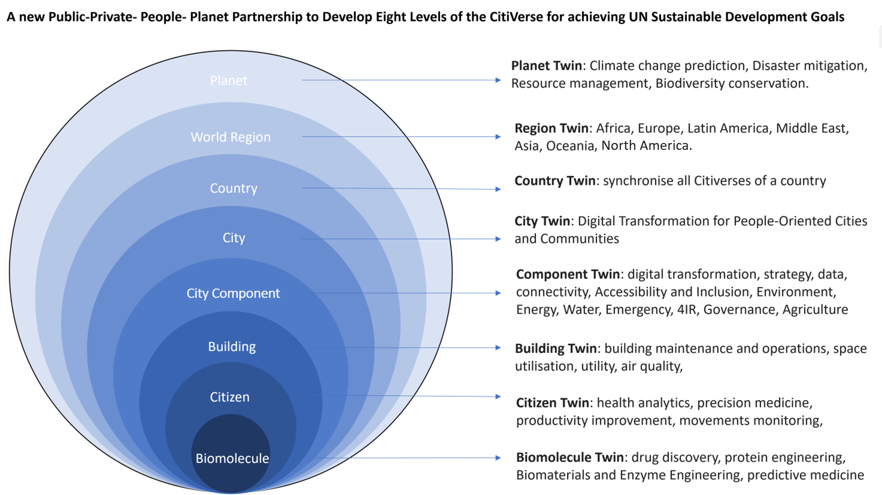
Figure 8 – A PPPPP for developing the eight levels of the CitiVerse
The eight layers are visualized in descending order of scope and illustrate that, despite being centred on the city as its primary zone of implementation, the CitiVerse concept is most useful when extended far above and below this scale – from the planetary to the microscopic.

10.2.1 Planet twin
This layer refers to the use of metaverse-related technologies to monitor and visualize planetary-scale data, most obviously weather and climate data, and to capture and analyse the impacts on particular cities or their contributions to global problems such as carbon emissions or biodiversity loss. The European Commission, for example, has an ambitious flagship project to create Destination Earth, a highly accurate digital model of the Earth. Launched in 2020, this EUR 3 billion project leverages Earth observation data, AI and high-performance computing for improved disaster preparedness, optimized infrastructure planning and accelerated progress towards the UN's S DGs [b-Hoffmann].

10.2.2 Region twin
While city and national governments are likely to be the primary actors guiding the development of the CitiVerse concept, regional partnerships and collaborations will enable them to share resources and knowledge. For example, it is likely that a CitiVerse platform developed for a city in Africa will have more in common with other African cities than it does with one developed for a city in North America. Such differentiation can help to ensure that virtual environments remain regionally and culturally appropriate. Since May 2023, the EU has planned for a two-year CitiVerse funding round to leverage interconnected virtual worlds for positive transformations in cities and communities across the EU [b-Hupont Torres].

10.2.3 Country twin
When all the CitiVerses of a country are synchronized together, it is possible to have a country-level CitiVerse to provide optimized operation of the country's infrastructure, as well as boost its overall digital transformation. For example, Singapore is at the forefront of developing a national digital twin – a virtual replica of the entire country, incorporating real-time data and simulations [b-Lawton]. Countries like China, Japan, Finland and Latvia have included AI, digital twins, Web3 and other metaverse-enabling technologies in their national CitiVerse development plans.

10.2.4 City twin
Creating a fully immersive, synchronized digital twin of a whole city requires significant computing power, data integration and advanced AI capabilities. Also, implementing such complex systems can be expensive, requiring investment in infrastructure, software and skilled personnel. In addition, balancing transparency and citizen privacy within a vast virtual representation of a city raises complex ethical and legal questions. Despite the challenges, the potential benefits of city twin are attracting interest from cities, companies and researchers. It is expected that there will be continued development and gradual adoption over time. Some predicted in October 2023 that around 700 cities would have deployed some form of metaverse infrastructure by 2030 [b-ABI Research].

10.2.5 Component twin
Based on the ITU Toolkit on digital transformation for people-oriented cities and communities, the key component twin of the CitiVerse includes digital transformation, strategy, data, connectivity, accessibility, environment, energy, water, emergency, the Fourth Industrial Revolution (4IR), governance and agriculture [b-ITU 2]. In 2021, the United Kingdom's National Grid Electricity System Operator began the development of the world's first digital twin of the national electricity network, to decarbonize the energy system. These efforts are projected to yield GBP one billion annual cost savings by 2030, five million tonnes of CO₂ emission reduction and 50% faster fault response time, transforming the electricity network for a sustainable future [b-NationalGrid].

10.2.6 Building twin
The global digital twin market for buildings is expected to reach USD 35.8 billion by 2025, up from USD 3.8 billion in 2019, representing an 837% growth [b-Marketsandmarkets]. Forty per cent of construction companies are already using or planning to use digital twins [b-Groombridge]. Vancouver International Airport, the second busiest airport in Canada by passenger traffic (19.0 million), launched a digital twin project in 2022 using 3D models, real-time data and AI analytics to improve passenger experience, optimize operations and enhance safety, through improved communications and collaboration among stakeholders. Impact includes a 10% reduction in baggage handling delays, a 20% reduction in waiting time at security checkpoints, and a 5% reduction in boarding time [b-Unity].

10.2.7 Citizen twin
The citizen twin is also called human twin. While not currently capable of replicating an entire person, it can be used for surgeons to better prepare for complicated surgeries and to prevent the development of serious medical conditions, to keep the citizens healthy. In June 2022, three-year-old conjoined twins, Arthur and Bernardo Lima, who were joined at the head with fused brains, were separated successfully using human twin. Using extensive CT and MRI scans of the twins' heads to create 3D models replicating the twins' fused cranium, including blood vessels, nerves and brain junctions, surgeons in Rio de Janeiro, Brazil and London, UK, rehearsed for six months and successfully separated the oldest conjoined twins with fused heads in history [b-Times Now News].

10.2.8 Biomolecule twin
A digital twin at the biomolecule level refers to a computational model replicating, with high fidelity, the structure, dynamics and interactions of a specific biomolecule. These models hold immense potential in preclinical drug discovery, ranging from individual cells to cell cultures, tissues, organs and animal models [b-Bordukova]. Several companies and research groups are demonstrating the potential. For example, Insilico Medicine is using AI and physics-based digital twin simulations to revolutionize drug discovery. They use AI-powered digital twin platforms to optimize the drug discovery, which has led to the discovery of more than 80 novel drug candidates across various fields. Having raised over USD 460 million in funding, Insilico Medicine stands poised to leverage its advanced technology and collaborations, to reshape the future of drug development [b-Bates].
There is no one-size-fits-all model for utilizing CitiVerse. Every city will be different. Cities may consider developing one or some of the eight levels of the CitiVerse in line with their mandate and resources.

11 Considerations for CitiVerse
1) A PPPPP, where the development of the digital future will take full consideration of using frontier technologies to support a people-centred CitiVerse.
2) The development of CitiVerse is part of the wider digital transformation of local, national, international and global digital infrastructure programmes, which takes a long time and requires substantial financial resources. Governments should have a pragmatic and balanced approach when setting out their plan and roadmaps for the CitiVerse development, to ensure return on investment.
3) Governments should look at developing effective financing strategies using traditional measures, as well as new opportunities through the digital assets and tokenisation in the CitiVerse.
4) Open standards and the interoperability of CitiVerses will play an important part in their future development, locally, nationally, internationally and globally.
5) Focus on inclusivity and accessibility: ensure the CitiVerse is designed for everyone, regardless of ability, income or location. This includes providing multiple access points, diverse content and language options.
6) Prioritize data privacy and security: implement robust security measures to protect user data and privacy. Transparency around data collection and usage is crucial. Considering the big impact of quantum computing on the global encryption system, it is recommended that all future CitiVerse needs to be quantum-safe.
7) Universities should consider developing relevant professional training courses to help educate governments, business, investors and graduates with the relevant skills and knowledge, to provide the right to talents to join the fast-evolving development of CitiVerse.
8) More innovative technologies will be playing an important part of the CitiVerse development. It is important to always scan the horizon and ensure frontier technologies can be used to better support the development of CitiVerse at different levels.
9) A full analysis of the environmental impact of various technologies within the CitiVerse ecosystem should be conducted to ensure an overall positive impact of using CitiVerse to mitigate climate changes.
10) Continuously monitor and evaluate: regularly assess the impact of the CitiVerse and adjust as needed. This ensures the CitiVerse remains relevant and effective, and addresses the evolving needs of inhabitants.

12 Standardization and related activities on the CitiVerse
IEC-ISO-ITU Joint Smart Cities Task Force (J-SCTF)
The IEC-ISO-ITU J-SCTForce facilitates international standardization related to smart cities, in alignment with SDG 11 – "Make cities inclusive, safe, resilient and sustainable". Together with relevant stakeholders, this taskforce builds synergies and minimizes the overlap of standards work in ITU-T, IEC and ISO related to smart cities and communities, while identifying new areas of cooperation within this domain.
ITU, through its ITU-T Study Group 20 on "IoT, Smart Cities and Communities", may provide an international platform for the development in the future of standards to build a people-centred Citiverse.
ITU's call to action related to CitiVerse
It should be noted that ITU has so far adopted calls to action (presented below) on CitiVerse in ITU Forum events on metaverse. The first call to action was adopted on 13 September 2023 in Arusha, Tanzania, as a conclusion of the event on "Cities and the metaverse: shaping a CitiVerse for all in Africa". The second call to action was adopted on 18 October 2023 in Riga, Latvia, during the event on "Building virtual worlds including the metaverse for a people-centred, connected and inclusive Europe".
Call to Action: Cities and the metaverse: shaping a CitiVerse for all in Africa [b-ITU 3]
We, the participants of the 3rd ITU Forum on "Cities and the metaverse: shaping a CitiVerse for all", have acknowledged that:
• Cities act as engines of local, national, international socio-economic development. Strong urban economies are essential for poverty reduction and the provision of adequate housing, infrastructure, education, health, safety and basic services.
• Cities worldwide are facing increasing challenges brought on by indiscriminate urbanization and climate change. Solving these challenges requires new models of inhabitant engagement, new ways of cooperation between various institutions and stakeholders, supported by novel ways of decision-making.
• Smart sustainable cities can harness the full potential of information and communication technologies (ICT and frontier technologies such as metaverse to address the urban challenges, offering the transparent and viable pathway for the achievement of the Sustainable Development Goals, especially SDG9 and SDG11.
• International standards are instrumental in disseminating best practices, guidelines, frameworks and generating key consensus that would address these urban challenges and build a more sustainable future for all.
• Recognizing the work carried out by the United for Smart Sustainable Cities (U4SS Cities Initiative Focus Group on metaverse, ITU-T Study Groups and in particular ITU-T Study Group 20 on IoT, smart cities and communities.
• Recalling ITU-T Resolution 98 on enhancing the standardization of the Internet of Things and smart cities and communities for global development, ITU Resolution 200 on the Connect 2030 Agenda and the United Nations 2030 Agenda for Sustainable Development.
• Emphasizing the digital transformation opportunities presented by the metaverse to connect the unconnected and achieve the Sustainable Development Goals (SDGs).
We, the participants of the 3rd ITU Forum on "Cities and the metaverse: shaping a CitiVerse for all", declare an all stakeholders Call to Action in the African region to join us in the development and standardization of an open and secure metaverse for the benefit of all including the key points of action:
• Energy poverty: Call for international collaboration between public and private sector to attract more investment to expand electrification, on-grid and off-grid, to ensure the 620 million African who are suffering from no or little access to electricity will achieve universal access, and that this development should be supported by appropriate policies, regulations, and incentives.
• Connectivity: Accelerate the development of digital public infrastructure to enable the metaverse, which allows for the combining the physical and virtual worlds, ensuring reliable and affordable connectivity for all.
• Diversity and Inclusivity: Ensure the metaverse reflects and supports the diverse needs and aspirations of the African region by promoting and facilitating participation of all stakeholders, including governments, industry, academia and civil society.
• Open, Interoperable and Transparent Standards: Working together with standards developing organizations such as ITU, industries and other key stakeholders to develop metaverse standards that are open, safe, secure and inclusive.
• Socio-economic Opportunities: Create new socio-economic opportunities to improve the quality of life for all by maximizing the opportunities of the metaverse to drive sustainable digital transformation.
• People-centred cities and the CitiVerse: Enable smart, sustainable and resilient cities and communities by creating innovative metaverse applications in urban planning, transportation, health, and public services to accelerate digital transformation in cities and communities for the benefit of all inhabitants with a special focus on biodiversity.
We urge all stakeholders in the African region to join us as we continue our metaverse journey. Together, we can harness the power of the metaverse to accelerate innovation, connectivity and prosperity, realizing the promise of the SDGs and building a better future for all to ensure that no one is left behind.
Call to Action: Building virtual worlds including the metaverse for a people-centred, connected and inclusive Europe [b-ITU 4]
We, the participants of the Special Session of the International Telecommunication Union (ITU) Focus Group on metaverse and co-creation workshop at the 5G Techritory conference held on 18 October 2023 in Riga, Latvia:
• Recalling ITU Resolution 98 on enhancing the standardization of the Internet of Things and smart cities and communities for global development and the EU initiative on Web 4.0 and virtual worlds;
• Acknowledging the importance of ITU Resolution 200 on the Connect 2030 Agenda and the United Nations 2030 Agenda for Sustainable Development;
• Emphasizing the importance of a transparent and collaborative international standards development process for the metaverse;
• Committing to working together with standards developing organizations such as the ITU-T, indusIfora and other key stakeholders to develop metaverse standards that are open, safe, secure, interoperable and inclusive;
• Acknowledging the declaration on European Digital Rights and Principles;
• Recalling Europe's Digital Decade: digital targets for 2030 and its emphasis on skills, business, and government.
We call on the European region to leverage the opportunities presented by the ITU Focus Group on metaverse and join us in the development and standardization of an open, inclusive and secure metaverse for the benefit of all, including the following key points of action:
• Integration of Health Care and Technology: Emphasize Europe's social welfare and unified health system as a key for leveraging the metaverse, showcasing Europe's expertise in data protection and privacy, positioning it as a leader in secure healthcare solutions within the metaverse.
• Innovation in Real Estate and Construction: Highlight the significance of Europe's digital infrastructure implementation and human-centric approach for improved operational efficiencies in the metaverse, to advocate for government involvement and cooperation to drive widespread adoption of metaverse technologies across diverse asset portfolios.
• Cultural Integration in Tourism, Hospitality, National Heritage, and Arts: Showcasing Europe's rich cultural heritage and diversity through immersive experiences in the metaverse, highlighting the importance of collaborating with EU countries, content owners, and stakeholders within the tourism and cultural sectors to ensure comprehensive integration.
• Language and Communication Enablement: Emphasize the crucial role of language in effective communication within the metaverse, stressing the significance of localization to ensure that content is accessible to a diverse audience across various languages.
• Collaborative Governance and Resource Allocation: Propose the establishment of common language data spaces and effective data legislation to facilitate seamless communication and language support, while highlighting the need for collaborative governance and a comprehensive approach to data management in the metaverse.
We urge all stakeholders in the European region to join us, as we continue our metaverse journey, leveraging Europe's strengths, fostering strategic partnerships, and emphasizing collaborative governance and resource allocation for successful integration and leadership in the metaverse.

13 Conclusion
The quest for digital transformation focuses on the ability to enhance diversity and communications, and operational efficiency and reduce costs. As planning remains an integral part of the digital transformation process, embedding the metaverse in cities can play a key role in envisioning how the adoption of technologies such as IoT and AI could impact urban operations and human communication, while bridging the gap between the virtual and physical ecosystems.
The establishment of a CitiVerse requires the engagement of several stakeholders (hardware and software developers, language models and language technologies, city leaders, inhabitants, and public and private agencies) and compliance with the law of the land. However, as the CitiVerse extends beyond the physical existence of a given city into the digital space, further analyses and studies are required, to prevent the fragmentation of legislation on the governing of the metaverse and avoid discrimination and exclusion.
Given the dynamic nature of urban ecosystems and the far-reaching application of metaverse, the adoption of the metaverse in cities needs further research under the umbrella concept of the CitiVerse, which itself is an amalgamation of broad concepts – "cities" and "metaverse". International standards, such as the ones developed by ITU in close collaboration with other relevant SDOs and sister UN agencies, can pave the way for examining the various possibilities for manifesting the metaverse in the real world, for the benefit of current and future generations as the digital and physical worlds become irrevocably intertwined.

Appendix I
Examples of adoption of CitiVerse worldwide
(This appendix does not form an integral part of this Technical Report.)

I.1 Dubai, UAE Metaverse Guidelines
Dubai is one of the seven emirates of the United Arab Emirates (UAE) and a highly vibrant city with a population of more than 3.5 million people in the Arabian Gulf region. Dubai has set itself on an ambitious course through a rapid and successful transformation in economic and social sectors. Dubai has embarked upon its fourth generation of digital transformation through the establishment, in 2021, of the Dubai Digital Authority, with the vision of digitalizing life in Dubai.
Launched in July 2022, the Dubai Metaverse Strategy aims to make Dubai the number one city in the region and one of the top 10 cities globally in terms of metaverse economy. The strategy aims to build on Dubai's achievement of attracting a large number of companies in the fields of blockchain and metaverse, and to increase them by five times the current number. It also promotes Dubai's ambitions to support more than 40 000 virtual jobs by 2030. This strategy is based on the five pillars of fostering innovation, cultivating talent, developing use cases, adopting and scaling up safe platforms, and refining regulations and infrastructure. The strategy's key pillars focus on XR (which blends the physical and virtual worlds), AR, VR, MR and digital twins.
In this context, Metaverse Guidelines was issued in 2023, to identify impactful metaverse applications and to provide a framework for Dubai government entities to regulate and define optimal uses of the metaverse in government work. The purpose of the guidelines is to provide Dubai government entities with a unified and well-coordinated approach to entering and creating a world-class, globally leading, effective presence in metaverse. These guidelines also aim to attain a trusted high-quality metaverse experience for various Dubai stakeholders, including government entities and their customers.
The guidelines provide direction for Dubai's presence in metaverse, common metaverse elements for Dubai government entities, government entity-specific presence in metaverse, choosing a metaverse platform, and implementing in metaverse. Dubai aims to attain a citizen-centric CitiVerse for various stakeholders, including residents, businesses, visitors and government entities.
"Metaverse Guidelines" constitutes an anticipatory soft regulation tool for Dubai in embracing metaverse and carefully planning its adoption through collaboration with, and coordination of, various city stakeholders. It resolves some of the uncertainties stemming from the nascent features of metaverse as an emerging technology.
Dubai has traditionally embraced emerging technologies in its digital transformation journey and harnessed their benefits by carefully and strategically utilizing them to provide world-class, leading digital services at the city level. Metaverse is no exception in this and Dubai intends to adopt metaverse in conjunction with other emerging technologies, such as blockchain, IoT, AI and digital twin, to capitalize on their synergistic nature in taking digital transformation to the next level. In this context, the guidelines provide strategic support and direction for Dubai.

I.2 Making the CitiVerse a reality: the city of Seoul
The city of Seoul, winner of the 2022 World Smart City Awards (see Figure I.1) at Smart City Expo World Congress, is one of the first cities to embark on the journey to create a city-wide metaverse platform, referred to as "Metaverse Seoul" [b-Seoul-Metavers] (depicted in Figure I.2), which serves as a virtual replica of the city for the provision of urban services as well as the enhancement of existing services.
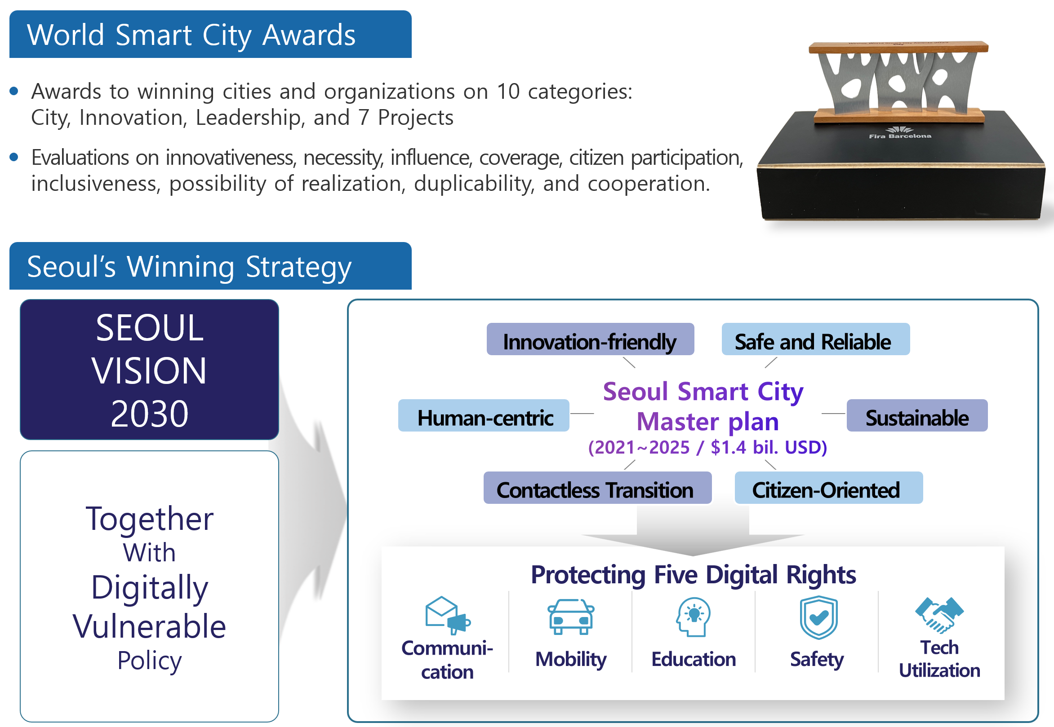
Figure I.1 – Seoul won World Smart City Awards
Seoul's 2022 World Smart City Award win was not merely for a single technological achievement but for its holistic and citizen-centric approach to urban innovation, with its metaverse strategy being a cornerstone of this vision. The city's winning entry was evaluated across a comprehensive set of criteria, including innovation, necessity, influence, coverage, citizen participation, inclusiveness, possibility of realization, and cooperation, underscoring the depth and thoughtfulness of its plan.
The "Metaverse Seoul" strategy, developed under the "Seoul Vision 2030," stands out for its mission to ensure "Together with digitally vulnerable policy." This mission is a core component of the Seoul Smart City Master Plan 2021-2025 – a USD1.4 billion initiative. The plan's emphasis on inclusiveness is particularly critical. It goes beyond technology for technology's sake and actively protects five fundamental digital rights – communication, mobility, education, safety, and tech utilization – to bridge the digital divide and ensure all citizens can benefit from the city's digital transformation.
By integrating the metaverse into a broader smart city framework, Seoul demonstrated a profound understanding of how this technology can serve a public purpose, rather than just being a novelty. The plan's focus on being "human-centric" and "citizen-oriented" proves that the city's ambition for innovation is directly tied to improving the daily lives and digital access of its residents, especially the most vulnerable. This comprehensive and inclusive strategy was a key factor in Seoul's recognition as a global leader in urban innovation.
This plan was set in motion as early as November 2021, with an anticipated investment of USD 5.2 million in metaverse technologies as part of the city's digital transformation strategy.
Metaverse Seoul will have "virtual" administrative offices related to services for education, culture and tourism. Inhabitants can create unique avatars to access these services and engage in day-to-day activities, including filing taxes, retrieving public documentation, conducting bank transactions and cryptocurrency operations [b-Huynh-The].
The deployment of this platform is driven by PPP and was closely curated with over 700 companies. The platform is intended to be rolled out in phases over the course of four years starting October 2022, with room to include additional services based on feedback from users.
Metaverse Seoul, launched on 16 January 2023, is a metaverse platform developed by the city government and was the world's first of its kind. The platform is integrated into civil administration to create new public services and it features technical and institutional systems for all citizens to use easily. It offers 23 key services, including public complaint services, the Mayor's Office, Tax Square, virtual tour at Dongdaemun Design Plaza and the Safety Experience Hall.
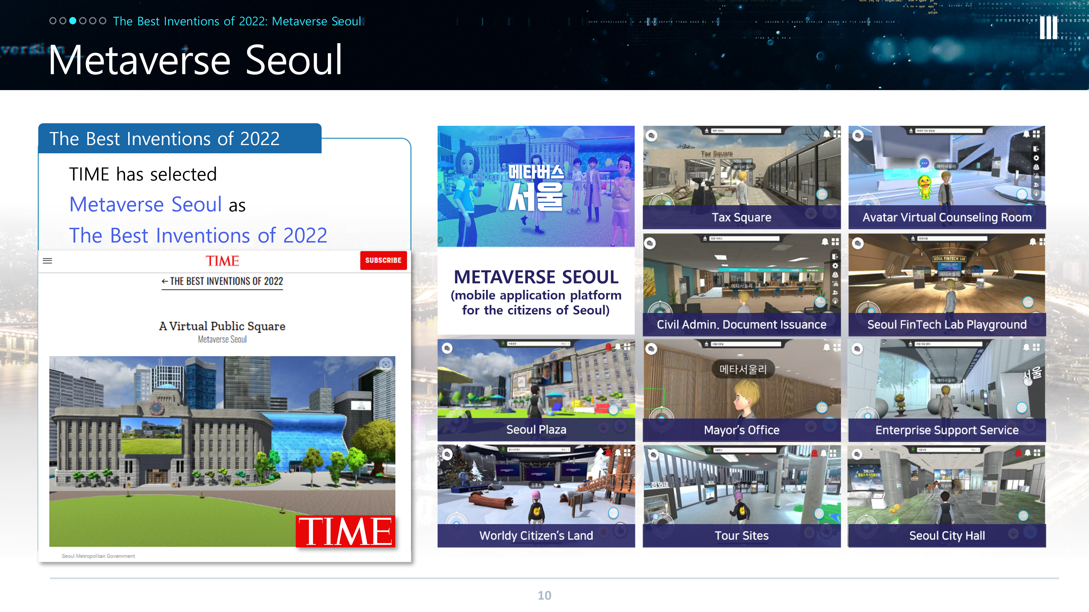
Figure I.2 – Metaverse Seoul mobile application platform
Seoul Digital Foundation, as the control tower organization for the digital transformation of the city of Seoul, has pushed forward several projects for citizen participation, such as metaverse content development education programmes and contests. Winners of the contests had uploaded their content to Worldy Citizen's Land, one of the metaverse spaces on the platform. The foundation has previously published the ethical guidelines of metaverse, which all virtual worlds will need.
The aftermath of the COVID-19 pandemic has transformed the way people interact with one another. This has also percolated into the tourism industry, which is oriented towards providing services including transit, transportation, accommodation and access to restaurants at specific destinations. In the post-COVID age, CitiVerse can serve as a gateway to digital tourism. In this context, Metaverse Seoul enables users to digitally experience visiting and touring a variety of tourist attractions in the city. including Seoul City Hall, Seoul Plaza, Blue House, N Seoul Tower, Gyeongbok Palace, Seoul Forest, Han River, Lotte World Tower, Gwanghwamun Square and the Bukchon Hanok Village – to name a few.
Time magazine in the US has recognized Metaverse Seoul as one of the Best Inventions of 2022 (see Figure I.3), as an only case from the public sector Seoul Metropolitan Government and Seoul Digital Foundation will expand the city's reputation to a globally leading city by stimulating the metaverse ecosystem.
Figure I.3 – Metaverse Seoul won Time's "Best Inventions of 2022" award [b-Heussner]

I.3 Pioneering the CitiVerse: the City of Tampere
The City of Tampere in Finland has set forth its metaverse strategy, Tampere Metaverse Vision 2040 (depicted in Figure I.4), for enhanced urban living based on the intersection of the digital and physical environments through the metaverse, to provide a seamless experience for its inhabitants.
In keeping with this metaverse strategy 2040, The Metaverse Institute has been collaborating closely with the City of Tampere, its inhabitants, private sector and research institutions, to chart out its Metaverse Governance Operating Model, which is based on human-centricity and oriented towards delivering positive urban experiences [b-Zhang].
The metaverse vision 2040 features the following pillars:
• Happiness: "My city is a fun place to live, work and play"
• Equality: "My city is inclusive and leaves no one behind"
• Governance: "My city listens to me and engages me in decisions affecting my life and livelihood"
• Sustainability: "My city is a regenerative city, it is carbon negative, produces zero waste and is in harmony with nature"
• Health and well-being: "My city is clean, green and safe"

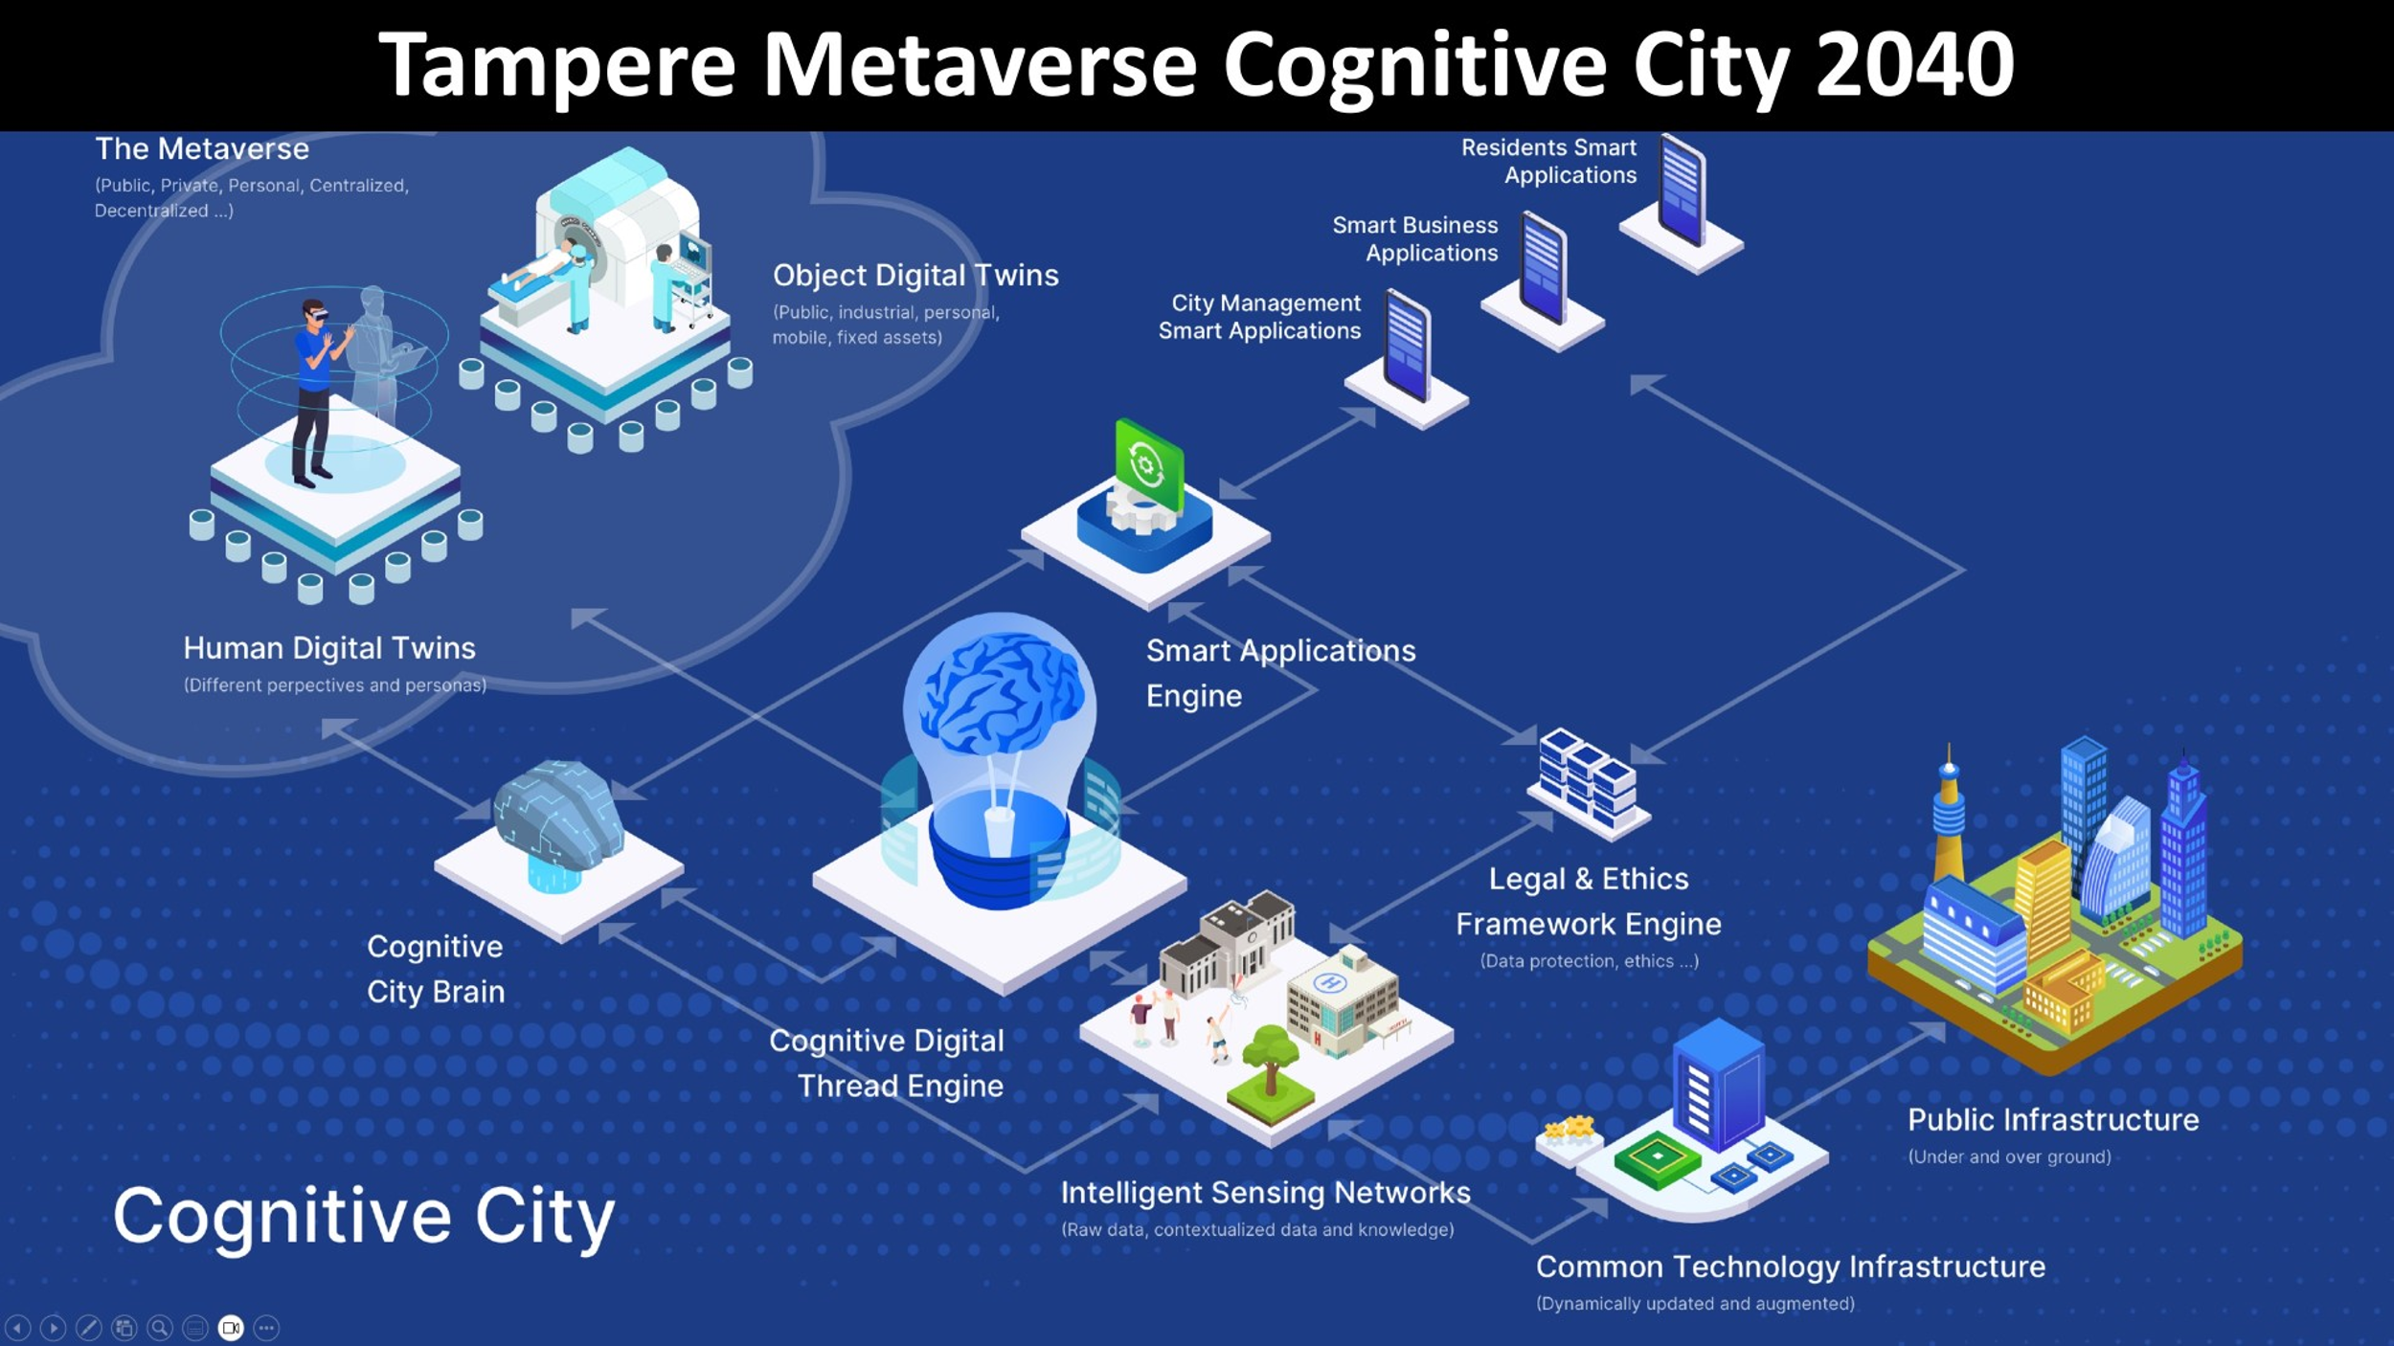
Figure I.4 – Tampere Metaverse Cognitive City 2040 [b-Zhang]
The fulcrum of all services in the CitiVerse vision of Tampere is accessibility, with the aim of leaving no one behind.
The CitiVerse ecosystem of Tampere, illustrated in Figure I.5, will be self-sustaining and fully automated and will evolve continuously. To keep this ecosystem as agile as possible, inhabitants will be invited to provide their feedback on upcoming metaverse legislations, to ensure value for money for the city. Through their metaverse strategy, Tampere aims to deliver meta-town halls and host meta Oscars, deriving from the expertise of its inhabitants and experts, keeping digital residency and inclusivity as the central enabler.
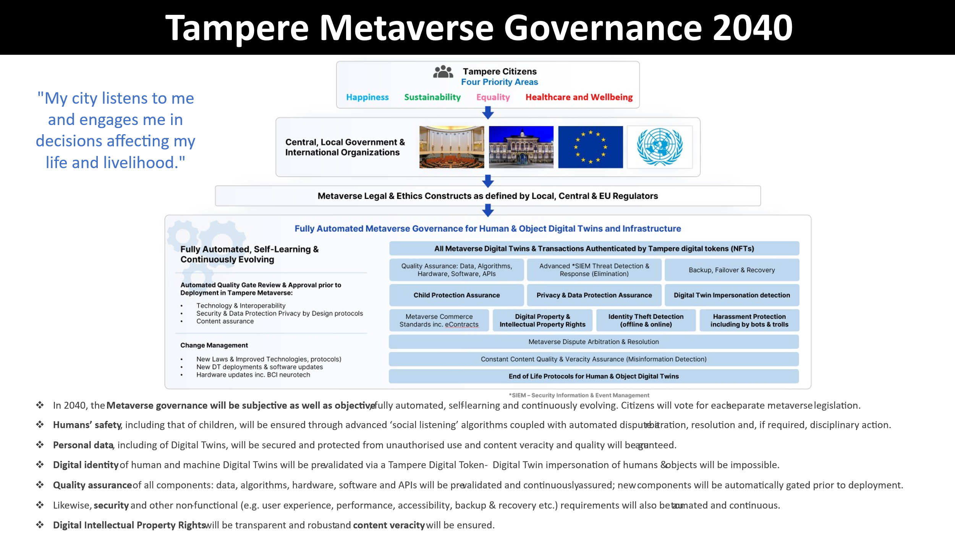
Figure I.5 – Tampere metaverse strategy mechanism [b-Zhang]
The City of Tampere won the World Smart City Award in Enabling Technologies at the Barcelona Smart City World Congress awards ceremony on 8 November 2023. Tampere was honoured for its diverse approaches to harnessing smart technology to enhance the everyday lives of its citizens and businesses. The competition presentation, titled "AI and insight-enabled urban services – social value through data", highlighted the city's versatile use of its smart data centre, the IoT platform, ranging from security solutions to support for businesses. Tampere's IoT platform is pioneering in Finland and Europe, with no other cities having an IoT platform of this scale integrated into daily decision-making. It also boasts remarkable innovation through its user-friendly, application-building features, allowing the city to craft custom applications without the need for coding expertise. These applications can be constructed swiftly, using readily available data, facilitating functions such as traffic planning, real-time traffic data analysis, and the creation of anomaly detection alarms. For instance, in the realm of lighting maintenance, the system's anomaly detection capabilities can alert maintenance personnel via e-mail if any irregularities or issues arise, ensuring timely and efficient responses to potential problems. City officials can custom create applications that serve their daily needs.
Tampere has built multiple AI and insight-enabled new urban services to benefit residents, city staff and business ecosystems in the city. These solutions have been designed with a human-centric and purpose-driven approach and build on Tampere's extensive data and IoT platform, analytics toolkit and intelligent algorithms. In collaboration with other European cities, Tampere is now co-developing an ethical framework to intelligently adjust to the evolving needs of the cities, to utilize AI in responsible ways and taking the steps towards CitiVerse.
The journey to the present has been more than seven years long and has required perseverance and innovation skills from different parts of the city organization. In Tampere, the smart city development curve is now at a point where the results are starting to show. These are, for example, safer streets; safeguarding the elderly from unnecessary falls and the youngest citizens from playground incidents; smarter business decision-making; optimizing opening hours and resource allocation; smoother events; preventing security threats; and ensuring fast response in times of increased flows of people. The smart use of technologies has opened endless opportunities for citizen engagement, such as gamified apps where residents are rewarded for sending feedback on important public matters. It is estimated that just one of the projects highlighted in the proposal, SURE, brought Tampere annual savings of EUR 7.5 million [b-Zhang].

I.4 Queretaro, Mexico and its CitiVerse project, Queretaro Reborn
With more than a million inhabitants, Queretaro is one of the most populated state capitals in Mexico. It lies just three hours north of Mexico City and, being at the centre of some of the most important highways in the country and with an international airport, it is well connected for an ever-growing economy. A historical city, rich in traditions and culture, it is at the same time one of the 10 cities of the future, according to the Ranking of Global Cities of the Future 2021 by the Financial Times, and renowned as a UNESCO World Heritage, Creative City and Learning City. Adding to its allure, the state is also home to the Sierra Gorda, a UNESCO-protected biosphere reserve celebrated for its dramatic canyons and diverse ecosystems. This is shown in Figure I.6.

Figure I.6 – View of Queretaro city, Mexico
In Queretaro, the citizens are put at the centre of the city's evolution. In other words, for all, all innovation must start with considering and giving its place to the person, to the inhabitants whose quality of life is the main criterion for every policy.
Having a well-understood sense of purpose, centred on the absolute value of the person, of each citizen, is the way to promote the more equitable, inclusive, secure and sustainable future the city's inhabitants believe in.
This is also why, during the Mayor of the City of Queretaro's two terms, the city has moved forward with the same mission: to grow today, thinking of the generations of tomorrow; that is, design, build and work in the present but with an eye on the future.
The city is, therefore, committed to innovation and the use of technology to improve people's quality of life, with elements such as:
• Intelligent stations and apps for cyclists.
• Projects developed by companies with global leadership, such as Continental, which provide specialized technology in mobility (vehicle-to-everything system).
• With a strategic installation for security, "C4", which has 6 500 monitoring points and more than 400 citizen-assistance buttons, and integrates applications such as bracelets for the elderly.
• The next Centre for Innovation and Creative Technology, called "BLOQUE", a public space that will place the binomial formed between the talent of Queretaro and the digital industry at the centre of development and quality of life in the city.
The Queretaro Reborn project exemplifies a human-centric approach to CitiVerse development. By prioritising environmental sustainability and citizen well-being, the project implements initiatives such as planting 11 000 trees (reducing annual CO₂ emissions by more than 200 000 tons) and investing in 235 000 square meters of affordable housing, 35 000 square meters of recreational spaces, more than 40 000 square meters of pedestrian zones, and 49 new parking areas. These interventions aim to enhance public spaces, foster community cohesion and improve the overall quality of life for residents.
The project's vision extends beyond infrastructure development. It fosters a sense of collective faith in the city's future, empowering residents, particularly young people and entrepreneurs, to become active participants in shaping a prosperous, innovative and inclusive urban ecosystem. The Queretaro Reborn project aspires to a future CitiVerse that resonates with opportunities for all.

I.5 The Open Urban Platform with digital twin, Rotterdam, the Netherlands
In Rotterdam, the city government foresees a role of the government to create a "responsible" digital infrastructure in the form of a privately developed Open Urban Platform (OUP) combined with an external installed Governance Board that will oversee responsible private exploitation. The OUP would enable all stakeholders within, and later outside, the ecosystem to be digitally connected to each other – civilian, company, knowledge institute, visitor and so on – to exchange data and services with one another.
Rotterdam's urban digital ecosystem: a blueprint for a collaborative CitiVerse
Rotterdam's approach to its urban digital ecosystem, depicted in Figure I.7, is a holistic model for a modern CitiVerse. At its core is the Open Urban Platform (OUP), a privately developed but publicly governed digital foundation built on the city's 3D digital twin. This platform serves as a central hub, enabling seamless data exchange and collaboration among all stakeholders—residents, businesses, knowledge institutes and visitors. The city's strategy is comprehensive, addressing key urban challenges in public space, sustainability, safety and smart mobility, while also fostering entrepreneurship and healthy living. By prioritizing fundamental conditions such as privacy, ethics and data ownership from the outset, Rotterdam is not only building a technical infrastructure but also a framework of trust. This model, which emphasizes interoperability with neighbouring cities, showcases a forward-thinking vision, where the digital ecosystem is a shared resource for driving innovation and improving the quality of life for all citizens.
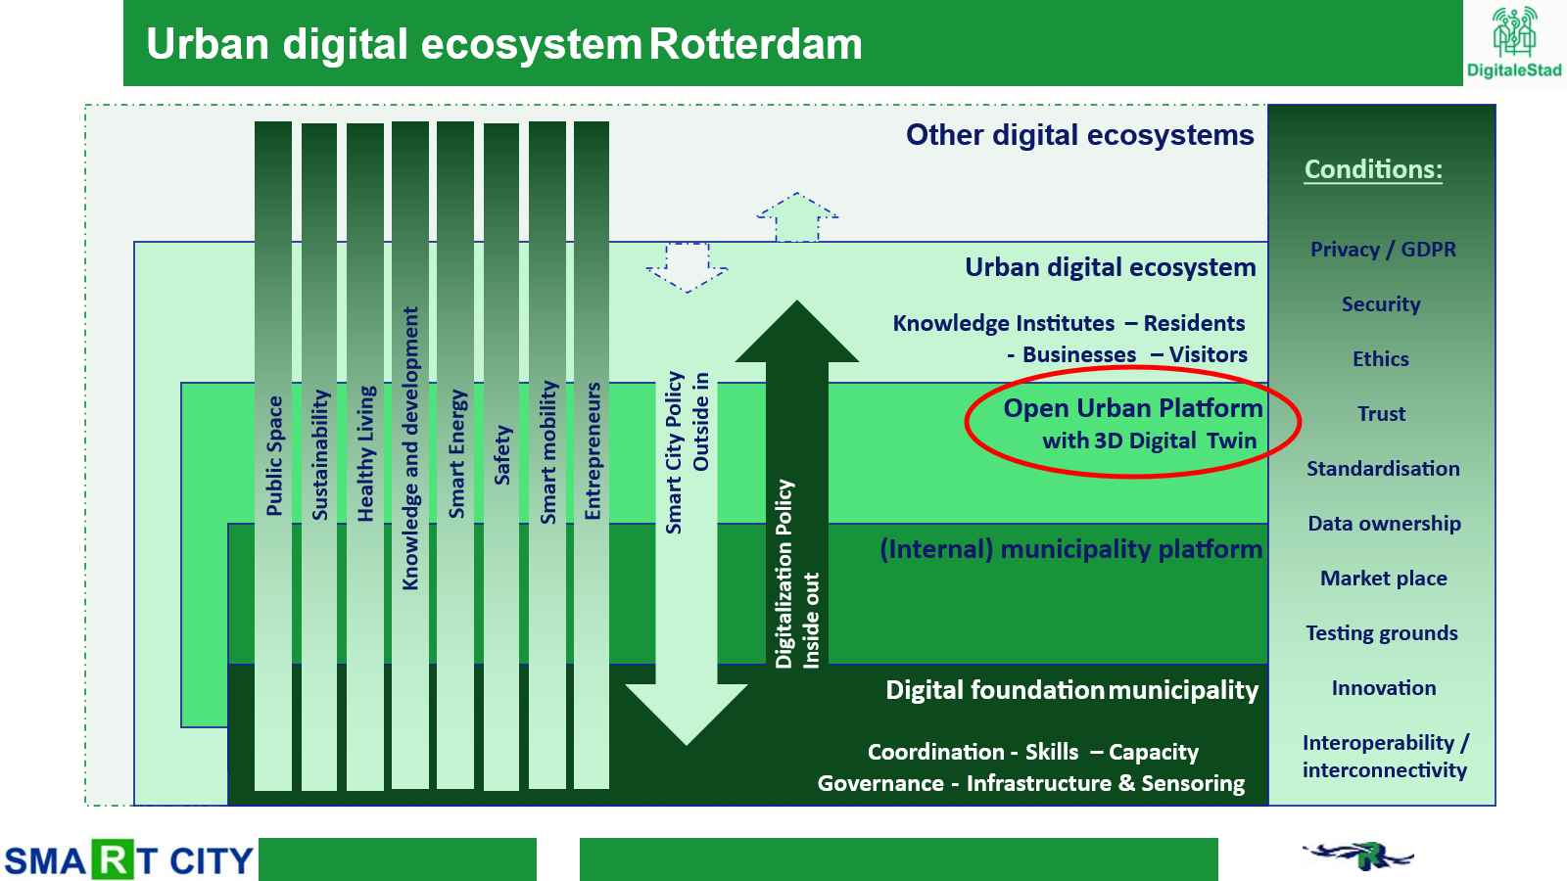

Figure I.7 – Urban digital ecosystem of Rotterdam, the Netherlands
The OUP is developed using the digital twin data concept. The digital twin (DT) gives meaning and direction to the OUP. The OUP will offer the DT to the city as a basic service. The OUP offers all DT data to be re-used through a data marketplace.
For Rotterdam, the digital twin is, therefore, a base for all kinds of smart services and applications to help deal with the new challenges and to use the opportunities. The municipality also developed several new applications (and data sources) itself:
• Co-creation in the digital city – an application to involve citizens more in urban issues in their surroundings and able them to participate and co-create by using all kinds of available digital methods and techniques (e.g., 3D and DT, AR/VR and gamification principles).
• Permit check service – an application in which geo (3D city model/DT) and building information modelling (BIM) models (of new building plans) are brought together and combined with smart rules and regulations ("smart" zoning plans). It then becomes possible to organize the permit process more efficiently, much faster and more transparently.
• SAFE Rotterdam 3D – this application offers the safety department a better information position when they encounter an emergency incident, by presenting them with a DT of the current situation, supplemented with extra data about 3D indoor and the underground.
• DT sustainability – work is carried out with the department for sustainability to create a DT for the sustainability challenges the city faces. This DT will also become the generic bases for all separate applications that are currently in use.
• DT underwater – this DT brings together several datasets from different stakeholders to create a common and shareable image of the underwater world.
• Energy savings potential / solar potential (new data sources) – based on the 3D city model (see Figure I.8), these potential calculations create new generic (use of open data standards), scalable (can be easily scaled to city level) and maintainable (databases are already a maintained data source) data sources.
• Regional cooperation "borderless landscape" (interconnected platforms) – together with the city of The Hague and the province of South Holland, a regional digital infrastructure is built, based on interconnected and interoperable (urban) platforms. Other municipalities and stakeholders can connect to this infrastructure.
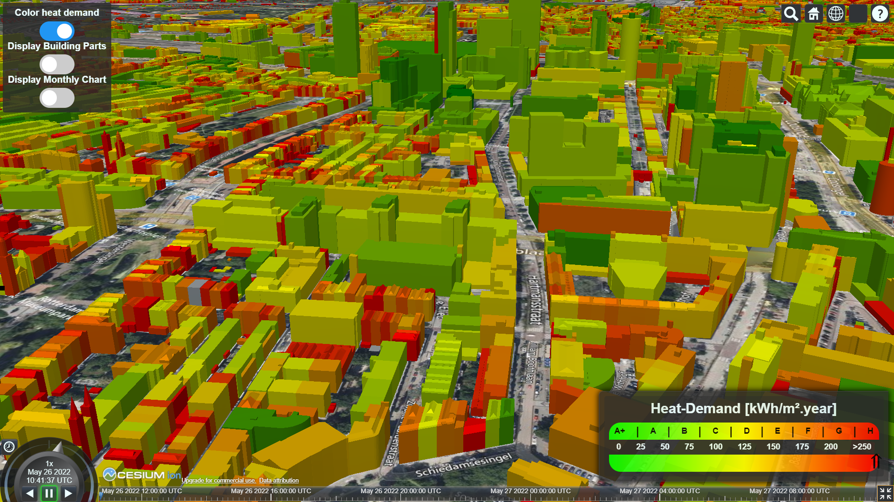
Figure I.8 – Using the 3D city model to calculate energy savings potential
To enhance data availability, the FAIR principles, which stand for findable, accessible, interoperable and re-usable data sources, are applied. The architectural principles behind this are covered by what are called the MIM and PPI approaches.
The MIMs stand for minimal interoperability mechanisms and are pieces of software that contain "a minimum" of functionalities that can work independently on a particular process (for example, checking somebody's identity). By bringing multiple MIMs together, a larger functionality can be created, like an OUP (see Figure I.9).
These MIMs work together based on pivotal points of interoperability (PPIs), which can be seen as standardized connectors between MIMs, based on open data standards. Every piece of software (MIM) knows in which format the data will be supplied and in which format it is expected to deliver its outcome so it can be used by others.
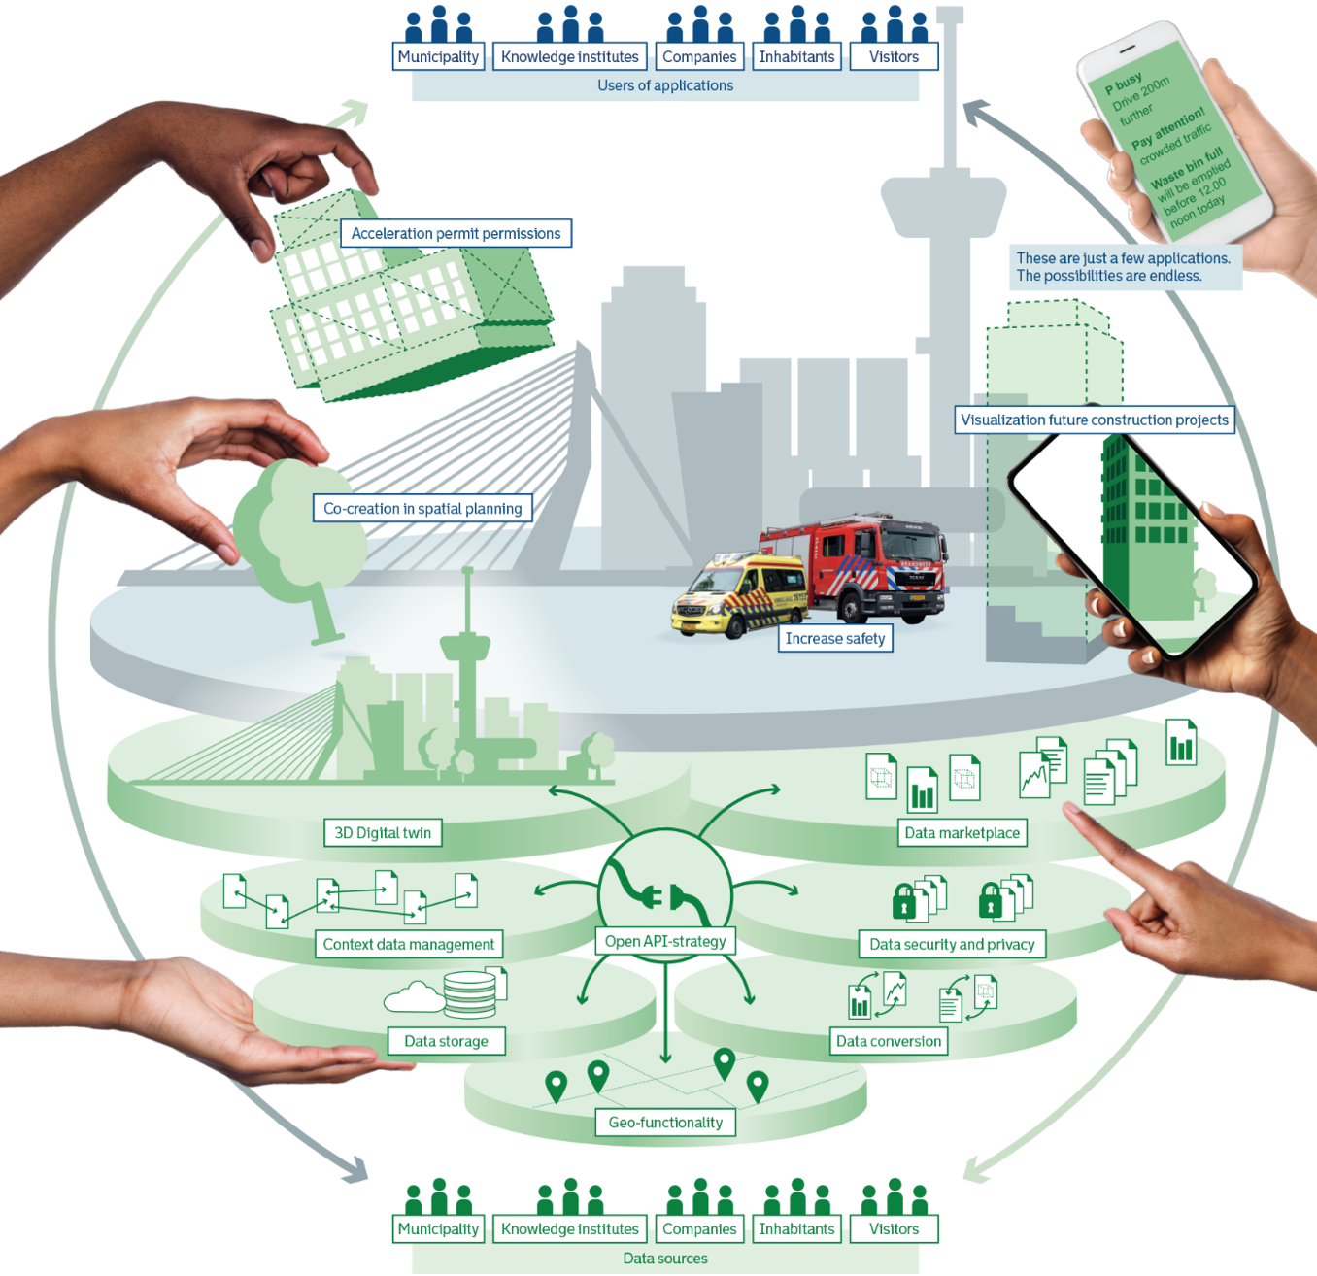
Figure I.9 – OUP with digital twin, with applications, users and data sources
The OUP with digital twin is currently developed and will be fully operational by the end of 2024.
With the development of the digital twin, the focus has been mainly on the physical-digital dimension of the city. But citizens' social lives are also, largely, already digital. Consequently, a logical next step for Rotterdam to take is to develop the digital twin into an urban digital community (UDC) (see Figure I.10), in which the social world will also be fully connected to the OUP. This next step is important to take because, especially on the social-digital dimension, a lot of questions arise regarding digital equality and digital divide, ethics, privacy and transparency, in light of all the new digital developments (e.g., AI, robotics and immersive) coming into the city and disrupting the "traditional" social-physical world.
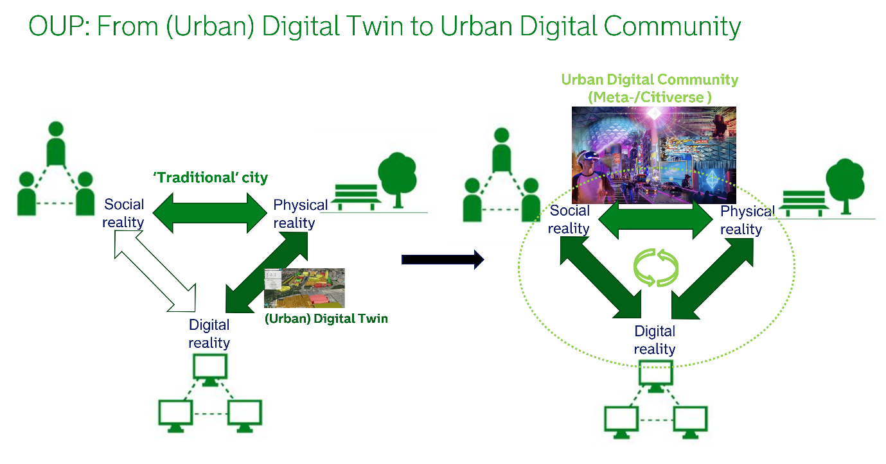
Figure I.10 – From urban digital twin to UDC, Rotterdam, the Netherlands

I.6 Meta/CitiVerse use case for volunteering for peace and development
The Korea International Cooperation Agency (KOICA) is pioneering the use of a CitiVerse for international development with its WFK Town (see Figure I.11) – an innovative digital platform built on ZEP. This initiative is a prime example of how bilateral and multilateral organizations are embracing emergent technology to create a dynamic, accessible hub for volunteerism. By serving as an interactive space for recruitment, leadership development and project showcasing, WFK Town transforms the traditional volunteering model. It offers a new, immersive way for young people to engage with global development, overcoming geographical barriers and providing a space for digital collaboration that can significantly expand the reach and impact of international cooperation efforts.
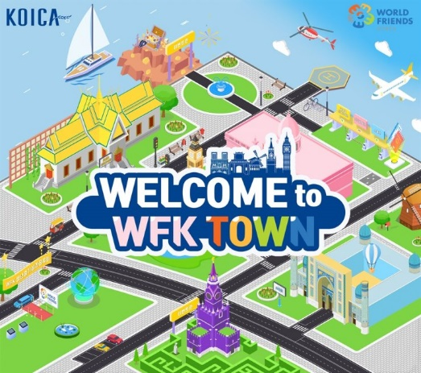
Figure I.11 – WFK Town on the ZEP metaverse for volunteering
Per public sources, the Korea International Cooperation Agency (KOICA) has launched a volunteer-driven CitiVerse called World Friends Korea (WFK) Town on the ZEP metaverse platform, aimed at young individuals interested in volunteering abroad or pursuing careers in international development.
This announced initiative comes amidst a global push for digitalization of volunteering as part of a broader digital transformation movement that offers an opportunity to weave digital volunteering opportunities in bilateral and multilateral development cooperation efforts globally.
The WFK Town was reported to serve as a hub for interactive communications, featuring sections for volunteer recruitment, fostering global leadership, and interactive communications.
A reported event in this volunteer-involving CitiVerse included a disbandment ceremony for a WFK youth volunteer group, showcasing their project achievements, such as providing eco-friendly training in Cambodia and raising awareness of unexploded ordnance in Laos.
The WFK Town initiative is an excellent use case, as bilateral and multilateral development cooperation entities adapt to emergent technologies and further integrate digital aspects into volunteer-involving programmatic activities. This includes extending remote and online volunteering opportunities through CitiVerse that can leverage powerful digital analytical tools for optimizing volunteer experience and the SDGs impact that volunteers bring to the communities being served.
Volunteer-led initiatives that scale volunteering opportunities in CitiVerse can engage interested individuals, especially young people interested in international development cooperation, by providing access to development cooperation projects through the metaverse while offering metaverse volunteers various services, including learning opportunities and dynamic volunteer experiences.
Volunteering in an international development CitiVerse offers opportunities for individuals to contribute to causes related their personal and professional interests, connect with local and global communities, develop valuable skills, promote cross-cultural understanding, and address pressing challenges faced by communities, while providing novel insights and data on volunteerism.

I.7 EDIC on local digital twins towards the CitiVerse
A European Digital Infrastructure Consortium (EDIC) is an instrument made available to Member States under the Digital Decade Policy Programme 2030 (see Figure 1.12), to speed up and simplify the set-up and implementation of multicountry projects. Each EDIC is a legal person established by a Commission decision upon the application of at least three Member States and Commission approval. The founding Member States define the EDIC´s governance structure and other functioning rules in the Statutes. Its budget will be based on its members' contributions complemented by other sources of revenues, which may include EU and national grants.
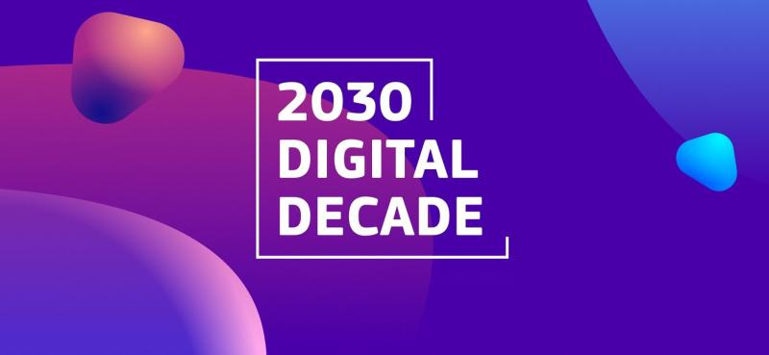
Figure I.12 – EU's 2030 Digital Decade
To date, the European Commission has only published an implementing Commission Decision for two EDICs (on 1 February 2024). One of them is the EDIC on local digital twins towards the CitiVerse, promoted by Directorate General for Communications Networks, Content and Technology (DG CONNECT).
In addition, the Valencia City Council who hosts the EDIC seat for Spain, through its smart city service, will initially chair the EDIC Assembly – the highest-governing and decision-making body of the Consortium.
At present, eight countries are part of this EDIC as founders (Croatia, Czechia, Estonia, France, Latvia, Portugal, Slovenia and Spain), in addition to three others that have formalized their request (Belgium, Luxembourg and Slovakia). The forecast is that many more will join soon.
Beyond collaborating on the Digital Europe Programme (DEP) of the European Commission procurement for the development of the EU's Local Digital Twin toolbox, which will become its first infrastructure, this EDIC will establish a common understanding and the first steps of a European CitiVerse, laying down the foundation for the EU CitiVerse and pursuing joint activities among the members (e.g., joint public procurement or shaping the supply market). It will gather and maintain existing infrastructure solutions that have been developed by individual Member States or, in the context of the DEP, for cities and local communities, and provide a long-term sustainability mechanism for these.
In particular, the EDIC will serve as the long-term sustainability mechanism for the EU's smart communities data space, the EU's Local Digital Twin toolbox of components, reference architectures, building blocks and models that will be made available to all communities in Europe. It can host new services and applications, including those developed by the smart communities dataspace and the testing and experimentation facilities.
Within the objectives of EDIC on local digital twins towards the CitiVerse are to gather relevant national and local initiatives in this area; to join forces to establish cooperation at the EU level and share related assets; to create an EU common national and EU infrastructure and solutions; to establish the EU reference hub on capacity-building actions; to foster the technical interoperability of data and services by introducing common agreements and standards; and to identify and aggregate common assets from EDIC members, which can create greater value to IPR owners by common delivery and service. In a nutshell, EDIC aims to foster cooperation for developing new innovative ideas for digital twins and CitiVerse.

Appendix II

ITU survey on CitiVerse
(This appendix does not form an integral part of Technical Report.)
As cities face numerous challenges, including population growth, aging infrastructure, environmental degradation and energy consumption, the concept of CitiVerse has become increasingly popular with governments worldwide. CitiVerse often uses a combination of emerging technologies within the metaverse ecosystem, such as AI, IoT, blockchain and digital twin, to create smarter, more sustainable and inclusive cities.
1. How do you imagine the CitiVerse?
2. How do you see the CitiVerse? As an extension of the physical city? As an abstraction of the physical city? As both? Please explain briefly.
3. What are the main challenges for your cities to use metaverse-related technologies to develop people-centred future cities?
4. What are the new opportunities that metaverse-related technologies bring to address existing challenges being faced by cities?
5. If you see effective case studies involving the use of metaverse-related technologies to create more inclusive, more sustainable cities, please provide more details here.
6. What are the key areas of cities that can benefit from using metaverse-related technologies, and how?
7. Does your country or institution have a plan for developing CitiVerse in the next five years? (Yes/No). If yes, can you share main highlights of the plan?

Bibliography

[b-ITU-T L.1600] Recommendation ITU-T Y.4900/L.1600 (2016), Internet of things and smart cities and communities – Overview of key performance indicators in smart sustainable cities.
[b-ITU-T Y.2060] Recommendation ITU-T Y.4000/Y.2060 (2012), Overview of the Internet of things.
[b-ITU-T Y.4904] Recommendation ITU-T Y.4904 (2019), Smart sustainable cities maturity model. https://www.itu.int/ITU-T/recommendations/rec.aspx?id=13864
[b-ITU FGMV-20] ITU (2023), FGMV-20 Definition of metaverse. https://www.itu.int/en/ITU-T/focusgroups/mv/Documents/List%20of%20FG-MV%20deliverables/FGMV-20.pdf
[b-ITU 1] ITU (2023), Global offline population steadily declines to 2.6 billion people in 2023. https://www.itu.int/en/mediacentre/Pages/PR-2023-09-12-universal-and-meaningful-connectivity-by-2030.aspx
[b-ITU 2] ITU (2023), Modules – Toolkit on digital transformation for people-oriented cities and communities. https://toolkit-dt4c.itu.int/modules/
[b-ITU 3] ITU (2023), Call to Action: Cities and the metaverse: shaping a citiverse for all in Africa. https://www.itu.int/cities/wp-content/uploads/2023/09/Tanzania-Arusha-Call-to-Action.pdf
[b-ITU 4] ITU (2023), Call to Action: Building virtual worlds including the metaverse for a people-centred, connected and inclusive Europe. https://www.itu.int/metaverse/2nd-special-session-fg-mv/
[b-ABI Research] ABI Research (2023), Urban Metaverse: Use Cases, Applications, and Technologies. https://www.abiresearch.com/press/close-to-700-cities-to-deploy-urban-metaverse-functionality-by-2030-enabling-citizen-centric-and-smart-infrastructure-use-cases/
[b-Abukmeil] Abukmeil, M., Ferrari, S., Genovese, A., Piuri, V., & Scotti, F. (2021), A Survey of Unsupervised Generative Models for Exploratory Data Analysis and Representation Learning. ACM Computing Surveys, Journal of AI, Vol. 54, No. 5, pp.1-40. https://doi.org/10.1145/3450963
[b-Ahmad] Ahmad, H., Rafique, W., Rasool, R., Alhumam, A., Anwar, Z., and Qadir, J. (2023), Leveraging 6G, extended reality, and IoT big data analytics for healthcare: A review. Computer Science Review, Vol. 48. https://doi.org/10.1016/j.cosrev.2023.100558
[b-Ahmed] Ahmed, E., Yaqoob, I., Hashem, I. A. T., Khan, I., Ahmed, A. I. A., Imran, M., and Vasilakos, A. V. (2017), The role of big data analytics in Internet of Things. Computer Networks, Vol. 129, pp. 459-471. https://doi.org/10.1016/j.comnet.2017.06.013
[b-Attaran] Attaran, M., Celik, B. (2023), Digital Twin: Benefits, use cases, challenges, and opportunities, Decision Analytics Journal, Vol. 6, pp.100-165. https://doi.org/10.1016/j.dajour.2023.100165
[b-Bates] Bates, A. (2024), AI in Pharma and Medicine: What's in store for 2024? https://eularis.com/ai-in-pharma-and-medicine-whats-in-store-for-2024/
[b-Bordukova] Bordukova, M., Makarov, N., Rodriguez-Esteban, R., Schmich, F., and Menden, M. (2024), Generative artificial intelligence empowers digital twins in drug discovery and clinical trials. Expert Opinion on Drug Discovery, Vol 19, pp. 33-42.
[b-Felice] Felice, F., Luca, C., Chiara, S., Petrillo, A. (2023), Physical and digital worlds: implications and opportunities of the metaverse, Procedia Computer Science, Vol.217, pp.1744-1754. https://doi.org/10.1016/j.procs.2022.12.374
[b-Gartner] Gartner (2023), Augumented Reality (AR).https://www.gartner.com/en/information-technology/glossary/augmented-reality-ar
[b-Geospatial World] Geospatial World (2022), In its Simplest Form, Metaverse is the Digital Extension of a Smart City. https://www.geospatialworld.net/prime/in-its-simplest-form-metaverse-is-the-digital-extension-of-a-smart-city/
[b-Groombridge] Groombridge, D., Karamouzis, F., and Chandrasekaran, A. (2021), Top strategic technology trends for 2022. https://www.gartner.com/en/newsroom/press-releases/2021-10-18-gartner-identifies-the-top-strategic-technology-trends-for-2022
[b-Gui] Gui, J., Sun, Z., Wen, Y., Tao, D., and Ye, J. (2023), A Review on Generative Adversarial Networks: Algorithms, Theory, and Applications. IEEE Transactions on Knowledge and Data Engineering. Vol.35, No. 4, pp.3313−3332. https://dl.acm.org/doi/10.1109/TKDE.2021.3130191
[b-Heussner] Heussner, K. (2022), THE BEST INVENTIONS OF 2022 A Virtual Public Square Metaverse Seoul. https://time.com/collection/best-inventions-2022/6226981/metaverse-seoul/#:~:text=A%20Virtual%20Public%20Square&text=The%20City%20of%20Seoul,play%20games%20in%20Seoul%20Plaza
[b-Hoffmann] Hoffmann, J., Bauer, P., Sandu, I., Wedi, N., Geenen, T., Thiemert, D., (2023), Destination Earth – A digital twin in support of climate services, Climate Services, Vol.30. https://doi.org/10.1016/j.cliser.2023.100394
[b-Hu] Hu, L. (2022), Generative AI and Future. https://pub.towardsai.net/generativeai-and-future-c3b1695876f2
[b-Hupont Torres] Hupont Torres, I., Charisi, V., De Prato, G., Pogorzelska, K., Schade, S., Kotsev, A., Sobolewski, M., Duch Brown, N., Calza, E., Dunker, C., Di Girolamo, F., Bellia, M., Hledik, J., Nai Fovino, I. and Vespe, M., (2023), Next Generation Virtual Worlds: Societal, Technological, Economic and Policy Challenges for the EU, Luxembourg, Publications Office of the European Union. https://publications.jrc.ec.europa.eu/repository/handle/JRC133757
[b-Huynh-The] Huynh-The, T., Pham, Q., Pham, X., Nguyen, T., Han, Z., Kim, D. (2023), Artificial intelligence for the metaverse: A survey, Engineering Applications of Artificial Intelligence, Vol.117, Part A. https://doi.org/10.1016/j.engappai.2022.105581
[b-Lawton] Lawton (2023), How Singapore created the first country-scale digital twin in Venture Beat. https://venturebeat.com/business/how-singapore-created-the-first-country-scale-digital-twin/
[b-Jovanović] Jovanović, M. (2023), Generative Artificial Intelligence: Trends and Prospects. Generative Artificial Intelligence: Trends and Prospects | IEEE Journals & Magazine | IEEE Xplore
[b-Kung] Kung, A. (2023), Report of TWG CitiVerse: Standardisation Landscape for CitiVerse. https://zenodo.org/records/10262579
[b-Kim] Kim, Y., Yoo, S., Lee, H., Kim, S. (2020), Characterization of Digital Twin. https://www.researchgate.net/publication/353930234_Characterization_of_Digital_Twin
[b-Li] Li, B., Luo, Z., Mao, B. (2022), Non-photorealistic Visualization of 3D City Models using Visual Variables in Virtual Reality Environments, Procedia Computer Science, Vol. 214, pp.1516-1521. https://doi.org/10.1016/j.procs.2022.11.338
[b-Marketsandmarkets] Marketsandmarkets (2025), Digital Twin Market Size, Share & Trends. https://www.marketsandmarkets.com/Market-Reports/digital-twin-market-225269522.html
[b-NationalGrid] National Gird (2021), National Grid ESO launches world-first programme to digitise Great Britain's energy system and advance the transition to net zero. https://www.nationalgrideso.com/document/217536/download
[b-NCPFlanders] NCP Flanders (2023), Info day for the Developing CitiVerse call topic. https://ncpflanders.be/activities/info-day-on-developing-cityverse-call
[b-Othman] Othman, A., and Ghoul, O. (2022), BuHamad – The first Qatari virtual interpreter for Qatari Sign Language. Nafath, Vol.7, No. 20. https://doi.org/10.54455/mcn.20.01
[b-Qatar Government] Qatar Government (2024), MCIT Enters a New Era of Digital Transformation with the Launch of the Digital Agenda 2030. https://www.mcit.gov.qa/en/media-center/news/mcit-enters-new-era-digital-transformation-launch-digital-agenda-2030
[b-Rogers] Rogers, E., Singhal, A., and Quinlan, M. (2014) Diffusion of innovations in an integrated approach to communication theory and research (pp. 432-448). Routledge.
[b-Seoul-Metavers] Seoul Metaverse Government (2023), Official release of Metaverse Seoul. https://english.seoul.go.kr/official-release-of-metaverse-seoul/
[b-Shi] Shi, F., Ning, H, Zhang, X., Li, R, Tian, Q., Zhang, Q., Zheng. Y., Guo, Y., Daneshmand, M. (2023), A new technology perspective of the Metaverse: Its essence, framework and challenges, Digital Communications and Networks. https://doi.org/10.1016/j.dcan.2023.02.017
[b-Squareyards] https://www.squareyards.com/blog/new-3d-metaverse-platform-launched-for-real-estate-in-dubai-by-square-yards
[b-Stokel-Walker]
[b-Times Now News] Times Now News (2022), Conjoined Twin whose brains were fused together have been separated in 27-hour surgery. https://www.timesnownews.com/viral/conjoined-twins-whose-brains-were-fused-together-have-been-separated-in-a-27-hour-surgery-article-93296188
[b-Tokyo] Tokyo (2021), Tokyo is creating the future with digital transformation. https://www.metro.tokyo.lg.jp/english/governor/speeches/2021/0928/05.html
[b-UAE] UAE (2022), Dubai Metaverse Strategy. https://u.ae/en/about-the-uae/strategies-initiatives-and-awards/strategies-plans-and-visions/government-services-and-digital-transformation/dubai-metaverse-strategy
[b-Unity] Unity (2023), Flying into the metaverse with YVR's digital twin. https://unity.com/case-study/vancouver-airport-authority
[b-Wellington] Wellington (2023), Wellington's Bloomberg Global Mayors Challenge Winning Project. https://wellington.govt.nz/your-council/projects/bloomberg-global-mayors-challenge
[b-Wellington 2] Te Atakura – First to Z Wellington (2023), Te Atakura – First to Zero. https://wellington.govt.nz/your-council/plans-policies-and-bylaws/policies/te-atakura
[b-Yang] Yang, S. (2023), Storytelling and user experience in the cultural metaverse, Heliyon, Vol. 9, No.4. https://www.sciencedirect.com/science/article/pii/S2405844023019667
[b-Zalan] Zalan, T., Barbesino, P., (2023), Making the metaverse real, Digital Business, Vol.3, No. 2. https://doi.org/10.1016/j.digbus.2023.100059.
[b-Zhang] Zhang, C., You, N., Kerimi, D., El Adl, A., and Roberts, R. (2023) Tampere Metaverse Vision 2040 – The World's First People-Centred Metaverse Strategy. https://www.tampere.fi/sites/default/files/2023-08/tampere_metaverse_vision_2040_web.pdf
________________

