Standardization Sector
ITU Focus Group Technical Specification
(04/2024)
ITU Focus Group on metaverse
Requirements, functional framework and capability of IoT for metaverse
Working Group 3: Architecture & Infrastructure
ITUPublications | International Telecommunication Union


Technical Specification ITU FGMV-31
Requirements, functional framework and capability of IoT for metaverse
Summary
This Technical Specification provides requirements, functional framework and capability of Internet of things (IoT) for metaverse, including general requirements, high-level reference frameworks and associated capabilities.
Keywords
Functional framework, Internet of things (IoT), metaverse, requirements.
Note
This is an informative ITU-T publication. Mandatory provisions, such as those found in ITU-T Recommendations, are outside the scope of this publication. This publication should only be referenced bibliographically in ITU-T Recommendations.
Change Log
This document contains Version 1.0 of the ITU Technical Specification on "Requirements, functional framework and capability of IoT for metaverse" approved at the 6th meeting of the ITU Focus Group on metaverse (FG-MV) held virtually on 30 April 2024.
Acknowledgements
This Technical Specification was researched and written by Yi Xie (China Mobile, China), Chao Ma (CAICT, China), Jie Cheng (China Mobile, China), Ye Sun (CAICT, China), Minshi Chen (China Mobile, China), Yue Wang (China Mobile, China), and Dong Chen (China Mobile, China) as a contribution to the ITU Focus Group on metaverse (ITU FG-MV). The development of this document was coordinated by Hideki Yamamoto (OKI, Japan), as FG-MV Working Group 3 Chair.
Additional information and materials relating to this report can be found at: https://www.itu.int/go/fgmv. If you would like to provide any additional information, please contact Cristina Bueti at tsbfgmv@itu.int.
Editor: | Yi Xie  China Mobile  China | Tel: +86 13910866107  E-mail: xieyi@chinamobile.com
Editor: | Chao Ma  CAICT China  China | Tel: +86 18612866101  E-mail: machao@caict.ac.cn
Editor: | Jie Cheng  China Mobile  China | Tel: +86 13811723151  E-mail: chengjiewl@chinamobile.com
Editor: | Ye Sun  CAICT China  China | Tel: +86 18515231106  E-mail: sunye1@caict.ac.cn
Editor: | Minshi Chen  China Mobile  China | Tel: +86 13911773802  E-mail: chenminshi@chinamobile.com
Editor: | Yue Wang  China Mobile  China | Tel: +86-13911924072  E-mail: wangyuewl@chinamobile.com
Editor: | Dong Chen  China Mobile  China | Tel: +86-13910765767  E-mail: chendongwl@chinamobile.com
WG3 Chair: | Hideki Yamamoto  OKI  Japan | E-mail: yamamoto436@oki.com

© ITU 2025
Some rights reserved. This publication is available under the Creative Commons Attribution-Non Commercial-Share Alike 3.0 IGO licence (CC BY-NC-SA 3.0 IGO; https://creativecommons.org/licenses/by-nc-sa/3.0/igo).
For any uses of this publication that are not included in this licence, please seek permission from ITU by contacting TSBmail@itu.int.

Table of Contents
Page
1 Scope 1
2 References 1
3 Terms and definitions 1
3.1 Terms defined elsewhere 1
3.2 Terms defined in this Technical Specification 1
4 Abbreviations 2
5 Conventions 2
6 Introduction 2
6.1 Object linking in virtual worlds in metaverse and the physical world 2
6.2 The concept of MVIoT 3
6.3 User devices and IoT devices connecting to MVIoT 4
7 Requirements of MVIoT 5
7.1 Communication requirements 5
7.2 Computation requirements 5
7.3 Interaction requirements 5
7.4 Spatio-temporal consistency requirements 6
7.5 Security requirements 6
7.6 Extensibility requirements 6
8 Functional framework of MVIoT 6
9 Service support and application support layer capabilities of MVIoT 7
9.1 IoT enabler capability for L1-MV 7
9.2 IoT enabler capability for L2-MV 8
Bibliography 9

Technical Specification ITU FGMV-31
Requirements, functional framework and capability of IoT for metaverse

1 Scope
This Technical Specification provides the requirements, functional framework and capabilities of the Internet of things (IoT) for metaverse. The scope of this Technical Specification includes:
– Requirements of the metaverse using IoT enablement
– Functional framework of the metaverse using IoT enablement
– Capabilities of the metaverse using IoT enablement

2 References
[ITU-T Y.4000] Recommendation ITU-T Y.4000/Y.2060 (2012), Overview of the Internet of things.
[ITU-T Y.4401] Recommendation ITU-T Y.4401/Y.2068 (2015), Functional framework and capabilities of the Internet of things.
[ITU FGMV-20] ITU Focus Group Technical Specification FGMV-20 (2023), Definition of Metaverse.

3 Definitions

3.1 Terms defined elsewhere
This Technical Specification uses the following terms defined elsewhere:
3.1.1 application [b-ITU-T Y.2091]: A structured set of capabilities, which provide value-added functionality supported by one or more services, which may be supported by an API interface.
3.1.2 device [ITU-T Y.4000]: With regard to the Internet of things, this is a piece of equipment with the mandatory capabilities of communication and the optional capabilities of sensing, actuation, data capture, data storage and data processing.
3.1.3 Internet of things (IoT) [ITU-T Y.4000]: A global infrastructure for the information society, enabling advanced services by interconnecting (physical and virtual) things based on existing and evolving interoperable information and communication technologies.
3.1.4 metaverse [ITU FGMV-20]: An integrative ecosystem of virtual worlds offering immersive experiences to users, that modify pre-existing and create new value from economic, environmental, social and cultural perspectives.
NOTE – A metaverse can be virtual, augmented, representative of, or associated with the physical world.
3.1.5 physical world [b-ISO/IEC 18039]: Physical reality spatial organization of multiple physical objects.
3.1.6 virtual world [b-ISO/IEC 18039]: Virtual environment, spatial organization of multiple virtual objects, potentially including global behaviour.

3.2 Terms defined in this Technical Specification
None.

4 Abbreviations and acronyms
This Technical Specification uses the following abbreviations and acronyms:
AR Augmented Reality
GNSS Global Navigation Satellite System
IoT Internet of Things
L1-MV One-way (uni-directional) Link object Metaverse
L2-MV Two-way (bi-directional) Link object Metaverse
MVIoT Metaverse using IoT enablement functionality
NL-MV No-Link object Metaverse
PII Personally Identifiable Information
VR Virtual Reality

5 Conventions
The following conventions are used:
The keywords "is required to" indicate a requirement which must be strictly followed and from which no deviation is permitted, if conformance to this Technical Specification is to be claimed.
The keywords "is recommended" indicate a requirement that is recommended but which is not required. Thus, this requirement need not be present to claim conformance.

6 Introduction

6.1 Object linking in virtual worlds in metaverse and the physical world
The metaverse is an integrative ecosystem of virtual worlds offering immersive experiences to users that modify the pre-existing value and create new value from economic, environmental, social and cultural perspectives [ITU FGMV-20]. Metaverse can be categorized into the following three types by virtual object features:
– No-link object metaverse (NL-MV): In this type, the virtual world in metaverse consists of virtual objects in metaverse that do not link to the physical objects directly. To offer immersive experiences to users, the virtual objects in metaverse may be mapped to the physical objects in the world conceptually. However, in this type, the change of physical objects will not be reflected to virtual objects in metaverse and vice versa. For example, the game metaverse is a kind of NL-MV. In the game metaverse, users can break through the reality of physical world rules and create native experiences. The similarity between the physical world and the virtual world is less; the avatars flying as birds in the game metaverse will not be reflected to the corresponding users in the physical world.
– One-way (uni-directional) link object metaverse (L1-MV): In this type, the virtual world in metaverse consists of virtual objects in metaverse that link to the physical objects directly but the direction of the link is one way, which is from the objects in the physical world to objects in the virtual world. With a one-way link from the physical world to the virtual world, only changes in physical objects in metaverse will be reflected to the virtual objects in the virtual world. For example, to build a virtual Yangtze River in the virtual world, it is necessary to deploy numerous sensors in the Yangtze River in the physical world. Only by capturing the changes in the water level of the Yangtze River in real-time can a virtual Yangtze River in the virtual world be built that is exactly the same as the Yangtze River in the physical world. There is more similarity between the physical world and virtual world, but the changes in the Yangtze River in the virtual world will not be reflected in the Yangtze River in the physical world.
– Two-way (bi-directional) link object metaverse (L2-MV): In this type, two types of L1-MV are available. In this type, the virtual objects in metaverse can interact with the physical objects in the physical world. The changes in virtual objects are reflected in the change in the physical world and vice versa. For example, in the L2-MV, a virtual dam corresponding to the dam on the Yangtze River in the physical world is constructed. The virtual dam is capable of receiving real-time data from sensors deployed on the dam in the physical world, such as water flow, water level and structural integrity. At the same time, it can simulate the effects of various operations on the virtual dam, such as opening or closing the dam gates. With the bi-directional link between the physical world and the virtual one, remote control over the physical dam can be achieved. In response to a predicted flood, the virtual dam can automatically calculate the optimal timing and degree of gate opening, to minimize flood damage while also preserving water resources. Similarly, during drought conditions, it can optimize water release to ensure the sustainability of downstream ecosystems and communities.
There are several technologies to realize L1-MV and L2-MV. One technology is digital twins. A reference model for the metaverse based on a digital twin enabling is described in [b-ITU FGMV-29]. Another technology is IoT, specified in [ITU-T Y.4000] and [ITU-T Y.4401].
This Technical Specification describes metaverse using IoT enablement functionality (MVIoT) to realize L1-MV or L2-MV by IoT. In the following sub-clause and clauses, the concept of MVIoT, user devices and IoT devices connecting to MVIoT, and the requirements, functional framework and capabilities of MVIoT are provided.

6.2 The concept of MVIoT
With a multitude of IoT devices ranging from sensors to actuators, each operating on different protocols, the integration of these disparate IoT devices into a cohesive metaverse system poses a significant challenge. IoT enablers bridge the gap between various IoT devices by providing standardized interfaces and protocols for seamless connectivity. Moreover, IoT enablers streamline the management and orchestration of diverse IoT devices within the metaverse, ensuring efficient data exchange and coherent operation.
The MVIoT provides users with a real, lasting and smooth interactive experience of seamlessly switching between the virtual and physical worlds by utilizing IoT enablers to facilitate the acquisition of physical environment data and its transformation into virtual world data for achieving seamless integration between the physical and virtual environments and enabling real-time monitoring of the physical environment status and layout within the virtual world. The MVIoT also utilizes IoT enablers to map IoT devices from the physical world into the virtual world to enable users to interactively manage and operate IoT devices remotely through the virtual world. The overview of MVIoT is shown in Figure 1. It can be used in the metaverse specified in [b-ITU FGMV-15].
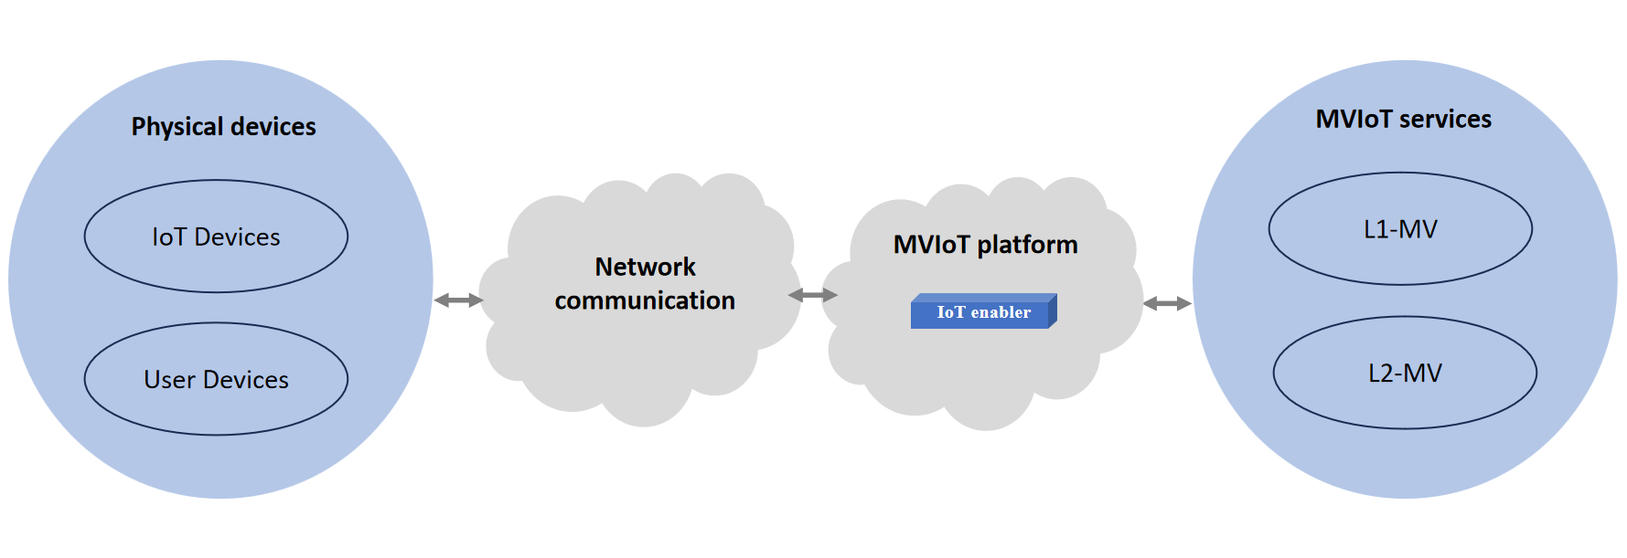
Figure 1 – The overview of MVIoT

6.3 User devices and IoT devices connecting to MVIoT
Physical devices connecting to MVIoT can be categorized into the following two types, according to whether the user owns and operates.
– User devices: equipment for the starting point and ending point of traffic, owned and operated by users [b-ITU-T Y.3121]. In the MVIoT, users use this kind of device to interact and change the situation in metaverse. User devices include brain interfaces, augmented reality (AR)/virtual reality (VR) devices, microphones, gesture recognition, haptic devices, game controllers and so on. The most important feature of "user devices" in the MVIoT is that user devices are necessary for metaverse to be used. As the data of user devices are sent to or received from the metaverse platform, it is required that the metaverse platform receives data from user devices to change the situation of metaverse based on users' intentions. Furthermore, it is required that the metaverse platform generates information in metaverse and sends data to user devices to make users understand the situation of metaverse. This type of device will not have the corresponding virtual object in the virtual world to show; however, the information generated by this kind of device and the information sent to this kind of device are reflected in the avatar in metaverse.
– IoT devices: with regard to IoT, these are pieces of equipment with the mandatory capabilities of communication and the optional capabilities of sensing, actuation, data capture, data storage and data processing [ITU-T Y.4000]. In the MVIoT, this type of device is not handled by users in the physical world. The IoT devices include sensors such as cameras, water quality monitors, temperature monitors and other IoT devices to change the physical world situation, such as robot arms, water valves and door locks. The most important feature of IoT devices in the MVIoT is that the devices are necessary to obtain real-world environmental data and realize virtual and real interaction. There is a requirement for communication capabilities to transmit data to the virtual world and achieve interaction between the virtual world and the physical one. Some of these types of devices may appear as objects in metaverse. For example, in the MVIoT, users can control smart home devices in the physical world through virtual entities, or operate robots in the physical world through virtual controllers.
Figure 2 shows the overview of user devices and IoT devices connecting to MVIoT.
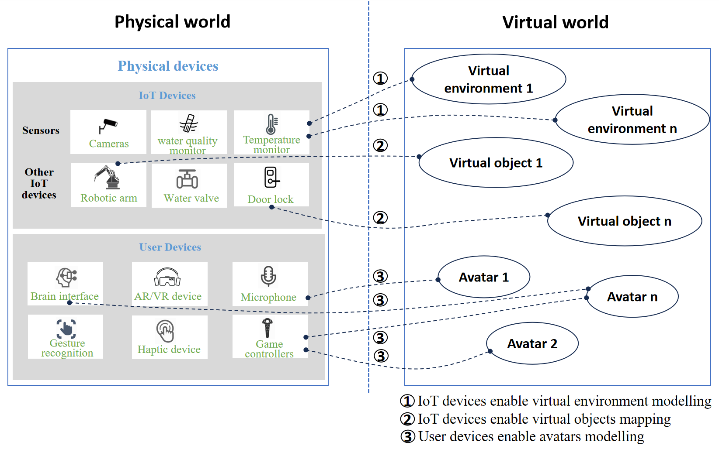
Figure 2 – The overview of user devices and IoT devices connecting to MVIoT

7 Requirements of MVIoT

7.1 Communication requirements
– [CommR-ReqR-1] It is required that MVIoT forms a link between IoT devices and the MVIoT services.
– [CommR-RecR-1] It is recommended that MVIoT forms a responsive and uninterrupted link between IoT devices and the MVIoT services.

7.2 Computation requirements
– [CompR-RecR-1] It is recommended that MVIoT supports cloud computing and multi-access edge computing technologies for data analysis, scene/object recognition and modelling.
– [CompR-RecR-2] It is recommended that MVIoT has a diversity of computational capabilities; it is also recommended that the communication infrastructure and the metaverse service platform have computational capacities.
– [CompR-RecR-3] It is recommended that MVIoT supports the collaborative management and scheduling of computing resources, to achieve the optimal performance of metaverse service performance.

7.3 Interaction requirements
– [IR-RecR-1] It is recommended that MVIoT supports protocol identification and conversion for IoT devices to integrate diverse IoT devices into the MVIoT platform.
– [IR-RecR-2] It is recommended that MVIoT supports mappings between IoT devices in the physical world and corresponding virtual objects in the virtual world, to ensure consistency and accuracy.
– [IR-RecR-3] It is recommended that MVIoT supports real-time feedback and response from the virtual world to the physical world, to operate and manage IoT devices in the physical world.
– [IR-RecR-4] It is recommended that MVIoT supports real-time feedback and response from the physical world to the virtual world, to operate and manage virtual objects or avatars in the virtual world.
– [IR-RecR-5] It is recommended that MVIoT enables IoT devices to instantly understand and respond to operational instructions, to realize immediate interaction and feedback.

7.4 Spatio-temporal consistency requirements
– [SpaR-RecR-1] It is recommended that MVIoT supports timing synchronization to map between the physical world and the virtual world.
– [SpaR-RecR-2] It is recommended that MVIoT supports relative positioning, absolute positioning or a combination of positioning mechanisms, like global navigation satellite system (GNSS)-based positioning and network-based positioning, to obtain accurate and reliable location awareness information for IoT devices.
– [SpaR-RecR-3] It is recommended that MVIoT supports continuous data mining for synchronization in the metaverse, by acquiring fresh data from the physical world, to update the context and scene-awareness information in real time.

7.5 Security requirements
– [SecR-RecR-1] It is recommended that MVIoT supports security mechanisms, to ensure the safety of data during transmission, storage and processing, such as preventing leakage of important sensitive data and protecting user personally identifiable information (PII).
– [SecR-RecR-2] It is recommended that MVIoT is established based on the identifiers of physical and virtual objects, to realize access authentication and access control, both within the same metaverse platform and between different metaverse platforms.

7.6 Extensibility requirements
– [ER-RecR-1] It is recommended that MVIoT supports the integration of new IoT devices and technologies, to support the growing and evolving needs of metaverse applications.

8 Functional framework of MVIoT
Figure 3 gives a functional framework of MVIoT. According to the IoT reference model in [ITU-T Y.4000] and an implementation view of the IoT functional framework in [ITU-T Y.4401], the functional framework of MVIoT is composed of four layers, as well as management capabilities and security capabilities that are associated with the four layers. The four layers are application layer; service support and application support layer; network layer; and device layer.
The functional capabilities described in [ITU-T Y.4401], which are not illustrated in this framework, are necessary to implement MVIoT. The capabilities defined with solid-line boxes are the functional entities specific to IoT enablement for metaverse.
The metaverse platform includes the IoT enabler, which is mapped to service support and application support layer capabilities. The devices include IoT devices and user devices, which are mapped to device layer capabilities based on "IoT device" and "end user" specified in [ITU-T Y.4401], and will not specify any new capability in this Technical Specification. The applications such as immersive socializing and immersive meeting, which are mapped to the application layer, will not specify any new capability in this Technical Specification either. Networks that include IoT transport controls, which are mapped to the network layer, also will not specify any new capability in this Technical Specification.
The reference framework defined here is based on the reference model of IoT with new defined capabilities that are designed to meet the requirements of MVIoT.
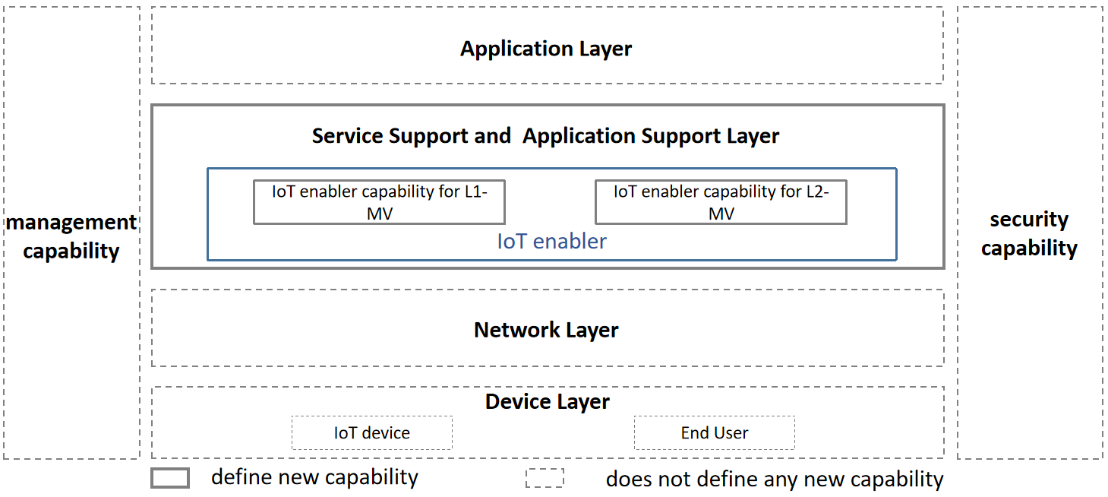
Figure 3 – The functional framework of MVIoT
In this framework, management capabilities can refer to clause 8.5 management capabilities specified in [ITU-T Y.4000]. Management capabilities are used to fulfil the interoperability, scalability, reliability, high availability and manageability requirements.
In this framework, security capabilities can refer to clause 8.6 security and privacy protection capabilities specified in [ITU-T Y.4000]. Security capabilities are used to fulfil the communication security, data management, service provision security, security integration, mutual authentication and authorization, and security audit.
There are no new defined capabilities in the device layer, the network layer and application layer in this Technical Specification, but these are presented primarily for supporting the understanding of the reference framework.

9 Service support and application support layer capabilities of MVIoT
The service support and application support layer consists of one enabling capability grouping, namely, the IoT enabler. The IoT enabler capability grouping contains two main capabilities: the IoT enabler capability for L1-MV, and the IoT enabler capability for L2-MV, according to the two types of object linking in the virtual world in metaverse and the physical world.

9.1 IoT enabler capability for L1-MV
IoT enabler capability for L1-MV provides management functions of IoT devices to realize L1-MV. IoT enabler capabilities for L1-MV include, but are not limited to. the following:
– Device access capabilities: focus on providing relevant access functions that support the connection and management of various IoT devices. This includes device registration, protocol conversion, and multiple-interface support to ensure seamless access to and exit from IoT devices in the metaverse.
– Computation scheduling capabilities: focus on providing relevant functions of heterogeneous computing power interconnection, including, but not limited to, computing resource perception, identification, measurement and management.
– Data processing capabilities: focus on collecting, storing and analysing self-describing data and real-time status data from IoT devices, to acquire device properties and device working status, in order to generate virtual objects corresponding to physical IoT devices and realize IoT device working status management.
– Synchronization capabilities: focus on sensing and tracking timing, location and status information for synchronization between virtual and physical objects automatically.
– Security capabilities: focus on providing security control capabilities, including authentication, access control and data encryption, to ensure data security and PII protection for IoT devices in the metaverse.

9.2 IoT enabler capability for L2-MV
IoT enabler capability for L2-MV provides management functions of IoT devices to realize L2-MV. In addition to the capabilities described in clause 9.1, IoT enabler capabilities for L2-MV include, but are not limited to, the following:
– Actuating management capabilities: focus on receiving feedback information from the metaverse and converting it into the corresponding protocols to support the devices executing operations.

Bibliography

[b-ITU-T Y.2091] Recommendation ITU-T Y.2091 (2011), Terms and definitions for next generation networks.
[b-ITU-T Y.3121] Recommendation ITU-T Y.3121 (2023), Quality of service requirements and framework for supporting deterministic communication services in local area networks for IMT-2020.
[b-ITU FGMV-15] ITU Focus Group Technical Specification FGMV-15 (2023), Accessibility requirements for metaverse services supporting IoT.
[b-ITU FGMV-29] ITU Focus Group Technical Specification FGMV-29 (2024), Reference model for the metaverse based on a digital twin enabling integration of virtual and physical worlds.
[b-ISO/IEC 18039] ISO/IEC 18039:2019, Information technology – Computer graphics, image processing and environmental data representation – Mixed and augmented reality (MAR) reference model.
______________

