|  |  |  |
| --- | --- | --- |
|  | | Standardization Sector |
| **ITU Focus Group Technical Specification** | |
| **(03/2024)** | |
|  | ITU Focus Group on metaverse | |
|  | **Reference model for the metaverse based on a digital twin enabling integration of virtual and physical worlds**  Virtual/Real World Integration* | |

|  |  |
| --- | --- |
| **ITUPublications** | **International Telecommunication Union** |

**Technical Specification ITU FGMV-29**

Reference model for the metaverse based on a digital twin enabling integration of virtual and physical worlds

Summary

This Technical Specification provides the reference model for the metaverse based on digital twins enabling the integration of virtual and physical worlds. In order to realize this integration of the virtual and physical worlds, a reference model for interaction is necessary, with digital twins serving as a key component of this model. This Technical Specification aims to establish the reference model for the metaverse based on digital twins, enabling the seamless integration of virtual and physical worlds.

Keywords

Digital twin, integration, reference model, integration enabler

**Note**

This is an informative ITU-T publication. Mandatory provisions, such as those found in ITU-T Recommendations, are outside the scope of this publication. This publication should only be referenced bibliographically in ITU-T Recommendations.

Change Log

This document contains the ITU-T Technical Specification on "*Reference model for the metaverse based on a digital twin enabling integration of virtual and physical worlds*", approved at the 5thmeeting of ITU Focus Group on metaverse (ITU FG-MV), held on 5-8 March 2024 in Queretaro, Mexico.

Acknowledgements

This Technical Specification was researched and written by Haksuh Kim (Electronics and Telecommunications Research Institute, Rep. of Korea) and Changkyu Lee (Electronics and Telecommunications Research Institute, Rep. of Korea). The development of this document was coordinated by Shane He (Nokia, Finland), as FG-MV Working Group 4 Chair and Julien Maisonneuve (Nokia, Finland), as FG-MV Working Group 4 Vice-chair.

Special thanks to Hideo Imanaka and Hideki Yamamoto for their helpful reviews and contributions.

Additional information and materials relating to this Technical Specification can be found at: <https://www.itu.int/go/fgmv>. If you would like to provide any additional information, please contact Cristina Bueti at [tsbfgmv@itu.int](mailto:tsbfgmv@itu.int).

|  |  |  |
| --- | --- | --- |
| **Editor:** | Haksuh Kim  ETRI  Korea (Rep. of) | Tel.: +82 42 860 3981  E-mail: [tuple@etri.re.kr](mailto:tuple@etri.re.kr) |
| **Editor:** | Changkyu Lee  ETRI  Korea (Rep. of) | Tel.: +82 42 860 6157  E-mail: [changkyu.lee@etri.re.kr](mailto:changkyu.lee@etri.re.kr) |
| **WG4 Chair:** | Shane He Nokia Finland | Tel.: +33620250907 E-mail: [shane.he@nokia.com](mailto:shane.he@nokia.com) |
| **WG4 Vice-chair:** | Julien Maisonneuve  Nokia | Tel.: +33621810832  E-mail: [julien.maisonneuve@nokia.com](mailto:julien.maisonneuve@nokia.com) |

© ITU 2025

Some rights reserved.This publication is available under the Creative Commons Attribution-Non Commercial-Share Alike 3.0 IGO licence (CC BY-NC-SA 3.0 IGO; [https://creativecommons.org/licenses/by-nc-sa/3.0/igo](https://eur03.safelinks.protection.outlook.com/?url=https%3A%2F%2Fcreativecommons.org%2Flicenses%2Fby-nc-sa%2F3.0%2Figo&data=05%7C02%7CChristelle.Gachet%40itu.int%7C0fe5406e5055456a0b5a08dc7bce06f3%7C23e464d704e64b87913c24bd89219fd3%7C0%7C0%7C638521372006151524%7CUnknown%7CTWFpbGZsb3d8eyJWIjoiMC4wLjAwMDAiLCJQIjoiV2luMzIiLCJBTiI6Ik1haWwiLCJXVCI6Mn0%3D%7C0%7C%7C%7C&sdata=HtXL1m3ekhVn82amVYFS35Ip8LaaB74uwbUtbEu0fKM%3D&reserved=0)).

For any uses of this publication that are not included in this licence, please seek permission from ITU by contacting [TSBmail@itu.int](mailto:TSBmail@itu.int).

**Table of Contents**

Page

1 Scope 1

2 References 1

3 Definitions 1

3.1 Terms defined elsewhere 1

3.2 Terms defined in this Technical Specification 1

4 Abbreviations and acronyms 1

5 Conventions 2

6 Overview 2

7 Reference model 3

7.1 General 3

8 Integration enabler 4

8.1 General 4

8.2 Systems integration functions 5

8.3 Digital twin integration functions 6

9 Operational flow 6

9.1 Operational procedures of integrating third-party systems 6

9.2 Operational procedures of integrating digital twin systems 8

Bibliography 10

**Technical Specification ITU FGMV-29**

Reference model for the metaverse based on a digital twin enabling integration of virtual and physical worlds

# 1 Scope

This Technical Specification provides the reference model for the metaverse based on digital twins enabling the integration of virtual and physical worlds. The scope of this Technical Specification includes the following:

- Reference model to integrate the metaverse based on digital twins to physical world applications;

- Functional entities of the reference model for the metaverse based on digital twins.

# 2 References

None.

# 3 Definitions

## 3.1 Terms defined elsewhere

This Technical Specification uses the following terms defined elsewhere:

**3.1.1 physical object** [b-ISO/IEC 18039]: Object that exists in the real world.

**3.1.2 virtual object** [b-ITU-T FGMV-28]: A computer-generated entity that is designated for a virtual world.

NOTE – A virtual object may associate with a physical object, which becomes a digital twin.

## 3.2 Terms defined in this Technical Specification

None.

# 4 Abbreviations and acronyms

This Technical Specification uses the following abbreviations and acronyms:

API Application Programming Interface

DTAC Digital Twin Access Control

DTDA Digital Twin Data Acquisition

DTIA Digital Twin Information Acquisition

DTIF Digital Twin Integration Function

DTS Digital Twin Synchronization

DTSD Digital Twin System Discovery

DTSR Digital Twin System Registration

FE Functional Entity

SDC System and Data Collaboration

SIF Systems Integration Function

TPSAA Third-Party System Authentication and Authorization

TPSD Third-Party System Discovery

TPSR Third-Party System Registration

TSI Third-Party System Interaction

# 5 Conventions

In this Technical Specification, the keyword "functions" is defined as a collection of functionalities. It is represented by the following symbol in this Technical Specification:

Functions

The keyword "functional entity" (FE) is defined as a representation of functionality that has not been further subdivided at the level of detail described in this Technical Specification. It is represented by the following symbol in this Technical Specification:

Functional entity (FE)

NOTE – In the future, other groups or other Technical Specifications may possibly further subdivide these FEs.

# 6 Overview

The concept presented in Figure 1 illustrates the metaverse, which is built upon the integration of virtual and physical worlds through digital twins. The metaverse represents a vast virtual space composed of various virtual worlds, each with its distinct purpose and characteristics. Just as our universe consists of different planets and countries, the metaverse comprises diverse virtual environments like homes, towns, classrooms and playgrounds. Within these virtual worlds, users create avatars to represent themselves. They can engage with digital objects and other avatars in numerous ways.

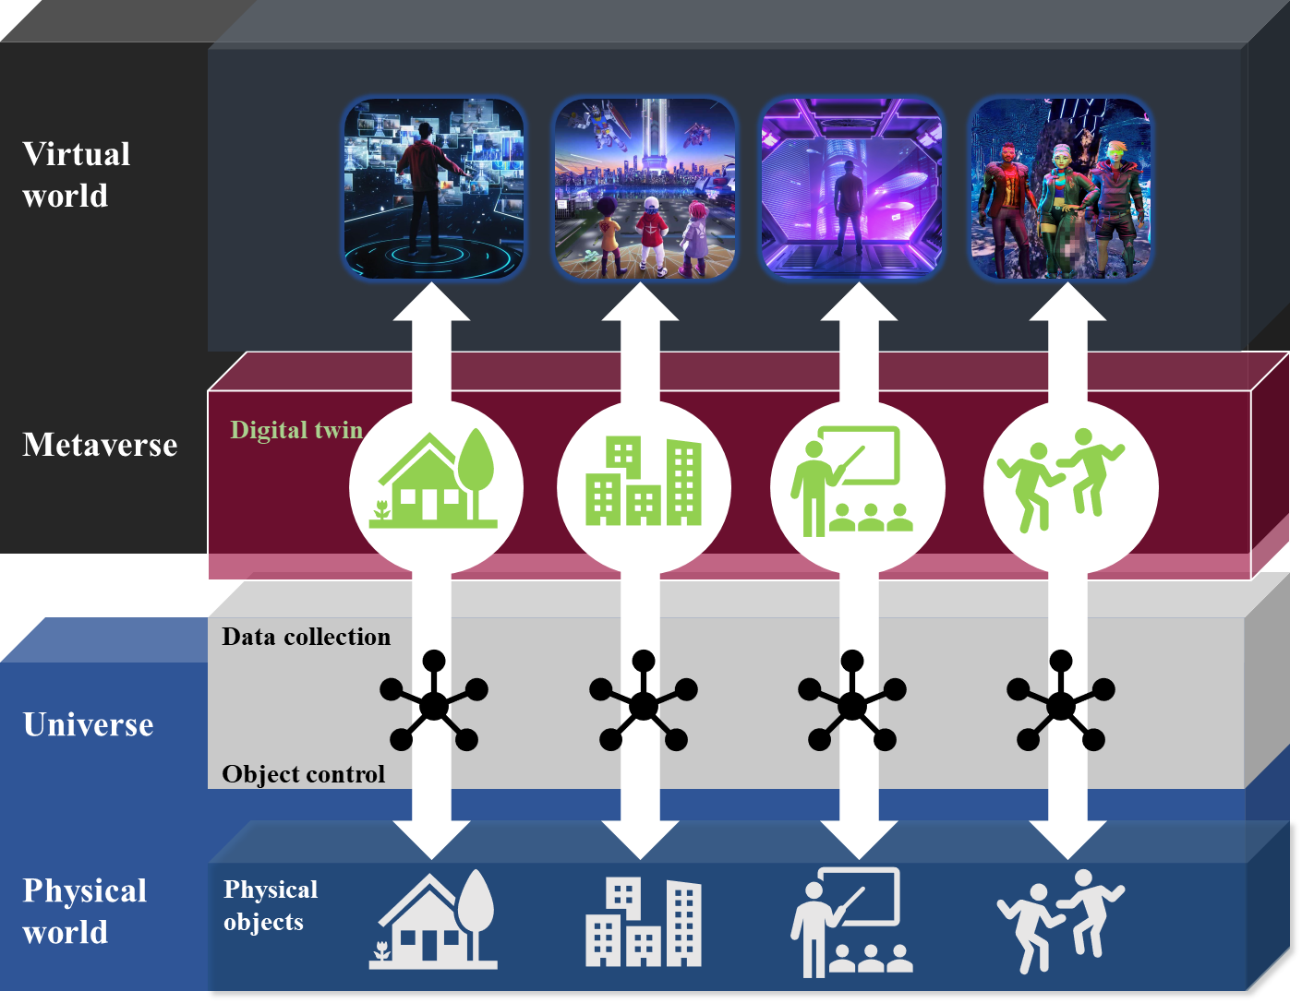

Figure 1 – Concept of the digital twin-based integration between virtual and physical worlds

NOTE – Interoperability in terms of cross-platform metaverses is out of the scope of this Technical Specification, while the integration enablers specified in this Technical Specification can be used for improving the interoperability of cross-platform scenarios.

Digital twins serve as a key component for integrating virtual and physical worlds, allowing users to extend their experience beyond the confines of the virtual environment. As digital representations of physical objects, digital twins comprise the virtual worlds. Avatars representing users are an example of digital twins in virtual worlds. For the integration of virtual and physical worlds, the digital twin is an interface between them. For example, as an avatar, the digital twin of a user can mirror the facial expressions captured by the user’s equipment. Digital goods are another example of digital twins integrating the worlds. Users can watch digital goods like pictures or clothes. In virtual worlds, users can even dress up their avatars. If a user purchases any digital good in the virtual world, the physical objects corresponding to the digital good will be delivered to the user. The virtual world for engineering can also be integrated with the physical world. Avatars of geographically dispersed engineers may meet together and design a machine using the digital twins of the real component of a product. After finalizing the design, the machine can be built in the physical world according to the design made in the virtual world.

To realize this integration of virtual and physical worlds, a reference model for interaction is necessary, with digital twins serving as a key component of this model. This Technical Specification aims to establish the reference model for the metaverse based on digital twins, enabling the seamless integration of virtual and physical worlds.

# 7 Reference model

## 7.1 General

Figure 2 shows a reference model for the metaverse based on a digital twin enabling the integration of virtual and physical worlds.



Figure 2 – Reference model for the metaverse based on a digital twin enabling the integration of virtual and physical worlds

NOTE 1 – Integration enabler is not a system but a set of functionalities which can be within the metaverse system, digital twin system, and/or third-party system.

NOTE 2 – A digital twin can be corresponding to a physical object, while another digital twin is not.

NOTE 3 – Third-party system in this Technical Specification does not consider another metaverse system and digital twin system that are related to interoperable metaverse services.

This reference model defines the integration enabler to facilitate the integration of digital twins and the metaverse. The integration enabler serves as a management system to incorporate digital twin objects into the metaverse, building interrelated operations and interworking with external third-party systems.

The third-party systems, metaverse systems and digital twin systems are outside the scope of this Technical Specification but are depicted in order to support the understanding of the reference model.

# 8 Integration enabler

## 8.1 General

Figure 3 shows FEs of the integration enabler in the reference model of the metaverse, which is built upon digital twin technology to enable the integration of virtual and physical worlds. The integration enabler comprises two main components: systems integration functions (SIF) and digital twin integration functions (DTIF).

The SIF are responsible for facilitating the integration of the virtual world with external third-party systems. The DTIF are designed to support the integration of one or multiple digital twin systems, allowing for the creation of a unified virtual world.



Figure 3 – FEs of the integration enabler for the reference model

NOTE – An integration enabler is a set of functionalities. It is represented with the same shape as that of an FE as defined in clause 5.

## 8.2 Systems integration functions

The SIF support integration with external third-party systems.

### 8.2.1 Third-party system registration FEs

The third-party system registration (TPSR) FE provides functionality for external systems to integrate with the metaverse system by registering their own information. Additionally, it offers a monitoring feature for the registered external systems' statuses and performance. This FE collects information such as system type, system ID, system properties, service charge, service level and application programming interfaces (APIs) during the registration process.

### 8.2.2 Third-party system discovery FE

The third-party system discovery (TPSD) FE provides functionality to search for registered system information through the registration process, enabling the metaverse system to identify systems that meet the conditions from metaverse systems.

### 8.2.3 Third-party system authentication and authorization FE

The third-party system authentication and authorization (TPSAA) FE provides functionality for user information management for system access and access permission to interact with the system and use its resources.

### 8.2.4 System and data collaboration FE

The system and data collaboration (SDC) FE provides functionality for service execution and the necessary data sharing among multiple third-party systems. This includes data processing, transformation and API conversion for seamless service and data collaboration.

### 8.2.5 Digital twin data acquisition FE

The digital twin data acquisition (DTDA) FE provides functionality for third-party systems to directly request digital twin information from the DTIFs. It works with the third system interaction FE of DTIFs.

## 8.3 Digital twin integration functions

The DTIF provide the capability to map multiple digital twin systems into a single virtual world.

### 8.3.1 Digital twin system registration FE

The digital twin system registration (DTSR) FE provides functionality for digital twin systems to integrate with the metaverse system by registering their own information. Additionally, it offers a monitoring feature for the statuses and performance of the registered digital twin systems. This FE collects information such as digital twin system type, digital twin system ID and digital twin system properties during the registration process.

### 8.3.2 Digital twin system discovery FE

The digital twin system discovery (DTSD) FE provides functionality to search for registered digital twin system information through the registration process, enabling the metaverse system to identify digital twin systems that meet the conditions from metaverse systems.

### 8.3.3 Digital twin information acquisition FE

The digital twin information acquisition (DTIA) FE provides functionality for the integration enabler to retrieve information of the digital twin from the selected digital twin system.

### 8.3.4 Digital twin synchronization FE

The digital twin synchronization (DTS) FE provides functionality for synchronization between virtual and physical objects.

NOTE – The synchronization targets include the state, location, behaviour, and other attributes of an object.

### 8.3.5 Digital twin access control FE

The digital twin access control (DTAC) FE provides management functionality for controlling access to each digital twin and specifying the characteristics, including the behaviour that each object can perform.

### 8.3.6 Third-party system interaction FE

The third-party system interaction (TSI) FE provides functionality for collecting digital twins’ information upon request from a third-party system. It works with the DTDA FE of SIF.

# 9 Operational flow

## 9.1 Operational procedures of integrating third-party systems

Figure 4 shows the operational procedures of integrating third-party systems.

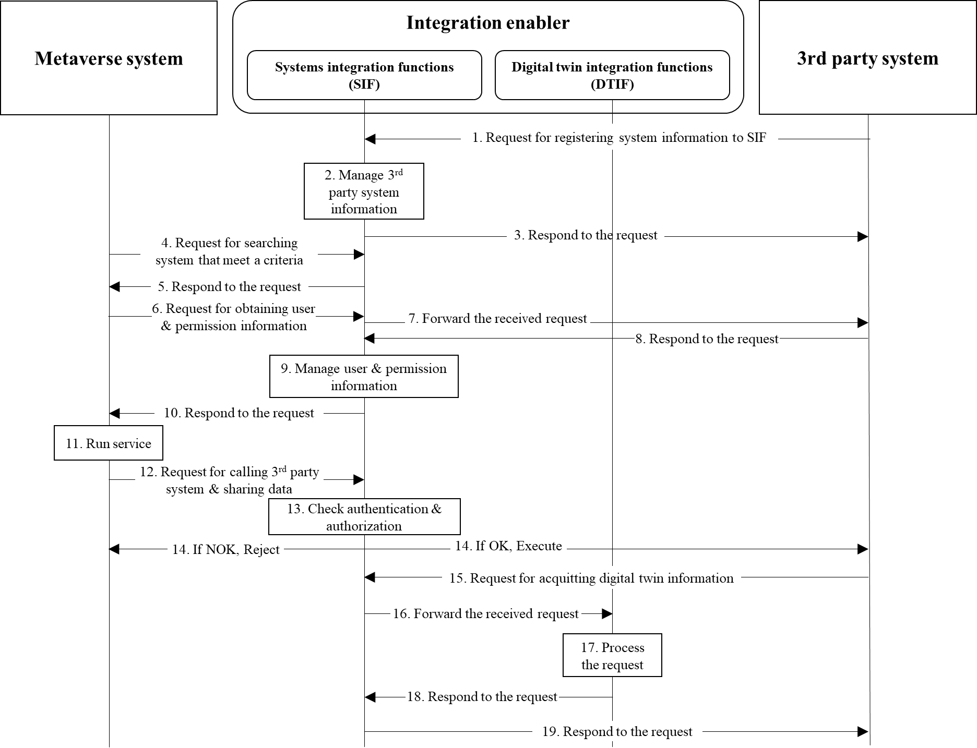

Figure 4 – Operational procedures of integrating third-party systems

The description of each step of the operational procedures is as follows:

1. The third-party system registers its information to the SIF of integration enabler;

2. The SIF manages registered third-party system information;

3. The SIF responds to the registering request;

4. The metaverse system searches for third-party systems that meet the criteria in the SIF;

5. The SIF responds to the searching request;

6. The metaverse system requests user authentication and authorization from third-party system;

7. The SIF forwards the received request to third-party system;

8. The third-party system responds with user and permission information;

9. The SIF manages user and permission information for accessing the third-party system;

10. The SIF responds to the request from the metaverse system;

11. The metaverse system runs the service using the selected third-party system;

12. The metaverse system initiates a request to utilize third-party system or share data;

13. The SIF verifies user authentication and authorization for accessing third-party system;

14. If the request is valid, the SIF forwards it to the third-party system for execution. If the request is invalid, the SIF rejects it;

15. If the third-party system requires digital twin information, it can request the information from the SIF;

16. The SIF forwards the received request to the DTIF;

17. The DTIF processes the request for the digital twin's information;

18. The DTIF responds to the acquisition request;

19. The SIF responds to the request from the third-party system.

NOTE – The third-party system receives information about the digital twin through the metaverse system. If it needs to collect additional information, it can request to collect the information directly through the integration enabler.

## 9.2 Operational procedures of integrating digital twin systems

Figure 5 shows the operational procedures of integrating digital twin systems.

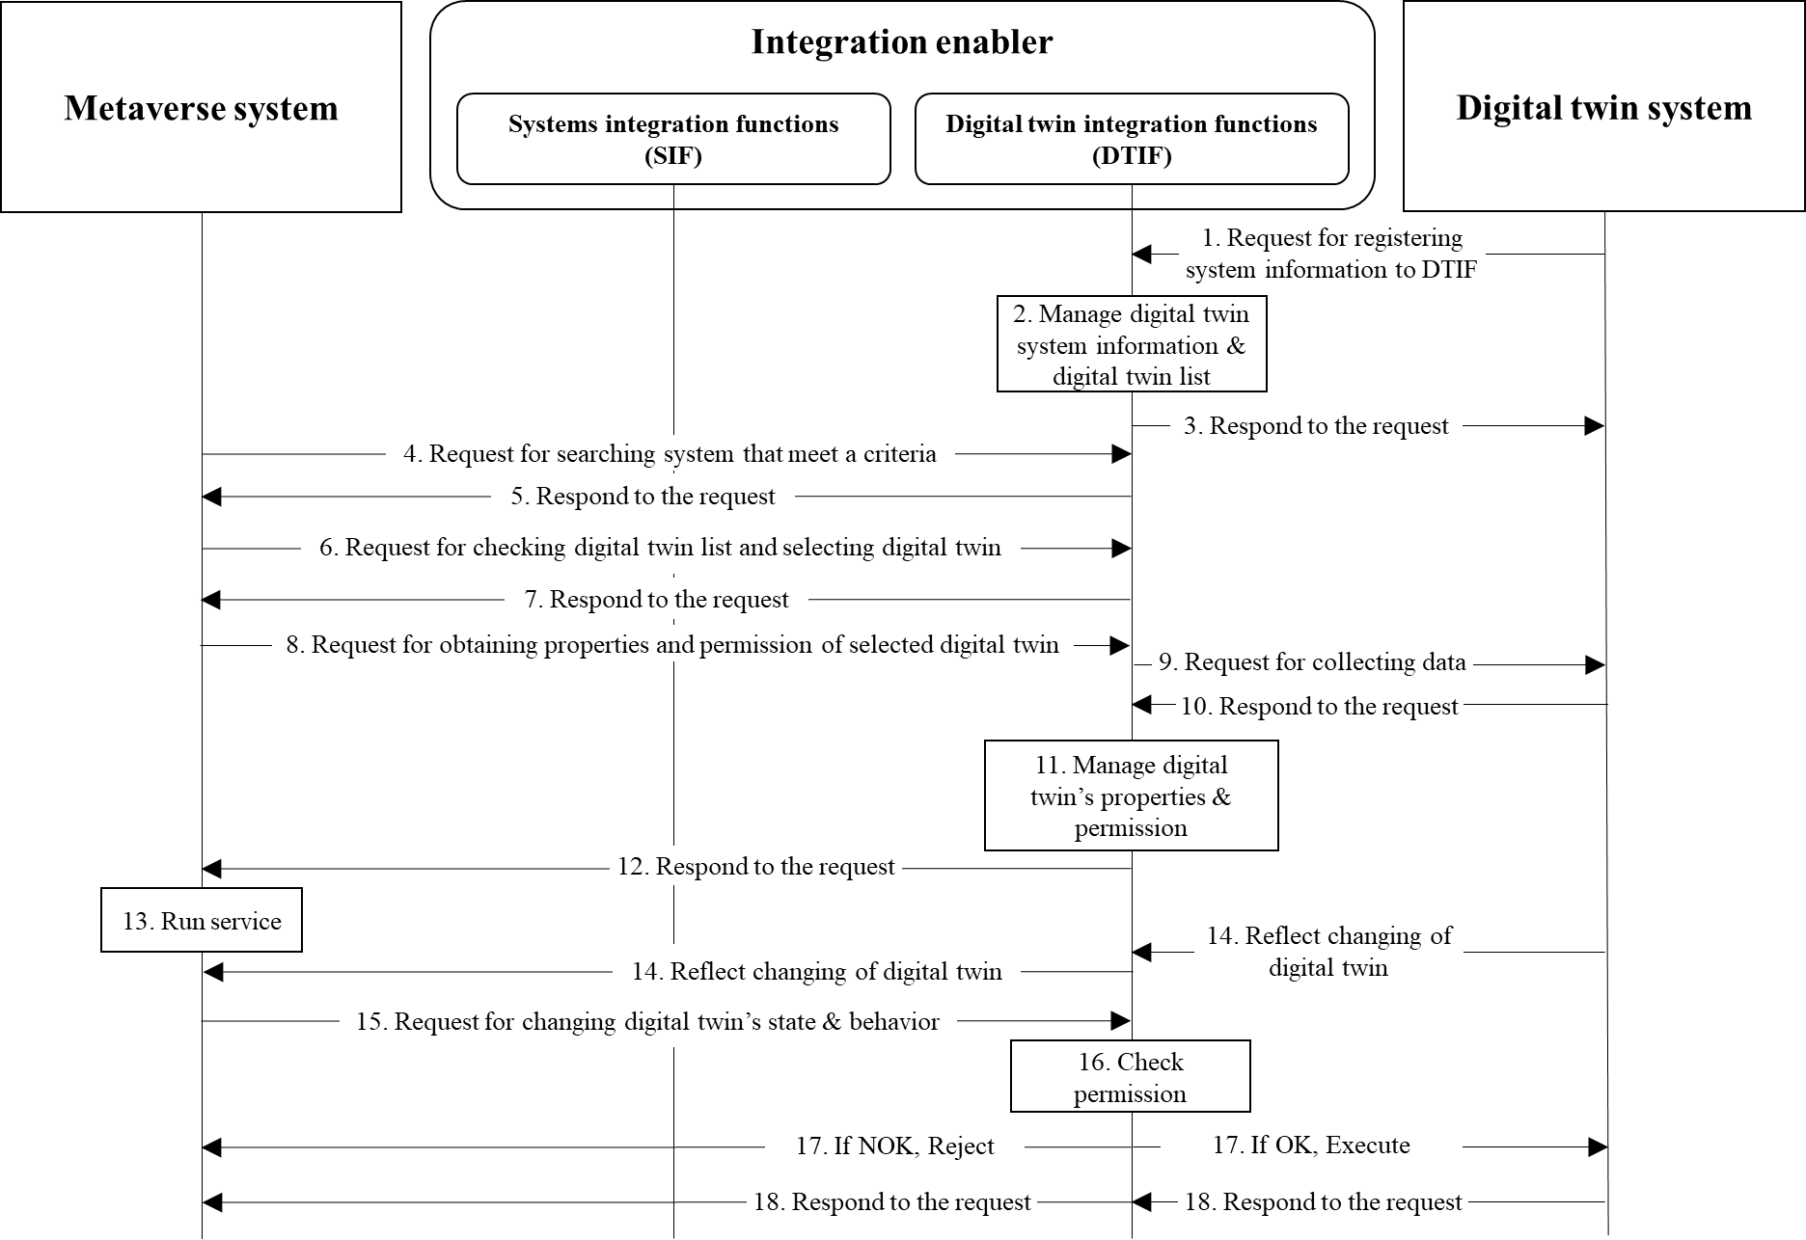

Figure 5 – Operational procedures of integrating digital twin systems

The description of each step of the operational procedures is as follows:

1. The digital twin system registers its information to the DTIF of the integration enabler;

2. The DTIF manages registered digital twin system information and digital twin list;

3. The DTIF responds to the registering request;

4. The metaverse system searches for digital twin systems that meet the criteria in the DTIF;

5. The DTIF responds to the searching request;

6. The metaverse system checks the digital twin information list and selects the digital twins it wants to use;

7. The DTIF responds to the request from the metaverse system;

8. The metaverse system requests the DTIF to obtain properties and permission of selected digital twin;

9. The DTIF forwards the metaverse system's request to the digital twin system;

10. The digital twin system responds to the request from the DTIF;

11. The DTIF manages the digital twin's properties and permission;

12. The DTIF responds to the request from the metaverse system;

13. The metaverse system runs the service;

14. The changing of the physical object is reflected in the metaverse system through the DTIF;

15. The metaverse system requests the DTIF to change the state or behaviour of the object;

16. The DTIF verifies permissions, to ensure that the change request can be applied;

17. If the request is valid, the DTIF forwards it to the digital twin system for execution. If the request is invalid, the DTIF rejects it;

18. The digital twin system responds to the request from the DTIF.

NOTE – The digital twin system does not interact with other digital twin systems; instead, it interacts with the metaverse system and third-party systems.

Bibliography

[b-ISO/IEC 18039] ISO/IEC 18039:2019, *Information technology – Computer graphics, image processing and environmental data representation – Mixed and augmented reality (MAR) reference model.*

[b-ITU-T FGMV-28] Technical Specification ITU FGMV-28, *Requirements for the metaverse based on digital twins enabling integration of virtual and physical worlds.*

______________