|  |  |  |
| --- | --- | --- |
|  | | Standardization Sector |
| **ITU Focus Group Technical Specification** | |
| **(03/2024)** | |
|  | ITU Focus Group on metaverse | |
|  | **Requirements for the metaverse based on digital twins enabling integration of virtual and physical worlds**  *Working Group 4: Virtual/Real World Integration* | |

|  |  |
| --- | --- |
| **ITUPublications** | **International Telecommunication Union** |



Technical Specification ITU FGMV-28

Requirements for the metaverse based on digital twins enabling integration   
of virtual and physical worlds

Summary

Technical Specification ITU FGMV-28 provides service scenarios and requirements for the digital twin-based integration of virtual and physical worlds. Three categories of use cases and their service scenarios are introduced, and requirements with respect to digital twin, metaverse, and system interaction are defined.

Keywords

Digital twin, integration, service scenario, requirements.

**Note**

This is an informative ITU-T publication. Mandatory provisions such as those found in ITU‑T Recommendations lie outside the scope of this Technical Report, which should only be referenced bibliographically in ITU-T Recommendations.

**Change Log**

This document contains the ITU-T Technical Specification on *"Requirements for the metaverse based on digital twins enabling integration of virtual and physical worlds"*, approved at the 5thmeeting of ITU Focus Group on metaverse (ITU FG-MV), held on 5-8 March 2024 in Queretaro, Mexico.

Acknowledgements

This Technical Specification was researched and written by Changkyu Lee (Electronics and Telecommunications Research Institute, Rep. of Korea). The development of this document was coordinated by Shane He (Nokia, Finland), as FG-MV Working Group 4 Chair and Julien Maisonneuve (Nokia, Finland), as FG-MV Working Group 4 Vice Chair.

Special thanks to Haksuh Kim, Pilar Orero, Hideo Imanaka, and Hideki Yamamoto for their helpful reviews and contributions.

Additional information and materials relating to this Technical Specification can be found at: <https://www.itu.int/go/fgmv>. If you would like to provide any additional information, please contact Cristina Bueti at [tsbfgmv@itu.int](mailto:tsbfgmv@itu.int).

|  |  |  |
| --- | --- | --- |
| **Editor:** | Changkyu Lee ETRI  Korea (Rep. of) | Tel: +82 42 860 6157  E-mail: [changkyu.lee@etri.re.kr](mailto:changkyu.lee@etri.re.kr) |
| **WG4 Chair:** | Shane He Nokia Finland | Tel: +33620250907 E-mail: [shane.he@nokia.com](mailto:shane.he@nokia.com) |
| **WG4 Vice-chair:** | Julien Maisonneuve  Nokia | Tel: +33621810832  E-mail: [julien.maisonneuve@nokia.com](mailto:julien.maisonneuve@nokia.com) |

© ITU 2025

Some rights reserved.This publication is available under the Creative Commons Attribution-Non Commercial-Share Alike 3.0 IGO licence (CC BY-NC-SA 3.0 IGO; [https://creativecommons.org/licenses/by-nc-sa/3.0/igo](https://eur03.safelinks.protection.outlook.com/?url=https%3A%2F%2Fcreativecommons.org%2Flicenses%2Fby-nc-sa%2F3.0%2Figo&data=05%7C02%7CChristelle.Gachet%40itu.int%7C0fe5406e5055456a0b5a08dc7bce06f3%7C23e464d704e64b87913c24bd89219fd3%7C0%7C0%7C638521372006151524%7CUnknown%7CTWFpbGZsb3d8eyJWIjoiMC4wLjAwMDAiLCJQIjoiV2luMzIiLCJBTiI6Ik1haWwiLCJXVCI6Mn0%3D%7C0%7C%7C%7C&sdata=HtXL1m3ekhVn82amVYFS35Ip8LaaB74uwbUtbEu0fKM%3D&reserved=0)).

If you wish to reuse material from this publication that is attributed to a third party, such as tables, figures or images, it is your responsibility to determine whether permission is needed for that reuse and to obtain permission from the copyright holder. The risk of claims resulting from infringement of any third-party owned material in the publication rests solely with the user.

**Table of contents**

Page

1 Scope 1

2 References 1

3 Definitions 1

3.1 Terms defined elsewhere 1

3.2 Terms defined in this Technical Specification 2

4 Abbreviations and acronyms 2

5 Conventions 2

6 Overview 2

7 Service scenarios of the metaverse based on digital twins 3

7.1 Interaction initiated from the virtual world 4

7.2 Interaction initiated from a physical world 9

7.3 Synchronization between virtual and physical worlds 11

8 Requirements for the metaverse based on digital twins 17

8.1 Requirements related to digital twin 17

8.2 Requirements related to metaverse 17

8.3 Requirements related to system interaction 17

Bibliography 19

Technical Specification ITU FGMV-28

Requirements for the metaverse based on digital twins enabling integration   
of virtual and physical worlds

# 1 Scope

This Technical Specification provides service scenarios and requirements for the metaverse based on digital twins enabling integration of virtual and physical worlds. The scope of this Technical Specification includes the following:

– service scenarios of the metaverse based on digital twins;

– requirements for the metaverse based on digital twins.

# 2 References

None.

# 3 Definitions

## 3.1 Terms defined elsewhere

This Technical Specification uses the following terms defined elsewhere:

**3.1.1** **augmented reality (AR)** [b-ITU-T P.1320]: An environment containing both real and virtual sensory components. The augmented reality continuum runs from virtual content that is clearly overlaid on a real environment (assisted reality) to virtual content that is seamlessly integrated and interacts with a real environment (mixed reality).

**3.1.2** **digital twin** [b-ITU-T Y.4600]: A digital representation of an object of interest.

NOTE – A digital twin may require different capabilities (e.g., synchronization, real-time support) according to the specific domain of application.

**3.1.3** **Internet of things (IoT)** [b-ITU-T Y.4000]: A global infrastructure for the information society, enabling advanced services by interconnecting (physical and virtual) things based on existing and evolving interoperable information and communication technologies.

**3.1.4** **metaverse** [b-ITU FGMV-20]: An integrative ecosystem of virtual worlds offering immersive experiences to users, that modify pre-existing and create new value from economic, environmental, social and cultural perspectives.

NOTE – A metaverse can be virtual, augmented, representative of, or associated with the physical world.

**3.1.5** **mixed reality (MR)** [b-ITU-T P.1320]: An environment containing both real and virtual components that are seamlessly integrated and interact with each other in a natural way (one end of the augmented reality continuum).

**3.1.6** **physical object** [b-ISO/IEC 18039]: Object that exists in the real world.

**3.1.7** **physical world** [b-ISO/IEC 18039]: Physical reality spatial organization of multiple physical objects.

**3.1.8** **virtual reality (VR)** [b-ITU-T P.1320]: An environment that is fully generated by digital means. To qualify as virtual reality, the virtual environment should differ from the local environment.

**3.1.9** **virtual world** [b-ISO/IEC 18039]: Virtual environment, spatial organization of multiple virtual objects, potentially including global behaviour.

## 3.2 Terms defined in this Technical Specification

This Technical Specification defines the following term:

**3.2.1 virtual object**: A computer-generated entity that is designated for a virtual world.

NOTE – A virtual object may associate with a physical object, which becomes a digital twin.

# 4 Abbreviations and acronyms

This Technical Specification uses the following abbreviations and acronyms:

AR Augmented Reality

IoT Internet of Things

MR Mixed Reality

MV Metaverse

VR Virtual Reality

# 5 Conventions

The following conventions are used in this Technical Specification:

– The keywords "is required to" indicate a requirement which must be strictly followed and from which no deviation is permitted if conformance to this Technical Specification is to be claimed;

– The keywords "is recommended" indicate a requirement which is recommended but which is not absolutely required. Thus, this requirement need not be present to claim conformance.

# 6 Overview

Figure 1 shows the concept of the integration based on digital twins enabling integration of virtual and physical worlds. The metaverse is a vast virtual space made up of many different virtual worlds, each with its own unique purpose and characteristics. Similar to the way our universe is composed of different planets and countries, the metaverse is comprised of different virtual environments, such as homes, towns, classrooms, and playgrounds. In these virtual worlds, users create avatars to represent themselves, and interact with digital objects and other avatars in various ways.

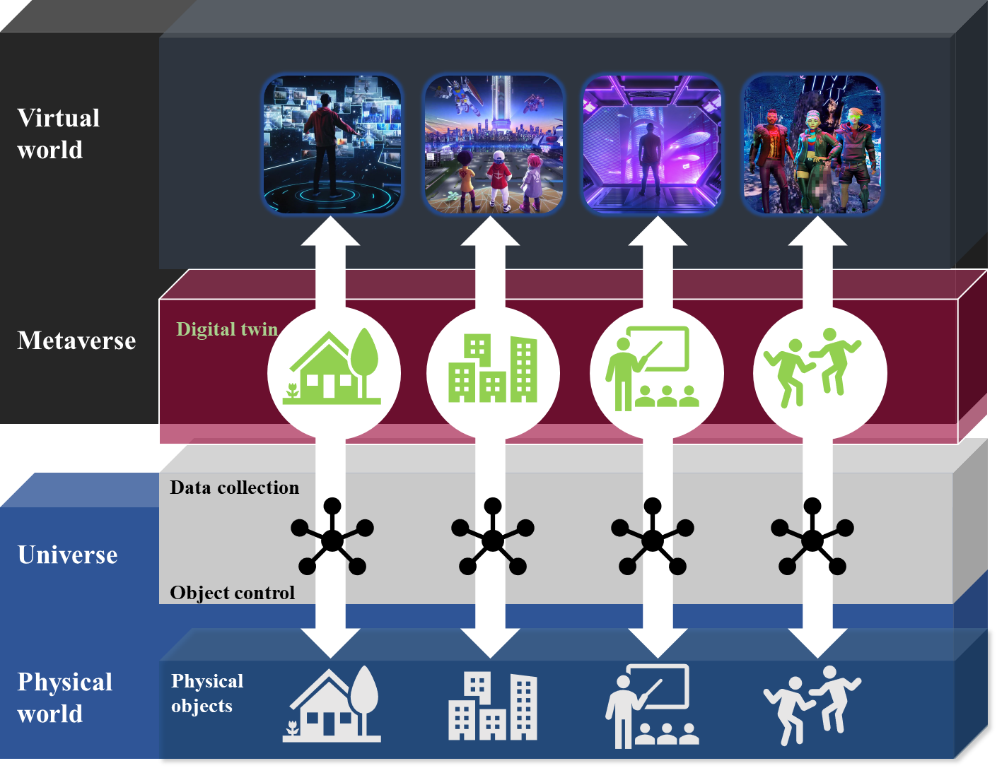

Figure 1 – Concept of the digital twin-based integration between virtual and physical worlds

Digital twin serves as interaction interface for integrating the virtual and physical worlds, allowing users to extend their experience beyond the confines of the virtual environment. As digital representation of physical objects, digital twins are part of the virtual worlds. Avatars representing users can be an example of digital twin in the virtual worlds. For the integration of virtual and physical worlds, the digital twin is an interface between them. For example, as an avatar, a digital twin of a user can mirror the facial expression captured by the user equipment. Digital goods are another example of digital twin integrating the worlds. Users can watch digital goods such as a picture or clothes. In virtual worlds, the users can even dress up their avatars. If a user purchases any digital good in the virtual world, the physical objects corresponding to the digital good will be delivered to the user. A virtual world for engineering can also be integrated with the physical world. Avatars of geographically dispersed engineers may meet together and design a machine using the digital twins of the real component of a product. After finalizing the design, the machine can be built in the physical world according to the design made in the virtual world.

To realize such integration of virtual and physical worlds, an interface for interaction is needed and the digital twin can be the interface between them. This Technical Specification explores the use cases of the metaverse based on digital twins and defines the requirements for the metaverse based on digital twins enabling the integration of virtual and physical worlds.

# 7 Service scenarios of the metaverse based on digital twins

NOTE – The conceptual figures and the corresponding figure for operation flows may not include the same entities as the operation flows contain the entities that participate in actual interaction.

## 7.1 Interaction initiated from the virtual world

### 7.1.1 Delivering products generated in the virtual world to the physical world

#### 7.1.1.1 Description

Delivering products generated in virtual world to physical world is about creating virtual objects and placing an order for the virtual object to be manufactured and delivered to the physical world home.

#### 7.1.1.2 Assumptions

The assumptions related to this use case include the following:

– It is assumed that there is a metaverse where a user can design and generate their own items.

– It is assumed that there is a manufacturer who can receive orders made from the metaverse users.

– It is assumed that there is an economic system which allows users to purchase physical products derived from their virtual form.

#### 7.1.1.3 Scenario and operation flows

There is a user who needs various objects, such as clothes or furniture, for an immersive virtual shopping experience. The users could purchase the objects already made by other users or manufacturers in the virtual world; however, they want to design, generate and receive their own objects (like customized items). During the virtual experience, the users feel as if they have the user-generated virtual objects in physical world. The users then place an order for the manufacture of the real products and these are produced and delivered. Additionally, the real projects, as physical objects, can be synchronized with the virtual objects. Figure 2 shows the conceptual diagram of this scenario.

NOTE 1 – The role of digital twins in this scenario is to be used for producing physical objects and reflect the characteristics of the corresponding physical objects produced.

NOTE 2 – This document does not specify the operator of the commerce system. The operator may be a metaverse service provider, a commerce service provider, a manufacturer, etc.

Figure 2 shows Conceptual diagram for delivering products generated in the virtual world 
to the physical world


Figure 2 – Conceptual diagram for delivering products generated in the virtual world   
to the physical world

NOTE 3 – A 3rd party system refers an external system besides the metaverse system and digital twin system, and this Technical Specification considers the commerce system in Figure 2 as a 3rd party system.

Figure 3 depicts the operation flows for delivering products generated in the virtual world to the physical world.

Figure 3 shows Operation flows for delivering products generated in the virtual world 
to the physical world


Figure 3 – Operation flows for delivering products generated in the virtual world   
to the physical world

1) A user designs and generates own virtual objects in the metaverse. Metaverse systems offer the user the virtual experience with the generated virtual objects.

2) The user places an order for manufacturing the real products corresponding to the generated virtual objects. For ordering, the metaverse, commerce, and manufacturer systems can interact with each other.

3) The manufacture produces the ordered items and delivers the products to the user.

4) The user can request a digital twin system for synchronization between the real products, as physical objects, and virtual objects, if the products support synchronization.

### 7.1.2 Ordering ingredients for a cooking recipe in a virtual world

#### 7.1.2.1 Description

Ordering ingredients for a recipe in a virtual world is about assessing any missing ingredients in the recipe of a virtual food in addition to the ingredients already in the home in the physical world and placing an order for the missing ingredients to be delivered to the real-world home.

#### 7.1.2.2 Assumptions

The assumptions related to this use case include the following:

– It is assumed that there is a metaverse which is capable of providing the recipe of a requested virtual object.

– It is assumed that a user has the metaverse representing the user's home.

– It is assumed that there is a supplier which can receive the order made from the metaverse.

– It is assumed that there is an economic system which allows users to purchase real ingredients listed in the recipe.

#### 7.1.2.3 Scenario and operation flows

There is a user enjoying various virtual experiences within the virtual world. During the experiences, the user may want to cook a virtual meal in the comfort of the user's own home. The user needs to retrieve the recipe of the desired dish and assesses which ingredients are already available in the user's home in the physical world by exploring the user's home metaverse. If any ingredient is missing, the user places an order for it. Based on the order, suppliers, such as the nearest market, will then deliver the ordered materials to the user's doorstep. Figure 4 shows the conceptual diagram of this scenario.

NOTE 1 – The role of digital twins in this scenario is to generate virtual dishes and check the availability of ingredients at the home in the physical world.

NOTE 2 – This use case is applicable to various services beyond virtual cooking. Making a virtual piece of furniture can be an example. In such cases, the term "instruction" can be used instead of "recipe".

NOTE 3 – This document does not specify the operator of commerce system. The operator may be a metaverse service provider, a commerce service provider, a supplier, etc.

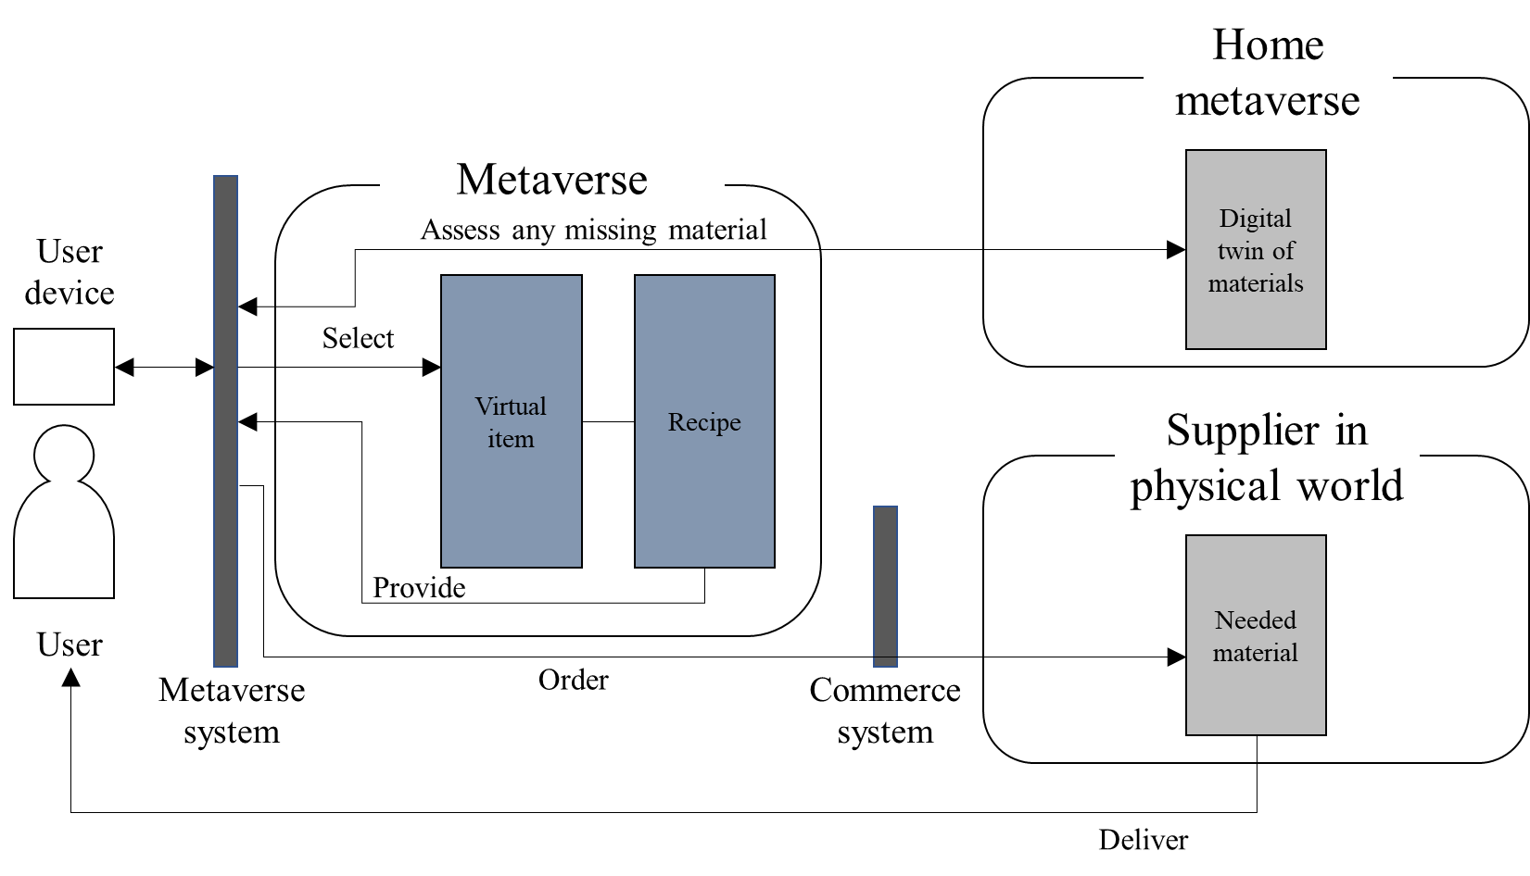

Figure 4 – Conceptual diagram for ordering ingredients for a recipe in virtual worlds

NOTE 4 – A user can interact with both metaverses through the metaverse system.

Figure 5 depicts the operation flows for ordering ingredients for a recipe in a virtual world.

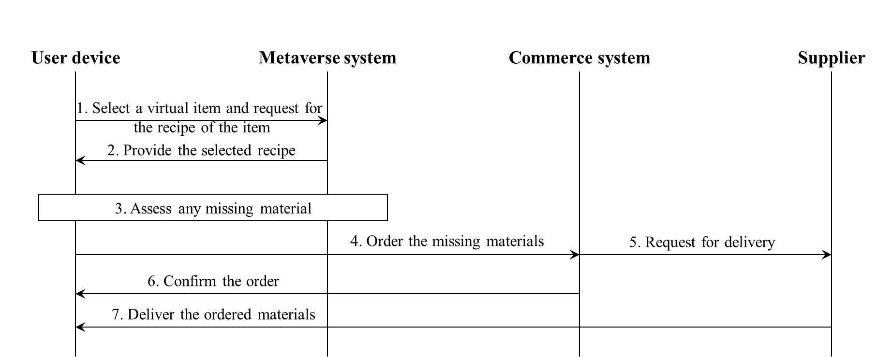

Figure 5 – Operation flows for ordering ingredients for a recipe in a virtual world

1) A user selects a virtual dish and requests its recipe.

2) The metaverse system offers the user the requested recipe.

3) The user assesses ingredients in the home metaverse and finds ingredients needed for the recipe.

4) The user places an order for purchasing the needed ingredients.

5) The commerce system requests supplier for delivery.

6) The commerce system confirms the user about the order.

7) Supplier delivers the ordered material to the user.

### 7.1.3 Scheduling integration process

#### 7.1.3.1 Description

A digital twin can be used in multiple virtual worlds simultaneously. Multiple integration requests can be made in that case, but the integration of the digital twin with the physical object in the physical world needs to be scheduled as only one digital twin can be integrated once at a time.

#### 7.1.3.2 Assumptions

The assumptions related to this use case include the following:

– It is assumed that there are multiple metaverses where users use the same digital twin.

– It is assumed that there is a physical object that can be integrated with the digital twin through a digital twin system.

#### 7.1.3.3 Scenario and operation flows

There are users who want to use a certain 3D model of a physical object in a physical world. A metaverse system can interact with the digital twin system that manages the digital twin, which users want to use. During the service, certain users want to integrate the digital twin with the corresponding object in physical world. Based on the request from the metaverse system, the digital twin system will conduct the requested integration work for a specific user who has the highest priority. Figure 6 shows the conceptual diagram of this scenario.

NOTE – The role of digital twins in this scenario is to provide virtual experience to the users and to integrate with the corresponding physical objects.

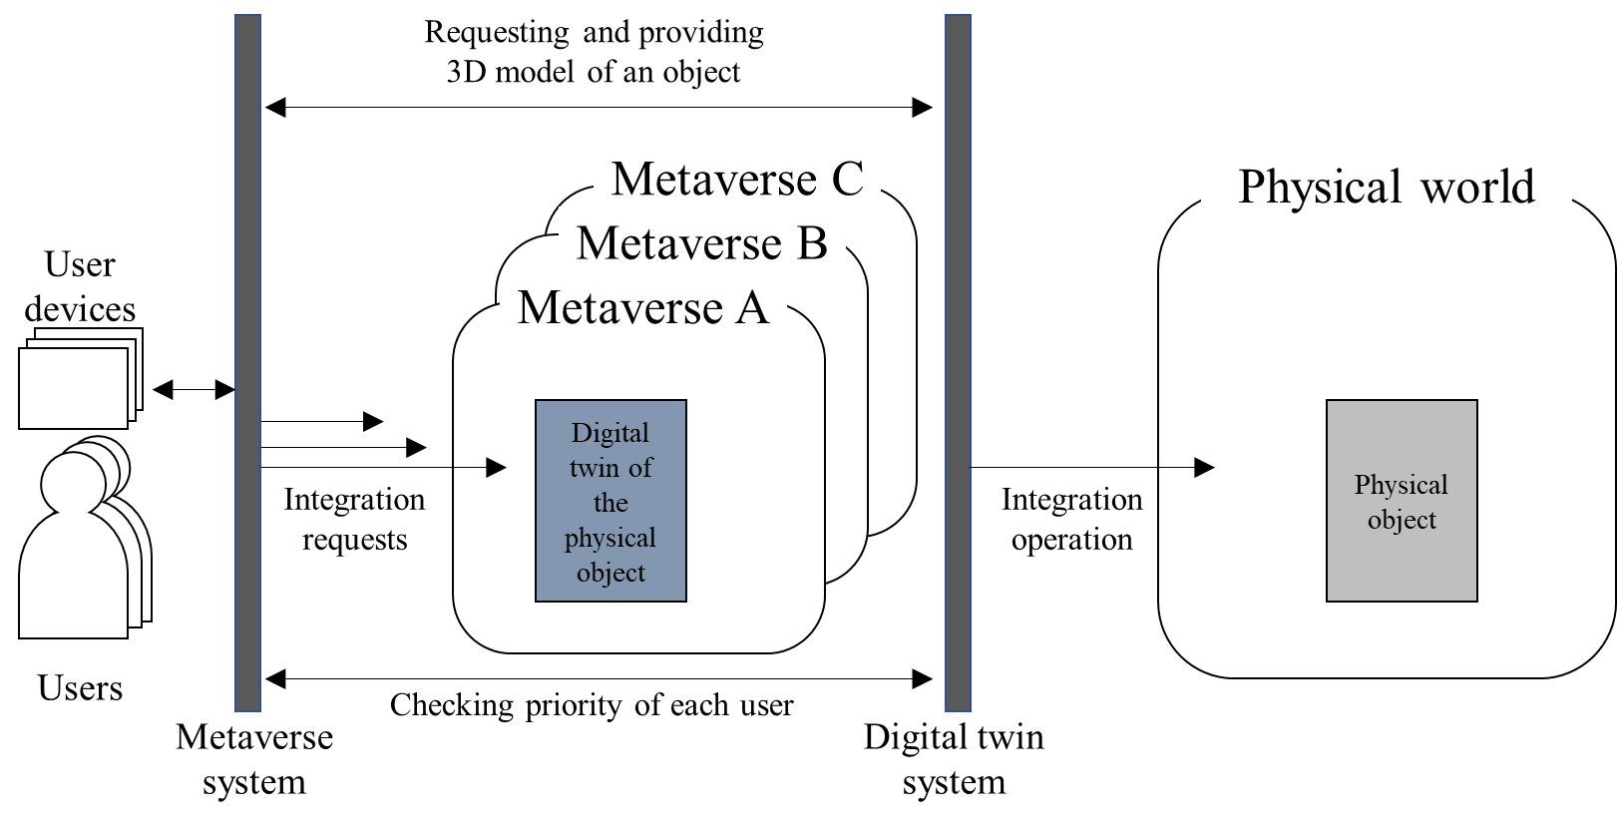

Figure 6 – Conceptual diagram for scheduling integration process

Figure 7 depicts the operation flows for the scheduling integration process.

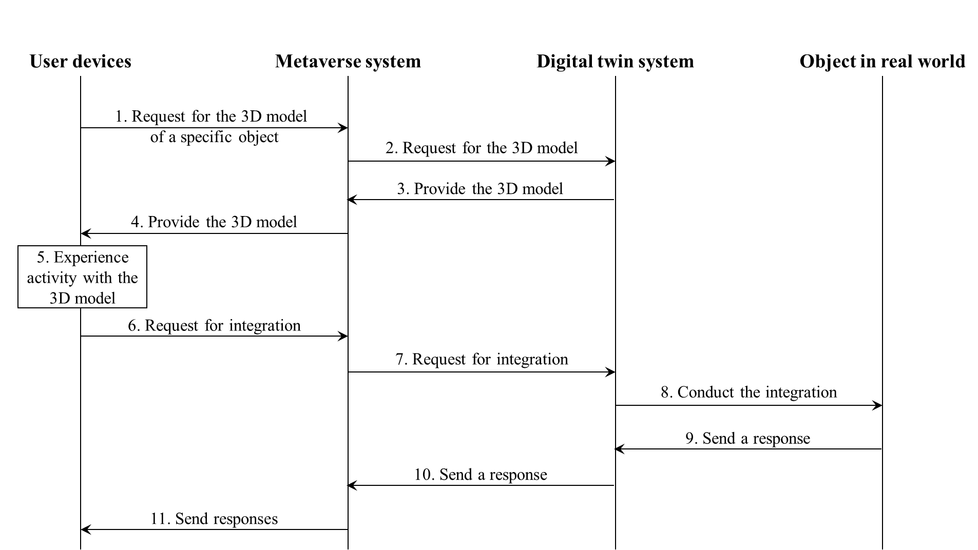

Figure 7 – Operation flows for scheduling integration process

1) Users request to experience the digital twin (i.e., 3D model of digital twin) of a specific physical object in the physical world.

2) The metaverse system interacts with the digital twin system to get the requested 3D model.

3) The digital twin system provides the requested 3D model.

4) Metaverse system provides the requested 3D model.

5) Users enjoy the experience with the 3D model.

6) A set of users request the integration based on their experience.

7) Metaverse system interacts with digital twin system for the requested integration. For the integration, the digital twin system recognizes the priority level of each user and gives the information to the digital twin system when it requests for integration.

8) Digital twin system conducts the integration and sends a response to the metaverse system.

9) The physical object in the physical world sends a response to the digital twin system.

10) The digital twin system sends a response to the metaverse system.

11) The metaverse system sends responses to the users requested integration. Note that only a specific user will receive the response indicating successful integration.

## 7.2 Interaction initiated from a physical world

### 7.2.1 Notifying a guest in a physical world to a virtual world

#### 7.2.1.1 Description

Notifying a guest in a physical world to a virtual world is about a user's avatar in a virtual world being notified of a guest arriving at the user's home in the physical world.

#### 7.2.1.2 Assumptions

The assumptions related to this use case include the following:

– It is assumed that a user has the metaverse representing the user's home.

– It is assumed that the home metaverse has a digital twin of the user's home components in the physical world.

– It is assumed that the user can add digital twins of the items, which the user is interested in, to his/her home metaverse.

NOTE 1 – The technical methods for interaction between virtual and physical worlds and those among virtual worlds are implementation dependent, which are not under the scope of this document.

#### 7.2.1.3 Scenario and operation flows

A user wants to install new furniture and appliances to a living room space on the second floor of their home. To simulate the installation, the user selects the digital twins of the desired furniture and appliances and installs them in the living room space of the home metaverse.

NOTE 2 – This document does not limit methodologies to access home metaverses, including virtual reality (VR) and mixed reality (MR).

NOTE 3 – The role of digital twins in this scenario is to exchange information with the corresponding physical objects in order to control the physical objects.

During the user's activities in the virtual world, a guest arrives at the front door of the home in the physical world and requests entry. The user receives a notification through the digital twin of the front door, checks the visitor's identity by viewing the video or picture captured by built-in camera in the front door, and opens the door by pressing the displayed door-open button on the digital twin. As a result, the front door opens, allowing the guest to enter and meet up with the user. Figure 8 shows the conceptual diagram of this use case.

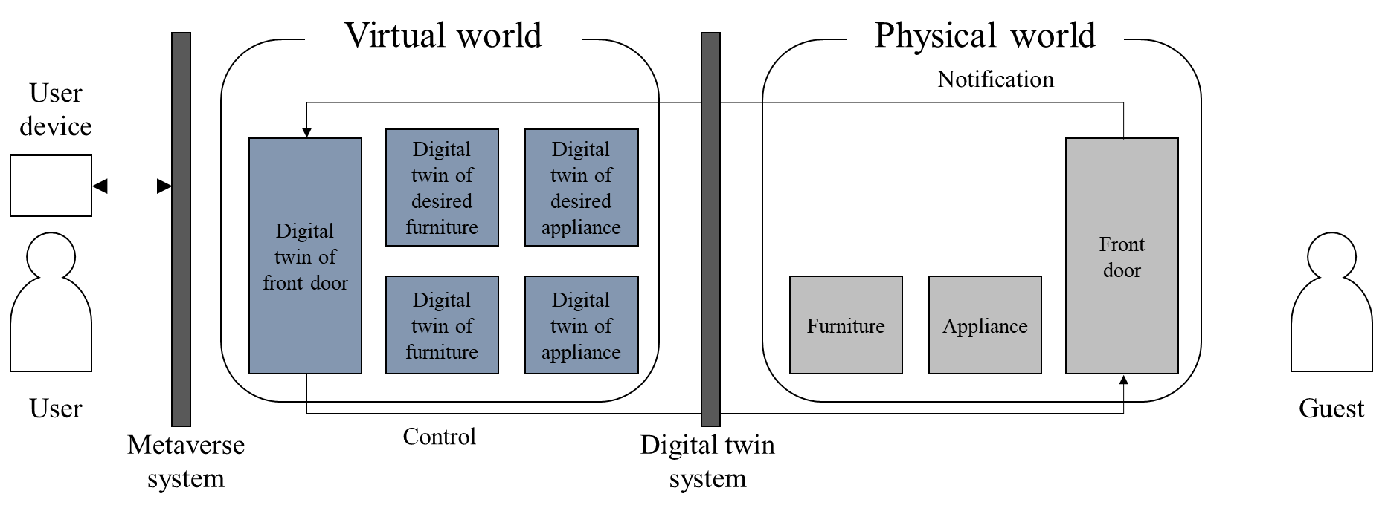

Figure 8 – Conceptual diagram for notifying a guest in the physical world

Figure 9 depicts the operation flows for the interaction initiated from the physical world in the above scenario. The metaverse system in Figure 9 operates a home metaverse where users can interact with digital twins of home components, while the digital twin system manages the digital twins in the home metaverse by supporting synchronization between physical objects and the corresponding digital twins.

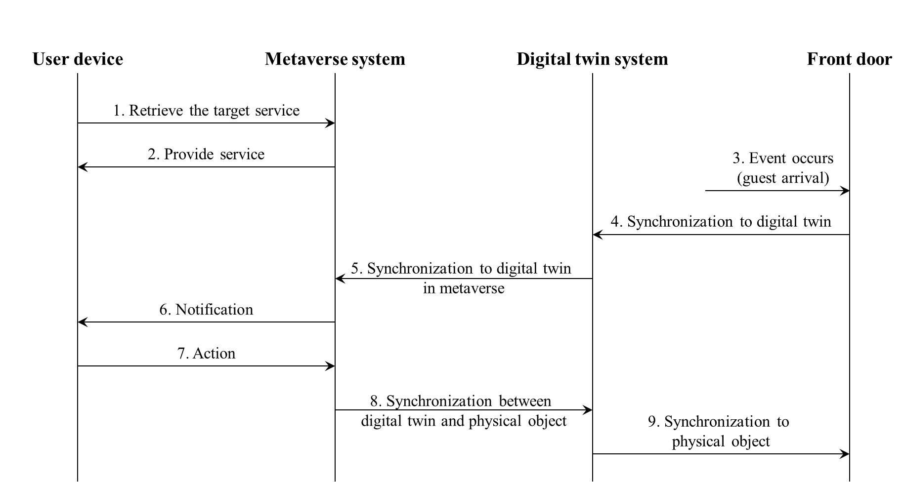

Figure 9 – Operation flows for notifying a guest in a physical world to a virtual world

1) A user selects digital twins of physical objects to be used in the home metaverse.

2) After step 1, the user utilizes digital twins in the metaverse system according to their purpose.

3) While the user is working operations, a guest arrives at the front door and requests entry.

4) The front door sends a request to the digital twin system to synchronize itself with the corresponding digital twin for the entry request.

5) The digital twin system synchronizes the metaverse system for the entry request.

6) The metaverse system notifies the user of the guest arrival.

7) The user selects the digital twin of the front door and performs an action, such as checking the guest's identity through the screen and opening the door by pressing the door-open button displayed on the digital twin.

8) The metaverse system synchronizes with the digital twin for door open request.

9) The digital twin system synchronizes with the front door to open it.

## 7.3 Synchronization between virtual and physical worlds

### 7.3.1 Constructing a 3D spatial map

#### 7.3.1.1 Description

Spatial mapping can be considered as constructing a map in a virtual world, or from a physical world to a virtual world. A typical example could be a factory that constructs a digital platform with a 3D spatial map of the entire space of the factory including physical environmental information and digital information.

#### 7.3.1.2 Assumptions

The assumptions related to this use case include the following:

– It is assumed that a service provider is able to provide services based on a spatial map.

– It is assumed that a user is able to access and update the spatial map, which the user is authorized to access.

– It is assumed that a user is able to obtain position information via e.g., mobile devices.

NOTE 1 – Construction process of spatial map is implementation dependent, which are not under the scope of this document.

#### 7.3.1.3 Scenario and operation flows

A user wants to equip a new component on an existing system in a factory. To optimize the installation process, the user selects the digital twins of the target component and installs them in the 3D spatial map of the factory.

NOTE 2 – The role of digital twins in this scenario is to generate a 3D spatial map of the factory in the physical world.

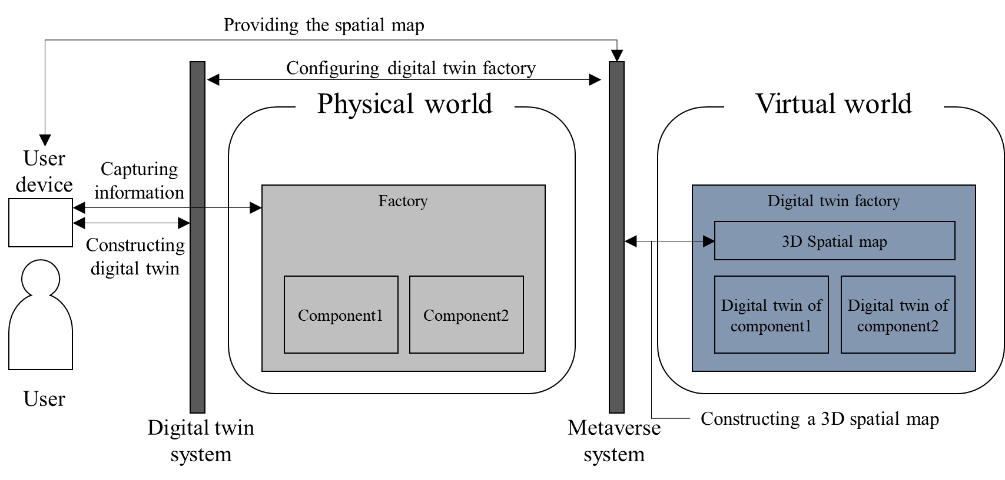

Figure 10 – Conceptual diagram for constructing spatial map

Figure 11 depicts the operation flows for constructing a spatial map. The digital twin system builds digital twins based in the information from a user device and interacts with the metaverse system in order to construct the digital twin factory. After the construction, the metaverse system provides the spatial map to the user.

NOTE 3 – It is assumed that a user with a mobile device is authorized to deliver data for the purposes of spatial mapping.

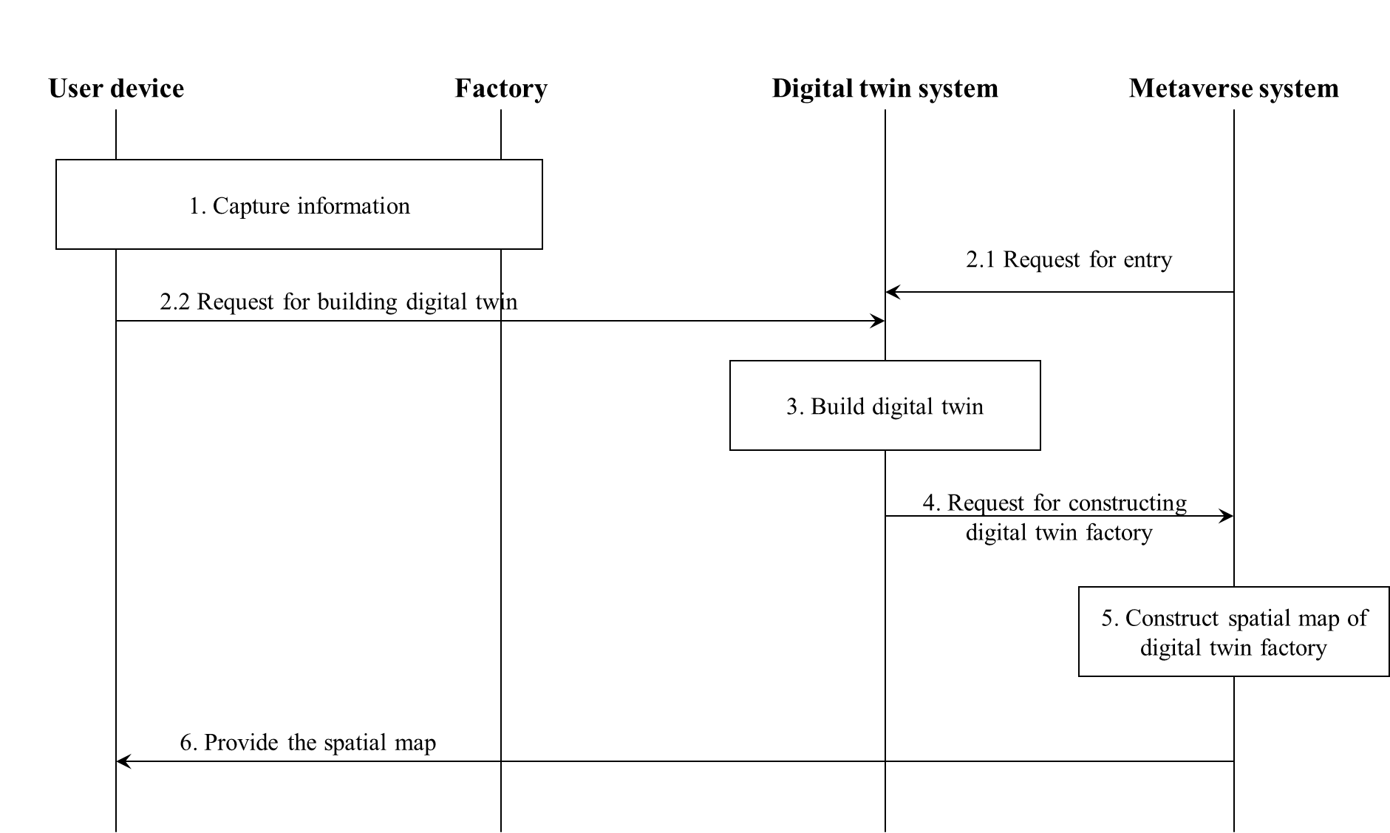

Figure 11 – Operation flows for constructing spatial map

1) A user device starts to provide information as needed e.g., image or video or AR/MR media collected from the camera of the mobile device. The user can provide the information at the required position of the factory.

2.1) The service request made by the user is triggered by applications from metaverse system.

2.2) The user device uploads the captured images, video, other data (including the serial number of required components) with the positioning information of the user device in order to request to build the digital twin.

3) The digital twin system collects the information provided and constructs digital twins.

4) With the position information and digital twins built, the digital twin system requests a metaverse system to construct a spatial map.

5) The metaverse system constructs a spatial map with digital twins.

6) The metaverse system sends the constructed spatial map to the user.

### 7.3.2 Location synchronization

#### 7.3.2.1 Description

As introduced in clause 7.3.1, spatial mapping can be considered as constructing a map in a virtual world, or from the physical world to a virtual world. Based on a constructed 3D spatial map in the virtual world, another key use case concerns keeping the location information aligned between the physical world and the virtual world.

#### 7.3.2.2 Assumptions

The assumptions related to this use case include the following:

– It is assumed that service provider is able to provide services based on a spatial map.

– It is assumed that the user is able to access and update the spatial map, which the user is authorized to access.

– It is assumed that the user is able to obtain position information via for example mobile devices.

NOTE 1 – The construction process of the spatial map is implementation dependent, which is not under the scope of this document.

#### 7.3.2.3 Scenario and operation flows

A user updates the location of a component on an existing system in a factory (e.g. moving of the device from one place to another, or the location of robots in the factory may update automatically), which may impact the production or transportation process in the virtual world. The user authorizes the digital twins of the target component to synchronize the location information in the 3D spatial map via the metaverse system.

NOTE 2 – The role of digital twins in this scenario is to keep the location information aligned between the physical and virtual worlds.

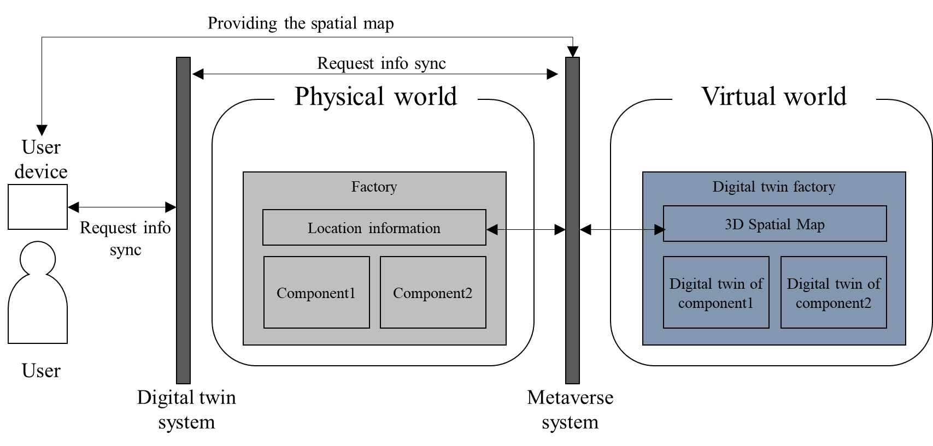

Figure 12 – Conceptual diagram for location synchronization

Figure 13 depicts the operation flows for location synchronization.

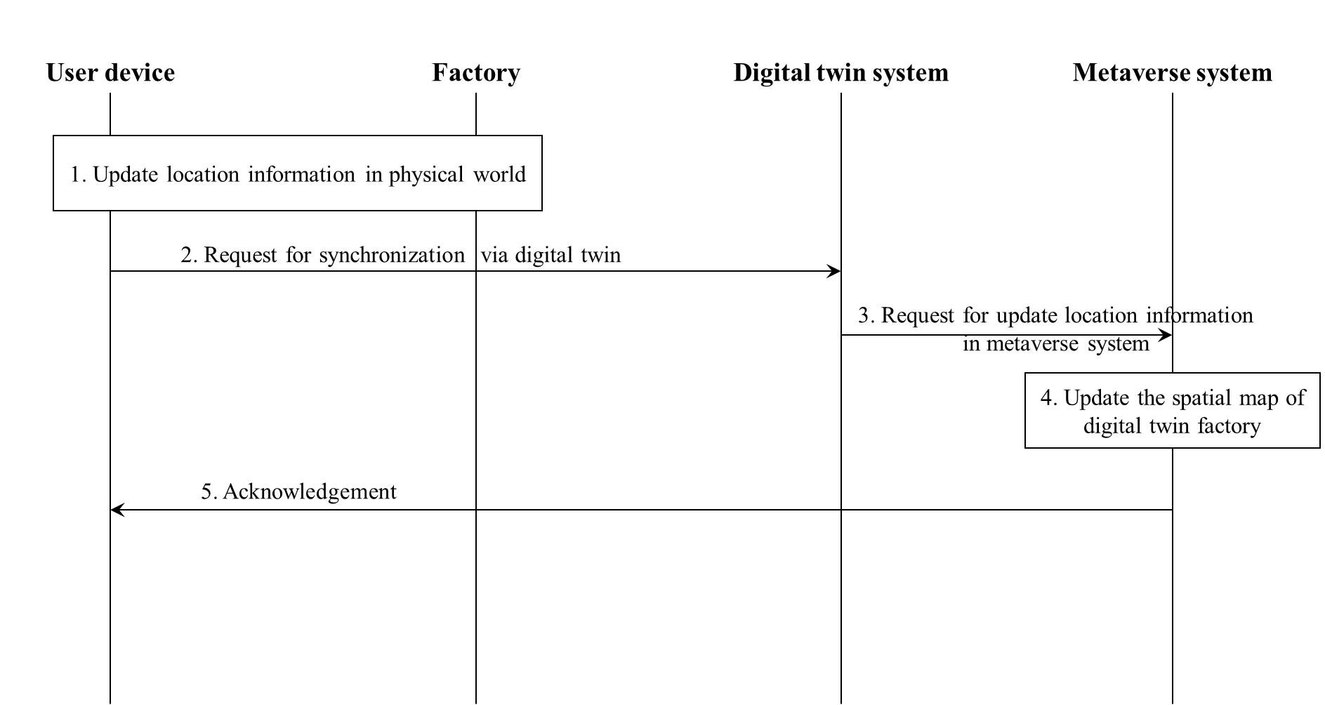

Figure 13 – Call flows for location synchronization

1) A user updates the location information in the physical world.

2) The user requests for location information synchronization via the digital twin system.

3) The digital twin system forwards the request to the metaverse system.

4) With the position information and digital twins built, the metaverse system updates the spatial map.

5) The metaverse system sends an acknowledgement to the user.

### 7.3.3 Localization in spatial map

#### 7.3.3.1 Description

According to the 3D spatial map and location synchronization between a virtual world and real world, localization in a spatial map is another example to indicate usage of the metaverse and digital twin system in a factory. Figure 14 shows a conceptual diagram for localization in a spatial map.

#### 7.3.3.2 Assumptions

The assumptions related to this use case include the following:

– It is assumed that a service provider is able to provide services based on spatial maps.

– It is assumed that a user is able to access and update the spatial map, which the user is authorized to access.

– It is assumed that a user (including authorized 3rd party users) is able to obtain position information via e.g., mobile devices.

NOTE 1 – The construction process of the spatial map is implementation dependent, which is not under the scope of this document.

#### 7.3.3.3 Scenario and operation flows

A user wants to obtain virtual information and/or a service at a certain location. For example, the user is wearing a pair of AR glasses while checking the status of a device, the virtual information related with this device is expected to be displayed via the AR glasses.

The user can issue a localized service request to the metaverse system which may include the user's preferences, device parameters, etc.

Additionally, an authorized 3rd party user can obtain the service list related with the position information via e.g., mobile devices from the metaverse system remotely.

NOTE 2 – The role of digital twins in this scenario is to forward the localization service request to the metaverse system.

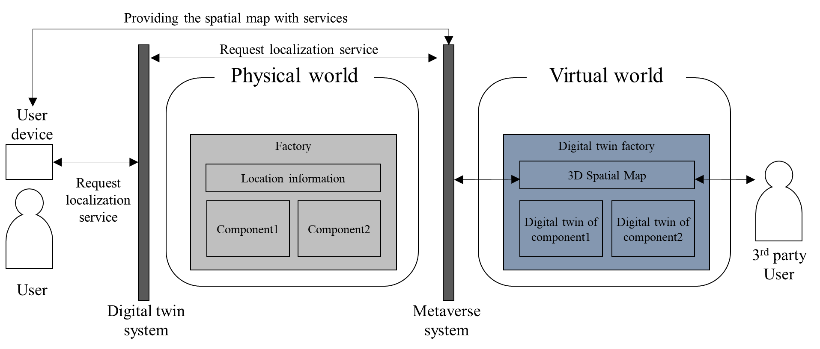

Figure 14 – Conceptual diagram for localization in spatial map

Figure 15 depicts the operation flows for localization in a spatial map.

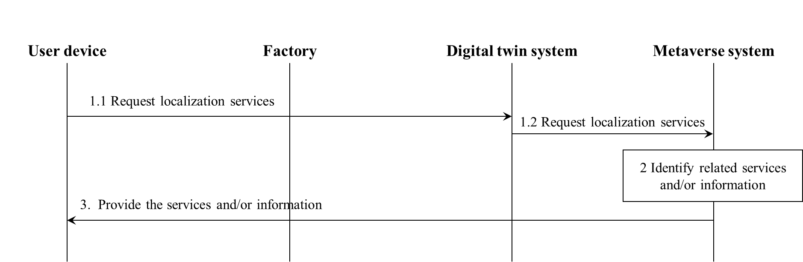

Figure 15 – Conceptual diagram for localization in spatial map

1.1 and 1.2) A user sends the localization service request to the metaverse system via a digital twin system.

2) The metaverse system identifies the services and/or information as per the user's request.

3) The metaverse system sends the service and/or information to the user.

# 8 Requirements for the metaverse based on digital twins

## 8.1 Requirements related to digital twin

The following requirements relate to digital twin for digital-based integration between virtual and physical worlds:

– REQ-DT-01: A digital twin is required to be uniquely identifiable in a metaverse.

– REQ-DT-02: A digital twin is required to be maintained by a digital system that can interact with the metaverse system.

– REQ-DT-03: The digital system is required to be searchable in order to use the digital twin in metaverse.

– REQ-DT-04: The digital system is required to provide the information of the digital twin maintained by the system.

– REQ-DT-05: The digital system is required to manage the information on access rights of each digital twin.

– REQ-DT-06: A digital twin is required to be capable of interacting with entities including avatars of users and other digital twins in a metaverse.

– REQ-DT-07: A digital twin is required to be capable of synchronizing with the corresponding physical object in the physical world at an appropriate period or on user's request.

– REQ-DT-08: A digital twin used in a metaverse is recommended to have characteristics that specify the user priority to synchronize with the corresponding physical object.

NOTE 1 – A user cannot request for synchronization of a specific digital twin, if a synchronization requested by a user with higher priority is in progress.

NOTE 2 – The interaction between digital twins is not under the scope of this Technical Specification.

## 8.2 Requirements related to metaverse

The following requirements relate to metaverse for digital-based integration between virtual and physical worlds:

– REQ-MV-01: The metaverse is required to be capable of providing the information of digital twins that users require.

– REQ-MV-02: The metaverse system is required to be capable of interacting with the digital twin system maintaining the digital twins selected by users.

– REQ-MV-03: The metaverse is required to be capable of providing the experience of using the digital twins selected by users.

– REQ-MV-04: The metaverse system is required to be capable of interacting with the digital system to be synchronized with physical objects.

NOTE – The synchronization can be conducted with respect to the physical object's movement, position, characteristics such as colour, etc.

– REQ-MV-05: The metaverse is recommended to be capable of providing the information of 3rd party services that users can use in the metaverse.

– REQ-MV-06: The metaverse is recommended to be capable of providing the services offered by a 3rd party service provider.

– REQ-MV-07: The metaverse system is recommended to be capable of interacting with a 3rd party system that offers the service selected by the users.

## 8.3 Requirements related to system interaction

The following requirements relate to system interaction for digital-based integration between virtual and physical worlds:

– REQ-SI-01: The digital system and the metaverse system are required to be capable of interacting with each other.

– REQ-SI-02: The digital system, the metaverse system, and 3rd party system are recommended to be capable of interacting with each other.

– REQ-SI-02: The metaverse system is required to be capable of connecting to the digital twin system that users are willing to use.

– REQ-SI-03: The metaverse system is required to be capable of connecting to the 3rd party system offering the 3rd party services that users are willing to use.

– REQ-SI-04: The 3rd party system is recommended to be capable of connecting to the digital system that the services need.

Bibliography

[b-ITU-T Y.4000] Recommendation ITU-T Y.4000/Y.2060 (2012), *Overview of the Internet of things.*

[b-ITU-T Y.4600] Recommendation ITU-T Y.4600 (2022), *Requirements and capabilities of a digital twin system for smart cities*.

[b-ITU-T P.1320] Recommendation ITU-T P.1320 (2022), *Quality of experience assessment of extended reality meetings*.

[b-ITU FGMV-20] Technical Specification ITU FGMV-20 (2023), *Definition of metaverse.*

[b-ISO/IEC 18039] ISO/IEC 18039:2019, *Information technology – Computer graphics, image processing and environmental data representation – Mixed and augmented reality (MAR) reference model.*

______________