|  |  |  |
| --- | --- | --- |
|  | | Standardization Sector |
| ITU Focus Group Technical Report | |
| (03/2024) | |
|  | ITU Focus Group on metaverse | |
|  | Guidelines for metaverse application in power systems  *Working Group 2: Applications & Services* | |

|  |  |
| --- | --- |
| **ITUPublications** | **International Telecommunication Union** |



|  |
| --- |
| Technical Report ITU FGMV-27  Guidelines for metaverse application in power systems |

Summary

This Technical Report provides the connotation, mapping mode, and implementation logic of the power metaverse, and provides the application framework and key technical details. For the convenience of understanding and use, it also lists three typical application scenarios aligned with power system business needs. This Technical Report provides a reference for decision-making, technical research, and application practice in the power metaverse.

Keywords

Application framework, application scenarios, key technologies, metaverse, power system.

Note

This Technical Report is an informative ITU-T publication. Mandatory provisions, such as those found in ITU‑T Recommendations, are outside the scope of this publication. This publication should only be referenced bibliographically in ITU-T Recommendations.

Change Log

This document contains Version 1.0 of the ITU Technical Report on "*Guidelines for metaverse application in power system*" approved at the 5th meeting of the ITU Focus Group on metaverse (FG‑MV), held on 5‑8 March in Queretaro, Mexico.

Acknowledgements

This Technical Report was researched and written by Dong Wang (State Grid Corporation of China, China), Da Li (State Grid Corporation of China, China), Tingting Wen (State Grid Corporation of China, China), Yuntao Wang (China Academy of Information and Communications Technology (CAICT), China), Mingyang Lei (State Grid Corporation of China, China), Bin Hua (State Grid Corporation of China, China), Chenda Zhang (State Grid Corporation of China, China), Jun Yan (State Grid Corporation of China, China), Tao Wang (CSG Electric Power Research Institute, China), Tong Li (State Grid Corporation of China, China), Yihui Zhang (China Academy of Information and Communications Technology (CAICT), China), Ping Song (State Grid Corporation of China, China), Qiyu Lu (State Grid Corporation of China, China) and Md. Selim Reza (Internal Resources Division, Bangladesh). The development of this document was coordinated by Yuntao Wang (CAICT, China) and Yuan Zhang (China Telecom), as FG-MV Working Group 2 Co-chairs, Julien Maisonneuve (Nokia), as FG-MV Working Group 2 Vice-chair and by Jie Song (State Grid Corporation of China) as Chair of Task Group on power metaverse.

Additional information and materials relating to this report can be found at: <https://www.itu.int/go/fgmv>. If you would like to provide any additional information, please contact Cristina Bueti at [tsbfgmv@itu.int](mailto:tsbfgmv@itu.int).

|  |  |  |
| --- | --- | --- |
| **Editor**: | Dong Wang State Grid Corporation of China China | Tel: +86 15901524796 E-mail: [wangdong@sgdt.sgcc.com.cn](mailto:wangdong@sgdt.sgcc.com.cn) |
| **Editor**: | Da Li State Grid Corporation of China China | Tel: +86 18210099015 E-mail: [lida@sgdt.sgcc.com.cn](mailto:lida@sgdt.sgcc.com.cn) |
| **Editor**: | Tingting Wen State Grid Corporation of China  China | Tel: +86 18101301872 E-mail: [wentingting@sgdt.sgcc.com.cn](mailto:wentingting@sgdt.sgcc.com.cn) |
| **WG2 Co-chair and Editor:** | Yuntao Wang China Academy of Information and Communications Technology (CAICT)  China | Tel: +86 18611547086 E-mail: [wangyuntao@caict.ac.cn](mailto:wangyuntao@caict.ac.cn) |
| **Editor**: | Mingyang Lei State Grid Corporation of China  China | Tel: +86 18822786620 E-mail: [leimingyang@sgdt.sgcc.com.cn](mailto:leimingyang@sgdt.sgcc.com.cn) |
| **Editor**: | Bin Hua State Grid Corporation of China  China | Tel: +86 13801638031 E-mail: [13801638031@163.com](mailto:13801638031@163.com) |
| **Editor**: | Chenda Zhang State Grid Corporation of China  China | Tel: +86 13811859869 E-mail: [476633753@qq.com](mailto:476633753@qq.com) |
| **Editor**: | Jun Yan State Grid Corporation of China  China | Tel: +86 13601735704 E-mail: [yanjun_mail@sina.com](mailto:yanjun_mail@sina.com) |
| **Editor**: | Tao Wang CSG Electric Power Research Institute China | Tel: +86 15818127110 E-mail: [wangtao@csg.cn](mailto:wangtao@csg.cn) |
| **Editor**: | Tong Li State Grid Corporation of China  China | Tel: +86 15940480873 E-mail: [lt1_ldk@ln.sgcc.com.cn](mailto:lt1_ldk@ln.sgcc.com.cn) |
| **Editor**: | Yihui Zhang China Academy of Information and Communications Technology (CAICT) China | Tel: +86 15210988408 E-mail: [zhangyihui@caict.ac.cn](mailto:zhangyihui@caict.ac.cn) |
| **Editor**: | Ping Song State Grid Corporation of China  China | Tel: +86 13916741278 E-mail: [nwtiger@163.com](mailto:nwtiger@163.com) |
| **Editor**: | Qiyu Lu State Grid Corporation of China  China | Tel: +86 13761150655 E-mail: [zjluqiyu@163.com](mailto:zjluqiyu@163.com) |
| **Editor**: | Md. Selim Reza Internal Resources Division Bangladesh | Tel: +88 01631894767 E-mail: [sa@ird.gov.bd](mailto:sa@ird.gov.bd)  [selimr.mohfw@gmail.com](mailto:selimr.mohfw@gmail.com) |
| **WG2 Co-chair**: | Yuan Zhang  China Telecom China | E-mail: [zhangy666@chinatelecom.cn](mailto:zhangy666@chinatelecom.cn) |
| **WG2 Vice‑chair**: | Julien Maisonneuve Nokia | E-mail: [julien.maisonneuve@nokia.com](mailto:julien.maisonneuve@nokia.com) |

© ITU 2025

Some rights reserved.This publication is available under the Creative Commons Attribution-Non Commercial-Share Alike 3.0 IGO licence (CC BY-NC-SA 3.0 IGO; [https://creativecommons.org/licenses/by-nc-sa/3.0/igo](https://eur03.safelinks.protection.outlook.com/?url=https%3A%2F%2Fcreativecommons.org%2Flicenses%2Fby-nc-sa%2F3.0%2Figo&data=05%7C02%7CChristelle.Gachet%40itu.int%7C0fe5406e5055456a0b5a08dc7bce06f3%7C23e464d704e64b87913c24bd89219fd3%7C0%7C0%7C638521372006151524%7CUnknown%7CTWFpbGZsb3d8eyJWIjoiMC4wLjAwMDAiLCJQIjoiV2luMzIiLCJBTiI6Ik1haWwiLCJXVCI6Mn0%3D%7C0%7C%7C%7C&sdata=HtXL1m3ekhVn82amVYFS35Ip8LaaB74uwbUtbEu0fKM%3D&reserved=0)).

If you wish to reuse material from this publication that is attributed to a third party, such as tables, figures or images, it is your responsibility to determine whether permission is needed for that reuse and to obtain permission from the copyright holder. The risk of claims resulting from infringement of any third-party owned material in the publication rests solely with the user.

**Table of Contents**

Page

1 Scope 1

2 References 1

3 Definitions 1

3.1 Terms defined elsewhere 1

3.2 Terms defined in this Technical Report 2

4 Abbreviations and acronyms 2

5 Conventions 2

6 Background 2

7 The connotation of power metaverse 3

7.1 The mapping mode of the real and virtual power system 3

7.2 The implementation logic of power metaverse 3

8 The framework of power metaverse 4

8.1 Infrastructure 5

8.2 Core technologies 5

8.3 Service support 6

8.4 Business applications 6

9 Typical application scenarios in the power metaverse 6

9.1 Virtual power plant 6

9.2 Smart grid management 9

9.3 Power trading 10

Appendix A – Core technologies 13

A.1 Digital twin 13

A.2 Artificial intelligence 14

A.3 Blockchain 15

A.4 The Internet of things 16

A.5 Human-computer interaction 17

A.6 Big data 17

A.7 Cloud computing 18

A.8 Extended reality 19

Bibliography 20

Technical Report ITU FGMV-27

Guidelines for metaverse application in power systems

# 1 Scope

This Technical Report provides the guidelines for the application of power metaverse. The scope of this Technical Report includes:

– The mapping mode of real and virtual power systems;

– The implementation logic of power metaverse;

– The framework of power metaverse;

– Application details of key technologies in power metaverse;

– Typical application scenarios in power metaverse.

# 2 References

[ITU-T Y.4000] Recommendation ITU-T Y.4000/Y.2060 (2012), *Overview of the Internet of things.*

[ITU FGMV-09] Technical Report ITU FGMV-09 (2023), *Power metaverse: Use cases relevant to grid side and user side.*

[ITU FGMV-20] Technical Specification ITU FGMV-20 (2023), *Definition of metaverse*.

# 3 Definitions

## 3.1 Terms defined elsewhere

This Technical Report uses the following terms defined elsewhere:

**3.1.1 artificial intelligence** [b-ITU-T M.3080]: Computerized system that uses cognition to understand information and solve problems.

**3.1.2 augmented reality (AR)** [b-ITU-T P.1320]: An environment containing both real and virtual sensory components. The augmented reality continuum runs from virtual content that is clearly overlaid on a real environment (assisted reality) to virtual content that is seamlessly integrated and interacts with a real environment (mixed reality).

**3.1.3 blockchain** [b-ITU-T F.751.0]: A type of distributed ledger that is composed of digitally recorded data arranged as a successively growing chain of blocks with each block cryptographically linked and hardened against tampering and revision.

**3.1.4 big data** [b-ITU-T L.1390]: A term that describes the large volume of data – both structured and unstructured – that inundates a business on a day-to-day basis. Big data can be analysed for insights that lead to better decisions and strategic business moves.

**3.1.5 cloud computing** [b-ITU-T Y.3500]: Paradigm for enabling network access to a scalable and elastic pool of shareable physical or virtual resources with self-service provisioning and administration on-demand.

**3.1.6 digital twin** [b-ITU-T Y.4600]: A digital representation of an object of interest.

**3.1.7 extended reality (XR)** [b-ITU-T P.1320]: An environment containing real or virtual components or a combination thereof, where the variable X serves as a placeholder for any form of new environment (e.g., augmented, assisted, mixed, virtual or diminished reality).

**3.1.8 Internet of things (IoT)** [ITU-T Y.4000]: A global infrastructure for the information society, enabling advanced services by interconnecting (physical and virtual) things based on the existing and evolving interoperable information and communication technologies.

**3.1.9 mixed reality (MR)** [b-ITU-T P.1320]: An environment containing both real and virtual components that are seamlessly integrated and interact with each other in a natural way (one end of the augmented reality continuum).

**3.1.10 virtual reality (VR)** [b-ITU-T P.1320]: An environment that is fully generated by digital means. To qualify as virtual reality, the virtual environment should differ from the local environment.

## 3.2 Terms defined in this Technical Report

None.

# 4 Abbreviations and acronyms

This Technical Report uses the following abbreviations and acronyms:

3D Three-Dimensional

AI Artificial Intelligence

AR Augmented Reality

DT Digital Twin

HCI Human-Computer Interaction

IoT Internet of Things

ML Machine Learning

MR Mix Reality

PM Power Metaverse

SMPL Skinned Multi-Person Linear

VPP Virtual Power Plant

VR Virtual Reality

XRExtended Reality

# 5 Conventions

None.

# 6 Background

Under the general trend of global low-carbon development, the types of international energy consumption have accelerated the transformation from fossil fuels to low-carbon energy. It has become a common choice for countries to increase the consumption proportion of power. The traditional power system will face unprecedented challenges. On one hand, the large-scale renewable energy's access to the power system, which has the characteristics of randomness, volatility and intermittency will bring impact on the safe and stable operation of the power grid. On the other hand, the digital transformation of power systems needs a lot of digital simulation modelling and analysis. There are deficiencies in power dispatching operation, real-time interaction of power grid transient, etc.

Metaverse [ITU FGMV-20] is an integrative ecosystem of virtual worlds offering immersive experiences to users that modify pre-existing and create new value from economic, environmental, social and cultural perspectives. It can realize "real to virtual" through intelligent perception and data collection of power grid status. It can also realize "virtual to real" through intelligent analysis, scientific decision-making, and real-time operation control. Based on the power metaverse (PM), it can strengthen power grid perception, decision-making, and control capabilities [b-Zhou]. It also helps improve renewable energy consumption capacity and promotes the upgrading of smart "transmission-distribution-consumption". It provides technical support for comprehensively addressing the operational complexity and security risks brought by the power system construction.

The construction of PM is still in the exploration and research stage. This Technical Report provides the connotation and application framework of PM and provides the key technical details. By drawing on typical application scenarios aligned with power system business needs, this report provides valuable insights and recommendations to support the low-carbon transformation of the power system.

# 7 The connotation of power metaverse

## 7.1 The mapping mode of the real and virtual power system

The PM [b-Zhou] refers to a new form, which maps the real power system into a virtual power system through the use of the Internet of things (IoT), blockchain, big data, digital twin (DT), extended reality (XR), human-computer interaction (HCI) and other technologies. It can realize the whole process of power production, transmission, storage and consumption visibility, measurability and manageability. To more vividly demonstrate the mapping relationship between real power systems and virtual power systems, and to facilitate the understanding of the connotation of the PM, a mapping mode is proposed, as shown in Figure 1.

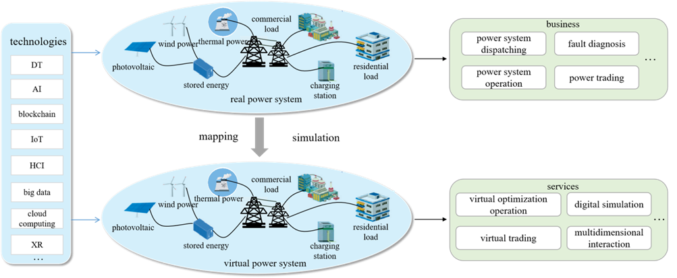

Figure 1 – Mapping mode of the real and virtual power system

## 7.2 The implementation logic of power metaverse

The implementation logic of the PM is shown in Figure 2. The meaning of each part is as follows.

1) **Real power system**: It is composed of the power generation, transmission, transformation, distribution, consumption, storage and dispatching centres, which is the physical skeleton to support the construction of the PM.

2) **Virtual power system**: It is the mapping of the real power system, which is the digital skeleton of the PM.

3) **Virtual interactive**: It can realize perception, interaction, management and control of real power system and virtual power system as the communication medium.

4) **Intelligent analysis**: By "virtual interactive", the data of a real power system can be integrated into a virtual power system. Then, "intelligent analysis" can analyse the data and provide an intelligent decision in the "virtual power system", while the decision will synchronize with the "real power system". The data analysis decisions will also provide guidance and suggestions to users through "human-computer interaction".

5) **Human-computer interaction**: It is the communication medium between the PM and users and is the key link to realize strong interaction and ubiquitous information visualization.

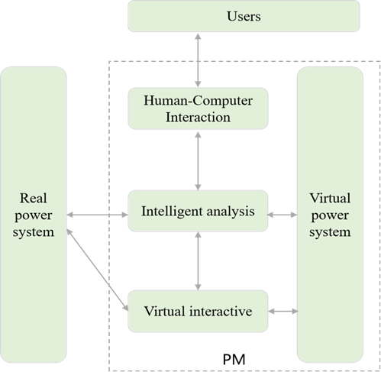

Figure 2 – Implementation logic of the power metaverse (PM)

# 8 The framework of power metaverse

The application framework of the PM, which is shown in Figure 3, consists of the infrastructure, core technologies, service support and business applications. In the upper layer of the operation logic progressive, close contact can achieve devices and platforms interconnection.

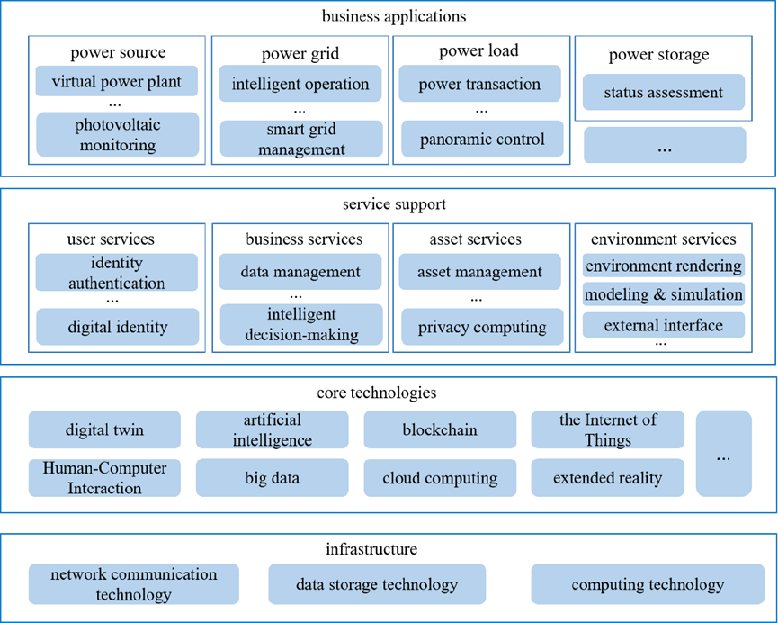

Figure 3 – Framework of the PM

## 8.1 Infrastructure

The infrastructure layer provides the base for the operation of the PM, including network communication, storage, computing, and other supporting technologies. Among them:

1) **Network communication technology**: The emerging fixed and mobile network technology meets the requirements of high throughput and low delay for data transmission in the PM. It helps to realize the efficient processing of the PM operation and constructs a PM governance system that combines real and virtual.

2) **Data storage technology**: It contains distributed and high-speed storage technologies. Distributed storage technology provides users with distributed keys, which can help improve the security and privacy of data. Therefore, it is more convenient for multi-modal mass data transmission. The high-speed storage technology can provide support for fast scene loading, fast multi-scene switching and other functions.

3) **Computing technology**: It can provide computing power for complex functions such as physical computing, rendering, data coordination and synchronization, artificial intelligence (AI), projection, motion capture and translation, etc.

## 8.2 Core technologies

Core technologies layer provides a system-level foundation of technical capabilities for service support, which regards blockchain as the core and integrates DT, AI, IoT, HCI, big data, cloud computing, XR and other technologies. Among them, blockchain technology can solve the trust problem in the PM and make the digital virtual world realize the large-scale value exchange. DT, IoT, XR, and HCI help open up the boundary between the real and the virtual world. Big data, cloud computing, AI and other technologies provide technical support for the realization of various functions in the PM.

The technical details of all core technologies can be found in Appendix A.

## 8.3 Service support

Service support layer is a collection of application services based on core technologies which can provide support for business application scenario construction and function realization. According to the type of service, it can be classified into user services, business services, asset services, and environmental services.

1) **User services**: Include identity authentication, digital identity.

2) **Business services**: Include data management, intelligent decision-making.

3) **Asset services**: Include asset management, privacy computing.

4) **Environment services**: Include environment rendering, modelling and simulation, external interface.

## 8.4 Business applications

Business applications layer provides specific application support in the PM. According to the characteristics of the power business, it forms scene applications including source, grid, load and storage.

**Power source applications**: Provides services for energy suppliers including coal, oil, natural gas and other traditional energy and solar energy, wind, hydro-power and other renewable energy. The application scenarios include virtual power plant (VPP) and photovoltaic monitoring.

**Power grid applications**: Provides services to power transmission networks such as power transmission lines and power system equipment. The application scenarios include smart grid management, intelligent operations, virtual simulation training, and so on.

**Power load applications**: Provides services to end-users such as residents, large enterprises and public facilities. The application scenarios include power transactions, panoramic control, etc.

**Power storage applications**: Provides services to energy storage equipment and storage technologies. The application scenarios include state assessment of power storage equipment, etc.

# 9 Typical application scenarios in the power metaverse

Three representative cases are listed, emerging as typical application scenarios of the power metaverse, the virtual power plant, smart grid management, and power trading. Different from cases in [ITU FGMV-09], which share more light on the power metaverse muti-resource modelling applications, these scenarios embody the intersection of core technologies and energy innovation, showcasing how the convergence of digital and physical realms can enhance operational efficiencies, promote sustainability, and drive market dynamics in the energy sector. Each scenario underscores the power metaverse's potential to reshape our energy future by leveraging advanced controls and real-time data analytics. From aggregating distributed resources in virtual power plants to optimizing smart grid operations and facilitating renewable energy trading, these applications highlight the transformative role of the power metaverse in accelerating the state-of-the-art energy transition.

## 9.1 Virtual power plant

Based on advanced control, measurement and communication technologies, the virtual power plant (VPP) can aggregate a large amount of multi-element distributed resources on the demand side. It can provide the necessary flexibility support for the power system through diversified regulation means, supporting the consumption of renewable energy. In the power metaverse, the VPP can realize the integration and coexistence of physical space entities and information dimensions. The created digital space can evolve synchronously with physical VPP, and reflect its state by holographic simulation, dynamic monitoring, real-time diagnosis and accurate prediction. Then, the results of the diagnosis, prediction, participation in the power market and dispatching control are fed back to the physical entity of the VPP. Based on the construction of the VPP in the PM, it can reflect the real-time equipment load, user load, new energy output, distribution network operation status and so on, thus achieving dynamic monitoring of the operational status of the VPP.

### 9.1.1 Description

This scenario describes that the PM technology is used to optimize control and achieve minimal operating costs for virtual power plants. This scenario describes the use of the PM technology. The procedures in the application scenario are as follows:

1) **DT modelling construction**:

• **Inputs**: Data of power generation resources (distributed photovoltaic, distributed wind power, gas turbines and others), flexible loads (household/public electric vehicles charging posts, air conditioners, water heaters, etc.), energy storage equipment (decentralized energy storage, heat storage tanks and ice storage).

• **Controlled variables**: Power generation, charging and discharging power, load reduction capability, and power balance constraint

• **Outputs**: Operating costs, cost of purchasing and selling power, cost of gas turbines, cost of energy storage, and cost of reducing load.

2) **Batch generation of multi scenario samples**: In the PM space, samples consisting of inputs, controlled variables and outputs are constructed in batches to cover all the scenarios, providing rich data resources for cost optimization of virtual power plant operation scheduling. In the PM, Operators can construct multi-objective optimization scheduling models containing wind, light, and energy storage, and coordinate operations. The complementary use of wind and solar energy enhances the consumption of wind and solar energy and the reliability of power grid operation. Due to the integration of the VPP into renewable energy, the cost of the power generation is lower. By utilizing the PM technology, the power system tends to purchase the VPP electricity first, reducing the benchmark quantity of thermal power units and promoting the low-carbon transformation of the power system. The following two strategies given below can be adopted to conduct.

**Strategy 1: Multi source coordinated operating optimization**. During periods when photovoltaic power is not available, the internal load of the VPP is high, and the supply of electricity from gas turbines is insufficient. VPP as a consumer, purchases electricity from the grid to meet its own load demand, while in other periods, VPP sells electricity to the grid as a producer. For low output scenarios of photovoltaics, increasing the output of gas turbines and discharging energy storage can reduce the load and reduce the amount of reduction. For photovoltaic high output scenarios, reducing the output of gas turbines and charging energy storage can reduce the load and increase the reduction amount. Through coordinated operation of multiple sources, the trading volume of the VPP systems is the same in each photovoltaic scenario. In summary, the coordinated operation of multiple energy sources within the VPP fully explores the flexibility of energy, which is conducive to suppressing the uncertainty of photovoltaic output and encouraging more renewable energy to be integrated into the system.

**Strategy 2: Operating cost prediction**. In the day ahead trading stage, due to the uncertainty of photovoltaic output not being considered, the scheduling cost of the VPP is relatively low. In the intraday stage, there is a deviation between the actual photovoltaic output and the predicted photovoltaic output. When the actual photovoltaic output is lower than the predicted value, based on the trading strategy in the pre-day stage, VPP needs to purchase the insufficient power generation at a high price, resulting in an increase in intraday and total costs. VPP decision-makers need to reduce photovoltaic risk costs within the set range and improve transaction efficiency.

3) **Intelligent decision-making**: Based on the aggregated sample data of various power sources such as photovoltaics, gas turbines, and energy storage, as well as the operational scheduling requirements of the VPP, the overall scheduling cost of the virtual power plant (VPP) is minimized through strategy optimization. In response to the uncertainty of photovoltaic output, the conditional risk value theory is adopted to measure the risk, effectively reducing the system operating costs and improving the consumption rate of renewable energy.

4) **Closed-loop feedback**: The variation of status and behaviours of the VPP are monitored and delivered to the digital twin (DT) platform. Further iterate the sample data continuously and optimize the decision algorithm.

### 9.1.2 Assumptions

The assumptions related to the scenario include the following:

– It is assumed that various power generation data, flexible loads data, and energy storage equipment data are available.

– It is assumed that the network communication quality is reliable.

– It is assumed that meteorological factors are not considerable.

– It is assumed that the virtual power plant can operate normally and stably.

### 9.1.3 Service scenario

The virtual power plant operations manager aims to reduce scheduling costs without affecting normal operations. For this purpose, the PM is applied to generate an optimization strategy. Then the VPP operation managers receive the feedback and adjust their costs of photovoltaic. Thus, better promoting the integration and utilization of resources.

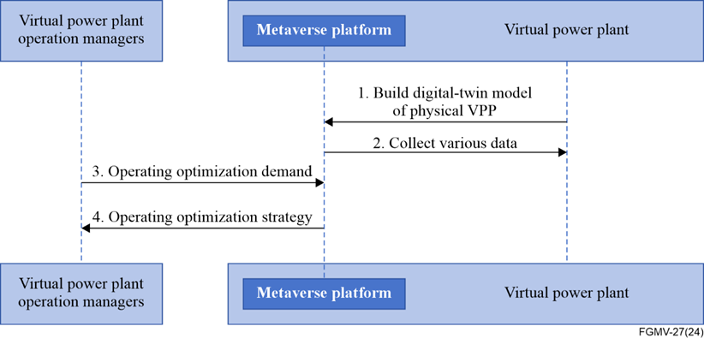

Figure 4 – Service dataflow for operating optimization of the VPP

1) The PM is employed to construct a DT for the corresponding VPP in the virtual world.

2) Metaverse platform obtains various data from the VPP such as the power generation data, flexible loads data, and energy storage equipment.

3) VPP operation managers deliver the operating optimization demand to the metaverse platform.

4) Metaverse platform determines the optimization strategy for multisource coordinated operating optimization, operating cost prediction and control to the VPP operation managers.

## 9.2 Smart grid management

In the PM, the management effect of the smart grid is greatly improved, leading to a more efficient, sustainable, and resilient energy future. Real-time grid visualization and monitoring enables workers to immerse themselves in a virtual power grid, complete with three-dimensional (3D) models of substations, power lines, and renewable energy sources. This allows them to track power flows in real-time, identify potential bottlenecks or outages, and analyse historical data to predict future load demands. Stakeholders can collaborate virtually within the same environment, facilitating problem-solving and decision-making. In the PM, microgrids are designed and managed, integrating diverse renewable energy sources such as solar panels and wind turbines. Power generation, storage, and distribution strategies are optimized based on real-time data and local demand.

### 9.2.1 Description

This scenario describes that the PM technology is used to improve the management level of smart grids. This scenario describes the use of the PM technology. The procedures in the application scenario are as follows:

1) **DT modelling construction**:

• **Inputs**: Power grid basic data, operational status of grid-side equipment.

• **Controlled variables**: Weather conditions.

• **Outputs**: Operation status prediction result, diagnosis results of power grid faults.

2) **Batch generation of multiscenario samples**: In the PM space, samples consisting of inputs, controlled variables and outputs are constructed in batch to cover all the scenarios. The following two strategies can be adopted to perform sample generation.

**Strategy 1: Enhanced grid monitoring and predictive maintenance with AI**. Utilize AI algorithms to collect, analyse, and interpret real-time data from metaverse-enabled sensors deployed throughout the power grid. Create digital twins of grid assets to continuously monitor their condition and predict wear and tear. Simulate potential maintenance scenarios to identify bottlenecks and optimize asset performance and implement proactive maintenance strategies to extend asset lifespan and minimize downtime.

**Strategy 2: Integration of renewable energy sources in microgrids**. Design and implement microgrids within the metaverse, integrating diverse renewable energy sources such as solar panels and wind turbines. Optimize power generation, storage, and distribution based on real-time data and local demand within the metaverse environment. Encourage the integration of distributed generation and storage systems to enhance grid resilience and sustainability.

3) **Intelligent decision-making**: Based on the above strategy, and the batch-generated samples, decision-making is done to form the operation status prediction result, and diagnosis results of power grid faults, thus improving the management ability of the power grid.

4) **Closed-loop feedback**: The operating status of the power grid is monitored and delivered to the DT platform. Further iterate the sample data continuously and optimize the decision algorithm.

### 9.2.2 Assumptions

The assumptions related to this use case include the following:

– It is assumed that there is a centralized metaverse platform that facilitates the integration and interoperability of distributed smart grid systems.

– It is assumed that smart grid operators and stakeholders have access to appropriate hardware and software, including multimodal input devices such as virtual reality (VR) headsets, haptic gloves, and other immersive technologies.

– It is assumed that the metaverse platform provides a secure and reliable environment for data exchange and collaboration among smart grid operators, consumers, and other stakeholders.

– It is assumed that the metaverse platform allows for the creation and deployment of customized smart grid applications and services, enabling operators to tailor their solutions to specific needs and requirements.

– It is assumed that users, including smart grid operators and consumers, have the necessary skills and knowledge to effectively interact with the metaverse platform and utilize its features for smart grid management.

### 9.2.3 Service scenario

This clause describes the service flow for metaverse contents and service discovery service.

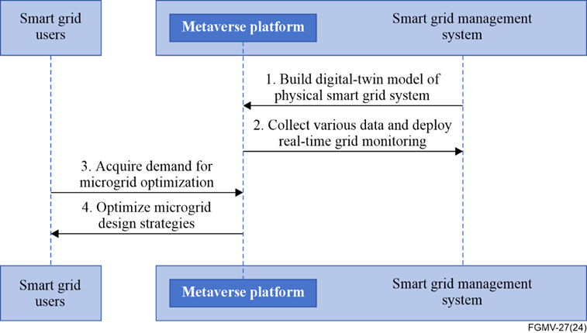

Figure 5 – Service flows for the smart grid management

1) The PM is employed to construct a DT model of a physical smart grid system on a metaverse platform.

2) Metaverse platform collects various data from smart grid management system and deploys real-time grid monitoring.

3) Smart grid users deliver microgrid optimization demand to the metaverse platform.

4) Metaverse platform determines the optimization strategy for microgrid design, management and improvement to smart grid users.

## 9.3 Power trading

With the progress of renewable energy generation technology and the improvement of people's environmental awareness, government agencies have begun to use market means and incentive policies to promote the consumption of renewable energy. The renewable energy quota system based on green certificate trading is a widely implemented policy. Under the quota system policy, power trading platforms are divided into electricity trading platforms and green certificate trading platforms. From the perspective of the power supply side, the power supply is mainly provided by traditional energy power generation companies represented by thermal power plants and clean energy power generation companies represented by wind power producers. As policymakers, government departments allocate quota tasks to various power generation companies. Each power generation company can earn its own profits by selling electricity. Among them, when renewable energy generators use renewable energy to generate electricity, government departments will issue them with green certificates, which can be used for transactions with traditional thermal power generators to obtain another portion of profits. Due to the correlation between the price of green certificates and the output and sales volume of renewable energy generators, renewable energy generators can choose different strategies to participate in market transactions: on the one hand, holding a portion of green certificates to sell when the trading price of green certificates increases; on the other hand, it is also possible to sell green certificates in real time to earn profits.

### 9.3.1 Description

This scenario describes that the PM technology is used to construct an optimal decision model for power generation entities including the electricity market and green certificate trading market. It helps analyse the market behaviour of the power generation enterprises. This scenario describes the use of the PM technology. The procedures in the application scenario are as follows:

1) **DT modelling construction**:

• **Inputs**: Cost of thermal power generation (fuel cost, maintenance cost, and equipment depreciation cost), cost of wind power generation (maintenance costs, equipment depreciation costs, and system backup costs).

• **Controlled variables**: Revenue obtained by thermal power generation companies, revenue earned by wind power generators, electricity prices for thermal power and wind power.

• **Outputs**: Thermal power generation and wind power generation.

2) **Batch generation of multiscenario samples**: Samples consisting of inputs, outputs and controlled variables are generated in batch to cover all the possible scenarios. The following two strategies can be adopted to perform a sample generation.

**Strategy 1: Impact of quota ratio changes on the profits of various power generation companies**. Maximizing profits is the goal pursued by various power generation companies. In addition, during the process of adjusting the quota ratio, the changes in profits of each power generation company can indirectly reflect the changes in market decision-making behaviour. The implementation of a quota system has a very significant promoting effect on the power generation of wind power producers. In the pursuit of maximizing profits by various power generation companies, the increase in quota ratio has a significant incentive effect on wind power producers, which is conducive to the sustainable and healthy development of wind power enterprises.

**Strategy 2: Impact of quota ratio changes on electricity trading prices and green certificate prices influence**. With the increase of the quota ratio, the implementation of the quota system has led to a simultaneous increase in the transaction price of electricity on the power trading platform and the transaction price of green certificates. The reason is that thermal power generation companies need to pay both the cost of power generation and the cost of purchasing green certificates in the quota system. For wind power producers, retaining green certificates when the quota ratio increases can increase the price of green certificates. At the same time, the number of green certificates that thermal power generation companies need to purchase increases. In order to reduce the cost of purchasing green certificates, thermal power generation companies will reduce their electricity generation to increase profits, resulting in an increase in the transaction price of the power trading platform. In the green certificate market, wind power producers are unable to exercise market power by retaining green certificates, which will reduce wind power output, reduce the number of green certificates that can be traded in the green certificate market, and thus increase the trading price of green certificates.

3) **Intelligent decision-making**: Based on the above strategy, analyse the sensitivity changes of the power generation, revenue, green certificate trading volume, and green certificate trading prices of various types of power generation companies under different quota ratios. Then, based on the decision optimization results, analyse the market power behaviour of each power generation company.

4) **Closed-loop feedback**: The optimal analysis result is conducted in the physical world. The market behaviours of power generation enterprises are monitored and delivered to the DT platform. Further iterate the sample data continuously and optimize the decision algorithm.

### 9.3.2 Assumptions

The assumptions related to the scenario include the following:

– It is assumed that the trading electricity of each thermal power generation company and wind power producer is within the safe output range of the unit.

– It is assumed that the total number of green certificates actually sold by each wind power producer is equal to the total number of green certificates purchased by each thermal power generator.

– It is assumed that the actual number of green certificates sold by wind power producers shall not exceed the upper limit of the number of green certificates available for sale by themselves.

### 9.3.3 Service scenario

Power market supervisors are responsible for regulating the electricity market and maintaining market balance. For this purpose, the PM is applied to optimize market decision-making for power generation entities. This clause describes the service flow for metaverse contents and service discovery service.

Figure 6 shows Service dataflow for optimizing market decision-making 
for power generation entities 


Figure 6 – Service dataflow for optimizing market decision-making   
for power generation entities

1) Power market supervisors deliver market behaviour analysis demand to the metaverse platform.

2) Metaverse platform constructs an optimal decision model for power generation entities including the electricity market and green certificate trading market and analyses their market behaviour by multiple strategies.

3) Power trading platform and green certificate trading platform deliver analysis results to the metaverse platform.

4) Metaverse platform provides guidance and suggestions to the power market supervisors.

Appendix A  
  
Core technologies

(This appendix forms an integral part of this Technical Report.)

## A.1 Digital twin

### A.1.1 Overview

DT technology is a set of virtual information structures that integrate physical feedback data with AI, machine learning (ML), and software analysis. Then it establishes a digital twin with the abilities to define, demonstrate, interact, serve, and evolve, which is the physical entity mapping with the whole space scale and the whole life cycle. Figure A.1 shows the technology system of the digital twin (DT), which contains four layers, including data assurance, modelling and computing, twinning function, and immersive experience.

1) **Data assurance layer**: It is the operation foundation of the whole DT system, which mainly consists of a high-performance sensor data acquisition, high-speed data transmission, and life-cycle data management.

2) **Modelling and computing layer**: Using data-driven and mathematical modelling methods for modelling at multiple physical and scale levels. The established model is ready to match and synchronize with the actual system in real-time and can predict the future state and lifespan of the system.

3) **Twinning function layer**: It provides the corresponding functions for the actual system design, production, use and maintenance requirements, including model management, simulation service, and twin co-intelligence.

4) **Immersive experience layer**: It aims to provide users with a good interpersonal environment, so that users can get an immersive technical experience to quickly understand and master the features and functions of complex systems through voice and body movements, and to accurately analyse and make decisions. It includes a virtual set of numbers, a user interface and three-dimensional (3D) virtual mapping.

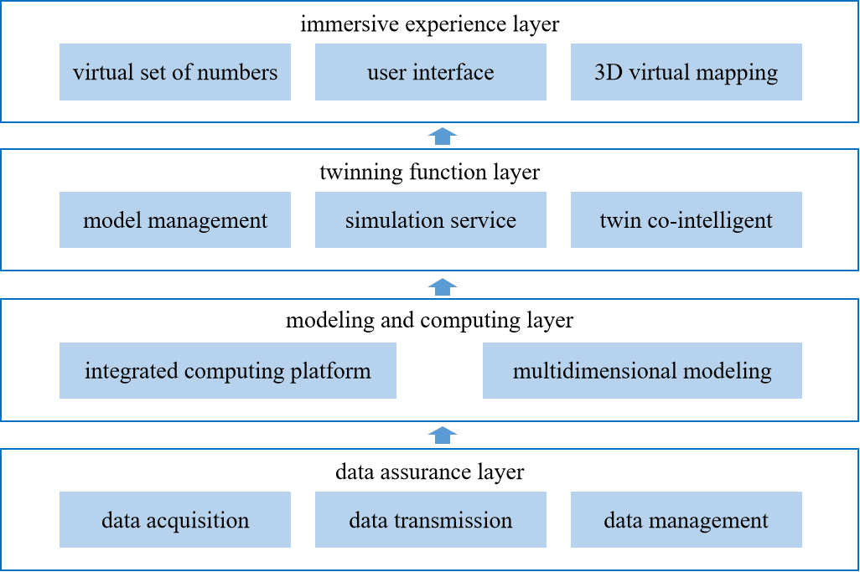

Figure A.1 – Technical framework of digital twin

### A.1.2 Digital twin application in power metaverse

DT can realize many functions and applications in power systems through the fusion of the physical power grid and its digital image. It can upload the sensor data and related derived data from the physical power grid to the data centre and input the collected data into the digital mirroring model. Then, the model is updated iteratively through the data analysis and simulation calculation. The updated power grid information is displayed in real time. The application of the DT is reflected in the equipment layer, power grid layer, service layer, and the operation management layer.

1) **Equipment layer**: It can help achieve some equipment service functions such as on-site and remote friendly, autonomous status management and defect diagnosis, full lifecycle management, and decision-making.

2) **Power grid layer**: It can realize the functions of individualized risk assessment of power grid operation, automatic and predictive dispatching of the power grid combined with equipment status, life cycle management of the power grid, on-line analysis and decision-making, etc. It can guide the independent planning and decision-making of the power grid.

3) **Service layer**: It helps to achieve batch business processing, operation and inspection support, load classification prediction, holographic training and other services in the distribution station area.

4) **Operational management layer**: It can achieve functions such as asset management optimization, operational risk management services, and full value chain collaboration of the power grid. At the same time, it is of great significance for guiding enterprise digital and intelligent operation management and decision-making.

## A.2 Artificial intelligence

### A.2.1 Overview

AI is a new technology science that studies and develops the theory, method, technology and application system for simulating, and extending human intelligence. The technology framework of AI consists of a resource layer, platform layer, service layer and application layer, as shown in Figure A.2.

1) **Resource layer**: Includes computing resource, network resource, storage resource and data resource.

2) **Platform layer**: Includes data management, model training and model management.

3) **Service layer**: It integrates intelligent voice, natural voice processing, image recognition and other model services, including voice recognition, voiceprint recognition, syntax analysis, keyword extraction and entity recognition.

4) **Application layer**: Include user management, authority control, configuration management, service management, mirror management, resource management and so on.

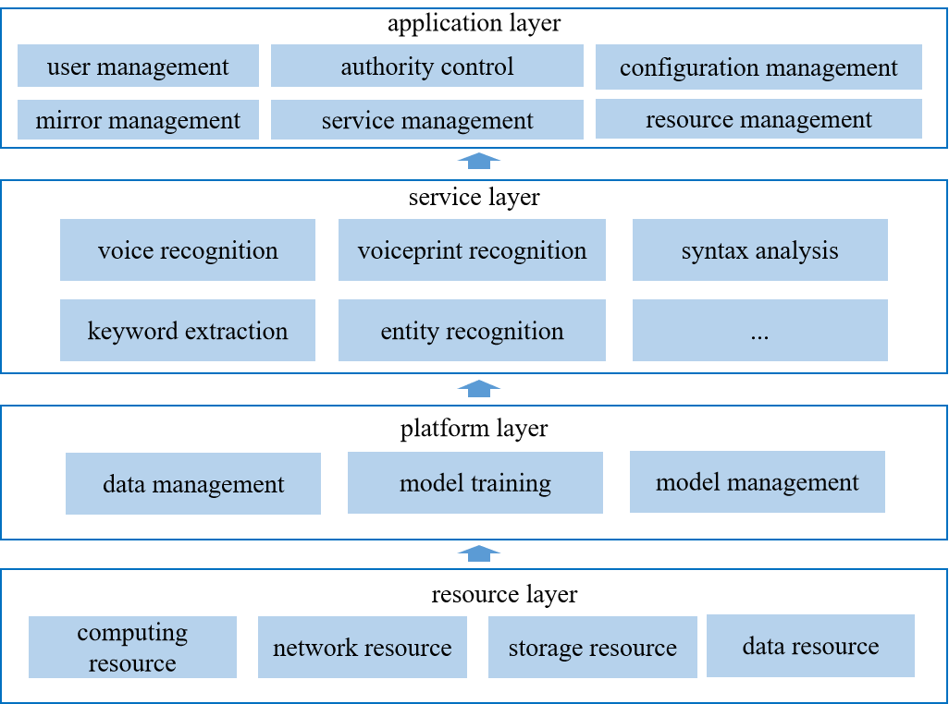

Figure A.2 – Technical framework of artificial intelligence

### A.2.2 Artificial intelligence application in the power metaverse

The application scenarios of AI in the PM include multi-mode fusion of virtual digital human interaction, real-time rendering and modelling of virtual digital human 3D model, virtual reality (VR) interaction, and data interaction [b-Wangdong].

1) **Multi-mode fusion of virtual digital human interaction**: Virtual digital human lacks the ability of intelligent interaction such as vision, hearing and action expression. Several deep algorithm models can be used to build models of facial expression transfer, speech generation, motion capture, speech-driven face generation, etc. It will help virtual digital humans realize intelligent question answering and retrieval of power systems.

2) **Real-time rendering and modelling of virtual digital human 3D model**: In order to solve the problem of low automatization of 3D modelling of virtual digital human, a dense human 3D grid model based on skinned multi-person linear (SMPL) was constructed, the real-time rendering and modelling is realized by combining the skin model and the 3D reconstruction model based on the nerve radiation field. The cost of virtual digital human modelling is reduced.

3) **VR interaction**: In the PM, there exists the problem that the field personnel cannot deal with, i.e., the equipment fault in time during inspection. Based on the VR, intelligent inspection and fault diagnosis technology can identify and deal with typical faults and hidden dangers.

4) **Data interaction**: There exists the problem that data and 3D model assets are dispersed and cannot be reused. By building a 3D model library of power components, the physical mapping and dynamic interaction between physical equipment and virtual space are realized.

## A.3 Blockchain

### A.3.1 Overview

Blockchain is a kind of technology that integrates distributed storage, point-to-point transmission, consensus mechanism, encryption algorithm and so on [b-Yang]. Figure A.3 shows the technical framework of blockchain which is composed of the base layer, platform layer, application service layer, user layer and cross-functional layer.

1) **Base layer**: Provide the software environment and hardware facilities, including computing resource, peer-to-peer network, storage resource, etc.

2) **Platform layer**: Provide the core technical support for the application service layer and the user layer, including smart contract, consensus mechanism, ledger record, password service, time series service, cross-chain service, and digital signature.

3) **Application service layer**: Provide simple, easy-to-use and reliable data invocation, including access management, node management, evidence storage and retrieval, and trading service.

4) **User layer**: Provide the interface services required by users, including business function, user function and management function.

5) **Cross-layer function**: Provide functional components across multiple layers to ensure accurate management of the business, including development management, operation maintenance, security protection and regulatory audit.

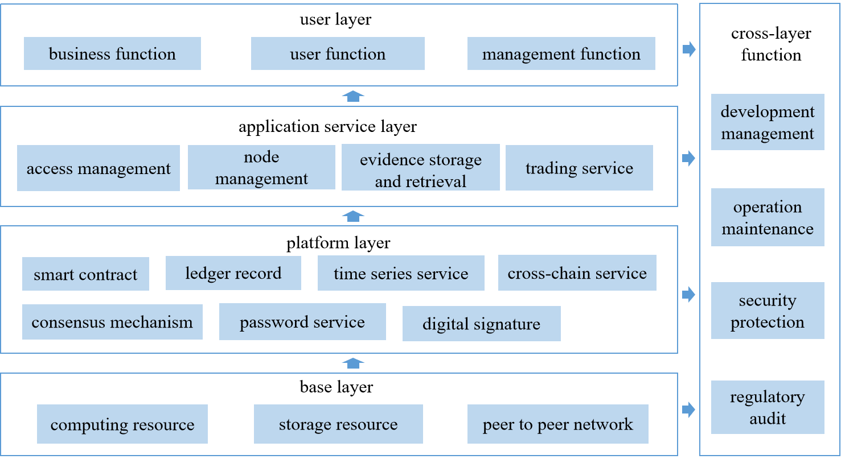

Figure A.3 – Technical framework of blockchain

### A.3.2 Blockchain application in the power metaverse

Blockchain is an important means to construct an identity system and value system in the PM [b‑Yang]. In order to solve the problems that participants in the virtual space lack identity and cannot prove themselves, a set of decentralized digital identity resolution technology system is constructed, including identification, attributes and authentication mechanism. Aiming at the problems of an isolated island of a digital identity information and lack of credit, a decentralized multi-certificate of identity and a trusted digital profile model are constructed based on the diversity of users' behaviours. Combined with the characteristics of the electric power business scene, the economic operation rules and related operation system of the PM are built to promote the circulation of the value assets.

## A.4 The Internet of things

### A.4.1 Overview

The essence of IoT is defined as a new generation of in-depth applications of information technology, which integrates with the physical world through the ability of perception and information processing. The technical framework of IoT is aligned with [ITU-T Y.4000].

### A.4.2 IoT in power metaverse

IoT is the entrance and passage of the PM connecting the physical world, which can effectively integrate the power system infrastructure resources and improve its management level. It can be widely used in the power grid equipment management, transmission line maintenance, intelligent substations and so on. [b-Wangdong].

1) **Power grid equipment management**: In the PM, through IoT, it can achieve real-time monitoring and early warning of equipment status, mechanical status, and operational status. By deploying intelligent sensors on the tower, transmission line and other equipment, and forming a multi-sensor cooperative sensing network, it can realize target recognition, intrusion analysis and region location. At the same time, the combination of identification, electronic tag and electronic work ticket can realize the operation identification and safety behaviour analysis in the process of equipment maintenance, thus enhancing the ability of security protection.

2) **Transmission line maintenance**: In the PM, it can help to achieve multi-directional security state monitoring, achieve all-weather transmission line awareness, detect problems in a timely manner and reduce the time needed to find faults on the transmission lines.

3) **Intelligent substation**: A lot of advanced sensors are used to realize real-time panoramic monitoring, automatic operation control and cooperative interaction.

## A.5 Human-computer interaction

### A.5.1 Overview

HCI is the discipline, process and method that supports the interaction between humans and computers through the design and implementation of software and hardware. It includes user interface design, interaction technology, usability testing and evaluation, computer vision and graphics, natural language processing and speech recognition, VR and augmented reality (AR).

### A.5.2 Human-computer interaction in power metaverse

HCI is an important carrier of the immersive experience provided by the PM and an important interface between the real and virtual worlds.

1) **Real-time monitoring and assessment**: By wearing a device to perceive the user's state information from multiple dimensions and capture the user's input actions, the participants' senses are fully connected. Then, the virtual spatial information in real-time is fed back to the user in the form of vision, hearing and touch. It can be used in power systems for operational inspection, fault diagnosis, virtual training, etc. In the PM, it is necessary to carry out real-time monitoring of the data information and the running state of the equipment in various scenes, through the combination of the wired and the wireless equipment. Based on the HCI equipment, it can realize fully automatic monitoring, intelligent inspection and fault diagnosis.

2) **Improving the working environment**: Workers can realize the dangerous operation of the physical equipment in a virtual operating environment, which can not only improve work efficiency but also ensure workers' safety. At the same time, it can also be applied to immersive training, combining power business needs and application scenarios, to establish a virtual simulation training environment, thus improving the training experience and effect.

## A.6 Big data

### A.6.1 Overview

The basic principle of big data technology includes data acquisition, processing, storage and analysis. Data acquisition includes real-time acquisition and historical data acquisition [b-Li]. Data processing involves data cleaning, integration, transformation, etc. Data analysis is the core of big data technology, which includes descriptive analysis, predictive analysis and normative analysis. Through this analysis, it can mine the value of data to support decision-making.

### A.6.2 Big data in the power metaverse

Big data is the database and data analysis engine for the PM.

1) **Power system real-time monitoring**: It is an important part that provides power operators with real-time information about the status of the power grid. Big data can process a large amount of real-time data and historical data from various sensors and monitoring devices. Through data mining and ML, it can quickly find anomalies in the power system, and effectively improve the security and stability of the power system.

2) **Power system fault prediction**: Big data can extract fault features, build fault prediction models, and give early warning in time from the huge amount of equipment operation data. It can achieve the potential factors that may lead to failure through the association analysis and help power operators to take preventive maintenance measures to avoid failure.

3) **Power market decision support**: Big data can collect and process all kinds of data such as historical data and real-time data [b-Yue].

4) **Energy efficiency management**: Big data can collect and process power consumption data, equipment status data, environmental data, and other power system operation data. Then, scientific management of energy efficiency management [b-Wang] and decision-making are realized by data mining, ML and prediction analysis.

## A.7 Cloud computing

### A.7.1 Overview

Cloud computing is a kind of distributed computing, which can use the network "Cloud" to divide the huge data processing program into numerous small programs. The results obtained by these programs are then processed and analysed in combination with a system composed of multiple servers and then provided to the user. The technical framework is shown in Figure A.4.

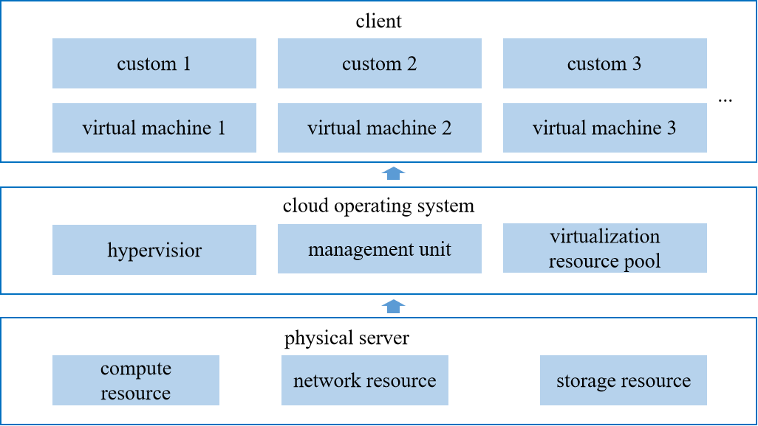

Figure A.4 – Technical framework of cloud computing

### A.7.2 Cloud computing in the power metaverse

Cloud computing [b-Chen] is an important part of the PM, which makes it work by providing software-defined infrastructure, deliver servers, storage space, databases, networks, and analytics to the users. The application of cloud computing is embodied in:

1) **Smart grid construction**: It will map the smart grid in the PM through data collection, analysis and processing, to realize the real-time monitoring, intelligent analysis and prediction of the grid operation state. It can improve the power system data efficient storage, and process analysis capabilities.

2) **Data centre construction**: It is a very important part of the power system and can undertake data storage, processing and analysis tasks. Cloud computing can improve the overall efficiency of a data centre by providing more reliable and efficient computing-storage capabilities.

3) **New energy access**: Cloud computing can provide efficient computing and storage capabilities for new energy access to meet the needs of power systems for new energy integration.

4) **Power equipment remote monitoring**: Cloud computing can provide efficient data storage and processing capability for remote monitoring of power equipment, thus reducing the cost of manual monitoring and improving the reliability and security of the power equipment operation.

## A.8 Extended reality

### A.8.1 Overview

Extended reality (XR) technology is a cross-subject involving computer science and technology, psychology, human engineering and other fields, including AR, VR and mix reality (MR). Among them:

1) **AR**: It can integrate virtual world information and real-world information through 3D modelling, multimedia, intelligent interaction, real-time tracking and registration and other technologies [b-Liu].

2) **VR**: It integrates simulation technology, electronic information, computer technology, and so on [b-Huang]. It can let users experience the virtual world to get a real-life experience.

3) **MR**: It is a kind of technology that merges AR and VR technology to create a new visualization environment by merging the virtual world and the real world [b-Liu].

### A.8.2 Extended reality in the power metaverse

XR can be widely applied in the PM, specifically reflected in:

1) **AR in patrol, overhaul and electric power rush repair**: The field of patrol, overhaul and electric power rush repair is an important part of the power grid work, in which AR can be applied to improve the level of individual work in the power system. In addition, in the process of power grid maintenance, field personnel use smart wear equipment to communicate with power enterprises in real-time. Then, power enterprises can receive real-time scenes and improve work efficiency.

2) **VR in equipment operation and training**: Based on VR, the three-dimensional model of the power system can be built, and the three-dimensional visualization of power equipment can be realized. It can simulate the operation of the power system and predict and optimize the operation state. In addition, VR can also be applied to the power system training and education, it can improve the training effect of power engineers through the immersive experience, thus reducing training costs.

3) **MR in the 3D display of power grid resources**: MR can be used to overlay the grid resource data. The related personnel can project the grid resource on the real equipment by means of holographic projection and display the grid resource interactively by means of gesture operation. MR can promote the construction of a 3D display of power grid resources, so that workers can rely on intelligent communication equipment to complete resource query, positioning, deployment, and improve the efficiency of equipment maintenance and repair.

Bibliography

[b-ITU-T F.751.0] Recommendation ITU-T F.751.0 (2020), *Requirements for distributed ledger systems.*

[b-ITU-T L.1390] Recommendation ITU-T L.1390 (2022), *Energy saving technologies and best practices for 5G radio access network (RAN) equipment*.

[b-ITU-T M.3080] Recommendation ITU-T M.3080 (2021), *Framework of artificial intelligence enhanced telecom operation and management (AITOM)*.

[b-ITU-T P.1320] Recommendation ITU-T P.1320 (2022), *Quality of experience assessment of extended reality meetings*.

[b-ITU-T Y.3500] Recommendation ITU-T Y.3500/ISO/IEC 17788 (2014), *Information technology – Cloud computing – Overview and vocabulary*.

[b-ITU-T Y.4600] Recommendation ITU-T Y.4600 (2022), *Requirements and capabilities of a digital twin system for smart cities*.

[b-ITU FGMV-02] Technical Report ITU FGMV-02 (2023), *Metaverse: an analysis of definitions.*

[b-Chen] Chen, M., Zhang, K., Wang, X., Zheng, L., and Cao, Y., (2022), *Research on the application and development of cloud computing in power informatization construction*. Science and Technology & Innovation. No.20, pp. 176-178.

[b-Huang] Huang, X.G., Xu, X.W., Xu, J.Y., and Wu, Y.C., (2023), *Research on application of virtual reality technology in power system*. Electric Engineering. No.22, pp. 87-90.

[b-Li] Li, Z., (2023), *Application of big data in power information systems*, Application of IC. Vol.40, No.12, pp. 266-277.

[b-Liu] Liu, J.W., (2021), *Application of augmented reality, virtual reality and hybrid reality technology in power system*. Wireless Internet Science and Technology, Vol.18, No.22, pp. 78-79.

[b-Yang] Yang, X.L., Cheng, H.X., Chen, H., Yang, K., Ma, Y.C., (2024), *A method for uploading carbon emission data of distribution network based on blockchain technology*, Distribution & Utilization. Vol.41, No.01, pp. 83‑90.

[b-Yue] Yue, S.Y., (2023), *Application of big data technology in electric power marketing system*. Application of IC, Vol.40, Vol.40, No.12, pp. 156-157.

[b-Wang] Wang, Q., Liu, J., Hu, Y., and Zhang X., (2019), *Optimal operation strategy of multi-energy complementary distributed CCHP system and its application on commercial building*. IEEE Access. Vol. 7, pp. 127839‑127849.  
<<https://ieeexplore.ieee.org/abstract/document/8826545>>

[b-Wangdong] Wangdong D., Jiang W., Xuan J.X., et al., (2022), *Special Report on the Integration and Development of Metaverse and Electric Power Information and Communication*. IEEE PES.

[b-Zhou] Zhou, B., Xi, C., Li, G., and Yang, B. (2022), *Metaverse Application in Power Systems*. Power Generation Technology. Vol.43, No.1, pp. 1-9.  
<<https://www.pgtjournal.com/EN/10.12096/j.2096-4528.pgt.21144>>

______________