Standardization Sector
ITU Focus Group Technical Report
(03/2024)
ITU Focus Group on metaverse
Considering online and offline implications in efforts to build confidence and security in the metaverse
Working Group 6: Security, Data & Personally identifiable information (PII) Protection
ITUPublications | International Telecommunication Union


Technical Report ITU FGMV-23
Considering online and offline implications in efforts to build confidence and security in the metaverse
Summary
If the metaverse continues to progress towards the digital twinning of the world (possibly the universe), then presumably "everyone" is (or should be) represented in the metaverse and therefore the absence of participation (whether involuntarily or by choice) is not necessarily a path to opting out of the implications.
With the metaverse still in its nascent phase, implications for participants and for non-participants alike are a new consideration; although early data would suggest that these implications range from issues relating to security, confidence, and trust, to ethical and other related issues.
New frameworks on building confidence and security in the metaverse may be able to pre-empt negative outcomes by drawing on existing knowledge and trends around trust and safety, as well as digital inclusion and exclusion. Specifically, accounting for the broad spectrum of populations and related assets, actions, attitudes, relationships, and outcomes that are likely to characterize engagement with the metaverse.
Technical Report ITU FGMV-23 explores this further using the "User confidence framework" introduced in ITU FGMV-06 Technical Report on "Guidelines for consideration of ethical issues in standards that build confidence and security in the metaverse" (which was approved at the third meeting of the ITU Focus Group on metaverse, held from 3-5 October 2023 in Geneva, Switzerland), and its related framework for metaverse participation.
Keywords
Avatar, confidence in the metaverse, decentralized platforms, digital realm, implied contract of confidence, in-world; intra-metaverse, metaverse, realms of metaverse participation, off-world, metazen, netizen, networked integration, physical realm, online, offline, personhood in the metaverse, peri-metaverse, phygital, Web 1.0, Web 2.0, Web 3.0.
Note
This is an informative ITU-T publication. Mandatory provisions, such as those found in ITU-T Recommendations, are outside the scope of this publication. This publication should only be referenced bibliographically in ITU-T Recommendations.
Change Log
This document contains Version 1.0 of the ITU Technical Report "Considering online and offline implications in efforts to build confidence and security in the metaverse" approved at the 5th meeting of the ITU Focus Group on metaverse (FG-MV), held on 5-8 March in Queretaro, Mexico.
Acknowledgements
This Technical Report was researched and written by Radia Funna (Build n Blaze, LLC.) and Araba Sey (Research ICT Africa) as a contribution to the ITU Focus Group on metaverse (FG-MV). The development of this document was coordinated by Vincent Affleck (DSIT, United Kingdom), as FG-MV Working Group 6 Chair and Radia Funna (Build n Blaze, LLC.), as Chair of Task Group on building confidence and security in the metaverse.
Special thanks to Wendy Teresa Goico Campagna for her contribution on behalf of the Dominican Republic.

Additional information and materials relating to this report can be found at:
https://www.itu.int/go/fgmv. If you would like to provide any additional information, please contact Cristina Bueti at tsbfgmv@itu.int.

Editor & Task Group Chair: | Radia Funna  Build n Blaze, LLC. | Email: rfunna@buildnblaze.com
Editor: | Araba Sey  Research ICT Africa | Email: asey@researchictafrica.net
WG6 Chair: | Vincent Affleck  DSIT  United Kingdom | Email: vincentaffleck2@hotmail.com

Disclaimer
The designations employed and the presentation of the material in this publication do not imply the expression of any opinion whatsoever on the part of ITU concerning the legal status of any country, territory, city or area or of its authorities, or concerning the delimitation of its frontiers or boundaries.
The ideas and opinions expressed in this publication are those of the authors; they do not necessarily reflect those of ITU nor of its Member States. The reference to specific companies, products or services does not imply that they are endorsed or recommended by ITU in preference to others of a similar nature that are not mentioned.
If you wish to reuse material from this publication that is attributed to a third party, such as tables, figures or images, it is your responsibility to determine whether permission is needed for that reuse and to obtain permission from the copyright holder. The risk of claims resulting from infringement of any third-party owned material in the publication rests solely with the user.
This publication is being distributed without warranty of any kind, either expressed or implied. The responsibility for the interpretation and use of this publication lies with the reader. In no event shall ITU be liable for damages arising from its use.

© ITU 2024
FGMV-06 (2023-10)
ii
Some rights reserved. This publication is available under the Creative Commons Attribution-Non Commercial-Share Alike 3.0 IGO licence (CC BY-NC-SA 3.0 IGO; https://creativecommons.org/licenses/by-nc-sa/3.0/igo). For any uses of this publication that are not included in this licence, please seek permission from ITU by contacting TSBmail@itu.int.

Table of contents
Page
1 Scope 1
2 References 1
3 Definitions 1
3.1 Terms defined elsewhere 1
3.2 Terms defined in this Technical Report 2
4 Abbreviations and acronyms 2
5 Conventions 3
6 Engagement in the metaverse 3
6.1 Introduction 3
6.2 History 3
6.3 A paradigm shift in user engagement? 4
7 Building confidence and security in the metaverse 7
7.1 Why is confidence relevant to user engagement? 7
7.2 Building confidence and security across a range of metaverse engagement 7
8 Conclusion 10
Annex A – User confidence framework 11
Bibliography 14

Technical Report ITU FGMV-23
Considering online and offline implications in efforts to build confidence and security in the metaverse

1 Scope
This Technical Report explores online and offline implications in efforts to build confidence and security in the metaverse for participants and non-participants, using the "User confidence framework" first introduced in [b-ITU FGMV-06]. Specifically, the report:
1. Analyses the evolution of the Internet and corresponding evolution in associated risks and harms related to its use and non-use.
2. Presents the metaverse as a paradigm shift in user engagement across a bidirectional physical-digital range including online, offline, "in-world" and "off-world" engagement.
3. Explores online and offline implications in efforts to build confidence and security in the metaverse relating to its use and non-use in this range of engagement.
4. Discusses a real-world example illustrating the impact of digital inequalities on user participation.

2 References
None.

3 Definitions

3.1 Terms defined elsewhere
This Technical Report uses the following terms defined elsewhere:
3.1.1 avatar [b-ISO/IEC 23005-4]: Digital entity that can be used as a (visual) representation of the user inside the virtual environments.
3.1.2 extra-metaverse [b-ITU FGMV-24]: Area of activity located outside the metaverse, either in the digital realm, the physical realm or through a network connecting both realms.
NOTE 1 − Realm is defined broadly as the area of activity [b-Collins/realm] to include the virtual world and the physical world.
NOTE 2 − The "digital realm" is the virtual world or "online", which is defined as connected to, served by, or available through a system and especially a computer or telecommunications system (such as the Internet) [b-Webster/online].
NOTE 3 − The "physical realm" is the physical world as we know it or "offline", which is defined as not connected to or served by a system and especially a computer or telecommunications system [b-Webster/offline].
3.1.3 intra-metaverse [b-ITU FGMV-24]: Area of activity located within the metaverse.
3.1.4 metaverse [b-ITU FGMV-20]: An integrative ecosystem of virtual worlds offering immersive experiences to users, that modify pre-existing and create new value from economic, environmental, social and cultural perspectives.
NOTE − A metaverse can be virtual, augmented, representative of, or associated with the physical world.
3.1.5 metazen [b-Oliver Wyman]: Citizen of the metaverse whose virtual and daily lives are fully intertwined.
3.1.6 netizen [b-Webster/netizen]: Active participant in the online community of the Internet.
3.1.7 networked integration [b-ITU FGMV-24]: Metaverse users or non-users tied to at least one connection between the physical world and the digital world.
NOTE − This could occur if a user or non-user is connected to an object in the physical world that is also connected to the digital world (e.g., "things" connected to the Internet as with the Internet of things (IoT)).
3.1.8 off-world [b-ITU FGMV-24]: Relating to participant absence from a virtual online environment.
NOTE 1 − Referring to a participant as being "off-world" assumes prior "in-world" presence in a persistent metaverse environment where users may enter and exit without interrupting the activities of other participants or the metaverse "world" itself.
NOTE 2 − In-world is defined here as relating to presence in a virtual online environment [b-Collins/in-world], often using an avatar.
3.1.9 peri-metaverse [b-ITU FGMV-24]: Area of activity located within and outside the metaverse while staying either in the digital realm or in a merged digital-physical realm.
3.1.10 personhood in the metaverse [b-ITU FGMV-24]: Personal identity and existence in digital and digital-physical merged spaces.
NOTE 1 − Based on a definition of personhood as the quality or condition of being a person; especially personal identity or selfhood [b-OED].
NOTE 2 − There must be a one-to-one relationship between the user and their "personal identity and existence" as represented in the space. For example, a single user may not have multiple identities, nor can a single identity represent multiple users.
NOTE 3 − User personal identity and existence can include but is not limited to avatars and other user assets.
NOTE 4 − User personal identity and existence retains all human rights and responsibilities.
3.1.11 phygital [b-Gaggioli]: A neologism that results from the synthesis of the terms "physical" and "digital" − refers to a new concept of space that originates from the increasing convergence of the physical dimension and the virtual dimension.
3.1.12 realms of metaverse participation [b-ITU FGMV-24]: Areas of activity related to user engagement in the metaverse.
3.1.13 user confidence in the metaverse [b-ITU FGMV-06]: A user's state of certainty and belief in the reliability of a metaverse platform or environment.
NOTE 1 − Confidence is generally defined as the quality or state of being certain [b-Webster/confidence].
NOTE 2 − Stressing the importance of the user's state of certainty and belief in the environment, this definition of user confidence seeks to provide a path to:
i. Considering user intent when developing principles that govern metaverse engagement.
ii. Empowering individual users by addressing their expectations in immersive contexts.
3.1.14 user implied contract of confidence [b-ITU FGMV-06]: An agreement between the user and the platform provider implicit in the user's willingness to co-create with and entrust resulting assets to the platform. This is especially noteworthy when assets, including user 'avatars', can represent the individuals' personhood.

3.2 Terms defined in this Technical Report
None.

4 Abbreviations and acronyms
This Technical Report uses the following abbreviations and acronyms:
AI Artificial Intelligence
AR Augmented Reality
ICT Information Communication Technology
IoT Internet of Things
VR Virtual Reality
XR Extended Reality

5 Conventions
None.

6 Engagement in the metaverse

6.1 Introduction
Humans have a long history of building tight bonds and shortening the distance that divides them [b-Xu-et.al]. This history predates the evolution of modern humans about 300,000 years ago and continues today with the fast evolution of emerging technologies that seek to export human interactions beyond the physical realm.
In human history, efforts to export or represent physical experiences beyond in-person interactions are wide ranging, from cave drawings to the invention of language to the current information age with platforms (like social networking sites) dedicated to increasing the speed, efficiency, and intimacy of virtual interactions.
Just as social networking sites (in the form of social media) advanced virtual interactions beyond the one-way consumption of static websites; a nascent metaverse has the potential to further deepen that engagement with the addition of immersion (using technologies such as augmented reality (AR) and virtual reality (VR)) and presence (in the form of avatars).

6.2 History
Often described as its next generation, the metaverse has its roots in the Internet's approximately 34-year history, which started with Tim Berners-Lee's invention of the World Wide Web in 1989; 20 years after the first version of the Internet was created with the Advanced Research Projects Agency Network (ARPANET).
The Internet really took off when the World Wide Web was donated to the public domain in 1993 and entered general use. Its first 15 years, often referred to as Web 1.0, was defined by content consumption [b-Blank-Reisdorf], likely reaching its height with the launch of Google's search engine in 1998.
Facebook's launch in 2004 ushered in the next evolution of the Internet, an era of social networking that continues today, and has been defined by collaborative consumption [b-Blank-Reisdorf]. About 10 years later (around 2014), Web 3.0 began alongside Web 2.0. Although there is no single definition for Web 3.0, this report uses a definition of Web 3.0 as an Internet and computing era differentiated by on-demand user customization, multi-layered engagement, and a resurgence of decentralized systems [b-ITU FGMV-25].
Still in its nascent phase, it is in the era of Web 3.0 that the metaverse starts to take shape, as early entrants, starting with Linden Lab's Second Life (launched in 2003) and the online gaming platform Roblox (launched in 2006), help shift the metaverse from concept to reality.
The term "metaverse" – a portmanteau of "meta" (meaning beyond) and "verse" (a shortened form of universe) – was introduced by science fiction writer Neal Stephenson to describe a 3D virtual space in his 1992 novel Snow Crash. The concept of a full-immersion virtual reality was introduced about 10 years earlier in science fiction writer Vernor Vinge's 1981 novella True Names as the "Other Plane". About 10 years after Snow Crash, Second Life launched, translating an online virtual world where users could create their own avatars and interact with one another into reality.

6.2.1 From digital divides to data injustice
With each major evolution in the infrastructure and affordances of the Internet, a corresponding evolution has occurred in the associated risks and harms related to its use or non-use. In broad strokes, the period of one-way consumption was characterized by concerns about populations that lacked the hardware and/or infrastructure to access the Internet. The term "digital divide" was coined in the mid-1990s to describe the difference between those with (usually higher socio-economic status countries and groups) and those without (typically lower socio-economic status countries and groups) Internet access and was often expressed as a national or global statistic. It was considered detrimental to be unable to consume the Internet and policy was directed at "closing" the digital divide.
As the landscape shifted to more participatory modes of Internet access and use, concerns were also shifting to the distribution of outcomes based on different types and degrees of Internet access and consumption. The terminology also shifted from that of a digital divide to that of multiple digital inequalities. A key realization here was that access is a necessary but insufficient condition for the Internet to benefit users. Disadvantages to be addressed emerged, amongst other things, from differences in the quality of infrastructure (e.g., speed), technology (e.g., features or smartphones), location of use (e.g., home or public), types of use (e.g., instrumental or non-instrumental), frequency and diversity of uses; and other conditions such as low affordability, low digital skills, lack of relevant content, and socio-cultural barriers such as gender norms.
Yet another shift has occurred with the increasing decentralization of some aspects of the Internet and the transformation of Internet companies from content providers into platforms for the sharing of user-created content. One outcome of this trend is the acceleration of the monetization of users via their digital trails (their data), with monumental implications from being visible or invisible, trackable, targetable, and manipulable based on this data, which invariably reflects existing social inequalities. While the relevance of a digital divide and digital inequalities has not completely disappeared, there is a clear turn towards issues of justice, with calls for data justice as a pre-requisite for social and economic justice. Calls here are for imposing higher standards of ethics, responsible and inclusive technologies, transparent data utilization in the public interest, limiting risks and providing redress for harms, and actively promoting economic opportunity and environmental sustainability to protect the interests of the most marginalized in society.

6.3 A paradigm shift in user engagement?
The emergent nature of the metaverse in an evolving Web 3.0 environment is already blurring the line between digital and physical worlds. This evolution is happening at the same time as the Internet continues to reach stunning levels of user engagement, most recently, the 2021 milestone of 4.66 billion people connected, which is more than half of the world's population.
The metaverse – with a novel and aspirational goal of a seamless boundary between the physical realm and computer-generated or virtual realms – hopes to encompass many aspects of our current and future existence to enhance our connectivity and the quality of our shared experiences [b-Nagendran].
Given the unprecedented connectivity afforded by the Internet (despite the continued presence of a digital divide), the range and speed of change brought on by underlying technologies (including artificial intelligence (AI)), and the ambitious promise of the metaverse itself; at least one question emerges, are we at the precipice of a paradigm shift in user engagement?

6.3.1 Understanding the metaverse experience
What the metaverse proposes, like so many technologically driven transformative processes, is a re-evaluation of the Internet itself. Until now, the cyberspace we have interacted with has been localized, stored at first within physical servers and more recently, in the cloud. As it grows and develops, the metaverse will evolve and iterate, shifting the balance until we, as its users, will constantly be "within" the Internet, rather than have access to it, and within the billions of interconnected computers around us [b-Ball].
In efforts to understand user engagement in the metaverse, we could take a cue from communications research, which has developed different typologies of Internet use and demonstrated links between types of use and a range of outcomes. While some models outline differences in quality of use (e.g., high-speed, broadband, 2G, 3G, synchronous, asynchronous), others identify categories of use (e.g., social interaction, information-seeking, entertainment, commercial transactions), and still others define usage in terms of depth or intensity (e.g., heavy use, light use, frequent use, episodic use, non-use, indirect use) or user skill levels (e.g., basic, intermediate, advanced). Metaverse engagement should be conceptualized with similar acknowledgment of the many forms that could constitute engagement, and with flexibility to accommodate any new dimensions and/or language of engagement that emerge in the metaverse context.
The quality and depth of experience is expected to continue to evolve, just as the concept of the metaverse itself has evolved over the years from a single virtual world (narrow and purely physical like the platform Second Life) to a future iteration, an interoperable convergence of the physical and virtual worlds (a broad and blended reality) [b-Barrera-Shah].
The current range of experiences in the metaverse can be defined in three fundamental dimensions:
1. The level of immersiveness,
2. The degree of fidelity between the virtual environment and the real world, and
3. The level of sociability permissible amongst the users [b-Barrera-Shah].
Figure 1 illustrates a possible organizing framework of the "modern" metaverse that acknowledges its systematic 15-year evolution as a concept.
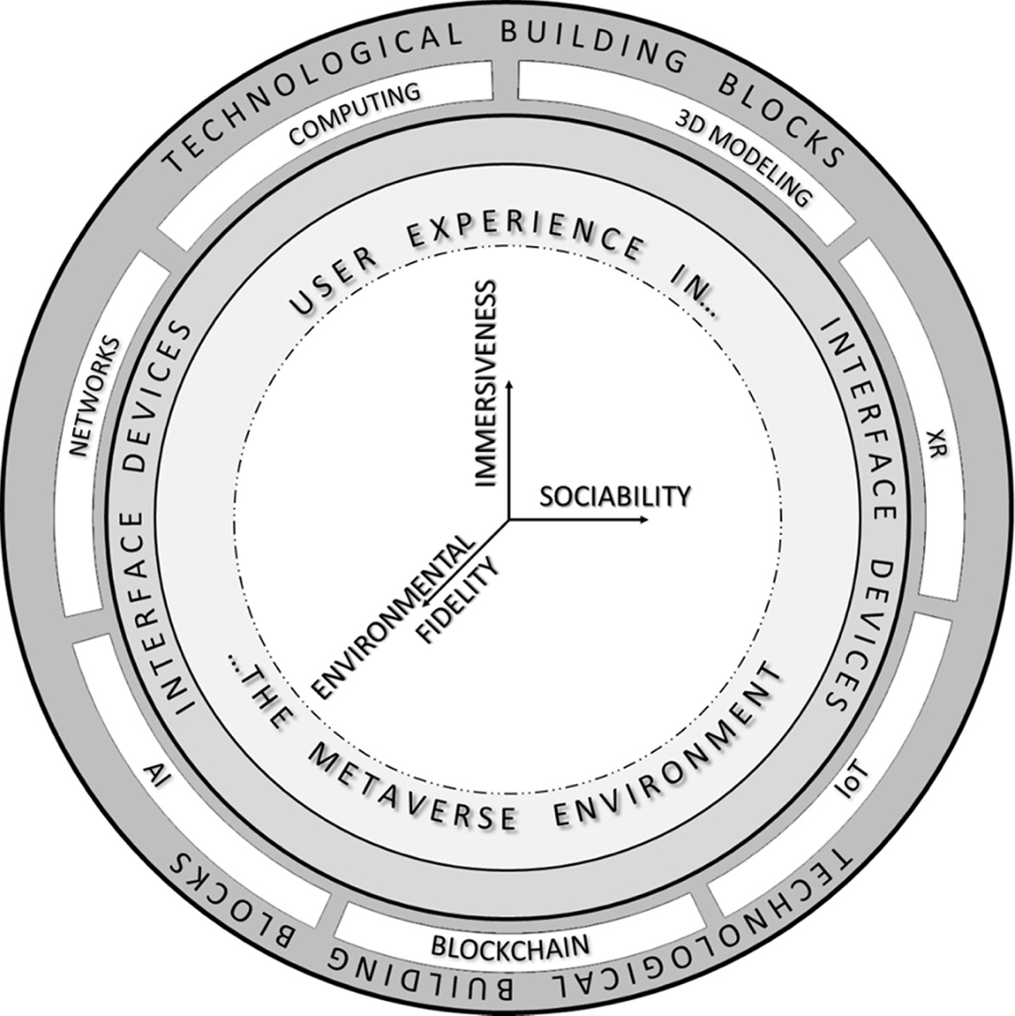
The interface devices that determine how users may access and experience the metaverse environment (e.g. VR headset, AR glasses, brain-computer interface).
Inside the metaverse environment where users can interact.
The major technological building blocks that help define the basic foundational architecture of the metaverse.
Source: [b-Barrera-Shah]
Figure 1 − The metaverse experience: An organizing framework

6.3.2 Understanding metaverse participation
The metaverse is something of a paradox, both an inhabited and enacted space as well as an impermanent interface between the digital and physical realms [b-Van-Der-Merwe]. This concept, referred to as "phygital", originates from the increasing convergence of physical and digital dimensions. The integration of computers in everyday objects and the increasing bidirectional information ﬂow between the digital and the physical realms is transforming our surrounding environment (including our bodies) into seamlessly programmable interfaces, where virtually every object can be creatively re-conﬁgured to provide new kinds of phygital experiences [b-Gaggioli].
As metaverse engagement extends beyond the metaverse experience itself, spanning across these phygital spaces, a phygital understanding of user participation is needed, especially one that can evolve with the evolving landscape.
A range of metaverse participation (to help contextualize metaverse engagement across the bidirectional information ﬂow between the digital and the physical realms) can be defined within three realms of participation as follows [b-ITU FGMV-24]:
1. Intra-metaverse: Area of participant activity located within the metaverse. Engagement can occur "in-world" or as a "metazen".
2. Peri-metaverse: Area of participant activity located within and outside the metaverse while staying either in the digital realm or in a merged digital-physical realm. Engagement can occur "online" or as a "netizen".
3. Extra-metaverse: Area of activity located outside the metaverse, either in the digital realm, the physical realm or through a network connecting both realms. Engagement can occur beyond the metaverse with the inclusion of "off-world", "offline" and "networked integration".
See Annex A for more details.

7 Building confidence and security in the metaverse

7.1 Why is confidence relevant to user engagement?
Charting pathways to metaverse engagement requires understanding how people move from non-use to use. A variety of theories (e.g., diffusion of innovation, theory of planned action) have established that one of the factors shaping people's preparedness to adopt new technologies is their degree of trust or confidence in the new technology. In essence, the process of adoption (and associated drivers such as confidence) starts before actual adoption occurs. This extends to elements of social acceptance; social concerns about the negative impacts of digital technologies, from addiction to online violence to labour exploitation, could constrain mainstreaming of the metaverse.
As the metaverse actively seeks to blur the lines between digital and physical; users should be confident not only about the fate of their digital or datafied selves that they "leave" behind when they exit the metaverse environment, but also about the potential impact on their real world lives. Already, online social media activity, for example, is increasingly becoming subject to official scrutiny, with real positive and negative offline consequences (e.g., for employment opportunities and criminal justice).
Furthermore, metaverse-related labour occurs both online and offline. Key aspects of the organizations (e.g., equipment, staff) that create and manage the platforms, exist outside the metaverse. From an ethical standpoint, the conditions under which the metaverse is developed, deployed, and maintained should be of interest to users, if lessons are to be learned from past failures such as exploitative platform work in the Web 2.0 era.

7.2 Building confidence and security across a range of metaverse engagement
Even in its nascent phase, the metaverse is promising to change the rules of digital engagement by supercharging the participatory nature of today's web culture [b-ITU FGMV-06]. As virtual and real-world boundaries become increasingly blurred, so too could the boundaries that protect privacy, data, intellectual property rights, and personhood; especially as platform providers require users to divulge more and more of their real-world identities, relationships, locations, and social networks to enable continuity and authenticity in their virtual interactions [b-ITU FGMV-06].
In clause 6, the range of experiences within the metaverse was defined, as was the range of metaverse engagement across a now bidirectional information ﬂow between the digital and the physical realms. A major component of metaverse engagement (as discussed in that clause), is the ability to engage "more immersively". Specifically, this includes the level of immersiveness and the degree of fidelity between the virtual environment and the real world [b-Barrera-Shah].
Given the importance of engaging immersively, in terms of building confidence and security across the range of metaverse engagement, it bears examining the nature of this engagement and how it relates to and/or differs from engagement in prior digital environments.
Much can be learned from historical trends, considering the wealth of evidence that digital worlds largely replicate the uneven social, economic, and political systems in the real world (e.g., in terms of digital access, use, participation, and impacts). Most prominent is the consistent finding that the Internet provides the most benefit to people that enjoy a diverse range of Internet uses, and that have the skills, resources, and flexibility to partake of the Internet fully and at will as consumers and/or producers.
Certain populations, already experiencing social discrimination and abuse, are more susceptible to online violence, making the Internet simultaneously a place to find community in relative anonymity and a place to be made visible and subject to attack, both physically and rhetorically [b-Partridge-Sey].
Mapping this to the metaverse, it stands to reason that there will be differences in the metaverse experience itself (e.g., quality, frequency, range), and as such, users will have differing levels of confidence in its likelihood of putting them at risk at different levels of immersion.
Key questions arise relating to user expectations:
1. Would people expect the metaverse to accurately reflect the real world (as presumably the developers do) and/or
2. Would the expectation be that it will serve as an alternative reality providing escape from the real world?
Implications for the user implied contract of confidence [b-ITU FGMV-06] are that what is expected for, by, and of the user should account for different types and degrees of engagement and the possibility that these may be associated with different expectations. This requires a period of study to continue to understand the dynamics of metaverse engagement and map out varieties of engagement as they emerge.
Considering the variety of metaverse engagement forms that will manifest, approaches to building confidence and security might be layered according to what types or dimensions of engagement are being considered. From the perspective of off-world metaverse engagement, for example, the possibility of indirect engagement must also be considered. Just as one might visit a website or undertake a transaction on behalf of another person, there might be people who never enter the metaverse but have had someone perform a task for them in the metaverse or might have a vested interest in someone else's (e.g., a child) engagement with the metaverse.
The extent to which a lack of access (or limited access) impacts equitable engagement must also be considered. A real-world example is illustrated below:

The digital inequality paradox
Impact of digital inequalities on user participation (a real-world example)
The digital inequality paradox refers to the observation by Research ICT Africa (RIA), that as more people are connected to ever more sophisticated technologies, digital inequalities are also increasing between those with, without and with limited levels of digital access and use. This is largely because of failures to address the structural conditions that underly pre-existing social and economic inequalities, which then manifest in differential abilities to utilize the full range of capabilities enabled by digital technologies.
One example is the distinction between digital access and meaningful digital access. There is an assumption that with some form of digital infrastructure covering most populations worldwide, the digital divide has been closed and the benefits of digitalization should flow equally to all. This is far from the reality in the majority world. Differences in the quality and reliability of infrastructure, affordability of devices and data, digital skills, relevancy of digital content, and social acceptability of access, amongst other things, systematically impede some groups from benefitting at the same level as others. RIA's 2017 After Access surveys showed that in the six countries covered in Africa, only about one-quarter access the Internet using a desktop computer, while 72% access via mobile phone. It could be reasonably argued that there is a qualitative difference in the online experience and range of activities possible on a computer versus a mobile phone.
Furthermore, even as mobile phones dominate the digital landscape in the majority world, technology has evolved towards multi-media content, with implications for those who cannot afford smartphones. As illustrated in Figure 2, except for South Africa, the proportion of national populations reliant on basic and feature phones far outstrips those that have smartphones, constraining the ability to access data-heavy online content for most.
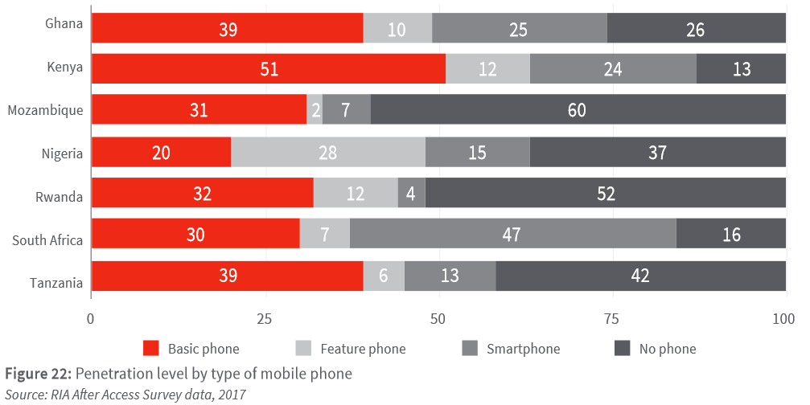
Figure 2: Types of mobile phones (RIA After Access surveys)
Similar differential access and outcomes can be observed in the rate of participation in the platform economy, including unexplained gender gaps in income levels of the relatively small number (2%) of platform workers across the African countries surveyed. Other divides (rural-urban, gender, age, digital skills, physical ability, etc.) emerge and persist with each technological advancement, making it possible for those with adequate resources to do more and better, while leaving the under-resourced even less equipped to function with inequitable agency in an increasingly sophisticated digital environment.
Meaningful access is more possible for those with strong and reliable Internet connections; sufficiently high socio-economic status to afford computers, smartphones, and data; and reservoirs of social capital to transform opportunities found online into real-world benefits. The simplistic view of digital access in binary terms is inadequate to capture the dimensions of disadvantage and ultimately injustice associated not with lacking digital access but with the type, quantity, and freedom of that access. It is no longer a question of eliminating the divide between "digital haves" and "have-nots", but a need to recognize the existence of other categories, such as the digital "have-less" [b-Cartier-et.al] whose dependence on "working class ICTs" [b-Qui] or experience of other constraints; requires accommodation in digital development and policy.
Source: [b-RIA] [b-RIA/WSIS]
It is reasonable to expect that this digital inequality phenomenon will be observed if or when the metaverse becomes more mainstream. What type and quality of digital infrastructure, and what range of digital skills will be necessary for meaningful engagement in the metaverse? How confident can the digital "have-less" be in an environment that requires technical, social, economic, and even political capabilities that are beyond their reach?
If the "User confidence framework" were to be leveraged, what measure of reliability, co-ownership, co-responsibility, and transparency [b-ITU FGMV-06] can they expect or practically activate with their limited resources? What levels of security and safety can the "have-less" access, and what exclusions, risks and harms might they be subject to because of their differential capacities to engage in the metaverse?
For some, confidence in the metaverse will require being convinced that it will not simply reproduce unjust social realities. Because of the history of digital technologies replicating social inequalities, building that type of confidence will require markedly different mechanisms than building confidence in the technical capabilities of the metaverse. It will, however, be well worth the effort, if the metaverse is to be socially sustainable.

8 Conclusion
It was the aim of this Technical Report to explore online and offline implications in efforts to build confidence and security in the metaverse for participants and non-participants. To address the increasing convergence of physical and virtual spaces, this report presented an organizing framework for a range of metaverse experiences across three dimensions:
1. Immersiveness,
2. Fidelity, and
3. Sociability.
It also presented an approach to metaverse participation, within and beyond the metaverse, across three realms:
1. Intra-metaverse,
2. Peri-metaverse, and
3. Extra-metaverse.
The implications of both participation and resulting experience, including real-world harms, were discussed, starting with the historical context of the evolution of the Internet and corresponding evolution in associated risks.
Although efforts to research confidence-related implications in the metaverse revealed scarcity in scholarly work, this report was able to leverage guiding principles from Technical Report ITU FGMV-06 to map historical trends as they relate to these implications. This provided context and grounding for a discussion on building confidence and security in the metaverse including a real-world example of implications.
Given that the metaverse is still in its early stages, it should be noted that, its ultimate direction is yet unknown. The views proposed in this report are therefore meant to be broad and flexible.

Annex A
User confidence framework
Components of the "User confidence framework" [b-ITU FGMV-06] [b-ITU FGMV-24] relevant to this Technical Report are included below.
Confidence definition
The first component of the "User confidence framework" is a definition of user confidence in the metaverse as follows:
"A user's state of certainty and belief in the reliability of a metaverse platform or environment" [b-Funna/confidence] [b-ITU FGMV-06].
The definition stresses the importance of the user's state of certainty and belief in the environment to provide a path to:
1. Considering user intent when developing principles that govern metaverse engagement.
2. Empowering individual users by addressing their expectations in immersive contexts.
An implied contract of confidence
The second component of the "User confidence framework" is a definition of a user implied contract of confidence as "An agreement between the user and the platform provider implicit in the user's willingness to co-create with and entrust resulting assets to the platform. This is especially noteworthy when assets, including user 'avatars', can represent the individuals' personhood" [b-Funna/confidence] [b-ITU FGMV-06].
Basic tenets as they relate to expectations surrounding user engagement in the metaverse can be extrapolated from an implied contract of confidence to include:
• What is expected for the user: Primarily from policymakers while considering the roles of all relevant stakeholders for the welfare of users (including advocates and users themselves).
• What is expected by the user: Naturally gravitating towards user perspectives.
• What is expected of the user: Likely stemming from developers or system providers, allowing for the dynamic shaping and reshaping of expectations by the user community.
Confidence dimensions
The third component of the "User confidence framework" is a set of "confidence dimensions" to help centre user experience in principles that build confidence and security in the metaverse [b-ITU FGMV-06].
Confidence dimensions
Dimensions | Descriptions
Reliability | - The metaverse may have the potential to redefine reality, but the realization of this potential is dependent on the real or perceived reliability of its platforms.  - Platforms should enable reliability of immersive environments by prioritizing "persistence" and consistency to meet user expectations of a co-created reality.
Co-ownership | - Co-creation should lead to co-ownership: Platforms should address user co-ownership of co-created assets and value, including providing autonomy, control, and self-protection of avatars and other assets.  - The potential extension of personhood in the form of avatars should also be considered.
Co-responsibility | - Platforms and users are together co-creators and co-owners, each with responsibilities, which should be clearly and adequately communicated.  - The resulting co-dependence should also be addressed.
Transparency | - In this nascent phase of the metaverse, it is important to be mindful of the role that users play in creating a shared reality, often by entrusting their "person" in the form of avatars to immersive environments.  - Platforms should reflect the implications of this responsibility with transparent practices, inclusive design, and ethical and responsible use.
Source: [b-ITU FGMV-06]
Security and safety dimensions
The fourth component of the "User confidence framework" is a set of "security and safety dimensions" to help highlight the need for safety and security practices in the context of confidence in the metaverse that may more adequately address the quality, depth, and range of user engagement as physical and digital boundaries continue to blur [b-ITU FGMV-24].
Security and safety dimensions
Dimensions | Descriptions
Security  Trust dimensions | - Security by design should focus on hardening infrastructure and software against novel threats, particularly cybercrime, fraud, and disinformation.  - Companies should use an adaptive zero-trust security model.  - Data protection should be in place to protect the confidentiality and integrity of experiences, data, and applications.
Safety  Human dimensions | - Safety is the top priority in virtual environments. Safety policies, practices, and technologies should consider the convergence of physical and digital dimensions.  - Platforms must proactively implement policies, technologies, and practices to discourage harmful content and behaviours.  - Companies should invest in predictive and real-time detection capabilities, as well as in-world features and off-world guidance to empower users to manage their own safety as it relates to the environment.
[b-ITU FGMV-24]
A new framework for metaverse participation
The fifth component of the "User Confidence Framework" is a new framework for metaverse participation to define realms of participation — that can evolve to absorb future dimensions of engagement as the line between digital and physical realities continues to blur [b-ITU FGMV-24].
Framework for metaverse participation
Realm | Meaning | Range of participation
Intra | Intra-metaverse: Area of activity located within the metaverse. | In-world (digital realm): This type of engagement occurs when a participant is present in a virtual online environment [b-Collins/in-world], often using an avatar. It can span from engagement in purely virtual worlds to engagement in broad and blended realities.  Metazen (digital realm): Citizen of the metaverse whose virtual and daily lives are fully intertwined [b-Oliver Wyman]. In the intra realm, "metazen" also refers to participants continued metaverse presence (especially through merged digital-physical realities) even when the participants (or their avatars) are "off-world".
Peri | Peri-metaverse: Area of activity located within and outside the metaverse while staying either in the digital realm or in a merged digital-physical realm. | Online (digital realm): This type of engagement is available through a system and occurs when a user is connected to or served by that system (especially a computer or telecommunications system such as the Internet) [b-Webster/online]. It can occur inside or outside of the actual virtual online environment, so long as the user is connected to the overall system. For example, users in the metaverse and users on the Internet that are not in the metaverse are online.  Netizen (digital realm): An active participant in the online community of the Internet [b-Webster/netizen]. In the peri realm, "netizen" also refers to participants' active online presence or continued direct engagement even in the absence of a current online connection.
Extra | Extra-metaverse: Area of activity located outside the metaverse, either in the digital realm, the physical realm or through a network connecting both realms. | Off-world (digital and physical realms): This occurs when a participant is absent from a virtual online environment. Referring to a participant as being "off-world" assumes prior in-world presence in a persistent metaverse environment where users may enter and exit without interrupting the activities of other participants or the metaverse "world" itself.  Networked integration (digital and physical realms): This refers to metaverse users or non-users tied to at least one connection between the physical world and the digital world. This could occur if a user or non-user is connected to an object in the physical world that is also connected to the digital world (e.g. "things" connected to the Internet as with the Internet of things (IoT)).  Offline (physical realm): This refers to the absence of connection to or service by a system (especially a computer or telecommunications system) [b-Webster/offline]. Possible engagement in the metaverse would be either by proxy or through knock-on effects; and the person in question may or may not be aware of that engagement. To be offline is to be in the physical world, the world as we know it.
[b-ITU FGMV-24]

Bibliography

[b-ITU-T X.1400] Recommendation ITU-T X.1400 (2020), Terms and definitions for distributed ledger technology.
https://www.itu.int/rec/T-REC-X.1400-202010-I
[b-ITU FGMV-06] ITU Focus Group on Metaverse. Technical Report FGMV-06, Guidelines for consideration of ethical issues in standards that build confidence and security in the metaverse. http://handle.itu.int/11.1002/pub/822f50e6-en
[b-ITU FGMV-20] ITU Focus Group on Metaverse. Technical Report FGMV-20 (2023), Anthopoulos, L., Funna, R., An, X. et. al. (2023). Definition of metaverse.
http://handle.itu.int/11.1002/pub/822f50fd-en
[b-ITU FGMV-24] ITU Focus Group on Metaverse. Technical Report FGMV-24 (2024), Funna, R., A framework for confidence in the metaverse.
http://handle.itu.int/11.1002/pub/822f5101-en
[b-ITU FGMV-25] ITU Focus Group on Metaverse. Technical Report FGMV-25 (2024), Funna, R. Near-term and long-term implications for people in the metaverse.
http://handle.itu.int/11.1002/pub/822f5102-en
[b-ISO/IEC 23005-4] ISO/IEC 23005-4:2018, Information technology – Media context and control – Part 4: Virtual world object characteristics.
[b-Ball] Ball, M. (2021). Framework for the Metaverse. The Metaverse Primer.
https://www.matthewball.vc/all/forwardtothemetaverseprimer
[b-Barrera-Shah] Barrera, K.G., Shah, D. (2023). Marketing in the Metaverse: Conceptual understanding, framework, and research agenda. Journal of Business Research, 155 (A). https://doi.org/10.1016/j.jbusres.2022.113420
[b-Blank-Reisdorf] Blank, G., Reisdorf, B. (2012). The Participatory Web. Information, Communication & Society, 15(4): 537-554. http://dx.doi.org/10.1080/1369118X.2012.665935
[b-Cartier-et.al] Cartier, C., Castells, M., & Qui, J. L. (2005). The Information Have-Less: Inequality, Mobility, and Translocal Networks in Chinese Cities. Studies in Comparative International Development, 4 (2), 9-34.
[b-Collins/in-world] Collins English Dictionary. (2024. Definition of In-world. https://www.collinsdictionary.com/us/dictionary/english/in-world
[b-Collins/realm] Collins English Dictionary. (2024. Definition of Realm. https://www.collinsdictionary.com/dictionary/english/realm
[b-Funna/confidence] Funna, R. (2023). Proposed scope of TG on Building confidence and security in the metaverse. ITU-T FG-MV: FGMV-O-WG6-TG-building-001.
https://extranet.itu.int/sites/itu-t/focusgroups/mv/wg/wg6_output/FGMV-O-WG6-TG-building-001.docx
[b-Funna/4ir] Funna, R. (2018). The fourth industrial revolution will eliminate the gender stereotypes created by the first. United States: Quartz.
https://qz.com/1177843/the-fourth-industrial-revolution-will-eliminate-the-gender-stereotypes-created-by-the-first
[b-Gaggioli] Gaggioli, A. (2017). Phygital Spaces: When Atoms Meet Bits. Cyberpsychology, Behavior, and Social Networking, 20(12):774. http://dx.doi.org/10.1089/cyber.2017.29093.csi
[b-Nagendran] Nagendran, A., Compton, S., Follette, W.C. et al. (2022). Avatar led interventions in the Metaverse reveal that interpersonal effectiveness can be measured, predicted, and improved. Scientific Reports, 12(1). https://doi.org/10.1038/s41598-022-26326-4
[b-OED] Oxford English Dictionary. (2024). Personhood Definition & Meaning.
https://www.oed.com/search/dictionary/?scope=Entries&q=personhood
[b-Oliver Wyman] Oliver Wyman Forum. (2024). The Citizens of the Metaverse. https://www.oliverwymanforum.com/global-consumer-sentiment/the-new-people-shaping-our-future/the-citizens-of-the-metaverse.html
[b-Partridge-Sey] Partridge, A., Sey, A. (2023). Global Governance of Artificial Intelligence: Lessons from Digital Inequality and Intersectionality Research.
https://researchictafrica.net/publication/global-governance-of-artificial-intelligence-lessons-from-digital-inequality-and-intersectionality-research/
[b-Qui] Qui, J. L. (2010). Network labour and non-elite knowledge workers in China. Work Organisation, Labour & Globalisation, 4(2), 80-95. https://doi.org/10.13169/workorgalaboglob.4.2.0080
[b-RIA] Research ICT Africa. (2020). RIA’s Submission on UN Secretary-General’s HLP on Digital Cooperation Research ICT Africa. South Africa: Research ICT Africa.
https://researchictafrica.net/publication/rias-submission-on-un-secretary-generals-hlp-on-digital-cooperation/
[b-RIA/WSIS] Gillwald, A. (2020). Measuring digital inclusion, pp. 19. South Africa: Research ICT Africa.
https://www.researchictafrica.net/wp/wp-content/uploads/2020/12/Measuring_Digital_Inclusion-Digital_Inclusion_or_Digital_Inequality-WTIS.pdf
[b-Tulane] Tulane University. (2024). What You Need to Know About Decentralized Social Networks.
https://sopa.tulane.edu/blog/decentralized-social-networks
[b-Van-Der-Merwe] Van Der Merwe, D. (2021). The Metaverse as Virtual Heterotopia. 3rd world conference on research in social sciences (1).
https://www.dpublication.com/wp-content/uploads/2021/10/41-20250.pdf
[b-Webster/confidence] Merriam-Webster, Incorporated. (2023). Definition of Confidence. https://www.merriam-webster.com/dictionary/confidence
[b-Webster/netizen] Merriam-Webster, Incorporated. (2024). Definition of Netizen. https://www.merriam-webster.com/dictionary/netizen
[b-Webster/offline] Merriam-Webster, Incorporated. (2024). Definition of Offline. https://www.merriam-webster.com/dictionary/offline
[b-Webster/online] Merriam-Webster, Incorporated. (2024). Definition of Online. https://www.merriam-webster.com/dictionary/online
[b-WEF-Accenture] World Economic Forum, Accenture. (2023). Metaverse Privacy and Safety.
https://www3.weforum.org/docs/WEF_Metaverse_Privacy_and_Safety_2023.pdf
[b-Xu-et.al] Xu, M., Guo, Y., Hu, Q., et. al. (2023). A trustless architecture of blockchain-enabled metaverse. High-Confidence Computing, 3(1).
https://doi.org/10.1016/j.hcc.2022.100088
_________________

