|  |  |  |
| --- | --- | --- |
|  | | Standardization Sector |
| **ITU Focus Group Technical Specification** | |
| **(12/2023)** | |
|  | ITU Focus Group on metaverse | |
|  | **Service scenarios and high-level requirements for metaverse cross-platform interoperability**  *Working Group 5: Interoperability* | |

|  |  |
| --- | --- |
| **ITUPublications** | **International Telecommunication Union** |

**Technical Specification ITU FGMV-19**

Service scenarios and high-level requirements for metaverse  
cross-platform interoperability

Summary

This deliverable specifies the service scenarios and high-level requirements for metaverse cross-platform interoperability. With the increasing number of metaverse platforms being developed, there is a need to create an open and seamless metaverse interoperable environment between metaverse platforms that fosters innovation and collaboration. This deliverable aims to identify the various intended service scenarios and high-level requirements of four types of metaverse cross-platform interoperability: avatar interoperability, asset interoperability, content interoperability, identity interoperability.

Keywords

Metaverse, metaverse cross-platform interoperability, requirements, service scenarios.

Note

This is an informative ITU-T publication. Mandatory provisions, such as those found in ITU-T Recommendations, are outside the scope of this publication. This publication should only be referenced bibliographically in ITU-T Recommendations.

Change Log

This document contains Version 1.0 of the ITU Technical Specification on "*Service scenarios and high-level requirements for metaverse cross-platform interoperability*" approved at the 4th meeting of the ITU Focus Group on metaverse (ITU FG-MV), held on 4-7 December 2023 in Geneva, Switzerland.

Acknowledgments

This Technical Specification was researched and written by Jungha Hong (ETRI, Korea (Republic of)), Wook Hyun (ETRI, Korea (Republic of)), MiYoung Huh (ETRI, Korea (Republic of)) and Xiaojun Mu (China Unicom, China) as contributors to the ITU Focus Group on metaverse (FG-MV). Hideo Imanaka (NICT, Japan) coordinated the development of this document as FG-MV Working Group 5 Chair.

Additional information and materials relating to this report can be found at: <https://www.itu.int/go/fgmv>. If you would like to provide any additional information, please contact Cristina Bueti at [tsbfgmv@itu.int](mailto:tsbfgmv@itu.int).

|  |  |  |
| --- | --- | --- |
| **Editor**: | Jungha Hong ETRI Korea(Republic of) | E-mail: [jhong@etri.re.kr](mailto:jhong@etri.re.kr) |
| **Editor**: | Wook Hyun ETRI Korea(Republic of) | E-mail: [whyun@etri.re.kr](mailto:whyun@etri.re.kr) |
| **Editor**: | MiYoung Huh ETRI Korea(Republic of) | E-mail: [myhuh@etri.re.kr](mailto:myhuh@etri.re.kr) |
| **Editor**: | Xiaojun Mu China Unicom China | E-mail: [muxj@chinaunicom.cn](mailto:muxj@chinaunicom.cn) |
| **WG5 Chair:** | Hideo Imanaka  NICT Japan | E-mail: [h.imanaka@nict.go.jp](mailto:h.imanaka@nict.go.jp) |

© ITU 2024

Some rights reserved.This publication is available under the Creative Commons Attribution-Non Commercial-Share Alike 3.0 IGO licence (CC BY-NC-SA 3.0 IGO; [https://creativecommons.org/licenses/by-nc-sa/3.0/igo](https://eur03.safelinks.protection.outlook.com/?url=https%3A%2F%2Fcreativecommons.org%2Flicenses%2Fby-nc-sa%2F3.0%2Figo&data=05%7C02%7CChristelle.Gachet%40itu.int%7C0fe5406e5055456a0b5a08dc7bce06f3%7C23e464d704e64b87913c24bd89219fd3%7C0%7C0%7C638521372006151524%7CUnknown%7CTWFpbGZsb3d8eyJWIjoiMC4wLjAwMDAiLCJQIjoiV2luMzIiLCJBTiI6Ik1haWwiLCJXVCI6Mn0%3D%7C0%7C%7C%7C&sdata=HtXL1m3ekhVn82amVYFS35Ip8LaaB74uwbUtbEu0fKM%3D&reserved=0)).

For any uses of this publication that are not included in this licence, please seek permission from ITU by contacting [TSBmail@itu.int](mailto:TSBmail@itu.int).

**Table of contents**

Page

1 Scope 1

2 References 1

3 Definitions 1

3.1 Terms defined elsewhere 1

3.2 Terms defined in this Technical Specification 1

4 Abbreviations and acronyms 1

5 Conventions 2

6 Overview of metaverse cross-platform interoperability 2

6.1 Metaverse interoperability 2

6.2 Aspects of metaverse cross-platform interoperability 3

6.3 Metaverse cross-platform interoperability 5

7 Service scenarios of metaverse cross-platform interoperability 6

7.1 Metaverse search: Cross-platform metaverse content discovery service 7

7.2 Metaverse learning: Content exploration and learning across platforms 10

7.3 Metaverse exhibitions: Cross-platform metaverse exhibitions 13

7.4 Metaverse safety patrol: Safety patrol service 15

7.5 Metaverse SNS: Social networking services on metaverse 18

7.6 Metaverse shopping: Cross-platform metaverse shopping 21

7.7 Metaverse tourism: Seamless exploration across multiple platforms 23

7.8 Metaverse signage: Product promotion with seamless transitions cross-platforms 25

7.9 Metaverse co-working: Cross-platform metaverse co-working 28

8 High-level requirements for metaverse cross-platform interoperability 30

8.1 General requirements for metaverse cross-platform interoperability 30

8.2 High-level requirements for avatar interoperability 30

8.3 High-level requirements for asset interoperability 31

8.4 High-level requirements for content interoperability 31

8.5 High-level requirements for identity interoperability 31

Appendix I – Status of standardization activities for metaverse cross-platform interoperability 32

I.1 ITU-T SG11 32

I.2 VRM Consortium 32

I.3 W3C 32

I.4 3GPP 38

I.5 Metaverse Standards Forum 39

Bibliography 40

**Technical Specification ITU FGMV**-**19**

Service scenarios and high-level requirements for metaverse  
cross-platform interoperability

# 1 Scope

This Technical Specification provides service scenarios and high-level requirements for the metaverse cross-platform interoperability. The scope of this Technical Specification includes the following:

– Service scenarios of the metaverse cross-platform interoperability;

– High-level requirements for the metaverse cross-platform interoperability.

NOTE – The service scenarios are intended in this deliverable, since currently there are no services over the metaverse cross-platform interoperability.

# 2 References

None.

# 3 Definitions

## 3.1 Terms defined elsewhere

This Technical Specification uses the following terms defined elsewhere:

**3.1.1 digital signage (DS)** [b-ITU-T H.780]: A system that sends information, advertising and other messages to electronic devices (e.g., displays, speakers) in accordance with the time of day and the location of the display, or the actions of audience. Contents and their relevant information, such as display schedules, are delivered over networks.

**3.1.2 metaverse** [b-ITU FGMV-20]: An integrative ecosystem of virtual worlds offering immersive experiences to users, that modify pre-existing and create new value from economic, environmental, social and cultural perspectives.

## 3.2 Terms defined in this Technical Specification

This Technical Specification defines the following terms:

**3.2.1 home avatar**: the avatar which exists within original metaverse platform, remaining customizable for its corresponding entity. This primary version of an avatar 'in the metaverse resides exclusively within a specific metaverse platform or avatar service.

NOTE – The entity includes users, Internet of thing devices, robots, digital humans, artificial intelligence, system components, etc.

**3.2.2 roaming avatar**: the avatar transitioning across various metaverse platforms from original metaverse platform, potentially undergoing alterations or transformations aligned with the destination platform's compatibility and features.

# 4 Abbreviations and acronyms

This Technical Specification uses the following abbreviations and acronyms:

AI Artificial Intelligence

API Application Programming Interface

AR Augmented Reality

MCDSP Metaverse Content Discovery Service Provider

NFT Non-Fungible Token

SDO Standards Development Organization

SNS Social Networking Service

URL Uniform Resource Locator

VR Virtual Reality

# 5 Conventions

The following conventions are used in this Technical Specification:

– The keywords "is required to" indicate a requirement that must be strictly followed and from which no deviation is permitted if conformance to this Technical Specification is to be claimed.

– The keywords "is recommended" indicate a requirement that is recommended but which is not absolutely required. Thus, this requirement need not be present to claim conformance.

– The keywords "can optionally" indicate an optional requirement that is permissible, without implying any sense of being recommended. This term is not intended to imply that the vendor's implementation must provide the option and that the feature can be optionally enabled by the network operator/service provider. Rather, it means the vendor may optionally provide the feature and still claim conformance with the specification.

# 6 Overview of metaverse cross-platform interoperability

## 6.1 Metaverse interoperability

In general, virtual worlds in metaverse are constructed on a single metaverse platform. Since the avatars and digital assets of users are developed in the platform, users can move from one virtual world to another with their avatars and assets (without any modifications) within the platform. In this regard, interoperability of avatars and assets on a single metaverse platform is achieved as a basic feature, as shown by the green line in Figure 6-1.

In a multi-platform environment as shown in Figure 6-1, the avatar of user Bob created on platform 2 cannot visit virtual world A on platform 1, since the avatar development mechanism and/or data format on platforms 1 and 2 may differ. User Alice has to make or set up another avatar on platform 2 when she wants to visit virtual world B on platform 2. In addition, assets and content created on metaverse platform 1 cannot move to metaverse platform 2, as shown in the blue line of Figure 6-1.

Interoperability is important in the development of the metaverse because it allows developers to create and share content across different platforms. It also allows users to have a seamless and cohesive experience, as they can move between different virtual worlds without creating new accounts or starting from scratch. Relevant standardization activities in other standards development organizations (SDOs) are listed in Appendix I. Standards for metaverse cross-platform interoperability are required.

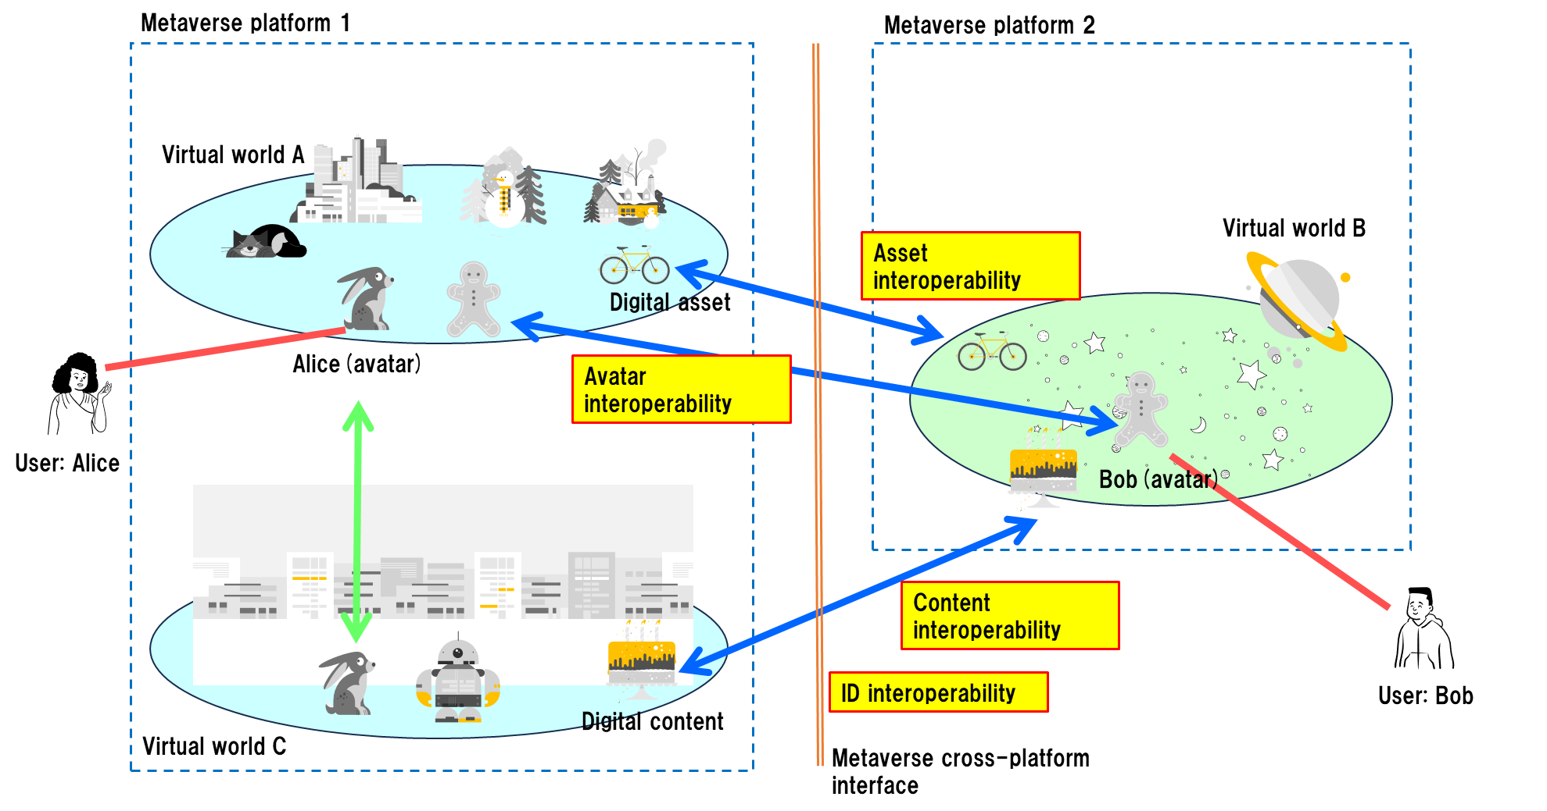

Figure 6-1 – Overview of metaverse interoperability

## 6.2 Aspects of metaverse cross-platform interoperability

The need for metaverse cross-platform interoperability arises from the fact that there are multiple metaverse platforms being developed by different companies, each with its own set of rules, protocols, and assets. This might cause a fragmented metaverse environment, making it difficult for users to move between different virtual worlds and for developers to create cross-platform applications.

There are different aspects of metaverse cross-platform interoperability to enhance the user experience. This document focuses on the following aspects:

– **Avatar interoperability**: This refers to the ability of digital entities including users to move avatars between different metaverse platforms while preserving their appearance, identity, and functionality. It allows users to create a single avatar that can be used across multiple virtual worlds, eliminating the need to create a new avatar for each platform. By maintaining consistency and continuity of their digital representation, users can engage themselves in various environments and situations, while also facilitating identity recognition and user tracking. Achieving avatar interoperability requires compatibility of avatar attributes such as access rights/agreements, appearance, movements, and behaviours across different platforms. Common standards and protocols for avatar creation, customization, and transfer are essential in ensuring avatar interoperability between platforms.

– **Asset interoperability**: This refers to the transfer of digital assets, such as tokenized items like non-fungible tokens (NFTs), virtual real estate, and digital currencies, across metaverse platforms. It enables digital entities including users to move and transact their assets across platforms, fostering cross-platform commerce. Achieving asset interoperability involves leveraging technologies like blockchain to facilitate secure and transparent asset transfers. The establishment of standards and protocols for asset formats and metadata is essential in ensuring compatibility and enabling the interoperability of these digital assets between metaverse platforms.

– **Content interoperability**: This refers to the ability of different metaverse platforms to share and exchange various digital elements associated with activities in the metaverse, such as user-generated content, games, experiences, and applications. This encompasses a diverse range of media formats, including 3D images, animation, sound, text, digital objects, and digital elements. It is crucial that such content be compatible and exchangeable across platforms, requiring the establishment of standards and protocols for content formats, metadata, and licensing, as well as for content discovery, storage, and retrieval mechanisms It also requires the development of tools and technologies that enable creators and developers to easily create, share, and distribute content across different platforms. This eliminates the need for duplicating the content creation process for each platform, streamlining workflows and enhancing collaboration in the metaverse ecosystem. As well as for content storage, retrieval, archiving, and disposition meeting legal and regulatory requirements.

– **Identity interoperability**: This refers to the transfer of the entities' identities between different metaverse platforms. It enables the entities to maintain unified identities across multiple virtual worlds, allowing for a smooth transition between platforms without the need to create new accounts. This encompasses not only for the identities of the entities but also identity-related aspects for all entities within the metaverses, such as avatars and their associated items. To achieve identity interoperability, digital identities should be designed to be unique and consistently recognized across metaverse platforms.

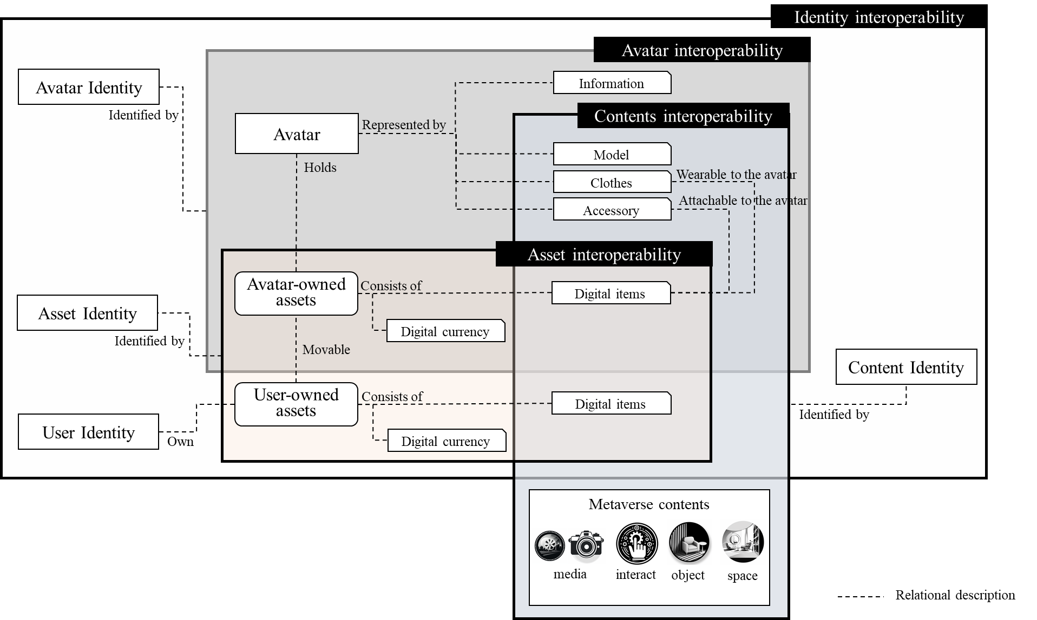

Figure 6-2 – Relationships among cross-platform interoperability aspects

The interoperability aspects cannot be strictly divided, and there may be some overlap since cross-platform interoperability relates each interoperability aspect. For example, when an avatar moves to another metaverse platform, it needs to exchange the avatar information, avatar content, identity, and assets. Figure 6-2 shows the logical relationship among the four interoperability aspects as follows:

– Users can maintain several distinct user identities/accounts within a platform or across multiple platforms;

NOTE 1 – This allows a single user to take on different online personas suited to various contexts, interests, and social circles;

– A single user identity possesses more than one user assets and avatars, enabling a diverse range of personalized experiences and interactions;

– An avatar and user can hold digital assets including digital items and digital currencies;

NOTE 2 – Digital currency is an asset used for transactions in the metaverse.

NOTE 3 – An avatar can take avatar-owned assets when moving to another metaverse.

NOTE 4 – Digital assets can be movable by user between user-owned assets and avatar-owned assets.

– The shapes of digital items and avatars are one of types of content;

– The digital item can be attachable to the avatar, such as fashion items and accessory;

– The digital item can be wearable to the avatar, such as clothes, costumes, and hats.

By securing interoperability of these aspects, it is possible to ensure interoperability across heterogeneous metaverse platforms.

## 6.3 Metaverse cross-platform interoperability

Metaverse cross-platform interoperability refers to different metaverse platforms' ability to interact seamlessly, allowing digital entities including users to access content, assets, and experiences across multiple virtual worlds. This interoperability is achieved by standardized protocols that enable communication and data exchange between different metaverse platforms.

Two different approaches may be considered to achieve interoperability between different metaverse platforms: direct and indirect interoperability.

– **Direct interoperability** refers to the ability of two or more metaverse platforms to directly communicate and exchange data with each other, using a common set of protocols and application programming interfaces (APIs). For example, a user could enter one metaverse platform with their avatar and virtual assets and then move **to** another platform without having to go through transfer processes. Direct interoperability requires cooperation between the different metaverse platforms and the creation of common standards and protocols for asset and avatar transfer. These standards would need to be agreed upon and implemented by all participating platforms. This is a complex process that requires a lot of coordination and agreement between different parties, but if successful, it would greatly enhance the user experience and create a seamless and interconnected metaverse.

– **Indirect interoperability** refers to the ability of different metaverse platforms to indirectly communicate and exchange data with each other through data exchanging functions which might be provided by the third-party services, which are services developed and provided by a party other than the company that owns the metaverse platform. The data exchanging functions could offer additional features, functionalities, or experiences to users, complementing the core services provided by the metaverse platform itself. The exchanging services could include virtual asset exchanges, ownership and intellectual property rights management, identity verification, authentication services, and policy interoperability services. For example, a user could export their avatar or digital assets from one platform, and then import them into another platform. While indirect interoperability is less seamless than direct interoperability, it can still provide a way for users and content creators to share and reuse content across different platforms.

Figure 6-3 depicts the concept of metaverse cross-platform interoperability, which implies things like being able to use the same avatar and items in different metaverses, or being able to join the same virtual event from different devices.

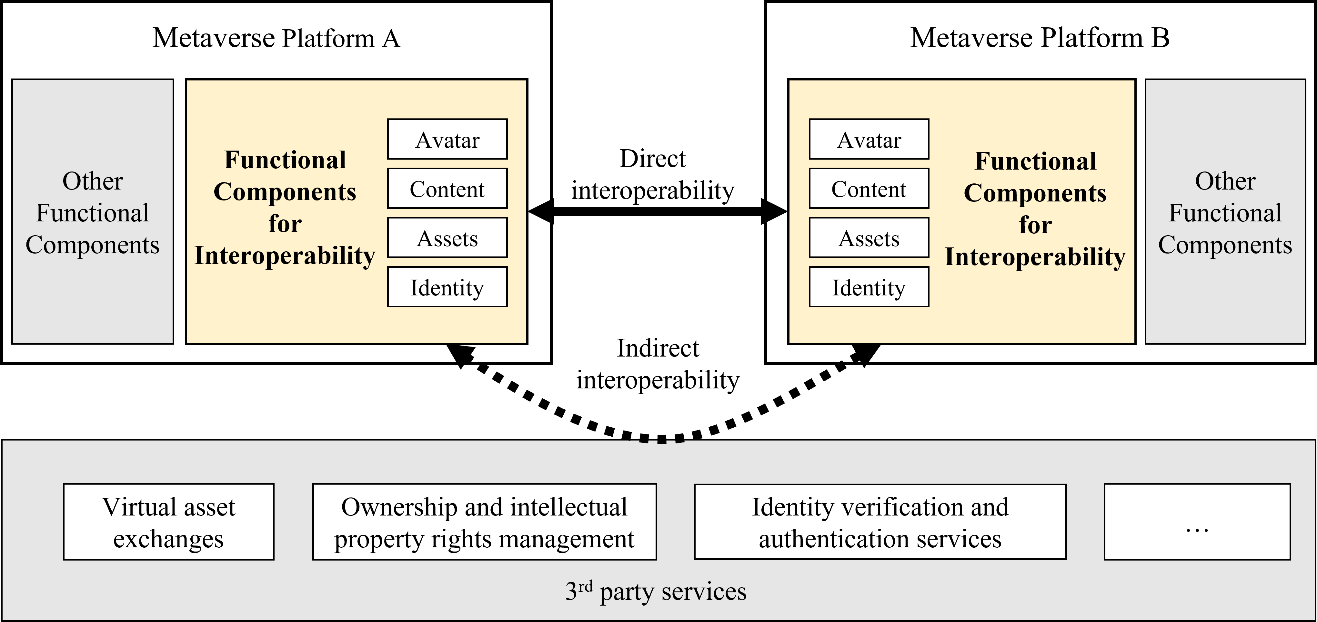

Figure 6-3 – Concept of metaverse cross-platform interoperability

# 7 Service scenarios of metaverse cross-platform interoperability

This clause describes several considerable service scenarios realized by interoperable metaverse platforms. These service scenarios are not fully implemented because no interoperability capability between platforms is provided yet.

Table 7-1 summarizes the relationships of service scenarios and required interoperability aspects which are described in clause 6.

| Table 7-1 – The relationship of service scenarios and interoperability aspects | | | | | | |
| --- | --- | --- | --- | --- | --- | --- |
| Scenario | Description | Avatar interoperability | Asset interoperability | Content interoperability | Identity interoperability | ref. |
| Metaverse search | This service acts as a directory or marketplace for the metaverse, showcasing various offerings from different creators, providers, or businesses. |  | Content purchase, Content publish | Content discovery/ preview/mashup |  | 7.1 |
| Metaverse learning | Metaverse learning is a virtual school where users, teachers and students, can connect remotely for learning. | Avatar migration |  | Content retrieval,  Content purchase |  | 7.2 |
| Metaverse exhibition | Metaverse exhibition is a virtual exhibition that exists across multiple metaverse platforms. | Avatar migration | Asset migration | Media art migration |  | 7.3 |
| Metaverse safety patrol | Safety patrol can monitor threats in the metaverse, support victims, and punish perpetrators to make the metaverse world a safer place. | Safety patrol dispatch, Avatar migration |  |  | Reputation query, Access control | 7.4 |
| Metaverse social networking service (SNS) | Metaverse can be a new area of social networking, where users can interact with each other and digital objects in real time in a virtual world. | Avatar migration | Asset migration | Social decoration, Sharing photos/ posts/ videos, Spatial interaction | Social networking, Access control | 7.5 |
| Metaverse shopping | In metaverse shopping, a user can buy/sell virtual items or invest in a property. | Avatar migration | Asset migration | Item purchase |  | 7.6 |
| Metaverse tourism | The metaverse tourism service allows travel enthusiasts to create a customized tourism that takes them through different metaverse platforms. | Avatar migration | Asset purchase, Asset migration |  |  | 7.7 |
| Metaverse signage | Metaverse signage is virtual signage that displays wayfinding information between different metaverse services offered within the platform. | Avatar migration |  |  |  | 7.8 |
| Metaverse co-working | Metaverse co-working is a virtual co-working service that allows users to collaborate and communicate remotely in a more immersive way. | Avatar migration |  | Meeting material migration |  | 7.9 |

## 7.1 Metaverse search: Cross-platform metaverse content discovery service

A discovery service in the metaverse is a tool that helps users find and access various virtual experiences, content, or services within the metaverse. This service acts as a directory or marketplace for the metaverse, showcasing various offerings from different creators, providers, or businesses. It is also possible to create mashup services or content by combining content from other distributed metaverse platforms.

### 7.1.1 Description

The contents and service discovery for the metaverse should allow users to search for specific content or services based on keywords, categories, or other criteria and filter results based on factors such as popularity, price, or creator. Furthermore, it is needed to support multimodal inputs from the users. Users can preview content or experience before purchasing it and read reviews from other users to make informed decisions. Social recommendations can also be available based on the user's social connections, interests, or past experiences in the metaverse.

As is, a discovery service in the metaverse aims to make it easier for users to find, access, and engage with the vast array of offerings.

Users can search for services other metaverse platforms provide through the discovery service. It's essential to identify which contents are interoperable and which are not, as the distributed metaverse platform will offer independently operated services. Platform service providers can enhance competitiveness by linking with various metaverse platforms to support interoperability. In addition, users can create their content or services by combining the metaverse content that has been searched and deploying them on their metaverse platforms. Figure 7-1 shows the concept of the metaverse contents discovery service scenario.

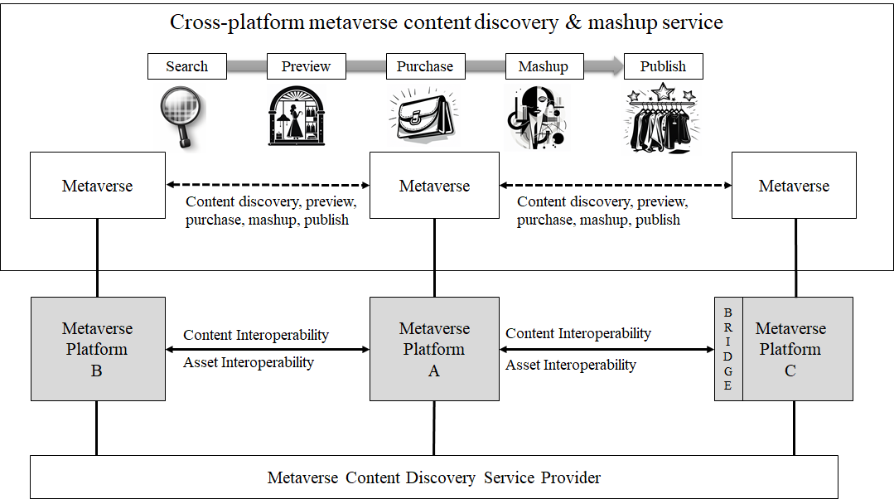

Figure 7-1 – Concept of the metaverse content discovery service scenario

Nevertheless, it can become challenging for users to discover content that matches their interests in numerous dispersed and independent metaverses. In this case, it may be beneficial to have a dedicated metaverse content discovery service provider (MCDSP), which might be provided by 3rd party service providers to provide an enhanced user experience. An MCDSP can help users navigate the various platforms, find the content and services that meet their needs, and be a central hub to find information about different metaverse platforms and their content. This can include information about virtual real estate, gaming experiences, social networks, virtual events, virtual education, and virtual tourist destinations. It is also possible to purchase the content on other platforms by jumping there, but this scenario gives more seamless experiences to the users since they don't need to know where the content is from.

The MCDSP can also provide users with relevant information about the platforms, such as the types of experiences and activities available, the number of users, and the quality of the user experience.

### 7.1.2 Assumptions

The assumptions related to this scenario include the following:

– It is assumed that metaverse platforms A, and B provide a standardized interface for searching and exchanging their contents, and metaverse platform C uses a metaverse bridge to interact with other metaverse using their interface.

– It is assumed that a user is connected to the metaverse platform A.

– It is assumed that users can create their mashup content using multiple distributed content and publish it onto a specific metaverse platform.

### 7.1.3 Service scenario

This clause describes the typical service flow for metaverse contents and service discovery service as shown in Figure 7-2.

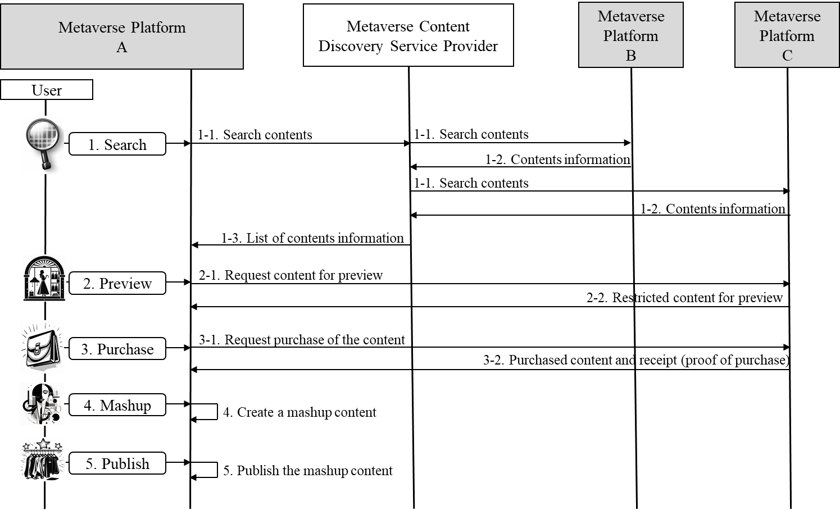

Figure 7-2 – Service flows for the metaverse content discovery scenario

1 The user searches for metaverse content using the discovery service. Using the discovery service's user-friendly intuitive interface, the user searches for specific content based on keywords, categories, or other criteria including multimodal inputs from the user.

– The metaverse platform A sends the user's intention to the MCDSP to request content information through several distributed metaverse platforms.

– Each metaverse platform gives content information that matches the query request. It includes the metaverse platform address, hardware requirements, billing information, etc.

– The MCDSP gathers and provides the information to the metaverse platform A.

2 The user requests to preview the content or experience before purchasing it and read reviews from other users to help them make informed decisions. During the preview, users can try the content using their immersive devices.

– The metaverse platform A interacts with platform C to get content for preview.

– The metaverse platform C gives content restricted to only preview to platform A.

3 The user purchases a specific digital content from platform C.

– When the user requests metaverse platform A to purchase the content of platform C, and the platform interacts with platform C to buy it on behalf of the user.

– The metaverse platform A interacts with platform C to purchase the content.

– The metaverse platform C gives content and its receipt to platform A, and platform A will make the user own it.

4 The user creates a mashup content in its metaverse platform A.

5 The user publishes and locates the mashup contents into the metaverse platform A. This user metaverse content can also be searched through the discovery service and used for creating a new service by other users.

## 7.2 Metaverse learning: Content exploration and learning across platforms

A metaverse learning is a virtual school where users, teachers and students, can connect remotely for learning.

### 7.2.1 Description

In the scenario of metaverse learning, a virtual school known as the metaverse school is created, enabling teachers and students to connect through avatars. This approach enables an immersive learning environment and facilitates interactive and collaborative experiences within a virtual classroom. Teachers have the flexibility to create instructional materials by accessing a diverse range of content available from numerous content servers within the metaverse. Similarly, students are not limited to solely utilizing the materials provided by their teachers. They can also learn relevant content from various content servers, enriching their learning experience.

By creating a metaverse school in virtual space, students and teachers from around the world can seamlessly connect and learn together, regardless of the platform they use. Teachers have the advantage of accessing a wide array of content from various platforms, including 3D models, interactive visualizations, virtual libraries, and more. Students, in turn, can access and explore diverse learning materials that cater to their unique learning styles and preferences, without any limitations posed by geography or physical boundaries. This opens up exciting opportunities for remote and distance learning, ensuring that everyone has equal access to quality learning and the ability to maximize their learning potential. Figure 7-3 shows the concept of metaverse learning over cross-platform.

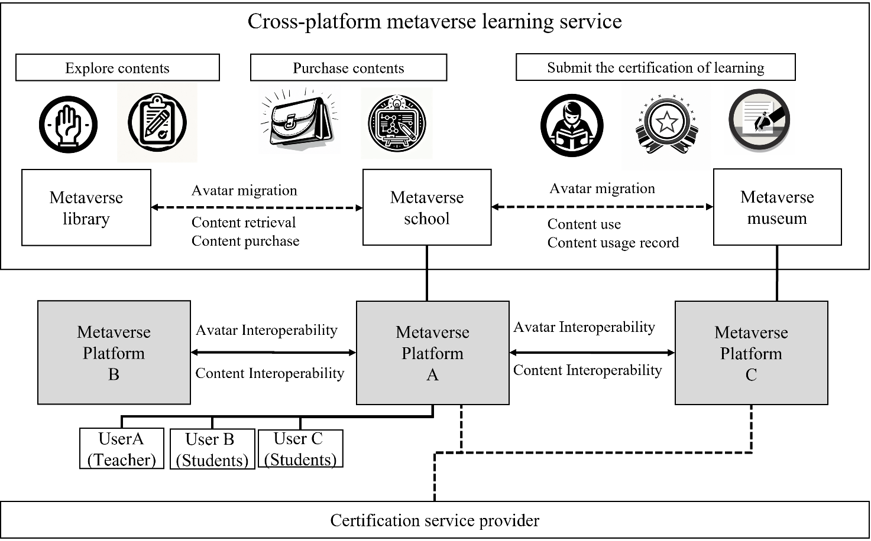

Figure 7-3 – Concept of metaverse learning over cross-platform

### 7.2.2 Assumptions

– It is assumed that the metaverse school, the metaverse library, and the metaverse museum exist on a metaverse platform, with each being provided on different metaverse platforms A, B, and C. It is assumed that User A is a teacher and Users B and C are students in the metaverse school.

– It is assumed that the metaverse library offers a variety of content, including learning materials, and provides diverse search functionalities, such as topic, media type, running environment, and required device type, to facilitate easy content discovery for users. This allows users to find content aligned with their interests or specific needs to create learning materials or engage in learning.

– It is assumed that the metaverse museum, in addition to its unique functions as a museum, is responsible for providing supplementary content related to students' lessons in the learning area. It is assumed that there is a contractual agreement between the metaverse museum and the metaverse school, specifying designated lists of allowable users and content list.

– It is assumed that the metaverse museum manages the records of content utilization, including the list of contents accessed by users, timestamps of usage, learning outcomes, and provides certification marks by a certification service provider which might be a third-party service provider to users who have studied the content.

### 7.2.3 Service scenario

This clause describes the typical service flow for metaverse learning service as shown in Figure 7-4.

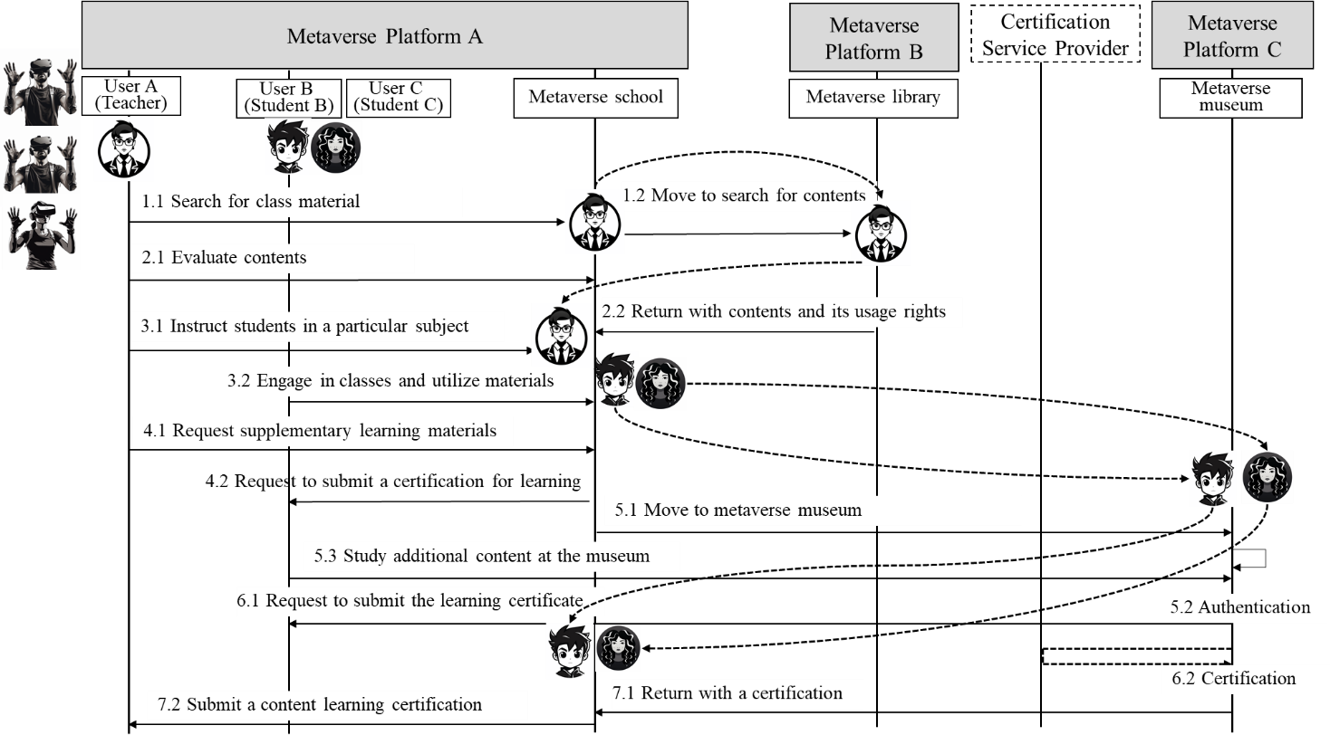

Figure 7-4 – Service flows for metaverse learning service scenario

1 User A (teacher) enters the metaverse school as their avatar to prepare learning materials for the class. To find the contents required for lesson preparation, User A navigates to the metaverse library and performs searches using various keywords such as subject, media type, execution environment, and device requirements.

2 When the desired contents are found, User A checks if there are any issues accessing the contents using the devices utilized in the class. User A decides to purchase the contents to make it available for all users of the metaverse school. The purchased contents and contents usage rights are transferred from the metaverse library to the metaverse school. User A completes the lesson materials by combining the contents available at the metaverse school with the contents obtained from the metaverse library.

3 User A, User B and User C participate in virtual classes by entering the metaverse school with their avatars. User B and User C (students) engage in the shared use of contents prepared by User A.

4 After the class is over, User A requests User B and User C to learn supplement contents available at the metaverse museum in order to enhance their understanding of the lesson, and then submit a learning certification.

5 User B and User C enter the metaverse museum with their avatars from the metaverse school. At the museum, their status as authorized users and their access to specific contents are verified. If granted permission, User B and User C can engage in learning the relevant contents available at the metaverse museum.

6 The metaverse museum generates and manages records of contents utilization, including lists of contents used, usage history, and user learning outcomes. The museum also provides User B and User C with learning certification for the contents they have studied. These certifications may include information such as the user who completed the learning, the contents studied, and the learning outcomes.

7 User B and User C return to the metaverse school with their contents learning certification and submit them to User A.

## 7.3 Metaverse exhibitions: Cross-platform metaverse exhibitions

A cross-platform metaverse exhibition provides immersive knowledge that spans multiple metaverse platforms, offering visitors an immersive and enlightening journey. Leveraging advanced technologies, including augmented reality (AR) and virtual reality (VR), attendees can traverse a range of exhibits, interactive installations, and curated digital content. This innovative approach presents a novel way for individuals to immerse themselves in various thematic showcases, irrespective of their physical location.

### 7.3.1 Description

This service scenario outlines a cross-platform metaverse exhibition that harnesses the capabilities of immersive technologies such as AR, VR, haptic sense, temperature, humid, and scent to deliver an unparalleled viewing experience. Spanning multiple metaverse platforms, the exhibition offers visitors the chance to delve into various digital art pieces, installations, and curated showcases.

Through interactive engagements, attendees can immerse themselves in the stories behind the artworks, interact with dynamic installations, and even witness the evolution of pieces in real-time. The seamless integration across platforms ensures that visitors can transition from one platform to another without missing a beat in their viewing experience.

The cross-platform metaverse exhibition breaks geographical boundaries, allowing art enthusiasts from all corners of the globe to experience and interpret a diverse range of artworks, irrespective of their physical location. It transcends the traditional art viewing norms, offering an immersive, interactive, and expansive experience. The convergence of immersive technologies in this space accentuates the depth, making it a revolutionary approach to art exhibitions in the digital age. Figure 7-5 shows the concept of cross-platform metaverse exhibitions.

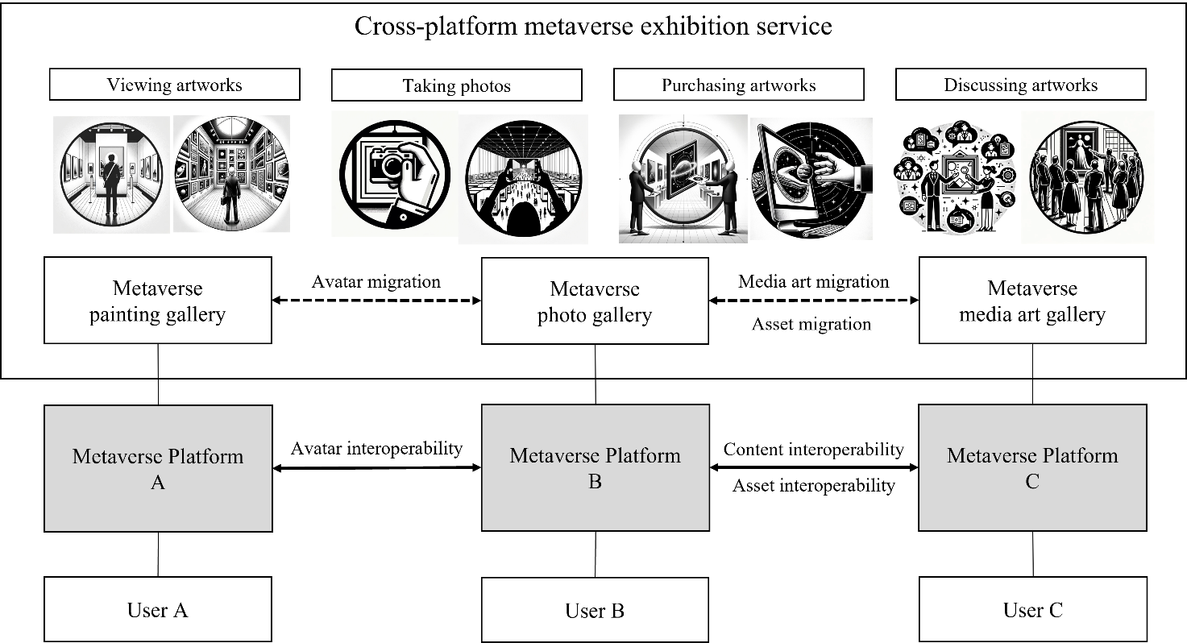

Figure 7-5 – Concept of cross-platform metaverse exhibitions

### 7.3.2 Assumptions

The assumptions related to this service scenario include the following:

– It is assumed that there are three metaverse exhibitions on metaverse platform A, B, and C, respectively: metaverse painting gallery, metaverse photo gallery, and metaverse media art gallery hosted.

– It is assumed that the metaverse exhibitions have partnerships with different metaverse platform providers to support cross-platform metaverse exhibition service.

– It is assumed that the metaverse exhibition has access to advanced technologies such as augmented reality (AR) and virtual reality (VR) to provide an immersive and interactive experience for visitors.

– It is assumed that visitors have access to the necessary technology and equipment to access the metaverse exhibitions on different platforms.

### 7.3.3 Service scenario

This clause describes the typical service flow for the service scenario of cross-platform metaverse exhibition service as shown in Figure 7-6.

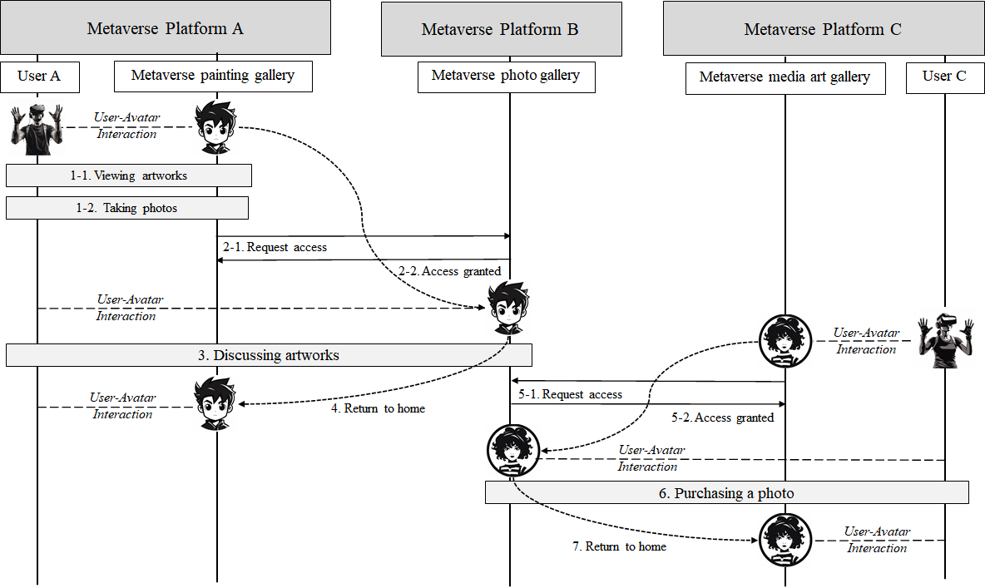

Figure 7-6 – Service flows for the cross-platform metaverse exhibitions

Visitors may start by exploring platform A, where they can immerse themselves in a virtual gallery showcasing various paintings. They can then seamlessly transition to platform B, where they can appreciate a photo exhibition detailing the themes and stories behind each captured moment. Finally, on platform C, visitors can engage with media art exhibits, using AR technology to interact and experience art in a whole new dimension.

1 Users A, B, and C access the metaverse platforms A, B, and C, respectively, and visit their respective galleries.'

2 User A on the metaverse paining gallery can have a closer look for any artwork using their AR/VR devices.

3 User A can take virtual photos with paintings and seamlessly move to metaverse photo gallery on metaverse platform B.

4 User A can access the activated photos and learn about the background of each photo through an audio description.

5 User A comes back to the metaverse paining gallery on metaverse platform A.

6 User C on the metaverse media art gallery can manipulate and interact with virtual elements of the art using AR tools.

7 User C can seamlessly move to the metaverse photo gallery on metaverse platform B, purchase a photograph, and then return to the metaverse media art gallery on platform C to continue his exploration.

## 7.4 Metaverse safety patrol: Safety patrol service

Safety issues in virtual worlds are not a new phenomenon, and users of the metaverse have expressed concerns about safety issues. To protect user safety, metaverse platforms can operate organizations or services such as Safety Patrol to protect users. Safety Patrol can monitor threats in the metaverse, support victims, and punish perpetrators to make the metaverse world a safer place.

### 7.4.1 Description

In virtual reality games, there have been instances of harassment, physical assault, bullying, hate speech, and more. As the metaverse provides users with an increased sensory experience, bad behaviour within the metaverse can be even more serious than current online harassment. Problematic behaviours in virtual reality generally occur in real-time and are difficult to track as they are not typically recorded. Therefore, a safety patrol is necessary to prevent immediate user harm and online harassment. However, it may be difficult for every metaverse to operate its own independent safety patrol. Therefore, a separate provider of metaverse Patrol as a Service can take on this role, and each metaverse platform can ensure safety through an agreement with this service provider. In this scenario, when the metaverse platform receives a request for help from an online user, it accompanies the user with a Safety Patrol to monitor the situation nearby and immediately warn users who engage in problematic behaviours. This can be especially useful for protecting children in the metaverse environment. This patrol ensures it can be distinguished from regular users through consistent uniforms or marks. In addition, it warns users who engage in problematic behaviours in advance or reports them to the metaverse platform administrator for future reference. The metaverse platform administrator will impose sanctions on the user based on the report and record it in the reputation management system of the platform to ensure accountability. It is feasible to either employ a safety patrol service as a 3rd party service or integrate a safety patrol system directly within the metaverse platform. Utilization of the safety patrol service facilitates rapid adoption of new functionalities. Alternatively, constructing the safety patrol system internally within the platform enables the provision of features specifically tailored to that particular environment. However, in either case, it is important to secure mechanisms for interoperability and information sharing to ensure a safe metaverse environment.

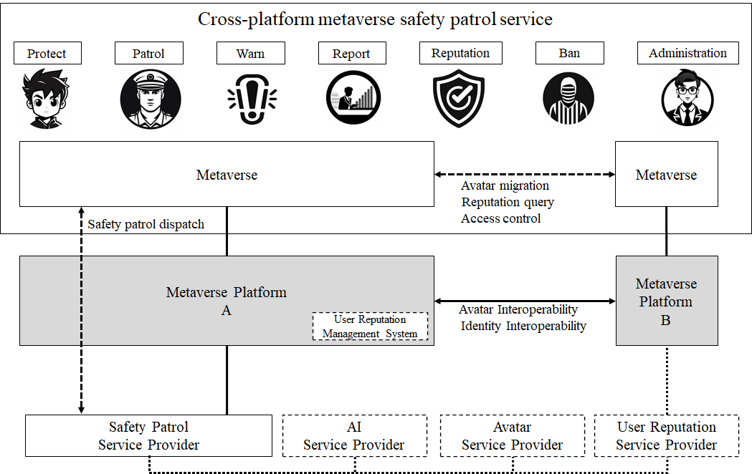

Figure 7-7 – Concept of a safety patrol service over metaverses

Figure 7-7 shows a concept of a safety patrol service over metaverses. As shown in this Figure, the patrol is visible and operated through a combination of the AI service provider, avatar service provider, and safety patrol service provider.

### 7.4.2 Assumptions

The assumptions related to this service scenario include the following:

– It is assumed that metaverse platform A has entered into an agreement with a metaverse patrol as a service provider.

– It is assumed that metaverse platform A has shared its platform's rules and policies with the patrol service provider in advance.

– It is assumed that metaverse platform A has granted the patrol's avatar the necessary level of authority within the platform.

– It is assumed that the patrol operates as an AI patrol avatar through collaboration with an avatar service provider and an AI service provider.

### 7.4.3 Service scenario

This clause describes the typical service flow for metaverse safety patrol service as shown in  
Figure 7-8.

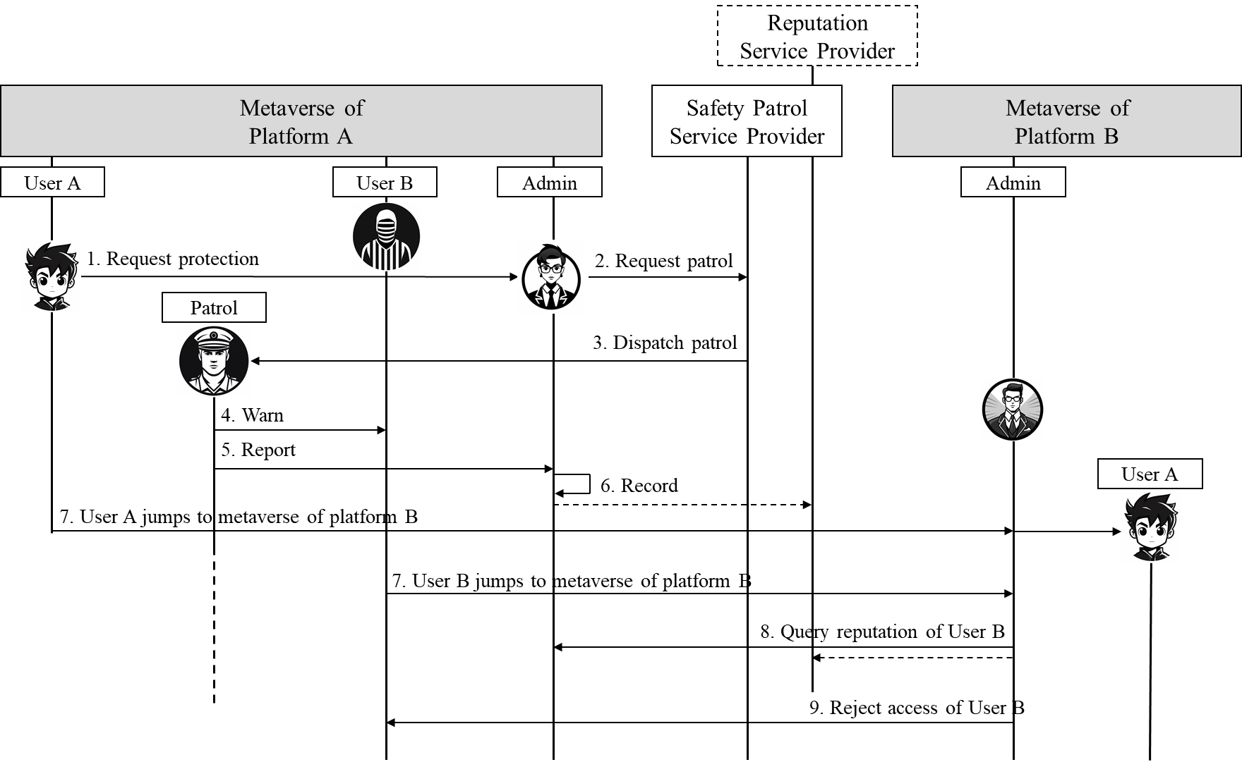

Figure 7-8 – Service flows for a safety patrol service over metaverses

1 When User A experiences harassment or problematic behaviour, the user requests patrol services through the metaverse platform A.

2 When a request for help comes in, the platform requests patrol services from a provider to have a safety patrol accompany the user and monitor the situation.

– The patrol prevents problematic situations by being distinguished from regular users through consistent uniforms or marks. Alternatively, an item indicating that the user avatar is protected by the patrol and only revealing the patrol's avatar, when necessary, may be attached to avoid rendering performance issues due to additional avatars.

– The patrol uses artificial intelligence provided by an AI service provider to determine if other users' real-time conversations and actions are problematic.

3 Safety patrol monitors users exhibiting potential problematic behaviour and immediately issues warnings if necessary.

– The platform requests an AI service provider to make judgments based on the rules and policies of the metaverse platform and user behavioural data.

– If necessary, appropriate sanctions can be immediately enforced according to the permissions granted by the platform.

4 Patrols create reports on detected issues and send them to the metaverse platform administrators.

5 The administrator reviews the reports and decides on sanctions for the problematic user, User B.

6 If sanctions are imposed, the reputation management system for that user is recorded, and additional measures are reviewed and implemented to prevent recurrence.

– User B, subject to sanctions, may be blocked from accessing the metaverse.

– It is also possible to the sanction record into other systems, such as Reputation Service Provider, depending on the platform's policy.

7 User A jumps to metaverse platform B, and User B follows.

8 The administrator checks the reputation of Users A and B.

– Depending on the situation, other metaverse platforms having an agreement may share reputation information.

– This can be done automatically without the intervention of the actual administrator.

9 The platform rejects the access of User B according to the result of the reputation review.

## 7.5 Metaverse SNS: Social networking services on metaverse

This service scenario is about social networking services in the metaverse. Users can display content such as NFT assets and user-created content in their personal metaverse social space, and visitors can access and interact with the user's content. Additionally, users can delegate their avatars to artificial intelligence to greet visitors. It is also possible to upload user's photos, video clips, and postings as well in the metaverse social space. Compared to existing SNS services composed of text, images, and videos, metaverse social space can provide immersive service through interactive 3D content. Traditional SNS provides relatively basic interaction in a 2D environment through sharing text, images, videos, commenting, and liking, primarily delivering information via timelines or feeds. On the other hand, the metaverse offers real-time interaction and a high level of immersion in a 3D or VR environment through avatars, allowing users to have more lifelike experiences in virtual spaces where physical location and exploration are emphasized.

### 7.5.1 Description

Metaverse can be a new area of social networking, where users can interact with each other and digital objects in real time in several virtual worlds over different metaverse platforms. Metaverse SNS (Social Networking Service) provides users to organize NFT assets, upload personal photos and videos, record daily activities, post photos and text, and communicate with friends through comments and various activities even in different platforms. Users can customize the appearance of their avatars, including clothing, accessories, and animations, and interact with others in virtual environments, games, and events. Metaverse SNS platforms provides the transfer of avatars and accessories between platforms. Users can expand their social network and participate in various communities and events by promoting interoperability and collaboration between platforms.

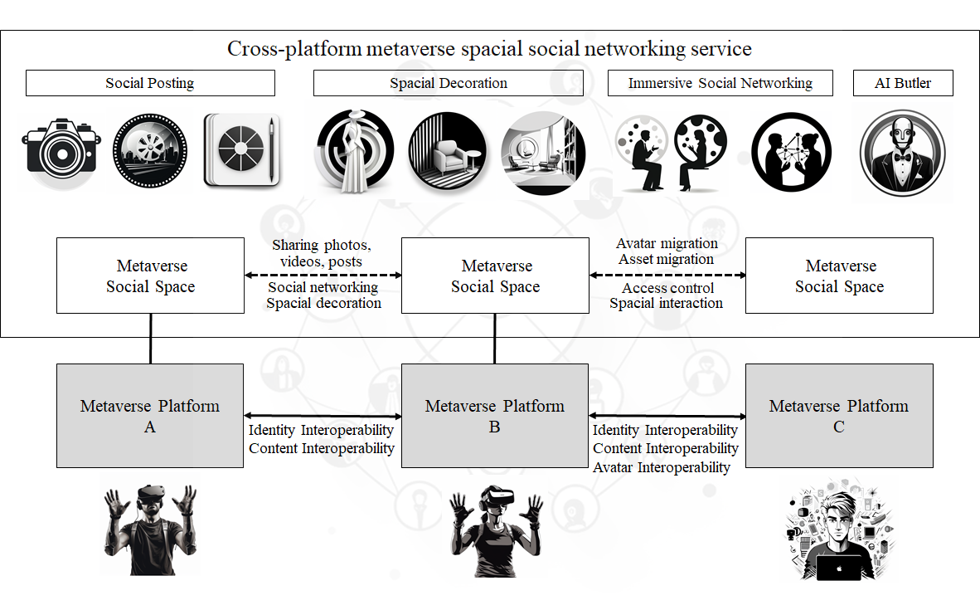

Figure 7-9 – Concept of the metaverse social networking service scenario

Figure 7-9 shows a concept of the metaverse SNS scenario. In the concept, a metaverse social space resides on top of metaverse platforms. That is, a metaverse platform can hold multiple metaverse, and those platforms can interact with each other directly or via a metaverse bridge. It is also possible to interact with NFT/Blockchain service provider, AI service provider, avatar service provider, etc. In this scenario, a user's avatar can either be affiliated with the metaverse platform or a separate avatar service provider.

### 7.5.2 Assumptions

The assumptions related to this service scenario include the following:

– It is assumed that the user's SNS space in the metaverse is called "metaverse social space".

– It is assumed that Users A, B, and C each own a metaverse social space and, being in a mutual friendship, can freely visit each other's spaces. User C is assumed to have connected artificial intelligence to the avatar to cater to visitors on behalf.

### 7.5.3 Service scenario

This clause describes the typical service flow for metaverse social networking service as shown in Figure 7-10.

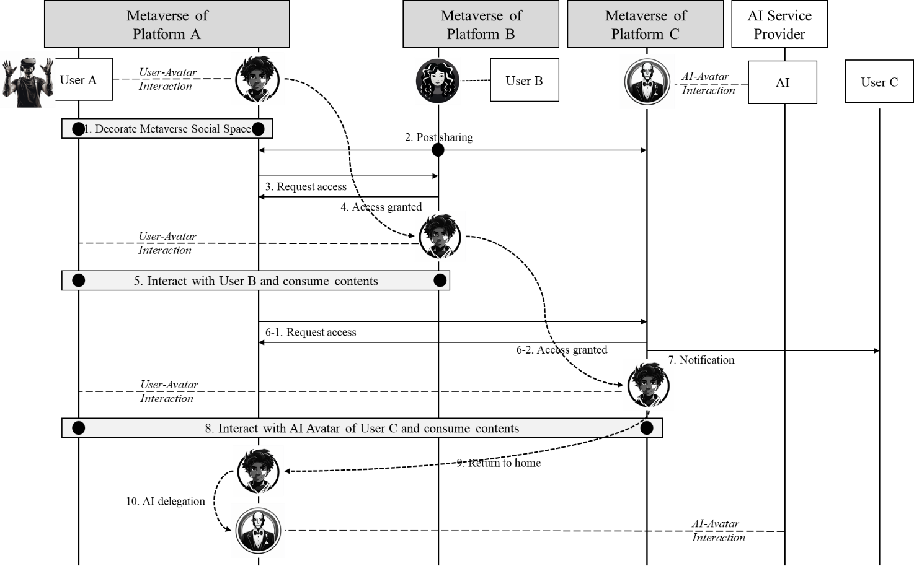

Figure 7-10 – Service flows for the metaverse social networking service

1 Users create their own metaverse social spaces using the tools provided by each metaverse platform. In this step, users can do the following:

– Place their digital assets, items, photos, posts, videos, party rooms, and playable games that they have purchased as NFTs in their metaverse social space.

– Invite friends to their space and make content accessible to other users even when the user is not online.

– Grant differentiated access rights to their spaces and content.

– Set content display and access conditions when decorating their spaces.

– Create multiple metaverse social spaces and specify them as public or private. For private spaces, access can be limited to invited users for a certain period of time.

– Place their avatars in their metaverse spaces. These avatars can mimic the user's appearance and behaviour or be set to a different appearance as desired. When the user is offline, an AI-powered avatar greets visiting friends. The avatar only provides information the user has allowed and engages in conversations that align with the user's intentions.

– Place portals linked to their friends' metaverse spaces on their own metaverse social space. The connection of these portals is only possible if it is allowed by the bilateral agreement between the user and the friend. These portals only allow movement for people who are friends with the user, and users who are not friends can only see information that the portal owner has allowed. It is also possible to send friend requests to other users connected to them through portals placed in visited metaverse social spaces.

2 User B uploads a post for sharing to the friends, and the platform B sends notifications to the friends in other platforms. In this case, this notification will be sent only once for preventing from massive respective notification if there are lots of friends in other platforms.

– For the posting of a static content, this notification can include a uniform resource locator (URL) or API for the post that is accessible through the interactions among platforms, and it may include texts, thumbnails, snapshot, short video clips, etc.

– For the posting of an invitation, this notification can include invitations on a specific event, and this can be realized as a portal, or special links available during pertained period.

3 User A sends a request to move to User B's metaverse platform through a portal. The user retains the avatar, identity, and accessories they were using and can either maintain their avatar as it is or change it to fit the other platform.

– User can use their avatar as it is without any modification if each platform supports it;

– The appearance of the avatar may be altered during the compliance checks to follow the rule or policy of the target metaverse platform;

– Items not allowed are disabled if it does not fit the target platform.

4 The metaverse platform checks the user's identity to confirm whether the user has permission to access the metaverse space.

5 User A shares their experience of the content in the metaverse space and engages in conversation or enjoys content such as movies and games together with User B in their metaverse social space using their avatar. Multiple users can participate online at the same time.

– Users collaboratively create content and issue NFTs on the metaverse space with other users;

– Users exchange their items with each other, and the avatars can bring the items to their metaverse social space when they return.

6 User A moves to User C's metaverse social space through User B's portal. User information and avatar model files are received from User A's metaverse platform since that information is maintained in the metaverse platform A.

7 When User A's entry is permitted, notifications such as email, messenger, phone, or text messages may be sent to the user.

8 User C's AI-powered avatar communicates with User A in natural language to leave a message for their friend or request their friend's content. In addition, users can communicate with friends through their avatars. Various contact methods such as mobile phones, VoIP, email, and messenger can be used.

9 User A returns to their metaverse SNS space.

10 When logging out of metaverse SNS space, User A delegates its avatar to an AI by requesting to the AI service provider.

– The user can indicate their preferences regarding whether the avatar can contact the owner or what information can be provided to visiting friends.

– Users can check messages or notifications left by visitors to their personal space later when they log in again.

## 7.6 Metaverse shopping: Cross-platform metaverse shopping

In a cross-platform metaverse shopping, users can seamlessly buy, sell, and trade digital assets and/or content across platforms. This interconnected ecosystem allows for broader opportunities and increased versatility in virtual transactions.

### 7.6.1 Description

Metaverse platforms offer users access to virtual worlds and economies where they can participate in various activities and acquire digital assets such as virtual currencies, real estate in virtual worlds, and other virtual goods. However, due to the decentralized and fragmented nature of these platforms, some digital assets may be exclusively available on specific platforms.

In such cases, cross-platform metaverse shopping can enable users to buy or sell virtual items or invest in exclusive properties that are not available on their current platform. For example, a user who plays a game on one metaverse platform may find a rare virtual item or exclusive virtual property that is only available on another platform. Without the ability to transfer digital assets, the user would not be able to acquire these items or invest in the property.

By enabling trading and transferring of digital assets between metaverse platforms, users can seamlessly buy, sell, and trade digital assets across platforms. This functionality allows users to diversify their digital asset portfolios, take advantage of exclusive opportunities, and maximize the potential value of their digital assets. Additionally, cross-platform metaverse shopping services that support multiple metaverse platforms can facilitate these transactions, making it easier for users to trade and transfer their digital assets across various platforms. Figure 7-11 shows the concept of cross-platform metaverse shopping.

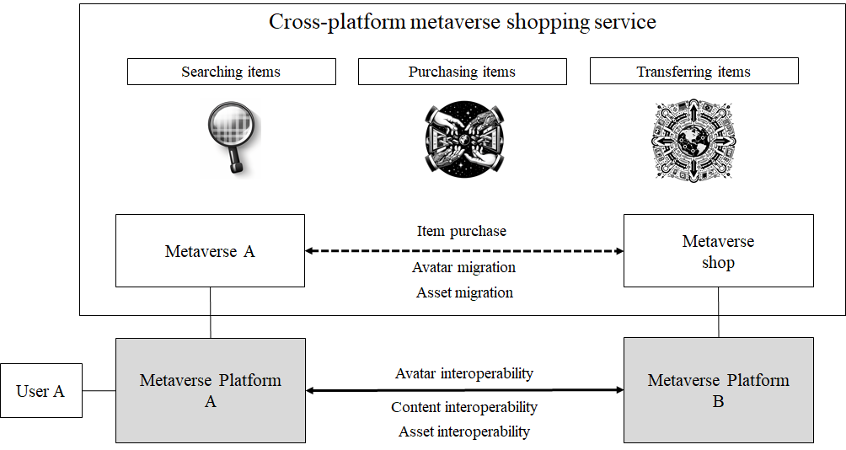

Figure 7-11 – Concept of cross-platform metaverse shopping

### 7.6.2 Assumptions

The assumptions related to this service scenario include the following:

– It is assumed that the user has an account on the metaverse shopping.

– It is assumed that the metaverse shop possesses digital items which the user wants to buy.

### 7.6.3 Service scenario

This clause describes the typical service flow for the service scenario of the cross-platform metaverse shopping service as shown in Figure 7-12.

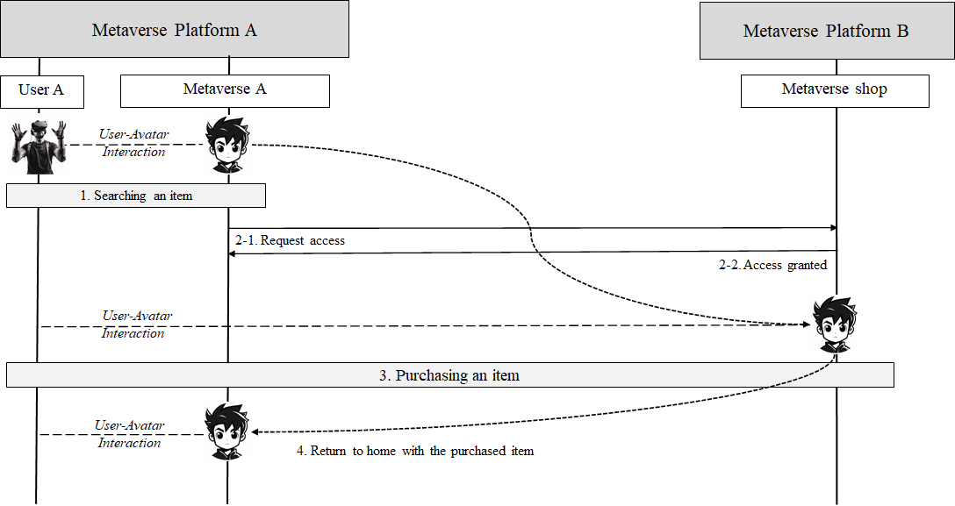

Figure 7-12 – Service flows for cross-platform metaverse shopping

User A searches for a digital item which he wants to purchase and finds it in the metaverse shop.

1 User A can seamlessly move from metaverse A on the metaverse platform A to the metaverse shop on the metaverse platform B.

2 User A purchases the digital item he searched for.

3 The cross-platform metaverse shopping service validates the transfer of the purchased item and transfers it from the metaverse shopping to the metaverse A.

4 User A returns to metaverse A.

## 7.7 Metaverse tourism: Seamless exploration across multiple platforms

The metaverse tourism service allows users (tourists) to select a customized tourism that takes them through different metaverse platforms. With seamless transitions between platforms, users can explore a variety of attractions and environments, ranging from natural landscapes to virtual concerts and cultural experiences. Additionally, the service provides an opportunity for social interaction with friends and other users, allowing for shared experiences across the metaverse.

### 7.7.1 Description

User A and user B decide to take a metaverse tourism together and select a metaverse tourism package that they both like. This metaverse tourism package includes not only the metaverse palace tourism offered by metaverse platform A, but also the metaverse city and metaverse concert tourisms offered by metaverse platform B.

While on a metaverse tourism, user A and user B discover a metaverse gift shop on metaverse platform A. To commemorate the trip, they decide to purchase a hat souvenir that they can wear on their avatars while traveling. They can attach the hat souvenir to their avatars while traveling and keep it attached to their avatars as they move between metaverse platforms.

While exploring the virtual world on metaverse platform A, user A and user B see that a metaverse concert that is part of their metaverse tourism package is being offered on metaverse platform B, so they move to metaverse platform B. The metaverse concert is offered on metaverse platform B, and user A and user B decide to attend. Their avatars move from metaverse platform A to metaverse platform B without any registration or signup.

User A and user B attend and enjoy the concert on metaverse platform B, and then User A returns to metaverse platform A to continue the metaverse palace tourism where User A left off. Figure 7-13 shows the concept of cross-platform metaverse tourism.

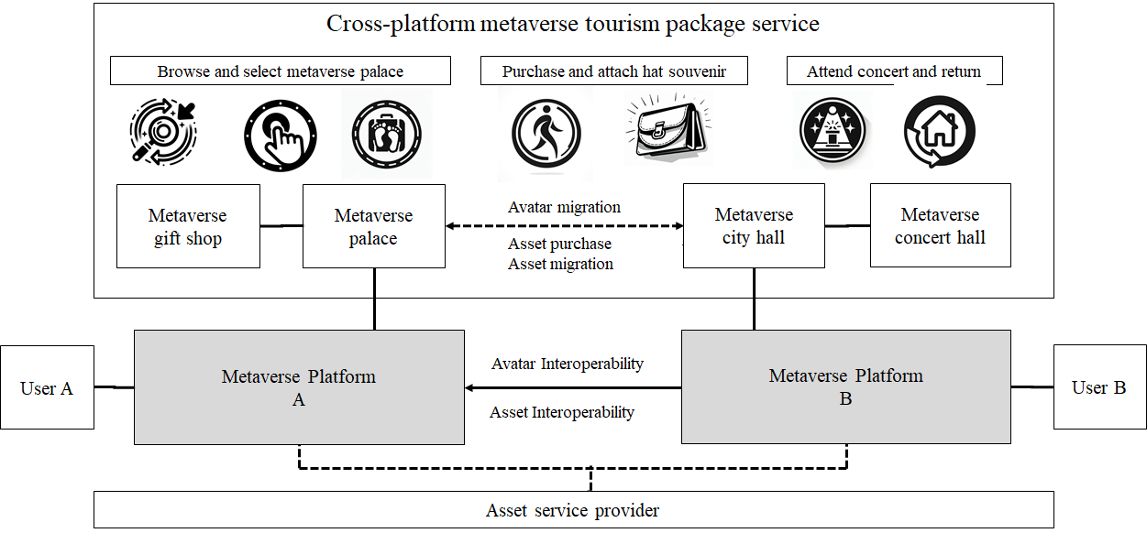

Figure 7-13 – Concept of the cross-platform metaverse tourism

### 7.7.2 Assumptions

The assumptions related to this scenario include the following:

– It is assumed that tourists have the necessary equipment and devices to access various metaverse platforms.

– It is assumed that there is an established partnership or integration between metaverse platform A and metaverse platform B to ensure seamless transitions between the two platforms.

– It is assumed that their avatars can seamlessly move from metaverse platform A to metaverse platform B without additional registration or sign-up.

– It is assumed that the platform has implemented appropriate security measures to ensure the safety and privacy of users during the tourism, including measures to prevent unauthorized access to personal information and digital assets.

### 7.7.3 Service scenario

This clause describes the typical service flow for metaverse tourism service as shown in Figure 7-14.

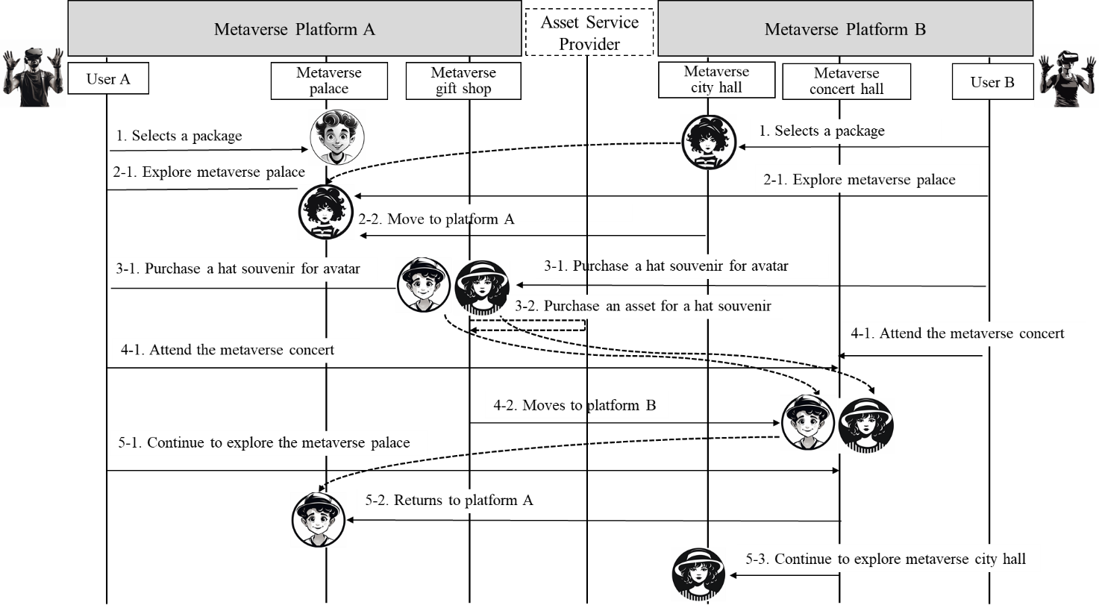

Figure 7-14 – Service flows for the metaverse tourism service scenario

1 User A and user B browse a metaverse tourism package that they both like. The selected metaverse tourism package includes tourisms offered by platform A and platform B.

2 To use the metaverse palace tourism together, user A accesses metaverse palace on metaverse platform A, user B accesses metaverse city tourism on metaverse platform B and then moves to metaverse palace tourism on metaverse platform A.

3 While on the metaverse palace on platform A, user A and user B notice a metaverse gift shop and decide to purchase a souvenir to attach to their avatars during the tourism. The two users purchase a hat as a souvenir provided by asset service provider which might be a 3rd party service provider. They can wear on their avatars as they travel from platform to platform.

4 While exploring the metaverse palace on metaverse platform A, user A and user B see that a metaverse concert that is part of their metaverse tourism package is being offered on metaverse platform B, so they move to metaverse platform B. The metaverse concert is offered on metaverse platform B, and they decide to attend. Their avatars move from metaverse platform A to metaverse platform B without any registration or signup. User A and user B enjoy the metaverse concert on metaverse platform B.

5 User A returns to metaverse platform A to continue the metaverse palace tourism and User B resumes the metaverse city tourism.

## 7.8 Metaverse Signage: Product promotion with seamless transitions cross-platforms

Digital signage [b-ITU-T H.780] refers to any type of communication that provides information or guidance to users. In the metaverse, signage can be used for various purposes, such as wayfinding, displaying information, promoting events, and branding in a virtual space:

– Wayfinding: In large virtual worlds, signage can be used to help users navigate and find their way around. This could include directional signs, maps, or landmarks that help users orient themselves within the space;

– Informational displays: Signage can also be used to display information to users in the metaverse. For example, a museum might use signage to provide information about exhibits or historical artifacts;

– Event promotion: Signage can be used to promote events or activities within the metaverse. For example, a virtual concert might use signage to advertise the time and location of the event, as well as provide information about the performers;

– Branding: Just like in the physical world, signage can be used to promote brands and products in the metaverse. This could include billboards, product displays, or even virtual storefronts.

### 7.8.1 Description

Signage of metaverse street virtual signage that displays wayfinding information between different metaverse services offered within the metaverse street. In this case, in addition to its primary purpose of providing directions in the virtual space, the metaverse signage provides a link to the metaverse product store, which provides more information about the advertised product.

The metaverse product stories a metaverse dedicated to that brand, built to promote and sell products, and can include a virtual storefront or product showcase where users can interact with products in a more immersive way. By creating a service dedicated to a specific brand on one metaverse service platform, rather than multiple different metaverse service platforms, businesses can effectively showcase their brand and products in the most effective way. User A can access the different metaverses on the platform through signage of metaverse street that provides wayfinding information within the virtual environment. Metaverse signage is accessible on Metaverse Platform A. A user is browsing the virtual space and comes across a link to a metaverse promoting a specific product. The user decides to enter the metaverse to learn more. When the user clicks the link, the user is redirected to a metaverse product store that provides a virtual store or product showcase. This metaverse is powered by Metaverse Platform B, a dedicated platform for promoting featured products. This allows avatars to move between different Metaverse platforms while maintaining their appearance, identity, and functionality. Instead of having to create a new avatar on each platform the user utilizes, users can create a single avatar that can be used in multiple virtual worlds. Using the same avatar across different platforms not only helps users maintain continuity and identity, but also reduces the time and effort required to create a new avatar for each platform. After exploring the product, the user chooses to return to the metaverse service platform A. Signage service providers, as third-party providers, may also provide the way to promote their products and services across multiple metaverse platforms. However, this is not considered in this service scenario. Figure 7-15 shows the concept of cross-platform metaverse signage.

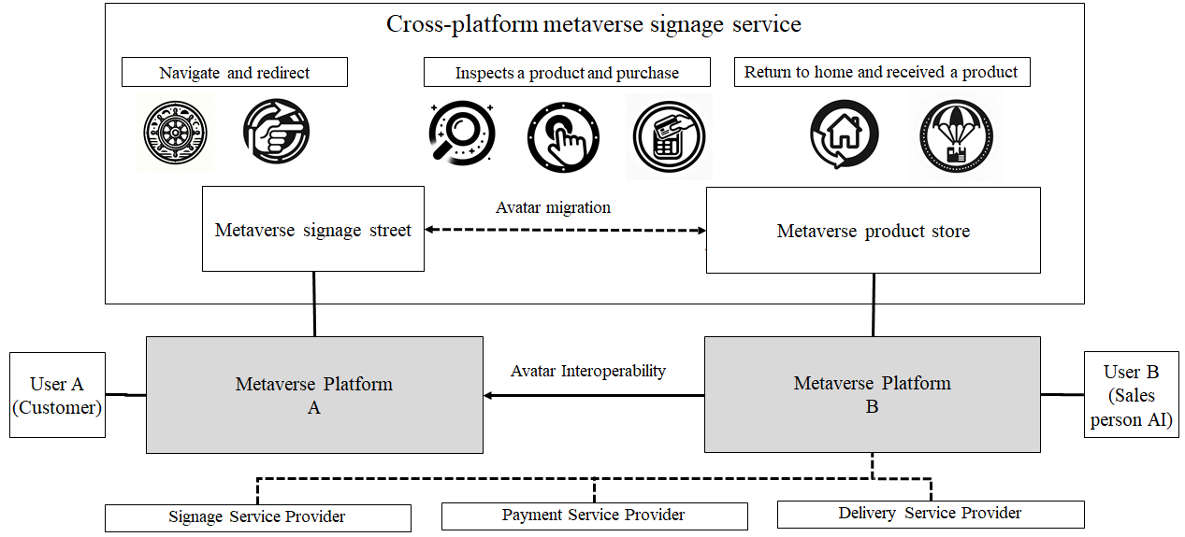

Figure 7-15– Concept of the metaverse signage service scenario

### 7.8.2 Assumptions

The assumptions related to this scenario include the following:

– It is assumed that the metaverse platform A allows users to navigate the virtual environment and interact with the signage. Signage service provider might be a 3rd party service provider.

– It is assumed that metaverse product store of the metaverse platform B is specifically designed to promote branded products through virtual stores or product showcases.

– It is assumed that the metaverse platform B allows avatars to move from metaverse service platform A while preserving their appearance, identity, and functionality.

### 7.8.3 Service scenario

This clause describes the typical service flow for metaverse signage service as shown in Figure 7-16.

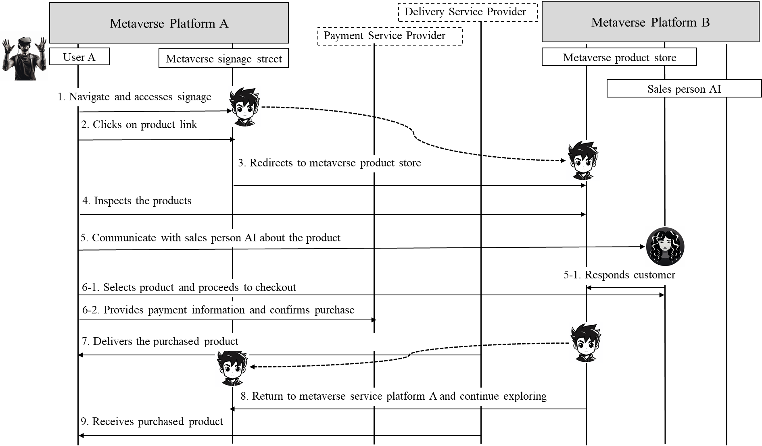

Figure 7-16 – Service flows for the metaverse signage service scenario

1 User A navigates various metaverses available in the metaverse signage street of metaverse platform A.

2 After navigating the virtual space, User A discovers a link of the metaverse signage that provides detailed information about a specific product. To learn more about this, User A decides to click on the link.

3 The link clicked by User A redirects to a metaverse product store designed for promoting a specific product. This metaverse product store is hosted on metaverse platform B and serves as a virtual store or product showcase. It offers users detailed information about the product and allows them to thoroughly examine and even purchase the product. Cross-platform interoperability makes it easy for users on metaverse platform A to utilize the product marketing metaverse built on metaverse platform B.

4 User A enters the metaverse product store of metaverse platform B. Utilizing virtual reality (VR) technology, User A can examine the product in a more immersive manner.

5 User A can also engage in additional queries and responses about the product with sales person AI.

6 User A selects the desired product, proceeds with the payment, inputs payment information, and confirms the purchase to the payment service provider, which might be a 3rd party service provider.

7 The metaverse product store sends a purchase confirmation message to the User A, finalizing the purchase and providing an estimated delivery date. The product will be shipped to the user's address.

8 User A chooses to return to the metaverse signage street of metaverse platform A. User A can continue using the virtual space of metaverse platform A.

9 User A later receives the purchased product at the metaverse product store from delivery service provider, which might be a 3rd party service provider.

## 7.9 Metaverse Co-working: Cross-platform metaverse co-working

Metaverse co-working is a virtual co-working service that allow users to collaborate and communicate remotely in a more immersive way. Users can access the virtual offices for co-working through the metaverse platform.

### 7.9.1 Description

Metaverse co-working entails leveraging metaverse technology to provide virtual co-working services, thereby offering an online work environment while maintaining the offline work environment and eliminating spatial limitations. In other words, it is beyond the typical online work environment of remote work and creates a virtual co-working environment. Users can access the metaverse co-working offices through the metaverse platform and animate their avatars to walk into a co-working office, work in a conference room, give a presentation, and so on. This makes it possible for people to co-work from anywhere, anytime, even if they are in different physical spaces, through the medium of the metaverse.

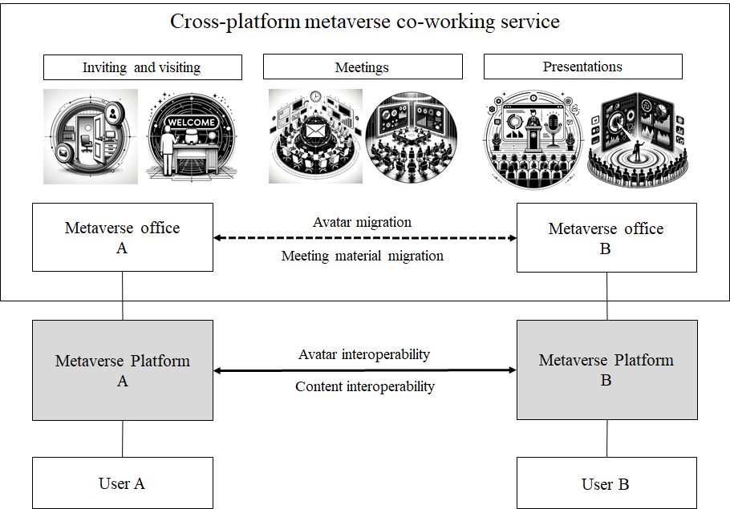

Figure 7-17 – Concept of cross-platform metaverse co-working service

Metaverse co-working service enables real-time collaboration by providing a variety of features and collaboration tools, including voice and text chat, video conferencing, file sharing, and presentation sharing. Meeting material migration provides secure ways of exchanging meeting materials such as files and presentations. Users can also communicate and interact with others through avatars, navigate different spaces, and create a personalized work environment.

An advantageous feature of metaverse co-working is its compatibility across multiple metaverse platforms, ensuring that users can collaborate and communicate with team members and clients, irrespective of the platforms they utilize. This interoperability enhances connectivity and streamlines workflows, promoting efficient and effective remote work dynamics. Figure 7-17 shows the concept of cross-platform metaverse co-working service.

### 7.9.2 Assumptions

The assumptions related to this service scenario include the following:

– It is assumed that User A and B access the metaverse office A and B on the metaverse platform A and B, respectively.

– It is assumed that there is an invite or join feature between the metaverse office A and B, User B visits to the metaverse office A and joins a meeting in the metaverse office A.

### 7.9.3 Service scenario

This clause describes the typical service flow for the scenario of the metaverse co-working service as shown in Figure 7-18.

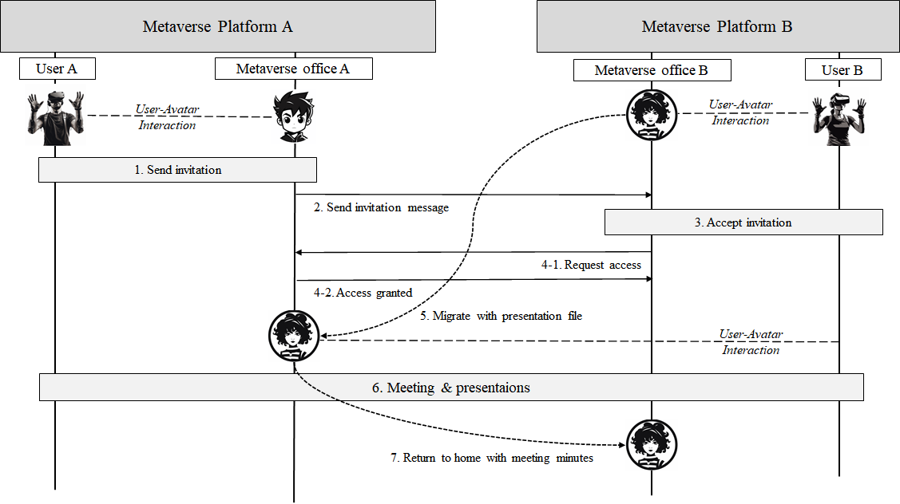

Figure 7-18 – Service flows for cross-platform metaverse co-working service

User A and B work in the metaverse offices A and B, respectively and User A wants to invite User B to the metaverse office A for a meeting.

1 User A sends User B an invitation to attend a meeting in metaverse office A and asks to give a presentation. The invitation may include the meeting schedule, location, and a link to share the presentation file.

2 User B accepts the invitation from User A, and moves to the metaverse office A on metaverse platform A. User B takes the presentation file with him.

3 Users A and B have a real-time interactive meeting in metaverse office A. They use their avatars to communicate through voice and gestures, and share their presentations on a virtual screen. User B starts to give a presentation. User A and the other participants can watch User B's presentation in real time, ask questions, and discuss it.

4 During the meeting, Users A and B can leverage the features of metaverse office to perform additional collaborative tasks. For example, they can share and edit documents simultaneously, or use a whiteboard to share and organize ideas.

5 After the meeting, User B returns to the metaverse office B with the meeting minutes file.

# 8 High-level requirements for metaverse cross-platform interoperability

The following sub-clauses describe general requirements and high-level requirements for metaverse cross-platform interoperability in the four aspects; avatar, asset, content, and identity.

## 8.1 General requirements for metaverse cross-platform interoperability

This clause lists general requirements for cross-platform interoperability as shown in Table 8-1.

Table 8-1 – General requirements for cross-platform interoperability

|  |  |
| --- | --- |
| Req.ID | Requirements |
| GENHR-001 | It is recommended that metaverse platform is interoperable with other metaverse platform. |
| GENHR-002 | It is recommended to be interoperable between metaverses on heterogeneous platforms. |
| GENHR-003 | It is recommended to ensure secure and trust environment for exchanging information between metaverse platforms. |

## 8.2 High-level requirements for avatar interoperability

Avatar interoperability realizes that an avatar of a metaverse platform can visit other metaverses in another metaverse platform by using the same or similar avatar with the original characteristics. This clause lists high-level requirements regarding avatar interoperability as shown in Table 8-2.

Table 8-2 – High-level requirements for avatar interoperability

|  |  |
| --- | --- |
| Req.ID | Requirements |
| AVIHR-001 | It is recommended to enable avatars to migrate across different metaverse platforms while retaining their original characteristics. |
| AVIHR-002 | It is required that each metaverse platform exchanges the constrains during the migration procedures for compliance and performance. |
| AVIHR-003 | It is recommended to synchronize attributes of avatar after experiencing by roaming avatar across metaverse platforms. |
| AVIHR-004 | It is recommended to ensure avatar's consistent representation across metaverse platforms. |
| AVIHR-005 | It is required to be accessible to the avatar-related data across the metaverse platforms. |

## 8.3 High-level requirements for asset interoperability

This clause lists the high-level requirements essential for achieving digital asset interoperability across multiple metaverse platforms as shown in Table 8-3.

Table 8-3 – High-level requirements for asset interoperability

|  |  |
| --- | --- |
| Req.ID | Requirements |
| ASIHR-101 | It is recommended to ensure secure and trust environment for transforming digital assets between metaverse platforms. |
| ASIHR-102 | It is recommended to facilitate the seamless exchange, recognition, and use of digital assets across different metaverse platforms. |

## 8.4 High-level requirements for content interoperability

This clause lists the high-level requirements essential for achieving content interoperability across multiple metaverse platforms as shown in Table 8-4.

Table 8-4 – High-level requirements for content interoperability

|  |  |
| --- | --- |
| Req.ID | Requirements |
| COIHR-101 | It is required that content data including information for management, searchability, and interoperability, be able to transfer between metaverse platforms. |
| COIHR-102 | It is required to ensure content portability and format compatibility on moving or sharing content across metaverse platforms. |
| COIHR-103 | It is recommended to facilitate secure sharing of user content across metaverse platforms. |

## 8.5 High-level requirements for identity interoperability

This clause lists the high-level requirements essential for achieving identity interoperability across multiple metaverse platforms as shown in Table 8-5.

Table 8-5 – High-level requirements for identity interoperability

|  |  |
| --- | --- |
| Req.ID | Requirements |
| IDIHR-101 | It is recommended to use the same identity of digital entity in the home platform when digital entity moves to other metaverse platforms. |
| IDIHR-102 | It is required to follow the policy of identity usage of visiting metaverse platform when digital entity moves to other metaverse platforms. |
| IDIHR-103 | It is recommended to support a variety of authentication methods for identity from visited metaverse platforms. |
| IDIHR-104 | It is recommended to support users to view and manage all identities of their digital entity when it moves to other metaverse platforms. |
| IDIHR-105 | It is recommended to support users to view and manage all avatars associated with their unique identities across the metaverse platforms. |

Appendix I  
  
Status of standardization activities for metaverse cross-platform interoperability

(This appendix does not form an integral part of this Technical Specification.)

This appendix summarizes the status of standardization activities of other SDOs related to metaverse cross-platform interoperability. Relevant standards in other SDOs can be utilized for stage 3 work of metaverse interoperability standards.

## I.1 ITU-T SG11

In the context of metaverse interoperability, ITU-T study group 11 (SG11) recognizes the potential roles that XDR (Extended Detection and Response) and DPI (Deep Packet Inspection) can play. XDR, as a security concept, is designed to identify and respond to cyber threats by integrating diverse security data sources and tools, enhancing our understanding of the overall security landscape.

Furthermore, DPI, a technology integral to some XDR solutions, allows for a deeper level of network analysis. DPI contributes to advanced detection and response capabilities within the XDR framework, which are fundamental for ensuring the security and integrity of the metaverse.

Additionally, SG11 acknowledges the importance of the draft Recommendation ITU-T [Q.DPI-TR](https://www.itu.int/ITU-T/workprog/wp_item.aspx?isn=18937), "Testing requirements of DPI device," which encompasses tests based on [b-ITU-T Y.2770]. The theoretical usability of these tests for Metaverse interoperability highlights a potential avenue for enhancing security measures. However, SG11 agrees that determining the suitability and implementation of these tests necessitates the availability of comprehensive Metaverse interoperability protocol specifications, which are currently lacking.

SG11 shares the opinion that detailed Metaverse interoperability protocol specifications are a critical prerequisite for effectively utilizing the tests proposed in draft Recommendation ITU-T Q.DPI-TR. Once these specifications become available, SG11 can assess their applicability and contribute to shaping effective standards for secure metaverse interoperability.

## I.2 VRM Consortium

The VRM Consortium has been focusing on avatar interoperability by developing and promoting interoperable avatar format VRM. VRM Consortium's efforts include the development of a standard specification for the interoperable avatar format [VRM 1.0](https://eur03.safelinks.protection.outlook.com/?url=https%3A%2F%2Fvrm.dev%2Fen%2Fvrm1%2Findex.html&data=05%7C01%7Ctsbfgmv%40itu.int%7C8b01a6f9538d4be8dd6708dbd6e15c78%7C23e464d704e64b87913c24bd89219fd3%7C0%7C0%7C638340035659837367%7CUnknown%7CTWFpbGZsb3d8eyJWIjoiMC4wLjAwMDAiLCJQIjoiV2luMzIiLCJBTiI6Ik1haWwiLCJXVCI6Mn0%3D%7C3000%7C%7C%7C&sdata=J69W9A25UOrJlxntjLgl6vLVMSnzz8EcaniXAwbxJkA%3D&reserved=0), as well as a reference implementation for Unity.

VRM Consortium are currently working on the development of additional extensions for VRM, including an animation file.

Additionally, VRM Consortium co-chair the [Interoperable Character/Avatar Working Group in the Metaverse Standards Forum](https://eur03.safelinks.protection.outlook.com/?url=https%3A%2F%2Fmetaverse-standards.org%2Fdomain-groups%2Fworking-group-chairs%2F&data=05%7C01%7Ctsbfgmv%40itu.int%7C8b01a6f9538d4be8dd6708dbd6e15c78%7C23e464d704e64b87913c24bd89219fd3%7C0%7C0%7C638340035659837367%7CUnknown%7CTWFpbGZsb3d8eyJWIjoiMC4wLjAwMDAiLCJQIjoiV2luMzIiLCJBTiI6Ik1haWwiLCJXVCI6Mn0%3D%7C3000%7C%7C%7C&sdata=1XF5%2F45LrPkRsE8EC3BtEuNYXqs%2BX1incIZqbdmdHTk%3D&reserved=0).

## I.3 W3C

For WG5, W3C note that most of these specifications likely fall into the content interoperability aspect.

For your information, this list was also provided as input to the Metaverse Standards Register developed by the Metaverse Standards Forum.

Published/Ongoing W3C work items related to the Metaverse

The list matches the list of specifications shared with the Metaverse Standards Forum as input to the Metaverse Standards Register. It contains a handful of proposals incubated in a W3C Community Group but that have not yet been adopted by a Working Group. These are flagged with a "Proposed" status.

| Committee | Reference | Title | Status (Target date) |
| --- | --- | --- | --- |
| W3C Immersive Web WG | WebXR  https://www.w3.org/TR/webxr/ | WebXR Device API | Ongoing |
| W3C Immersive Web WG | WebXR-AR  https://www.w3.org/TR/webxr-ar-module-1/ | WebXR Augmented Reality Module - Level 1 | Ongoing |
| W3C Immersive Web WG | WebXR Depth Sensing  https://www.w3.org/TR/webxr-depth-sensing-1/ | WebXR Depth Sensing Module | Ongoing |
| W3C Immersive Web WG | WebXR Dom Overlays  https://www.w3.org/TR/webxr-dom-overlays-1/ | WebXR DOM Overlays Module | Ongoing |
| W3C Immersive Web WG | WebXR Gamepad  https://www.w3.org/TR/webxr-gamepads-module-1/ | WebXR Gamepad Module | Ongoing |
| W3C Immersive Web WG | WebXR Hand Input  https://www.w3.org/TR/webxr-hand-input-1/ | WebXR Hand Input Module | Ongoing |
| W3C Immersive Web WG | WebXR Hit Test  https://www.w3.org/TR/webxr-hit-test-1/ | WebXR Hit Test Module | Ongoing |
| W3C Immersive Web WG | WebXR Layers  https://www.w3.org/TR/webxrlayers-1/ | WebXR Layers API Level 1 | Ongoing |
| W3C Immersive Web WG | WebXR Lightning Estimation  https://www.w3.org/TR/webxr-lighting-estimation-1/ | WebXR Lightning Estimation API Level 1 | Ongoing |
| W3C Immersive Web WG | WebXR Anchors  https://immersive-web.github.io/anchors/ | WebXR Anchors Module | Ongoing |
| W3C Immersive Web CG | WebXR Raw Camera Access  https://immersive-web.github.io/raw-camera-access/ | WebXR Raw Camera Access Module | Proposed |
| W3C Immersive Web CG | The <model> Element  https://immersive-web.github.io/model-element/ | The <model> Element | Proposed |
| W3C GPU for the Web WG | WebGPU  https://www.w3.org/TR/webgpu/ | WebGPU | Ongoing |
| W3C GPU for the Web WG | WGSL  https://www.w3.org/TR/WGSL/ | WebGPU Shading Language | Ongoing |
| W3C Audio WG | Web Audio  https://www.w3.org/TR/webaudio/ | Web Audio API | Published (06/2021) |
| W3C Web Real-Time Communications WG | WebRTC  https://www.w3.org/TR/webrtc/ | WebRTC: Real-Time Communication in Browsers | Published (03/2023) |
| W3C Web Real-Time Communications WG | Audio Output Devices  https://www.w3.org/TR/audio-output/ | Audio Output Devices API | Ongoing |
| W3C Web Real-Time Communications WG | Media Capture and Streams  https://www.w3.org/TR/mediacapture-streams/ | Media Capture and Streams | Ongoing |
| W3C Web Real-Time Communications WG | WebRTC Stats  https://www.w3.org/TR/webrtc-stats/ | Identifiers for WebRTC's Statistics API | Ongoing |
| W3C Web Real-Time Communications WG | MediaStreamTrack Content Hints  https://www.w3.org/TR/mst-content-hint/ | MediaStreamTrack Content Hints | Ongoing |
| W3C Accessible Platform Architectures WG | XAUR  https://www.w3.org/TR/xaur/ | XR Accessibility User Requirements | Published (08/2021) |
| W3C Accessible Platform Architectures WG | SAUR  https://www.w3.org/TR/saur/ | Synchronization Accessibility User Requirements | Published (06/2023) |
| W3C Accessible Platform Architectures WG | NAUR  https://www.w3.org/TR/naur/ | Natural Language Interface Accessibility User Requirements | Ongoing |
| W3C Accessible Platform Architectures WG | RAUR  https://www.w3.org/TR/raur/ | RTC Accessibility User Requirements | Published (05/2021) |
| W3C Accessible Platform Architectures WG | Accessibility of Remote Meetings  https://www.w3.org/TR/remote-meetings/ | Accessibility of Remote Meetings | Published (07/2022) |
| W3C Accessible Platform Architectures WG | CTAUR  https://www.w3.org/TR/ctaur/ | Collaboration Tools Accessibility User Requirements | Ongoing |
| W3C Accessible Platform Architectures WG | Making Content Usable for People with Cognitive and Learning Disabilities  https://www.w3.org/TR/coga-usable/ | Making Content Usable for People with Cognitive and Learning Disabilities | Published (04/2021) |
| W3C Accessible Platform Architectures WG | MAUR  https://www.w3.org/TR/media-accessibility-reqs/ | Media Accessibility User Requirements | Published (12/2015) |
| W3C Accessible Platform Architectures WG | WAI-Adapt Symbols  https://www.w3.org/TR/adapt-symbols/ | WAI-Adapt: Symbols Module | Ongoing |
| W3C Accessible Rich Internet Applications WG | Core AAM  https://www.w3.org/TR/core-aam-1.2/ | Core Accessibility API Mappings 1.2 | Ongoing |
| W3C Accessible Rich Internet Applications WG | Graphics AAM  https://www.w3.org/TR/graphics-aam-1.0/ | Graphics Accessibility API Mappings | Published (10/2018) |
| W3C Accessible Rich Internet Applications WG | WAI-ARIA 1.1  https://www.w3.org/TR/wai-aria-1.1/ | WAI-ARIA Rich Internet Applications 1.1 | Published (12/2017) |
| W3C Accessible Rich Internet Applications WG | WAI-ARIA Graphics  https://www.w3.org/TR/graphics-aria-1.0/ | WAI-ARIA Graphics Module | Published (10/2018) |
| W3C Web Fonts WG | WOFF 2.0  https://www.w3.org/TR/WOFF2/ | WOFF File Format 2.0 | Published (03/2022) |
| W3C Web Fonts WG | IFT  https://www.w3.org/TR/IFT/ | Incremental Font Transfer | Ongoing |
| W3C Browser Testing and Tools WG | WebDriver  https://www.w3.org/TR/webdriver/ | WebDriver | Ongoing |
| W3C Pointer Events WG | Pointer Events  https://www.w3.org/TR/pointerevents/ | Pointer Events | Ongoing |
| W3C Web of Things WG | WoT Thing Description  https://www.w3.org/TR/wot-thing-description/ | Web of Things (WoT) Thing Description 1.1 | Published (07/2023) |
| W3C Web of Things WG | WoT Architecture  https://www.w3.org/TR/wot-architecture/ | Web of Things (WoT) Architecture 1.1 | Published (07/2023) |
| W3C Web of Things WG | WoT Discovery  https://www.w3.org/TR/wot-discovery/ | Web of Things (WoT) Discovery | Published (07/2023) |
| W3C Web Authentication WG | WebAuthn  https://www.w3.org/TR/webauthn/ | Web Authentication: An API for accessing Public Key Credentials | Published (04/2021) |
| W3C Web Payments WG | Payment Request  https://www.w3.org/TR/payment-request/ | Payment Request API | Published (09/2022) |
| W3C Web Payments WG | Payment Handler  https://www.w3.org/TR/payment-handler/ | Payment Handler API | Ongoing |
| W3C Web Platform Incubator CG | Web Speech  https://wicg.github.io/speech-api/ | Web Speech API | Proposed |

**• WebXR** describes support for accessing virtual reality (VR) and augmented reality (AR) devices, including sensors and head-mounted displays, on the Web.

**• WebXR-AR** expands the WebXR Device API with the functionality available on AR hardware.

**• WebXR Depth Sensing** is a module extending the capabilities of WebXR Device API. It enables apps to obtain depth information computed by supported XR devices in order to provide more immersive experiences. The example use cases of depth sensing API include (but are not limited to) simulating physical interactions of virtual objects with the real world, occlusion, and non-visual applications that can make use of increased awareness of users' environment.

**• WebXR DOM Overlays** expands the WebXR Device API with a mechanism for showing interactive 2D web content during an immersive WebXR session. When the feature is enabled, the user agent will display the content of a single DOM element as a transparent-background 2D rectangle.

**• WebXR Gamepad** describes support for accessing button, trigger, thumbstick, and touchpad data associated with virtual reality (VR) and augmented reality (AR) devices on the Web.

**• WebXR Hand Input** expands the WebXR Device API with the functionality to track articulated hand poses.

**• WebXR Hit Test** describes a method for performing hit tests against real world geometry to be used with the WebXR Device API.

**• WebXR Layers** describes support for various layer types used in a WebXR session.

**• WebXR Lightning Estimation** describes support for exposing estimates of environmental lighting conditions to WebXR sessions.

**• WebXR Anchors** describes a method to create anchors tracked by the underlying system.

**• WebXR Raw Camera Access** provides a means to access the raw camera image displayed behind an immersive AR session, when the device is responsible for rendering that camera image.

**• The <model> Element** allows embedding 3D graphical content into an HTML document. The HTMLModelElement interface then provides a means to interface with the embedded resource.

**• WebGPU** exposes an API for performing operations, such as rendering and computation, on a Graphics Processing Unit.

**• WGSL** defines the Shading language for WebGPU.

**• Web Audio** describes a high-level Web API for processing and synthesizing audio in web applications. The primary paradigm is of an audio routing graph, where a number of AudioNode objects are connected together to define the overall audio rendering. The actual processing will primarily take place in the underlying implementation (typically optimized Assembly / C / C++ code), but direct script processing and synthesis is also supported.

**• WebRTC** defines a set of ECMAScript APIs in WebIDL to allow media and generic application data to be sent to and received from another browser or device implementing the appropriate set of real-time protocols.

**• Audio Output Devices** defines a set of JavaScript APIs that let a Web application manage how audio is rendered on the user audio output devices.

**• Media Capture and Streams** defines a set of JavaScript APIs that allow local media, including audio and video, to be requested from a platform.

**• WebRTC Stats** defines a set of WebIDL objects that allow access to the statistical information about a RTCPeerConnection. These objects are returned from the getStats API of WEBRTC.

**• MediaStreamTrack Content Hints** extends MediaStreamTrack to provide an optional hint about the user's preference on how the media should be treated when insufficient resources for perfect reproduction are available.

**• XAUR** lists user needs and requirements for people with disabilities when using virtual reality or immersive environments, augmented or mixed reality and other related technologies (XR).

**• SAUR** summarizes relevant research, then outlines accessibility-related user needs and associated requirements for the synchronization of audio and visual media. The scope of the discussion includes synchronization of accessibility-related components of multimedia, such as captions, sign language interpretation, and descriptions. The requirements identified herein are also applicable to multimedia content in general, as well as real-time communication applications and media occurring in immersive environments.

**• NAUR** outlines accessibility-related user needs, requirements and scenarios for natural language interfaces.

**• RAUR** outlines various accessibility related user needs, requirements and scenarios for real-time communication (RTC).

**• Accessibility of Remote Meetings** summarizes considerations of accessibility that arise in the conduct of remote and hybrid meetings. Such meetings are mediated, for some or all participants, by real-time communication software typically built upon Web technologies.

**• CTAUR** outlines various accessibility-related user needs, requirements and scenarios for collaboration tools. The tools of interest are distinguished by their support for one or more specific collaborative features. These features include real-time editing of content by multiple authors, the use of comments or annotations, and revision control.

**• Making Content Usable for People with Cognitive and Learning Disabilities** is for people who make web content (web pages) and web applications. It gives advice on how to make content usable for people with cognitive and learning disabilities. This includes, but is not limited to: cognitive disabilities, learning disabilities (LD), neurodiversity, intellectual disabilities, and specific learning disabilities.

**• MAUR** presents the accessibility requirements users with disabilities have with respect to audio and video on the web.

**• WAI-Adapt Symbols** provides web content authors a standard approach to support web users with various cognitive and learning disabilities who: customarily communicate using symbolic languages generally known as Augmentative and Alternative Communications (AAC); need more familiar icons (and other graphical symbols) in order to comprehend page content.

**• Core AAM** describes how user agents should expose semantics of web content languages to accessibility APIs. This helps users with disabilities to obtain and interact with information using assistive technologies. This specification defines support that applies across multiple content technologies, including general keyboard navigation support and mapping of general-purpose roles, states, and properties provided in Web content via WAI-ARIA.

**• Graphics AAM** defines how user agents map the WAI-ARIA Graphics Module markup to platform accessibility APIs. It is intended for user agent developers responsible for accessibility in their user agent so that they can support the accessibility of graphics.

**• WAI-ARIA 1.1** provides an ontology of roles, states, and properties that define accessible user interface elements and can be used to improve the accessibility and interoperability of web content and applications. These semantics are designed to allow an author to properly convey user interface behaviours and structural information to assistive technologies in document-level markup.

**• WAI-ARIA Graphics** defines a WAI-ARIA 1.1 module of core roles specific to web graphics.

**• WOFF 2.0** specifies the WOFF font packaging format. This format was designed to provide lightweight, easy-to-implement compression of font data, suitable for use with CSS @font-face rules. Any properly licensed TrueType/OpenType/Open Font Format file can be packaged in WOFF format for Web use. WOFF 2.0 provides improved compression and thus lower use of network bandwidth, while still allowing fast decompression even on mobile devices.

**• IFT** defines two methods to incrementally transfer fonts from server to client. Incremental transfer allows clients to load only the portions of the font they actually need which speeds up font loads and reduces data transfer needed to load the fonts. A font can be loaded over multiple requests where each request incrementally adds additional data.

**• WebDriver** is a remote control interface that enables introspection and control of user agents. It provides a platform- and language-neutral wire protocol as a way for out-of-process programs to remotely instruct the behaviour of web browsers.

**• Pointer Events** describes events and related interfaces for handling hardware agnostic pointer input from devices including a mouse, pen, touchscreen, etc. For compatibility with existing mouse based content, this specification also describes a mapping to fire Mouse Events for other pointer device types.

**• WoT Thing Description** describes a formal information model and a common representation for a Web of Things (WoT) Thing Description. A Thing Description describes the metadata and interfaces of Things, where a Thing is an abstraction of a physical or virtual entity that provides interactions to and participates in the Web of Things.

**• WoT Architecture** describes the abstract architecture for the W3C Web of Things.

**• WoT Discovery** describes a process to obtain the Thing Description of a Thing that can run in a variety of use cases. This includes ad-hoc and engineered systems; during development and at runtime; and on both local and global networks. The process also works with existing discovery mechanisms, be secure, protect private information, and efficiently handles updates to WoT Thing Descriptions and the dynamic and diverse nature of the IoT ecosystem.

**• WebAuthn** defines an API enabling the creation and use of strong, attested, scoped, public key-based credentials by web applications, for the purpose of strongly authenticating users. This specification also describes the functional model for WebAuthn conformant authenticators, including their signature and attestation functionality.

**• Payment Request** standardizes an API to allow merchants (i.e., web sites selling physical or digital goods) to utilize one or more payment methods with minimal integration. User agents (e.g., browsers) facilitate the payment flow between merchant and user.

**• Payment Handler** defines capabilities that enable Web applications to handle requests for payment.

**• Web Speech** defines a JavaScript API to enable web developers to incorporate speech recognition and synthesis into their web pages. It enables developers to use scripting to generate text-to-speech output and to use speech recognition as an input for forms, continuous dictation and control. The JavaScript API allows web pages to control activation and timing and to handle results and alternatives.

## I.4 3GPP

The 3rd Generation Partnership Project (3GPP), Working Group 4 of Service and Application (SA4) provided their work related to metaverse interoperability. For WG5, 3GPP SA4 note that most of these specifications likely fall into the content interoperability aspect.

TS 26.118 Virtual Reality (VR) profiles for streaming applications

The present document provides technologies for interoperable Virtual Reality services with focus on streaming and consumption. Virtual Reality (VR) is the ability to be virtually present in a space created by the rendering of natural and/or synthetic image and sound correlated by the movements of the immersed user allowing interacting with that world. Suitable media formats for providing immersive experiences are specified to enable Virtual Reality Services in the context of 3GPP bearer and user services.

TS 26.511 5G Media Streaming (5GMS); Profiles, codecs and formats

5GMS is a 3GPP media service built on top of the 5G system. It contains a collection of service-oriented profiles defining media capabilities and interoperability points. One of them is the streaming VR 360 contents.

TR 26.918 Virtual Reality (VR) media services over 3GPP

This Technical report is a comprehensive analysis of 360 virtual reality, from concepts of presence, quality impacts by form factors, candidate media formats. It also includes a large collection of use cases covering both streaming and conversational scenarios, relevant for metaverse experiences.

TR 26.928 Extended Reality (XR) in 5G

This Technical Report collects information on eXtended Reality (XR) in the context of 5G radio and network services. Extended reality (XR) refers to all real-and-virtual combined environments and associated human-machine interactions generated by computer technology and wearables. It includes representative forms such as augmented reality (AR), mixed reality (MR), and virtual reality (VR) and the areas interpolated among them. In this Technical Report, baseline technologies for XR type of services and applications are introduced outlining the QoE/QoS issues of XR-based services, the delivery of XR in the 5G system, and an architectural model of 5G media streaming defined in TS 26.501. In addition to the conventional service category, interactive, streaming, download, and split compute/rendering are identified as new delivery categories. A survey of 3D, XR visual and audio formats is also provided.

Use cases and device types are classified, and processing and media centric architectures are introduced. This includes viewport independent and dependent streaming, as well as different distributed computing architectures for XR. Core use cases of XR include those unique to AR and MR in addition to those of VR discussed in 3GPP TR 26.918, ranging from offline sharing of 3D objects, real-time sharing, multimedia streaming, online gaming, mission critical applications, and multi-party call/conferences. Based on the details in the report, proposals for potential standardization areas are documented.

TR 26.930 Study on the enhancement for Immersive Real-Time communication for WebRTC

This technical report is the outcome of the study for enhancement of 5G-RTC architecture and the WebRTC-based common signalling protocol for establishment of media session/data path of immersive Real-Time Communication service. The signalling protocol supports interoperability between operators and service providers.

## I.5 Metaverse Standards Forum

The Metaverse Standards Forum (MSF), maintains the Metaverse Standards Register for metaverse related standards here: <https://register.metaverse-standards.org>. The Metaverse Standards Register is a publicly accessible database of organizations, specifications, policies, recommendations, guidelines and open-source software related to metaverse interoperability. In this moment, there are no standards or specifications on metaverse cross-platform interoperability in the Metaverse Standards Register.

Bibliography

[b-ITU-T H.780] Recommendation ITU-T H.780 (2012), Digital signage: Service requirements and IPTV-based architecture.

[b-ITU FGMV-20] Technical Specification ITU FGMV-20 (2023), Definition of metaverse. Available at: <https://www.itu.int/en/ITU-T/focusgroups/mv/Pages/deliverables.aspx>

[b- ITU-T Y.2770] Recommendation ITU-T Y.2770 (2012, *Requirements for deep packet inspection in next generation networks*.

__________________