|  |  |  |
| --- | --- | --- |
|  | | Standardization Sector |
| **ITU Focus Group Technical Report** | |
| **(10/2023)** | |
|  | ITU Focus Group on metaverse | |
|  | **Power metaverse: Use cases relevant to grid side and user side**  *Working Group 2: Applications & Services* | |

|  |  |
| --- | --- |
| **ITUPublications** | **International Telecommunication Union** |

Technical Report ITU FGMV-09

Power metaverse: Use cases relevant to grid side and user side

Summary

This Technical Report provides steps for the realization of a power metaverse applied in the power system from the perspectives of the user and the grid, for relevant use cases. Each use case describes the application scenario, assumptions made and a service scenario.

Keywords

Metaverse, power metaverse, use cases.

Note

This is an informative ITU-T publication. Mandatory provisions, such as those found in ITU-T Recommendations, are outside the scope of this publication. This publication should only be referenced bibliographically in ITU-T Recommendations.

Change Log

This document contains Version 1.0 of the ITU Technical Report on *"Power metaverse: Use cases relevant to grid side and user side"* approved at the third meeting of the ITU Focus Group on metaverse (ITU FG-MV), held on 3-5 October 2023 in Geneva, Switzerland.

Acknowledgements

This Technical Report was researched and written by Jie Song (State Grid Corporation of China, China), Xingang Yang (State Grid Corporation of China, China), Weiqiang Yao (State Grid Corporation of China, China), Aiqiang Pan (State Grid Corporation of China , China), Yi Wu (State Grid Corporation of China, China), Mengyuan Zhang (State Grid Corporation of China, China), Xing He (Shanghai Jiao Tong University China), Yuntao Wang (China Academy of Information and Communications Technology (CAICT), China), Tangyun Xu (State Grid Corporation of China , China), Qingsong Zhang (Chongqing University of Posts and Telecommunications, China), Shuyan Ma (Shanghai Jiao Tong University China), Qin Qin (State Grid Corporation of China, China), Guofeng Wang (Shanghai EBang Information Technology Co., Ltd, China), Juntao Liu (NARI, China), Juan Yan (Chongqing University of Posts and Telecommunications, China), Haiyang Chen (Chongqing University of Posts and Telecommunications, China), Haiyang Chen (Chongqing University of Posts and Telecommunications, China), Yingjie Tian (State Grid Corporation of China, China), Qibin Zhou (Shanghai University, China), Xiaoyan Bian (Shanghai University of Electric Power, China), Si Huang (Shanghai University, China), Hong Guan (State Grid Corporation of China, China), Yan Yang (Chongqing University of Posts and Telecommunications, China) and Fujin Zhong (Chongqing University of Posts and Telecommunications, China) as a contribution to the ITU Focus Group on metaverse (ITU FG-MV).

Additional information and materials relating to this report can be found at: <https://www.itu.int/go/fgmv>. If you would like to provide any additional information, please contact Cristina Bueti at [tsbfgmv@itu.int](mailto:tsbfgmv@itu.int).

|  |  |  |
| --- | --- | --- |
| **Editor:** | Jie Song State Grid Corporation of China  China | Tel: +86 13671802496  E-mail: songjie_456@163.com |
| **Editor:** | Xingang Yang State Grid Corporation of China China | Tel: +86 13482535125  E-mail: xingangyang@163.com |
| **Editor:** | Weiqiang Yao State Grid Corporation of China China | Tel: +86 13916023540  E-mail: [yaoweiqiang@sh.sgcc.com.cn](mailto:yaoweiqiang@sh.sgcc.com.cn) |
| **Editor:** | Aiqiang Pan State Grid Corporation of China China | Tel: +86 13636396426  E-mail: [dsy_panaq@126.com](mailto:dsy_panaq@126.com) |
| **Editor:** | Yi Wu State Grid Corporation of China China | Tel: +86 15622183677  E-mail: [wu.yi.christian@gmail.com](mailto:wu.yi.christian@gmail.com) |
| **Editor:** | Mengyuan Zhang State Grid Corporation of China China | Tel: +86 15000980771  E-mail: [z_mengyuan@163.com](mailto:z_mengyuan@163.com) |
| **Editor:** | Xing He Shanghai Jiao Tong University China | Tel: +86 18801966321  E-mail: [hexing_hx@126.com](mailto:hexing_hx@126.com) |
| **Editor:** | Yuntao Wang China Academy of Information and Communications Technology (CAICT)  China | Tel: +86 18611547086  E-mail: [wangyuntao@caict.ac.cn](mailto:wangyuntao@caict.ac.cn) |
| **Editor:** | Tangyun Xu State Grid Corporation of China China | Tel: +86 17321295031  E-mail: [xty_921@163.com](mailto:xty_921@163.com) |
| **Editor:** | Qingsong Zhang Chongqing University of Posts and Telecommunications China | Tel: +86 19823812770  E-mail: [songqz159@gmail.com](mailto:songqz159@gmail.com) |
| **Editor:** | Shuyan Ma Shanghai Jiao Tong University  China | Tel: +86 15844279865  E-mail: [mashuyan0809@163.com](mailto:mashuyan0809@163.com) |
| **Editor:** | Qin Qin State Grid Corporation of China China | Tel: +86 15000980016  E-mail: [Apologizeqin7@gmail.com](mailto:Apologizeqin7@gmail.com) |
| **Editor:** | Guofeng Wang Shanghai EBang Information Technology Co., Ltd China | Tel: +86 13661886854  E-mail: [www.link@163.com](http://www.link@163.com) |
| **Editor:** | Juntao Liu NARI China | Tel: +86 15300412769  E-mail: [7180182@qq.com](mailto:7180182@qq.com) |
| **Editor:** | Juan Yan Chongqing University of Posts and Telecommunications China | Tel: +86 15310330245  E-mail: [yimu3an@gmail.com](mailto:yimu3an@gmail.com) |
| **Editor:** | Haiyang Chen Chongqing University of Posts and Telecommunications China | Tel: +86 13666716299  E-mail: [chenhaiyang2022@163.com](mailto:chenhaiyang2022@163.com) |
| **Editor:** | Yingjie Tian State Grid Corporation of China  China | Tel: +86 13901712348  E-mail: [13901712348@163.com](mailto:13901712348@163.com) |
| **Editor:** | Qibin Zhou Shanghai University China | Tel: +86 13817790981  E-mail: [zhouqibin@shu.edu.cn](mailto:zhouqibin@shu.edu.cn) |
| **Editor:** | Xiaoyan Bian Shanghai University of Electric Power China | Tel: +86 13371896732  E-mail: [bianxy@shiep.edu.cn](mailto:bianxy@shiep.edu.cn) |
| **Editor:** | Si Huang Shanghai University China | Tel: +86 17755452321  E-mail: [secrystal_hs@163.com](mailto:secrystal_hs@163.com) |
| **Editor:** | Hong Guan State Grid Corporation of China  China | E-mail: [guanhong@sh.sgcc.com.cn](mailto:guanhong@sh.sgcc.com.cn) |
| **Editor:** | Yan Yang Chongqing University of Posts and Telecommunications China | Tel: +86 15909392133  E-mail: [yanyang@cqupt.edu.cn](mailto:yanyang@cqupt.edu.cn) |
| **Editor:** | Fujin Zhong Chongqing University of Posts and Telecommunications China | Tel: +86 17723557276  E-mail: [zhongfj@cqupt.edu.cn](mailto:zhongfj@cqupt.edu.cn) |

ã ITU 2024

Some rights reserved.This publication is available under the Creative Commons Attribution-Non Commercial-Share Alike 3.0 IGO licence (CC BY-NC-SA 3.0 IGO; [https://creativecommons.org/licenses/by-nc-sa/3.0/igo](https://eur03.safelinks.protection.outlook.com/?url=https%3A%2F%2Fcreativecommons.org%2Flicenses%2Fby-nc-sa%2F3.0%2Figo&data=05%7C02%7Canibal.cabrera%40itu.int%7C0fe5406e5055456a0b5a08dc7bce06f3%7C23e464d704e64b87913c24bd89219fd3%7C0%7C0%7C638521372007831165%7CUnknown%7CTWFpbGZsb3d8eyJWIjoiMC4wLjAwMDAiLCJQIjoiV2luMzIiLCJBTiI6Ik1haWwiLCJXVCI6Mn0%3D%7C0%7C%7C%7C&sdata=V4LM72V7Z%2F80irqs1MTJY8U1C%2FFVgqCq26On8J9MZuo%3D&reserved=0)).

For any uses of this publication that are not included in this licence, please seek permission from ITU by contacting [TSBmail@itu.int](mailto:TSBmail@itu.int).

**Table of contents**

Page

1 Scope 1

2 References 1

3 Definitions 1

3.1 Terms defined elsewhere 1

3.2 Terms defined in this Technical Report 1

4 Abbreviations and acronyms 1

5 Conventions 2

6 Background 2

7 Steps for the realization of a power metaverse plus use cases 3

7.1 Steps for realization of power metaverse 3

7.2 Air conditioning 4

7.3 Electric vehicles 8

7.4 Combined heat and power 11

7.5 Energy storage 15

7.6 Multi-energy complementarity 17

7.7 Resilient power grid 20

7.8 DGA inspection 23

Bibliography 26

Technical Report ITU FGMV-09

Power metaverse: Use cases relevant to grid side and user side

# 1 Scope

This Technical Report provides steps for the realization of a power metaverse, along with relevant use cases. The scope of the document is:

– steps for the realization of a power metaverse;

– user-side cases of the power metaverse to balance the supply and demand of the grid by promoting the participation of adjustable and controllable resources on the user side;

– grid-side cases of the power metaverse to enhance the automation and intelligence of core businesses in the distribution network.

# 2 References

None.

# 3 Definitions

## 3.1 Terms defined elsewhere

This Technical Report uses the following terms defined elsewhere:

**3.1.1 artificial intelligence** (AI) [b-ITU-T M.3080]: Computerized system that uses cognition to understand information and solve problems.

**3.1.2 digital twin** [b-ITU-T Y.4600]: A digital representation of an object of interest.

**3.1.3 Internet of things** [b-ITU-T Y.4000]: A global infrastructure for the information society, enabling advanced services by interconnecting (physical and virtual) things based on existing and evolving interoperable information and communication technologies.

**3.1.4 sensor** [b-ITU-T Y.4105]: An electronic device that senses a physical condition or chemical compound and delivers an electronic signal proportional to the observed characteristic.

## 3.2 Terms defined in this Technical Report

None.

# 4 Abbreviations and acronyms

This Technical Report uses the following abbreviations and acronyms:

AI Artificial Intelligence

AR Augmented Reality

CCHP Combined Cooling Heating and Power

CHP Combined Heat and Power

DE Digital Entity

DGA Dissolved Gas Analysis

DNN Deep Neural Networks

DT Digital Twin

EV Electric Vehicle

GAN Generative Adversarial Network

ICT Information and Communication Technology

ID Identifier

IoT Internet of Things

LSTM Long Short-Term Memory

MR Mixed Reality

PCA Principal Component Analysis

PE Physical Entity

PM Power Metaverse

RCNN Regional Convolutional Neural Network

RMT Random Matrix Theory

UEIoT Ubiquitous Electric Internet of Things

V2G Vehicle-to-Grid

VE Virtual Entity

VR Virtual Reality

WCAG Web Content Accessibility Guidelines

YOLO You Only Look Once

# 5 Conventions

None.

# 6 Background

With the rapid development of the Internet of Things (IoT), big data, artificial intelligence (AI) and other modern ICT, the construction and operational cost of infrastructure for data collection, transmission, storage and application is decreasing rapidly. It is feasible to use the metaverse to facilitate a digital transformation of the power industry. The power metaverse (PM), which is a specific representation of the metaverse in the power industry, has been employed in various core power grid businesses, such as operational planning, equipment maintenance and personnel training. It is capable of establishing digital models dual-driven by mechanism and knowledge to make an in-depth and fine-grained analysis of and use cases the behaviour and states of physical entities (PEs) in the context of various time and/or space scales, so as to facilitate real-time simulation and deduction for the power system.

In the power industry, a digital twin (DT) is employed to construct a 1-to-1 mapping from the physical world to a virtual space, which objectively reflects the operational status of equipment, systems or any combination of relevant objects. A power metaverse is a higher-order form of a digital twin (DT) in the power industry. It can be employed to establish a 1-to-N mapping considering time factor to predict and deduce the status of objects based on artificial intelligence. The major difference between them can be described as follows: given any PE, DT creates a corresponding Virtual Entity (VE) to simulate the PE, where a 1-to-1 mapping is established to reproduce behaviour and states of PE in a DT space. More specifically, it cannot only perform simulations for monitoring but can also conduct deductions for prediction; and each prediction result is the end of a possible evolutionary path.

# 7 Steps for the realization of a power metaverse plus use cases

## 7.1 Steps for the realization of a power metaverse

The realization of a PM consists mainly of four steps: DT modelling construction, batch generation of multi-scenario samples, intelligent decision-making and closed-loop feedback, respectively. Each step is described below in detail.

1) **DT modelling construction**: Employ a unified DT modelling function to create virtual entities (Ves) for physical entities (PEs), where a VE is an abstract model that realistically represents the main features of the corresponding PE as listed below.

a) Typicality: A VE can reflect basic characteristics of the corresponding PE, including attributes and functions.

b) Generality: A VE can simulate the corresponding PE in the context of various time and space scales.

c) Nesting: VEs can be organized as a whole, to simulate a more complicated PE.

d) Interactivity: VEs can reproduce the interaction between the corresponding PEs.

e) Synchronicity: A VE can simulate the variation of states and behaviours of the corresponding PE in real time.

f) Predictability: A VE can deduce a variation of statuses and behaviours of the corresponding PE.

g) Autonomy: A VE can perform decision-making proactively to support deductions.

h) Self-optimization: A VE can improve intelligent decision-making based on historical experience.

2) **Batch generation of multi-scenario samples**: Once a VE is constructed, additional methods are taken to simulate and deduce dynamic processes of a corresponding PE in various time scales, hierarchical levels and evolutionary paths. The crucial point here is to generate data in batches for all possible scenarios, in order to provide adequate samples for decision-making when considering a large number of factors relevant to the internal status and external environment.

3) **Intelligent decision-making**: Decision-making in a digital world is typically a high-dimensional problem, which cannot be solved by simplified mechanism modelling. Given the massive data samples generated in the previous step, it is feasible to output decision-making strategies using RMT and AI technologies. Besides, during the training process, human intervention is also essential to introduce domain knowledge and cognitive experience, in order to promote continuous iteration of decision-making strategies.

4) **Closed-loop feedback**: The outputs of decision-making strategies are translated into instructions that can be executed in the physical world. During the execution of instructions, the variation occurring in the physical world is captured by sensors and delivered to the digital world for updating digital models, data samples and decision-making strategies, leading to a continuously repeated closed-loop process.

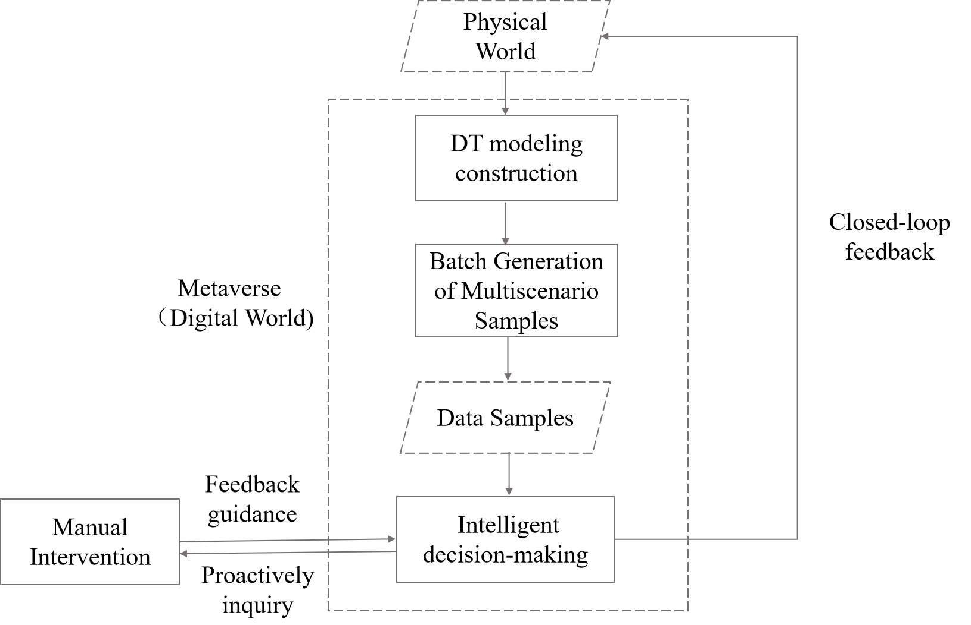

Figure 1 – Steps for the realization of PM

Figure 1 shows the steps for the realization of a PM. In what follows, several use cases are given to facilitate a better understanding of PM application in the power system from the user's and grid's perspectives. All these use cases are technically based on the steps for realization. In each use case, an elaborate demonstration of the application scenario is given at the very beginning, followed by the description, assumptions, service scenario and high-level service requirements.

## 7.2 Air conditioning

Air conditioning load is a highly promising demand-side resource. Since air conditioning hours are flexible, it is feasible for the energy manager of a shopping mall to adjust the power of the air conditioning load. Rational air conditioning usage can relieve the pressure on the power supply during peak load periods and achieve the effect of peak shaving and valley filling. At the same time, compared to constructing new power plants, using temperature-controlled loads as auxiliary services has a lower investment cost and fewer carbon emissions thus bringing significant economic and social benefits [b-Jiang]. Based on PM technology, building energy managers can participate considerably in the grid load regulation. They can decide the adjustable air conditioning power according to the indoor temperature demand of customers. Then the adjustable power is uploaded to the metaverse platform, and the air conditioning scheduling strategy can be optimized to maximize participation in peak load response without affecting, or slightly affecting, user comfort.

### 7.2.1 Description

This use case describes the scenario where PM technology is used to achieve load smoothing by adjusting the air conditioning operation of the mall without affecting, or slightly affecting, customer comfort. The procedures in this use case scenario are as follows:

1) **DT modelling construction**: Map the mall's operating environment and air conditioning operation parameters from the physical world to the virtual space to establish the corresponding DT.

• **Inputs**: weather conditions, customer flow and comfort requirements.

• **Controlled variables**: air conditioning load.

• **Outputs**: room temperature and customer satisfaction.

2) **Batch generation of multi-scenario samples**: The input-controlled-output sample sets can be generated in a batch manner, thereby providing rich data resources for subsequent decision-making. For instance, use the DT world to simulate various customer flow and indoor temperature sample sets. Then, upload the datasets to the energy department of the shopping mall, where the manager will collect customer demand for indoor temperature and report the adjustable air conditioning power to the twin space, which in turn facilitates the batch simulation of various air conditioning output strategies in the PM space. Finally, its impact on two key aspects is respectively assessed by the shopping mall energy manager and grid dispatch operator: the mall's output status and peak-shaving and valley-filling effects on the power grid [b-Yaoyao]. As a result, it provides considerable support for generating intelligent dispatching strategies.

**Strategy 1:** **Use load shifting to participate in peak load response**. The energy department of malls can use PM technology to connect with energy suppliers and storage facilities to participate in energy market transactions. In the DT world, the output curves of the air conditioning peak load are generated in bulk. During low grid load periods, the manager can choose to purchase a large amount of cheap electricity to reduce the mall's temperature. During high grid load periods, the air conditioning power can be reduced according to the adjustable air conditioning power reported by the shopping mall energy manager, to relieve the pressure on the power supply, achieving the effect of peak shaving and valley filling.

**Strategy 2:** **Use load reduction to participate in peak regulation response**. In the DT space, the air conditioning operates at a constant temperature, while different operating temperatures can be simulated. So, the energy department manager can explore how to simultaneously meet customer comfort requirements and maximize peak load response effects, achieving optimal air conditioning operation states.

3) **Intelligent decision-making**: In the PM, intelligent scheduling and optimization algorithms can determine the best scheduling strategy by integrating and analysing feedback from management personnel and batch-generated sample data [b-He]. The algorithms take into account factors such as the comfort demand, energy consumption targets and power costs of the mall to achieve the peak-shaving and valley-filling effect. In a DT space, it is possible to combine historical data of other environmental parameters and electricity consumption data for prediction. Based on these predictions, the air conditioning scheduling strategy can be optimized to maximize participation in peak load response [b-Chen]. Once the optimized strategy is uploaded to the dispatch centre, the grid dispatch operator can combine expert experience to manually intervene in the given air conditioning operating strategy. Then, the final operating strategy is passed on to the shopping mall energy managers for implementation.

4) **Closed-loop feedback**: The building energy managers receive instructions from the dispatch centre to adjust the air conditioning load operation status of the shopping mall based on intelligent decision-making results. The adjusted air conditioning load status, indoor temperature and other parameters of the shopping mall will again be transmitted to the building energy managers in real time, forming a closed-loop feedback for initiating a new round of analysis.

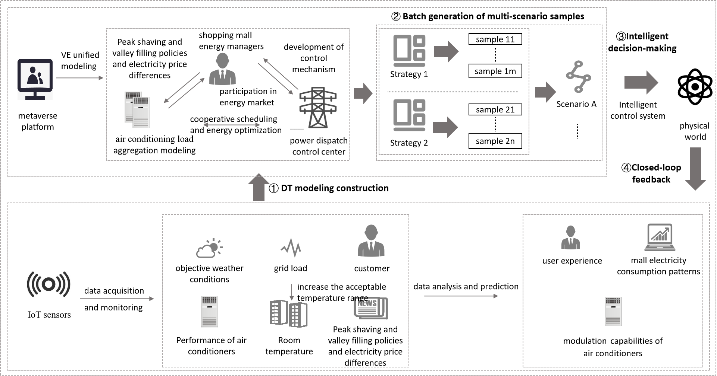

Figure 2 – Control of air conditioning in the PM space

Various flexible resources are often overlooked and difficult to collaborate with at the cognitive and perceptual levels. However, with PM technology, the great potential of air conditioning participation in load response can be exploited fully. Through simulation and scenario projections, intelligent analysis and collaborative scheduling, PM can significantly improve the energy efficiency and effectiveness of peak shaving and valley filling. Simultaneously, the energy department of the mall can adjust the operation mode and air conditioning parameters in the DT space dynamically by considering factors such as temperature, customer flow and grid load demand. This enables more scientific automatic control of air conditioning and reduces operational costs.

This case highlights the benefits of using PM technology for automatic air conditioning control in a mall setting. The benefits of such automation can be applied to various building types, including residential buildings, commercial offices, schools and hotels. Furthermore, this use case has potential applications for other fields, where load demand and energy efficiency are critical. For example, in storage areas such as food and pharmaceuticals the adjustable refrigeration equipment power can be assessed by the energy manager and uploaded to the PM platform. Then, the operating strategies can be optimized in the PM according to the load demand of the power system. Another example can be greenhouse plant cultivation, which often requires specific humidity and temperature levels for optimal growth. With PM technology, the greenhouse's heating, ventilation and lighting systems can be adjusted to smooth out loads and reduce energy consumption.

In the future, there will be greater recognition of the significant potential of temperature-controlled loads as demand-side resources. With the continuous development of PM technology, devices such as air conditioning will become more sophisticated, enabling more precise and intelligent automatic control.

### 7.2.2 Assumptions

The assumptions related to this use case include the following:

– It is assumed that different sensor devices for monitoring indoor temperature, humidity, customer flow and other information should be suitably deployed in accordance with the geographical distribution features of malls.

– It is assumed that the multivariate heterogeneous data collected and stored are preprocessed and integrated into a digital world.

– It is assumed that within the metaverse, a virtual energy market can be established where energy suppliers and consumers can trade and exchange energy credits.

– It is assumed that a PM can simulate and test different energy management strategies for air conditioning systems without impacting the physical environment.

– It is assumed that user interaction is established matching diverse user profiles, securing communication with all users regardless of their language, age or disability.

### 7.2.3 Service scenario

The energy manager of a shopping mall aims to maximize the participation of air conditioning in the activities of peak shaving of power supply and demand, without making any negative impact on customer comfort. For this purpose, the power metaverse is applied to generate an optimization strategy that facilitates the control of air conditioning operation in the shopping mall.

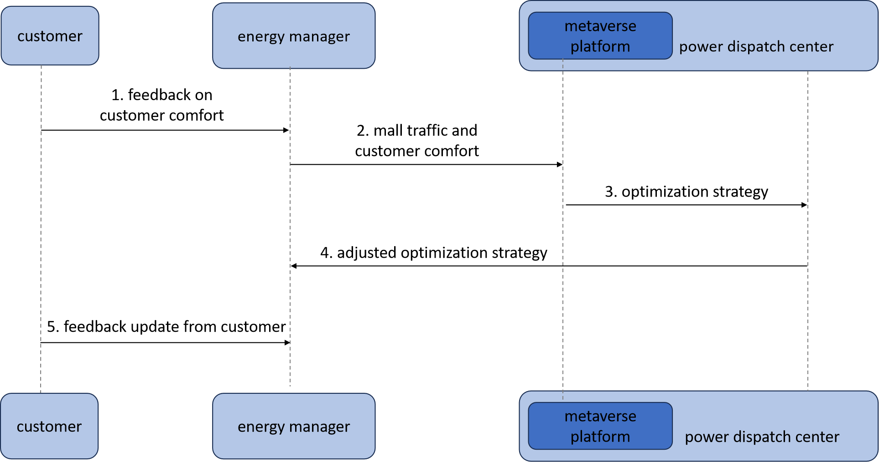

Figure 3 – Service data flow for the control of air conditioning

1) Customers deliver feedback on temperature comfort to the energy manager of a shopping mall via mobile clients.

2) The energy managers collect data about mall traffic and customer comfort and forwards the information to the metaverse platform.

3) The metaverse platform determines the optimization strategy of the power supply and demand [b‑ITU‑T L.1240]; it delivers the optimization strategy to the power dispatch centre.

4) The power dispatch centre adjusts the optimization strategy according to expert knowledge and experience, and it delivers the adjusted optimization strategy to the energy manager.

5) The energy manager controls the power consumption behaviour of air conditioning based on the adjusted optimization strategy and waits for the customer feedback update.

## 7.3 Electric vehicles

As the level of electrification in transportation continues to increase, electric vehicles (EVs) are actively promoted as flexible resources. Through PM technology, EV owners may engage fully in virtual power dispatch to balance power demand.

### 7.3.1 Description

This use case describes where peak shaving and valley filling are achieved through flexible charging and discharging strategies for EVs on the PM platform. The procedures in this use case scenario are as follows:

1) **DT modelling construction**: Map the parameters related to EVs and charging piles from the physical world to the virtual space to establish the corresponding DT.

• **Inputs**: the user's stopping time, remaining car battery power, charging needs and the degree of willingness to participate.

• **Controlled variables**: charging and discharging power for EVs.

• **Outputs**: EV battery charge status, user travel satisfaction and cost satisfaction [b‑Chengshan].

2) **Batch generation of multi-scenario samples**: Samples consisting of inputs, controlled variables and outputs are constructed in batches to cover all the scenarios, providing rich data resources for subsequent decision-making. For example, a virtual EV battery-trading market is established in the metaverse platform, where EV owners can report their car's adjustable capacity and time slots according to their travel plans. The twin platform simulates different charging and discharging strategies after receiving the EV load dispatchable capacity. Taking into account the impact of different strategies on user output and distribution network load smoothing effect, optimize the charging and discharging behaviour of EVs.

**Strategy 1: Consider ordered charging and discharging with the minimum user expense**. During peak electricity demand, an EV’s owner can sell their battery capacity to other users to provide additional energy supply. During off-peak electricity demand, an EV’s owner can purchase battery capacity from the market sold by other users. Through the simulation of energy trading between peaks and valleys, the potential of EVs to participate in peak load regulation can be maximized.

**Strategy 2:** **Orderly charging and discharging while balancing cost and travel comfort**. The vehicle owner's satisfaction with travel is greatest when they conduct random charging for convenience. When vehicle owners pursue their cost expenditure purely based on electricity price regulation, their satisfaction with travel is the lowest. In order to encourage users to participate in peak regulation, the charging and discharging time can be speculated based on the length of the user's charging and discharging period compared to the peak and off-peak electricity price periods [b-Wangjing]. Using charging behaviour as an illustration, if the user's charging duration exceeds the length of the off-peak electricity price period, they should charge at the start of the off-peak period. If the user's charging duration does not exceed the length of the off-peak electricity price period, they can start charging at any time during that period, and the same goes for discharging.

Meanwhile, on the PM platform, various transportation and electric load demand scenarios can be simulated to explore appropriate settings for the charging capacity and spatial distribution of charging piles. Batch simulations using PM technology can generate significant data samples related to EVs' participation in load response scenarios, enabling dispatch centre personnel to identify the best charging and discharging strategies for electric vehicles.

3) **Intelligent decision-making**: In the PM, intelligent scheduling and optimization algorithms can determine the optimal scheduling strategy based on batch-generated sample data. To accomplish peak shaving and valley filling, these algorithms can consider elements like user experience, charging and discharging expenses, and power demand [b-Chenweijia]. They can also be combined with other historical traffic conditions and grid load curves for prediction. Based on the prediction results, the charging strategy of EVs is optimized to maximize their participation in peak load regulation.

4) **Closed-loop feedback**: EV owners will receive instructions from the dispatch centre to adjust EV charging plans based on intelligent decision-making results. After executing the strategy, the effect of orderly charging and discharging will be transmitted to the twin space in real time. This leads to a new round of the intelligent decision-making strategy, forming a continuously iterative and optimized closed-loop control.

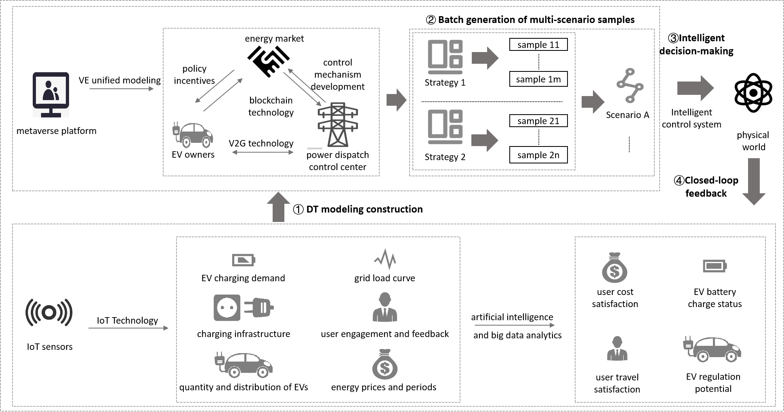

Figure 4 – Control of electric vehicle in the PM space

EVs have tremendous potential for peak-shaving and valley-filling applications. The adoption of PM technology can fully leverage an EV's flexible energy regulation and power supply-demand balancing capabilities. This technology can be widely applied in other sectors as well. For example, a PM can simulate residential electricity consumption scenarios in the residential sector to determine optimal electricity usage strategies. During periods of high grid load, through price differentials or incentive mechanisms residents can be encouraged to shift the usage time of high-energy-consuming devices such as washing machines, dryers and dishwashers from peak hours to off-peak hours thus reducing the electricity demand during peak periods. PM technology may simulate weather and soil moisture conditions in agriculture for optimal irrigation time scheduling. Intelligent irrigation systems and energy consumption methods can avoid large-scale irrigation operations during high energy demand, bringing about peak shaving and valley filling.

In summary, adjusting the electricity usage period can, to some extent, balance the demand and supply of electricity, reduce the load pressure during peak periods, and improve energy utilization efficiency. With the continuous development of relevant technologies and the promotion of cooperation between all parties, electric vehicles based on peak-shaving technology will play an increasingly important role in the future, contributing to the power system's reliability, sustainability and economy.

### 7.3.2 Assumptions

The assumptions related to this use case include the following:

– It is assumed that the metaverse's energy infrastructure is scalable and capable of accommodating a growing number of EVs and participants.

– It is assumed that energy regulatory frameworks within the metaverse are established to support and encourage the integration of EVs into demand response programmes. These regulations may address issues such as energy market rules, standards for vehicle-to-grid (V2G) technologies and grid interconnectivity requirements.

– It is assumed that robust privacy and security measures are in place to protect user data and ensure the safe operation of the metaverse's energy infrastructure. This includes secure communication protocols, encryption, authentication mechanisms and user consent frameworks.

– It is assumed that a significant number of EVs are present within the metaverse, distributed geographically and available for participation in demand response programmes.

– It is assumed that EVs are equipped with V2G technology, enabling bidirectional power flow between the grid and the vehicles. This allows the vehicles to not only consume electricity but also to feed surplus power back to the grid during peak demand periods.

– It is assumed that user interaction is established matching diverse user profiles, securing communication regarding user consent with all users regardless of their language, age or disability.

### 7.3.3 Service scenario

EV owners aim to reduce their charging costs without affecting daily travel plans. For this purpose, the power metaverse is applied to generate an optimization strategy of demand response of the power grid. EV owners adjust their charging and travelling behaviour according to the optimization strategy, in order to obtain charging services at a more affordable price.

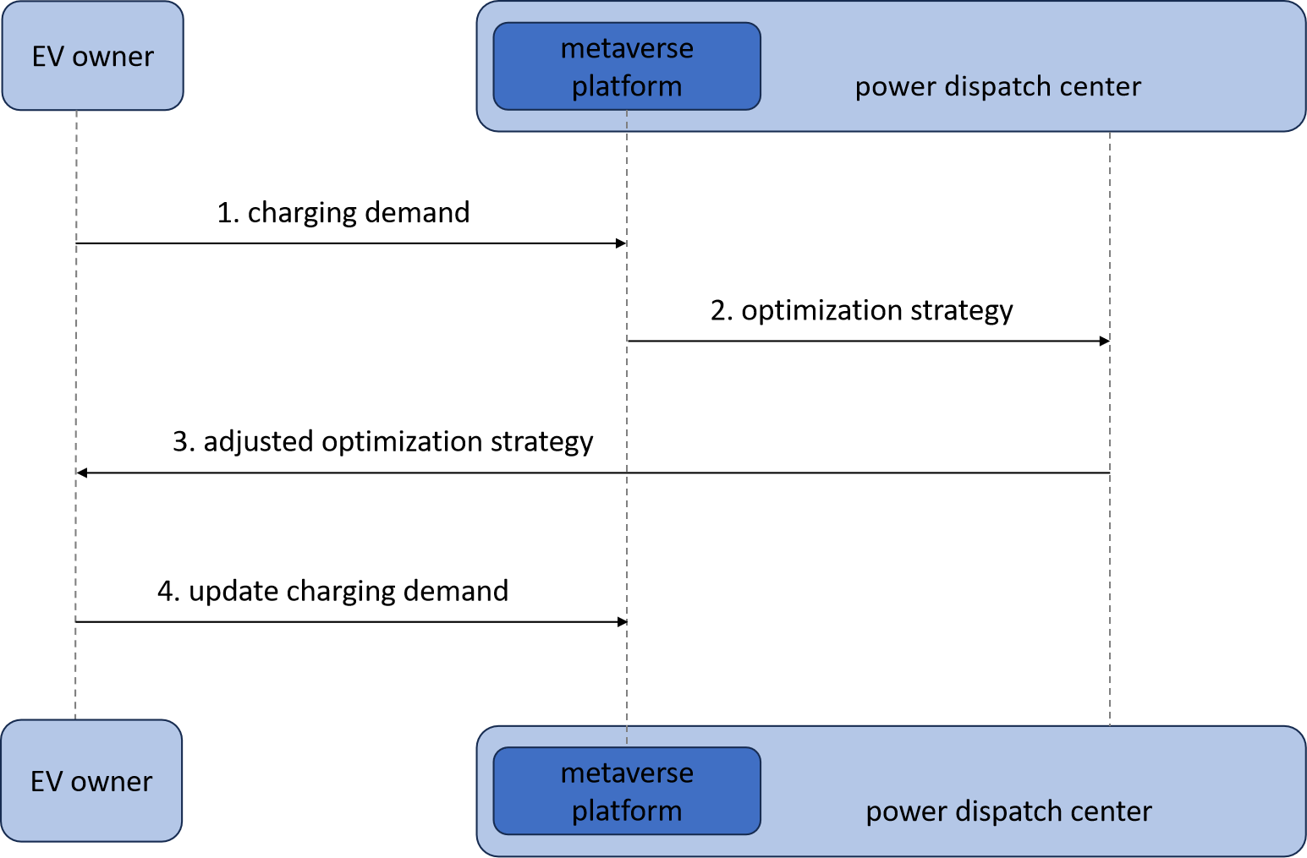

Figure 5 – Service data flow for the control of electric vehicles

1) EV owners report their charging demands to a metaverse platform via mobile clients.

2) The metaverse platform determines an optimization strategy of demand response [b-ITU-T L.1240] and delivers the optimization strategy to the power dispatch centre.

3) The power dispatch centre adjusts the optimization strategy according to expert knowledge and experience and delivers the adjusted optimization strategy to EV owners.

4) EV owners charge their cars according to the adjusted optimization strategy and update their charging demands.

## 7.4 Combined heat and power

Cogeneration is an energy system that improves energy utilization efficiency by generating heat and electricity. Appropriate heat load arrangements can enhance the ability of cogeneration plants to participate in peak load regulation and renewable energy consumption. The cogeneration system may achieve higher intelligence, flexibility and synergy by utilizing PM technology.

### 7.4.1 Description

This use case describes the scenario where PM technology is applied to improve the performance of combined heat and power systems, to manage energy more efficiently and achieve flexible deployment and sustainable use of energy. The procedures in this use case scenario are as follows:

1) **DT modelling construction**: Map the operating parameters of the thermal power plants in the physical world to a PM space and establish corresponding DT models.

• **Inputs**: weather conditions, heat storage and generation capacity of combined heat and power (CHP) plants, and user-acceptable temperature ranges.

• **Controlled variables**: heat load and thermoelectric ratio.

• **Outputs**: room temperature and user satisfaction.

2) **Batch generation of multi-scenario samples**: For the combined heat and power systems, the indoor temperature of a heated building during a certain period is the consequence of the cumulative impact of heat supply over multiple periods in the past. As a result, the change in heat supply during a certain period of the day does not impact the indoor temperature significantly. The PM technology can create a virtual environment for the cogeneration system to conduct various experiments and tests. The CHP plant operators can report the adjustable power capacity to the twin platform according to parameters such as indoor temperature and outdoor weather. The PM platform receives the CHP plant's adjustable load signal and optimizes the operation of the CHP plant. The platform can simulate various energy supply situations, load demands and equipment operation statuses, considering the output of the cogeneration plant and the effect of participation in peaking and new energy consumption. For instance, the PM platform can establish a virtual environment for a cogeneration system to simulate the operating strategy of **thermal power plants** under various power demands. During peak load hours of the grid, reducing the heating flow rate of the plant and generating more electricity according to the adjustable power capacity uploaded by the operators can alleviate the pressure on the power grid supply. Conversely, during off-peak periods, less electricity but more heat is generated to compensate for the storage of heat supply [b-Verda]. This approach facilitates peak shaving and valley filling, optimizing the overall energy utilization.

Thermal power plants with heat storage devices have greater peak load regulation and renewable energy absorption potential. The following two solutions may be simulated in a PM based on the connection between the maximum waist load heat storage capacity and the highest peaking compensating heating demand in the low load hours [b-Lv].

**Strategy 1**: If the maximum heat storage in the waist load period exceeds the maximum peaking compensation heat demand during the low load period, the system will store as much heat as possible in the waist load period. Then priority is given to meeting the peaking heat demand in the trough hours and reducing power generation to increase the proportion of wind power consumption in the trough hours. The extra heat storage is then adjusted to the peak hours to decrease the turbine's heat supply power during those times and raise the percentage of condensing steam generation, hence boosting peak power output.

**Strategy 2**: If the maximum demand for peaking compensated heating during the low load period is higher than the maximum heat storage during the waist load period, it will first store as much heat as it can during the waist load period and the shortfall will be stored during the peak load period. Therefore, the requirement for peaking compensated heating in the trough hours is as nearly satisfied as feasible, and the wind power can be maximally integrated into the power grid.

3) **Intelligent decision-making**: Algorithms for intelligent decision-making and optimization are used to design and improve the peaking strategy for the cogeneration system based on the models and real-time data in the PM. By analysing the real-time status of the system and the demand of the power system, intelligent algorithms can provide the best peak-shaving scheme to achieve efficient energy utilization and balance of the power system. To accomplish peak shaving and renewable energy consumption, these algorithms can consider elements such as the heating impact, cogeneration plant income and power demand [b-Li]. In this process, the CHP operators can also make some suggestions to the operating strategies. Predictions can also be made by combining historical outdoor temperature changes, new energy output and grid load curves. Based on the prediction results, the operation status of the cogeneration plant is optimized to maximize its contribution to load smoothing and renewable energy consumption.

4) **Closed-loop feedback**: CHP plant operators will receive instructions from the dispatch centre to adjust the CHP plant operational status based on intelligent decision-making results. The effect of the strategy execution will be mapped to the twin space again to update the parameters. The updated parameters will then be used as inputs for the new round of intelligent decision-making, forming a closed-loop feedback of iterative upgrading.

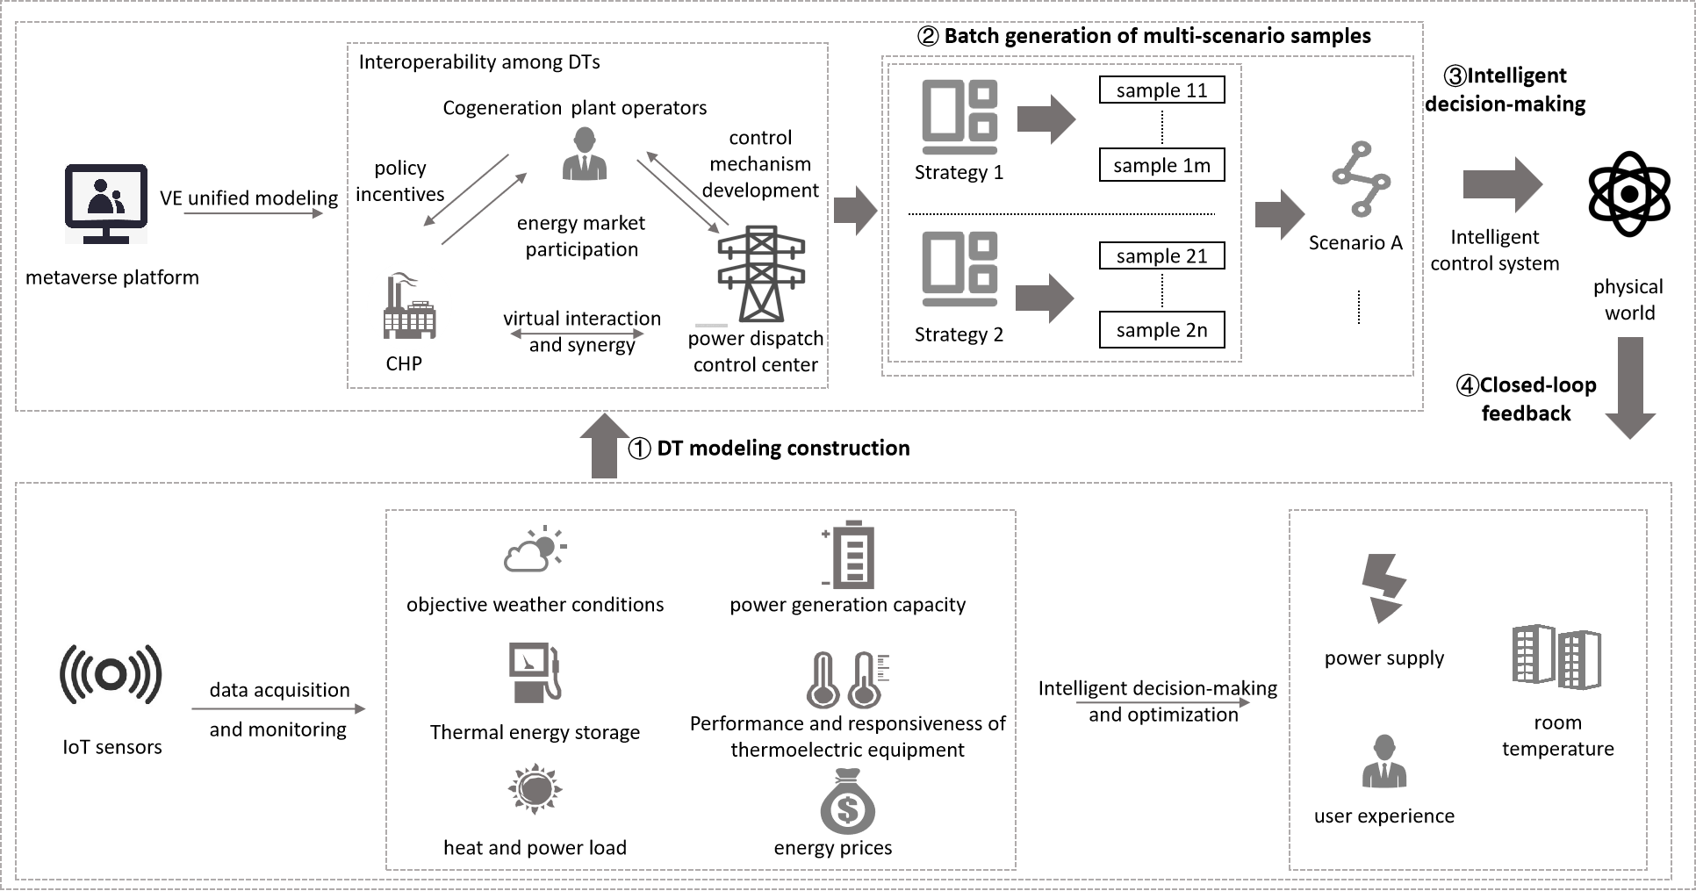

Figure 6 – Control of combined heat and power in the PM space

By participating in peak-load regulation through cogeneration, the traditional reliance on coal-fired power generation can be reduced, promoting the use of renewable energy and thus reducing greenhouse gas emissions and environmental pollution. By converting waste heat from the power-generating process into usable thermal energy, cogeneration technology may improve energy utilization efficiency and reduce energy consumption and carbon emissions. The cogeneration system may achieve higher intelligence, flexibility and synergy by utilizing PM technology. As a result, it may more effectively take part in peak load management of power systems and smooth out the renewable energy consumption. At the same time, it can offer reliable power supply, optimize energy usage efficiency and support energy transformation and sustainable development. With intelligent energy management and optimization algorithms in a PM, CHP systems can optimize scheduling based on factors such as electricity market prices, energy demand and supply, achieving both economic and sustainability goals.

Overall, CHP will play a significant role in the energy industry and has broad prospects for participating in peak load regulation and boosting new energy consumption. By optimizing energy utilization, reducing energy waste and carbon emissions, and achieving flexible scheduling of energy systems in a PM, CHP is expected to promote sustainable energy development, facilitate energy transition and achieve carbon neutrality goals.

### 7.4.2 Assumptions

The assumptions related to this use case include the following:

– It is assumed that the real-time data from the thermal power plant is available, including power generation capacity, energy demand and operational parameters such as temperature, pressure and efficiency.

– It is assumed that a demand response mechanism within the metaverse can be implemented, which allows the thermal power plant to adjust its power output based on grid requirements and signals from the metaverse platform.

– It is assumed that smart contracts within the metaverse can be utilized to automate and regulate the demand response process, ensuring secure and transparent transactions between the thermal power plant and other entities in the energy ecosystem.

– It is assumed that within the metaverse platform users can monitor and control their energy consumption, receive incentives for demand response and contribute to a sustainable energy ecosystem.

– It is assumed that user interaction is established matching diverse user profiles regardless of their language, age or disability, hence securing that all users can monitor and control their energy consumption, and all users understand issues related to receiving incentives for demand response.

### 7.4.3 Service scenario

The operations manager of the cogeneration plant aims to participate in the activities of peak shaving and valley filling of power supply and demand. For example, when power demand in a certain region is approaching the upper limit of power supply, the operations manager increases the load of the cogeneration plant to meet the need of power consumers. On the contrary, when power demand is at a lower level the operations manager decreases the load of cogeneration plant. For this purpose, the PM is applied to generate an optimization strategy that facilitates the control of load capacity in the cogeneration.

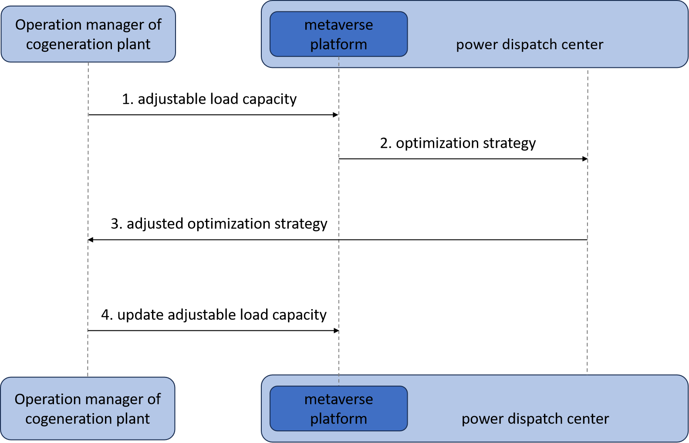

Figure 7 – Service data flow for the control of combined heat and power

1) The operations manager of the cogeneration plant determines the adjustable load capacity based on power and heat demand, and delivers the adjustable load capacity to the metaverse platform.

2) The metaverse platform determines the optimization strategy for power supply and demand, and it delivers the optimization strategy to power the dispatch centre.

3) The power dispatch centre adjusts the optimization strategy according to expert knowledge and experience, and it delivers the adjusted optimization strategy to the operations manager.

4) The operations manager controls the operational status of the cogeneration plant according to the adjusted optimization strategy and updates the adjustable load capacity.

## 7.5 Energy storage

Energy storage is a crucial and indispensable piece of equipment, as well as a key supporting technology for building a new power system that relies on renewable energy resources [b-Kang]. However, currently, the design, operation and optimization of energy storage systems face challenges, such as complex grid environments, unpredictable load demands and market fluctuations [b-ITU-T L.1220]. PM technology can handle various complex variables effectively through simulation and optimization, assisting operators of power grid systems and energy storage stations in gaining a better understanding and control of energy storage systems, thereby enhancing their performance, reliability and cost-effectiveness.

### 7.5.1 Description

PM technology can be used to adjust the charging and discharging behaviour of energy storage stations to achieve peak and valley reduction in the grid system.

The procedures in this use case scenario are as follows:

1) **DT modelling construction**: Map the operating parameters of energy storage stations and grid loads from the physical world to the virtual space in the PM.

• **Inputs**: rated capacity, ramp rate, charging and discharging efficiency, maximum charge-discharge duration, grid load data and maintenance costs.

• **Controlled variables**: charging and discharging behaviour of the energy storage station.

• **Outputs**: charging and discharging schedule, power curve of the energy storage station.

2) **Batch generation of multi-scenario samples**: In the PM space, samples consisting of inputs, controlled variables and outputs are constructed in batch to cover all the scenarios, providing rich data resources for subsequent energy storage charging and discharging scheduling. In the metaverse, grid system dispatchers and storage station operators can access a virtual platform, checking various data curves for grid load, renewable energy generation efficiency and energy storage facility state. Based on this information, they can then evaluate different charging and discharging strategies adopted by the energy storage station on the grid load in the metaverse platform. When the power demand is low, energy storage stations store electricity from renewable energy sources such as solar and wind power, as well as surplus power from the grid, for future needs. During peak power demand or periods of insufficient power supply, energy is discharged from the storage stations back to the grid to alleviate the supply pressure during peak load periods, thereby achieving peak-shaving and valley-filling functionality. Additionally, by utilizing PM technology a massive amount of data samples are made available for configuration optimization by simulating and deducing the characteristics and application requirements of different energy storage scenarios. In order to optimize the configuration of energy storage stations, it is necessary to analyse factors such as the quantity, capacity and layout of energy storage devices. This analysis will further enhance the accuracy and efficiency of charging and discharging strategies for energy storage.

3) **Intelligent decision-making**: The optimal real-time energy storage charging and discharging adjustment strategy can be determined based on batch-generated sample data using intelligent decision-making and scheduling algorithms. These algorithms can comprehensively consider the factors of power demand, electricity prices, storage costs, charging and discharging efficiency, aiming to achieve the effect of peak shaving and valley filling. In a DT space, other environmental parameters and historical data on electricity consumption can also be combined for prediction. Based on the prediction results, the charging and discharging strategies of the energy storage are adjusted to make the energy storage station more flexible to respond to the changes and demands of the power system.

4) **Closed-loop feedback**: Intelligent decision-making is applied to the energy storage power stations in the physical world, forming a closed loop with the building of a DT and the generation of samples to iteratively optimize the charge anddischarge decision. By monitoring and evaluating the operational performance of the energy storage power station, new sample data is generated continuously and iteratively, and achieves a more accurate and efficient control of energy storage charging and discharge behaviours.

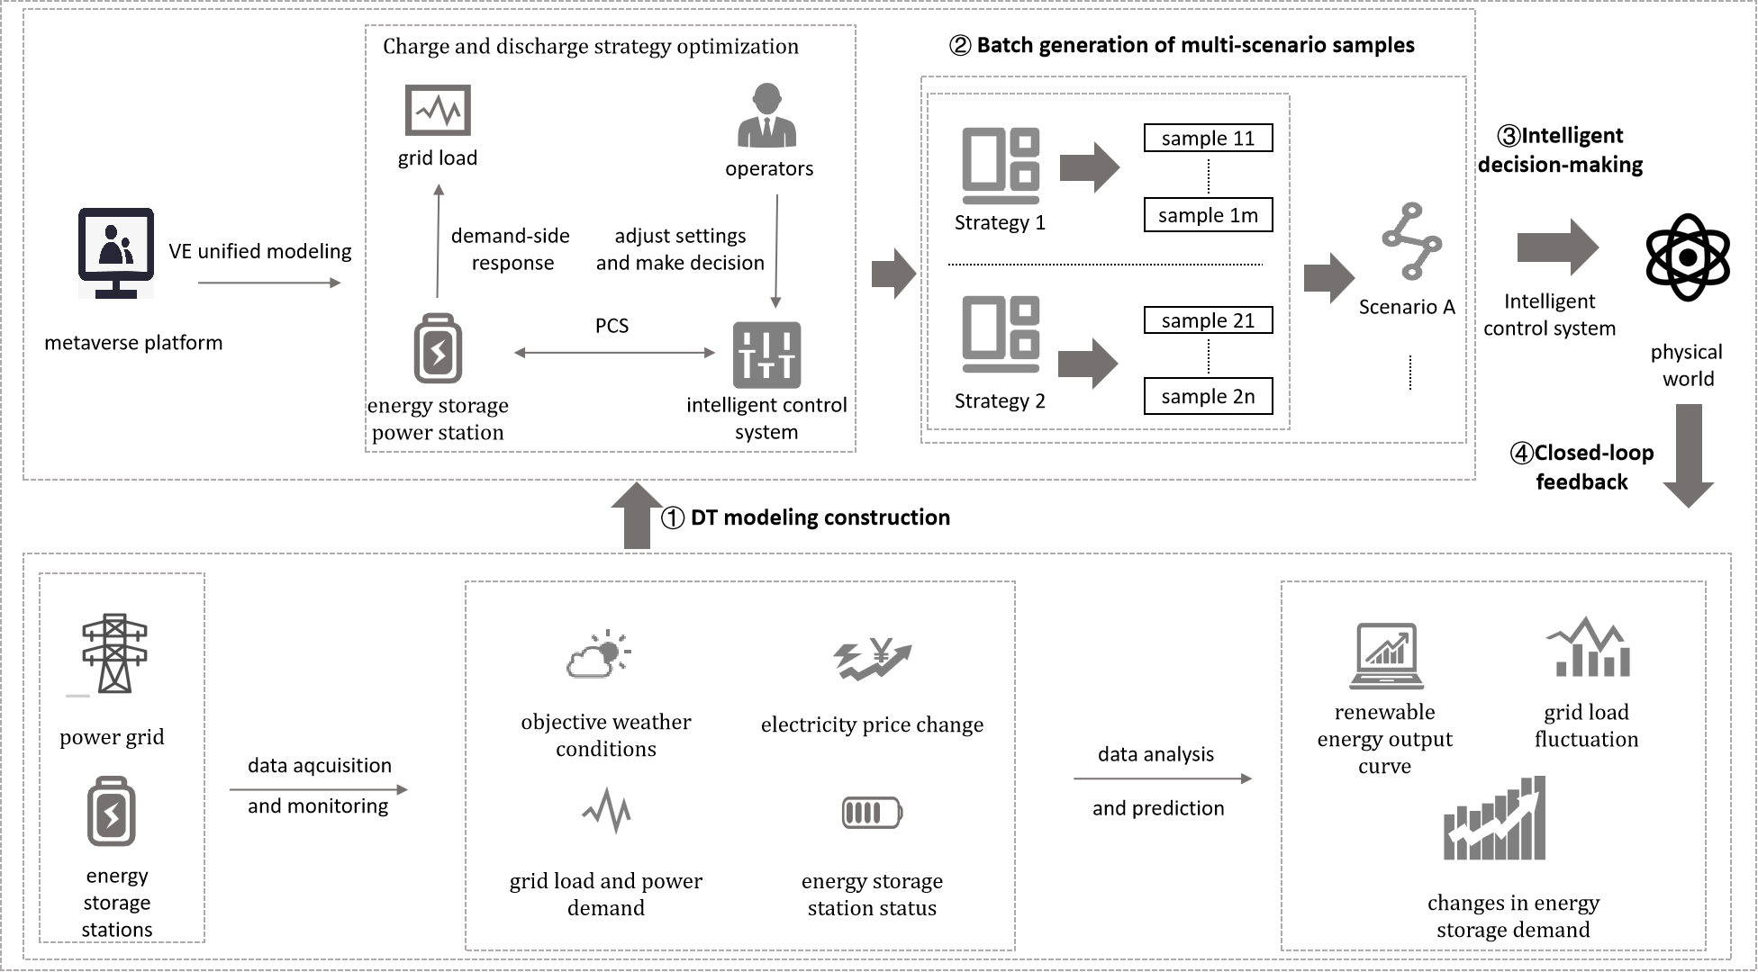

Figure 8 – Control of energy storage in the PM space

### 7.5.2 Assumptions

The assumptions related to this use case include the following:

– It is assumed that rich data can be acquired through various sensors, as well as third-party platforms.

– It is assumed that the network communication quality is reliable.

### 7.5.3 Service scenario

The operations manager of an energy station aims to take an active part in the peak shaving and valley filling activities of power supply and demand. For example, when power demand in a certain region is approaching the upper limit of power supply, the energy station serves as a power supplier to meet the need of air conditioning, electric vehicles and other power consumers (if any). On the contrary, when power demand is at a lower level, energy station receives electricity from traditional and/or renewable energy sources. For this purpose, a PM is employed to generate an optimization strategy to facilitate the control of power charging and discharging behaviours of an energy station.

ç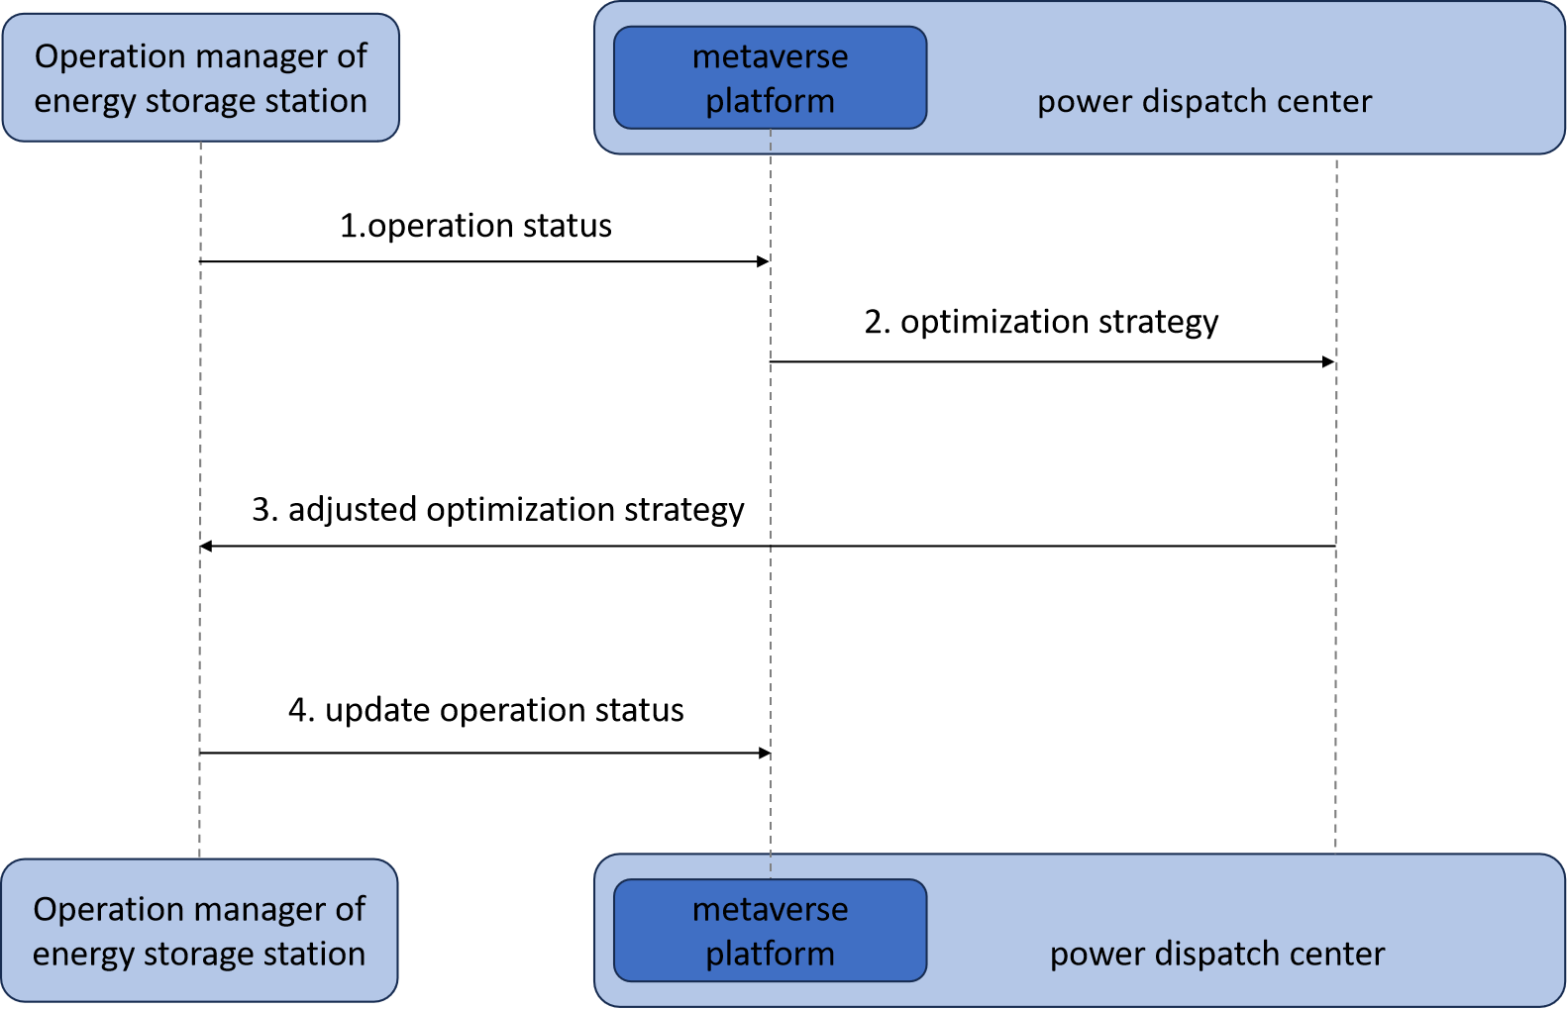

Figure 9 – Service data flow for the control of energy storage

1) The operations manager delivers operational status information of an energy storage station to the metaverse platform.

2) The metaverse platform determines the optimization strategy for peak shaving and valley filling, and it delivers the optimization strategy to the power dispatch centre.

3) The power dispatch centre adjusts the optimization strategy according to expert knowledge and experience, and it delivers the adjusted optimization strategy to the operations manager.

4) The operations manager controls the charging and discharging behaviours of energy station storage according to the adjusted optimization strategy and updates the operational status of the energy station.

## 7.6 Multi-energy complementarity

Multi-energy complementarity refers to the utilization of a combination of different forms of energy to achieve stable, reliable and sustainable energy supply. However, multi-energy complementarity systems involve integrating and managing multiple energy sources, leading to increased complexity of the energy system. The metaverse can consider factors such as the complementary relationship between various energy sources, the flexibility of energy distribution, and energy stability to better manage and optimize the coordinated supply and efficient utilization of multi-energy sources [b‑Wang].

### 7.6.1 Description

This use case describes the scenario where PM technology is used to create a multi-energy complementary integrated energy system in an industrial park, to realize multi-energy cooperative supply and energy cascade utilization. The procedures in this use case scenario are as follows:

1) **DT modelling construction**: Map the PEs of renewable energy power stations, thermal power stations, buildings, boilers, charging stations and their state data in industrial park settings to a virtual space.

• **Inputs**: weather conditions, multi-energy supply, user demand and user experience.

• **Controlled variables**: parameters of energy supply and conversion.

• **Outputs**: electrical energy, thermal energy, cooling energy and user satisfaction.

2) **Batch generation of multi-scenario samples**: Samples consisting of inputs, controlled variables and outputs are constructed in batch to cover all the scenarios, providing rich data resources for subsequent energy storage charging and discharging decisions. For integrated energy systems energy sources are diverse and adopting different multi-energy collaborative supply schemes will produce different effects. Additionally, the design of an energy cascade utilization strategy also affects the efficiency of energy utilization. PM technology can provide an energy trading platform for the park's integrated energy system. Consumers in the park can report their detailed energy needs on the trading accessible platform. At the same time, various energy suppliers in the park sell the energy on the platform. Further, the simulated operational outcomes caused by different energy complementary schemes and cascade utilization strategies in an industrial park scenario: 1) the effect of supplying power, heating and cooling for the park; and 2) the utilization rate of energy.

**Strategy 1**: Simulate the complementary effect under different energy combinations based on the renewable energy output curve [b-Xu]: when the supply of renewable energy is insufficient, increasing the proportion of thermal power generation can compensate for the shortage and randomness of wind power output. Conversely, when the supply of renewable energy is sufficient, the output of thermal power generation can be reduced. Generating a batch of multi-energy complementary schemes is conducive to optimizing the collaborative supply of various energy sources.

**Strategy 2**: Simulate the high temperature requirements of industrial processes in the PM: after being used at high temperatures, waste heat can be recovered through heat exchangers and used for low-temperature thermal energy needs such as heating and hot water supply. After the low-temperature utilization, the remaining thermal energy can be further heated up by heat pumps and other technologies to meet the energy demand of higher temperatures. Similarly, the system could utilize excess electricity to produce hydrogen through water electrolysis, which can be stored and utilized as another form of energy. The hydrogen produced can be used in applications such as fuel cell power generation and hydrogen-powered vehicles. Utilizing PM technology to generate demand-responsive energy cascade utilization schemes in batches will provide important data support to improve energy utilization efficiency.

3) **Intelligent decision-making**: Based on the sample data generated in batches, multi-energy supply data, and energy demand in the metaverse, the multi-energy collaborative supply and cascade utilization schemes for industrial parks are determined and optimized. In addition, a PM can also combine environmental parameters, real-time and historical energy consumption data for predictive analysis, dynamically adjust comprehensive energy utilization strategies and maximize energy efficiency.

4) **Closed-loop feedback**: Intelligent decision-making is applied to the comprehensive multi-energy complementary energy system of the industrial park in the physical world, forming a closed loop with the building DTs and the generation of samples to iteratively optimize the charge and discharge decision. By monitoring and evaluating the effectiveness of the application of this decision in enhancing multi-energy complementarity, improving energy utilization and meeting the energy demand of the park, the sample data is continuously iterated and decision-making algorithms are optimized.

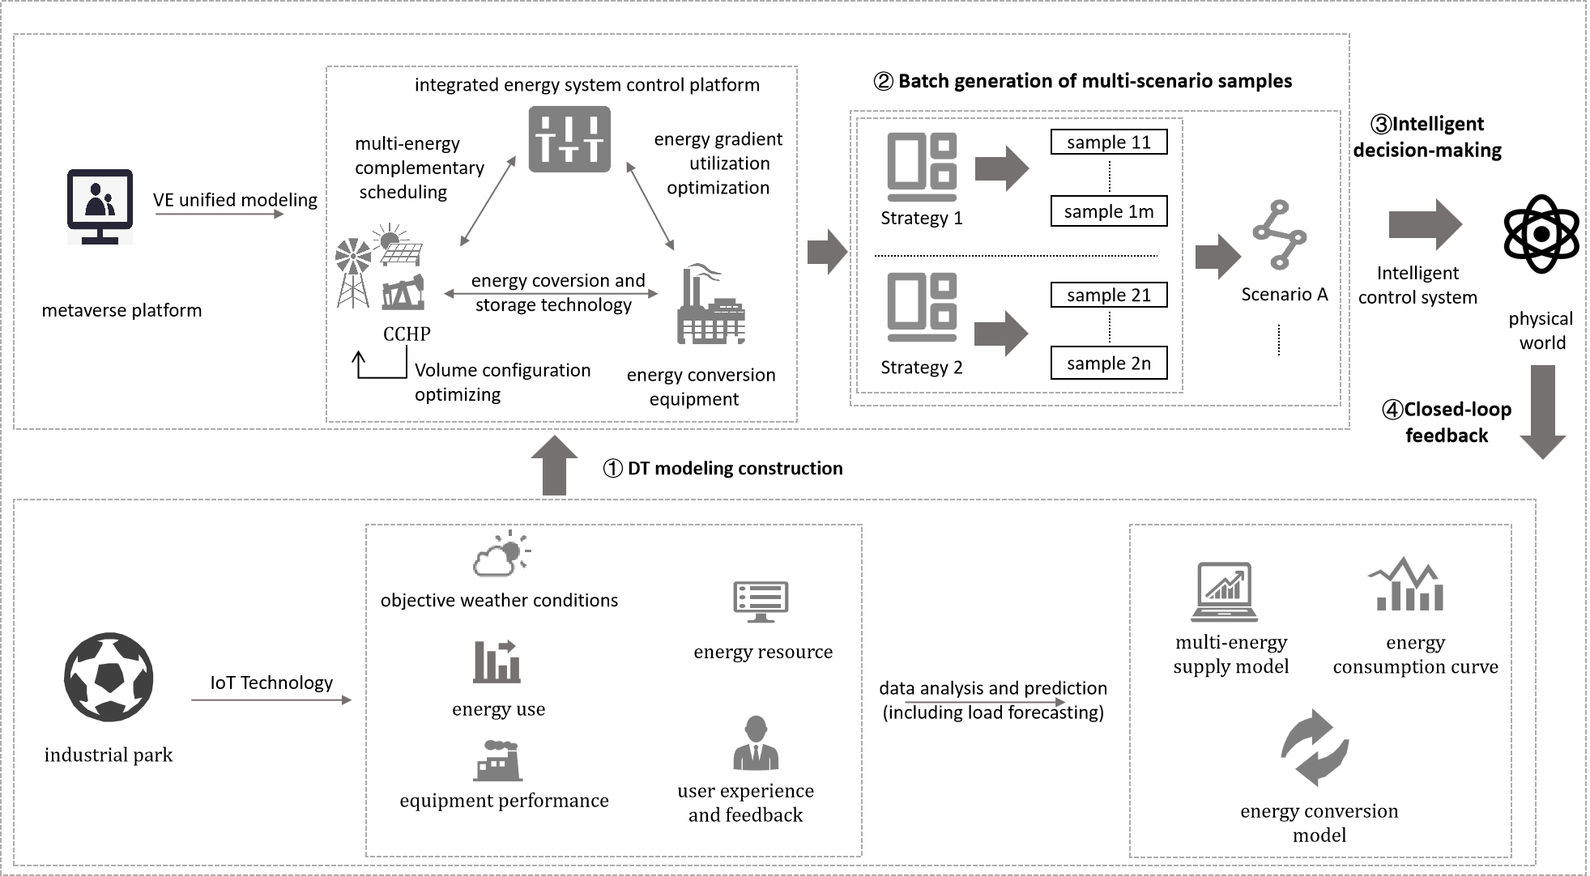

Figure 10 – Control of multi-energy complementarity in the PM space

### 7.6.2 Assumptions

The assumptions related to this use case include the following:

– It is assumed that various power generation and energy conversion devices are already in normal production and operation.

– It is assumed that various sensors have been deployed in a reasonable manner, capable of collecting rich data information and uploading it.

– It is assumed that the network communication quality is reliable.

– It is assumed that there is sufficient simulation computing capability or the ability to utilize third-party cloud computing services to meet computational requirements.

– It is assumed the trading platform is accessible for all users, regardless of their language, age or disability.

### 7.6.3 Service scenario

Typically, there are various kinds of traditional and renewable energy resources available in an industrial park including, but not limited to, photovoltaic, wind turbine and so on. Besides, there are also various kinds of energy consumers that have power consumption characteristics that are different from each other. Hence, power supply and demand in an industrial park is dynamically fluctuating, and it is required to control the fluctuation in a lower level to achieve energy saving and balance. For this purpose, a PM is applied to facilitate multi-energy complementarity in the industrial park.

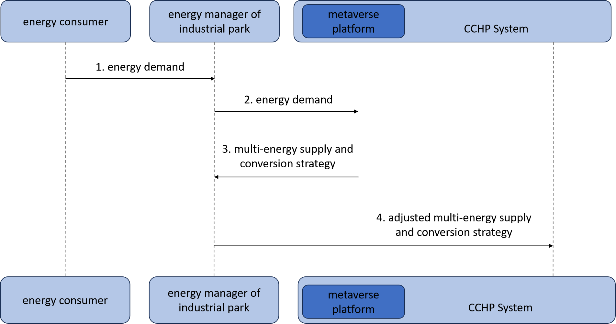

Figure 11 – Service data flow for the control of muti-energy complementarity

1) An energy consumer delivers energy demand to the energy manager of an industrial park.

2) The energy manager forwards energy demand to the metaverse platform.

3) The metaverse platform generates a multi-energy supply and conversion strategy that facilitates the control of energy supply equipment in the industrial park, and it delivers the strategy to the energy manager.

4) the energy manager adjusts the optimization strategy based on expert knowledge and experience and sends the adjusted strategy to the CCHP system. Upon the arrival of the strategy, the CCHP system performs the strategy to optimize the balance of power supply and demand in the industrial park.

## 7.7 Resilient power grid

In the context of dual carbon strategy, the power system is facing great challenges in maintaining its safety and reliability. Particularly, extreme weather conditions may incur equipment malfunctions, resulting in negative impacts on grid operation. Users, including dispatchers, maintenance personnel and power system researchers, can build a resilient power grid with the help of PM technology and enhance the ability of the real grid to withstand extreme weather.

### 7.7.1 Description

This use case describes how to use the PM technology to enhance power grid resilience under the influence of extreme weather conditions, where load prediction is the key to detecting equipment hazards before malfunctions occur. The users input the data relevant to the weather conditions they want to simulate and the PM will give several preliminary coping strategies. Users give feedback on these strategies based on real-world situations and make the final decision [b-He]. The following are related steps in this use case scenario:

1) **DT modelling construction**: Create VEs for PEs of each component of the power grid in the virtual space.

• **Inputs**: operational status of grid-side equipment, power output of source-side equipment and load characteristics of user-side equipment.

• **Controlled variables**: extreme weather condition.

• **Outputs**: load prediction result and emergency plans for possible equipment abnormalities.

2) **Batch generation for multi-scenario samples**: Samples consisting of inputs, controlled variables and outputs are generated in batch to cover all possible scenarios. With the support of the PM technology, load prediction is conducted in various time and space scales, in order to locate potential risks of equipment in operation. The following two strategies can be adopted to conduct load prediction in the virtual space.

**Strategy 1: Load prediction based on univariate regression**. Given historical operation data of equipment, a load prediction model is created using univariate regression methods. Equipment is assumed to be at risk of malfunctioning when its load features significantly differ from those in normal times.

**Strategy 2: Load prediction based on multivariate regression**. Given that historical weather condition data is available, a load prediction model is created for each device using multivariate **regression** methods. And a device is assumed to be at risk of malfunctioning when its load features are significantly different from those in normal times.

Immediately after the detection of equipment hazard, emergency plans are generated to eliminate potential operation risks by conducting emergency plans like load transferring and equipment maintenance, according to decision-making.

3) **Intelligent decision-making**: Based on the batch-generated sample data, decision-making is done to form optimal emergency plans for specific weather conditions.

4) **Closed-loop feedback**: The optimal emergency plan is conducted in the physical world. The variation of status and behaviours of PEs are monitored and delivered to the DT platform.

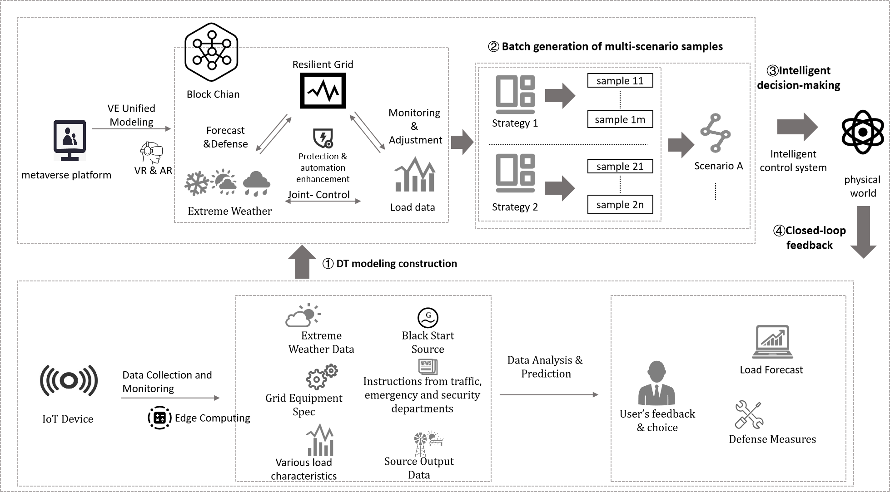

Figure 12 – Control of resilient power grid in the PM

Extreme weather conditions may incur a great impact on power output of equipment on the source side, load characteristics of user-side equipment and the operational status of grid-side equipment. For instance, power consumption in summer or winter is much higher than that in autumn or spring. In this use case, PM technology is employed to improve power grid resilience by detecting hazardous equipment and generating emergency plans under extreme weather conditions. PM technology can be also applied to islanded microgrids and EV charging stations, to enhance power supply reliability.

### 7.7.2 Assumptions

The assumptions related to this use case include the following:

– It is assumed that grid-side equipment data is accessible. Status information of primary and secondary equipment on the grid side should be collected including, but not limited to, rated capacity, rated voltage, load loss, short-term tolerable current and impedance.

– It is assumed that source-side equipment data is accessible, including renewable and conventional energy generation data, to develop operating modes under various circumstances.

– It is assumed that user-side equipment data is accessible, including load characteristics of user-side equipment, to evaluate the responsiveness of the power grid under extreme weather conditions.

– It is assumed that extreme weather condition data is accessible, including typhoons, earthquakes, extreme cold and extreme high temperatures.

### 7.7.3 Service scenario

Extreme weather has a significant negative impact on the operation of a power grid. It is necessary for operational managers of power grids to conduct load prediction based on extreme weather forecasts, so as to identify potential risks and develop emergency plans. Based on the emergency plans, equipment inspectors carry out inspections to ensure power supply safety. For this purpose, the PM is applied to facilitate load prediction, emergency plan development and equipment inspection.

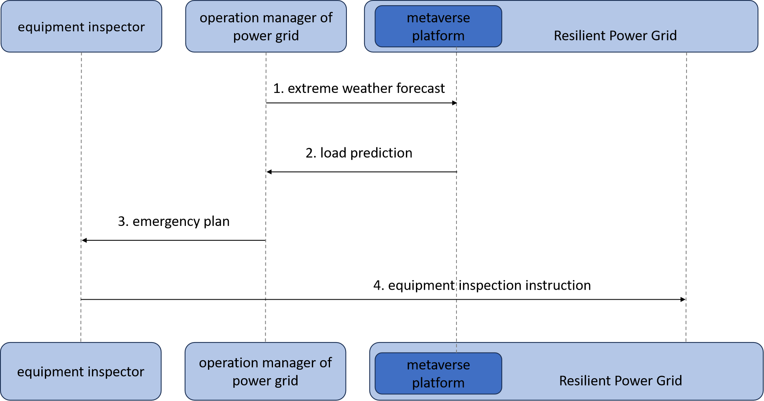

Figure 13 – Service data flow for resilient power grid in the PM

1) The operations manager of the power grid uploads extreme weather forecast to the metaverse platform.

2) The metaverse platform conducts load prediction based on the extreme weather forecast to identify potential risks. Meanwhile, it delivers load prediction results to the operations manager of the power grid.

3) The operations manager develops an emergency plan that guides the equipment inspector in completing the task of inspection. More specifically, the emergency plan indicates a set of equipment that may suffer heavy load or overload under the influence of extreme weather conditions and suggests how to protect the equipment.

4) The equipment inspector delivers inspection instructions to the resilient power grid, so as to remotely conduct inspection affairs.

## 7.8 DGA inspection

The transformer operation and maintenance team is responsible for completing the test of gases dissolved in oil. A dissolved gas analysis (DGA) inspection is one of the most widely used diagnostic tools for detecting and evaluating faults in electrical transformers filled with insulating liquid. During the inspection, the composition of oil samples is analysed to determine the proportion of characteristic gases dissolved in the oil, in order to determine whether the transformer is at risk of malfunctioning.

### 7.8.1 Description

This use case describes how to use the PM technology to simulate and deduce the process of a DGA inspection, so as to provide inspectors with immersive, interactive and multisensory experiences when conducting sampling, testing and other inspection behaviours. The following are related steps in this use case scenario:

1) **DT modelling construction**: Create VEs for the corresponding PEs of the transformer, surrounding environment and mobile laboratory system of a DGA, where the inputs, outputs and controlled variables are described below.

• **Inputs**: specification and operational status of a transformer and information on the surrounding environment, which are collected using MR/VR technologies.

• **Controlled variables**: proportion of various kinds of gases dissolved in the oil.

• **Outputs**: transformer condition assessment outcomes.

2) **Batch generation for multi-scenario samples**: Samples consisting of inputs, outputs and controlled variables are generated in batch to cover all possible scenarios. The following two strategies can be adopted to perform sample generation.

**Strategy 1: Experiment-driven sample generation**. Firstly, conduct DGA inspections in the mobile laboratory system. Meanwhile, collect the values of inputs, outputs and controlled variables via IoT infrastructure. Secondly, reproduce the whole process in the virtual world using 3D reconstruction, VR and AR.

**Strategy 2: AI-driven sample generation**. Firstly, set up a GAN model based on historical data of inputs, outputs and controlled variables. Secondly, produce data samples via the GAN model with varying values of inputs and controlled variables.

3) **Intelligent decision-making**: Given the result of the transformer condition assessment, decision-making is conducted to obtain the optimal maintenance solution for specific malfunctions and hazards.

4) **Closed-loop feedback**: The optimal maintenance solution is conducted in the physical world. The variation of status and behaviours of PEs are monitored and delivered to the DT platform.

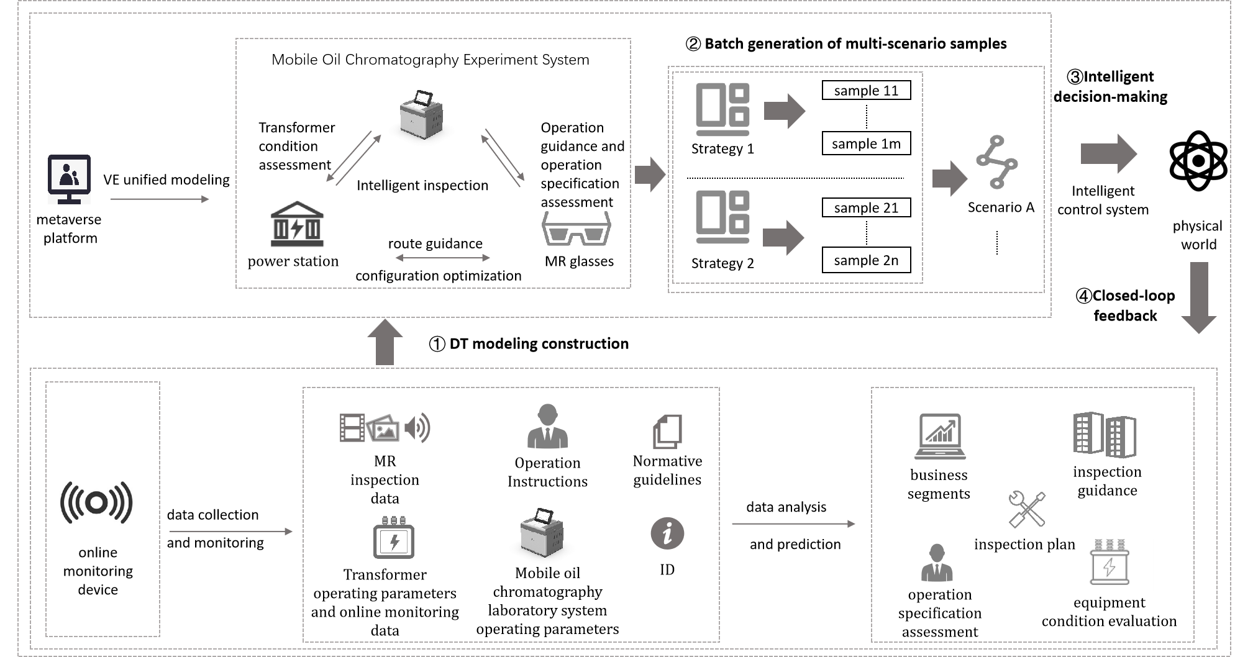

Figure 14 – Control of DGA inspection in the PM space

Nevertheless, in this use case, the MR glasses can also provide users with relevant information about the inspection, such as the types of experiences and activities available, the number of users and the quality of the user experience.

In the past few years, several smart substations have been built, where main routines like device operation and maintenance are conducted with the support of modern ICTs. This use case demonstrates how to employ PM technology to facilitate intelligent inspection for transformers in substations. With the support of the PM technology, inspectors cannot only obtain guidance for DGA, but can also generate maintenance solutions for specific malfunctions, resulting in a remarkable improvement in both efficiency and effectiveness. In addition, the PM technology can be applied to various primary and secondary equipment including, but not limited to, transmission lines, smart meters and so on.

### 7.8.2 Assumptions

The assumptions related to this use case include the following:

– It is assumed that various kinds of sensors can be used to collect visual, auditory, tactile and other sensory information during the inspection for model training.

– It is assumed that a user has accessible multi-language and multimodal input devices, such as MR glasses and mobile clients, and uses them to collect visual, auditory, tactile and other sensory information during the inspection.

– It is assumed that transformer operational data includes DGA, grounding current, vibration and so on.

– It is assumed that a unique device identifier is assigned to each device to make it feasible to retrieve the specification of devices online.

– It is assumed that the operational instruction given by inspectors is recorded.

– It is assumed that MR glasses and mobile clients are used to collect sample data to provide normative guidelines for AI models and inspectors to generate high-quality samples.

– It is assumed that a user can interact with the mobile laboratory system of gases dissolved in oil by MR glasses or mobile clients etc. and establish a mobile laboratory system to facilitate sample generation.

### 7.8.3 Service scenario

The transformer operation and maintenance team perform a DGA inspection to detect potential abnormalities of the transformer. To keep the process of DGA inspection in a standard and efficient way, a PM is applied to facilitate the process of inspection. The service flow is described below.

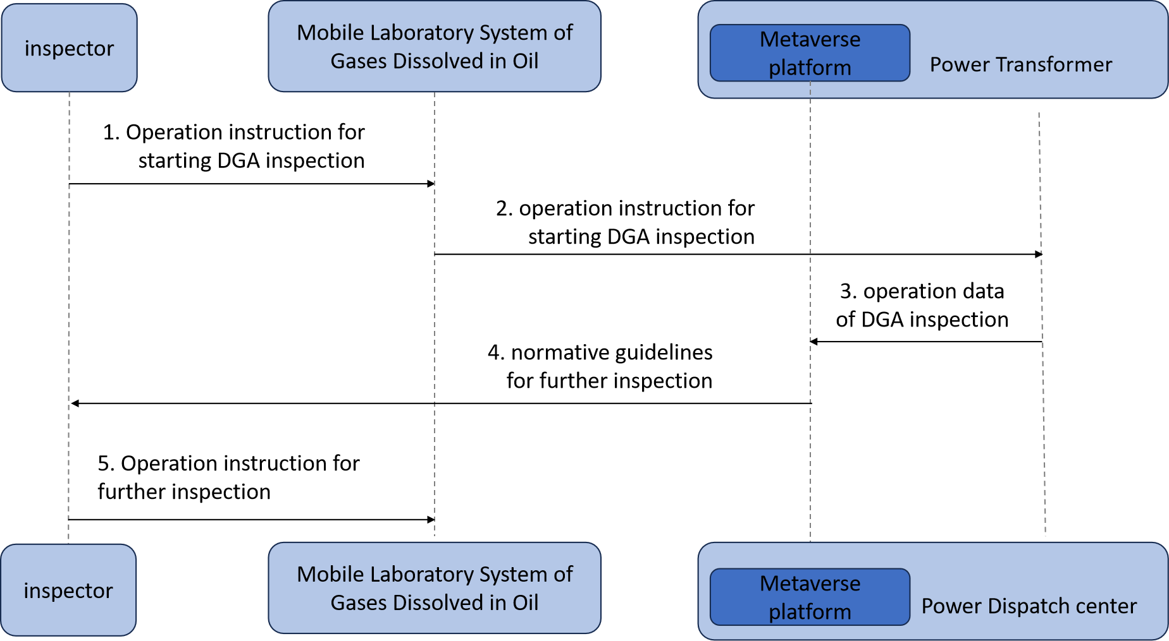

Figure 15 – Service data flows for the DGA inspection use case

1) An inspector delivers operational instruction to a mobile laboratory system to start a DGA inspection.

2) A mobile laboratory system forwards operational instructions to a power transformer to conduct a DGA inspection.

3) A power transformer delivers operational data of a DGA inspection to the metaverse platform.

4) A metaverse platform evaluates the operational data of a DGA inspection to diagnose potential abnormalities of a transformer. Then, it generates normative guidelines for further inspection and delivers the guidelines to the inspector.

5) The inspector delivers further operational instruction to a mobile laboratory system to proceed on a DGA inspection (if necessary).

Bibliography

[b-ITU-T L.1220] Recommendation ITU-T L.1220 (2017), *Innovative energy storage technology for stationary use - Part 1: Overview of energy storage*.

[b-ITU-T L.1240] Recommendation ITU-T L.1240 (2022), *Evaluation method of safety operations and energy saving for power supply systems in telecommunication rooms or buildings*.

[b-ITU-T M.3080] Recommendation ITU-T M.3080 (2021), *Framework of artificial intelligence enhanced telecom operation and management (AITOM)*.

[b-ITU-T Y.3090] Recommendation ITU-T Y.3090 (2022), *Digital twin network – Requirements and architecture*.

[b-ITU-T Y.4000] Recommendation ITU-T Y.4000/Y.2060 (2012), *Overview of the Internet of things*.

[b-ITU-T Y.4600] Recommendation ITU-T Y.4600 (2022), *Requirements and capabilities of a digital twin system for smart cities*.

[b-Chen] Chen Y., Chen X., Chen X. and Nicholas. M., (2012), *The Fair Allocation of Power to Air Conditioners on a Smart Grid*, IEEE Transactions on Smart Grid, Vol. 3, No. 4, pp. 2188–2195.

[b-Chengshan] Cheng S., Wang Y., Liao W., Zuo X. and Dai Jiang., (2022), *Bi-level multi-objective optimization of a new energy microgrid with electric vehicles*, Power System Protection and Control, Vol. 50, No. 12, pp. 63-71.

[b-Chenweijia] Chen W., Li G., Zhang T., Zhou M. and Wang J., (2023), *A Scheduling Approach for Fuel Cell Hybrid Electric Vehicle Fleets Considering Carbon*, Power System Technology.

[b-He] He X., Chen M., Tang Y., Qian A., and Zhang D., (2022), *System Theory Study on Situation Awareness of Energy Internet of Things Based on Digital Twins and metaverse (I): Concept, Challenge, and Framework*, Proceedings of the CSEE. <https://doi.org/10.13334/j.0258-8013.pcsee.222413>

[b-Jiang] Jiang T., Li Y., Jiang Y., Zhou H. and Ju P., (2022), *A review of key technologies for temperature-controlled loads to provide auxiliary services to the power system*, Automation of Electric Power Systems, Vol. 46, No. 11, pp. 191-207.

[b-Kang] Kang M., Tsb. B., Vkr. A., Pk. C., Sgs. A., and Skr. A. (2021), *Empowering smart grid: a comprehensive review of energy storage technology and application with renewable energy integration*, Journal of Energy Storage, Vol. 39, No. 7, pp. 102591.1-102591.22.

[b-Li] Li P., Wang H., Wang Y., Han Y. and Li W. (2017), *Improving the peaking capacity of CHP units using the thermal dynamics of buildings and heat networks*, Automation of Electric Power Systems, Vol. 41, No. 15, pp. 26‑33.

[b-Lv] Lv Q., Chen T, Wang H., Yu T., Li Q. and Tang W. (2014), *Analysis of peaking capacity of cogeneration units after configuration of heat storage*, Automation of Electric Power Systems, Vol. 38, No. 11, pp. 34-41.

[b-Verda] Verda, V. and Colella, F., (2011) *Primary energy savings through thermal storage in district heating networks*, Energy, Vol. 36, No. 7, pp. 4278-4286.

[b-Wang] Wang Q., Liu J., Hu Y., and Zhang X. (2019), *Optimal Operation Strategy of Multi-Energy Complementary Distributed CCHP System and its Application on Commercial Building*, IEEE Access, vol. 7, pp. 127839‑127849.

[b-Wangjing] Wang J., Wang L., Guo Y., Sun Y. and Guan C. (2016), *Microgrid economic dispatch method considering electric vehicles*, Power System Protection and Control, Vol. 44, No. 17, pp. 111-117.

[b-Xu] Xu W., Zhou D., Huang X., Lou B. and Liu D. (2020), *Optimal allocation of power supply systems in industrial parks considering multi-energy complementarity and demand response*, Applied Energy, Vol. 275, No. 8, pp. 115407.1-115407.10.

[b-Yaoyao] Yao Y., and Zhang P. (2018), *Coordinated control method for large-scale inverter air conditioners participating in auxiliary services of power systems*, Automation of Electric Power Systems, Vol. 42, No. 22, pp. 127‑134.

_____________