Standardization Sector
ITU-T Focus Group Technical Report
(10/2025)
ITU Focus Group on cost models for affordable data services
Terminology and taxonomy for international Internet connectivity
Working Group 2: International Internet connectivity cost
ITUPublications | International Telecommunication Union


Technical Report ITU-T FG-CD-D6
Terminology and taxonomy for international Internet connectivity

Summary
This Technical Report examines international best practices in cost assessment methodologies, regulatory frameworks and standardization approaches relevant to ensuring affordable data services. It provides an overview of key cost modelling techniques – such as long-run incremental cost (LRIC), fully allocated cost (FAC) and hybrid models – and their application in different regulatory contexts. The report highlights how accurate cost accounting, supported by transparent and standardized practices, can help balance affordability for consumers with the financial sustainability of service providers. It further emphasizes the need for ongoing research and cross-sector collaboration to adapt cost models to technological advancements and evolving market dynamics, ultimately promoting universal access to affordable data services.
Keywords
Activity-based costing (ABC), affordable data services, FAC/FDC (fully allocated cost/fully distributed cost), infrastructure sharing, interconnection; life-cycle costing (LCC), long-run average incremental cost (LRAIC), long-run incremental cost (LRIC), LRIC-plus (LRIC+), reference interconnection offer (RIO), retail-minus, scorched-node, spectrum policy, total service LRIC (TSLRIC/TSLRIC+), weighted average cost of capital (WACC), IP transit, last mile, first mile, Internet supply chain, middle mile, international mile, international transit, bandwidth costs, peering costs, donut peering, Internet exchange point (IXP), submarine cable, satellite broadband, spectrum refarming.

Note
This is an informative ITU-T publication. Mandatory provisions, such as those found in ITU-T Recommendations, are outside the scope of this publication. This publication should only be referenced bibliographically in ITU-T Recommendations.

Change Log
This document contains Version 1.0 of the ITU-T Technical Report on "Terminology and taxonomy for international Internet connectivity" approved at the FG-CD meeting held online on 1 October 2025.

Acknowledgements
This Technical Report was written by the Editor below based on input documents received and outputs of WG 2, as a contribution to the ITU Focus Group on cost models for affordable data services (FG-CD). If you would like to provide any additional information, please contact Vijay Mauree at tsbfgcd@itu.int.

Editor: | Prof. Emanuele Giovannetti  Anglia Ruskin University and  FG-CD Vice Chair | Email: emanuele.giovannetti@aru.ac.uk

© ITU 2026
Some rights reserved. This publication is available under the Creative Commons Attribution-Non Commercial-Share Alike 3.0 IGO licence (CC BY-NC-SA 3.0 IGO; https://creativecommons.org/licenses/by-nc-sa/3.0/igo).
For any uses of this publication that are not included in this licence, please seek permission from ITU by contacting TSBmail@itu.int.
Table of Contents
Page
1 Introduction 1
2 The four (plus one "invisible") miles of the Internet supply chain 5
3 Infrastructure costs 6
3.1 Submarine cable infrastructure 7
3.2 Satellite infrastructure 8
3.3 Internet exchange points (IXPs) 11
3.4 International Internet routing as digital value chain 13
3.5 Bandwidth costs 16
3.6 International bandwidth capacity 21
4 Market demand: international bandwidth usage 22
5 Market and competitive costs 24
5.1 National regulation that mandates access to international facilities 24
5.2 Policies to reduce the costs of international connectivity 25
5.3 Dynamic competition 26
6 References 26
6.1 Policy references 26
Appendix I 27
Bibliography 30

Technical Report ITU-T FG-CD-D6
Terminology and taxonomy for international Internet connectivity

1 Introduction
The costs of international Internet connectivity (IIC) play a vital role in influencing the accessibility and affordability of Internet services around the globe. The International Telecommunication Union (ITU) collects data, indicators and metrics that are a natural starting point for analysis of country and regional differences in their costs of international Internet connectivity.
The purpose of this report is to clarify terminology and organize a taxonomy relevant for the metrics and indicators that the ITU uses to quantify and evaluate the global costs associated with international Internet connectivity.
Also, when possible, suggestions for improvements, of either the metrics, underlying concepts, or practical data access that make the use of this valuable data easier for policymakers, are considered. Hence, some additional metrics and extensions based on external data sets are also proposed, as a relevant step forward to assess the costs of IIC, whenever possible and relevant within the scope of this initial enquiry.
The broad cost categories of relevance for Internet connectivity can be grouped into: infrastructure costs, bandwidth costs, operational costs, regulatory costs, market and competitive costs, geographic and environmental costs and end-user costs. In the following, a taxonomy is suggested some of these costs' components are considered and discussed, focusing whenever possible on their relevance for international Internet connectivity.
Before exploring the above costs categories in more detail, and while a comprehensive ITU-D (2021) document on modelling cost and guidelines is available, we discuss some of the key terms of particular importance on the methodology for assessing connectivity integrating material from ITU-D (2021) with four contributions, presented by Mr Papa Gorgui TOURE, from [b-Tactikom, 2025-1], [b-Tactikom, 2025-2], [b-Tactikom, 2025-3], [b-Tactikom, 2025-4] to this Focus Group's Online meeting held on 25 June 2025.
These considerations are of specific relevance for sectors moving from a previously monopolised state to a more competitive one. In detail, ex-ante regulation, often based on modern equivalent asset (MEA), defined by the Independent Regulators Group (IRG) as "The lowest cost asset, providing at least equivalent functionality and output as the asset being valued" was essential when there was a simple monopolised operator, to assess relevant costa and prevent excessive markups on these costs. However, in a more competitive setting, ex-post regulation becomes essential, and it needs to rely on real data from operators who actively contribute to cost calculations. This collaborative approach, also termed co-regulation, aligns regulatory policies with operators' business needs. This requires moving to hybrid cost models, balancing regulatory oversight with support for competitive marketing strategies in increasingly complex market ecosystems [b-Tactikom, 2025-1].
This new context requires an analytic accounting perspective, whereby fully allocated costs (FAC), defined as "attributes the costs (including common and joint costs) to services based on each service's utilization of the different cost elements (i.e., table of routing factors)" [b-ITU 2021], i.e., are to model costs, avoiding the inclusion of any cost not specifically related to telecommunication applications and their services.
These advanced cost models often incorporate a system termed activity-based costing (ABC), particularly suitable with the process of virtualization of network functions which are no longer necessarily tightly associated with dedicated physical infrastructure. ABC can be defined as a system to measure the cost and effectiveness of activities, products and services based on the resources used to create the relevant product or service. The ABC therefore estimates the costs of these resources, used or spent in a given process, consisting of the set of activities required to produce products or services. Operationally, these resources are first allocated to the specific activities, followed by a second phase where these activities are allocated to the products. This allocation is made in both cases through their cost drivers. As suggested by [b-Tactikom, 2025-2], when a cost model adopts the "ABC" system, the best way to go may be full simulation of all activities of the operator, whereby an activity is composed of many tasks, each of which with different characteristics.
This leads to the relevance of focusing on how the main activities are composed. As discussed below in the report, this involves a clear representation of the network aspects of the relevant services, including access to users, domestic nodes or switches, international nodes or switches, domestic transmission routes, national transmission routes and international transmission routes. Once these activities are identified, the next step is to allocate all eligible costs to each of the main activities, calculate the sharing factors of each main activity among the operator's subnetwork, fine-tune the routing factors of each subnetwork share among services defined on each application, calculate services volumes and, finally, derive the average cost price per service unit.
An analytical allocation of costs is therefore essential for including critical elements such as network virtualization, interoperator cost sharing and territorial coverage requirements, all requiring passive infrastructure sharing [b-Tactikom, 2025-1], since entry costs would remain unbearable if they were not allowed to share passive infrastructure of incumbent operator and have interconnection agreement with the latter. As stated, "Passive infrastructure sharing is where non-electronic infrastructure such as towers, poles, ducts and premises are shared but all the active network electronics remains proprietary to the individual network operators". Similarly required is the costing of forms of active infrastructure sharing, mainly via the introduction of costing mechanisms for national roaming agreements, whereby "Active sharing includes electronic infrastructure such as switches and radio access nodes as well as passive network elements." Active infrastructure sharing can be implemented in alternative ways depending on how deeply the active electronics are shared: multi-operator radio access network (MORAN) where the components of the radio access network are shared, but each operator is assigned its own dedicated radio spectrum, multi operator core network (MOCN), where radio network elements and spectrum are shared, but each operator maintains its own core network; and national roaming – where the entire mobile network is shared, for example to extend the service coverage area of a smaller network operator [b-ITU-World Bank 2022].
Long run incremental costing, (LRIC), defined by Ofcom as "a forward-looking approach to costing that values assets on the basis of the cost of replacing or providing them today". In other words, LRIC treats the cost of a product as the sum of strictly product-specific fixed and variable costs and looks to the cost of replacement or provision in assessing cost. These can be further sub-divided [b-ITU 2021] into: pure long-run incremental costs (pure LRIC), "the costs that would be saved if certain services, groups of services or activities (defined as an increment) were not provided. These incremental costs are aligned with the variable costs in the long run. In this approach, neither common costs nor joint costs are allocated to the services" and long-run incremental costs plus common costs (LRIC+), that allows for the recovery of common and joint costs that are not incremental to any given service.
Two alternative cost-modelling approaches are defined in [b-ITU 2021]: top-down cost models (TD) are built up starting from an operator's balance sheet and bottom-up cost models (BU) are built up starting from a set of basic inputs (e.g., demand, coverage, geographical and technical information). The network costs are then calculated as the product of the number of network elements and their unit cost. BU cost models are especially relevant as being used for setting: interconnection charges, wholesale access costs and international Internet connectivity costing [b-Tactikom, 2025-3]. This approach ensures that cost models reflect technological efficiency but also respect historical/geographical realities of a country's telecom infrastructure. BU requires a whole-network cost modelling, hence a representation of the relevant network topology.
There are three common approaches used for network topology design in bottom-up models [b-ITU 2021]: scorched node, which uses the location of existing network nodes; modified scorched node, whereby the location of network nodes does not correspond strictly to operators' networks but is based on their existing nodes and scorched Earth, which estimates the locations of an optimized network without the restrictions of the existing network.
The scorched node, where existing network node locations, such as switches, exchanges, routers, are kept fixed, but, within this fixed node structure, an entrant is allowed to re-optimize transmission links, capacities and equipment is used by regulators and analysts to estimate fair and efficient costs for interconnection and international connectivity.
In order to include different activities, the concept of network slicing (NS) is essential [b-Tactikom, 2025-4]. NS "Enables multiple logical networks to operate on a shared physical network infrastructure by creating "slices" that are logically separated, self-contained, independent and secured. These sliced networks can be independently configured to target specific services or users with distinct needs for speed, latency and reliability. Network slicing focuses on the generation of multiple, independent virtual networks on a common physical telecom infrastructure, each optimized for specific services or user requirements. The comparison of resources aggregated under each main activity with the share of those belonging to each vertical layer (subnetwork) will result in the calculation of the main activities sharing factors. In this case, the vertical layer (subnetwork) is a functional segment of a telecommunications network that represents one stage of the end-to-end transmission chain (such as access, middle mile, core, or international connectivity), typically defined by its role, technology, and position within the overall architecture. It is "vertical" in the sense that each layer builds upon the underlying infrastructure to provide progressively higher-level services and it can be defined as a subnetwork, or as a logical or functional part of the network (e.g., access, aggregation, core, international transit), that is considered as a building block with its own resources (equipment, links, capacity) and the overall costs are first estimated per subnetwork, then attributed to services based on usage within the whole system, with its own topology, nodes, costs, and management responsibilities. Hence, different vertical layers are interconnected, to form the complete end-to-end network (E2E), the entire path between endpoints in a communication, including all network segments, devices, access, core, edge, transport, any intervening network (or cloud/network-cloud segments), up to the user/terminal, and the application. The idea is that from the origin/source device or server to the destination device or server, everything in between affects the service. On each subnetwork, the comparison between resources aggregated under main activities (horizontal layers) on single or grouped applications and those associated with each service defined therein, will result in routing factors (RF) calculations. RF are the coefficients used to translate resource usage into service-specific cost allocation. Hence RF address the question of "How much of each subnetwork's resources does a given service consume?". Their calculation is based on a multistep process. First, aggregate resources under main activities (horizontal layers) then by distributing the activity resources into subnetworks (vertical view) and finally, allocating these to services using routing factors, given that each service (voice call, broadband, leased line, streaming, etc.) has a different routing path through subnetworks [b-Tactikom, 2025-2].
In conclusion, this report focuses on clarifying the terms and proposing a taxonomy underlying the costs of international Internet connectivity, based on causality as the key guiding principle [b-Tactikom, 2025-2]. Causality means that costs should be attributed according to the actual cause-and-effect relationship between resource consumption and service provision; hence, a service should bear costs only to the extent it causes them to be incurred and, if a service does not drive the use of a resource, it should not be allocated those costs.
The causality principle directly underpins the two structuring rules of analytic accounting: the principle of fairness which is to protect the service provider (appropriate part of any resource used by a service must be charged to the latter) and the principle of justice, i.e., to protect the consumer (no part of a resource not used by a service should be charged to the latter). In this setting, the principle of causality ensures that routing factors (the proportional use of subnetworks/resources by each service) are the mechanism linking cost origin to cost allocation, simultaneously avoiding cross-subsidies, where one service pays for another's costs, and under-recovery, where the operator fails to recover costs for certain services, allowing for a bottom-up Total Service Incremental calculation of resources shares used by each service in all sections of the network.
In summary, according to [b-Tactikom, 2025-2], the key costing steps, some of which will be expanded upon further in this report, consist in: i) Identify subnetworks, ii) Identify applications (which can also be grouped by categories), iii) Describe the topology of each subnetwork (scorched node approach), iv) Describe the sharing principles of each main activity, v) Define the services for each application (or category of applications), vi) Collect the data on traffic of each application (or category of applications), vii) Test the full path of nodes and routes dimensioning, including incremental effect of services on resources; viii) Calculate the main activities sharing and subnetworks applications routing factors; ix) Proceed with the analytic division of all administrative, technical and commercial support; x) Analytic dumping of administrative charges on commercial and technical activities; xi) Affectation and/or allocation of resulting technical and commercial to main activities using, where appropriate, distribution keys taken from technical analysis made above; xii) Calculate and allocate weighted average cost of capital (WACC), whereby WACC corresponds to the average rate of return that capital providers (equity + debt) require for financing the network. Such rate, WACC, is usually applied to the regulatory asset base (RAB) – i.e., the value of the capital invested in the network infrastructure. Its role is to ensure the fair remuneration of invested capital, so that operators can recover both, operating costs (OPEX) and capital costs (CAPEX + financing costs); xiii) Apply sharing and routing factors to the aggregated main activities costs to have total endogenous cost price of each service, and finally, xiv) Calculate the unit cost of each service and of each main activity.
In this way, once the total capital cost (depreciation + WACC × RAB) is known, it must be allocated causally across services. Without causality, WACC-based capital costs could be misapplied, leading to overcharging some services (violating justice) or undercharging others (violating fairness, and possibly deterring efficient investment). In summary, the causal principles discussed earlier (fairness & justice) apply not only to OPEX and resource use, but also to the financial cost of capital (WACC). Practically, this is achieved by mapping subnetwork assets (with WACC) to service usage via routing factors.
In the following, after having clarified in this introduction the key approach used for the costing of Internet connectivity, we focus on the specific terminology for the different elements and activities underlying the costing for International Internet connectivity.

2 The four (plus one "invisible") miles of the Internet supply chain
The costs of international Internet connectivity results from a complex series of steps through which Internet contents are transmitted from origin to source. These steps, forming the Internet supply chain, are subdivided into different relevant segments, also called "miles" each one interacting with the others in a non-necessarily linear way, and each one populated by complex ecosystems of players. While a full description of this, though necessary, goes beyond the scope of this document, here we report some of the key concepts and terms that help in identifying the key steps whereby international Internet costs forms, and can therefore be addressed by policymakers. The ITU workshop on cost models for data services and international Internet connectivity (8-9 April 2024) addressed some of these issues in different presentations.
The "Internet supply chain" components are characterised by the different steps that range from the first mile to the middle mile and finally to the last mile, based on the original World Bank definition of the four "miles" that form the various segments of telecommunications and Internet networks.Their definitions are provided below.
• International mile: refers to the international connectivity that links a country to the global Internet. This typically involves undersea cables, satellites, and cross-border fibre-optic cables. Importance: This mile is crucial for a country's connection to the global information infrastructure, allowing data to flow in and out of the country. It represents the international gateways through which Internet traffic enters and exits a nation.
• Middle mile: refers to the backbone network and infrastructure that connects the international gateways to regional and national networks within a country. Long-distance fibre-optic cables and other high-capacity links typically form the middle mile, ensuring efficient and reliable data transmission across a country. This also includes critical components such as national backbones, intercity networks, local hosting of content and IXPs.
– A critical component of this mile is formed by the content delivery networks (CDNs). These are essential to cache data in every country, and the denser they are the shorter the chains need to be to access data locally. Only a few countries have a density of caches in tier 2 cities, and, notably, most caches are from private groups such as Google and Meta.
– The second critical component is the fibre cable. With regard to this, the World Bank, in collaboration with the International Telecommunication Union (ITU), developed the open fibre data standard (OFDS) initiative [b-D'Ignazio 2009]. This standard provides a framework for collecting, sharing, and utilising data related to fibre-optic infrastructure in a consistent and interoperable manner. By standardising the way data about fibre networks is collected and shared, the OFDS leads to improved transparency and reduced information asymmetry. It supports efficient network planning and deployment and promotes investment by reducing risks associated with infrastructure development. However, the OFDS is also crucial for enhancing the ability of regulators, operators, and governments to effectively monitor and manage telecommunications infrastructure. Interestingly, the OFDS includes data on physical infrastructure: information about the physical attributes of the fibre network, such as cable routes, types of cables, and physical locations of nodes; network topology: details on how different parts of the network are interconnected, including the relationships between different network elements (e.g., connections between nodes and links); operational data: data related to the operational status of the network, such as the capacity of links, traffic data, and performance metrics; ownership and access rights: information on who owns different parts of the network and the access rights associated with them; geospatial data: geographical data that shows the exact location of fibre-optic cables and infrastructure on maps, using standardised geospatial formats. One of the key features of the OFDS is its focus on interoperability. The standard is designed to be compatible with existing data systems and formats used by different stakeholders, including telecommunications operators, governments, and regulators. Interoperability facilitates the easy sharing and integration of data across various platforms and systems.
• Last mile: refers to the final segment of the network that connects end-users (households, communities, businesses, and institutions) to the broader telecommunications network. This could involve various technologies, such as fibre-optic lines, DSL, cable, wireless, or even satellite connections, depending on the geography and urbanisation of an area. The last mile is often the most challenging and expensive segment to develop, especially in remote or rural areas.
• First mile: focuses on the end-user devices and local access networks that connect users to the last mile infrastructure. This includes routers, modems, mobile phones, computers, and local area networks (LANs). The first mile is essential for enabling users to access the Internet. Together, these "miles" describe the entire journey of data from international sources through national infrastructure down to the individual user and their devices. Each mile has its own set of challenges and requirements, and effective network development needs to address all four to ensure affordable access to Internet services.
However, it has been noted that also essential is the notion of a fifth mile, also called invisible, as it is composed of an immaterial infrastructure.
• Invisible mile. This refers to aspects of network infrastructure and connectivity that are not physically visible and is used to describe elements like spectrum management, policy and regulatory frameworks, data governance, cybersecurity, and the quality of service that support and enable the physical infrastructure of the network. The invisible mile, therefore, represents the less tangible elements that make networks function effectively. These elements often require strong institutional frameworks, a skilled workforce, and international cooperation, which are critical to the success of the physical infrastructure.
In the next clauses, we shall discuss in more detail some of these terms. However, for the purpose of clarifying the relevant terminology, it is helpful to also refer to the full table of OFDS terminology reported in the appendix.

3 Infrastructure costs
International Internet connectivity materializes as international transfers of Internet protocol (IP) data packets that follow specific and multiple routes from origin to final destination, where these are recomposed to acquire a meaning for the receiver. The origin might be a content hosting site and the destination is where the initial request to access a webpage hosted at such a site was done and can be located anywhere in the world. These transfers of Internet protocol (IP) data packets take place along the Internet infrastructure, and some of their costs are due to technical-cost aspects, while others are related to economic, market and potentially regulatory aspects governing the economic transactions among the different operators that own the relevant components of the infrastructure used for the IP data transfers. The infrastructure costs for ICC reflect all the steps taken by the IP data packets along the relevant infrastructure. Contrary to many other network infrastructures, such as water, gas, oil, and railways, the physical infrastructure required to carry IP data packets is very diversified. The key costs associated with each different typology are:

3.1 Submarine cable infrastructure
Costs associated with the installation, maintenance, and operation of submarine cables that facilitate international data transmission. Typical data sources for submarine cable infrastructure are industry reports and databases from submarine cable operators (see Figure 1).
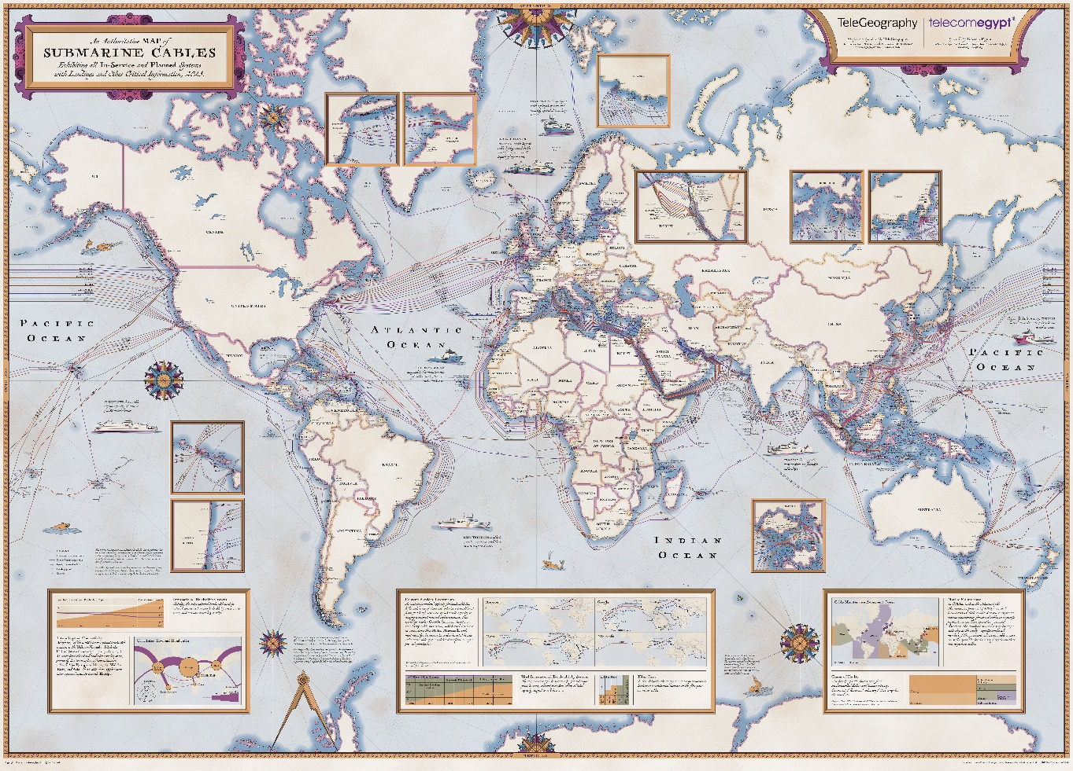
Figure 1 – Submarine Cables, Telegeography*
There is a necessity to factor into the costs the impact of "single points of failures" such as cable cuts, as subsea cables may take long to repair, as well as those of "areas of risk" such as corridors that contain multiple subsea cables. This leads to the relevance of considering the redundancy costs. "For resilience and redundancy, it is necessary to have diverse routed transit circuits from a particular country to a particular peering point or alternate peering point. The higher the number of redundant routes, the lower the total impact on available capacity in the event of one route failure. This leads to the necessity to design networks balancing the trade-offs between the price of the long-distance routes and the network resilience by assessing the probability of a fault, the time to repair and the avoidance of any "single point of failure" that could affect more than one route due to any fault or event.
Small Island Developing States (SIDs) face very high costs for redundancy. For example, the Seychelles was connected to Internet by only one subsea cable running 1 800 km from the islands to the mainland of Africa at Dar es Salaam in Tanzania. Hence, to increase resilience via redundancy, Seychelles had to invest in a new subsea cable route to Mombasa in Kenya. Moreover, to cater for the possibility of one of the cables failing, operators may be forced to buy twice as much capacity (on each cable) than they need to deliver services. To counter these challenges faced by SIDs, some Island states, such as Cabo Verde, are positioning themselves as subsea cable hubs, linking multiple cables as they transit across oceans. These costs should be included in the costs of longline redundancy, where the cost of purchased bandwidth of each alternative route should be added as the total costs and divided by the actual amount of used bandwidth, to obtain the redundancy costs for used Mbit/s.

3.2 Satellite infrastructure
Costs related to satellite communication systems used for international Internet connectivity, including satellite launches, ground stations and satellite bandwidth. Typical data sources for satellite infrastructure are available from reports from satellite operators. According to the satellite industry report by the Satellite Industry Association "The first broadband satellite began service in 2008 with a capacity of 10 gigabits per second (Gbit/s); 2019 satellites have capacities of up to 260 Gbit/s, a number expected to increase to 1 terabit per second or 1 Tbit/s in 2023. These terabit capacity geostationary satellites will provide orders of magnitude capacity increases and resulting consumer broadband benefits, remaining competitive with terrestrial offerings. In addition to these GEO innovations, several companies have already launched or have plans to launch thousands of new high-throughput (non-geostationary) satellites in low-Earth and medium-Earth orbits to provide high-speed broadband at low latency levels. Launch, deployment and initial service offerings of the first of these operational satellites have already begun".
Figure 2 shows how satellite broadband works virtually, while Figure 3 illustrates the orbital launch attempts.
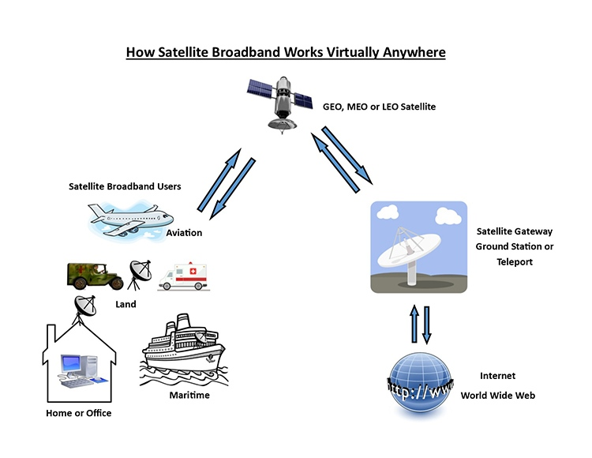
Figure 2 – How satellite broadband works
Source: https://sia.org/satellites-services/broadband-connectivity
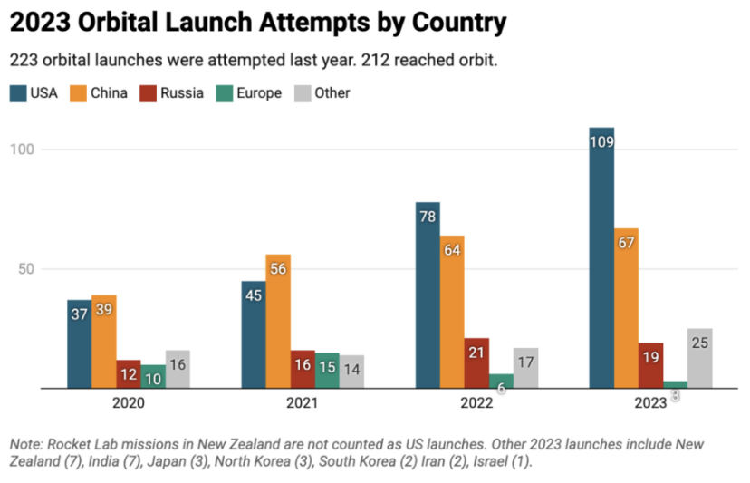
Figure 3 – Orbital launch attempts
Source: https://payloadspace.com/2023-orbital-launches-by-country/
Currently Starlink, owned by SpaceX, is one of the dominant global LEO providers; it offers subscription-based satellite Internet services that vary by region. As of mid-2025, monthly service fees in Europe average €65–€85, with higher installation costs in rural zones. In the United States, pricing is significantly higher, at around $120/month, while in developing regions such as sub-Saharan Africa or South Asia, Starlink offered discounted plans at $30–$50/month. Latin American countries report average monthly fees of $50–$70. A critical component is, however, the hardware kit, which typically might cost $300–$600 globally, though discounts are occasionally offered in partnership with governments or NGOs.
A Rest of World report, by Khadija Alam and Damilare Dosunmu, (10 January 2025) compared the price of Starlink's residential service to the cheapest unlimited fixed Internet plan offered by leading Internet service providers. The results, reported in Table 1, indicate that in at least five of the 16 African countries where the service is available, a monthly Starlink subscription is cheaper than the leading fixed Internet service provider.
Table 1 − Comparison of Starlink's residential service price with the cheapest
unlimited fixed Internet plans from leading Internet service providers
Country | Cheapest Starlink price per month (USD) | Leading fixed Internet provider | Cheapest unlimited fixed Internet price per month (USD)
Botswana | 28.54 | BTC | 27.05
Eswatini | 50.18 | EPTC's Eswatini.net | 22.66
Ghana | 33.9 | Telecel Ghana (formerly Vodafone Ghana) | 71.13
Zambia | 28.81 | Zamtel | 26.97
Kenya | 10.04 | Safaricom | 23.16
Zimbabwe | 30 | Liquid (Econet subsidiary) | 221.74
Mozambique | 46.95 | Vodacom | 54.75
Nigeria | 48.47 | IPNX | 9.59
Benin | 47.12 | SBIN | 31.29
Rwanda | 28.78 | GVA Rwanda's CanalBox | 17.99
Madagascar | 28.73 | Yas (formerly Telma) | 10.39
Cape Verde | 32.7 | Alou (CVTelecom subsidiary, formerly CVMultimédia) | 42.04
In 2025, the European Union has intensified efforts to establish sovereign and secure satellite communication infrastructure as an alternative to the growing dominance of non-European providers such as SpaceX's Starlink. At the core of the EU's ambitions is the infrastructure for resilience, interconnectivity and security by satellite (IRIS), a new multi-orbital satellite constellation funded by a public-private partnership. With a planned fleet of 264 low Earth orbit (LEO) satellites and 18 medium Earth orbit (MEO) satellites, IRIS is designed to serve both governmental and commercial needs, including secure communications, emergency response, and broadband access in underserved areas. The project is based on approximately €6.5 billion in public funding from the EU and the European Space Agency (ESA), and from private partners including Eutelsat, SES, and Hispasat. The first launches are expected in late 2025, with partial service potentially available by 2028 and full operations targeted for 2030. Complementing IRIS, the EU has approved a €3.1 billion merger between Luxembourg-based SES and USA-based Intelsat. This consolidation is expected to enhance Europe's geostationary and LEO communication capabilities, enabling faster deployment of services in critical areas. Finally, to address short-term needs until IRIS becomes operational, the EU is coordinating the use of existing governmental satellite assets through the Govsatcom initiative. Starting in 2025, EU Member States can pool available satellite capacity to support crisis response, military operations, and civil protection, thereby providing an early form of strategic autonomy.

3.3 Internet exchange points (IXPs)
Costs associated with the establishment and operation of IXPs, including infrastructure setup, maintenance, and interconnection fees. IXPs are a critical component of the Internet networks, both for domestic and international connectivity. IXPs are organisations allowing Internet service providers (ISPs) and other members of the Internet ecosystems to share the IXP infrastructure to route their upstream IP packets traffic in a cost-effective and technically efficient way. IXPs provide an example of active infrastructure sharing.
Traffic sharing through peering at IXPs is cost effective since, once an ISP is a member of an IXP, it will have no extra interconnection costs for exchanging traffic, neither to reach the peer, as the peers are already co-located at the IXPs, nor to pay for the costs of interconnection, as public peering is often free, being based on reciprocity. The key cost-saving feature of IXPs is that every member must deploy just one link, to the IXP, rather than several links equal to the number of premises of all other ISPs. Local traffic stays local instead of being rerouted, possibly over international routes, by upstream transit providers. Quality of service is particularly enhanced by virtue of the reduction of routing and hops and by keeping local traffic exchanges at the local IXP. Benefits like reduced transit costs, reduced investment costs, and improved QoS for consumers are all major success factors in reducing the costs of international Internet connectivity.
In LLDCs Local traffic that can be accessed via peering with other local providers, at IXPs, is often the 'cheapest' type of traffic, while in some more developed markets, IP transit ports are cheaper than Internet exchange (IXP) ports, and peering yields other benefits. Even for IXPs costs there is a crucial efficiency component, since payment is usually a flat fee for a port of a given amount of Gbit/s, then the effective "cost per Mbit/s" is expensive if only a small amount is utilised. A key aspect is whether global content providers are present at IXPs, so that the value an eyeball network, can get from the peering port is greater. According to ISOC, by 2019 there were some Internet exchanges in Africa where over 80% of global Internet traffic could be sourced through peering, however, this can be 10% or less in LLDCs where the local peering ecosystem is less developed. The European Internet Exchanges Association publishes live data usage of 13 of the leading African IXPs.
The distribution of IXPs across regions is uneven, as shown by data from the ITU Tariff Policies Survey, in 2021, on the availability of IXPs across regions in Table 2 below. This uneven distribution might be at the source of different connectivity costs, which underlie inequality in affordability across regions. Clearly, a detailed country analysis will be useful in better understanding the role of IXPs in determining international Internet connectivity costs and, therefore, affordability.
Another aspect of paramount importance for the functioning of IXP infrastructures is their governance. This can clearly affect the criteria and admissibility of alternative forms of peering, free or paid for, and those underlying the choice to refuse interconnection. Indeed, the interconnection cost might depend on whether IXPs are profit-driven or are cooperative membership-driven infrastructures aimed at maximising benefit for the membership. [b-ITU 2021] captured the distribution of these governance types across different ITU regions. A further key feature of the governance of this infrastructure-sharing mechanism relates to the issue of whether paid peering is allowed at the IXP. This is important since, as soon as paid peering occurs, the paid transactions at the IXP are like interconnection fees and would then become a possible subject of regulatory relevance. This data on IXPs, shown in Table 2, should be considered together with other data collected by the ITU on the modalities of international Internet connectivity, shown in Table 3, and data on the international Internet connectivity regulatory policies, shown in Table 4, to study the impact of IXPs on the final costs of countries' costs of ICC, also collected by the ITU.
• Key limitations for IXPs effectiveness
IXP members peer based on mutual willingness, as there is no obligation. In essence, the participants place their router at the IXP and advertise the IP routes that they are willing to share with their peers. Since not all members of an IXP will have peering access to all other members' routes, the effectiveness in reducing ISPs' (national or international) Internet connectivity costs will vary depending on members' mutual willingness to peer. Usually, the decisions about whether to peer or not to peer, which are represented in IXPs Peering Matrices, may depend on the nature of the two operators. These include private ISPs, national research and education networks (NRENs), Internet infrastructure operators, over-the-top (OTT) providers, application service providers (ASPs), online service providers (OSPs), content and application providers (CAPs), and possibly government networks. Moreover, the decisions about whether to peer or not to peer also depend on operators' sizes, their asymmetry, and their role within the Internet interconnection network.
IXP can also provide private peering, which still reduces costs as it takes place at an already shared location. While IXPs provide shared infrastructures among different types of members, their relevance in reducing connectivity costs is bound by the amount of peering that is taking place within an IXP [b-D'Ignazio 2009] and [b-D'Ignazio 2014]. The set of bilateral peering decisions between each member of an IXP can be visualised through their peering matrices. These provide a snapshot of how effective an IXP is in facilitating peering.
These data can be collected when they are not publicly available through the different regional IXP associations. Typical data sources for costs associated to Internet exchange points can be found in Databases and directories of IXPs (PeeringDB), reports from Internet exchange organizations (e.g., the European Internet Exchange Association (Euro-IX) that gathers 70 IXPs from around the world, or the Internet Exchange Point Report by the Internet Society. The ITU Data hub, also, contains precious data on IXPs and their governance, collected through ITU's dedicated questionnaires, from the ITU Tariff Policies Survey.
Table 2 − IXPs and their governance
 |  | Number of countries/economies
Indicator |  | Africa | Arab States | Asia & Pacific | CIS | Europe | The Americas | Total
How many Internet Service Providers are connected to each IXP in your country? |  | 21 | 7 | 9 | 3 | 12 | 16 | 68
Are IXPs in your country for profit or not for profit? * | Profit | 5 | 2 | 7 | 4 | 16 | 5 | 39
Are IXPs in your country for profit or not for profit? * | Not profit | 18 | 9 | 12 | 2 | 16 | 15 | 72
Are IXPs in your country for profit or not for profit? * | Other | 2 | 0 | 1 | 0 | 3 | 0 | 6
Is paid peering allowed at the IXPs in your country? | Yes | 3 | 4 | 8 | 1 | 18 | 6 | 40
Is paid peering allowed at the IXPs in your country? | No | 16 | 5 | 7 | 1 | 1 | 7 | 37
Is private peering allowed at the IXPs in your country? | Yes | 6 | 6 | 7 | 3 | 15 | 7 | 44
Is private peering allowed at the IXPs in your country? | No | 11 | 3 | 7 | 0 | 1 | 6 | 28
Region size |  | 44 | 22 | 40 | 9 | 46 | 35 | 196
* This indicator allows multiple choice per country/economy.
Year: 2021 or latest available data. Source: ITU World Tariff Policies Database Section 9. Part 4: Access to International Facilities (International Connectivity) ITU Tariff Policies Survey – results 2021.

3.4 International Internet routing as digital value chain
IXPs only capture one of the many relevant data points for connectivity. Suppose, for example, that you are a user accessing the Internet via a mobile Internet connection. The key elements in determining the cost of connectivity, both at domestic and international levels, depend on the set of traffic exchange agreements that drive the routing of the IP traffic from the users' mobile connection to the final destination point, be it a website hosted abroad or the e-mail address of a colleague located in the same country. Hence, the framework required to analyse the different components forming the cost of international Internet connectivity needs to shift from a simplified linear representation to a complex network scenario. Focusing on the first mile only, the process of reducing costs for a provider from blending the expensive longline international circuits with the local traffic options is represented in the complex network Figure 4, below.
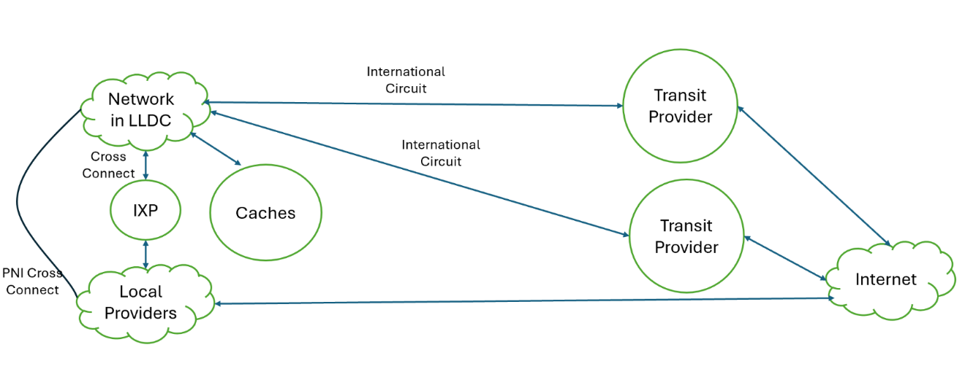
Figure 4 – Complex network
Leading to a cost formula that includes the different cost elements of connectivity within a blended complex IP transit model, for the first mile.
$$First Mile Cost per Mbit/s= \frac{Longline Cost+Redundant Longline Costs+IXP Caching Costs+PNI Peering Costs+Caching Costs+ IP Transit Cost}{Used Bandwidth (Mbps)}$$
In a complex network model, the network infrastructure design and governance determine the path and modalities for the exchange and transport of Internet protocol (IP) data packets. As for most digital commodities and markets, the key cost in interconnection markets is mainly associated with fixed costs, as actual variable per-byte costs are often negligible. Hence, the key elements underlying the fixed costs are:
i) The cost is embedded in the contractual conditions defining the terms of each traffic exchange among different providers, or autonomous systems (AS) by suppliers on top of technological costs. These markups on original input costs might add up along the entire sequence of hops in an end-to-end communication path. Some of these hops might have a zero price if they happen through free peering or similar traffic exchange agreements, while others are usually priced in terms of carrying capacity, e.g., based on fixed-price contracts, with traffic capacity ceilings. However, these additional trading costs result from the set of (often confidential) bilateral agreements established among providers.
ii) The actual length, in terms of the number of hops that the end-to-end path needs to go through from the origin to the destination of a traffic exchange, determines the number of implicit and explicit contractual steps required for a successful information transfer. Clearly, this length depends on the properties and design (topology) of the network, in particular its density, average path length, and overall level of network hierarchy.
This leads to the relevance of assessing the possible emergence of bottlenecks, or gatekeepers, that may control key parts of the interconnection network. Such control, if present, allows for the possibility of increasing markups on the cost of services, and of interconnection, thereby eventually reducing the affordability of international Internet connectivity. The key point is that the structure, concentration, and governance of networks carrying international Internet traffic significantly contribute to differences in local access costs and determine affordability. These routing factors affecting cost determination, however, provide new challenges, as the tools and methods to assess market concentration across the different networks of the Internet are characterized by a lack of data and difficulties in market definitions and require an approach that can identify the key elements of network centrality of particular operators within the entire system.
This possibility clearly highlights the importance of developing relevant regulatory information based on the scorched node approach discussed in clause 1, which focuses on the topological representation of networks. This approach is essential not only for determining access costs and ensuring interoperability, as emphasized by the open fibre data standard (OFDS) initiative, but also for identifying potential price mark-ups related to international Internet connectivity costs due to established provider network centrality.

3.4.1 International Internet connectivity network infrastructure from a user's perspective
The representation of the Internet as a complex network has a long history and dedicated research centres worldwide; see, for example, the centre for applied Internet data analysis (CAIDA) work. Understanding the full formation of costs requires focusing on exploring the international Internet connectivity network starting from a final user's perspective, for example, starting from data collected from users' mobile handsets and exploring the effects of connectivity bottlenecks all the way along the complex upstream access layers of the Internet, as they all will ultimately affect a user's mobile broadband affordability.
Traceroute, a diagnostic command-line interface command for displaying possible routes (paths) and transit delays of packets across an Internet protocol (IP) network, can be used to explore the complex networks formed by international Internet connectivity, based on the identification of all the steps (hops) of an end-to-end path. These hops display the entire network of possible routes from a mobile user accessing the Internet from a given mobile provider to any destination, domestic or international. Once the network is represented, it becomes possible to identify the operators that serve as key essential nodes within this complex network, potentially acting as "gatekeepers" who may impose higher markups on costs, resulting in increased final international Internet connectivity prices and reduced affordability.
• Metrics assessing gatekeepers' centrality and overall hierarchy in international Internet connectivity networks
Once the complex network links and nodes are identified, two simple metrics can be used to estimate the level of concentration of these networks and hence the possibility of specific providers charging higher markups, leading to lower affordability in international Internet connectivity. These are:
a) Clustering coefficient: measuring how well-connected a node's neighbours are to each other. See Figure 5, below:
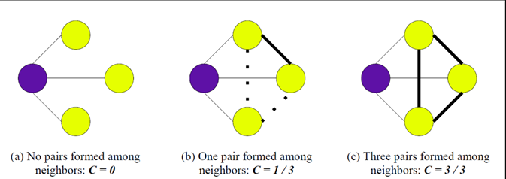
Figure 5 – The clustering coefficient
b) Eigenvector centrality, a metric to measure a provider's (node's) direct and indirect power and influence, capturing a node's network centrality as well as the centrality of its connections, and of their connections, etc.
Clearly, a gatekeeper role emerges, with the risk of increasing the price-cost margins when a provider along the IP packet routing path is very well connected, it has high (eigenvector) centrality, and its direct neighbours are poorly interconnected among themselves so that they are unable to bypass such a central node, for example, to access an international gateway.

3.5 Bandwidth costs
These are another critical cost element. The focus here is on the portion of access costs to international connection in retail price and can be divided into: international bandwidth prices, peering costs, and transit costs.

3.5.1 Portion of access costs to international connection in retail price
The ITU collects data about the Portion of access costs to international connection in retail price (series ID 11901, series code tpInterInternetConn_PortionOfCost). This is a crucial variable to understand the link between international Internet connectivity and affordability. From this data, the relationship is particularly evident among the 7.65% of countries in the world where access costs represent more than 50% of the total cost. This data also shows that this percentage increases to 15.90% for African countries.
Table 3 details the portion of access costs to international connection in retail price.
Table 3 − Portion of access costs to international connection in retail price
Portion of access costs to international connection  in retail price | World | Africa | Arab States | Asia & Pacific | CIS | Europe | Americas
Above 50% | 7.65% | 15.90% | 4.54% | 10% | 0% | 4.34% | 2.85%
26% – 50% | 9.18% | 22.70% | 9.09% | 7.50% | 11.10% | 2.17% | 2.85%
10% – 25% | 11.20% | 20.50% | 13.60% | 15% | 0% | 2.17% | 8.57%
Less than 10% | 10.20% | 2.27% | 18.20% | 2.50% | 22.20% | 19.60% | 8.57%
Source: ITU https://datahub.itu.int/data/?i=11901
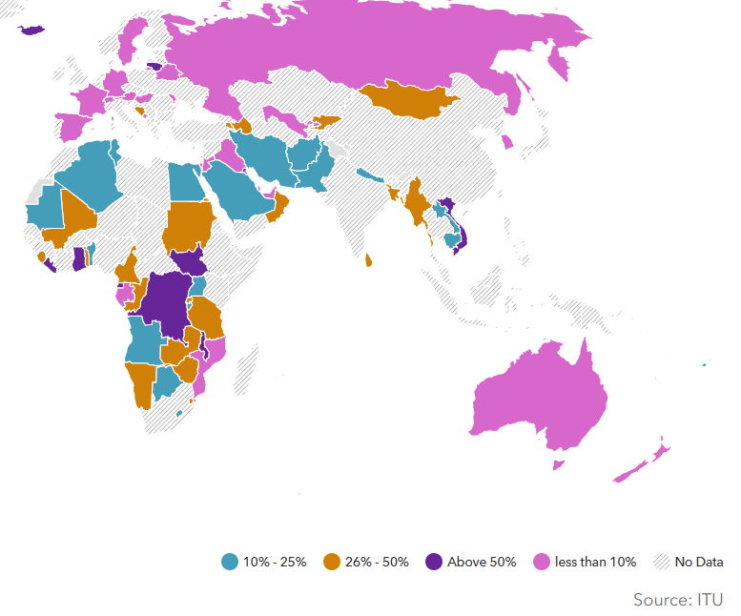
Figure 6 – Map of access costs to international connection in retail price*

3.5.2 International bandwidth prices
These are costs incurred by Internet service providers (ISPs) for purchasing international bandwidth from submarine cable operators or satellite providers for transmitting data across international borders. Prices are typically expressed in price per megabits per second (Mbit/s) or price per gigabyte (GB) of data transfer.
While the ITU does not publish this data, it collects the distribution of these alternative modalities to access to international connectivity and international landing points are collected by the ITU. This data is based on 136 countries out of 196 countries, 2021. In addition, data on three, not mutually exclusive, modalities are presented: submarine cable, used by 52.6% of countries; fibre used by 46.9% of countries; satellite used by 50% of countries and other modalities are used by 5.1% of countries. Limitation of publicly available data: ending years per country are inconsistent across economies. The web-based views are clear; the downloaded files are not user-friendly for policy elaborations and statistical analysis about the different modalities. These are in a downloadable file under the different indicator International Landing points, that seem to be equivalent to the modalities feature of the indicator "Country access to international connectivity".
Table 4 shows the modalities of international Internet connectivity.
Table 4 − Modalities of international Internet connectivity
Indicator |  | Africa | Arab States |  | Asia & Pacific |  | CIS | Europe | The Americas | Total
Does your country have access to international connectivity? | Yes | 40 | 17 |  | 28 |  | 6 | 39 | 31 | 161
Does your country have access to international connectivity? | No | 0 | 0 |  | 0 |  | 0 | 0 | 0 | 0
If yes, by which modes?* | Submarine cable | 33 | 16 |  | 22 |  | 1 | 23 | 30 | 125
If yes, by which modes?* | Satellite | 32 | 14 |  | 26 |  | 4 | 25 | 21 | 122
If yes, by which modes?* | Fibre | 30 | 12 |  | 16 |  | 6 | 32 | 20 | 116
If yes, by which modes?* | Other | 2 | 1 |  | 3 |  | 0 | 7 | 1 | 14
How many international landing stations do you have in your country? Please indicate the number of points per type.* | Submarine cable | 26 | 15 |  | 21 |  | 1 | 11 | 22 | 96
 | Satellite | 24 | 11 |  | 21 |  | 3 | 6 | 12 | 77
 | Fibre | 22 | 13 |  | 11 |  | 5 | 9 | 11 | 71
 | Other | 4 | 0 |  | 1 |  | 0 | 4 | 1 | 10
Who has control over the landing points in your country?* | Incumbent operator | 19 | 13 |  | 20 |  | 4 | 19 | 17 | 92
Who has control over the landing points in your country?* | Government | 11 | 4 |  | 6 |  | 2 | 3 | 4 | 30
Who has control over the landing points in your country?* | Private and Public Partnership (PPP) | 12 | 1 |  | 3 |  | 1 | 8 | 2 | 27
Who has control over the landing points in your country?* | Consortium of alternative operators | 5 | 3 |  | 4 |  | 0 | 3 | 4 | 19
Who has control over the landing points in your country?* | Other | 10 | 6 |  | 11 |  | 2 | 20 | 15 | 64
Region size |  | 44 | 22 |  | 40 |  | 9 | 46 | 35 | 196
Typical industry data sources for costs associated to international bandwidth prices may be costly to be obtained, and can be found in telecommunications market reports and databases (TeleGeography's Global Bandwidth Research Service), as well as pricing data from ISPs, telecommunications regulators, and industry associations.

3.5.3 Peering costs
Costs associated with establishing peering agreements with other networks or ISPs to exchange traffic directly, reducing the reliance on expensive transit routes. Peering costs might be zero, i.e., network can exchange IP packets for free, or might be paid for. The key difference with transit is that traffic even under paid peering is only exchanged directly and not carried to other providers across the Internet. Hence, peering, free or paid for, only allows for limited direct reach, while not granting universal connectivity. An example of peering can be seen for Google. "Google has an open peering policy, subject to certain technical, commercial and legal requirements". All of Google's peering locations at the Internet exchanges (IXPs) and private facilities are in its PeeringDB entry. "Google offers peering on a non-charged ("settlement free") basis". Note that this type of direct peering occurs at common physical locations and both Google and any peering network bear their own costs in reaching any such location. As a result, networks may find that peering reduces their overall costs compared with exchanging traffic with Google via their upstream transit providers.
Typical peering costs data, when this is not free, are kept in agreements and pricing information, which is rarely disclosed by ISPs and network operators, and in reports on Internet peering and transit arrangements from industry analysts.

3.5.4 Transit costs
Costs incurred by ISPs for routing international Internet traffic through transit providers or upstream carriers. The workshop presentation by Brian Longwe, CTN, Malawi on "New & Old Models for Internet Connectivity Provision" provides a clear scheme to understand them. This starts with the classification of the Internet service providers into three tiers, whereby:
• Tier 1 are providers that: do not pay to have their traffic delivered, can deliver traffic to the entire Internet routing table solely through their peering relationships, peer on more than one continent; own or lease transoceanic fibre optic transport; deliver packets to and from customers and to and from peers around the world.
• Tier 2 are providers that: pay transit via Tier 1 ISPs; peer with other tier 2 ISPs to deliver Internet traffic to end customers through tier 3 ISPs; are regional or national carriers; are often referred to as "wholesale network operators". Finally,
• Tier 3 are providers that: purchase Internet transit from Tier 2 ISPs (and sometimes Tier 1); are primarily engaged in delivering Internet access to end customers; provide the "on-ramp" or local access to the Internet for end customers, do peering with other Tier 3 ISPs.
However, this traditional hierarchy can be challenged by alternative peering structures such as:

3.5.5 Donut peering
A concept in Internet networking where smaller Internet service providers (ISPs) or regional networks bypass traditional, large Internet exchange points (IXPs) or tier 1 networks to directly peer with each other. This approach is named "donut peering" because it creates a network topology that resembles a donut: the traffic flows around the central (tier 1) providers, avoiding them as much as possible, which represents the "hole" in the middle. The presentations also referred to the new approaches for widespread connectivity needed to overcome the challenges posed by traditional infrastructure deployment, which is often costly and slow. These include:

3.5.6 Community networks
Telecommunications infrastructure built, managed, and used by local communities rather than by commercial operators. These networks are typically established in areas where commercial providers have no incentive to operate due to low profitability. Their key features are often: local ownership and operation (community members who are directly involved in the set-up, management and maintenance of the network); affordability and inclusivity (these networks aim to provide affordable Internet access to everyone in the community (see [b-APC] and [b-Internet Society])).

3.5.7 TV white spaces (TVWS)
These refer to the unused or underutilized spectrum in the television broadcast bands. This spectrum can be repurposed to deliver broadband Internet services, especially in rural and underserved areas. These can be accessed without needing a licence, making it an affordable option for expanding connectivity. Moreover, the lower frequencies in TVWS can cover larger areas and penetrate obstacles more effectively than higher-frequency signals. TVWS technology can provide cost-effective and extensive wireless coverage, helping to bridge the digital divide.

3.5.8 Spectrum refarming
Spectrum refarming involves reallocating spectrum from legacy technologies (e.g., 2G or 3G networks) to more advanced and efficient technologies (e.g., 4G, 5G). This process maximizes the use of limited spectrum resources to enhance network capacity and coverage [b-GSMA] and [b-ITU 2020a].

3.5.9 Access infrastructure sharing
This refers to the practice of multiple operators sharing network infrastructure, such as towers, fibre-optic cables, and base stations. This can take the form of passive sharing (e.g., towers and ducts) or active sharing (e.g., radio access networks). A wholesale open access network (WOAN) is a specific model where a single, shared network infrastructure is provided on a wholesale basis to all operators. These help in reducing costs: by sharing infrastructure, operators can significantly lower deployment and maintenance costs, increasing coverage, particularly in rural and underserved areas.
All these approaches help in framing innovative strategies to expand and improve connectivity, especially in areas that have traditionally been underserved by conventional telecommunications infrastructure. They may offer cost-effective, sustainable, and inclusive solutions that contribute to bridging the digital divide globally. The key problem remains whether individual incentives are sufficient, or policy intervention is needed to support these alternatives as instruments to cope with example of market failures in providing efficient levels of public goods.
The ITU collects country data on their type of connection to international transit. The question allows for answers with multiple modalities. The distribution of transit across countries in 2021 was as follows (see Table 5):
Table 5 − Type of connection to international transit
Direct national connection to international Internet | 23.5%
By using IP hub Tier 1 | 6.63%
By using IP hub Tier 2 | 4.59%
Both by using IP hub and IP transit | 21.4%
National Gateway | 23%
By using IP transit | 17.3%
By using IP hub Tier 3 | 4.59%
Other | 4.59%
Source: ITU, data Series ID is 11893, Series code tpInterInternetConn_TypeConnection. Indicators available at https://datahub.itu.int/data/?i=11893
Data sources for transit costs can be found in transit pricing data from upstream carriers and transit providers. As an example, Hurricane Electric IP Transit service provides quotes online, starting from $200 per month, depending on the name and city of the data centre where one needs IP transit and of course on the bandwidth required, 100 Gbit/s, 10 Gbit/s, 1 Gbit/s, etc. Transit is provided in colocation facilities such as Equinix, CoreSite, Cologix, Telehouse, Interxion, Itconic, Global Switch, etc. and cities such as New York, Los Angeles, San Jose, Seattle, Dallas, Chicago, Atlanta, Ashburn, Toronto, London, Amsterdam, Paris, Frankfurt, Zurich, Stockholm, Hong Kong, and Tokyo.

3.6 International bandwidth capacity
This indicator (3.1: Lit/equipped international bandwidth capacity) refers to the total lit capacity of international links, namely fibre-optic cables, international radio links and satellite uplinks to orbital satellites at the end of the reference year (expressed in Mbit/s) (see Table 6). If the traffic is asymmetric (i.e., different incoming and outgoing traffic), then the highest value out of the two should be provided. Out of the initial design capacity of any link, understood as the maximum potential bandwidth if the links were equipped with existing technologies, only a share of it will be equipped or lit to allow the transfer of data. Some of that lit cross-border capacity will be leased to third parties. This is known as contracted capacity.
Table 6 – Lit/equipped international bandwidth capacity
Lowest 10 Economies | Value, expressed in Mbit/s | Year
Wallis and Futuna | 0 | 2014
Ascension | 20 | 2016
St. Helena | 70 | 2016
Saint Vincent & the Grenadines | 97.5 | 2022
Samoa | 100 | 2022
Curaçao | 170 | 2022
Saint Lucia | 640 | 2018
Cook Islands | 762 | 2017
Central African Rep. | 1.39K | 2019
South Sudan | 1.4K | 2022
Highest 10 Economies | Value, expressed in Mbit/s | Year
New Zealand | 42M | 2018
Kenya | 46.4M | 2022
Indonesia | 47.3M | 2022
Luxembourg | 70.5M | 2013
Malaysia | 92.8M | 2022
Taiwan, Province of China | 109M | 2022
India | 139M | 2022
China | 169M | 2022
Hong Kong, China | 190M | 2022
Singapore | 261M | 2022
Source: ITU https://datahub.itu.int/data/?i=19255
This indicator measures lit or equipped capacity. It excludes unused, reserve or 'design' capacity. Lit/equipped international bandwidth of operators owning and operating international links (self-supply) should be included, as well as international bandwidth capacity of leased or contracted international links by service providers. The data is collected by the ITU and expressed in Mbit/s (i4214l). Source: (Handbook for the collection of administrative data on telecommunications/ICT).

4 Market demand: international bandwidth usage
To capture market demand, the ITU calculates country values of international bandwidth usage (see Table 7). It represents the average usage of all international links, including optical fibre cables, radio links and traffic processed by satellite ground stations and teleports to orbital satellites (expressed in Mbit/s). This indicator (i4214u) is expressed in Mbit/s and is discussed in the Handbook for the collection of administrative data on telecommunications/ICT. The average should be calculated over the twelve-month period of the reference year. If the traffic is asymmetric (i.e., different incoming and outgoing traffic), then the highest value out of the two values should be provided. All international links used by all types of operators, namely fixed, mobile and satellite operators should be considered. The combined average usage of all international links can be reported as the sum of the average usage of each link.
Table 7 – International bandwidth usage. International bandwidth divided
by the number of Internet users
Region | Value | Year
Africa | 84.9 | 2022
Arab States | 168 | 2022
Asia & Pacific | 192 | 2022
CIS | 117 | 2022
Europe | 397 | 2022
Land Locked Developing Countries (LLDC) | 86.5 | 2022
Least Developed Countries (LDC) | 37.7 | 2022
The Americas | 261 | 2022
World | 233 | 2022
Source: ITU https://datahub.itu.int/data/?i=242&u=per+Internet+user
• Clarifications and scope
1) This indicator refers to the used capacity of international connections between countries (i.e., actual traffic carried over international links).
2) If the traffic is asymmetric (i.e., different incoming and outgoing traffic), then the highest value out of the two should be provided.
3) Traffic carried by operators owning and operating international links (self-supply) should be considered, as well as traffic carried over leased or contracted international links by service providers.
4) In the case of traffic processed by satellite uplinks to orbital satellites, broadcast/multicast and data/unicast can be considered.
5) The reported data should account for all types of traffic, including traffic associated with but not limited to:
a) All IP based services (IPLC, IPVPN, VoIP, …).
b) Clients of the service provider, subsidiaries and own usage.
c) Links to international subsidiaries.
d) Providers with which the service provider established transit agreements.
e) Providers with which the service provider established peering agreements.
f) Content providers or OTT providers.
• Methodology: Method of collection: Data can be collected from facilities-based carriers that provide wholesale international connectivity. An alternative method would be to collect the data from all operators in the country that contract or self-supply international bandwidth, namely fixed, mobile, and satellite operators. There are other entities that may have direct connections to international carriers, namely OTT and content providers. For the sake of completeness, national authorities should strive to take these operators into account. Care should be taken to avoid double counting when collecting data both from service providers and facilities-based carriers.
• Relationship with other indicators: This indicator (i4214u) concerns the actual average usage of the 'lit' bandwidth capacity measured by Indicator 3.1: Lit/equipped international bandwidth capacity, in Mbit/s (i4214l). Some traffic monitoring tools present results in terms of percentage of capacity. This data can be used to report indicator i4214u as long as the calculation method follows the guidelines presented in the methodological issues section and the reporting unit is Mbit/s.
• These data points are then averaged over the reporting period (the calendar year, in this case) and converted to Mbit/s, which is the reporting unit.
1) For data collection, processing and storage purposes, some operators produce weekly or monthly averages that will then be used to compute the 12-month average. In this specific case, the figure reported to ITU would be the sum of these yearly averages for all international links.
2) Some network monitoring systems produce figures for the 95th percentile because some tariffing models (i.e., " 95th percentile burstable billing model") are based on this metric. If the reported figures are based on the 95th percentile, a note should be inserted in the comment section.
3) In some cases, countries may not have access to network monitoring systems or equivalent data. If this is the case, contracted international bandwidth can be reported. A note should be inserted in the comments section indicating that the reported figure refers to contracted international bandwidth.
Data available at https://datahub.itu.int/data/?i=242&u=per+fixed+broadband+subscriptions.
ITU Facts and Figures 2021: States that the basic assumption of the methodology for estimates of the international bandwidth usage estimates is that international bandwidth usage is a function of demand for total bandwidth capacity in a country, which can be obtained by multiplying the number of Internet users by their average bandwidth use. Since very few countries publish monthly or quarterly statistics on international bandwidth usage and given the extraordinary nature of Internet activity in 2020 and 2021 due to the COVID-19 pandemic, estimates were performed using proxy indicators.
Comment from ITU Facts and Figures: International bandwidth usage in 2021 reached a worldwide total of 932 Tbit/s, up from 719 Tbit/s in 2020. This represented a 30% increase, following a similar increase to that of the previous year. The highest regional total for international bandwidth usage was in the Asia-Pacific region, at over 400 Tbit/s, which was twice as high as in Europe (204 Tbit/s) or the Americas (180 Tbit/s). On a per-user basis, Europe led, at 340 kbit/s per Internet user, followed by the Americas at 214 kbit/s and the Arab States at 174 kbit/s. This was the first time that the per-user figure in the Arab States was higher than that for the Asia-Pacific region. International bandwidth usage in the LDCs amounted to just 34 kbit/s per Internet user, in sharp contrast with developing and developed countries (144 kbit/s and 296 kbit/s, respectively).
• Limitation of publicly available data: The ending years per country are inconsistent across economies. Not user-friendly for policy elaborations and statistical analysis. This is also included in the core list of indicators https://www.itu.int/en/ITU-D/Statistics/Documents/coreindicators/Core-List-of-Indicators_March2022.pdf.

5 Market and competitive costs
This category of costs is one of the most interesting, as it is meant to reflect the possibility of economic rent due to monopolization or significant market power that creates markups on top of the underlying cost. There is a scarcity of data in this particular category. We discussed, in clause 3.4, how the centrality of operators within the international Internet connectivity networks can be assessed by collecting information on these network topologies. Below, we discuss some related ITU data on regulatory features that refer to how national regulations address the possibility of market power.

5.1 National regulation that mandates access to international facilities
• Definition: National policy or regulation that mandates access to international facilities/landing points (see Tables 8 and 9). This is based on 119 countries out of 196 countries, 2021.
• Data: Only 35.2% of the world countries have such a mandate, and based on 70 countries out of 196 countries, 2021, 31.6% of countries have an open access mandate. Finally, the question is reported by different markets. These are: international Internet backbone 13.8%, the national Internet backbone 10.7%, the domestic Internet backhaul 10.7%, and other 2.04%.
Table 8 − National policy or regulation that mandates access to international
facilities/landing points
Regions and groups | Open access mandate | National policy or regulation that mandates access to international facilities/landing points | Year
Africa | 61.40% | 63.60% | 2021
Arab States | 31.80% | 36.40% | 2021
Asia and Pacific | 35% | 40% | 2021
CIS | 0.00% | 11.10% | 2021
Europe | 13% | 13% | 2021
The Americas | 22.90% | 28.60% | 2021
World | 31.60% | 35.20% | 2021
 | Based on 70 countries out of 196 countries | Based on 119 countries out of 196 countries
Source: ITU https://datahub.itu.int/data/?i=20369
Table 9 – National policy or regulation that mandates access to international facilities
by market
Markets | Country percentage
International Internet backbone | 13.80%
National Internet backbone | 10.70%
Domestic Internet backhaul | 10.70%
Other | 2.04%
Source: ITU https://datahub.itu.int/data/?i=20369&d=Markets

5.2 Policies to reduce the costs of international connectivity
ITU considered four different policies seen as steps used to optimize costs of international connectivity. In Table 10, we report the distribution of these policies among regions. From this data we can see that the "implementation of Internet exchange point (IXP)" is a step adopted by 47.70% of the African countries, indicating this as a key priority towards reducing the costs of international Internet connectivity.
Table 10 – Steps used to optimize costs of international connectivity
Steps used to optimize costs of international connectivity | World | Africa | Arab States | Asia & Pacific | CIS | Europe | The Americas
Hosting of most frequently visited web sites (e.g., search engines, data canters, content delivery network (CDN), cache servers, etc.) | 11.70% | 4.54% | 13.60% | 17.50% | 11.10% | 13% | 11.40%
Encourage the development of local content | 5.10% | 6.81% | 4.54% | 5.00% | 0% | 4.34% | 5.71%
Implementation of Internet exchange point (IXP) | 23% | 47.70% | 18.20% | 12.50% | 11.10% | 15.20% | 20%
Other | 12.80% | 11.40% | 18.20% | 10% | 11.10% | 10.90% | 17.10%
Source: ITU, https://datahub.itu.int/data/?i=11902 Series ID 11902, Series code tpInterInternetConn_StepsOptimize.

5.3 Dynamic competition
By incorporating specific data sources and indicators for each relevant category of its value chain, this terminology and taxonomy report aims to facilitate a more granular understanding of the costs associated with international Internet connectivity and enable stakeholders to access relevant data for analysis and decision-making. However, given the rapid change of the IIC technologies and markets, a proper regulatory analysis would require a more profound understanding of the dynamic aspects of this sector. Such an investigation would include focusing on the economic conditions allowing for market entry as well as on exit costs, all elements clearly affected by the structuring and topologies of the IIC networks and ecosystems. In this report, we addressed some of the key terms and concepts that might be useful for these extensions, with a clear focus on the role of the scorched node approach and its possible dynamic modification due to the competitive processes and their impediments.

6 References

6.1 Policy references
Recommendation ITU-T D.52 on "Establishing and connecting regional Internet exchange points to reduce costs of international Internet connectivity". It guides regional collaboration to establish central hubs or Internet exchange points (IXPs) that enable local Internet traffic to be routed locally, saving international bandwidth and reducing the costs of international Internet connectivity – https://www.itu.int/rec/T-REC-D.52.

Appendix I
Table I.1 details the open fibre data standard terminology.
Table I.1 − Open fibre data standard terminology
Concept | Definition
Aerial cable | A fibre cable that is deployed aerially, usually along electricity power transmission lines.
Backhaul | A network path between base station systems and a core network.
Border crossing | The International Boundary, the point at which control transfers from one international operator to the next international operator, normally exists within the Inter Country Path Core Element (ICPCE). Generally, this would be half-way along a submarine cable or terrestrial border crossing ICPCE. The Border Crossing Point may coincide with the International Boundary (for example, for a terrestrial border crossing ICPCE) or, in the case of a submarine cable (for example), there would be two border crossings, corresponding to the coastline of the operator's country, which would not coincide with the International Boundary.
Co-operative | An autonomous association of persons united voluntarily to meet their common economic, social and cultural needs and aspirations through a jointly owned and democratically-controlled enterprise.
Contract | An agreement between the public and private sector to develop a network.
Data centre | Structure, or group of structures, dedicated to the centralized accommodation, interconnection and operation of information technology and network telecommunications equipment providing data storage, processing and transport services together with all the facilities and infrastructures for power distribution and environmental control together with the necessary levels of resilience and security required to provide the desired service availability.  NOTE 1 – A structure can consist of multiple buildings and/or spaces with specific functions to support the primary function.  NOTE 2 – The boundaries of the structure or space considered the data centre, which includes the information and communication technology equipment and supporting environmental controls, can be defined within a larger structure or building.
Dense wavelength division multiplexing (DWDM) | A technology that multiplexes a number of optical carrier signals onto a single optical fibre by using different wavelengths.
End users | End users are private citizens, small or large companies or public institutions purchasing services over the network.
Equipped network capacity | The transmission rate of the links in the network, irrespective of the services (voice, data, Internet, other) which are delivered through it. This is a measure of throughput and is expressed in gigabit per second (Gbit/s). The equipped capacity is the total capacity of the circuits (E1, DS3, STM-1 and so on) which have been activated in the network transmission equipment on that particular route.
Identifier | A unique identifier for an organization.
Internet exchange point (IXP) | A physical access point that Internet service providers (ISPs) and content delivery networks (CDNs) connect to for the purpose of exchanging traffic.
Internet protocol (IP) | A network layer protocol that defines the addressing mechanism on the Internet to allow data to be transmitted.
Investor | An organization that provides financing for the development of a network.
Link dark fibre availability | Unused optical fibre, available for use in fibre-optic communication.
Link go-live date | Year the network went live.
Link length | The physical length of fibre optic cable between the endpoints.
Link network provider | The organization that operates the active network infrastructure, i.e., the electrical elements, such as lit fibre, access node switches and broadband remote access servers. The network provider delivers service providers' services to end users. It can own or lease the active network infrastructure.
Link number of fibres | The number of individual optical fibres in a cable.
Link physical infrastructure provider | The organization that owns and operates the passive network infrastructure, i.e., the non-electrical elements, such as dark fibre, ducts and physical sites.
Link route | A polyline showing a more detailed route of the span / The physical route of the link between its endpoints.
Multi-protocol label switching (MPLS) | A routing technique that directs data from one node to the next based on labels rather than network addresses.
Network | A telecommunication network. A network consists of a set of nodes interconnected by links.
Network phase | A set of nodes and/or links deployed as a group.
Node services | The services available at the endpoint, using the open node services codelist.
Node type: add drop site | A point at which individual digital bit streams can be added to or dropped from a multiplexed signal in order to redirect bit streams between network paths.
Node type: aggregation | A point at which multiple fibre optic cables are spliced together. Typically located between an exchange or POP and GPON splitters or customer premises.
Node type: Cabinet | A distribution cabinet to which end users are connected by a standard phone line.
Node type: cable landing | The location where a submarine or other underwater cable makes landfall.
Node type: CAI | Community anchor institution.
Node type: chamber | An optical cable connection chamber. Normally used to house splice closures or excess fibre optic cable.
Node type: exchange | A telephone exchange.
Node type: peering point | A point at which two or more networks agree to exchange their traffic.
Node type: point of interconnection | A point at which networks interconnect. An interconnection point is a demarcation point between networks.
Node type: point of presence (PoP) | A demarcation point, access point, or physical location at which two or more networks or communication devices share a connection.
Node type: pole | A pole used to support aerial fibre optic cable.
Node type: repeater site | A site at which fibre optic signals are amplified or repeated. Also known as a regeneration facility.
Operational | The span is live and carries traffic.
Operational status | The status of the network infrastructure.
Planned | Financing for the link has been arranged. Advanced network plan for which financing has been finalized, but a contract may not yet have been awarded.
Private | A for-profit business that is not owned or operated by the government.
Proposed | An early network plan for which financing is being sought.
Public private partnership (PPP) | A long-term contract between a private party and a government entity, for providing a public asset or service, in which the private party bears significant risk and management responsibility and remuneration is linked to performance.
Service providers | Sells services (e.g., Internet, TV, telephony, etc.) to the end user.
Synchronous optical networking (SONET) | A standardized protocol for transferring multiple digital bit streams synchronously over optical fibre. SONET is used in the US and Canada.
Span | A direct physical connection between two nodes.
Synchronous digital hierarchy (SDH) | A group of fibre optic transmission rates that transport digital signals with different capacities.
Tower | A self-supporting or cantilevered structure, while a mast is held up by stays or guys. A mast is a ground-based or rooftop structure that supports antennas at a height where they can satisfactorily send or receive radio waves.
Under construction | The span is in the process of being physically deployed.
Source: Table on glossary for the Standard. https://documents1.worldbank.org/curated/en/099063023160023332/pdf/P1761460fac12e0b09cb90f26880158a4f.pdf.

Bibliography

[b-ITU 2018] International Telecommunication Union (ITU), (2020), Infrastructure Sharing in Telecommunications: Issues and Best Practices.
[b-ITU 2020a] International Telecommunication Union (ITU), (2020), Spectrum Management for Mobile Broadband.
[b-ITU 2020b] International Telecommunication Union (ITU), (2020), The Last-mile Internet Connectivity Solutions Guide: Sustainable Connectivity Options for Unconnected Sites. https://www.itu.int/en/myitu/Publications/2020/12/16/09/24/Last-mile-Internet-Connectivity-Solutions-Guide-2020
[b-ITU 2021] International Telecommunication Union (ITU), (2021), Economic policies and methods of determining the costs of services related to national telecommunication/ICT networks. https://www.itu.int/hub/publication/d-stg-sg01-04-2-2021/
[b-ITU-World Bank 2022] Digital Regulation Platform, https://digitalregulation.org/the-infrastructure-sharing-imperative/
[b-APC] Association for Progressive Communications (APC), (2020), Community Networks and Local Access: Promoting Alternatives to Internet Infrastructure.
[b-D'Ignazio 2009] D'Ignazio A. and Giovannetti E. (2009), Asymmetry and Discrimination in Internet Peering: Evidence from the LINX, International Journal of Industrial Organization, Vol.27, pp. 441-448.
[b-D'Ignazio 2014] D'Ignazio A. and Giovannetti E. (2014), Continental Differences in the Clusters of Integration: Empirical Evidence from the Digital Commodities Global Supply Chain Networks, International Journal of Production Economics, Volume 147-B, pp 486–497.
[b-Giovannetti 2015] Giovannetti, E. and Sigloch S. (2015), An "Internet Periphery Study: Network Centrality and Clustering for Mobile Access in Bhutan". Telecommunications Policy, Volume 39, Issue 7, August 2015, Pages 608-622.
[b-Giovannetti 2016] Sigloch, Sebastian, Giovannetti, Emanuele & Fennell, Shailaja, (2016), An exploratory network analysis of mobile broadband provider's infrastructure relationships in Tamil Nadu, India, 27th European Regional ITS Conference, Cambridge (UK) 2016, 148705, International Telecommunications Society (ITS).
[b-Giovannetti 2022] Giovannetti, E. and Hamoudia, M. (2022), The Interaction between Direct and Indirect Network Externalities in the Early Diffusion of Mobile Social Networking, Eurasian Business Review, March 2022.
[b-GSMA] GSMA (2019), Maximizing Mobile Spectrum Utilization: A Guide to Spectrum Refarming.
[b-Internet Society] Internet Society (2018), Community Networks: The Internet by the People, for the People.
[b-Tactikom, 2025-1] Tactikom, FG-CD-I-87, Compared evolutions of markets, regulation and cost modelling. https://extranet.itu.int/sites/itu-t/focusgroups/cd/input/Forms/06.aspx (access restricted to the focus group).
[b-Tactikom, 2025-2] Tactikom, FG-CD-I-86, Activity Based Costing (ABC) role and implementation. https://extranet.itu.int/sites/itu-t/focusgroups/cd/input/Forms/06.aspx (access restricted to the focus group).
[b-Tactikom, 2025-3] Tactikom, FG-CD-I-85, Hybrid cost models broad guidelines for affordable communication data.https://extranet.itu.int/sites/itu-t/focusgroups/cd/input/Forms/06.aspx (access restricted to the focus group).
[b-Tactikom, 2025-4] Tactikom, FG-CD-I-85, Costs sharing, routing factor and market slicing in complex networks using hybrid cost models. https://extranet.itu.int/sites/itu-t/focusgroups/cd/input/Forms/06.aspx (access restricted to the focus group).
[b-World Bank 2020] World Bank (2020), Wholesale Open Access Networks: A New Approach to Connectivity.

______________

Guidelines on cost modelling: Economic policies and methods of determining the costs of services related to national telecommunication/ICT networks (ITU-D Question 4/1). https://www.itu.int/dms_pub/itu-d/opb/stg/D-STG-SG01.04_CST_MOD-2021-PDF-E.pdf.
Independent Regulators Group (IRG). Principles of implementation and best practice regarding FL-LRIC cost modelling. 24 November 2000.
Uyen Tu Tran, Hien Thi Tran, Factors of application of activity-based costing method: Evidence from a transitional country, Asia Pacific Management Review, Volume 27, Issue 4, 2022, Pages 303-311, ISSN 1029-3132.
See The infrastructure sharing imperative, ITU-World Bank 2022, https://digitalregulation.org/the-infrastructure-sharing-imperative/#:~:text=Passive%20infrastructure%20sharing%20is%20where,of%20a%20smaller%20network%20operator.
https://www.ofcom.org.uk/siteassets/resources/documents/consultations/uncategorised/8036-cost-orientation/summary/cost_orientation.pdf?v=333902
When considering allocative efficiency, it is important to consider only future or forward-looking costs. In other words, costs that occurred in the past or that do not contribute to present or future production should not be included in a cost calculation for pricing purposes when the goal is to achieve allocative efficiency. This is essentially because past costs are not relevant for future decision-making (i.e., as expended costs, they cannot be influenced by future production, and therefore future production decisions should not take them into account). To describe a cost as "forward-looking" is therefore to make a statement about cost causation, not one simply about its timing.
See Ericsson, Network slicing – an essential enabler of differentiated connectivity, at https://www.ericsson.com/en/network-slicing.
See [b-ITU 2020b].
See for example https://digitalregulation.org/the-evolving-internet-value-chain/.
This new edition of the Submarine Cable Map by TeleGeography depicts "529 cable systems and 1,444 landings that are currently active or under construction".
* The designations employed and the presentation of material on this map do not imply the expression of any opinion whatsoever on the part of ITU and of the Secretariat of the ITU concerning the legal status of the country, territory, city or area or its authorities, or concerning the delimitation of its frontiers or boundaries.
In 2024, several countries in Africa had their Internet severely disrupted by an undersea rock fall on the west coast of Africa cutting 4 subsea cables, as well as a separate incident which cut 3 subsea cables due to an ongoing spree of attacks on ships in the Red Sea.
Why More is Better When it Comes to Subsea cables, Ben Roberts https://www.afpif.org/2016/08/why-more-is-better-when-it-comes-to-subsea-cables-and-africa/.
Typical data sources for costs associated to satellite launch are industry reports and databases from organizations like SpaceX or Arianespace.
The data obtained from reports published by national communications authorities, and cheapest prices from companies' websites. Source Rest of the World [https://restofworld.org/2025/starlink-cheaper-internet-africa/].
See https://defence-industry-space.ec.europa.eu/eu-space/iris2-secure-connectivity_en?utm_source=chatgpt.com
Active infrastructure sharing: involving advanced technical models and a more complex type of sharing, whereby operators share not only passive elements but also the active layer of their networks. Active sharing can be extended to joint management systems, whereby an operator can negotiate access to its mobile switching centres and/or its packet-switching core network with other operators [b-ITU 2021].
Eyeball networks are data networks that predominantly serve end users by offering fixed or mobile data services. In Africa, mobile network operators providing mobile data, serve the largest number of eyeballs, or end users. ISPs however provide fixed line data services using wired (normally fibre), fixed wireless access (FWA), or direct satellite VSAT services. In the case of Malawi, the largest eyeball networks are MNOs Airtel Malawi and TNM Malawi, but there are also several ISPs such as Datanet Malawi and Converged Networks Malawi (CNM).
Moving Toward an Interconnected Africa: The 80/20 Initiative – Internet Society https://www.internetsociety.org/resources/doc/2021/moving-toward-an-interconnected-africa-the-80-20-initiative/
Live Traffic Data from Internet Exchanges in Africa https://ixpdb.euro-ix.net/en/explore/ixps/?reverse=&sort=name&q=&region=2
Whereby PNI is a private network interconnect.
See the EU Digital Market Act (DMA). "Gatekeepers are large digital platforms providing so-called core platform services, such as for example online search engines, app stores and messenger services. Gatekeepers will have to comply with the do's (i.e., obligations) and don'ts (i.e., prohibitions) listed in the DMA." https://digital-markets-act.ec.europa.eu/index_en.
https://www.caida.org/
Two studies followed these steps to explore the level of concentration of the international Internet connectivity markets: one focusing on the Internet connectivity network in Bhutan [b-Giovannetti 2015] and a second [b-Giovannetti 2016] conducting a similar exploration for the mobile access upstream connectivity of three major Tamil Nadu mobile broadband providers (Aircel, Bharti Airtel, and Vodafone). Both studies used crowdsourced traceroute-based active Internet periphery measurements to retrieve the complex networks prior to applying the metrics to identify the potential gatekeepers.
* The designations employed and the presentation of material on this map do not imply the expression of any opinion whatsoever on the part of ITU and of the Secretariat of the ITU concerning the legal status of the country, territory, city or area or its authorities, or concerning the delimitation of its frontiers or boundaries.
https://peering.google.com/#/options/peering.
See [b-ITU 2018] and [b-World Bank 2020].
Method of collection: Data can be collected from facilities-based carriers that provide wholesale international connectivity. An alternative would be to collect the data from all operators in the country that contract or self-supply international bandwidth, namely fixed, mobile and satellite operators. There are other entities that may have direct connections to international carriers, namely over-the-top providers and content providers. For the sake of completeness, national authorities should strive to take these operators into account. Care should be taken to avoid double counting when collecting data both from service providers and facilities-based carriers. Relationship with other ITU indicators: This indicator (i4212l) concerns the actual usage of the 'lit'/equipped bandwidth measured in indicator 3.2: International bandwidth usage, in Mbit/s (i4214u).
Methodological issues: 1. Some operators will be able to report international bandwidth data provided by widely available network monitoring systems and tools (i.e., MRTG-Multi Router Traffic Grapher, PRTG, Cacti, OpenNMS, etc.). In general, these network monitoring tools compute average traffic usage in the following way: The basic unit or data point used to compute this indicator is the number of bits (or octets) transferred during the sampling interval divided by the duration of the sampling interval in seconds: The sampling interval is the period of time over which the measurement is taken. The more usual sampling interval is five minutes.
https://www.itu.int/en/ITU-D/Statistics/Documents/facts/FactsFigures2021.pdf.
All documentation and consultation records are available publicly online following the open approach. Two main online sources for information related to OFDS can be found at OFDS GitHub repository and OFDS documentation site.

