Standardization Sector
ITU Focus Group Technical Report
(10/2025)
ITU Focus Group on cost models for affordable data services
Emerging business models and related use cases and best practices for international Internet connectivity enabling affordable data services
Working Group 2: International Internet Connectivity Cost
ITUPublications | International Telecommunication Union


Technical Report ITU-T FG-CD-D5
Emerging business models and related use cases and best practices for international Internet connectivity enabling affordable data services

Summary
This Technical Report identifies the emerging business models, related use cases and best practices across the globe for IIC enabling affordable data services. It aims to describe the recent innovations/ideas that have evolved into business models, which lead to reduction in cost in IIC.
Keywords
Access facilitation charges, border gateway protocol (BGP), cable landing stations (CLS), caching, co-location charges, content delivery networks (CDNs), international Internet connectivity (IIC), Internet exchange points (IXPs), IP transit, IPv6 transition, low-earth orbit (LEO), multiprotocol label switching (MPLS), network function virtualization (NFV), open-access models, resource public key infrastructure (RPKI), satellite broadband, software-defined networking (SDN), special purpose vehicles (SPVs), submarine cable systems, terrestrial fibre backbones.

Note
This is an informative ITU-T publication. Mandatory provisions, such as those found in ITU-T Recommendations, are outside the scope of this publication. This publication should only be referenced bibliographically in ITU-T Recommendations.
Change log
This document contains Version 1.0 of the ITU-T Technical Report on "Emerging business models and related use cases and best practices for IIC enabling affordable data services" approved at the FG-CD meeting held online on 1st October 2025.
Acknowledgements
This Technical Report was written by the Editor below based on input documents received at the FG-CD meetings, as a contribution to the ITU Focus Group on cost models for affordable data services (FG-CD). If you would like to provide any additional information, please contact Vijay Mauree at tsbfgcd@itu.int.

Editor | Ashutosh Rai  Ernst & Young  India | Tel: +91-9739900007  Email: Ashutosh.Rai1@in.ey.com

© ITU 2026
Some rights reserved. This publication is available under the Creative Commons Attribution-Non Commercial-Share Alike 3.0 IGO licence (CC BY-NC-SA 3.0 IGO; https://creativecommons.org/licenses/by-nc-sa/3.0/igo).
For any uses of this publication that are not included in this licence, please seek permission from ITU by contacting TSBmail@itu.int.

Table of Contents
Page
1 Scope 1
2 References 1
3 Definitions 1
3.1 Terms and definitions 1
3.2 Terms defined in this Technical Report 2
4 Abbreviations 2
5 Introduction 3
6 Global trends and drivers in international Internet connectivity (IIC) 3
7 IIC value chain 4
8 Emerging business models for affordable IIC 5
8.1 Submarine cable systems 5
8.2 Terrestrial fibre networks 6
8.3 Satellite connectivity 7
8.4 Internet exchange points (IXPs) 8
8.5 Content delivery networks (CDNs) 8
8.6 Supporting technologies and protocols 9
9 Case studies and best practices 11
9.1 Africa: Regional integration and submarine cable-led affordability 11
9.2 Asia-Pacific: Indonesia's Palapa Ring and regional backbone models 11
9.3 Latin America: Cross-border fibre and cooperative financing 12
9.4 Island and small-state contexts: Tonga and the Pacific islands 12
9.5 India's experience 12
9.6 Case study: Malawi – Understanding first mile data transit costs in an LLDC 13
9.7 Cross-cutting best practices 16
10 Key challenges and enablers 16
11 Recommendations 17
11.1 Strengthen policy and regulatory frameworks 17
11.2 Facilitate investment through public-private partnerships 17
11.3 Integrate infrastructure planning and deployment 18
11.4 Expand regional cooperation and cross-border connectivity 18
11.5 Develop technical capacity and skills 18
11.6 Enhance monitoring and impact evaluation 18
11.7 Support local content and ecosystem development 18
12 Conclusion 18
Annex A – Calculation of first mile data cost for LLDCs and SIDs 20
A.1 Types of networks 20
A.2 Cost factors and calculations of first-mile data cost (IP transit) in a land locked least developed country 20
A.3 Comparison of the various cost components 24
A.4 Summary – calculating the overall IP transit cost from the cost components 25
A.5 Policy interventions 27
Bibliography 29

Technical Report ITU-T FG-CD-D5
Emerging business models and related use cases and best practices for international Internet connectivity enabling affordable data services

1 Scope
This Technical Report identifies and analyses emerging business models, related use cases, and best practices that enable affordable international Internet connectivity (IIC). It focuses on how recent innovations in submarine cables, terrestrial backbones, satellite systems, Internet exchange points (IXPs), content delivery networks (CDNs), and supporting protocols are being translated into sustainable business and regulatory models worldwide. The analysis draws on case studies, regulatory frameworks, and cost benchmarks to illustrate lessons learned and practices with demonstrated impact.

2 References
None.

3 Definitions

3.1 Terms and definitions
This Technical Report uses the following terms defined elsewhere:
3.1.1 activated capacity: The subset of lit capacity that is commercially in service and actively carrying Internet traffic.
3.1.2 border gateway protocol (BGP): The inter-domain routing protocol used to exchange reachability information between autonomous systems on the Internet.
NOTE – This definition is based on [b-IETF RFC 4271].
3.1.3 cable landing station (CLS): A facility where an international submarine cable terminates and interfaces with national terrestrial networks.
NOTE – This definition is based on [b-ITU-T D.52].
3.1.4 content delivery network (CDN): A distributed network of servers that cache and deliver content closer to end users to improve performance and reduce transit and backbone load.
3.1.5 diplomatic data corridor (DDC): A state-to-state arrangement enabling landlocked countries to access submarine cable or backbone capacity through neighbouring countries, often on preferential or subsidized terms.
3.1.6 international Internet connectivity (IIC): The set of facilities and arrangements that enable international exchange of Internet traffic between countries, including submarine cables, satellite links, and cross-border terrestrial backbones.
NOTE – This definition is based on [b-ITU-T D.50].
3.1.7 Internet exchange point (IXP): A single physical network infrastructure operated by a single entity with the purpose to facilitate the exchange of Internet traffic, keeping local/regional traffic local and reducing the costs of international connectivity.
NOTE – This definition is based on [b-ITU-T D.52].
3.1.8 lit capacity: The portion of the physical capacity of a submarine cable or backbone system that has been equipped with transmission technology and is technically ready for service.
3.1.9 neutral landing station: A cable landing station that is governed by a carrier-neutral or open-access regime, enabling multiple operators to access international bandwidth capacity on equal terms.
3.1.10 open-access model: An ownership and operational framework under which essential IIC infrastructure (e.g., CLS, terrestrial backbone, or IXP) is made available to all eligible operators on cost-based, transparent, and non-discriminatory terms.
3.1.11 peering: A bilateral (or multilateral at an IXP) interconnection arrangement between networks to exchange traffic directly, generally under voluntary commercial terms.
NOTE – This definition is based on [b-OECD].

3.2 Terms defined in this Technical Report
None.

4 Abbreviations
This Technical Report uses the following abbreviations and acronyms:
BGP Border Gateway Protocol
CDN Content Delivery Network
CLS Cable Landing Station
DDC Diplomatic Data Corridor
DFI Development Finance Institution
FWA Fixed Wireless Access
IIC International Internet Connectivity
ILD International Long Distance
IoT Internet of Things
IP Internet Protocol
IPv4 Internet Protocol version 4
IPv6 Internet Protocol version 6
ISP Internet Service Provider
IXP Internet Exchange Point
LEO Low-Earth Orbit
MPLS Multiprotocol Label Switching
NAT Network Address Translation
NFV Network Function Virtualization
PNI Private Network Interconnect
PPP Public-Private Partnership
QoS Quality of Service
RPKI Resource Public Key Infrastructure
SDN Software-Defined Networking
SPV Special Purpose Vehicle
TRAI Telecom Regulatory Authority of India
USF Universal Service Fund
VSAT Very Small Aperture Terminal
WACC Weighted Average Cost of Capital
WDM Wavelength Division Multiplexing

5 Introduction
International Internet connectivity (IIC) is a fundamental component of the global digital ecosystem, supporting the exchange of data across countries and continents. As digital platforms, cloud services, and streaming applications expand, reliable international connectivity has become central to economic growth and social participation.
Ensuring that such connectivity is both affordable and widely accessible is an increasingly important priority for governments, regulators, operators, and development partners. This report examines the business models, use cases, and practices that are reshaping the economics of IIC. It highlights how new approaches are reducing costs, expanding access, and strengthening resilience, particularly in underserved and unserved regions. Also, frontier technologies including 5G wireless systems, artificial intelligence, big data analytics, blockchain, and the Internet of Things (IoT) are highly data-driven and require resilient, reliable, and affordable broadband infrastructure. In many landlocked developing countries (LLDCs), such infrastructure is not robust enough to meet the growing demand for data. This results in a cycle of high costs and limited access, reinforcing digital divides.
The report also identifies enablers and challenges that influence the effectiveness of these models, offering lessons from global practice to inform policy, regulatory, and investment strategies. The next section presents recent global trends and drivers that provide the context for these business models.

6 Global trends and drivers in international Internet connectivity (IIC)
The landscape of international Internet connectivity has undergone significant change in recent years, shaped by technology, market forces, and policy developments. At the centre is the sustained growth in international bandwidth usage, which expanded globally at a compound annual growth rate of about 30 percent between 2018 and 2022. In Africa the rate was even higher, around 44 percent, reflecting both rising demand and the rollout of new submarine and terrestrial fibre systems. In mature markets such as North America and Europe, growth was steadier at roughly 20-25 percent, sustained by demand for low-latency, high-speed links.
New actors and technologies are reshaping the supply side. Content and cloud providers have become major investors in submarine cables, adding capacity and introducing competition in markets previously dominated by incumbents. Regional and national backbone initiatives are extending connectivity inland, reducing the disadvantages faced by landlocked economies. Low-earth orbit satellite constellations are broadening options for remote and hard-to-reach regions. The establishment of Internet exchange points (IXPs) and the deployment of content delivery networks (CDNs) are improving efficiency by keeping data flows local and reducing dependence on costly international transit.
Policy and regulatory frameworks in some regions are adapting to these shifts. Open-access models, competition-oriented regulation, and collaborative financing approaches, such as public-private partnerships (PPP), are increasingly used to bridge viability gaps. Regional cooperation is also gaining ground as a means of lowering cross-border barriers.
These global trends demonstrate how demand pressures, technological change, and policy evolution are reshaping the IIC landscape.

7 IIC value chain
The international Internet connectivity (IIC) ecosystem is composed of interconnected segments that together enable the flow of data across borders and to end users (see Figure 1). Each segment influences affordability, reliability, and service quality, and each presents opportunities for innovative business models to address connectivity gaps.
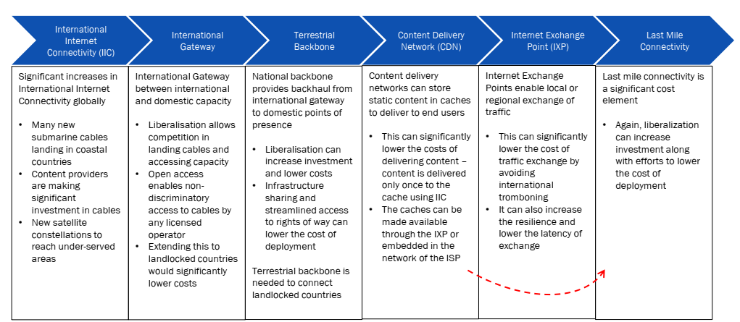
Figure 1 – Value Chain of IIC
At the global level, submarine cable systems and international gateways form the international segment of connectivity. These undersea fibre-optic cables and landing stations connect continents and regions, carrying most international Internet traffic. Advances such as wavelength-division multiplexing (WDM) and fibre amplification continue to expand capacity. Ownership and operational arrangements in this segment, whether consortium-based, content provider-led, or hybrid, significantly shape wholesale costs and competitive dynamics.
Once data reaches national borders, terrestrial fibre networks and national backbones distribute it to urban centres, rural communities, and neighbouring countries. These backbones, including cross-border fibre links, determine whether international capacity translates into affordable and reliable services domestically. Approaches such as infrastructure sharing and integrated rights-of-way management have been used to improve efficiency in this part of the chain.
For areas where fibre is not viable, satellite connectivity provides an alternative. Traditional geostationary systems offered broad coverage but with high latency and limited bandwidth. The introduction of low-Earth orbit (LEO) constellations has created lower-latency and higher-capacity options. These are relevant for remote, landlocked, and island regions, and they also support resilience when terrestrial networks are disrupted.
At local and regional levels, Internet exchange points (IXPs) and content delivery networks (CDNs) contribute to efficiency by localizing traffic flows. IXPs enable direct peering among networks, which reduces reliance on costly upstream transit. CDNs bring popular content closer to users, which improves user experience and reduces repeated long-haul transfers.
Protocols and routing technologies connect all these segments and ensure interoperability. The border gateway protocol (BGP) coordinates routing information between networks worldwide. Peering agreements and interconnection arrangements influence both performance and cost. Secure routing practices, including the use of resource public key infrastructure (RPKI), strengthen the reliability of international data flows.
A well-functioning value chain requires supportive policies and collaborative approaches. Open-access principles, competition-oriented regulation, and transparent financing arrangements ensure that investments in one segment create benefits across the entire system. This value chain framework provides the basis for analysing emerging business models in the following section.

8 Emerging business models for affordable IIC
In response to rising data demand and persistent gaps in access, new business models are reshaping international Internet connectivity (IIC). Moving beyond vertically integrated approaches, these models emphasize collaboration, shared infrastructure, and targeted investment. They vary in scale and structure but share a focus on open access, cost efficiency, and sustainability. The subsections below outline selected models across the IIC value chain, with examples of outcomes and practices that have improved affordability.

8.1 Submarine cable systems
Submarine cable systems and international gateways account for more than 99 percent of intercontinental Internet traffic. Historically, these systems were developed and operated by incumbent telecommunication operators or closed consortia, which often limited competition and kept wholesale bandwidth prices high. Over the past decade, however, several new models have emerged that expand capacity and reduce costs.
One development has been the direct participation of global content and cloud providers such as Google, Meta, Microsoft, and Amazon. By leading or co-financing new cable systems to meet their global service needs, these firms have increased international bandwidth supply and introduced competitive dynamics in markets that were previously constrained.
A second change concerns the governance of cable landing stations (CLSs). Traditionally, landing facilities were tightly controlled, restricting access for competing providers. Recent initiatives have promoted carrier-neutral or open-access landing stations, often through special-purpose vehicles involving multiple operators, governments, or development financiers. Such arrangements allow licensed operators to access submarine cable capacity on equal terms, improving competition and reducing downstream costs for ISPs and end users.
Financing approaches have also diversified. Development finance institutions (DFIs) have supported shared regional systems such as the Eastern Africa Submarine Cable System (EASS), while private ventures like MainOne in West Africa illustrate how new entrants can create competitive infrastructure through innovative funding strategies.
These models have produced measurable effects. In several African markets, wholesale bandwidth prices fell by more than 70 percent over the past decade, contributing to lower retail prices and expanded Internet use. In East Africa, latency on international links dropped from several hundred milliseconds (satellite-based) to below 50 milliseconds following the introduction of submarine capacity.
Policy and regulatory practices play a central enabling role. Lessons observed in different regions include:
• Promoting competition and open access: Allowing cost-based, non-discriminatory access to landing stations and interconnection points encourages competitive entry. This approach has been supported in Peru and in the European Union.
• Providing regulatory certainty: Transparent and efficient permitting procedures for subsea deployment create a more predictable environment for investors, as seen in Singapore and France.
• Safeguarding resilience: Cable protection zones in Colombia and Australia, as well as repair-friendly frameworks in India, highlight how regulatory measures can reduce risks of disruption. The Internet blackout in Tonga in 2022 after volcanic activity illustrated the importance of diverse routing and multiple cable connections.
Affordability in submarine cable systems also depends on the financing approach. Alongside consortium-led models, innovative mechanisms such as direct foreign investment, government support, commercial bank loans, vendor financing, and indefeasible rights of use (IRU) sales are increasingly being adopted. These options help spread capital expenditure and reduce entry barriers, creating more competitive conditions in markets where demand alone might not justify investment.

8.2 Terrestrial fibre networks
Once international bandwidth enters a country through submarine cables and international gateways, terrestrial fibre networks and regional backbones play a pivotal role in distributing this capacity inland. These middle-mile networks are essential for ensuring that the benefits of international connectivity reach national markets, urban centres, and underserved rural areas.
Historically, many countries faced challenges in developing comprehensive terrestrial fibre infrastructure. High deployment costs, complex geographies, and limited commercial viability in remote areas often resulted in backbone gaps or monopolistic control, driving up transport costs and limiting service expansion. In response, a range of innovative business models has emerged to address these barriers and foster more inclusive connectivity.
One prominent model involves pan-regional private networks, exemplified by companies like liquid intelligent technologies in Africa. Through strategic expansion, acquisitions, and partnerships with utility companies, such networks have created extensive cross-border fibre corridors that bypass traditional bottlenecks and introduce competitive backbone services.
Open-access national backbones have also become a key strategy for expanding affordable fibre connectivity. In this approach, governments or neutral entities establish wholesale-only networks that are accessible to all licensed operators on fair and transparent terms. Botswana's BoFiNet and similar initiatives in Romania and Lithuania demonstrate how public investment can break incumbent control and catalyse service expansion by enabling retail providers to compete on equal footing.
Public-private partnerships (PPPs) offer another path to balanced backbone development. These arrangements typically involve private firms building and operating fibre infrastructure with partial public support and price caps to ensure affordability. Examples from Malawi to France's Limousin region show how PPPs can align incentives and share deployment risks, bringing fibre to otherwise economically marginal areas.
A particularly cost-effective strategy has been leveraging existing utility infrastructure such as electricity grids, railways, and pipelines to deploy fibre alongside other public works. Policies that mandate the inclusion of fibre ducts in public construction ("dig once") or partnerships with utilities to share rights-of-way can dramatically lower deployment costs. Oman Broadband Company and Zambia's ZESCO Telecoms illustrate how these models reduce duplication and promote rapid network expansion.
Cross-border regional initiatives further reinforce the role of terrestrial fibre in driving down costs for landlocked countries and improving overall resilience. East Africa's corridor routes, for instance, connect submarine cable landing sites in Kenya to Uganda, Rwanda, and beyond, providing alternative paths and lowering transit costs for interior markets. These cooperative models have been replicated in Latin America, Southeast Asia, and other regions, underscoring the importance of cross-border agreements and regional planning.
For landlocked countries, the benefits of submarine cables are realized only when affordable cross-border interconnection links them to robust national backbone networks. In many regions, cross-border transit remains expensive due to limited providers, bilateral monopolies, or inefficient self-supply arrangements.
Several models are emerging to reduce these costs:
• Operator integration across borders: groups with presence in neighbouring markets can internalize transit and lower charges.
• Regional ISP consortia: collective bulk purchase of capacity, either as dark fibre (via IRUs) or IP transit at landing stations, then distributed at discounted rates inland.
• Multilateral agreements: regional trade or open-access interconnection frameworks that pool infrastructure such as roads, railways, or electricity lines to create shared fibre routes.
Best practices from these models emphasize the value of structural separation between wholesale and retail functions, policies that encourage shared infrastructure, and regulatory oversight to prevent new backbone monopolies. Integrating backbone development into broader infrastructure projects and fostering cross-border coordination are also key to ensuring that the full potential of international connectivity is realized at the national and local levels.

8.3 Satellite connectivity
Satellite connectivity forms a critical component of the international Internet connectivity (IIC) ecosystem, particularly for regions beyond the reach of terrestrial fibre or submarine cable systems. Historically, satellite Internet relied on geostationary (GEO) satellites operating at altitudes of around 36 000 km. These systems offered broad coverage but suffered from high latency and limited bandwidth, making them a last-resort option for mainstream Internet services.
Recent technological advancements, however, have transformed the potential of satellite connectivity. The emergence of low-earth orbit (LEO) satellite constellations, exemplified by systems like SpaceX's Starlink and OneWeb, has redefined the economics and performance of satellite broadband. Operating at altitudes of 500-1 200 km, low-earth orbit satellites deliver significantly lower latency, often comparable to terrestrial networks, and higher bandwidth, enabling a broader range of applications and improved user experiences.
The business models underpinning satellite connectivity are also evolving. Direct-to-consumer models, such as Starlink's, enable households and enterprises in remote areas to purchase satellite terminals and subscriptions independently, bypassing the need for extensive ground-based infrastructure. Alternatively, partnerships between satellite operators and national telecom providers, as seen with OneWeb, integrate satellite capacity into broader network offerings, supporting enterprise, government, and community access.
These new models have opened opportunities for affordable connectivity in areas that fibre cannot reach such as mountainous, landlocked, or small island regions. They also play a vital role in enhancing network resilience. For instance, satellite links have provided emergency connectivity in disaster-affected areas when terrestrial networks have been damaged or disrupted.
Despite these advances, satellite services face unique challenges. Spectrum allocation and licensing requirements vary across jurisdictions, and regulatory barriers can slow deployment. The high upfront costs of satellite user equipment, though declining, can also limit affordability for some users. Additionally, satellite networks must manage finite spectrum resources and avoid interference with terrestrial systems to maintain service quality.
Emerging best practices in this domain highlight the importance of integrating satellite capacity into national broadband strategies, ensuring regulatory frameworks facilitate entry and competition, and leveraging public-private partnerships to make satellite connectivity more accessible. As the technology matures and new constellations enter service, satellite connectivity will continue to be a crucial enabler of affordable Internet services, particularly in the most remote and underserved regions.

8.4 Internet exchange points (IXPs)
Internet exchange points (IXPs) are physical locations where multiple networks including Internet service providers (ISPs), content providers, and other stakeholders interconnect and exchange data traffic directly. By enabling local and regional traffic to remain within their respective areas, IXPs significantly reduce dependence on costly international transit routes and improve overall data delivery performance.
Historically, the absence of local IXPs meant that even traffic between neighbouring networks within a country had to traverse international links, driving up costs and adding unnecessary latency. The establishment of IXPs addresses this challenge by creating efficient hubs for domestic and regional peering, resulting in more resilient and cost-effective data flows.
IXPs also play a critical role in fostering competitive data ecosystems. By lowering transit costs and reducing latency, they enable smaller ISPs and local content providers to offer competitive services, thereby expanding affordable data access to more communities. As a result, IXPs directly contribute to the broader goals of network affordability and inclusivity.
The growth of IXPs has been particularly notable in emerging markets, with Africa, Asia-Pacific, and Latin America establishing new exchange points in both major cities and smaller regional centres. These efforts have often been supported by regional integration initiatives and development partnerships aimed at boosting intraregional connectivity and reducing the digital divide.
Best practices from successful IXPs highlight the importance of inclusive governance models that involve a wide range of stakeholders. Open and transparent peering policies, regulatory support for neutral facilities, and active promotion of peering arrangements are essential to maximizing the benefits of IXPs. Additionally, IXPs can serve as anchors for the deployment of local content delivery network (CDN) caches, further enhancing affordability and performance by localizing high-demand content.
As data volumes continue to grow and the need for affordable connectivity intensifies, IXPs and regional interconnection will remain key elements in national and regional strategies to reduce costs and improve service quality. Their continued expansion and integration into broader connectivity frameworks are essential to unlocking the full potential of international Internet connectivity for all users.

8.5 Content delivery networks (CDNs)
Content delivery networks (CDNs) have emerged as a critical layer in the international Internet connectivity (IIC) ecosystem, complementing the physical infrastructure of cables, fibre, and satellites by optimizing the delivery of digital content. CDNs work by deploying distributed servers that cache popular or high-demand content such as video, software updates, and web applications closer to end users. This approach dramatically reduces the need for repeated long-haul data transfers, minimizing congestion on international and backbone networks.
The business models of CDNs vary widely, ranging from commercial services offered by global providers like Akamai, Cloudflare, and Amazon CloudFront to proprietary networks operated by large content platforms like Google and Netflix. Many CDNs partners directly with ISPs and IXPs to colocate caching servers within national or regional networks, ensuring that content can be delivered locally rather than fetched from distant data centres across the globe.
Local content caching has several immediate benefits for affordability and performance. By serving content locally, CDNs reduce the upstream bandwidth requirements of ISPs, lowering transit costs and enabling more competitive pricing for end users. In many markets, CDN deployments have also been associated with significant improvements in latency and user experience, enabling smooth streaming, faster downloads, and better access to cloud services.
In emerging economies and underserved regions, the establishment of CDN nodes is often closely linked to the presence of robust IXPs and open-access backbone infrastructure. These local enablers create an environment where CDN providers can deploy caching servers cost-effectively, amplifying the benefits of infrastructure investments in cables and fibre. Furthermore, localized content delivery helps to level the playing field for smaller ISPs and content creators, who might otherwise struggle to compete with established players reliant on costly international transit.
Best practices in this segment highlight the importance of supportive policies that encourage CDN deployment and partnerships with local ISPs. Regulatory frameworks that promote transparent interconnection and equal access to last-mile and backbone facilities can unlock new opportunities for CDNs to expand and enhance their services. The integration of CDNs into broader connectivity strategies aligned with submarine, terrestrial, satellite, and IXP investments ensures that the affordability and performance gain they enable reach all users, not just those in major urban centres.
As demand for data continues to grow and digital platforms become ever more central to economic and social life, CDNs and local content caching will remain indispensable tools for improving the affordability, efficiency, and resilience of international Internet connectivity.
Beyond conventional CDN deployments, several models are shaping affordability outcomes:
• Colocation hubs – Large IXPs and data centres where ISPs and CDNs interconnect, reducing distance between content source and destination. High network density creates economies of scale and downward pressure on transit prices.
• Private CDNs – Dedicated networks established by major content providers to deliver their own services with enhanced performance and security. Cost-effective for large-scale providers with focused traffic.
• Public CDNs – Shared infrastructures operated by third parties, offering broad geographic reach at lower cost for smaller providers, though with less customization.
• Hybrid CDNs – Combining private and public elements, enabling businesses to manage premium or localized traffic while leveraging public CDN reach for broader delivery.
• Telco-CDN partnerships – Operators integrate CDN functionalities within their networks, reducing backbone load and improving quality of experience for data-intensive services.
• Peer-to-Peer CDNs – Low-cost distribution models that utilize idle edge resources, particularly effective for live streaming and large file transfers.
• Federated CDNs – Cooperative arrangements among smaller CDNs to extend geographic coverage and share infrastructure costs, creating a more competitive ecosystem.
These diverse approaches illustrate how CDN strategies are evolving into multi-layered ecosystems that improve efficiency, localize content, and reduce international transit dependence.

8.6 Supporting technologies and protocols
Underlying the physical infrastructure and innovative business models that shape international Internet connectivity (IIC) are essential technologies and protocols that ensure efficient, secure and resilient data exchange. These foundational enablers, while often invisible to end users, play a critical role in realizing the affordability, performance and inclusivity goals of emerging connectivity models.
At the core of global Internet routing is the border gateway protocol (BGP), which orchestrates the exchange of routing information between autonomous networks across the world. BGP enables data packets to find the most efficient and cost-effective paths, dynamically adjusting to network conditions and changes in topology. In international contexts, BGP's role in managing routing policies and optimizing transit agreements is vital for ensuring that affordable connectivity reaches end users.
Peering arrangements and routing practices also play a central role in shaping the economics of IIC. Direct peering between networks enabled by Internet Exchange Points (IXPs) reduces reliance on costly upstream transit and improves the performance of local and regional traffic. Routing policies that prioritize local paths and minimize dependence on expensive international backbones further reduce costs and enhance service quality.
Equally important are the technical standards and protocols that support interoperability, security, and optimized data flows. Protocols such as multiprotocol label switching (MPLS), secure BGP implementations like resource public key infrastructure (RPKI), and advanced traffic engineering techniques allow networks to use available capacity more efficiently and to manage congestion. These measures complement physical investments, ensuring that data flows remain predictable, reliable, and resilient even in the face of evolving traffic patterns or security threats.
A significant enabler of this evolving ecosystem is the transition from Internet Protocol version 4 (IPv4) to Internet Protocol version 6 (IPv6). IPv4, the fourth version of the Internet Protocol (IP), has served as the backbone of Internet communication for decades, offering simplicity and efficiency. However, with its limited 32-bit address space and constraints on security and routing efficiency, IPv4 is increasingly insufficient to meet the demands of a hyper-connected world driven by IoT and 5G applications.
IPv6, the next-generation protocol, addresses these limitations with a vastly expanded 128-bit address space, ensuring that there will be no shortage of IP addresses for the foreseeable future. Beyond its larger address space, IPv6 includes enhanced security features, improved routing efficiency, and built-in support for quality of service (QoS) and multicasting, making it especially beneficial for data-intensive applications like video streaming and IoT device management.
One of the key advantages of IPv6 is the elimination of the need for network address translation (NAT). NAT, a workaround in IPv4 to conserve limited addresses, introduces complexity and processing overhead. IPv6's design allows direct device-to-device communication, reducing equipment needs, processing delays, and network overhead. Its simpler header structure further improves data transmission efficiency, reducing bandwidth consumption and infrastructure costs for ISPs and enterprises alike.
IPv6's capabilities also extend to optimizing content delivery. Anycast addressing in IPv6 allows a single IP address to be used by multiple servers in different locations, routing users to the nearest server for faster and more efficient content delivery. Multicasting similarly enables simultaneous data delivery to multiple recipients, dramatically lowering bandwidth requirements for large-scale updates or streaming.
The cost implications of these features are substantial. By reducing the need for specialized hardware, simplifying network architectures, and optimizing routing and content delivery, IPv6 can lead to lower infrastructure costs and ultimately lower data prices for end users. These efficiencies also foster a more competitive ecosystem by lowering barriers to entry for smaller ISPs and service providers.
Globally, the adoption of IPv6 is gaining momentum, with India leading the way at over 83% IPv6 capability, largely due to initiatives by major providers like Reliance Jio. Many countries in Western Europe, Southeast Asia, and beyond have surpassed 50% IPv6 capability, driven by the combined need for more IP addresses, enhanced security, and improved network efficiency.
Best practices in this domain highlight the importance of collaborative governance and targeted capacity building. Technical training for network operators, clear regulatory guidelines on interconnection and routing security, and investments in monitoring infrastructure are crucial for safeguarding the reliability and inclusivity of international data flows. As new technologies such as software-defined networking (SDN) and network function virtualization (NFV) mature, they offer further opportunities to optimize traffic management and routing in ways that support affordability and equitable access.
Ultimately, supporting technologies and protocols – including BGP, peering and routing arrangements, MPLS, secure BGP implementations, and IPv6 – form the invisible backbone of the global Internet. Their effective deployment and ongoing evolution ensure that investments in submarine cables, terrestrial fibre, satellite systems, and content delivery networks translate into tangible benefits for all users. They are integral to realizing the full promise of emerging business models and creating an inclusive and affordable digital future.

9 Case studies and best practices
This section highlights real-world applications of innovative business models in international Internet connectivity (IIC), showcasing how they contribute to affordable and resilient data services across diverse contexts. Each regional case study underscores specific challenges, approaches, and lessons that inform global best practices.

9.1 Africa: Regional integration and submarine cable-led affordability
Africa's international Internet connectivity landscape has undergone remarkable growth and transformation over the past two decades. In 2000, only three submarine cables landed on the continent, creating a bottleneck in affordable international bandwidth. By 2012, this number had surged to 15, significantly expanding capacity and improving regional resilience.
These expansions have had tangible impacts across the value chain. Increased submarine cable capacity has directly contributed to lowering wholesale bandwidth prices, enabling more competitive markets and spurring-new Internet-based services. It has also fostered the growth of Internet Exchange Points (IXPs) across the continent, which further reduce costs by keeping local and regional traffic within Africa instead of routing it through costly international links.
A notable example of innovative regional collaboration is the case of Malawi, a landlocked and least developed country. Recognizing the challenges posed by its geography, Malawi has pursued diplomatic data corridors (DDCs) dedicated data routes established through state-to-state agreements with neighbouring countries. These DDCs leverage existing submarine cables in sea-facing countries, such as Tanzania, Mozambique, and Zambia, to create affordable and sustainable inbound data channels.
The initial agreement between Malawi's Electricity Supply Corporation (ESCOM) and Tanzania's national backbone operator (TTCL) has paved the way for a series of partnerships. These collaborations eliminate costly transit charges and duplication of infrastructure, promising to reduce data rates and expand affordable broadband access within Malawi. Future agreements with Zambia, Mozambique, South Africa, and Namibia aim to build on this momentum, enhancing Malawi's connectivity through a shared regional infrastructure approach.
These African initiatives underscore the importance of regional political cooperation, innovative use of existing resources, and pragmatic regulatory reforms. They provide compelling evidence that strategic, collaborative efforts can overcome geographic and economic barriers, transforming Africa's connectivity landscape and advancing the goal of digital inclusion for all.
Another notable initiative is the Southern African Development Community (SADC) borderless fibre project. Member States contribute fibre pairs to each cross-border route, splice them at national borders, and retain responsibility for their domestic segments. The resulting regional mesh provides equal rights and capacity to all participants, dedicated exclusively to regional traffic. This cooperative approach demonstrates how multilateral arrangements can overcome high transit costs, strengthen resilience, and extend affordable connectivity to landlocked markets.

9.2 Asia-Pacific: Indonesia's Palapa Ring and regional backbone models
Asia-Pacific provides a compelling illustration of integrated infrastructure and policy initiatives. Indonesia's Palapa Ring project, a public-private partnership, has connected remote islands with high-capacity fibre, combining subsea and terrestrial elements to create an open-access wholesale network. This model has driven down transit prices and supported competitive services in previously underserved areas. Other examples in the region include cooperative fibre corridors in South-east Asia and cross-border fibre initiatives supported by regional development organizations.

9.3 Latin America: Cross-border fibre and cooperative financing
Latin America's approach to overcoming geographic barriers includes leveraging regional fibre initiatives and cooperative financing to connect landlocked countries such as Bolivia and Paraguay. These efforts often involve partnerships between national governments, private operators, and development banks to create shared infrastructure that reduces transit costs and enhances network resilience. These models highlight the importance of cross-border planning and the role of international financing in bridging market gaps.

9.4 Island and small-state contexts: Tonga and the Pacific islands
Small Island developing states face unique connectivity challenges due to their isolation and vulnerability to natural disasters. In Tonga, the establishment of the country's first submarine cable in 2013 supported by development finance, dramatically improved bandwidth availability, complemented by satellite connectivity for redundancy. Similar models across the Pacific Islands have combined cable deployment with satellite backup, creating affordable and resilient links for small populations.

9.5 India's experience
India has established a comprehensive and forward-looking framework to ensure affordable and competitive access to international Internet connectivity, recognizing the central role of submarine cable landing stations (CLS) in bridging domestic and global digital networks.
Regulatory and policy framework
The Telecom Regulatory Authority of India (TRAI) plays a central role in regulating access to CLS facilities. Under the current framework, any eligible Indian international long distance (ILD) or Internet service provider (ISP) operator holding international gateway permission from the Department of Telecommunications (DoT) can request access to international submarine cable capacity. Both the CLS owner and the access seeker must hold valid licences, ensuring a level playing field for all authorized players in the market.
To ensure fair and transparent access, TRAI has laid down detailed regulations that mandate access to essential CLS facilities on non-discriminatory terms. These regulations include the International Telecommunication Access to Essential Facilities at Cable Landing Stations Regulations (2007, amended in 2012), and the Access Facilitation Charges and Co-Location Charges Regulations (2012, amended in 2018). These instruments collectively define the rights and obligations of CLS owners and access seekers, covering technical, commercial and procedural aspects of interconnection.
Economic approach to access charges
A cornerstone of India's regulatory approach is its transparent methodology for determining Access Facilitation Charges and co-location charges. TRAI adopts a bottom-up costing model based on detailed data submissions by operators. This method considers key cost elements, including operating expenses, depreciation (using the straight-line method), and capital costs calculated at a pre-tax weighted average cost of capital (WACC) of 15%. This approach ensures that access charges are directly linked to the actual costs of service provision, promoting cost-efficiency and preventing excessive markups.
Growth of submarine cable infrastructure
India has emerged as a significant hub for submarine cable infrastructure, with 17 submarine cables landing at various CLS locations as of June 2023. These include major international systems such as AAE-1, BBG, SEA ME WE 3, SEA ME WE 4, and IMEWE, landing in strategic locations like Mumbai, Chennai, Cochin, Tuticorin, and Trivandrum. This robust infrastructure base has positioned India as a key gateway for international bandwidth in South Asia.
Capacity utilization trends
TRAI data underscores the effectiveness of India's regulatory and economic policies. From 2016 to 2022, total lit capacity on submarine cables landing in India increased from 39 282 Gbit/s to 138 606 Gbit/s. During the same period, activated capacity grew even faster, from 9 137 Gbit/s (23% of lit capacity) in 2016 to 111 111 Gbit/s (over 80% of lit capacity) in 2022. This impressive growth in activated capacity demonstrates the success of India's efforts to ensure that the benefits of international connectivity are fully realized and extended to end users.
Best practices and lessons learned
India's experience highlights several best practices that can inform other countries seeking to strengthen their international connectivity:
• Transparent regulation and cost-based pricing ensure that access charges are fair, fostering competition and affordability.
• Inclusive licensing and access frameworks create a level playing field for ILD operators and ISPs, promoting diverse participation in the IIC market.
• Data-driven monitoring and regular stakeholder consultation enable ongoing adjustments to ensure that regulatory practices remain aligned with market realities.
• Proactive planning and investment facilitation have transformed India from a limited-access market into a regional hub for international bandwidth.
By fostering a balanced ecosystem of regulation, investment, and competition, India has laid the foundation for continued growth in digital services and inclusion. Its approach to submarine cable landing stations and international bandwidth access offers a proven roadmap for leveraging international Internet connectivity to drive socio-economic development and bridge digital divides.

9.6 Case study: Malawi – Understanding first mile data transit costs in an LLDC
Malawi, a landlocked least developed country (LLDC) in Southern Africa, illustrates how geography, infrastructure, and policy choices drive the high cost of international Internet connectivity. Historically, wholesale and consumer data prices have been significantly above regional averages, but targeted reforms are now underway.
Figure 2 below shows at least four very geographically diverse routes from Malawi to the nearest IP Transit Hubs (London or Johannesburg), crossing terrestrially through neighbouring countries such as Zambia, Tanzania, Mozambique and Zimbabwe, to then connect to subsea cable landing points in non-landlocked countries with cable landing stations such as South Africa, Tanzania and Mozambique. Choices of which routes to use are normally made based on reliability, cost, and strategic considerations.
Network context in Malawi
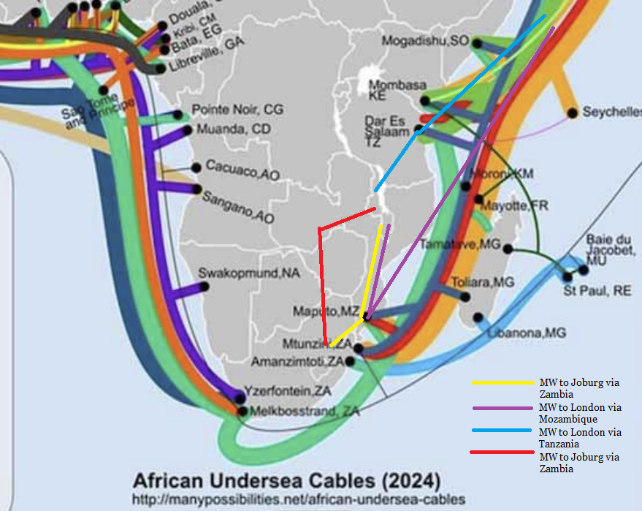
Figure 2 – Routes from Malawi to major Internet transit hubs
The Internet ecosystem in Malawi comprises three main categories of networks, aligned with global definitions:
• Eyeball networks – operators serving end users. In Malawi, Airtel and TNM dominate mobile broadband, while ISPs such as Datanet Malawi and Converged Networks Malawi (CNM) provide fibre, fixed wireless, and VSAT services.
• Content networks – such as Netflix, Google, and Meta, which deploy caches or points of presence (PoPs) to bring popular content closer to users. Netflix, through the ITU Partners2Connect initiative, pledged to expand cache presence in LLDCs, though Malawi's deployment remains limited.
• Transit networks – such as liquid intelligent technologies, which extend backbone capacity across borders. Malawi benefits from being "land-linked" with Zambia, Tanzania, and Mozambique, but still depends on multiple expensive segments before reaching major hubs.
Traffic between these networks is managed through border gateway protocol (BGP), with most exchanges occurring via settlement-free peering at IXPs or PNIs when present.
Cost factors in first mile connectivity
The "first mile" costs for Malawian operators are built up from several layers (for a more detailed explanation on the costs see the annex based on the contribution received from Ben Roberts, Digital Economy Advisors and Malawi Communications Regulatory Authority (MACRA)):
• Longline circuits
International leased lines link Lilongwe to peering hubs such as Johannesburg or London. Routes involve at least three terrestrial and subsea segments, each attracting separate costs and cross-connect fees. For example, a 10 Gbit/s leased line at USD 10 000/month but only 6.5 Gbit/s utilized yields an effective USD 1.54 per Mbit/s.

• IP transit
Operators pay global backbones for access to the full routing table. Prices improve with larger commitments: a 100 Gbit/s port may be priced at USD 0.20/Mbit/s with overspill at USD 0.25/Mbit/s, billed on a 95th percentile basis. Small Malawian operators cannot reach such economies of scale, keeping prices high.
• Redundancy
To safeguard against outages, operators must provision multiple diverse routes. With only two routes, redundancy effectively doubles costs while only securing 50% of bandwidth in case of failure. Events in 2024 such as multiple subsea cable cuts on the West Coast and Red Sea highlighted the vulnerability of single-route dependence.
• Localisation of traffic
○ IXPs: Malawi has limited peering opportunities. By contrast, INX-ZA in South Africa charges USD 220/month for a 10 Gbit/s port, equating to USD 0.022/Mbit/s if fully used. In Malawi, underutilisation reduces efficiency.
○ PNIs: Direct links between networks can deliver near-zero incremental costs but are rare in Malawi.
○ Caching: Content providers supply cache servers free, but operators bear hosting and backhaul. Efficient caches can deliver bandwidth at 20-30% of longline costs but require sufficient market size and supportive data protection laws.
Simple vs. complex models
Malawi's networks historically followed a "pipe and port" model, combining longline and IP transit costs:
Average cost per Mbit/s= (Longline cost + IP transit cost)/Used Bandwidth
This kept per-Mbit/s rates high.
Increasingly, operators are evolving toward blended "complex models", incorporating redundancy, peering, PNIs, and caches:
Blended cost per Mbit/s= (Longline + Redundancy + IXP + PNI + Caching + Transit)/ Used bandwidth
Evidence from African hubs (Johannesburg, Nairobi, Lagos) shows that blended models reduce unit costs dramatically, bringing prices closer to European benchmarks.
Policy Interventions in Malawi
The Malawi Communications Regulatory Authority (MACRA), working with government and partners, has launched multiple initiatives to address high first mile costs:
• Call to Action #DataMustFall – public campaign driving affordability.
• Additional IXPs – to expand domestic peering opportunities.
• Diplomatic data corridors – agreements with neighbours to secure affordable cross-border transit.
• Driving demand – reducing device taxes and stimulating broadband adoption.
• Rural expansion – using the universal service fund (USF) to finance last-mile rollout.
• Tariff regulation – ensuring consumer data prices remain affordable.
• Data protection law – enabling cache providers to deploy equipment in-country.
• E-government services – stimulating local content and domestic traffic flows.
Lessons for LLDCs and SIDs
Malawi demonstrates that structural disadvantages of LLDCs such as longline dependence, multi-segment costs, and redundancy challenges can be mitigated through:
• Regional cooperation (diplomatic corridors).
• Market-enabling policies (IXPs, caches).
• Demand stimulation (devices, e-services).
For SIDs such as Seychelles or Cabo Verde, parallels exist: redundancy costs are disproportionately high, but turning geography into an advantage (as a hub) can flip the equation.

9.7 Cross-cutting best practices
These regional examples converge around several common best practices. Inclusive governance structures such as consortia, neutral backbone operators, and public-private partnerships, align stakeholder interests and foster open-access competition. Transparent licensing frameworks and regulatory support are critical to ensuring infrastructure investments translate into affordable, high-quality services for end users. Furthermore, integrating backbone development with last-mile connectivity, leveraging utility infrastructure through "dig once" policies, and fostering cross-border collaboration have proven essential to expanding affordable data services.

10 Key challenges and enablers
The implementation and scaling of innovative business models in international Internet connectivity (IIC) face a range of challenges and enabling factors. Recognizing and addressing these elements is essential for ensuring that emerging models deliver affordable, high-quality data services to all users, particularly in unserved and underserved areas.
One of the primary challenges is the high upfront investment costs associated with deploying submarine cables, terrestrial backbones, and satellite systems. While collaborative financing models and public-private partnerships have helped mitigate these costs, securing sustainable funding remains a persistent hurdle, especially in markets with limited commercial viability.
Regulatory and policy frameworks play a crucial role in shaping outcomes. In many cases, legacy regulations favour incumbent operators or do not fully support open access principles, limiting the benefits of new investments. Establishing transparent licensing regimes, competition-oriented policies, and clear guidelines for open access infrastructure is essential to ensuring that the affordability gains from new models reach end users.
Market concentration and monopoly risks are another concern. Although the entry of new players and consortium-based investments has improved competition in many regions, dominant positions can still emerge, particularly in backbone and wholesale markets. Regulatory oversight and periodic market assessments are critical to maintaining fair competition and preventing the re-emergence of monopolistic bottlenecks.
In many regions, particularly in landlocked contexts, cross-border transit remains costly due to a limited number of providers, bilateral monopoly arrangements, and reliance on inefficient self-supply models. These structural factors reinforce market concentration and require proactive regulatory measures to ensure competition and fair access.
Technical and operational challenges also affect the viability of emerging models. Inadequate local capacity to manage complex network operations, limited technical expertise, and challenges in integrating new technologies, including secure BGP implementations and advanced routing protocols, can hinder the realization of affordability and performance goals.
Conversely, several enablers have emerged as critical to overcoming these challenges:
Inclusive governance models, whether through consortium ownership, neutral backbone operators, or transparent public-private partnerships, align stakeholder interests and ensure that infrastructure investments are broadly accessible. These models foster competitive environments that drive down prices and improve service quality.
Development finance and international cooperation are also key enablers, particularly for projects in remote or economically disadvantaged areas. Blended financing models that combine public, private, and donor funds help address viability gaps and ensure that even the most challenging markets can benefit from modern connectivity solutions.
Policy innovation and regional cooperation have proven effective in lowering costs and expanding access. Policies that mandate the inclusion of fibre ducts in public works, cross-border agreements that reduce barriers to regional interconnection, and regional regulatory harmonization efforts all contribute to more cost-effective and sustainable connectivity.
Finally, capacity building and technical skills development are essential to ensure that new investments can be managed effectively and that local stakeholders have the expertise needed to support and maintain the infrastructure. Training programmes, knowledge-sharing initiatives, and international collaboration all play a role in strengthening the technical foundations of IIC.
As the global digital landscape continues to evolve, addressing these challenges and leveraging these enablers will be critical to scaling and sustaining innovative business models. The lessons learned from successful implementations provide a foundation for overcoming these barriers and creating inclusive, affordable, and resilient connectivity for all.

11 Recommendations
Drawing on the preceding analysis of emerging business models and global case studies, this section outlines actionable recommendations and concrete strategies to enable affordable, inclusive, and sustainable international Internet connectivity (IIC). These recommendations are intended to guide policymakers, regulators, development partners, and industry stakeholders in translating innovative connectivity models into impactful outcomes.

11.1 Strengthen policy and regulatory frameworks
• Establish clear open access policies that mandate non-discriminatory access to submarine cable landing stations, terrestrial backbones, and cross-border infrastructure.
• Promote transparent licensing and fair competition frameworks to prevent monopolistic control over critical IIC infrastructure.
• Develop national broadband plans that explicitly address the affordability and inclusivity of international transit, integrating IIC considerations into broader digital economy strategies.
• Implement regulatory measures to facilitate equitable peering arrangements at IXPs and support local CDN deployments.

11.2 Facilitate investment through public-private partnerships
• Structure innovative financing models, such as blended financing that combines public, private, and concessional capital, to de-risk investments in unserved and underserved areas.
• Support the creation of neutral, shared infrastructure entities (e.g., special purpose vehicles (SPVs) for submarine cable consortia or wholesale fibre networks) to spread costs and reduce duplication.
• Leverage development finance institutions to provide long-term debt or equity capital for backbone projects, especially where commercial viability is marginal.
• Encourage governments to provide regulatory certainty and investment-friendly environments to attract private capital for submarine and terrestrial connectivity expansions.

11.3 Integrate infrastructure planning and deployment
• Implement "dig once" or infrastructure sharing policies that require fibre deployment to be integrated with new transport, energy, and water infrastructure works.
• Create national or regional infrastructure registries to identify existing rights of way, ducts, and fibre routes that can be leveraged for new deployments.
• Encourage co-investment models between telecommunication providers and utility companies (e.g., railways, power grids) to extend fibre coverage at lower cost.

11.4 Expand regional cooperation and cross-border connectivity
• Support regional initiatives to build cross-border fibre links that connect landlocked countries and remote regions to submarine cable landing points.
• Harmonize regulatory frameworks across borders to ensure seamless interconnection and equitable cost-sharing arrangements for transit and peering.
• Establish regional regulatory working groups or task forces to address specific barriers, such as licensing inconsistencies and interconnection tariffs.

11.5 Develop technical capacity and skills
• Launch training programs for network engineers, regulatory staff, and technical managers to build expertise in managing and optimizing IIC infrastructure, including advanced routing and BGP management.
• Support local institutions and universities to develop specialized courses and research initiatives in international connectivity, peering arrangements, and data centre management.
• Facilitate regional workshops and knowledge-sharing platforms that bring together public and private actors to exchange best practices and lessons learned.

11.6 Enhance monitoring and impact evaluation
• Establish data-driven monitoring frameworks that track key performance indicators such as wholesale bandwidth prices, retail affordability, latency, and network resilience.
• Promote transparent reporting by submarine cable operators, backbone providers, and ISPs to ensure accountability and identify market failures or emerging bottlenecks.
• Encourage independent assessments of connectivity projects' socio-economic impacts to refine policies and prioritize interventions that maximize inclusive digital growth.

11.7 Support local content and ecosystem development
• Encourage CDN deployment and local hosting of popular content to reduce dependence on international transit and improve user experience.
• Create incentives for local content development and caching at IXPs to foster domestic digital ecosystems and reduce bandwidth costs.
• Develop policies that facilitate the integration of content providers into peering and interconnection arrangements, ensuring equitable cost-sharing and access.

12 Conclusion
This report has explored how emerging business models, technologies, and partnerships are reshaping international Internet connectivity (IIC) and enabling more affordable data services worldwide. By examining real-world case studies and best practices, it has highlighted the critical role of inclusive governance, open-access infrastructure, and cross-border cooperation in bridging connectivity gaps.
While progress is evident, challenges such as high investment costs, market concentration, and regulatory barriers remain significant. Addressing these issues requires targeted policy reforms, innovative financing approaches, and sustained collaboration between public and private actors. Technical capacity building and robust monitoring will be key to ensuring that connectivity investments deliver equitable and lasting benefits.
Looking forward, stakeholders must prioritize affordability, resilience, and inclusivity in all connectivity initiatives. With shared commitment and coordinated action, international Internet connectivity can become a powerful catalyst for digital transformation and social inclusion worldwide.

Annex A
Calculation of first mile data cost for LLDCs and SIDs

A.1 Types of networks
The global Internet is made up of thousands of IP data networks, each having an "autonomous system number", that connect to each other through various means but mostly using the BGP protocol to control the way traffic is routed over these interconnections. 99.9% of these interconnections are "settlement free peering" meaning that the interconnecting parties do not bill each other for the data exchanged. They can be implemented via a "Private Interconnect" in a common data centre where both interconnecting parties have network presence, or more often via an Internet Exchange Point (IXP) which facilitates these interconnections. IP data networks often fall into one of the categories below
a) Eyeball networks are data networks that predominantly serve end users by offering fixed or mobile data services. In Africa, mobile network operators providing mobile data, serve the largest number of eyeballs, or end users. ISPs however provide fixed line data services using wired (normally fibre), fixed wireless access (FWA), or direct satellite VSAT services. In the case of Malawi, the largest eyeball networks are MNOs Airtel Malawi and TNM Malawi, but there are also several ISPs such as Datanet Malawi and Converged Networks Malawi (CNM).
b) Content networks are networks that predominantly provide data-based content services. They often implement networks that are specifically designed to deliver their content closer to their subscribers (or "eyeballs"). Netflix is a well-known example of a content network delivering its subscription video services to subscribers. Netflix deployed a global network consisting of "points of presence" (PoPs) which deliver the full range of its services to users, as well as "content caches" which store the most watched content and deliver it closest to the end user. Content caches may be hosted at an open public location, such as an IXP, being available for multiple networks to connect to, or may be hosted within a single larger eyeball network for that network's exclusive use. Netflix points of presence exist in cities in Africa such as Johannesburg and Nairobi. A large number of Netflix cache appliances exist inside the networks of operators in Africa, and in 2022 Netflix pledged (through the ITU's Partners 2 Connect initiative) to increase the number of caches in LLDCs in order to enhance the quality-of-service delivery in those countries [b-Netflix].
c) Transit networks can be global or regional and seek to connect and provide IP backbone services between the large global peering and interconnection points. Transit networks often provide global IP transit services to both eyeball networks and content networks as described above. Pan-African transit network, liquid intelligent technologies, recently announced extension of its backbone network to the border crossing between Zambia and Malawi [b-Connecting Africa].

A.2 Cost factors and calculations of first-mile data cost (IP transit) in a land locked least developed country
The first mile IP transit costs are built up from a combination of costs listed the below.

A.2.1 Long-distance network transport costs to peering/transit points
Some locations/cities in the world are hubs of connectivity where costs of IP transit can be significantly cheaper than in other locations. These cities often are home to the largest Internet Exchange Points, and according to Euro IXP [b-Euro-IX 2020], (the association of Internet exchange points), four of the largest Internet Exchange points in the Europe/Africa Region are located in London, Amsterdam, Frankfurt and Johannesburg.
Data presented by Telegeography [b-African NGU] shows that in Africa, Johannesburg is the city that has the lowest IP transit prices, as well as being home to the largest (measured in terms of traffic) Internet peering point in Africa.
In a particular country, IP Network operators of all 3 kinds (backbone, eyeball and content defined in clause A.1 above), may run long distance transport links from that country to the most cost-effective locations where there are large peering points (IXPs) and/or the price of IP transit is cheapest. In the continent of Africa, these backbone network transport links are now mostly either 100 Gbit/s or 10 Gbit/s links, depending on the size of the market, but some operators have deployed 400 Gbit/s links between certain cities in Africa [b-Huawei].
These long-distance circuits are a chain of terrestrial and subsea routes, and for an LLDC such as Malawi, having no coastline hence no cable landing stations, a circuit from Lilongwe to London for instance will be more complex, containing various 'segments' of terrestrial network and subsea cable routes. Each segment may be ultimately sourced from different country operators or subsea cable owners, and additionally there may be "cross connect charges" for certain segments to connect to others. The cost of each segment does depend on several factors, but the length of the circuit (distance) is one of the main factors, along with the volume of data traffic flowing on a particular route, the busiest routes being the cheapest. Pricing is also directly a factor of the volume of data link being purchased so 100 Gbit/s links are considerably cheaper per Mbit/s than 10 Gbit/s links for instance. Additionally, longer-term commitment contracts, such as lease contracts or IRUs (indefeasible rights of use) will yield cheaper initial pricing; however, with rapid price erosion, long-term contracts can be a risk that leaves an operator locked into higher-than-market pricing in the latter years of the contract.
Due to its landlocked status, long-distance transit routes from Malawi to any large peering points may not only be great in distance but will transit through at least three "segments" of national country backbone or subsea fibre. Malawi does have the advantage of being "land-linked" and bordering four countries, with three of them having cross border fibre access, but due to the factors above, there are multiple digital "roads" to Malawi to choose from, but they are all comparatively expensive.
The network routes are made up of sections of terrestrial circuits, subsea circuits, and cross connects, all of which have different cost implications for Internet connectivity.
Figure A.1 shows the makeup of a complex international circuit.
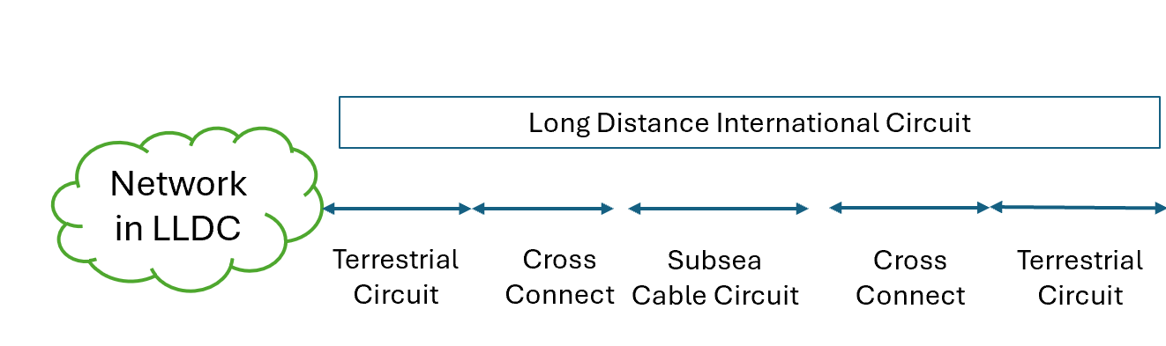
Figure A.1 – The makeup of a complex international circuit
Formula 1 – Cost per Mbit/s of international longline
The cost per Mbit/s of international longline is defined as follows:
The purchased capacity available on a long-distance line may not be fully utilised, with a degree of inefficiency, so when calculating the cost per Mbit/s of a long-distance line, we divide by the used capacity, rather than the available capacity.
$$Cost per Mbit/s oflongline= \frac{\sum{Longline cost}\left(Cost of Section 1…+Cost of Section N+ Cost of cross connects\right)}{Used Bandwidth (Mbit/s)}$$
So, if a long distance leased line is 10 000 Mbit/s and costs in total $10 000 per month, and the traffic being used on the line is 6 500 Mbit/s then.
Longline cost per Mbit/s = $10 000 /6500 = $1.515 per Mbit/s

A.2.2 IP transit costs
These are the fees that (most) operators pay to one or more IP transit providers in order to access the global Internet routing table. The exceptions to this are the tier 1 networks which are a small club of some of the biggest backbone networks in the world that peer with each other, and don't take Internet transit from anyone else.
IP transit is typically billed per Mbit/s, as a CIR (committed information rate) with some kind of overspill billing if you exceed that limit. The higher the CIR you commit to then the better price you get per Mbit/s. So, for instance, you may get a 100 Gbit/s port from an IP transit supplier but commit to buy 10 Gbit/s at a rate of $0.20 per Mbit/s, i.e., fixed $2000 per month, but pay a higher rate of say $0.25 per Mbit/s for extra traffic if you go over the 10 Gbit/s. The overbilling is measured as "95th percentile method" [b-Redcentric].
Formula 2 – Cost per Mbit/s of IP transit
The purchased capacity committed information rate (CIR) of IP transit may not be fully utilised, with a degree of inefficiency, so when calculating the cost contribution to IPT, we divide by the used capacity, rather than the available capacity. The burst bandwidth may be billed at a different rate from CIR, hence the cost of IPT becomes a weighted average of
$$Cost per Mbit/s of IP transit= \frac{Total CIR data spend+Total burst bandwidth spend+Cross connect costs}{Total used bandwidth (Mbit/s)}$$

A.2.3 Transport costs of redundancy links
For resilience and redundancy, it is necessary to have diverse routed transit circuits from a particular country to a particular peering point or alternate peering point. Providing one redundant route (2 total routes) may effectively double the cost of IP transit. If you have only 2 long-distance transit routes, then it stands to reason that only 50% of the bandwidth will be available in the condition of an outage on one of the routes. If there are 3 routes then 66% of bandwidth is available when one route fails, and with 4 routes then 75% is available and so on. In summary, the higher the number of redundant routes, then the lower the total impact on available capacity in the event of one route failure. Once a country becomes dependent on Internet, then having a long outage where only 50% of the normal bandwidth is available creates a serious problem indeed, where Internet users will experience the Internet slowing down to a point of being unusable, and telecommunication operators will experience huge packet loss and degradation of quality of service.
Network builders thus design networks with this in mind, looking to optimise the price of the long-distance routes vs the resilience. Considerations include the probability of a fault on a route (availability) and the time to repair in case of a failure on a route, and in particular avoidance of any "single point of failure" that could affect more than one route due to any particular fault or event. One common case of failure of a long-distance route may be cable cuts, and in terms of repair times, subsea cables usually take weeks or months to repair, whereas terrestrial cable faults are nearly always repaired in less than a day, though they might be cut more frequently.
Besides single points of failure, one would also consider single "areas of risk" such as corridors that contain multiple subsea cables, or areas and countries that pose significant political risk. In 2024, a number of countries in Africa had their Internet severely disrupted by an undersea rock fall on the west coast of Africa cutting four subsea cables, as well as a separate incident which cut three subsea cables due to an ongoing spree of attacks on ships in the Red Sea.
For small island developing states (SIDs) the cost of having redundancy can work out to be particularly expensive. Seychelles, for instance, was connected to the Internet for a long time by only one subsea cable running 1800 km from the islands to the mainland of Africa at Dar es Salaam in Tanzania. To put in place resilience and redundancy, Seychelles had to invest into a completely new subsea cable on a totally different route to Mombasa in Kenya. But to cater for the possibility of one of the cables failing, operators may be forced to buy twice as much capacity (on each cable) than they need to deliver services. In order to counter these challenges faced by SIDs, some Island states, such as Cabo Verde are positioning themselves as subsea cable hubs, linking multiple cables as they transit across oceans. Ben Roberts, in his blog "Why More is Better when it comes to Subsea cables" states that resilience is one of the prime reasons why it is best to have as many cables as is economically possible [b-Ben Roberts]. A comprehensive map of these subsea cables is published online and maintained by Telegeography [b-Telegeography].
Formula 3 – cost of longline redundancy
The purchased capacity available on a set of long-distance lines for geographic redundancy will not be fully utilised, providing extra capacity to allow for one or more routes to be temporarily out of service without impacting performance, so when calculating the cost per Mbit/s of a long-distance line, we divide by the used capacity, rather than the available capacity.
$$Weighted average cost per Mbit/s of longline= \frac{\sum{\left(Cost of longline 1+Cost of longline 2 .. Cost of longline N\right)}}{Used bandwidth (Mbit/s)}$$

A.2.4 Local traffic IXP
Local traffic that can be accessed via peering with other local providers is often the 'cheapest' type of traffic in LLDCs. However, in some more developed markets, IP transit ports are cheaper than Internet exchange (IXP) ports, though it is generally accepted that peering yields other benefits. Normally an operator pays a flat fee per month for a particular port speed at an IXP, and then gets value from this peering point by peering with local providers (other networks and content providers). INX ZA in South Africa displays its peering port fees on its website [b-INX ZA]. Of course, the more efficiently the port is used, the cheaper the traffic.
So, if you pay a flat fee for a port of 10 Gbit/s, then the effective "cost per Mbit/s" is less if you are actually using more traffic, and quite expensive if you only use a small amount. In more developed markets, the global content providers will be present at those exchanges, meaning the value you can get from the peering port is greater. According to ISOC, by 2019 there were some Internet exchanges in Africa where over 80% of global Internet traffic can be sourced through peering [b-80/20 Initiative], however this can be 10% or less in LLDCs where the local peering ecosystem is less developed. The Association of European Internet Exchanges publishes live data usage of 13 of the leading African IXPs [b-Live Traffic Data].
Formula 4 – cost of IXP peering bandwidth
$$Cost per Mbit/s of IXP peering= \frac{IXP Port fee+Cross connect costs}{Total Used IXP Bandwidth (Mbit/s)}$$

A.2.5 Local traffic private network interconnect (PNI)
A PNI is the cheapest and simplest way of sourcing IP traffic if there are sufficient volumes to be exchanged between two networks. If two large operators decide that they have sufficient IP traffic for each other's networks, and are both located at some mutually convenient point, such as a carrier neutral data centre, then they may decide to deploy a private interconnect to link their 2 networks via a fibre cable connecting each other's IP Ethernet ports. As per the types of networks defined earlier in Section 1, this may commonly be done between two large eyeball networks, or between an eyeball network and a content network. The capital expenditure and ongoing running costs for this type of interconnect are very low or even zero, depending on whether a host data centre charges a recurring monthly fee for the interconnection.
Formula 5 – cost of PNI peering bandwidth
$$Cost per Mbit/s of PNI peering= \frac{Cross connect costs}{Total used IXP bandwidth (Mbit/s)}$$

A.2.6 Locally internally cached traffic
Great benefits can be realized through win-win partnerships between eyeball networks and content networks. The larger content and CDN providers such as Google (YouTube), Netflix, Akamai, Meta (Facebook) all operate a partnership model whereby they will agree to supply "cache servers" to operators at no cost to purchase and maintain the servers. Operators then host these within their network infrastructure, supplying bandwidth to the cache and covering the data centre power and hosting for the servers. The caches add benefit by caching some of the most popular content, especially large files and videos, that are frequently downloaded by the customers of the eyeball networks. International bandwidth is only required to download the file the first time it is viewed and thereafter the data file is served locally from the cache, making savings on the international capacity required.
Open Telecom Data publishes a map showing the locations of cache servers globally [b-CDN] and it can be seen that there are a good number of caches in Africa, but with the most caches per country residing in digital hub cities such as Johannesburg, Nairobi and Lagos. Some LLDC countries have no caches at all, for various reasons, but predominantly that the markets may be too small to meet the traffic thresholds that make economic sense for a CDN provider to supply the cache servers. Also, the cache providers often have policies that data protection laws must exist in a country before shipping their caches there. Again, the more you use the caches up to their maximum port output capacity, then the cheaper the Mbit/s, but also the "caching ratio" of input bandwidth to output bandwidth increases based on higher utilisation.
Formula 6 – cost of running operator caches
With many caches being provided free of charge by content networks to large eyeball networks, the costs borne by the operator are the power costs of hosting the server, as well as the bandwidth used to "fill" the cache. The delivered bandwidth is usually much greater than the cache fill bandwidth, so this is where the cost saving is achieved.
$$Weighted average cost per Mbit/s of caching= \frac{Cost of cache fill bandwidth+Cost of powering and hosting the cache}{Cache delivered bandwidth (Mbit/s)}$$

A.3 Comparison of the various cost components
In summary, the international longline circuit component can be expensive for LLDCs and SIDS, given that they may not have access to competitive markets of multiple subsea capacity, distances may be far, and demand volumes comparatively low. Adding redundant circuits to ensure resilience pushes up the cost higher still. Careful thought must be given to planning of routes and negotiating this expensive component of the first-mile data costs. By comparison, all the methods of localizing traffic, including local peering and caching, result in delivery of traffic at considerably lower unit rates (see Figure A.2).

Figure A.2 – Comparison of the cost components of first-mile IP traffic
a) Long-line international circuit, can be anything from $10 000 to $100 000 per month for a 10 Gbit/s circuit from an LLDC to a major data hub, depending on various factors. The cost contribution can be upwards $1 to $10 per Mbit/s (depending on the actual used capacity) therefore.
b) IP transit pricing in a major IP transit hub such as London or Johannesburg can range from $0.15 to $0.50 depending on volume purchased.
c) Cost of redundancy can effectively double the cost of the contribution to IPT costs of longline circuits, if there are only 2 redundant routes, then purchasing double the capacity becomes necessary to ensure uninterrupted service.
d) A 10 Gbit/s port at INX ZA IXP in South Africa is 3 995 ZAR which is about $220. If the port is fully utilised then that equates to $0.022 per Mbit/s, making it one of the cheapest forms of traffic.
e) For a PNI, a typical cross connect in a commercial data centre may be $100 per month. However, many large MNOs may cross connect to other operators in their own data centres. The monthly cost for PNI Traffic therefore can be $0 to $0.01 for 10 Gbit/s of traffic exchanged.
f) For operator cached traffic, the cache fill bandwidth component is the major input cost, with the power component being lower. A 2-kW server, with a rate of $0.20 per kWh costs $288 per month to run. The efficiency of the cache fill bandwidth to the delivered bandwidth is therefore the main factor, so larger networks, with more users accessing the same content regularly, get the most benefit from the caching. With multiple variables in play, we can assume that cached bandwidth is about 20% to 30% of the first-mile longline bandwidth, so about $0.20 to $3 per Mbit/s.

A.4 Summary – calculating the overall IP transit cost from the cost components

A.4.1 Simple model – Pipe and port
The simple model assumes the simplest configuration, whereby an operator in a country builds a simple network consisting of a single longline from their location to an IP transit supplier, and purchases IP transit from that supplier. The cost of IP transit is therefore a simple summation of the costs for the longline circuit and the IP transit, as illustrated in Formula 1 and Formula 2 above.
Figure A.3 shows the simple first-mile IP transit model.
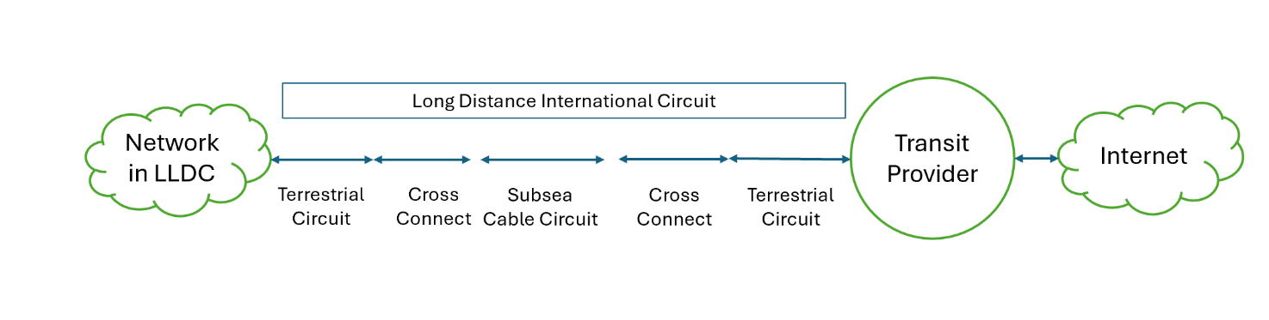
Figure A.3 – Simple first-mile IP transit model
Formula 7 – Simple IP transit model
$$Average cost per Mbit/s= \frac{Longline cost+IP transit cost}{Used bandwidth (Mbit/s)}$$

A.4.2 Complex model – Local peering + Local CDN + Pipe and port + Redundancy
With all the methods of obtaining first-mile Internet traffic described above, networks naturally become more complex over time (see Figure A.4). The economic benefits of caching and peering, in reducing the first-mile cost, are obvious and benefit large and small networks. Most networks in LLDCs, if they have any competition, will need to reduce data costs to remain competitive hence will deploy network strategies to take advantages of local traffic wherever possible, evolving into the "complex network" scenario shown below in Figure A.4. In this scenario, the cost reduction of first-mile data is achieved by blending the more expensive longline international circuits with the local traffic options. As illustrated in Formula 8, the first-mile cost becomes a blended weighted average of each method. Careful planning of capacity provisioning, selecting appropriate link and port size, is also required to ensure efficient use of each resource.
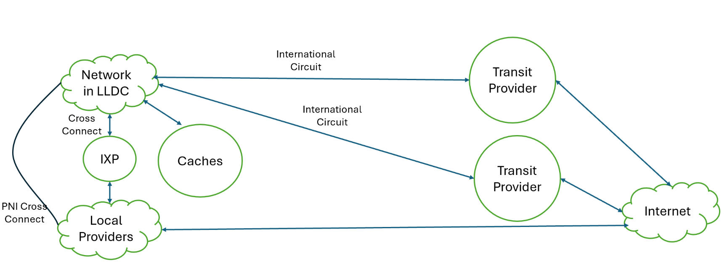
Figure A.4 – Complex Model – Complex network with local peering, caching, redundancy
Formula 8 – Complex IP transit model
$First Mile Cost per Mbit/s$ =
$$\frac{Longline cost+Redundant longline costs+IXP caching costs+PNI peering costs+Caching costs+ IP transit cost}{Used bandwidth (Mbit/s)}$$

A.4.3 Comparison data of simple model vs complex model – Real world pricing
The complex model for the more sophisticated network scenario, in principle, delivers cheaper IP bandwidth pricing. Locally hosted data is delivered without expensive longline circuits, and this brings down the blended cost. To realize these gains in practice requires that network designers efficiently use the resources in their networks to maintain cost efficiency. The theory is proven by market data from Telegeography in Figure A.5 below, which shows that in Johannesburg and some other African cities that are emerging as IP transit hubs, that the market price for blended IP transit is significantly lower than pricing for the simple network model. Furthermore, the market trend data shows that five years ago that IP transit was significantly more expensive. The three cities, Johannesburg, Nairobi and Lagos, have enjoyed significant investment into data centres, are in countries with more than five subsea cable landings, and have thriving and successful Internet exchanges. These conditions have made a conducive environment where eyeball networks, content networks and transit networks all exist, connecting to each other via settlement free peering or paid IP transit at the IXPs and datacentres. The emergence of more "IP transit hubs" in Africa where the IP transit pricing is on a par with Europe, increase the options for LLDCs in Africa such as Malawi, to source their IP transit from. Instead of paying for expensive longlines all the way to London, Malawi can now use much shorter circuits to get to Johannesburg and Nairobi for instance and take advantage of cheaper IP transit and peering in those hub cities. This further drives down the average costs of bandwidth on the continent.
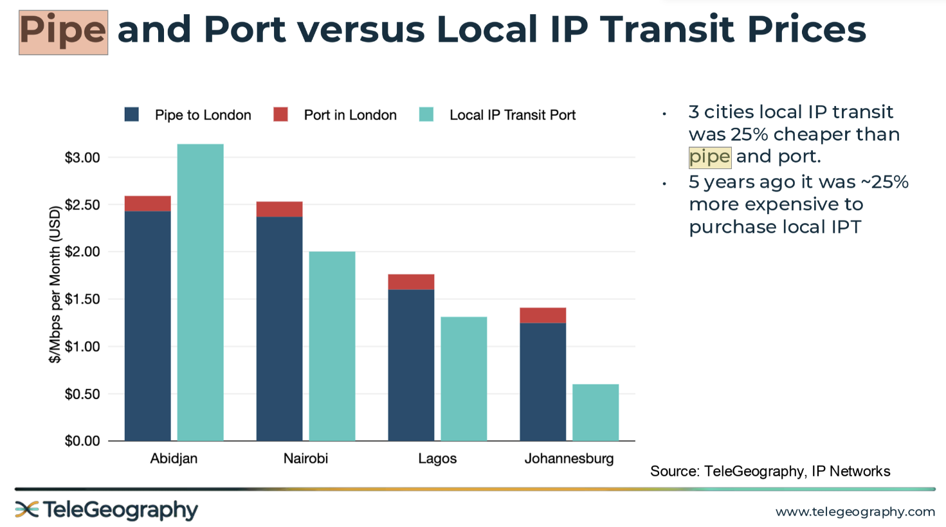
Figure A.5 – Market data comparison of pipe and port vs complex model of IP transit costs

A.5 Policy interventions
Driving down the cost of first-mile data therefore can be influenced by policies, and such policies should be geared towards:
a) Localizing more traffic to reduce the transit costs. Localizing traffic can be done by hosting more content locally, or by using caches to keep popular content locally.
b) Increasing the overall traffic used in a country, driving traffic demand, so as to reduce the cost per Mbit/s.
c) Incentivizing and easing the cost of building infrastructure that provides first-mile connectivity.
d) Collaborations on projects and policy with other nations that are involved in the value chain of the connectivity.

Bibliography

[b-ITU-T D.50] Recommendation ITU-T D.50 (2011), International Internet connection.
[b-ITU-T D.52] Recommendation ITU-T D.52 (2016), Establishing and connecting regional Internet exchange points to reduce costs of international Internet connectivity.
[b-IETF RFC 4271] IETF RFC 4271 (2006), A Border Gateway Protocol 4 (BGP-4), Internet Engineering Task Force.
[b-80/20 Initiative] Moving Toward an Interconnected Africa: The 80/20 Initiative – Internet Society,
<https://www.internetsociety.org/resources/doc/2021/moving-toward-an-interconnected-africa-the-80-20-initiative/>
[b-African NGU] Patrick Christian, African Network Geography Update,
<https://www.afpif.org/wp-content/uploads/2024/08/Network-Infrastructure-Trends-in-Africa.pdf>
[b-Ben Roberts] Ben Roberts, Why More is Better When it Comes to Subsea cables, <https://www.afpif.org/2016/08/why-more-is-better-when-it-comes-to-subsea-cables-and-africa/>.
[b-CDN] Open Mapping of CDN Caches of Leading CDN Providers, <https://opentelecomdata.org/cdns/>
[b-Connecting Africa] Connecting Africa,
<https://www.connectingafrica.com/fiber-networking/liquid-launches-kenya-ethiopia-zambia-malawi-fiber-routes>
[b-Euro-IX 2020] Euro-IX 2020 report – Internet Exchange Points
<https://www.euro-ix.net/media/filer_public/cf/7c/cf7c8cb1-40c9-4e37-9d79-02b61ccc081e/ixp_report_2020_.pdf>
[b-Huawei] Huawei,
<https://www.huawei.com/en/news/2019/2/safaricom-end-to-end-400g-backbone-network>
[b-INX ZA] INX ZA,
<https://support.inx.net.za/en/kb/article/what-are-the-port-costs>
[b-Live Traffic Data] Live Traffic Data from Internet Exchanges in Africa,
<https://ixpdb.euro-ix.net/en/explore/ixps/?reverse=&sort=name&q=&region=2>.
[b-Netflix] Netflix,
<https://about.netflix.com/en/news/netflix-open-connect-pledges-expanded-local-access-for-over-100m>
[b-OECD] Organisation for Economic Co-operation and Development (OECD) (2013), Internet Traffic Exchange: Market Developments and Policy Challenges.
[b-Redcentric] Redcentric – Explanation of 95th percentile billing, <https://www.redcentricplc.com/colocation/what-is-95th-percentile-billing-for-internet/>
[b-Telegeography] Telegeography Submarine cable map,
<https://www.submarinecablemap.com/>

______________

The designations employed and the presentation of material on this map do not imply the expression of any opinion whatsoever on the part of ITU and of the Secretariat of the ITU concerning the legal status of the country, territory, city or area or its authorities, or concerning the delimitation of its frontiers or boundaries

