Standardization Sector
ITU Focus Group Technical Specification
(01/2024)
ITU Focus Group on Autonomous Networks
(FG-AN)
Gap analysis for autonomous networks
ITUPublications | International Telecommunication Union


Technical Specification
Gap analysis for autonomous networks
Summary
Use cases for autonomous networks has been documented in Supplement 71 and an architecture framework for autonomous networks was specified in Recommendation ITU-T Y.3061. ITU-T also approved Recommendation ITU-T Y.3060 on overview of trust in autonomous networks. In addition, FG AN worked-on proof of concept, Build-a-thon, and the results from the PoC were published as an output deliverable of FG AN. As a conclusion, FG intends to capture in this document further steps and the gaps from the current state of the art in autonomous networks.

Note
This is an informative ITU-T publication. Mandatory provisions, such as those found in ITU-T Recommendations, are outside the scope of this publication. This publication should only be referenced bibliographically in ITU-T Recommendations.

Contributors: | Leon Wong  FG-AN chair,  Rakuten Mobile  Japan | Email: leon.wong@rakuten.com
Contributors: | Vishnu Ram O.V.  India | Email: vishnu.n@ieee.org
Contributors: | Paul Harvey  University of Glasgow  UK | Email: paul.harvey@glasgow.ac.uk
Contributors: | Xiaojia Song  China Mobile  P.R. China | Email: songxiaojia@chinamobile.com
Contributors: | Leon Wong  FG-AN chair,  Rakuten Mobile  Japan | Email: leon.wong@rakuten.com
Contributors: | Vishnu Ram O.V.  India | Email: vishnu.n@ieee.org
This Technical Specification has been published as approved by the focus group, without any subsequent editorial review.

© ITU 2026
Some rights reserved. This publication is available under the Creative Commons Attribution-Non Commercial-Share Alike 3.0 IGO licence (CC BY-NC-SA 3.0 IGO; https://creativecommons.org/licenses/by-nc-sa/3.0/igo).
If you wish to reuse material from this publication that is attributed to a third party, such as tables, figures or images, it is your responsibility to determine whether permission is needed for that reuse and to obtain permission from the copyright holder. The risk of claims resulting from infringement of any third-party owned material in the publication rests solely with the user..
Table of contents
Page
1 Scope 1
2 References 1
3 Definitions 1
3.1 Terms defined elsewhere 1
3.2 Terms defined in this Technical Specification 1
4 Introduction 1
5 Topics for further analysis 2
6 Conclusion and proposed future steps 5
Appendix A – Gaps captured in https://extranet.itu.int/sites/itu-t/focusgroups/an/ input/FGAN-I-306.docx 6
Appendix B – Analysis of [ETSI ZSM] 12

Technical Specification ITU FG-AN
Gap analysis for autonomous networks

1 Scope
Based on the work done by ITU FG AN and its interaction with other like-minded groups, this Technical Specification captures the gaps and potential future steps to address those gaps, in autonomous networks.

2 References
[ITU-T Y.3060] Recommendation ITU-T Y.3060, Autonomous networks – overview on trust.
[ITU-T Y.3061] Recommendation ITU-T Y.3061, Autonomous Networks – Architecture framework.
[ITU-T Supplement 71] Supplement 71 to ITU-T Y-series Recommendations, Use cases for autonomous networks.
[FGAN-I-126] ITU-T FG AN Contribution, FUT, Minna, Nigeria, Standards gap analysis for AN.
[FGAN-I-306] ITU-T FG AN Contribution, University of Glasgow, Rakuten Mobile, Vishnu Ram OV, Inputs for gap analysis for ITU Architecture framework for AN.
[FGAN-O-013-R1] ITU-T FG AN Technical Specification, Use cases for Autonomous Networks.
[FGAN-O-029] ITU-T FG AN Deliverable, Technical Report on Proof-of-Concept activities.

3 Definitions

3.1 Terms defined elsewhere
None.

3.2 Terms defined in this Technical Specification
None.

4 Introduction
ITU FG AN along with its parent group (SG13) has analysed several use cases related to Autonomous Networks. These use cases were analysed and published as [ITU-T Supplement 71]. Based on these use cases, an architecture framework for AN [ITU-T Y.3061] was arrived at.
Recently the focus group has concentrated on PoC and produced Technical Reports such as [FGAN−O-029].
Each of the use cases described in [FGAN-O-013-R1] called out the open issues corresponding to that use case. In addition, [FGAN-O-029] details certain future steps studied as part of proof of concept activities done in WG3 of FG AN. [FGAN-I-126] captures the discussion and gaps analysed with respect to work of specific SDOs. [FGAN-I-306] also analysed gaps for ITU architecture framework for AN.
In addition, inputs were added from several liaisons exchanged with various bodies and contributions received from several members and discussions thereof.
The gaps identified are discussed below.

5 Topics for further analysis
Gap Id | FGAN-GAP-001
Title | Representation mechanisms and transfer protocols for knowledge
Description | Representation mechanisms and transfer protocols for knowledge need further study. The use case requirements pointed to the need for a knowledge base. The architecture framework [ITU-T Y.3061] specified the knowledge base.  However, detailed specifications on the potential representation mechanisms and protocols for transfer of knowledge are beyond the scope of such a pre-standards study. It is possible that this requires a larger discussion, among various SDOs and industry bodies to identity potential alignment of various forms of knowledge representation suitable for various use cases and selection thereof.  Interoperability of the knowledge base (KB) that allows storage, query, export, import and modification of knowledge using standard mechanisms as specified in [ITU-T Y.3061] needs to be specified in detail to prevent interoperability issues in future among various vendors providing this function.
Reference | [FGAN-O-013-R1]
Future work | Discuss the following in a global forum:  1) comparison between existing forms of knowledge representations, and transformations, suitable for autonomous networks, as could be applicable to frameworks such as [ITU-T Y.3061];  2) possible interoperability studies with various vendors in the context of the use cases specified in [ITU-T Supplement 71].

Gap Id | FGAN-GAP-002
Title | Interoperability scenarios for AN Sandbox
Description | As described in [ITU-T Y.3061], it is possible that simulators are used in AN Sandbox for experimentation. There are heterogeneous simulators even for one use case, there are several vendors and open source simulators used by the industry and academia. Driving end to end experimentation scenarios with simulators which do not use uniform or standard interface makes it difficult to automate the scenario.  Addition of new simulation capabilities, flagging of new requirement for simulation are difficult due to non uniform capabilities and non-standard interfaces.
Reference | [FGAN-O-013-R1]
Future work | Need global study on metadata on API and interfaces for simulators (similar to described in [ITU-T Y.3181]). Need further discussions on harmonizing baseline representations for metadata and APIs for simulator capabilities to enable discovery of supported features.

Gap Id | FGAN-GAP-003
Title | Level and mechanisms for supervision in AN
Description | While we discussed peer-in-the-loop scenarios, where the peers include models and humans, it is still to be studied which messages are to be exchanged for these peer-in-the-loop scenarios.  It is possible that certain implementations are more loose or relaxed in this supervision, e.g., the messages could relate to request for comments on certain experiments or adaptations being applied. It is also possible there is a capability exchange planned between different peers. Synchronous and asynchronous events could be thought of to enable such peer in the loop scenarios.
Reference | [FGAN-O-013-R1]
Future work | Need further study on detailed use case wise scenarios for peer in the loop as well as the implementations of loosely coupled and tightly coupled supervision mechanisms.  This question might be important to recognise the autonomy but at the same time ensure the quality of autonomous decisions.

Gap Id | FGAN-GAP-004
Title | Integrating operational controllers
Description | There are heterogeneous implementations of automation loops and closed loop frameworks. Integration and configuration of various controllers as described in [ITU-T Y.3061] are to be studied considering the interoperability with various closed loop frameworks and autonomous network functions.
Reference | [FGAN-O-013-R1]
Future work | Need further study on interface and integration of various closed loop frameworks. This would include a survey of existing frameworks, their capabilities, the interfaces exposed and API implementations for integration with AN. Since multiple such frameworks may exist, this should be a global study, including various vendors and opensource.

Gap Id | FGAN-GAP-005
Title | Optimization of AN functions
Description | AN functions may include conflicting goals such as coverage and power optimizations. Conflict resolution needs to be studied, especially considering the intents from operators.  Another point of optimization is latency in application of AN decisions from the various AN framework components.
Reference | [FGAN-O-013-R1]
Future work | With multiple AN frameworks, enabled by standards and interoperability, operators need ways to resolve conflicts in decisions taken by AN frameworks. Scenarios, priorities need to be defined and studied so that the predictable outcomes can be expected.  Overhead in terms of latency and other aspects, imposed by AN functions needs to be studied as well.

Gap Id | FGAN-GAP-006
Title | A catalog of experiments
Description | A list of baseline experiments that is suitable for each use case, and use of standard design mechanisms such as modelling languages, e.g., Unified Modeling Language, for representation of the designs could be studied as future step.
Reference | [FGAN-O-29]
Future work | A machine readable and writable form of experiments, starting with a baseline set of experiments could be either bootstrapped with human feedback or derived using existing models.  Discussion on representation mechanisms for experiments would help further standards in the area.

Gap Id | FGAN-GAP-007
Title | Controller marketplace formats.
Description | Lack of a unified repository format for marketplace and a reference marketplace for autonomous networks which can store the controllers for various use cases hinders reuse, extension and integration of controllers.
Reference | [FGAN-O-29]
Future work | Marketplace formats (similar to the ML Marketplace described in [ITU−T Y.3176]) and baseline implementations for the marketplace would create a repository for controllers. Evolution of AN Controllers may happen independently of the technology evolution in future AN underlay networks. Integration of Controller repositories will provide a mechanism for network operators to follow the innovation curve in the domain of autonomous networks, riding the wave of enablers such as AI/ML, etc.

Gap Id | FGAN-GAP-008
Title | On-demand handling of new use cases
Description | Current state of analysis of use cases and knowledge base in AN points to the capabilities of deriving new use cases based on offline analysis algorithms. But this requires further enhancement to the method of representing the use cases in the reference code (i.e., to convert all functions into properties in TOSCA).
Reference | [FGAN-O-29]
Future work | Create reference pipelines and tools for derivation of new use cases. Validation and experimentation of such use cases are to be studied in AN Sandbox.

Gap Id | FGAN-GAP-009
Title | Dynamic data handling with heterogeneous APIs
Description | Heterogeneous data handling APIs hinders integration of data sources and sinks. Thus, non-uniform APIs does not allow onboarding new network functions, use cases and underlays into AN framework integration.
Reference | [FGAN-O-29]
Future work | Similar to [ITU-T Y.3174], a study into data handling techniques in AN is needed. A study of APIs and metadata regarding the APIs, with an aim to discover new Controllers and overlays, is needed.
Gap Id | FGAN-GAP-010
Title | Study on evolution mechanisms
Description | Ability to plug in various evolution mechanisms.
Reference | [FGAN-O-29]
Future work | A study in integration of various evolution mechanisms.

6 Conclusion and proposed future steps
FG AN analysed use cases, architecture and proof of concept in the area of autonomous networks. Each of the use cases described in [FGAN-O-013-R1] called out the open issues corresponding to that use case. In addition, [FGAN-O-029] details certain future steps studied as part of proof of concept activities done in WG3 of FG AN. [FGAN-I-126] captures the discussion and gaps analysed with respect to work of specific SDOs. [FGAN-I-306] also analysed gaps for ITU architecture framework for AN.
In addition, inputs were added from several liaisons exchanged with various bodies and contributions received from several members and discussions thereof. Based on the work done by ITU FG AN and its interaction with other like-minded groups, this document captures the gaps and potential future steps to address those gaps, in Autonomous Networks.
Based on the gap analysis done by FG AN, it is clear that the study of autonomous networks acquires increased significance in the context of future networks such as IMT-2030. Continued discussion and engagement of various entities such as academia, start-ups and industry are needed with workshops and plug-fests for exchange of information and experience in this field.
In this context, it is proposed that autonomy in networks and applications and service be studied in the context of a global initiative which brings together various ITU members and non-members into a community enabling a broader study, given the background work done by FG AN.

Appendix A
Gaps captured in https://extranet.itu.int/sites/itu-t/focusgroups/an/
input/FGAN-I-306.docx
Organisation | Standards / Platforms | Description and Applicability | Gap Analysis
3gpp SA5 –  Management, orchestration, and Charging  Selected relevant contributions and/or LS/i:  – FGAN-I-056-LS  – FGAN-I-097  – FGAN-I-141-LS  – FGAN-I-220  – FGAN-I-240-LS | 3GPP TS 28.100 | This document describes an interpretation of autonomous network levels, as well as certain use cases, requirements and solutions for the levels of autonomous functions in a 3GPP network. | TS 28.100 describes a framework for the categorisation of network levels, and not an architectural framework on how to achieve autonomous operation.  Such levels may be used to comment on the current operational status of autonomy.  Thus, there exists a "value add" in integration of such frameworks to the ITU Architecture framework for AN as it can help to quantify its benefit.  However, we do not find overlap or duplication of efforts.
 | 3GPP TS 28.533 | This document describes a network management and orchestration architecture for 3GPP networks including network slicing. | 3GPP TS 28.533 describes an architecture for the management of an underlay network. It does not describe autonomous management or autonomous operation.  Synergy exists between these works in that TS 28.533 may be an underlay to this architecture framework.  However, we don't find overlap or duplication of efforts.
 | 3GPP TS 28.312 | This document discusses topics in the area of intent-driven management relating to service and network management. | 3GPP TS 28.312 describes the concept and manipulation of "intent". It does not describe how autonomous operation may be achieved based on an intent. This document describes an architectural framework to achieve autonomous operation.  Synergy exists between these works as the intent may be used to provide a "utility function", as consumed by this architectural framework.  However, we do not find overlap or duplication of efforts.
 | 3GPP TS 28.313 | This document describes the concepts and specifications of self-organising networks (SON) in a 3GPP system. | 3GPP TS 28.313 describes centralised and distributed SON pre-defined processes, which may or may not be hierarchical. It does not describe the autonomous and automatic design, adaptation, and validation of controllers.  Synergy exists between these works as the SON algorithms may be provided to this architectural framework (as modules) to be included in the controller designs.  However, we don't find overlap or duplication of efforts.
 | 3GPP TS 28.530 | This document describes the network management and orchestration architecture for 3GPP networks, including network slicing. | 3GPP TS 28.530 describes the lifecycle management of closed loops. The scope of the closed loops in 3GPP TS 28.530 is limited to 4 stage Monitor, analyse, decide, action loops.  The ITU architecture framework for AN has no such limitation as such design considerations are left to the architecture.  Synergy exists between these works as the lifecycle management can be utilised by the framework in the provisioning of controllers.  However, we don't find overlap or duplication of efforts.
ETSI  Selected relevant contributions / liasons:  – FGAN-I-005  – FGAN-I-016  – FGAN-I-048-LS  – FGAN-I-059-LS  – FGAN-I-096-LS  – FGAN-I-159  – FGAN-I-192-LS  – FGAN-I-257  – FGAN-I-258  – FGAN-I-268-LS | ETSI TS 103 195−2 | This document describes the generic autonomic network architecture (GANA) reference architectural reference model. | ETSI TS 103 195-2 describes an architectural reference model that seeks autonomy through the use of various forms of pre-defined "autonomics algorithms" applied directly to the network, possibly using closed loops.  It does not consider the automatic design or validation of these closed loops nor the feedback between these steps and the deployment of a closed loop to the network.  We do not find overlap or duplication of efforts.
 | ETSI GS ZSM 008 | This document describes an investigation of end to end (E2E) service management and describes associated lifecycle actions for such services. | ETSI GS ZSM 008 describes the practical elements of how services in the network should interact. It does not describe how their autonomous operation should or could be achieved.  Synergy exists between these works as service lifecycle management can be utilised by controllers designed by this architectural framework via modular encapsulation or the E2E Orchestrator Component.  We do not find overlap or duplication of efforts.
 | ETSI GR ZSM 011 (work in progress) | Intent-driven autonomous networks: general aspects | ETSI GR ZSM 011 (work in progress) describes intent and associated lifecycle management of an intent.  It does not describe how to achieve autonomous operation through the design and validation of closed loop.  Synergies may exist between these works as an intent may be used to provide a "utility function", as consumed by this architectural framework.  We do not find overlap or duplication of efforts.
 | ETSI GS ZSM 002 | Zero-touch Service Management: Reference Architecture  This document describes a reference architecture for zero-touch management concerning management services and service management. | ETSI GS ZSM 002 describes the use of certain technologies, such as AI and closed loops, to enable necessary functions in the operation of a network and its services.  It does not describe how to achieve autonomous operation through the design and validation of closed loop.  Synergies exist between these works as closed loops designed, validated, and selected in this architecture could be integrated to an underlay via inter-operation with the ZSM architecture.  We do not find overlap or duplication of efforts.
 | ETSI GS ZSM 009-2 | Zero-touch network and Service Management (ZSM); Closed-Loop Automation; Part 2: Solutions for automation of E2E service and network management use cases. | ETSI GS ZSM 009-2 describes the predefined design of closed loops in various use case categories. It doesn't address the autonomous design and validation of closed loops.  We do not find overlap or duplication of efforts.
 | ETSI GS ENI 005 | Experiential Networked Intelligence (ENI); System Architecture | ETSI ENI describes an external entity that provides varying degrees of AI-based intelligent support to a system or service in the form of data and actions. It uses predefined internal mechanisms to drive this process.  It does not address the autonomous design, validation, or deployment of closed loops. Instead, in some cases, ETSI ENI augments the operation of existing deployed closed loops in the target system or service.  We do not find overlap or duplication of efforts.
IETF / IRTF  Selected relevant contributions:  – FGAN-I-021 | RFC 7575 | Autonomic Networking: Definitions and Design Goals  This document describes a set of design goals for autonomous networks. | RFC 7575 is a description of a set of design goals or aspirations in the area of autonomous operation in a managed network. It does not describe an architectural framework for autonomous networks.  We do not find overlap or duplication of efforts.
IETF / IRTF  Selected relevant contributions:  – FGAN-I-021 | RFC 8993 | A Reference Model for Autonomic Networking  This document describes an abstract reference model for autonomic networking. | The draft does not provide an architectural framework and does not seek fully autonomous operation.  It does recommend the use of closed loops, but it does not address the autonomous design, validation, and adaptation of closed loops  We do not find overlap or duplication of efforts.
IETF / IRTF  Selected relevant contributions:  – FGAN-I-021 | draft-li-coinrg-distributed-learning-architecture-00  (active till 11/11/2023) | Distributed Learning Architecture based on Edge-cloud Collaboration  This document describes considerations and concerns about federated learning in edge computing contexts. | The draft is concerned with the training of ML models on distributed compute infrastructure (federated learning).  It is not concerned with an architectural framework for autonomous networks, nor the autonomous operation of the network.  We do not find overlap or duplication of efforts.
NGMN  Selected relevant contributions:  – FGAN-I-032  – FGAN-I-196 | Autonomous System and Network Automation Framework | This document describes various design considerations in what an autonomous network may require. | This white paper discusses various high-level design considerations in the holistic operation of an autonomous network, with a particular focus on the use of machine learning technical enablers. In this case, autonomous framework refers to a collection of technological enablers that together may provide an environment in which autonomous operation may occur in time.  It does not describe an architectural framework to realise the autonomous operation in the network. It does not mention evolutional AI as a technological enabler.  We do not find overlap or duplication of efforts.
TMForum  Selected relevant contributions and/or LS/i:  – FGAN-I-032  – FGAN-I-057-LS  – FGAN-I-100-LS  – FGAN-I-112-LS  – FGAN-I-181  – FGAN-I-217-LS  – FGAN-I-180  – FGAN-I-185  – FGAN-I-193 | IG1251 | Autonomous Networks Reference Architecture  This document describes a reference architecture for autonomous networks, focusing on design principles. | This document discusses a reference architecture of autonomous networks, focusing the description of "autonomous domains" and their interaction across business, service, and resource layers in the network, as well as the use of closed loops.  It does not address the autonomous design or validation of closed loops.  We do not find overlap or duplication of efforts.

Appendix B
Analysis of ETSI ZSM
This appendix provides an analysis of scenarios in [ETSI ZSM 001], [ETSI ZSM 002] and [ETSI ZSM 009] with respect to the key concepts in ITU Focus Group in Autonomous Networks (ITU FGAN). Any relationship with the documents in the FGAN is called out.
Table 1 below describes potential points to further analyse which may be derived in the context of zero touch and closed loops from ETSI ZSM, noted here for deriving specific gaps (if any). These are loosely connected to the requirements, architecture and enablers provided in the ETSI ZSM documents, selected based on relevance to FGAN. A one-to-one mapping may not be always available for the requirements with the ones in the ETSI ZSM documents.
Table 1 – Points to analyse (1)
Serial Number | Points to ponder | Description | Reference clause in [ETSI ZSM 001]  [ETSI ZSM 002]
1 | 1. Recipe-based composition of controllers (or network instances) and the ability to come up with potentially new recipes.  2. Network status (e.g., resource status and characteristics) from underlays and requirements from slice customers may be used as inputs for recipe design.  What are the algorithms that can be used for recipe-making? What metadata is needed?  What are the requirements for representation of slice and design representation in template (e.g., TOSCA)? | "Reduce time-to-market of network slice" or network instances requires automation of LCM (life cycle management). "Template design can be automated, based on learning".  "Specifying network slice characteristics using templates" and evolution of underlay networks may add complexity.  In the absence of a template – "network slice instance needs to be created from scratch" – requires on-demand "recipe-based composition".  – Rebalancing of network resources, PnP of network slice resources, monitoring may be done by the automation frameworks (e.g., ZSM). | 6.2.1.1 Network slice lifecycle management [ETSI ZSM 001]  Figure 1: derived from the above sub-clause.  4.2.9 Principle 09: Service composability [ETSI ZSM 002]  5.3.1 General functional requirements  [Func-Gen-04] [ETSI ZSM 002]  5.3.1 General functional requirements  [Func-Gen-07]  [ETSI ZSM 002]  5.3.2 Functional requirements for data collection  [Func-DColl-09] [ETSI ZSM 002]
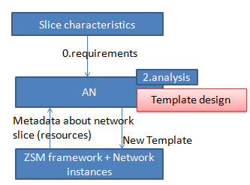
Figure 1
Table 2 – Points to analyse (2)
Serial Number | Points to ponder | Description | Reference clause in [ETSI ZSM 001]
2 | In a recipe-based controller (or network instance) composition, as the requirements change, and the underlay network capabilities evolve, "interdependence" and "independence" needs to be defined.  Selection of Mechanisms for monitoring, analysing, and adapting – e.g., migration, acceleration – needs to be studied, keeping in mind the parallel evolution of the controller components and the underlays. | – Isolation is needed to make sure there is no interference between network slice instances – level of independency between network slice instances, needs Assessment of negative impacts caused by the behaviour of other network slice instances.  – Reconfiguration of network functions as well as the reallocation of network resources may be needed.  Based on:  Monitoring of resources in shared network underlay, slice requirements (from say verticals about required level of independency), and Observed levels of interference, Assessment and adaptation (e.g., conflict resolution) may be done by AN. | 6.2.1.2 Network slice isolation management  Figure 2: derived from the above sub-clause.
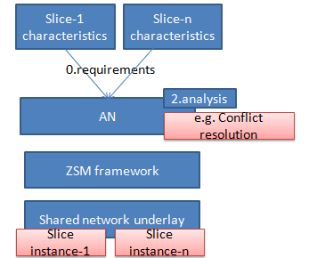
Figure 2
Table 3 – Points to analyse (3)
Serial Number | Points to ponder | Notes | Reference clause in [ETSI ZSM 001]  [ETSI ZSM 002]
3 | 1. Vertical-driven, intent-based requirements for autonomous service management.  2. Continuous evolution, adaptation of closed loops and services, based on evolving slice-customer requirements. | Slice-customers (vertical networks operators) may represent controller requirements in abstract format (e.g., TOSCA).  Closed loops (controllers) are formed by underlying frameworks (e.g., ZSM) using such abstract formats.  The actions of the controllers (like monitoring, analysis and resulting actions on the network instances) are derived from such abstract formats.  Continuous update of such requirements may influence inputs for evolution, experimentation and adaptation of closed loops and services. | 6.2.1.3 Network slice monitoring [ETSI ZSM 001]  Figure 3: derived from the above sub-clause.  4.2.10 Principle 10: Intent-based interfaces [ETSI ZSM 002]  5.3.1 General functional requirements  [Func-Gen-03] [ETSI ZSM 002]  5.3.2 Functional requirements for data collection  [Func-DColl-09] [ETSI ZSM 002]
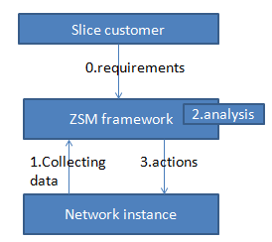
Figure 3
Table 4 – Points to analyse (4)
Serial Number | Points to ponder | Description | Reference clause in [ETSI ZSM 001]  [ETSI ZSM 002]
4 | As the controller requirements evolve/change, automatic mapping is needed between the requirements from the verticals and management of different domains like RAN, Core and Transport.  Automatic Preparation and composition is needed for controllers.  Feedback to humans.  Feedback to verticals (e.g., via application orchestrators) is needed. | Capability to make the management coordination across different technical domains, including at least Core network domain, RAN network domain, transport network domain and virtualization part may be provided by the automation frameworks. | 6.2.1.4 E2E network slicing provisioning in support of 5G services  Figure 4: derived from the above sub-clause.  5.3.1 General functional requirements  [Func-Gen-04] [ETSI ZSM 002]  5.3.1 General functional requirements  [Func-Gen-06] [ETSI ZSM 002]  5.3.1 General functional requirements  [Func-Gen-11] [ETSI ZSM 002]  6.1.2.3 Management domains  [ETSI ZSM 002]  6.1.2.4 The end-to-end (E2E) service management domain  [ETSI ZSM 002]
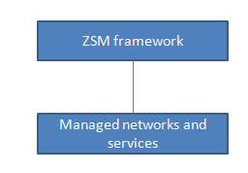
Figure 4
Table 5 – Points to analyse (5)
Serial Number | Points to ponder | Description | Reference clause in [ETSI ZSM 001]
5 | How to arrive at the mapping and coordination between the PM (performance measurement) from various domains vs. e2e?  How to derive the PM mechanism based on service requirements? | Capability to measure performance in different managed domains (e.g., RAN, CN) to manage the end to end network services and the end to end network slicing may be provided by automation frameworks. PM data may be reported per domain, per NF etc. Mapping of PM data to service characteristics and LCM (life cycle management) is to be done. | 6.2.1.5 Performance monitoring of E2E network slicing and service in support of 5G network and service  Figure 5: derived from the above sub-clause.  5.3.1 General functional requirements  [Func-Gen-04] [ETSI ZSM 002]
 | How to feedback from the PM mechanism to service LCM in the application orchestrator? |  | 5.3.1 General functional requirements  [Func-Gen-06] [ETSI ZSM 002]  5.3.1 General functional requirements  [Func-Gen-11] [ETSI ZSM 002]  5.3.2 Functional requirements for data collection  [Func-DColl-04] [ETSI ZSM 002]  5.3.3 Functional requirements for data services  [Func-CDS-01] [ETSIZSM 002]  5.3.3 Functional requirements for data services  [Func-CDS-04] [ETSI ZSM 002]  6.1.2.3 Management domains  [ETSI ZSM 002]  6.1.2.4 The end-to-end (E2E) service management domain  [ETSI ZSM 002]
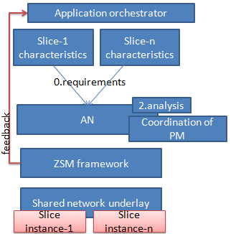
Figure 5
Table 6 – Points to analyse (6)
Serial Number | Points to ponder | Description | Reference clause in [ETSI ZSM 001]
6 | Ability to discover, adapt the exposure from the network slice to the vertical customer.  Ability to match the controller functions in the network slice to the vertical customer. | Authorized vertical industry customer to access the exposed information about NSaaS including performance and fault information of the network slice, and the exposure depends on the different scenarios of the management requirements from the customer.  "Easy integration" of slice to the slice customer also includes in-step adaptation. | 6.2.2.1 Exposure to support management and orchestration of NsaaS.

Table 7 – Points to analyse (7)
Serial Number | Points to ponder | Description | Reference clause in [ETSI ZSM 001]
7 | Reference points between the "customer" (e.g., NAO or vertical industry operator) and the automation framework needs to be defined. These may use well-defined industry reference (e.g., TMF). | The requirements from vertical industries may need to be considered by the management system as the inputs for network design and deployment.  The management system may need to have the capability for allowing vertical industry to manage certain aspects of network slice (cross domain, with existing management systems in place).  Exposure to slice customer:  – Slice customer may manage the aspects of underlying cross domain network slices. Thru ref point (a)  Design of network slice by management system may be based on ref (a)  – Interoperable Management/monitoring of network slices may be done via ref (b) | 6.2.2.2 E2E 5G network slicing management and orchestration in support of 5G services  Figure 6: derived from the above sub-clause.  5.3.1 General functional requirements  [Func-Gen-02]  [ETSI ZSM 002]  5.3.1 General functional requirements  [Func-Gen-11] [ETSI ZSM 002]  5.3.2 Functional requirements for data collection  [Func-DColl-09] [ETSI ZSM 002]  6.1.2.3 Management domains  [ETSI ZSM 002]  6.1.2.4 The end-to-end (E2E) service management domain  [ETSI ZSM 002]
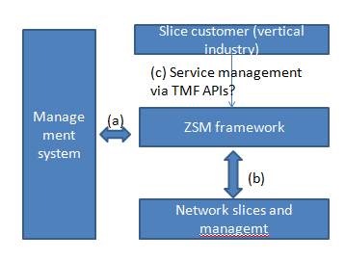
Figure 6
Table 8 – Points to analyse (8)
Serial Number | Points to ponder | Description | Reference clause in [ETSI ZSM 001]
8 | 1. Standard interfaces and coexistence with frameworks for service LCM.  2. Monitoring, prediction and reallocation of resources needed to support dynamic changes in the requirements.  3. Predictively detect abnormal behaviour.  Automatically restore and Perform recovery actions based on KPIs.  Interoperate with other management systems.  4. Conflict resolution needs to be implemented across various automation frameworks.  5. Automatic preparation, installation, configuration and verification of controllers.  6. Automatic software upgrade of controllers and verification of controllers.  7. Intent mapping to lower level policies is needed. Intents and policies may be stored in an open repository.  8. Collection of data, analysis, decision and actions may be governed by overall constraints specified in the controller intent. | Consumer/producer relation with other management frameworks is needed.  AI/ML mechanism may be used for analysis and prediction.  Automatic software deployment for Management software is needed to cover controllers.  Automatic software upgrade of management services and NFs are assumed to be provided by automation frameworks (e.g., ZSM). This may include upgrade, verification, rollback and in-service upgrade.  Policy may be provided as part of Controller specification (intent) or derived from the intent specification at runtime using language features (e.g., TOSCA substitution).  Policy triggering and execution may be done after deployment of controllers in the underlays. | 6.2.3 Automation of E2E network and service management  5.2.2 Non-functional requirements for cross-domain data services  [NFunc-CDS-06]  [ETSI ZSM 002]  5.2.3 Non-functional requirements for cross-domain service integration  [NFunc-Int-01]  [ETSI ZSM 002]  5.3.1 General functional requirements  [Func-Gen-04] [ETSI ZSM 002]  5.3.1 General functional requirements  [Func-Gen-06] [ETSI ZSM 002]  5.3.1 General functional requirements  [Func-Gen-08] [ETSI ZSM 002]  5.3.1 General functional requirements  [Func-Gen-11] [ETSI ZSM 002]  5.3.3 Functional requirements for data services  [Func-CDS-02] [ETSI ZSM 002]
5.3.3 Functional requirements for data services
[Func-CDS-02]
[ETSI ZSM 002]
5.3.4 Functional requirements for cross-domain service integration and
access
[ETSI ZSM 002]
6.1.2.1 Management Function
[ETSI ZSM 002]
6.1.2.4 The end-to-end (E2E) service management domain
[ETSI ZSM 002]

Table 9 – Points to analyse (9)
Serial Number | Points to ponder | Description | Reference clause in [ETSI ZSM 001]
9 | 1. Different domains may host closed loops which may be amenable to management at different degrees.  2. NaaS may itself need AN component interface [??].  3. Tradeoff between abstraction/information-hiding vs. service management. | Resources being managed by network and service management platforms from any domain (e.g., Transport, IP, access, media, etc.) should expose service capabilities (i.e., Network as a Service) in the ZSM framework.  – The management (service and network level) platforms of the above-mentioned domains are also becoming more autonomous.  – Service management needs E2E service level principles across multiple domains. | 6.3.1 NaaS lifecycle and exposure with a network slicing scenario  Figure 7: derived from the above sub-clause.  5.3.1 General functional requirements  [Func-Gen-03]  [ETSI ZSM 002]  5.3.1 General functional requirements  [Func-Gen-05]  [ETSI ZSM 002]
5.3.1 General functional requirements
[Func-Gen-06]
[ETSI ZSM 002]
5.3.1 General functional requirements
[Func-Gen-07]
[ETSI ZSM 002]
5.3.1 General functional requirements
[Func-Gen-08]
[ETSI ZSM 002]
5.3.1 General functional requirements
[Func-Gen-11]
[ETSI ZSM 002]
6.1.2.2 Management functions
[ETSI ZSM 002]
6.1.2.3 Management domains
[ETSI ZSM 002]
6.1.2.4 The end-to-end (E2E) service management domain
[ETSI ZSM 002]
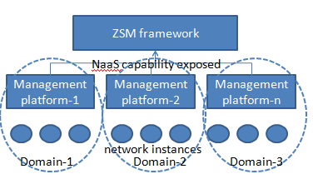
Figure 7
Table 10 – Points to analyse (10)
Serial Number | Points to ponder | Description | Reference clause in [ETSI ZSM 001]
10 | Configuring and adapting data schemas (as explained in [ITU−T Y.3174]).  Integration of ML frameworks as per [ITU-T Y.3172]. | Telemetry data inform the management system about the performance and health of the network and the services.  The functionality for automated/autonomous network management provided by the ZSM framework is data-driven and therefore needs access to telemetry data to perform its tasks.  Telemetry data can be accessed by all parts of the ZSM framework that need such information.  Categorize the requirements relating to the data being collected is the so-called three 'V's of data: Velocity, Volume and Variety which describes three defining properties or dimensions of data.  Data need to be in real-time.  There should be preprocessing and filtering that limit the data volume the data of interest governance scheme to enable common access to data. | 6.4.1 Access to up-to-date telemetry data  Figure 8: derived from the above sub-clause.  5.3.1 General functional requirements  [Func-Gen-04] [ETSI ZSM 002]  5.3.1 General functional requirements  [Func-Gen-09] [ETSI ZSM 002]  5.3.2 Functional requirements for data collection  [Func-DColl-01] [ETSI ZSM 002]  5.3.2 Functional requirements for data collection  [Func-DColl-03] [ETSI ZSM 002]  5.3.2 Functional requirements for data collection  [Func-DColl-04] [ETSI ZSM 002]  5.3.2 Functional requirements for data collection  [Func-DColl-05] [ETSI ZSM 002]  5.3.2 Functional requirements for data collection  [Func-DColl-06] [ETSI ZSM 002]  5.3.3 Functional requirements for data services  [Func-CDS-02] [ETSI ZSM 002]  5.3.3 Functional requirements for data services  [Func-CDS-04] [ETSI ZSM 002]  5.3.3 Functional requirements for data services  [Func-CDS-11] [ETSI ZSM 002]
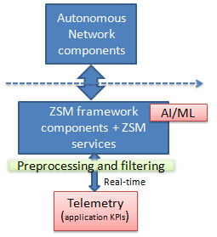
Figure 8
Table 11 – Points to analyse (11)
Serial Number | Points to ponder | Description | Reference clause in  [ETSI ZSM 001]
11 | Autonomous training, retraining, serving, updating of MLaaS and capturing of "knowledge" and the role of MLFO in autonomy – important. | – Requirements to support machine learning algorithms need to be addressed by the ZSM framework.  ML-as-a-Service (MLaaS): Splitting training and operation as microservices.  The results from training service are exported to model repositories, where "knowledge" from past experiences is stored.  ML serving frameworks [Y.3179] allows deployment of AI/ML aaS.  MLFO allows monitoring, orchestration of MlaaS.  Data set repo stores data.  REST interface to data sources is added to collect data from network and simulated sources. | 6.4.2 Machine learning for network & service automation  Figure 9: derived from the above sub-clause.  5.3.1 General functional requirements  [Func-Gen-04] [ETSI ZSM 002]  5.3.3 Functional requirements for data services  [Func-CDS-02] [ETSI ZSM 002]
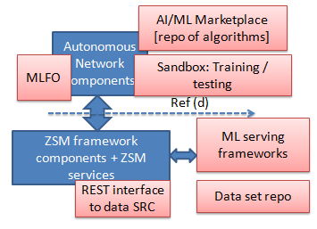
Figure 9
Table 12 – Points to analyse (12)
Serial Number | Points to ponder | Description | Reference clause in [ETSI ZSM 001]
12 | Resource usage prediction.  Service state prediction (KPIs and health).  Evolution of analytics to include new proactive prediction mechanisms using network states, KPIs, topology, and the relying infrastructure data that can also be used in the KPI prediction. | – Evolution of Passive processing to proactive prevention.  KPI prediction – used to deal with possible risks and failures in advance – e.g., network scaling based on predicted resource capability to avoid congestion. | 6.4.3 Predictive analytics  Figure 10: derived from the above sub-clause.  5.3.3 Functional requirements for data services  [Func-CDS-04] [ETSI ZSM 002]
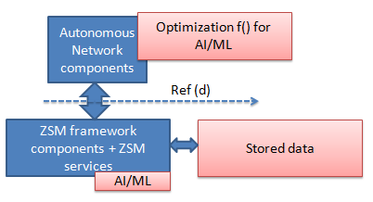
Figure 10
Table 13 – Points to analyse (13)
Serial Number | Points to ponder | Description | Reference clause in [ETSI ZSM 001]
13 | 1. Evolution/specification of new abnormal conditions, new error states.  2. Corresponding actions, triggers, including escalations and delegations – have to be specified.  3. Monitoring and governance of the root cause analysis process. | By defining conditions (expected KPI values or policy conditions) as well as actions to be triggered, The ZSM framework can solve the problem, escalate it, or delegate it. | 6.4.4 Real time monitoring and analysis  Figure 11: derived from the above sub-clause.  5.3.3 Functional requirements for data services  [Func-CDS-02] [ETSI ZSM 002]
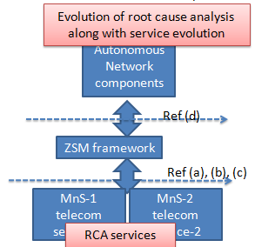
Figure 11

Table 14: Points to analyse (14)
Serial Number | Points to ponder | Description | Reference clause in [ETSI ZSM 001]
14 | – Requesting for passive access to continuous up to date traffic in the network or service topology for an authorized consumer.  Request for specific telemetry, QoS/QoE and RCA.  Based on this, AN components will trigger specific digital twin in the Sandbox. | Small or large atomic functions to perform tasks in a process.  It has to be possible in a very agile manner to introduce new functionality and concepts independent on the network or service function.  This needs to be setup with individual components outside of the network or service nodes. | 6.4.5 Proposal for analytics domains and concepts for interaction  Figure 12: derived from the above sub-clause.  5.3.3 Functional requirements for data services  [Func-CDS-02] [ETSI ZSM 002]
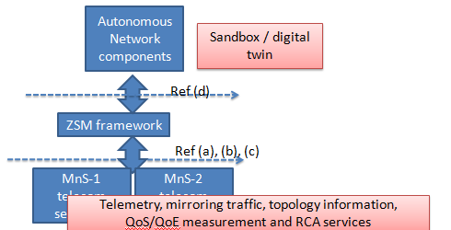
Figure 12
Table 15 – Points to analyse (15)
Serial Number | Points to ponder | Description | Reference clause in [ETSI ZSM 001]
15 | 1. Evolution/  specification of new abnormal conditions, new error states.  2. Corresponding actions, triggers, including escalations and delegations – have to be specified.  3. Monitoring and governance of the root cause analysis process. | Variety of AI algorithms available to a ZSM framework owner.  interfaces/APIs necessary to feed such AI algorithms with appropriate data needs to be investigated and defined.  ZSM framework shall ensure that data is available not only inside management domains but also outside them so that such data can be available to any authorized consumer. | 6.4.6 AI for network and service automation  Figure 13: derived from the above sub-clause.  5.3.1 General functional requirements  [Func-Gen-04] [ETSI ZSM 002]  5.3.1 General functional requirements  [Func-Gen-08]  [ETSI ZSM 002]  5.3.2 Functional requirements for data collection  [Func-DColl-04] [ETSI ZSM 002]  6.1.2.2 Management functions  [ETSI ZSM 002]  6.1.2.3 Management domains  [ETSI ZSM 002]  6.1.2.6 Data services  [ETSI ZSM 002]  8.2 Data security  [ETSI ZSM 002]
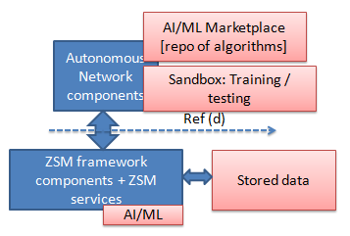
Figure 13
Table 16 – Points to analyse (16)
Serial Number | Points to ponder | Description | Reference clause in [ETSI ZSM 001]
16 | Autonomous LCM of ZSM framework components and services. | ZSM framework is a set of functional components.  It is necessary to improve ZSM services in a very agile way.  CI/CD for ZSM functional component lifecycle (development, test, deployment and operation phases).  ZSM functional components should be reused, and developed and deployed  in an automatic way.  A ZSM service is a management capability exposed by one or more functional components of the ZSM framework. | 6.4.7 CI/CD for ZSM framework functional components  Figure 14: derived from the above sub-clause.  5.2.2 Non-functional requirements for cross-domain data services  [NFunc-CDS-04]  [ETSI ZSM 001]  5.3.1 General functional requirements  [Func-Gen-04] [ETSI ZSM 002]  5.3.1 General functional requirements  [Func-Gen-07]  [ETSI ZSM 002]
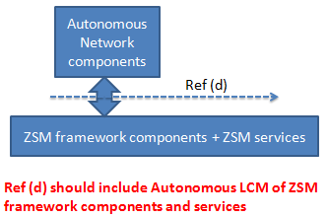
Figure 14
Table 17 – Points to analyse (17)
Serial Number | Points to ponder | Description | Reference clause in [ETSI ZSM 001]
17 | Dynamic policy adaption using intents, orchestration for closed loops, trust building components. | Separation of concern and time perspectives.  Centralized and distributed automation.  Automation functions will become self-learning and adaptive by using ML.  Advanced analytics and dynamic policy have to replace these human qualities.  Automated recommendation and policy, Monitoring the performance, proving the effects of automation functions, and keeping an audit trail of all changes is essential for trust-building. | 6.4.8 Zero-touch self-optimizing network  Figure 15: derived from the above sub-clause.  5.3.1 General functional requirements  [Func-Gen-03] [ETSI ZSM 002]  5.3.1 General functional requirements  [Func-Gen-04] [ETSI ZSM 002]
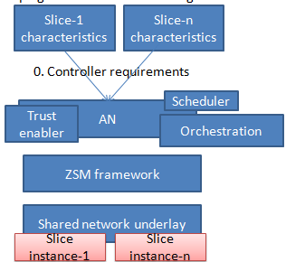
Figure 15
Table 18 – Points to analyse (18)
Serial Number | Points to ponder | Description | Reference clause in [ETSI ZSM 001]
18 | 1. The format of knowledge – could be partial trained models or something else?  2. Stability of learning and diversity of knowledge.  3. Delay in applying and updating knowledge.  4. Trust aspects to avoid impacts to SLA. | The main questions that need to be answered in this regard are related to the pre-training phase, the learning phase, and the interval of policy updates, as well as the question of human intervention.  Use of a simulated environment or sand-box to learn the policies and store the experience/knowledge in a repository to be used later in live deployments.  There is a need for a knowledge memory that would allow different learned policies to be stored and shared to speed up the self-learning algorithm's learning process | 6.4.9 Self-learning based on reinforcement learning  Figure 16: derived from the above sub-clause.  5.3.2 Functional requirements for data collection  [Func-DColl-01] [ETSI ZSM 002]  5.3.2 Functional requirements for data collection  [Func-DColl-04] [ETSI ZSM 002]  5.3.3 Functional requirements for data services  [Func-CDS-02] [ETSI ZSM 002]  6.1.2.6 Data services  [ETSI ZSM 002]
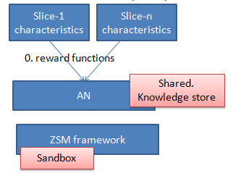
Figure 16
Table 19 – Points to analyse (19)
Serial Number | Points to ponder | Description | Reference clause in [ETSI ZSM 001]  [ETSI ZSM 002]
19 | Optimization of AI/ML is automated using Autonomous network components. | AI and ML are expected to support management services for closed loop - it is required to keep optimizing ML used in closed loop.  Stored data gets populated from non-production and production network.  AI/ML in ZSM framework uses this stored data for training and optimization. | 6.4.10 Optimization of supervised/unsupervised learning used in management services for closed loop  Figure 17: derived from the above sub-clause.  5.3.1 General functional requirements  [Func-Gen-03] [ETSI ZSM 002]  5.3.1 General functional requirements  [Func-Gen-04] [ETSI ZSM 002]  5.3.2 Functional requirements for data collection  [Func-DColl-02] [ETSI ZSM 002]  5.3.2 Functional requirements for data collection  [Func-DColl-04] [ETSI ZSM 002]  5.3.3 Functional requirements for data services  [Func-CDS-02] [ETSI ZSM 002]  5.3.3 Functional requirements for data services  [Func-CDS-04] [ETSI ZSM 002]  6.1.2.1 Management services  [ETSI ZSM 002]  6.1.2.6 Data services  [ETSI ZSM 002]
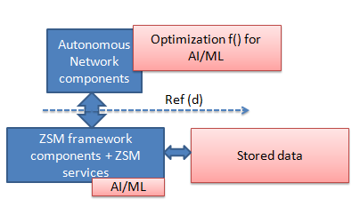
Figure 17
Table 20 – Points to analyse (20)
Serial Number | Points to ponder | Description | Reference clause in [ETSI ZSM 001]  [ETSI ZSM 002]
20 | 1. Where are AN components hosted?  2. How to enable coordinated AN in operators and enterprise network? should include communication service templates + AN templates.  3. What is the role played by open APIs?  4. Ref point between ZSM framework to operators/enterprise networks should include management service and slice management. | – Enterprises in vertical industries will have private communication services for their business in conjunction with the 5G operators' networks.  – Enterprises will request to an operator by using APIs (with communication service templates) exposed by the operator's management system to create, operate, maintain the communication services on the operator's network as well as the enterprises' premise.  Enterprises to supervise the network management and UE subscription services for private network | 6.5.2 Private communication services hosted by an operator  Figure 18: derived from the above sub-clause.  8.2 Data security  [ETSI ZSM 002]
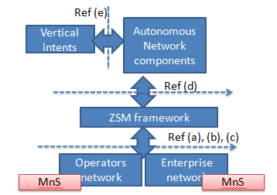
Figure 18
Table 21 – Points to analyse (21)
Serial Number | Points to ponder | Description | Reference clause in [ETSI ZSM 001]  [ETSI ZSM 002]
21 | In case of autonomous healing, enabling decryption of traffic for identification and isolation during malfunction, requires specific controller behaviour. | The autonomous network is expected to provide a secure and authenticated communication between network entities.  However, historical events have evident that troubleshooting such encrypted traffic culminates in indeterministic behaviour as it is not possible to decrypt traffic from a malfunctioning network entity.  Therefore, the AN needs to provide authorization mechanism for notifying the network owner entities about the possibility of decryption during troubleshooting period while eliminating the possibilities of replay-attack on network entities. | 6.6.1 Troubleshooting of encrypted traffic in ZSM framework  5.4 Security requirements  [ETSI ZSM 002]  8.2 Data security  [ETSI ZSM 002]  8.3 Data privacy  [ETSI ZSM 002]
Table 22 – Points to analyse (22)
Serial Number | Points to ponder | Description | Reference clause in [ETSI ZSM 001]
22 | AN needs to enable Standard experimentation triggers to service management frameworks which in turn can trigger CI/CD environments. | CI/CD pipelines need to run in a ZSM controlled deployment through interface exposed by ZSM framework.  ZSM framework will deploy the new network service software to the running environment as a network service instance, which is controlled by ZSM framework.  Frequent service upgrade is also triggered by the CI/CD pipeline, and executed by the ZSM framework. | 6.7.2 Testing: CI/CD for network services  Figure 19: derived from the above sub-clause.  5.3.1 General functional requirements  [Func-Gen-08]  [ETSI ZSM 002]
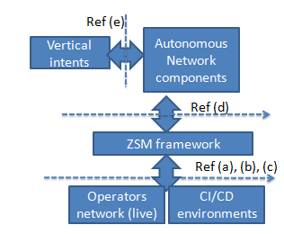
Figure 19
Table 23 – Points to analyse (23)
Serial Number | Points to ponder | Description | Reference clause in [ETSI ZSM 001]
23 | The evolution of tracing capabilities based on the evolution of underlying network. explanation capabilities need to be integrated.  Information on the various capabilities for tracing provided by the underlying network needs to be discovered. | Automated tracing and to trigger automatically the appropriate follow-up actions.  Considering of several data sources, e.g., policies, rules, profiles, and to realize automatically the appropriate tracing procedures.  Support capability of enabling automated tracing capabilities based on the capabilities of the underlying network.  support the capability of enabling automated tracing capabilities with the use of AI and machine learning functionalities and applications. | 6.8.1 Automated tracing capabilities  Figure 20: derived from the above sub-clause.  5.3.1 General functional requirements  [Func-Gen-04] [ETSI ZSM 002]  5.3.2 Functional requirements for data collection  [Func-DColl-04] [ETSI ZSM 002]  5.3.3 Functional requirements for data services  [Func-CDS-04] [ETSI ZSM 002]  6.1.2.6 Data services  [ETSI ZSM 002]
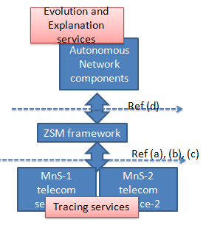
Figure 20

Table 24 – Points to analyse (24)
Serial Number | Points to ponder | Description | Reference clause in [ETSI ZSM 001]
24 | AN components acts as consumer of ZSM service framework.  Underlying networks act as providers of telecom services to the ZSM framework.  The lifecycle of (telecommunication) services is handled by the ZSM framework. | Evolution of the ZSM framework itself (incl. migration to ZSM from non-automated systems).  ZSM framework exposes ZSM services to consumers. Consumers of ZSM services use one or several of the management capabilities exposed by the ZSM framework.  Providers are entities that the ZSM framework uses to manage networks and (telecommunication) services. | 6.9.1 ZSM framework as entity in an ecosystem  Figure 21: derived from the above sub-clause.  5.3.1 General functional requirements  [Func-Gen-11]  [ETSI ZSM 002]  6.1.2.2 Management functions  [ETSI ZSM 002]  8.2 Data security  [ETSI ZSM 002]  8.3 Data privacy  [ETSI ZSM 002]
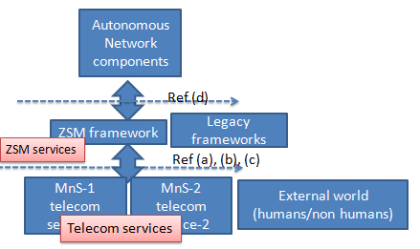
Figure 21

______________

