Standardization Sector
ITU-T Focus Group Deliverable
(11/2020)
Focus Group on Artificial Intelligence for Health
(FG-AI4H)
DT4HE Output 1
Guidance on AI and digital technologies for COVID health emergency
ITUPublications | International Telecommunication Union


ITU-T FG-AI4H Deliverable
DT4HE Output 1 – Guidance on AI and digital technologies
for COVID health emergency

Summary
This document describes the diverse nature of addressing a pandemic such as COVID-19 and proposes to set up a guidance on how to leverage artificial intelligence (AI) and other digital technologies to combat COVID-19 and other health emergencies. This document proposes a framework for AI and digital interventions targeted towards public health emergencies. It aims at identifying best practices and use cases on AI and other digital technologies to combat COVID-19. The use cases were collected and classified following the emergency life cycle stages framework. It also discusses the technical feasibility, digital governance and performance evaluation on digital response to COVID-19, and other health emergencies.
This document was developed by the ad-hoc group on digital technologies for the COVID-19 health emergency (AHG-DT4HE). It serves as a response from FG-AI4H to numerous global calls to utilize AI and other digital technologies in the fight against COVID-19. Additionally, it aims to facilitate experience sharing and collaboration among various stakeholders, fostering global dialogue and cooperation on digital projects for general health emergencies.

Keywords
Artificial intelligence, COVID-19, digital technologies, guidance, health emergency.
Note
This is an informative ITU-T publication. Mandatory provisions, such as those found in ITU-T Recommendations, are outside the scope of this publication. This publication should only be referenced bibliographically in ITU-T Recommendations.

Change Log
This document contains Version 1 of the ITU-T Focus Group on AI for Health (FG-AI4H) DT4HE Output 1 on "Guidance on AI and digital technologies for COVID health emergency" approved by correspondence by the FG-AI4H on 30 November 2020. It was originally developed by the FG-AI4H Ad-hoc Group on Digital Technologies for COVID Health Emergencies (AHG-DT4HE).

Editors: | Shan Xu  CAICT, China |  | E-mail: xushan@caict.ac.cn
 | Ana Rivière Cinnamond  PAHO/WHO |  | E-mail: rivierea@paho.org
Contributors: |  | (in alphabetical order)
 |  | Ananya Gangavarapu  EthicallyAI, US |  | E-mail: ananya@ethicallyai.org
 |  | Andrea Romaoli Garcia  United Nations Association, US |  | E-mail: andgarciar@gmail.com
 |  | Pradeep Balachandran  Technical Consultant (Digital Health), India |  | E-mail: pbn.tvm@gmail.com
 |  | Yue Gao  CAICT, China |  | E-mail: gaoyue1@caict.ac.cn

© ITU 2025
Some rights reserved. This publication is available under the Creative Commons Attribution-Non Commercial-Share Alike 3.0 IGO licence (CC BY-NC-SA 3.0 IGO; https://creativecommons.org/licenses/by-nc-sa/3.0/igo). For any uses of this publication that are not included in this licence, please seek permission from ITU by contacting TSBmail@itu.int.
If you wish to reuse material from this publication that is attributed to a third party, it is your responsibility to determine whether permission is needed for that reuse and to obtain permission from the copyright holder.

Table of Contents
Page
Introduction v
1 Scope 1
2 References 1
3 Definitions 1
3.1 Terms defined elsewhere 1
3.2 Terms defined in this document 2
4 Abbreviations and acronyms 2
5 Conventions 2
6 Roadmap 2
7 Framework 3
8 Applications at different stages of public health emergency lifecycle 4
8.1 Prevention stage 4
8.2 Preparedness stage 5
8.3 Response stage 6
8.4 Recovery stage 7
9 Future work 7
Annex A – Literature review on stage definition of emergency management 9
Annex B – Digital cases collection on COVID-19 11
B.1 Temperature measuring patrol robot (1) 14
B.2 Contact tracing (5) 15
B.3 AI-powered spread modelling system (1) 20
B.4 COVID-19 statistic dashboard (1) 21
B.5 Social networks fighting infodemic (1) 22
B.6 "XR" tech to upskill clinicians remotely (1) 23
B.7 AI in retail optimization (1) 24
B.8 Smart medical waste platform (1) 25
B.9 Digital mental health support (1) 26
B.10 Autonomous vehicles and robots to delivery meal (1) 27
B.11 AI-based virtual assistants (1) 28
B.12 AI-assisted voice robot (1) 29
B.13 Online drug supply (1) 30
B.14 AI-assisted CT scan (2) 31
B.15 Drones and robots for supplies transport (2) 33
B.16 Disinfection robot (1) 35
B.17 AI-assisted potential drug discovery (1) 36
B.18 AI-assisted genome sequencing (1) 37
B.19 AI-driven proactive healthcare unrelated to COVID-19 (1) 38
Page
B.20 AI-driven mental health monitoring (1) 39
B.21 AI-driven economy's reaction monitoring (1) 40

Introduction
Since the onset of the outbreak of an unknown pneumonia in Wuhan, Hubei Province, China in December 2019, the spread of the virus – later named SARS-CoV-2 – has overwhelmed the world. While on 31 December 2019 there were only 27 cases reported, in just one month on 31 January 2020, the total confirmed cases had increased to 11,791. The World Health Organization (WHO) declared COVID-19 as a public health emergency of international concern (PHEIC) on 31 January 2020. Currently, the entire world can be compared to an epidemic control "laboratory". Everyone is actively involved in finding effective ways to combat the virus, but the pandemic continues to be a major public health threat worldwide. According to the WHO data as of 18 September 2020, there were 29,987,026 confirmed cases and 942,735 deaths globally, and the numbers are still growing. Cooperation between various levels and organizations is essential to confront this threat.
Digital technologies can play a critical role in supporting health professionals and protecting human lives, through rapid screening of early symptoms, identifying risk via chatbots, assisting diagnosis with suggestions/references, monitoring patients' vital signs, facilitating remote care, supporting treatments and vaccines, predicting the evolution and potential mutations of viruses, optimizing hospital operations, providing information to the public in a rapid and widespread manner, etc. All digital means at our disposal, and artificial intelligence (AI), in particular, are expected to be used to accelerate progress in prevention and control in a safe, reliable and evidence-based way.

ITU-T FG-AI4H Deliverable
DT4HE Output 1 – Guidance on AI and digital technologies
for COVID health emergency

1 Scope
This deliverable collects effective ways and use cases demonstrating how AI and other digital technologies have combatted COVID-19 through the lifecycle stages of public health emergency management, including prevention, preparedness, response and recovery. The outputs are expected to evolve towards a more generalizable mechanism on the health emergency continuum, eventually applicable to other pandemics.

2 References
[1] World Health Organization (‎2016)‎. Monitoring and evaluating digital health interventions: a practical guide to conducting research and assessment. World Health Organization. https://apps.who.int/iris/handle/10665/252183. License: CC BY-NC-SA 3.0 IGO.
[2] World Health Organization. Regional Office for the Western Pacific (‎2017)‎. Asia Pacific strategy for emerging diseases and public health emergencies (‎APSED III)‎: advancing implementation of the International Health Regulations (‎2005)‎: working together towards health security. Manila: WHO Regional Office for the Western Pacific. https://apps.who.int/iris/handle/10665/259094. License: CC BY-NC-SA 3.0 IGO.
[3] OECD (2020), OECD Policy Responses to Coronavirus (COVID-19) – Using artificial intelligence to help combat COVID-19, https://web.archive.org/web/20200529184931/ https://read.oecd-ilibrary.org/view/?ref=130_130771-3jtyra9uoh&title=Using-artificial-intelligence-to-help-combat-COVID-19 (archived 2020-05-29).
[4] Cronstedt M. Prevention, preparedness, response, recovery-an outdated concept? [J]. Australian Journal of Emergency Management, 2002, 17(2): 10.
[5] Dong E, Du H, Gardner L. An interactive web-based dashboard to track COVID-19 in real time[J]. The Lancet infectious diseases, 2020, 20(5): 533-534.
[6] Bullock J, Pham K H, Lam C S N, et al. Mapping the landscape of artificial intelligence applications against COVID-19[J]. arXiv preprint arXiv:2003.11336, 2020.

3 Definitions

3.1 Terms defined elsewhere
This Deliverable uses the following terms defined elsewhere:
3.1.1 prevention [Nature]: Disease prevention is a procedure through which individuals, particularly those with risk factors for a disease, are treated to prevent a disease from occurring. Treatment normally begins either before signs and symptoms of the disease occur, or shortly thereafter. Treatment can include patient education, lifestyle modification, and drugs.
3.1.2 preparedness [WHO]: Emergency preparedness is a programme of long-term development activities whose goals are to strengthen the overall capacity and capability of a country to manage efficiently all types of emergency and to bring about an orderly transition from relief through recovery and back to sustainable development. The goal of emergency preparedness is to strengthen the capacity of governments, organizations, institutions, and communities to withstand a disaster or emergency situation.
3.1.3 response [WHO]: Emergency response is sometimes a cyclical process, involving repeated assessment, planning, action, and review, to respond appropriately to needs and capacities as they evolve. It starts with an initial assessment and may be triggered spontaneously by the disaster event, or officials may authorize the mobilization of people and resources. Rapid and effective mobilization is facilitated by proper disaster preparedness.
3.1.4 recovery [WHO]: The aim of emergency recovery is to re-establish the economic, social, and cultural life of the people affected and to rebuild damaged areas.

3.2 Terms defined in this Deliverable
None.

4 Abbreviations and acronyms
This Deliverable uses the following abbreviations and acronyms:
AHG DT4HE Ad-hoc group on Digital Technologies for COVID Health Emergency
COVID-19 Coronavirus Disease 2019
DEL Deliverable
FG-AI4H Focus Group on Artificial Intelligence for health
ITU International Telecommunication Union
PHEM Public Health Emergency Management
SARS-CoV-2 Severe Acute Respiratory Syndrome-Coronavirus 2
WHO World Health Organization

5 Conventions
None.

6 Roadmap
The roadmap of this document consists of the following three parts (Figure 1):
– In the short term, it plans to build a mechanism to collect effective experience on AI and other digital health technologies in combating COVID-19, including use cases, best practice reports and corresponding analysis. Digital health collaboration, webinars and project cooperation are also included within its network of experts.
– In the mid-term, a generalized experience extracted from this COVID-19 health emergency is expected, delivering a guidance on a digital technologies-based approach that covers the entire cycle of public health emergency management, including prevention, preparedness, response and recovery, etc.
– Eventually, this document will evolve towards a more generalizable framework on the health emergency continuum, applicable to other health emergencies.
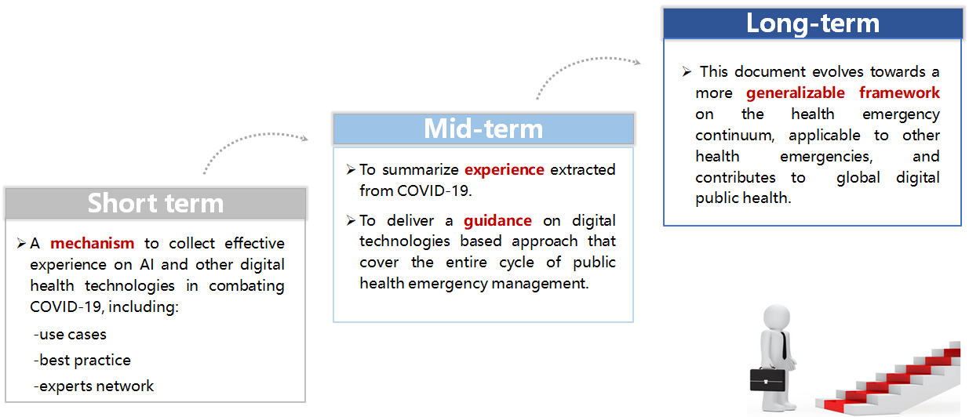
Figure 1 – Roadmap of the AHG DT4HE

7 Framework
The framework is organized in four sections (Figure 2):
– AI applications: Presents the main part of this document, including collection and classification of AI and other digital technologies at different stages of health emergencies. Prevention, preparedness, response and recovery (PPRR), a commonly used framework in public health emergency management, was selected with a combination of OECD reports on AI applications classification for COVID-19. A detailed literature review can be found in Annex B.
– Enablement factors: Considers the main technical feasibility factors on AI and other digital interventions on COVID-19 and other health emergencies. These may be taken into consideration during technical preparedness and maturity assessment.
– Digital governance: Considers governance factors on AI and other digital interventions on COVID-19 and other health emergencies. These may include data privacy, ethics, human rights, etc.
– Value assessment: Contains measures and indicators to evaluate the value of different AI and digital interventions. These may include wider applicability, transparency, scalability, privacy and ethics, etc.
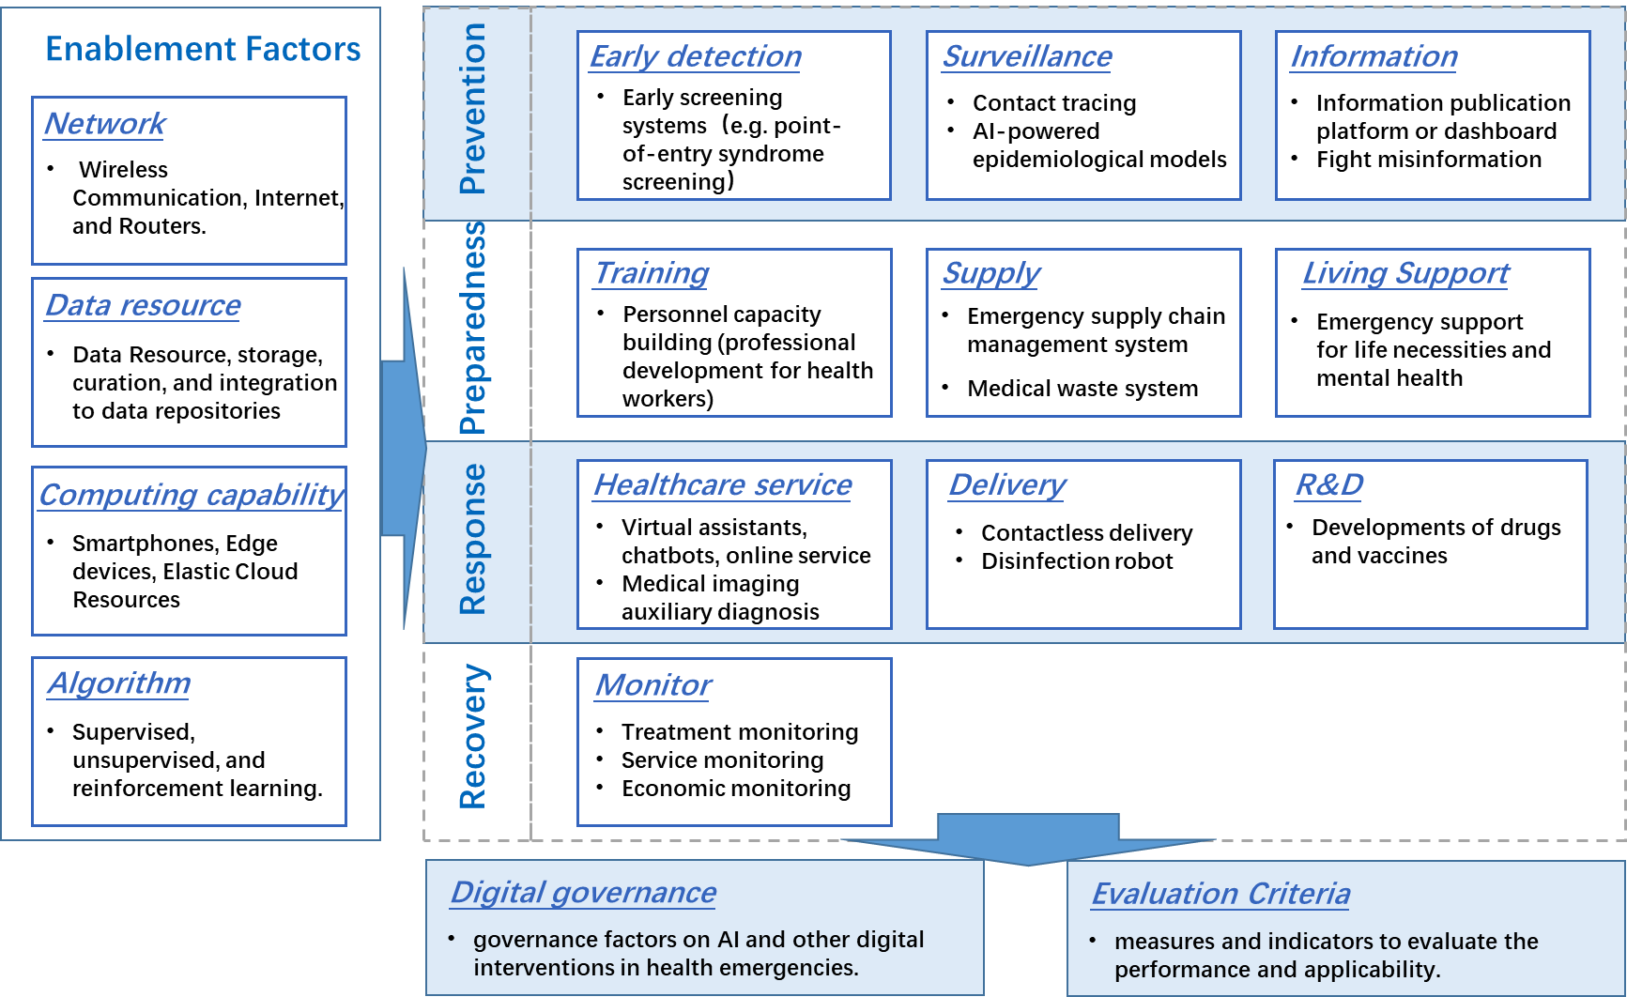
Figure 2 – AI applications at different stages of the COVID-19 response
(adapted from OECD)

8 Applications at different stages of public health emergency lifecycle

8.1 Prevention stage
At the prevention stage, actions usually begin before signs and symptoms of the disease occur or shortly thereafter to protect individuals, particularly those with risk factors from a disease. Sometimes, it is also referred to as mitigation. The positive role of AI and other digital tools can be reflected in fields of early detection, surveillance, and fighting misinformation, etc.

8.1.1 Early detection
Early screening systems can facilitate population risk assessment with precision syndrome screening. The traditional detection is based on the infrared mode. It can locate passengers with abnormal temperatures, but it cannot effectively distinguish the target with too many heat sources in crowded places. However, AI models can help with the consistency of abnormal temperature and body positioning. After matching the abnormal temperature area with its actual counterpart, the AI syndrome screening system can automatically alert medical staff to conduct a second measurement of the target's forehead temperature. As a result, these syndrome screening systems are usually deployed in densely populated areas such as railway stations, airports, subway stations, shopping malls and building entrances, etc. More details and cases can be found in Annex B.

8.1.2 Surveillance
Contact tracing followed by treatment or isolation, is a key control measure in the battle against infectious diseases. Accurate modelling of contact tracing requires explicit information about the disease–transmission pathways from each individual, and hence the network of contacts. The information acquisition is currently through three ways: (1) travelling data through telecommunication analysis, (2) exposure notification based on proximity calculations using Bluetooth and others, and (3) self-report symptoms with geographic data. Corresponding details and cases can be found in Annex B.
AI-powered epidemiological models can help detect the epidemiological patterns and identify virus transmission chains. AI technologies have demonstrated their potential to gather epidemiological data more rapidly than traditional reporting of health data, by mining confirmed cases data, mainstream news, online content, and other information channels in multiple languages to provide early warnings and evidence-based knowledge on infectious diseases control. More details and cases can be found in Annex B.

8.1.3 Information
Information publication platforms or dashboards can publish authoritative information and track real-time change on confirmed cases, deaths, growth rates and geographical distribution, etc. They can provide an overview of the whole situation and support decision-making. One of the most known cases is an interactive web-based dashboard hosted by the Center for Systems Science and Engineering (CSSE) at Johns Hopkins University, Baltimore, MD, USA, to visualise and track reported cases in real time. More cases can be found in Annex B.
Fighting disinformation is a crucial task in public risk communication. In response to a growth in the volume and diversity of misinformation in circulation, the number of fact-checks concerning COVID-19 has increased dramatically. Social networks and search engines use personalised AI information, tools and algorithms to find and remove problematic material on their platforms. A centralized AI-based knowledge system can also encourage individuals to consider the veracity of information before sharing it on social media. AI systems are also identifying the patterns of disinformation and developing effective mitigation strategies proactively. More details and cases can be found in Annex B.

8.2 Preparedness stage
At the preparedness stage, a programme of long-term development activities can put all the right components (including levels of emergency plans and system readiness) in place and strengthen the overall capacity and capability of a country to manage all types of emergencies. These activities can be divided into three types according to the corresponding capacity on personnel resource, medical supply resource and citizen living support.

8.2.1 Training
Personnel capacity building can be done through telemedicine to improve professional development for health workers. Knowledge transfer and remote consultations on telemedicine platforms and mobile apps from designated tertiary hospitals to primary care facilities can play an important role in reducing nosocomial transmission. Besides, online training for frontline health workers in primary care facilities in self-protection, diagnosis and treatment will also help professional development. More details and cases can be found in Annex B.

8.2.2 Supply
Emergency supply chain digital systems play a role in decision-making in emergency supply distribution and dispatch. E-commerce companies developed AI-based matchmaking applications and coordinated with local health authorities to procure personal protective equipment (PPE) from their global networks of suppliers. AI and big data analytics for automated matchmaking forecasting were implemented in supporting the front-line protection and cutting off the virus spreading. More details can be found in Annex B.
Medical waste system is based on internet of things (IoT) and AI technologies to provide full-process management of medical waste and to reduce nosocomial infection in hospitals or other medical institutions. With AI-based automatic control on sorting, packing, transferring, heat preservation, and other smart IoT terminals, the system enables data synchronization and consistency with hospitals and government supervision departments and, consequently, improves the safety and transparency of medical waste management. More details can be found in Annex B.

8.2.3 Living support
Emergency support for life necessities refers to various digital living applications including online consultation, online shopping and deliveries (medicines, food and groceries, etc.), online study/work, mental health support, etc. Most of these AI and digital applications were in use prior to the outbreak and can be directly activated within the COVID-19 context to support a quarantined living period. More cases and details and cases can be found in Annex B.

8.3 Response stage
The response stage involves various interventions on saving lives, protecting community assets, reducing economic losses, and alleviating suffering. It usually starts with an initial assessment and may be triggered spontaneously by the disaster event, or officials may authorize the mobilization of people and resources. Major responses by AI and other technologies observed in COVID-19 are classified into health service, automatic delivery, and research acceleration, etc.

8.3.1 Healthcare service
Virtual assistants, chatbots and other online services have been deployed to support healthcare organisations. These tools can help to triage people depending on the presence of symptoms (based on internet platforms, mobile applications, AI and big data analysis models, etc.) and are usually client-to-provider interventions aimed to help users self-assess risk and to suggest a course of action. This can eventually strengthen the supply of the health system to meet the surging demand. More cases and details can be found in Annex B.
AI-powered medical imaging auxiliary diagnosis tools are deployed to analyse medical images based on pattern recognition and to relieve medical staff with heavy burdens. Deep learning models have been developed to extract visual features from volumetric chest computed tomography (CT) exams, and some AI tools can reach more than 90% sensitivity and specificity. However, there is overlap in the chest CT imaging findings of all viral pneumonias with other chest diseases, which necessitates a multidisciplinary approach to the final diagnosis used for patient treatment. More cases and details can be found in Annex B.

8.3.2 Delivery
Contactless delivery with semi-autonomous robots and drones are being deployed to support hospitals and communities through delivering food, medications and groceries; aiding doctors, nurses, and community workers; and performing contactless deliveries to reduce cross-infections. More cases and details can be found in Annex B.
Disinfection robots are used to reduce human exposure to potentially contaminated surfaces. As a result, there is now a greater interest in cleaning and disinfection robots in these settings. Existing disinfection robots work through a combination of automated or semi-automated processes. These most commonly include machines using UV-C light, which works by altering DNA and RNA so that organisms cannot replicate, and vapour and fogging systems that spray chemical disinfectants. More cases and details can be found in Annex B.

8.3.3 R&D
Development of drugs and vaccines is urgently required to fight COVID-19. This requires a large number of clinical trials to evaluate drug combinations composed of repurposed therapies. Timelines for the broad deployment of vaccine and antibody therapies have been estimated to be 12-18 months or longer. As study results of these combinations continue to be evaluated, there is a need to move beyond traditional drug screening and repurposing by harnessing AI to rapidly identify regimens that mediate unexpected and markedly enhanced treatment outcomes. More cases and details can be found in Annex B.

8.4 Recovery stage
The recovery stage refers to the coordinated process of supporting emergency-affected communities in restoration of emotional, social, economic and physical wellbeing, and returning a community to normal or near-normal conditions. Typical recovery actions include assessing what has taken place in terms of treatment, service and economic recovery to facilitate continuous learning and improve future work.

8.4.1 Monitor
Treatment monitoring includes monitoring and evaluation (M&E) of the effectiveness of COVID-19 targeted treatment, including the utilization rate of medical supplies, turnover rate of hospital beds and other equipment, and real-time recovery status in hospitals, cities and regions. These can be important lessons for improving healthcare work on emergency response in the future. More cases and details can be found in Annex B.
Service monitoring includes the assessment of social resource use due to COVID-19. In the face of a health emergency, medical and social resources will usually be urgently allocated and tilted to health emergency response, which will to some extent affect other health services and other social services. AI and big data analyses can help to answer the question of the appropriate degree of negative influence, which is important for decision support on emergency recovery. More cases and details can be found in Annex B.
Economic monitoring includes a more macroeconomic assessment of the impact on economic growth (e.g., GDP, unemployment rate, etc.). AI tools can help monitor the economic recovery status, establish prediction models for decision-makers and provide policy advice on data analysis. More cases and details can be found in Annex B.

9 Future work
Areas for which content is sought for future versions of this document include:
– Technical feasibility assessment
• Network connectivity
• Data availability
• Computing capacity
• Model adaptability
– Digital governance
– Performance evaluation

Annex A
Literature review on stage definition of emergency management
Type | Source | Document | Stage division and sequence
Type | Source | Document | Prevention | Prepare | Response | Recovery | Mitigation | Detection | Surveillance | Risk communication
Public health emergency management | WHO WPRO | Asia Pacific strategy for emerging diseases and public health emergencies (APSED III) | ⑤  Prevention through health care | ①  Public health emergency preparedness | ⑦  Regional preparedness, alert, and response | ⑧  Monitoring and evaluation |  | ③ Laboratory  ④  Zoonoses | ② Surveillance, risk assessment, and response | ⑥  Risk communication
Public health emergency management | WHO/Europe | Emergency cycle webpage | ① | ② | ③ | ④
Public health emergency management | OECD | Using artificial intelligence to help combat COVID-19 | ②  Prediction, surveillance |  | ③  Delivery, service automation | ④  Monitor |  | ①  Early warning, diagnosis
Public health emergency management | Academia | The evolution of public health emergency management as a field of practice [J]. American journal of public health, 2017, 107(S2): S126-S133. |  | ② | ③ | ④ | ①  Mitigation focuses on reducing hazard losses or risk and controlling anticipated damage
Type | Source | Document | Stage division and sequence
Type | Source | Document | Prevention | Prepare | Response | Recovery | Mitigation | Detection | Surveillance | Risk communication
 |  | Prevention, preparedness, response, recovery-an outdated concept?[J]. Australian Journal of Emergency Management, The, 2002, 17(2): 10. | ①  PPRR was first proposed in 1997, and has since been in common use. | ② | ③ | ④
Generic emergency management | Emergency Risk Management/ Disaster Risk Reduction of the ERF Sendai Framework
Generic emergency management | US government (FEMA) | National Response Framework | ① | ②  Protection | ④ | ⑤ | ③
Generic emergency management | Resilient Community Organisations | Emergency Management: Prevention, Preparedness, Response & Recovery | ① | ② | ③ | ④
Generic emergency management | City of St. Louis | City Emergency Management Agency | ① | ③ | ④ | ⑤ | ②

Annex B
Digital cases collection on COVID-19
Table B.1 contains a map of the AI and digital use cases at different stages in COVID-19.
Table B.1 – Index of AI and digital use cases at different stages in COVID-19
Stage | Application | Use cases | Case titles | Countries | Case
1. Prevention | 1.1 Early detection | 1.1.1 Early screening systems (e.g., point-of-entry syndrome screening) | 5G patrol robots have been deployed to monitor body temperatures and mask wearing in public places in China. | China | Pg. 13
1. Prevention | 1.2 Surveillance | 1.2.1 Contact tracing | Itinerary card proves whether one has been to any epidemic-stricken region or country in the past 14 days. | China | Pg. 10
1. Prevention | 1.2 Surveillance | 1.2.1 Contact tracing | Google and Apple partner on the Contact Tracing API and Bluetooth specification to warn users of COVID-19. | USA | Pg. 10
1. Prevention | 1.2 Surveillance | 1.2.1 Contact tracing | Indian AarogyaSetu App keeps track of other app users that a person came in contact with. | India | Pg. 10
1. Prevention | 1.2 Surveillance | 1.2.1 Contact tracing | UAE launches new "LHOSN UAE" official app to track COVID-19. | UAE | Pg. 10
1. Prevention | 1.2 Surveillance | 1.2.1 Contact tracing | The PathCheck suite of open source software gives solutions for digital contact tracing and exposure notification. | Global | Pg. 10
1. Prevention | 1.2 Surveillance | 1.2.2 AI-powered epidemiological models | BlueDot spotted coronavirus before anyone else had a clue. | Canada | Pg. 19
1. Prevention | 1.3 Information | 1.2.3 Information publication platform or dashboard | Johns Hopkins University (JHU) develops a real-time data dashboard to track coronavirus. | USA | Pg. 20
1. Prevention | 1.3 Information | 1.3.1 Fight misinformation | Social media and search engines are using personalised AI information and tools to fight the COVID-19 "infodemic." | USA | Pg. 21
2. Preparedness | 2.1 Training | 2.1.1 Personnel capacity building (professional development for health workers) | NHS workers use "XR" technology to train remotely during COVID-19 pandemic. | UK | Pg. 22
Table B.1 – Index of AI and digital use cases at different stages in COVID-19
Stage | Application | Use cases | Case titles | Countries | Case
 | 2.2 Supply | 2.2.1 Emergency supply chain management system | The Saudi supermarket Danube Online is using AI to minimize delivery time during quarantine. | Saudi Arabia | Pg. 24
 | 2.2 Supply | 2.2.2 Medical waste system | Neusoft Hanfeng smart 5G medical waste IOT supervision platform provides full-process management. | China | Pg. 24
 | 2.3 Living support | 2.3.1 Emergency support for life necessities and mental health | BioBeats mental health solution supports employee's mental health post lockdown. | UK | Pg. 25
 | 2.3 Living support |  | Food ordering app Meituan ramped up its "contactless delivery" options through autonomous vehicles and robots. | China | Pg. 26
3. Response | 3.1 Health service | 3.1.1 Virtual assistants, chatbots, online service | The Orbita COVID-19 Virtual Assistant helps in public education and COVID-19 patients screening. | Australia | Pg. 27
3. Response | 3.1 Health service | 3.1.1 Virtual assistants, chatbots, online service | Wuzhu intelligent voice robot system improves the efficiency of large-scale investigation. | China | Pg. 28
3. Response | 3.1 Health service | 3.1.1 Virtual assistants, chatbots, online service | Dingdang Medicine Express helps people under the epidemic situation seek medical advice at home. | China | Pg. 29
3. Response | 3.1 Health service | 3.1.2 Medical imaging auxiliary diagnosis | Alibaba CT Imaging Analytics for COVID-19 can detect coronavirus in seconds with 96% accuracy. | China | Pg. 30
3. Response | 3.1 Health service | 3.1.2 Medical imaging auxiliary diagnosis | Ping An Smart Healthcare develops COVID-19 CT image Intelligent Reading System. | China | Pg. 30
3. Response | 3.2 Delivery | 3.2.1 Contactless delivery | Terra Drone UAV systems were employed to transport medical samples and quarantine supplies in China. | Japan | Pg. 32
3. Response | 3.2 Delivery | 3.2.1 Contactless delivery | Pudu Robotics' robot "Pudubot" is offering delivery service in hospitals worldwide during COVID-19. | China | Pg. 32
3. Response | 3.2 Delivery | 3.2.2 Disinfection robot | Chinese hospitals buy Danish UVD mobile disinfection robots to fight coronavirus. | Denmark | Pg. 34
3. Response | 3.3 R&D | 3.3.1 Developments of drugs and vaccines | The AI-identified potential COVID-19 treatment "baricitinib" has entered clinical trials. | UK | Pg. 35
3. Response | 3.3 R&D | 3.3.1 Developments of drugs and vaccines | Alibaba's Whole Genome Sequencing Analysis gives rapid and accurate testing for COVID-19. | China | Pg. 36
Table B.1 – Index of AI and digital use cases at different stages in COVID-19
Stage | Application | Use cases | Case titles | Countries | Case
4. Recovery | 4.1 Monitor | 4.1.1 Treatment monitoring | AI can identify unseen sufferers of COVID-19 and enable proactive healthcare. | USA | Pg. 37
4. Recovery | 4.1 Monitor | 4.1.2 Service monitoring | AI-driven text analysis helps monitor how the virus and lockdown is affecting mental health. | USA | Pg. 38
4. Recovery | 4.1 Monitor | 4.1.3 Economic monitoring | Satellites and AI monitor Chinese economic recovery from the COVID-19 outbreak. | China | Pg. 39

B.1 Temperature measuring patrol robot (1)
Title | 5G patrol robots have been deployed to monitor body temperatures and mask-wearing in public places in China. Link
Time stamp | Feb 6, 2020
Countries | China
Keywords | 5G, robot, body temperature monitoring, voice alert, 24-hour
Abstract | The city station branch of the First Affiliated Hospital of Zhejiang University Medical College has rapidly deployed a set of 5G-based patrol robots, which are used for infrared temperature measurement screening, and epidemic prevention and control command. The 5G patrol robots integrate IoT, AI, cloud computing and big data technologies to conduct environmental sensing, dynamic decision-making and autonomous motion control, as well as behavioural sensing and interaction. These robots are equipped with five high-resolution cameras and infrared thermometers capable of scanning the temperature of 10 people simultaneously within a radius of 5 metres and error of 0.5 ℃. The robots can record body temperatures and carry out mask recognition quickly while people move. If the temperature exceeds the set value, or if a pedestrian is found not wearing a mask, the robot will immediately start the alarm system.
Providers | Gosuncn Group Co, China Mobile, the First Affiliated Hospital of Zhejiang University Medical College
Users | people who need body temperature monitoring
Application | fixed point guard or patrol, precision temperature measurement, mask recognition
Emergency stage | prevention
Enabling technologies | 5G, infrared thermal imaging, IoT, AI, cloud computing, big data
Dependencies | precise temperature measurement within 10 meters from the human body
More info | N/A
Image | 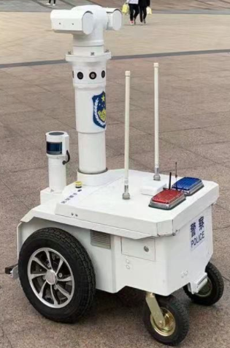

B.2 Contact tracing (5)
Title |  | Itinerary card proves whether one has been to any epidemic-stricken region or country in the past 14 days. Link
Time stamp |  | Feb 29, 2020
Countries |  | China
Keywords |  | contact tracing, risk assessment, telecommunication
Abstract |  | CAICT, China Telecom, China Unicom and China Mobile jointly launched an itinerary card based on telecommunication data. The 1.0 version can give a self-check and proof if you have been to any epidemic region in the past 14 days or not. The 2.0 version is based on Bluetooth low energy (BLE) protocol to make close contact reminders possible. It is launched by the State Council to effectively support the social recovery from the epidemic.
Providers |  | CAICT, China Telecom, China Unicom and China Mobile
Users |  | 1.6 billion mobile-phone users
Application |  | contact tracing
Emergency stage |  | prevention
Enabling technologies |  | big data analysis, AI, smart phone, Bluetooth low energy (BLE)
Dependencies |  | Data resource, ethic and comprehensive usage of the data.
More info |  | • Is the "itinerary card" accessible to everyone?  If you have a mobile phone, and you are a user of any of the three operators – China Telecom, China Unicom or China Mobile – you can use this service. However, users who just opened a new account can only use the service after 14 days.  • When can I use an "itinerary card"?  The "itinerary card" is used to help returnees prove what regions they have visited in the past 14 days. Therefore, the employer and the community management department can use it when checking the itinerary of workers.  • Does the "itinerary card" only show the place where you registered your phone number?  Of course not. The "itinerary card" can display information about the countries (regions) and cities (any stays of more than 4 hours) which users have visited in the past 14 days.
Image |  | 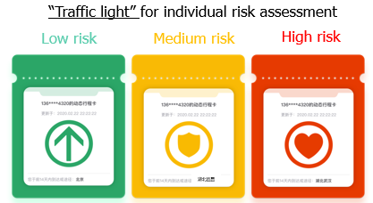
Title | Google and Apple partner on the Contact Tracing API and Bluetooth specification to warn users of COVID-19. Link
Time stamp | May 20, 2020
Countries | USA
Keywords | contact tracing, Bluetooth, API, scalable, interoperability
Abstract | Google and Apple have teamed up to develop a comprehensive solution that includes application programming interfaces (APIs) and operating system-level technology to assist in enabling contact tracing. The new API and Bluetooth low energy specification is called "Exposure Notification" (formerly called "Contact Tracing"), which is to inform users if they've recently been in contact with someone who has been positively diagnosed with COVID-19. The plan is to implement this solution in two steps while maintaining strong protections around user privacy. First, in May 2020, both companies planned to release APIs that enable interoperability between Android and iOS devices using apps from public health authorities. These official apps are available for users to download via their respective app stores. Second, in the coming months, Apple and Google will work to enable a broader Bluetooth-based contact tracing platform by building this functionality into the underlying platforms. This is a more robust solution than an API and would allow more individuals to participate, if they choose to opt in, as well as enable interaction with a broader ecosystem of apps and government health authorities.
Providers | Google and Apple
Users | Android and iOS devices' users
Application | contact tracing, alerting
Emergency stage | prevention
Enabling technologies | big data analysis, AI, smart phone, Bluetooth low energy (BLE)
Dependencies | Because the solution is designed with user privacy and security in mind, it's debatable how effective they'll be at limiting the spread of COVID-19.
More info | N/A
Image | 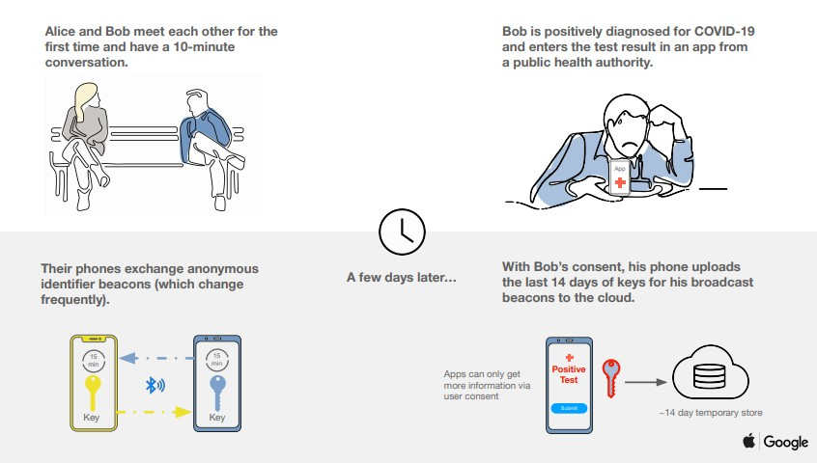
Title | Indian AarogyaSetu App keeps track of other app users that a person came in contact with. Link
Time stamp | April 2, 2020
Countries | India
Keywords | contact tracing, privacy concerns, India official
Abstract | Aarogya Setu App, India's main contact tracing technology, is designed to keep track of other app users that a person came in contact with. It then alerts users if any of the contacts test positive for COVID-19. It will keep a record of all other Aarogya Setu users that it detected nearby using Bluetooth. It will also use a GPS log of all the places that the device had been at 15-minute intervals. These records are stored on the phone till the time any user tests positive or declares symptoms of COVID-19 in a self-assessment survey in the app. In such cases, the records are uploaded to the servers. The app is available in English and 10 Indian languages.
Providers | the Government of India and the National Informatics Centre under the Ministry of Electronics & Information Technology
Users | the people of India
Application | contact tracing, risk alerts, self-assessment test
Emergency stage | prevention
Enabling technologies | Bluetooth, GPS, algorithms, AI, smartphone, Android or iOS
Dependencies | • The app is a coronavirus tracking app that uses data provided by users, Bluetooth and location generated social graphs to track if one has come close to anyone who could have tested positive for COVID-19.  • The app is based on location and users' data. To make it work properly, the app requires more data from different locations. This is pretty similar to how Google Maps detects whether there's a traffic jam in some area based on location data.  • The app is not open source, which means that it cannot be audited for security flaws by independent coders and researchers.
More info | N/A
Image | 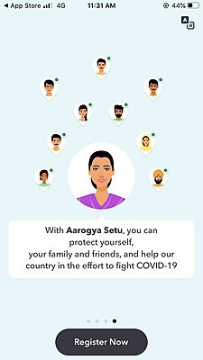
Title | UAE launches new "ALHOSN UAE" official app to track COVID-19. Link
Time stamp | Apr 26, 2020
Countries | United Arab Emirates (UAE)
Keywords | COVID-19 tests, contact tracing, nationwide campaign, official integrated digital platform
Abstract | The United Arab Emirates has launched a new integrated coronavirus app named "ALHOSN UAE", which serves as the official digital platform for COVID-19 tests and contact tracing in the country. Alhosn combines the features of STAY HOME and TRACE COVID, the two apps previously launched by the department of health. It also guarantees a high degree of privacy protection to the users through AI. Alhosn provides quick access to COVID-19 test results as well as contact tracing for rapid and accurate virus containment. The App is being updated to include a third function which is remote monitoring of quarantined individuals. Once fully adopted, Alhosn could allow safe access to public areas.
Providers | the Ministry of Health and Prevention, Abu Dhabi Health Authority and Dubai Health Authority
Users | anyone living in the UAE using a supported Bluetooth-enabled smartphone
Application | control and contain the coronavirus, national contact tracing, monitoring self-isolating
Emergency stage | prevention
Enabling technologies | Bluetooth, AI, decentralised model for contact tracing, mobile phone technologies, Android or iOS
Dependencies | Bluetooth-enabled smartphone running on Android or iOS.
More info | Every user will have a unique QR code, which would contain information about the user's health. The app is encrypted and the data remains on the user's phone. Through this data, the competent health authorities can identify people who can transmit the virus and who could be at a risk of contracting the virus. They can then communicate with those at risk and re-test them.
Image | 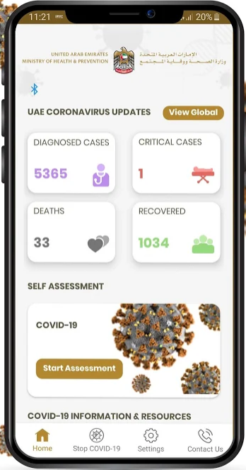
Title | The PathCheck suite of open source software gives solutions for digital contact tracing and exposure notification. Link
Time stamp | April 18, 2020
Countries | Global
Keywords | contact tracing, open source, customizable, end-to-end, fast deployment
Abstract | The PathCheck Google Apple Exposure Notification (GAEN) solution is a full open source system for deploying the GAEN API. PathCheck GAEN includes a customizable mobile app and a production-ready exposure notification server based on the Google open source project. The PathCheck suite of open source software gives public and private sector organizations solutions for digital contact tracing and exposure notification. The PathCheck GAEN app is based on the PathCheck Platform, and is easy to build custom versions of the app from the PathCheck GitHub repo. Health departments can choose to add the modules they need and set their own custom configuration settings and notices. The PathCheck GAEN Exposure Notification Server (ENS) is built with the leading Google open source project. By building with Google, departments of health can be confident they have the scalability and capabilities required.
Providers | MIT-hosting PathCheck Foundation, a 501(c)3 charitable organization with full-time leaders from technology and health, full-time engineers, and dedicated professional volunteers.
Users | health departments
Application | contact tracing, exposure notification, ingestion of location diary data, publication of hot spot maps,
Emergency stage | prevention
Enabling technologies | Bluetooth, GPS, AI, smartphone, Android or iOS
Dependencies | The solution is based on Google open source.
More info | The technology platform that comes into place to contain COVID-19 with exposure notification, case management, epidemiological information collection, and citizen communication may be advanced over time to address a wide range of other needs after the pandemic is contained.
Image | 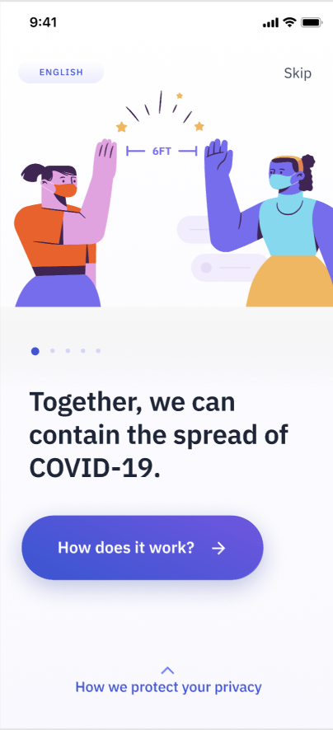

B.3 AI-powered spread modelling system (1)
Title | BlueDot spotted coronavirus before anyone else had a clue. Link
Time stamp | Jan 25, 2020
Countries | Canada
Keywords | early warning, AI-driven algorithm, possible outbreaks' prediction
Abstract | On Dec 30, 2019, BlueDot, who uses a platform built around AI, machine learning and big data to track and predict the outbreak and spread of infectious diseases, alerted its private sector and government clients about a cluster of "unusual pneumonia" cases happening around a market in Wuhan, China, which is a few days earlier than the WHO official notices on Jan 9. BlueDot uses an AI-driven algorithm that scours foreign-language news reports, animal and plant disease networks and official proclamations to give its clients advance warning to avoid danger zones. The algorithm does not use social media postings because that data is too unreliable. However, it does have one trick up its sleeve: access to global airline ticketing data that can help predict where and when infected residents are headed next. It correctly predicted that the virus would jump from Wuhan to Bangkok, Seoul, Taipei, and Tokyo in the days following its initial appearance.
Providers | BlueDot
Users | health care, government, business, and public health clients
Application | pandemic surveillance, early warning, spread prediction
Emergency stage | prevention
Enabling technologies | machine learning, AI, NLP, big data
Dependencies | Much of BlueDot's predictive ability comes from data it collects outside official health care sources including, for example, the worldwide movements of more than four billion travellers on commercial flights every year; human, animal and insect population data; climate data from satellites; and local information from journalists and healthcare workers, pouring through 100,000 online articles each day spanning 65 languages.
More info | • The BlueDot engine gathers data on over 150 diseases and syndromes around the world searching every 15 minutes, 24 hours a day.  • The engine has been used to successfully predict that the Zika virus would spread to Florida in 2016, six months before it happened. The software also determined that the 2014 Ebola outbreak would leave West Africa.
Image | 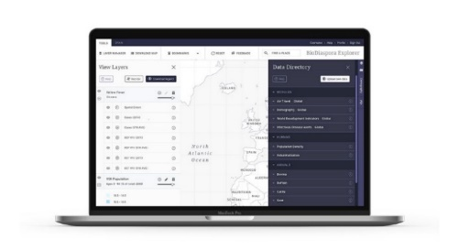

B.4 COVID-19 statistic dashboard (1)
Title | Johns Hopkins University (JHU) develops a real-time data dashboard to track coronavirus. Link
Time stamp | Jan 22, 2020
Countries | USA
Keywords | reliable, worldwide, zoom in, data visualization
Abstract | Johns Hopkins University (JHU) COVID-19 Dashboard is one of the most widely searched and accessed dashboards. It's an interactive, web-based dashboard that tracks real-time data on confirmed coronavirus cases, deaths, and recoveries for all affected countries. The sources of information are both national and international, which makes it a reliable dashboard. You can zoom in on your desired country and get information about it. This information includes the number of people who are currently confirmed by testing positive, people who recovered and also the number of people who have unfortunately died because of this outbreak. You can get information worldwide but also by selecting different countries and extracting information about it.
Providers | Johns Hopkins University (JHU)
Users | providers, public health authorities, researchers, and the general public
Application | global cases and trends tracking in real-time, spread tracking, data visualization
Emergency stage | prevention
Enabling technologies | mobile internet, AI, machine learning
Dependencies | • It is regularly updated with data from the WHO, CDC, NHC, and Dingxiangyuan, a social networking site for health care professionals that provides real-time information on cases.  • Desktop and mobile devices.
More info | • The health system is using artificial intelligence and machine learning in its platform and aims to collaborate with others to incorporate data in the future.  • All data is made freely available, initially as Google sheets but now in a GitHub repository, along with the feature layers of the dashboard.  • Availability of graphs.
Image | 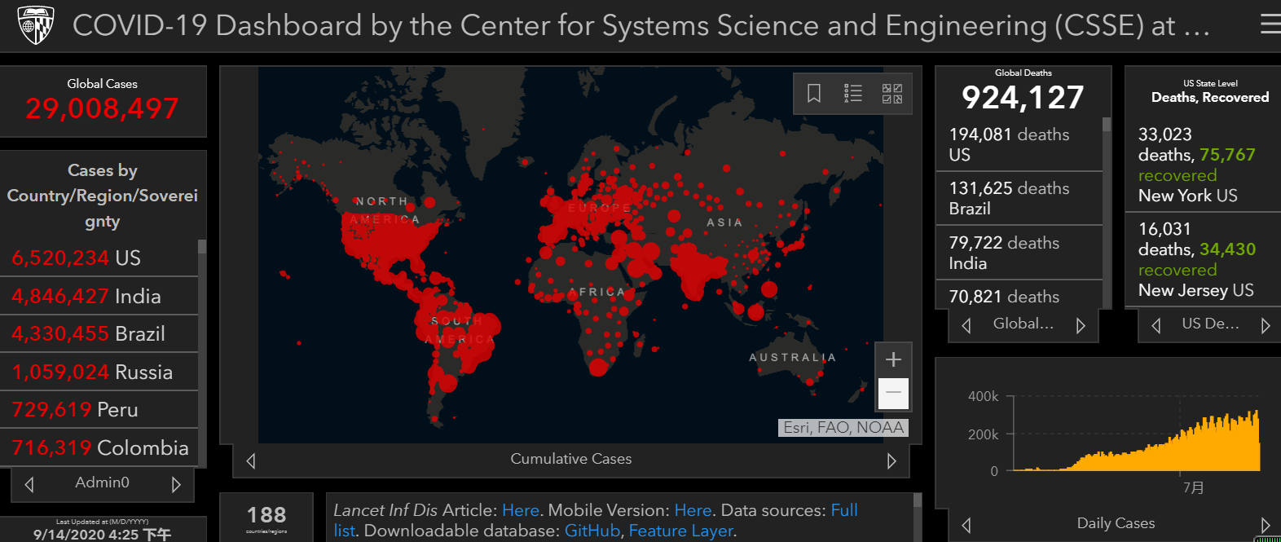

B.5 Social networks fighting infodemic (1)
Title | Social media and search engines are using personalised AI information and tools to fight the COVID-19 "infodemic". Link
Time stamp | Mar 8, 2020
Countries | USA
Keywords | misinformation, AI, social media, search engines
Abstract | Social media and search engines are using personalised AI information and tools and relying on algorithms to find and remove problematic material on their platforms. Technology giants like Google and Facebook are battling to combat the waves of conspiracy theories, phishing, misinformation and malware. A search for coronavirus/COVID-19 yields an alert sign coupled with links to verified sources of information. YouTube, on the other hand, directly links users to the WHO and similar credible organizations for information. Videos that misinform are scoured for and taken down as soon as they are uploaded. Twitter has attempted to signal to the users and observers a potential rise in false positives, or erroneous content removals.
Providers | Google, Facebook, YouTube, Twitter, Reddit, and other social networks and search engines
Users | the users of social media and search engines
Application | information verification, conspiracy theories intervention, public health partnerships
Emergency stage | prevention
Enabling technologies | AI, algorithms, big data
Dependencies | Effectively addressing online disinformation and misinformation problems will require regulatory change and structural reckoning with the fundamentally predatory elements of current business models.
More info | N/A
Image | 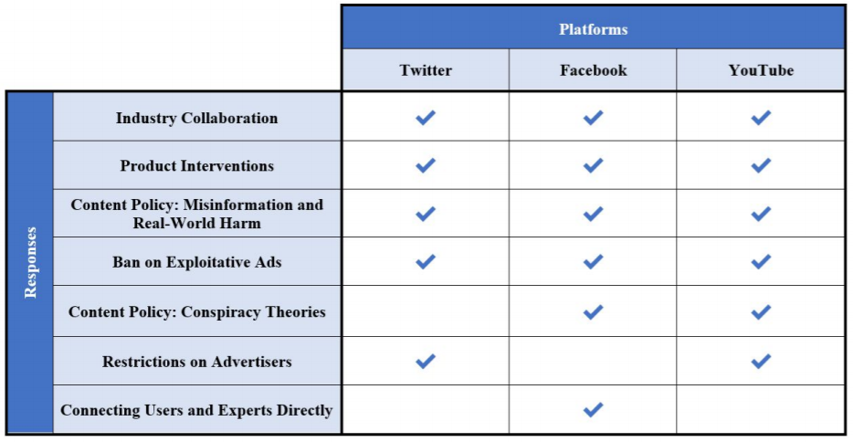

B.6 "XR" tech to upskill clinicians remotely (1)
Title | NHS workers use "XR" tech for training remotely during COVID-19 pandemic. Link
Time stamp | May 28, 2020
Countries | UK
Keywords | virtual, augmented and mixed reality (XR), interactive training, remote education, NHS employees
Abstract | Bristol-based training company Virti delivered remote educational programmes to NHS employees. Virti specially designed COVID-19 modules for use on their immersive training platform – accessible to NHS staff via a virtual reality headset, desktop or smart device. Clinicians from all over the country accessed the training, with tens of thousands of training sessions recorded. Virti's interactive software has been used to upskill clinicians on key areas such as how to safely apply and remove personal protective equipment (PPE), how to navigate an unfamiliar intensive care ward, and how to engage with patients and their families. Virti's technology uses virtual and augmented reality to recreate hospital environments and real patient cases that the user can interact with. The system then uses artificial intelligence to assess users objectively and improve their performance.
Providers | Virti
Users | NHS employees in UK
Application | remote learning at scale, upskilling clinicians
Emergency stage | preparedness
Enabling technologies | data-driven XR, AI
Dependencies | approval by Health Education England
More info | N/A
Image | 

B.7 AI in retail optimization (1)
Title | The Saudi supermarket Danube Online is using AI to minimize delivery time during quarantine. Link
Time stamp | Apr 16, 2020
Countries | Saudi Arabia
Keywords | AI-powered, supermarket chain, minimize delivery time, real-time task manager
Abstract | Danube Online, the Saudi-based hypermarket and supermarket chain, is using AI to minimize delivery time during quarantine. Using AI-enabled "aisle-mapping" technology, packers can locate items in an online customer's order, which are tracked around stores using an app. Danube Online has implemented three key Reflexis systems across its store operations: Real-Time Task Manager, Q-Audit and Q-Forms. The introduction of these systems improved Danube Online's operational efficiency by enhancing management control and increasing visibility around tasks and reporting.
Providers | Reflexis Systems, Inc.
Users | shoppers in Saudi
Application | speeding up goods delivery, simplifying store execution, optimizing labor decisions, workforce management, employee self-service
Emergency stage | preparedness
Enabling technologies | AI, "aisle-mapping" technology
Dependencies | AI
More info | The Reflexis ONE work platform delivers intelligent communication, real-time task management and AI-powered workforce management solutions, giving corporate, field & store managers and associates the tools they need to succeed.
Image | 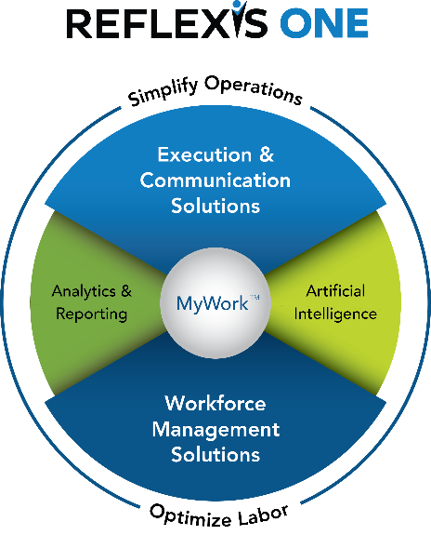

B.8 Smart medical waste platform (1)
Title | Neusoft Hanfeng smart 5G medical waste IOT supervision platform provides full-process management. Link
Time stamp | Mar 6, 2020
Countries | China
Keywords | Internet of Things, 5G, medical waste management platform, smart terminals
Abstract | Neusoft Hanfeng's 5G Medical Waste Union Supervision Platform is based on the Internet of Things device layer. It uses smart IoT terminals to sort, pack, transfer and store medical waste. The data is synchronized and uploaded to the data platform in real time. The system guarantees the compliance of medical waste treatment in hospitals and the real-time supervision from government departments. It consequently improves the safety and transparency of medical waste treatment and avoids risks.
Providers | Neusoft Hanfeng, IoT Technology
Users | hospitals, medical and health supervision institutions at all levels, and ecological environment departments at all levels in the provinces and municipalities
Application | medical waste treatment in hospitals, real-time monitoring, risk prediction
Emergency stage | preparedness
Enabling technologies | smart IoT equipment, 5G, AI, algorithms, mobile internet
Dependencies | It's based on the Internet of Things device layer and data platform.
More info | N/A
Image | 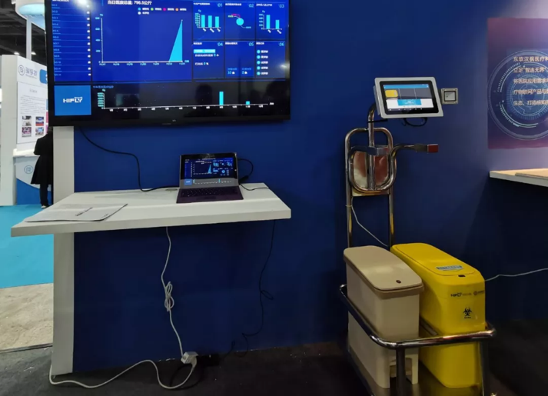

B.9 Digital mental health support (1)
Title | BioBeats mental health solution supports employee's mental health post lockdown. Link
Time stamp | June 22, 2020
Countries | UK
Keywords | AI-powered, digital mental health, lockdown, workplace-centric, employees guiding
Abstract | BioBeats mental health solution combines an AI-powered app "BioBase" and a wearable device "BioBeam" that collects biometric health data, such as heart rate variability and activity, as well as psychometric data to provide employees with personalised health insights and tools. BioBase tracks one's heart rate, activity, sleep, mood & cognitive function. When wearing the BioBeam, one's health data will be monitored in real-time to provide a live Wellbeing Score. Over time, BioBase learns how one's behaviours, interactions and environments impact one's mental wellbeing. Then to help cope with stress and anxiety, one can access digital coaching courses on BioBase that incorporate proven techniques, such as CBT and ACT. Through continuous measurement, the technology is able to provide personalised coaching programmes for mental wellbeing, resilience and recovery. The products are purpose-built for use within companies to promote better mental health and build deeper resilience.
Providers | BioBeats
Users | employers whose employees are in lockdown due to COVID-19
Application | mental health care, personalised coaching programmes
Emergency stage | preparedness
Enabling technologies | AI, mobile technology, wearable device, iOS or Android
Dependencies | AI-powered app, wearable device
More info | The employers will never have access to their employees' personal data. BioBeats also works closely with scientific health practitioners and universities. The aggregated and anonymised data collected informs ongoing health and mental wellbeing scientific studies.
Image | 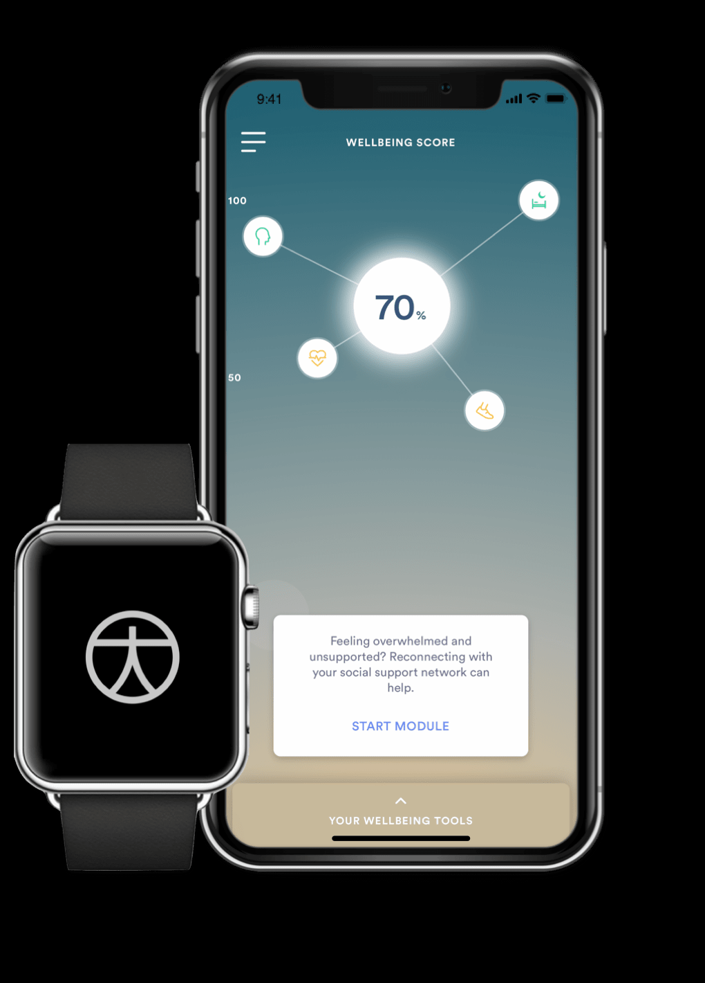

B.10 Autonomous vehicles and robots to delivery meal (1)
Title | Food ordering app Meituan ramped up its "contactless delivery" options through autonomous vehicles and robots. Link
Time stamp | Feb 21, 2020
Countries | China
Keywords | delivery vehicles, robots, indoor and outdoor, autonomous, contactless
Abstract | As of Feb 21 2020, food ordering app Meituan Dianping had started using autonomous vehicles to send grocery orders to customers in Shunyi district in Beijing, and was looking to launch similar robot delivery services in other districts in the capital city. The company began testing indoor delivery robots and drones for deliveries in 2019, but this is the first time it is deploying autonomous delivery vehicles on public roads. The vehicle can carry up to 100 kilograms of goods and deliver three to five orders on each trip. According to Meituan Dianping, Xiaodai, an outdoor transport robot, can roam around gated compounds and claims to be able to choose the best delivery routes and avoid obstacles on the road. Fudai, the company's indoor delivery robot, works mainly inside hotels and office buildings, and can bring food orders to users on different floors by using lifts. This project is to minimise the risk of potential infections caused by human contact and meet the needs of customers in this special time.
Providers | Meituan Dianping
Users | e-commerce companies
Application | unmanned delivery services, food delivery, grocery orders delivery
Emergency stage | preparedness
Enabling technologies | AI, big data, robot, camera, radar, GPS
Dependencies | camera, radar, GPS to avoid pedestrians and obstacles
More info | Although unmanned delivery services existed before the epidemic, the outbreak has promoted its popularity.
Image | 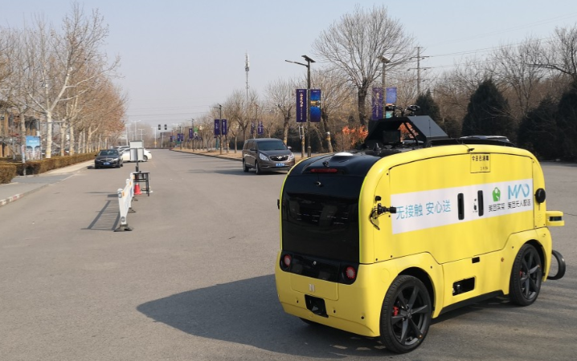

B.11 AI-based virtual assistants (1)
Title | The Orbita COVID-19 Virtual Assistant helps in public education and COVID-19 patients screening. Link
Time stamp | Mar 18, 2020
Countries | Australia
Keywords | conversational AI, interactive chatbot, virtual assistant
Abstract | Orbita debuted a new interactive chatbot and voice assistant specifically to support healthcare organizations during the COVID-19 pandemic. The Orbita COVID-19 Virtual Assistant aims at helping educate the public and supports medical professionals in screening and triaging people who may have been infected by the virus. The virtual assistant can answer questions about the coronavirus and use a series of questions built on data from the Centers for Disease Control and Prevention and other reputable sources to perform a preliminary screening for symptoms. Depending on what the answers are, the AI can then suggest the next best steps for further testing and treatment. The chatbot can be added to any healthcare provider's website as a chatbot for free.
Providers | Orbita
Users | public and medical professionals, healthcare and life science organizations
Application | triaging and navigating patients, screening for symptom, employee health check
Emergency stage | response
Enabling technologies | AI, NLP, big data, SMS
Dependencies | data from the Centers for Disease Control and Prevention and other reputable sources
More info | Orbita is working with its clients to integrate the AI assistant into a new or existing voice app on Amazon Alexa or Google Assistant. By building it into existing software, the AI assistant can send out text alerts and even potentially call people to remind them of appointments. The relative flexibility of the Orbita platform allows for healthcare providers to build upon the free version of the chatbot with custom content.
Image | 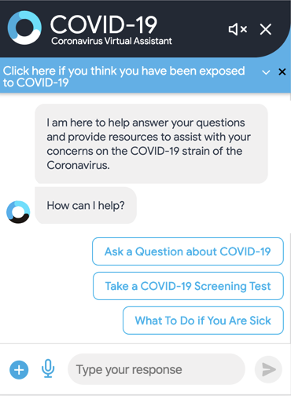

B.12 AI-assisted voice robot (1)
Title | Wuzhu intelligent voice robot system improves the efficiency of large-scale investigation.
Time stamp | Feb 17, 2020
Countries | China
Keywords | voice robot, telephone follow-up, accurate investigation, grassroots
Abstract | Wuzhu Technology epidemic prevention and control intelligent voice robot system performs manual secondary follow-up on people with sensitive data results. By robot process automation and big data technology, the system helped grassroots organizations improve the efficiency of epidemic prevention and control on a large scale. More specifically, it helped solve the following problems: 1) the whole population policy publicity and implementation; 2) the whole population research and survey; 3) regularly closed-loop tracking of the diseased; 4) social sampling survey; 5) automatic data collection and analysis of medical institutions.
Providers | Wuzhu Technology
Users | the whole population who can be contacted through telephone
Application | accurate investigation and follow-up, grassroots prevention and control, policy publicity and implementation, social sampling survey
Emergency stage | response
Enabling technologies | Intelligent voice robot, AI, big data, NLP, deep learning
Dependencies | robot process automation technology, big data from health hotline
More info | • Epidemic notification robot: When there is an emergency that needs to be notified to some groups in time, one-to-one fast batch call notification can be achieved. For those who did not answer in time, they can also redial multiple times to ensure that everyone answers and responds.  • Regular survey of returnees: It carries out return visits to returnees and potential risk investigation through outbound calls, collect returnees' physical conditions, ask about contact status, give reasonable suggestions and automatically generate reports on the status of those interviewed.  • Rehabilitation report: For patients and their families treated in isolation, it can communicate the treatment status of the patients in isolation to their families regularly through outbound calls to help their families understand the progress of the patient's treatment and changes in the condition.  • Return visit after healing: After the patient is discharged from the hospital, the physical condition is regularly tracked and the daily diet, health, and psychological status at home are collected to prevent recurrence.
Image | 

B.13 Online drug supply (1)
Title | Dingdang Medicine Express helps people under the epidemic situation seek medical advice at home.
Time stamp | Mar 10, 2020
Countries | China
Keywords | online-to-offline, drug delivery service, drug supply guarantee, chronic disease
Abstract | Dingdang Medicine Express delivers anti-epidemic products such as masks, disinfectants and alcohol to users through the whole process of contactless "Anxinda" distribution service. With the help of big data, Dingdang realizes epidemic prevention supply and scheduling. Its "treatment + medicine" and " shop online + delivery to the door" modes meet the needs for epidemic prevention supplies and knowledge. Patients could consult a doctor and buy medicine online, with their orders delivered within half an hour. Moreover, nurses could arrive at your home to offer some medical services, such as measuring blood pressure and giving an injection.
Providers | Dingdang Medicine Express Technology
Users | people at home
Application | delivering medicine to the door, home medical observation guidance, home health assessment services, chronic disease follow-up services
Emergency stage | response
Enabling technologies | big data, mobile internet, AI, algorithms
Dependencies | Dingdang uses big data to achieve epidemic prevention supply and dispatch.
More info | • Dingdang Medicine Express has made efforts to build a new online-to-offline medicine retail model, and has established its offline drug stores and specialized delivery team to satisfy consumers' demands for over-the-counter (OTC) medicine in 24 hours.  • After passing this epidemic, Dingdang Kuaiyao's layout will be opened up to the entire industry chain to build a healthy ecosystem of "medicine + inspection + medicine + insurance + nourishment".
Image | 

B.14 AI-assisted CT scan (2)
Title | Alibaba CT Imaging Analytics for COVID-19 can detect coronavirus in seconds with 96% accuracy. Link
Time stamp | Mar 15, 2020
Countries | China
Keywords | CT scan image analysis, cloud intelligence, Covid-19 screening
Abstract | Alibaba Cloud Intelligence DAMO Academy offers CT image analysis services for COVID-19, which is used for COVID-19 screening. By analysing CT images, this solution gives the quantitative prediction of the probability of COVID19 and common pneumonia for doctor reference. It also provides the automatic segmentation and analysis of lesion areas. Using a simple API, CT departments can link their existing local cloud imaging applications to store, view and share CT scan images, tapping into the DAMO Core Algorithm. This installation takes three working days.
Providers | Alibaba DAMO Academy
Users | hospitals, COVID-19 screening centers
Application | • Quantitative prediction of the probability of COVID19 and common pneumonia for doctor reference  • Automatic segmentation and analysis of lesion area and supports multiple output parameter types, lightweight deployment and instant online business processes, and integrated intelligent image service.
Emergency stage | Response
Enabling technologies | • Deep Learning based image analysis  • Standard DICOM protocol, compatible with PACS
Dependencies | The system was trained on images and data from 5,000 confirmed coronavirus cases.
More info | • Analyse CT scan images in around 2 seconds in the fastest case  • Deliver a diagnosis averagely in 10 seconds  • 60x faster than experienced radiologists  • Analyse CT scans of 13,000 patients daily on average  • 96% accuracy using > 5000 patient samples for training  • Solution compatible with PACS – all features ready to go out-of-box
Image | 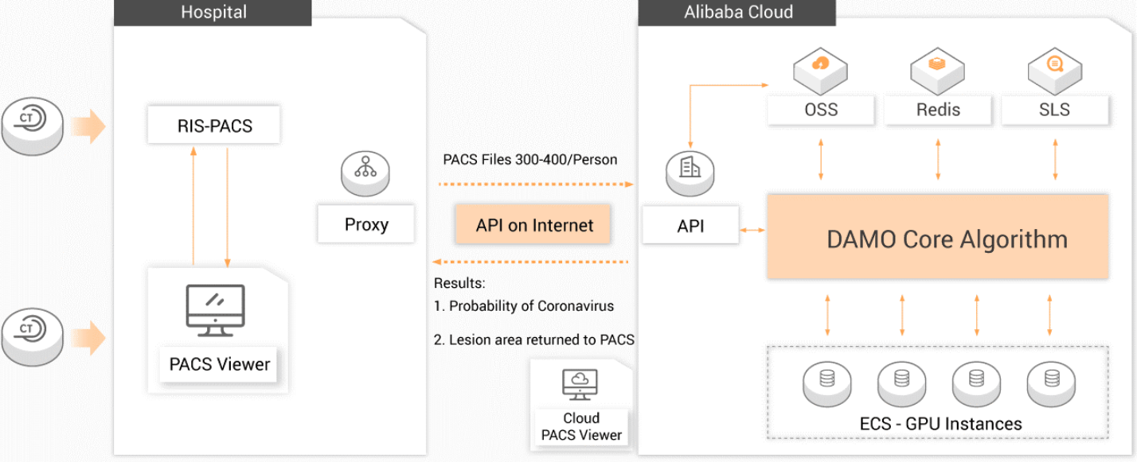
Title | Ping An Smart Healthcare develops COVID-19 CT image Intelligent Reading System. Link
Time stamp | Feb 19, 2020
Countries | China
Keywords | CT images, intelligent reading, intelligent imaging, AI, remote
Abstract | Ping An Smart Healthcare's COVID-19 intelligent reading system has provided services to more than 1500 medical institutions across China. It supports remote AI image reading and electronic film image sharing. It can issue intelligent analysis results in about 15 seconds with an accuracy rate of over 90%. The system has covered 9 major systems of the human body, and supports various devices such as CT, X-ray, MRI, ultrasound, pathological fundus cameras, and fundus OCT. It can help doctors fully identify lesions and issue diagnostic reports faster and more quickly. Intelligent assessment can help doctors quickly and effectively complete the detection, triage and evaluation of patients with COVID-19.
Providers | Ping An Insurance（Group）Company of China
Users | medical institutions, especially at the primary level in China
Application | CT image reading, intelligent analysis, patients screening and prognosis
Emergency stage | response
Enabling technologies | AI, biomedical data mining, deep learning based image analysis, public or private cloud
Dependencies | Ping An opened its own public cloud platform, and can be quickly accessed by the medical institutions through the cloud or local deployment.
More info | • Electronic film image sharing function can help reduce repeated filming;  • Comparative analysis of different scan images of the same patient, quantitative measurement of changes in the lesion, can assist doctors in intelligently assessing the patient's disease development trend, treatment effect, outcome, etc., helping doctors quickly and effectively complete the detection, triage and evaluation of COVID-19 patients.  • Within 44 hours after being launched, the imaging doctors of the cooperative medical institution have used the system to perform intelligent image reading for more than 2,000 patients.
Image | 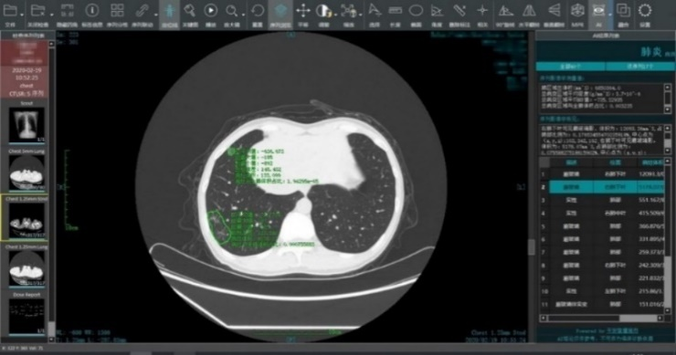

B.15 Drones and robots for supplies transport (2)
Title | Terra Drone UAV systems were employed to transport medical samples and quarantine supplies in China. Link
Time stamp | Feb 6, 2020
Countries | Japan
Keywords | unmanned aerial vehicles, drone, automatic operation, contactless
Abstract | Through its business partner Antwork, Japanese company Terra Drone employed its UAV system to transport medical samples and quarantine supplies in China to fight the coronavirus. At 9 a.m. on Feb. 6, a medical delivery drone flew from the People's Hospital of Xinchang County to the disease control centre of Xinchang County, marking the launch of the first urban-air transportation channel to help to fight COVID-19. Antwork's RA3 and tr7s drones and unmanned RH1 station are ensuring that medical samples and quarantine materials can travel with minimal risk between Xinchang County People's Hospital and Xinchang County's disease control centre. The automatic, unmanned air delivery system significantly reduces contact between samples and personnel, as well as improves delivery speed.
Providers | Terra Drone, Antwork
Users | hospitals, public health departments
Application | medical transport, contactless delivery, urban drone delivery
Emergency stage | response
Enabling technologies | AI, data processing, terrain filtering algorithms, drone, 4G LTE communication, 3D modeling
Dependencies | • Terra UTM is a soft- and hardware environment created by Terra Drone from Japan to manage multiple UAV missions simultaneously using 4G LTE communication.  • Whereas normal LiDAR units rely on an Inertial Measurement Unit (IMU) to calculate the orientation of the sensor, Terra Drone have developed a LiDAR unit that does not need an IMU.  • Terra Mapper is a photogrammetric data processing software developed in-house by Terra Drone to speed up the data processing time taken by drones.
More info | N/A
Image | 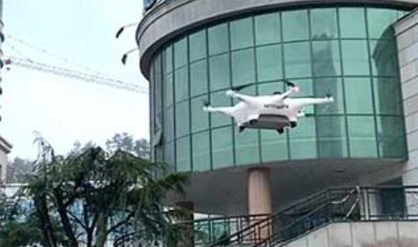
Title | Pudu Robotics' robot "Pudubot" is offering delivery service in hospitals worldwide during COVID-19. Link
Time stamp | Mar 2, 2020
Countries | China
Keywords | robot, hospitals and restaurants, non-contact, fully automatic, large-capacity delivery
Abstract | After the outbreak of COVID-19, the pandemic with the characteristic of human-to-human transmission, a large number of hospitals and restaurants are seeking help from Pudu Robotics out of an urgent need for non-contact delivery. Pudu Robotics responded positively by devoting robots to several hospitals in Seoul, South Korea, Beijing, China, Wuhan, China and so on. Because Pudu Robotics' robots are fully automatic, they can achieve the delivery process all by themselves, which reduces contact between people and effectively prevents the spread of the virus. Pudubot is equipped with multi-sensor and positioning and navigation technology. With large-capacity trays, Pudubot can deliver lots of medicines, meals, and other supplies to patients in the hospital to reduce the burden on medical staff.
Providers | Pudu Technology
Users | hospitals, restaurants
Application | medicines, meals and other supplies delivery in large capacity
Emergency stage | response
Enabling technologies | AI, algorithms, computing capabilities, big data analysis, robot, visual positioning, navigation technology, lidar (new generation radar), camera, UWB, RGBD, IMU, encoder, 3D multi-sensors
Dependencies | • Hardware platform Mohism II  • Computing capabilities
More info | N/A
Image | 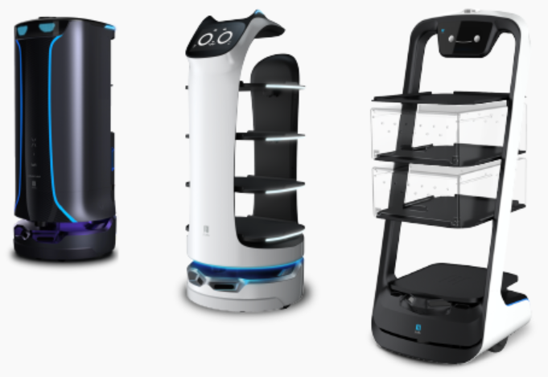

B.16 Disinfection robot (1)
Title | Chinese hospitals buy Danish UVD mobile disinfection robots to fight coronavirus. Link
Time stamp | Feb 19, 2020
Countries | Denmark
Keywords | disinfection robots, ultraviolet light, remotely controlled
Abstract | Danish Blue Ocean Robotics shipped UVD robots to Chinese hospitals to disinfect rooms. The robot consists of a mobile base equipped with multiple lidar sensors and an array of UV lamps mounted on top. To deploy a robot, you drive it around once using a computer. The robot scans the environment using its lidars and creates a digital map. You then annotate the map indicating all the rooms and points the robot should stop to perform disinfecting tasks. The robot emits a concentrated ultraviolet-C light throughout an area to remove virtually all airborne viruses and bacteria on the surfaces of a room without exposing any human personnel to infection. The robot can eliminate 99.999% of all bacteria within 10-15 minutes in a patient room. The robot is remotely controlled by a health worker who remains a safe distance away. These robots increase the safety of both staff, patients and their relatives by reducing the risk of contact with bacteria, viruses and other harmful microorganisms.
Providers | Blue Ocean Robotics
Users | hospitals
Application | disinfection in hospitals
Emergency stage | response
Enabling technologies | AI, algorithms, lidar sensors, mobile robot technologies, UV light module,
Dependencies | The robot relies on simultaneous localization and mapping (SLAM) to navigate.
More info | • The UVD robot won the robotics industry's "Oscar" – IERA Award in 2019.  • The robot has a safety system that uses four layers of safety, enabling the robot to move around in all kinds of environments – even in high-traffic areas – as it shuts down if people get too close. It has a unique capability to sense, document and show the users how well disinfected an area is, enabling the user to easily and quickly adjust the process and optimize the quality, if needed.
Image | 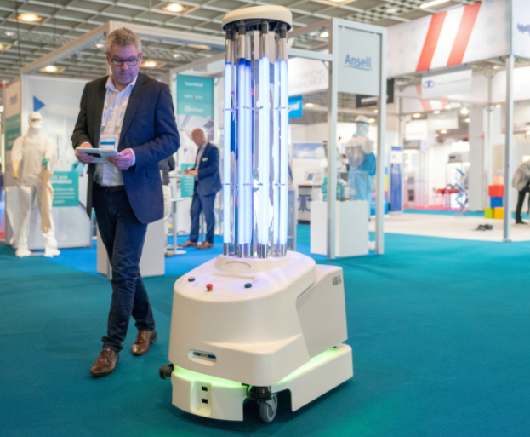

B.17 AI-assisted potential drug discovery (1)
Title | The AI-identified potential COVID-19 treatment "baricitinib" has entered clinical trials. Link
Time stamp | July 3, 2020
Countries | UK
Keywords | drug development, AI, autonomous, clinical trials
Abstract | BenevolentAI initially identified baricitinib as a potential treatment for COVID-19 using its machine learning system. Through the integration of protein network biology, biological processes, tissue, cell line, pharmacology, multi-omics, disease and clinical data from public and commercial resources, BenevolentAI recreated representations of disease-relevant mechanisms and generated predictive models for the diseases, which are in turn improved with feedback from experimental data. BenevolentAI identified 47 potential drugs for COVID-19 but baricitinib, an approved treatment for rheumatoid arthritis, was the only appropriate candidate. As both a JAK1/2 inhibitor and an AAK1 inhibitor, the drug has anti-inflammatory properties and is thought to interrupt the passage of SARS-CoV-2 into cells and prevent intracellular assembly of virus particles. Baracitinib is currently being assessed in more than 12 clinical trials worldwide, including large global trials by the NIAID and Eli Lilly.
Providers | BenevolentAI
Users | pharmaceutical companies
Application | drug research, clinical trials
Emergency stage | response
Enabling technologies | machine learning, AI, big data
Dependencies | the quality of the data, including meta-data.
More info | • The first clinical trials for the drug began in April.  • On 15 June, Eli Lilly started patient enrolment for a Phase III clinical trial of baricitinib to treat adults hospitalised due to COVID-19 infection. The Phase III trial will enrol approximately 400 patients across the US, Europe and Latin America.  • Baricitinib is indicated in 70 countries to treat adults with moderately to severely active rheumatoid arthritis (RA). Inhibition of JAK1/JAK2 is expected to mitigate the cytokine storm related to the complications of COVID-19. The drug may block the host cell proteins involved in viral reproduction, decreasing the infected cells' ability to produce more virus.
Image | 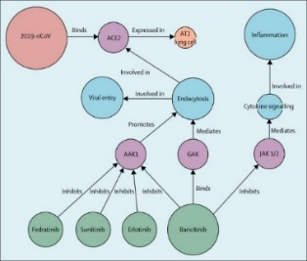

B.18 AI-assisted genome sequencing (1)
Title | Alibaba's Whole Genome Sequencing Analysis gives rapid and accurate testing for COVID-19. Link
Time stamp | Feb 5, 2020
Countries | China
Keywords | virus genome sequencing, gene evolution analysis, protein structure prediction
Abstract | Alibaba Cloud Intelligence DAMO Academy offers whole genome sequencing data analysis for coronavirus diagnosis to medical institutions in multiple regions. It provides a total solution from virus genome sequencing from sample to report to realize virus screening and diagnosis, gene evolution analysis and virus protein 2D/ 3D structure prediction. This technology greatly reduces the data analysis time to 0.5 hours for an experiment of 20 samples in parallel, and is able to test one sample within 43.5 minutes.
Providers | Alibaba Group
Users | • Local disease control centres  • Hospital clinical inspection centres  • Laboratories with experimental and sequencing capabilities  • Customs and other agencies that need to manage the epidemic
Application | • Establish virus screening, diagnosis and analysis capabilities  • Viral gene data screening, automated analysis and reporting, and evolution and protein structure prediction
Emergency stage | response
Enabling technologies | • Optimized training of algorithms based on public datasets for analysing  • Distributed and parallel algorithms to speed up the analysis process and provide rapid virus stitching capabilities  • AI algorithms for evolutionary analysis and protein structure analysis enabling to discover the evolutionary source and time, and 3D structure of the virus
Dependencies | • Public datasets such as PDB  • Automated laboratory library building from third party partners.  • Gene sequencing from third party partners
More info | • 5x faster than traditional solutions, takes only 3 hours to build gene library, 11 hours to complete sequencing,10 minutes to achieve data analytics  • Reaching > 99% accuracy based on all Zhejiang province patient data, compared to 60% accuracy of nucleic acid PCR testing (industry consensus)  • One-stop deployment, with step-by-step training and library construction
Image | 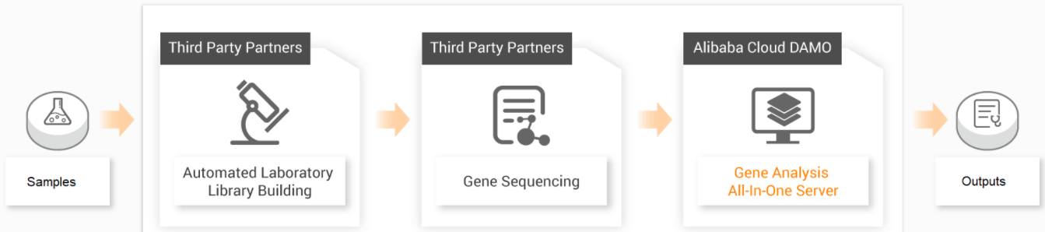

B.19 AI-driven proactive healthcare unrelated to COVID-19 (1)
Title | AI can identify unseen sufferers of COVID-19 and enable proactive healthcare. Link
Time stamp | May 21, 2020
Countries | USA
Keywords | healthcare analytics, risk assessment, proactive healthcare, AI
Abstract | As the nation's eyes focus on COVID-19, another healthcare crisis is unfolding out of sight. Hidden from view, millions of Americans who don't have COVID-19 are suffering healthcare crises in their homes. These unseen individuals are facing major challenges, on multiple levels: acute, chronic and preventive. Patients are waiting longer at home before coming to the hospital for acute illnesses. Patients with chronic diseases are not receiving maintenance care that can prevent their conditions from getting worse. Prealize supports delivery of proactive healthcare by leveraging the power of AI and machine learning to identify not only patients at rising risk of health changes, but also the timing and key drivers of that risk. By using AI to identify high-risk patients, Prealize can determine who is most likely to show up at the hospital before they do. For example, Prealize can offer virtual psychotherapy for those at the highest risk of their mental health worsening, and remote blood pressure and weight management programs to those most likely to get hospitalized with heart failure.
Providers | Prealize
Users | Americans who don't have COVID-19, but have needs for acute, chronic and preventive healthcare.
Application | healthcare analytics, accurate predictions of risk, proactive healthcare
Emergency stage | recovery
Enabling technologies | AI, machine learning, algorithms, big data,
Dependencies | Where traditional rules-based modelling incorporates dozens of static features to make predictions, next-generation predictive analytics employs recent advances in machine learning to utilize dynamic features in the hundreds of thousands or millions, as algorithms continue to train on member-specific claims data.
More info | The technological solution empowers provider organizations and insurers to not only predict future healthcare episodes, but identify the underlying clinical drivers and guide engagement strategies for individual patients.
Image | 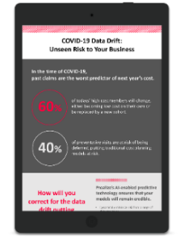

B.20 AI-driven mental health monitoring (1)
Title | AI-driven text analysis helps monitor how the virus and lockdown is affecting mental health. Link
Time stamp | Apr 27, 2020
Countries | USA
Keywords | mental health monitoring, AI-driven, twitter, wellbeing impact
Abstract | The scholars in Stanford University have been examining Twitter posts to estimate how COVID-19 and the changes that it's brought to the way we live our lives, is affecting our mental health. Using AI-driven text analysis, they queried over two million tweets hashtagged with COVID-related terms during February and March, and combined it with other datasets on relevant factors including the number of cases, deaths, demographics and more, to illuminate the virus' effects on mental health. The analysis showed that much of the COVID-19-related chat in urban areas was centred on adapting to living with, and preventing the spread of the infection. Rural areas discussed adapting far less, which the psychologist attributed to the relative prevalence of the disease in urban areas compared to rural; meaning those in the country have had less exposure to the disease and its consequences.
Providers | Stanford University
Users | researchers
Application | mental health analysis, wellbeing impact measurement
Emergency stage | recovery
Enabling technologies | AI, big data, machine learning, algorithms
Dependencies | • Twitter posts  • Datasets on relevant factors including the number of cases, deaths and demographics
More info | N/A
Image | 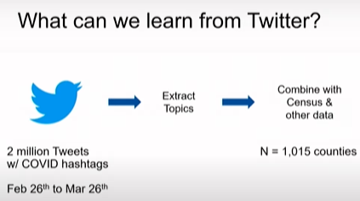

B.21 AI-driven economy's reaction monitoring (1)
Title | Satellites and AI monitor Chinese economic recovery from the COVID-19 outbreak. Link
Time stamp | Mar 10, 2020
Countries | China
Keywords | Economy monitoring, satellite, GPS, social networking
Abstract | Researchers on WeBank's AI Moonshot Team have taken a deep learning system developed to detect solar panel installations from satellite imagery and repurposed it to track China's economic recovery from the COVID-19 outbreak. The team used its neural network to analyse visible, near-infrared and short-wave infrared images from various satellites, including the infrared bands from the Sentinel-2 satellite. This allowed the system to look for hotspots indicative of actual steel manufacturing inside a plant. Moving beyond satellite data, the researchers took daily anonymized GPS data from several million mobile phone users in 2019 and 2020, and used AI to determine which of those users were commuters. Finally, the team used natural language processing technology to mine Twitter-like services and other social media platforms for mentions of companies that provide online working, gaming, education, streaming video, social networking, e-commerce and express delivery services.
Providers | WeBank (Tencent)
Users | economy researchers
Application | economic recovery tracking, manufacturing and commercial activity analysing
Emergency stage | recovery
Enabling technologies | deep learning, AI, NLP, big data, GPS
Dependencies | GPS data from several million mobile phone users; infrared images from various satellites
More info | N/A
Image | 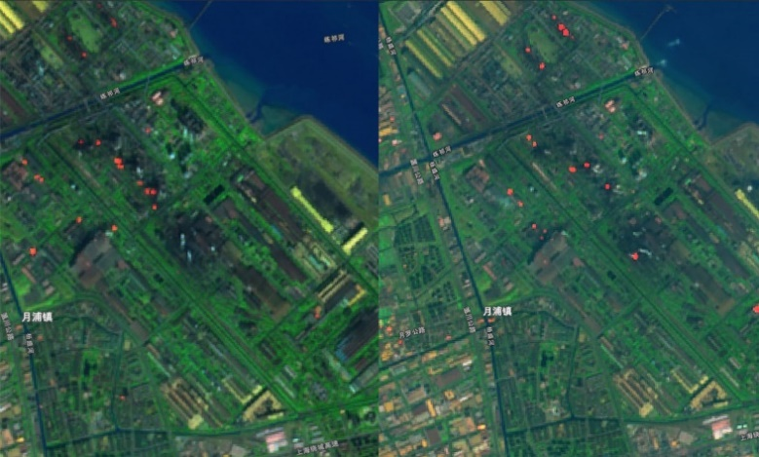
________________

WHO Timeline – COVID-19: https://www.who.int/news-room/detail/08-04-2020-who-timeline---covid-19 (visited 2025-02-21).
COVID-19 Dashboard, Johns Hopkins University https://www.arcgis.com/apps/opsdashboard/ index.html#/bda7594740fd40299423467b48e9ecf6 (visited 2025-02-21).
https://www.nature.com/subjects/disease-prevention
http://web.archive.org/web/20191022155153/ https://www.who.int/environmental_health_emergencies/preparedness/en/ (archived 2019-10-22).
http://web.archive.org/web/20220121104454/ https://www.who.int/water_sanitation_health/hygiene/emergencies/em2002chap4.pdf (archived 2022-01-21).
http://web.archive.org/web/20191022155228/ https://www.who.int/environmental_health_emergencies/recovery/en/ (archived 2019-10-22).

