 |  | International Telecommunication Union
 |  | ITU-T | Technical Report
 |  | TELECOMMUNICATION  STANDARDIZATION SECTOR  OF ITU |  | (10/2021)
 | ITU-T Focus Group on Environmental Efficiency for Artificial Intelligence and other Emerging Technologies (FG-AI4EE)
FG-AI4EE D.WG3-01
Guidelines on the implementation of eco-friendly criteria for AI and other emerging technologies
Working Group 3 – Implementation Guidelines of AI and Other Emerging Technologies for Environmental Efficiency Working Group Deliverable
 | Focus Group Technical Report
FOREWORD

The International Telecommunication Union (ITU) is the United Nations specialized agency in the field of telecommunications, information and communication technologies (ICTs). The ITU Telecommunication Standardization Sector (ITU-T) is a permanent organ of ITU. ITU-T is responsible for studying technical, operating and tariff questions and issuing Recommendations on them with a view to standardizing telecommunications on a worldwide basis.

The procedures for establishment of focus groups are defined in Recommendation ITU-T A.7. ITU-T Study Group 5 set up the ITU-T focus group Environmental Efficiency for Artificial Intelligence and other Emerging Technologies (FG-AI4EE) at its meeting in May 2019. ITU-T Study Group 5 is the parent group of FG-AI4EE. Deliverables of focus groups can take the form of technical reports, specifications, etc., and aim to provide material for consideration by the parent group in its standardization activities.

Deliverables of focus groups are not ITU-T Recommendations. For more information about FG-AI4EE and its deliverables, please contact Charlyne Restivo (ITU) at tsbfgai4ee@itu.int.

NOTE

This is an informative ITU-T publication. Mandatory provisions, such as those found in ITU-T Recommendations, are outside the scope of this publication. This publication should only be referenced bibliographically in ITU-T Recommendations.

© ITU 2021

This work is licensed to the public through a Creative Commons Attribution-Non-Commercial-Share Alike 4.0 International license (CC BY-NC-SA 4.0). For more information visit https://creativecommons.org/licenses/by-nc-sa/4.0/ .

Technical Report FG-AI4EE D.WG3-01
Guidelines on the implementation of eco-friendly criteria for AI and other emerging technologies
Summary
This Technical Report provides guidelines to policymakers, technologists, innovators, environmentalists, and other stakeholders from the technology industry, environmental sciences, and policy arena, on the topic of eco-friendly criteria to assess the environmental impacts of artificial intelligence (AI) and other emerging technologies. With collective intellectual efforts from FG-AI4EE experts based all around the world, these guidelines aim to serve as common factors, rather than a comprehensive list, for the above-mentioned stakeholders to consider while developing, deploying, and promoting any piece of technology into the market and society.
While "emerging technologies" is a broad term, this report identifies a few sample technologies through their accordant applications and areas of work in 16 applicable industry domains, which we hope our stakeholders can use as references to improve the environmental efficiency of their own technological products and/or services. When discussing environmental efficiency, this report approaches eco-friendly criteria from an adjusted model of "life-cycle assessment of product", in with which three stages of environmental impacts – materials, use, and end of life – are examined. The core of this report "guidelines and recommendations", provides both long-term and short-term strategies, which include not only specific examples for certain technologies addressing the three stages of environmental efficiency, but also an instrument to be used to localize such guidelines as well as to allow global benchmarking.
Ultimately, the findings and discussion of this Technical Report hope to accelerate actions on climate change and environmental sustainability for the common good, as well as a more sustainable future and planet, as defined by UN SDG Goal 13 on climate action.

Keywords
Artificial intelligence, eco-friendly criteria, environmental impacts, guidelines and recommendations, multi-stakeholder engagement, other emerging technologies, survey and evidence-based approach, technological impacts.

Change log
This document contains Version 1.0 of the ITU-T Technical Report on "Guidelines on the implementation of eco-friendly criteria for AI and other emerging technologies" approved at the ITU-T Study Group 5 meeting held in X[Place]X on X[Date]X.

Editor-in-chief: | Bosen LIU  Ladder Education Group  Africa, Caribbean, and China | E-mail: bosenliu82@ucla.edu
Co-editors: | Fonbeyin Henry ABANDA  Oxford Institute for Sustainable Development  Oxford Brookes University  United Kingdom | Email: fabanda@brookes.ac.uk
 | Tony LEE LUEN LEN  ECOSIS Ltd.  Mauritius | Email: tony@ecosisltd.com
 | Luca VALCARENGHI  Scuola Superiore Sant'Anna  Italy | Email: luca.valcarenghi@santannapisa.it
 | Vimal WAKHLU  Telecommunications Consultants India Ltd.  India | Email: vimalwakhlu@gmail.com
 | Ingrid VOLKMER  International Digital Policy Initiative  University of Melbourne  Australia | Email: ivolkmer@unimelb.edu.au
 | Yongjing WANG  School of Engineering  University of Birmingham  United Kingdom | Email: y.wang@bham.ac.uk

Table of Contents
Page
1 Scope 1
2 References 1
3 Definitions 1
3.1 Terms defined elsewhere 1
3.2 Terms defined in this Technical Report 2
4 Abbreviations and acronyms 2
5 Conventions 3
6 Introduction 3
6.1 Introduction of the technical report 3
6.2 Introduction of technologies and applications 4
7 Environmental impacts of AI and sampled emerging technologies 7
7.1 Definition of stages for the analyses of the environmental impact 7
7.2 Sampled technologies and their environmental efficiency 8
8 Guidelines and Recommendations 15
8.1 Strategy for localizing decision-making and/or creating global benchmarking guidelines 15
8.2 Possible actions to improve environmental efficiency on AI and sampled emerging technologies 17
8.3 Possible actions to improve environmental efficiency for all application of other emerging technologies 20
8.4 Recommendations for different stakeholders 22
Annex A Generic survey for national policy-makers 24
Annex B Generic survey for technology industy 27
Annex C Generic survey for national citizens 30
Bibliography 32

Technical Report FG-AI4EE D.WG3-01
Guidelines on the implementation of eco-friendly criteria for AI and other emerging technologies

1 Scope
The Technical Report is intended to be used for policy-making and business decision-making by governments and enterprises at different scales in various industries. This report aims to achieve three goals.
The first goal is to identify artificial intelligence (AI), AI-enabled and various forms of other emerging technologies and enablers from other emerging technologies taking due consideration of regional differences, priorities and industries. By assessing the mainstream as well as upcoming technologies in each particular region (with all ITU categorized regions included), determining whether most, if not all, of our stakeholders would be relevant in the conversation on technological impacts.
The second goal, as a deliverable for part of the Artificial Intelligence for Environmental Efficiency Group, is to explore environmental impacts of possible examples of technologies identified through both qualitative and quantitative factors of environmental indicators. The model to help achieve this goal is an adjusted "life-cycle assessment of product" model, which consists of three stages of implementation of a technology. The three stages examined in order to connect environmental impacts to identified technology include a) materials; b) use; and c) end-of-life. Although only a few examples of technologies are given in this report, similar analysis and guidelines for implementing eco-friendly criteria of other technologies beyond this report can be conducted using the same framework presented in clauses 7, 8 and in the annexes.
The third goal is to propose guidelines and recommendations on implementing eco-friendly criteria for AI and other emerging technologies at both macro and micro levels, including 1) data collection strategy prior to implementing recommendations in order to meet localized needs and ensure evidence-based approach for decision making; 2) recommended actions to be implemented at all three environmental stages identified for AI and other emerging technologies in this report; 3) possible actions for other emerging technologies from a technological and environmental perspective; and 4) general recommendations for different stakeholders working in industries related to AI and other emerging technologies.

2 References
[ITU-T L.1410] Recommendation ITU-T L.1410 (2014), Methodology for environmental life cycle assessments of information and communication technology goods, networks and services.

3 Definitions

3.1 Terms defined elsewhere
This Technical Report uses the following terms defined elsewhere:
3.1.1 artificial intelligence [b-ISO/IEC 2382-28]: An interdisciplinary field, usually regarded as a branch of computer science, dealing with models and systems for the performance of functions generally associated with human intelligence, such as reasoning and learning.
3.1.2 augmented reality [b-ITU-T J.301]: A type of mixed reality where graphical elements are integrated into the real world in order to enhance user experience and enrich information.
3.1.3 big data [b-ISO/TR 24291]: Extensive datasets – primarily in the data characteristics of volume, variety, velocity, and/or variability – that require a scalable technology for efficient storage, manipulation, management, and analysis. Big data is commonly used in many different ways, for example as the name of scalable technology used to handle big data extensive datasets.
3.1.4 blockchain [b-ITU-T F.751.0]: A type of distributed ledger that is composed of digitally recorded data arranged as a successively growing chain of blocks with each block cryptographically linked and hardened against tampering and revision.
3.1.5 digital twin [b-ISO/TR 24464]: Compound model composed of a physical asset, an avatar and an interface.
3.1.6 drone [b-ISO/IEC 21384-4]: Unmanned system which is remotely or autonomously operated.
3.1.7 Internet of things [b-ITU-T Y.4000]: A global infrastructure for the information society, enabling advanced services by interconnecting (physical and virtual) things based on existing and evolving interoperable information and communication technologies.
3.1.8 mixed reality [b-ISO/IEC 18038]: Merging of real and virtual worlds to generate new environments where physical and synthetic objects co-exist and interact.
3.1.9 quantum computing [b-ISO/TS 80004-1]: Use of quantum phenomena for computational purposes.
3.1.10 virtual reality [b-ISO 9241-394]: Set of artificial conditions created by computer and dedicated electronic devices that simulate visual images and possibly other sensory information of a user's surrounding with which the user is allowed to interact.
3.1.11 3D printing [b-ISO/ASTM 52900]: Fabrication of objects through the deposition of a material using a print head, nozzle, or another printer technology.

3.2 Terms defined in this Technical Report
This Technical Report defines the following terms:
3.2.1 extended reality: Combines all forms of real-virtual environments and human-machine interactions, including but not limited to augmented reality, mixed reality, and virtual reality.
3.2.2 Industry 4.0: An industrial approach where one or more digital technologies are used throughout industrial processes in order to produce more and better.

4 Abbreviations and acronyms
This Technical Report uses the following abbreviations and acronyms:
ABS Acrylonitrile Butadiene Styrene
ADP Abiotic Depletion
AI Artificial Intelligence
AP Acidification Potential
CFRP Carbon Fibre-Reinforced Polymers
CNC Computer Numerical Control
CO2 Carbon Dioxide
CPU Central Processing Unit
DL Deep Learning
DVFS Dynamic Voltage/Frequency Scaling
EP Eutrophication Potential
FAEP Freshwater Aquatic Eco-toxicity Potential
FPGA Field Programmable Gate Array
GHG Greenhouse Gas
GPU Graphics Processing Unit
GWP Global Warming Potential
HDD Hard Disk Drive
HTP Human Toxicity Potential
ICT Information and Communications Technology
IEC International Electrotechnical Commission
ISO International Organization for Standardization
ITU International Telecommunication Union
LCA Life-Cycle Assessment
LMDs Last Mile Distributors
MAEP Marine Aquatic Eco-toxicity Potential
ODLP Ozone Layer Depletion Potential
PET Polyethylene Terephthalate
PLA Polylactic Acid
POCP Photochemical Ozone Creation Potential
SDG Sustainable Developmental Goal
SSD Solid State Drives
TETP Terrestrial Eco-toxicity Potential
UAV Unmanned Aerial Vehicle

5 Conventions
None.

6 Introduction

6.1 Introduction of the technical report
While "emerging technologies" is a broad term, this report presents a few sample technologies such as artificial intelligence (AI), drone, 3D printing, and Industry 4.0/Industry 4.0 applications that are discussed in detail. This report also covers other technologies such as blockchain, digital twins, Internet of things, extended reality, quantum computing, and big data with generic environmental guidelines. This report identifies 16 applicable domains that can be used as references to improve the environmental efficiency of their own technological products and/or services. Some of the 16 application domains overlap with United Nations sustainable development goals (SDGs), such as education, health, infrastructure, energy, etc.; others include key concerns of nations, such as defence, etc.; and the rest involve other practices of society such as entertainment, etc. Ultimately, the findings and discussions of this report hope to accelerate actions on climate change and environmental sustainability for the common good, as well as helping to achieve more sustainable future and planet, as defined by UN SDG Goal 13 on climate action.
When discussing environmental efficiency, this report approaches eco-friendly criteria from an adjusted model of "life-cycle assessment of product". We examine three stages of environmental impacts: 1) Materials – this stage includes raw material extraction, transport, and manufacturing of a technology; 2) Use – this stage includes relevant operation, consumption, maintenance, repair, replacement, and refurbishment of a technology; and 3) End of life – this stage includes the deconstruction/demolition, waste processing, disposal, and recycling (reuse, recovery, recycling, remanufacturing) of a technology.
The core of this report "Guidelines and Recommendations" provides both long-term and short-term strategies. Such strategies include not only specific examples for certain technologies addressing the three stages of environmental efficiency, but also a set of three surveys to facilitate evidence-based policymaking and/or technology launching. These surveys are used to localize such guidelines as well as to allow global benchmarking. Generic survey templates for main stakeholders are provided in the annexes in this report. At the same time, with the understanding that policy and markets may have different interests, we hereby call for multi-stakeholder engagement for consensus-making throughout the process and hope to promote the establishment of public-private partnerships for all stakeholders to mobilize the best of their resources.

6.2 Introduction of technologies and applications
Before moving into analysis of environmental efficiency of AI and other emerging technologies, this part of the technical report provides in Table 1 a list of AI and other emerging technologies in accordance with their technological application and applicable area of work for different domains.
Table 1 – Identification and examples of applications of AI and other emerging technologies through applicable domains
S.no. | Domain | Emerging technologies | Technological applications and applicable areas of work
1 | Education | Artificial intelligence  Internet of things  Digital twins  Extended reality  Blockchain  3D printing | e-Education platform  Digital libraries  Maintaining authenticity of Certificates  Skill development  The working of complex machines
2 | Health | Artificial intelligence  Internet of things  Digital twins  Extended reality  Blockchain  3D printing  Drones | Digital health  Ingestible sensors  m-Health  Diabetic retinopathy/ Diagnostics  Physical disabilities  Health data protection  Robots  Prosthetics  Dentistry  Robotic surgeries  Precision biopsies  Disease management  Parkinson's  Phobia management  Post trauma stress management  Rehabilitation  Drone-based  Defibrillators  Pathology sample collection  Organ transport
3 | Manufacturing | Artificial intelligence  Internet of things  Digital twins  Extended reality  3D printing | Industry 4.0  Predictive maintenance  Robots  Condition monitoring  3D manufacturing  Prototype development  Drones  Health care products
4 | Infrastructure | Artificial intelligence  Internet of things  Digital twins  3D printing | Condition monitoring  Asset management  Drilling platforms  Construction  Robots
5 | Governance | Artificial intelligence  Internet of things  Blockchain  Big data and analytics  Digital twins | Control of corruption  Revenue collection  Assets management  Digitization of records
6 | Agriculture | Artificial intelligence  Internet of things  Blockchain  Big data and analytics  Digital twins | Smart Farming  Marketing information  Protection of crops from diseases and locust attacks  Weather forecasting  Robots
7 | Financial inclusion | Artificial intelligence  Internet of things  Digital twins  Big data and analytics | Direct transfer benefits  Mobile banks
8. | Disaster management | Artificial intelligence  Internet of things  Digital Twins  Extended reality  Big data and analytics | Disaster preparedness  Disaster management  Emergency response
9 | Security | Artificial intelligence  Internet of things  Digital twins  Extended reality  Big data and analytics | Crime and criminal tracking system  Banking sector
10 | Smart energy | Artificial intelligence  Internet of things  Digital twins  Big data and analytics | Smart grids  Smart meters  Renewable energy  Net metering
11 | Environment | Artificial intelligence  Internet of things  Digital twins  Extended reality  Blockchain  Drones  Quantum computing | Air quality monitoring  Water management  Waste management  Green patches management  Forest Cover Management  Marine resources management  Repair of damage under water
12 | Habitat | Artificial intelligence  Internet of things  3D printing  Digital twins | Urban planning  Water management  Waste management  Affordable housing  Asset management
13 | Entertainment | Artificial intelligence  Internet of things  Extended reality | Digital Content  Gaming
14 | Mobility | Artificial Intelligence  Internet of things  Digital twins  Drones | Road traffic management  Real time information display  Autonomous vehicles
15 | Transportation | Artificial intelligence  Internet of things  3D printing  Big data and analytics  Digital twins | Vessels management  Trucks management  Air traffic management  Autonomous vehicles
16 | Defence | Artificial intelligence  Internet of things  Digital twins  Extended reality  Big data and analytics  Blockchain  Quantum computing  Drones | Reconnaissance  Resource management

7 Environmental impacts of AI and sampled emerging technologies

7.1 Definition of stages for the analyses of the environmental impact
For any technology that is transformed into a product, there is a product life-cycle. The product life-cycle of AI and emerging technologies can be illustrated as in Figure 1.
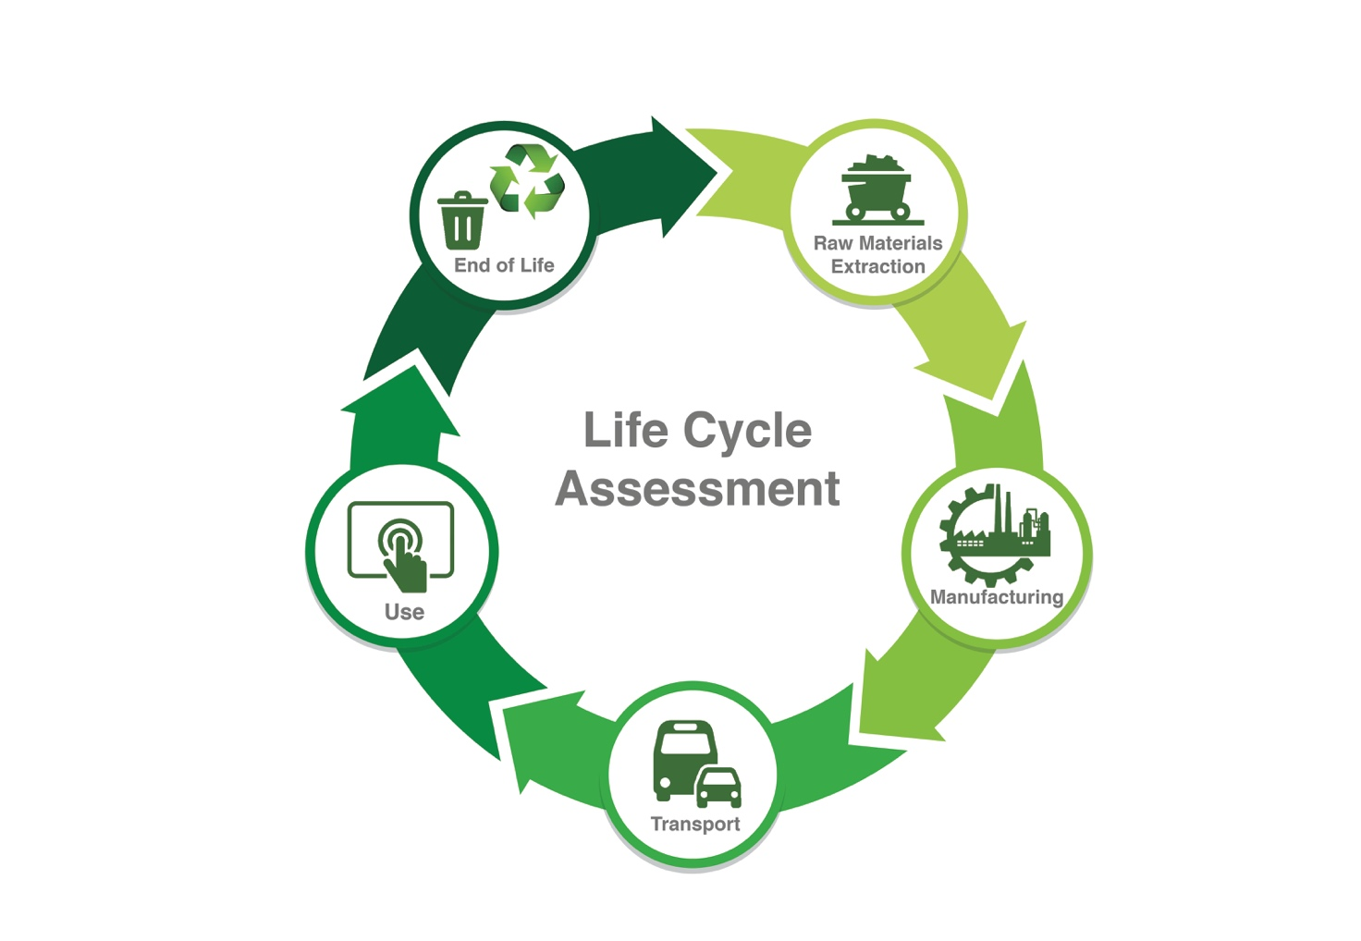
Figure 1 – Life-cycle assessment
The life-cycle assessment (LCA) is a method to assess all the potential environmental impacts of a product, process, or activity over its whole life-cycle, refer to [ITU-T L.1410] for detailed information on methodologies for LCA applicable to AI technologies. It is a theoretical approach that employs a conceptual structure to assess and record the differing dimensions of environmental impact, e.g., pollution to air, land and water when predicting the overall impact of a development or process [b-An et al 2019].
As an environmental assessment tool, it quantifies all the environmental impacts of a product or service over its entire life, hence one of LCA's alternative names 'cradle to grave analysis'. Engineering professionals are routinely tasked with determining design options that offer the minimum environmental impact during building, operation and the end-of-life phases of a project. LCA is uniquely valuable in assessing and documenting the evidence used in this decision process. Full details about the LCA process are available from a number of sources [b-Laurent 2014], [b-Mälkki-Alanne 2017], [b-Rousseaux 2017], but all LCAs must be carried out in accordance with the international standard on LCA [ITU-T L.1410], [b-ISO14044 2006a], [b-ISO14040 2006b].
The environmental categories considered in the environmental assessment are global warming potential (GWP), abiotic depletion (ADP elements), abiotic depletion (ADP fossil), acidification potential (AP), eutrophication potential (EP), freshwater aquatic eco-toxicity potential (FAEP), human toxicity potential (HTP), marine aquatic eco-toxicity potential (MAEP), ozone layer depletion potential (OLDP), photochemical ozone creation potential (POCP), and terrestrial eco-toxicity potential (TETP).
Based on the standard LCA, this study analyses each technology based on the adjusted model of product life-cycle, divided into the three stages below:
1. Materials – This stage includes the raw materials extraction, transport, and manufacturing.
2. Use – This stage includes the operation, consumption, maintenance, repair, replacement, and refurbishment.
3. End of life – This stage includes the deconstruction/demolition, transport, waste processing, disposal, and recycling (reuse, recovery, recycling, remanufacturing).

7.2 Sampled technologies and their environmental efficiency

7.2.1 Artificial intelligence

7.2.1.1 Materials
AI requires computing power. The computing power is, in general, provided by computers/servers equipped, nowadays, with central processing units (CPUs), graphical processing units (GPUs) or field programmable gate arrays. They are built with an assembly of digital circuits that are, eventually, based on transistors. In addition, for data storage, hard disk drives (HDDs) or solid state drives (SSDs) are utilized. All the components of a computer are then interconnected by circuit boards.
CPUs are primarily made out of silicon, copper, phosphorous, and boron. GPUs are made of tantalum and palladium transistors and capacitors, gold and silicon. Circuit boards are primarily made of aluminium, copper, tin, zinc, gold or silver for connections and switches, and ABS or fibreglass. Solid state drives (SSDs) are based on memories exploiting transistors made of wafers of silicon. HDDs are made of aluminium or glass and coated with a magnetic material. Magnetic underlayers were made of nickel, cobalt and iron, but are today replaced by more expensive metals such as platinum and ruthenium for their superior properties.
The main environmental impact is in the mining of the Earth's crust. The impact is firstly from depletion of natural resources, secondly the energy used in mining, transporting and manufacturing, and thirdly the chemical processes for the manufacturing. The latter produces hazardous waste. Whilst silicon comes from widely available sand, ruthenium is ranked 76th out of the ninety rare earth metals. Some metals like tantalum, used for transistors, are found abundantly; yet places where such metals can be found may not always be in a condition for efficient mining activities due to factors like social instability, which add more burden to the environmental process where for example additional transportation may need to be arranged, which results in more CO2 emissions

7.2.1.2 Use
Whilst studies show that AI can address some of Earth's environmental challenges, it is also reported that the use of power intensive GPUs to run machine learning training contributes to increased CO2 emissions.
Between 2012 and 2018, computing power has increased 300,000 fold impacting energy consumption. A study released in 2018 in the MIT Technology review found that a "regular" AI using a single high-performance graphics card has the same carbon footprint as a flight across the United States. For example, if an algorithm is designed and trained to recognize a cat, it needs to process millions of cat images. A more sophisticated process using 213 million parameters resulted in 300,000 KGs of CO2, which equates to the emissions of five cars during their entire lifetime, including emissions from their manufacturing.
The energy use of AI depends on several factors:
a) hardware type;
b) hardware architecture;
c) application type;
d) source of energy (depending on the location).
Hardware type
Figure 2 shows a continuum between hardware type denoting flexibility and power efficiency.
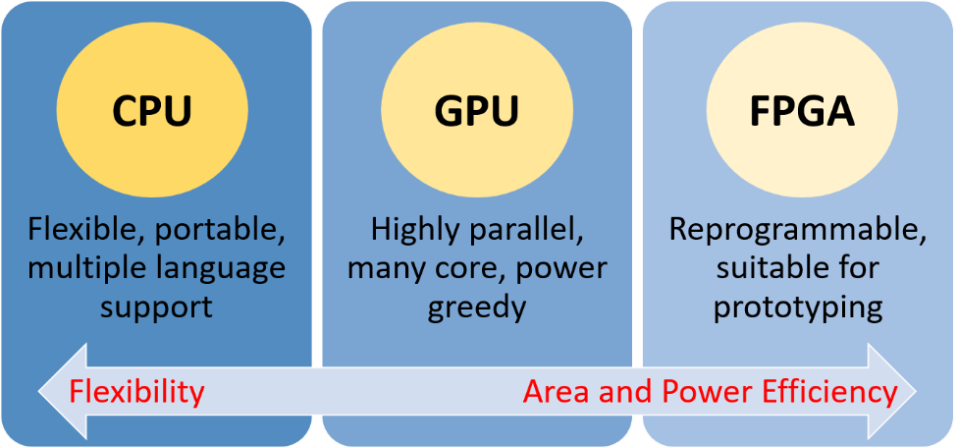
Figure 2 – Hardware platforms comparison
Power consumption is divided into leakage power and dynamic power, arising from being on with no runtime activities, and from switching of transistors during runtime activities respectively.
It is important to also consider the environmental impacts associated with the capture, storage, analysis and transfer of AI applications using networks and data centres.

7.2.1.3 End-of-life
The end-of-life of AI hardware presents many commonalities with most of the consumer electronics. End-of-life electronic and electrical equipment, or e-waste, generates waste management issues that can have negative environmental and health consequences if not properly disposed of.
Hardware is generally recycled, and metals are removed for re-use. The failure to close the loop on e-waste leads not only to significant adverse environmental impacts, but also to the systematic depletion of the resource base of secondary equipment. Recycling involves either dismantling and separation, or direct re-use, repair or refurbishment.

7.2.2 Drones

7.2.2.1 Materials
The design and production of a drone depends on so many factors such as application, environment, size, weight, etc., [b-Koiwanit 2018], [b-Chung 2019]. These factors also have an influence on the choice of materials used in manufacturing its components.
The increasing demand for payload capacity and drone performance made the industry switch to carbon fibre-reinforced polymers (CFRP) which is now the primary material used in the construction of the unmanned aerial vehicle (UAV) airframes. Kevlar/epoxy composites have been used in propeller construction, as it is lighter than CFRP.
The study by Koiwanit in 2018 illustrates the environmental impacts of a drone delivery system in Chiang Mai, Thailand [b-Koiwanit 2018]. The components considered are frame, electronic speed control, battery, servo motor, propeller and a box.
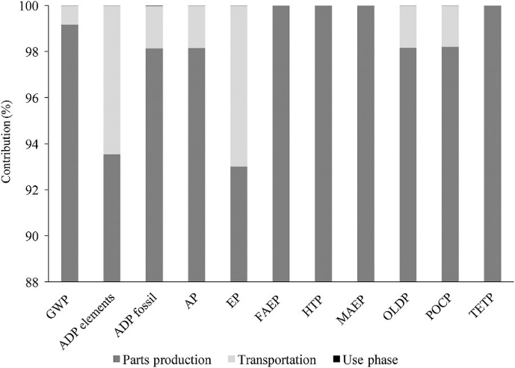
Figure 3 – Contributions of each process toward all impact categories. [b-Koiwanit 2018]
Based on Figure 3, it is evident that the production of drone components negatively affects the environment more than during the transport and the use phases.

7.2.2.2 Use
One of the main applications of UAVs is as delivery drones. Following the first commercial drone delivery approved by the Federal Aviation Administration in 2015, drone delivery may become widespread over the next five to ten years, particularly for what is known as the "last-mile" logistics of small light items. Drones could augment, or in some situations even replace, truck fleets and could have important implications for energy consumption, public safety, personal privacy, air pollution, city noise, air traffic management, road congestion, urban planning, and goods and service consumption patterns in urban areas.
A study by Stolaroff et al., 2018 assessed the life-cycle greenhouse gas emissions of drones for commercial package delivery in different regions of the US [b-Stolaroff 2018]. The study compared three delivery modes: drones, delivery truck and retail pick. For last mile delivery, drones were found to have the least environmental impact.
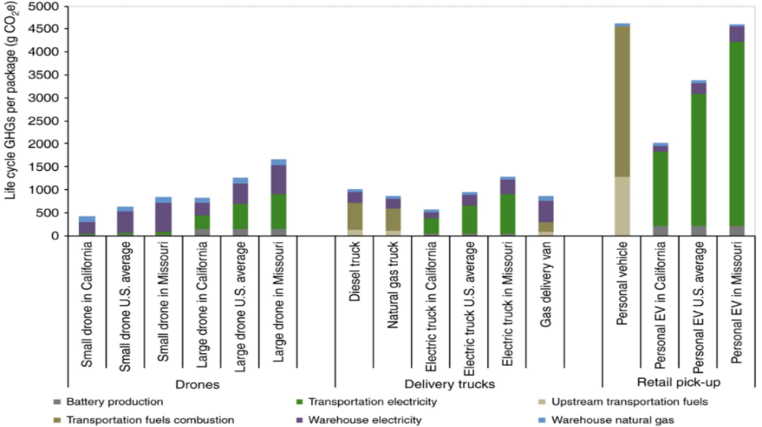
Figure 4 – Comparison of life-cycle greenhouse gas emissions per package delivered for drone and ground vehicle pathways under base case assumptions [b-Stolaroff 2018]
Drones could reduce CO2 emissions as well as other air pollutants for that sector. Several comparative studies [b-Park 2018], [b-Stolaroff 2018] show that delivery drones are more CO2-efficient than conventional means of transport, with the amount of CO2 emissions being greatly reduced.
These studies do not consider broader systemic effects along the entire logistics chain. For instance, even if the environmental impacts from direct emissions are reduced, emissions relating to extra warehousing, required by a drone-based logistics system, may reduce or eliminate the benefits [b-Stolaroff 2018].
In addition, as for many other technologies, the life-cycle of batteries needs to be factored in. At present, the absence of comprehensive assessments of the environmental impact of delivery drones prevents robust conclusions about greenhouse gas and air pollutants.
Among significant negative environmental effects, the threat to wildlife, especially birds, is a key concern. Operating at low altitude, usually below 500 metres, drones are likely to come into contact with wild animals. Beyond the obvious risk of collision, birds could be affected by the noise and stress caused by the frequent presence of drones in their habitat. Drones can also have a detrimental impact on an animal's reproduction and survival. Bird species, animals in larger groups (more than 30 individuals) and animals in the non-breeding stage of their reproductive cycles were found to be more sensitive to disturbances relating to the presence of drones.
Other potential environmental implications include noise pollution, which can lead to discomfort and health impacts on humans living close to delivery air corridors, and negative visual impacts on urban environments.
Potential environmental risks include the debris resulting from collisions and dropped cargo and the related responsibility for their disposal. Generally made from plastics, metals, and other non-biodegradable materials, UAVs or drones can pollute environments if they "were to crash in an inaccessible or protected area".

7.2.2.3 End-of-life
Carbon reinforced fibre polymer is used in manufacturing drones [b-ElFaham 2020]. Yet carbon reinforced fibre polymer are incredibly difficult to recycle [b-Kim 2020].
Glass-based products are extremely difficult to recycle with cellulose-based material, while aluminium and thermoplastics are highly recyclable.
Use of plastics for manufacturing drones leads to a decrease in plastic waste.
The latest UAVs are powered by lithium-ion batteries (LIBs) while older drone models use nickel cadmium (NiCad) and nickel-metal hybrid (NiMH) batteries. Owing to their high energy-density, light weight, and small self-discharge rate, lithium-polymer (LiPo) batteries remain the most commonly used. It has been demonstrated that LIBs can result in harmful environmental conditions like water and soil contamination when sent to a landfill. The high cost of the processing to recover resources from the battery which could be more than that of manufacturing new ones, makes recycling not viable. Batteries also contain heavy metals and other hazardous materials.

7.2.3 3D printing

7.2.3.1 Materials
Materials for 3D printing include various materials such as glass, starch, ceramics, organic materials, elastomers, resins, concrete and metals. However, 3D printing is not yet versatile enough to work with most materials. For example, not every metal or plastic can be temperature controlled enough for printing.
Depending on the material component, materials can have the biggest environmental impact.
A study of an industrial 3D printing application by Agustí-Juan et al., 2017 evaluated the environmental impacts of a robotically fabricated concrete wall [b-Agustí-Juan 2017]. The results of the impact analysis are presented in Figure 5 where "robot+tool production" refers to the in-situ fabricator construction robot and an attached tool for welding, bending and cutting. Based on Figure 5, it can be concluded that the "robot and tool production" have the least impacts on the environment compared to the material consumed in the process such as concrete and reinforced steel.
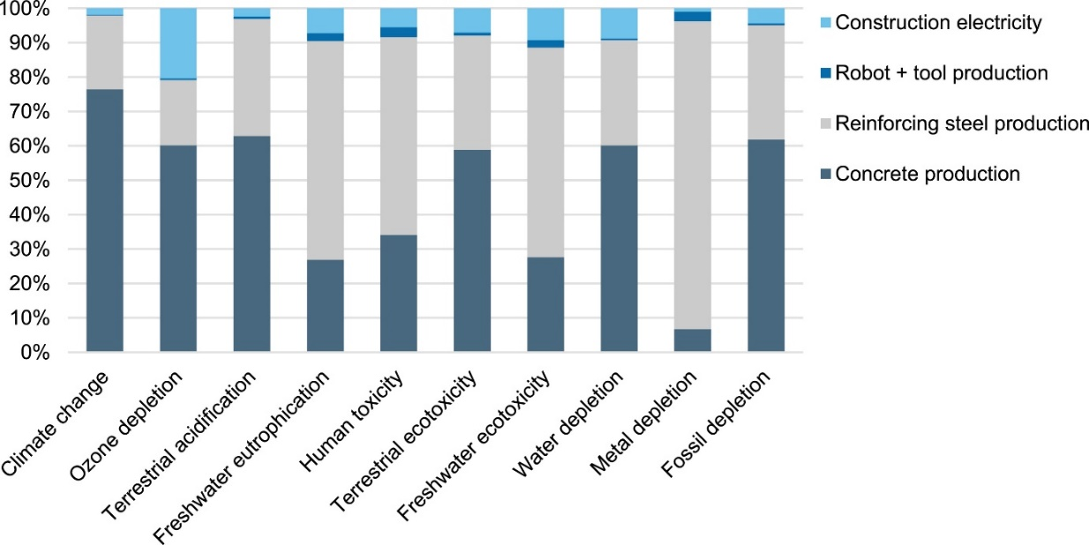
Figure 5 – Environmental impact of a robotically constructed concrete wall
[b-Agustí-Juan 2017]
While Agustí-Juan et al., 2017 assessed the environmental impacts of robot and tools in the 3D printing of a concrete wall, it is important to note that other components of the 3D printer were not considered. For example, the computer hosting the digital model and 3D printer's batteries were not discussed. On further examination of the literature, it emerged that there is paucity of research about complete information related to the different parts of a 3D printer. Hence, most studies often focus on the material used in the 3D printing process. Mikula et al., 2021 examined the recyclable content of polymers for 3D printing of commercial filaments [b-Mikula 2021]. Han et al., 2021 assessed the environmental impact of 3D printed buildings with recycled concrete [b-Han 2021], see Figure 6.
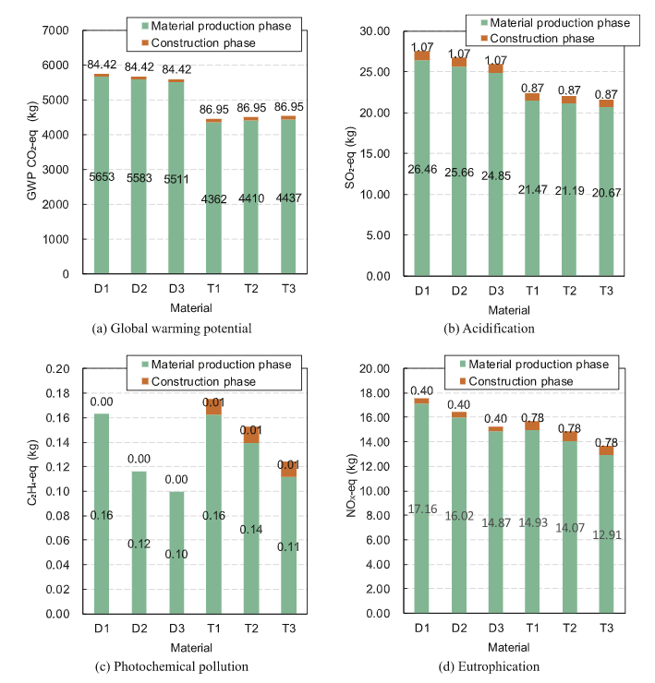
Figure 6 – Environmental impact of 3D printed buildings with recycled concrete [b-Han 2021]
D1, D2, D3 for 3D printing and T1, T2, T3 for conventional construction techniques are mix proportions of the 1m³ concrete presented in Han et al., 2021. Based on Figure 6, the impact of the production of concrete is higher for all the categories of the indicator.
Different materials have different environmental impacts. A study by Telenko and Seepersad, 2012 found selective laser sintering of Nylon 12 to cause three times the embodied energy of Acrylonitrile-butadiene-styrene granulate (ABS) or Polyethylene terephthalate (PET) and 48 times that of salt without epoxy [b-Telenkon 2012].
Whilst literature on 3D printers often states that waste levels are "near zero", due to parts being constructed using only the necessary amount of material, 3D printers do not necessarily compare favourably with traditional production techniques in terms of waste. Although not a dominant life-cycle impact, waste is generated where support structures are required, whilst inkjet-style 3D printers waste around 40% of their material, not counting support material. Whilst they may generate less waste than computer numerical control (CNC) machining (which could result in levels of waste as high as 95%), there may still be waste material generated in the form of the print bed and supports necessary for complex geometries, resulting in waste levels higher than injection molding.
It should be added that prototyping also generates waste.
The materials used for the equipment must also be factored in for a holistic view of the environmental impact.

7.2.3.2 Use
It was argued in a recent publication that the specific energy of current additive manufacturing systems is one to two orders of magnitude higher compared to that of the conventional manufacturing process [b-Kellens 2017].
A lifecycle study found that in contrast to a high production scenario, printing just one part a week and leaving the machine on the rest of the time, had roughly ten times the impact per part compared to using the same machine at maximum utilization. In an industrial environment use of the minimum number of printers to process the maximum quantity of jobs can substantially reduce the environmental impacts of 3D printing by amortizing the impacts of printer manufacture and reducing wasted energy use whilst idle.
The impact of utilization levels on energy consumption will depend on the specific printing technology. Some printers require extensive idle energy in the form of atmosphere generation, warm up and cool down between jobs, whilst others are able to print nearly without interruption.
Energy impacts depend on the machine design. The following factors can have an influence on 3D printing energy impacts in an industrial environment:
– Build volume: This will determine the number of parts that can be printed simultaneously on a specific printer. There will be energy efficiency gains for machines that are able to print more parts at once.
– Layer thickness: Low layer thicknesses will provide improved surface finish and higher geometric tolerances but are likely to result in lower process speed and higher energy consumption, due to the greater total number of layers required to build the part.
– Material type: Variation in specific heat capacities and material densities will have an influence on energy required in the printing process. Printers using materials that can be worked with at lower temperatures are likely to have lower impacts.
– Process speed: Process speed can vary considerably between printers due to build volumes, layer thickness, etc. The longer the process speed, the higher the energy impacts are likely to be per part.
There is also another aspect of in-use energy to consider, that is the usage of the 3D printed part itself. Recent studies have found that 3D printed metal parts can be up to 50% lighter than machined parts and result in carbon savings in the aeronautical parts-use stage equalling "three to four orders of magnitude more" than the amount of CO2 emitted to make them.
Studies have found that little bits of plastic and some volatile organic compounds end up in the air when printing. Air pollution should be considered.

7.2.3.3 End-of-life
Most material for 3D printers are made of thermo-plastics. In theory, most types of thermoplastics can be melted down and recycled, with differing amounts of efficiency and material loss between each type. However, the types of plastics that are processed by recycling plants can vary significantly.
Polylactic acid (PLA) is a biodegradable plastic, which means it can be broken down over time by bacteria and fungi. However, PLA has a long degradation time, as well as its potential to produce trace heavy metal residues after it degrades, makes it incompatible with commercial composting facilities.

8 Guidelines and Recommendations

8.1 Strategy for localizing decision-making and/or creating global benchmarking guidelines
To assess understandings, attitudes, behaviours and practices of key stakeholders in this digital policy territory that links technologies and environments, we suggest adopting the survey method as an instrument to gain crucial insights for (re)shaping a comprehensive policy framework as well as business decisions based on local contexts. The survey instrument contains three parts, each targeting a major stakeholder, namely policy makers, industry executives and general citizens who are involved in either part or all of the material, use, and end-of-life stages of a technology product or service. Combined, these three surveys can produce crucial insights for international organizations, national governments, and the private sector to identify key areas of concerns and actions prior to setting the international, national and industrial agenda of technology and environment for both the public and private interests.
If the surveys are conducted at a national scale, they can ideally include all regions/provinces of the country, including under-represented areas for comprehensive localization. If the surveys are conducted at an international scale, besides the national approach of inclusion, such surveys can also aim to have a fair distribution of Global North and Global South countries for a balanced global benchmark.

8.1.1 Survey for policy makers
It is proposed that this survey include 10 questions and target senior national policy makers in ministries responsible for digital policy and for the environment. The aim is to include about 100-500 policy makers nationwide from all sectors of related ministry for the national survey and all continents for the international survey. The survey can contain the following themes: 1) existing policy and its situation on implementation; 2) effectiveness of current policy; and 3) foreseeing policy areas that can be helpful to address current concerns.
This survey template consisting of 10 questions, can be found in Annex A.

8.1.2 Survey for private industry executives
This survey can assess the awareness of the private companies operating at different levels and include executives of technological industries in order to gain knowledge about their approach to address environmental concerns (e.g. minimize carbon emissions) and their willingness to 1) adopt proactive sustainability measures, 2) invest in new climate friendly technologies, 3) enable sustainable energy efficiency solution in their implementation; and 4) minimize e-waste. The survey can include about 100-500 executives of national/international technological corporations.
This survey template consisting of 11 questions, can be found in Annex B.

8.1.3 Survey for general citizens
This survey is a representative survey among citizens in all regions/provinces of a country and is aimed to include 500-1000 citizens. The survey seeks to access: 1) citizens' awareness and perception of this issue; 2) known practices developed to enable climate neutral technology use; 3) different levels of knowledge among citizens regarding environmental pollution and health related issues exacerbated by technology use.
This survey template consisting of 7 questions, can be found in Annex C.

8.1.4 Case study-related surveys: examples to contextualizing survey templates (in Annex)
While questions on our generic survey templates have the potential to accommodate the needs for insights from almost all relevant stakeholders, it is equally important to localize certain generic questions and/or add a few more questions in the survey based on local context of technology and environmental efficiency. In order to facilitate the adoption of contextualized surveys, the following case studies are provided as examples; yet questions proposed in this case study section are "questions to be considered when adjusting generic questions" and are for users to brainstorm their contextualization strategies, they may not be used directly as survey questions in the actual survey.
1) Case study for policymakers
A new product, a portable drone available for personal and commercial use, is about to be released into the market by the fictional company DroneX. It is expected to be a massive success and to be used in by several sectors, from drone enthusiasts to delivery companies.
Upon approving the product for rollout, it is discovered that the drones are rich in carbon reinforced fibre polymer, which is extremely difficult to recycle. In addition the production reports released by DroneX have shown that manufacturing the products causes much more carbon emissions than the established average for companies that make unmanned aerial vehicles (UAVs) of similar size.
Contextualizing questions from generic survey template with the following considerations:
1 – Are there existing policies in your territory to ensure manufacturers keep carbon emissions of technology products under a particular ceiling? What about recyclable materials?
2 – If there are no such policies or if they need to be created/updated, what data would the appointed Ministry need before conducting the process?
3 – Regarding releases with massive commercial potential such as the one of DroneX, how does the government balance economic benefits with environmental responsibility?
4 – Are there policy levers currently in place within the government to ensure environmental preservation? e.g. applied research facilitators, tech R&D branches, capacity to regulate innovative sectors.
5 – If policymakers decide to tackle the issue with DroneX, requesting the company to reduce their carbon emissions and use more recyclable materials, what would you say are the biggest challenges to accomplish changes in the product rollout?
2) Case study for private industry executives
Your company is ready to release a new technological product that has tremendous commercial potential. Upon receiving government approval for the rollout, you are notified that governmental programmes supporting green initiatives in the territory have requested the use of more recyclable materials (which are more expensive) and lower carbon emissions during manufacturing in order to approve the product for market launch.
Contextualizing questions from generic survey template with the following considerations:
1 – How much are you willing to pay extra for recyclable materials if it gets a product into the market with an eco-friendly approval? Do you have a specific return on invested capital metric for such situations?
2 – If lower carbon emissions are the only way to go for this product release, what manufacturing benefits would you usually require from the government in exchange for compromising your profits?
3 – In contrast, what are the measures considered too drastic that would steer your company away from fulfilling a territory's request? Is there a specific formula you utilise to verify if a product rollout is still worthwhile under a sizing sample of the target population?
4 – Would you consider sacrificing the performance of a product in order to fit the environmental guidelines?
5 – How would the changes towards an environmentally friendly label affect the selling price of the product? Would you consider a higher gross-profit margin once the product can be advertised as low carbon-emissive and with recyclable materials?
3) Case study for citizens/general technological users
You are well past due to get a new phone; you have had yours for a few years and it is working quite poorly to the point of compromising your work routine and social reach. Upon research, you find that major tech companies A and B have released their new respective phones; A1 and B1, which are extremely similar in all performance and design factors.
Company A's phone is made with highly recyclable materials and manufactured under low carbon emissions, while B1's is not. However, A1 is about 30% more expensive than B1, which fits quite well within your price range.
Contextualizing questions from generic survey template with the following considerations:
1 – Would you be willing to purchase A1 instead of B1, being an extremely similar product but simply pricier?
2 – What if eco-friendly A1 was the same price as B1, but with poorer performance? E.g. worse battery, camera, screen resolution, design.
3 – If they were similar in every way and you found yourself completely split between choosing one or the other, would discovering A1's environmentally-friendly features legitimately make you choose it over B1, or it would not be enough to enforce a decision?
4 – How willing are you to trade obsolete tech products in for recycling at a low return rate than selling them on platforms such as eBay for a higher return? If you are not, is there any factor(s) that would change your mind?
5 – On a scale of 0-10, how much do you keep up with information regarding carbon emissions, technology consumption and environmentally friendly initiatives towards the companies that you enjoy? Please justify the rating.

8.2 Possible actions to improve environmental efficiency on AI and sampled emerging technologies

8.2.1 Artificial intelligence

8.2.1.1 Material
A general approach from the material viewpoint is the replacement of electronic components with optical components. As mentioned in The future of deep learning is photonic, "…Computing with light could slash the energy needs of neural networks…" [b-Hamerly 2021]. Indeed, the utilisation of computers based on optical elaboration of the signals could potentially benefit not only the energy consumption but also contribute to the saving of rare earth materials.
From the energy efficiency viewpoint, in general, an optical elaboration of the signal requires less energy than and electronic one. For example, in deep learning the relevant operation to be conducted are mainly multiply-and-accumulate operations. Such operations could be easily performed by letting two optical beams, representing the two factors, impinge on a beam splitter and then adding the received photocurrent [b-Hamerly 2019]. Other approaches based on other optical devices are possible, such as Mach-Zehnder interferometers.
However, fully replacing electronics with optics requires further study because, for example, optical memories are just prototypes and not ready for mass production. However, a new technology that was not available to earlier generations is now available: integrated photonics.

8.2.1.2 Use
There are several techniques for improving energy efficiency of processors, namely:
– Dynamic voltage/frequency scaling (DVFS) based techniques.
– CPU-GPU workload division-based techniques. A scaling experiment revealed that CPU and GPU dynamic scaling can save significant amount of energy while providing reasonable performance.
– Architectural techniques for saving energy in specific GPU components, such as caches.
– Application-specific and programming-level techniques for power analysis and management.
– Hardware cooling solutions.
Best practices are recommended as training models repeatedly to achieve accuracy by a very small measure may incur very high costs. Datasets should be equally optimized.
More research can be promoted on Tiny AI as this solution is made to dramatically reduce the size of the algorithms which can be built on small hardware or on devices with low power consumption thus ultimately reducing the environmental impact.
On energy sources, promotion of usage of alternative and renewable resources should be sought.
Architecture
Different hardware accelerators are being investigated to overcome the increasing complexity demand and provide a better energy efficiency for different deep learning applications [b-Capra 2020]. Today's trend is driven by Internet of things (IOT) applications where the computation capability should be near the sensors, which requires strict power constraints since they are battery powered or they rely on energy harvesting systems [b-Shaque 2018]. With IOT applications, the power consumption might go beyond the required power when integrating GPUs. With this scenario, DL algorithms should be accelerated with alternative technologies such as low-power FPGAs, which are reprogrammable and flexible. The flexibility of FPGA establishes a possible hardware optimization that are required for energy-efficient acceleration of deep learning models.
Location
Tracking the emerging consumption and emission from AI software is equally important as AI deployed hardware. The purpose of such calculation is to measure the amount of CO2 produced by the cloud or the computing resources that are used when executing the algorithm codes. Developers can reduce emissions by targeting their cloud infrastructure in regions that use lower carbon energy sources.
8.2.1.3 End-of-life
The hardware can be diverted from landfill or incinerators through recycling and re-use.
Governments can initiate collective recycling plan programs, through which different models of a type of technology can be recycled. Authorities can also negotiate with private sector companies for re-use.
Extender producer responsibility (EPR) such as take-back obligation from manufacturers and importers can be a solution, as the e-waste can be appropriately channelled to recycling plants, or to repair and refurbishment centres.

8.2.2 Drones

8.2.2.1 Materials
Materials can be substituted with materials from renewable sources, recycled materials, or recyclable materials. Plant-based bioplastic is both recyclable and bio-degradable. It can be used for 3D printing of drones. 3D printed drones would also allow quick repairs in remote locations.
Highly energy efficient batteries should be used in running drones. Batteries that can be recyclable should be used. Solar energy can also be used to power some quadcopter drones [b-Lin 2020].

8.2.2.2 Use
Reductions in emissions will depend on finding ways to diminish the size of drones [b-Stolaroff 2018] and continuously increase the use of renewable energy sources, such as solar and wind power, for drone operation [b-Park 2018].
For delivery applications, energy from renewable sources should be considered as an alternative to power warehouses.
As for any technology, optimization of processes, such as aerial mapping or travel routes identification, is important.

8.2.2.3 End of life
Recycling of hardware can be reached through flexible take-back plans involving collaboration within the private sector. For example: recycling of drones may not necessarily go through its original companies but with flexible options of recycling through other consumer electronic companies.
Re-use of waste from electronic and electrical equipment (WEEE) and deeper manual dismantling prior to mechanical treatment can be promoted.
Research can be promoted in the field of recycling and re-use of waste products from batteries.

8.2.3 3D printing

8.2.3.1 Materials
Eco-friendly material should be used as printing material and for manufacturing of the different components of 3D-printers.
For consumer and small-scale industrial printers, some more environmentally sound feedstock options exist in the form of corn-starch polymer, wood-based composite, and recycled plastic feedstock in contrast to the previously prevalent ABS feedstock.
The following factors need to be considered for optimization; shrinkage, emissions from the material, finishing needs, heat capacity and melting point for thermal 3D printing.

8.2.3.2 Use
In order to reduce the impacts of in-use energy, the following could be considered:
– Reduce active print time per part.
– Hollow parts and supports rather than solid.
– Optimized layer thickness: Larger layer thicknesses mean faster processing speed and lower energy consumption, due to the reduced number of layers required to build the part. The largest layer thickness should be chosen to achieve the acceptable level of surface finish and geometric tolerance.
– Optimized orientation: To eliminate supports by carefully orientating the part, reducing waste impacts.
– Increase the build volume: For metal sintering, printing multiple parts can result in reductions in per-part energy of 3 to 98%.
An industry standard of reporting plant information should be defined to allow of easy computation embodied energy, material quantities and CO₂ emissions associated with its manufacturing.
Energy from renewable sources should be used to operate the 3D printers.
Ink for 3D printers should be as eco-friendly as possible.

8.2.3.3 End-of-life
Some printed plastics are not contaminated but are often discarded after being used once. Instead of the clean plastics to be discarded it can be directly recycled and reused. Furthermore, the non-contaminated plastics can be used in 3D printing.
The packaging of the 3D printers and their components should be recycled at the end of their life.
Most studies have focused on the environmental impacts of materials used in printing. Further studies about the impacts of the 3D printers need to be conducted.

8.3 Possible actions to improve environmental efficiency for all applications of other emerging technologies
While emerging technologies have different meanings in different contexts, the recommendations listed in Table 2 provide examples and options for possible actions to be taken in order to improve environmental efficiency while implementing technologies:
Table 2 – Examples for possible actions connecting technology implementation and environmental efficiency
S.no. | Environmental impact areas | Possible environmental efficiency action items
1 | Energy consumption in data centre /platforms | • The IT infrastructure including the data centre needs to be localized as far as possible from areas with habitants to prevent cross continental usage, which has environmental implications.  • Maximum possible use of renewable energy sources  • Heat generated in the data centre can be used for heating/ cooling the buildings to save on further consumption of energy.
2. | Energy consumption in quantum computing | • The quantum computing infrastructure needs to be localized as far as possible to prevent cross continental usage, which has environmental implications  • Maximum possible use of renewable energy sources  • Heat generated in the quantum computing centres to be used for heating/cooling the buildings, housing them to save on further consumption of energy
3. | Materials used for the IoT sensors | • Materials used need to be environmentally friendly, i.e. easily degradable after the completion of their life-cycle, since recovering millions/billions of such devices may not be physically and commercially viable.
4. | Batteries recycling | • The suppliers of the electronic hardware, including batteries, for a large number of IoT devices should also be made responsible for collecting the product at the end of the life-cycle to prevent these batteries and electronics from creating hard to manage e-waste.
5. | Materials used for the various aids for physically challenged people | • Materials for prosthetics used should be eco-friendly  • Ingestible sensors in medical devices should get dissolved in the body without harming the body
6. | Handling e-Waste | • There is a need for incentivizing entrepreneurs to establish of e-waste management plants.
It is also important to consider not only the environmental efficiency of the technologies but also the effects of using technologies in applications.
For example, Industry 4.0 is the ongoing digitalization of manufacturing and industrial practices to improve their productivity, flexibility, and cost-effectiveness. It is an industrial approach where one or more digital technologies are used throughout industrial processes in order to produce more and better.
Digital technologies such as robots and AI applied to manufacturing can effectively make manufacturing more environmentally efficient. Examples of direct impact of adopting Industry 4.0 technologies are listed in Table 3.
Table 3 – Direct impact of Industry 4.0 on environmental efficiencies – examples
Manufacturing processes | Examples of adopting Industry 4.0 technologies | Direct impacts on environmental efficiency
Development | • Using simulations to understand the mechanism of machines  • Using big data analytics to characterize the dynamics of supply chains | Less experiment (Waste↓)
Design | • Using cyber-physical systems to design machines | Fewer design cycles (Waste↓)
Prototype | • Using 3D printing for rapid prototyping | Less material consumption in making prototypes  (Waste↓)
Production | • Using big data analytics to optimize the allocation of production workstations  • Using smart sensors and controllers to monitor and reduce the CO2 emissions by machines | Optimized production processes (Waste↓ and CO2 emissions ↓
Test | • Autonomous inspections based on robots and computer vision | N/A
Quality assurance | • Using big data analytics to understand patterns in product defects  • Autonomous condition monitoring of equipment based on the Internet of things | Reduced defected products (Waste↓ and CO2 emissions ↓)
Support | • Remote technical support and training based on augmented reality | Fewer travels (CO2 emissions ↓)
Logistics | • Cloud planning for supply chain management and delivery | Fewer travels (CO2 emissions ↓)
Industry 4.0 technologies generally improve the environmental efficiency of manufacturing processes by allowing less waste to be generated in the production of a unit product.
Industry 4.0 can also help build a more circular economy. A circular economy is an alternative to a traditional linear economy (make, use, dispose) in which we keep resources in use for as long as possible, extract the maximum value from them whilst in use, then recover and regenerate products and materials at the end of each service life. Figure 7 is an illustration of the circular economy.
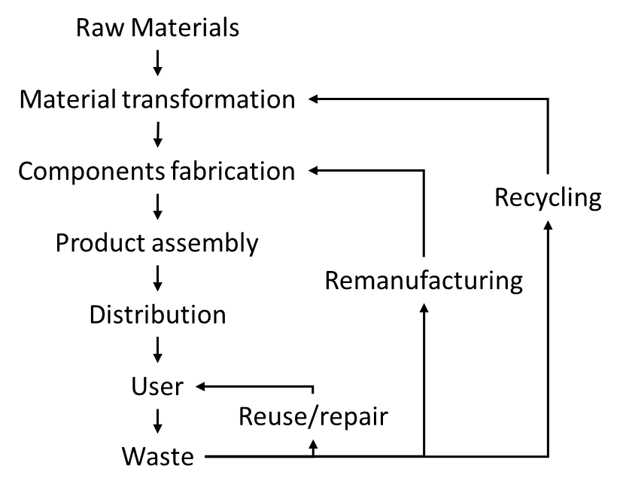
Figure 7 – Life-cycle of a product in Industry 4.0
Industry 4.0 technologies can help build the circular economy in a number of ways including but not limited to:
• Use of robots to accelerate disassembly.
• Use of 3D printing for high-value product repair.
• Augmented reality and virtual reality to support product repair and remanufacturing.
• Use analytics to support product design.
• Adoption of ICT to support the development of new business models focused on repair, reuse, remanufacturing and recycling.
• Adoption of digital twins to enable real-time asset monitoring and remanufacturing planning.

8.4 Recommendations for different stakeholders
Throughout the implementation of any emerging technology, stakeholders from both the public and the private sectors (who are likely to be involved in one or more of the following processes 1) development, 2) deployment, 3) market and business, and 4) regulations, policies, and standards) need to be aware of the environmental consequences. Below is a list of generic recommendations to facilitate the understanding of links between technology and environmental factors:

8.4.1 Development
– Track breakthrough innovations worldwide without dismissing country of origin, since potential global benefits might hide under assumptions and or prejudices.
– Challenge and educate technological entrepreneurs to think laterally, aiming for greater impact and good.
– Consider the full life-cycle of a new product.

8.4.2 Deployment
– Reinforce resilience of critical technological infrastructure nodes.
– When deploying frontier technologies to developing countries through Foreign Development Investment, be intentional from the onset about supporting ongoing repair and maintenance by local stakeholders in the host country.
– Create long-term strategic partnerships with last mile distributors (LMDs) to ensure steady benefits of these technologies to low-income consumers in developing countries, including:
• manufacturers of emerging technology-enabled products should engage in ongoing consultation with LMDs and their customers through the different design, test, and iteration phases of products;
• service providers (software and training companies) should focus on low-cost tailored platforms and services they need;
• governments should acknowledge the key role of LMDs in supporting SDGs and ensure they are included in dialogues and collaboration with the private and public sectors.
– Include active participation of the end users of new technologies throughout the different phases of their implementation, in order to make sure maintenance is assured as well as financial, material, and human return of investment.

8.4.3 Business and market
– Raising funds through green bonds and gasoline taxes to a local-first financing approach to address green economy from the root.
– Enable ultra-long-term financing and investment strategies, with a triple target of investing in people, in sustainable and resilient infrastructure as well as in innovation.

8.4.4 Regulations, policies, and standards
– Multi-stakeholder engagement to call for consensus-making.
– Licensing agreements between the public and the private sectors to better inform regulations.
– Enforcement of mandatory quality standards to support sustainable markets.
– Research to create evidence-based regulations, policies, and standards.
– Provision of clarification about end-of-life responsibilities to different stakeholders, including users.

Annex A
Generic survey for national policy-makers
1) When you think about your policy strategies for the next few years:
How do you see the link between technological development and environmental issues?
(Only tick one response)
• we see environmental issues as a key priority in our technological policy strategies
• we will address the environmental implications sometime in the next years
• our focus is entirely on technological development, and we cannot do much regarding environmental implications
• we will wait for international best practice models before we approach environmental issues
• don't know
• other, such as (please fill in) ...............................................................................
2) Are you following international policy discussions regarding the implications of technology on the environment?
• all the time (please continue with Q 3)
• most of the time (please continue with Q 3)
• sometimes (please continue with Q 3)
• no (please continue with Q 4)
3) When do you tend to follow international policy discussions regarding implications of technology on the environment?
• when they address a specific technology sector
• when they address a specific environmental sector
• when they address a specific technology life-cycle
• when they address a specific SDG
• when they address our larger region
• when they address our country
• don't know
• other, such as (please fill in) ...............................................................................
4) What are the policy targets when addressing technology related environmental implications in your country?
(Tick all that apply)
• reduce energy consumption
• preserve natural habitat
• minimize waste
• enable recycling
• enhance the circular economy
• minimize pollution and environmental hazards
• reduce emissions
• don't know
• other, such as (please fill in) ............................................................................
(5) How do you approach environmental policy targets while enabling technological transformation?
(Tick all that apply)
• use established policy tools
• refine existing policy tools
• develop new policy tools
• don't know
• other, such as (please fill in) ............................................................................
(6) What are your aims in terms of policy targets?
(Tick all that apply)
• enable a holistic approach across most or all technology sectors
• develop technology sector specific policy approaches
• develop policy approaches along government sectors
• environmental issues are a key focus of our government as such
• don't know
• other, such as ............................................................................... (Fill in)
(7) Are you developing strategies to enable public awareness for environmental issues relating to technologies?
• yes (please continue with Q 8)
• no (please continue with Q 9)
(8) How do you enable public awareness?
(Tick all that apply)
• press briefings
• media campaigns
• social media campaigns
• social media news feeds by government officials
• advertising
• working together with technology sectors to enable public awareness
• don't know
• other, such as ............................................................................... (Fill in)
(9) How do you promote environmentally sustainability among the technological sector in your country?
(Tick all that apply)
• enable tax reduction for environmental efficiency
• encourage private/public partnerships to target sector specific environmental issues
• launch awareness campaigns for local technology industries
• produce best practice models based on international strategies
• don't know
• other, such as ............................................................................... (Fill in)
(10) Which monitoring measures do you have in place?
• regular government assessments
• benchmarking processes
• specific government committees following up with technology industries
• regular meetings with specific industries
• we do not actively monitor progress
• don't know
• other, such as ............................................................................... (Fill in)

Annex B
Generic survey for technology industry
1) What is the geographical focus of your company?
• national
• broader region
• international
• truly global (all continents)
2) Do you orient your company along national or international plans of environmental efficiency?
• national
• international
• both
• don't know
• other, such as (please fill in) ...............................................................................
3) What is the degree of importance when you think about concrete investments into environmental efficiency in the coming few years
how important are investments into these areas for your company?
• top priority
• very important
• somewhat important
• not important as we have other issues to address
4) Specifically, carbon free energy has become a topic in public debates internationally:
why is carbon free energy relevant for your company?
Below are a few statements, please tick all that apply:
• it helps to minimize costs
• it will enable us to position ourselves as a leader in our sector
• it is a selling point for our products
• it is key to our customers - so we must incorporate it
• environment is a high priority in our company
• it is just a current trend which will pass
• not relevant to us as we have other priorities at the moment
• don't know
• other, such as (please fill in) ...............................................................................
5) Where do you have energy efficient measures already in place?
(Tick all that apply)
• we source material from energy efficient companies
• energy efficiency is relevant to us in all in-house production processes
• we only collaborate with energy efficient industry partners
• we use energy efficient data storage
• our delivery/logistics uses energy efficient transportation
• we adopt models to enable energy efficiency during the lifetime of our products
• we are in the process of developing energy efficient approaches
• we have not yet developed energy efficient approaches
• don't know
• other, such as (please fill in) ...............................................................................
6) When you consider the different components of your business – which are the segments you consider most relevant when addressing broader environmental issues?
Response options below apply relate to technology-centred and data-centred businesses.
(Tick all that apply)
• product development
• our manufacturing processes
• data servers
• cloud computing
• data centres as such
• blockchain procedures
• logistics/transport to reach the customer
• recycling of our products
• don't know
• other, such as (please fill in) ...............................................................................
7) Are some of the issues listed in Question 6 processed overseas?
• yes (please continue with Q 8)
• no (please continue with Q 9)
8) Do you assess your overseas business partners regarding their environmental efficiency?
• yes, we would not enter an international business partnership unless this is guaranteed
• yes, from time to time
• yes, we have adopted concrete measures to assess their environmental efficiency
• that is not necessary as we focus on our own environmental efficiency
• don't know
• other, such as (please fill in) ...............................................................................
9) Do you assess your national business partners regarding their environmental efficiency?
• yes, we would not enter a national business partnership unless this is guaranteed
• yes, from time to time
• yes, we have adopted concrete measures to assess their environmental efficiency
• that is not necessary as we focus on our own environmental efficiency
• don't know
• other, such as (please fill in) ...............................................................................
10) How do you promote environmental efficiency among your staff to develop a 'green' corporate culture?
• in newsletters
• corporate guidelines
• we have a special committee for informing staff
• we hold regular meetings to maximise environmental efficiency
• we promote best practice models
• don't know
• other, such as (please fill in) ...............................................................................
11) Where do you see the main future challenges for achieving environmental sustainability?
(Please fill in) ............................................................................................................

Annex C
Generic survey for national citizens
1) When it comes to the implications of technologies on the environment - how aware are you of the implications?
• very aware
• aware
• somewhat aware
• not really aware
• don't know
2) When you think about these implications – what are you most concerned about?
(Tick all that apply)
• my health, health of my family and friends
• broader environment
• safety of my home
• safety of resources, clean water, clean food, etc.
• energy efficiency
• implications on future generations
• don't know
• other, such as (please fill in) .....................................................................................
3) How would you rank your knowledge about the implications of technologies on the environment?
• significant knowledge
• good knowledge
• some knowledge
• very basic knowledge
• none
4) Would you be willing to pay a higher price if a technology has high 'green' standards?
• yes
• no
5) What are your sources for getting information about environmental protection and technologies? (Tick all that apply)
• educational institutions, schools, universities
• media, such as radio and television
• digital search platforms
• my social media community
• digital newsfeeds
• blogs
• friends, family
• government
• events
• don't know
• other, such as (please fill in) ...................................................................................
6) When you consider your technology recycling practice - which components do you normally recycle at a dedicated recycling station?
• batteries
• old mobile phones
• computer
• cables
• household technology
7) How do you think you could contribute to more public awareness for environmentally efficient technologies?
(Please fill in) ..................................................................................................................

Bibliography

[b-ITU-T F.751.0] Recommendation ITU-T F.751.0 (2020), Requirements for distributed ledger systems.
[b-ITU-T J.301] Recommendation ITU-T J.301 (2014), Requirements for augmented reality smart television systems.
[b-ITU-T Y.4000] Recommendation ITU-T Y.4000/Y.2060 (2012), Overview of the Internet of things.
[b-ISO/IEC 18038] ISO/IEC 18038:2020, Information technology — Computer graphics, image processing and environmental representation — Sensor representation in mixed and augmented reality.
[b-ISO/IEC 21384-4] ISO 21384-4:2020, Unmanned aircraft systems — Part 4: Vocabulary.
[b-ISO/IEC 2382-28] ISO/IEC 2382-28:1995, Information technology — Vocabulary — Part 28: Artificial intelligence — Basic concepts and expert systems.
[b-ISO/TR 24291] ISO/TR 24291:2021, Health informatics — Applications of machine learning technologies in imaging and other medical applications.
[b-ISO/TR 24464] ISO/TR 24464:2020, Automation systems and integration — Industrial data — Visualization elements of digital twins.
[b-ISO/TS 80004-1] ISO/TS 80004-1:2015, Nanotechnologies — Vocabulary — Part 1: Core terms.
[b-ISO 9241-394] ISO 9241-394:2020, Ergonomics of human-system interaction — Part 394: Ergonomic requirements for reducing undesirable biomedical effects of visually induced motion sickness during watching electronic images.
[b-ISO/ASTM 52900] ISO/ASTM 52900:2015, Additive manufacturing — General principles — Terminology.
[b-ITU-T terms] ITU-T Terms and Definitions. https://itu.int/go/terms
[b-ISO terms] International Organization for Standardization Terms and Definition. https://www.iso.org/obp/ui/#home
[b-ISO14044 2006a] ISO, 2006a, ISO14044, Environmental management life cycle assessment requirements and guidelines. International Organization for Standardization, Geneva, Switzerland.
[b-ISO14040 2006b] ISO, 2006b, ISO14040, Environmental management life cycle assessment principles and framework. International Organization for Standardization, Geneva, Switzerland.
[b-Agustí-Juan 2017] Agustí-Juan, I. et al., 2017, Potential benefits of digital fabrication for complex structures: Environmental assessment of a robotically fabricated concrete wall, Journal of Cleaner Production, Vol. 154, pp. 330-340.
[b-An et al 2019] An, J., Middleton, R. S., & Li, Y. (2019). Environmental performance analysis of cement production with CO2 capture and storage technology in a life-cycle perspective. Sustainability (Switzerland), 11(9). https://doi.org/10.3390/su11092626
[b-Capra 2020] Capra, M., et al., 2020, Hardware and Software Optimizations for Accelerating Deep Neural Networks: Survey of Current Trends, Challenges, and the Road Ahead, IEEE Access, Vol. 8, pp. 225134-225180, doi: 10.1109/ACCESS.2020.3039858.
[b-Chung 2019] Chung, P.-H., et al., 2019, Design, Manufacturing, and Flight Testing of an Experimental Flying Wing UAV. Applied Sciences.
[b-ElFaham 2020] ElFaham M.M., Mostafa A.M. and Nasr G.M., 2020, Unmanned aerial vehicle (UAV) manufacturing materials: Synthesis, spectroscopic characterization and dynamic mechanical analysis (DMA). Journal of Molecular Structure, Vol. 1201, No. 127211.
[b-Hamerly 2019] Large-Scale Optical Neural Networks Based on Photoelectric Multiplication. Ryan Hamerly, Liane Bernstein, Alexander Sludds, Marin Soljačić, and Dirk Englund. Phys. Rev. X 9, 021032 – Published 16 May 2019.
[b-Hamerly 2021] The future of deep learning is photonic: computing with light could slash the energy needs of neural networks. 29 June 2021. https://spectrum.ieee.org/the-future-of-deep-learning-is-photonic#toggle-gdpr
[b-Kellens 2017] Kellens K. et al., 2017, Environmental Dimensions of Additive Manufacturing Mapping Application Domains and Their Environmental Implications, Journal of Industrial Ecology, Vol. 21, No. S1, pp. S49-S68.
[b-Kim 2020] Kim. D.H.et al., 2020, Enhanced and Eco-Friendly Recycling of Carbon-Fiber-Reinforced Plastics Using Water at Ambient Pressure, American Chemical Society, Vol. 8, No. 6.
[b-Koiwanit 2018] Koiwanit J., 2018, Analysis of environmental impacts of drone delivery on an online shopping system, Advances in Climate Change Research, Vol. 9, No. 3, pp. 201-207.
[b-Laurent 2014] Laurent, A., Clavreul, J., Bernstad, A., Bakas, I., Niero, M., Gentil, E., Christensen, T.H., Hauschild, M.Z., 2014, Review of LCA studies of solid waste management systems – Part II: Methodological guidance for a better practice. Waste Management (New York, N.Y.), Vol. 34, pp. 589–606. doi:10.1016/j.wasman.2013.12.004
[b-Lin 2020] Lin, C.-F.et al., 2020, Solar Power Can Substantially Prolong Maximum Achievable Airtime of Quadcopter Drones, Advanced Science, Vol. 7, No. 2001497.
[b-Mälkki-Alanne 2017] Mälkki, H., & Alanne, K., 2017, An overview of life cycle assessment (LCA) and research-based teaching in renewable and sustainable energy education, Renewable and Sustainable Energy Reviews, Vol. 69, pp. 218-231. doi:10.1016/j.rser.2016.11.176
[b-Mikula 2021] Mikula, K., et al., 2021 3D printing filament as a second life of waste plastics-a review, Environmental Science and Pollution Research, Vol. 28, pp. 12321-12333.
[b-Park 2018] Park, J. et al., 2018, A Comparative Analysis of the Environmental Benefits of Drone-Based Delivery Services in Urban and Rural Areas, Sustainability, Vol. 10.
[b-Rousseaux 2017] Rousseaux, P., Gremy-Gros, C., Bonnin, M., Henriel-Ricordel, C., Bernard, P., Floury, L., Staigre, G., Vincent, P. (2017). Eco-tool-seeker": A new and unique business guide for choosing ecodesign tools. Journal of Cleaner Production, Vol. 151, pp. 546–577. doi:10.1016/j.jclepro.2017.03.089
[b-Shaque 2018] Shaque, M. et al., 2018, An overview of next-generation architectures for machine learning: Roadmap, opportunities and challenges in the IoT era, Proc. Design, Automat. Test Eur. Conf. Exhib. (DATE), March., pp. 827-832.
[b-Stolaroff 2018] Stolaroff, J.K. et al., 2018, Energy use and life cycle greenhouse gas emissions of drones for commercial package delivery, Nature Communications, Vol. 9, No. 409.
[b-Telenko 2012] Telenko, C. and Seepersad, C., 2012, A comparison of the energy efficiency of selective laser sintering and injection molding of nylon parts, Rapid Prototyping Journal, Vol. 18, pp. 472-481.

