|  |  |  |  |
| --- | --- | --- | --- |
|  | **International Telecommunication Union** | | |
|  |  | | |
| **ITU-T** | **Technical Report** | |
| TELECOMMUNICATION STANDARDIZATION SECTOR OF ITU | | (10/2021) |
|  | ITU-T Focus Group on Environmental Efficiency for Artificial Intelligence and other Emerging Technologies (FG-AI4EE) | | |
|  | **FG-AI4EE D.WG2-06**  **Assessing environmentally efficient data centre and cloud computing in the framework of the UN sustainable development goals**  Working Group 2 – Assessment and measurement of the environmental efficiency of AI and emerging technologies working group deliverable | | |
|  | Focus Group Technical Report | | |

FOREWORD

The International Telecommunication Union (ITU) is the United Nations specialized agency in the field of telecommunications, information and communication technologies (ICTs). The ITU Telecommunication Standardization Sector (ITU-T) is a permanent organ of ITU. ITU-T is responsible for studying technical, operating and tariff questions and issuing Recommendations on them with a view to standardizing telecommunications on a worldwide basis.

The procedures for establishment of focus groups are defined in Recommendation ITU-T A.7. ITU‑T Study Group 5 set up the ITU-T Focus Group Environmental Efficiency for Artificial Intelligence and other Emerging Technologies (FG-AI4EE) at its meeting in May 2019. ITU-T Study Group 5 is the parent group of FG-AI4EE. Deliverables of focus groups can take the form of technical reports, specifications, etc., and aim to provide material for consideration by the parent group in its standardization activities.

Deliverables of focus groups are not ITU-T Recommendations. For more information about FG‑AI4EE and its deliverables, please contact Charlyne Restivo (ITU) at [tsbfgai4ee@itu.int](mailto:tsbfgai4ee@itu.int).

NOTE

This is an informative ITU-T publication. Mandatory provisions, such as those found in ITU-T Recommendations, are outside the scope of this publication. This publication should only be referenced bibliographically in ITU-T Recommendations.

© ITU 2021

This work is licensed to the public through a Creative Commons Attribution-Non-Commercial-Share Alike 4.0 International license (CC BY-NC-SA 4.0). For more information visit <https://creativecommons.org/licenses/by-nc-sa/4.0/>.

Technical Report FG-AI4EE D.WG2-06

Assessing environmentally efficient data centre and cloud computing   
in the framework of the UN sustainable development goals

Summary

As the role of data centre and cloud computing keeps increasing, so are the concerns over their huge energy use, increased energy cost, associated impacts on climate change and environment. In recent years, the data centre and cloud industry has made excellent progress in enhancing energy efficiency and adopting renewable energy sources. However, a sole focus on energy efficiency may cause burden shifting and overlook other relevant environmental problems stemming from other parts of the data centres' life cycle and cloud computing value chain.

Therefore, to support the development of sustainable efficient data centres and cloud computing services, this Technical Report aims to conduct an environmental sustainability assessment encompassing the entire life cycle and factoring in a broad spectrum of energy and environmental problems that are needed to achieve the relevant UN sustainable development goals (SDGs). An integrated methodology addressing both technical and implementation challenges will be applied to yield actionable recommendations to policy makers and industry experts to develop and design sustainable data centres and cloud computing services.

Keywords

Cloud computing, data centre, impact assessment, life cycle, policy gap analysis, sustainable development goals, sustainability matrix.

Change Log

This document contains Version 1 of the ITU-T Technical Report on "*Assessing Environmentally Efficient Data Centre and Cloud Computing in the framework of the UN Sustainable Development Goals*" approved at the ITU-T Study Group 5 meeting held virtually on XXX.

|  |  |  |
| --- | --- | --- |
| **Editors**: | Tiago Serrenho European Commission – DG JRC | E-mail: [tiago.serrenho@ec.europa.eu](mailto:tiago.serrenho@ec.europa.eu) |
|  | Paolo Bertoldi European Commission – DG Joint Research Centre | E-mail: [paolo.bertoldi@ec.europa.eu](mailto:paolo.bertoldi@ec.europa.eu) |

**Table of Contents**

**Page**

1 Scope 1

2 References 1

3 Definitions 1

3.1 Terms defined elsewhere 1

3.2 Terms defined in this Technical Report 1

4 Abbreviations and acronyms 1

5 Conventions 2

6 Assessing environmentally efficient data centre and cloud computing in the framework of the UN sustainable development goals 2

6.1 Introduction 2

7 Data centre environmental and energy impacts 3

7.1 Electricity consumption and production 3

7.2 Data centre water consumption 6

7.2.1 Water consumption in electricity generation 6

7.2.2 Water use in data centre cooling 7

7.3 Data centre waste 7

7.3.1 E-waste 7

7.3.2 Waste heat 9

7.4 Embedded carbon in DC construction materials 10

8 Socio-economic impacts 12

9 Energy and sustainability measurement indicators available for DCs and cloud computing 14

10 Sustainable development goals and data centres 18

10.1 Goal 6 – Clean water and sanitation: Ensure availability and sustainable management of water and sanitation for all 18

10.2 Goal 7 – Affordable and clean energy – Ensure access to affordable, reliable, sustainable and modern energy for all 19

10.3 Goal 9 – Industry, innovation and infrastructure 19

10.4 Goal 11 – Sustainable cities and communities 20

10.5 Goal 12 – Responsible consumption and production 20

10.6 Goal 13 – Climate action 20

10.7 Goal 14 – Life below water 21

10.8 Goal 15 – Life on land 21

11 Analysis of policies that facilitate the development of environmentally efficient data centre and cloud in support of the achievement of the Paris agreement and the UN SDGs 22

12 Conclusions 24

Bibliography 26

Technical Report ITU-T D.WG2-06

Assessing environmentally efficient data centre and cloud computing  
in the framework of the UN sustainable development goals

# 1 Scope

This Technical Report will adopt a multi-impact and life cycle approach and include the following aspects:

• An assessment of environmental and energy impacts of data centre and cloud computing through a life cycle approach.

• A mapping of available sustainability and energy measurements of data centre and cloud computing.

• An analysis of the links to the 17 SDGs with breakdown indicators being evaluated.

• A policy gap analysis of policies that facilitate the development of environmentally efficient data centres and cloud in support of the achievement of the Paris agreement and the UN SDGs.

• Conclusions.

# 2 References

None.

# 3 Definitions

## 3.1 Terms defined elsewhere

This Technical Report uses the following terms defined elsewhere:

**3.1.1 cloud computing** [b-ITU-T Y.3500]: Paradigm for enabling network access to a scalable and elastic pool of shareable physical or virtual resources with self-service provisioning and administration on-demand.

NOTE 1 – Examples of resources include servers, operating systems, networks, software, applications, and storage equipment.

NOTE 2 – This report uses terms defined by UNEP life cycle terminology [b-UNEP terms] and ITU Terminology [b-ITU terms] websites.

**3.1.2 data centre** [b-ITU-T X.1053]: A facility used to house computer systems and associated components, such as telecommunication and storage systems.

## 3.2 Terms defined in this Technical Report

None.

# 4 Abbreviations and acronyms

This Technical Report uses the following abbreviations and acronyms:

BRE Building Research Establishment

CER Cooling Efficiency Ratio

CUE Carbon Usage Effectiveness

DC Data Centres

DCiE Data Centre Infrastructure Efficiency

EDE Electronics Disposal Efficiency

ERF Energy Reuse Factor

GHG Greenhouse Gas

IEC Industrial Emission Directive

IoT Internet of Things

IP Internet Protocol

ITEEsv IT Equipment Energy Efficiency for servers

ITEUsv IT Equipment Utilization for servers

MCPD Medium Combustion Plant Directive

MWth Megawatt thermal

PPA Power Purchase Agreements

PUE Power Usage Effectiveness

pPUE Partial Power Usage Effectiveness

REF Renewable energy factor

SDGs Sustainable Development Goals

WEEE Waste electrical and electronic equipment

WUE Water Usage Effectiveness

# 5 Conventions

None*.*

# 6 Assessing environmentally efficient data centre and cloud computing in the framework of the UN sustainable development goals

## 6.1 Introduction

As Rong H. et al., in (b-JRC, 2021) defined data centres (DC) as computer warehouses that store a large amount of data for different organisations in order to meet their daily transaction processing needs. They contain servers for the collection of data and network infrastructure for the utilisation and storage of the data. Data centres are the backbone of the IT infrastructures of the globe and help to sustain the constant need for data management.

The energy intensity of the data centre industry is well known, with a global electricity demand of 200 TWh, or around 0.8% of global final electricity demand (b-Masanet, 2020).

On top of being a very intensive industry, there are other numerous environmental impacts that cannot be overlooked. Water consumption for example. Data centres consume water directly for cooling, in some cases 57% sourced from potable water, and indirectly through the water requirements of non-renewable electricity generation (b-Mytton, 2021).

Other environmental aspects of data centres are also significant with the environmental impact being present in all of the lifecycle of a data centre. From the building stage, operation, expansion or demolition, there are numerous environmental impacts that need to be considered when assessing the impact of data centres and these cannot be unlinked with the UN sustainable development goals.

The sustainable development goals, launched by the United Nations under the 2030 agenda for sustainable development, in 2015, provides a shared blueprint for peace and prosperity for people and the planet, now and into the future. At its heart are the 17 sustainable development goals (SDGs), which are an urgent call for action for all countries – developed and developing – in a global partnership. The UN recognizes that ending poverty and other deprivations must go hand-in-hand with strategies that improve health and education, reduce inequality, and spur economic growth – all the while tackling climate change and working to preserve the oceans and forests.

This Technical Report aims to give an overview of the sustainability impacts of data centres, their correlation with the sustainable development goals and how these can interact.

# 7 Data centre environmental and energy impacts

With regard to the concerns of the impact of the environment on a data centre, one is forced to think of all the aspects in the lifecycle of the infrastructure. From the site prospection to the development and construction of the shell of the actual building, retrofitting or expansion of older structures, the actual operation of the data centre and finally the end of life and the demolition stage.

This sub-chapter aims to deliver an overview of the environmental impacts inherent to data centres in its lifecycle, which are directly and indirectly related with the SDGs and outline some of the mitigation measures that can be used in order to minimize such impacts.

## 7.1 Electricity consumption and production

Electricity is the main environmental indicator connected in the life of a data centre due to the high intensity of the server rooms processing, storing and transmitting data into the internet.

Since 2010, the number of internet users worldwide has doubled while global internet traffic has grown 12-fold, or around 30% per year.

Demand for data and digital services is expected to continue its exponential growth over the coming years with global internet traffic expected to double by 2022 to 4.2 zettabytes per year (4.2 trillion gigabytes). The number of mobile internet users is projected to increase from 3.8 billion in 2019 to 5 billion by 2025, while the number of Internet of things (IoT) connections is expected to double from 12 billion to 25 billion. These trends are the driving force in the exponential growth of the demand for data centres and network services (b-IEA, 2020).

Figure 1 illustrates examples of electricity usage (TWh) of data centres.

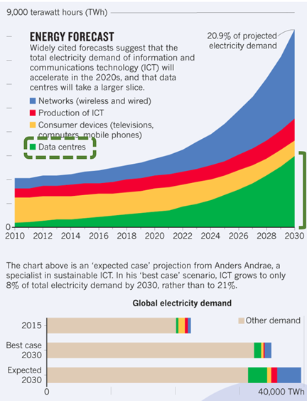

Figure 1 – Electricity usage (TWh) of data centres 2010-2030 (b-Sean Ratka, 2020)

With most of the world's internet protocol (IP) traffic going through data centres, greater connectivity is therefore propelling demand for data centre services and energy use (mostly electricity), with multiplying effects: for every bit of data that travels the network from data centres to end users, another five bits of data are transmitted within and among data centres. Global data centre electricity demand in 2019 was around 200 TWh, or around 0.8% of global final electricity demand (b-IEA, 2020).

Also, in the EU, in 2015, the amount of electricity consumed corresponded to around 2.25% of the total EU electricity 28 (EU-28) and this amount is expected to double by 2030 (b-Bertoldi, 2018).

Nevertheless, the strong demand for data centre services is being minimized by the achievements in the energy efficiency of servers, storage infrastructure and overall efficiency of the DC infrastructure. Although edge DCs will demand for smaller data centres closer to the final consumers, the trend is still for the development and operation of larger, more efficient DCs, instead of smaller and more inefficient ones. Emerging technologies like artificial intelligence, machine learning or blockchain are technologies that will increase the burden in the DC infrastructure and energy networks.

In the JRC report on data centre trends under the EU code of conduct there is a clear indication that although the computing demand is growing, the power usage effectiveness (PUE) of the participant DCs has had a decreasing trend (b-Bertoldi, 2017). For example, companies like Google are reporting, in comparison with five years ago they now deliver around seven times as much computing power with the same amount of electrical power (b-Google, 2020).

Since the decline of renewable energy prices in the last several years and with electricity reaching up to 70% (b-Sean Ratka, 2020) of the DC costs, some companies, that are aware of the impact their industry is having, have started to look into purchasing or even producing their own electricity via renewables. The largest players in the ICT sector are also the largest buyers of renewables (Figure 2). These companies seldom make use of the power purchase agreements (PPA) with energy utilities, in order to offset their environmental impact, or even themselves become players in the energy market by selling the exceeding electricity that is produced onsite.

Figure 2 illustrates the largest US energy buyers in 2019.

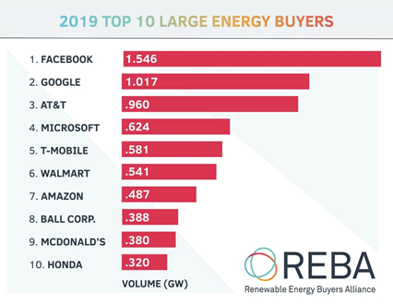

Figure 2 – Largest US energy buyers in 2019 (GW) (b-Sean Ratka, 2020)

Data centres can be considered a significant player within a local energy grid. Demand-side management is also another impact that can be considered. A positive one in this case, data centres can serve as an opportunity to add flexibility of grids through demand-side management via their energy storage ability, allowing grids to integrate larger shares of renewables. Some hyperscale data centres are using strategies like time shifting of computing tasks to periods of the day where the share of renewables is much higher.

Another positive impact from the operation of data centres may be the use of waste heat from the server halls directly to the neighbouring heating network. Being a natural by-product of the operation of a DC, the use of this waste heat which is used in district heating for communities where the data centre is installed is also another positive way to contribute for the decarbonization of cities.

An impact that is theoretically small but where no DC can escape are fossil fuel greenhouse gas (GHG) emissions that are generated from standby emergency generators. Having to rely on a fully functioning data flow, DCs often need to rely on standby heavy-duty diesel generators to ensure that the electricity flow remains uninterrupted until the normal functioning of the grid is re-established. For example, the EU, being aware of the impact of such emitters has demanded an industrial emission directive (IEC) license for back-up generators servicing data facilities, with a total rated thermal input exceeding 50 MW i.e., if the back-up generator operates for more than 18 hours a year. The [medium combustion plant directive (MCPD)](https://eur-lex.europa.eu/legal-content/EN/TXT/?uri=CELEX:32015L2193)also regulates pollutant emissions from the combustion of fuels in plants with a rated thermal input equal to or greater than 1 megawatt thermal (MWth) and less than 50 MWth.

## 7.2 Data centre water consumption

While data centre energy consumption may be the most significant environmental aspect in the lifecycle of a DC. However, there is another very important aspect that needs to be taken into consideration when evaluating the sustainability impact of this type of infrastructure, which is the water consumption. Water being an essential element for life in the planet and crucial for numerous sectors, the availability and quality of water is a growing global concern. According to the article by David Mytton on data centre water consumption (b-Mytton, 2021), future projections suggest that water demand will increase by 55% between 2000 and 2050 due to growth from manufacturing (+400%), thermal power generation (+140%) and domestic use (+130%). ICT is another sector contributing alongside to the demand for water.

There are two main activities within data centres that consume water: Water used in electricity generation and water used for cooling.

David Mytton's article also mentions that in 2014, a total of 626 billion litres of water use was attributable to the US data centres. Although some of the water being used in cooling the data centres is from non-potable sources, some DCs are still drawing more than half of their water from potable sources (Figure 3). This is especially important when large numbers of DCs are placed near densely populated areas where the data is being consumed. It is not rare that some of these DCs located in areas needed for the people's consumption are already affected by droughts and high stress in aquifers, thus having to compete with the demand from larger DCs.

Figure 3 illustrates the water source by year for Digital Realty.

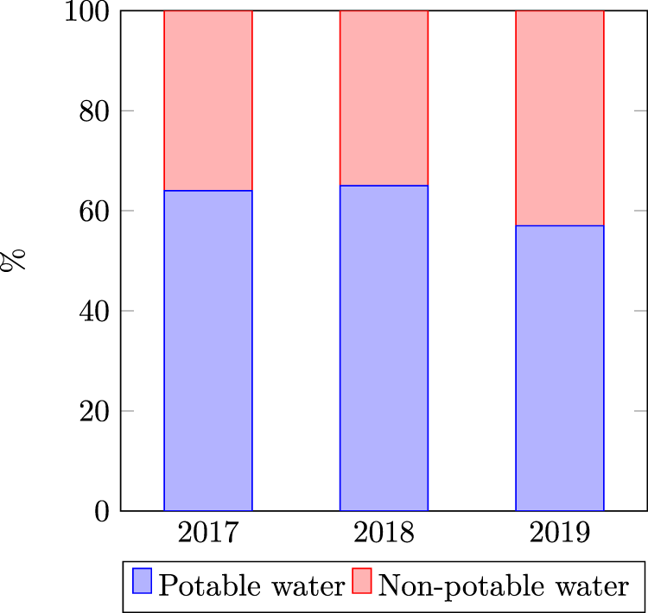

Figure 3 – Water source by year for Digital Realty, a large global   
data centre operator (b-Mytton, 2021)

### 7.2.1 Water consumption in electricity generation

The electricity used to power data centres requires significant volumes of water. Power plants burn fuel to heat water, generating steam to turn a turbine which then generates electricity. Results are often seen from the huge cooling towers next to power plants (b-Mytton, 2021).

Water used in the electricity generation is 4 times greater than the electricity used onsite for cooling: 7.6 litres of water is used for every 1 kWh of electricity generated compared to 1.8 litres per kWh of total data centre site energy use.

Only solar and wind power do not involve water in the generation – instead the manufacturing process contributes to the majority of the water footprint.

Figure 4 illustrates direct and indirect level of water consumption in data centres in the United States of America.

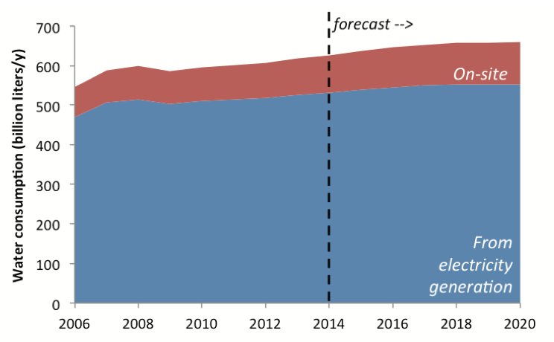

Figure 4 – Direct vs. indirect U.S. data centre water consumption (b-Mytton, 2021)

### 7.2.2 Water use in data centre cooling

Besides bytes, heat is another output from the ICT equipment. To cool the DCs down to an ideal operating temperature, water is often used to cool down the server rooms. There are several heat removal methods to cool the IT equipment and transfer the heat outside. The idea behind this heat removal is to use a heat exchanger to transfer heat energy from one fluid to another. Chilled water systems usually cost less than other systems e.g., Glycol or air-cooled chillers. The efficiency which improves with the data centre's capacity increase, is considered very reliable and can be optimized with other systems to operate at higher water temperatures. During the cooling processes of the environment air, the air can be cooled by re reducing air temperature by cooling water which is called as a heat transfer mechanism. Some data centres use cooling towers where the external air travels across a wet media so that the water evaporates. Other data centres use adiabatic economisers where water is sprayed directly into the air flow or onto a heat exchange surface, thereby cooling the air entering the data centre. In both the techniques, the evaporation results in water loss. A small 1 MW data centre using one of the above type of traditional cooling can use around 25.5 million litres of water per year (b-Schneider Electric, 2017).

## 7.3 Data centre waste

### 7.3.1 E-waste

The global e-waste monitor 2020 (b-UNU/UNITAR, 2020) has recorded 53.6 million metric tonnes of electronic waste generated worldwide in 2019, up 21 per cent in just five years. According to the report, Asia generated the greatest volume of e-waste in 2019 – some 24.9 Mt, followed by the Americas (13.1 Mt) and Europe (12 Mt), while Africa and Oceania generated 2.9 Mt and 0.7 Mt respectively (b-ITU, 2020).

With the constant growth of new and refurbished DCs there is a consequent creation of waste electrical and electronic equipment (WEEE), or e-waste. Nevertheless, due to long primary lifecycles of the critical infrastructure that make up a data centre site such as generators or an uninterruptible power supply (UPS), the data centre industry itself is not a major contributor to e-waste. On the other hand, all the components within the IT structure of a data centre with constant needs of systems to be recycled or refreshed for optimal efficiency may be significant contributors of e-waste in the case of the actual IT components like servers and other hardware parts.

Data centre equipment consists almost entirely of largely (greater than 99 per cent) composed "common" metals (e.g., steel, copper, aluminium) and polymers (e.g., ABS, PVC, PBT), while ten critical raw materials typically make up 0.2 per cent of components. Publicly available information about such materials in data centre equipment is limited and focused on enterprise server compositions.

Supply risk to critical raw materials is high, and their recycling rate from WEEE is estimated to be only around 1 per cent. Some metals are recycled more often because of their stable properties, consistent qualities, and well-established and more economically viable recycling technologies, including having a market for resale. End-of-life management companies face many challenges in recovering critical raw materials and rare earth elements from infrastructure equipment, particularly the viability of technology and economic recovery and these are further compounded by the falling value of the WEEE, meaning there is less value to extract. In general, data centre WEEE contains more high-grade recycling materials than small IT devices such as laptops. For example, data centres use high-grade circuit boards and backplanes that have on average, a higher precious metal content than the typical circuit boards from an individual consumer or small IT devices.

Figure 5 illustrates common electrical and electronic equipment (EEE) components and materials found in data centres.



Figure 5 – Common EEE components and materials found in data centres, including critical raw materials of high economic importance (b-JRC, 2015)[1]

### 7.3.2 Waste heat

Not all impacts arising from the operation of data centres are negative. The energy intensity of data centres comes with a great amount of waste heat that has the potential to be used elsewhere, namely in the heating of the supporting structures of the DC, and most significantly, in district heating infrastructure.

Waste heat utilization may represent an important step for data centre operators to reach a future net-zero energy goal. Some nordic European countries are already implementing this sustainability measure by rejecting data centre hall server waste heat into district energy systems for reuse. Stockholm's data parks for example, aim to use waste heat from data centres to heat 10% of the city by 2035. This trend is expected to become more omnipresent as EU-wide policies are being drafted. For this to succeed, waste heat recovery should be inserted in the design stage of the cooling system of new or refurbished DCs. Not all data centre cooling systems are sufficiently conducive or efficient to extract the energy minimizing thermal losses. Liquid cooling for example, is more efficient than air cooling for waste heat recovery.

Figure 6 illustrates waste heat usage for district heating.

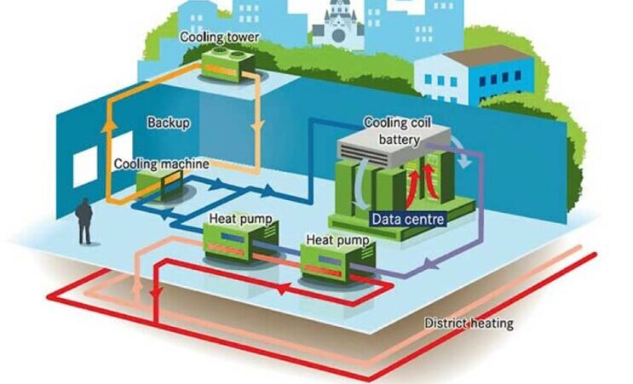

Figure 6 – Waste heat usage for district heating (b-Nortek, 2020)

## 7.4 Embedded carbon in DC construction materials

Having gone through the traditional steps used by data centre operators in the mitigation of the environmental impact of its operation, one tends to think further down the rabbit hole as to what steps are needed to be taken after all the efficiency has been achieved. A data centre hoping to advance in its sustainability efforts is almost obliged to start thinking of a circular economy, the lifecycle, carbon offsets or carbon credits.

As mentioned above one of the most procured way for DCs to minimize environmental impact is through the production of renewables onsite and the use of power purchase agreements by procuring the electricity supply through energy utilities selling renewable energy.

One factor that renewable production is unable to address is the embodied carbon. The green building council (b-WGBC, 2019) states that, "In a building life cycle, embodied carbon is the carbon dioxide equivalent (CO2e) or greenhouse gas (GHG) emissions associated with the non-operational phase of the project." It further states, "This includes emissions caused by extraction, manufacture, transportation, assembly, maintenance, replacement, deconstruction, disposal and end of life aspects of the materials and systems that make up a building." The whole life carbon of a building is both the embodied carbon and the carbon associated with the operations of the data centre.

Carbon emissions in a building can be divided in different categories:

• End of life carbon: Carbon emissions associated with deconstruction/demolition, transport from site, waste processing and disposal phases of a building or infrastructure's lifecycle which occur after its use.

• Operational carbon: The emissions associated with the energy used to operate the building or in the operation of the infrastructure.

• Upfront carbon: The emissions caused in the production of the materials and construction phases of the lifecycle before the building or infrastructure begins to be in use. In contrast to other categories of emissions listed here, these emissions have already been released into the atmosphere before the building is occupied or the infrastructure begins operation.

• Use stage embodied carbon: Emissions associated with materials and processes needed to maintain the building or infrastructure during use such as for refurbishments. These are in addition to the operational carbon emitted due to heating, cooling, power, etc.

• Whole life carbon: Emissions from all lifecycle phases, encompassing both embodied and operational carbon together.

Traditionally the emissions regarding embodied carbon are overlooked but as operational carbon is reduced, the share of importance of embodied carbon will continue to grow and DC operators must start focusing on also addressing the efforts needed to tackle embodied carbon.

Embodied carbon emissions can be affected by several factors. The choices made relating with the type of structure, materials used and their carbon intensity in the production and transport stages are all to be taken into consideration. On the other hand, there are several materials that can absorb or sequester carbon which can offset emissions from other lifecycle stages.

As mentioned by the (b-WGBC, 2019), opportunities for reducing or eliminating embodied carbon are equally varied and will differ between the types of projects as well as by region. In general, the greatest savings can usually be realized at the earliest stages of a project. As a project progresses, it becomes more challenging and more expensive to make design changes in order to reduce embodied carbon (see figure below).

Figure 7 illustrates the carbon reduction potential.

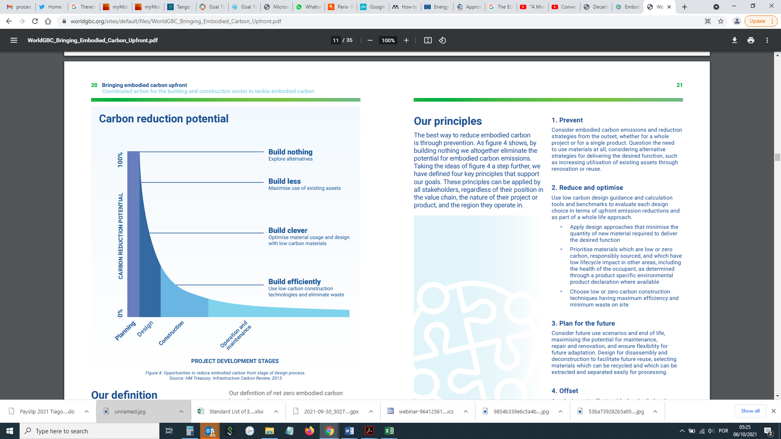

Figure 7 – Carbon reduction potential (b-WGBC, 2019)

As a principle the consideration of the embodied carbon should arrive at a very early stage of the project so that all interested parties are aware of the carbonic impact of a project. There should be a questioning of the status quo on the use of traditional materials and consider alternatives that may achieve the same solution.

Only at the last resort should a DC aim for offsetting carbon emissions, for this is limited in time and is a finite sustainability measure. The aim should be towards the reduction of emissions upfront with the prioritization of less-impactful materials and construction techniques.

For example, in the article, "A path towards climate neutral production of cement in Austria via a new circular economy" (b-Spaun, 2021), taking the Austrian case and the European cement industry which aims to become climate neutral by 2050, the European cement association set a goal of having net zero emissions in its carbon neutrality roadmap. And this goal is to be reached by measures taken at each stage along the value chain. In Austria, cement clinker is produced in rotary kilns with a preheater. This state-of-the-art technology enables the use of waste heat for preheating fuels and raw materials, thus reducing the overall energy consumption for the production of cement. Moreover, several cement companies in Austria supply waste heat for district heating. In addition to energy efficiency, resource efficiency is an important pillar of cement production in Austria: for each tonne of cement produced, 441 kg of secondary materials are reused (b-Spaun, 2021). By placing Austria in the forefront of cement players in reducing their global impact, this example may be used in other markets like: the use of alternative resources in cement production, the use of alternative raw materials, the use of alternative fuels and the use of alternative clinkers.

Other manufacturing techniques are also being developed, for example, Sweden, is developing a new manufacturing process in steel production, called the green steel.

Figure 8 illustrates embodied energy and embodied carbon of different building materials.

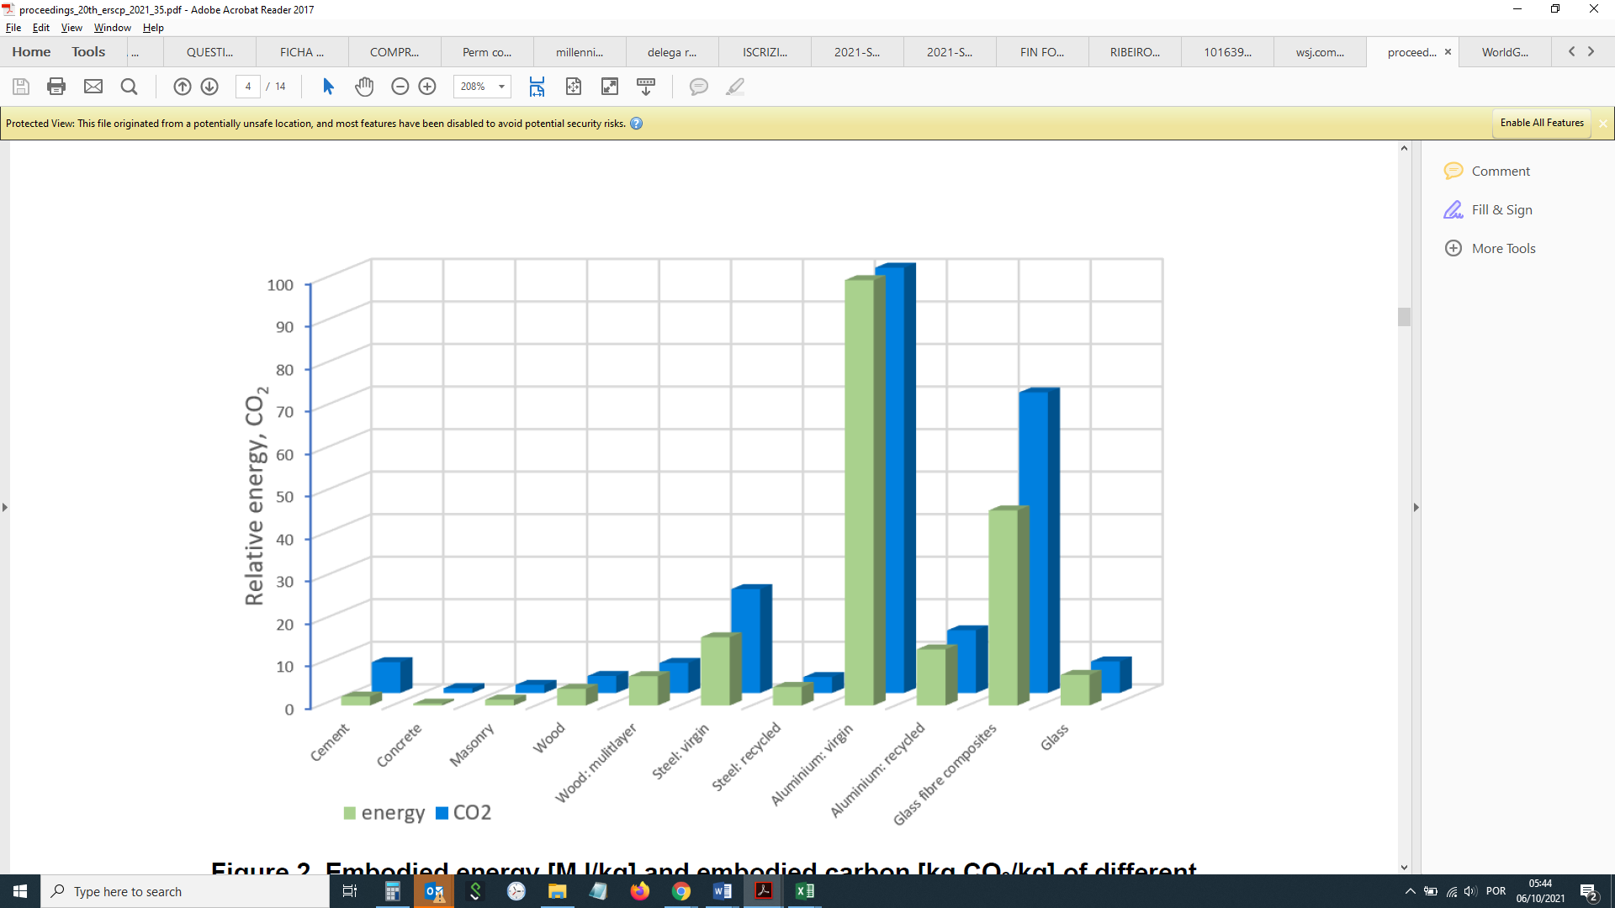

Figure 8 – Embodied energy [MJ/kg] and embodied carbon [kg CO2/kg] of   
different building materials (b-WGBC, 2019)

# 8 Socio-economic impacts

Data centres especially large hyperscale data centres have a great footprint at the place where they are implemented, in terms of both space, economic, environmental and social impact. The question is how much and to what extent DCs are implemented in the community.

Several studies have been done on the socio-economic impacts of the implementation of data centres in local communities. A thesis (b-Ipsen, 2018) examining the social and environmental impacts of the development and operation of data centres, using a Facebook data centre in Prineville, Oregon as a case study has explored what impact the technology industry has on the local social and natural environment, as well as the broader implications of data centre operations. Some of the conclusions were firstly, big data companies have tried to accommodate local concerns regarding the facilities and to integrate them within the social fabric of the communities where they are built and operated. Consequently, in the short-term, they appear to have little or no impact on the social life of the local citizens. Secondly, the environmental impacts of data centres are difficult to determine at a global scale. While big data companies invest in 'green' energy they share little information about their waste disposal and recycling, and the amount of space these buildings require is growing.

Based on the first chapter of this work, data centres appear heroic and almost entirely beneficial to community life, especially to small rural towns. There are cases in the United States that show that the presence of data centres from Facebook or Apple have lifted the socio-economic conditions of the rural communities where they were installed.

Even if it may be evident that the presence of data centres can be beneficial for the communities, this is usually a matter of short-term with the manpower being used mainly in the construction phase, via subcontracting local companies, the truth is DCs do not give the same consistency of work that traditional first sector jobs can provide. For the operations part, traditionally, companies tend to hire highly qualified professionals that come to the site to work and who do not come from the actual place of installation.

In a study conducted by Oxford economics, commissioned by Google (b-Oxford Economics, 2018), it is affirmed that Google data centres provide important local spillover effects to their host communities. Within a few years of a data centre opening most communities experienced employment gains (beyond those at the data centre itself) or increases in the number of college-educated residents. According to this research each of these benefits was spurred by Google's decision to locate a data centre in that community. Moreover, it is likely that these benefits persist and continue to grow beyond the first few years of the data centre's opening.

Using a regression framework, counties hosting a Google data centre were found to have experienced more job growth than the matched control counties. The impact began approximately one to two years prior to the opening of a data centre (presumably due to site acquisition, construction, and related activities) and continued throughout the tested period (three years beyond the opening date). Also, Google's commitment to long-term renewable energy seems to have spurred economic gains in addition to the environmental benefits that have resulted from the program. Specifically, because of Google's clean energy commitment, $2.1 billion was invested in eight new renewable energy projects. The construction of these projects created more than 2 800 (temporary) construction jobs.

A CBRE's data centre solutions group produced a 'white paper' (b-CBRE, 2021) that evaluated the overall cost of leasing a one MW data centre throughout the U.S. and the relation between the jobs and the capital investment. The paper also declared that data centres tend to be relatively low on employment. Typical headquarters, manufacturing, or shared service operations can have between 200 and 1 000 jobs onsite. By comparison the number of jobs at a typical data centre can be anywhere between five and thirty. Nevertheless, it was indicated that capital investment is another driver of tax revenue growth for the communities. While low on employment, data centres are highly capital-intensive. Capital investment in a data centre could be around $50 million on the low end and up to $1 billion on the high end depending on the type of facility. This investment comes in the form of the construction of a new building, purchases of computer servers and ultimately consumption of electricity, to name a few. Some of the ways a state and community make money from a data centre's capital investment may be through sales taxes on construction materials, sales/use taxes on equipment purchases, sales taxes or franchise fees on power consumption, personal income taxes from construction and permanent jobs, local income taxes from construction and permanent jobs or real estate taxes on a newly constructed or renovated building.

In another report on the economic impact of a hyperscale data centre establishment in Norway (b-Menon Economics, 2017), it states that in the public debate, it is often claimed that data centres contribute with a relatively small economic impact and that this economic impact only occurs in IT-related industries, to then rebate that this understanding does not take into consideration the investment and construction phase, and more importantly, effects for the broader supply chain and the catalytic effects resulting from a data centre establishment. The report estimates the effects of a potential hyperscale data centre that is expected to be built in three stages over a period of ten years, where operations will start gradually once the individual steps have been completed. They have estimated that a data centre will contribute to national employment with more than 6 800 full-time workers over a 12-year analysis period, and more than 450 full-time workers in the following years when the data centre is in full operation. In addition, an economic impact of more than NOK 5.2 billion could be linked to the data centre establishment over the period of analysis, with approximately NOK 320 million in annual economic impact thereafter (b-Menon Economics, 2017).

# 9 Energy and sustainability measurement indicators available for DCs and cloud computing

This chapter aims to identify the different indicators available for the environmental impact assessment of data centres and cloud computing

The search for increased efficiency is one that is always present in the mind of DC developers and operators. Overall, it comes down to a matter of reducing operating costs. For these efficiency improvements to occur, it requires measuring and monitoring a set of key performance indicators that allow these agents to act upon the information collected.

As pointed out in (b-Reddy, 2017) the green grid consortium proposed the power usage effectiveness (PUE), currently the prevailing metric, which was published in 2016 as a global standard under ISO/IEC 30134-2:2016. The green grid consortium also proposed the partial power usage effectiveness (pPUE), based on the PUE and the data centre infrastructure efficiency (DCiE) which measures the efficiency of data centres by relating power consumption to the IT equipment. PUE and DCiE help data centre operators know the efficiency of the data centre where pPUE measures the energy efficiency of a zone in a data centre. The consortium also proposed metrics such as carbon usage effectiveness (CUE), water usage effectiveness (WUE) and electronics disposal efficiency (EDE) to measure the CO2 footprint, the water consumption per year, and the disposal efficiency of the data centres respectively (b-Reddy, 2017).

Power usage effectiveness (PUE)

Introduced by the green grid in 2007 and adopted by the industry as the standard choice, the PUE is intended to help operators understand a data centre's efficiency and reduce energy consumption. It is defined as the ratio of total data centre input power to the power used by the IT equipment.

**PUE = Total facility power / IT equipment power**

The higher the PUE value is the lower the efficiency of the facility as more "overhead" energy is consumed for powering the electrical load. The ideal PUE value is one which indicates the maximum attainable efficiency with no overhead energy. This is not attainable at present due to the consumption of electricity by UPS, fans, pumps, transformers, lighting and other auxiliary equipment in addition to the consuming IT load. The PUE is defined in the international standard ISO/IEC 30134-2:2016.

Below, a table prepared by (b-Reddy, 2017) is presented outlining an overview of the energy efficiency metrics. The unit of each metric is listed, including the objective, optimal value and the category to which it belongs.

Figure 9 illustrates energy efficiency metrics.

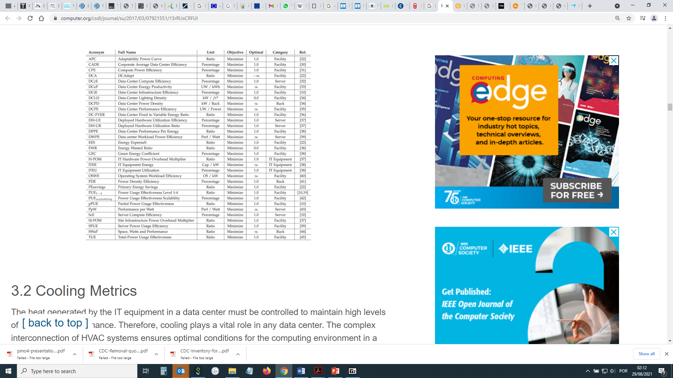

Figure 9 – Energy efficiency metrics overview (b-Reddy, 2017)

The same author proposes other environmental key performance indicators beyond energy efficiency, including water usage effectiveness or carbon efficiency.

Figure 10 illustrates green metrics.

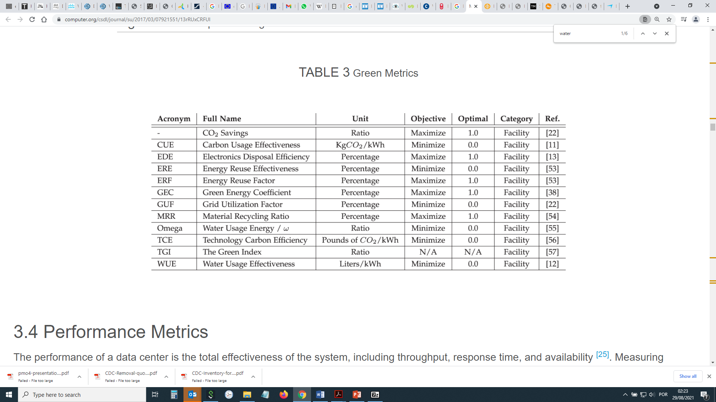

Figure 10 – Green metrics (b-Reddy, 2017)[2]

Non-DC specific environmental and sustainability standards

Other than the previous outlined specific DC KPI's there are further international standards that DC operators can also implement, giving them the tools to construct and operate the DC in an efficient and environmental sound way.

**ANSI/BICSI 002-2019**, Data centre design and implementation best practices covers all major systems found within a data centre. This standard not only lists what a data centre requires, but also provides ample recommendations on the best methods of implementing a design to fulfill the specific needs.

Data centre certification according to **EN 50600** is the first European-wide, transnational standard that provides comprehensive specifications for the planning, construction and operation of a data centre with a holistic approach. It defines requirements in the criteria aspect construction, power supply, air conditioning, cabling, security systems and specifies criteria for the operation of data centres. Part 4 of the standard relates directly with the environmental control.

**ISO 9000 – Quality System**. The ISO 9000 family of quality management systems is a set of standards that helps organizations ensure they meet customer and other stakeholder needs within statutory and regulatory requirements related to a product or service.

**ITU-T standard L.1400**, is the family of Recommendations, developed by ITU that outlines an overview and general principles of methodologies for assessing the environmental impact of information and communication technologies. Below this family, the following recommendations have been outlined: **L.1410** Methodology for environmental life cycle assessments of information and communication technology goods, networks and services; **L.1420** Methodology for energy consumption and greenhouse gas emissions impact assessment of information and communication technologies in organizations; **L.1430** Methodology for assessment of the environmental impact of information and communication technology greenhouse gas and energy projects; **L.1440** Methodology for environmental impact assessment of information and communication technologies at city level; **L.1450** Methodologies for the assessment of the environmental impact of the information and communication technology sector.

**ISO 14001** sets out the criteria for an environmental management system and can be certified to. It maps out a framework that a company or organization can follow to set up an effective environmental management system. Designed for any type of organization, regardless of its activity or sector, it can provide assurance to company management and employees as well as external stakeholders that environmental impact is being measured and improved.

**ISO 50001** is based on the management system model of continual improvement also used for other well-known standards such as ISO 9001 or ISO 14001. ISO 50001 provides a framework of requirements for organizations to develop a policy for more efficient use of energy, fix targets and objectives to meet the policy, use data to better understand and make decisions about energy use, measure the results, review how well the policy works, and continually improve energy management.

The family of **ISO/IEC 30134** Information technology standards for data centres regarding key performance indicators is another noteworthy standard, with sub-standard relating with different KPIs.

− ISO/IEC 30134-1:2016 Part 1: Overview and general requirements

− ISO/IEC 30134-2:2016 Part 2: Power usage effectiveness (PUE)[3]

− ISO/IEC 30134-3:2016 Part 3: Renewable energy factor (REF)

− ISO/IEC 30134-4:2017 Part 4: IT Equipment Energy Efficiency for servers (ITEEsv)

− ISO/IEC 30134-5:2017 Part 5: IT Equipment Utilization for servers (ITEUsv)

− ISO/IEC 30134-6:2021 Part 6: Energy Reuse Factor (ERF)

− ISO/IEC AWI 30134-7: Part 7: Cooling Efficiency Ratio (CER)

− ISO/IEC FDIS 30134-8: Part 8: Carbon Usage Effectiveness (CUE)

− ISO/IEC FDIS 30134-9: Part 9: Water Usage Effectiveness (WUE)

A different type of sustainability standards for data centres relates with voluntary construction schemes like the ones from the building research establishment (BRE) that certifies buildings under the building research establishment's environmental assessment method (BREEAM) scheme, or its American counterpart from the US green building council that certifies buildings under the leadership in energy and environmental design (LEED) certification scheme.

BREEAM (2021) sustainability assessment method is used for [masterplan](https://breeam.com/discover/technical-standards/communities/) projects, [infrastructure](https://breeam.com/discover/technical-standards/infrastructure/) and [buildings](https://www.breeam.com/discover/technical-standards/). It recognises and reflects the value in higher performing assets across the built environment lifecycle, from [new construction](https://breeam.com/discover/technical-standards/newconstruction/) to [in-use](https://breeam.com/discover/technical-standards/breeam-in-use/) and [refurbishment](https://breeam.com/discover/technical-standards/refurbishment-and-fit-out/).

BREEAM have produced two new annex documents which must be used in conjunction with the BREEAM international new construction 2016 manual for all data centre assessments. [Annex 1](https://www.breeam.com/wp-content/uploads/sites/3/2019/11/SD233-Annex-1-Data-Centre-Revised-Issues.pdf) includes background information and revised issues which completely replaces issues in the BREEAM NC 2016 manual. [Annex 2](https://www.breeam.com/wp-content/uploads/sites/3/2019/11/SD233-Annex-2-Data-Centre-Criteria-Annex.pdf) gives an overview of all changes to the technical criteria in BREEAM NC 2016.

LEED building design and construction: data centres (b-USGBC, 2021)

This rating system is specifically designed and equipped to meet the needs of high-density computing equipment such as server racks, used for data storage and processing. A typical building is designed to meet heating and cooling needs for occupant comfort whereas a data centre must provide massive cooling power for its servers. LEED BD+C: Data centres addresses the unique needs of these energy-intense buildings to improve efficiency.

Finally, the **EU code of conduct for data centres** (b-JRC, 2021), also a voluntary scheme, was established in response to increasing energy consumption in data centres and the need to reduce the related environmental, economic and energy supply security impacts. The aim of the code of conduct is to inform and stimulate data centre operators and owners to reduce energy consumption in a cost-effective manner without hampering the mission critical function of data centres. The code of conduct aims to achieve this by improving understanding of energy demand within the data centre, raising awareness and recommending energy efficient best practices and targets. This code of conduct is a voluntary initiative aimed to bring interested stakeholders together including the coordination of other similar activities by manufacturers, vendors, consultants and utilities. The code of conduct identifies and focuses on key issues and agreed solutions described in the best practices document.

# 10 Sustainable development goals and data centres

From the 2015 launch of the sustainable development goals (SDGs) with the presentation of the 17 goals, one cannot pass the potential influence that DCs can have on the local environment and social layers where this type of infrastructure is installed. The impacts that DCs can have in their lifecycle can be either negative or positive. Outlined below is a description of DCs and their **direct** impact on the applicable SDGs.

Figure 11 illustrates the 17 sustainable development goals.



Figure 11 – UN sustainable development goals (United Nations)[4]

## 10.1 Goal 6 – Clean water and sanitation: Ensure availability and sustainable management of water and sanitation for all

With billions of people still lacking access to safe drinking water, sanitation and hygiene and with 2.3 billion people living in water-stressed countries, water management is a critical issue that needs to be considered in all stages of the lifetime of a data centre. As seen before, due to a highly energy intensive and heat generating industry, the issue of the availability and sustainable management of water is of upmost importance.

There are two issues relating with the consumption and availability of water in DC management. Firstly, data centres are ideally located in areas near to the final data consumers. This may happen in water scarce, drought-prone areas where DCs may be competing with the population for the access of water coming from aquifers and surface sources. Like power plants, data centres in their servers' corridors use millions of litres of water for cooling as an alternative for electricity intensive mechanical chillers.

A way for DC operators to be on top of their water consumption is, as seen before, via the indicator on water usage effectiveness that aids the DC administration to realize the impact that their DC is having in this environmental aspect.

Lately, some companies like Google, have realized that the water being used for the cooling systems is not required to be a clean drinkable source, thus setting up systems with local water and sewage treatment organisations in order to set up systems to use grey water, to be reused for evaporative cooling.

Increasing the temperature of the DC and the server corridors, seal the data centre to minimize imbalances between the humidity and temperature. Raising the humidity of the DC or reusing rainwater are other best practices that can be applied in DCs, thereby reducing the cooling needs and consequent water consumption.

The usage of non-potable water is another way that can be looked into and is currently being used by several DC operators for the cooling of their facilities.

Related targets: 6.1, 6.3, 6.4, 6.5.

## 10.2 Goal 7 – Affordable and clean energy – Ensure access to affordable, reliable, sustainable and modern energy for all

Goal 7 is probably the most relevant SDG in what concerns its relationship with the operation of data centres. As outlined before, DCs are highly intensive structures that despite becoming more efficient, it is at the same time, trying to cope with the demand of the ICT world in need for data processing and storage.

The information and communication technologies and data centres more specifically can relate to energy efficiency and the use of renewable energy in two ways. One is the greening of data centres where DCs are being transformed to cause lesser impact to the environment. The other is the use of ICT and DCs into making sure that the technologies are being used into developing new solutions like the optimization of smart grids, smart buildings or by participating actively in the energy market via power purchase agreements (PPA) or producing a renewable energy onsite.

The use of renewables with the installation of PV onsite or by way of power purchase agreements of solar and wind power is in full speed and the industry is adopting these practices to be implemented especially in large, energy intensive DCs from bigger internet and cloud service players.

Related targets: 7.2, 7.3.

## 10.3 Goal 9 – Industry, innovation and infrastructure

The SDG 9 aims to "Build resilient infrastructure, promote inclusive and sustainable industrialization and foster innovation" and specifically target 9c, access to ICTs and affordable internet access are seen as enabling this goal. This target that aimed to significantly increase access to information and communications technology and strive to provide universal and affordable access of the internet in least developed countries by 2020 is directly connected with the accessibility of reliable data connections to the population and DCs playing a very important role in this. But not only this, with the advent of Industry 4.0, ICT, and consequently DCs, all this play an important role in fostering innovation and making the industry more efficient and therefore more sustainable. With the result of the covid-19 crisis and global manufacturing decreasing, the increase of investment in R&D is essential in finding solutions for such crisis and increasing the resilience of society.

Related targets: 9.1, 9.2, 9.4. 9.5.

## 10.4 Goal 11 – Sustainable cities and communities

Goal 11 has the objective of making cities and human settlements inclusive, safe, resilient, and sustainable. When one thinks about cities and ICTs, smart cities is a subject that comes into play immediately and in fact a city can be 'smart' only if it is sustainable.

The Internet of things, which will allow for smart cities to be powered by millions of connected devices and objects and the coordination of interoperable technologies is a space where data centres, and especially edge data centres will play a very important part. With edge DCs being smaller facilities located close to the populations they serve; they deliver cloud computing resources and cached content to end users. With this proximity and overall roll-out of smartphone technologies, ICT and DCs will be able to make cities more safe, resilient and sustainable.

This proximity will also be able to act upon other issues like disaster risk reduction and the ability for cities to act on the needed adaptation for climate change, awareness for air quality, municipal waste management or the use of public spaces like the green areas. The same can be said for sustainable transport and the use of public transport. The easiness and quickness of IoT technologies will ultimately be able to aid in the use of public transport for all urban populations.

Related targets: 11.2, 11.3, 11.5, 11.6.

## 10.5 Goal 12 – Responsible consumption and production

In 2019, the amount of e-waste generated was 7.3 kg per capita, with only 1.7 kg per capita documented to be managed in an environmentally sustainable manner. E-waste generation is expected to grow by 0.16 kg per capita annually to reach 9 kg per capita in 2030. The annual rate of growth in e-waste recycling over the past decade was 0.05 kg per capita, which will need to increase more than tenfold if all the e-waste is to be recycled by 2030 (b-Spaun, 2021).

ICT and responsible consumption and production are linked in a way of the increase of dematerialization and virtualization of products and services and via the innovative ICT applications that may enable sustainable production and consumption. The use of cloud computing, demand response and smart grids thanks to smart meters are several ways that can help individuals and companies reduce their consumption and allow energy companies to reduce their energy production. Nevertheless, these uses come with a price via the negative impacts of using such technologies which are energy consuming and may even face a rebound effect with the change in people's behaviours. Other negative impacts may be, for example, the increased production of e-waste, which should be considered and accounted for.

Related targets: 12.1, 12.2, 12.4, 12.5, 12.6, 12.a.

## 10.6 Goal 13 – Climate action

Goal 13, climate action outlines for the taking of urgent action to combat climate change and its impacts. This goal aims for the strengthening of resilience and adaptive capacity to climate related hazards, the integration of climate change measures into national and local strategies and planning, the improvement of education and finally creating awareness among human and institutional capacity for tackling climate change.

With data centres being a very highly intensive industry, goal 13, is one of the most important SDG goals. The definition of climate strategies in the DC industry in general and individual structures is crucial, both for the environment where DCs are installed but also in terms of cost-effectiveness. This has been especially important in the last years with bitcoin mining representing a great amount of energy consumption with little concern for energy efficiency other than the location of these servers being in cold desert areas. For this there is a need for the implementation of mitigation measures in all DCs which will ultimately result in the reduction of costs for the DC operators, independently of their goal.

The positive impact of ICT and DCs on climate change is the potential of data processing that can help science to act upon the information collected by satellites or sensors.

The implementation of voluntary schemes for the improvement of the efficiency of data centres may be one way of mitigating the impacts of the operation of DCs, along with traditional legislative diplomas in place for energy intensive companies.

Related targets: 13.1, 13.2, 13.3.

## 10.7 Goal 14 – Life below water

Goal 14 – Life below water, relates to a specific byproduct of data centres which is the rejected water used for cooling in the water-cooled data centres. This has a more significant impact with hyperscale DCs located near lakes, rivers or even the sea, where the wastewater that has passed through the cooling system is then sent back to the environment. This operation comes of course with the cost of having the cooling water being heated to temperatures higher than the ones present in the natural environment. This can ultimately cause some nuisance to the fauna and flora in the region.

Due to this it is of special importance that the water being used for cooling and the rejected water passes through a buffer system to cool the water down to the surrounding environmental temperature. This is done so that life below water remains unaffected thereby minimizing the impact of the installation of such cooling systems.

Another best practice that can minimize the impact of using water for the cooling of DCs is using non-potable water i.e., wastewater or actual seawater. This significantly reduces the use of water, with water being a natural resource, especially in drought-prone areas.

Related targets: 14.1, 14.2.

## 10.8 Goal 15 – Life on land

Together with the previous goal (SDG 14), goal 15 also connects with data centres in the way of the impact that the DC has on the site where it is implemented. When talking about large data centres, the amount of the area and the environmental impact in terms of landscape and the consumption of natural resources may be of significance. SDG 14 aims to protect, restore and promote sustainable use of terrestrial ecosystems, sustainably manage forests, combat desertification, halt and reverse land degradation and halt biodiversity loss. DC operators should use their best judgment when choosing a DC site, aiming to minimize most of the environmental impact of such an implantation.

Ideally DCs should be installed in brownfield sites and impermeable areas where operators can then remediate the plot when the lifetime of the DC ends, instead of greenfield sites, where the environmental impacts may be higher in terms of biodiversity and the impermeabilization of the land thus potentiating water evaporation and the desertification.

As a good practice and due to the size of the implementation, hyperscale DCs are subject to the execution of an environmental declaration and an environmental impact assessment study prior to the approval and construction of a DC. This way, both the authorities and the DC operators can assess and minimize the potential impacts of all the stages of the lifecycle of a DC, in terms of the conservation of nearby habitats or to combat desertification.

# 11 Analysis of policies that facilitate the development of environmentally efficient data centre and cloud in support of the achievement of the Paris agreement and the UN SDGs

The Paris agreement and the sustainable development goals path is through a global movement and is achievable via actions performed by individuals in their daily and work life, by organizations and every actor living in modern society. This may be achieved by daily actions or voluntary schemes and agreements by some of the interested parties in a given ecosystem living near one of the data centres, but ultimately these efforts need an institutional push and leverage in order to drum up efforts from all parties.

This is where public policies are introduced regionally or at a multi country level. Given below are some of the public policies that (also) aim to promote and facilitate the development of environmentally efficient data centres.

• **Paris agreement** (b-UNFCCC, 2021)

The Paris agreement speaks of the vision of **fully realizing both technology development and transfer** for improving resilience to climate change and reducing GHG emissions. It establishes **a technology framework** to provide overarching guidance to the well-functioning technology mechanism. This mechanism means to accelerate technology development and transfer through its policy and implementation arms.

The Paris agreement is overall the main political instrument that puts the scientific society, the public sector and the private companies to seriously discuss about the long-term objectives with regard to climate change and to reach near-carbon neutrality.

• **European green deal** (b-European Commission, 2021)

The European Commission proposes the transformation of the EU economy and society to meet climate ambitions. The European Commission adopted a set of proposals to make the EU's climate, energy, transport and taxation policies fit for reducing net greenhouse gas emissions by at least 55% by 2030, compared to levels in 1990. Achieving these emission reductions in the next decade is crucial to Europe becoming the world's first climate-neutral continent by 2050 and making the European green deal a reality.

The benefits of the European green deal are presented as follows: Fresh air, clean water, healthy soil and biodiversity, renovated energy efficiency buildings, future-proof jobs and skills training for the transition to a globally competitive and resilient industry. Below are some of the legislative packages that fit into reaching the European green deal.

Legislative packages

• **EED** (b-European Commission, 2018)

With the European green deal, the EU is increasing its climate ambition and aims at becoming the first climate-neutral continent by 2050. The commission has therefore revised the energy efficiency directive together with other EU energy and climate rules to ensure that the new 2030 target of reducing greenhouse gas emissions by at least 55% (compared to 1990) can be met.

To meet the EU 2030 climate target energy efficiency needs to be prioritized. To step up its efforts the European Commission put forward, in July 2021, a proposal for a new directive on energy efficiency as part of the package "Delivering on the European green deal".

The proposal for the revised directive promotes 'energy efficiency first' as an overall principle of the EU energy policy and marks its importance and relevance in both its practical applications in policy and investment decisions.

The proposal raises the level of ambition of the EU energy efficiency target and makes it binding. The revised directive also requires EU countries to collectively ensure an additional reduction of energy consumption of 9% by 2030 compared to the 2020 reference scenario projections. This 9% additional effort corresponds to the 39% and 36% energy efficiency targets for primary and final energy consumption outlined in the climate target plan and is simply measured against the updated baseline projections that were made in 2020. This means that the overall EU energy consumption should be no more than 1 023 million or mega tonnes of oil equivalent (Mtoe) of primary energy and 787 Mtoe of final energy by 2030.

• **EPBD** (b-European Commission, 2021a)

The energy performance of buildings directive is the European Union's main legislative instrument aiming to promote the improvement of the energy performance of buildings within the community. It was inspired by the 'Kyoto Protocol' which commits the EU and all its parties by setting binding emission reduction targets. The building sector is crucial for achieving the EU's energy and environmental goals. At the same time, better and more energy efficient buildings improve the quality of a citizens' life while bringing additional benefits to the economy and the society.

In October 2020, the commission presented its renovation wave strategy as part of the European green deal. The strategy contains an action plan with concrete regulatory, financing and enabling measures to boost building renovation. Its objective is to at least double the annual energy renovation rate of buildings by 2030 and to foster deep renovation.

• **Renovation wave** (b-European Commission, 2020a)

To pursue the dual ambition of energy gains and economic growth, in 2020 the commission published a new strategy to boost renovation called "[A Renovation Wave for Europe – Greening our buildings, creating jobs, improving lives](https://eur-lex.europa.eu/legal-content/EN/TXT/?qid=1603122220757&uri=CELEX:52020DC0662)".

This strategy aims to double annual energy renovation rates in the next ten years. Along with reducing emissions, these renovations will enhance quality of life for people living in and using the buildings and should additionally create many green jobs in the construction sector.

• **Zero pollution action plan** (b-European Commission, 2021b)

On 12 May 2021, the European Commission adopted the EU action plan: "Towards a zero pollution for air, water and soil" (and annexes) – a key deliverable of the European green deal.

The zero-pollution vision for 2050 is for air, water and soil pollution to be reduced to levels that are no longer considered harmful to health and natural ecosystems that respect the boundaries with which our planet can cope, thereby creating a toxic-free environment.

This is translated into key 2030 targets to speed up reducing the pollution at source. These targets include:

• Improving air quality to reduce the number of premature deaths caused by air pollution by 55%;

• Improving water quality by reducing waste, plastic litter at sea (by 50%) and microplastics released into the environment (by 30%);

• Improving soil quality by reducing nutrient losses and chemical pesticides' use by 50%;

• Reducing the EU ecosystems by 25% where air pollution threatens biodiversity;

• Reducing the share of people chronically disturbed by transport noise by 30%;

• Significantly reducing waste generation and residual municipal waste by 50%.

**• Circular economy action plan** (b-European Commission, 2021c)

The EU's new circular action plan paves the way for a cleaner and a more competitive Europe.

The European Commission adopted the [new circular economy action plan (CEAP)](https://eur-lex.europa.eu/legal-content/EN/TXT/?qid=1583933814386&uri=COM:2020:98:FIN) in March 2020. It is one of the main building blocks of the [European green deal](https://ec.europa.eu/info/node/123797), Europe's new agenda for sustainable growth. The EU's transition to a circular economy will reduce pressure on natural resources and will create sustainable growth and jobs. It is also a prerequisite to achieve the EU's 2050 climate neutrality target and to halt biodiversity loss.

The new action plan announces initiatives along the entire life cycle of products. It targets how products are to be designed, promotes circular economy processes, encourages sustainable consumption, aims to ensure that waste is prevented, and the resources used are kept in the EU economy for as long as possible.

It introduces legislative and non-legislative measures targeting areas where action at the EU level brings real added value.

**• European industrial strategy** (b-European Commission, 2021d)

The EU relies on Europe's industry to lead the transition towards climate neutrality and digital leadership. The aim is for the EU industry to become an accelerator and enabler of change, innovation and growth.

In March 2019, the European Council called on the European Commission to present a long-term vision on industrial policy. The council followed up with conclusions in May 2019, presenting a vision for the European industry in 2030. The European Commission published its new industrial strategy in March 2020.

Other larger players in the global panorama have also declared their commitments for the achievement of the Paris agreements. The USA has presented a shy proposal of a green new deal, whereas the **People's Republic of** **China** has recently declared its intentions to be a carbon neutral state by 2060, while the **Republic of Korea** has vouched for carbon neutrality by 2050 as per the Paris agreement.

**Japan** has defined a new strategy named beyond zero carbon (b-METI, 2021), which aims to promote innovation and technology as the agents of change in tackling the challenges of global warming; promote green finance to support the development of innovation and new technologies and support greater international cooperation for business-led adoption of innovative green technologies.

On the other hand, **Canada** (b-Canada, 2021) has vouched for the achievement of reaching net zero emissions by 2050. The Canadian Net-Zero Emissions Accountability Act, introduced in the parliament on 19 November 2020, will formalize Canada's target to achieve net-zero emissions by the year 2050, and establish a series of interim emissions reduction targets at 5-year milestones towards that goal. It will also require a series of plans and reports to support accountability and transparency and help ensure Canada hits all of its milestones on the way to its goal in order to achieve a prosperous net-zero economy by the year 2050.

# 12 Conclusions

Being in the environmental dimension and on the other sustainability pillars, the data centre industry cannot and will not excuse itself from its responsibilities in contributing to the economic development of the ICT industry, but most importantly to the socio-economic issues of the communities where it remains inserted. It is without a doubt a highly impactful industry nevertheless remains one of the main foundations in the age of the internet or in the age of big data, contributing for the maintenance and growth of the binary world, via the Internet of things, cloud computing, data storage, artificial intelligence or machine learning.

In fact, the proof that the DC industry has not excused itself from achieving a better environmental performance is that every consecutive year the energy efficiency achieved in the last several years has always been compensating the needs of more than the required computing capacity.

The commitments like the Paris agreement and the sustainable development goals allows for having measurable, mid-long-term visions that are supported by constant monitoring via targets and indicators. For it to differentiate itself, it is of critical importance that the DC industry gets together to define a long-term vision for itself, basing it on the key performance indicators that it has in its possession. Institutional targets like carbon neutrality, zero waste, full circularity or reaching the tangent of a PUE near or to one should be the norm and not the exception.

The achievement of such sustainability goals is only possible when the subject is brought to the data centre lifecycle and learns about the DCs daily life, from the concept to design stage with the choice of using sustainable materials, to the construction phase making use of the least impactful ways of production, to the operation by implementing energy and environmental management systems, metering and sub-metering its energy flows and finally in the end-of-life when it comes to give another destination the IT products or the building itself. The implementation of voluntary schemes and standards may give an excellent perspective into managing all the lifecycles of a DC.

An issue of great importance both in the way of the functioning of a DC and the environment is the use and disposal of water used for the cooling of a DC. In a time where water is becoming scarce in some locations, DCs may be seen as increasing the water stress to the ecosystems thus the presence of water experts in a DC structure is of the essence. For this, it is of utmost importance that metrics like the water usage effectiveness work with other efficiency parameters like the PUE or the carbon usage effectiveness and all of these must be sought and managed together as well.

Meeting the highest environmental standards with the surroundings of the DC is considered essential. The use of brownfield instead of greenfield for the implementation of a DC and occasionally using the existing infrastructure is also highly recommended.

Data centres also have a role to play in the energy transition by aligning with the SDGs on sustainable and accessible renewable energy. Despite agreeing that the DC industry is highly energy intensive, it is also clear that efforts are being made by the industry (at least in hyperscale DCs) in making sure that the electricity being supplied is either coming from renewable sources or some of it is produced onsite.

Bibliography

[b-ITU-T L.1400] Recommendation ITU-T L.1400 (2011), *Overview and general principles of methodologies for assessing the environmental impact of information and communication technologies*.

[b-ITU-T L.1410] Recommendation ITU-T L.1410 (2014), *Methodology for environmental life cycle assessments of information and communication technology goods, networks and services*.

[b-ITU-T L.1420] Recommendation ITU-T L.1420 (2012), *Methodology for energy consumption and greenhouse gas emissions impact assessment of information and communication technologies in organizations*.

[b-ITU-T L.1430] Recommendation ITU-T L.1430 (2013), *Methodology for assessment of the environmental impact of information and communication technology greenhouse gas and energy projects*.

[b-ITU-T L.1440] Recommendation ITU-T L.1440 (2015), *Methodology for environmental impact assessment of information and communication technologies at city level*.

[b-ITU-T L.1450] Recommendation ITU-T L.1450 (2018), *Methodologies for the assessment of the environmental impact of the information and communication technology sector.*

[b-ITU-T Y.3500] Recommendation ITU-T Y.3500 (2014), *Information technology – Cloud computing – Overview and vocabulary*.

[b-ITU-T X.1053] Recommendation ITU-T X.1053 (2017), *Code of practice for information security controls based on ITU-T X.1051 for small and medium-sized telecommunication organizations*.

[b-EN 50600] EN 50600 *Data center certification*. https://www.tuvit.de/en/services/data-centers-colocation-cloud-infrastructures/din-en-50600/

[b-ISO 9000] ISO 9000 FAMILY *Quality Management*. https://www.iso.org/iso-9001-quality-management.html

[b-ISO 14001] ISO 14001:2015, *Environmental management systems – Requirements with guidance for use*. https://www.iso.org/standard/60857.html

[b-ISO 50001] ISO 50001, *Energy Management*. https://www.iso.org/iso-50001-energy-management.html

[b-ISO 9001] ISO 9001, *Quality management systems – Requirements*. https://www.iso.org/standard/62085.html

[b-ISO/IEC 30134-1:2016] ISO/IEC 30134-1:2016, Information technology – Data centres – Key performance indicators – Part 1: Overview and general requirements. https://www.iso.org/standard/63450.html

[b-ISO/IEC 30134-2:2016] ISO/IEC 30134-2:2016, Information technology – Data centres – Key performance indicators – Part 2: Power usage effectiveness. https://www.iso.org/standard/63451.html

[b-ISO/IEC 30134-3:2016] ISO/IEC 30134-3:2016, Information technology – Data centres – Key performance indicators – Part 3: Renewable energy factor (REF). https://www.iso.org/standard/66127.html

[b-ISO/IEC 30134-4:2017] ISO/IEC 30134-4:2017, Information technology – Data centres – Key performance indicators – Part 4: IT Equipment Energy Efficiency for servers (ITEEsv). https://www.iso.org/standard/66191.html

[b-ISO/IEC 30134-5:2017] ISO/IEC 30134-5:2017, Information technology – Data centres – Key performance indicators – Part 5: IT Equipment Utilization for servers (ITEUsv). https://www.iso.org/standard/66934.html

[b-ISO/IEC 30134-6:2021] ISO/IEC 30134-6:2021, Information technology – Data centres key performance indicators – Part 6: Energy Reuse Factor (ERF). https://www.iso.org/standard/71717.html

[b-ISO/IEC AWI 30134-7] ISO/IEC AWI 30134-7, Information technology – Data centres key performance indicators – Part 7: Cooling Efficiency Ratio (CER). https://www.iso.org/standard/80493.html

[b-ISO/IEC FDIS 30134-8] ISO/IEC FDIS 30134-8, Information technology – Data centres key performance indicators – Part 8: Carbon Usage Effectiveness (CUE). https://www.iso.org/standard/77691.html

[b-ISO/IEC FDIS 30134-9] ISO/IEC FDIS 30134-9, Information technology – Data centres key performance indicators – Part 9: Water Usage Effectiveness (WUE). https://www.iso.org/standard/77692.html

[b-ANSI/BICSI 002-2019] ANSI/BICSI 002-2019, *Data Center Design and Implementation Best Practices*. https://www.bicsi.org/standards/available-standards-store/single-purchase/ansi-bicsi-002-2019-data-center-design

[b-UNEP terms] UNEP Glossary of Life Cycle Terms. https://www.lifecycleinitiative.org/resources/life-cycle-terminology-2/

[b-ITU terms] ITU Terminology. https://www.itu.int/br_tsb_terms/

[b-Bertoldi, 2017] Bertoldi, P., Avgerinou, M., Castellazzi, L. (2017), *Trends in data centre energy consumption under the European Code of Conduct for Data Centre Energy Efficiency*, EUR 28874 EN, Publications Office of the European Union, Luxembourg, 2017, ISBN 978-92-79-76445-5, doi:10.2760/358256, JRC108354.

[b-Bertoldi, 2018] Bertoldi, P., Diluiso, F., Castellazzi, L., Labanca, N., and Ribeiro, Serrenho, T. (2018), *Energy Consumption and Energy Efficiency Trends in the EU-28 2000-2015*. EUR 29104 EN, Publications Office of the European Union, Luxembourg, 2018, ISBN 978-92-79-79372-1, doi:10.2760/6684, JRC110326. https://publications.jrc.ec.europa.eu/repository/handle/JRC110326

[b-BREEAM, 2021] BREEAM (2021), *Community of passionate influencers improving the built environment*. <https://www.breeam.com/> (Accessed in September 2021).

[b-Canada, 2021] Government of Canada – Net-Zero Emissions by 2050, <https://www.canada.ca/en/services/environment/weather/climatechange/climate-plan/net-zero-emissions-2050.html> (Accessed in September 2021).

[b-CBRE, 2021] CBRE (2021), *The Mystery Impact of Data Centres on Local Economies Revealed*. [https://www.areadevelopment.com/data-centres/Data-Centres-Q1-2015/impact-of-data-centre-development-locally-2262766.shtml](https://www.areadevelopment.com/data-centers/Data-Centers-Q1-2015/impact-of-data-center-development-locally-2262766.shtml) (Accessed in September 2021).

[b-Oxford Economics, 2018] Oxford Economics (2018), *Google data centres: economic impact and community benefits*. <https://www.oxfordeconomics.com/recent-releases/d8d830e4-6327-460e-95a5-c695a32916d9> (Accessed in September 2021).

[b-European Commission, 2018] European Commission (2018), *Energy efficiency directive*. <https://ec.europa.eu/energy/topics/energy-efficiency/targets-directive-and-rules/energy-efficiency-directive_en> (Accessed in July 2021).

[b-European Commission, 2020] European Commission (2020), *Energy-efficient Cloud Computing Technologies and Policies for an Eco-friendly Cloud Market, European Commission*. <https://digital-strategy.ec.europa.eu/en/library/energy-efficient-cloud-computing-technologies-and-policies-eco-friendly-cloud-market> (Accessed in May 2020).

[b-European Commission, 2020a] European Commission (2020), *Renovation wave*. <https://ec.europa.eu/energy/topics/energy-efficiency/energy-efficient-buildings/renovation-wave_en> (Accessed in July 2021).

[b-European Commission, 2021] European Commission (2021), *A European Green Deal*. <https://ec.europa.eu/info/strategy/priorities-2019-2024/european-green-deal_en#highlights> (Accessed in July 2021).

[b-European Commission, 2021a] European Commission (2021), *Energy performance of buildings directive.* <https://ec.europa.eu/energy/topics/energy-efficiency/energy-efficient-buildings/energy-performance-buildings-directive_en> (Accessed in July 2021).

[b-European Commission, 2021b] European Commission (2021), *Zero pollution action plan*. <https://ec.europa.eu/environment/strategy/zero-pollution-action-plan_en> (Accessed in September 2021).

[b-European Commission, 2021c] European Commission (2021), *Circular economy action plan*. <https://ec.europa.eu/environment/strategy/circular-economy-action-plan_en> (Accessed in September 2021).

[b-European Commission, 2021d] European Commission (2021), *European industrial strategy*. <https://ec.europa.eu/info/strategy/priorities-2019-2024/europe-fit-digital-age/european-industrial-strategy_en> (Accessed in September 2021).

[b-Google, 2020] Google (2020), *Google Sustainability Report, 2020*. <https://www.gstatic.com/gumdrop/sustainability/google-2020-environmental-report.pdf> (Accessed in July 2021).

[b-Hutson, 2021] Hutson, M. (2021), *The Promise of Carbon-Neutral Steel, The New Yorker, 2021*. <https://www.newyorker.com/news/annals-of-a-warming-planet/the-promise-of-carbon-neutral-steel>

[b-IEA, 2020] IEA (2020), International Energy Agency. <https://www.iea.org/reports/data-centres-and-data-transmission-networks> (Accessed in July 2021).

[b-ITU, 2020] ITU (2020), INTERNET WASTE A thought paper for International E-Waste Day 2020, International Telecommunication Union and the WEEE Forum, 2020, ISBN Electronic version: 978-92-61-32491-9.

[b-Ipsen, 2018] Ipsen, Heather, (2018), "*Catching the Cloud and Pinning It Down: the Social and Environmental Impacts of Data Centres*". Theses – ALL. 211. <https://surface.syr.edu/thesis/211>.

[b-JRC, 2015] European Commission, Joint Research Centre (2015), *Environmental Footprint and Material Efficiency Support for product policy*. <https://publications.jrc.ec.europa.eu/repository/bitstream/JRC96944/lb-na-27467-en-n%20.pdf> (Accessed in May 2021).

[b-JRC, 2021] European Commission, Joint Research Centre (2021), *Code of Conduct for Data Centres Energy Efficiency*. <https://e3p.jrc.ec.europa.eu/communities/data-centres-code-conduct> (Accessed in May 2021).

[b-Masanet, 2020] Masanet, E. et al., (2020). *Recalibrating global data centre energy-use estimates.* Science, 367(6481), 984-986. <https://doi.org/10.1126/science.aba3758>

[b-Menon Economics, 2017] MENON-PUBLICATION NR. 39/2017 Leo Grünfeld, Caroline Wang Gierløff og Lars Stemland Eide, *Economic impact of a hyperscale data centre establishment in Norway, 2017*. <https://www.statkraftdatacentersites.com/globalassets/9-statkraft-datacentres/documents/menon_economic-impact-report_english.pdf> (Accessed in October 2021).

[b-METI, 2021] Ministry of Economy, Trade and Industry – *Japan's Roadmap to "Beyond-Zero" Carbon*. <https://www.meti.go.jp/english/policy/energy_environment/global_warming/roadmap/index.html> (Accessed in September 2021).

[b-Mytton, 2021] Mytton, D. (2021), *Data centre water consumption*. npj | Clean Water 4, 11. <https://doi.org/10.1038/s41545-021-00101-w>

[b-Nortek, 2020] Nortek data center (2020), *Waste Heat Utilization is the Data Center Industry's Next Step Toward Net-Zero Energy*. [https://www.nortekdatacentre.com/waste-heat-utilization-is-the-data-centre-industrys-next-step-toward-net-zero-energy/](https://www.nortekdatacenter.com/waste-heat-utilization-is-the-data-center-industrys-next-step-toward-net-zero-energy/) (Accessed in September 2021.

[b-Reddy, 2017] Reddy, V., Setz, B., Rao, G., Gangadharan, G., and Aiello, M. (2017). "*Metrics for Sustainable Data Centres*" in IEEE Transactions on Sustainable Computing, vol. 2, no. 03, pp. 290-303, 2017.doi: 10.1109/TSUSC.2017.2701883

[b-Schneider Electric, 2017] Schneider Electric, White Paper 59 (2017), *The Different Technologies for Cooling Data Centres*. <https://download.schneider-electric.com/files?p_Doc_Ref=SPD_VAVR-5UDTU5_EN> (Accessed in September 2021).

[b-Sean Ratka, 2020] Energy Post (2020), *The nexus between data centres, efficiency and renewables: a role model for the energy transition*. <https://energypost.eu/the-nexus-between-data-centres-efficiency-and-renewables-a-role-model-for-the-energy-transition/> (Accessed in July 2021).

[b-Spaun, 2021] Sebastian S., et al., (2021), *A Path towards Climate neutral Production of Cement in Austria via a new Circular Economy.* Proceedings of the 20th European Roundtable on Sustainable Consumption and production. DOI: 10.3217/978-3-85125-842-4-24. https://diglib.tugraz.at/download.php?id=612dfa88c5513&location=browse

[b-UN, 2015] United Nations sustainable development goals, <https://sdgs.un.org/goals> (Accessed in January 2021).

[b-UNEP DTU, 2020] Environmental sustainability of data centres: A need for a multi-impact and life cycle approach, UNEP DTU, C2E2. <https://c2e2.unepdtu.org/kms_object/environmental-sustainability-of-data-centres-a-need-for-a-multi-impact-and-life-cycle-approach/>

[b-UNEP DTU, 2020a] Data Centres: Digitalisation Powerhouse and Energy Efficiency Potential, UNEP DTU, C2E2. <https://c2e2.unepdtu.org/kms_object/data-centres-digitalisation-powerhouse-and-energy-efficiency-potential/>

[b-UNFCCC, 2021] The Paris Agreement. <https://unfccc.int/process-and-meetings/the-paris-agreement/the-paris-agreement> (Accessed in July 2021).

[b-UNU/UNITAR, 2020] Forti, V., Baldé C., P., Kuehr, R., Bel, G. (2020), *The Global E-waste Monitor 2020: Quantities, flows and the circular economy potential*. United Nations University (UNU)/United Nations Institute for Training and Research (UNITAR) – co-hosted SCYCLE Programme, International Telecommunication Union (ITU) & International Solid Waste Association (ISWA), Bonn/Geneva/Rotterdam.

[b-USGBC, 2021] USGBC (2021), Building Design and Construction: Data Centers. <https://www.usgbc.org/discoverleed/certification/bd-c-data-centers/>, (Accessed in September 2021).

[b-WGBC, 2019] World Green Building Council, 2019, Bringing embodied carbon upfront: Coordinated action for the building and construction sector to tackle embodied carbon. <https://www.worldgbc.org/sites/default/files/WorldGBC_Bringing_Embodied_Carbon_Upfron.pdf>, (Accessed in October 2021).

______________

1. Based on data from Peiró & Ardente, at [https://publications.jrc.ec.europa.eu/repository/bitstream/  
   JRC96944/lb-na-27467-en-n%20.pdf](https://publications.jrc.ec.europa.eu/repository/bitstream/JRC96944/lb-na-27467-en-n%20.pdf)
2. Further information on the calculation of the KPIs can be found in the Appendix A of (b-Reddy, 2017).
3. See: [Power usage effectiveness – Wikipedia](https://en.wikipedia.org/wiki/Power_usage_effectiveness)
4. See: [Home | Sustainable Development (un.org)](https://sdgs.un.org/)