 | International telecommunication union  Telecommunication Standardization Bureau
 |  | Geneva, 11 May 2026
Ref: | TSB Circular 136  SG2/MCB | To:  - Administrations of Member States of the Union;  - State of Palestine (Res.99 (Rev. Dubai, 2018))  Copy to:  - ITU-T Sector Members;  - ITU-T Associates of Study Group 2;  - ITU Academia;  - The Chair and Vice-Chairs of ITU-T Study Group 2;  - The Director of the Telecommunication  Development Bureau;  - The Director of the Radiocommunication Bureau
Tel: | +41 22 730 5901
Fax:  E-mail: | +41 22 730 5853  tsbsg2@itu.int
Subject: | Issuer Identifier Number (IIN) Notification
Dear Sir/Madam,
1 ITU-T Study Group 2 (Operational aspects of telecommunications and ICTs) has approved a revision to Recommendation ITU-T E.118, Numbering resources for Cards to identify accounts for charging telecommunication services in which the Issuer Identifier Number (IIN), once assigned, no longer needs to be registered with the International Telecommunication Union (ITU). Only a notification is required. The IIN is a part of the primary account number (PAN) which has a total length of 19 characters. The IIN follows the Major Industry Identifier (MII) “89” for telecommunications purposes, followed by the E.164 Country Code. The structure is as follows:
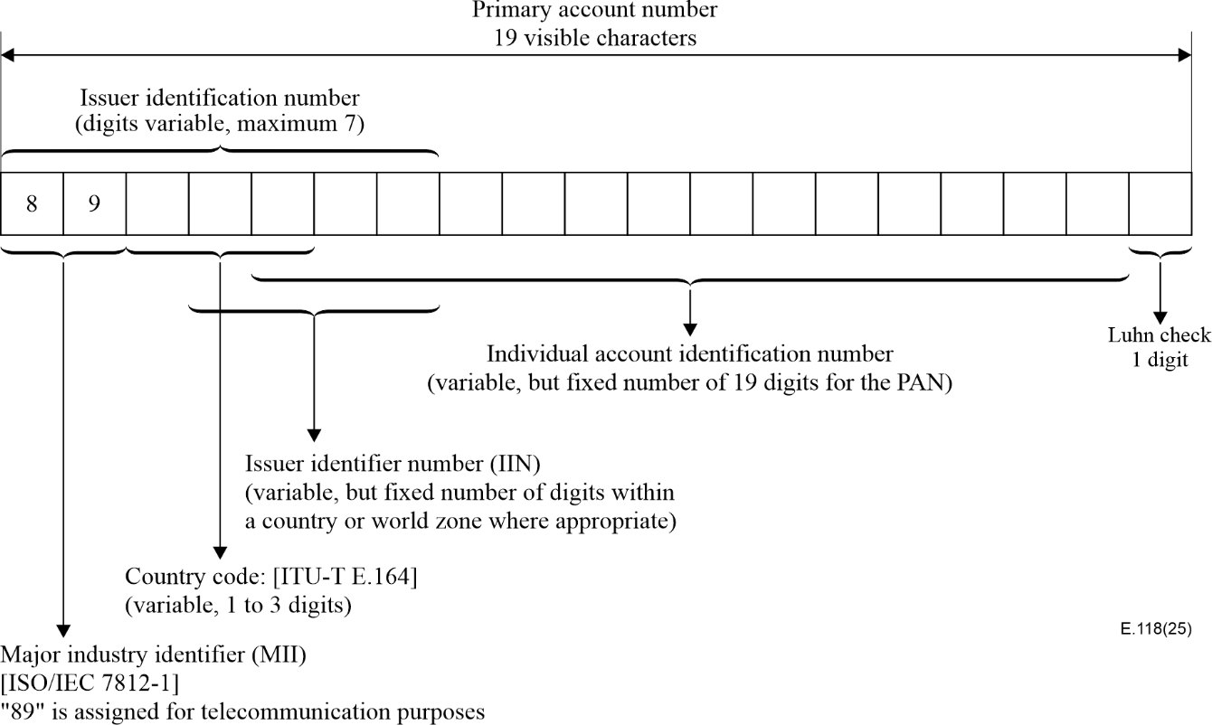

2 In addition to this change, Administrations may now allow sub-assignments as a matter of national policy. If sub-assignments are permitted, the numbering structure will be as follows:
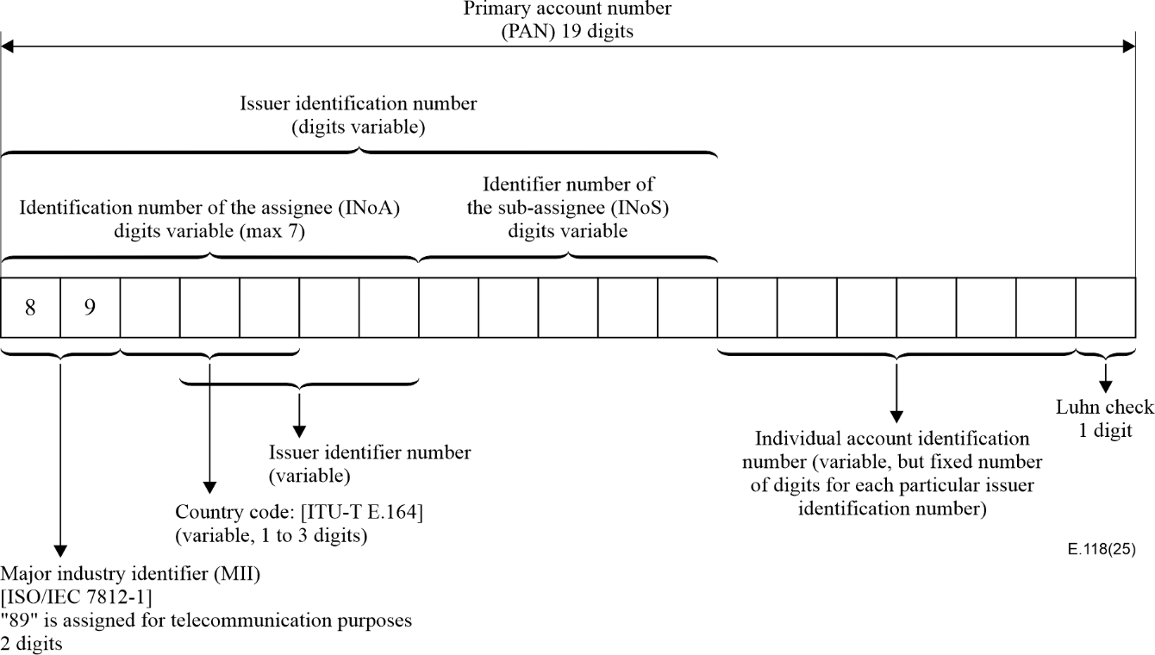

3 The IIN is described as the identification number for the entity that charges the clients.
The IIN – identifies the issuer in case of no sub-assignment and, in any case, it identifies the assignee in the country which is identified by the Country Code (CC). Together with the MII and the CC it shall have a variable number of digits with a maximum of 7. The MII “89” is assigned by ISO/IEC to ITU-T for telecommunication purposes in accordance with ISO/IEC 7812-1. The CC’s length and may consist of 1 to 3 digits in accordance with Rec. ITU-T E.164.
The Identifier Number of the Sub-assignee (INoS), in countries where the Administration permits sub-assignments, identifies the sub-assignee of an assignee identified by the Identification Number of the Assignee (INoA). This field may also be used by the Administration for the assignment of smaller blocks of numbering resources.
For charge cards, issuers may incorporate an additional validation mechanism on the card in addition to the parity check digit computed according to the Luhn formula (see ISO/IEC 7812-1, Annex B). The validation feature may be modified when new cards are issued.
4 The list of assigned IINs is maintained by the ITU-TSB. As per point 6 of Recommendation ITU-T E.118, assigned E.118 resources will be reported by Administrations and regularly published by TSB on the International Numbering Resources page of the ITU Website (please refer to the Operational Bulletin).
5 At its 2026 session, ITU Council decided to abrogate Decision 601, as a result no fees will be collected by ITU as from 11 May 2026 (inclusive) for notification of any assigned E.118 resources.

6 For further information on IIN, please see: http://www.itu.int/en/ITU-T/inr/forms/Pages/iin.aspx.
7 Please address your comments to:
Operational Bulletin and Numbering Administration
International Telecommunication Union
Telecommunication Standardization Bureau
Place des Nations CH - 1211 GENEVA 20, Switzerland
Tel: +41 22 730 5211
Fax: +41 22 730 5853
E-mail: tsbtson@itu.int
Yours faithfully,

(signed)

Seizo Onoe
Director of the Telecommunication
Standardization Bureau

