 |  | International telecommunication union  Telecommunication Standardization Bureau
 |  |  | Geneva, 5 March 2026
Ref: | TSB Circular 121  CB |  | To:  - To Administrations of Member States of the Union;  - The State of Palestine (Res. 99 (Rev. Dubai, 2018));  - To ITU-T Sector Members;  - To ITU-T Associates;  - To ITU Academia;  - To Permanent Missions and Embassies in Geneva;  - To Relevant international, regional and national organisations;  - To Intergovernmental organizations operating satellite systems;  - To the United Nations;  - To Specialized agencies of the United Nations and the International Atomic Energy Agency  Copy:  - To the chairs and vice-chairs of ITU-T study groups;  - To the Director of the Telecommunication Development Bureau;  - To the Director of the Radiocommunication Bureau
Contact:  Tel:  Fax:  E-mail: | Cristina Bueti  +41 22 730 6301  +41 22 730 5853  virtualworlds@itu.int
Subject: | 3rd UN Virtual Worlds Day: AI, Spatial Intelligence, and the Citiverse:  Shaping Trusted Digital Futures  (Geneva, Switzerland, 11-12 May 2026)
Dear Sir/Madam,
1 The International Telecommunication Union (ITU), on behalf of the Food and Agriculture Organization of the United Nations (FAO), the International Training Centre of the International Labour Organization (ITCILO), the United Nations Development Programme (UNDP), the United Nations Economic Commission for Africa (UNECA), the United Nations Economic Commission for Europe (UNECE), the United Nations Economic Commission for Latin America and the Caribbean (UNECLAC), the United Nations Guatemala, the United Nations Human Settlements Programme (UN-Habitat), the United Nations Joint Staff Pension Fund (UNJSPF), the United Nations International Computing Centre (UNICC), UN Innovation Network, the United Nations Children’s Fund (UNICEF), UN Tourism, the United Nations Research Institute for Social Development (UNRISD), the United Nations University (UNU), the UN Futures Lab, the World Intellectual Property Organization (WIPO), the World Bank, and World Meteorological Organization (WMO), would like to invite you to the 3rd UN Virtual Worlds Day. The event will take place in Geneva, Switzerland, on 11 and 12 May 2026, and will be hosted by ITU.
2 The 3rd UN Virtual Worlds Day provides a unique UN global platform for policymakers, city leaders, industry and academia to shape how AI-enabled virtual worlds, spatial intelligence and the Citiverse can support trusted, people-centred digital transformation. It brings together governments, cities, UN entities, industry and standards experts to connect policy priorities with practical implementation, partnerships and international standards, helping turn global commitments into measurable action at national and local levels.
3 The event will include an Ambassadors’ Roundtable to examine how the Global Digital Compact can move from shared global commitments to real-world delivery in the era of AI, spatial intelligence, and the citiverse.
4 The UN Virtual Worlds Day will be held in conjunction with:
- the 2nd Citiverse Assembly (12 May 2026), and
- the meeting of ITU-T Study Group 20 on Internet of Things, digital twins, and smart sustainable cities and communities (12–21 May 2026).
5 Participation in the UN Virtual Worlds Day is free of charge and open to individual experts and organizations from all sectors and relevant disciplines.
6 To enable ITU to make the necessary arrangements, participants are invited to register online via the UN Virtual Worlds Day homepage as soon as possible. Places are limited and registration will be handled on a first-come, first-served basis. Registration is required for remote participation as well as on-site participation and pre-registration is carried out exclusively online.
7 I would remind you that citizens of some countries are required to obtain a visa in order to enter and spend any time in Switzerland. The visa must be requested at least four (4) weeks before the date of beginning of the workshop and obtained from the office (embassy or consulate) representing Switzerland in your country or, if there is no such office in your country, from the one that is closest to the country of departure.
8 Additional details and documentation, including registration and programme, will be made available on the UN Virtual Worlds Day homepage.
I wish you a productive and enjoyable event.
Yours faithfully,  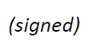  Seizo Onoe  Director of the Telecommunication  Standardization Bureau | 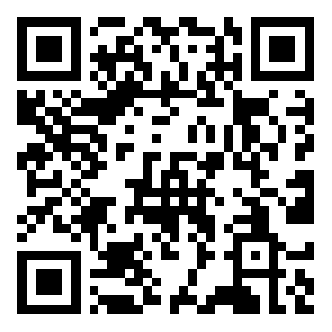  More information

