Ministry of Communication, Telecommunications and Digital (MTCN)
Republic of Senegal
Office of the Minister

To:
Mr Seizo Onoe
Director of Telecommunication Standardization Bureau
International Telecommunication Union
Geneva
000027/MCTN/SG/DT
Dakar, 21 January 2026
CONFIDENTIAL

Subject: Nomination of Ms Aminata Drame Thiam as second vice-chair of TSAG (Africa)
Ref.: Letter of 26 June 2026, ref. 062/06/ATU/SC/ITU-TSB/2025

Dear Director,
I refer to the correspondence from the African Telecommunications Union (ATU) dated 26 June 2025, relating to the regional consensus reached on the designation of the second vice-chair of the Telecommunication Standardization Advisory Group (TSAG), representing Africa.
In this context, and in accordance with the agreement reached between the African Member States, I am pleased to officially notify you that the Republic of Senegal designates Ms Aminata Drame THIAM as second vice-chair of TSAG for the period 2025-2026, representing Africa.
Please submit this nomination to TSAG for consideration and validation, in accordance with established procedures.
Yours sincerely,

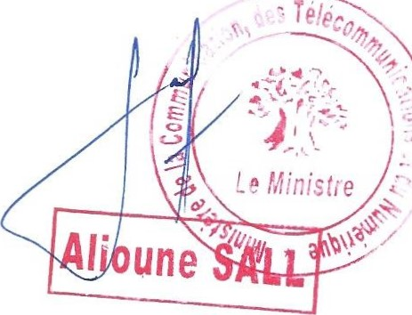
Minister

Mamadou DIA administrative building — second floor — Dakar, Senegal — BP 4027
Tel.: (221) 33 889 76 18

