 | INTERNATIONAL TELECOMMUNICATION UNION  TELECOMMUNICATION  STANDARDIZATION SECTOR  STUDY PERIOD 2025-2028 |  | TSAG-TD259
 |  |  | TSAG
 |  |  | Original: English
 |  |  | Geneva, 26-30 January 2026
TD
Source: |  | TSB
Title: |  | Analytical report: Survey on human rights integration in ITU-T study groups and TSAG
Contact: |  | Olivier Alais  TSB |  | E-mail: olivier.alais@itu.int

Please see below.


Analytical report:

Survey on human rights integration in ITU-T study groups and TSAG
(Version 1.0)
November 2025

Table of contents

Executive summary 3
1. Introduction 5
2. Methodology 5
3. Survey results 5
3.1 Respondent profile 5
3.2 Awareness and relevance 6
3.3 Current practices in study groups and TSAG 7
3.4 Organizational practices 8
3.5 Needs and support 10
4. Analysis 10
5. Draft proposal 11
Annex: Aggregated results 13

Executive summary
This report presents the results of the Survey on Human Rights integration in ITU-T study groups and the Telecommunication Standardization Advisory Group (TSAG), conducted with study groups, TSAG management team and ITU-T secretariat as a follow-up of the discussions at TSAG in May 2025.
Key findings
- Relevance recognized: 84% of the respondents see human rights as relevant in standardization, though understanding is uneven.
- Fragmented integration: 56% of the respondents report that human rights are considered in their standardization activities, but few formal processes exist.
- Organizational practices uneven: Over half of respondents (54%) indicated that the organizations they represent systematically integrate human rights into policies or strategies, but with varied depth and no shared benchmarks.
- High demand for support: Respondents expressed a strong interest in good practices, training and AI tools.
- Gaps and risks: Lack of ITU-T-wide processes, reliance on individuals, limited external expertise and difficulty addressing long-term impacts.
Participation
Conducted in September 2025, the survey received 55 responses from all ITU-T study group and TSAG management teams, with representation across governments, regulators, private sector, service providers, manufacturers, research institutes, as well as ITU staff working with the study groups and TSAG. All six ITU regions were represented in the responses, ensuring a global perspective.
Awareness and relevance
60% of respondents reported being at least moderately familiar with human rights in standardization, and 84% considered them relevant to the standardization work. Human rights were often described as "compass" or "guardrails," with emphasis on privacy, inclusion, accessibility, and security. However, 40% reported little or no familiarity.
Current practices
Over half (56%) said their study group considered human rights, but that the approaches remained fragmented and '"ad hoc"'.
Examples cited included:
- Health & safety: SG5 standards on electromagnetic fields.
- Accessibility & inclusion: SG2's emergency numbering (E.161.1, E.164, E.106) and SG20's Q8/20 on "human-centric digital services."
- Privacy & security: SG17's 400+ standards on cybersecurity and data protection.
- Non-discrimination: Avoidance of biased terminology, and accessibility initiatives.
It was noted that formal processes to consider human rights in the work of the study groups are absent, and that study groups relied on informal practices or individual expertise.
Organizational approaches
Asked about whether and how human rights considerations are integrated into policies, technology strategy, R&D, product development or standardization in their respective organizations (e.g., ministry, regulatory agency, private sector), respondents mentioned adherence to or consideration of national laws, corporate responsibility frameworks, accessibility initiatives, and partnerships with UN bodies. About half (54%) reported systematic integration in their work, but approaches remain uneven and lack shared benchmarks.
Needs and support
Respondents expressed interest in:
- learning about good practices from other SDOs (79%),
- receiving targeted training (62%), and
- exploring AI-powered review tools (62%).
Nearly 90% indicated willingness to engage in training and continued dialogue on the topic of human rights integration in standardization.
Draft proposals
Based on the survey responses, the following activities could be considered to increase awareness and capacity regarding human rights integration in the work of ITU-T study groups and TSAG. These include:
- Developing practical guidance and tools;
- Providing targeted training for delegates and staff;
- Promoting knowledge exchange through webinars and dialogues;
- Introducing a simple "Human Rights in Standards" visibility mechanism;
- Exploring the development of an AI-based tool to identify potential risks; and
- Appointing a dedicated ITU-T focal point to coordinate related activities.

Introduction
This report presents the results of the Survey on human rights integration in ITU-T study groups and the Telecommunication Standardization Advisory Group (TSAG), conducted in response to the discussions at TSAG in May 2025.
The survey was developed by ITU's Telecommunication Standardization Bureau (TSB) in collaboration with experts from the Office of the United Nations High Commissioner for Human Rights (OHCHR) to assess awareness, practices, and needs related to human rights in technical standardization.

Methodology
The survey was structured in five sections: respondent profile, awareness, study group practices, organizational practice and support needs. The questionnaire combined multiple-choice and open-ended questions (see Annex: Aggregated results).
The questionnaire was addressed to chairs, vice-chairs, and members of the ITU-T secretariat of ITU-T study groups and TSAG via the respective management team mailing lists. It was open from 3 to 22 September 2025.
Responses were analysed using descriptive statistics and thematic review.

Survey results

3.1 Respondent profile
The survey received 55 complete responses across all groups on about 120 persons solicited, covering the management teams and secretariats of all ITU-T study groups and TSAG.
Study group affiliation: Respondents represented all ITU-T study groups and TSAG. The largest shares came from SG12 (Performance, QoS and QoE) with 10 responses, followed by SG21 (Technologies for multimedia, content delivery and cable television), SG17 (Security) and SG3 (Tariff and accounting principles and international telecommunication/ICT economic and policy issues) with 8 responses each, and TSAG with 7 responses (see Annex Q1).

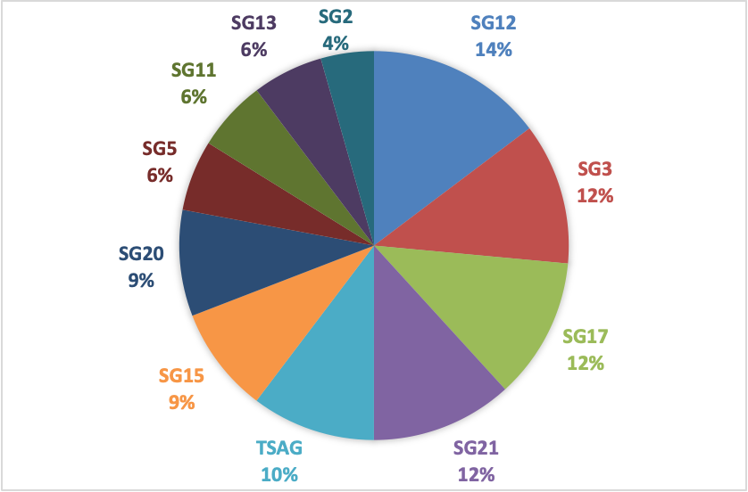
Figure 1: Study group affiliation

Gender distribution: Of the 55 respondents, 65% identified as male and 35% as female. The figures reflect a broader gender imbalance in ICT standardization (see Annex Q2).

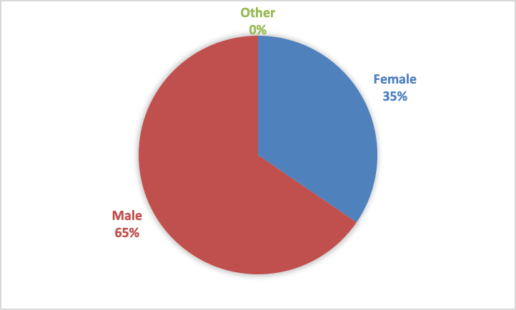
Figure 2: Gender distribution

Regional representation: All six ITU regions were represented: Asia-Pacific 29% (12 respondents), Africa 21% (9), Europe 17% (7), the Americas 12% (5), Arab States 12% (5), and the CIS region 9% (4). These figures exclude the responses from the ITU secretariat (see Annex Q3).
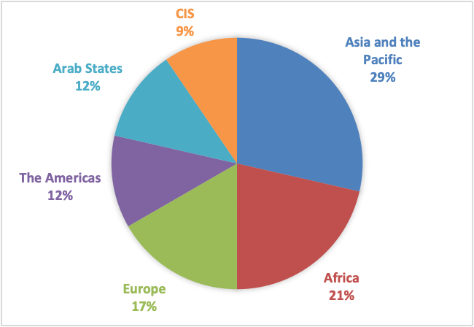
Figure 3: Regional representation

Organization type: Respondents came from diverse organizational backgrounds. Government and regulators 42% (23 responses), ITU secretariat 24% (13), private sector 16% (9), service providers 9% (5), manufacturers/product developers 5% (3), research institutes 4% (2). None of the respondents identified in the academia category (see Annex Q4).

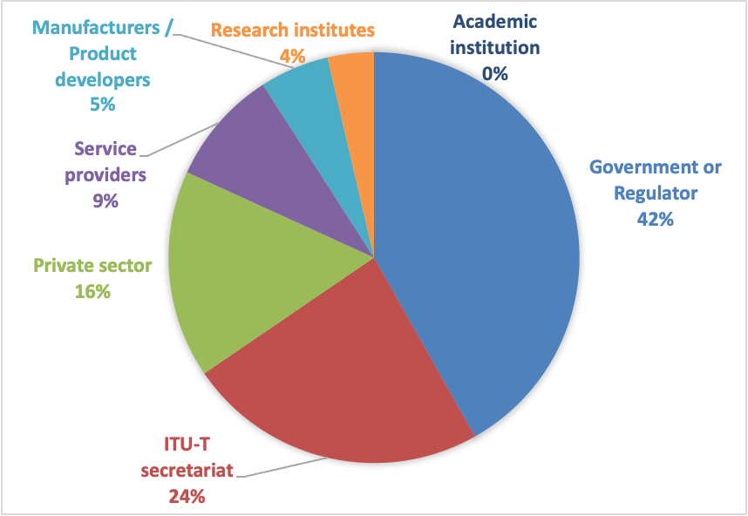
Figure 4: Organization type

Overall, the responses reflect a broad cross-section of stakeholders, providing a credible foundation for assessing awareness, practices, and support needs regarding human rights integration in technical standardization.

3.2 Awareness and relevance
The survey shows that awareness of human rights in the context of technical standardization is relatively high among respondents.
Overall, 60% of respondents reported being at least moderately familiar with the concept, including 20% who were very familiar and 6% who were extremely familiar.
However, 40% of respondents indicated low or no familiarity, including 18% who were not at all familiar (see Annex Q5).
When asked about relevance, 84% of respondents considered human rights to be moderately, very, or essentially relevant to the work of their respective study or advisory group (see Annex Q6).
The responses to the related open-ended question further illustrate this point (see Annex Q7). Commonly cited themes included:
- Compass/guardrails for standardization: Respondents described human rights as a "compass" or "guardrails" for standardization, guiding technologies to empower individuals and societies while preventing harm.
- Protection of life, safety, and privacy: Frequent references to safety, security, data protection, and privacy as central elements of human rights in standards.
- Accessibility, inclusion, and non-discrimination: Emphasis on ensuring equal access to technology, inclusion of vulnerable groups (persons with disabilities, elderly, youth), and preventing discrimination.
- Trust and socio-technical dimensions: Emphasis that standards should reflect cultural values, foster digital inclusion, and provide safeguards for vulnerable groups. Some also highlighted the importance of grounding these considerations in national contexts.
- Quality of service and fairness: Standards are seen as tools to guarantee equal service quality and fairness for all users.
- Sustainability and environment: A few respondents linked human rights to the right to a healthy environment ("human right to have a green planet").
- Equal participation in standardization processes: Some respondents noted that human rights also apply to how standards are made: ensuring equal voice for delegates regardless of origin or gender.
- Skepticism or uncertainty: A minority expressed doubts or uncertainty ("no relationship," "not sure"), indicating that the link between human rights and technical standardization is not universally understood.
The survey results indicate that the findings suggest that respondents broadly recognize the importance of integrating human rights into technical work, though understanding varies in depth.

3.3 Current practices in study groups and TSAG
Survey responses show that while awareness of human rights is relatively high, the extent to which study groups and TSAG integrate these considerations into their work is uneven. While 56% of respondents reported that their study group does take human rights into account when developing Recommendations or other deliverables, 22% responded negatively, and another 22% were unsure (see Annex Q8). This indicates that, although good practices exist, they are not yet systematic across ITU-T.
Several respondents described concrete ways human rights are reflected in technical work (see Annex Q9):
- Health and safety: SG5's work addresses public health risks from electromagnetic fields, with standards that set exposure limits and frameworks for assessment.
- Accessibility and inclusion: SG2's Recommendations (E.161.1, E.164, E.106) ensure universal access to numbering and emergency services, supporting rights to life and non-discrimination. SG20's Question 8/20 on "human-centric digital services" integrates accessibility, digital health, and inclusion. ITU-T Y.2360 also focuses on accessibility for diverse demographic groups.
- Privacy and data protection: SG17 has developed more than 400 standards to safeguard personally identifiable information and strengthen cybersecurity (e.g., X.1058, X.1080.0, X.1086). SG20 emphasizes people-centred IoT and smart city standards, while national examples link encryption, anonymization, and informed consent to rights protection.
- Terminology and non-discrimination: Some study groups avoid discriminatory terminology (e.g., replacing "master/slave" with neutral terms). Standards are also developed to reflect inclusiveness for people with disabilities, older persons, and youth.
- Consumer protection: SG3 work incorporates consumer rights into Recommendations. National initiatives illustrate how technical norms embed human rights safeguards despite challenges such as low digital literacy.
- Sustainability and environment: Some study groups integrate human rights considerations into green development, circular economy, and life-cycle analysis (LCA) standards.
- Ad-hoc adjustments: In SG17, proposals with potentially harmful language (e.g., X.1451) were revised after expert input. This shows that peer review and discussion can mitigate risks, although such practices remain ad hoc.
- Process safeguards: Delegates noted that provisions conflicting with human rights are generally avoided, but impacts often emerge later at the implementation stage, which is harder to address systematically.
One-third (33%) of respondents said their study group has some form of process or discussion to address human rights, while 28% said no and 39% were not sure (see Annex Q10). Where mechanisms exist, they are mostly informal and vary by group (see Annex Q11):
- Some respondents pointed to correspondence groups, focus groups, and liaisons with other bodies as channels for integrating diverse perspectives into standardization.
- SG21 was cited for its work on remote captioning services (FSTP-ACC-RCS), which directly address accessibility.
- Several noted that in practice, Recommendations inherently incorporate human rights dimensions such as accessibility, equity, and privacy, even when not explicitly labelled as "human rights."
- In SG17, approaches remain ad hoc, depending on the expertise of knowledgeable delegates rather than systematic procedures or formal guidance.
- Respondents highlighted that human rights concerns often emerge organically in discussions, even in the absence of dedicated processes. Examples provided were around mobility, facial recognition, and digital identity systems.
Overall, the findings show that human rights considerations already appear in many areas of ITU-T work, particularly on privacy, accessibility, security, and consumer protection. However, integration remains fragmented and inconsistent, often dependent on individual expertise, national practices, or specific projects rather than common guidance or institutionalized procedures.

3.4 Organizational practices
Survey results show that many participating organizations already integrate human rights into their strategies and operations, though with varying levels of formality and depth.
Of the 48 respondents, more than half (54%) reported that their organization systematically integrates human rights into policies, technology strategies, R&D, product development, or standardization. A further 25% indicated that integration occurs occasionally, while 4% said no and 17% were unsure (see Annex Q12).
Examples provided illustrate diverse approaches (see Annex Q13):
- Regulatory and legislative frameworks: Several respondents highlighted telecommunications and data protection laws that explicitly safeguard rights such as privacy, equality, freedom of expression, and access to information. These frameworks often extend to areas like spectrum management, consumer protection, and competition oversight.
- Environmental and sustainability measures: Some study groups and national authorities link standards to the right to health and ecological sustainability, for example through guidance on circular economy, life-cycle analysis and environmental protections.
- Inclusion and accessibility policies: Measures cited include gender equity initiatives, quotas for persons with disabilities, and universal access programs to ensure non-discrimination and digital inclusion.
- Corporate responsibility mechanisms: Examples include codes of conduct, supplier onboarding criteria, due diligence requirements, and reporting processes that integrate human rights into ICT supply chains.
- Institutional practices: Some organizations have set up dedicated consumer rights departments, ethics committees, and governance bodies, as well as regular consultation with civil society and rights groups, to integrate human rights into decision-making.
When asked whether their organizations had issued policies, training or tools specifically addressing human rights and technology, 58% of respondents answered yes, 19% no, and 23% were unsure (see Annex Q14).
Examples include (see Annex Q15):
- Privacy and ethical frameworks: Adoption of privacy policies, internal codes of ethics, and governance charters that embed principles of dignity, fairness, and accountability.
- Training and capacity building: Programs on gender equality, accessibility, cybersecurity, human rights, and responsible technology use, often delivered through in-person workshops or institutional training plans.
- E-learning platforms: Online modules dedicated to diversity, inclusion, and digital rights awareness, accessible to both staff and stakeholders.
- Consumer and user protection tools: Mechanisms such as complaints hotlines, child online protection measures, and monitoring systems to track accessibility and quality of ICT services.
- International partnerships: Collaboration with organizations such as OHCHR, UNESCO, and regional bodies to promote digital literacy, inclusion, and rights-based approaches in ICT.
- Standards, certifications, and Environmental, Social, and Governance (ESG) models: Use of frameworks like SA8000, ISO standards, ESG commitments, and gender equity quality models to benchmark organizational practices and demonstrate compliance with human rights norms.
Overall, most participating organizations are actively engaging with human rights, whether through formal policies, legal frameworks, or corporate responsibility practices. However, the diversity of approaches and uneven depth of integration suggest the need for more consistent guidance and shared best practices across the sector.

3.5 Needs and support
The survey asked respondents what types of support would help their study group better integrate human rights into standardization and 42 respondents provided answers (multiple choice, see Annex Q16). The most frequently selected answers were:
- Examples of good practices from other SDOs (79%) was the highest-rated option, reflecting a desire to learn from comparable experiences.
- Next came Targeted training (62%) and an AI-powered review tool (62%), pointing to the need for both capacity-building and innovative technical aids.
- Webinars, panels, and technical dialogues (50%): to facilitate awareness-raising and exchange.
- Other forms of support mentioned included a human rights impact assessment framework (40%), human rights branding (31%), expert guidance or external review (31%), and broader participation (29%).
- Fewer respondents identified accountability mechanisms (10%) or dedicated focal points (14%) as immediate priorities.
When asked about their interest in participating in training or dialogue, most respondents expressed openness: 86% were at least moderately interested, while indicated no interest (5%) or slight interest (9%) (Annex Q17).

Analysis
The survey provides the first systematic picture of how human rights are currently perceived and addressed across ITU-T study groups and TSAG. Several important findings emerge.
Broad recognition of relevance, but uneven understanding: A clear majority of respondents consider human rights relevant to their study group's work (84%). Open-ended responses described human rights as "guardrails" or a "compass" for standardization, with recurring themes of privacy, accessibility, non-discrimination, and security. At the same time, a minority expressed uncertainty or saw limited connection, suggesting that awareness is high but not yet consistently translated into practical understanding.
Good practices exist, but integration remains fragmented: 56% of respondents reported that their study group already takes human rights into account when developing Recommendations. Examples range from electromagnetic field exposure limits and emergency numbering to accessibility standards, privacy protections, and terminology reform. However, only 33% confirmed the existence of processes or guidance to address human rights, with many describing practices as ad hoc or reliant on individual expertise. This indicates the presence of valuable examples but the absence of a systematic framework.
Organizational engagement is advancing, but unevenly: At the institutional level, 54% of respondents said their organizations systematically integrate human rights into policies or strategies, while a further quarter do so occasionally. Examples included regulatory frameworks, corporate responsibility initiatives, accessibility programs, and consumer rights mechanisms. Yet the diversity of approaches and depth of implementation highlight the lack of shared standards or benchmarks across organizations.
Strong demand for tools, training, and comparative learning: Respondents identified concrete forms of support that would help study groups better integrate human rights. The most requested were examples of good practices from other SDOs (79%), targeted training (62%), and AI-powered review tools (62%). Interest in training is high, with nearly 90% of respondents expressing at least moderate willingness to participate. This reflects a readiness among study group leadership to engage, provided that practical and accessible resources are available.
Key gaps and risks: The findings reveal several gaps that could hinder the consistent integration of human rights across ITU-T's standardization work. While ITU-T study group and TSAG leadership broadly recognizes the importance of human rights and several study groups demonstrate good practices, integration remains fragmented and largely ad hoc. Many study groups rely on individual expertise rather than shared tools or frameworks, highlighting a strong demand for structured guidance, targeted training, and comparative examples. Overall, ITU-T is well positioned to build on existing initiatives but needs a coherent, systematic approach to ensure that human rights are consistently embedded throughout its standardization activities. These findings correspond to four main gaps summarized in the table below.
Gaps and risks | Related annex questions
Lack of structured, ITU-T-wide processes leads to fragmented and inconsistent integration of human rights across study groups. | Q8, Q9, Q10, Q11
Reliance on individual expertise and national practices persists due to the absence of shared tools, frameworks, and guidance materials. | Q9, Q10, Q11, Q14, Q15, Q18
Limited engagement of external expertise and insufficient analytical capacity hinder the identification of indirect or long-term human rights impacts. | Q10, Q11, Q18
Knowledge and capacity gap persists regarding human rights in standardization. | Q5, Q8

Draft proposal
Based on significant interest identified by the survey responses, the following activities could be considered to increase awareness and capacity on human rights integration in the work of ITU-T study groups and TSAG, achieving quick wins to build early momentum:
- Guidance and tools: Provide concise checklists, taxonomy and notes for selected study groups to identify potential human rights implications early in standards development.
- Training and awareness: Launch targeted training modules for management teams and other interested delegates and ITU staff on the links between human rights and technical standards.
- Knowledge exchange: Organize webinars, panels, technical dialogues to maintain awareness, and foster dialogue and good practices from other SDOs.
- Human rights branding: Introduce a simple visibility mechanism to highlight ITU-T Recommendations that integrate human rights considerations.
- AI-powered review pilot: Explore the development and testing of an AI-based tool to help screen draft Recommendations for potential human rights risks.
- Dedicated focal point: Appoint human rights focal point in ITU-T to pursue the work on this matter.

Annex: Aggregated results

Q1: Which group are you currently affiliated with?
Answered: 55 Skipped: 0

ANSWER CHOICES | RESPONSES
SG12 – Performance, Quality of Service (QoS) and Quality of Experience (QoE) | 18.18% | 10
SG3 – Economic and policy issues | 14.55% | 8
SG17 – Security | 14.55% | 8
SG21 – Multimedia, content delivery and cable television | 14.55% | 8
TSAG – Telecommunication Standardization Advisory Group | 12.73% | 7
SG15 – Transport, access and home networking | 10.91% | 6
SG20 – Internet of Things (IoT), digital twins and smart cities | 10.91% | 6
SG5 – Environment, electromagnetic fields (EMF), climate action and circular economy | 7.27% | 4
SG11 – Protocols, testing and combating counterfeiting | 7.27% | 4
SG13 – Future networks | 7.27% | 4
SG2 – Operational aspects | 5.45% | 3
TOTAL |  | 68

Q2: What is your gender?
Answered: 55 Skipped: 0

ANSWER CHOICES | RESPONSES
Male | 65.45% | 36
Female | 34.55% | 19
Other | 0.00% | 0
TOTAL |  | 55

Q3: In which region are you based?
Answered: 55 (including 13 ITU-T secretariat) Skipped: 0

Including ITU-T secretariat

ANSWER CHOICES | RESPONSES
Europe (including ITU-T secretariat) | 36.36% | 20
Asia and the Pacific | 21.82% | 12
Africa | 16.36% | 9
The Americas | 9.09% | 5
Arab States | 9.09% | 5
Commonwealth of Independent States | 7.27% | 4
TOTAL |  | 55

Excluding ITU-T secretariat

ANSWER CHOICES | RESPONSES
Asia and the Pacific | 28.57% | 12
Africa | 21.43% | 9
Europe (excluding ITU-T secretariat) | 16.67% | 7
The Americas | 11.90% | 5
Arab States | 11.90% | 5
Commonwealth of Independent States | 9.52% | 4
TOTAL |  | 42

Q4: Which type of organization do you represent?
Answered: 55 Skipped: 0

ANSWER CHOICES | RESPONSES
Government or Regulator | 41.82% | 23
ITU-T secretariat | 23.64% | 13
Private sector | 16.36% | 9
Service providers | 9.09% | 5
Manufacturers / Product developers | 5.45% | 3
Research institutes | 3.64% | 2
Academic institution | 0.00% | 0
TOTAL |  | 55

Q5: How familiar are you with the concept of human rights in the context of technical standardization?
Answered: 50 Skipped: 5

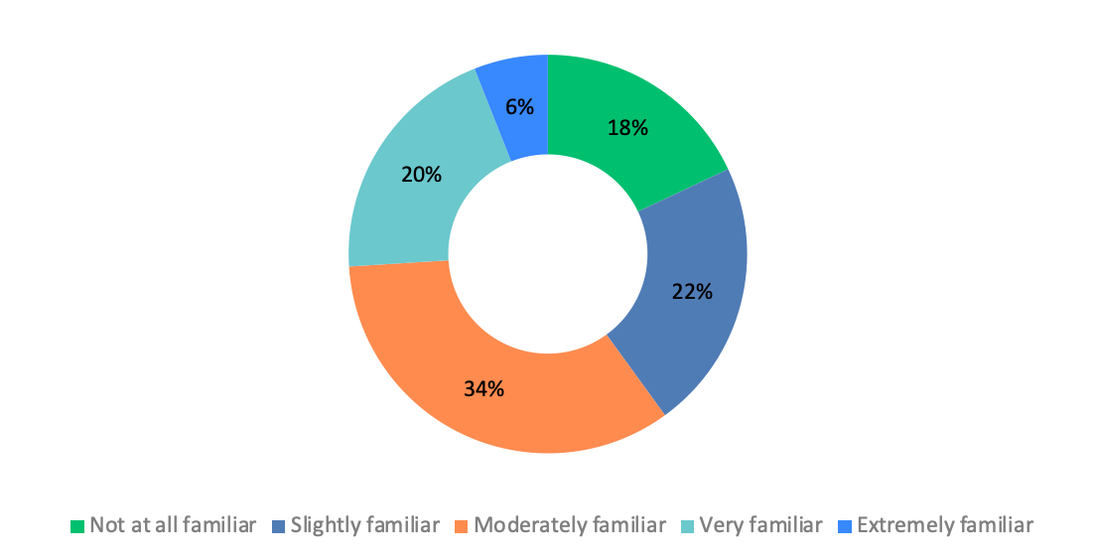
ANSWER CHOICES | RESPONSES
Not at all familiar | 18.00% | 9
Slightly familiar | 22.00% | 11
Moderately familiar | 34.00% | 17
Very familiar | 20.00% | 10
Extremely familiar | 6.00% | 3
TOTAL |  | 50

Q6: To what extent do you think human rights are relevant to your study group's work?
Answered: 50 Skipped: 5

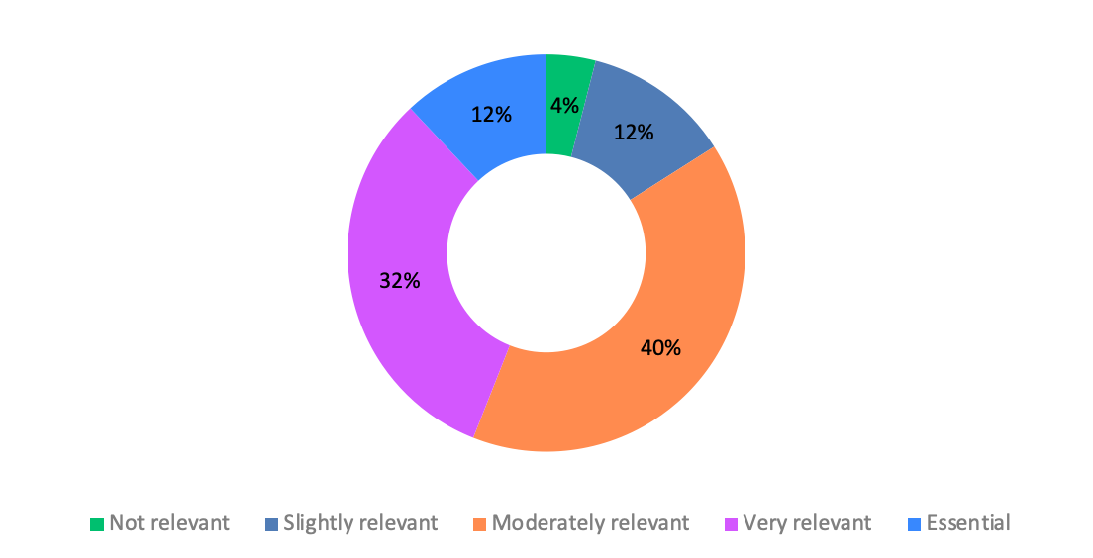
ANSWER CHOICES | RESPONSES
Not relevant | 4.00% | 2
Slightly relevant | 12.00% | 6
Moderately relevant | 40.00% | 20
Very relevant | 32.00% | 16
Essential | 12.00% | 6
TOTAL |  | 50

Q7: In your own words, how would you describe the role of human rights in technical standardization?
(Open-ended response)
Answered: 39 Skipped: 16

# | RESPONSES
1 | Human rights serve as a compass in technical standardization, ensuring that technologies built on global standards empower rather than endanger individuals and societies.
2 | The role of human rights in technical standardization is very important in protecting the life of human and to keep on his safe, security and privacy.
3 | The decisions made in setting standards shape how technologies impact people's daily lives. If standards account for issues like privacy, accessibility, and fairness, they help ensure technology benefits everyone rather than creating risks or exclusions.
4 | To give a guideline.
5 | Human rights form an essential fabric to every development and innovation. Human needs are generally refined by basic human rights across individuals. Consequently, standards that govern innovative ideas, technology and evolution must be woven with human rights as its fabrics.
6 | human rights must also be protected online and HR to be promoted, respected, protected and fulfilled through the entirety of digital technologies' lifecycle
7 | privacy issue is getting important
8 | standards must take into account the possibility of protecting human rights. the use and application of technical standards should not require the concession of human rights.
9 | HR should be safeguarded when elaborating a standard, should the nature of the standard allow it.
10 | Human rights play a crucial role in technical standardization by ensuring that standards are developed with safeguards to protect fundamental freedoms like privacy, expression, accessibility, and non-discrimination.
11 | Technical standards should serve society fairly and inclusively without infringing on their rights in any way.
12 | Nous sommes dans une société fortement numérisée. En Côte d'Ivoire, où les droits de l'homme sont protégés par la Constitution et soutenus par des mécanismes nationaux et internationaux, ce rôle de la normalisation est particulièrement important pour accompagner la digitalisation tout en assurant la protection des droits des groupes vulnérables, l'inclusion numérique, l'éthique et la responsabilité sociale.
13 | I think that there is no relationship between them
14 | Human rights provide the guardrails for technical standardization. They ensure that as technologies are designed, deployed, and scaled, they are done in ways that are fair, inclusive, respectful of dignity, and mindful of the different realities people live in.
15 | The technical standards create foundation of digital system and platform. The technical standards play a crucial role in protecting human rights by creating guard rails for the technology.
16 | Human Rights should be considered as a 'concern' that lead to requirements that can be interpreted technically.
17 | As my group work on energy efficiency and ecologic item Human right to have a green planet
18 | ensuring survival of species, including human and quality of life for all.
19 | Human rights are essential in technical standardization because standards reflect the values and interests of their creators, and can significantly impact human rights like privacy, freedom of expression, and non-discrimination
20 | not sure
21 | to guarantee the same quality of service and quality of experience to anybody.
22 | I would say that, since standardization is mostly targeting consensus between human beings sitting around a table, the human rights are less inside the documents themselves than between the contributors and delegates, than must have equal right of speech and wight in final decisions, whatever their origin, their gender, etc.
23 | I believe that consideration for human rights is essential in establishing technologies that leave no one behind.
24 | Standards provide requirements and are also policy tools. Considering human rights in standardization allow/force technology to be developed and deployed in a safe way that protect the human being.
25 | ?
26 | Basic concept to adopt standardizations
27 | mainly on accessibility equal rights and on wide spread of technologies for the good of human kind
28 | Nowadays, technological advances are happening faster. However, human rights must remain a fundamental pillar to ensure that people are protected, not discriminated against, and able to fully benefit from the opportunities that technology provides.
29 | Human rights should be considered even in technical field. For example, service should be provided equally over the world.
30 | in discussions of network technologies, we have to respect human rights such as privacy etc.
31 | Ensure that standardized technologies are designed on the way to help protecting user's privacy and data
32 | standards must take into account the possibility of protecting human rights
33 | Keeping in mind the ultimate human user of standards
34 | standards must take into account the possibility of protecting human rights
35 | Each one can be fair to get and/or provide services for public, and protect the youth, older and disables.
36 | Violence that may face by children or by woman. May there should some technical stranded similar to to emergency call, but for such as cases
37 | Technical standards are more than engineering specifications. They shape how billions of people connect, communicate, and access information. Embedding a human rights perspective ensures inclusive accessibility and builds safeguards against the misuse of emerging technologies such as AI and IoT devices.
38 | Embedding human rights in technical standards ensures technology respects privacy, equality, and dignity for all
39 | Human rights should ensure that the development and implementation of technical standards consider all fundamental human rights, such as freedom of expression, privacy, and accessibility. This means including human rights principles into the standard developing process.

Q8: Does your study group take human rights considerations into account when developing Recommendations or other deliverables, both to identify potential risks and to promote human rights?
Answered: 50 Skipped: 5

ANSWER CHOICES | RESPONSES
Yes | 56.00% | 28
No | 22.00% | 11
Don't know | 22.00% | 11
TOTAL |  | 50

Q9: If yes, please provide examples of how human rights have been considered in the standardization process.
(You may describe specific experiences and key takeaways, including what worked well and any challenges encountered - Open-ended response)
Answered: 21 Skipped: 7

# | RESPONSES
1 | Protect the health against exposure to electromagnetic fields which are caused by telecommunications/ICT equipment.
2 | There are key recommendations and standards developed under the study group that takes into accounts this. I would speak specifically to those I am involved in. ITU-T Y.2360 was a standard developed with the very essence of huma rights in mind. Specifically, this standard looks at the accessibility issues for different demographics group within a society and their need. This standard reinforces the need to develop recommendations and standards by carrying all societal demographics equally in the standards developing process. In the course of the standards development, engagements were carried out with different stakeholders across countries to come up with the standard.
3 | standards must take into account the possibility of protecting human rights
4 | SG2 has worked in universal access and no-discrimination Ex. Rec ITU-T E.161.1, emergency numbers, symbols, etc. (fundamental human rights) Rec. ITU-T E164 international numbering => everyone could connect -accessibility, related to security, inclusiveness, right to life NNAI management=> protection of personal data, data protection and misuses Rec.ITU-T E106 =>International Emergency Preference Scheme (IEPS) for disaster relief operations
5 | We have been avoiding the discriminatory words like 'black/ white', 'master', 'man' in developing documents.
6 | 1°) Protection du Consommateur Plusieurs recommandations établi au niveau de la SG3, Ces dernières années, intègrent cette préoccupation. 2°) en Côte d'Ivoire, dans le cadre de l'opérationnalisation de la stratégie IA et de Gestion des données, un texte de loi devrait être produit prochainement et qui adresse la question de l'éthique et de la responsabilité dans l'utilisation des systèmes d'IA, 3°) Protection de la vie privée et des données personnelles Exemple : en Côte d'Ivoire, prise de la loi de 2013 en Côte d'Ivoire qui s'étend sur les principes de protection des données, avec des normes sur l'anonymisation, le chiffrement, et le consentement éclairé des utilisateurs. Difficulté : - Niveau de maturité / Niveau d'alphabétisation des population faible (-50%) pour appréhender ces questions. - travail en silo, des différentes structures institutionnelles, qui ne permet pas d'avoir une prise en charge multisectorielle et holistique de ces questions - Maintenir un équilibre entre innovation technologique et exigences strictes de confidentialité.
7 | X.1451 is a typical example that when initiated was showing concerns against Human Rights and after due explanation and mathematical ones, Human Rights helped China to establish X.1451. SG17 has a practice to check for Human Rights aspects when establishing and developing its Recommendations. This happened because Human Rights people usually are onboarded by some administrations, eg the UK and so, they have the knowledge of what is toxic to Human Rights and they have the knowledge on how to write things correctly. In that case Human Rights specialists asked China the possibility to rewrite the text of the proposal as it was understood there was no bad intention but the language was not appropriate. China agreed and it ended up with a great result. However Human Rights people refused to offer a general training because simply the conditions are not met to scale such an exercise and this is the limit. This is only when key people with proper training and deep knowledge and experience that such results can be reached. And it is not unique nor can it avoid issues. For example, X.509 is blessing for humanity as it helps asymmetric encryption. But at the same time, cyber criminals are using it to hide their command and controls communications during their attacks. So, it is not because something is good one day that one understands the mid- and long-term implications. Finding positive or negative direct impacts to Human Rights is already a task. Finding positive indirect impacts to Human Rights is much more difficult, finding negative indirect impacts to Human Rights is an epic task.
8 | we write recommendation on efficiency circular economy and LCA on support of green development
9 | All documents of the research group directly or indirectly take into account the issue of ensuring human rights
10 | ensure the equity of information
11 | conducting experiments and developing standards considering about gender, languages, age and etc..
12 | accessibility matters sustainability concept
13 | Every work developed within the ITU is open to discussion by all members, and it is very common for human rights issues to be raised. One example that comes to mind is the creation of study questions that specifically address human rights, such as Q8/SG20, titled 'Human-centric digital services enabled by Internet of Things (IoT) and smart sustainable cities and communities (SSC&C),' which relates to digital health, accessibility, and inclusion.
14 | Some recommendations provide guidelines and requirements to provide a service.
15 | we discuss topics regarding human rights such privacy etc.
16 | Some standards on emergency telecommunications have been developed, and in the actual implementation, there have been applications to obtain numbering resources for various uses including military ones that have required very careful consideration by the numbering experts.
17 | For example, SG17, SG20 and SG21 develop standards for the disables, older, youth; and SG17 and SG20 develop standards to protect PII and data privacy.
18 | SG17 is responsible for developing international standards to enhance confidence, security and trust in the use of telecommunications/ICTs. SG17 has developed 400+ standards to protect personal identifiable information, preserve privacy, and support security of ICT infrastructure and services.
19 | Human rights in standardization are reflected through accessibility, privacy, security, safety, and inclusiveness requirements embedded directly in ITU-T Recommendations. In SG20, this translates into ensuring that IoT, smart city, and digital twin standards promote people-centered, trustworthy, and rights-respecting digital ecosystems.
20 | In many standardization processes, delegates actively avoid including provisions that could conflict with human rights. Explicitly problematic texts are rare because technical standards generally aim for neutrality and focus on interoperability and safety. The main challenge is that human rights implications may emerge during implementation at the national level, rather than in the standard itself, and it is not always clear how these risks can be fully addressed early in the drafting process.
21 | On many occasions while discussing contributions to develop new standards or amending existing ones. Human rights are always present and considered during the discussion, and gladly most of the participating member states delegates agrees on that.

Q10: Are there processes, guidance documents or internal discussions in your study group that help identify or address human rights issues?
Answered: 49 Skipped: 6

ANSWER CHOICES | RESPONSES
Yes | 32.65% | 16
No | 28.57% | 14
Not sure | 38.78% | 19
TOTAL |  | 49

Q11: If yes, please provide examples.
(Open-ended response)
Answered: 16 Skipped: 5

# | RESPONSES
1 | to establish a framework to address concerns about measurement and assessment related to human exposure to electromagnetic fields, and to present a set of Recommendations in order to address effectively this issue.
2 | There are correspondence and focus groups that are created within the study group that provides guidance by accommodating the views of different stakeholders. Furthermore, the study group has liaison with different bodies and it encompasses their views in the engagements of the study group.
3 | SG21-TD54/WP2 Rapporteur Q1/21 Output - Draft revised Technical Paper FSTP-ACC-RCS (V3) "Overview of Remote Captioning Services"
4 | In all the Recommendations born and approval process, in the NNAI management =>Although it does not appear in the mandate, it is inherent to the way the SG works.
5 | As explained earlier there are no written guidance or documentation, this is simply an ad-hoc knowledge by SG17 community and it resolves by opened discussions when the right knowledgeable people are there
6 | All documents of the Study Group provide for the provision of human rights
7 | P.800, P.910
8 | As I mentioned before, human rights frequently arise during our standardization discussions. For example, there are concerns about using technology to improve mobility, as well as ensuring that facial recognition systems do not lead to discrimination, among other important issues.
9 | Internal discussions mostly
10 | ITU-T X.1058 Information technology - Security techniques - Code of practice for personally identifiable information protection ITU-T X.1080.0 Access control for telebiometrics data protection ITU-T X.1086 Telebiometrics protection procedures - Part 1: A guideline to technical and managerial countermeasures for biometric data security
11 | Human Rights info are highlighted to the management of the group by the Secretariat and are provided to the SG by publishing info documents from various sources, including liaison statements from TSAG. There isn't a clear process though.

Q12: In your organization (e.g., ministry, regulatory agency, private sector), are human rights considerations integrated into policies, technology strategy, R&D, product development or standardization?
Answered: 48 Skipped: 7

ANSWER CHOICES | RESPONSES
Yes, systematically | 54.17% | 26
Yes, occasionally | 25.00% | 12
No | 4.17% | 2
Not sure | 16.67% | 8
TOTAL |  | 48

Q13: If yes, could you briefly describe how human rights are addressed in your organization?
(Open-ended response)
Answered: 30 Skipped: 8

# | RESPONSES
1 | Human rights are not an abstract principle but form part of the regulatory lens guiding spectrum management, broadcasting, consumer protection, competition oversight, and digital inclusion. We address human rights in standards by ensuring that the technical standards enforced by regulation are implemented in ways that protect constitutional rights, especially privacy, equality, freedom of expression, and access to information.
2 | by defining a framework to protect both human and environment
3 | By promoting universal access, accessibility, and trust in ICTs. While not a human rights body, its work supports principles such as inclusion, security, and consumer protection.
4 | The organization has a dedicated Department that addresses issues related to consumers and their rights. This Department is fully accessible by rights and consumer groups across the country. Their views form an integral component in all decision-making processes. They are a key stakeholder
5 | equal opportunity
6 | Law of the Republic of Uzbekistan "On telecommunications" 27.12.2024 № LRU-1015. Items 26, 28
7 | We have national and European regulations in this respect.
8 | For ex. The Regulator obtained Level 1 certification in the Gender Equity Quality Model awarded by the National Institute for Women. There is a specific committee working on these issues. There is a quota for disability and work initiation (students), and online procedures that make access universal and easier. Documentation accessibility is key.
9 | My organisation is primarily a technical and regulatory body, but many of our activities intersect directly with the protection and promotion of human rights, especially as ICTs are fundamental to exercising rights in the digital age. Here are some of the ways our activities address human rights: 1. Our licensing and spectrum allocation decisions ensure pluralism in broadcasting, preventing media monopolies that could undermine democratic discourse. 2. Enforcement of net neutrality principles ensures users can access diverse online content without discrimination. 3. Our oversight of broadcast and telecom services supports citizens' right to receive and impart information. 4. Our SIM registration frameworks are designed to balance national security with individual privacy rights. 5. Our quality of service (QoS) monitoring ensures operators provide services to consumers in accordance with the agreed-upon KPIs in their licences. 6. The licenses we issue contain consumer protection clauses and dispute resolution processes to safeguard against exploitative or discriminatory practices.
10 | Gender equality, facilities for physically challenging persons, Corporate Social Responsibility, SA8000 certification.
11 | - Problématiques prises en compte dans les politiques publiques à travers les Stratégies et textes législatifs établis, cependant la mise en œuvre n'est pas évidente, du fait d'une non coordination d'une structure à l'autre,
12 | We frame regulations and recommendations through open and transparent consultative process which allows participation of all relevant stakeholders including human right experts and consumer organisations
13 | There are many ways that Human Rights are considered by my company (a big big US based multinational). In its Corporate Responsibility and its report, in our Products license agreements, in Procurement to 3rd parties, to onboard 3rd parties, In employee trainings, in code of conduct, etc.
14 | Our organization respects human rights by fulfilling the following responsibilities: a) avoiding negative impacts on human rights in the course of our activities; b) eliminating the consequences of negative impacts, if they occur; and c) seeking to prevent or mitigate negative impacts on human rights. Internal documents have been developed and approved on these principles.
15 | ensure the equality by means of diversity
16 | We are committed to providing barrier-free communication services.
17 | Improving connectivity and access to modern services for socially vulnerable groups.
18 | Principles like gender equal rights (including salaries) or regular consultation of stakeholders on the strategy are in the official position of the company. In everyday life, we try also to do our best, but there are still some bad habits... And the company is not fighting them as hard as it should especially then it is about the attitude of managers towards employees.
19 | Human rights are addressed in our work through the development of standards that protect people and the environment. For example, in ITU-T Study Group 5 we develop guidance to assess and manage human exposure to electromagnetic fields, ensuring compliance with health and safety limits. We also create requirements to support the design of more sustainable ICT goods, contributing to the right to health, a safe environment, and sustainable development. At the same time, I believe it is important to create brief and simple guidance on how human rights should be addressed in Study Groups, as there is still a need for more clarity and direction on this matter.
20 | ?
21 | Our Policy is summarized below; - Alignment to the international code of conduct and rules - Scope is internal area, but our suppliers and business partners - Governance Committee is set - Continuous human right due diligence - Review, necessary modification and salvation - Talks with stake holders
22 | equity and universal access
23 | We are currently undergoing a process of digital transformation; however, it is important to ensure that everyone is included. Therefore, concerns such as digital literacy, gender equality, infrastructure development, expanding coverage to reach rural areas, and other related actions are being addressed through public policies that are under development.
24 | E-learning is provided.
25 | ITU is discussing human rights.
26 | There are various policy instruments to address non discrimination, on accessibility, etc.
27 | In the ITU-T study groups, we usually discuss the techniques to improve, ensure or protect human rights, but not mention this keyword itself, for some member states believe the human rights are not in the mandates of ITU-T. As for my organization, China Unicom is a state company which has the responsibility to protect the human rights according to our regulations.
28 | Human rights related training are mandatory for staff members
29 | The management actively support awareness of the staff.
30 | Privacy, freedom of expression, and non-discrimination.

Q14: Has your organization issued any policies, training, or tools related to human rights and technology?
Answered: 47 Skipped: 8

ANSWER CHOICES | RESPONSES
Yes | 57.45% | 27
No | 19.15% | 9
Not sure | 23.40% | 11
TOTAL |  | 47

Q15: If yes, please provide examples.
(Open-ended response)
Answered: 21 Skipped: 6

# | RESPONSES
1 | All the regulations are based on the Bill of Rights in the Constitution.
2 | Social Media platforms are utilized by the organisation in enlightening and training the general public on issues relating to rights. A dedicated portal is created for all rights related issues. Complaints are equally received via the social media platform or portal. A dedicated avenue is created for child online as well. The following portals are used: 1. https://ncc.gov.ng/consumers/child-online-protection 2. https://consumer.ncc.gov.ng/
3 | Privacy Policy
4 | Seminars and trainings are held regularly
5 | Accessibility policies in all Government and Regulators is centralized by the Electronic Government Agency. Meetings to explain and show the commitment process
6 | Dispute resolution committee that addresses complaints from both consumers and operators.
7 | SA8000 certification, ESG goals
8 | L'ARTCI (Autorité de Régulation des Télécommunications/TIC de Côte d'Ivoire) s'engage activement dans la promotion des droits de l'homme dans le secteur des technologies de l'information et de la communication. Notamment : 1°) Organisation de sessions de formation et de sensibilisation pour ses agents et partenaires sur les enjeux des droits numériques, y compris la confidentialité, la cybersécurité, et l'inclusion numérique. 2°) Mise à disposition d'outils de surveillance et de contrôle visant à assurer la qualité, l'accessibilité et la sécurité des services numériques, avec un accent particulier sur la non-discrimination et la protection des groupes vulnérables. 3°) Collaboration avec l'UIT sur des initiatives (en cours projet sur l'inclusion numérique) ou HCDH pour intégrer les recommandations en matière de régulation respectueuse des droits de l'homme dans ses cadres normatifs et réglementaires.
9 | As per before: - Corporate Responsibility Report - Employee Training - Procurement processes to onboard 3rd parties - Product license agreements - Code of Conduct - etc.
10 | Training on opportunity and code of conduct
11 | code of ethics, collective agreement, internal regulations
12 | e-learning for diversity
13 | Already mentioned two questions ago. No need to repeat myself.
14 | ?
15 | Guided by the principles of ethically utilizing technology and data that support innovation, we provide services and products with consideration for human rights. - Avoiding human rights violations caused by technological advancements - Protecting privacy and respecting freedom of expression - Realizing services and products that are easy for everyone to use - Conducting surveys with local communities and eliminating human rights infringements in the supply chain - Avoiding negative impacts on human rights due to climate change progression
16 | We are establishing, for example, partnerships with international institutions to promote digital literacy for both older adults and young people."
17 | E-learning
18 | ITU is discussing this survey on human rights integration etc.
19 | For example, China Unicom has developed and deployed tools or specific functions for the elderly in our digital applications and services.
20 | ITU human rights related training for staff members: 1. Cybersecurity Awareness Essentials – Digital security best practices 2. I Know Gender – Gender equality and sensitivity 3. United to Respect: Preventing Sexual Harassment and Other Prohibited Conduct 4. Ethics & Integrity at ITU – Ethical conduct and integrity 5. Greening the Blue – Environmental sustainability 6. Prevention of Sexual Exploitation and Abuse (PSEA)
21 | trainings on various Human Rights are made mandatory for staff, e.g. accessibility, security etc.

Q16: What type of support would help your study group better integrate human rights considerations?
(Select all that apply)
Answered: 42 Skipped: 13

ANSWER CHOICES | RESPONSES
Examples of Good Practices from Other SDOs | 78.57% | 33
Targeted Training | 61.90% | 26
AI-Powered Review Tool | 61.90% | 26
Webinars, Panels, and Technical Dialogues | 50.00% | 21
Human Rights Impact Assessment Framework | 40.48% | 17
Human Rights Branding | 30.95% | 13
Expert Guidance or External Review | 30.95% | 13
Broader Participation | 28.57% | 12
Dedicated Focal Point or Resource Team | 14.29% | 6
Accountability and Follow-Up Mechanisms | 9.52% | 4
Other (please specify) | 9.52% | 4
TOTAL |  | 175

Other (please specify):
- It is important to take human rights into account in technical standards, harmonizing them with the engineering purpose that originated them and vice versa.
- SG15 has published guidance documents related to SG15 works. A similar document related to 'Human Rights' can be prepared.
- Acknowledging that a real method is missing based on the Theory of Design. This is the nexus by which HR requirements can enter technical realm
- First would be good to have clear example of the work of each SG in Human rights, so it is easy to understand and see where is missing and how it should be incorporated.

Q17: How interested would you be in participating in a training or dialogue on human rights in standardization?
Answered: 43 Skipped: 12

ANSWER CHOICES | RESPONSES
Not interested | 4.65% | 2
Slightly interested | 9.30% | 4
Moderately interested | 58.14% | 25
Very interested | 20.93% | 9
Extremely interested | 6.98% | 3
TOTAL |  | 43

Q18: Do you have any other suggestions for how ITU-T and OHCHR could support the integration of human rights in the standardization process?
(Open-ended response)
Answered: 23 Skipped: 32

# | RESPONSES
1 | ITU-T and OHCHR could provide simple guidance to help SGs identify human rights impacts in standards and raise awareness through briefings or training.
2 | More information on how human rights can be integrated would be useful.
3 | Periodic engagements and webinars on trending and hot topics would help
4 | Take proactive steps to facilitate and increase participation by women, experts and stakeholders from underrepresented backgrounds, including from lower- and middle-income countries. Support civil society and other stakeholders, to independently participate in standard-development processes, such as through voluntary assistance and capacity-building Gender-mainstream standard-development processes to create gender-responsive standards Conduct due diligence to identify, mitigate and remedy adverse human rights impacts
5 | no
6 | no
7 | They should cooperate on a case-by-case basis or establish a mechanism.
8 | In the standardization process, ITU-T inherently considers the issue of human rights, not explicitly (as might be seen in ITU-D), but implicitly. Therefore, there isn't much that needs to be done, just better coordination and verification of their consideration in the work carried out.
9 | Training on human rights in standardisation.
10 | Help in preparing a SG15 guidance document on human rights
11 | RAS
12 | Embed human rights checks early in standards development Establish human rights in ICT work program Training and sensibilization for specialized groups like Engineers, CEOs to increase awareness and consciousness about human rights aspects. Introduce ways in which we increase public visibility in standardization work for transparency and accountability Craft ways to develop a repository of case studies and emerging rights concerns for benchmarking
13 | ITU-T and OHCHR could arrange short sessions during Study Group meetings and create some digital contents to sensitize the contributors and participants about relevance of human rights in standards
14 | Work on the Theory of Design first, without it, nothing can practically happen in hard text for standardization. Another thing is to get ITU-T have a Resolution that defines the terms anthropology, ethics and societal. Without this term no designer can do his job correctly. Design is the end of a process from Anthropology --> Ethics --> Lawfare --> Technology WHEN there is a human Anthropology of the Entity of Interest to study. When there is not this is a reverse tree path: Technology --> multiple Lawfare codes --> for each of them a code of ethics --> for each of them an anthropology and then it is about choosing the 'best' branch vs a number of requirements including HR themselves
15 | Implement human rights training for standards developers, integrate human rights policies into operational procedures, and continuously monitor and provide remedy for any adverse human rights impacts stemming from standards
16 | none
17 | none
18 | no, sorry
19 | ?
20 | Widely spread the policy to the members/participants and have some dialogues, share good examples
21 | Perhaps we could promote a joint webinar to share your different perspectives on human rights in the context of digital transformation.
22 | None
23 | The important thing is updating current or providing new Resolutions at WTSA or PP meetings, to make the human right related studies into the mandates of ITU-T.

TSAG requested the TSB Director to continue working on the issue of human rights and standardization, within the existing budget and ITU mandate, taking into account C19R1. TSAG-C19R1: To develop a survey of study group chairs and vice-chairs to assess the extent to which they are aware of human rights issues in standardization and how they might impact the work in their study group and to report back to TSAG with draft proposals to increase awareness and capacity.
TSAG requested the TSB Director to continue working on the issue of human rights and standardization, within the existing budget and ITU mandate, taking into account C19R1. TSAG-C19R1: To develop a survey of Study Group chairs and vice-chairs to assess the extent to which they are aware of human rights issues in standardization and how they might impact the work in their Study Group and to report back to TSAG with draft proposals to increase awareness and capacity.

