 | INTERNATIONAL TELECOMMUNICATION UNION  TELECOMMUNICATION  STANDARDIZATION SECTOR  STUDY PERIOD 2025-2028 |  |  | TSAG-TD137
 |  |  |  | TSAG
 |  |  |  | Original: English
 |  |  |  | Geneva, 26–30 May 2025
TD
Source: |  | TSB, Director
Title: |  | ITU-T draft operational plan for 2026-2029 and 2024 performance report
Contact: |  | Alassane Ba  FRMD, General Secretariat | E-mail: alassane.ba@itu.int

Abstract: | This document presents the draft operational plan for ITU-T for 2026-2029 as well as the 2024 performance report.

Action: TSAG is invited to review ITU-T Operational Plan for 2026-2029 and to provide guidance as deemed appropriate.

ITU-T draft operational plan for 2026-2029 and 2024 performance report

1 Synthesis

1.1 The newly approved Strategic Plan for 2024-2027, Annex 1 to Resolution 71 (Rev. Bucharest 2022), is the instrument that sets the 2 goals and the 5 thematic priorities for the Union and the Standardization Sector for this timeframe.

The Mission of the ITU-T Sector lies within the broader framework of the purposes of the ITU as defined in Article 1 of the ITU Constitution and is: “to promote the development of technical facilities and their most efficient operation with a view to improving the efficiency of telecommunication services, increasing their usefulness and making them, so far as possible, generally available to the public; to facilitate the worldwide standardization of telecommunications, with a satisfactory quality of service”

1.2 The Telecommunication Standardization Sector is, moreover, committed to pursuing and developing its 9 outputs, namely:

- WTSA – World Telecommunication Standardization Assembly
- WTSA Regional consultation sessions
- TSAG – Telecommunication Standardization Advisory Group
- ITU-T General assistance & Cooperation
- ITU-T Study Groups
- Bridging the standardization gap
- Training activities, including workshops and seminars
- ITU-T publications and database publications (Incl. Op. Bulletin)
- Allocation and management of international telecommunication numbering, naming, addressing and identification resources in accordance with ITU-T Recommendations and procedure.

1.3 The following Capital Success Factors are to be considered in the implementation of the mission and outputs as stated above:

- The mission and outputs of the ITU-T are clearly understood and shared by our membership.
- The required resources level for implementing these outputs is made available and economically/efficiently monitored.
- The working methods and activities of the Sector continue to be improved in a cooperative and synergic manner between the membership and the Telecommunication Standardization Bureau.

1.4 In the 2026-2029 timeframe, ITU-T will primarily focus on implementing the World Telecommunication Standardization Assembly (WTSA-24, New Delhi, India) decisions. This will include the regular work of the ITU-T Study Groups and the delivery of other events and initiatives including AI for Good Global Summit and its online community. The preparatory process for WTSA-28 is expected to be launched in 2027.

The key and most challenging issues for 2026-2029 will be the following:
- To guarantee that the major ITU-T events in the period are conducted in a successful manner, facilitated by significant preparatory and organizational work.
- To increase participation of industry, academia and open-source communities in the standardization work of the sector, in synergy with the relevant perspective of ITU member states.
- To continue to assist ITU-T study groups and related groups in their studies according to their workplans
- To develop implementable international standards and foster their widespread adoption by industry globally.
- To increase cooperation with regional and national standards development organizations, forums and consortia.
- To expand the BSG programme to increase member's literacy and effective participation in the standardization process of the ITU-T study groups.
- To ensure that AI accelerates progress towards achieving the UN SDGs and develop safe, secure, and trustworthy AI systems that contribute to sustainable development through AI for Good Global Summit and its online community supported by 47 UN partners.

1.5 Thematic priorities

The following chart presents the breakdown of planned TSB human resources among the five thematic priorities for the considered four-year timeframe.

1.6 Structure of the operational plan

The Union’s operational plan by thematic priorities is presented in document C25/28. The sector’s operational plans are presented as additions to the Union’s operational plan.

The 2026-2029 ITU-T Operational Plan has a result-based structure and sets forth details concerning the 9 ITU-T outputs as well as the expected results, key performance indicators and risk factors.

For each of the outputs, the following information is provided:

- Description of the output and major trends/policy issues relating to the output.
- Detailed statement of expected results and KPIs for the years 2026 as well as measurement indications and threat and risk assessment when applicable.
- Human resources allocation for the 2026 to 2029 timeframe.

2 ITU-T Outputs - Operational plan 2026-2029
The following chart presents the breakdown of planned TSB human resources among the 9 outputs for the considered four-year timeframe.

2.1 WTSA – World Telecommunication Standardization Assembly
Description
The World Telecommunication Standardization Assembly (WTSA) sets the overall direction and structure for ITU-T. It meets every four years and defines the general policy for the Sector, establishes the study groups, approves their expected work programme for the next four-year period, and appoints their chairs and vice-chairs.

2024 Performance Report
2024 Statement of achieved results
Expected results | Achieved results | Key performance indicators | Measurement / performance data
WTSA-24 held in New Delhi from October 15 to 24, 2024, marked a significant milestone in reinforcing ITU’s global leadership in setting international standards. With over 3,700 participants from 164 countries, the assembly ensuring that technological advancements align with shared human values and contribute to a connected, equitable digital future. | A key outcome was the adoption of eight new resolutions addressing critical areas.  The assembly also saw structural reforms within ITU-T, including the creation of Study Group 21, focusing on multimedia and content delivery technologies. These changes aim to streamline standardization efforts and enhance responsiveness to technological advancements.  The event featured over 15 side events, including the AI for Good Impact India initiative, highlighting the country's commitment to ethical AI and digital inclusivity. | Key performance indicators include, but not limited to: statistics on participants, including, countries, % of women, participating ministers; # of proposals, meetings, hours of interpretation, considered documents; # of Revised Recs., Revised and new Resolutions. | See below
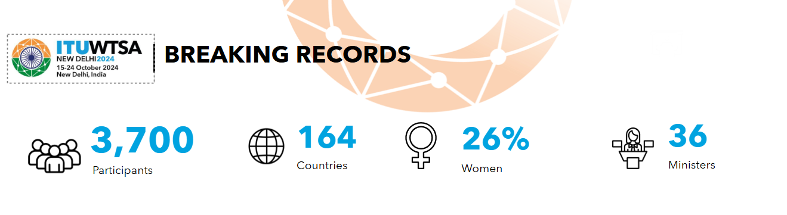
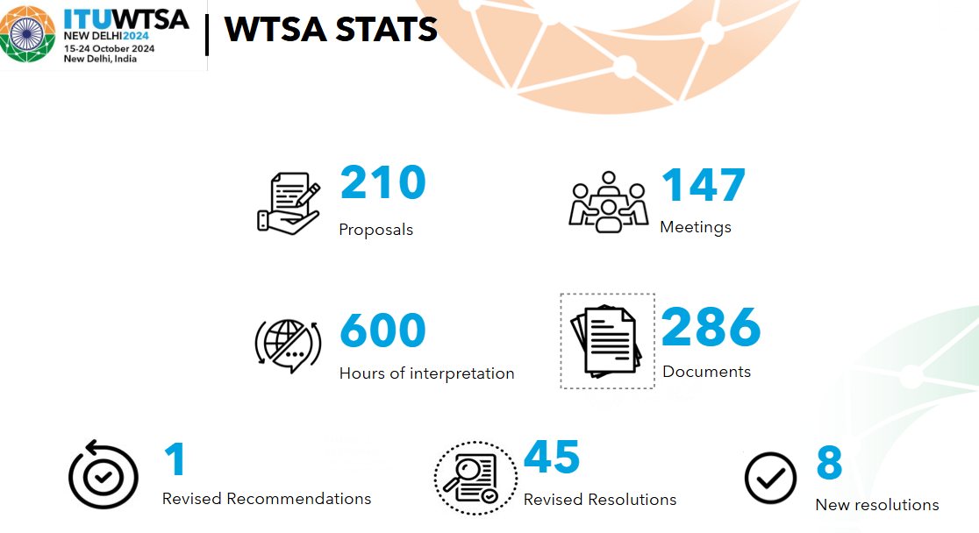

2024 Threat and risk assessment
Perspective | Risks reported | Impact reported | Mitigation measures implemented
Operational/  Organizational | Inadequate resources and support in the planning/organizational state of the meetings | Low | Necessary support was made available to ensure the smooth running of WTSA-24.

2026 Statement of expected results and risk analysis
2026 Statement of expected results
Expected results | Key performance indicators
Progress of work in ITU-T Study Groups and TSAG. | Output from TSAG and ITU-T study groups.
Progress of actions on WTSA Resolutions. | Progress of the WTSA action plan.

2026 Threat and risk assessment
Perspective | Key risk indicator | Impact | Likelihood | Mitigation
Stakeholders | Conduct actions from WTSA-24 Resolutions and preparation for WTSA-28. Progress depends on provided Contributions. | Medium | Medium | Encourage submission of necessary Contributions.
Stakeholders | Objectives and action plan to meet timelines |  |  | Active collaboration with membership and partners to meet timeline

2026-2029 human resources allocation
Work/months
Grade | 2026 | 2027 | 2028 | 2029
E2 | 0.0 | 0.0 | 1.8 | 0.0
D1 | 0.0 | 0.0 | 3.6 | 0.0
D2 | 0.0 | 0.0 | 1.8 | 0.0
P5 | 0.0 | 0.0 | 14.4 | 0.0
P4 | 0.0 | 0.0 | 25.8 | 0.0
P3 | 0.0 | 0.0 | 15.6 | 0.0
P2 | 0.0 | 0.0 | 18.0 | 0.0
P1 | 0.0 | 0.0 | 5.4 | 0.0
G7 | 0.0 | 0.0 | 1.8 | 0.0
G6 | 0.0 | 0.0 | 19.2 | 0.0
G5 | 0.0 | 0.0 | 5.4 | 0.0
G4 | 0.0 | 0.0 | 0.0 | 0.0
TOTAL | 0.0 | 0.0 | 112.8 | 0.0

2.2 WTSA Regional consultation sessions
Description
Regional preparatory meetings are organized by the Regional Telecommunication Organizations in coordination with ITU, in particular with the Telecommunication Standardization Bureau.

2024 Performance Report
2024 Statement of achieved results
Expected results | Achieved results | Key performance indicators | Measurement / performance data
Regional preparatory meetings help Members in achieving greater regional coordination and engage early on Members in the WTSA-24 preparation process. | Smooth running of WTSA-24 regional preparatory process by the six Regional Telecom Organizations in coordination with TSB. The whole process helped in creating a basis for consensus at WTSA-24. | # of meetings in 2024:  Inter-regional meeting (IRM): 3  Africa: 2  Americas: 6  Arab States: 1  Asia and the Pacific: 6  CIS: 3  Europe: 5

2024 Threat and risk assessment
Perspective | Risks reported | Impact reported | Mitigation measures implemented
Operational/  Organizational | Inadequate resources and support in the planning/organizational state of the meetings | Low | Necessary support was made available to ensure the smooth running of WTSA Regional consultation sessions

2026 Statement of expected results and risk analysis
2026 Statement of expected results
Expected results | Key performance indicators
Preliminary discussion toward WTSA-28. | Progress of the preparatory work in each Region.

2026 Threat and risk assessment
Perspective | Key risk indicator | Impact | Likelihood | Mitigation
Stakeholders / operational | Delayed host country volunteers and/or arrangements | High | Medium | Active collaboration with membership to identify possible venue
Stakeholders | Mobilization at regional level for organizing a meeting calendar | High | High | Active coordination with regional telecommunication organizations to develop a programme of meetings and sharing of information with stakeholders
Stakeholders | Organization of Inter-regional Meetings (IRM) | High | Low | Coordination with TSAG management team and membership

2026-2029 human resources allocation
Work/months
Grade | 2026 | 2027 | 2028 | 2029
E2 | 0.0 | 0.0 | 1.2 | 0.0
D1 | 0.0 | 0.0 | 1.2 | 0.0
D2 | 0.0 | 0.0 | 1.2 | 0.0
P5 | 0.0 | 0.0 | 3.0 | 0.0
P4 | 0.0 | 0.0 | 6.0 | 0.0
P3 | 0.0 | 0.0 | 1.8 | 0.0
P2 | 0.0 | 0.0 | 1.2 | 0.0
P1 | 0.0 | 0.0 | 0.0 | 0.0
G7 | 0.0 | 0.0 | 1.2 | 0.0
G6 | 0.0 | 0.0 | 1.8 | 0.0
G5 | 0.0 | 0.0 | 1.2 | 0.0
G4 | 0.0 | 0.0 | 0.0 | 0.0
TOTAL | 0.0 | 0.0 | 19.8 | 0.0

2.3 TSAG – Telecommunication Standardization Advisory Group
Description
The Telecommunication Standardization Advisory Group (TSAG) provides ITU-T with flexibility between WTSAs by reviewing priorities, programmes, operations, financial matters and strategies for the Sector. It also follows up on the accomplishments of the work programme, restructures and establishes ITU-T study groups, provides guidelines to the study groups, advises the Director of the Telecommunication Standardization Bureau (TSB), and produces organization and working procedures in the shape of A series Recommendations.

2024 Performance Report
2024 Statement of achieved results
Expected results | Achieved results | Key performance indicators | Measurement / performance data
The responsibilities of TSAG are set forth in Article 14A of the ITU Convention, WTSA Resolutions 1, 22, 40, 45, and other relevant Resolutions.  In 2024, TSAG met twice in Geneva (four in the Study Period 2022-2024) to finalize the preparation of WTSA-24.  TSAG Reports to WTSA-24 contain achieved results:  Part I: Doc24 – General  Part II: Doc25 – Draft revised Resolutions  Part III: Doc26 – Draft revised Recs. of the ITU-T A-series  Part IV: Doc27 – TSAG report in respect of WTSA Resolution 22 | Achievements includes: TSAG examined 111 contributions and produced numerous technical documents and liaison statements.  Developed new Recommendations (e.g., ITU-T A.18, A.24) and revised existing ones (e.g., ITU-T A.7, A.8).  Proposed the consolidation of ITU-T Study Groups 9 and 16 into a new Study Group C (=21).  Developed an action plan for vibrant industry engagement and proposed new resolutions on sustainable digital transformation and the evolving role of industry.

2024 Threat and risk assessment
Perspective | Risks reported | Impact reported | Mitigation measures implemented
Operational/  Organizational | Inadequate resources and support in the planning/organizational state of the meetings | Low | Necessary support was made available to ensure the smooth running of WTSA Regional consultation sessions

2026 Statement of expected results and risk analysis
2026 Statement of expected results
Expected results | Key performance indicators
Good management of ITU-T Study Group activities. | Outputs from ITU-T Study Groups.
New/updated A-series Recommendations and other documents. | Developed documents.
Enhanced review of priorities, programmes, operations, financial matters, and strategies | Review of ITU-T priorities, programmes, operations, financial matters, and strategies by TSAG implemented  Regular review by TSAG of progress in the implementation of the established work programme/plan adopted by WTSA conducted
Preparation and organization of the meetings of TSAG and implementation of the recommendations and advice  Efficient support to the TSAG activities, including the TDAG meeting  Regional support to the TSAG activities | Number of TSB submissions timely prepared and distributed  Number of contributions from members, including their posting on the web timely processed  Dissemination of the final summary of the TSAG meeting within the prescribed delay following completion of the meeting

2026 Threat and risk assessment
Perspective | Key risk indicator |  | Impact | Likelihood | Mitigation
Stakeholders | TSAG's activities depend on provided Contributions. |  | Medium | Medium | Encourage submission of necessary Contributions.
Organizational matters | Inadequate level of support for processing documents and ensuring the smooth running of the meeting |  | High | Low | Seek the necessary level of resources and support to ensure that the processing of documents and the smooth running of the meetings can be ensured

2026-2029 human resources allocation
Work/months
Grade | 2026 | 2027 | 2028 | 2029
E2 | 1.2 | 1.2 | 1.2 | 1.2
D1 | 1.8 | 1.8 | 1.8 | 1.8
D2 | 1.2 | 1.2 | 1.2 | 1.2
P5 | 4.2 | 4.2 | 4.2 | 4.2
P4 | 10.8 | 10.8 | 10.8 | 10.8
P3 | 6.0 | 6.0 | 6.0 | 6.0
P2 | 7.2 | 7.2 | 7.2 | 7.2
P1 | 1.8 | 1.8 | 1.8 | 1.8
G7 | 1.2 | 1.2 | 1.2 | 1.2
G6 | 6.6 | 6.6 | 7.2 | 6.6
G5 | 2.4 | 2.4 | 2.4 | 2.4
G4 | 0.0 | 0.0 | 0.0 | 0.0
TOTAL | 44.4 | 44.4 | 45.0 | 44.4

2.4 ITU-T General assistance & cooperation
Description
TSB provides support and fosters collaboration within ITU-T, ensuring effective communication and cooperation among Member States, Sector Members, Associates, Academia and other relevant stakeholders to advance global telecommunication standards.
TSB also leverages multistakholder collaboration via the AI for Good Global Summit and its online community supported by 47 UN partners.

2024 Performance Report
2024 Statement of achieved results
Expected results | Achieved results | Key performance indicators | Measurement / performance data
Enhanced assistance and cooperation in implementing ITU-T mandates | Summary of TSB facilitation of ITU-T activities (July 2024-May 2025) is available in TSAG-TD9 (2025-05)
Increased communications with other standards organizations | Communications have been effectively made via liaison statements. | Number of ITU-T incoming and outgoing liaison statements to/from SG/TSAG meetings | Source: ITU-T Liaison Statements database (TSB database)
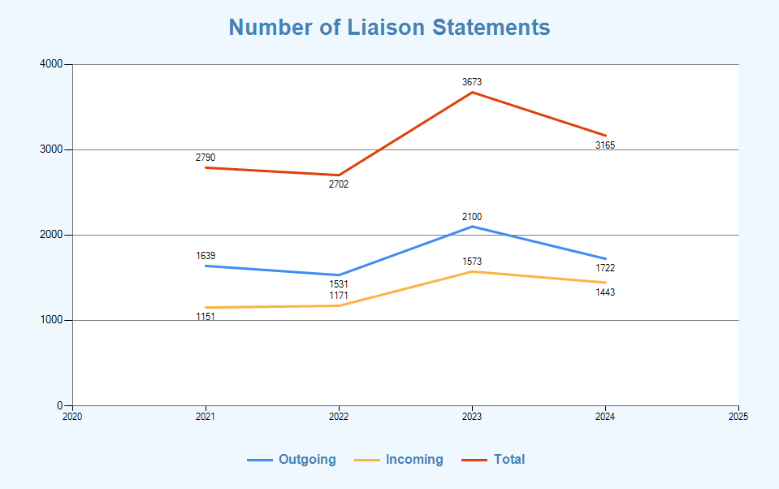
Decreased number of conflicting standards  Increased number of memoranda of understanding / collaboration agreements with other organizations | Chart available below. | Number of joint ITU-T and other SDOs developed standard (ISO/IEC, ETSI) | Source: ITU-T Work Programme (TSB database)
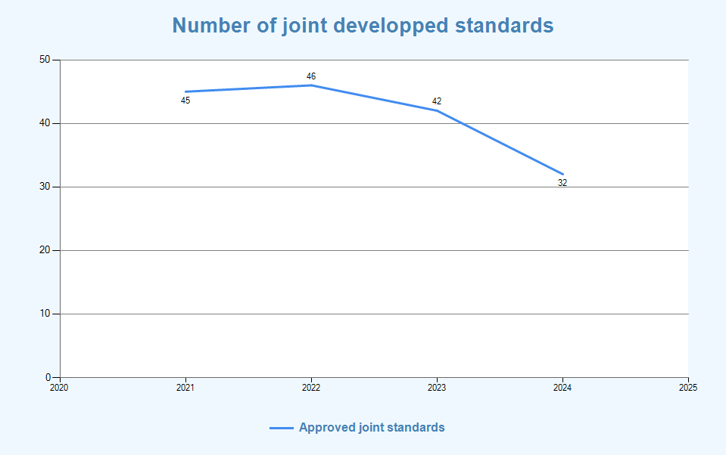
Enhanced and effective cooperation with other orgs | Effective cooperation was made though ITU-T A.5 process.  (ITU-T A.4 and A.6 were withdrawn in 2023 to focus on A.5 qualification.) | # qualified orgs. under ITU-T A.5: 51 | Source: ITU-T Work Programme (TSB database)
Increased number of workshops / events organized jointly with other organizations | Increased number of Joint Workshops with other organizations  - 36 in 2024  - 24 in 2023 | # of joint workshops | Source TSB Events

2024 Threat and risk assessment
Perspective | Risks reported | Impact reported | Mitigation measures implemented
Operational/  Organizational | Inadequate resources in providing general support. | Medium

2026 Statement of expected results and risk analysis
2026 Statement of expected results
Expected results | Key performance indicators
Collaboration and coordination with other organizations. | Output from groups in question.
Countries supported on specific topics | Publications, reports, studies prepared, guidelines adopted, and events organized on specific topics
Situation analysis conducted awareness increased, dialogue fostered, and guidelines prepared on specific topics to foster Telecommunication standardization activities knowledge | Percentage or number of Member States supported over the 4-year period

2026 Threat and risk assessment
Perspective | Key risk indicator | Impact | Likelihood | Mitigation
Stakeholders | Coordination and collaboration may not work efficiently due to different working methods. | Medium | Medium | Find practical solutions with stakeholders
Finance | Insufficient financial  resources | High | Medium | Prepare realistic estimates. Prepare forecasts based on coordination and communication with the members

2026-2029 human resources allocation
Work/months
Grade | 2026 | 2027 | 2028 | 2029
E2 | 1.8 | 3.0 | 1.2 | 3.0
D1 | 1.8 | 1.8 | 1.2 | 1.8
D2 | 1.2 | 1.8 | 1.2 | 1.8
P5 | 1.2 | 1.2 | 0.6 | 1.2
P4 | 14.4 | 15.6 | 10.2 | 15.6
P3 | 11.4 | 11.4 | 8.4 | 11.4
P2 | 8.4 | 8.4 | 5.4 | 8.4
P1 | 0.0 | 0.0 | 0.0 | 0.0
G7 | 1.8 | 3.0 | 1.2 | 3.0
G6 | 2.4 | 2.4 | 1.8 | 2.4
G5 | 1.8 | 3.0 | 1.2 | 3.0
G4 | 0.0 | 0.0 | 0.0 | 0.0
TOTAL | 46.2 | 51.6 | 32.4 | 51.6

2.5 ITU-T study groups

Description
Standardization work is carried out by the technical study groups (SGs) in which representatives of the ITU-T membership develop Recommendations (standards) for the various fields of international telecommunications.
ITU-T SGs assemble experts from around the world to develop international standards known as ITU-T Recommendations, which act as defining elements in the global infrastructure of information and communication technologies (ICTs). Standards are critical to the interoperability of ICTs and whether we exchange voice, video or data messages, standards enable global communications by ensuring that countries’ ICT networks and devices are speaking the same language.

2024 Performance Report
2024 Statement of achieved results
Expected results | Achieved results | Key performance indicators | Measurement / performance data
ITU-T Standardization work has been carried out by ten Study Groups in the 2022-2024 Study Period. | Total of 16 meetings of ITU-T Study Groups were held in 2024.  Executive summaries of ITU-T study group meetings can be found on their respective homepages.  From July 2024 to May 2025, 381 new and revised ITU-T Recommendations and related texts were approved.
Increased utilization of ITU-T recommendations | Chart available below | Number of ITU-T Publications approved per year | Source: ITU-T Publications (TSB database), as of May 2025
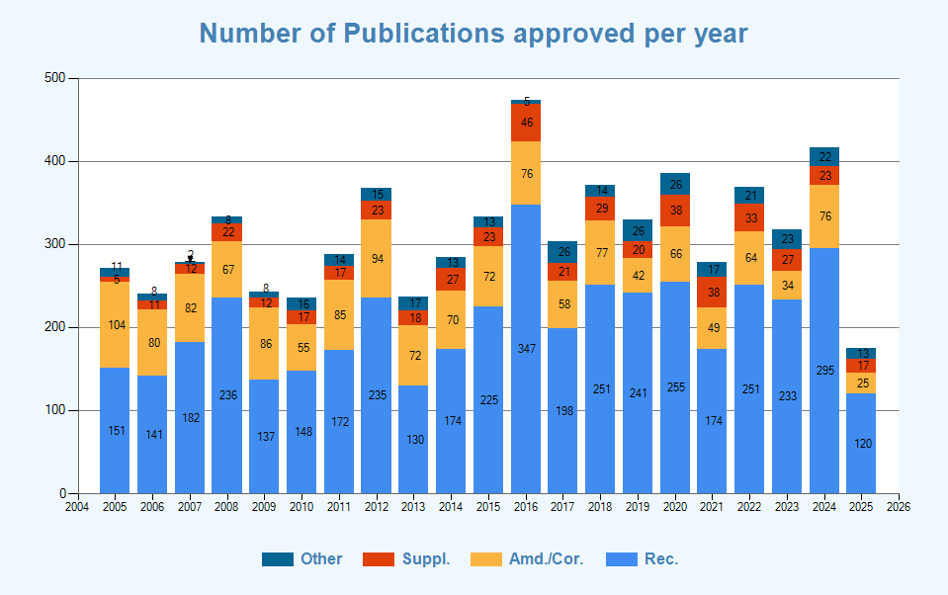

Increased utilization of ITU-T recommendations | 3.1 Million downloads (trends visible from Power bi) | Number of downloads of ITU-T Recs per year | Power BI

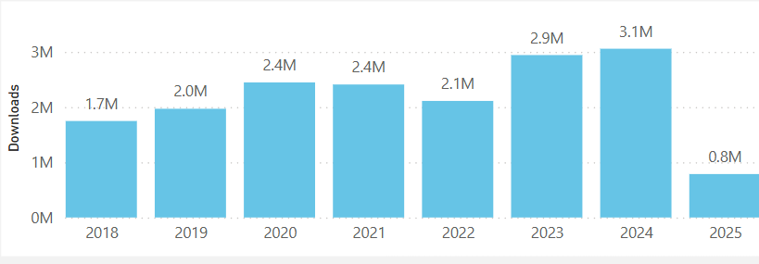

Increased utilization of ITU-T recommendations |  | Visits to ITU-T Website per year

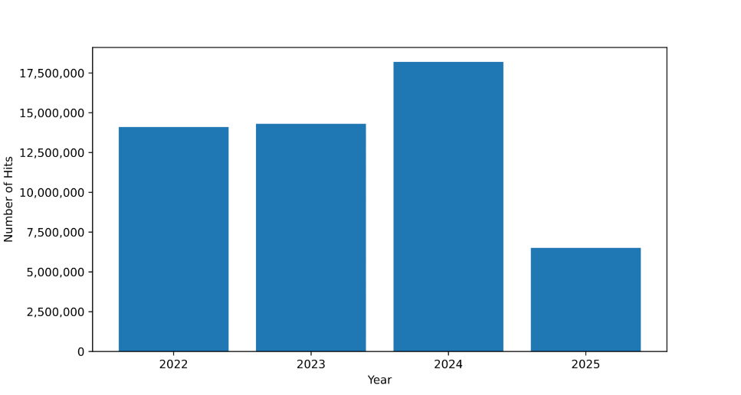
Improved conformance to ITU-T recommendations |  | # of conformity test events | None
Improved conformance to ITU-T recommendations |  | # of entries in conformity database | As of 2025, 14 Testing Laboratories (TL), which scope of accreditation cover ITU-T Recommendations, registered in ITU TL Database, https://itu.int/go/tldb
Enhanced standards in new technologies and services | Chart available below | New work items per year (excluding revised, amendment and corrigenda, supplements and non-normative texts) | Source: ITU-T Work programme (TSB database)
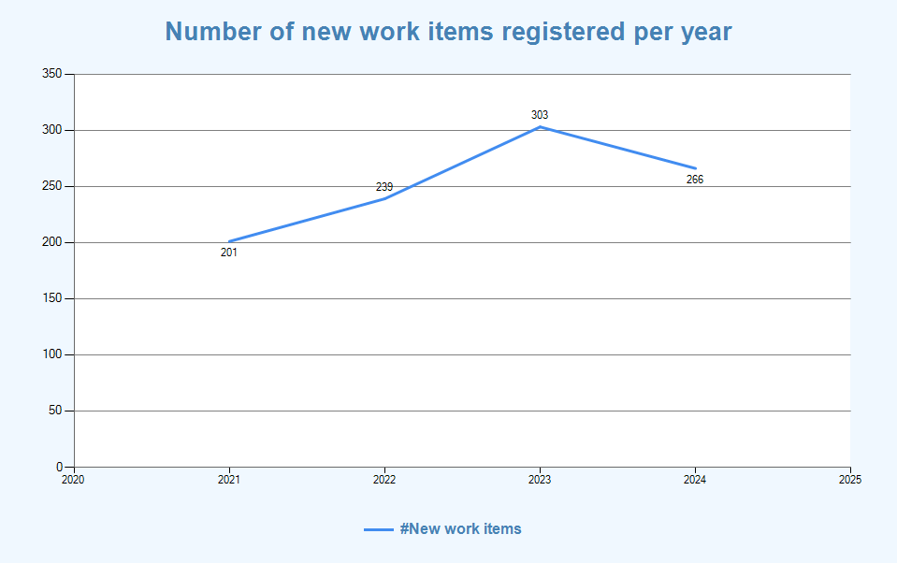

2024 Threat and risk assessment
Perspective | Risks reported | Impact reported | Mitigation measures implemented
Stakeholders/  partners | Low or limited participation by the membership in the work of the related Study Groups | Low | Raise further awareness of the planned and ongoing work of the Study Groups and their value to the membership. The meeting saw an  adequate level of contributions from the membership to progress the work of the related Study Groups topics under study
Organizational  capabilities /  Finance | Inadequate level of resources/support for the processing of documents, facilitating of the  Study Groups process and the running of meetings | Low | As the necessary level of resources/support was made available for the meetings, the processing of documents and the smooth running of the meetings could be ensured

2026 Statement of expected results and risk analysis
2026 Statement of expected results
Expected results | Key performance indicators
Development of ITU-T Recommendations and other documents. | Output from ITU-T Study Groups.
Overall organization of ITU-T Study Groups, as well as the overall planning of SGs. | Facilities utilization rate for Study Groups meetings
Enhanced knowledge-sharing and dialogue amongst Member States, Sector Members Associates and Academia on standardization issues | Number of participants in ITU-T Study Group meetings and related activities;  Number of contributions received by ITU-T Study Groups

2026 Threat and risk assessment
Perspective | Key risk indicator | Impact | Likelihood | Mitigation
Stakeholders | No or a limited number of contributions from the members to progress the work of the related Study Group Questions. | High | Medium | Encourage, through all appropriate ways and means possible the submission of contributions from the membership on the topics under study in order to ensure that the agreed work plans can be implemented.
Stakeholders | Low or limited participation by the membership in the work of the related Study Group Questions. | High | Low | Raise further awareness of the planned and ongoing work of the Study Groups and their value to the membership

2026-2029 human resources allocation
Work/months
Grade | 2026 | 2027 | 2028 | 2029
E2 | 4.2 | 4.2 | 3.0 | 4.2
D1 | 8.4 | 10.8 | 8.4 | 10.8
D2 | 6.0 | 6.0 | 4.8 | 6.0
P5 | 48.6 | 54.6 | 43.8 | 54.6
P4 | 66.6 | 67.2 | 51.0 | 67.2
P3 | 43.2 | 43.2 | 34.2 | 43.2
P2 | 57.6 | 57.6 | 45.0 | 57.6
P1 | 15.0 | 15.0 | 12.6 | 15.0
G7 | 4.2 | 4.2 | 3.0 | 4.2
G6 | 68.4 | 68.4 | 55.2 | 68.4
G5 | 21.0 | 21.0 | 18.6 | 21.0
G4 | 0.0 | 0.0 | 0.0 | 0.0
TOTAL | 343.2 | 352.2 | 279.6 | 352.2

2.6 Bridging the standardization gap

Description
TSB provides support and assistance to developing countries in bridging the standardization gap in relation to standardization matters, information and communication network infrastructure and applications, and relevant training materials for capacity building, taking into account the characteristics of the telecommunication environment of the developing countries.

2024 Performance Report
2024 Statement of achieved results
Expected results | Achieved results | Key performance indicators | Measurement / performance data
BSG activities including capacity building relevant to standards development, WTSA and electronic working methods and tools were held | 22 BSG events were held in 2024. 173 fellowships were requested from January to June 2024 and 89 were awarded | # of BSG events
Increased participation in the ITU-T standardization process, including attendance of meetings, submission of contributions, taking leadership positions and hosting of meetings / workshops, especially from developing countries | Chart available below | Total of ITU-T Events registered in ITU events calendar, grouped by following type: Statutory (SG and TSAG), Regional Groups, Other (Workshops, FG, etc.) | Source: ITU Event calendar (CRM/GEM database)
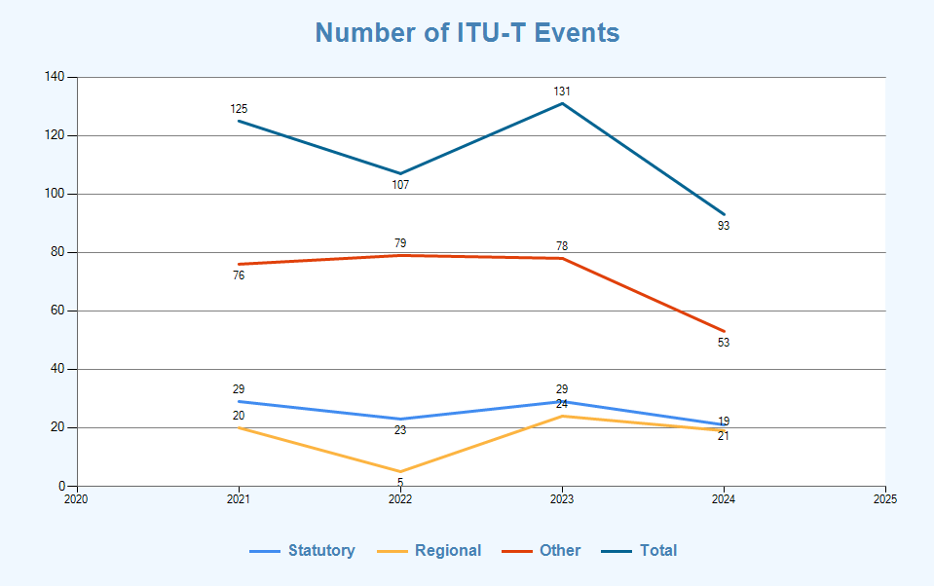

 | Chart available below | Total of rapporteur groups meetings per year | Source: ITU-T Work programme (TSB database)
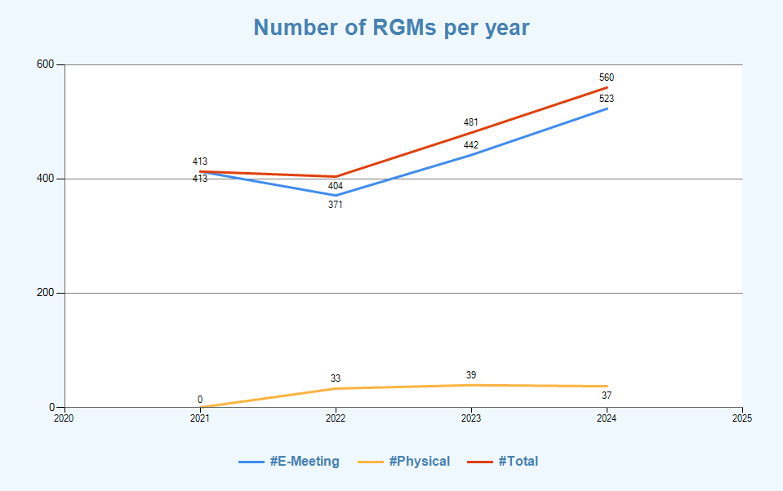

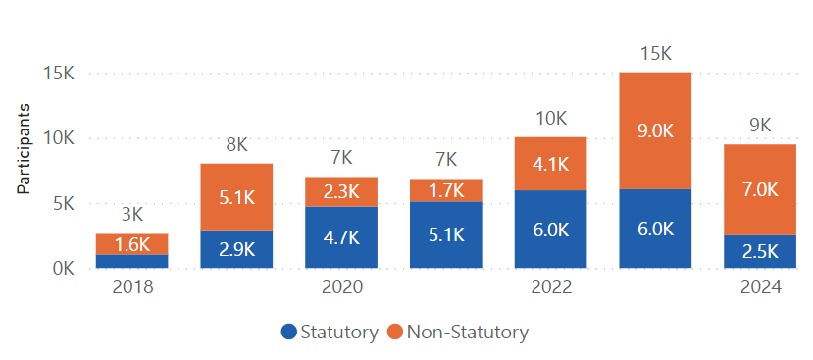

Increase of the ITU-T membership, including Sector Members, Associates and Academia | Combined net increase of 6 ITU-T members in 2024 (-1 ITU-T Sector Members; +6 ITU-T Associates). Source: Membership Annual Report 2024 available in PowerBI. (Academia participation is not included as this category is ITU-wide and is overseen by SPM) | ITU-T Total Sector Members, Associates, Academia | Source: Membership Annual Report 2024 available in PowerBI

2024 Threat and risk assessment

Perspective | Risks reported | Impact reported | Mitigation measures implemented
Organisational / Operational | Inadequate resources and support in the planning and delivery of the meeting. | Low | Appropriate planning, anticipation of requirements, and adequate provision of resources;

2026 Statement of expected results and risk analysis
2026 Statement of expected results
Expected results | Key performance indicators
Enhanced ability of all countries, in particular developing countries, to develop and implement strategies, policies and practices for digital inclusion, access and use telecom/ICTs, implement, and participate in the development of ITU-T Recommendations, best practices and regulations | Total number of ITU-T study group leadership positions held (by level of development)
 | Total number of ITU-T study group meetings/participants
 | Total number of countries represented in the ITU-T study group meetings
 | Total number of contributions submitted to ITU-T study group meetings
 | Total number of ITU-T Recommendation downloaded

Total number of workshops and other events in support of ITU-T study group meetings

Number and geographic distribution of physical and remote participants in these workshops/events

2026 Threat and risk assessment
Perspective | Key risk indicator | Impact | Likelihood | Mitigation
Strategic perspective | Decrease or stagnation in the percentage of participation, contributions, downloads, and numbers of meetings and events of ITU-T. | High: Limited participation from developing countries could hinder global standardization efforts and impede progress towards bridging the standardization gap. | Moderate to high, depending on the effectiveness of initiatives and external factors impacting participation. | Strengthen supporting pillars of the new BSG program - i.e., resource and partnership - with targeted stakeholders and partners to achieve the KPIs in collaboration with BDT trough enhanced TSB tools and platforms addressing the specific needs and challenges faced by especially developing countries.
Technological and operational perspective | Low utilization rate or adoption of TSB tools and platforms by participants especially from developing countries. | Moderate to high: Underutilization of tools and platforms could hinder knowledge sharing, collaboration, and capacity-building efforts in developing countries with collaboration with BDT. | Moderate, depending on the accessibility, usability, and relevance of OPD tools and platforms to stakeholders especially from developing countries. | Enhancement of user experience and accessibility of TSB tools and platforms to cater to the needs and preferences of developing country users. Provision of training and capacity-building programs to facilitate the adoption and utilization of TSB tools and platforms in collaboration with BDT. Collaboration with regional organizations and partners to promote awareness and facilitate access to OPD tools and platforms in developing countries.

2026-2029 human resources allocation
Work/months
Grade | 2026 | 2027 | 2028 | 2029
E2 | 1.2 | 1.2 | 1.2 | 1.2
D1 | 2.4 | 2.4 | 1.8 | 2.4
D2 | 0.6 | 1.2 | 0.6 | 1.2
P5 | 9.6 | 9.6 | 8.4 | 9.6
P4 | 23.4 | 23.4 | 19.2 | 23.4
P3 | 12.6 | 12.6 | 10.8 | 12.6
P2 | 23.4 | 23.4 | 21.0 | 23.4
P1 | 6.6 | 6.6 | 3.6 | 6.6
G7 | 1.2 | 1.2 | 1.2 | 1.2
G6 | 14.4 | 14.4 | 10.8 | 14.4
G5 | 2.4 | 2.4 | 2.4 | 2.4
G4 | 0.0 | 0.0 | 0.0 | 0.0
TOTAL | 97.8 | 98.4 | 81.0 | 98.4

2.7 Training activities, including workshops and seminars

Description
Technical workshops, forums and symposia organized by TSB have become an integral part of ITU-T’s programme. Many of these activities were organized in collaboration with BR, BDT and ITU-T study group experts. The purpose of workshops, forums, tutorials, and symposia is to disseminate expert knowledge on state-of-the-art technologies and to promote awareness of ITU-T’s activities, working methods and priorities, as well as exploring new topics for future study group studies. Planned expenditure under this item relates to fellowships granted to facilitate participation of least developed countries in the work of the Sector.
To enhance capacity development on AI, TSB has been expanding ITU’s efforts to equip Member States with the knowledge and tools to leverage AI, ensuring its benefits are accessible and equitable worldwide by leveraging the AI for Good platform.
2024 Performance Report

2024 Statement of achieved results
Expected results | Achieved results | Key performance indicators | Measurement / performance data
Increased participation in ITU-T’s standardization activities and increased awareness of the relevance of ITU-T standards | Chart available below | # participants on Virtual platforms | MS PowerBI internal report

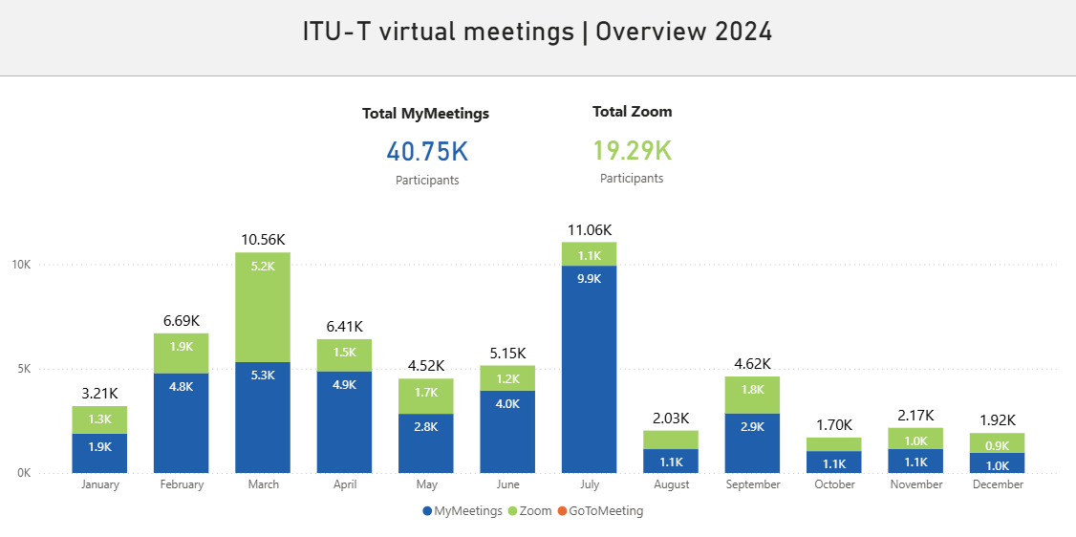
Workshops were held to assist Membership in knowledge sharing.  ITU-T workshops, symposia and webinars discuss emerging trends in standardization, increase the visibility of ITU-T work, enhance ITU-T collaboration with other bodies, attract and recruit new ITU-T members, and encourage peer-learning relevant to the development and implementation of international standards. | 98 in 2024, 89 in 2023.  In 2024, 98 ITU-T workshops, symposia and webinars were organized in addition to the weekly programming of the year-round AI for Good digital platform. | # of Workshops held in 2024/2023 | Data from TSB Events.  A listing of all past and planned events can be found on the ITU-T workshops homepage. The WTSA-24 related events can be found on Related Events - WTSA-24. For all Digital Transformation Dialogues, see dedicated web page.

2024 Threat and risk assessment
Perspective | Risks reported | Impact reported | Mitigation measures implemented
Organisational / Operational | Inadequate resources and support in the planning and delivery of the events. | Low | Appropriate planning, anticipation of requirements, and adequate provision of resources;

2026 Statement of expected results and risk analysis
2026 Statement of expected results
Expected results | Key performance indicators
Enhance global participation in ITU-T events | % increase in the number of participants and members.

2026 Threat and risk assessment
Perspective | Key risk indicator | Impact | Likelihood | Mitigation
Stakeholders | Participant engagement and attendance rates | Knowledge gaps, wasted resources | Depending on factors such as the relevance and quality of training, workshops and seminars content, the level of promotion and communication about such activities. | Needs assessment, effective communication. Improve cooperation with countries, regional offices and regional organizations so as to guarantee appropriate level of involvement by countries at the regional and/or local level.
Finance | Lack of resources to provide the appropriate support level in case of high demand from countries, partners and Members | High | Low | Prepare an appropriate budget forecast and resource mobilization strategy
Competency / knowledge | Lack of qualified experts in the field of activity | High | Medium | Anticipate resource requirements and initiate recruitment procedures as soon as possible. Create and keep up to date a roster for experts

2026-2029 human resources allocation
Work/months
Grade | 2026 | 2027 | 2028 | 2029
E2 | 1.2 | 1.2 | 1.2 | 1.2
D1 | 3.0 | 3.0 | 2.4 | 3.0
D2 | 1.2 | 1.2 | 0.6 | 1.2
P5 | 13.2 | 13.2 | 9.6 | 13.2
P4 | 19.8 | 19.8 | 18.6 | 19.8
P3 | 12.0 | 12.0 | 9.6 | 12.0
P2 | 32.4 | 32.4 | 29.4 | 32.4
P1 | 11.4 | 11.4 | 11.4 | 11.4
G7 | 1.2 | 1.2 | 1.2 | 1.2
G6 | 13.8 | 13.8 | 12.6 | 13.8
G5 | 6.0 | 6.0 | 3.6 | 6.0
G4 | 0.0 | 0.0 | 0.0 | 0.0
TOTAL | 115.2 | 115.2 | 100.2 | 115.2

2.8 ITU-T publications and database publications (including the Operational Bulletin)

Description
ITU-T publications include ITU-T Recommendations, supplements, technical reports and papers, software applications, WTSA proceedings, etc.
The ITU Operational Bulletin is a fortnightly publication containing administrative and operational information exchanged between administrations and recognized operating agencies (ROAs) and other service providers, entities, and organizations, in respect to international telecommunication services.

2024 Performance Report
2024 Statement of achieved results
Expected results | Achieved results | Key performance indicators | Measurement / performance data
Increased ITU-T publications | Chart already available under T5. ITU-T Study Groups | Number of ITU-T Publications approved per year | Source: ITU-T Publications (TSB database)
# of Database | 25 ITU-T Databases available in 2024
# of Operational Bulletin | Operational Bulletin is published on 1st and 15th each month, 24 per year.

2024 Threat and risk assessment
Perspective | Key risk indicator | Impact | Likelihood | Mitigation
Technological and operational | Potential downtime of services: Increased frequency of system errors or crashes  High volume of user complaints regarding service availability | High Negative impact on organization's reputation and user experience | Moderate to high, depending on system stability and maintenance practices | Regular monitoring of system performance and uptime
Human resources and knowledge management perspective | Loss of Critical Institutional Knowledge due to Staff Turnover: High turnover rate among key personnel.  Decreased employee engagement and satisfaction levels | High: Disruption of operations, decreased productivity, and loss of expertise | Moderate to high | Knowledge transfer processes to document and share critical information.
Operational and resource management | Requirement for Significant Time and Resource Investment in Maintaining Developed Applications: Increased backlog of maintenance tasks.  Higher than expected resource allocation for maintenance activities. | Moderate to high: Increased costs and potential delays in new development projects. | High, especially for complex applications | Automation of routine maintenance tasks to streamline processes. Regular assessment of resource allocation and adjustment of priorities.
Human resources and knowledge management | Vulnerability to Problems in Maintenance and Evolution of Applications if Developers Leave TSB: High turnover rate among development team members. | High: Disruption in maintenance and evolution activities, leading to potential delays and inefficiencies. | Moderate to high, depending on turnover rates and documentation practices. | Knowledge transfer processes to document and share critical information
Operational and workload management | Potential Sudden Increase in Editing and Publication Requests: Significant increase in the number of editing and publication requests within a short period.  High urgency or priority level assigned to incoming requests. | High: Potential backlog, resource constraints, and delays in meeting publication deadlines. | Moderate to high, especially during peak seasons or periods of increased activity. | Implementation of efficient workflow management tools and processes to streamline request handling. Capacity planning to ensure resources are allocated appropriately to handle fluctuations in workload.
Operational and contingency planning | Absence of Internal Backups for Publication Workflow Tasks: Lack of documented backup procedures for critical publication tasks. Dependency on specific individuals for task execution without redundancy. | Moderate to high: Disruption in publication workflows in case of staff absence or technical failures. | Moderate, but severity of impact can be high if backups are not in place | Development and documentation of backup plans for key publication tasks. Cross-training of staff to ensure multiple individuals can perform critical tasks.
Financial and resource management | Potential Reduction in Financial Resources for Hiring Editing Assistants: Budget cuts or financial constraints. Decrease in allocated funds for hiring new staff or filling vacant positions. | High: Limited capacity to meet editing demands, potential backlog, and decreased productivity. | Moderate to high, depending on organizational financial health and external economic factors. | Advocacy for the importance of editing services and their impact on organizational goals. Exploration of alternative funding sources or cost-saving measures

2026 Statement of expected results and risk analysis
2026 Statement of expected results
Expected results | Key performance indicators
Business continuity and a more efficient management of human and financial resources | Percentage decrease in manual processes through automation and digitization initiatives.
Enhance Coordination for the Multilingual Publication for Effective Standards Dissemination | Average Publication Turnaround Time

2026 Threat and risk assessment
Perspective | Key risk indicator | Impact | Likelihood | Mitigation
Technological and operational | Potential downtime of services: Increased frequency of system errors or crashes  High volume of user complaints regarding service availability | High Negative impact on organization's reputation and user experience | Moderate to high, depending on system stability and maintenance practices | Regular monitoring of system performance and uptime
Human resources and knowledge management perspective | Loss of Critical Institutional Knowledge due to Staff Turnover: High turnover rate among key personnel.  Decreased employee engagement and satisfaction levels | High: Disruption of operations, decreased productivity, and loss of expertise | Moderate to high | Knowledge transfer processes to document and share critical information.
Operational and resource management | Requirement for Significant Time and Resource Investment in Maintaining Developed Applications: Increased backlog of maintenance tasks.  Higher than expected resource allocation for maintenance activities. | Moderate to high: Increased costs and potential delays in new development projects. | High, especially for complex applications | Automation of routine maintenance tasks to streamline processes. Regular assessment of resource allocation and adjustment of priorities.
Human resources and knowledge management | Vulnerability to Problems in Maintenance and Evolution of Applications if Developers Leave TSB: High turnover rate among development team members. | High: Disruption in maintenance and evolution activities, leading to potential delays and inefficiencies. | Moderate to high, depending on turnover rates and documentation practices. | Knowledge transfer processes to document and share critical information
Operational and workload management | Potential Sudden Increase in Editing and Publication Requests: Significant increase in the number of editing and publication requests within a short period.  High urgency or priority level assigned to incoming requests. | High: Potential backlog, resource constraints, and delays in meeting publication deadlines. | Moderate to high, especially during peak seasons or periods of increased activity. | Implementation of efficient workflow management tools and processes to streamline request handling. Capacity planning to ensure resources are allocated appropriately to handle fluctuations in workload.
Operational and contingency planning | Absence of Internal Backups for Publication Workflow Tasks: Lack of documented backup procedures for critical publication tasks. Dependency on specific individuals for task execution without redundancy. | Moderate to high: Disruption in publication workflows in case of staff absence or technical failures. | Moderate, but severity of impact can be high if backups are not in place | Development and documentation of backup plans for key publication tasks. Cross-training of staff to ensure multiple individuals can perform critical tasks.
Financial and resource management | Potential Reduction in Financial Resources for Hiring Editing Assistants: Budget cuts or financial constraints. Decrease in allocated funds for hiring new staff or filling vacant positions. | High: Limited capacity to meet editing demands, potential backlog, and decreased productivity. | Moderate to high, depending on organizational financial health and external economic factors. | Advocacy for the importance of editing services and their impact on organizational goals. Exploration of alternative funding sources or cost-saving measures

2026-2029 human resources allocation
Work/months
Grade | 2026 | 2027 | 2028 | 2029
E2 | 0.6 | 0.6 | 0.6 | 0.6
D1 | 1.8 | 1.8 | 1.8 | 1.8
D2 | 0.0 | 0.0 | 0.0 | 0.0
P5 | 1.2 | 1.2 | 0.6 | 1.2
P4 | 18.6 | 18.6 | 15.0 | 18.6
P3 | 9.0 | 9.0 | 7.8 | 9.0
P2 | 10.2 | 10.2 | 10.8 | 10.2
P1 | 0.6 | 0.6 | 0.6 | 0.6
G7 | 0.6 | 0.6 | 0.6 | 0.6
G6 | 35.4 | 35.4 | 33.0 | 35.4
G5 | 12.6 | 12.6 | 12.6 | 12.6
G4 | 12.0 | 12.0 | 12.0 | 12.0
TOTAL | 102.6 | 102.6 | 95.4 | 102.6
2.9 Allocation and management of international telecommunication numbering, naming, addressing and identification resources in accordance with ITU-T Recommendations and procedure

Description
TSB is responsible for the allocation and management of international telecommunication numbering, naming, addressing, and identification resources. This process follows ITU-T Recommendations and procedures, ensuring global consistency and efficient communication networks.

2024 Performance Report
2024 Statement of achieved results
Expected results | Achieved results | Key performance indicators | Measurement / performance data
Timely and accurate allocation of international telecommunication numbering, naming, addressing and identification resources, as specified in the relevant recommendations | Total number of assigned UIN, SANC, shared E.164CC and IC, shared E.212 MCC and MNC | Number of assignments answered within a certain period of time | 264

2024 Threat and risk assessment
Perspective | Key risk indicator | Impact | Likelihood | Mitigation
Operational | Rate of exhaustion or depletion of available numbering, naming, addressing, and identification resources | Services disruptions, increased costs, regulatory non-compliance | Depending on factors such as the rate of demand | Resource monitoring and planning, policy and regulatory frameworks
Finance | Lack of resources to provide the appropriate support level in case of high demand | High | Medium | Appropriate budget forecast to be prepared to take into consideration request variances

2026 Statement of expected results and risk analysis
2026 Statement of expected results
Expected results | Key performance indicators
Stakeholder satisfaction | Feedback ratings from stakeholders (e.g., telecommunication operators, regulatory authorities) on the efficiency and effectiveness of resource allocation and management processes

2026 Threat and risk assessment
Perspective | Key risk indicator | Impact | Likelihood | Mitigation
Operational | Rate of exhaustion or depletion of available numbering, naming, addressing, and identification resources | Services disruptions, increased costs, regulatory non-compliance | Depending on factors such as the rate of demand | Resource monitoring and planning, policy and regulatory frameworks
Finance | Lack of resources to provide the appropriate support level in case of high demand | High | Medium | Appropriate budget forecast to be prepared to take into consideration request variances

2026-2029 human resources allocation
Work/months
Grade | 2026 | 2027 | 2028 | 2029
E2 | 0.6 | 0.6 | 0.6 | 0.6
D1 | 2.4 | 2.4 | 1.8 | 2.4
D2 | 0.6 | 0.6 | 0.6 | 0.6
P5 | 0.0 | 0.0 | 0.0 | 0.0
P4 | 13.2 | 12.6 | 11.4 | 12.6
P3 | 13.8 | 13.8 | 13.8 | 13.8
P2 | 4.8 | 4.8 | 6.0 | 4.8
P1 | 0.6 | 0.6 | 0.6 | 0.6
G7 | 0.6 | 0.6 | 0.6 | 0.6
G6 | 3.0 | 3.0 | 2.4 | 3.0
G5 | 0.6 | 0.6 | 0.6 | 0.6
G4 | 0.0 | 0.0 | 0.0 | 0.0
TOTAL | 40.2 | 39.6 | 38.4 | 39.6

_______________________

