 | INTERNATIONAL TELECOMMUNICATION UNION  TELECOMMUNICATION  STANDARDIZATION SECTOR  STUDY PERIOD 2025-2028 |  |  | TSAG-TD56
 |  |  |  | TSAG
 |  |  |  | Original: English
 |  |  |  | Geneva, 26-30 May 2025
TD
Source: |  |  | ITU-T representatives to IEC SMB/ISO TMB/ITU-T TSAG Standardization Programme Coordination Group (SPCG)
Title: |  |  | Report on progress made by the IEC SMB/ISO TMB/ITU-T TSAG Standardization Programme Coordination Group (SPCG)
Contact: |  | Mr Ajit Jillavenkatesa  ITU-T representative to IEC SMB/ISO TMB/ITU-T TSAG Standardization Programme Coordination Group (SPCG) |  | Tel:  E-Mail: ajillavenkatesa@apple.com
Contact: |  | Ms Miho Naganuma  ITU-T representative to IEC SMB/ISO TMB/ITU-T TSAG Standardization Programme Coordination Group (SPCG) |  | Tel: +81 70 1000 7370  E-mail: m_naganuma@nec.com
Contact: |  | Mr Per Fröjdh  ITU-T representative to IEC SMB/ISO TMB/ITU-T TSAG Standardization Programme Coordination Group (SPCG) |  | Tel: +46 73-031 24 13  E-mail: per.frojdh@ericsson.com
Contact: |  | Mr Olivier Dubuisson  ITU-T representative to IEC SMB/ISO TMB/ITU-T TSAG Standardization Programme Coordination Group (SPCG) |  | Tel: +33 6 74 95 46 37  E-mail: olivier.dubuisson@orange.com
Contact: |  | Mr Zhicheng Qu  ITU-T representative to IEC SMB/ISO TMB/ITU-T TSAG Standardization Programme Coordination Group (SPCG) |  | Tel: +86 185 1254 0427  E-mail: qu.zhicheng@zte.com.cn
Contact: |  | Mr Noriyuki Araki  TSB secretariat for ITU-T representatives to IEC SMB/ISO TMB/ITU-T TSAG Standardization Programme Coordination Group (SPCG) |  | Tel: +41 22 730 5828  E-mail: noriyuki.araki@itu.int

Abstract: | This TD reports on the progress made by the IEC SMB/ISO TMB/ITU-T TSAG Standardization Programme Coordination Group (SPCG) since the July - August 2024 TSAG meeting.
Actions: | The SPCG kindly requests ITU-T TSAG to take into consideration the provided information. ITU-T TSAG is kindly requested to re-appoint members for additional two-year term.
This TD contains the annual report to boards in the Annex, which was made by the IEC SMB/ISO TMB/ITU-T TSAG Standardization Programme Coordination Group (SPCG) and reports the progress since the July - August 2024 TSAG meeting.
ITU-T TSAG is invited to note the report and submit any comments. Also, ITU-T TSAG is kindly requested to re-appoint members of TSAG representative to the SPCG for additional two-year term.

Annex

Standardization Programme Coordination Group (SPCG)

Annual report to boards

Background
The SPCG was established by the technical boards of IEC, ISO, and ITU-T (TMB Resolution 57/2018) with the following tasks:
- Share information on new subject areas of strategic interest on proposals for new fields of technical activity under consideration in SMB, TMB and TSAG;
- Discuss and review new areas of strategic interest or proposals for new fields of activity from all three organizations and identify common interests and future challenges;
- Identify and recommend opportunities and mechanisms for coordination, collaboration and joint work to the respective technical boards (SMB, TMB, TSAG);
- Provide recommendations regarding coordination of new areas of work to the three boards (as appropriate).
The SPCG receives information about new fields of technical activity from the respective technical management boards on an ongoing basis. As of January 2025, SPCG has reviewed 79 proposals for new fields of activities, including 11 since the last report. Out of the 79 proposals, 53 proposals received the interest of more than one organization, and 39 SPCG recommendations were developed. 22 recommendations were taken on board by the relevant board. Note that this number is low as some proposals due not proceed but might be put on hold or integrated into existing structures.

Current status
Since the last report to the Boards in June 2024, the following new fields of activity have been assessed for coordination and cohesion within SPCG.
Originating organization | Topic | SPCG-identified relevant work in partner organizations | Details of SPCG-identified collaborations to be considered by proposer
IEC | Consistent and effective labelling across industries | ISO, ITU-T | ISO/TC 312  ISO/TC 335  ITU-T SG 11
ISO | Express delivery | None | N/A
ISO | Customer contact centers | IEC, ITU-T | ISO-IEC/JTC 1/ SC 39  ITU-T SG 2  ITU-T SG 12  ITU-T SG 16
ISO | Innovative ports and terminals | IEC | IEC/TC 18  IEC/TC 57  IEC/TC 65  IEC/TC 72
ISO | Sustainability in event management | ITU-T | ITU-T SG 16
ISO | Ayurveda and yoga | None | N/A
ISO | Cross-border trade of second-hand goods | None | N/A
ISO | Digital marketing | IEC, ITU-T | Collaboration areas to be further defined
ISO | Safety, security and good production practices of cannabis facilities and operations | None | N/A
ITU-T | Artificial intelligence native for telecommunication networks | ISO, IEC | ISO-IEC/JTC 1/SC 42  ISO-IEC/JTC 1/SC 6
ITU-T | Artificial intelligence watermarking and multimedia authenticity | ISO, IEC | Multi-stakeholder collaboration set up (see link).

SPCG maintains two landscape documents on the existing standardization activities in IEC, ISO and ITU-T. The landscapes are offered as tools to assist in possible coordination not only among the respective groups, but also for submitters for any new planned or proposed groups or fields, with the overall purpose of addressing any overlaps, and to avoid duplicative activities.
The first landscape is a representation of general topics where more than one organization is actively developing standards, covering cross-organizational topics such as accessibility, energy efficiency, blockchain, data management, virtual reality and artificial intelligence. Relevant ISO, IEC and ITU-T structures (TC, SC, PC, JTC, SyC, SG, FG) for each cross-cutting topic are identified in the landscape document. The second landscape is focused on artificial intelligence and machine learning (AI/ML) and is detailed at the level of individual standards.
The SPCG is converting the landscapes, currently in tabular format into virtual mapping tools. The landscapes have attracted interest from the wider standardization community and the SPCG is of the view that transforming them into a more modern and user-friendly format will enhance their accessibility and utilization. The tools will be hosted on the SPCG webpage on the WSC website.
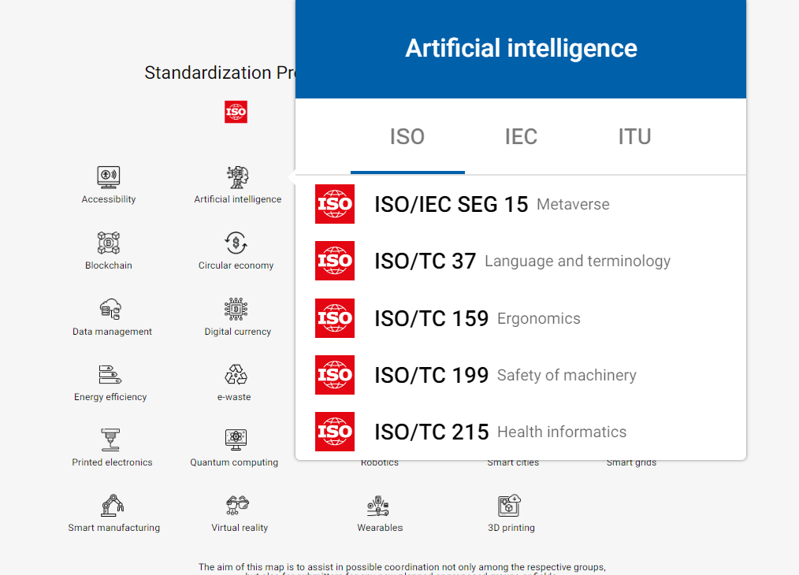
Figure 1. Screen shot of the SPCG interactive mapping tool currently under development. The figure shows an example; when you scroll over AI, the mapping lists all the existing ISO, IEC and ITU-T standards on AI (here only ISO standards are selected).

At the 24th SPCG meeting, held on 18 November 2024 in Paris, the SPCG members re-elected the current Chair Thomas Korssell (IEC/SMB) and Secretary Mikaela Sampson (ISO/CS) for an additional two-year term. Chairs are preferably elected from among the SPCG members for a term of two years and may serve one additional consecutive two-year term if re-elected.
SPCG members also serve two-year terms and are eligible for re-election. While there are no formal restrictions on the number of terms, each board determines the length of its members’ terms.
In addition to the proposals above, the following initiatives were shared:
- Invitation to an ISO International workshop on Framework for Implementing Environmental, Social and Governance (ESG) Principles (IWA 48)
- Invitation to an ISO international workshop on “Guidelines for Barnahus, a child friendly multidisciplinary and interagency response model for abused children”
- Invitation to participate in ISO Open Consultation on Resource-efficient Software

ISO Open Consultation is a new mechanism designed to explore an emerging topic with a broad range of stakeholders, and to document and consolidate global stakeholder expectations into an analytical report with recommendations for ISO action. The aim is not to reach consensus and develop a standard. The aim is to consolidate and define stakeholder expectations before

investing in a standardization process.

Other activities
- UN High-Level Advisory Board on AI’s final report, "Governing AI for Humanity" (September 2024).
The SPCG discussed the report, "Governing AI for Humanity", focusing on its third recommendation, "AI standards exchange," which calls for enhanced collaboration among standards organizations. A high-level response, highlighting existing collaboration, was provided to the WSC, allowing them to decide whether to share it with the UN High-Level Advisory Board on AI. The report was well received by the WSC and featured on the agenda of the WSC meeting on 28 November 2024.

- Transforming the landscape documents into virtual mapping tools – see above under ‘Current status’.

Next steps
ISO/TMB, IEC/SEC and ITU-T are requested to re-appoint members whose terms are set to expire in 2024.

Four meetings will be organized in 2025 with three virtual meetings on 5 March, 17 June and 4 September. A physical meeting will be organized in November 2025, however the exact date and location need to be confirmed.

___________________

