 | INTERNATIONAL TELECOMMUNICATION UNION  TELECOMMUNICATION  STANDARDIZATION SECTOR  STUDY PERIOD 2025-2028 |  |  |  |  | TSAG-TD42
 |  |  |  |  |  | TSAG
 |  |  |  |  |  | Original: English
 |  |  |  |  |  | Geneva, 26-30 May 2025
TD
(Ref.: 3GPP TSG SA-241935-LS33)
Source: |  | 3GPP TSG SA
Title: |  | LS/i on Metaverse application enablement [from 3GPP TSG SA]
LIAISON STATEMENT
For action to: |  |  |  | TSAG, MSF
For information to: |  |  |  | -
Approval: |  |  |  | TSG SA Meeting (Madrid, 13 December 2024)
Deadline: |  |  |  | -
Contact: |  |  | Sapan Shah |  | E-mail: sapan.shah@samsung.com

Please see below.

TSG SA Meeting #SP-106 SP-241935
10 - 13 December 2024, Madrid, Spain

Title: LS on Metaverse application enablement
Response to: None
Release: Rel-19
Work Item: Metaverse_App

Source: 3GPP TSG SA
To: ITU-T TSAG, MSF DAM-WG
Cc: ITU-T SG21, 3GPP TSG SA WG4, 3GPP TSG SA WG6

Contact person: Sapan Shah (sapan.shah@samsung.com)

Send any reply LS to: 3GPP Liaisons Coordinator, mailto:3GPPLiaison@etsi.org

Attachments: None

1 Overall description
3GPP SA6 is currently working on providing application enablement for metaverse applications. As part of this work, 3GPP SA6 has specified spatial anchors and spatial map services in 3GPP TS 23.437, and digital asset service in 3GPP TS 23.438 as part of the overall Service Enabler Architecture Layer (SEAL) services specified in 3GPP TS 23.434.
Particularly for the digital asset service, in Rel-19, 3GPP has considered an Avatar of a human as a digital asset and provided a service to enable metaverse applications and their users to manage (i.e. to create, update, get, delete and discover) digital assets.
3GPP SA6 believes that their digital asset service, as defined in 3GPP TS 23.438, also fulfils many of the requirements from FGMV as specified in clause 8.2 and clause 8.3 of FGMV-19 (https://www.itu.int/en/ITU-T/focusgroups/mv/Documents/List%20of%20FG-MV%20deliverables/FGMV-19.pdf). 3GPP SA6 also believes that the use cases considered in Metaverse Standard Forum Digital Asset Management Working Group can also be implemented using the digital asset service as provided in 3GPP TS 23.438.
3GPP SA6 kindly asks ITU-T TSAG and MSF DAM-WG to review the specifications for metaverse application enablement, and also provide any other application enablement requirements to consider for application enablement in the future releases of their specifications.
Furthermore, 3GPP SA6 is looking forward to having additional collaboration on topics of mutual interests.
For further information, please find below additional details about activities in 3GPP SA6:
3GPP SA6 have specified application enablement standards including, service frameworks (CAPIF, EDGEAPP, SEAL services including NSCE, ADAE, SEALDD) and vertical application enabler architectures (V2XAPP, UASAPP, 5GMARCH, PINAPP), to enable various industry vertical applications over 3GPP networks.
For a quick overview, Application Enablement Standards in 3GPP, and 3GPP SA6 R18 – 5G Critical Communications and Application Enablement Standards can be referred to. Additional background information can be found on the 3GPP SA6 web-page.
This is can be summarised through the figure below (endorsed in document S6-233819). This highlights how 3GPP SA6 has defined an application enablement layer that serves as an application middleware. Specifically, a set of application enablement APIs have been designed to hide the complexity of underlying the 5G core capabilities, and enable interactions between the Application Developers/Service Providers (ASPs) and the 3GPP Network Layer, across both user equipment (UE) and the core network.
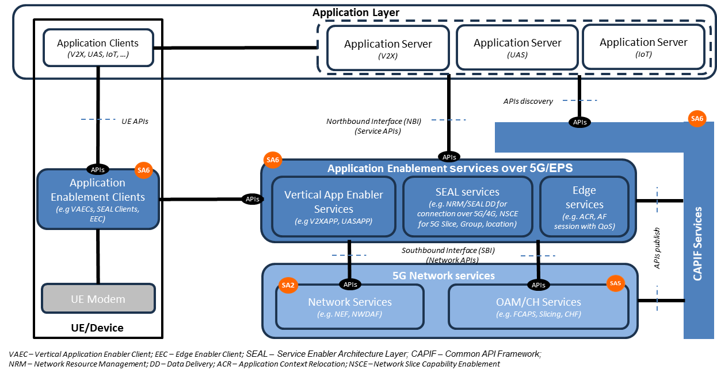
As part of the overall SA6 application enablement framework, the spatial anchors and spatial map service (as defined in 3GPP TS 23.437) and digital asset service (as specified in 3GPP TS 23.438) have been specified as part of SEAL services.
In summary, SA6 provides the following set of enablers:
- Vertical application enablers: SA6 has defined application enabler for verticals, such as V2XAPP (for V2X services), UASAPP (for UAS services) and 5GMARCH (for messaging over 5G).
- Services Framework
  - Service Enabler Architecture Layer (SEAL) Services: This framework specifies application plane and signalling plane entities for application-enabling services (e.g. group management, configuration management, location management, identity/key management, network resource management, data delivery, application data analytics enablement, AIML enablement, metaverse application services); that can be reused across multiple vertical applications.
  - Common API Framework (CAPIF): a unified Northbound API framework across network/application functions to facilitate a harmonized approach for API development within 3GPP.
  - Edge Application Enablement (EDGEAPP): Provides an edge enabling layer and application architecture for enabling Edge Applications on the Edge Data Network, including the exposure of northbound APIs towards Edge Applications.

2 Actions
To ITU-T TSAG, MSF DAM-W WG
ACTION: 3GPP TSG SA kindly asks ITU-T TSAG and MSF DAM-W WG to review the specifications indicated above and provide feedback if any. Feedback can be provided directly to TSG SA WG6, but kindly keep TSG SA informed.

3 Dates of next TSG SA and TSG SA WG6 meetings
TSG SA WG6#65 17th – 21st February 2025 Athens, GR
TSG SA#107 12th – 14th March 2025 Incheon, KR
TSG SA WG6#66 7th – 11th April 2025 Gothenburg, SE
TSG SA WG6#67 19th – 23rd May 2025 Fukuoka, JP
TSG SA#108 10th – 13th June 2025 Prague, CZ

_____________________

